[Type the company name]
Field of Accumulation: A Trove of Questions
Understanding Tibetan Religions Through Artistic Conventions
Elizabeth Harris
3/22/2017

“I know all the details of karma, but I do not really believe in it.
I have heard a lot of Dharma, but have never put it into practice.
Bless me and evil-doers like me
That our minds may mingle with the Dharma.”
-Words of My Perfect Teacher

Introduction
The Tibetan plateau is home to a unique blended culture of the religions, Buddhism and Bön. Bön, otherwise known as The Nameless Religion, was the reigning religious practice of this area until the introduction of Buddhism in the seventh century A.D., which came to eventually dominate the entire plateau. The Buddhist take-over was not immediate by any means, and was further complicated by the acceptance of Bön beliefs and traditions into Buddhism. To this day there is still debate between whether or not Bön is still its own religion, or just a ‘newer’ sect of Tibetan Buddhism.
“The Nyingma Lineage Refuge Field” dated 1800-1899, is a Buddhist scroll painting (thangka) depicting the distinct composition of a Field of Accumulation, also known as a Refuge Field. (Figure 1) This work represents the teachings of the Nyingma sect of Tibetan Buddhism and the lineage of the Heart-essence of the Vast Expanse; as described in the written guide by Patrul Rinpoche, Words of My Perfect Teacher. “Shenlha Odkar Tsog Shing” is a Bön scroll painting with a similar Refuge Field composition and is dated 1900-1959. (Figure 2) The teachings represented here are described in a book by Shardza Tashi Gyaltsen’s Heart Drops of Dharmakaya; a guide to the Dzogchen practice of the Bön. I intend to compare these two works by the six main aspects of a Refuge Field and their essential teachings, to show how Bön has become, or can be considered, the newest sect of Tibetan Buddhism.
What is Bön?
Bön is considered to have begun with a figure known as Tonpa Shenrab, who is believed to have been born in an enlightened realm and it is believed that he introduced the teachings to reach enlightenment to humans. These teachings took hold in the Kingdom of Zhangzhung, which was, believed to be, located on the western side of the Tibetan plateau. According to some adherents of this religion, Bön-pos, the Buddha Sakyamuni is claimed to have been a Bön-po teacher within the lineage of the founder of Bön. However, there are also claims that Bön was founded as a sect in the early eleventh century by another figure known as Gshen-chen Klu-dga’ and his disciples. This is possible, but during this same century was the re-introduction of Indian Buddhism by the figure known as Atisha. He believed that Tibetan Buddhism lacked structure and the changes he made to it lead to the creation of multiple sects within Tibet’s Buddhism.
Bon is a poly-theistic religion, which means it believes in the existence of multiple deities. These deities, according to Bon, live within and throughout the landscape. The practices of this religion are often used to appease and ask favor of the local deities; for example when a young child is sick it is believed that a wrathful spirit deity, or demon, has taken offense, it is then required to make offerings to appease the deity in order to save the child’s life. In Tibetan culture, life is precious because of religious reasons, but mostly because the environment and landscape of Tibet is a harsh place to survive, let alone live. This is also why many lay people of Tibet accepted Buddhism, because it benefitted them and their survival.
Tibetan Buddhism
Buddhism was introduced to the land of Tibet in the early seventh century by Padmasambhava; a teacher of Indian Buddhism who is also referred to as Guru Rinpoche or “The Precious Teacher”. The traditional story of Guru Rinpoche offers insight into the complications of determining the acceptance of Bon within Buddhism. It is believed that Guru Rinpoche was invited by the King of Tibet in the 7th century, to help with a particularly bad situation with malicious demons. The Buddhist Tantric practice and powers associated with Guru Rinpoche, as well as the man himself, are claimed to have subdued these demons. This event established the implications that Buddhism and its teachings were more powerful, and useful, than those of Bön.
During this period Bön was the main religious practice, Tibet was ruled by a patriarchal monarchy. This reign of monarchy is also partially responsible for the introduction of Buddhism, however the nobility within Tibet still clung to Bön until Buddhism proved to be more beneficial to their status and power in society. The fall of the monarchy in the 8th-9th century was the critical beginning moment of fusion between the two religions. From the downfall of the monarchy until the 11th century, the traditions and rituals were used simultaneously; the people of Tibet often used whatever method would work best at the time to aid their daily struggles. Then, the previously mentioned, Atisha introduced monastic rules and standards of practice for Buddhism around the year 1042. His influence ultimately created divisions within Tibetan Buddhism, forming the different sects and different styles of practice. Although, there is one sect that took little note Atisha, and that is the Nyingma sect of Tibetan Buddhism.
The Nyingma sect remained un-reformed, and kept the additions of Bön beliefs and practices within its teachings. It is the oldest sect, but is also considered the least ‘traditional’ form of Indian Buddhism. It involves many Tantric practices, which will be discussed further on.
Field of Accumulation
The Field of Accumulation, otherwise known as Refuge Field, is a type of painting composition that represents essential teachings within specific sects or lineages. These Refuge Fields are the focus, or objects, of a devotee’s offering, devotion, prayer, prostrations and so on, through which they can cultivate the necessary wisdom and merit to achieve Enlightenment. Refuge Fields serve as a Meditate-by-Numbers kind of visual aid for taking refuge. “Taking refuge” is considered to be step-one in pursuing protection from the danger of a samsaric existence, and is required for all teachings in order to reach Enlightenment. A samsaric existence is the belief in samsara; this is a wheel of existence, or cyclical existence, based on the suffering and karmic force of an individual’s actions. It is dependent upon the belief of reincarnation, and it ultimately never ends. Buddhism began with the intention of breaking this wheel and reaching a place absent of suffering, and ending the cycle of reincarnation. It is unclear if this final goal is shared with Bön, but they too want to end or escape from suffering.
There are three distinct types of Refuge Field compositions based upon descriptions in texts and trends within thangkas. First, there is the Lotus or Throne composition, which can be used interchangeably, and embodies the purity of an enlightened mind. Second, is the Palace composition that follows the same structure of a mandala; another ritual, based on an inner physical temple-like structure. Last, is the Tree composition and can be divided into a pyramidal peaked tree formation or a five-branched tree formation. All of these compositions are focused on the central figure of the image, which is often a very recognizable figure within the respective religion.
There are six main aspects of a Refuge Field; the Guru, the Buddha, the Sangha, the Dharma, deities of meditation, and deities of protection. Each one of these characteristics within the composition represents significant aspects vital to the beliefs and practices of the respective religions. The Guru, is the teacher and each individual is meant to envision their own teacher in this figure’s place. The teacher-student relationship is extremely important in this culture, and is often used to show the direct lines of teaching all the way back to The Buddha.
Nyingma Sect Artwork
“The Nyingma Lineage Refuge Field” depicts the lineage of the Heart-essence of the Vast Expanse, or the Longchen Nyingtik, in a five-branched tree formation. (Figure 1) This lineage focuses on the teachings of “The Great Perfection” in the Nyingma sect of Tibetan Buddhism. “The Great Perfection” is when “the nature of the mind is introduced directly and suddenly by the teacher.” This teaching originates from secret texts, or terma, that were revealed around the 10th century. These terma are believed to have been written by Guru Rinpoche, who hid the texts and said they would be revealed when the world was ready for those teachings. The terma were discovered and realized, or used successfully to attain Enlightenment, by figures known as tertons, or treasure revealers. The terton for this particular teaching is Rigdzin Jigme Lingpa who lived from 1729-1798. He received this teaching through a series of visions from the great lama of the fourteenth century, Longchenpa. Longchenpa is believed to have created the original composition for the field of accumulation, but he known to have systematized the Nyingma doctrines and “particularly discusses the subtleties of Dzogchen, the Great Perfection.” There is a guide to this teaching in Patrul Rinpoche’s Words of My Perfect Teacher, that explains the Heart-essence teachings. This guide is a prescriptive account to the practices of Buddhism, and more specifically to the Nyingma sect. The author is the student of Jigme Gyalwai Nyugu, who was the student of the terton Jigme Lingpa.
In the first thangka, the central figure is the Guru in the form of the great deity Vajradhara of Öddiyana with his female consort, Yeshe Tsogyal a dakini (deity). The image of Vajradhara of Öddiyana is visualized, and depicted in this image, with one face, two arms and two legs. All of the details of the figure are important to the identification of the figure, as well as the teachings they are trying to embody. He and his consort are the largest figures within this work and this displays the scale hierarchy which is used to emphasize their significance. He is seated in union with his consort, the white figure of Yeshe Tsogyal. “In union” refers to the tantric practice of arousing bodhicitta (wisdom) through the act of sexual intercourse.
The Buddha is situated on the foremost branch of the tree. It displays, “…the Buddha, the Conqueror Sakyamuni, surrounded by the thousand and two perfect Buddhas of this Good Kalpa as well as all the other Buddhas of the past, present and future and of all the ten directions.” This branch contains a lot of images of buddhas in the supreme nirmanakya form and each one is required to have the all the thirty-two major marks of the Buddha and the eighty minor marks of the Buddha. The “supreme nirmanakya form” is a version of the Buddha in which the compassion to help ordinary beings has manifested itself.
The right and left branches then hold the Sangha, or the monastic community of Buddhism. The right branch holds “the eight great Close Sons, headed by the bodhisattva Protectors of the Three Families--- Manjusri, Vajrapani and Avalokitesvara--- surrounded by the whole noble sangha of Bodhisattvas.” All of these figures are wearing the thirteen ornaments of the sambhogakaya, and stand with their feet together. Sambhogakaya in this image are figures of the monastic community that have limitless form, for these are the figures that appear in visions and embody joy. These thirteen ornaments of the sambhogakaya consist of five silk garments, a head band, a top or upper garment, a long scarf, a belt, and a lower garment; and eight jewels, a crown, earings, a short necklace, armlets on each arm, two long necklaces, a bracelet on each wrist, a rings on each hand, and an anklet on each foot.
On the opposite branch are, “the two principal sravakas, Sariputra and Maudgalyayana, surrounded by the noble sangha of sravakas and pratyekbuddhas.” Sravakas are ultimately figures of the students, who have learned and applied the important lessons from the right branch. All of the figures on this branch are standing, and hold staffs and alms-bowls.
The final, and top, branch the devotee is to visualize the Dharma; “the Jewel of the Dharma in the form of piles of books.” In meditation the devotee is instructed to visualize all 6,400,000 tantras of the Great Perfection with the labels out, however the artist of this work has not done so.
Between all of these branches are the male and female figures of the protection deities of wisdom and protectors who are constrained by their karmic links. This group of figures is what makes the distinction between the branches difficult. The male figures face outward, while the female figures face inward. The male figures are intended to “prevent outer obstacles from coming in, protecting us from hindrances and conditions unfavorable to practicing the Dharma and attaining enlightenment.” The female figures are intended to “keep inner accomplishments from leaking out.” These female figures are slightly ironic, because everyone who achieves Enlightenment surely ‘leaks,’ or gives their accounts of their inner accomplishments.

Bön Sect Artwork
The second Field of Accumulation is “Shenlha Odkar Tsog Shing” and is a much more recent work. (Figure 2) The composition for this painting was designed by Shardza Tashi Gyaltsen, the founder and Master of Studies of Bön-po monastic colleges in several countries, who is depicting one of his personal visionary experiences. He also wrote a book called Heart Drops of Dharmakaya; this book is a guide to the Dzogchen Practice of the Bön Tradition and to this Refuge Field.
This composition is incredibly dense with figures. The viewer’s eye is drawn to the over-lapping spheres that are accentuated by a rainbow outline. This rainbow outline is reminiscent of the rainbows Shardza saw within his vision, and when he died there are accounts of streams of rainbows projecting from his body. Within the largest sphere is the Guru figure, in the very center, of the seated figure known as Shenlha Okar , a Bön deity. He is depicted with white, pearlescent, skin, one face, that appears to be calm or in the act of meditation, and two hands that are placed in this lap in the meditation mudra. This figure is a Bön deity that represents the transcendental compassion of Tonpa Shenrab; the assumed creator of the Bön religion. This deity version is considered to be the “master teacher of all teachers” who now focuses primarily on teaching, and represents the Guru characteristic of Refuge Field compositions. His compassion, and dedication to teaching Bon, has helped all other earthly beings on the path to liberation, or Enlightenment. He is depicted with white or pearlescent skin for two reasons; “Odkar” translates to “white light” and he is considered to have the “body of perfection”.
Shenlha Odkar is always depicted in extravagant ceremonial robes and his hands in the meditation mudra. Similar to the Buddhist traditions, making these distinctions in details is important to correctly identify the figure and the practice that should be used in tandem with this image. His robes consists of a green scarf wrapped around his shoulders, that than billows out to the sides of the figure, and his lower body is dressed in multicolored scarves. The deity is also adorned with golden jewelry; a crown with red ribbons tied to the sides, necklaces, bracelets, anklets, and earrings.
The central figure sits upon a throne. This throne consists of a white moon disk that is on top of a pink and white lotus blossom that then sits on a golden throne sustained by two snow lions; this detail of the snow lions is meant to exhibit the deity’s supremacy over all other life forms. This lotus throne is representation of the figure’s enlightened mind. To further enhance the importance of this figure, he is significantly larger than the rest of the figures and this indicates a scale hierarchy. His white form is starkly contrasted by the dark blue sphere and green aureole that are behind him. It is unclear if this color choice is done for religious purposes or for artistic conventions or for readability of the image. Around these two dark circles are depictions of different animals that are significant to the religion, white snow lions, golden dragons, pink makaras, and a garuda at the very top with its wings out-stretched. This garuda, a very large legendary bird-like creature, is used to symbolize the attempt to prevent the arising of any obstacles, presumably to the path of Enlightenment.
Remaining within the large sphere, and to the viewer’s left of Shenlha Okar, are the meditational deities of Bön, a main aspect of Refuge Fields. On the viewer’s right are the Kandroma deities, and these represent characteristics of Bön tantric practices; such as elements, dreams, sleep, cutting, between state, and transference. Below the central figure of Shenlha Okar, are the figures of the Enlightened Wisdom Protectors which are another important Refuge Field characteristic. The most prominent being is the dark blue figure Yeshe Walmo in the center. Yeshe Walmo is portrayed in wrathful form with one face and two hands. She holds a sword above her head and a long knife towards her chest, most likely meant to be pointed or near the heart. She is the most recognizable figure in this group.
At the top of the larger sphere are two smaller circles with a similar rainbow outline. The smaller sphere on the right depicts the Refuge of the Sempa, and the sphere on the left depicts the Refuge of the Sanggye; these represent the monastic community, or the Sangha, element of Refuge Fields. Between these two spheres are numerous colorful squares that represent the Refuge of Bön, or the Dharma characteristic of Refuge Fields.

The Shared Teaching (Dzogchen)
The Nyingma tradition classifies all of its sacred teachings into nine yanas , or ‘vehicles’. The highest teaching within this tradition is called Dzogchen, or “The Great Perfection.” Dzogchen is the belief that the essence of all beings is a pure and total awareness, or Enlightenment. This teaching is the last teaching before anyone can reach Enlightenment, and helps the devotee cultivate rigpa, a sense of awakened awareness. In the Nyingma sect, this is achieved through Tantric practice; Tantra is considered the fastest vehicle used to reach Enlightenment within one’s lifetime. This teaching is esoteric in nature, which means it is a secret teaching that is handed down directly from teacher, who already knows the lesson, to student. In the Nyingma sect devotees utilize the Vajrayana tradition, and this combines the use of symbols, ritual and tantric practices to enable the flow of rigpa. This is the main function of the Field of Accumulation for this Nyingma sect artwork.
However, Bön claims Dzogchen as its own teaching. Bön also believes in nine methods that bring one to their ‘natural state’, or to become Enlightened. Dzogchen is also the highest teaching of Bön before one can realize their ‘natural state’. This teaching is also esoteric, and the lesson is immediately transferred, instantly and completely, to the student which is very similar to the teaching within the Nyingma sect. This instant teaching is what allows a devotee to achieve the, Enlightened, ‘natural state.’ Bön-pos believe that nothing is independent from nature, and that nothing exists independently from one’s mind just as the mind has no independent existence. So, according to Bön, to become Enlightened is to realize the connections of nature throughout everything, but in a much more complicated manner.
Conclusion
The end results are still the same; the devotee reaches the secret and ultimate knowledge, or understanding, of life that allows them to escape the cyclical suffering existence in the world. Both Bön and Buddhism seek to end the suffering in life, and both use the Dzogchen practice, or teaching, to do so. It is difficult to determine which religion’s teaching came first, and the centuries of blending the traditions and beliefs enhances this issue further. One of the greatest differences between these two faiths is their versions of history; each one favoring themselves and accusing the other of plagiarism and mimicry. But why does it matter who thought of it first? Both religions have seemed to have found the answer, using the same type of teaching even though some details differ slightly in what that answer actually is. Bön and Buddhism have benefitted from each other and continue to co-exist, and are still able to argue about the correct versions of their shared histories. I believe this teaching of Dzogchen, the shared histories of the two religions, and the survival of Bon beliefs, is what makes Bön the newest sect of Tibetan Buddhism. What is more important; having the answer first, or actually having an answer?

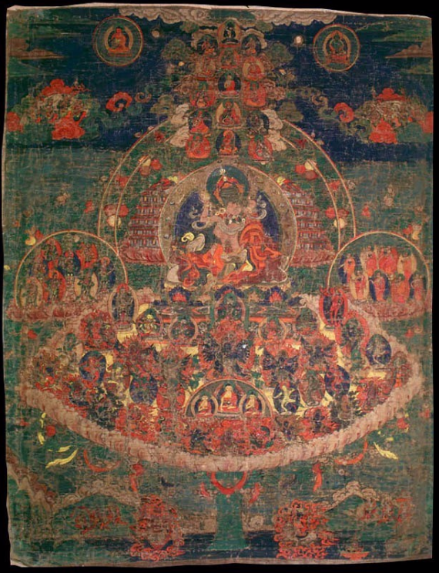
Figure 1: " Nyingma Lineage (Himalayanart)". 2017. Himalayanart.Org. Accessed February 27, 2017. http://www.himalayanart.org/items/90503.

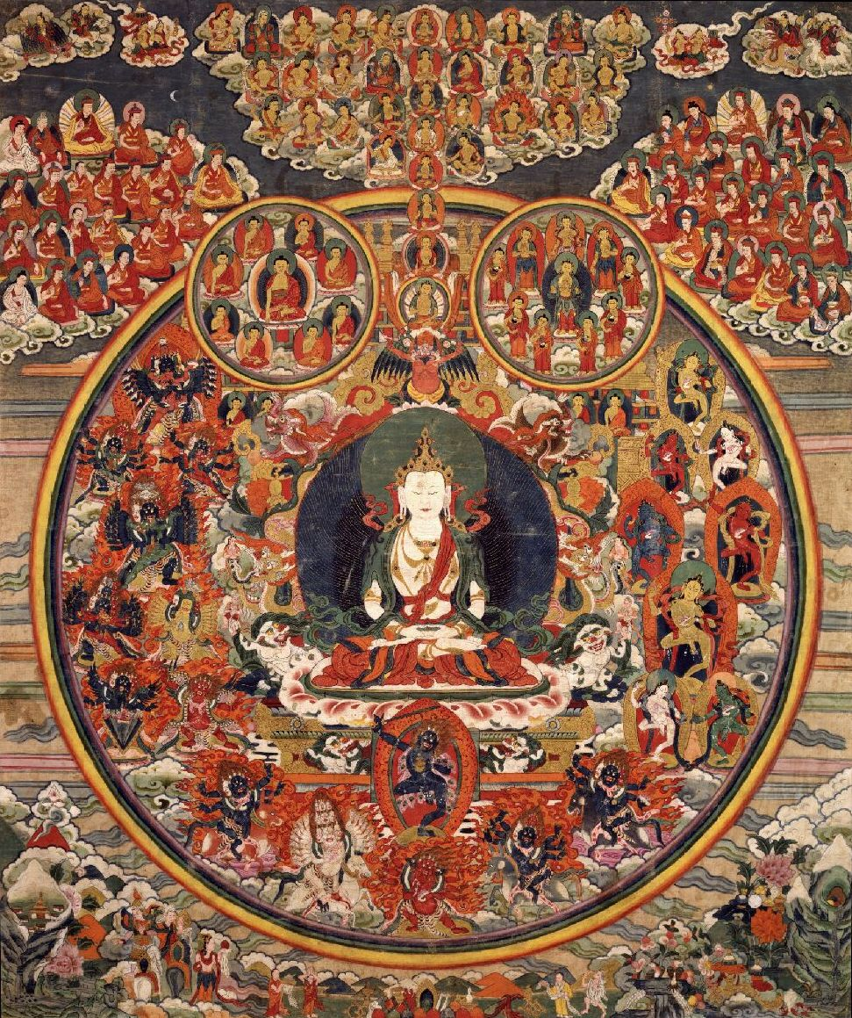
Figure 2: "Shenlha Okar (Bon Deity) (Himalayanart)". 2017. Himalayanart.Org. Accessed February 27, 2017. http://www.himalayanart.org/items/200013.
Bibliography
Dotson, Brandon. "Complementarity and Opposition in Early Tibetan Ritual." Journal of the American Oriental Society 128, no. 1 (2008): 41-67. http://www.jstor.org/stable/25608306.
Kenneth Ch'en. "Transformations in Buddhism in Tibet." Philosophy East and West 7, no. 3/4 (1957): 117-25. doi:10.2307/1397345.
Kirkland, J. Russell. "The Spirit of the Mountain: Myth and State in Pre-Buddhist Tibet." History of Religions 21, no. 3 (1982): 257-71. http://www.jstor.org/stable/1062161.
Kossak, Steven Miles. "Lineage Painting and Nascent Monasticism in Medieval Tibet." Archives of Asian Art 43 (1990): 49-57. http://www.jstor.org/stable/20111206.
Rinpoch, Patrul. Words of My Perfect Teacher. Translated by Padmakara Translation Group. Yale University Press, New Haven & London, 2011.
Tashi Gyaltsen, Shardza. Heart Drops of Dharmakaya. Translated by Lopon Tenzin. Snow Lion Publications, 2002.

This figure is recognized as the first person to achieve Enlightenment. His personal name is Siddhartha Gautama, and is often referred to as “The Buddha” or “the awakened one.” He is believed to have lived between 480-400 BCE.
Brandon Dotson. Complementarity and Opposition in Early Tibetan Ritual.
Ibid.
Steven Miles Kossak. Lineage Painting and Nascent Monasticism in Medieval Tibet.
Patrul Rinpoche. Words of My Perfect Teacher (WOMPT).
Patrul Rinpoche. WOMPT. pp (xxxvii).
Patrul Rinpoche. WOMPT. pp 179.
Ibid.
Patrul Rinpoche. WOMPT. pp 179.
Ibid.
Patrul Rinpoche. WOMPT. pp 267.
Patrul Rinpoche. WOMPT. pp 179.
Patrul Rinpoche. WOMPT. pp 179.
Ibid.
Gyaltsen. Heart drops of Dharmakaya.
Gyaltsen. Heart Drops of Dharmakaya.
Brandon Dotson. Complementarity and Opposition.

