Are Neuronal Mechanisms of Attention Universal Across Human Sensory and Motor Brain Maps?

Edgar A. DeYoe¹, Wendy E. Huddleston², Adam Greenberg³

¹ Department of Radiology, Medical College of Wisconsin, 8701 Watertown Plank Rd, Milwaukee, WI 53226

² Department of Rehabilitation Sciences & Technology, College of Health Sciences, University of Wisconsin - Milwaukee. Downer Ave, Milwaukee, WI 53211

³ Department of Biomedical Engineering, Medical College of Wisconsin & Marquette University, Milwaukee, WI 53226

Correspondence:
Edgar DeYoe
Department of Radiology, Medical College of Wisconsin
8701 Watertown Plank Rd, Milwaukee, WI 53226
deyoe@mcw.edu
ABSTRACT
One's experience of shifting attention from the color to the smell to the act of picking a flower seems like a unitary process applied, at will, to one modality after another. Yet, the unique experience of sight vs smell vs movement might suggest that the neural mechanisms of attention have been selectively optimized to employ each modality to greatest advantage. Relevant experimental data can be difficult to compare across modalities due to design and methodological heterogeneity. Here we outline some of the issues related to this problem and suggest how experimental data can be obtained across modalities using more uniform methods and measurements. The ultimate goal is to spur efforts across disciplines to provide a large and varied database of empirical observations that will either support the notion of a universal neural substrate for attention or more clearly identify to what degree attentional mechanisms are specialized for each modality.

KEYWORDS
Attention, Human, Motor, Vision, Audition

A Perspective: The first clear definition of attention is often ascribed to William James[1] who cast it as “the taking possession by the mind in clear and vivid form, of one out of what seem several simultaneously possible objects or trains of thought”. Perhaps it is this seemingly visual description that motivated subsequent studies of attention and its neural basis to focus heavily on the modality of vision[2-52]. Yet, it is rarely mentioned that James also pointed out that attention influences the motor system as well, noting that “…reaction time is shorter when one concentrates his attention on the expected movement than when one concentrates it on the expected signal”[1]. In accord with James, we suggest that it is opportune to ask if the considerable insights gained from the study of visual attention allow us to propose more general hypotheses about attention in the motor system as well as other, non-visual, sensory modalities. In the visual system, it is well established that attentional modulation can be retinotopically specific[30, 53] and can be directed selectively to behaviorally relevant locations or objects in visual space[54, 55]. Yet, one can readily attend to a variety of other sensory features as well as eye and body movements[56-65]. However, the structure of attentional modulation across modalities is unclear. At one extreme, neural mechanisms of attention may be shared across all modalities. Indeed, it has been proposed that "covert spatial attention emerges as a consequence of the reciprocal interactions between neural circuits primarily involved in specifying the visual properties of potential targets and those involved in specifying the movements needed to fixate them"[66]. At the other extreme, one might suppose that, through evolution, attentional mechanisms may have been uniquely specialized for each modality causing attentional behavior to vary across them[67]. To address this issue, we must carefully examine non-visual modalities to determine if they require a substantially different theoretical framework or if a common model applies to all. We must determine, empirically, which features and mechanisms within each modality are analogous, and to what degree. Herein, we seek to cast these issues in more specific terms and provide some suggestions for comparing attention across modalities using a common, quantitative methodology. To do so, we will focus on goal-directed, endogenous attentional processes.
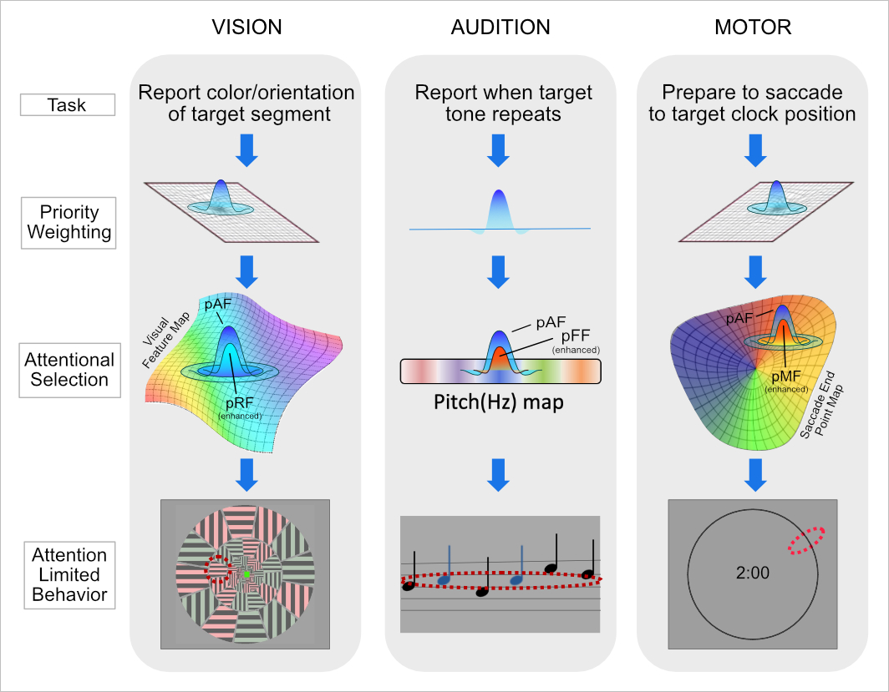
Figure 1. Attentional demands of tasks in different modalities may be mediated by similar neural mechanisms of information representation ("maps") and selection (local enhancement/suppression). Map colors represent a potentially continuous representation of some particular task relevant parameter. E.g. target orientation, tone frequency, clock position (polar angle) respectively for each modality.
First, let us consider how attentional processes elucidated in the visual system might extend to other systems. As outlined in Figure 1, a relatively simple task in the visual, auditory, and motor domains all require the generation of a high-level specification and prioritization of which specific types of information are required to perform the task. (How such a prioritization is generated is beyond the current focus of this paper). The resultant priority weighting is then transformed into a pattern of attentional modulation (enhancement/suppression) that is impressed upon an appropriate neural "map" which contains the relevant information needed to behaviorally perform the required task. In the case of these simple experimental tasks, the target (stimulus segment, pitch, saccade end point) is explicitly "cued" by some marker, though in day-to-day behavior the target might be inferred in various ways by the subject.
Our particular focus in the present context is on the neurophysiological mechanisms of attentional selection and the proposal that these mechanisms might share a common neural design across modalities (Figure 1). To make this plausible, we must generalize the concept of a "map" to encompass any representation of various types of information across some expanse of neocortex (Figure 2). In the visual system this might be a retinotopic or orientation selectivity map. In audition this might be a cochleotopic or audio-spatial map. In the saccadic motor system this could be a saccade endpoint or saccade direction map. Moreover, the "map" representation need not be conventionally topographic as in the case of the cytochrome oxidase "puff" pattern in V1 and "stripe" pattern in V2 that are thought to be associated with color processing[68-70]. As another example of an unconventional topographic map, Patel et al.[71] describe in detail, for example, how visual area LIP may have topographic characteristics, but that they are not necessarily complete nor continuous. Moreover, they make the important observation that: "...the absence of a topographic map in no way implies an absence of a complete representation of visual space" ...even though that representation may be disordered (Patel et. al. pp 6)[71]. In other words, strict, conventional topography is not an absolute prerequisite for "spatial" processing. This is especially true if one allows "space" to be a parameter that does not necessarily represent external physical space as is certainly the case in many (most) non-visual cortical areas (e.g., the acoustic-frequency organization of primary auditory cortex). These maps also need not be purely low-level, sensory representations but could also include higher-level characteristics such as visual object category[72] or auditory object perceptual grouping[73]. With this in mind, it is then relatively straightforward to understand how the application of a cortical pattern of attentional modulation impressed upon such a map may provide the basis for a wide variety of attention-related functions. Here we will refer to such a pattern as the "attentional field (AF)" to capture the concept of a macroscopic spatio-temporal pattern of attentional modulation distributed across the entire expanse of a neural map. If one allows for these generalizations of the map and attentional field concepts, then the generic application of an attentional field to a neural "map" might, indeed, provide a (nearly) universal mechanism for implementing attentional selection/enhancement within almost any modality [49]. In this context, the key to understanding each modality-specific instantiation and its effects on behavior would seem to lie in specifying the type and configuration of information represented within each "map" and specifying the spatio-temporal pattern of the attentional modulation (a.k.a. the attentional field) and the mode by which the two interact (e.g. spatial/featural selectivity). Given that the anatomical structure and local neurophysiology of neocortex seems to be relatively uniform throughout its expanse (barring a few notable exceptions), it would seem that a generic understanding of how information is represented in the cortex and how an attentional field is applied to it could then simply be customized according to (1) the particular information represented at any cortical location, (2) the particular topography/shape of the attentional field and (3) the specific mode of interaction of the two. For example, the attentional selection of one specific sensory stimulus or action alternative from among many similar stimuli or movement options could involve impressing a stereotyped pattern of focal enhancement/suppression upon an appropriate map at an appropriate location[74]. The mechanism responsible for one’s ability to attend to your spouse’s face in a crowd and the ability to reach out to press the ‘Q’ key on your laptop could both employ a similar attentional mechanism applied to a task-relevant neural map whose content includes the representation of many similar faces or the representation of many similar hand trajectory endpoints.
While conceptually attractive, one must ask to what extent such a generic, universal mechanism is truly applicable across multiple modalities. Indeed, one can imagine scenarios in which a universal mechanism might not fully explain observed behavior. For instance, in vision, it is widely accepted that when a simple visual feature value, (e.g., the color blue) is the focus of attention, then the group of objects that have the same blue color will evoke a perceptual "pop out" effect, even if the spatial distribution of those objects is irregular[2]. In this way, multiple visual objects and their locations can be selected simultaneously by visual attention. In the saccadic motor system however, multiple saccade trajectories could be planned but there is a restriction on how many different saccade directions can be attentionally selected immediately prior to execution because the eyes can only saccade in a single direction at one time. Thus, the first task requires a multifocal (or spatially complex) attentional field, but the saccade task necessarily requires a single attentional focus. It is conceivable, then, that a separate less complex attentional mechanism may have evolved for saccades while a separate, more complex mechanism evolved for vision. While such issues remain to be explored more fully, our present purpose is simply to point out potential reasons to suppose that attention may not operate in precisely the same manner across modalities[75]. Indeed, we need to examine the characteristics of neural maps, attentional signals, and their effects on behavior widely across modalities to determine if they have a universal neurobiological basis or if, instead, the brain has evolved specialized attentional mechanisms for each modality. This suggests that careful detailed examination of how the neurobiology of attention might differ across modalities, and how that would affect attention-limited behaviors, will be the key to determining the extent to which attentional mechanisms are truly universal throughout the brain.
The forgoing argument notwithstanding, it is important to point out that the potential existence of a universal neurobiological mechanism for implementing the effects of attention does not necessarily imply that the ultimate behavioral effects in each modality will be identical. The net behavioral effect will depend on the nature and organization of information encoded within each specific cortical area being modulated (e.g. size, informational topography, input/output connections) as well as the spatiotemporal pattern of the attentional field applied to each area and the nature of their interaction. For example, it is well known that the precision of attentional selection varies significantly both across the visual cortical hierarchy[76] and with eccentricity within the visual field[77]. While one might suppose that this reflects the property of cortical magnification in that similar sized foci of attentional enhancement in the cortex will affect a relatively small area in the central visual field but a larger area peripherally[78]. However, detailed measurement of attentional crowding limits show that they scale much faster than predicted by either acuity or cortical magnification in V1[77, 79] and are modestly different for upper vs lower visual field[77]. Such detailed psychophysical data led Intriligator & Cavanagh[77] to suggest that such "attentional resolution" might be determined by parietal cortical areas rather than occipital visual areas. The point of this example is that quantitative properties of both cortical maps, and attentional field patterns applied to them, are needed to understand how the neurobiology determines the psychophysical properties of attention-limited behaviors. If we then extend this logic to other modalities such as the auditory system, it becomes apparent that detailed quantitative information about, say, particular cochleotopic maps, and their associated attentional fields, are needed to permit a comparison with attentional mechanisms in the visual system and their behavioral effects. Similarly, in the saccadic motor system the organization of saccade endpoint maps may exhibit unique features such as differences in end point resolution at different eccentricities and upper vs lower field locations. Do they have a property analogous to visual cortical magnification; and how is the pattern of attentional modulation distributed across such a map?
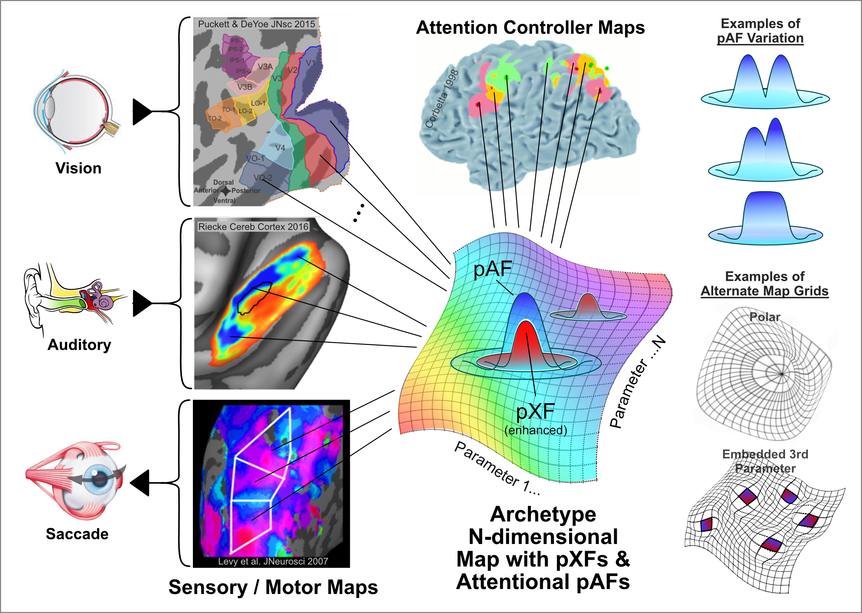
Figure 2. Neural maps (left) and their attentional modulation. The map concept can be generalized to a variety of cortical representations of various parameters of interest. The map representation can be spatially distorted and/or discontinuous (lower right) and need not even be topographic. The pattern of attentional modulation (pAF) within such a map can be tightly focused (center) or can be spatiotemporally complex (upper right) and is distinct from the population receptive or motor field (pXF) as determined by the task and requisite priority weighting conveyed by control systems that may themselves consist of priority maps.

While there are potentially many neural map and attentional field properties that might be compared across modalities, here, we discuss certain specific features of brain maps and attentional selection mechanisms that ostensibly appear to share conceptual similarities across multiple sensory and motor systems. We try to suggest how such conceptually similar neural mechanisms can lead to a variety of behavioral effects that individually might seem too disparate to have arisen from a single, canonical neural substrate. We accept (as have others[80]) that the brain, and particularly the cerebral cortex, evolved anatomical/physiological characteristics that, despite some variation across its surface, are arguably more uniform than disparate, at least in terms of the fundamental neural computations within each small patch of cortex. We propose that the mechanism of attentional selection is universal across modalities even though the content being selected may be specific to each modality. The variety of attention-related perceptual effects arising from cortical areas within each modality is therefore the result of the different inputs (different sources of information to be processed and/or motor control signals) and output targets of each area, rather than major differences in their local neural computations.
The importance of this hypothesis is that it directly highlights the possibility that attention throughout the brain is implemented by a universal neural design. Whether this might reflect a single, shared mechanism or multiple copies of a common mechanism remains to be determined. If there is a common mechanism for all modalities, it then suggests that the behavioral consequences of that mechanism should be comparable across modalities if only the proper perspective can be found. The key difficulty, however, is distinguishing apparent differences in attentional behavior that are due to differences in the information handled or actions controlled by each modality from variations in behavior that might reflect differences in the underlying neural mechanisms of attention. This is important experimentally and conceptually because it can shift the focus of behavioral experiments from assessing the functions of attention within each modality to comparing functions across modalities. Phenomenologically, this approach also addresses the common experience that volitionally shifting attention from, say, the color of a flower to its smell to the movement needed to pick it feels like simply shifting a unitary attentional "spotlight" from one feature to another even though those features are in different modalities. In contrast, trying to attend to all three simultaneously seems nearly impossible. Does this experience imply a common neural mechanism or is it just a perceptual illusion?
It is uniquely apropos to address this issue at the present time because of relatively recent advances in human brain imaging. As imaging voxel sizes have shrunk to the environs of 1 cubic millimeter, brain-imaging studies in humans and multi-neuron studies in animals have slowly converged toward a meso-scale focus that now provides a basis for comparing attentional mechanisms across modalities at an unprecedented level of detail and explanatory power. This modern meso-scale approach to human imaging arguably evolved from classical single neuron receptive field concepts[81, 82]. Indeed, human studies by Dumoulin & Wandell[83, 84] and others[85] put forward the notion of a population receptive field (pRF) which, echoing the concept of receptive fields of single neurons, can be defined as that portion of the visual field to which an imaging voxel is responsive. In other words, the pRF is the circumscribed region in visual space that causes the voxel to change its fMRI signal when a visual stimulus is drifted across or flashed within it. Since a 1x1x1mm or slightly larger imaging voxel is typically composed of thousands of individual neurons, the pRF represents a composite of all the receptive fields of the entire responsive neural population within the voxel. Moreover, compelling evidence from Logothetis and collaborators[86, 87] indicates that blood oxygenation level depended (BOLD) fMRI signals preferentially reflect local postsynaptic potentials rather than action potentials. This suggests that fMRI may be particularly useful for revealing signals from fields of synaptic endings that terminate within a voxel. Given the pRF perspective of human visual neurophysiology, the study of attention-related neural mechanisms in humans can also be approached on a similar scale of analysis[51, 85]. Such an approach, based on relatively small populations of neurons, can be used to compare human attentional mechanisms across modalities at an incredible level of detail and quantitation.
To perform such a cross-modal comparison, a key step is to empirically measure the spatial distribution of attentional modulation (AF) across cortical areas that represent information relevant to the particular task at hand[15, 76] (e.g. Fig 1). To accomplish this in quantitative detail, Puckett & DeYoe[51] developed a useful experimental strategy analogous to using a drifting visual stimulus to map pRFs in visual cortex. Rather than drift a discrete visual stimulus through the field of view, a unique task and display are used to induce the subject to drift their focus of attention through the visual field while the visual stimulus features remain dynamically uniform. Figure 2 shows an example of such a display consisting of a dartboard-like array of segments randomly colored and striped in one of 4 color/orientation combinations. Every 2 seconds, the pattern is re-randomized and the whole array slowly rotates at 1 revolution per minute so that, over time, any given location experiences each of the 4 color/orientation patterns equally. For a voxel whose pRF is centered at some particular location (Fig 3 upper row, green Gaussian blob), this visual stimulus generates a roughly uniform level of neuronal activation over time. However, the observer is instructed to constantly fixate the "+" at the center of the display while repeatedly reporting (by button press) the color/orientation pattern of one specific segment in the array (Fig 3 upper row left, represented by the yellow dotted outline which is not actually present in the stimulus array). Since the target segment is slowly rotating with the whole array, the subject's focus of attention is likewise drifting slowly through space. As the focus of attention (Fig 3 middle row left, red/blue DOG) drifts across the pRF of a particular voxel, its response is then modulated (Fig 3 bottom row) according to the spatial profile (pattern of enhancement and suppression) of the attentional field (approximately a spatial multiplication of the pRF and the AF at each successive location as the display slowly rotates.).
For the display shown in Figure 3, the array of segments was adjusted in density so that careful attention to a single segment allowed the subject to report its moment-by-moment sequence of color/orientation without significant interference from neighboring segments. In effect, this then required the subject to restrict their window of attention as small as possible to avoid interference from adjacent segments. Additionally, the task of reporting the color/orientation conjunction of the attended segment is known to require, top-down, focused attention[2], further ensuring that the subject's window of attention is under constant control and minimized in size. (This minimum size varies with the eccentricity of the ring containing the attended segment[77]). Under these conditions, an estimate of the topography of the attentional field can then be obtained from the timecourse of a voxel's response and is termed the voxel's population attentional field, pAF. This pAF estimate is obtained by modeling the full attentional field, its movement through the field of view, and its interaction with the voxel's pRF. Iterative optimization of the shape of the pAF is then used to find the profile that yields the best fit of the predicted to the empirical fMRI waveform[51]. Indeed, several dozen voxels having pRFs distributed along the ring containing the attended segment can provide multiple estimates of the macroscopic AF topography impressed upon a particular visual area. Puckett & DeYoe reported that under these conditions, the pAF was well modeled as a difference-of-gaussians function with a suppressive surround (Fig.3 middle row, left). Note that since each pAF is associated with a voxel within a topographic brain map (for vision, a retinotopic map), the pAF can be visualized within the space represented by the particular map as illustrated in Figure 3 (i.e., the external visual field). In turn, each visual area has its own, potentially unique, AF distribution which may depend on the types of visual information represented there and the types of information targeted for attentional selection (in visual areas that don't represent information currently targeted by attention, the attentional field may be effectively uniform and suppressive as suggested by the biased competition model[6]). Behavioral performance is then guided by the combined bottom-up sensory representation and the top-down attentional field. More specifically, we propose that the attentional field within a particular cortical area (or areas) that most strongly represents the information relevant to the current task determines (by winner-take-all) the overall behavioral effect of attention (e.g. reporting the color/orientation of a specific target segment).
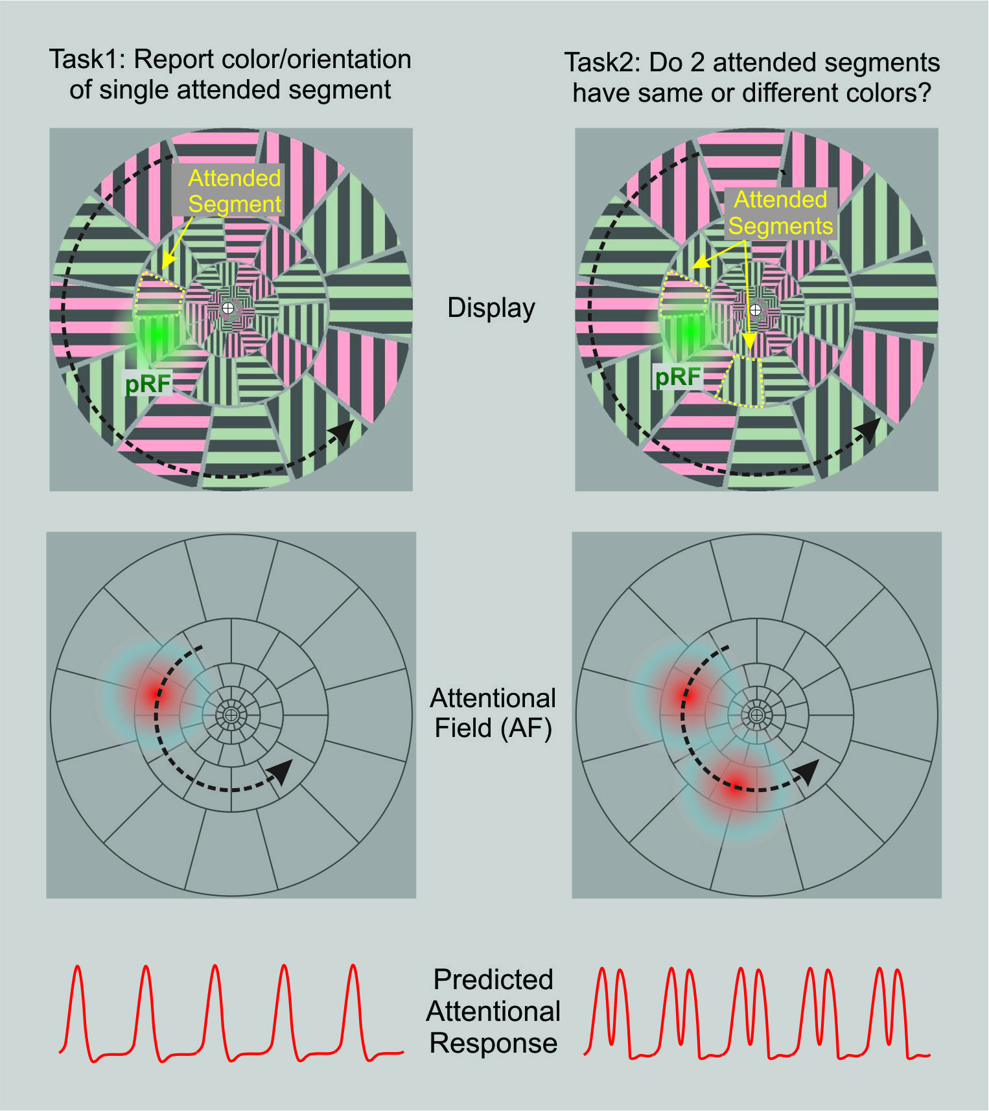
Figure 3. Attentional Drift Design: Display - color and orientation of segments changes randomly every 2 sec while whole array slowly rotates at 1 rpm. Attentional Field - Subject fixates center marker while covertly attending to a particular target segment or segments. Predicted Attentional Response - Voxel with pRF at fixed location (green) is modulated as attentional foci pass over it.
While the preceding example was intentionally aimed at forcing the subject to carefully control and minimize the size of their attentional focus, the approach is readily adaptable to more complex designs using different tasks and displays. One simple example is illustrated in the right column of Figure 3 where the task requires the observer to repeatedly report if the colors of two cued segments (yellow outlines) are the same or different. In this case, attention must be allocated, more or less, simultaneously to two separate segments as they slowly rotate with the whole array. As each of the two attended locations pass over the fixed pRF of a voxel of interest (Fig 3 upper-right green gaussian), its response is modulated as shown by the dual-peaked waveform in the lower right. Again, the spatial pattern of the modulating attentional field can be extracted from the timecourse of the voxel's response.
Conceptually, this Attentional Drift Design (ADD) can be extended to drift paths of any desired shape and to attentional fields having a variety of spatial configurations. Indeed, one can readily conceive of a design in which the observer's attention slowly drifts through some non-spatial featural dimension such as color or morphing faces. The key is creating constraints that cause the subject to exert consistent control over their allocation of attention within the parameter space of interest.
Moreover, this approach has been extended to other modalities[64, 88]. Audition provides an example of attention drifting over the range of a non-spatial signal (tone). As illustrated in the center column of Figure 1, a series of random 1-second pure tones can be presented successively with the observer cued to attend to, say, the middle frequency in the sequence. When the observer detects the cued tone, they must then shift attention to the next higher frequency. The attentional shifts occur relatively slowly (e.g. every 5 sec) so that over 40 sec. the observer has attended to each of, say, 8 different tone frequencies in the random sequence. Within a task-relevant cochleotopic brain map, a voxel tuned to a particular frequency (its population frequency field, pFF) will be modulated by attention whenever the attended pitch is within its preferred frequency range. (Note that, on average, the random stimulus sequence presents all 8 tones in the sequence within 8 sec. so that over time the stimulus evoked activity of all voxels in the map is roughly equal, except when modulated by attention.) As with the visual ADD paradigm, the profile of the AF applied to a particular cochleotopic map can be extracted from the fMRI timecourse of voxels tuned to particular frequencies. (Strictly speaking, since a voxel may be tuned to a range of frequencies, its pFF first needs to be determined using conventional frequency mapping stimuli. Then, using the ADD paradigm, the auditory pAF is iteratively modeled to predict the empirical fMRI waveform.)
In addition to using this design with sensory modalities, this ADD approach also can be readily extended to the motor domain[89]. A simple visual display can be used which consists of a circle at a fixed radius from a central RSVP stream (Figure 4, lower right). The RSVP stream consists of random letters interspersed with cued target locations which are flashed every 4 seconds. Infrequently (on average every 40sec.), a GO cue is presented to which the subject must saccade to the most recently cued target location. This task effectively confines visual attention centrally to monitor the RSVP stream while motor attention is directed peripherally to successively cued clock positions (e.g. 2:00). The infrequent, randomly timed saccades have little effect on the averaged fMRI timecourse. In this way, motor attention is slowly swept around the circle allowing the motor pAF to be modeled and mapped across various brain regions in frontal and parietal cortex.
The foregoing examples highlight the key features of the ADD approach. They each involve a task which requires the observer to drift their focus of attention through a relevant parameter space represented within some cortical (or subcortical) area of interest. As the focus of attention (the AF) passes over the population receptive or motor fields (visual, tone frequency, motor) of voxels within that area, they are temporally modulated, and the resulting waveform will reflect the shape of the AF as it passes by (in space and time). The primary advantage of this approach is that it allows comparable quantitative measurements of the attentional field within and across modalities. In turn, this allows one to assess the potential universality of the theoretical concept of an attentional field and its underlying neuronal mechanisms.

Neuronal Mechanisms: To help provide a more local view of the foregoing concepts, Figure 4 schematically outlines a speculative relationship between a voxel's pRF and its pAF at the neuronal level. (Figure 4 is not strictly anatomically accurate and is highly simplified.) Sensory (e.g. visual, auditory) input signals or motor (e.g. saccade target) output signals are distributed across fields of synaptic endings (axon terminations) that are, typically, topographically organized "maps" as depicted in Figure 1. For example, the retinal sensory input to primary visual cortex is via the well-known pathway through the lateral geniculate nucleus of the thalamus that terminates in cortical layer 4 which then is locally relayed by interneurons (not shown) onto pyramidal cells of layers 2/3. By spatially sampling from this field of input signals, the pyramidal cells build receptive fields that, for an fMRI voxel, collectively represent the pRF. In the eye movement domain, an analogous output scenario might arise from layer 2/3 pyramidal cells in frontal eye fields and/or the lateral intraparietal area, whose output signals represent a saccade target location which we have termed the pMF. The input or output signals of these neurons are attentionally modulated by top-down signals distributed across fields of topographically organized synaptic terminals in superficial cortical layers that typically arise from fronto-parietal cortical areas[90]. By spatially sampling from this field of modulatory signals, a neuron constructs a pAF which represents the spatial pattern of enhancement and suppression that, in effect, is the neural mechanism for attentional selection of task-relevant sensory information or motor action. In accordance with the concept of biased competition, these neurons are also embedded in a mesh of widespread lateral inhibitory influences which are represented schematically in Figure 4 by the yellow highlighted inhibitory interneurons (again, highly simplified). Accordingly, the field of superficial modulatory inputs then provides the "bias" that breaks the mutual inhibitory competition and effectively creates the voxel's pAF. However, not readily apparent here is the observation by Puckett & DeYoe[51] that a voxel's pAF is generally much larger than its pRF (roughly 1.5-3X) with a suppressive surround that is even larger. Whether this reflects the postsynaptic nature of fMRI signals [86] of the top-down modulatory field is unclear, though this difference in size suggests that modeling the top-down attentional effects as a simple point-like gain control may not be appropriate. Also, note that due to the topographic organization of the various input, output, and modulatory "fields", the resulting pRFs, pMFs and pAFs can be referenced to the respective "space" represented by a particular neural map. In vision, this would be a visual space map. In the saccadic system this could be a saccade endpoint location space. In the auditory system this could be a cochleotopic space (cf. Fig 1). Notably, since the pAF arises from a topographic field of modulatory inputs, it too can be referenced to the particular space represented by the map upon which it is impressed. Thus, in the visual system, the pAF can be depicted in visual space even though it is not being driven by visual inputs (in contrast to the pRF which is driven by the visual inputs). In other words, a depiction of the pAF can be thought of as representing the pattern of modulation of the visual information as if that modulation could itself be seen distributed across the visual field. This works similarly for other spaces such as cochleotopic or saccade target space.
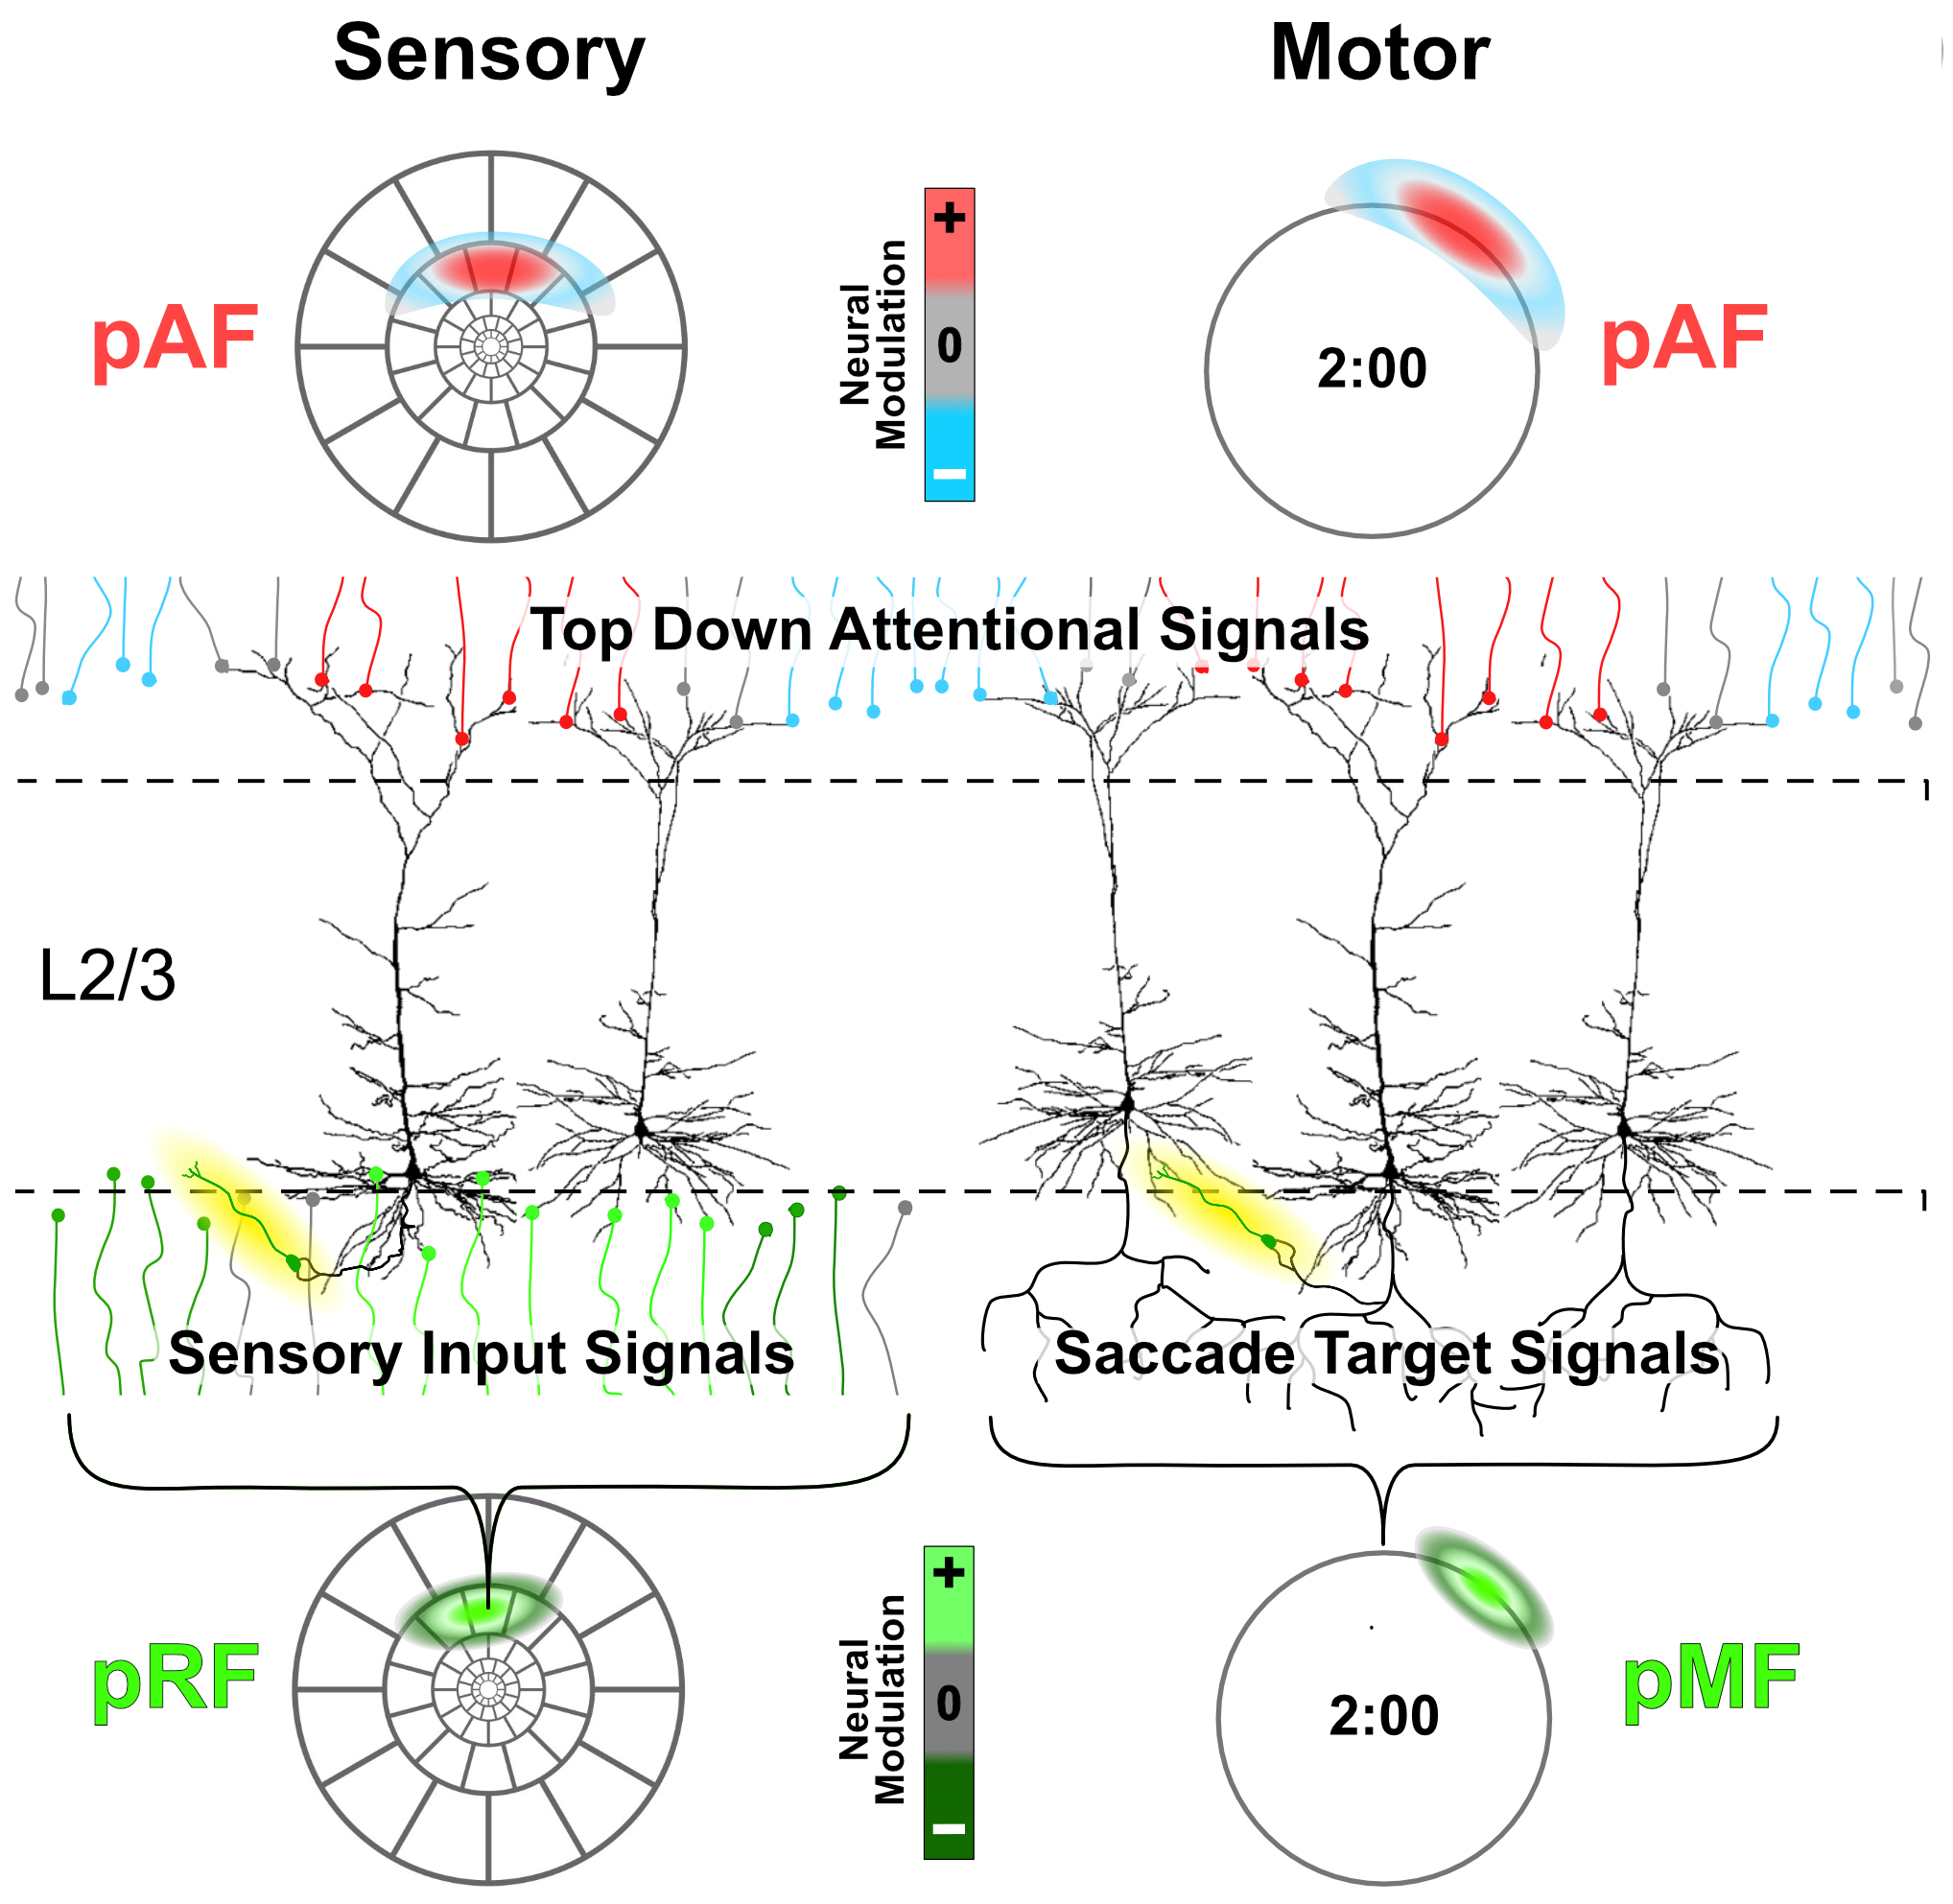
Figure 4. Schematic Relationship of a Voxel's pAF to its pRF or pMF: Sensory (e.g. visual) input signals or motor (e.g. saccade) output signals are distributed across fields of synaptic endings (or axon terminations) that are topographically organized. Similarly top-down attentional modulation signals are distributed across fields of synaptic terminals typically arising from fronto-parietal cortical areas. Inhibitory interneurons highlighted in yellow.

Relevance to preceding theories: As outlined above, our conceptual framework includes several components that are key to determining if attention is mediated by a universal neurobiological substrate. Specifically, there are three main neurobiological factors: (1) neural "maps", (2) attentional fields, and (3) their modes of interaction. Above, we have outlined our expanded concept of a neural map to include a variety of cortical representations of information or action alternatives. Indeed, conventional spatial or featural maps are components of a number of influential theories of attention including Treisman's feature integration theory[2], Desimone & Duncan's biased competition theory[6, 10] and Reynolds & Heeger's normalization theory[45], to mention a few. Whether a map is conventional, as in a retinotopic map, or more complex as in a "map" of facial features[91], a key functional aspect is that the map is a representation of information extending across an array of neurons that can be modified by a pattern of modulation applied to it. Indeed, the "map", as we have broadly defined it, might also be seen as a population of neurons constituting a multivoxel pattern representation of some task-relevant parameter or parameters[92, 93]. In such case, the pattern of attentional modulation, the attentional field, represents a mechanism through which attention can modulate the multivoxel pattern representation. (Though not addressed here, it is important to note that this scenario might also apply to maps in other portions of the brain such as the colliculus and thalamic pulvinar which are also involved in attentional control[27, 94-96].)
Our rationale for using the term "attentional field" is in accord with the idea that such a top-down modulating influence likely reflects the wide spatial distribution of synaptic inputs to cortical superficial and/or deep layers from "higher" cortical areas in the parietal and frontal lobes[90, 97]. This distribution is generally consistent with the laminar "feedback" pattern identified by Felleman & VanEssen[90]. Our neuronal concept of an attentional field appears similar to Desimone and Duncan's "attentional template" which is described as a top-down bias on visual processing[6]. The attentional field as envisioned in our framework is a conceptually separate entity that extends in space and time across an ensemble of neurons representing a neural map. This macroscopic conceptualization of an attentional field has often been absent (or implicit?) in earlier theories focused on single neurons. For example, in the work of Lee and Maunsell[98], attention is more simply represented as a "response gain control" that modulates the effects of a stimulus on the firing rate of a neuron. Alternately, it may operate as a contrast gain modulation[99], or perhaps other configurations[98, 100]. In such theories, the more global, spatial pattern of this gain control across an entire visual area and its ensemble of neurons is often not addressed. Consequently, this can leave the spatial effects of attention to be "inherited" as a modulation of the spatial pattern of excitatory and inhibitory regions of a neuron's receptive field. This does not then allow for any independent spatial effects that, theoretically, could arise from the properties of the AF itself. Indeed, Puckett & DeYoe[51] showed that the spatial characteristics of a voxel's pAF (the voxel's experience of the global AF) were not the same as those of the voxel's stimulus driven pRF. Typically, the pAF was a larger difference of gaussians (DOG) and had its own extended suppressive surround. However, in their experiments this relatively simple attentional profile was in part due to the nature of the stimulus array and the behavioral task which required a single tightly focused window of attention (see Fig 3 and associated text). More complex stimuli and attentional tasks may require the AF to have a more complicated spatial and featural profile with multiple or extended foci of enhancement and suppression (cf. Fig 2, right). Evidence for this sort of complex, non-contiguous attentional selection has been outlined in the past [101].
A conceptualization of the AF that appears fairly similar to our framework was included in Reynolds and Heeger's normalization theory of attention[45]. In their model, the AF represents a multiplicative (gain control) pattern of modulation extending across a neural space (map) whose dimensions are pRF center location (within the field of view) and preferred orientation (within a featural orientation map; their Figure 1). To simplify their exposition, the center location was expressed in only one dimension as was orientation preference. The spatial patten of the AF appeared to be a simple raised sinusoid that was selective in orientation space. A key feature of the R&H model is normalization which, as a component of an attentional model, constitutes a more sophisticated mode of interaction between the AF and a neural map. Normalization is accomplished through the incorporation of an additional divisive "suppressive field" that is also defined within the same space as the attentional field but involves a relatively broad integration across both the pRF location and orientation dimensions. Their model AF enhanced a selected range of orientations but did not itself include explicit suppressive effects. However, the authors did mention that this could be added, if warranted. In the R&H model, any attention-related suppressive effects are mediated by amplification of the stimulus drive field in regions that become included within the divisive suppressive drive field. Whether this is sufficient to account for all attention-related suppressive effects, especially as a model for attention within other modalities, remains to be tested experimentally. R&H do mention that their model may provide a more explicit mechanism that extends Duncan and Desimone's biased competition model of attentional selection (cf. [102]). The ubiquitous mutual suppression of biased competition presumably is the counterpart of the widespread suppressive field of the normalization model. Both models are sufficiently generic to be plausibly applied to other modalities. However, R&H go on to show how normalization could at least qualitatively account for details such as response vs contrast gain effects as well as scaling of neuronal tuning curves, all of which may or may not be applicable across modalities.
In the present discussion, we have not explicitly included normalization nor biased competition within our framework, though their inclusion would be an obvious extension. Exactly how the spatial characteristics of a complex AF would interact with both the spatial characteristics of a receptive field and a normalizing suppressive field would appear to be potentially complex, but amenable to modeling if the interactions remain linear over some reasonable range. Moreover, such additional complexity increases the likelihood that such a model may not be universally appropriate across modalities. Indeed, it would be most interesting to determine how and why any of the different models might vary in a substantial manner across modalities. If they do, it may help to indicate how neural processing and attentional selection have been optimized for each modality.
In this review, we have intentionally focused on a restricted range of attentional phenomena that tend to reflect top-down[6, 18, 22], goal-directed[45], endogenous[103] attentional control mechanisms. In other words, attentional behaviors under the observer's volitional control, whether cued or purely voluntary[104]. Our emphasis was on the specific role of attention and how it operates within the context of tasks having a relatively simple, well-defined goal. Factors beyond our scope included the mechanisms by which the observer determines the goal of a task, determines what information is needed to perform the task, and performs a response if one is required. We also have ignored exogenously controlled attention whose properties appear to be notably different[65]. We focused primarily on the subprocess of attentional selection/enhancement and did not specifically address other subprocesses such as alerting[94], baseline shifting[105, 106], reductions in low frequency variability[107], engagement/disengagement[49] or motivation[108]. Within this restricted context, we assume that the primary role of attention is the selection, enhancement, and/or suppression of information or action alternatives. Accordingly, we also did not address issues such as the binding problem and decision making. Finally, our ultimate focus was on neural mechanisms. Thus, our primary goal was to compare attention-related neural mechanisms across functional modalities; specifically vision, audition, and motor systems with an emphasis on cortical mechanisms responsible for attentional selection within consciously performed behaviors.

Conclusion: While our understanding of the brain mechanisms responsible for attention and its effects on behavior have relied heavily on experimentation and theories associated with vision, it is often tacitly assumed that these theories and mechanisms apply equally well to other sensory and motor modalities even though there are potentially valid reasons to suspect that this may not be the case. Examining the available data on this issue can be difficult since the behavioral effects of attention in different modalities often seem disparate and attempts by the same investigator to use identical methods across multiple modalities are rare. From a neuronal standpoint, however, one is struck by the overall similarity of basic neuronal anatomy and physiology throughout the cerebral cortex except for a few notable exceptions whose relevance to attention, if any, remains obscure. We propose to make this assumption explicit and hypothesize that the variety of behavioral effects attributable to attention within different modalities, and their associated cortical areas, reflects the different inputs (different sources of information to be processed and/or control signals) and output destinations rather than major differences in the effects of attention upon each cortical area. In other words, the neuronal effects of attention are ubiquitous and universal throughout the cerebral cortex. To begin to test this hypothesis we have proposed a useful experimental framework and fMRI methodology that can be applied to multiple modalities including vision, audition, and the motor system, in particular. Though the approach initially focuses relatively narrowly on comparing neural modulation/selection quantitatively across modalities, it is hoped that this will motivate future efforts to compare additional aspects of attention across a wide variety of modalities and submodalities throughout the human brain. This may lead to a firm experimental basis for asserting a universal neural theory of attention or may lead to a deeper understanding of how attention has been specialized to utilize each modality to greatest advantage.

Acknowledgements
Supported by a University of Wisconsin Milwaukee Research Growth Initiative Award to Huddleston, DeYoe and Greenberg.

Declarations
All manuscripts must contain the following sections under the heading 'Declarations'.
If any of the sections are not relevant to your manuscript, please include the heading and write 'Not applicable' for that section.
Funding: University of Wisconsin – Milwaukee Office of Sponsored Programs Research Growth Initiative Award 101x388 to WEH, EAD, and ASG.
Conflicts of interest/Competing interests: None
Ethics approval (include appropriate approvals or waivers): Review article, not applicable.
Consent to participate: Review article, not applicable.
Consent for publication: Review article, not applicable.
Availability of data and materials: Not applicable.
Code availability: Custom Matlab software for computation of population attentional fields available upon request from E. DeYoe.
Authors' contributions (optional: please review the submission guidelines from the journal whether statements are mandatory)

REFERENCES

1. James, W., The Principles of Psychology. Vol. I. 1890, Birmingham: The Classics of Psychiatry and Behavioral Sciences Library. 689.
2. Treisman, A.M. and G. Gelade, A feature integration theory of attention. Cognitive Psychology, 1980. 12: p. 97-136.
3. Moran, J. and R. Desimone, Selective attention gates visual processing in the extrastriate cortex. Science, 1985. 229(4715): p. 782-4.
4. Bundesen, C., A theory of visual attention. Psychol Rev, 1990. 97(4): p. 523-47.
5. Posner, M.I. and S.E. Petersen, The attention system of the human brain. Annual Review of Neuroscience, 1990. 13: p. 25-42.
6. Desimone, R. and J. Duncan, Neural Mechanisms of Selective Visual Attention. Annual Review of Neuroscience, 1995. 18: p. 193-222.
7. Luck, S.J. and S.A. Hillyard, The role of attention in feature detection and conjunction discrimination: an electrophysiological analysis. Int J Neurosci, 1995. 80(1-4): p. 281-97.
8. Culham, J.C., et al., Cortical fMRI activation produced by attentive tracking of moving targets. J Neurophysiol, 1998. 80(5): p. 2657-70.
9. Desimone, R., Visual attention mediated by biased competition in extrastriate visual cortex. Philos Trans R Soc Lond B Biol Sci, 1998. 353(1373): p. 1245-55.
10. Kastner, S., et al., Mechanisms of directed attention in the human extrastriate cortex as revealed by functional MRI. Science, 1998. 282(5386): p. 108-11.
11. Lu, Z.L. and B.A. Dosher, External noise distinguishes attention mechanisms. Vision Res, 1998. 38(9): p. 1183-98.
12. Luck, S.J. and M.A. Ford, On the role of selective attention in visual perception. Proc Natl Acad Sci U S A, 1998. 95(3): p. 825-30.
13. Roelfsema, P.R., V.A. Lamme, and H. Spekreijse, Object-based attention in the primary visual cortex of the macaque monkey. Nature, 1998. 395(6700): p. 376-81.
14. Wojciulik, E., N. Kanwisher, and J. Driver, Covert visual attention modulates face-specific activity in the human fusiform gyrus: fMRI study. J Neurophysiol, 1998. 79(3): p. 1574-8.
15. Brefczynski, J.A. and E.A. DeYoe, A physiological correlate of the 'spotlight' of visual attention. Nature Neuroscience, 1999. 2(4): p. 370-374.
16. Colby, C.L. and M.E. Goldberg, Space and attention in parietal cortex. Annu Rev Neurosci, 1999. 22: p. 319-49.
17. Carrasco, M., C. Penpeci-Talgar, and M. Eckstein, Spatial covert attention increases contrast sensitivity across the CSF: support for signal enhancement. Vision Research, 2000. 40(10-12): p. 1203-1215.
18. Kastner, S. and L.G. Ungerleider, Mechanisms of visual attention in the human cortex. Annu Rev Neurosci, 2000. 23: p. 315-41.
19. Beauchamp, M.S., et al., A parametric fMRI study of overt and covert shifts of visuospatial attention. Neuroimage, 2001. 14(2): p. 310-21.
20. Itti, L. and C. Koch, Computational modelling of visual attention. Nat Rev Neurosci, 2001. 2(3): p. 194-203.
21. Sperling, G., et al., Two computational models of attention, in Visual Attention and Cortical Circuits, J. Braun, C. Koch, and J.L. Davis, Editors. 2001, MIT press: Cambridge, MA. p. 177-214.
22. Corbetta, M. and G.L. Shulman, Control of goal-directed and stimulus-driven attention in the brain. Nat Rev Neurosci, 2002. 3(3): p. 201-15.
23. Pessoa, L., S. Kastner, and L.G. Ungerleider, Neuroimaging studies of attention: from modulation of sensory processing to top-down control. J Neurosci, 2003. 23(10): p. 3990-8.
24. Yantis, S. and J.T. Serences, Cortical mechanisms of space-based and object-based attentional control. Curr Opin Neurobiol, 2003. 13(2): p. 187-93.
25. Martinez-Trujillo, J.C. and S. Treue, Feature-based attention increases the selectivity of population responses in primate visual cortex. Curr Biol, 2004. 14(9): p. 744-51.
26. McMains, S.A. and D.C. Somers, Multiple spotlights of attentional selection in human visual cortex. Neuron, 2004. 42(4): p. 677-86.
27. Shipp, S., The brain circuitry of attention. Trends Cogn Sci, 2004. 8(5): p. 223-30.
28. Beck, D.M. and S. Kastner, Stimulus context modulates competition in human extrastriate cortex. Nat Neurosci, 2005. 8(8): p. 1110-6.
29. Boynton, G.M., Attention and visual perception. Curr Opin Neurobiol, 2005. 15(4): p. 465-9.
30. DeYoe, E.A. and J. Brefczynski, Neurophysiological correlates of the attentional spotlight in Neurobiology of Attention, L. Itti and G. Rees, Editors. 2005, Elsevier Science &Technology.
31. Silver, M.A., D. Ress, and D.J. Heeger, Topographic maps of visual spatial attention in human parietal cortex. J Neurophysiol, 2005. 94(2): p. 1358-71.
32. Carrasco, M., Covert attention increases contrast sensitivity: psychophysical, neurophysiological and neuroimaging studies, in Visual Perception, Part 1, Fundamentals of Vision: Low and Mid-Level Processes in Perception, S. MartinezConde, et al., Editors. 2006, Elsevier Science Bv: Amsterdam. p. 33-70.
33. Maunsell, J.H. and S. Treue, Feature-based attention in visual cortex. Trends Neurosci, 2006. 29(6): p. 317-22.
34. Serences, J.T. and S. Yantis, Selective visual attention and perceptual coherence. Trends Cogn Sci, 2006. 10(1): p. 38-45.
35. Buracas, G.T. and G.M. Boynton, The effect of spatial attention on contrast response functions in human visual cortex. J Neurosci, 2007. 27(1): p. 93-7.
36. Silver, M.A., D. Ress, and D.J. Heeger, Neural correlates of sustained spatial attention in human early visual cortex. J Neurophysiol, 2007. 97(1): p. 229-37.
37. Huddleston, W.E. and E.A. DeYoe, The representation of spatial attention in human parietal cortex dynamically modulates with performance. Cereb Cortex, 2008. 18(6): p. 1272-80.
38. Kelley, T.A., et al., Cortical mechanisms for shifting and holding visuospatial attention. Cereb Cortex, 2008. 18(1): p. 114-25.
39. Saygin, A.P. and M.I. Sereno, Retinotopy and attention in human occipital, temporal, parietal, and frontal cortex. Cereb Cortex, 2008. 18(9): p. 2158-68.
40. Womelsdorf, T., K. Anton-Erxleben, and S. Treue, Receptive field shift and shrinkage in macaque middle temporal area through attentional gain modulation. J Neurosci, 2008. 28(36): p. 8934-44.
41. Boynton, G.M., A framework for describing the effects of attention on visual responses. Vision Res, 2009. 49(10): p. 1129-43.
42. Carrasco, M. and Y. Yeshurun, Covert attention effects on spatial resolution, in Attention, N. Srinivasan, Editor. 2009, Elsevier Science Bv: Amsterdam. p. 65-86.
43. Datta, R. and E.A. DeYoe, I know where you are secretly attending! The topography of human visual attention revealed with fMRI. Vision Res, 2009. 49(10): p. 1037-44.
44. Lee, J. and J.H. Maunsell, A normalization model of attentional modulation of single unit responses. PLoS One, 2009. 4(2): p. e4651.
45. Reynolds, J.H. and D.J. Heeger, The normalization model of attention. Neuron, 2009. 61(2): p. 168-85.
46. Szczepanski, S.M., C.S. Konen, and S. Kastner, Mechanisms of spatial attention control in frontal and parietal cortex. J Neurosci, 2010. 30(1): p. 148-60.
47. Carrasco, M., Visual attention: The past 25 years. Vision Res, 2011. 51(13): p. 1484-525.
48. Tsotsos, J.K., A Computational Perspective on Visual attention. 2011: MIT Press. 208.
49. Buschman, T.J. and S. Kastner, From Behavior to Neural Dynamics: An Integrated Theory of Attention. Neuron, 2015. 88(1): p. 127-44.
50. Maunsell, J.H.R., Neuronal Mechanisms of Visual Attention. Annu Rev Vis Sci, 2015. 1: p. 373-391.
51. Puckett, A.M. and E.A. DeYoe, The attentional field revealed by single-voxel modeling of FMRI time courses. J Neurosci, 2015. 35(12): p. 5030-42.
52. Chou, K.F. and K. Sen, AIM: A network model of attention in auditory cortex. PLoS Comput Biol, 2021. 17(8): p. e1009356.
53. Brefczynski-Lewis, J.A., et al., The topography of visuospatial attention as revealed by a novel visual field mapping technique. J Cogn Neurosci, 2009. 21(7): p. 1447-60.
54. Cave, K.R. and N.P. Bichot, Visuospatial attention: Beyond a spotlight model. Psychonomic Bulletin and Review, 1999. 6(2): p. 204-223.
55. Chen, Z., Object-based attention: a tutorial review. Atten Percept Psychophys, 2012. 74(5): p. 784-802.
56. Beauchamp, M.S., R.W. Cox, and E.A. DeYoe, Graded effects of spatial and featural attention in human area MT and associated motion processing areas. Journal of Neurophysiology, 1997. 78(1): p. 516-520.
57. Wulf, G. and W. Prinz, Directing attention to movement effects enhances learning: a review. Psychon Bull Rev, 2001. 8(4): p. 648-60.
58. Bisley, J.W. and M.E. Goldberg, The role of the parietal cortex in the neural processing of saccadic eye movements. Adv Neurol, 2003. 93: p. 141-57.
59. Greenberg, A.S. and L. Gmeindl, Strategic control of attention to objects and locations. J Neurosci, 2008. 28(3): p. 564-5.
60. Huddleston, W.E., et al., Auditory and visual attention-based apparent motion share functional parallels. Perception & Psychophysics, 2008. 70(7): p. 1207-1216.
61. Da Costa, S., et al., Tuning in to sound: frequency-selective attentional filter in human primary auditory cortex. J Neurosci, 2013. 33(5): p. 1858-63.
62. Greenberg, A.S., et al., Control of spatial and feature-based attention in frontoparietal cortex. J Neurosci, 2010. 30(43): p. 14330-9.
63. Clark, D., F. Schumann, and S.H. Mostofsky, Mindful movement and skilled attention. Front Hum Neurosci, 2015. 9: p. 297.
64. Puckett, A.M., et al., Measuring the effects of attention to individual fingertips in somatosensory cortex using ultra-high field (7T) fMRI. Neuroimage, 2017. 161: p. 179-187.
65. Li, H.H., N.M. Hanning, and M. Carrasco, To look or not to look: dissociating presaccadic and covert spatial attention. Trends Neurosci, 2021. 44(8): p. 669-686.
66. Moore, T., K.M. Armstrong, and M. Fallah, Visuomotor origins of covert spatial attention. Neuron, 2003. 40(4): p. 671-83.
67. Kong, L., et al., Auditory spatial attention representations in the human cerebral cortex. Cereb Cortex, 2014. 24(3): p. 773-84.
68. Hendrickson, A.E., Dots, stripes, and columns in monkey visual cortex. Trends in Neurosciences, 1985. 8: p. 406-410.
69. DeYoe, E.A., T.C. Trusk, and M.T. Wong-Riley, Activity correlates of cytochrome oxidase-defined compartments in granular and supragranular layers of primary visual cortex of the macaque monkey. Vis Neurosci, 1995. 12(4): p. 629-39.
70. Preuss, T.M., H. Qi, and J.H. Kaas, Distinctive compartmental organization of human primary visual cortex. Proc Natl Acad Sci U S A, 1999. 96(20): p. 11601-6.
71. Patel, G.H., D.M. Kaplan, and L.H. Snyder, Topographic organization in the brain: searching for general principles. Trends Cogn Sci, 2014. 18(7): p. 351-63.
72. Uyar, F., et al., Retinotopic information interacts with category selectivity in human ventral cortex. Neuropsychologia, 2016. 92: p. 90-106.
73. Gurariy, G., R. Randall, and A.S. Greenberg, Manipulation of low-level features modulates grouping strength of auditory objects. Psychol Res, 2021. 85(6): p. 2256-2270.
74. Cisek, P., Cortical mechanisms of action selection: the affordance competition hypothesis. Philos Trans R Soc Lond B Biol Sci, 2007. 362(1485): p. 1585-99.
75. Huddleston, W.E., et al., Distinct saccade planning and endogenous visuospatial attention maps in parietal cortex: A basis for functional differences in sensory and motor attention. Cortex, 2021. 137: p. 292-304.
76. Greenberg, A.S., et al., Visuotopic cortical connectivity underlying attention revealed with white-matter tractography. J Neurosci, 2012. 32(8): p. 2773-82.
77. Intriligator, J. and P. Cavanagh, The spatial resolution of visual attention. Cognit Psychol, 2001. 43(3): p. 171-216.
78. Qiu, A., et al., Estimating linear cortical magnification in human primary visual cortex via dynamic programming. Neuroimage, 2006. 31(1): p. 125-38.
79. Duncan, R.O. and G.M. Boynton, Cortical magnification within human primary visual cortex correlates with acuity thresholds. Neuron, 2003. 38(4): p. 659-71.
80. Douglas, R.J. and K.A. Martin, Neuronal circuits of the neocortex. Annu Rev Neurosci, 2004. 27: p. 419-51.
81. Hubel, D.H. and T.N. Wiesel, Receptive fields and functional architecture of monkey striate cortex. Journal of Physiology, 1968. 195: p. 215-243.
82. Hubel, D.H. and T.N. Wiesel, Receptive fields, binocular interaction and functional architecture in the cat's visual cortex. Journal of Physiology, 1962. 160: p. 106-154.
83. Dumoulin, S.O. and B.A. Wandell, Population receptive field estimates in human visual cortex. Neuroimage, 2008. 39(2): p. 647-60.
84. Wandell, B.A. and J. Winawer, Computational neuroimaging and population receptive fields. Trends Cogn Sci, 2015. 19(6): p. 349-57.
85. Klein, B.P., B.M. Harvey, and S.O. Dumoulin, Attraction of position preference by spatial attention throughout human visual cortex. Neuron, 2014. 84(1): p. 227-237.
86. Logothetis, N.K., The underpinnings of the BOLD functional magnetic resonance imaging signal. Journal of Neuroscience, 2003. 23(10): p. 3963-71.
87. Logothetis, N.K. and B.A. Wandell, Interpreting the BOLD signal. Annu Rev Physiol, 2004. 66: p. 735-69.
88. Dick, F.K., et al., Extensive Tonotopic Mapping across Auditory Cortex Is Recapitulated by Spectrally Directed Attention and Systematically Related to Cortical Myeloarchitecture. J Neurosci, 2017. 37(50): p. 12187-12201.
89. Huddleston, W.E., et al. Human population motor fields and population motor attention fields as they relate to saccadic eye movement accuracy. in Society for Neuroscience Annual Conference. 2021. virtual.
90. Felleman, D.J. and D.C. Van Essen, Distributed hierarchical processing in the primate cerebral cortex. Cerebral Cortex, 1991. 1: p. 1-47.
91. Chang, L. and D.Y. Tsao, The Code for Facial Identity in the Primate Brain. Cell, 2017. 169(6): p. 1013-1028 e14.
92. Haxby, J.V., et al., Distributed and overlapping representations of faces and objects in ventral temporal cortex. Science, 2001. 293(5539): p. 2425-30.
93. Haxby, J.V., Multivariate pattern analysis of fMRI: The early beginnings. Neuroimage, 2012.
94. Goldberg, M.E. and R.H. Wurtz, Activity of superior colliculus in behaving monkey. II. Effect of attention on neuronal responses. 1972: p. 560-574.
95. Schneider, K.A. and S. Kastner, Effects of sustained spatial attention in the human lateral geniculate nucleus and superior colliculus. J Neurosci, 2009. 29(6): p. 1784-95.
96. Saalmann, Y.B., et al., The pulvinar regulates information transmission between cortical areas based on attention demands. Science, 2012. 337(6095): p. 753-6.
97. Paneri, S. and G.G. Gregoriou, Top-Down Control of Visual Attention by the Prefrontal Cortex. Functional Specialization and Long-Range Interactions. Front Neurosci, 2017. 11: p. 545.
98. Lee, J. and J.H. Maunsell, The effect of attention on neuronal responses to high and low contrast stimuli. J Neurophysiol, 2010. 104(2): p. 960-71.
99. Reynolds, J.H., T. Pasternak, and R. Desimone, Attention increases sensitivity of V4 neurons. Neuron, 2000. 26(3): p. 703-14.
100. Fiebelkorn, I.C. and S. Kastner, Functional Specialization in the Attention Network. Annu Rev Psychol, 2020. 71: p. 221-249.
101. Gobell, J.L., C.H. Tseng, and G. Sperling, The spatial distribution of visual attention. Vision Res, 2004. 44(12): p. 1273-96.
102. Reynolds, J.H., L. Chelazzi, and R. Desimone, Competitive mechanisms subserve attention in macaque areas V2 and V4. J Neurosci, 1999. 19(5): p. 1736-53.
103. Posner, M.I., Orienting of attention. Q J Exp Psychol, 1980. 32(1): p. 3-25.
104. Gmeindl, L., et al., Tracking the will to attend: Cortical activity indexes self-generated, voluntary shifts of attention. Atten Percept Psychophys, 2016. 78(7): p. 2176-84.
105. Kastner, S., et al., Increased activity in human visual cortex during directed attention in the absence of visual stimulation. Neuron, 1999. 22: p. 751-761.
106. Seydell-Greenwald, A., A.S. Greenberg, and J.P. Rauschecker, Are you listening? Brain activation associated with sustained nonspatial auditory attention in the presence and absence of stimulation. Hum Brain Mapp, 2014. 35(5): p. 2233-52.
107. Mitchell, J.F., K.A. Sundberg, and J.H. Reynolds, Spatial attention decorrelates intrinsic activity fluctuations in macaque area V4. Neuron, 2009. 63(6): p. 879-88.
108. Engelmann, J.B., et al., Combined effects of attention and motivation on visual task performance: transient and sustained motivational effects. Front Hum Neurosci, 2009. 3: p. 4.

