“Our Heritage, Our Treasure”:

The Rise, Fall, and Resurrection of the Lidice Memorial in Phillips, Wisconsin

Emily J. Herkert
History 489: Capstone
November 2015

Copyright for this work is owned by the author. This digital version is published by the McIntyre Library, University of Wisconsin – Eau Claire with the consent of the author.
Contents
Abstract…………………………………………………………………………………………...iii
Lists of Figures and Maps………………………………………………………………………...iv
Introduction………………………………………………………………………………………..1
Background………………………………………………………………………………………..3
Historiography…………………………………………………………………………………….8
The Construction of the Lidice Memorial……………………………………………………….13
Memorial Rededication……………………………………………………………………….….20
The Czechoslovakian Community Festival……...………………………………………………23
Conclusion……………………………………………………………………………………….28
Works Cited……………………………………………………………………………………...30

Abstract
The Lidice Memorial in Phillips, Wisconsin is a place of both memory and identity for the Czechoslovak community. Built in 1944, the monument initially represented the memory of the victims of the Lidice Massacre in the Protectorate of Bohemia and Moravia while simultaneously symbolizing the patriotic efforts of the Phillips community during World War II. After the memorial’s rededication in 1984 the meaning of the monument to the community shifted. While still commemorating Lidice, the annual commemorations gave rise to the Phillips Czechoslovakian Community Festival held each year. The memorial became a site of cultural identity for the Phillips community and is used as the basis for exploring the wider Czech and Slovak heritage of the community. Remembering Lidice has become part of what it means to be have Czech or Slovak heritage and be from Phillips, Wisconsin.

Figures and Maps
Figures
Figure 1 Lidice Memorial, Phillips, Wisconsin……………………………………………..2
Figure 2 Lidice before June 10, 1942………………………………………………………..6
Figure 3 Site of Lidice Village, June 2014…………………………………………………..7
Figure 4 Symbolic Meanings of Lidice Memorial…………………………………………16
Figure 5 Lidice Memorial Dedication Program, August 27, 1944…………………………18
Figure 6 Joseph Ondrecek Speaking at 1984 Memorial Rededication……………………..22
Figure 7 Czechoslovak Community Festival Program, 1992………………………………26

Maps
Map 1 Location of Lidice ………………………………………………………………...5
Map 2 Phillips, Wisconsin………………………………………………………………..9

Introduction
On the third week of June every summer, the Czechoslovak community of Phillips, Wisconsin gathers together to commemorate the village of Lidice and celebrate their ethnic heritage. Lidice was a small Czech community near Prague destroyed by Nazi Germans during World War II. The connection between Lidice and the ethnic heritage of Phillips appears confusing at first. Why would the small Wisconsin community of Phillips, in an annual cultural celebration, choose to commemorate an event that occurred years after their ancestors left Czech and Slovak lands to immigrate to the United States? As tragic as destruction of Lidice was, what is the connection to Phillips and why does this connection persist? The answer to these questions lies in the analysis of the construction of a Lidice memorial in Phillips in 1944 and the community’s ongoing connection with this monument.
The Lidice Memorial, seen in Figure 1, has a particularly interesting history that reveals much about identity formation and the connection to ethnic heritage. The memorial was constructed in 1944 not just as a way to preserve the memory of Lidice, but as part of the Phillips community’s support for the American war effort against the Germans. The memorial, which took on the meaning of fighting against oppression came to represent a hopeful future for Czech people. After the conclusion of World War II, the Lidice Memorial began to take on new meanings. It no longer recognized a current tragedy, but a historical one. When the memorial was rededicated in 1984 this connection was further solidified with the advent of the Phillips Czechoslovakian Community Festival. The fiftieth anniversary of the massacre at Lidice commemorated in 1992 alongside the Czechoslovak community festival underscores this connection. The meaning of the Lidice Memorial in Phillips, Wisconsin has evolved over time. The monument was initially intended to be a reminder of the massacre at Lidice and show patriotic support for the war effort against Germany, however the Lidice Memorial has become a place central to the cultural and ethnic identities of Czech and Slovak Americans living in the Phillips area.

Figure 1 – Lidice Memorial, Phillips, Wisconsin
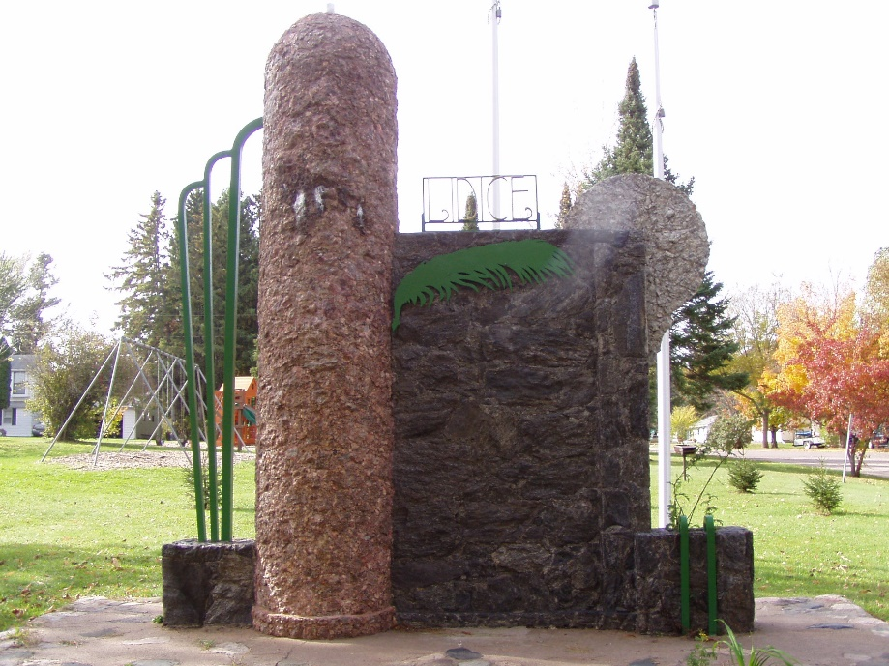
Source: Photograph by Emily J. Herkert, October 11, 2015.

I first became interested in the Lidice Memorial in Phillips in the spring of 2015. However, I have been interested in the village of Lidice since the summer of 2014. During that summer, I had the opportunity to study abroad in Central Europe as part of a month long program through the University of Wisconsin – Eau Claire. We travelled through Germany, the Czech Republic, Austria, Hungary, and Poland before returning to the United States. One of the most impactful sites that we visited was the Lidice Memorial and museum near Prague in the Czech Republic. I had heard about the Nazi destruction of Lidice before, but never learned about the events that happened there in detail. Once I returned home, I began researching the reaction to Lidice in the United States. Upon discovering the Lidice Memorial and its connection to the annual Phillips Czechoslovak Community Festival I became fascinated with the history of both the memorial and the reoccurring event. This topic is important because little to no research has been done on the creation, rededication, and continued emphasis of the Lidice Memorial in Phillips, and how it provides an example of how the public memory of a community facilitates the formation of identity. The primary sources I use in this paper are documents produced by the Phillips Czechoslovakian Community as well as newspaper articles from The Bee and Phillips Times from 1944 and The Bee from 1984 and1992.
Background
In order to understand the reaction of the Phillips Czech and Slovak communities to the Lidice Massacre, an understanding of what occurred in Lidice provides critical context. In 1938, under the command of Adolf Hitler, the Nazi Germans were looking to expand their Reich and occupy more territory in Eastern Europe. Hitler focused east, on Czechoslovakia, because of a large population of ethnic Germans living in the Sudetenland. The Nazis demanded that this territory be ceded to Germany. Hoping to prevent war in Europe, a conference was held in Munich, Germany in 1938. Negotiated largely by the English, French, Germans, and Italians with no Czechoslovak input, it was determined that Czechoslovakia should give up the Sudetenland to Germany. Hitler promised not to occupy territory east of the Sudetenland and the English and French appeased him in order to prevent war. On October 1, 1938 Nazi troops moved into the Sudetenland.
By March 10, 1939 the Nazis expanded their control to the rest of Czechoslovakia, establishing the Protectorate of Bohemia and Moravia in Czech lands and detaching the independent, but in actuality, the puppet state, of Slovakia. The president of Czechoslovakia, Edvard Beneš, was exiled to London. Hitler appointed Reinhard Heydrich the 2nd Reich Protector of the Protectorate of Bohemia and Moravia in September of 1941. Within days of his arrival in Prague, Heydrich had begun an oppressive regime, brutally silencing all protest in Prague and throughout the Protectorate. He quickly gained the nicknames “The Hangman” and “The Butcher of Prague.” In London, Beneš became concerned with the lack of Czech resistance to Nazi rule.
On May 27, 1942, two Czech paratroopers trained in London, Jan Kubiš and Jozef Gabčík attempted the assassination of Heydrich. Their assassination attempt was not instantly successful although Heydrich was wounded. Heydrich died of his injury on June 4, 1942. Heydrich’s assassination greatly angered the Nazi regime and resulted in an extremely brutal crackdown and investigation. In order to identify, locate, and apprehend Jan Kubiš and Jozef Gabčík, the Nazis turned to mass arrests, intimidation, torture and bribes. The men and their accomplices were located hiding in a church crypt in Prague, where they were surrounded and shot.
During the violent investigation, in which the Nazis were attempting every strategy to locate and apprehend everyone complicit with the assassination, somehow the name of the village of Lidice was brought up. Lidice village, a small community near Prague (See Figure 2), was suspected of harboring and aiding Heydrich’s assassins. There has never been any clear evidence to suggest that anyone in Lidice had any connection whatsoever to Heydrich’s assassination. Regardless of their lack of involvement, the community of Lidice paid the price.

Map 1 – Location of Lidice
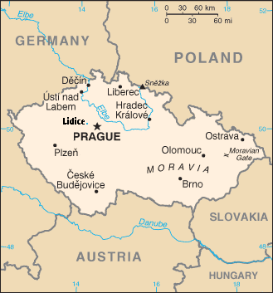
Source: “Lidice.” New World Encyclopedia. http://www.newworldencyclopedia.org/entry/Lidice. Accessed November 5, 2015.

On June 10, 1942, a little after midnight, a Nazi extermination squad arrived in the village. All the citizens of the community were pulled from their beds and rounded up. All 173 men in Lidice were shot and killed on the spot. The women were separated from their children and eventually sent to Ravensbruck concentration camp. Children who were very young were given to German families to receive a German re-education. Children who were not selected for Germanization were killed by exhaust gas in specially adapted vehicles at the Chelmo extermination camp in Poland. The Nazis then began the complete destruction of Lidice village. It was not enough to eliminate the inhabitants, the extermination squad blew up all standing structures in Lidice, attempting to erase its existence from the Earth. Figure 2 shows an image of Lidice before Nazi destruction and Figure 3 provides an example of what the Lidice Memorial site in the Czech Republic looks like today.

Figure 2 – Lidice before June 10, 1942.
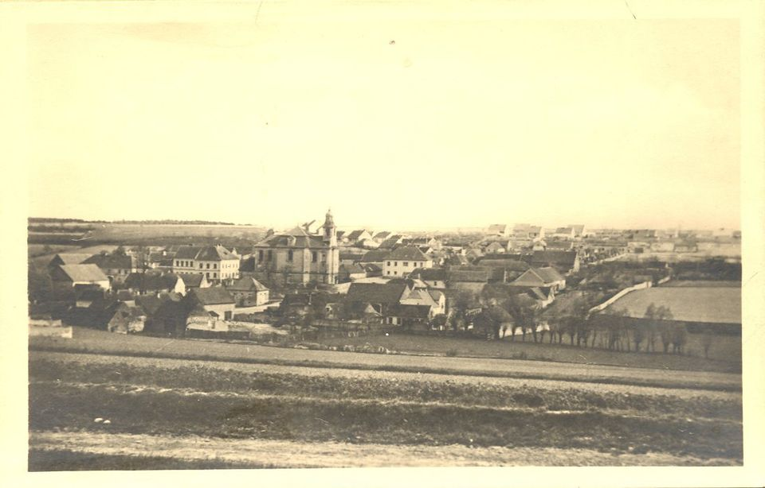
Source: Memorial and Reverent Area, http://www.lidice-memorial.cz/en/memorial/memorial-and-reverent-area/. Accessed Nov. 1, 2015.

Figure 3 – Site of Lidice Village, June 2014

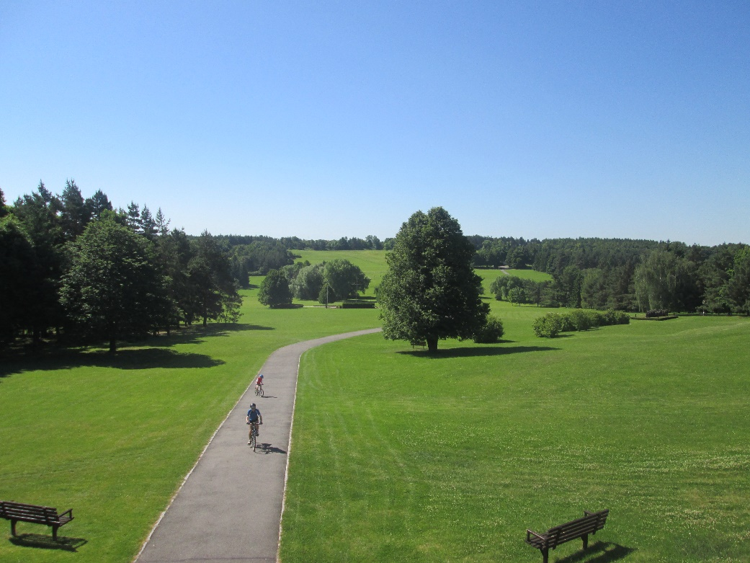
Source: Photograph by Emily J. Herkert, June 7, 2014.

The Nazis, instead of keeping the horrors of Lidice quiet, chose to film the destruction of the village and publish it for the entire world to see. The footage was meant to serve as a threat to anyone who was an enemy of the Reich. Instead, much of the world reacted with horror. As Chad Bryant writes in his book Prague in Black: Nazi Rule and Czech Nationalism, “Long before Auschwitz, Lidice had become the symbol of Nazi evil around the world.” This was the news that the Phillips Czechoslovak community received that sparked the inspiration to construct their own Lidice Memorial in 1944.
Historiography
There are two very important histories to consider when examining the story of the Lidice Memorial in Phillips, Wisconsin. The first involves Czechoslovak immigration to Wisconsin, their roles in the history of the State, and their efforts to maintain their ethnic identity. The other history that must be explored is the creation of war memorials and public memory. It is critical to consider why people are moved to create such monuments and how they can shape individual and group identity. The examination of these two histories will provide crucial context for the analysis of the Lidice Memorial.
The history of Czech immigration to the United States is often grouped with the stories of immigrants from other countries in Eastern Europe. Between 1812 and 1924 over three million people from Eastern and Northern Europe immigrated to the United States. These immigrants included the “Albanians, Belorussians, Bosnian Muslims, Bulgarians, Carpatho-Rusyns, Cossacks, Croats, Czechs, Estonians, Finns, Georgians, Gypsies, Hungarians, Jews, Latvians, Lithuanians, Macedonians, North Caucasians, Poles, Romanians, Russians, Serbs, Slovaks, Slovenes, Wends, and Ukrainians.” These groups were split between the larger German, Russian, and Austro-Hungarian empires. Typically immigrants from Eastern Europe, such as the Czechs and Slovaks, chose to move to the United States seeking economic opportunity. According to Roger Daniels in Coming to America: A History of Immigration and Ethnicity in American Life, the majority of immigrants from Eastern Europe left rural areas and farming communities but ended up settling in larger cities within the US due to a lack of available land. Daniels suggests that Eastern European immigrants found jobs primarily in manufacturing despite their background in farming.
The story of the Czech and Slovak immigrants that settled in the Phillips, Wisconsin area is different than the experiences of many Eastern European immigrant groups. The largest Czech populations in Wisconsin are centered around the larger cities of Milwaukee, Racine, and Kewaunee. The first Czech immigrants arrived in Milwaukee in 1848. However, many immigrants travelled initially to Chicago after arrival in the US before moving North. The Czech settlement of Phillips did not occur until after 1876 when the cutover areas of Northern Wisconsin were made available for farming (See Map 1). The lumber industry had cleared the land of trees making it available as farmland for immigrants. The Czech and Slovak population that moved to Phillips left manufacturing jobs in Chicago to return to the farming lifestyle they had been familiar with in Europe.
Map 2 – Phillips, Wisconsin
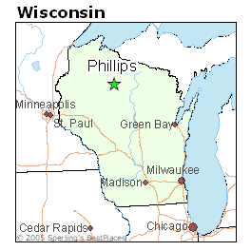
Source: Sperling’s Best Places to Live, http://www.bestplaces.net/city/wisconsin/phillips. Accessed November 1, 2015.
Czech immigrants were very active in the State of Wisconsin and did much to preserve their ethnic heritage. Karel D. Bicha, author of the article, “The Czechs in Wisconsin History,” suggests that Czech Americans in Wisconsin contributed most to the wider Czech immigrant community in the US was through journalism and fraternalism. Czech immigrants living in larger cities produced newspapers in the Czech language. Popular tittles included the Slavie, a newspaper produced in Racine that reached subscribers as far away as New York. Fraternal societies developed and flourished in the Czech community because of divides within the community over religion. Many Czech immigrants in Wisconsin were of the Catholic faith. Others within the Czech community considered Catholicism an aspect of the Austro-Hungarian Empire and considered the faith a symbol of oppression. This religious divide within the Czech community meant that churches could not as easily be used as community centers for the entire Czech population. This facilitated the development of fraternal organizations. Originating in Prague, organizations such as the Slovanska Lipa and later Sokol and the West Bohemian Fraternal Union, spread quickly throughout the US. The lodges of these organizations served as gathering places for Czech communities that promoted the preservation of Czech culture. Bicha suggests that although Wisconsin contributed greatly to the development of a distinct Czech voice in the US, assimilation occurred quickly due to a lack of new immigrants from Bohemia and Moravia. However, the fraternal organizations continued to serve as community centers in areas with Czech heritage.
The second history that must be examined in order to contextualize the history of the Lidice Memorial in Phillips, Wisconsin is the study of the construction of memorials and consideration of public memory. According to Alan Borg, in his book War Memorials: From Antiquity to the Present, historically, war memorials were constructed to commemorate wars themselves, specifically great victories. However, modern memorials “are much more concerned with the sacrifices of war, with the loss of young life in the defense of freedom.” Borg suggests that the reason for this transition is that historical memorials were often funded almost exclusively by governments and were meant to emphasize government power and dominance. More modern memorials are often created as sites of public memory by smaller groups, although many government sponsored memorials continue to be built. Modern memorials often provoke thoughts of what has been lost in pursuit of a better future. The Lidice Memorial in Phillips falls into the category of a modern memorial, honoring those killed in Lidice instead of commemorating the entirety of World War II.
Memorials are considered places of public memory because they symbolize the memory of a society, group, or community. John Bodnar defines public memory simply as the “body of beliefs and ideas about the past that help a public or society understand both its past, present, and by implication, its future.” Memorials, such as the Lidice Memorial in Phillips serve as a physical manifestation of this public or collective memory of the community. The twentieth century saw a large increase in the construction of memorials by communities within the United States. As Geoff Eley suggests in his forward for the book War and Memory in the Twentieth Century, the twentieth century saw a huge rise in “memory.” Eley means that with significant global changes in the twentieth century, facilitated by technological advancements and the mass media, a significant effort emerged to preserve the past and use it as a basis for identity formation. A common understanding of the past would be familiar and seemingly stable in a rapidly changing world. However, as is suggested by Kendall R. Phillips in Framing Public Memory, memory appears “within our cultural experience like a mirage: vivid and poignant but impermanent and fluid.” No matter how clear and direct memory seems to be, its meaning changes over time. The same is true when considering public memory.
Another significant aspect to keep in mind when considering public memory and memorials is that places of memory develop histories of their own, outside of the memory they are trying to preserve. According to Greg Dickinson, Carole Blair, and Brian L. Ott in their book, Places of Public Memory: The Rhetoric of Museums and Memorials, places of public memory develop three distinct histories. The first history is the story of the event or person that the place of memory was created to commemorate. The second is the history of the place of public memory itself, meaning its construction and preservation. The third history connected to memory places is the story of the individuals who visit that location and incorporate it into their own personal history. This paper is written in an effort to shed light on the history of the Lidice Memorial in Phillips, Wisconsin. The focus is on what Dickinson, Blair, and Ott would consider the memorial’s second history. However, this paper also discusses the first and third histories of the memorial.

The Construction of the Lidice Memorial
The news of the tragic massacre at Lidice spread quickly worldwide. The Nazis, instead of keeping the destruction of the village quiet, published the information. They wanted the village of Lidice to serve as a reminder of the consequences of being their enemy. As early as June 11, 1942, the day after the massacre, the New York Times reported the destruction of Lidice in a “War News Summarized” column, suggesting that German “vengeance squads” annihilated the village based on the accusation of harboring Heydrich’s assassins. News about the Germans’ action spread throughout the United States and within days, reactions could be seen across the country.
The Czechoslovakian community in Phillips, Wisconsin reacted viscerally to the news. According to Toni Brendel, a citizen of Phillips and a former co-chair of the Phillips Czechoslovakian Community Festival Committee, after hearing the news about Lidice over the radio, the Czechoslovak community experienced a very “personal pain,” hearing about victims whose last names were often identical to their own. After meeting and communicating with each other around the small town or at the local Sokal Hall, the Czech community determined that they wanted to construct a memorial in order to remember those who were slain that they felt such a personal connection. They wanted to honor people who had been killed across the world in a village that they speculated was very similar to their own community. By January of 1942 plans had been set for the creation of a monument on land belonging to the Sokol Hall.
The Czech community in Phillips, recognizing that raising funds and actually constructing the permanent memorial would take some time, elected to build a temporary memorial to commemorate Lidice until the final memorial could be completed. Located in the same place the permanent monument would be built, the temporary monument was meant to serve as a reminder while construction took place. This illustrates how committed the community in Phillips had become to honoring Lidice. The temporary memorial featured a large triangular shield with a cross on top. Attached to the front of the cross was a torch that could be lit during remembrance ceremonies. Money for both the temporary and permanent memorials was raised by donations from private citizens in Phillips, revealing the interest in the project throughout the community. The temporary monument was completed in June of 1943 and was the centerpiece of a somber ceremony that acknowledged one year since the destruction of Lidice. Phillips residents quietly attended the ceremony and then returned to their homes afterward with no further gathering in the Sokol Hall. The following summer construction on the permanent memorial would begin.
The Lidice Memorial Association was formed in order to plan both the memorial and dedication ceremony. The president of this committee was Frank Herda, the vice president was Frank Koel, the secretary was Ludmila Urban, the treasurer was Frank Rehak, Otto Jakoubek was in charge of publicity, and V.J. Hajny was an ex-officio committee member. This committee met many times over the course of 1943 and the spring and summer of 1944 in order to oversee the development of the memorial. V.J. Hajny was the architect of the project and also oversaw construction. Karel Novy and Joe Skomoroske completed the iron and steel work necessary for the project’s design. All workers and committee members volunteered their time and did not receive any monetary compensation, showcasing how devoted these community members were to the project. Ground was broken on the memorial on June 21, 1944.
There were two major ceremonies that occurred in the summer of 1944 during the process of constructing and dedicating the memorial. The first was on Sunday, July 30, 1944 for the laying of the corner stone of the monument. The ceremony involved a variety of local officials and committee members who were working on the memorial project. It began with the Pledge of Allegiance led by City Attorney Carl Bjork. Frank Herda, president of the Lidice Memorial Association, spoke briefly about the events at Lidice village before Karl Novy laid the corner stone. Community members placed an evergreen wreath on the corner stone and lit the torch on the temporary monument. The outside ceremony was concluded with V.J. Hajny speaking about his plans and inspiration for the finished memorial. The design of the memorial (see Figure 4) had specific meanings according to Czech tradition. The large round pillar represented the United Nations. The three green iron rods extending from the side of the monument represent the Bohemian, Moravian, and Slovakian peoples. The metal evergreen branch in the center of the monument represents the idea of rising again, in Czech tradition.
The proceedings then moved inside Sokol Hall. Ernest A. Heden, a Phillips visitor running for state senate, addressed the congregation about the significance of the Lidice Memorial. As he stated, “instead of having wiped it (Lidice) off the map of the world, as was the Nazi idea, it had been multiplied in many places in the world, to be a symbol to freedom of all mankind.” Following Heden, Ludmila Urban spoke in Czech about the women and children in

Figure 4 – Symbolic Meanings of Lidice Memorial
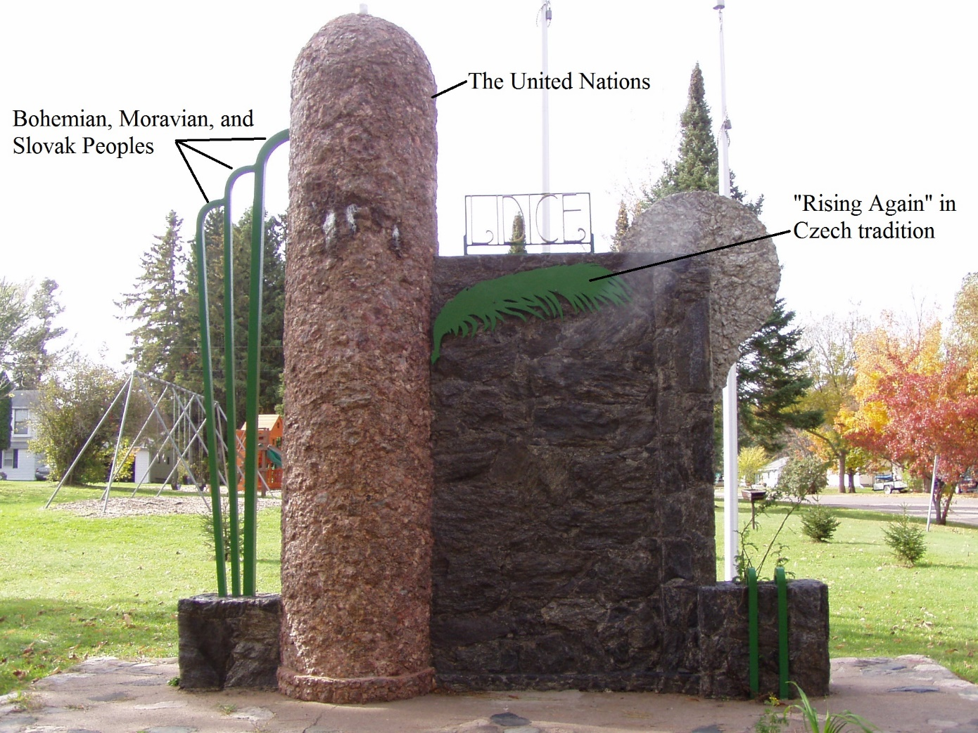
Source: Photograph by Emily J. Herkert, June 7, 2014.

Lidice, reportedly bringing everyone in the room to tears. She reminded the congregation that Germany had always been “a bad neighbor” to the Czechoslovaks and that the massacre at Lidice was only the latest in a long list of German aggressions. After another brief speaker, the congregation listened to a record called “The Murder of Lidice,” based on a play by Edna St. Vincent. The concluding speaker for the day was Otto Jakoubek who spoke in Czech about the importance of supporting the United States effort in the war against Germany. Jakoubek called for all citizens to purchase war bonds and follow laws without complaint in order to work toward victory.
The speakers at the second half of the corner stone laying ceremony, specifically Heden and Jakoubek, illustrate the symbolic importance that the Phillips community was already beginning to put on the Lidice monument even before the conclusion of its construction. The monument meant more than a simple remembrance of murdered villagers, it represented hope for the future of Czech people and victory in the war. While the monument itself was still a somber reminder of what happened in Lidice, the Phillips Czechoslovakian community placed additional meanings upon it. Honoring those killed in Lidice meant supporting the United States’ war effort.
The dedication of the Lidice memorial occurred on Sunday, August 27, 1944. The program for this event can be seen in Figure 5. Similar to the corner stone laying ceremony, the dedication ceremony occurred in two parts, an afternoon and an evening program. The afternoon program was held outside at the newly constructed monument despite rainy weather. The program began with the Philips High School band playing the “Star Spangled Banner.” A Czech music group called “The Internationals” played the Czechoslovakian anthem while the memorial was unveiled. Following the unveiling, Phillips mayor, Fred R. Struble, welcomed community members and guests to the ceremony. The crowd then witnessed a short tableau, or sketch, written by V.J. Hajny, the memorial’s designer, and performed by community members in traditional dress. Otto Jakoubek then gave a brief history of the events that occurred in Lidice before the Phillips High School band played a few selections.

Figure 5 – Lidice Memorial Dedication Program, August 27, 1944

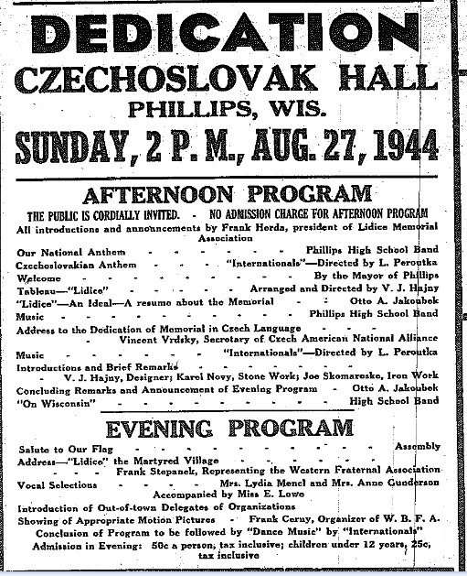
Source: “Dedication,” Bee and Phillips Times, August 27, 1944.
The headline speaker for the ceremony was Vincent Vrdsky, the secretary of the Czech American National Alliance (C.A.N.A.) in Chicago. Vrdsky complimented the Phillips community on their efforts to commemorate Lidice and emphasized the importance of voting in all elections. Vrdsky continued by suggesting:
The Nazis were frenzied with fear because they could not squelch thoughts of freedom in the conquered people. “Because the Hangman (Heydrich) was killed, Lidice lives forever. It lives again 45,000 [sic] miles from the original village – in Lidice, Ill., and here in Phillips in the memorial erected, and in many other places in the world. Lidice stands as a symbol of sacrifice, and as an unfaltering flame of liberty for all future generations.”

Vrdsky suggests an idea that had been implied at the at the corner stone laying ceremony, the Lidice memorial meant much more than a simple remembrance of murdered villagers. After Vrdsky spoke, Henry Zalenka from the Wisconsin C.A.N.A. made some brief statements followed by V.J. Hajny who introduced Karel Novy and Joe Skomaroske to the crowd. The first half of the program concluded with the song “On Wisconsin” played by the Phillips High School band.
The evening dedication program occurred inside of Sokol Hall. Unlike the afternoon program, which was free of charge, the evening program cost fifty cents for each adult and twenty-five cents for each child under the age of twelve. Several Czech members of the Phillips community as well as visitors for the dedication addressed the crowd, congratulating the Phillips community for their endeavors. The main speaker for the evening program was John Panek, a member of the Wisconsin C.A.N.A. from Milwaukee. Panek claimed that the memorial was a fitting tribute to the lives lost at Lidice and suggested that this was the first Lidice memorial to be erected by “citizens of Czechoslovak origin” anywhere in the world. Following Panek’s speech, two local women sang songs in Czech without accompaniment. This concluded the formal aspects of the dedication for the day. A dance and social followed. Music for the dance was provided by the music group, “The Internationals.”
As is shown both through the events of the corner stone laying ceremony and the memorial dedication ceremony itself, the Lidice memorial in Phillips had already taken on much more significance than the remembrance of slain villagers in the Protectorate of Bohemia and Moravia. Members of the Phillips community looked to the monument as inspiration to keep supporting the United States’ war effort against Nazi Germany and considered the monument symbolic of a hopeful future for the Czech people. As was illustrated even in the symbolism on the monument itself, tragic events like the one that occurred at Lidice would not stop the Czech people from prospering in the future.
Memorial Rededication
It cannot be accurately stated that there was ever a time after the dedication ceremony in 1944 that the Lidice memorial fell completely out of the awareness of the Phillips Czechoslovakian community. Each year ceremonies were held at the monument to remember the massacre at Lidice, but after the United States won the war, the memorial gradually lost the specific patriotic meanings that had been attributed to it. In 1947 and 1949 respectively Anton Brendl and Mrs. Joe Kucaba travelled to the destroyed village of Lidice and returned with soil to bury in a vault under the memorial. There was a ceremony for the placement of the vault as well as small ceremonies each year by the Czechoslovak community to remember the event. However, the monument did not begin attracting community wide attention again until the 1970s.
In 1974, Sokol Hall, the main gathering place of the Phillips Czechoslovakian community was demolished and the land was gifted to the City of Phillips by the Sokol organization. This included the land on which the Lidice Memorial is located. The gift of the land to the city stipulated that the area become a public park. The city named the new park Sokol Park in gratitude for the donation of land. The City of Phillips also took over maintenance of the memorial. This was not the only change to the physical environment around the monument. In 1977 a windstorm damaged the memorial and city funds were used to begin repairs. The repairs were completed in 1983, however that summer children playing in Sokol Park discovered that the vault containing the soil from Lidice had been exposed. That vault was removed and a committee was formed to plan a rededication of the monument. Over the winter of 1984 the rededication committee determined to combine the memorial rededication with a Czechoslovak community festival. This decision began the association between the Lidice memorial and the Phillips Czechoslovakian community’s connection with their identity and ethnic heritage.
The rededication of the Lidice Memorial took place on July 1, 1984. Unlike the original dedication ceremony, the rededication was brief, only an hour long solemn event followed by a reception. Laddie Zellinger, the chairman of the rededication committee, hosted the event. After a singing of the United States’ and Czechoslovakian national anthems, the mayor of Phillips, William Heindl, introduced the event’s special guest speaker Joseph Ondracek, shown below in Figure 6. Ondrecek investigated the Lidice massacre after World War II and assisted with the relocation of surviving Lidice women from the Ravensbruck concentration camp. He also helped trace Lidice children who had been placed in Germanization programs. During the ceremony, Ondrecek spoke primarily about his own experiences. Following his contribution, Therese Trojak recounted a brief history of the Lidice Memorial. To conclude the ceremony members of the Veterans of Foreign Wars Post 5778 fired a volley in salute to those killed at Lidice.

Figure 6 – Joseph Ondrecek Speaking at 1984 Memorial Rededication
Source: Toni Brendel, Lidice Remembered Around the World (Iowa City: Penfield Books, 2013), 26.

After the events at the Lidice Memorial, the assembled group traveled to the Phillips High School for a reception. This small reception eventually became the Czechoslovakian Community festival now celebrated each year in Phillips. This first celebration featured traditional Czech desserts such as kolaches. Two Czech dancing troupes, the Czech Slovak Tatra and the Czech Moravian dancers gave performances in the high school auditorium. The evening was concluded with an “an old fashioned Zabava,” or Czech party, at the Phillips VFW Hall.
The relatively small scale of the rededication ceremony demonstrates how remembrance and community emphasis on the Lidice Memorial had shifted since 1944. While the rededication followed by the Czechoslovak festival gathered a crowd, news about the monument and rededication ceremony did not dominate the newspaper as the building and dedication of the memorial had during World War II. The gathering after the event was small, and limited almost exclusively to the Phillips community and other small neighboring communities. What is important about the memorial rededication ceremony in 1984 followed by the cultural festival is that it began the association between commemorating Lidice and remembering the Phillips community’s Czech heritage. The Lidice memorial, once representing the people of Lidice who had been slain as well as a hopeful future for the Czech people, was transitioning in public thought to symbolize Czech identity and heritage in Phillips.
The Czechoslovakian Community Festival
There was a dramatic transition between the 1984 rededication of the Lidice memorial and the 1992 Czechoslovak Community Festival. These eight years marked the significant growth of the cultural festival as well as the reestablished importance of the Lidice Memorial in the Phillips Community. In 1992, the Phillips Czechoslovakian Community Festival Committee wanted to hold a ceremony of special significance because it had been fifty years since the destruction of Lidice Village. Instead of looking only at the history of what happened at Lidice, the committee reached out to both Czech and American dignitaries inviting them to the festival and asking about the reconstruction of Lidice in addition to the current political climate in post 1989 Czechoslovakia. This outreach illustrates the change in the emphasis placed on the memorial. The history of the Lidice Memorial in Phillips presents an opportunity for the Phillips Czechoslovakian community to form modern connections based on their ethnic heritage. The Phillips community had begun using the memorial as a tool in connecting with their own cultural identity.
The significant importance of the fiftieth anniversary of the destruction of Lidice led the Phillips community to invite many significant diplomats and politicians to their ceremony. On August 28, 1991, a full year before the 1992 festival, Shirley Temple Black, the American Ambassador to Czechoslovakia, replied to a letter from Laddie Zellinger. Black thanked the Phillips community for the invitation but would be unable to attend the event. She forwarded the information about the festival to the Embassy of the Czech and Slovak Federal Republic in the United States. Zellinger received another letter dated November 4, 1991. This letter was from Egon Ditmar in reply to an invitation from the Phillips community to Vaclav Havel, the President of Czechoslovakia. Ditmar expressed thanks on behalf of Havel, but explained that the president could not attend “due to budgetary and time commitments.”
Much closer to the 1992 Czechoslovak Community Festival, the festival committee received notice from three other important Czech figures. On May 21, 1992 Josef Ondracek, the speaker from the 1984 memorial dedication, offered his regrets that he could not attend the ceremony in person, but offered encouragement for the community festival. He also suggested that an additional plaque be added to the memorial to commemorate the village of Lezaky, a different Czech community annihilated by the Nazis. Although not added for the 1992 festival, the Phillips Czechoslovakian community would eventually take Ondracek up on his suggestion and add a plaque to the memorial recognizing Lezaky. On May 26, 1992, the festival committee received a letter from Rita Klímová, the Czechoslovak ambassador to the United States. Similarly to Black and Ditmar, Klímová expressed interest in the event, but could not attend due to budgetary restraints. The final letter was of significantly more interest to the Phillips Czechoslovakian Community Festival Committee. This letter dated May 1992, was from Pavel Muller, the current mayor of New Lidice, the town that had been built directly adjacent to the destroyed village. Muller’s letter offered encouragement for Phillips’ festival and commemorating Lidice. Pavel also provided information about Lidice in 1992, giving an outline of preservation efforts along with information about the growth of New Lidice. The Phillips committee was thrilled to hear directly from the mayor of New Lidice and quickly incorporated his letter into their plans for the Lidice commemoration ceremony.
The program for the 1992 Czechoslovak Community Festival highlights how significantly the event had grown since 1984 (See Figure 7). Instead of a few hour festival, the 1992 program reveals that the festivities took place over the course of an entire weekend, from Saturday, June 20 at ten in the morning through Sunday afternoon. The majority of these programs took place at Phillips High School instead of Sokol Park around the memorial. Most notable in the festival program is that the focus of the festival had shifted significantly away from remembering Lidice. Even though there was still a planned commemoration ceremony on Sunday afternoon, the majority of activities planned for the festival were associated with remembering Czech heritage and establishing a sense of Czech identity. Also notable is the absence of an identified speaker at the Lidice memorial service on Sunday, June 21st. Despite the festival committee’s best efforts, they were not able to attract any important Czech officials to the commemoration.

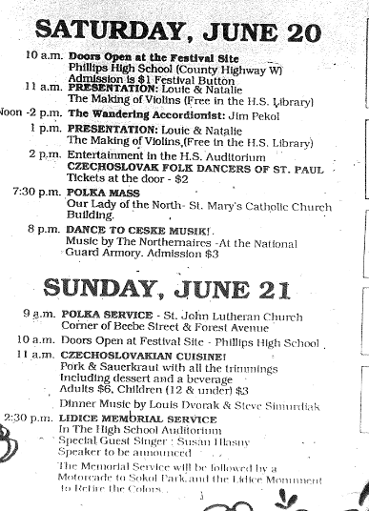
Figure 7 – Czechoslovak Community Festival Program, 1992
Source: “Program,” Bee, June 18, 1992.

The planned events focused on the music, food, and other elements of Czech culture. The fee to get into the festival was one dollar per person in order to pay for the entertainers. One highlight was a “Kiddie Karnival” offering children’s games to sponsor the Phillips Community Day Care Center. There was an arts and crafts fair with products for sale from local artists. The Czech bakery booth was exceedingly popular, selling traditional Czechoslovak cuisine such as kolaches, bobufka, listy, hoska, and Bohemian rye bread. According to festival organizers, the bakery booth was sold out by noon on Saturday. Another booth sold Czechoslovak gifts. A cultural booth focused on the history of Lidice village and featured replicas of traditional clothing that would have been worn by the women of Lidice on special occasions. There were musical performances, folk dances, and demonstrations throughout the festival.
The ceremony to commemorate fifty years since the destruction of Lidice village was held at the conclusion of the two-day festival. Starting at 2:30 in the afternoon at the Phillips High School auditorium, the ceremony featured John Slaby, a Phillips attorney, as the main speaker. Slaby discussed the different memorials that had been built to remember Lidice around the world and read the letter that the Phillips Czechoslovakian Community Festival committee had received from Pavel Muller, the mayor of New Lidice. George Tresnak, the Phillips Bee reporter who covered the event for the paper, suggested that although the focus of the ceremony was on the rebuilding of Lidice rather than its destruction, “feelings of hope were marred somewhat this year by the latest developments in Czechoslovakia that appear to be taking the Czechs and Slovaks down separate paths.” The Phillips Czechoslovakian Community Festival was held just months before the division of Czechoslovakia into the Czech Republic and Slovakia. The ceremony concluded with a motorcade from Phillips High School to the Lidice Memorial in Sokol Park.
The Lidice Memorial was still a central part of the Phillips Czechoslovakian Community Festival even though the vast majority of the festival’s events occurred at Phillips High School. Unlike in the past, when yearly celebrations would commemorate solely the destruction of Lidice, the growth of the Czechoslovak community festival illustrates a transition in thought. The Lidice Memorial became a way for the community to reach out and make modern connections with their ethnic past. Commemorating Lidice had become a part of how the Phillips Czechoslovakian community viewed and connected with their cultural identity. The Lidice Memorial had become not just a place of memory, but a place of identity.

Conclusion
The Phillips Czechoslovakian Community Festival continues to be held each year on the third weekend in June. The festival continues to grow each year with new attractions and vendors. Commemorating Lidice is still a major focus of the event along with preserving and sharing traditional Czech and Slovak culture. Each festival opens with a ceremony to remember Lidice Village. Modern highlights of the festival include the State Kolache baking and eating competitions and the Miss Czech-Slovak Wisconsin Pageant alongside a wide variety of musical performances and demonstrations. The theme of the 2015 festival was “Our Heritage, Our Treasure,” emphasizing the festival’s focus on cultural identity.
The Lidice Memorial in Phillips, Wisconsin has had many different meanings to the community since its construction in 1944. While always commemorating the slain villagers of Lidice, the memorial has taken on other meanings that reveal much more about the Phillips community. When the memorial was built and commemorated, the focus on patriotism and supporting the United States’ war effort indicate that, for the Phillips community, there was an association between those killed at Lidice and the reasons behind the war. The memorial also took on meanings of hope for Czech and Slovak people. Instead of focusing on Lidice as simply a tragedy, there is a clearly an effort to portray the Lidice villagers as martyrs who died for a better future. In 1984, when the destruction of Lidice was no longer a current event but a historical tragedy, thought about the Lidice memorial shifted significantly. The monument represented the past efforts of the Czech and Slovak people within the Phillips community and contributed to a sense of the community’s ethnic identity. With the advent of the Phillips Czechoslovak Community Festival in 1984 and the growth of the festival by 1992, the focus on developing and remembering cultural identity becomes clearer. Commemorating Lidice connects the Czechoslovak community of Phillips not only to their Czech and Slovak ancestors, but to their grandparents and great-grandparents that built the memorial in 1944. The Lidice Memorial is a major site of identity and memory for the Phillips Czechoslovakian community.

Works Cited
I. Primary Sources
Black, Shirley Temple. Phillips Czechoslovakian Community. Phillips Czechoslovakian Community. Vol. 2. Phillips, Wisconsin: Phillips Czechoslovakian Community, 1995.

Ditmar, Egon. Phillips Czechoslovakian Community. Phillips Czechoslovakian Community. Vol. 2. Phillips, Wisconsin: Phillips Czechoslovakian Community, 1995.

Klímová, Rita. Phillips Czechoslovakian Community. Phillips Czechoslovakian Community. Vol. 2. Phillips, Wisconsin: Phillips Czechoslovakian Community, 1995.

Muller, Pavel. Phillips Czechoslovakian Community. Phillips Czechoslovakian Community. Vol. 2. Phillips, Wisconsin: Phillips Czechoslovakian Community, 1995.

Phillips Area Chamber of Commerce. “32nd Annual Czech-Slovak Festival.” Czech-Slovak- Festival. Last modified March 29, 2015. Accessed April 6, 2015. http://www.czech- slovak-festival.com/.

Phillips Czechoslovakian Community. Phillips Czechoslovakian Community. Vols. 1 and 2. Phillips, Wisconsin: Phillips Czechoslovakian Community, 1991.

Wisconsin Historical Society. Wisconsin Architecture and History Inventory. “Lidice Memorial.” Phillips, Price County, Wisconsin. 19517.

II. Secondary Sources

Albright, Madeleine. Prague Winter: A Personal Story of Remembrance and War, 1937-1948. New York: HarperCollins, 2012.

Bicha, Karel D. “The Czechs in Wisconsin History,” The Wisconsin Magazine of History 53, no. 3 (Spring 1970): 194-203.

Bodnar, John. Remaking America: Public Memory, Commemoration, and Patriotism in the Twentieth Century. Princeton: Princeton University Press, 1992.

Borg, Alan. War Memorials: From Antiquity to the Present. London: Pen & Sword Books, 1991.

Brendel, Toni. Lidice: Remembered Around the World. Iowa City: Penfield Books, 2013.

Byrant, Chad. Prague in Black: Nazi Rule and Czech Nationalism. London: Harvard University Press, 2007.

Daniels, Roger. Coming to America: A History of Immigration and Ethnicity in American Life. New York: Perennial, 2002.

Dickinson, Greg., Carole Blair, and Brian L. Ott. Places of Public Memory: The Rhetoric of Museums and Memorials. Tuscaloosa, AL: The University of Alabama Press, 2010. Accessed October 30, 2015.

Eley, Geoff. “Forward.” In War and Memory in the Twentieth Century, edited by Martin Evans and Ken Lunn, vii-xiii. Oxford: Oxford International Publishers, 1997.

Hauner, Milan. “Terrorism and Heroism: The Assassination of Reinhard Heydrich.” World Policy Journal 24, no. 2 (Summer 2007): 85-89.

“History of Lidice Village.” Lidice Memorial. Accessed November 1, 2015. http://www.lidice- memorial.cz/en/memorial/memorial-and-reverent-area/history-of-the-village-lidice/.

Phillips Centennial Committee. Phillips, Wisconsin: an Album with Recollections of Some People and Places and Times Gone By; Centennial 76, 1876-1976. Park Falls, Wisconsin: F.A. Weber, 1976.

Phillips, Kendall R. Framing Public Memory. Tuscaloosa, AL: The University of Alabama Press, 2004. Accessed October 30, 2015.

Zaniewski, Kazimierz J. and Carol J. Rosen. The Atlas of Ethnic Diversity in Wisconsin. Madison, WI: The University of Wisconsin Press, 1998.

Madeleine Albright, Prague Winter: A Personal Story of Remembrance and War, 1937-1948, (New York: HarperCollins, 2012), 96-100.
Chad Bryant, Prague in Black: Nazi Rule and Czech Nationalism, (London, Harvard University Press, 2007), 26-27.
Ibid, 142-143.
Milan Hauner, “Terrorism and Heroism: The Assassination of Reinhard Heydrich,” World Policy Journal 24 no. 2 (Summer 2007): 86-87.
Milan Hauner, “Terrorism and Heroism: The Assassination of Reinhard Heydrich,” 87.
“History of Lidice Village,” Lidice Memorial, accessed November 1, 2015, http://www.lidice-memorial.cz/en/memorial/memorial-and-reverent-area/history-of-the-village-lidice/.
Chad Bryant, Prague in Black: Nazi Rule and Czech Nationalism, 172.
Roger Daniels, Coming to America: A History of Immigration and Ethnicity in American Life, 2nd ed. (New York: Perennial, 2002), 212.
Roger Daniels, Coming to America: A History of Immigration and Ethnicity in American Life, 213-214.
Kazimierz J. Zaniewski and Carol J. Rosen, The Atlas of Ethnic Diversity in Wisconsin, (Madison, WI: The University of Wisconsin Press, 1998), 86-87.
Karel D. Bicha, “The Czechs in Wisconsin History,” The Wisconsin Magazine of History 53, no. 3 (Spring, 1970): 199.
Ibid, 203.
Alan Borg, War Memorials: From Antiquity to the Present, (London: Pen & Sword Books, 1991), x.
Ibid, x-xi.
John Bodnar, Remaking America: Public Memory, Commemoration, and Patriotism in the Twentieth Century, (Princeton: Princeton University Press, 1992), 15.
Geoff Eley, “Forward,” in War and Memory in the Twentieth Century, ed. Martin Evans and Ken Lunn (Oxford: Oxford International Publishers, 1997), vii.
Kendall R. Phillips, Framing Public Memory, (Tuscaloosa, Alabama: The University of Alabama Press, 2004), 9.
Greg Dickinson, Carole Blair, and Brian L. Ott, Places of Public Memory: The Rhetoric of Museums and Memorials, (Tuscaloosa, Alabama: The University of Alabama Press, 2010), 30.
“War News Summarized”, New York Times, June 11, 1942.
Toni Brendel, Lidice Remembered Around the World (Iowa City: Penfield Books, 2013), 21.
Ibid, 22.
Phillips Czechoslovakian Community, Phillips Czechoslovakian Community (Phillips, Wisconsin: Phillips Czechoslovakian Community, 1991), 1:201.
Toni Brendel, Lidice Remembered Around the World, 22.
“Lidice Memorial Program Sunday,” Bee and Phillips Times, June 27, 1944.
“Lidice Memorial Started Wednesday,” Bee and Phillips Times, June 22, 1944.
“Lidice Monument Corner Stone Laid,” Bee and Phillips Times, August 3, 1944. .
Phillips Czechoslovakian Community, Phillips Czechoslovakian Community, 1:201.
Phillips Czechoslovakian Community, Phillips Czechoslovakian Community, 1:201
“Lidice Monument Corner Stone Laid,” Bee and Phillips Times, August 3, 1944.
“Lidice Monument Corner Stone Laid,” Bee and Phillips Times, August 3, 1944.
“Lidice Memorial Dedicated Sunday,” Bee and Phillips Times, August 31, 1944.
“Lidice Memorial Dedicated Sunday,” Bee and Phillips Times, August 31, 1944.
Ibid.
Advertisement, “Dedication,” Bee and Phillips Times, August 24, 1944.
“Lidice Memorial Dedicated Sunday,” Bee and Phillips Times, August 31, 1944.
“Dedication Sunday,” Bee and Phillips Times, August 24, 1944.
Phillips Centennial Committee, Phillips, Wisconsin: an Album with Recollections of Some People and Places and Times Gone By; Centennial 76, 1876-1976 (Park Falls, Wisconsin: F.A. Weber, 1976), 169.
Wisconsin Historical Society, Wisconsin Architecture and History Inventory, Lidice Memorial, Phillips, Price County, Wisconsin, 19517.
Toni Brendel, Lidice Remembered Around the World, 25.
“Former Czech resident to speak at Lidice rededication,” Bee, June 21, 1984; “Lidice Memorial rededicated Sunday,” Bee and Phillips Times, July 5, 1984.
“Lidice Memorial rededicated Sunday,” Bee, July 5, 1984.
Shirley Temple Black, letter to Laddie Zellinger, August 28, 1991, in Phillips Czechoslovakian Community, Phillips Czechoslovakian Community (Phillips, Wisconsin: Phillips Czechoslovakian Community) 2:184.
Egon Ditmar, letter to Laddie Zellinger, November 4, 1991, in Phillips Czechoslovakian Community, Phillips Czechoslovakian Community (Phillips, Wisconsin: Phillips Czechoslovakian Community) 2:184.
George Tresnak, “Famous Czech Immigrant gives regrets, can’t attend Phillips event,” Bee, May 21, 1992.
Rita Klímová, letter to Laddie Zellinger, May 26, 1992, in Phillips Czechoslovakian Community, Phillips Czechoslovakian Community (Phillips, Wisconsin: Phillips Czechoslovakian Community) 2:185.
Pavel Muller, letter to Laddie Zellinger, May 1992, in Phillips Czechoslovakian Community, Phillips Czechoslovakian Community (Phillips, Wisconsin: Phillips Czechoslovakian Community) 2:185.
“Program,” Bee, June 18, 1992.
George Tresnak, “Czech festival planning nearly complete, program schedule set,” Bee, May 7, 1992; George Tresnak, “Czech festival organizers feel pleasant exhaustion,” Bee, June 25, 1992.
George Tresnak, “Czech festival organizers feel pleasant exhaustion,” Bee, June 25, 1992.
George Tresnak, “Czech festival organizers feel pleasant exhaustion,” Bee, June 25, 1992.
Phillips Area Chamber of Commerce, “32nd Annual Czech-Slovak Festival,” Czech-Slovak Festival, last modified on March 29, 2015, accessed April 6, 2015, http://www.czech-slovak-festival.com/.

