THE MEMORY REMAINS:
CHILDREN’S EXPERIENCES IN
THE SOVIET GULAG DURING THE STALIN ERA (1929-1953)

Kelly Rooney
History 489
April 24, 2012

Copyright for this work is owned by the author. This digital version is published by McIntyre
Library, University of Wisconsin Eau Claire with the consent of the author.
CONTENTS

ABSTRACT iii
INTRODUCTION 1
History of the Gulag 4
Arrest 8
Transportation to Gulag prisons 11
Daily Life in the Gulag 14
Aftermath 22
CONCLUSION 24
WORKS CITED 25

Abstract

This paper will discuss the Soviet Gulag prison system during the Stalinist Era (1929-1953), with an emphasis on children’s experiences within the system. It includes a brief history of the Gulag system to aid readers that may be unfamiliar with the topic. Following the history, the paper will explore the path of those imprisoned: arrest, transportation, daily life in the Gulag, and finally, freedom. This paper will highlight the experiences of child prisoners.

Introduction
Ash to Ash,
Dust to Dust,
Fade to Black…
But the Memory Remains.
-Metallica

The epigraph above comes from the lyrics of a famous Metallica song. Most would agree that rock band Metallica and the Soviet Gulag have little in common. However, these lyrics are very fitting in regards to the topic at hand. During the existence of the Soviet Union, 1917-1991, one could be imprisoned, or even put to death, for speaking out against the Soviet state or its Communist government; thus, many times Soviet citizens had to rely on their memories of events rather than recording them in the written form. After the fall of the Soviet Union, in 1991, ex-prisoners from the Gulag began to come forth to share their memories of the experiences that they endured in the Gulag prisons.
Take a moment to step back in time to your childhood. These memories may include hot summer days full of baseball and lemonade stands; family vacations; being scolded for not being home by the time the street lights came on at night; or throwing a snowball at the boy or girl you had a secret crush on. Regardless of one’s specific memories, most look fondly back on their virtually carefree childhood days. Now imagine waking up each morning in weather as cold as -60 degrees Fahrenheit, in a one room shack that you share with many other people; walls so thin that one might say they are useless; in the same pair of pants and shirt that you have been wearing for months; a breakfast (if you were lucky enough to receive food that day) that consists of bread and water; your days filled with unending hours of work; always wondering when, and if, you will be freed from this prison you now call home. These are the childhood memories that are common among many adults who lived in Eastern Europe and Russia during Josef Stalin’s reign; memories of life in the Gulag.
Since the disbandment of the Soviet Union in 1991, the “Iron Curtain” has fallen and the exploration of what really happened in the Soviet Union has become a topic of much interest among researchers and historians. However, when it comes to the Gulag, many approach the topic from an adult’s perspective. This paper intends to view the Gulag system from the experiences of a child. It will explore the Soviet forced labor prisons from a statistical, historical level that will be intertwined with the stories, feelings and emotions of children that experienced this life style first hand. The paper will begin by giving a brief history of the Gulag system as a whole. Next, I will take the reader through the process that one endured as a Gulag prisoner: arrest; transportation to the Gulag; daily life in the prison camps; and finally, life after the Gulag.
In the introduction of Anne Applebaum’s book, Gulag: A History, she discusses an experience she had while in Prague; Soviet merchandise being sold on Charles Bridge. She recounts how odd she found it that “Westerns” had no problem purchasing Soviet
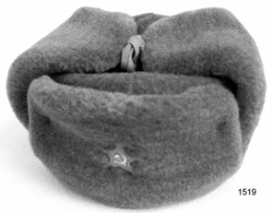
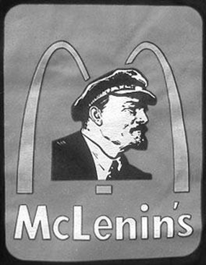
memorabilia. However, had the vendor been selling swastikas and pictures of Adolf Hitler, the western world would have been outraged. I had many similar experiences throughout my journey in Eastern Europe. In the Red Square, in Moscow, for example, there was a man impersonating Vladimir Lenin; people would pay to have their picture taken with him as he threw a red cloth sash around their neck and pretended to induct them into the Soviet Youth. Imagine if there was a man dressed as Adolf Hitler standing next to Brandenburg Gate, “inducting” people into the Nazi Youth; would there be a line of paying customers? Probably not. Applebaum and I are just two of thousands of tourists that vacation in these locations each year, but how many people are aware of what they are supporting when they return home proudly sporting their McLenin tee shirt and hammer and sickle fur hat? It was occurrences such as these that made me realize how unaware much of the Western world is about the horrors that occurred behind the infamous “Iron Curtain.” Years ago, I wrote a paper that involved the United States citizens and their awareness of the Gulag system; I sent out surveys and found that many people had never even heard of the Gulag. To be honest, even as a History major, I knew
Figure 2. Soviet Style Fur Hat
Source: NZ Antique & Historical Arms Association: Wellington Branch (Inc.) http://www.nzaaawgtn.org.nz/images/a09/it09_163.jpg (2012). Accessed March 12, 2012
Figure 1. McLenin Tee Shirt
Source: http://www.russianlegacy.com/catalog/mclenins-restaurants-shirt-pi-552.html?osCsid=706b24d6863ce89cfe366cd42e5bd79e Accessed March 12, 2012.
very little on the subject until I spent time in Eastern Europe. United States history classrooms and the media are chock-full of information pertaining to the Holocaust, but mention of the Gulag is quite rare. For example, when I did an internet search on Google.com and typed in the words “Nazi Holocaust” over 24 million sites were found; doing a similar search on Google, using the words “Soviet Gulag”, only 3 million sites were found. In other words, there are eight times as many sites pertaining to Holocaust than on the Gulag. In no way do I intend to imply that one event was more important than the other; the rational between the Gulag and the Holocaust were very different. “Nazi camps were used to exterminate whole groups of people, most notably the Jewish population of Europe. The GULAG was used as a weapon of ongoing political control over one country.” Nor am I implying that the reader lacks knowledge in either category. I simply present this fact to show the difference in resources available. For this reason, I feel it is necessary to begin with a brief history of the Gulag system.
History of the Gulag System
I mean, the surprise, I suppose, is that there hasn't yet been more interest from the West, and there aren't more Western scholars working on this subject…
-Anne Applebaum

A common misconception when discussing the Soviet Gulag system is the actual meaning of the
word “Gulag.” The term “GULAG” is actually an acronym for Glávnoe upravlénie ispravítelʾno-trudovýkh lageréĭ (Main Directorate of Corrective Labor Camps) . The GULAG was a Soviet bureaucratic institution that “operated the Soviet system of forced labor camps in the Stalin era.” According to Anne Applebaum, “it was, in fact, a very boring bureaucratic institution. But it kept many archives, and it kept track of things, and it attained a kind of Kafkaesque status among prisoners in the camps.” Many authors and historians, including Applebaum, credit Aleksandr I. Solzhenitsyn, author of The Gulag Archipelago, as the person who first used the term “Gulag” to describe the entire system. Because the term “Gulag” is so widely used to describe the Soviet forced labor camps as a whole, it will be used in the same manner throughout this paper.
Another misconception of the forced labor camps is that the system originated in the Soviet Union around 1917. In actuality, such camps existed much earlier in Eastern Europe. In fact, it could be argued that the idea of forced, imprisoned labor could be found throughout the world since the dawn of civilization. When covering the region discussed in this paper, however, similar camps were employed during Tsarist (Czarist) rule of Russia; “forced-labor brigades… operated in Siberia from the seventieth century to the beginning of the twentieth.” In 1917, two major events occurred in Russia: the February revolution and the October Revolution. These two events played a key role in ending the long reign of the Tsarist regime. One of the core leaders of the Revolution, Vladimir Lenin, took control of Russia in 1917, thus began Communist Rule in Russia. Shortly after Lenin took power, the forced labor camps took their “modern and more familiar” form.
Although, Gulags were in use throughout the span of the Soviet Union (Mikhail Gorbachev began the dissolution of the Gulags in the Soviet Union in 1987), this paper will focus on Gulags during the Stalin era due of the mass increase in the amount of camps created during his rule. Figure 3 and figure 4 show the true impact Josef Stalin had on Gulag system.
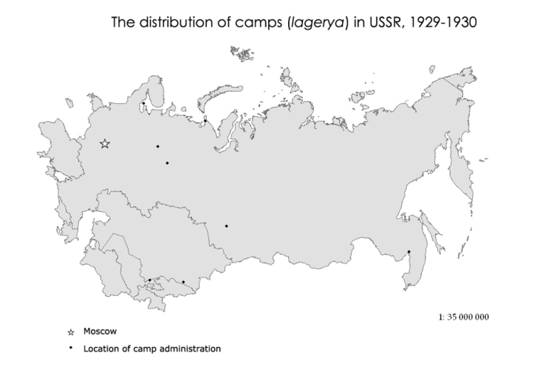
Figure 3. Camp Locations 1929-1930
Source: ESRC, “Prison system from the 1930s to the present," Mapping the Gulag. http:// Source: ESRC - UK Economic and Social Research Center. "Russia's www.gulagmaps.org/maps/map.php?series=1&map=5354 (2010). Accessed February 3, 2012

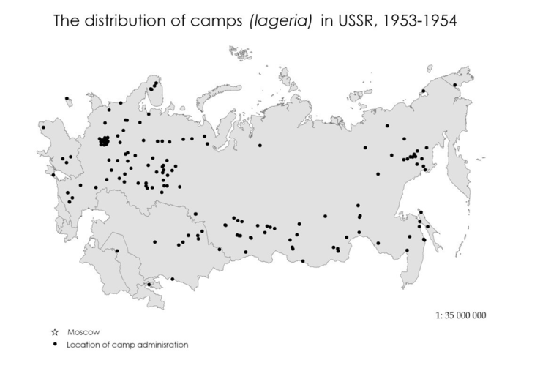
Figure 4. Camp Locations 1953-1954
Source: ESRC, “Prison system from the 1930s to the present," Mapping the Gulag. http:// Source: ESRC - UK Economic and Social Research Center. "Russia's www.gulagmaps.org/maps/map.php?series=1&map=5354 (2010). Accessed February 3, 2012

Stalin had at least two major reasons to employ the Gulag camps in masses. The first is well known; to imprison and “reeducate” the enemies of the Communist state and belief system. It must be noted that the term “enemies of the people” was quite strict and arrests were exercised very liberally. If one even spoke out against the Soviet government or communism in general and it was heard by the wrong ears arrests could be made. For example, “Man sentenced for three years for smiling ‘in sympathy’ while drunken soldiers in a restaurant in Odessa [Ukraine] told anti-Soviet anecdotes.” The second reason was that Stalin wanted to “excavate natural resources” from the Soviet land; included in these locations where the bitter cold lands of Siberia and the surrounding northern areas; all of which were virtually uninhabitable. These reasons, among others, led to the imprisonment of an estimated 28.7 million individuals from 1930 through 1953. Throughout my research I was unable to find a specific number of children that spent time in the Gulag during these years. Most estimates discuss the amount of people sent to the Gulag as a whole, not focusing on age or gender.

Arrest
Those who go to the Archipelago to administer it get there via the training schools of the Ministry of Internal Affairs.
Those who go there to be guards are conscripted via the military conscription centers.
And those who, like you and me, dear reader, go there to die, must get there solely and compulsorily via arrest.
- Aleksandr Solzhenit︠s︡yn

Imagine being in your warm bed in the middle of a cold night; all is calm, everyone is asleep, and your house has the mystical calm of twilight. Suddenly, there is a loud knock on your door. As you begin to open the door, NKVD pushes their way through into your house not even taking the time to wipe the mud from their massive boots. As you are still trying to wake up and comprehend what just happened, the lead officer informs you that you are under arrest for committing an illegal act against the Soviet Union; you are now an enemy of the people. He notifies you that you (and in many cases, the rest of your family) must pack a bag and leave with the NKVD officers immediately; however, the officer refuses to tell you where you are going or when you will return. What should you pack? Family heirlooms and photographs; food; soap; water; clothing? The entire time the NKVD is rushing and interrupting you, saying things like “You don’t need anything. They’ll feed you there. It’s warm there.” You will soon find out these are all lies.
Now, even for an adult, this experience would be beyond terrifying. But take a minute to imagine it from the eyes of a terrified child. Ilmars Salts was only ten years old when he was awoken in the wee hours of the morning on June 14, 1941. His mother told him get dressed and come down stairs with his younger brother, age seven, and his younger sister, who was only two and a half. As Ilmars entered his kitchen he saw his father being interrogated at the table by several men; “another man, holding a rifle with a Russian bayonet, stood near the window… I watched as the intruders emptied the contents of our large wood-and-glass cabinet, which held a collection of silver and tableware that had been accumulated over several generations, including monogrammed children’s christening spoons.” Note how Salts used the word “intruders,” he did not know who these men were or why they were in his house; until that unfortunate morning, he lived the life of a normal, ten year old boy. Official NKVD records state that Alexsandrs Janis Salts, Ilmars father, was arrested for the following reasons:
“-head of the section of aizargi (Guards) – a military Latvian paramilitary organization, from 1935
-the chairman of regional court, from 1934
- active in the Farmers’ Association party
- his father was a former uradnik (village policeman) for the czar.”
The official document also noted that Ilmars’ mother, Olga, was a “dangerous social element.” Ilmar notes that these documents “…-their inaccuracies, not to mention absurdities, aside- were the juridical foundation for my father’s arrest and our family’s deportation. This is just one example of the many reasons one could be arrested. The fact that one of Alexandrs’ “crimes” was being the son of a man who was a village policeman for the czar, an event that happened well over twenty years earlier, shows how vague the reasons for arrest were in many cases. The entire Salts family: mother, father, three children, and paternal grandmother, were deported to a Gulag camp in Siberia. Although this is only one example, the majority of arrests were made in a similar fashion (being awoken in the middle of the night). This tactic was used because it combined the element of surprise and confusion with that of fear. Also, it allowed for the NKVD soldiers to arrest whole families at one time.
Once a child’s parents were arrested they were fated to endure one of four possible lifestyles: being deported with their parents (as was the case for Ilmars Salts); being sent to an orphanage; living homeless on the streets; or in rare cases, the child would be allowed to reside with a family member or friend. Due to the fact that this paper focuses on life within a Gulag, we will focus on those children that were deported with their families.
Transportation
[At] 7 a.m., we were escorted out of our ancestral home…
As the truck pulled away, we must have all been thinking the same thing: Would we ever return to our house? Would we ever again be able to plant our gardens, take care of our animals, or raise our children there?
-Ilmars Salts

Transportation to the Gulag was an extremely long process; after being interrogated and arrested; prisoners were first transported by truck or cattle car. The experiences in the trucks/ cattle cars varied by location; some trucks had long benches for prisoners to sit on and although they were packed tightly they did not have the worst of experiences. Peasants and those being transported during the mass deportations in eastern Poland and the Baltic States, 1939-1941, fared far worse. A Lithuanian prisoner remembers being packed in so tightly in the truck that “the first prisoner spread his legs; the second sat between the first’s legs and spread his own legs – and so on until the truck was full.” Because NKVD officials made many stops to arrest “enemies of the state” these rides could last all day.
After being unloaded from the truck/cattle car, the prisoners were then loaded on to a train. Unfortunately, most families were split up first; usually sending the mother and children in one direction and the father in another. In many cases, when the families were separated they were not told where their other half would be going. For many children, this was the last time they would see their fathers.
The train ride would last anywhere from a few days up to several weeks depending on the prisoners’ final destination. These rides were horrific, to say the least. Much like their first journey on the trucks, the trains were equally crowded. Also, there were not any bathroom facilities; prisoners had to relieve themselves through holes made in the flooring of the train or wait until prison guards decided to stop the train. The lack of proper bathroom facilities led to a mutual embarrassment felt amongst the prisoners; this was another tactic to weaken the mentality of the prisoners. “Yet the real torment was not the crowding or the toilets or the embarrassment, but the lack of food – and especially the lack of water.” Food was only distributed in small amounts and water was so scarce that prisoners would try to catch rain water from the leaks in the train roofs or through the barred windows (that is to say if the train car had windows, many did not). One can imagine that the combination of the crowd, the unsanitary living conditions, and the lack of proper nutrition, would have caused many to perish on these long voyages. Herta Kaļiņina was 16 years old when her family was deported; years later, she commented on the deaths that occurred on the train. “No-one [sic] received any medical help. The dead were buried by the railroad tracks when the train halted. For we were nobody. A name on a list was simply crossed off.”
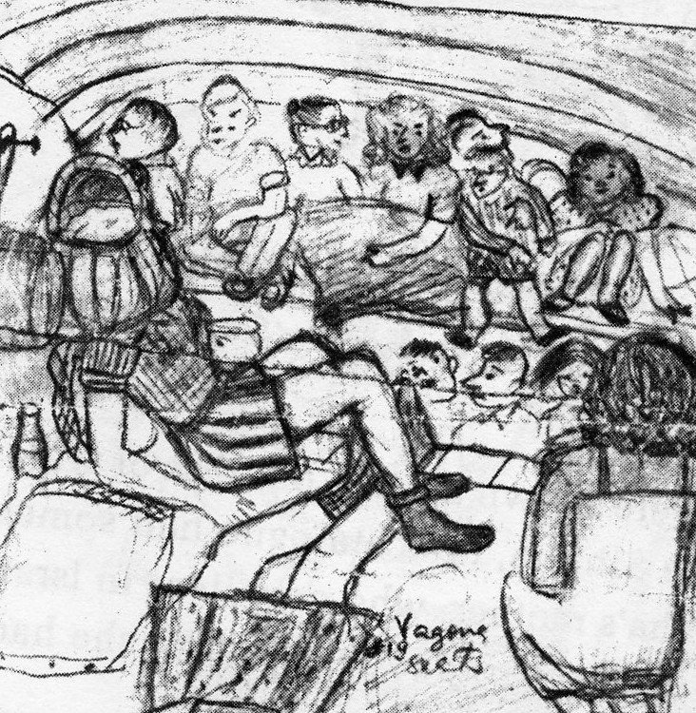
Figure 5. A Drawing of Women and Children on a Deportation Train.
-Drawn by Aina Roze, age 14
Source: Aina Roze, “Sketches on a Train Clattering to Sibera,” in We Sang Through Tears, ed Anda Līce (Rīga: Jānis Roze, 1999), 191.

As previously stated, a prisoner could be on a train from a few days up to several weeks. It was a rare occasion that the train would take deportees directly to their permanent location, where they would spend their entire sentence; much more likely was that they would spend time in at least one (if not several) “transit camps”. Prisoners were unloaded from the trains, reloaded into trucks, driven towards the “transit camps,” unloaded once again and were then forced to march the remainder of the way. In The Gulag Archipelago, Aleksandr Solzhenit︠s︡yn describes the nature of the transit camps:
In memory they all get mixed together because they are so similar: in the illiteracy of their convoys, in their inept roll calls based on case files; the long waiting under the beating sun or autumn drizzle; the still longer body searches that involve undressing completely; their haircuts with unsanitary clippers; their cold, slippery baths; their foul smelling toilets; their damp and moldy corridors; their perpetually crowed, nearly always dark, wet cells; the warmth of human flesh flanking you on the floor or on the board bunks; the bumpy ridges of bunk heads knocked together from boards; the wet, almost liquid bread; the gruel that cooked from what seems to be silage.
After being transferred from one camp to another, prisoners reached the permanent camps. Some prisoners may have spent their entire sentence at one camp; other prisoners were moved to several camps within the Gulag system.
Daily Life in the Gulag
I was then sixteen years old.
In the camps I discovered a ghastly world,
as in the most bloodcurdling circle of
Dante’s inferno.
-Napalys Kitkauskas

The horrors of arrest and transportation to the Gulag are images that most could only dream up in their worst nightmares. Unfortunately, for the “enemies” of the Soviet regime, the real nightmare was just beginning. Up until this point, many similarities can be found between the adult and children experiences; the main difference being how children, versus adults, viewed these events. The similarities are due to the fact that in most cases, adults and children made their journey together. However, once prisoners arrived at the camps, life once again, was turned upside down. We will first look at the similarities within the camps, and then the differences. As seen in Figure 4, there was an abundance of Gulag camps; because the intent of this paper is to analyze the system and lifestyle as a whole, I will not focus on any specific camps. Instead, I will present a general idea of what occurred in most camp situations, based on the research I have uncovered.
The three main things that were present in both children’s and adult’s lives were the living arrangements, the lack of proper nourishment, and the weather. The living arrangements were similar to those on the trains: cold, damp, crowded and unsanitary. “Prisoners typically lived in a camp zone surrounded by a fence or barbed wire, overlooked by armed guards in watch towers.” Lack of proper food and clean water is another unfortunate feature that followed prisoners to the camps. Food rations normally consisted of a small hunk of bread and some type of watery porridge or soup. In the early days of their incarcerations, prisoners may have had additional food that they packed before they were deported. Other ways to get food were to find it in the wild or to barter with locals in the area; exchanging your personal belongings for food. These alternative ways of obtaining food were often risky and short lived; thus, hunger was a dominating feature of someone imprisoned in the Gulag. Also, most camps in the 1930s, 40s, and 50s did not provide plates or utensils for inmates. Rather, they had to rely on items brought from home, found, or obtained in trade. Many camps were located in the Northern regions of Russia; one of the coldest places on Earth. Ilmars Salts recalled that the locals would “gauge the temperature simply by spitting – if their spit froze before hitting the ground, they would say it was about sixty below.” Most of the prisoners did not have clothes appropriate for such weather conditions. Those lucky enough to have useful possessions or warm clothing had to watch them closely so they would not be stolen by others. In times of desperation, common decency and morals are sometimes very hard to find. As mentioned before, there were significant differences in experiences within the Gulags. This portion will focus on three types of children: Infants and toddlers; youth who were imprisoned with their parents; and youth imprisoned in juvenile camps.
The laws governing the process of arresting mothers and children were never completely clear. “The operational order of 1937, which mandated the arrests of wives and children of ‘enemies of the people,’ explicitly forbade the arrest of pregnant women and women nursing babies. A 1940 order, on the other hand, said that children could stay with their mothers for a year and a half, ‘until they cease to need mother’s milk,’ at which point they had to be put in orphanages or given to relatives.” Regardless of the laws which were set forth, many pregnant and nursing women were arrested. However, they were not the only ones who had responsibility over infants; although many camps were normally separated by gender, several female inmates would get impregnated by guards each year. Some of these pregnancies were due to rape, however, there are also memoirs from former prisoners that mention women who got pregnant intentionally in hopes that they would receive better food and less strenuous workloads. Regardless of whether a woman was pregnant before she entered the Gulag, her real torment began once she gave birth.
Women who went into labor in the Gulag were allotted very little recovery time after delivery; Gulag commanders wanted the women back to work as quickly as possible, regardless of the shape they were in mentally or physically. Their children were immediately sent to “nurseries” on the grounds, ran by Gulag officials, who were often called “nurses.” Women were allowed a very short period each day to breast feed their child, other than that, they were not allowed contact with their newborns. Often times, once breast feeding ended, mothers were forbidden to see their child again. Prisoner Hava Volovich was one of the unlucky women to give birth in the Gulag. Her graphic memories of the nursery are as follows:
The nurse brought a steaming bowl of porridge from the kitchen, and portioned it out into separate dishes. She grabbed the nearest baby, forced its arms back, tied them in place with a towel, and began cramming spoonful after spoonful of hot porridge down its throat, not leaving it enough time to swallow. [Volovich also witnessed the nurses waking up the toddlers in the morning]… They would force them out of their cold beds with shoves and kicks… pushing the children with their fists and swearing at them roughly, they took off their night clothes and washed them in ice-cold water. The babies didn’t even dare cry.
The majority of camps had a “nursery” ran by Gulag officials. In camps that did not have a nursery, elderly women were left to watch the infants and young children, however, that did not mean that the children were cared for any better; “these women would calmly help themselves to the food we had left for our children.”
Although there are several similar accounts of this atrocious treatment; Gulag archives painted a different picture of the Gulag nurseries: “The sun shines in their Stalinist fatherland. The nation is filled with love for the leaders and our wonderful children are happy just as the whole young country is happy. Here, in wide warm beds, sleep the new citizens of our country…” The figure 6 and figure 7 show the difference between reality and the widely publicized propaganda found throughout the Soviet Union.
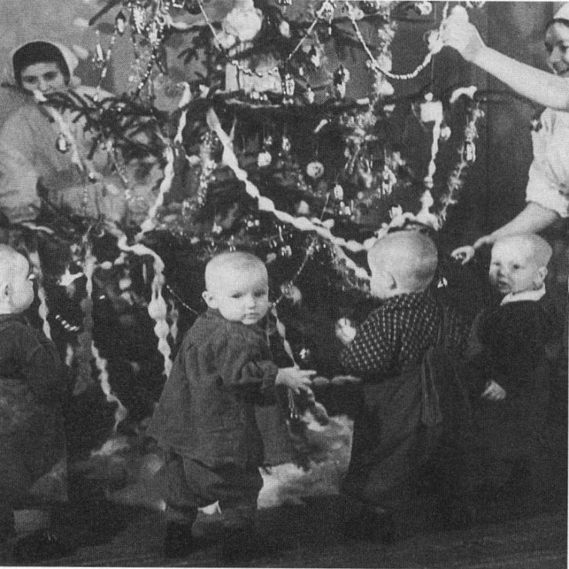
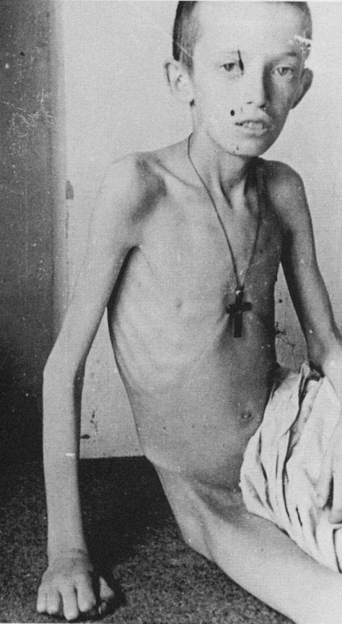

Figure 6. (left) Polish boy, 1941
Figure 7.(above) Camp nursery: decorating a holiday tree
Source: Anne Applebaum, Gulag: A History, (New York: Double Day, 2003)

At the age of two, the majority of children were removed from camp nurseries and sent to state run orphanages. Mothers often had mixed reactions about this. Some mothers believed it was best for their children, hoping that their children would fare better outside of the Gulag gates; other mothers, however, feared that their children would not actually make it to an orphanage, and instead would end up at another camp. Regardless of the feelings of the mother, young children were taken away; their names were often changed; and the chances that they would ever see their birth parents again were slim.
As mentioned earlier, many children were arrested with their families. However, there is a group of children that must not be forgotten when discussing the Gulag; those who were arrested for “crimes” in which they committed themselves. “In 1935, Soviet authorities … passed a notorious law making children as young as twelve liable to be charged as adults.” “Crimes,” under this law, included “stealing a few grains of wheat,” and “children of “enemies” suspected of collaborating with their parents.” Once arrested, these children were sent to juvenile camps. These camps were for youths between the ages of twelve and sixteen years of age; once the prisoner reached seventeen there were usually transferred to an adult camp to finish their sentence. The only persons of adult age in juvenile camps were the guards and other Soviet commanders.
There were many physical similarities between the juvenile camps and the adult camps: the barracks were unsanitary, cold and overcrowded; food and water were equally scarce; and prisoners were treated poorly by guards and, at times, other inmates. In many ways, the experiences of a youth at a juvenile camp and an adult at a main camp were also very similar. Children who were arrested for their own “crimes” were interrogated, arrested and transported in virtually the same manner as adults. Juvenile prisoners were also required to work long hours doing strenuous labor; “One NKVD order of 1940 directed children between the ages of twelve and sixteen to work four –hour days, and to spend a further four hours on school work. The same order required children age sixteen to eighteen to work eight-hour days, with two hours devoted to schoolwork.” As mentioned earlier, one of Stalin’s main interests in the Gulag system was to use the prisoners as slave labor to excavate natural resources. Figure 8 shows the resources harvested from various camps. 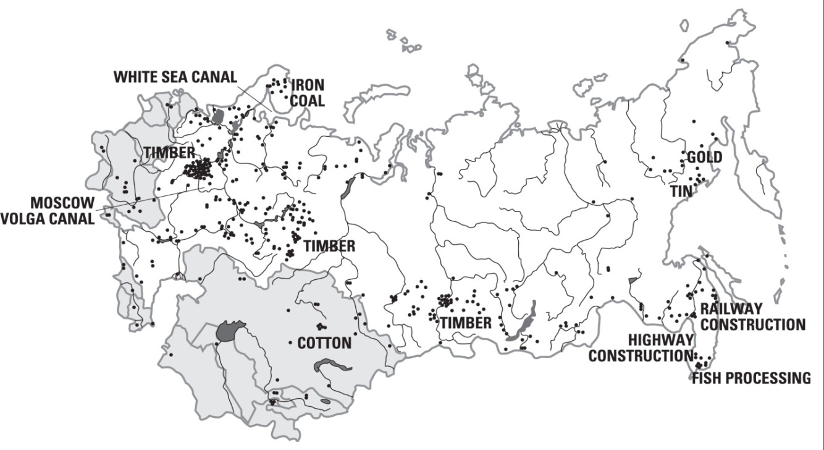
Figure 8. Correlation of Camps and Natural Resources
Source: David Hosford, “Gulag: Soviet Prison Camps and Their Legacy,” 9.

“The GULAG participated in every sector of the Soviet economy, including mining, highway and rail construction, arms and chemical factories, electricity plants, fish canning, airport construction, apartment construction and sewage systems… The GULAG played a central role in the Soviet economy… [it’s] population accounted for one out of every 50 workers in the Soviet Union.” Although this was “free labor” for the Soviet Government, Gulag prisoners never reaped from the benefits; rather they were worked to the verge of death, if not to death itself.
In addition to hard labor, children, both in the juvenile and adult camps, were also required to go to school (provided their camp was large enough to have one). These schools were not like the “typical” school one thinks of; these schools were reformist schools, used to teach youth how to be model Soviet citizens. Schools covered such topics as the Russian language (prisoners were shipped for countries all over the Soviet Union and many did not speak or write Russian fluently, if at all) and propaganda classes where students would learn the Soviet version of history.
One of the significant differences between children in the adult camps and those in the juvenile camps was the adult interactions. In adult camps, children, often times, lived with their mothers and sometimes even grandmothers. In these living situations, most parents worked hard to protect their children, provide for them as best as they could, and attempted to maintain the family values and beliefs. Ilmar Salts, in his memoirs, remembered a time when he and his friends were scolded by their mothers for hanging out and playing instead of collecting wild onions as their mothers asked them too: “…regardless of the jobs that we did and the responsibilities we took on, we were still just boys and sometimes prone to mischief.” Life was still a nightmare in every sense of the word, for these children, although they found opportunities to be “just boys” and girls. Youth imprisoned in juvenile camps did not have such a luxury of having their parents to love them and support them. They were left to their own devices and were prematurely forced into adulthood. The dream for all children in the Gulag, regardless of age, sex or location, was to reenter their countries and home as freed individuals.
Aftermath
Why is it that we see the truth of this affair only now, and why did we not do something earlier, during Stalin's life, in order to prevent the loss of innocent lives?
-Nikita S. Khrushchev

Josef Stalin died on March 5, 1953. In the years following Stalin’s death, Soviet officials found that not only were the Gulags unprofitable, but they also began to realize how inhumane they were. “Just three weeks after Stalin’s death, [Lavrenty] Beria declared a mass amnesty for prisoners with less than five-year sentences, pregnant women, women with children, and all children under eighteen. One million people were released” Resolutions continued to be issued by the Soviet elite. These resolutions included minimizing prison sentences; creating more realistic workloads and schedules; letters were allowed (officially) to pass from one camp to another; and eventually many camps were shut down. In 1956, Nikita S. Khrushchev, First Secretary of the Communist Party of the Soviet Union from 1953-1964, gave a speech to the Twentieth Party Congress of the Communist Party of the Soviet Union on February 25, 1956; this speech is referred to by many historians as “The Secret Speech.” “For the first time, Khrushchev openly attacked Stalin and the ‘cult of personality’ that surrounded him.” This speech, along with the slow dissolution of the Gulags, was all part of a campaign that became known as “De-Stalinization.”
As a result of the “De-Stalinization” process, many prisoners’ cases were reviewed and amnesty was granted; they were finally “free,” but to what avail? Many had been forcibly removed from their homes years before; homes, that many times were not returned to them until many years later. All of their worldly possessions had been destroyed, stolen, sold or traded. Men and women were now widows; many children, orphans. None the less, these “freed” individuals searched, often in vain, for their loved ones. Generally, it was easier to find out what happened to an adult; as mentioned earlier, children who were separated from their parents often underwent a name change. Parents who were lucky enough to find their children in an orphanage, often found that their children were permanently damaged. One mother returned from exile, and was reunited with her young daughter. The child, at the age of eight, could still barely talk, grabbed at food, and behaved like the wild animal that the orphanage had taught her to be.” Another consequence of the orphanage was that the children were “reeducated” to be proper Communists and were taught that their parents were “‘enemies of the people’ who deserved no love and no affection.” Children, who spent time in the camps, were also left with lifelong scars; they were forced to grow up too quickly, without any hope for a “normal” childhood lost forever.
Conclusion
…there's an issue in Russia now about how much you discuss the past. You know, should we apologize for the gulag? Should we think about it? Should we find the people responsible?
-Anne Applebaum

Since the fall of Communism, in 1991, prisoner memoirs have been published; government documents, released; and books that were banned during the Soviet Union are back on the shelves. In 2009, Russian Education Ministry added Aleksandr I. Solzhenitsyn’s The Gulag Archipelago, which was published in 1973 and banned in the Soviet Union, to the list of required reading for Russian high school students. As time passes, information is becoming more widely available, and yet the majority of our nation knows very little on the subject. When Gulags are discussed, it is usually based on the trials and tribulations of adults within the Gulag. The intent of this paper was to bring awareness to the reader about the Gulag as a whole but its true intent was to bring to light the forgotten souls of the Gulag; the children.

Works Cited
Primary Sources
Hetfield, James and Lars Ulrich. The Memory Remains. Performed by Metallica. “Reload”. CD. 1997.
Kaļiņina, Herta. “We Sang Through Tears.” In We Sang Through Tears. Edited by Anda Līce.
Rīga: Jānis Roze, 1999.
Khrushchev, Nikita S.. “The Secret Speech - On the Cult of Personality, 1956.” Congressional
Record: Proceedings and Debates of the 84th Congress, 2nd Session (May 22, 1956-June 11, 1956), C11, Part 7 (June 4, 1956) pp. 9389-9403. Modern History Sourcebook. http://www.fordham.edu/halsall/mod/1956khrushchev-secret1.html (accessed April 18, 2012).
Roze, Aina. “Sketches on a Train Clattering to Sibera.” In We Sang Through Tears. Edited by
Anda Līce (Rīga: Jānis Roze, 1999).
Šalts, Ilmārs. A stolen childhood: five winters in Siberia. Translated by Gunna Dickson. Rīga: SIA
Likten̦stāsti, 2008.
Volovich, Hava. “My Past.” Dodnes Tiagoteet (no year given): 260-64. Quoted in Anne
Applebaum, Gulag: A History (New York: Double Day, 2003), 321.

Secondary Sources
Applebaum, Anne. Gulag: a history. New York: Doubleday, 2003.
Center for History and New Media. "Gulag: Soviet Forced Labor Camps and the Struggle for
Freedom." George Mason University. http://gulaghistory.org/nps/onlineexhibit/stalin/living.php (2006). Accessed February 17, 2012.
ESRC - UK Economic and Social Research Center. "Russia's prison system from the 1930s to the
present." Mapping the Gulag.
http://www.gulagmaps.org/maps/map.php?series=1&map=5354 (2010). Accessed
February 3, 2012.
GARF–State Archive of the Russian Federation, Moscow, quoted in Anne Applebaum, Gulag: A
History. (New York: Double Day, 2003).
"Gulag." Google. http://www.google.com (accessed April 14, 2012).
“Gulag”. Dictionary.com. The American Heritage® New Dictionary of Cultural Literacy, Third
Edition. Houghton Mifflin Company, 2005.
http://dictionary.reference.com/browse/gulag (accessed: April 14, 2012).
Hosford, David, Pamela Kachurin, and Thomas Lamont. “Gulag: Soviet Prison Camps and Their
Legacy. National Resource Center for Russian, East European, and Central Asian Studies;
Harvard University. http://daviscenter.fas.harvard.edu/outreach/gulag.pdf. Accessed
April 15, 2012.
Kitkauskas, Napalys. Amžinojo įšalo žemėje [In the Frozen Land]. Edited by Aldona Žemaitytė,
(1989):202. Quoted in Tomas Balkelis, “Lithuanian Children in the Gulag: Deportations,
Ethnicity and Identity; Memoirs of Children Deportees, 1941-1952.” Lituanus: Lithuanian
Quarterly Journal of Arts and Sciences 51, no. 3 (Fall 2005).
PBS NewsHour. "'Gulag' ." PBS: Public Broadcasting Service.
http://www.pbs.org/newshour/bb/entertainment/july-dec03/gulag_08-12.html (2003).
Accessed March 29, 2012. (Ann Applebaum)
------ "Secret Police." Library of Congress Home. http://www.loc.gov/exhibits/archives/secr.html
(accessed March 15, 2012).
Solzhenit︠s︡yn, Aleksandr Isaevich, and Edward E. Ericson. The Gulag Archipelago, 1918-1956: An
Experiment in Literary Investigation. New York: Harper & Row, 1985.

James Hetfield and Lars Ulrich, The Memory Remains, performed by Metallica, “Reload”, Mercury Records, [CD], 1997.
“The political, military, and ideological barrier erected by the Soviet Union after World War II to seal off itself and its dependent eastern and central European allies from open contact with the West and other noncommunist areas,” Encyclopædia Britannica Online, s. v. "Iron Curtain," http://www.britannica.com/EBchecked/topic/294419/Iron-Curtain (accessed April 19, 2012).
Anne Applebaum, Gulag: A History (New York: Double Day, 2003),xviii.
"Gulag," Google, http://www.google.com [accessed April 14, 2012].
David Hosford, Pamela Kachurin, and Thomas Lamont, “Gulag: Soviet Prison Camps and Their Legacy,” National Resource Center for Russian, East European, and Central Asian Studies; Harvard University, http://daviscenter.fas.harvard.edu/outreach/gulag.pdf, (accessed April 15, 2012), 3.
PBS NewsHour. "'Gulag". PBS: Public Broadcasting Service. http://www.pbs.org/newshour/bb/entertainment/july-dec03/gulag_08-12.html (2003). (Accessed March 29, 2012), (Ann Applebaum)
Gulag, Dictionary.com, The American Heritage® New Dictionary of Cultural Literacy, Third Edition. Houghton Mifflin Company, 2005. http://dictionary.reference.com/browse/gulag (accessed: April 14, 2012).
Center for History and New Media. "Gulag: Soviet Forced Labor Camps and the Struggle for Freedom." Gulag: Many Days, Many Lives. http://gulaghistory.org/nps/reflections/survivors/ (2006). (Accessed March 29, 2012).
“of, relating to, or suggestive of Franz Kafka or his writings; especially : having a nightmarishly complex, bizarre, or illogical quality”; Merriam-Webster Dictionary, s.v. “Kafkaesque”
PBS NewsHour, "'Gulag".
Applebaum, Gulag, xvi.
Hosford, “Gulag,” 6.
Applebaum, Gulag, 579-81.
“Archipelago” is another term that Solzhenit︠s︡yn used to describe Soviet labor prisons.
Aleksandr Isaevich Solzhenit︠s︡yn and Edward E. Ericson, The Gulag Archipelago, 1918-1956: An Experiment in Literary Investigation, (New York: Harper & Row, 1985), 3.
NKVD (Народный комиссариат внутренних дел; People’s Commissariat of Internal Affairs) was the secret police organization ran under Josef Stalin. They were not subject to party control, nor were they restricted by law. “…The NKVD became a direct instrument of Stalin for use against the party and the country during the Great Terror of the 1930s,” and remained in existence until 1954, when the KGB (Комитет государственной безопасности; Committee for State Security), another form of secret police, was established; ------, "Secret Police," Library of Congress, http://www.loc.gov/exhibits/archives/secr.html (accessed March 15, 2012).
Solzhenit︠s︡yn and Ericson, The Gulag Archipelago, 5.
Ilmārs Šalts, A stolen childhood: five winters in Siberia, trans. by Gunna Dickson, (Rīga: SIA Likten̦stāsti,2008), 11-12.
Ibid., 16.
Ibid.
Ilmārs Šalts, A stolen childhood, 13-14.
Applebaum, Gulag, 161.
Applebaum, Gulag, 164-65.
Herta Kaļiņina, “We Sang Through Tears,” in We Sang Through Tears, ed Anda Līce (Rīga: Jānis Roze, 1999), 73.
Applebaum, Gulag, 167.
Solzhenit︠s︡yn and Ericson, The Gulag Archipelago, 533.
Napalys Kitkauskas, Amžinojo įšalo žemėje [In the Frozen Land], ed Aldona Žemaitytė, (1989):202, quoted in Tomas Balkelis, “Lithuanian Children in the Gulag: Deportations, Ethnicity and Identity; Memoirs of Children Deportees, 1941-1952,” Lituanus: Lithuanian Quarterly Journal of Arts and Sciences 51, no. 3 (Fall 2005).
Center for History and New Media, "Gulag: Soviet Forced Labor Camps and the Struggle for Freedom," George Mason University, 2006, http://gulaghistory.org/nps/onlineexhibit/stalin/living.php (accessed February 17, 2012).
Šalts, A stolen childhood, 59-60.
In most cases within the Gulag, children over the age of sixteen were considered adults.
Applebaum, Gulag, 317.
Hava Volovich, “My Past,” Dodnes Tiagoteet (no year given): 260-64 quoted in Anne Applebaum, Gulag: A History (New York: Double Day, 2003), 320.
Ibid.
Ibid., 321.
GARF–State Archive of the Russian Federation, Moscow, quoted in Anne Applebaum, Gulag: A History (New York: Double Day, 2003), 321
Applebaum, Gulag, 324.
Ibid., 327-28.
Ibid. 329-331
Hosford, Kachurin, and Lamont, “Gulag: Soviet Prison Camps and Their Legacy”.
Šalts, A stolen childhood, 71.
Nikita S. Khrushchev, “The Secret Speech - On the Cult of Personality, 1956,” Congressional Record: Proceedings and Debates of the 84th Congress, 2nd Session (May 22, 1956-June 11, 1956), C11, Part 7 (June 4, 1956), pp. 9389-9403.
Lavrenty Beria was a first deputy premier for the Soviet Union in 1953 He was also the head of the NKVD from 1938-1953.
David Hosford, “Gulag: Soviet Prison Camps and Their Legacy,” 33.
Applebaum, Gulag, 508.
Ibid., 327.
PBS NewsHour. "'Gulag". PBS: Public Broadcasting Service.
The Associated Press, "Russian Schools to Teach ‘The Gulag Archipelago’," New York Times, http://www.nytimes.com/2009/09/10/world/europe/10gulag.html?_r=2 (2009) (accessed April 18, 2012).

