Nationalist Theory and Politicization of Archaeological Resources: Manifestations in Iraq

Andrew Vang-Roberts

Vang-Roberts Consulting LLC

Abstract: Archaeological resources have been used by political regimes to further their own interests across time and space for many decades since the discipline was established as a profession in the late 19th century. Regime-backed 20th century dictators like Iraq’s President Saddam Hussein, Iran’s Grand Ayatollah Ruhollah Khomeini, and Egypt’s President Hosni Mubarak understood that whoever controls a nation’s archeological resources controls the nation’s memory. By controlling collective memory, a regime can assert control over its people. Archeological resources can be used to validate a regime’s control over physical space as well. Educating a population about its archeological past can help solidify the legitimacy of a political entity. However, power changes hands, and archaeological resources are not immune to the shifting of power, be it through external conflict, such as an invasion, or internal conflict, such as a revolution. While destruction of sites by military action is obviously destructive, as when overly zealous soldiers fire weapons into or bomb cultural sites intentionally. Archaeological resources are also impacted by changing political agendas. In situations where the ruling party is overthrown and a power vacuum forms, destructive activities such as looting and land development are expanded. This article examines how Iraq’s archeological resources were co-opted and politicized by Saddam Hussein Ba’athist government and how different political, societal, and academic forces interacted with these archaeological resources after the fall of the Ba’athists.
Keywords: Iraq, Saddam, Nationalism, Archeology, Politicization, Middle East

Nationalism and Archaeological Resources

Archaeological resources such as sites, artifacts, and research have been used by different governments in a number of ways historically. These resources have a substantial amount of potential power, allowing whoever controls them to control the collective memory of a people. In many contexts governmental control of archaeology is deeply tied to a nationalism and the ideology of the nation’s controlling regime. Nationalism itself penetrates all aspects of a society, including things buried beneath the earth. The interplay between archaeology and nationalism has been examined by many scholars (Trigger 1984:355-370; Kohl and Fawcett 1989, among others) in an attempt to understand how the two can affect each other. Many nationalist movements are in one way or another reliant on a specific interpretation of archaeological research to validate their existence. There is a difference between national archaeology and nationalist archaeology, however. National archaeology is simply a collection of archaeological evidence from within the geopolitical borders of a particular nation-state, while nationalist archaeology makes use of archaeological data for political ends (Kohl, 1998:223-246). Nationalist archaeology implies the existence of national archaeology, but the reverse is not necessarily the case.

In most cases archaeologists need the support of governments for research funding and legal rights to excavate (Trigger 1984:355-370; Sommer 2017:166-186). Many museums are at least partially funded by governments and as such governments have some sway over how the past is presented in this context as well. For example, the Smithsonian Institution in Washington, DC receives 64% of its funding from the Federal government (Smithsonian Institution 2020). Nationalist and authoritarian regimes will often turn to archaeology for validation in the form of a narrative that gives structure to a nation’s history. In 19th century Europe, the interest in archaeological research was partially influenced by the strong nationalism that characterized the post-Napoleonic era (Trigger 1984:355-370). Social class disparity may have also played a role in cementing the link between nationalism and archaeology. By creating a narrative of national unity archaeologists can distract the population from recognizing class inequality. This type of redirection of energy is an effective tactic used to keep large populations focused, comparable to the way contemporary US political factions will use a perceived common foe to attract followers that would normally be at odds.

Archaeology as National Prestige

National prestige is a powerful driving force behind governmental control of archaeology. Modern day Egypt provides an excellent example of a government using its archaeological resources to bolster national prestige. This practice dates back to 19th century European imperialism, as a result of which French and English colonial forces gathered ancient works of art from all around the world and filled their respective national museums with them in an attempt to highlight the dominance of their modern states. The main motivation was not to research these ancient cultures or to try to rewrite their national historic narratives; rather the seizing of archaeological resources was an attempt to validate the current power of their modern states. However, over time this practice evolved into a cultural inheritance mindset through which various European nations attempted to represent themselves as the inheritors of ancient cultures such as Egypt or Rome. France, Germany, and England funded major archaeological expeditions around the world but focused heavily on North Africa and the Middle East. The character of these expeditions was extremely competitive, with each team believing that their national pride was at stake if they did not gather up as much archaeological material as possible (Kohl 1998:223-246).

This interest in acquiring archaeological remains from distant lands meant that many prehistoric European sites were completely ignored. In late 19th century Germany for example an emphasis on Mesopotamian and Hellenistic Greek archaeology meant that the archaeological sites located within the borders of Germany were largely ignored from a research standpoint but were subjected to looting by local antiquarians. Consequently, the national archaeology of Germany was mostly untouched in terms of research, until after the First World War. With the German economy in ruins, overseas work was more difficult so sites closer to home became more enticing. This coupled with the rise of National Socialism and its nativist and racist approach to prehistoric archaeology led to more sites within Germany being studied (Arnold 1990:464-478; Arnold 2006:8-31). Unfortunately for scholarship at the time, these studies were so deeply intertwined with the destructive ideological program of the Nazi regime that the interpretation of data gathered at these sites was politically compromised. In these Nazi era projects, archaeological evidence of social hierarchy in ancient cultures was often ignored in favor of a racial hierarchal narrative, intent on proving the superiority of the Germanic people (Arnold 2006:3-31). Classical Near Eastern civilizations were viewed by some elements in the Nazi government as tainted due to their proximity to “racially inferior” multicultural groups (Arnold 2006:8-31). Nazi Germany was not attempting to represent itself as an inheritor of classical empires (as Mussolini did in Italy,) it was attempting to increase its national prestige via displays of other cultures to highlight its own perceived superiority. The fusion of national archaeology and nationalist archaeology is clearly visible in Nazi Germany and serves as a warning of the dangers of this combination.

Archaeology and National Identity

Archaeology can be used as a tool to identify a national or cultural origin point which can in turn support a nationalist regime. Most national bodies claim to have an identified origin, or a critical moment when a group of past peoples suddenly becomes a new people. This is similar to how some modern Americans view the US War of Independence as a shift from being British colonial subjects to a new, uniquely American identity. A nation will often trace its history back to a specific moment like a battle, revolution or declaration, and every historical event that comes after is treated as historical property of that nation. The further back in time a nation can trace its roots, the more validity its sovereign and controlling regime can lay claim to. The Chinese government has worked extensively to self-validate its power through this process (Friedman 1994:67-91; Sommer 2017:166-186; Trigger 1984:355-370), for example. This perceived national unity and validity may result in the misrepresentation of archaeological remains as being related to the contemporary group in power.

The discovery of a previously unidentified archaeological phenomenon can result in a national label being assigned to it. The lake dwelling sites in Switzerland are a good example of conveniently connecting national identity to archaeological sites. Being geographically situated between Germany, Austria, Italy, and France, Switzerland has been influenced by the cultures of all the nations that surround it (Sommer 2017:166-186). This influence from multiple vectors is one reason that the Swiss lacked a single national origin narrative and were characterized by a certain degree of disunity. The discovery of the Neolithic and Bronze Age lake dwelling sites in the second half of the 19th century was seen as uniquely Swiss (although in fact such sites are found as far east as Slovenia), and the government immediately coopted them as a national symbol (Sommer 2017:166-186). The appropriation of the lake dwellers as a proto-Swiss group filled the void the Swiss felt as a nation.

Archaeology and National Unity

When national unity is weakly developed in a country, archaeological resources can be used as a morale booster. In post-WWII Denmark, for example, a renewed interest in the Viking era was effectively used to create a sense of national unity (Trigger 1984:355-370) by emphasizing distinctions between the people of Denmark and the other northern European countries. This type of reasoning often assumes that the modern people of a nation-state are ethnically the same as the past inhabitants. In Denmark this was combined with the archaeologically-based Three Age System to claim that modern Danes were the same as the people living in the area during the Iron, Bronze, and Stone Ages (Trigger 1984:355-370). Both Mexico and China have also traditionally emphasized archaeological research as a means to create a national unity, Mexico with an emphasis on Mayan and Aztec sites and China with an emphasis on the Han Chinese culture (Trigger 1984:355-370; Friedman 1994:67-91). Responsible use of archaeology and nationalism does not inherently distort factors such as race, language, and culture (Kohl and Fawcett 1989). However, the ways that Viking Age archaeology or Han-centric Chinese archaeology have been used to support modern national identity would not be considered responsible based on the way Kohl and Fawcett (1989) describe responsible national archaeology. In both of these cases, governments have deliberately skewed the interpretation and representation of the evidence for different ethnic, linguistic, and cultural groups in hopes of creating a more glorified version of their history. In the case of Denmark, the emphasis was on the superiority of the ancient Danes as exemplified by the fact that they were never conquered by the Romans (Trigger 1984:358). This is also an irresponsible use of nationalist archaeology, as it implies cultural superiority over other groups (Kohl and Fawcett 1989). The Third Reich was infamous for using archaeology (Arnold 1990:464-78), biological anthropology (Schafft 2004), and ethnography (Lixfeld 1994) to try to validate the supposed superiority of their ancestors along with the presumed genetic purity of these ancient peoples.

Cultural and Historical Revision

Occasionally nationalism and archaeology are used by governments in an attempt to rewrite the cultural history of a people or region. In such cases a group in power will attempt to resurrect past cultural traditions and link these to a specific group in the present, regardless of whether the group being resurrected is related to them at all. When Yugoslavia changed its name to the Yugoslav Socialist Republic of Macedonia, the Yugoslavians were attempting to make two separate claims about their ties to the ancient past. First, they were attempting to de-emphasize their Slavic heritage by focusing on the ancient kingdom of Macedonia (Silberman 1989). This use of a single cultural designation ignores over two thousand years of history and cultural change that occurred between the height of Alexander’s kingdom and the dissolution of the USSR. Second, by connecting itself to Macedonia, Yugoslav nationalists were attempting to strengthen their ties to classical Greece (Silberman 1989). This is also problematic as the Macedonians were not viewed as Greek by the ancient city states and it is only recently that Macedonia has been associated with Greek culture and vice versa. The approach taken by Yugoslavia is a perfect example of the use of archaeology to cherry pick which parts of history should be considered representative of a nation.

Archaeology as Justification for Hostile Action

Regimes have also used archaeological resources to justify intrusions or hostile actions (Trigger 1984:355-370). Modern day Israel uses a combination of archaeology, history, and Biblical studies to justify its existence as a nation as well as its territorial expansion (Feige 2008:243-258). While Biblical era studies are emphasized in Israeli archaeology, prehistoric archaeology is often overlooked (Trigger 1984:355-370). This highlights another common characteristic of nationalist archaeology in which a specific time period or cultural group receives more emphasis. This is also demonstrated in Egypt, where the emphasis traditionally has been placed on ancient Egyptian civilizations, while other periods and groups receive little attention or are completely ignored (Trigger 1984:355-370). During times of national emergency Egypt has put additional emphasis on the pharaonic period, and deemphasized other periods of Egyptian archaeology (Silberman 1989). This includes the adoption of ancient symbols by government agencies during the governments of Gamal Abdel Nasser (1918-1970) and Anwar Sadat (1918-1981) (Silberman 1989). This type of adoption can be also seen in the National Socialist German government’s emphasis on using parts of the runic alphabet to create a connection to their perceived Germanic past. Possibly the most infamous example of Nazi use of ancient symbology is the appropriation of the swastika, a generic Indi-European sun symbol used in many cultures, or the use of the sowlio (ᛋ) rune by the SS organization and the Waffen SS, its paramilitary arm (Window 1982). Regimes that attempt to control archaeological research for their own purposes have a tendency to suppress knowledge that goes against their doctrines or that challenge the archaeological institutions they have already created. For example, S. N. Bykovski (1896-1936) and V. B. Aptekar (1899-1937), two Soviet archaeologists, were executed for challenging the established archaeological narrative of the ethnic superiority of the Russian people (Shnirelman 1996:130). Executing scholars whose ideas do not support the regime is an extreme example of how nationalist archaeology protects itself but other methods such as ostracization or defunding research that challenges the dominant narrative are more commonly used and also quite effective.

When looking at how regimes and governments use archaeology it is important to ask, “Who physically controls archaeological research and materials?” Nationalist movements will often appropriate histories and symbols. This is not cultural appropriation, but rather temporal appropriation, in the sense that a particular time period is used by descendant communities to promote a particular agenda in the present. Regimes not only engage its temporal appropriation but more subtly they can also appropriate research results. During the Pacific War of 1879, for example, Chile annexed portions of Peru. Along with the capture of strategic territory and resources, Chile also captured the archaeology of the region (Gänger 2009:691-714). They did this by seizing primary source material from Peru and all the research that went along with it. This allowed Chile to become an archaeological authority on ancient Peruvian sites and materials virtually overnight. The intellectual prestige of Chile increased with all this acquired source material and items of archaeological importance became intertwined with a nationalist movement. To maintain this prestige the Chilean government sent two major archaeological expeditions into the newly annexed territory to build on the coopted work of the Peruvian archaeologists (Gänger 2009:691-714). The annexation of territory and archaeological remains allowed early 20th century Chile to redefine itself as a scientific authority via a fusion of nationalism and archaeology.

In summary, political systems interact with archaeological resources in four primary ways: misrepresentation; cooption; annexation; and seizure. Misrepresentation occurs when a political body misrepresents an archaeological resource to change or influence public perception, as is seen in Nazi Germany, modern day Israel, and China. Cooption is when a national entity decides to use an archaeological resource to further its own political goals by attempting to show a linkage between the national entity and the resource, as demonstrated by Chinese and Israeli archaeology. Annexation takes place when knowledge and resources are controlled as part of a larger gambit, for example European colonial archaeology, which revolved around archaeological resources as a means of justifying the annexation of territory. Seizure is when a national entity takes over a resource for its own benefit, as seen when Chile annexed portions of Peru during the Pacific War of 1879. The nation of Iraq has experienced all of these forms of archaeological politicization over the course of its history. The following section will address the way that the government of Iraq used archaeology during the regime changes in the second half of the 20th century and early 21st century.

The Use of Archaeology in Transitions of Power in Iraq

Iraq’s archaeological resources have been influenced by both nationalist and national archaeology. How Iraq’s successive regimes have used and interacted with its archaeological past varies deeply over the course of its history. Ba’athist Iraq and Saddam Hussein used archaeology differently than the post-invasion government and ISIS/ISIL, for example. Archaeological studies in Iraq were initiated by colonial European nations such as France, England, and Germany. Archaeological research was almost completely in the hands of white Europeans and Iraqis themselves often had no idea what was being excavated or why (Good 2007). Due to the Mandate for Iraq and the installation of the Hashemite monarchy, British archaeologists had exceptional access to Iraq beginning in the second half of the 19th century and most early archaeological research in the region was conducted by the British under the auspices of the Hashemite government, neither of which was representative of the majority population.

Archaeology and Nationalism in Ba’athist Iraq

In the early 1970s the Ba’athist national reforms created an economically and culturally independent Iraq that enabled more Iraqi archaeologists to receive funding for projects within the country. Although Iraq has more than 6,000 years of archaeological heritage, the Ba’athist regime emphasized Mesopotamian civilization over all others. This may be because the former colonizers placed so much emphasis on it in their research that Iraqi archaeologists expanded on the existing data in much the same ways as the Chilean government did after the annexation of portions of Peru. During the reign of Saddam Hussein, the archaeology of Iraq went through a further transformation and was fused to his nationalist view of a powerful modern Iraqi nation-state, creating a Saddamist archaeological tradition. Saddam focused on Babylon specifically, and funded excavations and restorations of various ziggurats and sites using government resources. These restorations were part of a national strategy to create a unified “Babylonian” identity in Iraq, comparable to the Macedonian identity featured in Yugoslavian archaeological attempts to appropriate that aspect of the region’s past. The plan was to create a system of well-funded, restored, protected and accessible sites that could be visited by the Iraqi public. These efforts were a major part of Saddam’s 1970s literacy campaign to create a standard education system in Iraq. At these restored sites, Iraqis could explore reconstructed buildings, see artifacts, shop, eat, and learn about the Ba’athists national narrative of the country. Saddam made sure to have his name prominently inscribed on the bricks at his reconstructed Babylon as King Nebuchadnezzar had done before him (Figure 1) (De Cesari 2015:22-26; Amin 2019).

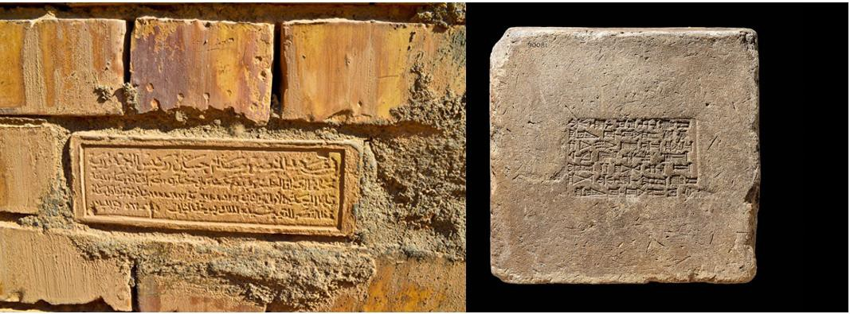

Figure 1: (Left) Brick at Babylon inscribed to commemorate Saddam’s reconstruction of the wall mimicking Nebuchadnezzar. Photo by Osama Shukir Muhammed Amin (http://www.ancient.eu/image/9875/saddam-hussein-plaque-in-babylon/). (Right) An Original Nebuchadnezzar brick from 6th-7th c BCE Babylon. (http://britishmuseum.withgoogle.com/object/a-building-block-from-babel).

In Saddam’s reconstruction of the temple of Nebuchadnezzar, he referred to himself as the son of Nebuchadnezzar and as the force that would glorify Babylon (Amin 2019). This was part of the campaign to pander to his personal ego and his need to effectively indoctrinate the populace to validate his regime’s rule. In fact, Saddam’s personality cult did as much as possible to present the leader as a Babylonian hero, with art, merchandise, and even coinage being produced to underline this connection with the ancient past (Figure 2). The Iran-Iraq war slowed down this production and reconstruction mentality, but projects continued throughout the 1980s regardless of resource constraints, as the Ba’athists felt these were high priority endeavors.

Figure 2: Commemorative coinage depicting Saddam and Nebuchadnezzar from 1987 (http://www.researchgate.net/publication/285573015_POST-COLONIAL_RUINS_Archaeologists_of_political_violence_and_IS).

This attempt to engage in temporal appropriation of Babylonian culture did not end with the cooption of archaeological sites; even the military and infrastructure of Saddam’s Iraq emulated this heritage. Weapon systems were renamed to elicit Babylonian symbology, such as the ubiquitous soviet T-72 battle tank, which in Iraqi service
was slightly modified for desert use and nicknamed the ‘Lion of Babylon’ (Cordesman 2003:481-616). This adoption of symbols associated with the archaeological part is not unlike the uses of runes on Nazi uniforms and some German systems during WWII. Public architecture was also redesigned to emulate perceived Babylonian styles, as can be seen in the Babylon Oberoi Hotel (aka the Babylon Rotunda Baghdad Hotel) and several other buildings in Baghdad, including multiple half-scale Ishtar gate reconstructions at the entrances of public buildings and spaces (Figures 3 and 4). These building projects were halted during the latter half of the Iran-Iraq war, resulting in unfinished structures.

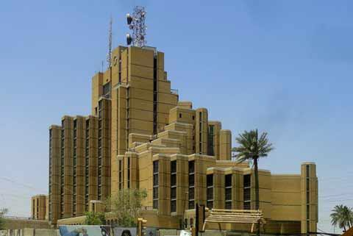

Figure 3: The Babylon Oberoi Hotel. Image from Building the Non-Aligned Babel: Babylon Hotel in Baghdad and Mobile Design in the Global Cold War (Kulić 2015:Fig. 12). (http://journals.openedition.org/abe/docannexe/image/924/img-12.jpg).

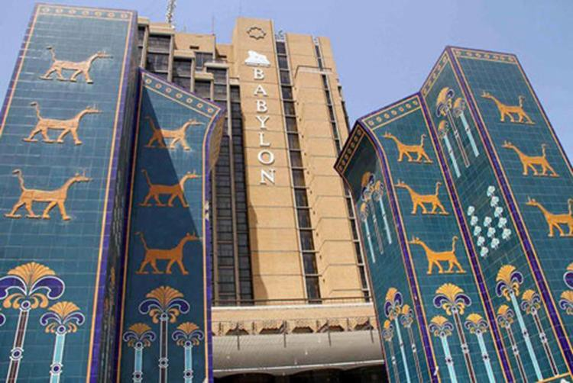

Figure 4: Stylized Ishtar gate entrance Baghdad. Image from Building the Non-Aligned Babel: Babylon Hotel in Baghdad and Mobile Design in the Global Cold War, In abe Journal (Kulić 2015:Fig. 2) (http://journals.openedition.org/abe/docannexe/image/924/img-2.jpg).

Archaeological Resources and Looting During Iraq’s Destabilization

Protections for archaeological sites and government oversight were strong during most of Saddam Hussein’s rule. Sites were well maintained and guarded; looters were punished as capital offenders for daring to plunder Iraq’s national property. However, after the Persian Gulf War and subsequent unrest in Iraq, looting began to increase as Saddam’s government was in disarray and its military forces had either deserted or were severely underfunded throughout the mid-1990s (Brodie 2011:117-133).

Although looting was a constant occurrence, analysis of auction market lots of artifacts from Iraq spiked during times of civil unrest such as after the Iran-Iraq war, the Gulf war, and the War on Terror (Figure 5). The lack of lots seen directly after 2003 can be attributed to the stolen items being too “hot” to sell, due to media attention and the work of Interpol and various academic institutions’ efforts to bring awareness to the issue. Furthermore, the use of the term “Iraq” by online retailers rapidly decreased in the post-invasion market and was replaced with the term “Mesopotamian” (Brodie 2011:117-133). This indicates that those engaged in the antiquities market were very much aware of the potential that these items were in fact stolen. Loosely defining where these items came from protected both the seller and buyer. While Iraq is a specific geographical location and political entity, Mesopotamia is not an entity that maps onto any modern geopolitical environment. This allows sellers to avoid losing clientele while circumventing local legislation that regulates trade in stolen antiquities.

Awareness of this potential can in some cases be attractive to prospective buyers motivated by risk as well as a sense that the buyer is “saving” the object (Yates and Smith 2019:385-392). Online retailers also stopped presenting their full stock of Mesopotamian artifacts but allowed prospective clients to inquire about non-displayed items, in some cases going so far as to openly state that the buyers should reach out to them privately “off-list” (Brodie 2011:117-133). Clients ranged from individuals to large organizations; a good example of the latter is Hobby Lobby’s purchase of 5548 artifacts. Beyond just acquiring artifacts to donate to the Museum of the Bible, Hobby Lobby used the donation of these artifacts to receive federal tax breaks (Brodie 2020:87-109). Although the number of lots of Mesopotamian goods on the market appears to decrease between 2003 and 2008, it is likely that substantially more antiquities from the region were being sold than were reported when the amount of money changing hands is considered (Brodie 2011:117-133). An increase in the sale of very rare and unique items such as Sin-iddinam barrels after 2003 indicates a substantial unreported antiquities market developed under cover of the chaos of Iraq’s transition of power (Brodie 2011:117-133).

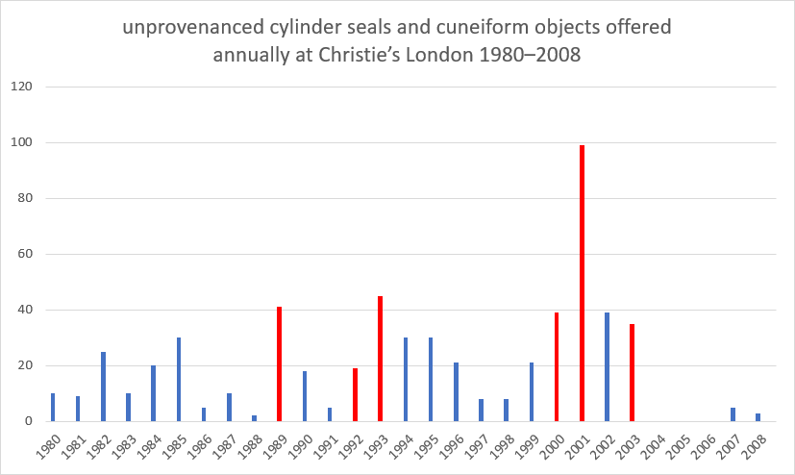

Figure 5: Number of lots of unprovenanced cylinder seals and cuneiform objects offered annually at Christie’s of London from 1980 to 2008. Years of civil unrest in Iraq during which sites had less state protection are marked in red (emphasis by author). The years 2004-2006 have no reliable data, although looting and sales undoubtedly took place (Brodie 2011:7.1)

Looting and Destruction after 2003

Shortly after the 2003 invasion an effort was made by the University of Chicago’s Oriental Institute to track damages to archaeological sites using aerial and satellite imagery. This method was found to be very effective at identifying looting and other site preservation issues. Overflights were conducted by the Italian Carabinieri with academic support from McGuire Gibson and John M. Russel using helicopters as early as May 2003. These initial observations provided the first photographic evidence of mass looting at large sites across southern Iraq, but due to the limits of time, safety, and geographical scale, these flyover surveys could not effectively observe small to medium sized sites. Early satellite images confirmed previously unverified reports that mass looting had occurred at small to medium sized sites as well, providing a way for archaeologists to examine large tracts of land and avoid the limits of direct aerial observation. Based on images obtained between 2003 and 2006 it was determined that looting took place near towns but just far enough on the outskirts of sites so that it would go more or less unnoticed (Stone 2008:125-138). This indicates that the looters needed to be near resources and were not equipped for prolonged field operations. It was also found that the majority of sites looted were from the third millennium BCE (Stone 2008:125-138), which indicates that the looters had targeted them for artifacts with particular market value. The looters also may have targeted such sites specifically because the Ba’athist regime had put such an emphasis on that time period. The looters would have been very familiar with this time period and the market value of such items after years of Ba’athist indoctrination.

Not all of the destruction has been caused by looting. During the 2003 invasion many archaeological sites fell into ruin or were destroyed by over-zealous weapons fire. For example, just outside of the town of Najaf, the restored ruins of several Babylonian structures were destroyed in an attempt to make room for helicopters until community members and professors from the local university pleaded with US troops to stop. With the disbanding of Iraqi military and police forces, the nation’s museums were looted, and countless artifacts made their way onto the black market (Poole 2008). Iraqi archaeology fell into disarray as museums that house archaeological collections were unable to confirm what they did and did not have. The Baghdad Museum lost over 15,000 artifacts to looting (Bogdanos 2005:477-526); the identity of these looters is still veiled by the fog of war and was not limited to the Baghdad Museum. Corruption ran rampant within the destabilized regime and some artifacts were found, lost, and found again many times over. This represented a change from the limited looting of pre-invasion Iraq, illustrating the chaotic nature of Iraqi archaeology under the transitional government. Archaeological sites were left unprotected, and looters dug pits and toppled standing structures in an attempt to find things to sell. Due to Coalition Provisional Authority Order 2 (Figure 6) (one of a series of orders used by the CPA to restructure Iraq), members of the former regime were not permitted to participate in the transitional government. This added to the problem as many archaeologists and academics were members of the former regime, creating an archaeological power vacuum in the country and destabilizing the archaeological community within Iraq. The same thing had happened in Iran after the Revolution (1979) when former regime members were removed from academic posts as part of a campaign to reject the previous government’s interest in pre-Islamic archaeology. Tehran’s Department of Archaeology was closed in 1979 and didn’t fully resume activities until 1990 (Abdi 2001:51-76).

Preservation of Governmental Transition

Work to preserve archaeological resources was conducted on a local scale in different Iraqi cities, such as Baghdad, Najaf, and Mosul. Grand Ayatollah Ali al-Sistani was instrumental in stopping large scale looting operations and worked with Italian and US troops to establish patrols near archaeological sites (Lawler 2008:321-329). The US military (particularly US Army Civil Affairs) also carried out several programs intended to educate US troops on protecting archaeological resources in country. These stopgap measures had a limited effect and did not create a system of protections like those established by the prior regime. The chaos of war gutted institutional oversight of Iraqi archaeology and transitional government attempts to regulate the situation were futile at best (Figure 7) (Adams 2001:13). Under the transitional government, some research conducted during the coalition occupation of Iraq was by private individuals from the US and UK, similar to archaeological projects at the beginning of the 20th century (Adams 2001:13).

The chaos of Iraq’s transitional government destabilized the protection of archaeological sites to such an extent that in some cases lawmakers arrested lawmakers. Abdel-Amir Hamdani, the Director of Antiquities in the Nasiriveh regions of Iraq, was arrested by the Iraqi government for attempting to enforce protection of archaeological sites when he stopped the building of several economically important factories (Lawler 2008:321-329). In addition, the Iraqi government had to break its own heritage protection laws in order to keep its population alive. In several cases large mounds were destroyed to make way for emergency agricultural projects (Gibson 2003:1848). This is in sharp contrast to the Ba’athist regime’s treatment of archaeological sites and shows that the post-Saddam government views its archaeological resources as expendable and secondary to other priorities, including development.

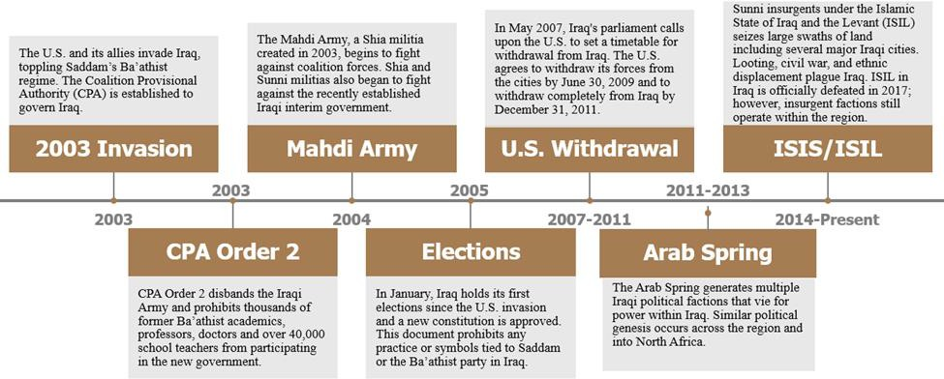

Figure 6: Timeline of Iraqi Political events from 2003 to the present.

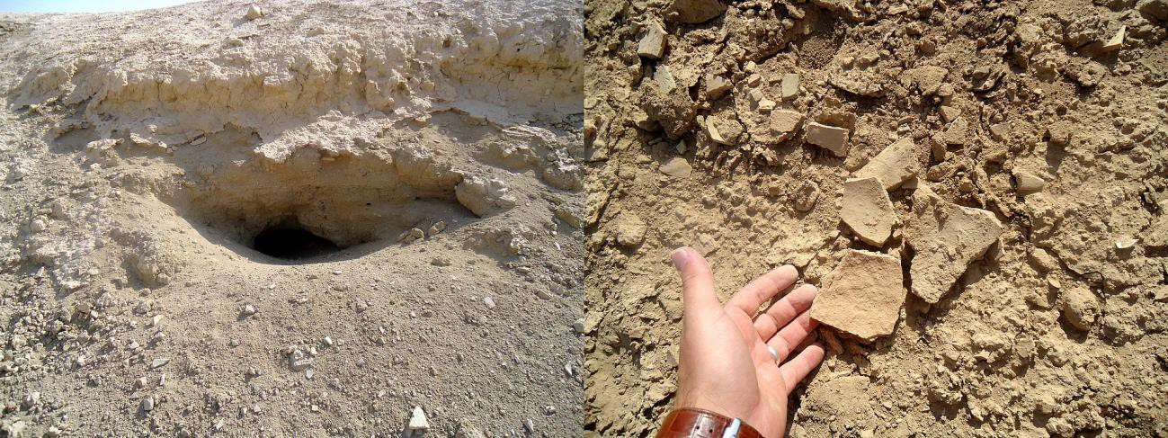

Figure 7: Looter’s Pit and Pot Sherds on the surface at the site of Kish. (http://en.wikipedia.org/wiki/Archaeological_looting_in_Iraq#/media/File:A_looter’s_pit(left)_at_the_ancient_Sumerian_city_of_Kish,_Iraq._Fragments_of_pottery_(right)_are_scattered_near_the_pit.jpg.)

ISIS/ISIL in Iraq

After US and coalition troops withdrew from Iraq, a power vacuum opened up that led to the rise of ISIS. This organization weaponized the destruction of Iraqi national archaeology in two ways. First, it destroyed or sold any pre-Islamic artifacts that it could, a reversal of the Ba’athists’ over-emphasis on pre-Islamic archaeology (Harmanşah 2015:170-177). This tactic was successful in destroying a unified Iraqi identity, which might have been fostered by
pre-Islamic artifacts. The second objective was to punish Western powers for their interference in Iraq. The more attention Western scholars paid to the destruction of sites and artifacts by ISIS, the more destruction occurred (Harmanşah 2015:170-177; Arnold 2014:2441-2448). While ISIS/ISIL was never the official government of Iraq, they did operate as a government in the areas they captured and as such, they demonstrate another regime’s treatment of archeological resources in the region. Regions governed by ISIS/ISIL were subject to the organization’s objections to idolatry, and as such pre-Islamic archaeological resources that could be defined as idolatry – including most figural representations – were subject to ISIS/ISIL’s destructive wrath. Members of ISIS/ISIL hailed from over 85 countries and represented multiple ethnicities. Many of these individuals have little or no connection to Iraq’s archaeological past and would not be disturbed by destroying these resources.

Conclusion

When considering how Iraq’s archaeological resources were treated by incoming governments compared to previous regimes, several trends emerge. First, Saddam’s Iraq venerated archaeological resources for their power to influence and control people rather than purely out of intellectual curiosity. Archaeological evidence in Saddam’s Iraq was in some cases treated as a national resource to be exploited, similar to Iraq’s oil reserves. Saddam’s government relied on selective exploitation of the archaeological record, a system in which cultural resources with little political power are ignored in favor of resources that can be exploited (Arnold 1999:1-4). This process can be likened to mining the past for valuable bits of knowledge while discarding the rest. Secondly, the transitional government of Iraq had other more urgent priorities than nationalizing archaeological resources. This, coupled with the rejection of Ba’athist policies and symbolism (as seen in the Constitution of Iraq), may have led to a general disinterest in archaeology for the transitional government. This is not to say that there were no concerted efforts in some departments of government to protect these resources, but that, as a whole archaeological resources were not valued as they had been before. Third, ISIS/ISIL’s destruction or archaeological heritage is a counter-institutional revolt that uses attacks on cultural patrimony as a medium through which to send a message to the West, a process also seen during Roman expansion into Europe (Arnold and Fernandez-Götz 2020:1-19). Although some members of ISIS/ISIL were former Ba’athist party members under Saddam, their willingness to completely reject these resources indicates that they are party motivated by anarchist impulses to simply burn everything to the ground and start anew. This contrasts with Saddam’s approach of “we need to take care of this” and the transitional government’s “we’ll get to it later” approach and instead asks “Why get to it at all?”. In addition, the prevalence of iconoclastic attitudes among members of ISIS/ISIL also fueled this destruction. In Islam, iconoclasm is not a general belief but rather a specific theological attitude held by some toward artistic representation. Contemporary iconoclastic attitudes are not only displayed by ISIS/ISIL but also in destruction of Sufi shrines in Mali during the Tuareg rebellion (Tharoor 2012) and the destruction of Buddhas in Afghanistan (Arnold 2014:2441-2448; Rathje 2001). These three contrasting approaches to archaeological resources provide us with a window into what is happening on the ground with Iraqi archaeology and allows us to peer into the mentality of these regimes through political and strategic lenses at the same time (Vang-Roberts 2021:86). Furthermore, it allows us to see the potential impacts of the politicization of cultural resources in future conflicts.

References

Abdi, Kamyar.
2001. “Nationalism, Politics, and the Development of Archaeology in Iran.” American Journal of Archaeology 105(1): 51-76.

Adams, Robert McC.
2001. “Iraq’s Cultural Heritage: Collateral Damage.” Science 293(5527): 13.

Amin, Osama Shukir Muhammed.
2021. “Saddam Hussein Plaque in Babylon.” Accessed August 29, 2021. https://www.ancient.eu/image/9875/ saddam-hussein-plaque-in-babylon/.

Arnold, Bettina.
2014. “Erasure of the Past.” In Encyclopedia of Global Archaeology, edited by Claire Smith, 2441-2448. New York: Springer.

Arnold Bettina
2006. “Ariedämmerung: Race and Archaeology in Nazi Germany.” World Archaeology 38(1):3-31.

Arnold Bettina
1999. “The Contested Past.” Anthropology Today 15(4):1-4.

Arnold Bettina
1990. “The Past as Propaganda: Totalitarian Archaeology in Nazi Germany.” Antiquity 64:464-78.

Arnold, Bettina and Fernández-Götz, Manuel
2020. “Internal Conflict in Iron Age Europe: Methodological Challenges and Possible Scenarios.” World Archaeology 51(1):1-19.

Bogdanos, Matthew.
2005. “The Causalities of War: The Truth About the Iraq Museum.” American Journal of Archaeology 109(3): 477-526.

Brodie, Neil.
2011. “The Market in Iraqi Antiquities 1980-2009 and Academic Involvement in the Marketing Process.” In Crime in the Art and Antiquities World: Illegal Trafficking in Cultural Property, edited by Stefano Manacorda and Duncan Chappell, 117-133. New York: Springer.

Cesari, Chiara De.
2015. “Post-Colonial Ruins: Archaeologies of Political Violence and IS.” Anthropology Today 31(6): 22-26.

Cordesman, Anthony H.
1994. “Offensive Air Power, Strategic Bombing and Preparation for the Ground Offensive.” In GW-7 Air Offensive, 481-616. Washington, DC: Center for Strategic and International Studies.

Feige, Michael.
2015. “’Where It All Began’: Archaeology, Nationalism, and Fundamentalism.” In Toward an Anthropology of Nation Building and Unbuilding in Israel, edited by Fran Markowitz, Stephen Sharot, and Moshe Shokeid, 243-58. Lincoln: University of Nebraska Press.

Friedman, Edward.
1994. “Reconstructing China’s National Identity: A Southern Alternative to Mao-Era Anti-Imperialist Nationalism.” The Journal of Asian Studies 53(1): 67-91.

Gänger, Stefanie.
2009. “Conquering the Past: Post-War Archaeology and Nationalism in the Borderlands of Chile and Peru, C. 1880-1920.” Comparative Studies in Society and History 51(4): 691-714.

Gibson, McGuire.
2003. “Conservation: Fate of Iraqi Archaeology.” Science 299(5614): 1848-49.

Goode, James F.
2007. Negotiating for the Past: Archaeology, Nationalism, and Diplomacy in the Middle East, 1919-1941. Austin: University of Texas Press.

Harmansah, Ömür.
2015. “ISIS, Heritage, and the Spectacles of Destruction in the Global Media.” Near Eastern Archaeology 78(3): 170-177.

Kohl, Phillip L.
1998. “Nationalism and Archaeology: On the Constructions of Nations and the Reconstructions of the Remote Past.” Annual Review of Anthropology 27: 223-246.

Kohl, Phillip L and Clare P Fawcett.
1989. Nationalism, Politics, and the Practice of Archaeology, 1st ed. Cambridge: Cambridge University Press.

Kulić, Vladimir.
____. “Building the Non-Aligned Babel: Babylon Hotel in Baghdad and Mobile Design in the Global Cold War.” Accessed August 29, 2021. http://journals.openedition.org/abe/924.

Lawler, Andrew.
2008. “Archaeology. On Iraq’s Front Lines.” Science 321(5885): 321-329.

Lixfeld, Hannjost.
1994. Folklore and Fascism: The Reich Institute for German Volkskunde, edited and translated by James R. Dow. Bloomington: Indiana University Press.

Poole, Robert.
2008. “Looting Iraq”. Accessed August, 29, 2021. http://www.smithsonianmag.com/arts-culture/looting-iraq-16813540/.

Rathje, William L.
2021. “Why the Taliban are Destroying Buddhas?” Accessed August 29, 2021. http://usatoday30.usatoday.com/ news/science/archaeology/2001-03-22-afghan-buddhas.htm.

Schafft, Gretchen E.
2004. From Racism to Genocide: Anthropology in the Third Reich. Urbana: University of Illinois Press.

Shnirelman, Victor A.
1996. “From Internationalism to Nationalism: Forgotten Pages of Soviet Archaeology in the 1930s and 1940s.” In Nationalism, Politics, and the Practice of Archaeology, edited by Philip L. Kohl and Clare Fawcett, 120-138. Cambridge: Cambridge University Press.

Silberman, Neil Asher.
1989. Between Past and Present: Archaeology, Ideology and Nationalism in the Modern Middle East. New York: H. Holt Press.

Sommer, Ulrike.
2017. “Archaeology and Nationalism.” In Key Concepts in Public Archaeology, edited by Gabriel Moshenska, 166-186. London: UCL Press.

_______.
2020. Smithsonian Institute. “Fact Sheet.” Accessed August 29, 2021. http://www.si.edu/newsdesk/ factsheets/smithsonian-institution-fact-sheet.

Stone, Elizabeth.
2008. “Patterns of Looting in Southern Iraq.” Antiquity 82: 125-138.

Tharoor, Ishaan.
2012. “Timbuktu’s Destructions: Why Islamists Are Wrecking Mali’s Cultural Heritage.” Accessed August 29, 2021. http://world.time.com/2012/07/02/timbuktus-destruction-why-islamists-are-wrecking-malis-cultural-heritage/.

Trigger, Bruce G.
1984. “Alternative Archaeologies: Nationalist, Colonialist, Imperialist.” Man 19(3): 355-370.

Vang-Roberts, Andrew.
2020. “Impacts of Politicization and Conflict on Archaeological Resources: An Analysis of Trends in Iraq.” Unpublished Master’s Thesis: University of Wisconsin-Milwaukee.

Windrow, Martin.
1982. The Waffen-SS. Oxford: Osprey Publishing.

