PEOPLE TO PEOPLE DIPLOMACY:
THE WISCONSIN-NICARAGUA PARTNERS OF THE AMERICAS, 1964-1985.

Matt Galaska
History 489
April 22, 2012

Abstract

The purpose of this paper is to shed light on what the Wisconsin-Nicaragua Partners of the Americas are; why they were founded; and what they have done since that time until 1985. In addition to this, a chronological account of their efforts before the 1979 Nicaraguan Revolution has been given; the trials and tribulations they faced after stemming from the political climate between the United States and Nicaragua will be explored; and how they attempted to overcome those issues has been included.

Copyright for this work is owned by the author. This digital version is published by McIntyre Library, University of Wisconsin-Eau Claire with the consent of the author.

CONTENTS

INTRODUCTION 1
Political Climate of Creation 2

Pre-Revolution: 1965- July 1979 6

Nicaraguan Post-Revolution Political Climate: Fork in the Road 17

Post-Revolution: August 1979-1985 20

CONCLUSION 26

Future Work 28

APPENDIX 30

WORKS CITED 33

Introduction

On April 6, 1973 the Milwaukee Journal published an article by Don Trenary who stated:
You go to remote eastern Nicaragua, which really isn’t very Nicaraguan, and you find traces of Wisconsin all over. You visit a place, and a person from Wisconsin pops up … As an indication of Wisconsin’s prestige in this area, where baseball is an important sport, is that the favorite big league team is the Milwaukee Brewers. This is a spinoff from the Wisconsin Nicaraguan sister state program. Wisconsin equipment is the backbone of the rural electrification in the northwest. Puerto Cabezas, a city of 5,300, is to be adopted this weekend by Fort Atkinson, Wis., in the first sister city relationship of the Wisconsin Nicaragua sister state program.

After reading this article, I was surprised. Could there really have been international baseball fans of the Milwaukee Brewers in Nicaragua? Not only that, but the seemingly widespread presence of Wisconsinites in Nicaragua, with affiliation to a program that I had never heard of beyond an archival description, also gave me pause. Since when had Wisconsin been sister states with Nicaragua, and what was a sister city relationship in this context? The questions prompted by this single piece of paper gradually snowballed as I began to delve further and further into the material.
I have found no secondary literature specifically dealing with the Wisconsin-Nicaragua Partners of the Americas (WNPA). There also is an absence of secondary literature on other Partnerships that existed between the United States and Latin America. I am aware of an extensive primary source collection of archival material for the Iowa/Yucatan partnership, but no secondary sources concerning any of the state partnerships and their respective Latin American partner countries. This paper seeks to fill a portion of that void by giving the reader a general sense of what the WNPA was and what it managed to accomplish between the years of 1964-1985. By splitting the paper into chronological sections, I attempt to show the reader the progression of events that led to this organization’s inception, its actions prior to the revolution in Nicaragua in 1979, and the post-revolution struggles it faced until 1985. It is also my intention to show that, despite the rising tension between the United States and Nicaragua on a governmental level due to Cold War ideologies, the WNPA continued its partnership with the people of Nicaragua through its people-to-people philosophy as best as it could despite the major cuts to its funding in 1983. The WNPA became an organization of volunteers who truly believed in the humanitarian programs that they were doing for the Nicaraguan people and effectively maintained their political neutrality while coming into contact with various agencies of both governments.
Political Climate of Creation

With events such as the 1959 Cuban Revolution sweeping aside the very dictators that the United States had previously relied on to check the spread of Communism in Latin America, Washington’s policy toward Latin America gradually began to thaw from one of utilizing the International Monetary Fund and the International Bank for Reconstruction and Development as placating elements to a policy of direct discussion, dialogue, and action. Also, the sense of disbelief, humiliation, and shock which resulted from the debacle of Vice President Richard Nixon’s 1958 good-will tour of Latin America helped sway policy-makers. While Nixon was in Caracas, Venezuela, his car was attacked by Venezuelans who proceeded to smash in its windows and chant anti-American slogans. In general, the attitude of many Latin Americans was a mix of frustration and anger toward the United States and its Cold War policies that supported the regimes of anti-Communist dictators and ignored their pressing economic needs.
On March 13, 1961, President John F. Kennedy gave an address during a White House reception to Latin American diplomats as well as members of Congress. President Kennedy called for the creation of a ten-year development program, the Alliance for Progress, in order to advance the economic, social, and political development of Latin America at a time when Cold War ideology was dominant. This call for a creation for an Alliance for Progress seemed to be genuine at first glance, but the Kennedy administration sanctioned the failed Bay of Pigs invasion in April of 1961. This may have resulted in a loss of impetus for the alliance as many Latin American countries could see another side of United States foreign policy in their own backyards. That being said, this address would encapsulate, especially after the hypocritical, failed Bay of Pigs invasion and the Cuban Missile Crisis in October of 1962, the United States’ foreign policy until 1973 when the program was dismantled. The amount of optimism and energy that surrounded the charismatic presidency of John F. Kennedy had been taken to an international level. During this address, Kennedy stated that:
Let us once again transform the American Continent into a vast crucible of revolutionary ideas and efforts, a tribute to the power of the creative energies of free men and women, an example to all the world that liberty and progress walk hand in hand. Let us once again awaken our American revolution until it guides the struggles of people everywhere – not with an imperialism of force or fear but the rule of courage and freedom and hope for the future of man.

From this quote, it can be seen how the United States, specifically the Kennedy administration, sought to mediate the broader issue of the Cold War and the indoctrination of Latin American countries toward adopting a revolutionary socialist formula. In essence, this program later became the quiescent stop guard that the Kennedy administration relied on after the failure of the more aggressive approach involving the Bay of Pigs invasion. With the exception of Cuba, all other Latin American countries demonstrated their support by signing the Alliance for Progress Charter into being on August 17, 1961.
As with any program, the stated goals and objectives become the measuring stick for later use in determining whether that program has succeeded or resulted in failure. The following truncated list of goals was established by the Alliance for Progress within its charter: raise the annual growth rate of per capita income by 2.5 percent, eliminate adult illiteracy (see Table A.1), six years of primary education for all children; increase life expectancy at birth by a minimum of five years; reduce the mortality rate of children by half; improve medical and other health services; provide potable water and sewage disposal; agrarian land reform; tax reform; adopt democratic institutions. With these goals as its centerpiece, the Alliance for Progress became the hope for a better future for the people of the Americas based on non-violent, government-to-government cooperation between the United States and nineteen Latin American countries.
In 1964, the National Partners of the Alliance (NAPA) was founded within the U.S. Agency for International Development (AID) as the people-to-people component of the Alliance for Progress program. It is important to note that in 1970, NAPA changed their name to National Partners of the Americas (also NAPA), and at the same time reformed into a non-profit, private sector, volunteer organization outside of the official trappings of AID. This can be seen as an attempt by the organization to distance itself from the federal government and further strengthen their neutrality. Also, “the top administrative body for all foreign aid is the State Department’s Agency for International Development.” NAPA sought to connect ordinary individuals from different states within the United States to counterparts in Latin American countries with respect to carrying projects that corresponded with the goals stated by the Alliance for Progress. Jim Boren, one of the founders, had been a Foreign Service officer stationed in Peru. During his time there, he had helped organize funding from groups back in his native state of Texas in order to conduct projects to help Peruvian communities. The Peruvian people affected by these projects would then reciprocate these efforts in some way for their Texan counterparts. Central to Boren’s philosophical framework was that the people helped would not become recipients of aid but rather participants of a cycle of mutual good-will. Ultimately, the help or aid given was not to be considered a hand-out. He also felt that in order to have a successful, working partnership, the people involved were key components rather than the amount or variety of funding. Since its inception, the people-to-people relationships established by the Partners became its main credence.
From here the connection between the Alliance for Progress, NAPA, and the Wisconsin-Nicaragua Partners of the Americas becomes clearer. The Wisconsin-Nicaragua Partners of the Americas was officially formed in 1965 in an effort to establish people-to-people relationships with Nicaragua and continues to operate to the present day. A mirror organization was formed the same year in Nicaragua in order to correspond and facilitate this emerging partnership. The WNPA was and continues to be part of a national organization, the Partners of the Americas, in the United States that arose following the Kennedy-era optimism of the 1960s and the formation of the Alliance for Progress.
Pre-Revolution: 1965-1979

With the creation of the National Partners of the Americas as the national organization overseeing the people-to-people aspect of the Alliance for Progress, each state was assigned a sister state which they would become partners with courtesy of the State Department. Wisconsin was chosen as Nicaragua’s sister state. It is unknown exactly why Nicaragua was selected as Wisconsin’s sister state. Perhaps the similar physical size and familiar agrarian feel of Nicaragua helped sway decision-makers. It is possible that the presence of elections though flawed and corrupt, for political candidates under the Somoza dictatorship also lent itself toward the good relations, in general, between the United States and Nicaragua at the time. Regardless, once the selection was made, the partnership had begun, albeit slowly.
The purpose of the WNPA was clear from the beginning. This non-profit, volunteer corporation strove, in the words of its charter: “To establish a partnership of mutual assistance between and for the benefit of the people of the State of Wisconsin, and the people of the Republic of Nicaragua, to include the exchange of information, technical advice, counseling, economic assistance, and all other things practical in developing the partnership.” With the formation of the WNPA, a people-to-people connection was established between the citizens of Wisconsin and the Nicaraguan people that went beyond government involvement and policy. Indeed, a key component that illustrates this is located in provision two of their articles of incorporation. This provision states that: “No substantial part of the activities of this corporation shall consist of carrying on propaganda, or otherwise attempting, to influence legislation; nor shall it in any manner or to any extent participate in or intervene in, including the publishing or distributing of statements, any political campaign on behalf of any candidate for public office.…” By creating and maintaining a people-to-people relationship with Nicaragua, the WNPA was able to avoid most political entanglements with governmental policy and red tape. This would become increasingly important during the years to come.
During the early years, the WNPA was closely intertwined with the Wisconsin state government, possibly due to its affiliation with AID. This is apparent when in 1965, the state of Wisconsin dispatched a special survey team to Nicaragua in order to better comprehend what type of help or aid it could offer. The team was quoted as saying “that [the] needs of Nicaragua include almost everything but rain.” More specifically, Dr. Henry Peters, the member of the team who represented medical pursuits, believed that medical items should be of top priority. Willbur Renk, the agricultural representative of the team, gave broad recommendations for future aid. He believed that the best way for Wisconsin to help Nicaragua agriculturally would be to share technical knowledge in order to boost the crop yield for Nicaraguan farmers. To accomplish this in the future, he proposed an exchange of personnel. Agricultural experts from Wisconsin would travel to Nicaragua to spread their knowledge while Nicaraguan students would come to Wisconsin to learn farming techniques. This later became a central tenet in the WNPA framework for agricultural programs.
Finally in 1966, the state was ready to implement its plan. The Governor’s Committee on the Partners of the Alliance for Progress, headed by Leroy Luberg who was also the dean of public services at the University of Wisconsin, decided upon sending a plane-load of medical supplies, school supplies, recreational equipment, and other goods in what was “one of the first concrete projects undertaken by the state in connection with its Alliance for Progress link with Nicaragua, first assigned to it by the State Department in 1964.” While literally sending tons of helpful goods to Nicaragua was an important first step, it hardly embodied the essence of a partnership that the WNPA articles of incorporation had attempted to form as guidelines. However, the interest of numerous Wisconsinites was piqued enough for them to show their support for the program. This was apparent in a telegram sent by a Mr. Kincaid in which he expressed his “hope that Congressman Vernon Thomson will support [the] Partners of [the] Alliance Program. It’s our best hope to prevent violent revolution in Latin America. Willbur Renk, Roy Luberg, Les Rogers, Dr. Peters and I are not interested in a boondoggle. We are very much impressed with the Partners program.” As the names of certain individuals contained in that message were the same as those who were members of the state survey team that had been dispatched to Nicaragua in 1965, it is hard to judge how widespread the support for the program actually was during this time.
The type of help provided to Nicaragua in 1966, sending material goods, typified the relationship between Wisconsin and Nicaragua for years to come with few exceptions. As of 1968, Philip Falk, a one-time superintendent of Madison schools and now on the administrative board of the WNPA, said, “the program has sent more than 40,000 pounds of used hospital equipment to Nicaragua” and that the WNPA “send[s] them a list of what we have and this is circulated by our counterpart there. The hospitals pick out what they want and we send them anything for which they’re willing to pay crating and transportation costs.”
Due to external events, the WNPA and the state of Wisconsin’s government once again joined efforts in order to respond to two hurricanes landing in 1971 and a devastating earthquake that rocked Nicaragua’s capital in 1972. Just two days before Christmas, a powerful earthquake and the resulting aftershocks leveled Nicaragua’s capital city of Managua, killing approximately 10,000 residents and leaving another 450,000 homeless (Figure A.2). The governor at the time, Patrick J. Lucey, “made a special holiday appeal to the people of Wisconsin to ‘share your Christmas bounty with the unfortunate people of Nicaragua.’” His special news conference aired on Christmas day because of the urgency of the situation in Managua. Governor Lucey asked Wisconsin residents to send money to WNPA as money was, and still is, easily convertible to whatever goods or services would be deemed necessary. In order to ascertain the needs of Nicaragua, the governor sent his executive secretary, Robert Dunn, and Dr. Ned Wallace, the director of UW-Madison’s Office of International Health Affairs, to Nicaragua to determine how the state could help. A similar trip had been taken the previous year following the hardship caused by Hurricane Edith. The importance of such survey trips was relevant as Dunn had later commented, “The success of our efforts was directly related to our trip. None of us would have thought that the most useful items we could send at that time were two motor boats.” Also, Dr. Henry Peters, the president of the WNPA and affiliate of the UW Medical School, called an emergency meeting in the governor’s conference room in order to map out potential plans for aid.
The response from Wisconsin citizenry to the plight of their Nicaragua counterparts was rapid and quite large. Different factors can be hypothesized for the level of monetary response to the 1972 earthquake such as a general holiday spirit, a humanitarian stance, possible guilt, or even support/awareness of the WNPA efforts and the idea of Nicaragua being Wisconsin’s sister state. Whether one or more of those factors were present, on January 3, 1973, monetary contributions had reached a total of $54,500. By the sixth of January, the total had reached $96,885 and continued to rise. Plans were formulated and action was finally taken by January 11 when 18,000 pounds of canned meat; 120,000 pounds of corn soya milk (for infants); 51,000 hypodermic needles; and 150,000 plastic bags were sent to Nicaragua in response to the threats of starvation and disease. With $134,000 still on hand and waiting to be spent, the WNPA responded to an urgent appeal from Dr. Abraham Rossman, the Nicaraguan director of hospital services, by sending $80,000 to furnish a new hospital in Managua. The effort and compassion shown by Wisconsinites did not go unnoticed by the Somozas or others in the Nicaraguan government. In fact, Governor “Lucey received a telegram … from Dona Hope Somoza, wife of Gen. Anastasio Somoza, Nicaraguan leader, thanking him for his kindness. ‘The Nicaraguan people will need the friendship and help of its friends for a long time,’ she wrote ‘for our battle will be long.’” Before the month was out, José Canton, the Director of Rural Health Services in the Ministry of Health, traveled to Wisconsin, and in the midst of meeting with governor Lucey and WNPA representatives, he said, “If it weren’t for the prompt aid from (the people in) Wisconsin,” Nicaragua “would have been swept by epidemic.” The WNPA responded in an effective way that helped facilitate the saving of Nicaraguan lives; though the relationship between the WNPA and Nicaragua was still predominantly one way and not reciprocal.
Following this mention of a political aspect, the relationship between the WNPA and the Somoza/Nicaraguan government was generally one of neutrality. True to their creed of political neutrality, the WNPA “receive[d] little direct encouragement from the Nicaraguan government,” but were “helped actively by leaders and individuals within Nicaragua. Greatest aid toward our goals is the time and dedication of Dr. José Antonio Canton, President of the Nicaraguan/Wisconsin Committee in Nicaragua, and high official in the Nicaraguan Ministry of Health.” The people-to-people relationship did include people involved with the governments of both sides, but since this was seen as an individual choice and not one that officially reflected the views or policy of each government; it kept the program out of a government-to-government mode of contact. Even though the WNPA officially strove for political neutrality, “in Nicaragua the honorary chairperson of the Partners, President Somoza, [had] given support to the program and has visited with the Governor of Wisconsin and the president of the University of Wisconsin, both active in the Partners.” This suggests closeness between the Wisconsin state government, the Partners organization, and the Somoza regime.
The year of 1973 also brought about the first instance of a sister city relationship. This was where the real people-to-people component of the partnership began. As previously mentioned in the introduction, the Nicaraguan city of Puerto Cabezas became the first Partner City after it was adopted by Fort Atkinson. In order to begin a partnership, members, usually with ties to their respective local governments such as a city planner, would initiate contact with the community that they desired to form a Partner City with (Figure A.1) as well as formally petitioning their City Council for permission. Once a mutual understanding was established, each community would notify either the WNPA or the Nicaraguan Partners with respect to their location. When a partnership was approved, a committee was then established in each city in order to communicate needs with each other and to formulate plans. This model mirrored the larger structure and relationship of the WNPA and the Nicaraguan Partners. With Puerto Cabezas and Fort Atkinson leading the way, other cities soon followed. Examples of this include Granada/Waukesha, Rivas/Sheboygan, Leon/Janesville, Bluefields/Racine, Corn Island/La Crosse, Masaya/Beloit, Waspam/Fond du Lac, and Managua/Stevens Point.
As to the nature and philosophy behind the Partner Cities, the WNPA stated that, “Our Partner City program, supplementing our state program, is aimed at creating even closer person-to-person relationships. Within city partnerships, partnerships between churches, service clubs, schools, professional groups, and others are formed.” The connections made between these communities and the various groups inherent to each community frequently went beyond the involvement of the Partner City committees. Indeed, “Once started the Partner program – Fort Atkinson has learned – is largely self-sustaining. People become involved on a person-to-person basis and like to work that way.” One instance of this was the High School Student Council President from Fort Atkinson traveling down to Puerto Cabezas in order to set up a student exchange program, a pen pal program, and the donation of school books and supplies.
The following year, 1974, a country report was released by an organization that had collected development assistance program information for groups operating in Nicaragua. The Technical Assistance Information Clearinghouse produced a Taich Country Report that showed the Wisconsin Partners cooperating with the Nicaraguan Partners through various programs from 1965 until 1974. These included, but are not limited to: educational programs that sponsored student exchanges and provided scholarships; food production and agriculture programs that assisted with irrigation projects; industrial development programs that gave counseling and advice on small business development and commerce; construction, housing, and planning programs aimed at constructing infrastructure and rebuilding the schools and hospitals destroyed by the 1972 earthquake; ambitious medicine and public health programs that strove to assist in the restructuring of the entire Nicaraguan health delivery system in urban and rural areas; and finally the tried and true method of delivered material goods such as 180 tons of medical supplies, foodstuffs, construction equipment, and a total cash contribution of $825,500 in disaster relief. This report revealed that despite their initial method of simply sending material goods, the WNPA had since branched out and began initiating programs that had actual importance to Nicaragua.
In 1976, a report was published evaluating the Partners of the Americas and their operational effectiveness. This evaluation was conducted by Development Associates, Inc. on behalf of AID in order to determine the viability and sustainability of further funding of the Partners of the Americas with grants. Eight out of forty-six Partners were selected for the study with the Nicaragua/Wisconsin partnership being one of the candidates studied. Some of the positive points with regard to the Partners program included:
[That] despite their relatively low membership base, the state and Latin American Partnerships are effective and reasonably viable based on [the] committed, hardworking volunteers who are reasonably effective in carrying out development and people-to-people programs; demonstrated [the] ability to tap individual and institutional resources to meet Latin American needs in limited areas; [met] minimal operational costs through the usual means of voluntary organizations; demonstrated [the] ability to obtain services of volunteers whose services, if compensated, would far exceed the cost of AID’s investment in payment of part of the cost of travel of the volunteers; and their effectiveness in the involvement of key U.S. and Latin American leaders in participation and support of their Partners program.

In spite of these positive determinations concerning the viability of the Partners, the report also outlined a few general negative points affecting the long-run viability of the program. Their main criticism was that each program relied heavily on AID funding in the form of grants in order to carry out their respective development programs. Also, the Partners’ membership base was considered “narrow” and the fund-raising capabilities of each organization were extremely limited. This reliance on AID funding through grants was an important note as the report commented on “the trend of U.S. policy [was] toward a lower level of AID funding worldwide and a concentration of AID efforts in the poorest of the poor countries.” This meant that AID funds were both dwindling and being siphoned away from Latin American countries in order to fund relief efforts in other comparatively poorer nations.
In addition to critiquing the Partners based in the United States, the report also focused on the pros and cons of the Latin Partnerships. They studied the eight converse partner countries of each United States Partner program selected in order to better understand the program’s symbiotic relationship. As with the United States Partners, the Latin American Partners were relatively small based on membership with more than 250-350 active members with all eight programs combined. These members, with the exception of Nicaragua, were almost entirely located in the area of the capital city for each partnership. Their relatively small member size generally did not hinder their operations:
Despite their small numbers, in most of the countries visited the Partners have demonstrated capacity, along with their U.S. colleagues, of identifying development needs, obtaining necessary resources, and following through on the implementation of successful projects. This comes about through an often bewildering set of inter-connecting relationships with governmental and non-governmental institutions and influential individuals. Their strength lies in their catalytic roles in tapping local resources. These are people with influence and connections. When a project developed between the U.S. and Latin American committee chairpersons and volunteer technicians meets a local need, these are the people who can find ways to provide local transportation and hotels and meals, who are instrumental in finding local funds to make the project go, and who can help develop the multipliers that will make a significant impact on the development process.

Thus, each Partner program seemed to attract individuals who were perfect for the job. Because of this resourcefulness, the Latin American Partners were mostly successful in joining up with their U.S. Partners in establishing useful projects in areas such as people exchanges, cultural activities, development, and sports. The report’s final assessment was that the majority of the state Partners were viable institutions due to the “dedication of their leadership group, their sense of identification with their Latin American Partners and the interests of their state, and the degree of public interest and support they generate.” Overall, the report reinforced the idea that the Partners should continue to receive funding from AID.
In March of 1978, it became increasingly clear to the WNPA that the political climate in Nicaragua had taken a turn for the worse and that things were going to worsen, fast. Violence between Somozan forces and political dissidents was increasing at an alarming rate. It was with this sense of foreboding that the WNPA sent out a newsletter to the Nicaraguan Partners that expressed their concern and attempted to project a sense of optimism. The following excerpt from this newsletter serves to illustrate this awareness as:
News of recent events in Nicaragua have caused us deep concern for the well-being of the people and our Partner associates there. Turmoil of whatever kind exacts a toll, but we are confident that, having weathered other times of crisis, including an earthquake and a hurricane, the Wisconsin/Nicaragua Partnership will survive and continue as a means of fostering greater mutual understanding and good-will. Our hope is that the projects on which we have collaborated and the people involved in them will not be adversely affected. May it reassure you to know that the Wisconsin Partners are pledged to continuance and expansion of communications and programs linking our Partner cities, institutions and individuals.

While the Wisconsin Partners looked on, the revolution began to take hold in Nicaragua.
Events continued to unfold in Nicaragua and the situation deteriorated rapidly for the United States-backed Somoza regime. The following is a brief explanation of the revolution. As early as 1978, President Somoza faced the potential threat of a military coup by his own National Guard; along with an ever increasing pressure by Cuban and Soviet-backed rebel forces. Gradually, the National Guard was overwhelmed, battle by battle. When the Somoza family finally fled to Miami, Florida, they were “turned away” by the United States and lived in exile in Paraguay. The Sandinista National Liberation Front (FSLN) entered Managua, Nicaragua’s capital, on July 19, and the bloody civil war had ended with the country in ruins.
Ironically, it could be said that President Kennedy’s goal of inspiring revolutionary ideas and efforts in an effort to awaken our “American revolution” had succeeded in Nicaragua even though the Alliance for Progress was ended in 1973. Nicaraguan men and women struggled against a dictatorship that restricted their freedom and liberties, while hoping for a better future. The revolutionary stage of the struggle for freedom had been won by the Nicaraguan rebels. With the military junta, which meant that the government was being led by a committee of military leaders, in control of the government, which way would they politically turn? Would traditional Latin American political culture rear its head and merely replace the old dictatorship with a new one or would the United States seize this chance to help establish a democratic institution in a newly-free Nicaraguan government?
Nicaraguan Post-Revolution Political Climate: Fork in the Road

During the months following the revolution in July of 1979, three factions vied for political supremacy of the government despite the military junta wielding overall control. As two WNPA observers, Robert T. Aubey and William Thiesenhusen, sent to Nicaragua mid-September remarked, “There is no one person or element emerging as a leader so far. In theory the junta agrees on what it wants to do, though the methods and emphasis are in dispute.” They believed that because of this situation of relative uncertainty, “that the timing and structure of U.S. aid would be critical to the future economic and political policies that will be supported by the junta.” Basically, if the United States provided enough aid, then the moderate position in the government would be elevated, but if they provided zero or inadequate aid, then the extreme leftist side of government would triumph. The report given by the two WNPA observers was not the only instance of this viewpoint.
A New York Times article, published March 17, 1980, also shed light on this stance as it vehemently criticized Congress for having stalled the passage of a $75 million aid package. The author expressed no qualms about criticizing America’s hypocritical stance of urging Nicaragua to be pro-democratic while withholding much needed money. This was clearly the case of the United States holding out a proverbial stick with no carrot. The author stated that “the American delay can only undermine the friends of democracy in Nicaragua.” He also quoted Chairman Zablocki of the House Foreign Affairs Committee as having said that, “‘we [supporters of the bill] cannot provide assurance that this assistance will turn the tide toward democratic forces. But of this I am sure of: not to provide assistance would be to walk away and leave the game to the Cubans and Soviet surrogates.’” Nicaragua’s need for outside aid following the revolution was not only apparent, but urgent as well.
The devastation left in the wake of the Nicaraguan revolution was immense, especially in Managua. Due to intense fighting that had taken place inside the city, the immediate effects of the war included severe damage to the business sector, the commercial sector, and the buildings in which they encompassed. The two WNPA observers previously mentioned had also met with businessmen and government officials during which time they received figures for the damage. It was estimated that 15 to 20 percent of the industrial firms of Managua were totally destroyed, another 40 to 45 percent of the business firms were seriously damaged, and 50 to 66 percent of the commercial establishments also suffered extensive damage or looting. Nicaragua’s capital city was merely one case of the country-wide devastation.
Although physical destruction of Managua represented the visible effects the war had on the Nicaraguan economy, there was also an invisible threat immediately looming over the nation. That threat was external debt. The new government of Nicaragua, which had come to power in mid-July, was confronted with a national external debt of $1.5 billion and a payment of almost $600 million due by the end of the year. On top of that, an additional $266 million had to be paid by the end of 1980. For a country that had just emerged from a civil war, with a ravaged countryside and its agricultural export revenue simply cut in half, about $350 million, the junta controlling the new government of Nicaragua was faced with immense financial challenges. This was especially true since the agricultural sector made up about 80 percent of their gross domestic product. They needed credit in order to rebuild their infrastructure and to pay off the old regime’s loans, and they needed it sooner rather than later.
It was in this uncertain financial and political climate that the failure of the United States to act helped determine the political culture of Nicaragua in the years to come. Having left that void open immediately following the revolution, this helped ensure the left, socialist party of the FSLN became the dominant political party and that its leader, Daniel Ortega, also became Nicaragua’s new president in 1985. When President Reagan took office in 1981, it was already too late. Relations between Nicaragua and the United States worsened as the junta strengthened its relations to Cuba and the Soviet Union and adopted greater socialist programs. A special article written by Alan Riding and published in the New York Times on November 10, 1981, described the point of view taken by Nicaraguan officials who “believe[d] that the Reagan Administration has lost all interest in improving relations with Nicaragua and is intent on destabilizing the two year-old Government by undermining the country’s troubled economy.” The resulting guerrilla war waged by Contra forces, a general label given to rebel groups opposing the FSLN, with U.S. financial support, at first public and then covert, also deepened the divide between normalizing relations between the Nicaraguan government and the U.S. government. President Reagan continued to suspect Nicaragua as a constant security risk in the region because it seemed to be on the verge of “going red” or Communist (Figure A.3).
Post-Revolution: August 1979-1985

After the revolution, the WNPA was anxious to make contact with their Nicaraguan Partners and assess the situation by sending down a fact-finding team. The havoc caused by the civil war made the efforts of the WNPA even more important due to the country literally being in ruins. The Partners were no longer starting with vague ideas but had clear objectives and goals to pursue. Though the political atmosphere between the United States and Nicaraguan governments was shaky, the Partners were no longer starting from scratch and had an organization in Nicaragua, which though small, was largely intact. The objectives and goals governing the Partner’s actions were once again reaffirmed in 1980 by a study undertaken for AID. Seeing as how AID held the purse strings for the grant money that the Partner organizations continued to rely heavily on, the goals listed in the study were taken quite seriously by the Partner higher-ups. That being said, they were largely generic guidelines and included the promotion of development of Latin American counties, to develop a self-help attitude in Latin America, to strengthen democratic organizations and broaden their understanding, and to establish lasting friendships.
The same AID study outlined numerous findings with respect to the Partnerships and thus provided insight to how the WNPA organization was functioning at this time. It is important to note that this study seemed to be an aggregate of the fifty Partnerships that were present during 1980, so even if the WNPA was doing absolutely terrible, it is possible that the results would not change much. Regardless, the findings from the study were that the Partners “program continue[d] to attract highly skilled professionals as volunteers and [was] an effective private volunteer community-based organization;” that it “continue[d] to complement AID’s development objectives by carrying out small but meaningful projects for low-income beneficiaries in agriculture, health, and education;” how it has “helped establish strong links between institutions and their professional staffs in most states and countries and scores of development projects have been carried out;” and how it has “support[ed] U.S. foreign policy by fostering people-to-people relationships and understanding.” The study finished up by highlighting a part of the Partnership that sometimes seemed to get lost along the way: reciprocation by the Nicaragua Partners. The majority of primary source material, by far, was concentrated on what the WNPA had done for the Nicaraguan Partners. However, the central idea of aid not to be seen as a hand-out was not clear in most cases. The AID study mentioned that the two major ways that Nicaraguan Partners were able to reciprocate for the technical assistance they received over the years: sports and cultural exchange.
The upheaval caused by the revolution severed all Partner City ties and communications in 1979. Since the political climate between Nicaragua and the United States began to break down, the Wisconsin Partner Cities had heard nothing but rumors of Nicaragua becoming Communist. As a result, The Wisconsin Partner Cities went from being inactive because of a lack of communication to an aversion toward cooperating with “Communist” Partner Cities. A WNPA member, Steve Heinzen attempted to discredit the rumors of Nicaraguan Partner Cities turning Communist in 1981. In his official report, based on his observations while traveling in Nicaragua, Heinzen declared that “the Partner Cities were not Somozan in 1964 (really 1965) when the Wisconsin-Nicaragua Partnership started! The Partner Cities are not Communist simply because the FSLN has taken control of the Federal Government.” This ardent declaration was given added emphasis later in his report when he expressed his dislike of Marxist Sandinistas in a joking manner. Heinzen wrote that, “I took on other personal action – I donated a pint of blood to the Nicaraguan Red Cross. I take a secret pleasure in the belief that if a Marxist Sandinista gets my blood it will drive him crazy!” Slowly, relations improved as Partner Cities began to communicate and reconnect through visiting delegations and the efforts of the WNPA and Nicaraguan Partner organization.
As relations continued to deteriorate on the international level, the WNPA members were frequently asked how it was that they were able to continue operating in such a hostile environment. In an article written by William Wineke and published in the Wisconsin State Journal on May 2, 1983, Peter Thornquist, the Coordinator for the WNPA, stated that, “The only reason we’re able to do the kinds of things we’ve been doing is that we’ve stayed clear of politics.” Another article, this time from the Washington Post on June 30, 1983, was published by Lawrence Harrison who reminisced about a personal run-in with the national politics between the Sandinistas and the United States back in 1980 during his stay in Nicaragua. His story explained:
Among other problems, the Sandinistas attempted to take over the Partners’ educational radio station (they subsequently did take it over); two Wisconsin plastic surgeons were harassed during a visit to Puerto Cabezas, where they did some highly complicated surgery free; and the Sandinistas circulated the word that the Partners personnel were CIA agents. The ambassador sent a letter to the junta expressing his concern, and I called on the comandante responsible for the Atlantic Coast. After I ran down a litany of problems, the comandante said, ‘You have to understand, Mr. Harrison, that Americans are not very popular in this country.’ I replied that I had lived in Nicaragua for 18 months, traveled extensively, and had the impression that, notwithstanding Sandinista efforts to paint us as devils, most Nicaraguan like Americans. I added that this seemed to be particularly true on the Atlantic Coast. He paused for a few moments, then broke into a broad grind and said, ‘You’re right.’

Misinformation and maintaining a political stance seemed to walk hand in hand. There was no mention of ordinary Nicaraguan citizens actively believing that the Partners were CIA agents or other such misleading information in the primary source material available from the collection. In fact, the suggestion that the people of Nicaragua had accepted the Partners was further reinforced by correspondence between the Executive Director of the Nicaraguan Partners, José Canton, and the WNPA in which he expressed that, “Government to Government might be something, but the relationship between people and people is completely different. THIS is a program accepted in Nicaragua by all due to its relationship of people to people.”
As previously mentioned, the partnership between Wisconsin and Nicaragua was reciprocal. It is important to bring attention to the Nicaraguan Partners efforts at reciprocating during this partnership as the majority of the paper has, due to primary source materials, focused on the WNPA contributions. The majority of the ways in which the Nicaraguan Partners were able to reciprocate for the technical assistance they received over the years were through sports and cultural exchange. An example of this cultural exchange between fellow the Partner Cities of Hartford and Matagalpa took place in May of 1983 when nine Matagalpans participated in Hartford’s Centennial as folkloric dancers, then travelled and performed at the Janesville public library on June 1. The nine folkloric dancers also performed at the Waukesha/Granada meeting at Carrol College on June 2, and made an appearance at the Milwaukee Public Museum on June 5 in order to coincide with Marian Olson’s Nicaraguan Archeology Exhibit. Through cultural exchanges such as those provided by the Nicaraguan dancers from Matagalpa and the Nicaraguan archeology exhibit, the Nicaraguan Partners sought to reciprocate with their Wisconsin partners.
As if the pressure on the Partners was not high enough, the WNPA ran into a measure of drama with a rival organization called the Wisconsin Coordinating Council on Nicaragua (WCCN) in 1984. The WCCN basically modeled itself in an almost identical fashion after the WNPA, except that their organization was political in nature. The WCCN had initially invited the WNPA to join their organization and work together in their humanitarian goals, but the WNPA stuck to their neutrality clause and declined. Although there was a separation between the two organizations, the WCCN attempted to “borrow” the heritage or prestige of twenty years of cooperation between Wisconsin and Nicaragua, which had been fostered by the WNPA, for their own uses. This did not go over so well with members of the WNPA and various press releases were made back and forth.
A 1984 article, written by Thomas Still and George Hesselberg, in the State Journal described the difference in the WCCN political stance to some extent in that the WCCN strove to educate Wisconsin citizens about Nicaragua and actively spoke out against U.S. policy toward Nicaragua. Ultimately, there was a scandal which involved Doug La Follette, the Secretary of State and member of WCCN. La Follette used his governmental office as the headquarters for the WCCN for a period of time until he was caught. There were a large number of news clippings describing this breach of ethics and even some colorful editorials about the uselessness of the Secretary of State position. The WCCN tried to defend itself by latching onto the history of the WNPA by saying there was precedence due to their use of Governor Lucey’s office in 1972 when the earthquake relief money was being collected. The WNPA was able to successfully distance itself from the controversy surrounding the WCCN.
One last element that hindered the WNPA was that in 1983 the political tension between the United States and Nicaragua reached threshold levels to the extent that Nicaragua had been excluded from funding from AID. While in Nicaragua during January, 1983, Peter Thornquist attended a meeting with Cary Coulter, the director of AID in Nicaragua, about the possibility of obtaining a new Organization Project Grant for the WNPA. He was informed that there were serious problems in that:
- A congressional mandate requires that the president determine whether or not a country receiving foreign aid is promoting international terrorism, and it was determined that Nicaragua was, making continuance of such aid impossible.
- The Brooks Alexander Act says that no foreign aid may be given to a country that is one year in arrears, which is the case with Nicaragua now for over half a year.
- Nicaragua doesn’t want American foreign aid, because most of it was slated for the private sector, which the government does not want to foster. There is 5.1 million dollars in the A.I.D. account now for Nicaragua that they cannot disburse.
This presented a major obstacle for the WNPA because, since their creation, they had been heavily dependent on AID funding through grants in order to carry on their organization. Later that year, the WNPA received written notification that all further economic assistance from AID would be impossible. The year 1984 arrived with the organization’s funds dwindling at a steady rate with no sign of stopping. United States Ambassador, Anthony Quainton, who was leaving his post mid-1984, expressed his opinion of the WNPA organization to the WNPA President at this time, Betty Bone, by writing that, “While the U.S. government funds are no longer available to support the program, I hope that ways can be found in Wisconsin and through independent foundations to continue the good work already begun. Your programs merit every encouragement, and I hope you will convey to your fellow volunteers my personal support for your efforts and that of this Embassy.” With their funding cut, the days of carrying out large-scale projects and trips to Nicaragua were gone and the people-to-people diplomacy of the program began to falter. The people-to-people diplomacy that had been fostered by the partnership between the WNPA and the Nicaraguan Partners could not survive President Reagan’s undeclared war on Nicaragua.
Conclusion
The early years of the WNPA generally followed the same pattern of one-way aid. While connected to Wisconsin’s state government, a team of specialists would travel down to Nicaragua and survey the country. Based on their recommendations, the WNPA would send tons and tons of material goods as aid. This one-way relationship between the sister states of Wisconsin and Nicaragua did not embody the ideals of a partnership as had been intended by the founders of the program. As shown by the 1974 Taich Country Report, the Partners eventually made headway in developing useful programs in addition to sending material goods. The cascade of funds donated by Wisconsin citizens following the earthquake that leveled Nicaragua’s capital city of Nicaragua showed, for a variety of reasons, the support that the regular folk felt for their Nicaraguan counterparts.
Beginning from 1973, the people-to-people theme of the WNPA was finally expressed in the formation of Partner Cities. A true connection and cultural exchange between ordinary citizens of Wisconsin and Nicaragua was established and flourished until the silence and suspicion surrounding the aftermath of the 1979 revolution in Nicaragua.
Prior to the revolution, the Partners were obviously connected to the Wisconsin State government as well as the Nicaraguan government. With successive state governors taking active roles in the Partners and President Somoza personally endorsing the program, the political ties were definitely present, but it is hard to pinpoint if this closeness to the politics on either side really affected the development programs carried out by the program. This is especially true since the political stance of the United States was extremely friendly to the anti-Communist Somoza regime until its collapse.
The mounting violence and political instability of 1978 ended with the fall of the Somoza dictatorship in the following year. The relative political insecurity that surrounded the formation of a new government in Nicaragua was a golden opportunity for the United States to push forward with the Alliance for Progress ideal of helping Latin American countries establish democratic governments. The failure to do so led to the formation of a socialist government with Daniel Ortega as Nicaragua’s president and the FSLN as the dominant political party in 1985. This resulted in an increase of political tension between the United States and Nicaragua that would overshadow the WNPA relationship during the following years.
The WNPA actively engaged in reforming the previous connections it had with its Nicaraguan Partners before the war. They were relatively successful in doing so, but encountered initial problems with reestablishing the ties between the Partner Cities due to misunderstandings and rumors of Communism. Their continued abidance of neutrality allowed them to operate in a country whose government generally distrusted anything to do with America. Their political neutrality actually contributed to the drama of the WCCN, but they were able to distance their organization from the failure of La Follette.
The political enmity between the United States and Nicaragua was finally able to cripple the organization after funding to Nicaragua was cut by AID. Neither their long tradition of political neutrality, nor their people-to-people relationships could help them overcome the serious lack of funding. Until relations between the Nicaraguan and U.S. governments could cool off, the WNPA was stranded.
The Wisconsin-Nicaragua Partners of the Americas represented an ideal that was born out of the Kennedy era foreign policy of the United States. It connected citizens from Wisconsin to those in Nicaragua in a way that transcended international politics and Cold War problems. The story of this humanitarian organization deserves to be heard since the WNPA was and still is an important part of Wisconsin’s state history. Its dependence on AID for funding was the major factor leading to its decline in operations in Nicaragua and in the people-to-people concept that it was centered around.
Future Work

Simply put, the potential surrounding this topic is enormous. The amount of untouched primary source documentation was absolutely astounding and at times a bit overwhelming despite the two months I had spent with the materials. The collection itself consists of four record center cartons and three archive boxes filled with folders located at the Wisconsin Historical Society in Madison. My original goals in researching this topic were to investigate the political aspect of the WNPA and find whether or not there was a breach in neutrality on their part, explore potential conflicts between WNPA and the Sandinista government of Nicaragua, and finally to see if any evidence existed as to whether personal opinion or viewpoints clouded decision-making within the WNPA. Since all seven cartons and archive boxes could not be sent at once, I selected those which, based off of descriptions, I believed to contain the most relevant information. Thus my research is limited to boxes three, four, five, and six. The scope of my research was also somewhat limited by the research questions that I had chosen to pursue, despite my later attempt at writing a general history of the organization during the period of time described in the paper. I chose to do this mostly because I felt that it would be more worthwhile to provide some sort of chronological literature on this untouched topic, rather than a more pointed look at the interplay between the WNPA and politics. So, basically, what I’m trying to say is I know there are events and possibly some contextual evidence that I have not seen or, rather, overlooked during my time spent researching. At this time, I have left out the financial information surrounding the program as I felt it would disrupt the flow of the paper due to tiny snippets of budgetary data randomly popping up here and there. More attention in any later expansion of this topic should include opinions or personal stories of those affected by the program in Wisconsin and in Nicaragua. Also, the aspect of student exchange and the problems encountered with individuals not returning to Nicaragua could be expanded on with the relevant evidence that this researcher failed to record. As with any research, there is always more that can be done. Hopefully, another bright-eyed, youthful History undergrad can be persuaded to broach this topic in the future!

Appendix 1
Figures

Figure 1. Copy of a proposal for the establishment of a Partner City.

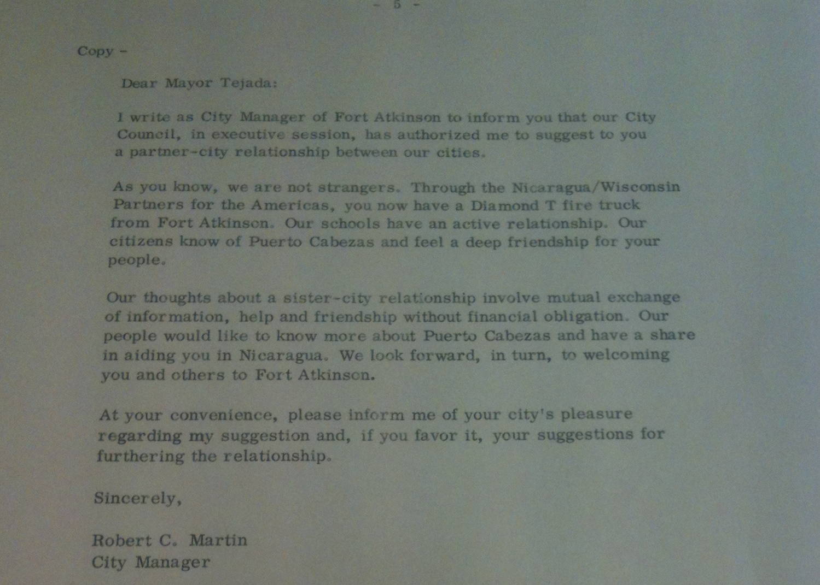

Source: Partner City Guidelines, WNPA Records, 1964-1985, Box 3 Folder 5, Wisconsin Historical Society, Madison Wisconsin

Figure 2. Red Cross volunteers in Managua after the December 23, 1972, earthquake.

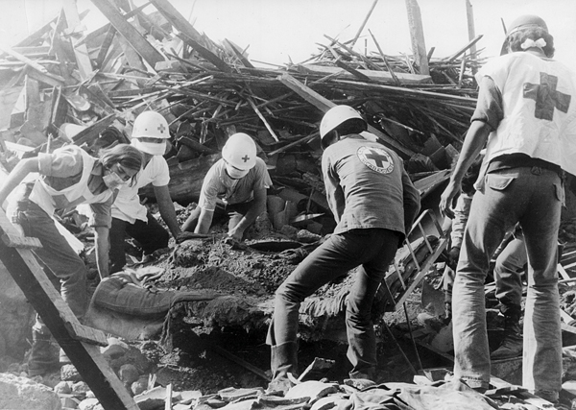

Source: http://www.redcross.int/images/2011_1/P17_1.jpg (accessed April 24, 2012).

Figure 3. Time Magazine cover of Nicaraguan President Daniel Ortega on March 31, 1986.

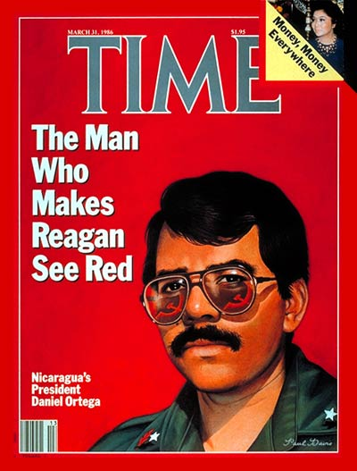

Source: http://latimesblogs.latimes.com/.a/6a00d8341c630a53ef0134861c598c970c-600wi (acecssed April 24, 2012).
Appendix 2
Table

Table 1. Illiteracy in Latin America circa 1950.

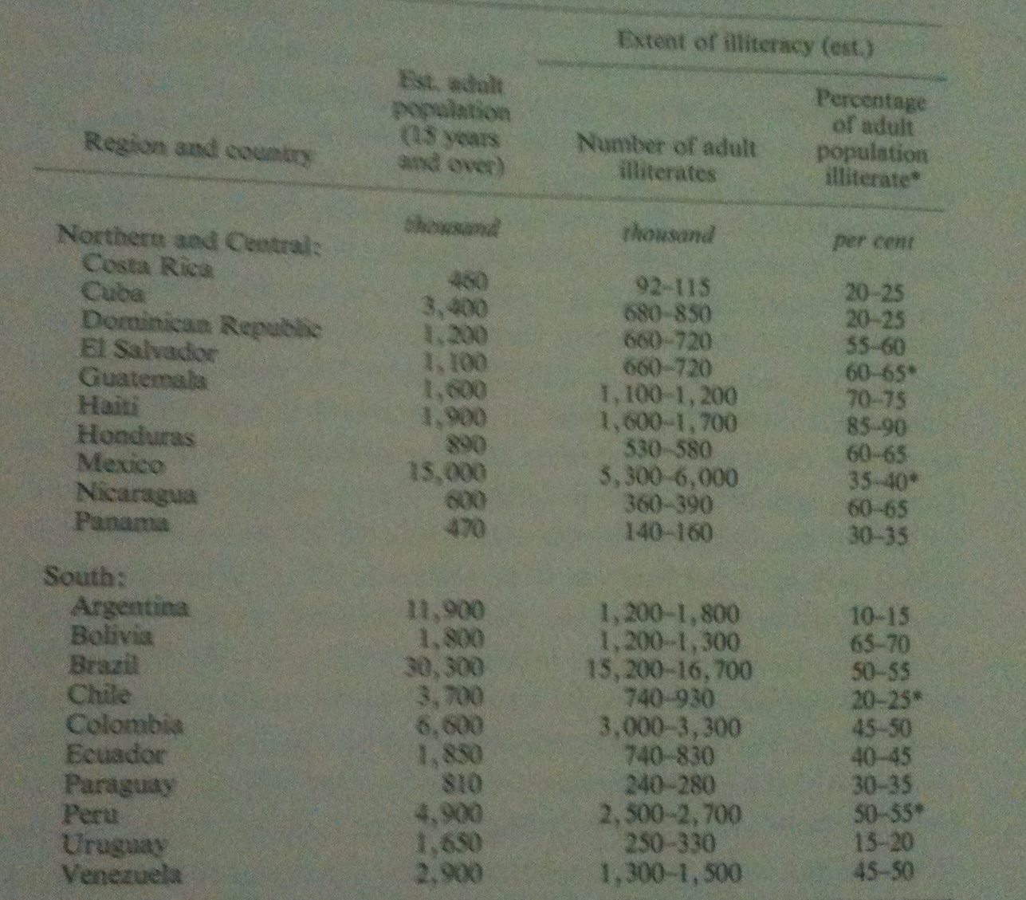

Source: Harvey S. Perloff, Alliance for Progress: A Social Invention in the Making (Baltimore; London: The John Hopkins Press, 1969), 24.
.

Works Cited: Primary Sources

Ambassador to WNPA President Correspondence 1984, WNPA Records, 1964-1985, Box 6 Folder 4, Wisconsin Historical Society, Madison, Wisconsin.
Articles of Incorporation 1965, WNPA Records, 1964-1985, Box 5 Folder 1, Wisconsin Historical Society, Madison, Wisconsin.
Aubey and Thiesenhusen Travel Report 1979, WNPA Records, 1964-1985, Box 6 Folder 6, Wisconsin Historical Society, Madison, Wisconsin.
Capital Times
Evaluation of the Partners of the Americas, WNPA Records, 1964-1985, Box 4 Folder 25, Wisconsin Historical Society, Madison, Wisconsin.

Green Bay Press-Gazette

José Canton Correspondence 1983, WNPA Records, 1964-1985, Box 6 Folder 4, Wisconsin Historical Society, Madison, Wisconsin.

Milwaukee Journal

Milwaukee Sentinel

Mr. Kincaid Telegram 1967, WNPA Records, 1964-1985, Box 5 Folder 10, Wisconsin Historical Society, Madison, Wisconsin.

New York Times

Noticias From the Partner’s Office, WNPA Records, 1964-1985, Box 4 Folder 33, Wisconsin Historical Society, Madison, Wisconsin.

Partner City Guidelines, WNPA Records, 1964-1985, Box 3 Folder 5, Wisconsin Historical Society, Madison Wisconsin.
Peter Thornquist Travel Report 1983, WNPA Records, 1964-1985, Box 6 Folder 10, Wisconsin Historical Society, Madison, Wisconsin.
United States Department of State, Alianza para Progreso John F. Kennedy, no. 1136, Washington, DC, Government Printing Office, (April 3, 1961): 471.

Taich Country Reports 1976, WNPA Records, 1964-1985, Box 4 folder 29, Wisconsin Historical Society, Madison, Wisconsin.

Steve Heinzen Travel Report 1981, WNPA Records, 1964-1985, Box 6 folder 8, Wisconsin Historical Society, Madison, Wisconsin.

Study Undertaken for the Agency for International Development 1980, WNPA Records, 1964-1985, Box 4 Folder 26, Wisconsin Historical Society, Madison Wisconsin.

Wisconsin State Journal

WNPA Spring Newsletter 1978, WNPA Records, 1964-1985, Box 6 folder 23, Wisconsin Historical Society, Madison, Wisconsin.

Works Cited: Secondary Sources

"History." Partners of the Americas. http://www.partners.net/partners/History.asp (accessed April 24, 2012).

Lake, Anthony. Somoza Falling. Boston: Houghton Mifflin, 1989.

Levinson, Jerome I. “After the Alliance for Progress: Implications for Inter-American Relations.” Proceedings of the Academy of Political Science 30, no. 4 (August 1972): 177-190.

Levinson, Jerome I. and Juan de Onis. The Alliance That Lost Its Way: A Critical Report on the Alliance for Progress. Chicago: Quadrangle Books, 1970.

Perloff, Harvey S. Alliance for Progress: A Social Invention in the Making. Baltimore; London: The John Hopkins Press, 1969.

Smith, Robert S. “The Alliance for Progress in the Seventh Year.” The High School Journal 52, no. 3 (December 1968): 113-123.

Somoza, Anastasio and Jack Cox, Nicaragua Betrayed: As told to Jack cox by former President Somoza. Boston; Los Angeles, CA: Western Islands, 1980.

Don C. Trenary, “Nicaraguans Know Wisconsin,” Milwaukee Journal, April 6, 1973.
Latin America as a global region also includes the Caribbean.
Jerome Levinson and Juan de Onis, The Alliance That Lost Its Way: A Critical Report on the Alliance for Progress (Chicago: Quadrangle Books, 1970), 6.
United States Department of State, Alianza para Progreso John F. Kennedy, no. 1136, Washington, DC, Government Printing Office, (April 3, 1961): 471.
Jerome I. Levinson, “After the Alliance for Progress: Implications for Inter-American Relations,” Proceedings of the Academy of Political Science 30, no. 4 (August 1972): 177.
Harvey S. Perloff, Alliance for Progress: A Social Invention in the Making (Baltimore; London: The John Hopkins Press, 1969), 23-27.
Robert S. Smith, “The Alliance for Progress in the Seventh Year,” The High School Journal 52, no. 3 (December 1968): 114.
Smith, Alliance for Progress, 114.
"History," Partners of the Americas, http://www.partners.net/partners/History.asp (accessed April 24, 2012).
Articles of Incorporation 1965, WNPA Records, 1964-1985, Box 5 Folder 1, Wisconsin Historical Society, Madison, Wisconsin.
Ibid.
Wisconsin State Journal, March 16, 1966.
Ibid.
Ibid.
Mr. Kincaid Telegram 1967, WNPA Records, 1964-1985, Box 5 Folder 10, Wisconsin Historical Society, Madison, Wisconsin.
Milwaukee Journal, May 22, 1968.
Michael Bauman, “State Aid Set for Nicaragua,” Wisconsin State Journal, December 26, 1972.
“3 Man Team From State to Survey Nicaragua,” Milwaukee Sentinel, December 27, 1972.
Bauman, “State Aid Set for Nicaragua.”
Capital Times, January 16, 1973.; Wisconsin State Journal, January 11,1973.
Green Bay Press-Gazette, January 26, 1973.
Partner City Guidelines, WNPA Records, 1964-1985, Box 3 Folder 5, Wisconsin Historical Society, Madison Wisconsin.
Evaluation of the Partners of the Americas, WNPA Records, 1964-1985, Box 4 Folder 25, Wisconsin Historical Society, Madison, Wisconsin.
The phraseology used by the author in that article, the decision to utilize adoption instead of a term or phrase pertaining to partnership, seemed a bit derogatory in nature, but throughout the memos, correspondence, and executive meetings, that sense of superiority was absent.
Partner City Guidelines, WNPA Records, 1964-1985, Wisconsin Historical Society.
Ibid.
Taich Country Reports 1976, WNPA Records, 1964-1985, Box 4 folder 29, Wisconsin Historical Society, Madison, Wisconsin.
Evaluation of the Partners of the Americas, WNPA Records, 1964-1985, Wisconsin Historical Society.
Evaluation of the Partners of the Americas, WNPA Records, 1964-1985, Wisconsin Historical Society.
Ibid.
Ibid.
WNPA Spring Newsletter 1978, WNPA Records, 1964-1985, Box 6 folder 23, Wisconsin Historical Society, Madison, Wisconsin.
Anastasio Somoza and Jack Cox, Nicaragua Betrayed: As told to Jack cox by former President Somoza (Boston; Los Angeles, CA: Western Islands, 1980), 390.; Anthony Lake, Somoza Falling (Boston: Houghton Mifflin, 1989), 250-257.
Aubey and Thiesenhusen Travel Report 1979, WNPA Records, 1964-1985, Box 6 Folder 6, Wisconsin Historical Society, Madison, Wisconsin.
Ibid.
New York Times, March 17, 1980.
Aubey and Thiesenhusen Travel Report 1979, WNPA Records, 1964-1985, Wisconsin Historical Society.
Ibid.
New York Times, November 10, 1981.
Study Undertaken for the Agency for International Development 1980, WNPA Records, 1964-1985, Box 4 Folder 26, Wisconsin Historical Society, Madison Wisconsin.
Ibid.
Ibid.
Steve Heinzen Travel Report 1981, WNPA Records, 1964-1985, Box 6 folder 8, Wisconsin Historical Society, Madison, Wisconsin.
Wisconsin State Journal, May 2, 1983.
Washington Post, June 30, 1983.
While I did not find any mention of this in the collection, someone with an understanding of Spanish may be able to query Nicaraguan newspapers from the time in order to find sources contrary to this. Also, it is possible that those sources might have been biased because of the controls that were present under the Sandinista government.
José Canton Correspondence 1983, WNPA Records, 1964-1985, Box 6 Folder 4, Wisconsin Historical Society, Madison, Wisconsin.
Noticias From the Partner’s Office, WNPA Records, 1964-1985, Box 4 Folder 33, Wisconsin Historical Society, Madison, Wisconsin.
Thomas Still and George Hesselberg, “Nicaragua Support Differences Arise,” State Journal, 1984.
Capital Times, September 20, 1984.
Peter Thornquist Travel Report 1983, WNPA Records, 1964-1985, Box 6 Folder 10, Wisconsin Historical Society, Madison, Wisconsin.
Ambassador to WNPA President Correspondence 1984, WNPA Records, 1964-1985, Box 6 Folder 4, Wisconsin Historical Society, Madison, Wisconsin.

