Faith, Family, Fighter:
The Story of Colonel Louis Hall DeLoss Crane

Wade Hendricks
History 489: Research Seminar
Spring 2017

Copyright for this work is owned by the author. The digital version is published in McIntyre Library, University of Wisconsin- Eau Claire with the consent of the author.

Contents

Abstract iii
Historiography 1
Religious Fervor 4
Career and Love 6
A Call to Arms 12
Fabricated Accusations 19
Blood and Honor 22
Conclusion 29
Works Cited 31

Abstract
“For the Confederate bullet that ended the Beloit man’s career closed a life of romance and honorable achievement that will always be recorded in the history of this section of the country”. Many of the men who fought in the American Civil War did not know what it meant to be a soldier. The armies were very diverse. Enlistees varied greatly, by religious denominations, immigrant backgrounds, and family backgrounds to name a few. These lead to different reasons for men to enlist. Some enlisted to protect home, others because were swayed by adventure, and pay. Louis Hall DeLoss Crane fought for a different reason, because it was the right thing to do. Louis had a hatred for the institution of slavery. This was instilled in him at a young age, passed down through the vigorous bond of father and son. James, Louis’ brother, said of Louis, “inheriting his father’s patriotic zeal, Col. L.H.D. Crane yielded up his life in full vigor of early manhood on the battle field of Cedar Mountain, 1862. A hundred times he said to me, “This war will be an utter failure if it doesn’t result in the complete and utter destruction of slavery.””

Introduction
Louis DeLoss Hall Crane was a man before his time. He was born to a family that instilled a tradition of anti-slavery views. He enlists in the Grand Army of the Republic knowing that the war was to keep the Union together. President Lincoln from the onset stated that it was a war to keep the Union intact. He enlisted anyway, and sacrificed himself because he knew the only way to keep the Union intact and prevent future bloodshed was to end the insidious institution of slavery. Louis was an abolitionist-warrior, and though his death came before President Lincoln issued the Emancipation Proclamation, he understood that the war must become one to end slavery.

Historiography
The most important sources for this study was primary documents. These primary documents were in the form of letters, diaries, and newspaper articles. The most helpful primary documents were the Quiner Scrapbook, Van R. Willard’s diary, and documents obtained from the Oneida County Historical Society, the Clinton Historical Society in New York State, the Beloit, Ripon, Iowa County Historical Societies in Wisconsin, and the Wisconsin Historical Society. From the Quiner Scrapbook came a plethora of newspaper clippings about the Third Wisconsin Infantry. In these clippings lie letters from the men who fought alongside Crane, and other aspects of life of the men of the Third. The Quiner Scrapbook lies a foundation to build upon. Van R. Willard’s diary offers more perspective from someone that also lived the life of a soldier in the Third Wisconsin. Lastly the documents obtained from the various historical societies were phenomenal. Without the help of the men and women at these institutions I would not have found hard proof of the abolitionist in Crane and how it was instilled to him by his father. These sources with the collaboration of primarily two secondary sources History of the Third Regiment of Wisconsin Veteran Volunteer Infantry, by Edwin E. Bryant, and A Narrative of Service: with the Third Wisconsin Infantry, by Julian Winser Hinkley lay the framework to follow the military career of Louis Hall DeLoss Crane. Both Bryant, and Hinkley fought with the Third Wisconsin during the war and lay an exceptional path to follow Crane’s life as a soldier. For the pre-enlistment life of Louis, Bryant, with some other sources from the aforementioned historical societies laid for foundation of unearthing a past not known or remembered for even people descended from Louis.
Richard Newman states that between the 1820s and 1830s there was a great transformation in the American abolitionist movement. The religious revivals that erupted at this time focused on eradicating sin, such as slavery, from secular society. John Stauffer also follows this view, he says that another reason for the progression of antislavery sentiment lies in religious roots. These roots stem from Puritan ideals and the emphasizing of a “sacred community devoted to social reform”. Stauffer continues saying that the Second Great Awakening lead to a tradition of religious perfectionism. This is evident in the split within many churches of America during the early to mid-19th century. Eventually Unitarians replaced Puritans and pushed for a, “sacred emotional community though a religion of the heart”. This stressed a more devotional piety instead of the intellectual and ritualist aspects of faith. By 1854, one Boston paper described Unitarians as “advancing towards a pure, evangelical faith” characterized by “personal communion with God through prayer.” Joseph T. Glatthaar agrees with this view. He says that religion was the driving force, and branded slavery as a sin that must be terminated. He sees the abolition movement as family oriented, and continues saying that the abolitionist families from the Central New York region would eventually spread throughout the North.
Chester Forrester Dunham agrees and says that the Northern ideology among the clergy’s number one belief was the supremacy of Higher Law, as well as slavery being morally wrong, and the duty of the Church being to crucify slavery. Higher Law simply is a moral and or religious principle that is believed to override legal laws. Higher Law Stauffer believes that the Higher Law led millions of Northerners to heed a higher law over slave law. It transformed antislavery sentiment”, and convinced, Northerners that slavery was their problem, not just the South’s. In particular the Fugitive Slave Act of 1850, angered many antislavery advocates, and abolitionists. William Seward, future United States Secretary of State said in his 18.. Higher Law speech that,

There is a higher law than the Constitution, which regulates our authority over the domain, and devotes it to the same noble purposes. The territory is a part, no inconsiderable part, of the common heritage of mankind, bestowed upon them by the Creator if the universe. We are his stewards, and must so discharge our trust as to secure in the highest attainable degree their happiness.

Seward continues saying,

There is no Christian nation, thus free to choose as we are, which would establish slavery. I speak on due consideration because Britain, France, and Mexico, have abolished slavery, and all other European states are preparing to abolish it as speedily as they can. We cannot establish slavery, because there are certain elements of the security, welfare, and greatness of nations, which we all admit, or ought to admit, and recognize as essential; and these are the security of natural rights, the diffusion of knowledge, and the freedom of industry.

Richard Newman insinuates that during the 1830s, areas of the Midwest and North wished for a more immediate process toward the freeing of the slaves. These views were more radical, and declared that slavery, “must be ended immediately and black Americans must be accorded full civil rights.” Stauffer sees, abolitionists as radicals that pushed for an “immediate end to slavery and advocated racial equality.” In order to preserve the Union many thought that would require the abolishment of the institution of slavery. With the creation of the Republican Party, created a political party for these abolitionist to gravitate to. The Republican Party was formed to oppose the spread of slavery into the western territories of the United States. The anti-slavery advocates as well as southern belligerence in policies like the Missouri Compromise, Fugitive Slave Act of 1850, and the Kansas-Nebraska Act created resentment among the Northern population. Stauffer would say the Missouri Compromise, Fugitive Slave Act of 1850, and the Kansas-Nebraska Act were created to preserve the Union. Soon after the creation of the Republican party, the Republicans won the presidential election. According to Manisha Sinah, Abraham Lincoln showed in 1837 working as an Illinois state representative his antislavery convictions. Lincoln,” refused to vote for proslavery resolutions condemning the abolition movement and defending slaveholders’ “right to property in slaves.” A protest signed only by Lincoln and a fellow Whig representative from Sangamon County who had been appointed to a judgeship clarified that “slavery is founded on both injustice and bad policy.”
Religious Fervor
Older forms of indentured servanthood and the bond-service of biblical times had often been harsh, but Christian abolitionists concluded that race-based, life-long chattel slavery, established through kidnapping, could not be squared with biblical teaching either in the Old Testament or the New.
Timothy J. Keller, The Reason for God: Belief in an Age of Skepticism

Louis Hall DeLoss Crane was born July 7, 1826 in Westmoreland, New York to Abijah Crane and his wife Hannah Emerson Hall. Louis was the second of six of Abijah and Hannah’s children. Edwin was Louis’s older brother by only fourteen months. Louis had two younger sisters and two younger brothers, Helen, James, Emile and George.
Louis came from a line of soldiers. Louis’ paternal grandfather Asa Crane and his maternal great-grandfather Daniel Emerson fought in the American Revolutionary War. Asa was a private in the New Jersey Continental Line. Daniel Emmerson was a captain of infantry at the Ticonderoga Alarm, and commanded a mounted company at the Rhode Island Alarm. Louis’ father Abijah also was part of Captain John A. Kiersted’s Company of infantry in Colonel John Dodd’s regiment of New Jersey detailed militia during the War of 1812. Louis would have had a sense of honor over his family’s willingness to risk everything for a noble cause they believed in.
Louis’ father Abijah, and grandfather Asa’s names both have biblical meanings. This shows the Crane family’s devoutness to Christianity. Abijah was known as a prominent Presbyterian minister and a prominent anti-slavery advocate. Soon religious revivals would erupt during the 1830s to the 1850s focused on eradicating the sin of slavery from secular society. In the central region of New York State there was a region known as the Burnt-Over District. The Burnt- Over District was a region of New York that got its name for its role in religious reforms, and revivalism during the early 1800s. One of the major reforms in this area was the anti-slavery movement. Over the years, the families that left this “hotbed” scattered though out the North. Abijah became the minister of the Westmoreland Congregational Church in January 1825, in central New York State. Abijah’s ministry was “eminently a successful one”, although he questioned the, “church government, with some very troublesome cases of church discipline.” These questions were all issues the New School of the Presbyterian Church championed. During the 1830s there was a split in the Presbyterian Church. These ideas were not foreign to other ministers in the church. One of the reasons for this division was the issue of slavery. This particular schism in the church occurred in 1837. The split was between the New School and the Old-School theologies within the Presbyterian Church. The New School sought more an abolitionist and radical approach to dealing with slavery than the Old School did. Commonly abolitionism was a family-oriented movement. Some men, “learned that abolitionism was God’s work and that the laws of God superseded the laws of man. Many men like Adolphus W. Greely, “adopted abolitionism because his father had concluded after extensive readings on the subject that slavery was wrong and taught his son so.” The family shared Abijah’s New School convictions. James Crane recalled, “Among our family traditions, there are few that we recall with more satisfaction than that he [Abijah] was heart and soul in sympathetic effort with Beriah Green, Gerrit Smith and others in Central New York, to stir up the mind of the people against the crime and incubus of slavery, that had already spread a pall over all the land.” Both Green and Smith were well known as prominent abolitionists during the time. Louis’ older brother Edwin followed in their father’s footsteps, and became a minister in the church.
Career and Love
I do believe that God blessed me in life with a wonderful family, a successful career, and a loving marriage, and remain thankful for that blessing.
Bonnie Tyler

Louis took a different approach to life than his father and older brother. While he was younger he, “grew up in an atmosphere conductive to health and vigor and was known for miles around Westmoreland for his athletic feats.” Professor Edward North, known as "Old Greek", from Hamilton College mentioned Louis as being a student at the Clinton Grammar School. Of Louis he said, “then a very busyish boy, free and racy with the pen, not over fond of dry books, yet ingrained with the stuff that patriots are made of.” Clinton was famous for many private schools in the 19th century, and the Grammar School was the most prestigious of all for boys. Louis attended Hamilton College located in Clinton, New York, where his family currently lived. Louis graduated from Hamilton in 1845, one year after his older brother Edwin had graduated from the same institution. Louis thought that perhaps medicine may be his calling, so he proceeded to attend medical school for a year. Deciding medicine was not his passion he traded in his stethoscope for a law book. Louis proceeded to enter the law school of his uncle Willis Hall.
Willis Hall was a prominent lawyer during the mid-nineteenth century. Willis also served as a New York Assemblyman and the Attorney-General of New York state. By 1850 Louis was admitted to the New York Bar. With his health failing, he relocated for a time in Selden, Long Island. Now with his health restored Louis then moved to Virginia where he met the love of his life, miss Lucy M. Burrall from Stockbridge, Massachusetts. Louis and Lucy wed in the fall of 1852. In the spring of 1853 the newlyweds then headed west together. The two first settled in a town located in Rock County Wisconsin. Beloit rests on the border of the states Wisconsin and Illinois, located on the confluence of the Rock River and Turtle Creek. They were drawn to this small hamlet due to Lucy’s family residing in the town for some years. Louis had nothing keeping him on the east coast anymore with his mother and father both dying in within a year of each other, 1846 and 1847.
In Beloit Louis took up a job as a school teacher at the Union School. He was an eminent success.” At the Union School, “Teachers were paid liberally, wages principal of character required is $800 for an academic year.” Rev. Jacob Baily from Beloit, Wisconsin shows what the attitude toward slavery was around the time Crane lived in Beloit. Baily says that slavery should never had been tolerated by the Christian Church. He goes to compare the pairing of American slavery and Christianity is like pairing heaven and hell. He goes so far to say that, “No true church of Christ can receive a slaveholder into her fellowship.” The uproar that the Fugitive Slave Act of 1850 caused created a furor from the clergy of the North. Louis would have been an adherent to the Higher Law ideals. The Higher Law is a belief that slavery is a sin against God as well as man. Slavery does not comply with the universal principles of morality, fairness, or justice and therefore cannot be the rule of the land. The Northern ideology among the Clergy saw the supremacy of Higher Law as being their number one belief, followed by as well as slavery being morally wrong, and the duty of the Church being to crucify slavery. In particular the Fugitive Slave Act of 1850, angered many antislavery advocates, and abolitionists. The Fugitive Slave Act, “required any and all citizens to hunt down suspected fugitives.” If citizens did not follow the act, they were subject to a harsh fine, and possibly prison time, just for doing something that was morally right, protecting runaway slaves. The Fugitive Slave Law lead millions of Northerners to believe in the Higher Law over that of slave law. This created a conviction among Northerners that slavery was not just the South’s problem, but also their own. The Crane family was adamant on their hatred for slavery. The spread of this insidious institution would have struck a chord for Louis. The passing of the Kansas-Nebraska Act of 1854 allowed slavery north of the 36ﹾ 30’ latitude. Louis would say to James of slavery a hundred times during the American Civil War, “This war will be an utter failure if it doesn’t result in the complete and utter destruction of slavery.”
One year after moving to Beloit, Louis and Lucy moved to Dodgeville, Wisconsin. Louis’s older brother Edwin died August 27, 1854 due to typhus fever. Edwin was doing missionary work in Gawar, Koordistan, Persia, present day Iran. With his mother, father, and eldest brother all dead, Louis was now the oldest left in the family at the age of twenty-seven. While in Persia Louis’s older brother Edwin and his wife Ann Eliza Crane had two children, Morris Grant Crane, and Edwin Hall Crane Jr. Morris died a week later, more than likely from the same affliction. His eldest son Morris was just over a year old when he died on September 6, 1854. Ann was six months pregnant with Edwin Jr when Edwin Sr succumbed to typhus fever. Somewhere along the line Edwin Jr is adopted by Louis and Lucy Crane in Illinois. In the 1860 Census for Ripon, Wisconsin, Edwin Hall Crane is five years old and living with Louis, Lucy, and their two-year-old daughter Mary. In the 1870 census Edwin Jr is said to have been born in Illinois. It is assumed that Louis and Lucy adopted Edwin Jr in Illinois, since the birth years line up on multiple documents. On November 1, 1858 Lucy gave birth to a girl, Mary Louise Crane.
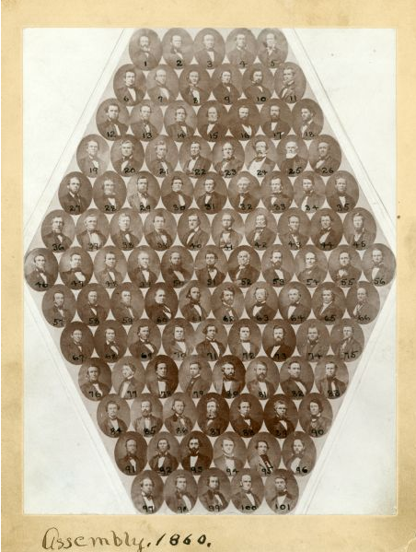
Louis’s younger sister, by two years, Helen moved to Dodgeville sometime between 1853 and 1858. She would die on January 16, 1858, another close death for Louis. In 1854 Louis followed in Uncle Willis’s footsteps once again and was elected District Attorney of Iowa County, Wisconsin, where he served for two years. Louis was a, “leading spirit in the incorporation of the community” of Dodgeville into a village. Louis was Dodgeville’s first president, elected in 1858. Louis then was elected chief clerk of the assembly, the lower house of legislature of Wisconsin, during the sessions between 1858 and 1861. Louis was almost unanimously reelected for four years in succession. As the chief clerk of the assembly Crane was responsible for producing official records of all Assembly action, make entries in the histories of legislation; direct Assembly proposals; present proposals which have passed the legislature to the governor, and manage the payroll for the Assembly. As the Chief Clerk in 1857, Crane received $600, the same was true for 1858. In 1859, there was a decline in pay to $500. Though the Chief Clerk position is non-partisan, it is assumed that Louis would have been swayed by the message of the Republican Party.
Figure 1. Wisconsin State Assembly:1860. 1860. Wisconsin Legislature composite photographs, 1858-1979, 1998, Wisconsin Historical Society, http://www.wisconsinhistory.org/Content.aspx?dsNav=Ny:True,Ro:0,N:4294963828-4294955414&dsNavOnly=Ntk:All%7c1860+assembly%7c3%7c,Ny:True,Ro:0&dsRecordDetails=R:IM46806&dsDimensionSearch=D:1860+assembly,Dxm:All,Dxp:3&dsCompoundDimensionSearch=D:1860+assembly,Dxm:All,Dxp:3
L.H.D. Crane
The Republican party was formed in Ripon, Wisconsin on March 20, 1854, by former members of the Whig Party who established this new party to oppose the spread of slavery. With the creation of the Republican Party, abolitionist gravitated toward it. Abolitionists were seen as radicals that pushed for an “immediate end to slavery and advocated racial equality.” In order to preserve the Union many thought that this would require the abolishment of the institution of slavery. The anti-slavery advocates as well as southern belligerence in policies like the Missouri Compromise, Fugitive Slave Act of 1850, and the Kansas-Nebraska Act created resentment among Northerners. These Acts and Compromises were created to protect the Union. Soon after the creation of the Republican party, the Republicans won the presidential nomination.
Abraham Lincoln was elected the first Republican president in 1861. Lincoln in 1837 working as an Illinois state representative his antislavery convictions. Lincoln, “refused to vote for proslavery resolutions condemning the abolition movement and defending slaveholders’ “right to property in slaves.” A protest signed only by Lincoln and a fellow Whig representative from Sangamon County who had been appointed to a judgeship clarified that “slavery is founded on both injustice and bad policy.” Wisconsin Republicans had reason to be elated over the creation of the party. “From its beginnings in a white schoolhouse in Ripon, the Republican flame had spread over Wisconsin like a prairie fire.” Lincoln even visited the state and spoke in Beloit in 1859. It is possible Louis was in attendance.
A Call to Arms

A hundred times he said to me, “This war will be an utter failure if it doesn’t result in the complete and utter destruction of slavery.”
James Crane

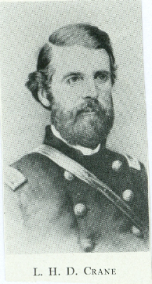
Cannon erupted on April 12, 1861 on the United States fort called Fort Sumter, in South Carolina. Newly elected President Lincoln acted swiftly. President Lincoln’s call to arms occurred April 15, 1861, originally calling for 75,000 troops. Wisconsin was to furnish as part of her quota, one regiment of infantry of 780 men. The Governor of Wisconsin Alexander W. Randall, a man Louis had known well while working as the Chief Clerk of the Assembly, had foreseen the need for more troops. Governor Randall issued an additional proclamation on April 16th stating, “and further service would be required as the exigencies of the service might demand.” The original enlistments of the 1st Wisconsin infantry was for a three-month period. On the 7th of May, the secretary of war notified Gov. Randall that all new volunteers should enlist for three years. So, the Third Wisconsin regiment accepted the change of terms. On May 30, 1861 Louis Hall DeLoss Crane heeded Lincoln’s call to arms to save the Union, and enlisted for a three-year term.
Figure 2. L.H.D. Crane. Crane Documents, Beloit Historical Society
Northern college educated men, like Crane, had ideas about honor revolved that around the idea of “obeying one’s conscience.” College would attempt to make men into honorable gentlemen. This college education may also explain why men like Crane who had a comfortable life, married with two young children decided to “obey his conscience” and volunteer at the age of 40. Crane and others like him viewed the world through a “lens of honor, Northern honor, or character, influenced how nineteenth-century men led their lives. In its broadest form, character can be defined as an idealized internal standard of behavior that emphasizes independent thought and selfless action.”
Soon the officers of the staff were named. Louis was elected Second Lieutenant of Company A, also known as the Watertown Rifles. Soon he was also promoted to the title of Adjutant. Less than a month later Lieutenant Crane left his home of Ripon for Fond du Lac. When Louis left for Camp Fond du Lac, Lucy brought her two children back to Beloit to move in with her parents. Lieutenant Crane and the rest of the Watertown Rifles arrived at Camp Fond du Lac on June 17, 1861. Camp life, “was a pleasant one”, yet “the orders that we had waited for so long and somewhat impatiently” had arrived. The regiment would head to Maryland. The first uniforms that the regiment were given were a gray hat, a blouse or frock, gray pants and a blue flannel shirt. Eventually the uniforms would have to be replaced by the regular army blues. Lieutenant Crane wearing the gray trousers and flannel blue shirts marched with the regimental procession through the streets of Fond du Lac, on their way to board the train headed east. Friends and family came to Fond du Lac to see the men off. Lieutenant Crane and the other men were about to, “bid adieu- perhaps forever”. “Yet in our hearts were light and we could bid adieu to all of these with cheerful hearts, for we knew we were engaged in a just and noble cause.” Lieutenant Crane boarded the trains headed south and reached Chicago early on the morning of July 12th. Lieutenant Crane and the Third Wisconsin would view patriotic women waving their kerchiefs, and farmers swinging their hats as they traveled through Indiana. A stop in Adrian, Michigan the regiment was treated to lemonade. In Toledo Crane was greeted with supper when a large crowd greeted the regiment. The stops in Buffalo, and Williamsport, Pennsylvania were accompanied by similar patriotic vigor, and generosity. Four days after leaving their home state of Wisconsin Crane and his fellow Badgers arrived at their destination of Hagerstown, Maryland.
Upon reaching Hagerstown the regiment started their first marches southward toward Harpers Ferry, Virginia. The weather was “extremely hot”. Crane and the rest of the Third finally reached Harpers Ferry to find that their first military duty would be to guard the ford and bridges of Harpers Ferry. The camp at Harpers Ferry was soon named Camp Pinkney. Here the men continued to drill. For food Crane received, “excellent ration- good coffee, brown sugar, bacon, hardtack, and desiccated vegetables.” From the camp Crane was able to hear the cannonade of the first battle of Bull Run. Exaggerated stories of the destruction of Union regiments came to camp, thus quelling, “all ideas of holiday soldiering vanished” from the minds of the men.
As the days weaned on, the Third remained in camp, and was ordered to prohibit harboring slaves. This order was in compliance with Congress’s Confiscation Act of 1861, which stated that only slave used to support the Confederate rebellion could be confiscated. This would have been an object of disagreement in Lieutenant Crane’s mind. “Federal troops considered it outrageous that their government allocated manpower and occasionally risked lives to protect the property of people who were in rebellion against that government.” Many of the Badgers held strong anti-slavery convictions. One man Edwin Bryant of the same company as Lieutenant Crane would say, “We should be on the alert to see, when we are conquerors, that we lose not the golden opportunity of stabbing slavery to the heart. Else has our labor, our expedition our sacrifice of blood been for naught.”
On August 17^{th,} the regiment marched out of Camp Pinkney. Crane and the regiment camped near a town called Buckeystown. Here Lieutenant Crane received his commission as Major. From Buckeystown the regiment continued to march southeast. The men had to endure the rain and march though deep mud. The reason for the march from Harpers Ferry was to repel any attempted invasion by the Confederates toward Washington, D.C.
Soon September came and with it the cold and chilly evenings. Crane and the Third were now ordered on the 12th of September to the city of Frederick, Maryland. Upon reaching Frederick, Crane soon would realize that much like many other border state cities that there would be plenty union supporters and southern sympathizers. After arriving in Frederick, the men learned the purpose of the march was to stop the pro-southern Maryland legislature that was set to meet in Frederick from voting to secede. General Banks selected the Third Wisconsin for the task. Major Crane and the rest of the Third Wisconsin on September 17, 1861 surrounded the building of the meeting. There they rounded up the pro-southern legislature, and took them prisoner. “Secretly by the 3rd, kept Maryland in the Union.” While in Frederick, Major Crane was able to finally discard the medley of gray and blue flannel they were provided, and replace it with the Union blue uniform.
On the 27th of October, Crane and the Third marched to their camp called Camp Jo, just down river from Darnestown. This camp was in the heart of the woods, which was pleasant for Crane. The camp was sheltered from the winds that would soon come during the late fall. The men began building log cabins from the pine trees readily available. This made for “very comfortable quarters”. On the 29th, Crane and the other officers were treated with a thanksgiving dinner. By the 2nd of December, Crane and the Third were off to march again for Frederick. The log houses that the men had built were now made into a giant bonfire. The march back to Frederick left Crane shivering on the cold side of a hill. Somehow the trains were slow, and Crane with his comrades were left to shiver near some fires for the night. Eventually the regiment reached Frederick once again.
While in Frederick for the winter, the colonel of the Third, Thomas Ruger, was selected as the provost marshal of the city, and the regiment itself was to be its military police for the winter. Men on both sides encountered the seasonal rhythm of the war. Fighting usually occurred during the warm months when the ground was drier and easier to traverse. During the winter months, men mostly sat in camp, tried to keep warm, and wait for the ground to harden. During much of the winter the mud, snow, and rain kept the ground softened to the point that drilling was not possible. The winter was spent by Crane and the men by killing time playing, “chess, checkers, cards, and dominoes.” The monotony of winter was broken up by a meeting of the Free Masons of the division. Louis and his father were both members of the Masonic fraternity. The men met in the Freemason Lodge of Frederick. The Freemasons are a fraternal organization which share the belief in a Supreme being, and explore ethical and philosophical issues. The Maine, Wisconsin, Texas, Massachusetts, Rhode Island, New York, Pennsylvania, Indiana, Maryland, and Michigan Lodges were all represented. A wonderful supper was prepared for the men. “Speeches, songs, toasts, music of bands and orchestras, and stories filled a couple of hours most agreeably.” The meeting adjoined when the sun finally set to the west. The men were “more than thankful for that light which enabled us to find brothers and friends in this remote region, who would administer to our comforts and give us a cordial welcome. Another event broke up the monotony of the winter. On the 10th of January Mrs. Maulsby, a resident of Frederick, held a military ball. All the officers were invited to this ball. Even General Banks, and his wife were in attendance. “The ball was elegantly draped with flags, banners and colors, procured from the various regiments.” “Uniforms of artillery, infantry, cavalry and staff corps were sprinkled plentifully, among the charming toilettes of the beautiful ladies of Monacacy Valley and Frederick City.” It would have been a welcomed interruption to winter camp life.
As Christmas passed Crane would have missed the loved ones back home. While being away from home every day was a struggle. Crane would think of home with fondness and miss his soulmate Lucy, and little ones Edwin and Mary. More than likely Crane would, “dream of home and home associations to dream of everything pertaining to beauty civilization & intelligence [and] to wake up & find death & desolation all around you to start up & go into the ranks & prove yourself a man then & there. I say to depict this scene & the feeling of the actors requires a language which no man was ever known to possess.” Men in the Civil War had families that needed them, as well as careers that would have been less dangerous, but these men continued to fight for their cause.
Soon the New Year passed, and winter gave way to spring. On February 22, 1862, Crane and the rest of General Banks’ Corps were ordered to enter the Shenandoah Valley of Virginia. On March 1, 1862, the Third Wisconsin commenced the building of a Pontoon bridge across the Potomac River to Harper’s Ferry. The bridge was built by the Badgers, and assisted by a corps of U.S. Engineers. First to cross the bridge were Generals McClellan, and General Banks followed by General Hamilton and his staff. The Third got the honor of heading Hamilton’s Brigade across the bridge. The movement of the army into the valley was in hopes to capture Winchester, where the now famous General “Stonewall” Jackson’s army waited. On the 11th of March the Union lines, “formed and swept along in fine style though the open fields toward Winchester.” General Hamilton was the senior officer and was hence in command. The Union line pushed aside the small detachment of Confederate Cavalry that General Jackson had left behind. The town of Winchester was now in the hands of the Union army. The town of Winchester appeared to have a fairly strong Union sentiment. General Hamilton was then transferred to General Heintzleman’s command. The brigade was now be led by Colonel Gordon of the Second Massachusetts. Crane and the Third remained in the town till the 22nd. For the next month, General Jackson avoided Union forces. The Third marched from Winchester, to near Manassas, cross the Blue Ridge Mountains, camp at Berryville, and then to Strasburg.
Fabricated Malicious Accusations
Everyone suffers at least one bad betrayal in their lifetime. It’s what unites us. The trick is not to let it destroy your trust in others when that happens. Don’t let them take that from you.
Sherrilyn Kenyon, Invincible

The men who fought in the American Civil war realized that combat was a paradox. For some men, the senses were dimmed or dulled, for others they were elevated by combat. “It was grand thrilling, and awesome and at the same time horrible, destructive, and demonstrative of the great weakness of mankind.” Combat would break or make a man, it was where men could prove their manhood, and pass the test of courage. “Under the enormous stress of battle, soldiers learned whether they and their friends could be counted on in moments of crisis or whether they were untrustworthy and unreliable. Performance in battle also elevated nobodies to greatness and demoted prominent individuals to insignificance.” The Fond du Lac Saturday Reporter ran a story on April 26, 1862 stating, “A letter from the Third Wisconsin Regiment stated, that on a recent occasion , when the rebels came disagreeably near, Major Crane made such fast time to the rear that he has been sick ever since.” The letter implies that Major Crane was so frightened by the sight of the enemy that in his cowardice escape became ill, and still has not be able to fight. As soon as a copy of the newspaper reached Crane and the rest of the Third, all of the officers of the Third signed a document stating the claims to be, “absolutely and utterly false”. That Major Crane has never, “shown any lack of personal courage.” Crane is mentioned by his comrades as “gallant”, and “popular” among the men. Of the aforementioned document, all the officers except one signed the document. The one who didn’t was a man by the name of George Whitman. George Whitman was also originally from the east coast, and lived in Darlington, Wisconsin. Darlington is about 25 miles south of Dodgeville. Whitman would do nothing notable after the war, so little could be found of him. Whitman would not fight at the battle of Cedar Mountain due to heat exhaustion, and would be mustered out of service in 1863 after being wounded at Antietam. Major Crane’s friend Colonel Ruger even wrote a letter to be published in the newspapers. Where he believes Whitman to have been the author of the “fabricated” lie. Ruger states, that the claim was, “unqualifiedly false”, and “fabricated”. Ruger goes on to say that, “Major Crane has always performed the duties assigned him with promptness. I have never had reason to believe, nor heard it intimated, that he lacks personal bravery.” Crane wrote his own letter to the newspapers which appeared in the papers May 14, 1862. Crane states,

I know of no words strong enough to express the cowardice and meanness of the person who will malign an officer, far from home, and enduring the hardships and privations of an active campaign, especially when it is considered that weeks and perhaps months will pass before a lie can be known here, or nailed at home. It will be observed that one officer has refused to sign the denial. This person assigns no reason for his refusal. I have therefore demanded a Court of Inquiry of Major General Banks, when that officer can have ample opportunity to make good, if he can, the statement which he seems willing, should stand uncontradicted to me, I am gentlemen. Very Respectfully L.H.D. Crane, Major 3rd Wisconsin.

The claim against Crane’s courage would be very damaging to his reputation and his pride. Northern men fought by a code of honor or character. In its most broadest form it can be defined as, “an idealized internal standard of behavior that emphasizes independent thought and selfless action.” Men who used their character did not feel intimidated by others and had an unshakeable self-confidence. “The conscience of the society,” he always knows the righteous course “as the magnet arranges itself with the pole.” Crane was fighting a just and noble cause, to end the institution of slavery. To be accused of running would have been detrimental to his character in Wisconsin as well as in New York. When the bullets are flying men find out who is courageous and who is a coward, who are heroes and who run in the face of death. Crane’s fellow officers and the men knew he was no coward. Crane knew what he was fighting for, and would set out to prove his bravery when offered the opportunity. While Crane and the other officers of the Third tried to vindicate these malicious claims, General Jackson hoped to attack whatever small force may be left at Winchester, and quickly retraced his steps.

Blood and Honor
Louis has lain himself a willing offering on the altar of his country. He died where a patriot loves to die- in the hour of battle, at the post where duty called him.
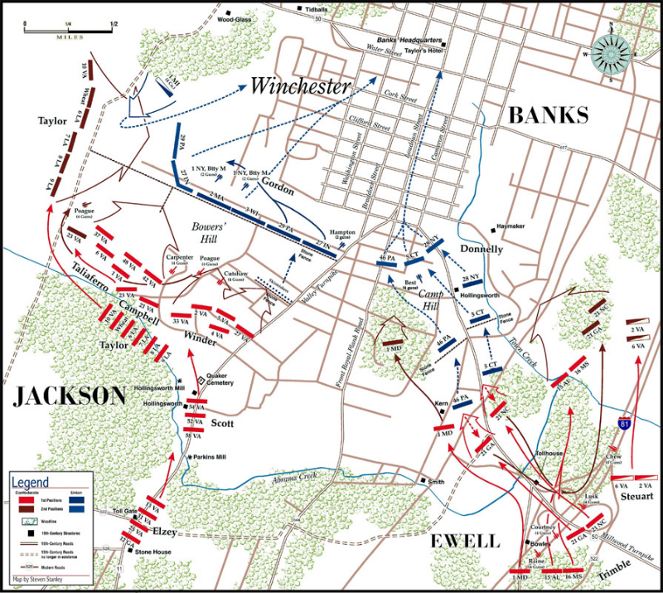
James Crane
Stories of a battle at Winchester led the Third to be ordered back to Winchester. The march was a hard one back to Winchester, marching twenty-five miles in one night. Crane and the Third were ordered to hastily defend a railroad ridge near Front Royal against attack, the next day the army was in full retreat toward Winchester. During the ordered retreat, the wagons were ordered to be burned, to not allow their capture. In the wagons were the rations, and cooking utensils of the Third. Most of the men went hungry for the night. On the morning of May 25, 1862 Crane was awakened by picket-firing at daybreak, he found out that the Confederates occupied the hills to the south.
3rd Wisconsin
Figure 2. Map of First Battle of Winchester, http://thomaslegion.net/firstbattleofwinchester.html
Crane and the Badgers, now inside the town of Winchester, awaited orders. On a thick misty morning, the Union battle lines were deployed on the western outskirts of Winchester. The purpose of this engagement was to slow the Confederate advance. Crane and the Badgers were deployed at the center of Gordon’s line which rested on the Union right. Colonel Gordon seeing he was about to be enveloped by the superior number of the Confederate advance, ordered the regiments on the right to spread out. At this time, Colonel Ruger sent forward Major Crane with two companies to command as skirmishers. Major Crane and his men sheltered behind a stone wall about seventy-five yards in front of the rest of the Third. Musket-balls flew with a destructive fire. With Gordon’s brigade outnumbered, orders were given to fall back. With the Confederate Army closing in around the Third, “it became evident that we should all be taken prisoners if we did not retreat.” The Third fell back in good order, stopping to fire a volley then continuing the retreat. Eventually behind another stonewall, Colonel Ruger ordered the men to make a stand. The enemy was forced to halt for a moment. Here Crane and the Third stayed for about fifteen minutes holding off the Confederates. This stand allowed time for the supply wagons to escape across the Potomac River. The regiment became split up on their retreat through the streets of Winchester. With the enemy on their heels Crane and some of the men from the Third found out that the residents of Winchester were not true Unionist after all. While retreating though the town, “The citizens both men and women fired on our men from the houses as we passed killing several and wounding others.” Soon the retreat became a mass of people. The roads were filled with refugees, runaway slaves, vehicles, and the Union soldiers trying to avoid the Confederate cavalry lead by Colonel Ashby. Major Crane and his group of the Badgers were the last to leave the town of Winchester, avoiding capture from the Confederate cavalry. For about thirty-five miles, the retreat was just an indistinguishable mass.
The Third reformed near the banks of the Potomac and took the ferry across the river. During the battle of Winchester, the third had lost less than other units in Gordon’s command. The Third received some praise for its behavior during the melee. The New York Evening Post, stated, “The Third Wisconsin, as cool as if on parade faced about and marched toward the town.” The “Third Wisconsin moved in excellent order through the town, though exposed to a galling fire.” The officers of the regular army said of the Third, “under Col. Ruger, did splendidly throughout the retreat, and while other troops (in a measure abandoned to themselves), were raising the devil to get across (the river at Williamsport) anyhow the Third formed as on parade, crossed in detachments under proper officers and were then reformed for duty on the other side. Other regiments behaved well, but the Third took the palm.” General Jackson was now left in control of the Shenandoah Valley. General Banks would not pursue till the 10th of June. On June 10th, Crane and the Third crossed the Potomac once again.
The Third marched and arrive on July 17th in Washington, MD a small hamlet west of Warrenton. Here Crane and the Third were to camp, and continue drilling. The heat was intense and would continue into August. Here Crane continued rapid promotion, and was promoted to Lieutenant Colonel. General Jackson learning that the Union had left a small brigade under General Crawford near Culpepper Court House in Virginia, moved to take advantage of this mistake. By August 7th Jackson moved northward toward Culpepper. Soon General Banks’ Corps was ordered to march south toward Culpepper. Near Culpepper was a place called Cedar Mountain, this is where the Crane and the Third faced their biggest challenge yet.
Crane and the Third were ordered to march at 3 A.M. The sun raged as the troops marched southward. The dust cloud enveloped the men, making it harder to gasp for breath in the scorching August heat. By 11 P.M. Crane and the Third reached Culpepper. Banks was ordered on the 9th of August to, “take up a strong position at or near Crawford’s brigade, to check the advance of the enemy, to determine his force, and the character of his movement as far as practicable.”
The night before the battle James Crane, Louis’ brother, was with Louis and the regiment. It is not certain why James was visiting Louis and the regiment, but during the upcoming battle he made himself of use helping at the field hospital. James wrote a letter to Lucy about Louis the night before the battle and the day of. James says that, “Louis welcomed me with his usual warmth of manner, but seemed sad and care worn. He complained of decreasing strength, stating that formally when he was ill he felt good natured toward everything and with everybody, but that recently, when suffering from any cause, he was sure to reel depressed. Louis “had received a slight stroke of paralysis. It was of short duration, however from this moment he seems to have had a presentiment that the end was near; and while I had not the slightest feeling or fear as regards my personal safety in the coming conflict, yet I could not resist the impression that Louis’ days were numbered. Louis took me one side and said he was going into battle in a few hours at the most, and of course no one could tell who would survive. He did not know that he had anything very special to say about business matters- that his friends best understood his business there, and calling Col. Ruger, said he wished me to attend his personal effect here. He would have said more. I know his thoughts were with you and the dear ones at home, but a silent press of the hand and we parted forever.”
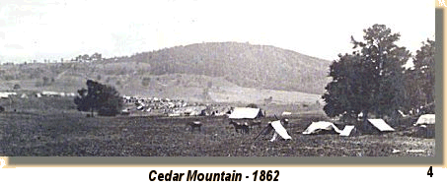
Crane and the Third moved out to join Crawford a little before 10 A.M on the 9th. The heat was intense as the men tried to keep a rapid pace. As Crane reached the battlefield he saw Cedar Mountain rise high before him. Cedar Mountain was covered with forest, and brush. Crawford’s brigade was already in line of battle, which led Gordon to place his brigade to the right of Crawford’s. The Third was on the far right of the Union line, on the right flank. Gordon ordered skirmishers to be sent out. Colonel Ruger sent six companies forward under Crane to scout the area. The skirmishers swept the woods to the front of the Third and found no rebels. The Union guns had by now opened fire upon the Confederate units to the front. About 5 P.M. Banks had ordered the whole line forward, except for Gordon’s brigade which was to be held in reserve. Soon Crawford rode up with his men and ordered Colonel Ruger to follow him and join the assault. The Third Wisconsin was under the command of General Gordon, not Crawford. Colonel Ruger replied that he, “expected orders from his own brigade commander, Gordon, and suggested that before detaching him from his brigade, it should be directed by superior authority.” Crawford left and soon returned with orders for the Third to join on Crawford’s right. Crane and six companies of the Third joined Crawford’s line and advanced forward.
Figure 3. U.S. Civil War Photographs, Cedar Mountain, http://www.usa-civil-war.com/Cedar_Mountain/cedar_mtn.html
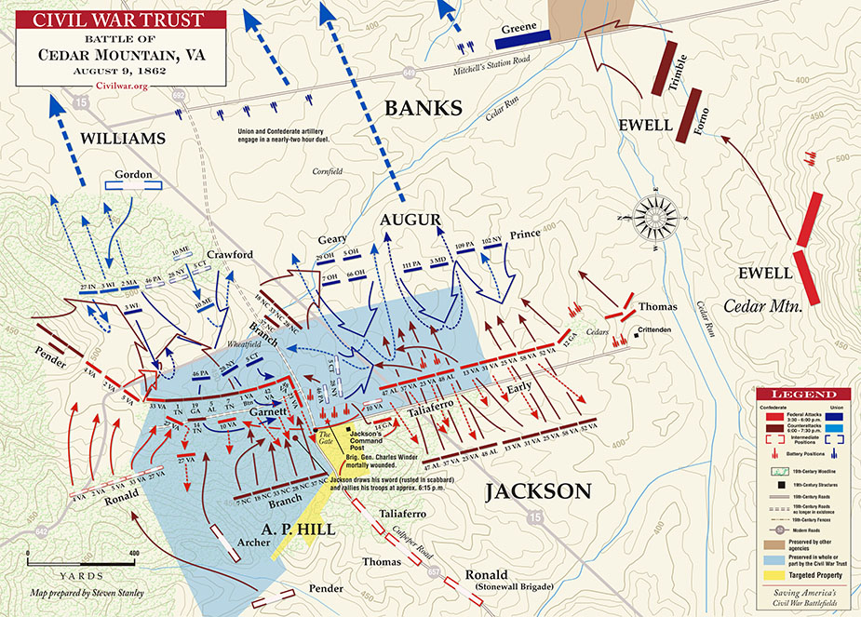
Crawford’s men moved swiftly forward and pushed a Confederate Brigade backwards. The six companies under Ruger, and Crane that advanced on Crawford’s right did not have such easy ground to cover than did Crawford’s men. Crane and his men faced thick woods, briers, and harsh and rocky ground. By the time the Third was able to reach the wheat field, Crawford’s brigade was nowhere in sight. Crane and his men advanced but 125 yards across the wheat field, and over a fence. Suddenly they were faced with a storm of death.
Where Crane was killed
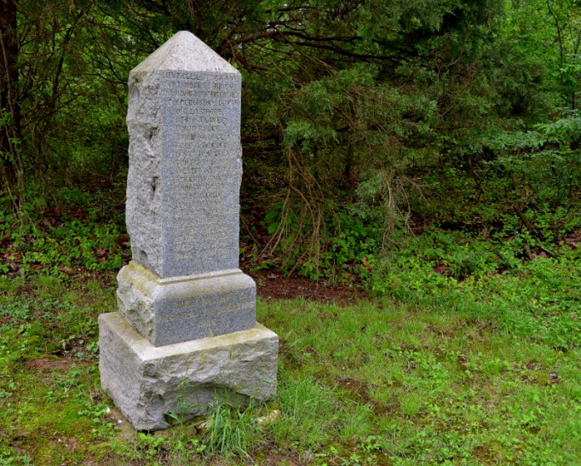
The famous Stonewall Brigade, four regiments strong advanced when Crawford had pushed back the Confederate Brigade to Crawford’s front. The Stonewall Brigade’s line almost enveloped the small contingency of the Third’s companies. One officer of the Second Virginia stated the volley they delivered, “was one of the most effective that he ever saw delivered in battle.” Soon the Fourth Virginia and the Fifth Virginia joined the melee against the small unit of Badgers. “Men were falling by scores each instant.” Colonel Ruger on his horse with balls flying about him, coolly ordered the men to fall back behind the fence. Lieutenant-Colonel Crane, in his place on the right, called on the men to be steady while the storm of bullets rained though the cloud of smoke in front. During this moment of the 267 men that were taken in to action, 30% were killed, wounded or missing. Col. Ruger says of the engagement, “The fight was made with great spirit by our men, and although the enemy’s line was broken in several places, our line was compelled to fall back on account of the flank fire.” Robert Krick writes, “as the Wisconsin men wavered (what else could they do, facing five full regiments with six-tenths of one regiment?), a conspicuously brave officer dashed through their lines on a dark clay bank hose in an attempt to rally them. Confederate rifles turned in unison in his direction, and the officer, Lieutenant Colonel Louis H. D. Crane of the Third Wisconsin, fell “riddled with bullets.” Major Van Brunt says that Crane was a “conspicuous target, and the last command he heard from Crane was to rally behind the fence.” J.C. Moore a captain of in the Second Virginia Infantry wrote, “When we repulsed the Union forces on the bushy field, an officer of the rank of colonel acted with most distinguished and conspicuous gallantry and remained too long at his post of duty. After we had made our charge, and in doing so had emerged from the cloud of smoke our volley had created, he was still in front endeavoring to rally the retreating men. Finding this to be impossible he slowly turned his horse to ride though a gap in the fence, when he was struck by one of the hundreds of bullets flying about him and fell from his horse. I afterwards saw him dead on the field and though I did not learn his name I am sure that no braver officer ever fell on any battlefield.” “When John Casler of the Thirty-third Virginia later went over the battlefield, he was attracted to the dead colonel’s shoulder straps- “beautiful ones, like solid gold.” The shoulder straps of solid gold was taken from his body prior to being retrieved from the battlefield. James says in the same letter that later in the day Louis’s servant Kelly, “came running up, saying his master was wounded and left on the field. Soon after came another and another who had seen him fall, and ongoing to him found life extinct. The last that was seen of Louis, he was waving his sword above his head, shouting out cheerfully, ‘Steady there, my boys! Stand firm!’.” General Gordon says, “The dead, the honored dead, speak for themselves; they gave up their lives for their country’s sake”
Figure 4. Map of the Battle of Cedar Mountain, https://civilwartalk.com/threads/the-battle-of-cedar-mountain-walking-and-driving-tour.124433/
Figure 5. Third Wisconsin Memorial, Cedar Mountain, https://civilwartalk.com/threads/the-battle-of-cedar-mountain-walking-and-driving-tour.124433/
Crane’s body was taken to Washington first then was ordered to be forwarded to the state of Wisconsin. The Governor of Wisconsin wished to have Crane buried in Madison, but Lucy wished for her husband to be buried in her family plot in Beloit. A newspaper from Wisconsin ran a story on Crane’s death. “The death of Col. Crane in action vindicates most compellingly his character from the foul charge of cowardice that was started by a paper in this State [Wisconsin], and which has never been retracted though proved to have been false by the certificate of all the commissioned officers of his regiment but one, and should cause the individual who attempted thus to blast the fame of a noble and gallant officer to blush with shame. It is very probable, that this insinuation as to the courage of Col. Crane, has had the effect to cause him unnecessarily to expose his life. Editors should be very careful not to reflect upon the character of an officer in the field, as to his courage, without positive knowledge of the truth of the charge.”
Crane’s Obituary in the Beloit Journal on September 4 1862 read that Crane’s body reached Beloit on a Friday evening. His funeral was held at the Congregational Church. The Beloit Brass Band played while the Masonic Fraternity headed the procession, and a large amount of people were in attendance. The reverend was, “intimately acquainted with Col. Crane, and alluded to his character, both as a Christian and churchman, and as a citizen, with the feeling and tenderness of a noble man who has lost a noble friend.” Of Crane, it was said, “the body of a true Christian, an honorable and patriotic citizen, a brave soldier, and a most affectionate and devoted husband and father. The grass will soon spring up afresh over the grave of one of the bravest victims of this horrible rebellion, and when we visit it let us pray for the success of the cause for which he fought.”
Conclusion
Louis was instilled with a hate for slavery from a young age. It was tradition passed down from his father Revernd Abijah Crane. Louis saw his father as an active participant in antislavery societies in New York, and shared his father’s patriotic zeal. Louis saw a lot of death, by the age of 31, Louis had seen his father, mother, eldest brother and younger sister all pass. He married, and moved west to settle in southern Wisconsin. Louis showed promise as a lawyer and served his state as the Chief Clerk of the Assembly. Living near Ripon, his hatred for slavery probably lead him into the ranks of the Republican Party, that ran on the zealous antislavery population. Louis would heed President Lincoln’s call to arms and leave his wife and two children both under six, to fight for a cause that he passionately believed in. James said that Louis about 100 times said, “This war will be an utter failure if it doesn’t result in the complete and utter destruction of slavery.” Louis fought gallantly for a cause championed by his father and passed on to him. When Crane “bid adieu” and boarded the train in Fon du Lac headed for death and glory, he knew the risk that he was taking, but knew that, “the utter destruction of slavery” was worth the risk. As James Crane would say, “Louis has lain himself a willing offering on the altar of his country. He died where a patriot loves to die- in the hour of battle, at the post where duty called him.” “For the Confederate bullet that ended the Beloit man’s career closed a life of romance and honorable achievement that will always be recorded in the history of this section of the country”.

Works Cited
Primary Sources
“Abijah Crane in the U.S., War of 1812 Service Records, 1812-1815”, accessed March 28, 2017, ancestery.com.
Bravery of Crane Memorialized by Beloit G.A.R. Post. GAR Clippings. 6/1/1862. Beloit Historical Society.
Beloit Historical Society, Crane, Louis, H.D. accessed February 28, 2017.
Coltrane, Jenn Winslow. Lineage Book, vol.LXII. ed. (Washington, D.C.: National Society of
Hinkley, Julian Winser. A Narrative of Service: with the Third Wisconsin Infantry. Madison WI: Wisconsin Historical Society, 1912.
Historical Society of the New York Courts. “Willis Hall”. accessed March 7, 2017. http://www.nycourts.gov/history/legal-history-new-york/legal-history-eras-02/history- era-02-hall.html.
Lyman, Rev. H., “History of Beloit”. (1856). accessed March 18, 2017, https://www.beloit.edu/archives/documents/archival_documents/history_of_beloit/.
Oneida County Historical Society. “Exercises in Commemoration of the Centennial Anniversary of the First Congregational Church of Westmoreland. N.Y. Tuesday, September 20, 1892”.
Raab, Steven, editor. With the 3rd Wisconsin Badgers: The Living Experience of the Civil War Through the Journals of Van R. Willard. Mechanicsburg, PA: Stackpole Books, 1999.
Raymond, M.D. “Clinton Grammar School Anniversary”. Clinton Courier. January 31, 1867. accessed March 7, 2017.

The Fraternity. “Alpha Delta Phi: 1832-1882” (Executive Council of the Alpha Delta Phi Fraternity, 1882). 13. accessed March 7, 2017. ancestry.com.

The Works of William H. Seward. Edited by George E. Baker. New York: Redfield, 1853
United States Federal Census. L H D Crane in the 1860. accessed March 7,1862. ancestery.com.
“Obituary Notices,” Utica-Oneida Weekly Herald, 1855-1859. Accessed March 28, 2017, Oneida County History Center.
Quiner Scrapbooks: Correspondence of the Wisconsin Volunteers, 1861-1865, Volume 3,” Wisconsin Historical Society, accessed March 23, 2017. http://content.wisconsinhistory.org/cdm/compoundobject/collection/quiner/id/33964/sho w/33638/rec/1,2,.

Secondary Sources
American Presbyterian Church. “History of American Presbyterianism,” accessed March 29, 2017, http://www.americanpresbyterianchurch.org/apc-history/presbyterian-history/the- schism-of-1837/.
Bryant, Edwin. History of the Third Regiment of Wisconsin Veteran Volunteer Infantry. Madison, WI: Veteran Association of the Regiment, 1891.
Dunham, Chester Forrester. The Attitude of the Northern Clergy Toward the South: 1860-1865. Philadelphia, PA: Porcupine Press, 1974.
Glatthaar, Joseph T. Forged In Battle: The Civil War Alliance of Black Soldiers and White Officers. New York, NY: The Free Press, 1990.
Klement, Frank L. Wisconsin and the Civil War. Madison, WI: Wisconsin Historical Society Press, 1997.
Krick, Robert. Stonewall Jackson at Cedar Mountain. Chapel Hill and London: The University of North Carolina Press, 1990.
Newman, Richard. "Abolition." In The New Encyclopedia of Southern Culture: Volume 3: History, ed. by Wilson Charles Reagan, 39-43. University of North Carolina Press, 2006.
Stauffer, John. “The Union of Abolitionists and Emancipationists in Civil War-Era Massachusetts.” In Massachusetts and the Civil War: The Commonwealth and National Disunion, ed. Matthew Mason, Katheryn P. Viens, and Conrad Edick Wright, 9-46 (University of Massachusetts Press, 2015)
Sinah, Manisha. “Lincoln’s Competing Political Loyalties: Antislavery, Union, and the Constitution.” In Abraham Lincoln and Liberal Democracy, ed. Nicholas Buccola, 164- 192. (Lawrence, KS: University Press of Kansas, 2016): 164-192.
Wisconsin State Legislature. “Office of the Assembly Chief Clerk”. accessed March 25, 2017. http://legis.wisconsin.gov/assembly/acc.
Wongsrichanalai, Kanisorn. “The Union of Gentlemen Restored: College-Educated Northern Reconciliation, and Northern Honor.” In Massachusetts and the Civil War: The Commonwealth and National Disunion, ed. Matthew Mason, Katheryn P. Viens, and Conrad Edick Wright, 275-298 (University of Massachusetts Press, 2015).

Bravery of Crane Memorialized by Beloit G.A.R. Post, GAR Clippings, 6/1/1862, Beloit Historical Society.
Exercises in Commemoration of the Centennial Anniversary of the First Congregational Church, of Westmoreland, N.Y., Tuesday, September 20, 1892” (Clinton, N.Y.: J.B. &H.B. Sykes Printers,1893), Oneida County Historical Society 56.
John Stauffer, “The Union of Abolitionists and Emancipationists, “In Massachusetts and the Civil War: The Commonwealth and National Disunion, ed. Matthew Mason, Katheryn P. Viens, and Conrad Edick Wright, 9-46 (Amherst, MA: University of Massachusetts Press, 2015), 18.
Stauffer, 17.
Chester Forrester Dunham, The Attitude of the Northern Clergy Toward the South: 1860-1865 (Philadelphia, PA: Porcupine Press, 1974), 36.
Stauffer, 18.
The Works of William H. Seward, ed. George E. Baker (New York: Redfield, 1853), 23.
The Works of William H. Seward, 27.
Richard Newman, "Abolition." In The New Encyclopedia of Southern Culture: Volume 3: History, ed. by Wilson Charles Reagan, (Chapel Hill, NC: University of North Carolina Press, 2006), 40.
Stauffer, 10.
Manisha Sinah, “Lincoln’s Competing Political Loyalties: Antislavery, Union, and the Constitution.” In Abraham Lincoln and Liberal Democracy, ed. Nicholas Buccola. (Lawrence, KS: University Press of Kansas, 2016), 165
Jenn Winslow Coltrane, Lineage Book, vol.LXIII, ed. (Washington, D.C.: National Society of Daughters of the American Revolution, 1907), accessed March 29, 2017. www.ancestry.com p. 134.
“Abijah Crane in the U.S., War of 1812 Service Records, 1812-1815”, accessed March 28, 2017, ancestery.com.
Edwin E. Bryant, History of the Third Regiment of Wisconsin Veteran Volunteer Infantry (Madison, WI: Veteran Association of the Regiment, 1891) 377.
Joseph T Glatthaar, Forged in Battle: The Civil War Alliance of Black Soldiers and White Officers (New York, NY: The Free Press, 1990) 15.
Exercises in Commemoration of the Centennial Anniversary of the First Congregational Church, Oneida Historical Society,15.
“History of American Presbyterianism,” American Presbyterian Church, accessed March 29, 2017, http://www.americanpresbyterianchurch.org/apc-history/presbyterian-history/the-schism-of-1837/.
Glatthaar, 15.
Exercises in Commemoration of the Centennial Anniversary of the First Congregational Church, of Westmoreland, N.Y., Tuesday, September 20, 1892” 56.
Bravery of Crane Memorialized by Beloit G.A.R. Post, GAR Clippings, 6/1/1862 Beloit Historical Society.
M.D. Raymond, “Clinton Grammar School Anniversary,” Clinton Courier, January 31, 1867, accessed March 7, 2017.
The Fraternity, “Alpha Delta Phi: 1832-1882” (Executive Council of the Alpha Delta Phi Fraternity, 1882), 13, accessed March 7, 2017, ancestry.com.
“Willis Hall,” Historical Society of the New York Courts, accessed March 7, 2017, http://www.nycourts.gov/history/legal-history-new-york/legal-history-eras-02/history-era-02-hall.html.
Beloit Historical Society, Crane, Louis, H.D. accessed February 28, 2017.
Bryant, 337.
Rev. H. Lyman, “History of Beloit,” (1856): accessed March 18, 2017, https://www.beloit.edu/archives/documents/archival_documents/history_of_beloit/.
Dunham, 41.
Dunham, 36.
Exercises in Commemoration of the Centennial Anniversary of the First Congregational Church, of Westmoreland, N.Y., Tuesday, September 20, 1892” 56.
“Obituary Notices,” Utica-Oneida Weekly Herald, 1855-1859. Accessed March 28, 2017, Oneida County History Center.
“Obituary Notices”.
L H D Crane in the 1860 United States Federal Census, accessed March 7,2017, ancestery.com.
Bryant, 378.
Beloit Historical Society, Crane, Louis, H.D. accessed February 28, 2017.
“Office of the Assembly Chief Clerk,” Wisconsin State Legislature, accessed March 25, 2017, http://legis.wisconsin.gov/assembly/acc .
Stauffer,10.
Sinah,165.
Frank L. Klement, Wisconsin and the Civil War, (Madison, WI: Wisconsin Historical Society Press, 1997), 23.
Bryant, 2.
Kanisorn Wongsrichanalai, “The Union of Gentlemen Restored: College-Educated Northern Reconciliation, and Northern Honor.” In Massachusetts and the Civil War: The Commonwealth and National Disunion, ed. Matthew Mason, Katheryn P. Viens, and Conrad Edick Wright. (University of Massachusetts Press, 2015). 276.
Wongsrichanalai, 280.
Steven S. Raab, editor., With the 3rd Wisconsin Badgers: The Living Experience of the Civil War Through the Journals of Van R. Willard (Mechanicsburg, PA: Stackpole Books, 1999) 7.
Raab, 7.
Julian Winser Hinkley, A Narrative of Service: with the Third Wisconsin Infantry (Madison, WI: Wisconsin Historical Society, 1912), 8.
Bryant, 19.
Bryant, 20.
Glatthaar, 27.
Quiner Scrapbooks: Correspondence of the Wisconsin Volunteers, 1861-1865, Volume 3,” Wisconsin Historical Society, accessed March 23, 2017. http://content.wisconsinhistory.org/cdm/compoundobject/collection/quiner/id/33964/show/33638/rec/1,2, 5.
Klement, 23.
Bryant, 37.
Hinkley, 14.
Wisconsin Historical Society, “Quiner Scrapbooks”,5.
Wisconsin Historical Society, “Quiner Scrapbooks”,2.
Wisconsin Historical Society, “Quiner Scrapbooks”,3.
Wisconsin Historical Society, “Quiner Scrapbooks”,3.
Glatthaar,25.
Wisconsin Historical Society, “Quiner Scrapbooks”,8.
Bryant, 43.
Glatthaar, 21.
Glatthaar, 22.
Wisconsin Historical Society, “Quiner Scrapbooks”,21.
Wisconsin Historical Society, “Quiner Scrapbooks”,21.
Wongsrichanalai, 280.
Wongsrichanalai, 281.
Bryant, 46.
Hinkley, 19.
Wisconsin Historical Society, “Quiner Scrapbooks”,31.
Wisconsin Historical Society, “Quiner Scrapbooks”,33.
Wisconsin Historical Society, “Quiner Scrapbooks”,30.
Wisconsin Historical Society, “Quiner Scrapbooks”,37.
Bryant, 68.
Bryant, 71.
Bryant, 75.
Wisconsin Historical Society, “Quiner Scrapbooks”, 61.
Bryant, 82.
Wisconsin Historical Society, “Quiner Scrapbooks”, 53.
Robert Krick, Stonewall Jackson at Cedar Mountain (Chapel Hill and London: The University of North Carolina Press, 1990), 168.
Bryant, 83.
Beloit Historical Society, Crane, Louis, H.D. accessed February 28, 2017.
Krick, 168.
Wisconsin Historical Society, “Quiner Scrapbooks”, 55
Wisconsin Historical Society, “Quiner Scrapbooks”, 54.
Wisconsin Historical Society, “Quiner Scrapbooks”, 54.
Wisconsin Historical Society, “Quiner Scrapbooks”, 54.
Exercises in Commemoration of the Centennial Anniversary of the First Congregational Church, of Westmoreland, N.Y., Tuesday, September 20, 1892” 56.
Exercises in Commemoration of the Centennial Anniversary of the First Congregational Church, of Westmoreland, N.Y., Tuesday, September 20, 1892” 56.
Wisconsin Historical Society, “Quiner Scrapbooks”, 54.
Bravery of Crane Memorialized by Beloit G.A.R. Post, GAR Clippings, 6/1/1862 Beloit Historical Society.

