Peace Around the World: American Foreign Policy Hits New Grounds

Bryce Grunwaldt
History 489: Research Seminar
Spring 2017

Copyright for this work is owned by the author. This digital version is published by McIntyre Library, University of Wisconsin-Eau Claire with the consent of the author.

Contents

Abstract iii
Introduction 1
Historiography 5
What the Americans Thought and Wanted 7
Other Thoughts Around the World 16
Case Study: Charles Stratton 20
Conclusion 28
Bibliography 29

Abstract
The world was at war and needed to be rebuilt. The question was, how could the world go about rebuilding itself after such an event like after World War I? Could this sort of war be prevented in the future? Did the United States have similar solutions to the problem as other countries? President Wilson knew his answer, and his answer would set the grounds to the peace talks in Paris. With the use of newly made organizations like the Inquiry and then later on the American Commission to Negotiate Peace, the United States had a plan for a peaceful future, but the problem was that not everyone at the conference was on board.

Introduction
Many people know about World War I and some are aware of the consequences it had around the world. Few are aware of what these consequences are and the impact that they had on history. Few are also aware that the world powers were deciding what the future would hold. The truth is that the consequences of the peace after World War I go far beyond prompting another world war. Cartographers and peacekeepers gathered in France post World War I to decide what the future of not just Germany’s colonies, but the future of the Middle East and Eastern Europe as well. Some places were put under the protection of other states through the use of mandates from the League of Nations like France in Syria, while other places were carved out of previous countries like Hungary from Austria-Hungary. American committees and commissions had many discussions about the decisions that should be made regarding the future of borders around the world. Two in particular were the Inquiry and the Committee to Negotiate Peace.
The Inquiry was an organization that was put together by Woodrow Wilson as World War I was coming to a close. It was made up of intellectuals from across the United States that would help to shape American foreign policy post World War I. These intellectuals came from backgrounds of geography, political science, law, and history. The maximum size of the Inquiry was 126 personnel including research collaborators, executives, and staff assistants. Key members were David Miller, James Shotwell, Walter Lippman, George Beer, and Stephen Bonsal. The staff members of the Inquiry would rely solely on factual evidence because they did not have any political bosses or lobbyists to serve. Due to the Inquiry, America would soon go from a country that would have a hands-off approach to world politics to a country concerned with the affairs of the world and interested in Weltpolitik.
The American Commission to Negotiate Peace was started after the Inquiry in November 1918. This body served as the American negotiating team at the Paris Peace Conference. The American Commission to Negotiate Peace was made up of five Commissioners Plenipotentiary, a secretariat, a group of technical advisors, and several administrative officers. Some members of the American Commission to Negotiate Peace came from its predecessor the Inquiry. Some notable members included Bernard Baruch, Archibald Coolidge, Allen Dulles, Ulysses Grant III, Herbert Hoover, Henry Morgenthau, and Robert Taft. This body continued up until they left Paris on December 9, 1919.
Also, in order to understand the situation post World War I, one must understand the mindset of each of the countries going into the Paris Peace Conference. France wanted to punish Germany and render it relatively useless militarily. Great Britain wanted to reduce Germany’s naval strength and maintain itself as the uncontested ruler of the seas. The United States, or rather President Wilson’s goal was to get the Fourteen Points passed through. Of the Fourteen Points, the one point he wanted passed the most was the clause establishing the League of Nations. Many other countries like Japan just wanted to have their voices heard but were largely ignored.
Even before countries had met at the peace talks and agreed on terms, several agreements and declarations were already made, drastically affecting how the talks would go. One such agreement was the Balfour Declaration. This declaration was announced by the British Government on November 2, 1917 and stated that the Jewish people would hold an establishment in Palestine and it would be defended by the British backing. This shook the Arab world and created many enemies in the process. Many Arabs were now concerned with what the future would hold for them. Harry N. Howard’s book on the King-Crane Commission also discussed the secret agreements and the problems they brought along. Howard stated that, “At the Paris Peace Conference, which was formally opened on January 18, 1919, the secret agreements of 1915-1917 and the declarations which had followed in the last year of the war were to form the basis for the discussions concerning the future of the Near East.” This concerned many because countries were beginning to think that the agenda on the talks had been decided before the talks even began.
Another agreement that was made was the Sykes-Piot Agreement. The Sykes-Piot Agreement was a secret agreement between England and France that helped to decide the future of the Middle East. In this agreement, the French and the English agreed to each have their own spheres of influence in the Middle East. France would get a sphere of influence in Syria, and England would get a sphere of influence in Iraq. Both sides were expected to recognize the other and not contest the claim, but this did not stop either side from attempting to undermine the other to gain advantage over them.
The combination of the Inquiry and The American Commission to Negotiate Peace showed that times were changing in America. People cared about the rest of the world and were no longer going to lay dormant and let the world pass them by. Wilson ensured that the United States made an impact on the international community by bringing some of its best and brightest minds to the Paris Peace Conference. Through the use of the Inquiry and the American Commission to Negotiate Peace the United States was able to make their foreign policy imprint on the world in a way that had never been done by the United States before.

Historiography
The most important book that I read that contributed to my paper was the book titled The Inquiry: American Preparations for Peace, 1917-1919 by Lawrence E Gelfand. This book was said to be the best in the field by another source. This book explained that the United States was in a transitional phase. The United States was no longer going to settle for complete isolationism, but strive on the international stage and the Inquiry’s impact on the Paris Peace Conference was the perfect opportunity. Gelfand talks about how the Inquiry was not just limited to one region of the world, but rather all across the globe. The Inquiry was also said to have had large impacts on Wilson’s fourteen points at the Paris Peace Conference. The Inquiry recommended mandate systems as well as general recommendations for Western Europe, Poland, the Balkans, the Middle East, and the Pacific Islands were incorporated into the peace treaties. The study reported by Gelfand encompasses April 1917-January 1919 when the Inquiry was disbanded.
Another important book I read was The King-Crane Commission by Harry N. Howard. This book added to the field because it talked about what was happening behind the scenes of the Paris Peace Conference. This book described some of the inner workings of countries discussions towards each other. This knowledge of the behind the scenes action was so influential on the conference itself and without fully understanding these “backroom deals” it would be impossible to know what each country truly wanted at the Paris Peace Conference. The book also discussed the American perspective in the Middle East and what other countries thought of an American presence there.
Another important book I read was Paris 1919: Six Months that Changed the World. This book written by Margaret MacMillan discussed the American perspective and how the Americans were received going into the Paris Peace Conference. MacMillan discusses to some depth about Wilson including what kind of a person he was, and how that affected the conference as a whole.
Another important author in my paper is Thomas O'Connor who wrote the "Library Service to the American Commission to Negotiate Peace and to the Preparatory Inquiry, 1917-1919." This was important to my paper because I got to learn some things about the Inquiry that I did not find elsewhere. Here I learned about the payments for people in the Inquiry and just how everything was funded. Interestingly enough it came from funding out of the president’s special contingency fund.

- What the Americans Thought and Wanted
The Americans had one overarching goal going into the Paris Peace Conference, to negotiate a peace. In order to do this not only did the Inquiry get involved, but Wilson himself went to Europe. This was unheard of and the cause of quite the criticism from opposition and even some of his supporters back in the United States. To calm his opposition, Wilson said that he must, “play my full part in making good what they gave their life’s blood to obtain.” Wilson would rely on his supporters to get some information regarding what to do at the Peace Conferences. Wilson said that “You tell me what’s right and I’ll fight for it.” Wilson also pointed out that the United States never joined the war for selfish reasons. This is unique to World War I because many of the nations that joined the war were in it for their own glory. Wilson furthered the point of the United States not being selfish by looking back at previous entanglements. The United States had just gone to war with Spain to free Cuba and let it make its own decisions. The United States had sent troops to Haiti, Nicaragua, and Dominican Republic to further democracy, order, and to teach them. So with these events, the world saw that the United States was not going to war for glory, but for the betterment of the parties involved.
Wilson also stressed the idea of self-determination. The idea of self-determination was never spelled out by Wilson. Some interpreted it as freedom to those who wanted their own state, but this would be proven false by looking at the Middle East and realizing that Wilson gave up on self-determination for those countries. In a statement Wilson made but never released he stated that “We say now that all these people have the right to live their own lives under governments which they themselves choose to set up. That is the American principle.” This of course did not apply to everyone. When the Irish approached him and asked for support, Wilson said they lived in a democratic country and so they should be able to figure it out through democratic means.
Another point Wilson tried to make was that this should be the final peace and in order to get this, there must be no retribution. Wilson said that there should be no unjust claims and no huge fines paid by Germany to the winners of the war. This would only help to alienate the German people and push them closer to war. This did not sit well with the other victors of the war. France and Great Britain felt like they needed to gain something from the war and simply letting Germany off the hook was completely out of the question. Part of the reason France had continued to press Germany to pay was because the French had not forgotten having to pay Germany with war reparations and with the Alsace and Lorraine just decades earlier.
Wilson also argued against the use of realism in international politics. The time of balance of power and fear of attack had failed and something new must be issued. Wilson instead argued in favor of liberalism through the use of international organizations and collective securities. Wilson claimed the Democratic Peace Thesis would work in international politics, meaning that democracies do not go to war with other democracies because the people in the democracies would not want to fight each other. Wilson also claimed that the League of Nations would attempt to be both a collective security and an international organization that would have its own laws, courts, and police. This would help to settle some fears in the opposition who worried about the powers of the League of Nations. This opposition was found primarily in two states, England and the United States itself.
Wilson ended up having a large impact on the Paris Peace Conference. He set the direction for much of the peace talks with his fourteen points. These points were said to be the “moral background” for many at the conference. Wilson was loved by many in Europe because of the American beliefs he brought to the conference. Streets were named after him, soldiers knelt in front of his picture, newspapers praised his name, and posters claimed “We Want a Wilson Peace.” Wilson embodied the idea that a there was a better human society in the future and that one day, everyone would live in harmony. Even though Wilson was so influential at the Paris Peace Conference, he would not promote the American peace idea by himself.
One person who made some recommendations for the United States foreign policy and for Wilson was Dr. George R. Montgomery. Montgomery was a principle member of the American Commission to Negotiate Peace and found himself giving advice to Wilson quite often. Montgomery would liked to have recommended the United States for the mandates in areas like Syria, but realized that the United States would not have wanted the additional responsibility. Montgomery also noted that the only mandate he could see the United States getting and going after would be Armenia, Kurdistan, or Anatolia because the United States had a vested interest in the success of the Armenian experiment. So, Montgomery did leave the United States out of the mandate, but did make three recommendations. These recommendations were to make Great Britain the Mandatory of Palestine, France the Mandatory of Lebanon, and France and Great Britain co-Mandatories of Syria under the direction of Prince Feisal. Montgomery said this in a statement that read:
- … Palestine be autonomously administered with Great Britain as the Mandatory; that the immigration of Jews be encouraged for the benefit which it will bring to the country; that proper reservation be made for the safeguarding of the Christian and Moslem Holy Places; that the boundaries of Palestine extend to the Litany river on the north, and on the east include Es Salt and Kerak, running along the heights south of Kerak to the Hejaz east of Akaba.
- … that the Lebanon be autonomously administered with France as the mandatory; that no restriction be put upon schools or universities with respect to language or religion; that the boundaries of Lebanon be enlarged to include the northern part of the Litany basin, but not to include Tripoli.
- … that Syria be administered with Prince Feisal as emir under a joint mandate to France and Great Britain; that the boundaries of Syria on the north be a line drawn from somewhere in the vicinity of the mouth of the Orontes, following as well as possible the language line to just south of Birajik on the Euphrates river; that the boundary on the east be the Euphrates river to some point like Abn Kemal and then the boundary line should run south to the Jof and west to Palestine.

As much as Montgomery thought that the United States should be the Mandatory over Syria, he realized that England and France would not consent and that the United States would not have wanted it in the first place.
Another two people who had an impact on the American foreign policy were Henry King and Charles Crane. King and Crane went into the Middle Eastern areas of Palestine, Syria, Lebanon, and Anatolia and met with local representatives. The report that was sent back outlined much of what the United States recommended to do in the Middle East. This report was generally thought of as a new diplomacy as opposed to the old-style diplomacy that was still being used at the Paris Peace Conference. This new style diplomacy considered self-determination as an important aspect when deciding the future of mandates and states. So, this report being part of the new style of diplomacy, recommended self-determination for countries in the Middle East. King and Crane recommended that these states would be better off without the following of the secret agreements, historic claims, and postwar realities. Two major lessons came out of the King-Crane Commission. One was that neutral observers do not exist. Instead world powers only need to pay attention to an area and they will become drawn in. The second lesson that was learned was that the King-Crane Commission exposed the need for United States policymakers to reassess what had previously guided them in their ideas surrounding nation building and nationalism. As stated earlier, the President would not be working alone, instead he hired a group of intellectuals known as the Inquiry to help him figure out what the best solutions were at the Paris Peace Conference.
The Inquiry set forward several recommendations for the President. One recommendation was on Wilson’s Fourteen Points. Wilson made a surprise announcement when he announced the Fourteen Points. He never spoke to some members of his cabinet about the Fourteen Points and instead asked for help from the Inquiry. The Inquiry did not help with all the points however, rather they spent their efforts on Points VI to XIV. In these points the Inquiry recommended that a successful American policy must include “a willingness to state war aims, an enthusiasm for a League of Nations, and ‘a demonstration to them that the diplomatic offensive is in progress, and that the Allies are not relying totally upon force.’” Another recommendation that the Inquiry helped to make was in Wilsons VI and VII Points of his Fourteen Points. In these points the Inquiry made sure to make Germany back out of Belgium and not take any autonomy away from Belgium. This was one way of putting the guilt clause on Germany without spelling out that the guilt clause and making the German Government sign it.
One specific example of the Inquiry’s impact on Wilson’s Fourteen Points was in Point VIII. The Inquiry’s recommendation stated, “Every act of Germany toward Alsace-Lorraine for half a century has proclaimed that these provinces are foreign territory, and no genuine part of the German Empire. Germany cannot be permitted to escape the stern logic of her own conduct. The wrong done in 1871 must be undone.” The end product for Wilson’s Point VIII stated, “…the wrong done by Prussia in 1871 in the matter of Alsace-Lorraine which has unsettled the peace of the world for nearly fifty years, should be righted in order that peace may once more be made secure in the interest of all.” The two statements are quite similar as they both discuss the Alsace-Lorraine and how the territory should not be under German control. The statements also both say that that it was a wrong that should be corrected for the best of all.
In general, many of the points that the Inquiry made were used in Wilson’s Fourteen Points, but adjustments had to be made. The Inquiry left little up to the imagination when they were making recommendations. The Inquiry would say things in a harsh and direct manner when calling out countries instead of adding a delicate touch when sending their written recommendations to President Wilson. This is where Wilson would help. Wilson would take what the Inquiry said as a baseline, and then modify it to be less blunt towards the countries in question. One example of this would be over the Italian expansion into the Balkans. The Inquiry stated that, “As Italy has neither an economic nor a nationalistic claim to the eastern shore of the Adriatic, her demand must be looked upon as primarily aggressive. Once established on that coast, the logic of strategic security would call for an advance into the hinterland and an extension of Italian imperialist influence among the Balkan states.” This statement has a very direct way of addressing the Italians by saying that they are simply trying to expand their presence unnecessarily into the Balkans. The Inquiry thought that Italy had no need to be there because they already had enough access to the sea. Wilson then edited what the Inquiry had to say and instead politely jumped over the controversial aspects of the claims made by Italy. Wilson in Point X stated that he advocated for an autonomous status for the ethnic groups within the spot in question while again the Inquiry was more explicit. The Inquiry stated that, “Towards Austria-Hungary the approach should consist of references to the subjection of the various nationalities, in order to keep that agitation alive, but coupled with it should go repeated assurances that no dismemberment of the Empires is intended.” Again, the Inquiry spelled things out more than Wilson wanted, so he edited what the general idea was and then put that forward.
The American Commission to Negotiate Peace had worked out several recommendations for the President. One recommendation regarded the Constantinople region. The report proposed that there should be an international state established with the aid of a mandate to best establish the international state. It was also recommended that the Bosphorus, Sea of Marmora, and Dardanelles be “permanently opened as a free passageway to the ships and commerce of all nations under international guarantees.” This was recommended to be overseen through a mandate by the United States or Great Britain despite the American population for the most part not wanting a mandate. This mandate overseen by the United States was something Wilson did not originally argue for. Instead, Wilson originally argues in favor of a small power, or some group of small powers, to administer the Constantinople or Straits Zone. Another recommendation that the American Commission to Negotiate Peace had was that a Syrian state should be made. This would be to the benefit of both the Syrian people and any future Mandatory. It was also stated that there was no recommendation of a specific mandatory, but that some sort of mandate should be established. Another recommendation by the American Commission to Negotiate Peace was that the Syrian desert should be treated differently than the state. YetaAnother recommendation was that no action should be taken regarding the tribal states in the Syrian and Mesopotamian area. The American Commission to Negotiate Peace also stated that “the policing of the Red Sea, Indian Ocean, and Persian Gulf coasts of Arabia, and the border lands behind these” are to be left and dealt with by Great Britain.
The United States shows much of what its foreign policy would be in the reports they produce. One report of the American Section of the International Commission on Mandates in Turkey from August 28th, 1919 said that:
The American people-having no political ambitions in Europe or the Near East; preferring, if that were possible, to keep clear of all European, Asian, or African entanglements; but nevertheless sincerely desiring that the most permanent peace and the largest results for humanity shall come out of this war-recognize that they cannot altogether avoid responsibility for just settlements among the nations following the war, and under the League of Nations. In that spirit they approach the problems of the Near East.

This was not the only report to come out; one from Crane and King to the American Commission to Negotiate Peace said something similar. In this report, Crane and King emphasized how countries did not want to be under the French mandate. Part of the reason for this was because the countries already saw themselves as independent. Syria and Palestine thought that they were ready for independence and wanted it as soon as possible and believed that there was no need for a mandate. They believed that they would end up a mere colony if not given the chance at independence. The only party to truly want to be under the French was Lebanon. This aggressive play by the French on Syria would have consequences. The report from King and Crane predicted that “proclamation of French mandate for all Syria would precipitate warfare between Arabs and French, and force Great Britain to dangerous alternative.” Instead of having a French mandate for Syria, King and Crane advocated for complete political independence for a united Syria. This new government would be a civil, constitutionalist, and federal monarchy under the rule of Prince Feisal as the king. This was not only the best option in King and Crane’s mind, but something that the people themselves in Syria wanted. King and Crane even said that Emir Feisal was becoming a standout figure in the Muslim world. Feisal not only treated Christians with respect, but could make Christians and Muslims get along. Feisal was a liberal who had an idea of a women college at Mecca. In King and Crane’s letter to the Commissions to Negotiate Peace, they made sure to mention that Feisal should be given his proper sympathy and support. In one specific letter wrote on July 10, 1919 they said that, “Every doctrine and policy concerning Syrian state should take this intimate consideration.” The prediction by King and Crane ended up being accurate and the result was something that would plague the French and the Middle East for decades.

- Other Thoughts Around the World
The world had one primary concern that needed to be addressed after World War I, money. The world had just gone through a war that was incredibly costly and the winners felt like they needed some compensation to make up for the fact that they even had to fight the war in the first place. In order to accomplish this goal, they needed to figure out how much the war cost. They needed to figure out how to maintain this new system of credit. They needed to address the new problem of war-created standards of wages to the post-war costs of production with only the necessary things being produced. They also needed to grow more food since the war caused a depletion in the stock of food. All of these problems loomed in the back of many countries minds at the Paris Peace Conference.
The British and French had a very different public face with regards to their purpose in Middle East. Here is a statement from England and France posted in a New York Times article stating what the goals were for the Middle East:
The aim of France and Great Britain in carrying on in the Near East the war let loose by Germany's ambitions is the complete and final liberation of the peoples so long oppressed by the Turks and the establishment of governments and administrations deriving their authority from the initiative and the free choice of the native populations.
In view of following out this intention, France and Great Britain are agreed to encourage and help the establishment of native governments and administrations in Syria and Mesopotamia actually liberated by the allies, and in the territories they are now striving to liberate, and to recognize them as soon as effectively established.
Far from seeking to force upon the populations of these countries any particular institution, France and Great Britain have no other concern than to ensure by their support and their active assistance the normal working of the governments and institutions which the populations shall have freely adopted, so as to secure just impartiality for all, and also to facilitate the economic development of the country in arousing and encouraging local initiative by the diffusion of instruction, and to put an end to discords which have too long been taken advantage of by Turkish rule.
Such is the role that the two Allied Governments claim for themselves in the liberated territories.

This joint statement released by England and France obviously plays up the liberating part of their goal and downplays the fact that they have an interest in these states that it would later exploit. The article also mentions nothing of how they would gain a stronger sphere of influence in the area.
The British voiced concerns over the future of the Middle East. The British had agreed with Wilson’s Fourteen Points when it came to Germany, but had no such deal to the Middle East. This led to a different policy when approaching Middle Eastern countries. Take Turkey for example; the British insisted that the non-Turkish populations or populations with a Turkish minority should be liberated from Turkish rule. The British also advocated for separation when the minority populations have been threatened. The British also wanted to make Turkey (even though it was newly independent) be required to accept foreign advisers appointed by the powers at the Peace Conference. The British did want to clarify that since the majority of the population in Anatolia was Turkish, the government set up there should represent a Turkish State. Overall the British were most concerned with the lack of open diplomacy being implemented because of the previous “backroom deals” that would plagued the Paris Peace Conference, removal of economic barriers, reduction of armaments, and the League of Nations.
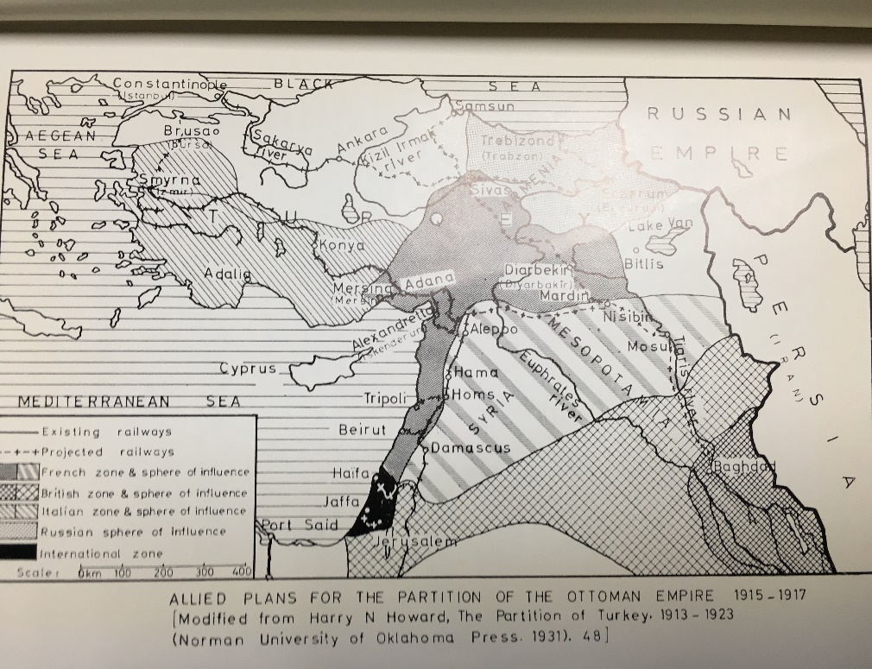
Many countries at the Peace Conference wanted to set up a mandate system in many of these new countries. The mandate system is when one country controls several aspects of another country in order to help them become stronger and readier for the future. The primary countries that pushed this were France and Britain. Both of these countries were former colonial empires and had experience “helping” other countries. France wanted to have a mandate over Syria because of its previous economic ties to Syria, while Britain wanted to control Iraq. These previous economic ties can be seen by the investments that France and Britain had in the Middle Eastern railroads. France pushed money into Syria because many French people had money tied up in Syria, while Britain had investments in Iraq for their railroad there. (See Figure 1) Wilson thought differently and did not want to have a mandate under the United States’ control. Even though some countries would have preferred to have been under the control of the United States, Wilson realized that the American people did not want to be in control of a mandate. Wilson even said that “if the United States were asked to assume a mandate, the request would have to be postponed until he could explain the matter to the American people, ‘and try to bring them to the point of view which he desired them to assume.’” Newly put onto the world stage after a time of isolationism, the American people were very uneasy about getting too involved in the world around them. This sense of American isolationism showed just years later when Congress to pass legislation allowing for the United States to join the League of Nations.
Figure 1. Allied Plans for the Partition of the Ottoman Empire 1915-1917. Source: Howard 7-8

Case Study: Charles G. Stratton
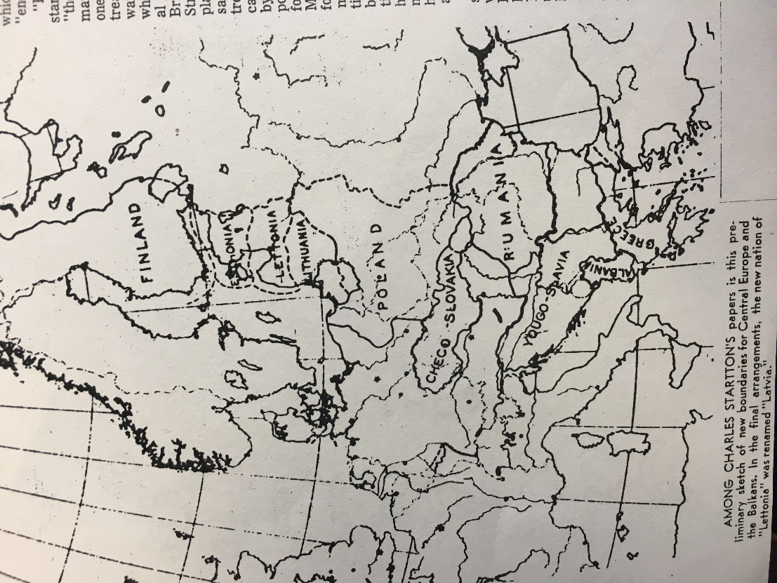
One person from our area that got the opportunity to work with the American Commission to Negotiate Peace was Charles G. Stratton from the University of Wisconsin River Falls or Wisconsin Normal School as it was known in 1919. Stratton was part of the Department of Geography and was taken along as an Assistant Cartographer. Stratton worked alongside Mark Jefferson the Chief Cartographer of the American Commission to Negotiate Peace. Stratton was known for his work as a cartographer. Stratton helped to contribute to the creation of countries like Yugoslavia, Czechoslovakia, Finland, Lithuania, Latvia, and Estonia. (See Figure 2) These countries had to be carved out of different areas in question after World War I and Stratton was one of the few people with the ability and position to do so. In addition to creating these new countries Stratton helped to define and recreate Poland. Some of the problems that Stratton faced while making these maps and new boundaries was working with the secret agreements that had been made by countries. As stated earlier France and England made the Sykes-Piot agreement which divided up the Middle East and where countries would have their own spheres of influence. These types of agreements were difficult to work with because Stratton was supposed to be drawing lines with Wilson’s self-determination in mind, along with these backdoor deals that had been made. These are two completely different ways to decide on borders, and Stratton had to work with both. In the end one of the driving factors that Stratton would use to draw the boundaries was the language and nationality of the groups. Stratton would attempt to bring people together that shared the common language and history and put them into one of these new countries.
Figure 2. Stratton’s Boundary Work. Source: Charles G. Stratton Papers, 1918-1920. 1 Folder.
River Falls in 1915 after going though schooling in Michigan. He only stayed there for a few years before he went to Paris. After the Armistice of World War I on November 11, 1918, Stratton was called upon to be an assistant cartographer to the American Commission to Negotiate Peace in Paris. Stratton’s main role was in establishing international boundaries in Europe.
Much of what the letters to come had to deal with was the compensation of Stratton. Stratton sent multiple letters back and forth to Ward A. Fitzsimmons, the Chief of Bureau of Accounts for the Department of State. In these letters, Stratton is told that his transportation expenses from Paris to New York will be paid for him. Stratton is also informed that he would receive a person expenditure account that would give him up to five dollars a day for miscellaneous expenses. Stratton is also told that his salary for the month of June would be 250 dollars. However, despite things seeming so cut and dry, Stratton ended up having many difficulties collecting his money after he got back to the United States.
Congress did not fund the groups in Paris directly. The Inquiry got its operating expenses paid for from the president’s special contingency fund which is normally used for national security and defense. The total budget from October 1917 to January 1919 was 241,200 dollars. This number is not the amount that the special contingency fund provided for however, because the Inquiry staff occasionally got paid by the universities that they took a leave of absence from. Overall it is estimated that the average payment for staff of the Inquiry was around 1,500 dollars.
When looking into the letters the first letter dated November 30, 1918 the Secretary of State writes to Stratton telling him he has been appointed to the staff of the American Commission to Negotiate Peace as an Assistant Cartographer. His salary would be set at 250 dollars per month and he would begin December 1st, 1918. The letter also says that “The actual and necessary expenses of transportation and subsistence will also be allowed.” This would come to be a problem in the future.
The letters following are all written after Stratton has served his time in Paris. There are no letters regarding his time spent in Paris or letters home to friends or family. The only letters to follow deal primarily with the lack of compensation that Stratton received for his time spent in Paris.
The next letter does not have a date on it, but it is written after Stratton had finished his time in Paris and before he writes complaining about not getting paid. It is to my best guess that the letter was written in early July or late June 1919. In this letter from the Secretary-General to Stratton, the Secretary-General thanks Stratton on behalf of Robert Lansing, Henry White, Edward House, and Tasker H. Bliss. The Secretary-General wished to congratulate him on his successful duties while connected with the Commission. He even stated that, “Your loyal service has been of genuine value to your country and the Commissioners are glad to take the opportunity of so saying to you.” The Secretary-General then continues on and sends his own appreciation for the services of Stratton.
In the next letter in the collection (not the next chronologically) dated April 30, 1919 Stratton is given a record of his payments he received for the maps he made. Stratton was paid a total of 44.48 dollars for ten maps. Of these ten maps, five were of different maps with two copies each. These maps were of Atlante per Tutti, Agostini; L.Europa Etnico Linguistica, Agostini; La Dalmazia (Atlas) and La Dalmazia text, Agostini; Carte Della Dalmazia, Agostini; and Atlante della Guerra Modiale, Agostini.
In the next letter dated May 31, 1919, WM McNeir wrote a letter to Fitzsimmons regarding Stratton’s departure. Stratton left for the United States on June 7, 1919 with his travel expenses paid for. The letter also says that Stratton should receive his entire salary for the month of June at 250 dollars.
In another letter dated July 8, 1919 Stratton sends his travel expenses to Fitzsimmons. Stratton claims to have spent nineteen dollars for transportation to Sandusky, Ohio from New York, then 21.35 dollars from Sandusky to Hudson, Wisconsin, then two dollars from Hudson to River Falls, 3.98 for his sleeping car fare, 1.40 for his lunch and dinner in New York, and 4.05 for his meals during transportation totaling up to 51.78 dollars for travelling expenses.
In his next letter dated September 4, 1919 Stratton writes to WM. McNeir a Disbursing Officer for the American Commission to Negotiate Peace. In this letter Stratton uses a stronger tone and questions why he was not paid for the month of June. Stratton says that he contacted Professor Jefferson and that Jefferson had been paid his salary for the month of June. Stratton then questions why Jefferson had been paid and why he had yet to receive compensation.
In the next letter also dated September 4, 1919, Stratton writes to Ward A. Fitzsimmons. Stratton acknowledges that he did receive compensation for the traveling expenses totaling 51.78 dollars but that he had still not received his payment for June. Stratton again mentions that Jefferson had been paid and that he had not and was wondering what was going to happen. Stratton was slightly confused because he had not received any conformation from Fitzsimmons about getting payment for the month of June. This upset Stratton because he thought that since him and Jefferson worked the same amount of time and left Paris at the same time, that he deserves similar compensation.
In the next letter Stratton writes dated September 4, 1919 as well, Stratton writes to another person named James A. Frear. In this letter, Stratton asks for help in getting himself paid for the month of June. Stratton explained his position and that Fitzsimmons got paid and he did not, so he hoped that Frear would be able to assist him in convincing the Bureau of Accounts to consider the payment.
In the next letter dated September 11, 1919 O. H. Grimwell sends a letter to Stratton regarding the previous letter Stratton sent to Frear. Grimwell was Frear’s secretary and said that in the absence of Frear from Washington, he could send the letter asking for payment to the Department of State. Grimwell stated that if the problem was not resolved shortly that he would advise Mr. Frear to attend to the matter.
In the next letter Stratton gets some good news. This letter dated September 19, 1919 from WM McNeir to Stratton, McNeir explains that he does not know why Stratton was not paid. McNeir reassures Stratton that he will be paid and that the “only excuse I can offer you is that the Bureau of Accounts is overwhelmed with business just at this time.” McNeir also says he will help Stratton by forwarding the letter onto his assistant who will put the letter through right away. McNeir then concludes by saying that Stratton will indeed receive his payment for the month of June.
In the next letter Stratton received some interesting news. This letter dated September 26, 1919 from Fitzsimmons to Stratton stated that Fitzsimmons has the payment for the month of June but that he cannot allow Stratton to receive compensation for his travelling expenses because he was appointed in New York. Stratton quickly responded with a letter on October 2, 1919 stating that he was appointed from Paris. Stratton stated that he went to the American Geographical Society in New York, but that he worked with the Inquiry. He also stated that he had already received the traveling expenses payment and that he hoped he explained the situation well enough to keep the payment.
In the next letter dated November 11, 1919 the Second Assistant Secretary for the Secretary of State, Alvey Adee, writes a letter to Stratton. Adee claims that Stratton should not be allowed the money given to him for the travels to River Falls, Wisconsin from New York City. Since he was appointed from New York City it would be impossible to allow such a claim.
In the next letter dated March 1, 1920 from James A. Frear writes to Stratton saying that he will forward the letter appealing for the money for travels to the State Department. The State Department will then decide the matter and as soon as the word is given, Frear says that he will let Stratton know the result.
In the next letter dated March 11, 1920 Stratton receives a letter from Frear with the results from the State Department. The State Department decides to let Stratton keep the payment for the travel expenses. Frear says that if the check is not received for his work in the month of June within a short time, that Stratton should contact him and he will take it up with the State Department again.
In the next letter dated March 18, 1920 Frank L. Polk the Secretary of State sent a letter to Frear saying the payment would be sent in the near future. The letter said that this decision reversed the previous decision to not have Stratton paid for his travel expenses.
Even though the letters from Stratton do not directly talk about things that American foreign policymakers put forward, they are still valuable to this paper. Through reading Stratton’s letters you get to understand just what the bureaucracy was like in the time when letters were the best communication. You get to understand things about the American Commission to Negotiate Peace that you did not previously know or be able to find out by simply reading secondary sources. We learn some of the works that Stratton got to work on and know the sort of impact that someone who lived just down the street had in such a crucial time in American foreign policy.

Conclusion
World War I was something completely new to the world. No one knew quite what to do afterwards except to prevent it from ever happening again. The attempt to do this was clear in the United States with Wilson hiring over a hundred experts across multiple disciplines to help him make America’s new foreign policy. These people like Charles Stratton, would end up setting the path for the future, which was very unknown coming out of World War I. With Wilson’s primary goal being to make a lasting peace, it was clear that he came into the Paris Peace Conference ready to make a better future. Wilson, a former professor himself, knew that if he was to set a promising future, he would need the best and the brightest minds the United States had to offer. Perhaps if the other countries like France and England had listened to people like King and Crane, then the world would be an entirely different place. The Middle East would be more at ease, especially when looking at Syria. It is clear that the impact the French Government had on Syria was very negative and set them up in a way that destined them to fail later on. It could be a stretch, but with a peace that the United States wanted, World War II may never have occurred. This of course could never be guaranteed, but without Germany having to pay war reparations, give away some of their land, and blatantly accept blame for World War I, a Nazi Germany rising up and starting World War II would be quite unlikely.

Works Cited

Primary Sources

"Anglo-French Joint Statement of Aims in Syria and Mesopotamia." New York Times, November 8, 1918.

Charles G. Stratton Papers, 1918-1920. River Falls SC 17. University Archives and Area Research Center. Chalmer Davee Library. University of Wisconsin—River Falls. River Falls, Wisconsin

"Papers relating to the foreign relations of the United States, The Paris Peace Conference, 1919." UW Digital Collections – Foreign Relations of the United States. http://digital.library.wisc.edu/1711.dl/FRUS.FRUS1919Parisv12.

Secondary Sources

Gelfand, Lawrence E. The Inquiry: American Preparations for Peace, 1917-1919. (Westport, CT: Greenwood Press, 1976).

Grunwaldt, Bryce. “Syria Civil War Roots: Colonization by France to Blame.” (Political Science Capstone, University of Wisconsin-Eau Claire, 2016)

Howard, Harry N. The King-Crane Commission: An American Inquiry in the Middle East. (Beirut: Khayats, 1963).

Lesch, David W. The Middle East and the United States: A Historical and Political Reassessment. Boulder, CO: Westview Press, 1999.

MacMillan, Margaret Olwen. Paris 1919: Six Months That Changed the World. New York, NY: Random House, 2003.

O'Connor, Thomas F. "Library Service to the American Commission to Negotiate Peace and to the Preparatory Inquiry, 1917-1919." Libraries & Culture 24, no. 2 (1989).

Rangel, Sandra. United States. Records of the American Commission to Negotiate Peace: Inventory of record group 256 (Washington DC: National Archives and Records Service, 1974).

"River Falls Cartographer Helped Create New Nations." Pioneer Press (St. Paul), November 24, 1968, Wisconsin ed., Third sec.

Shorrock, William I. "The Origin of the French Mandate in Syria and Lebanon: The Railroad Question, 1901-1914." International Journal of Middle East Studies 1, no. 2 (1970).

"Stratton Hall." University of Wisconsin River Falls. https://www.uwrf.edu/AboutUs/Buildings/StrattonHall.cfm.

"The Paris Peace Conference." The Advocate of Peace (1894-1920) 81, no. 1 (1919): 3-5. http://www.jstor.org/stable/20668167.

Sandra Rangel, United States. Records of the American Commission to Negotiate Peace: Inventory of record group 256 (Washington DC: National Archives and Records Service, 1974), 3.
Rangel, 3.
Harry N. Howard, The King-Crane Commission: An American Inquiry in the Middle East (Beirut: Khayats, 1963), 4.
Howard, 4.
Howard, 9.
Lawrence E. Gelfand. The Inquiry: American Preparations for Peace, 1917-1919. (Westport, CT: Greenwood Press, 1976).
Sandra Rangel, United States. Records of the American Commission to Negotiate Peace: Inventory of record group 256, 3.
Margaret Olwen MacMillan. Paris 1919: Six Months That Changed the World (New York, NY: Random House, 2003).
Thomas F. O'Connor. "Library Service to the American Commission to Negotiate Peace and to the Preparatory Inquiry, 1917-1919." Libraries & Culture 24, no. 2 (1989).
MacMillan, 3.
MacMillan, 8.
MacMillan, 9.
MacMillan, 11.
MacMillan, 13-14.
MacMillan, 15.
Howard, 198.
David W. Lesch. The Middle East and the United States: A Historical and Political Reassessment (Boulder, CO: Westview Press, 1999), 14.
Gelfand, 138.
Gelfand, 141.
Gelfand, 142-143.
Howard, 11.
Howard, 12.
"Papers relating to the foreign relations of the United States, The Paris Peace Conference, 1919." UW Digital Collections – Foreign Relations of the United States. http://digital.library.wisc.edu/1711.dl/FRUS.FRUS1919Parisv12, 751.
"Papers relating to the foreign relations of the United States, The Paris Peace Conference, 1919.", 750.
"Papers relating to the foreign relations of the United States, The Paris Peace Conference, 1919.", 749.
"The Paris Peace Conference." The Advocate of Peace (1894-1920) 81, no. 1 (1919): 3-5. http://www.jstor.org/stable/20668167.
"Anglo-French Joint Statement of Aims in Syria and Mesopotamia." New York Times, November 8, 1918.
Howard, 12-14.
William Shorrock. "The Origin of the French Mandate in Syria and Lebanon: The Railroad Question, 1901-1914." International Journal of Middle East Studies 1, no. 2 (1970), 133.
Howard, 21.
Howard, 19-21.
Charles G. Stratton Papers, 1918-1920. 1 Folder. River Falls SC 17, 1918-1920, 1925, 1954, 1958. University Archives and Area Research Center. Chalmer Davee Library. University of Wisconsin—River Falls. River Falls, Wisconsin.
"River Falls Cartographer Helped Create New Nations." Pioneer Press (St. Paul), November 24, 1968, Wisconsin ed., Third sec.
"Stratton Hall." University of Wisconsin River Falls. https://www.uwrf.edu/AboutUs/Buildings/StrattonHall.cfm.
O'Connor, 146.
O’Connor, 147.
Charles G. Stratton Papers, 1918-1920. 1 Folder.
Charles G. Stratton Papers, 1918-1920. 1 Folder.
Charles G. Stratton Papers, 1918-1920. 1 Folder.
Charles G. Stratton Papers, 1918-1920. 1 Folder.
Charles G. Stratton Papers, 1918-1920. 1 Folder.
Charles G. Stratton Papers, 1918-1920. 1 Folder.
Charles G. Stratton Papers, 1918-1920. 1 Folder.
Charles G. Stratton Papers, 1918-1920. 1 Folder.
Charles G. Stratton Papers, 1918-1920. 1 Folder.
Charles G. Stratton Papers, 1918-1920. 1 Folder.
Charles G. Stratton Papers, 1918-1920. 1 Folder.
Charles G. Stratton Papers, 1918-1920. 1 Folder.
Charles G. Stratton Papers, 1918-1920. 1 Folder.
Charles G. Stratton Papers, 1918-1920. 1 Folder.
Charles G. Stratton Papers, 1918-1920. 1 Folder.
Bryce Grunwaldt. “Syria Civil War Roots: Colonization by France to Blame.” (Political Science Capstone, University of Wisconsin-Eau Claire, 2016).

