SIXTY YEARS OF COMMUNITY:
ST. OLAF CATHOLIC PARISH IN EAU CLAIRE, WISCONSIN,
1952-2012

Michaela Walters
History 489
Fall 2012

Copyright for this work is owned by the author. This digital version is published by McIntyre Library, University of Wisconsin Eau Claire with the consent of the author

If society doesn't appreciate the impact of religion on the lives of people, it will sorely underestimate both what the society can do and sorely underestimate the ability of the society to achieve… If we more and more divorce ourselves from an adherence or appreciation of the impact of religion, we more and more become disinterested in terms of the impact of religion on lives, we'll quickly see ourselves in a rootlessness, if you want. Nothing pinning us down or holding us down.
~~Archbishop Jerome E. Listecki, former bishop of the Diocese of La Crosse

Abstract

This paper will explore how the parish community of St. Olaf in Eau Claire, Wisconsin, established in 1952, reflects the Roman Catholic Church, specifically at the local, state, and national levels in the United States. It will also discuss the various changes that have occurred in the past 60 years of its history in terms of the various locations of worship for the members, the growth of the community outreach programs, and the effects of the Second Vatican Council. This ecumenical council was a meeting of Catholic bishops from around the whole that brought reform to the Catholic Church and affected the relationship of the Catholic Church to the world. The parish at St. Olaf has grown from having only 125 families in 1952 to over 1,000 families in 2012.
CONTENTS

ABSTRACT……………………………………………………………………………………...iii

INTRODUCTION…..………………………………..…………………………………………...1

PART ONE: DIOCESE OF LA CROSSE………………………………..………………………2

PART TWO: THE ESTABLISHMENT OF ST. OLAF PARISH…..………………..…………..5

PART THREE: ST. OLAF PARISH AND THE COMMUNITY OF EAU CLAIRE, WI……...18

PART FOUR: AMERICAN ROMAN CATHOLIC CHURCH CONNECTION……….….......23

PART FIVE: ST. OLAF TODAY……………………………………..…….….……………….27

CONCLUSION……………………………………………………………….……………….....30

APPENDICES

APPENDIX A: Map of Catholic Dioceses in Wisconsin, 2012.…………………….......31
APPENDIX B: Tables …………………………………………………….…………….32
APPENDIX C: Illustrations of Important People in St. Olaf’s History …………..…….36
APPENDIX D: Illustrations of Important Events in St. Olaf’s History…………………43

BIBLIOGRAPHY…………………………………………………………………….……….....56

Introduction:
The greatest cliché known to man is that if you forget the past you are doomed to repeat it. Well, this concept can be applied to the idea of self: you do not know who you are without knowing where you come from. For this reason, the study of the Roman Catholic Church is vitally important, especially in regards to parishes and their effect on local communities. This paper will explore how the parish community of St. Olaf in Eau Claire, Wisconsin, established in 1952, reflects the Roman Catholic Church, specifically at the local, state, and national levels in the United States. It will also discuss the various changes that have occurred in the past 60 years of its history in terms of the location of its buildings, the development of the community outreach, and the effects of the Second Vatican Council.
The parish at St. Olaf has grown from having only 125 families in 1952 to over 1,000 families in 2012. Over its 60 years it has experienced change and expansion but the most obvious changes came from the Second Vatican Council. Unlike previous ecumenical councils in the Roman Catholic Church, such as the First Vatican Council, the Council of Trent, and the medieval Councils, the Second Vatican Council was a true general assembly because it assembled bishops and experts of every nationality and from every corner of the world on a scale that had never been before approximated.
With St. Patrick’s, Sacred Heart, St. James, and Immaculate Conception Catholic parishes already established, the announcement of another Catholic Church in Eau Claire was a surprise to many community members, Catholic and non-Catholic alike. However, the formation of St. Olaf reflected the need for a Catholic parish on the north side of Eau Claire. It has also been a very active member of the community since its beginnings. Today, the parish can boast having 70 different organizations and committees that engage the community of Eau Claire in one way or another.
Part One: The Diocese of La Crosse
The Diocese of La Crosse traces its roots to the Archdiocese of Milwaukee, which was established in 1843. In 1868, the Diocese of La Crosse was created out of land that had previously been part of the Archdiocese of Milwaukee: the region between the Mississippi and Wisconsin Rivers. At the time of this restructuring, the population of Catholics in Wisconsin was 30,000 and the total number of priests ministering to the area was only eighteen.
In 1905, the boundaries of the diocese shifted again with the establishment of the new Diocese of Superior. This new diocese contained all the land north of Pierce, Dunn, Chippewa, Clark, and Marathon counties. With this same shift, the Diocese of La Crosse gained Grant, Iowa, and Lafayette counties to the south. Later, in 1948, the last three counties mentioned were designated as the Diocese of Madison. This shift left the Diocese of La Crosse as it is today: 15,078 square miles and consisting of nineteen counties in west central Wisconsin.
During the diocese’s 144-year history, eleven bishops have served the Diocese of La Crosse. On August 22, 1945, Father John Patrick Treacy was named Coadjutor of the La Crosse Diocese and Titular Bishop of Metelis (see Appendix C, Illustration 1c). A coadjutor bishop is appointed to assist an ordinary bishop in the administration of a diocese. In this case, Bishop Treacy was assisting an ailing Bishop Alexander McGavick. He was consecrated bishop a few months later on October 2. Within a year, Bishop McGavick was forced to retire due to the restrictions that come from old age, and on July 23, 1946, the Pope Pius XII named Bishop Treacy Apostolic Administrator and Ordinary of the La Crosse Diocese.
When Bishop Treacy became Coadjutor of the Diocese of La Crosse, he was also selected as Titular Bishop of Metelis. Metelis is an ancient diocese of Lower Egypt established during the Fourth Century. Sometime in the Sixth Century it ceased to exist as an active Catholic center due to the Monophysite heresy which had spread through most of Egypt. The act of appointing Titular Bishops to areas that no longer are active dioceses arose from the concept that though the Church may be abandoned, it will never abandon its people. When Bishop McGavick passed away on August 25, 1948, Bishop Treacy succeeded to the La Crosse See, thereby losing his Titular See of Metelis.
The years during the Great Depression and World War II saw no physical expansion of the Diocese of La Crosse; some places even lacked both churches and schools, despite the growing Catholic communities within those areas. However, with the war over in 1946, the newly appointed Bishop Treacy wasted no time starting in establishing new parishes. In fact, during the reception for the new bishop, Archbishop Amleto Giovanni Cicognani, Apostolic Delegate to the United States, had this to say about Bishop Treacy:
For many years, either at his office-desk, or in parishes, or in institutions, by addresses and lectures, Msgr. Treacy endeavored to arouse zealous interest in the Faith, to spread it, to gather the means necessary for its expansion, and to send these means everywhere with generous and large vision. Thus his aim has been to make Christ and His Church better known, and loved, and to call all men to the love of God and love of neighbor—of all neighbors without distinction.

Within his first twelve years of service as bishop, Treacy established a total of 166 new Catholic institutions in the La Crosse Diocese: 31 churches, eight Catholic central high schools, 28 parish grade schools, 45 convents, 40 rectories, and 14 other types of religious institutions. In Eau Claire alone, Bishop Treacy established three parishes, St. James, St. Olaf, and Immaculate Conception; four grade schools, Immaculate Conception, St. James, St. Olaf, and Sacred Heart; one high school, Regis; three convents, Immaculate Conception, St. James, and St. Olaf; and one priory, St. Bede’s.
These additions made by Bishop Treacy in Eau Claire added to the two already existing parishes and Catholic hospital; they reflected the population growth of the city from 46,999 in 1940 to 58,300 in 1960. This population growth can be linked to the nation wide trend seen in the United States during the post-World War II years. These additions seen in Eau Claire, and throughout the Diocese of La Crosse, reflect the period of prosperity, expansion, and confidence in the region.
Part Two: The establishment of St. Olaf Parish
On July 2nd, 1952, Bishop Treacy announced the establishment of a new Catholic Parish on the north side of Eau Claire, Wisconsin. This new parish community in Eau Claire was one of the many churches that were established during Bishop Treacy’s era of growth. This new parish was to be called St. Olaf. Father Brian Konopa, current priest of St. Olaf, explained in his July 29, 2012 homily how the newly established church was given its name:
The name, St. Olaf, how was it chosen? Very little input. The very believable story is that the Bishop’s secretary, Father Tom Finnukin, a native of Eau Claire, told the Bishop that there [were] a lot of people of Norwegian extraction in Eau Claire; we should choose the patron saint of Norway. Apparently, part of the story was also, that maybe if we chose a Norwegian saint, more Norwegians would start going to church. And almost everyone knows that Norwegian Christians tend to be Lutheran. St. Olaf College in Minnesota, a Lutheran College, and there was a belief that maybe the Lutheran would check us out. And on the Lutheran hour on the radio, the minister questioned publicly does Eau Claire really need another Catholic Parish. And there were a lot of Catholic asking the same thing.

St. Olaf Haraldson was born in Scandinavia in the year 995, in the region that today is known as Norway (see Appendix C, Illustration 2c). At this point in Norway’s history, Christianity had made some appearance but the population remained largely pagan. It was a time where the culture expected, and even promoted, the behavior that is associated with Vikings: pillaging pirates. At the age of twelve, Olaf’s father, King Harald of Norway, signed him up to become a member of a group of marauding Vikings. With this group Olaf learned to pillage and murder with a clear conscious.
At age sixteen, Olaf left that lifestyle to become a mercenary soldier against England. While a mercenary soldier, Olaf created a reputation for being good at strategy, trickery, and efficiency and became well respected. At the age of eighteen, he decided to become baptized while in France. He then committed himself to Christianizing his native country by making himself king and uniting the clans. At this time Scandinavia was the only part of Western Europe that was still pagan. Part of his motivation for Christianizing Norway was political; European kings would not form alliances with the non-Christian Vikings. Olaf wanted his country to be seen in the eyes of the Europeans as more than just murderous pirates.
Olaf returned to his homeland and successfully made himself king. He brought English priests with him to be missionaries in his land; however, the conversion rate was slow. Due to this slow progress, Olaf took 300 of his best men and went to the regions that were resisting Christianity the strongest. He then destroyed their pagan temples, ordered them to become Christians, and punished those that refused conversion by cutting off a hand or foot, blinding them, or executing them. Olaf’s “biographer at the time says he let none go unpunished who would not serve God.”
When Olaf was thirty-three years old, he had to flee the country to save his life from an evading army. When he fled, he took his mistress and their son with him, and heir, and left his wife and daughter behind. The decision on Olaf’s part to leave his family behind would have been seen as reasonable for the cultural standards of the time. After two years in exile, Olaf returned to Norway to reclaim his thrown:
And the battle cry was on, onward, on Christ’s men, on Cross’s men, on King’s men. And they took the field, there was a solar eclipse, and King Olaf died. The first mortal blow he received was from an axe. His army disburse, they came back to claim his body, a soldier wiped the blood off of his face and as soon as the blood came in contact with his wounded hand it healed instantaneously. And there was a blind man on the battlefield also who experienced complete healing, he was able to see. So the sole Bishop of Norway said the king is a saint! It was easy for them to believe in their culture and to accept. For us…a little harder to accept. But there were miracles and they buried King Olaf in the first church he had built. And it became a place of pilgrimage and some miracles. Forty years later they transferred his body to a new cathedral church and when they saw the body, they say that the cheeks, the flesh of [his] face was as it were on his last day of life. And Norway became a Christian nation.

The announcement from Bishop Treacy about the new church in Eau Claire being named St. Olaf included a list of the church boundaries. On July 9th, 1952, only one week after Bishop Treacy’s announcement, St. Olaf’s first pastor, Father Robert Agnew, arrived in Eau Claire (see Appendix C, Illustration 3c). Father Agnew took that list of parishioners within the boundaries, knocked on their doors, and informed them that they were asked to be part of establishing the new St. Olaf Parish.
In the same homily as quoted above, Father Konopa discussed the different reactions to the establishment of a new parish in Eau Claire:
In the six years I’ve been in town, I’ve heard people tell stories of how oh you know there was an excitement about being a part of this. I’ve heard others say, well, we joined because you had to and that’s what you did in those days. And I’ve heard stories of people who said we’re not leaving Sacred Heart Parish. It wasn’t such an illustrious start.

There are two different parishioners that did not mind having another Catholic Parish established in Eau Claire because it was better for them based on where they lived. One of them, charter member Jeanne Lennie, described her reaction to the new church in an interview: “as far as I was concerned that was fine, because it was going to be closer for us, you know. But the people that went to Sacred Heart, they weren’t very happy with it…because they really wanted to continue with it and they had gone to Sacred Heart all their life. But actually some of the most active people were the ones that came from that parish.” The other member, Janet Figlmiller, who joined St. Olaf only a few months after its establishment had this to say about what she and her family thought of the new parish: “it was fine because it was out here, where we needed one, you know. It wasn’t [an issue] for [my husband] Dick and I at least.”
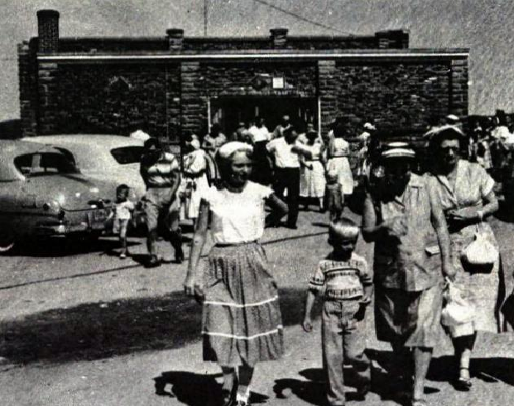 When Father Agnew first arrived in Eau Claire, he made his home, temporarily, at Immaculate Conception’s rectory. Having a place for himself, Father Agnew then went in search for a place for his parishioners. The only building big enough to hold Mass for the growing congregation was the Veterans of Foreign Wars (V.F.W.) Clubrooms at 1300 Riverview Drive (see Appendix D, Illustrations 3d and 4d for more pictures of the V.F.W.). It was not the most ideal location for a place of worship, but it was 33 by 52 feet and had the space needed for 200 people. The parish celebrated its first Mass at the new location on August 17, 1952. A folding chair was used for the altar, the parishioners could not kneel, and the charter members remember hearing empty bottles from the night before being broken outside during the service. The V.F.W. Clubhouse was not the most appropriate space for the celebration of Mass, but having observed its first Mass together as a congregation was “like a signal for the new parish [and its members] to say ‘we are.’”
Source: St. Olaf Parish, “Silver Jubilee, 1952-1977” (parish document, Eau Claire, WI, November 1977), 7.
Illustration 2.1 Sunday Church goers leave the V.F.W. after Mass

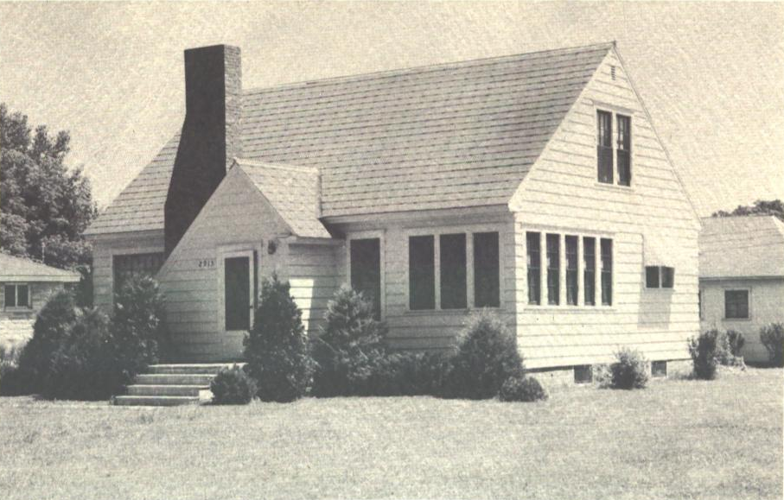The V.F.W. Clubhouse saw many “firsts” for the parishioners at St. Olaf. On October, 1952, St. Olaf had its first Baptisms in the new parish at the V.F.W. (see Appendix D, Illustration 1d). The first High Mass in the parish was held on December 25, 1952 at a Midnight Mass in the V.F.W. The high school students sang, while Sadie Agnew, Father Agnew’s mother, accompanied them on an organ that was borrowed from St. Benedicts School in Altoona.
Illustration 2.2 Parish House

On September 12, 1952, the parish bought a house, pictured to the right, at 2913 N. Hastings Way, to serve as the rectory and place for daily Mass for the 125 families that made up St. Olaf Parish. Father Agnew and his mother moved into the new rectory on October 3, 1952. A parishioner from St. Patrick’s Parish, Mary Curran, donated many of the furnishings for the new acquisition. This location also served the purpose of holding organizational meetings and confessions. A permanent rectory for the parish, located at 2408 North Lane, was purchased on October 16, 1953. This newly purchased home, pictured below, was across the street from the planned building site for the future parish.
Source: St. Olaf Parish, “Dedication Souvenir of the Parish of St. Olaf” (parish document, Eau Claire, WI, September 26, 1954), 15.
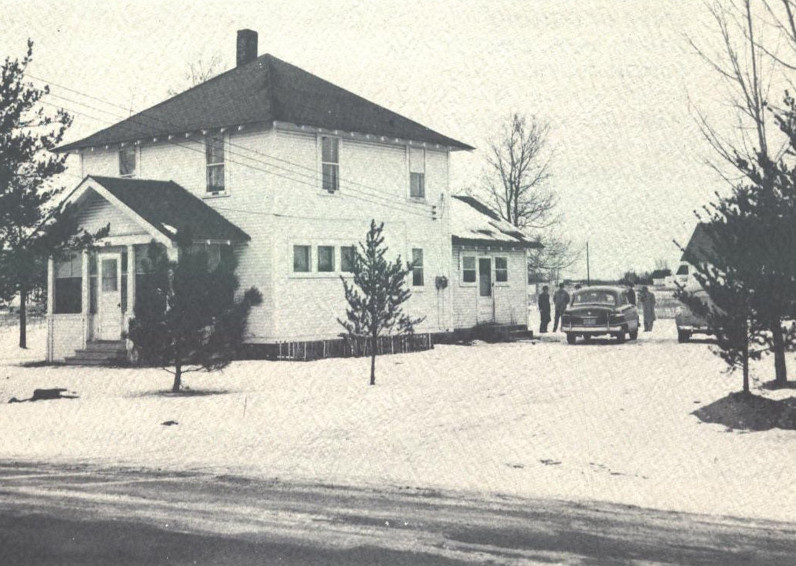
Source: St. Olaf Parish, “Dedication Souvenir of the Parish of St. Olaf” (parish document, Eau Claire, WI, September 26, 1954), 25.
Illustration 2.3 Permanent Rectory

As the parish grew, so too did the need for more Mass services. Soon three Masses were required each Sunday and Father Jerome Palmer, chaplain of St. Bede’s Priory, was asked to be the unofficial assistant on Sundays and Holy Days (see Appendix C, Illustration 4c). Father Palmer said his first Mass at St. Olaf on April 29, 1953. The Benedictine Sisters of St. Bede’s Priory also played a part in the early development of St. Olaf by teaching summer school and vacation schools in the living rooms, basements, and garages of various parishioners.
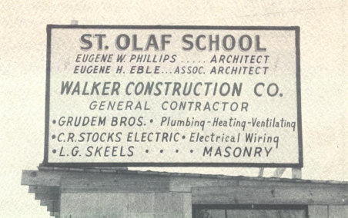The first permanent building that the congregation of St. Olaf decided to undertake was the construction of a school building; they did this so that their children would have a place where they could learn their faith. The building committee consisted of John Grill, Louis Statz, Andrew Carlson, Rudolph Epp, and John Hoeppner (see Appendix C, Illustration 5c). On May 24, 1953, this group of men asked Eugene W. Phillips, a Milwaukee architect, to draw up plans for the school. The bidding for the new school started on December 14, 1953, and soon after, the contracts were signed: Walker Construction Company was chosen as the general contractor; Grudem Brothers, of St. Paul, Minnesota, was selected for the plumbing, heating, and ventilating work; and C.R. Stocks Electrical Company was chosen to do the electrical work.
Source: St. Olaf Parish, “Dedication Souvenir of the Parish of St. Olaf” (parish document, Eau Claire, WI, September 26, 1954), 21.
Illustration 2.4 Construction-in-progress Sign
The fact that the school was built before the congregation even had a formal church reflects the importance that Bishop Treacy, and the congregation of St. Olaf Parish, placed on Catholic education. It definitely speaks to the concern that Bishop Treacy placed on Catholic education during his era of growth. The significance of Catholic education was addressed by Father Agnew in a funeral sermon for an eighth grade boy that died accidentally of strangulation in his yard on April 16, 1958:
People sometimes wonder why new Catholic parishes erect a school before they build a church. This morning we, unfortunately, seem to have the answer. Catholics are not so much concerned with having a beautiful edifice erected in their parish, but are concerned primarily with the proper training of their children as beautiful living temples of the Living God.

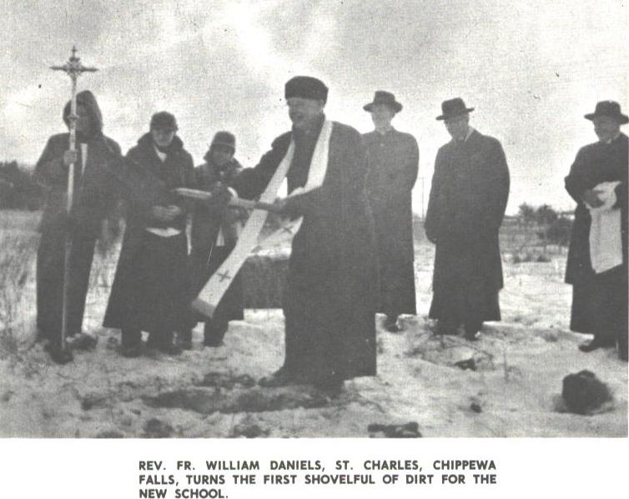Father Agnew, along with other priests from surrounding churches, participated in the ground breaking ceremonies for the new school on January 10, 1954. Reverend Father William Daniels, from St. Charles Church in Chippewa Falls, is shown on the left turning the first shovelful of dirt for the new school.
Source: St. Olaf Parish, “Silver Jubilee, 1952-1977” (parish document, Eau Claire, WI, November 1977), 12.

Illustration 2.5 Groundbreaking Ceremony
In September, 1954, Bishop Treacy dedicated the finished school building. The finished product had two stories and was 60 by 120 feet. The walls were left out of the second floor in order to provide enough space for a temporary chapel and living quarters for the teaching sisters. The new space on the second floor of the completed school building made the V.F.W. no longer necessary. In the Dedication Souvenir book, Father Agnew mentions the V.F.W. specifically by writing, “The Veteran of Foreign Wars deserve special mention for their goodness in furnishing us with a ‘church’ during these past two years.”
Initially, Bishop Treacy wanted to build a small permanent convent for the sisters, however, Father Agnew and Eugene Phillips, the architect, persuaded him to wait on those plans. In a letter to Father Agnew, Phillips wrote, “a small permanent convent…would be entirely inadequate and would require remodeling and of course enlarging [in the future when the number of nuns would increase].” A few days after receiving this correspondence from Phillips, Father Agnew sent the following to Bishop Treacy:
Mr. Phillips still believes that we would be saving money by proceeding with the original plan…As he points out, construction would be simple enough that our parishioners could easily handle it, and that plumbing and heating would have to be installed on that floor later on anyway…In thinking it over, it seems to me that, psychologically, the parishioners would respond better to the original proposal. They know that, as near as Immaculate Conception Parish, the Sisters are living in just as such temporary quarters in the school. Therefore, if I come out with the proposal of a ten-room school, several rooms of which we won’t need at the start, and then propose a separate wing for a convent, I feel sure that they will feel that I’m not looking out for their best interests and will immediately begin asking, “Why can’t we do like Immaculate Conception?”. On the other hand, as soon as the time comes that the school is actually filling up and we will need the entire area for classrooms, it would seem that the people would more readily fall in line with the job of quarters against the interest on the cost of building a convent immediately, I doubt that there would be a great deal of difference one way or the other. Nevertheless, as I say, it seems to me a better psychological approach to give the people the impression that we are trying to save them money, by being one jump ahead of them on the proposal of these temporary quarters.

The Franciscan Sisters of the Sorrowful Mother would eventually become the staff members of the school, however due to a lack of sisters to teach, the school classrooms were not open until September 1955. At that time the school opened its doors to 186 students in grades one through seven. Even though there were eight classrooms available the students were confined to only four. The small number of classrooms open was due to the limited teaching staff available; only three nuns and one lay teacher made up the school staff.
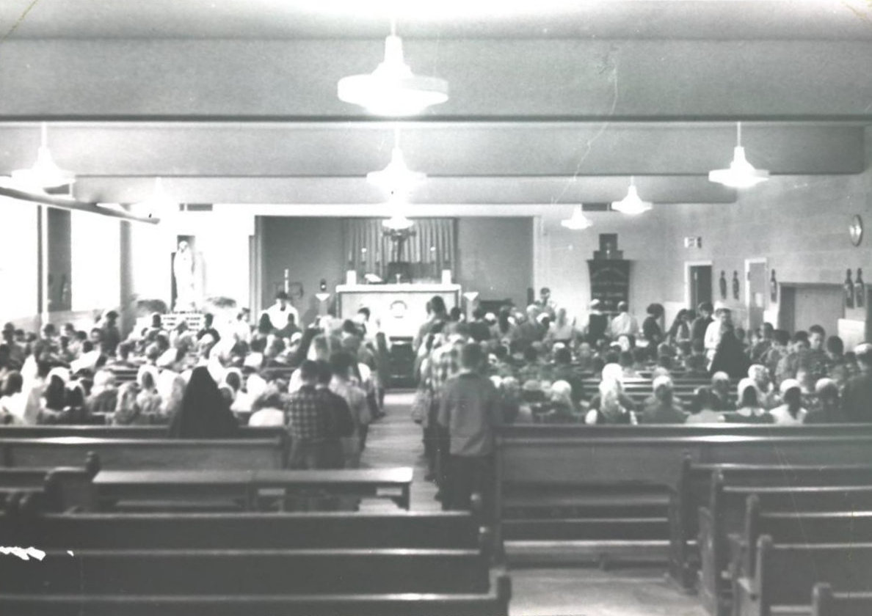The following years saw an increase in enrollment at the school so all the classrooms needed to be open. This meant that there was no longer available space on the second floor for the church: once again, the parishioners had to find a new space for worship. A room in the basement that had previously been used as a dining room and meeting hall then became the new church, as seen in the picture to the right.
Illustration 2.6 Mass held in cafeteria, 1957
Photograph Courtesy St. Olaf Parish
In the fall of 1960, additional changes were made to the school building: a combination gymnasium/auditorium, four more classrooms, and a music room were constructed. The gymnasium/auditorium was built to seat 500 people and served the purpose as temporary church. The reason for the need of physical improvements of the church can be seen in Appendix B, Table 5, which shows the growth of the parish. In a brochure to the parishioners about the plans for the new additions, Father Agnew stated that this area was to “serve as a church for many years to come. With it in use, you won’t have to sit in the kitchen, nor on the stairs, to assist at Sunday Mass. With it in use, the present ‘Church’ can again be used for its original purpose, a dining hall and meeting hall.”
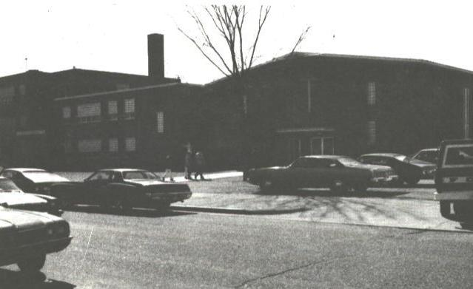In April 1969, discussion began about merging the schools at St. Olaf and Sacred Heart into one. However, it wasn’t until the next year, on March 24, 1970, that the Eau Claire Catholic School Board voted in favor of the proposed merger of the two schools. The merger took effect in the fall of 1970. In Appendix D, Illustration 9d, representatives from St. Olaf and Sacred Heart are seen signing consolidation papers. In the agreement, St. Olaf’s school building would accommodate grades one through five and Sacred Heart’s school building would accommodate grades six through eight. The two schools merged under the title, “St. Thomas Learning Center.” This merger only lasted for a short time before it ended: Sacred Heart was closed because there were not enough students. So in 1978, St. Olaf offered grades six through eight once again.
Illustration 2.7 1960 Addition to the School.
The “temporary” church in the gymnasium/auditorium, as seen on the right, was the place of worship for the members of St. Olaf Parish until 2001. On February 18, 2001, the current structure that is considered St. Olaf Parish today was dedicated and the “old church” renovated and renamed the Father Robert Agnew Parish Center.
Source: St. Olaf Parish, “Silver Jubilee, 1952-1977” (parish document, Eau Claire, WI, November 1977), 16.

Over the past sixty years there have been a total of six priests that have served the members of the St. Olaf Parish community. Table 2.1, shown below, lists of the priests that have served St. Olaf Parish. All of these priests had different personalities and brought different things to the parish. When speaking about all the priests that St. Olaf had over the years, Jeanne Lennie said, “each one of our pastors, each time that anybody leaves we say, ‘oh my gosh, we’ll never get another one that we like that well’, but we always have. They’re all different but you love them all and we have to just be so thankful that we have them.”
Table 2.1 Priests that have Served at St. Olaf Parish
(see Appendix C, Illustrations 3c and 6c-10c)
Name of Priest | Years they served St. Olaf Parish
Fr. Robert E. Agnew | 1952-1964
Fr. Mryon “Mike” Meinen | 1964-1974
Fr. William “Bill” Matzek | 1974-1985
Fr. William “Bill” Menzel | 1985-1991
Fr. Frank Corradi | 1991-2006
Fr. Brian D. Konopa | 2006-present
Source: St. Olaf Parish, “History,” St. Olaf Parish, http://saintolafparishorg/wp/about-st-olaf/history/ (accessed September 16, 2012).

When asked about Father Agnew, Janet Figlmiller, said that he was a “sweet and gentle man…he was just like his mother…just very, very nice.” Father Meinen was described by Figlmiller as being “just a farm boy, raised up in Chippewa County. He was a very sincere man…like I say, he was just a very typical farm boy…he was very nice, very sweet.” Mary-Ann Pozarski, a parishioner of St. Olaf since the 1970s said that Father Matzek “was very influential, I think, in getting the people to, oh how shall I say, kind of like Father Konopa is now, in getting everybody to be community. That was the way Father Matzek was also. Because he was there to get everybody to kind of join together again and be community.”
Carol Adams, a member of the church since 1970, said, “I think each of them brought something different, you know. And you could see where each of their strong points were; Father Menzel’s would have been with young people, and Father Bill Matzek was more, he was just all over.” At this point, Carol’s husband Gene, added that Father Bill “was more rounded than any of them I think, as far as, every area.” Gene went on to say that Father Corradi “was an outstanding person as far as sermons goes, and teaching. I think that was his strongest point.” He continued talking about the priest by saying, “Father Konopa is very strong in the same things that Father Bill was and even plus…and we’d like to keep him until he retires.” Carol added that Father Konopa is “very strong with young people also.”
Part Three: St. Olaf Parish and the community of Eau Claire, Wisconsin
Before the establishment of St. Olaf in 1952, Eau Claire, Wisconsin was no stranger to new churches and schools. During the 1850s, many families began settling in Eau Claire. A major concern for the community was having places to practice their religion. By 1861, Eau Claire had four different churches, from four different denominations: First Presbyterian built in 1857; First Congregational Church built in 1859; St. Peter’s Catholic Church built in 1859; and the first Baptist church built in 1861. By 1870, there were 10 churches, representing several denominations, throughout the city of Eau Claire. The establishment of these churches gave the community the sense that they were in it for the long haul.
Another major concern for the community of Eau Claire was educating the youth in religion because the families that settled in the area in the 1850s brought with them small children. By 1865, four public schools were established. Parochial schools were another thing that was constant in the young children’s lives and by 1870 Eau Claire saw its first Catholic school when St. Patrick’s constructed a frame building on North Barstow Street.
Eau Claire during the post-World War II years, like with many communities throughout the United States, saw a time of expansion and population growth. By 1950, Eau Claire became the tenth largest city in Wisconsin when it experienced a nearly 16 percent population increase in a 10-year period. This post-war baby boom required Eau Claire to add six new buildings to the public school system in 1953. This overflow in public schools was reflected in the fact that parochial schools, such as St. Olaf, were able to open and have decent enrollment numbers.
Despite the fact that religion had been an important part of Eau Claire’s nearly 100-year history, when Bishop Treacy first announced the plans for a new Catholic church, many residents, both Catholic and non-Catholic alike, questioned if there truly was a need for another parish. In a pamphlet created about the 1960’s school addition, Father Agnew shared statistics that he felt addressed the questions that many had about a new parish:
Since the start of the Parish, there have been: 410 Infant Baptisms. (An indication of the great run-over in our parish is that 100 of these children no longer live here, but have been more than replaced by others moved in.) 67 Adult Converts. 294 First Communions. (Until our school opened, most of our children received First Communion in neighboring parishes.) 62 Weddings. 50 Funerals.

In addition to providing a Catholic education, St. Olaf Parish has been an active member of the Eau Claire community since its inception. The parish’s first organization, the Altar Society, was formed on August 22, 1952 and created with the purpose of organizing social activities for the parish. Mrs. Victor Figlmiller Sr. was its first president; she was assisted by Mrs. John Grill, Mrs. John Hoeppner, Mrs. Clyde Omodth, and Miss Pat Gilfoy (see Appendix C, 11c). The group met at Sacred Heart Hall. The ladies of the Altar Society immediately began their work to raise money to go towards the parish’s debt and hosted its first big event, a bake sale. The sale was held in a parishioner’s basement on August 29 and was considered a “Big Success!” The next event they held, “Miles for Pennies” drive, in November raised $600.00.
The first Sunday in October of 1952 saw the parish’s first big community event, a turkey dinner at Sacred Heart Hall, where over 1,000 meals were served.
Illustration 3.1 Advertisement for St. Olaf’s first major event

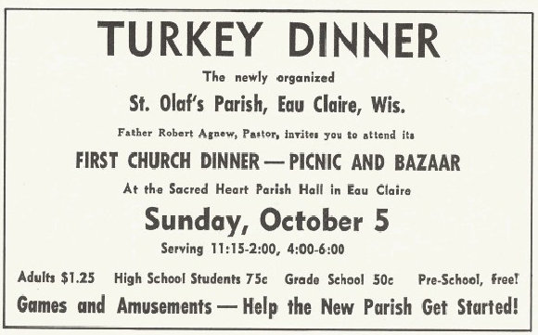
Source: St. Olaf Parish, “Silver Jubilee, 1952-1977” (parish document, Eau Claire, WI, November 1977), 9.

In June, 1953, St. Olaf had a number of “firsts”: on June 16, Wilmer Dekan and Frances Schoettle became St. Olaf’s first couple to be married in the church; on June 21, the first parish picnic was held at St. Bridget’s Hall in Springfield, Wisconsin; and on June 28, the church saw its first First Communion class. The first adult instruction class was held on July 13. On September 27, the men of the parish sponsored a lunch and supper at Sacred Heart Hall.
The “choir” was initially just Father Agnew’s mother playing the pump organ, with the kids singing along. Later in 1952, the adult choir was officially started by Irene Roberge and the members consisted of some of the female parishioners. It was not until Father Raschke was assisting at St. Olaf that men joined the choir. Jeanne Lennie recounts the story as follows: “he wanted some of the men in it too. So he told the men, at Lent, their Lenten penance was to join the choir, at least during Lent. Well the ones that came and joined the choir just stayed with us…there were quite a few men and they stayed because we had a good time.”
One of the more interesting events in the parish’s history was when Mrs. Sal Figlmiller, Altar Society president, was arrested at St. Olaf for hosting a Bingo, or what was then called House, Party. When asked about the Bingo arrest, Janet Figlmiller told the following story:
Sal was the chairlady of the group that had it. And they didn’t call it Bingo, they called it House. And Dad was calling the numbers off and we had gotten word that the police were on their way so what could we do we were all sitting there, you know, because I was helping Sal that night for serving lunch. And they came in and boy they arrested her right now. She was playing Bingo, you know. Oh she was so upset, and then to think they put it in the paper, and put her age in the newspaper. She was just mortified. But as soon as we heard, you know, saw them coming in, why I went to the phone and called, I don’t remember if it was St. James or some other parish, because they were having Bingo that night too. And it was just a political thing…it was against the law, gambling was against the law. It was kind of funny. The thing was, Mrs. Nix, was in our place playing Bingo, or playing House, and her son was the District Attorney. And she said, ‘if you prosecute that woman, you will never come in my house again.’ So it was all just kind of trickled out… [Sal] was the only one arrested because she was the chairlady.
The next time that Bingo shows up in St. Olaf’s records is the 1974 Annual Report.
On November 2, 1955, two months after the opening of the school, St. Olaf held its first Parent Teacher Association (P.T.A.) meeting with Donald McCrackin as the president. While at St. Olaf as the assistant pastor, Father Meinen organized the Athletic Program for the school and conducted a fund raising project which led to the purchase of an organ for the church. He also organized the St. Vincent de Paul Society, which brought aid to the poor and needy in the Eau Claire community.
In a letter written to the parishioners of St. Olaf on January 30, 1971, Father Meinen announced that the Bishop of La Crosse recommended that St. Olaf form a Parish Council. He wrote,
When all members of the Parish cooperate through one or more of their respective commissions and organizations in the programs of worship, education, and social life, the Parish becomes more and more effective in communicating to all its members. Hopefully, during the months of February and March we can establish a complete Parish Council through a democratic process with dually elected executive officers, committee heads, and members.

The establishment of the Parish Council was just one of many examples of how the Second Vatican Council affected the parish community at St. Olaf.
Part Four: St. Olaf’s Connection to the American Catholic Church
One of the biggest and more important connections that the parish community of St. Olaf has to the American Catholic Church was seen through the changes that occurred due to the Second Vatican Council. Pope John XXIII announced in January 1959 his intentions to call an ecumenical Council. On October 11, 1962, Pope John explained in his opening address his objectives for this council: to bring the Catholic Church up to date, and to gain with this goal an open relationship, or dialog, with fellow Catholics, people of other religions, and with the secular world (see Table 4.1 below).
Table 4.1 Important Dates of the Second Vatican Council
January 1959 | Pope John XXIII announced his intention to summon a Council
October 1962 | 1st session began
December 1972 | 1st session closed
June 3, 1963 | Pope John XXIII died
June 21, 1963 | Pope Paul VI elected as new pope and announced plans to continue Council
September 1963 | 2nd session began
December 1963 | 2nd session closed
September 1964 | 3rd session began
November 1964 | 3rd session closed
September 1965 | 4th session began
December 1964 | Council closed
Source: Vatican Council and Walter M. Abbott. The Documents of Vatican II, (New York: Guild Press, 1966), 741.

The Second Vatican Council broke a four-hundred-year tradition by changing the Roman Catholic Church’s relationship with the outside world from a defensive position to an engaging, active role with the world outside the Church. There were many changes that came after the Second Vatican Council convened, however there are only a few obvious changes that derived from this Council at St. Olaf Parish in Eau Claire, Wisconsin.
One change that was seen at St. Olaf as a consequence of the Second Vatican Council was the way that the Mass was celebrated. Before the Council, the Mass was said in Latin and not in English. Also, the priest would have his back to the congregation but after the Second Vatican Council, the priest would face the congregation directly. Though Gene Adams became a member of St. Olaf ten years after the Council’s implementation of its changes, Gene gives a good general description about how the Mass language changed:
We had our missals, and the missals were in Latin on one page and there was English on another. But it was all recited in Latin…the Latin was the usual routine which even though [we] knew how to respond [we] had to look on the other page to see what it meant…it was really very nice when it became all English because at least you knew what you were saying and there was a lot more reverent I think. It really was a breath of fresh air.

Gene also mentioned that the baptisms before the Second Vatican Council were never done during the Mass, but were held in small, private ceremonies in the afternoon. Carol Adams, Gene’s wife, added that “whereas now you get a feeling of community, that this person when they’re baptized is a new member of our community…so the sense of community has been stressed in the more recent years more, very much so, I think.” Jeanne Lennie remembers when the changes that Gene Adams talked about happened at St. Olaf:
Father Meinen was not one that did things slowly: we went right from one thing, right to the next, and that was it, you know. When Father Matzek came, he could see there was some people that, like shaking hands and things like that, some people just did not like that. And he could kind of sense that there was [that] kind of feeling in there. And he kind of backed up a little bit. And it really worked out very nicely that way…I think there was only one couple that I can remember of that went down to a different parish because they didn’t want the hand shaking of peace. Because the rest of them weren’t doing it yet, see, we did everything right away. No waiting for nothing.

A third change that happened from the Second Vatican Council was the physical arrangement of the church buildings. In 1980, St. Olaf had a fire in the church and Father Matzek decided to take the opportunity to change the arrangement of the St. Olaf in order to fit better within the teachings from the Second Vatican Council (see Appendix D, 17d). Mary-Ann Pozarski recalled in her interview when the remodeling due to the fire happened at St. Olaf:
Matzek was always a proponent for progression. He helped get the parish [more in line with the teachings from the Second Vatican Council]...When the fire happened, Matzek had them take out all of the pews and made them circular to the altar. The people loved that. It was so close, and it made everybody feel really, really close. You could sit in that front pew and still feel very, very welcome. But that was all too at the time of Vatican II, when they made all those changes and stuff like that.

Another more modern concept that came from the Second Vatican Council documents is the idea of having a gathering space for the parishioners of the church. Carol Adams said that “any new churches being built usually have them now.” When St. Olaf built its newest church building the plans included a gathering space for the members of the church.
Another change that was seen at St. Olaf Parish caused by the Second Vatican Council was the establishment of the Parish Council in 1971. Jay Dolan, Professor Emeritus at the University of Norte Dame, talks in his book, In Search of American Catholicism, about a “democratic impulse” that had always been present in the American Catholic communities since the late 1700s. Dolan then says that this idea was intensified when the Second Vatican Council document Lumen Gentium gave greater attention to the role of the laity and stressed the responsibilities they had in the Church. For the first time in history, church law was recommending that pastoral councils, which required clergy and laity to work together, should be established in parish communities.
St. Olaf Parish saw the involvement of the laity evolve in different ways as well. At the beginning of the parish, Father Agnew’s mother, Sadie Agnew, served as the housekeeper and the only other employee, aside from Father Agnew himself (see Appendix C, Illustration 12c). Today, the parish staff consists of Father Konopa, Deacon Bob Chittendon, Mary Jo Rone, secretary, Rhonda Nispel, business manager, and Kathy Pichler, director of Faith Formation. Another way that the laity became involved in Catholic churches was in the form of teachers. Mary-Ann Pozarski remembers that when her children went to school at St. Olaf in the 1970s there were only teaching nuns. Today, the Eau Claire Catholic Schools no longer have nuns teaching, and have only laity employed as teachers.
Part Five: St. Olaf Today
The 50th year anniversary of the Second Vatican Council was celebrated by St. Olaf Parish with a speaker at their Fall 2012 Harvest Festival. Father Konopa asked if Jeffrey S. Arrowood would present a speech at the event. Arrowood’s presentation was titled, “Live the Glory! How can the Documents of Vatican II Lead Us to Spiritual Growth?” The fact that this presentation was about the Second Vatican Council shows that even fifty years later, the Council has an effect on the minds of Catholics everywhere, including at St. Olaf Parish.
The parish community of St. Olaf has grown from its initial 125 families to over 1,000 families today. Due to this incredible increase in membership, the parish needed to construct a new building, because the “temporary” church/school auditorium no longer fulfilled the needs of the congregation. On February 18, 2001, the new church was dedicated and the “old church” was renovated as the “Father Robert Agnew Parish Center.” The new parish center was renovated with a new kitchen, rest rooms, and choir room.
One dramatic change that has happened to St. Olaf in recent years is the closing of its school in 2006. In his interview, Gene Adams said that “when the decision was made to close the school… [it] was hard for a lot of families who had the younger children at the time, which we did not at the time, but yet we could see the struggle, with the closing.” In 2005, a newspaper article announced that the Catholic Area Schools of the Eau Claire Deanery (CASE) were in jeopardy due to financial problems stemming from unpaid tuition from parents and unpaid subsidies from local parishes. Mary Stegmeir, author of the newspaper article, listed small class sizes in many of CASE’s elementary schools as a contributing factor as well. At that point in time, a committee was formed in order to research options for creating financial stability. The next year, in November officials from CASE announced that in June when other schools would be closing for the summer, St. Olaf would be closing for good. Tables 1 and 3 in Appendix B show how this school closing reflected trends in the diocese.
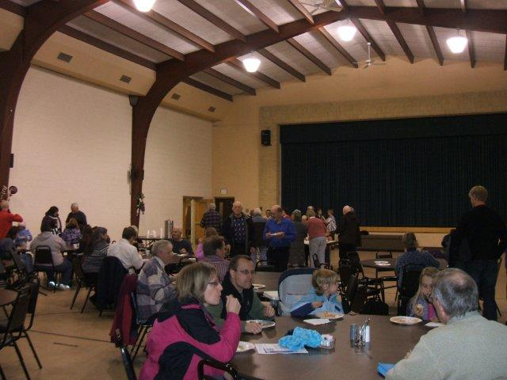Throughout the years, St. Olaf Parish has continued to be a very active member of the Eau Claire community. Many, if not all, the organizations that began in the first 20 years or so of St. Olaf’s history survive today in one form or another. For example, the “Get Acquainted” party that was held on February 8, 1953 is continued today under the name “New Parishioners Dinner”. The photo on the right is from January 2011’s dinner that was held in the Parish Center. Another major event that parishioners and community members go to every summer is the “St. Olaf Fun Fest.” This event has been around since the beginning but was initially known as the parish picnic. Another organization that survives today is the Parish Council.
Illustration 5.1 New Parishioners Dinner, January 2011
Source: saintolafparish.org/wp/new-parishioners-dinner-january-2011/
Illustration 5.1 New Parishioners Dinner, January 2011
As Janet Figlmiller said in her interview, St. Olaf Parish has “grown into a very active parish, which is wonderful.” This statement is made evident in a booklet released by the parish in November 2012. In this booklet, over 70 different organizations and committees are listed. Included in this list are organizations and commitments such as Music Ministry, Faith Formation Council, Vacation Bible School, Boy Scouts, Beacon House, St. Francis Food Pantry Delivery, Prayer Chain Ministry, Lend a Heart Lend a Hand, Finance Council, and much more. Parishioner, Janean Hankes, is quoted saying,
What is good about St. Olaf Parish? We are truly a welcoming parish, we have a large variety of ministries, and we really reach out to the larger community. I know the Holy Spirit is at work here in the people of St. Olaf! Hopefully what I can give comes close to the many riches I have received!
Conclusion.
St. Olaf Parish has seen a lot of changes in its 60 year long history. This paper explored how the parish community of St. Olaf in Eau Claire, Wisconsin, established in 1952, reflects the historical experience of the Roman Catholic Church, specifically at the local, state, and national levels in the United States. The parish community of St. Olaf has experienced various changes over the last 60 years of its history in terms places of worship, the increase of community outreach, and the affects of the Second Vatican Council. The parish at St. Olaf has grown from having only 125 families in 1952 to over 1,000 families in 2012. It has been affected by various events in the Church, but the most important of them has been the Second Vatican Council, which brought reform to the Catholic Church. Having research its past, it is my hope that in the future years, St. Olaf Parish continues to be an active, life-long member of the community of Eau Claire, Wisconsin.
Appendix A: Map of Catholic Dioceses in Wisconsin, 2012

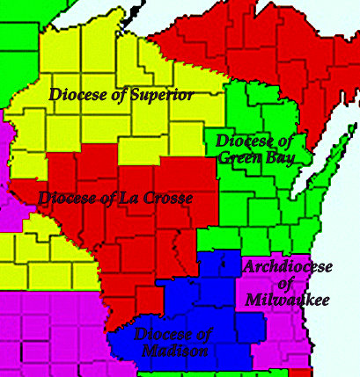
Source: http://www.cdeducation.org/oym/connections/dioceseusmap.htm. This map comes from the preceding website, however, the author added the names of the dioceses.
Appendix B: Tables
Table 1. Demographics for the Diocese of La Crosse in 2010.
Demographic | Total Number
Total Population | 849,626
Catholic Population | 196,246
Parishes | 165
Diocesan Priests | 166
Brothers | 4
Sisters | 393
Hermits | 5
Consecrated Virgins | 3
High Schools | 7
Enrollment, in high schools | 1,565
Elementary Schools | 63
Enrollment, in elementary schools | 7,138
Seminarians | 28

Source: “About the Diocese,” La Crosse Tribune (WI), December 6, 2009.

Table 2. List of Bishops Who Have Served the Diocese of La Crosse.
Name | Years
Bishop Michael Heiss | 1868-1880
Bishop Killian Flasch | 1881-1891
Bishop James Schwebach | 1891-1921
Bishop Alexander McGavik | 1921-1948
Bishop William Griffin (Auxiliary Bishop) | 1935-1945
Bishop John Treacy | 1948-1965
Bishop Frederick Freking | 1965-1983
Bishop John J. Paul (as Auxiliary Bishop) | 1977-1983
Bishop John J. Paul (as Bishop) | 1983-1994
Bishop Raymond L. Burke | 1995-2004
Bishop Jerome E. Listecki | 2005-2009
Bishop William P. Callahan | 2010-present
Source: “About the Diocese,” La Crosse Tribune (WI), December 6, 2009.

Table 3. Bishop Treacy’s Accomplishments in His First Twelve Years as Bishop.
Demographic | Numbers in 1946 | Numbers in 1958
Catholic population | 135,309 | 170,000
Priests | 291 | 377
Brothers | 19 | 1,296
Sisters | 48 | 1,319
Parishes | 140 | 160
Missions | 39 | 56
Diocesan Seminaries | 0 | 1
Philosophy and theology seminarians | 93 | 267
Catholic colleges | 1; Not open to public | 1; 321 students
High schools | 5 schools; 1,694 students | 12; 4,331 students
Grade schools | 86 schools; 16,451 students | 103 schools; 29,942 students
Students under Catholic instructions | 29,135 | 45,098
Religious people teaching in schools | 754 | 627
Lay people teaching in schools | 24 | 157
Patients in Catholic hospitals | 53,588 | 123,492
Student nurses | 3 schools; 253 students | 3 schools; 404 students
Infant baptisms | 4,568 | 6,308
Source: “Years 1948-1957 Saw Extensive Spiritual, Physical Growth within the Diocese of La Crosse”, Times-Review (La Crosse, WI), September 18, 1958.

Table 4. List of Priests That Have Assisted at St. Olaf Parish
Name of Priest | Years they served St. Olaf Parish | Contribution to Parish
Fr. Myron Meinen | 1957-1959 | Organized the Athletic Program for the school; Conducted fund raising project for new organ; Organized the St. Vincent de Paul Society that gave aid to the poor and needy in the area.
Fr. Robert Hegenharth | 1959-1961 | Organized the Christian Family Movement; Choir director
Fr. Bernard Raschke | 1961-1965 | Active in Christian Family Movement; Choir helper
Fr. Patrick Devine | 1965-1966 | Promoter of Christian Family Movement
Fr. Robert Murray | 1966-1967 (passed away after a car accident in November, 1967) | Actively involved in Christian Family Movement; Helped renew the parish directory
Source: St. Olaf Parish, “History,” St. Olaf Parish, http://saintolafparishorg/wp/about-st-olaf/history/ (accessed September 16, 2012).

Table 5. Growth of St. Olaf Parish
Year | Number of Families | Number of Students
1952, when first established | 125 | --
1952, by end of the year | 175 | --
1953 | 194 | --
1954 | 197 | --
1955 | 244 | 204
1956 | 272 | 252
1957 | 305 | 293
1958 | 339 | 325
1959 | 359 | 330
1960 | 383 | 345
1961 | 394 | 340
1962 | 409 | 337
1963 | 415 | 346
1964 | 475 | 377
1965 | 490 | 396
1966 | 495 | 325
1967 | 500 | 290
1968 | 515 | 325
1969 | 525 | 290
1970 | 500 | 315
1971 | 520 | 273
1972 | 500 | 143
1973 | 500 | 199
1974 | 525 | 199
1975 | 560 | 293
1976 | 690 | 205
1977 | 757 | 195
1978 | 802 | 190
1979 | 785 | 195
1980 | 828 | 205
1981-83 | n/a | n/a
1984 | 872 | 176
1985 | 901 | 196
1986 | 898 | n/a
1987 | 907 | n/a
1988 | 885 | n/a
1989-90 | n/a | n/a
1991 | 910 | n/a
1992-2005 | n/a | n/a
2006-2011 | n/a | --
2012 | +1,000 | --
Source: St. Olaf Parish, “Annual Reports” (report, Eau Claire, WI, 1952-1988).

Appendix C: Illustrations of Important People in St. Olaf’s History
Illustration 1c. Bishop John P. Treacy, bishop of the La Crosse Diocese from 1948-1965.
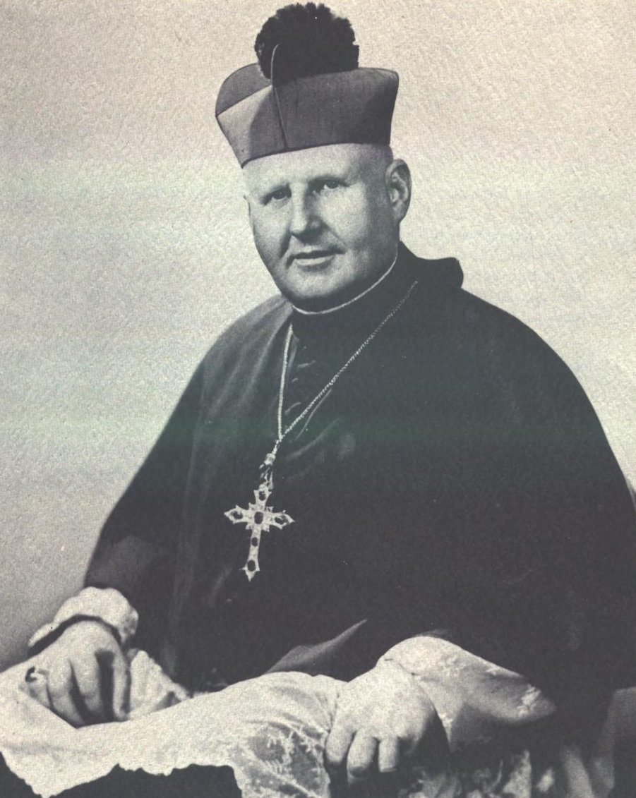
Source: St. Olaf Parish, “Dedication Souvenir of the Parish of St. Olaf” (parish document, Eau Claire, WI, September 26, 1954), 4.

Illustration 2c. St. Olaf of Norway
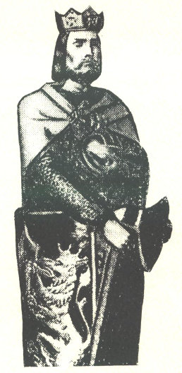
Source: St. Olaf Parish, “Dedication Souvenir of the Parish of St. Olaf” (parish document, Eau Claire, WI, September 26, 1954), 2.

Illustration 3c. Father Robert E. Agnew, priest at St. Olaf Parish from 1952-1964 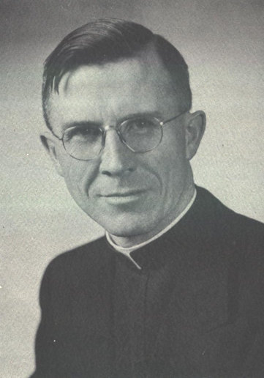
Source: St. Olaf Parish, “Dedication Souvenir of the Parish of St. Olaf” (parish document, Eau Claire, WI, September 26, 1954), 6.

Illustration 4c. Father Jerome Palmer, St. Bede’s Priory chaplain and unofficial assistant pastor at St. Olaf Parish
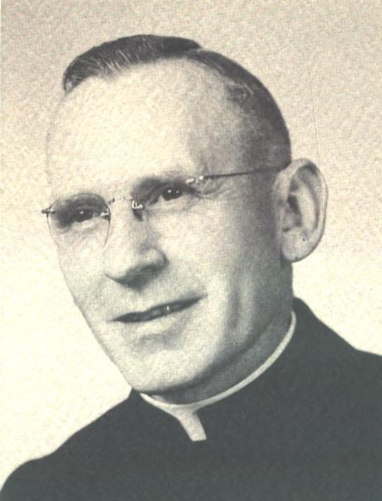
Source: St. Olaf Parish, “Dedication Souvenir of the Parish of St. Olaf” (parish document, Eau Claire, WI, September 26, 1954), 9.
Illustration 5c. Members of the Building Committee for the New School
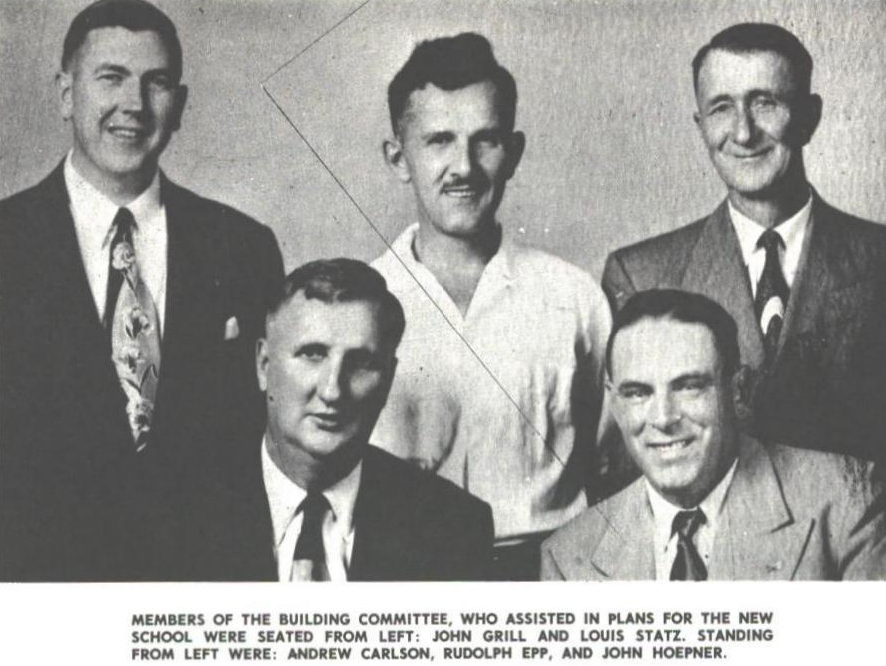
Source: St. Olaf Parish, “Silver Jubilee, 1952-1977” (parish document, Eau Claire, WI, November 1977), 10.

Illustration 6c. Father Mryon “Mike” Meinen, priest at St. Olaf Parish from 1964-1974
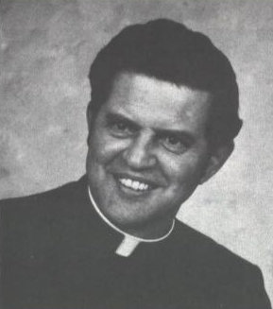
Source: St. Olaf Parish, “Directory of St. Olafs Catholic Parish Family” (parish document, Eau Claire, WI, 1970), 2.
Illustration 7c. Father William “Bill” Matzek, priest at St. Olaf Parish from 1974-1985
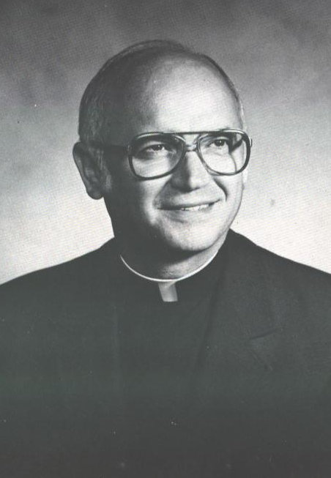
Source: St. Olaf Parish, “1952-1982, St. Olaf’s Parish” (parish document, Eau Claire, WI, 1982), 2.

Illustration 8c. Father William “Bill” Menzel, priest at St. Olaf Parish from 1985-1991
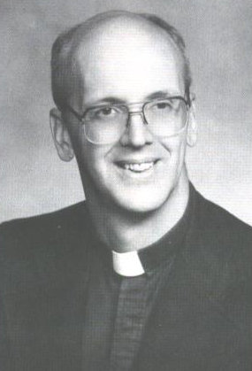
Source: St. Olaf Parish, “St. Olaf Parish, 1952-1987” (parish document, Eau Claire, WI, 1987), 3.
Illustration 9c. Father Frank Corradi, priest at St. Olaf Parish from 1991-2006
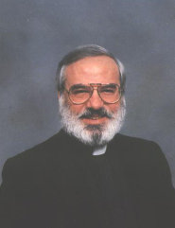
Source: St. Olaf Parish, “1992-1993 Parish Directory” (parish document, Eau Claire, WI, 1993).

Illustration 10c. Father Brian D. Konopa, priest at St. Olaf Parish from 2006-present
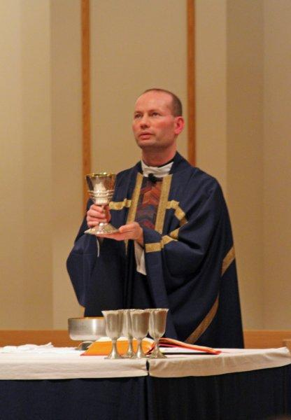
Photograph Courtesy St. Olaf Parish.
Illustration 11c. Officers of the First Altar Society
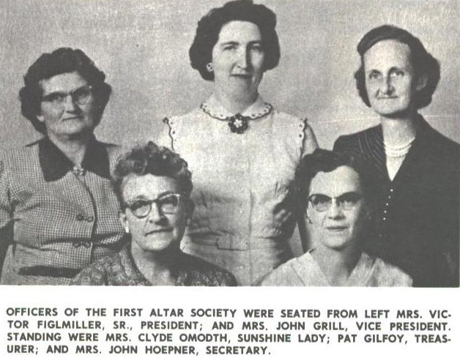
Source: St. Olaf Parish, “Silver Jubilee, 1952-1977” (parish document, Eau Claire, WI, November 1977), 8.

Illustration 12c. Father Agnew with his mother and housekeeper, Sadie Agnew
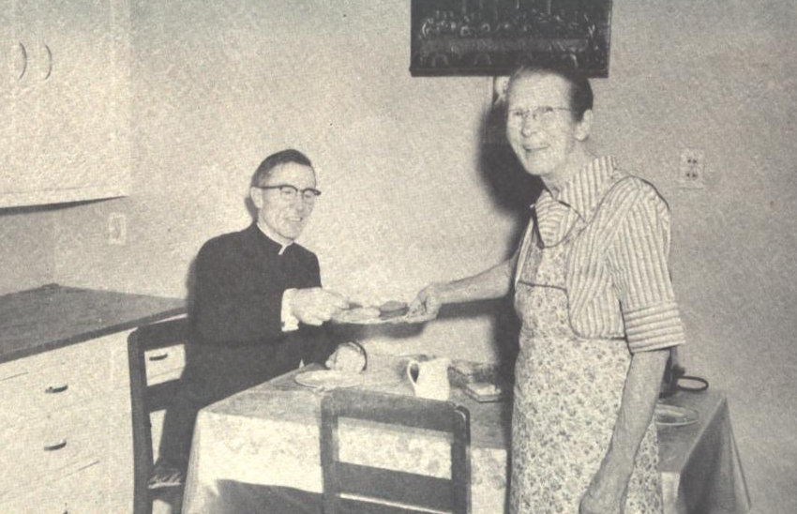
Source: St. Olaf Parish, “Dedication Souvenir of the Parish of St. Olaf” (parish document, Eau Claire, WI, September 26, 1954), 15.
Appendix D: Illustrations of Important Events in St. Olaf’s History

Illustration 1d. Two of the First Three Children Baptized at St. Olaf pictured below with Father Agnew
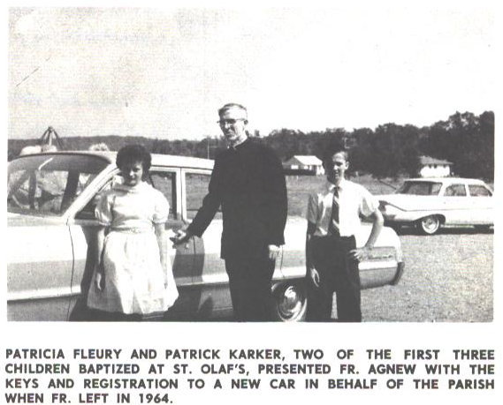
Source: St. Olaf Parish, “Silver Jubilee, 1952-1977” (parish document, Eau Claire, WI, November 1977), 9.

Illustration 2d. Altar inside of the Parish House on N. Hastings Way (later Western Avenue)
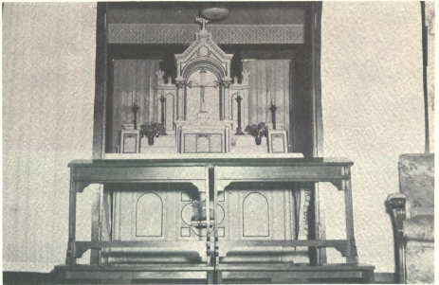
Source: St. Olaf Parish, “Dedication Souvenir of the Parish of St. Olaf” (parish document, Eau Claire, WI, September 26, 1954), 17.

Illustration 3d. Exterior of V.F.W. during Mass
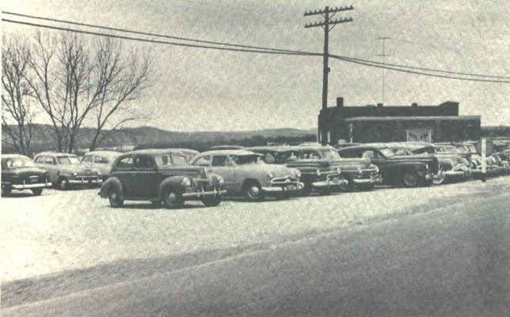
Source: St. Olaf Parish, “Dedication Souvenir of the Parish of St. Olaf” (parish document, Eau Claire, WI, September 26, 1954), 11.

Illustration 4d. Interior of the V.F.W. during Mass
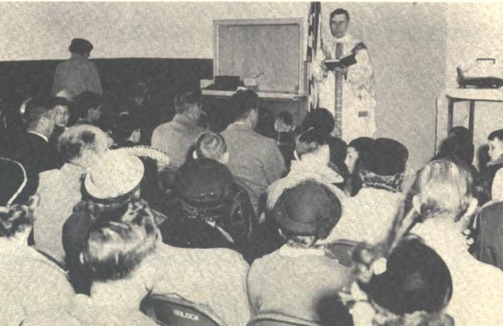
Source: St. Olaf Parish, “Dedication Souvenir of the Parish of St. Olaf” (parish document, Eau Claire, WI, September 26, 1954), 11.
Illustration 5d. Priests and Servers in Attendance at the Groundbreaking Ceremony
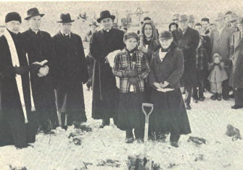
Source: St St. Olaf Parish, “Dedication Souvenir of the Parish of St. Olaf” (parish document, Eau Claire, WI, September 26, 1954), 27.

Illustration 6d. Crowd in Attendance at the Groundbreaking Ceremony
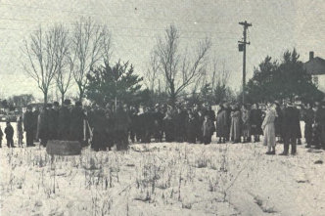
Source: St. Olaf Parish, “Dedication Souvenir of the Parish of St. Olaf” (parish document, Eau Claire, WI, September 26, 1954), 27.

Illustration 7d. Beginning of Construction on the School Building
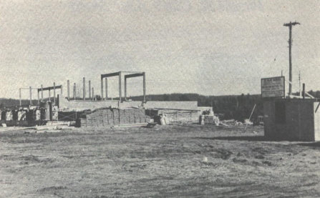
Source: St. Olaf Parish, “Dedication Souvenir of the Parish of St. Olaf” (parish document, Eau Claire, WI, September 26, 1954), 26.

Illustration 8d. Completed School Building
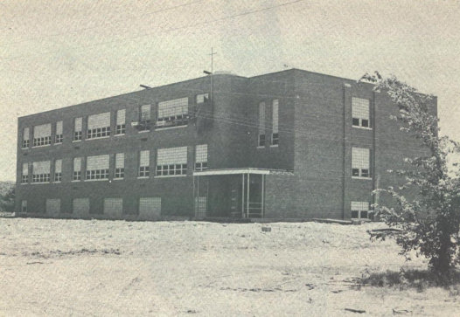
Source: St. Olaf Parish, “Dedication Souvenir of the Parish of St. Olaf” (parish document, Eau Claire, WI, September 26, 1954), 28.

Illustration 9d. Addition to the School
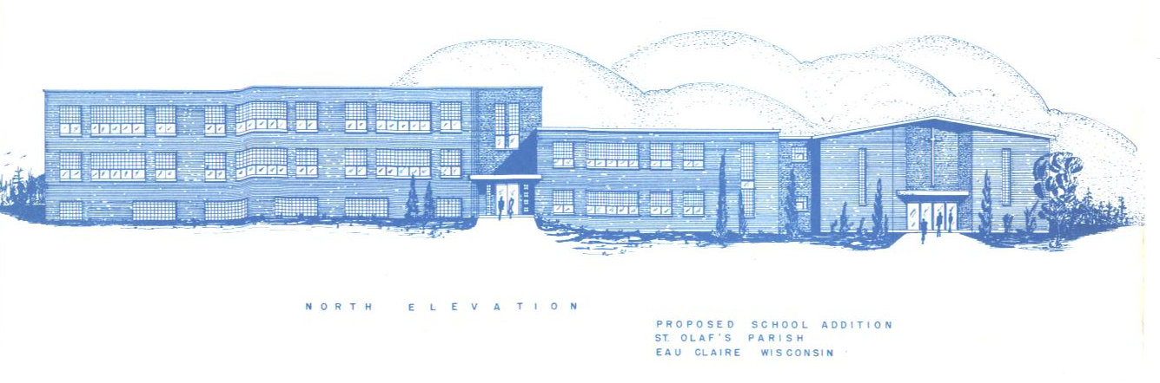
Source: “St. Olaf Parish, “Our Plans” (brochure, Eau Claire, WI, late 1950s).

Illustration 10d. Addition to the School, blueprint
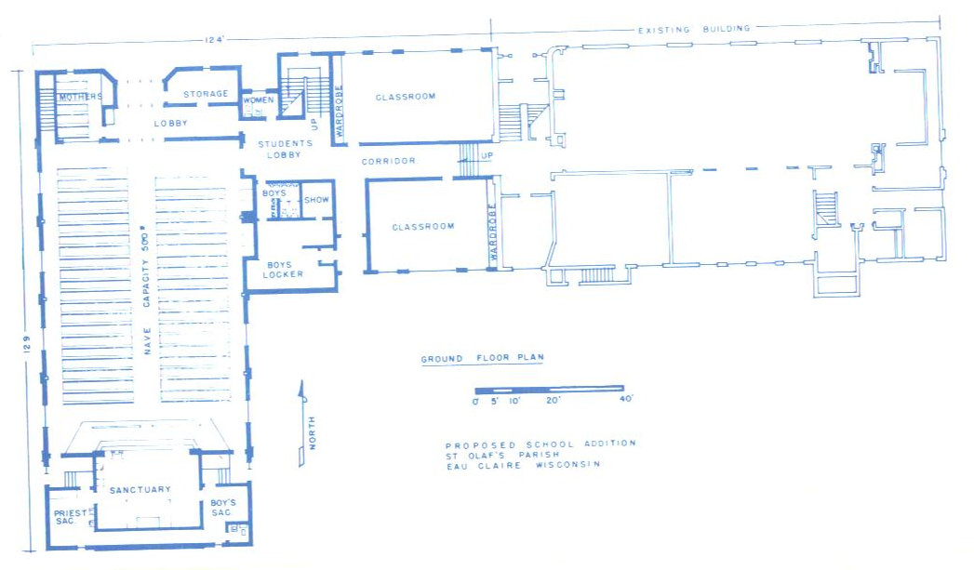
Source: St. Olaf Parish, “Our Plans” (brochure, Eau Claire, WI, late 1950s).

Illustration 11d. Representatives from St. Olaf and Sacred Heart are seen signing consolidation papers
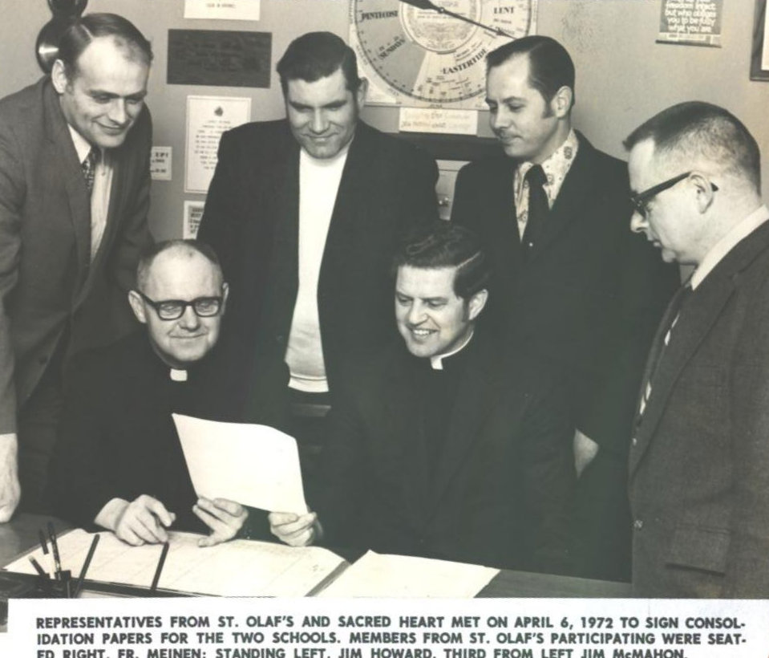
Source: photograph courtesy St. Olaf Parish

Illustration 12d. St. Thomas Learning Center Grades 1-5
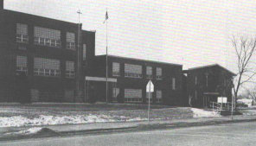
Source: St. Olaf Parish, “Saint Thomas 78 Omega” (school yearbook, Eau Claire, WI, 1978), 1.

Illustration 13d. St. Thomas Learning Center Grades 6-8
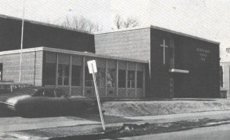
Source: St. Olaf Parish, “Saint Thomas 78 Omega” (school yearbook, Eau Claire, WI, 1978), 1.

Illustration 14d. First married couple
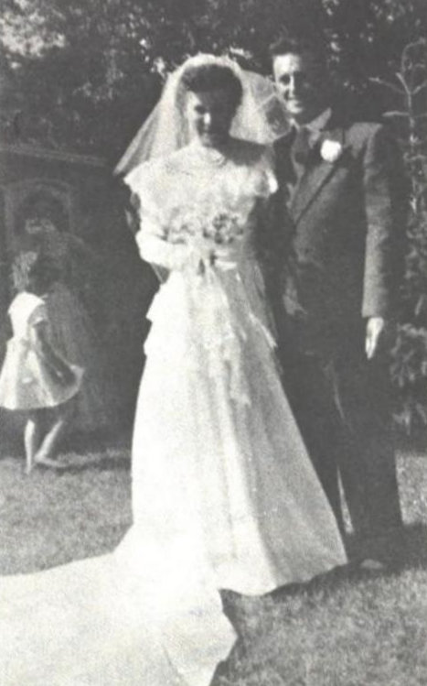
Source: St. Olaf Parish, “Dedication Souvenir of the Parish of St. Olaf” (parish document, Eau Claire, WI, September 26, 1954), 20.

Illustration 15d. First Parish Picnic
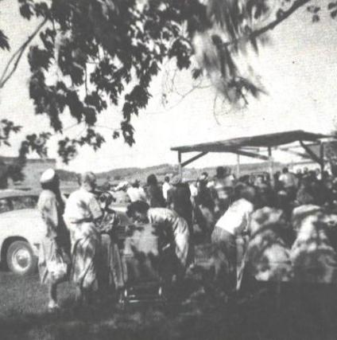
Source: St. Olaf Parish, “Dedication Souvenir of the Parish of St. Olaf” (parish document, Eau Claire, WI, September 26, 1954), 20.

Illustration 16d. First First Communion
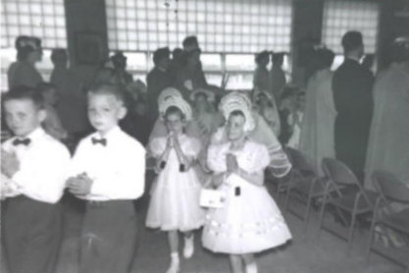
Source: Photograph Courtesy St. Olaf Parish

Illustration 17d. 1980 Fire
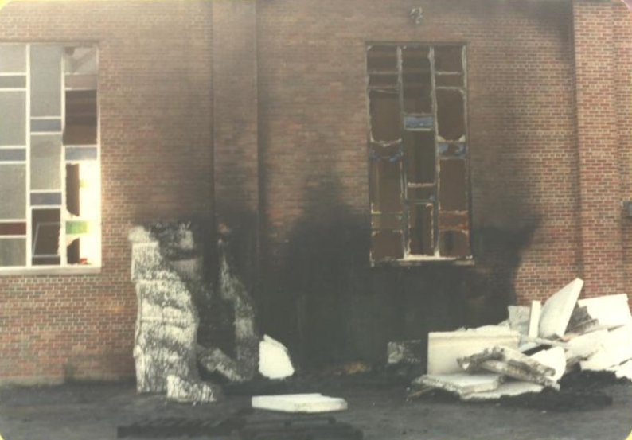
Photograph Courtesy St. Olaf Parish
Illustration 18d. Current church building
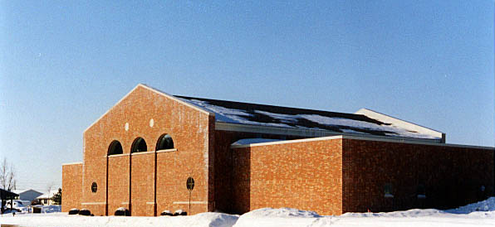
Photograph Courtesy St. Olaf Parish

Illustration 19d. Inside of current church building
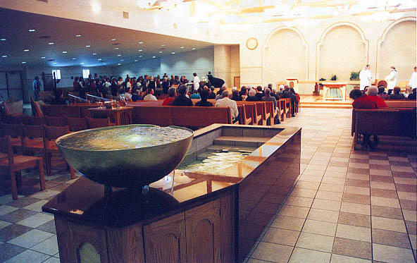
Photograph Courtesy St. Olaf Parish

Illstration 20d. The Father Robert Agnew Parish Center (previously used as the place of worship
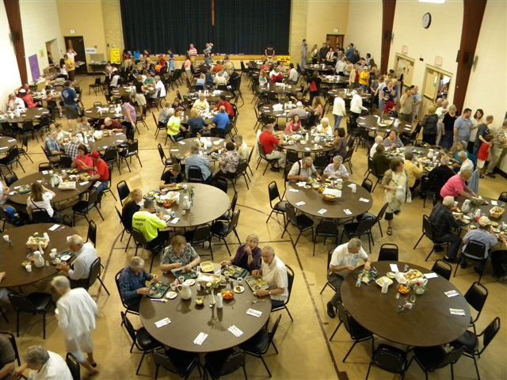
Photograph Courtesy St. Olaf Parish
Bibliography

Primary Sources

St. Olaf Parish. “1952-1982, St. Olaf’s Parish.” Parish document, Eau Claire, WI, 1982.
This source provided the photograph of Father William “Bill” Matzek.

St. Olaf Parish. “1992-1993 Parish Directory.” Parish document, Eau Claire, WI, 1993.
This source provided the photograph of Father Frank Corradi.

St. Olaf Parish. “Annual Reports.” Reports, Eau Claire, WI, 1952-1988.
These annual reports were published by the parish with the purpose of distributing them to the members of the parish. They were also sent to the Diocese of La Crosse. These became vital in my research because they allowed me to track the growth of the parish and helped me see what types of events were held during the years.
St. Olaf Parish. “Commitment to Parish Life.” Booklet, Eau Claire, WI, November, 2012.
This source was published by St. Olaf and distributed to the members of the church in order to update them on what types of organizations and committees St. Olaf’s provides in the hopes that parishioners would become active members in the parish. This gave me a comprehensive list of what activities St. Olaf was involved with in 2012.

St. Olaf Parish. “Dedication Souvenir of the Parish of St. Olaf.” Parish document, Eau Claire,
WI, September 26, 1954.
This document was published by the parish for a variety of reasons. First, so the “pioneers of the parish may preserve a remembrance of [the parish’s first attempts and first accomplishments.” Second, to inform new parishioners of the parish’s beginning. The final reason was so future generations would know what the founding members of the parish accomplished and sacrificed at the start of the parish. Many of the photographs found in this paper come from this document.

St. Olaf Parish. “Directory of St. Olaf’s Catholic Parish Family.” Parish document, Eau Claire,
WI, 1970.
This source provided the photograph of Father Myron “Mike” Meinen.
St. Olaf Parish, “Saint Thomas 78 Omega” (school yearbook, Eau Claire, WI, 1978).
This source provided the photographs of the two buildings that made up St. Thomas Learning Center.

St. Olaf Parish. “St. Olaf Parish, 1952-1987.” Parish document, Eau Claire, WI, 1987.
This source provided the photograph of Father William “Bill” Menzel.
St. Olaf Parish. “Our Plans.” Brochure, Eau Claire, WI, late 1950s.
This source provided the blueprints for the addition to the school

St. Olaf Parish, “PTA History” Record book, Eau Claire, WI, n.d.
This source provided most of the information about the merger of Sacred Heart and St. Olaf’s schools. The author and date are unknown, however, based on the condition of the book and the context clues found within the document, the most likely author was a member of the PTA board and the approximate date is late 1970s to early 1980s.

St. Olaf Parish. “Silver Jubilee, 1952-1977.” Parish document, Eau Claire, WI, November 1977.
This document was published and given to the members of the church in celebration of the 25th Anniversary of St. Olaf. It provided many of the background information on the formation of the church and many of the photographs came from it as well.

St. Olaf Parish. “St. Olaf’s Progress Report 1970.” Booklet, Eau Claire, WI, 1970.
This source was published by St. Olaf and handed out to the parishioners. I was able to pin-point the formation of the Parish Council using this source, which was one of the links to the changes that derived from the Second Vatican Council.

St. Olaf Parish. “Welcome to St. Olaf’s Parish.” Parish booklet, Eau Claire, WI, 1980s.
This booklet was published for the use of new parishioners. I estimated the date using events from the parish’s history. This helped show the progression of the locations in which the members of St. Olaf worshipped.

Secondary Sources
Barland, Lois. The Rivers Flow On: A Record of Eau Claire, Wisconsin from 1910 – 1960.
Stevens Point, WI: Worzalla Publishing, 1965.
This book was helpful because I found census data that supported my argument that the growth of St. Olaf Parish reflected the local growth of Eau Claire in the post-World War II years.

Dolan, Jay P. In Search of American Catholicism: a history of Religion and Culture in Tension.
Oxford: Oxford University Press, 2002.
Dolan’s book, In Search of American Catholicism gave me insight into how the Second Vatican Council was different from its predecessors. It also showed me what goals the Church wanted to accomplish through the Second Vatican Council. Dolan also shreds light into what specific changes were seen after the council’s policies were implemented in the United States.

Hieb, Jane. Eau Claire, heartland of the Chippewa Valley: an Illustrated History. Northridge,
CA: Windsor, 1988.
Hieb’s book gave me the context I needed in order to fit St. Olaf Parish into Eau Claire, Wisconsin’s history. It was a great overview of the development of Eau Claire up to the 1950s, when St. Olaf was established.

Hopkins, Vicki. “Detailed History from 1967.” St. Olaf Parish, written December 28, 1967,
http://saintolafparishorg/wp/about-st-olaf/history/
parish-history-of-st-olafs-catholic-church/.
This document was written by a parishioner of St. Olaf in 1967. I used this written history in order to fill in information I could not find in the Dedication Souvenir or the Silver Jubilee document.

Konopa, Father Brian. “Feast Day of St. Olaf.” Homily at St. Olaf Parish, Eau Claire, WI, July
29, 2012.
Father Konopa’s homily was my main source for the history of St. Olaf, the man. His narrative of St. Olaf brings the patron of Norway to life, while still being a reliable source of information. He gives insight into why a Norwegian saint was chosen as patron of the new parish.

St. Olaf Parish. “History.” St. Olaf Parish. http://saintolafparishorg/wp/about-st-olaf/history/
(accessed September 16, 2012).
This was another source that I went to in order to fill in missing information from the Dedication Souvenir and the Silver Jubilee document. I was able to find the dates that each priest served at St. Olaf on this website. It is reliable because it is the parish’s official website.

Vatican Council and Walter M. Abbott. The Documents of Vatican II. New York: Guild Press,
1966.
This source would usually be considered primary, however, I only used it to create the table of important dates from the Second Vatican Council.

Joe Orso, “Q&A: Listecki Looks at Diocese Future, Past After Two Years as Bishop.” La Crosse Tribune (WI), July 14, 2007.
See Appendix A for a map of the Catholic Dioceses in Wisconsin, 2012.
“About the Diocese,” La Crosse Tribune (WI), December 6, 2009.
“About the Diocese,” La Crosse Tribune
“About the Diocese,” La Crosse Tribune. For a more detailed list of demographics for the Diocese of La Crosse, see Appendix B, Table 1.
For a detailed list of who was Bishop in what specific years, see Appendix B, Table 2.
“Bishop Shepherds La Crosse Diocese In Era of Growth: A Priest for 40 Years”, Times-Review (La Crosse, WI), September 18, 1958.
“Metelis Titular See”, Times-Review (La Crosse, WI), September 18, 1958.
Every Catholic Bishop can trace the succession of his Episcopal mission back to the Apostles through a long line of predecessors and doctors and saints of the Church. Bishop Treacy was one of many American Bishops who could trace their apostolic lineage to one of the direct successors of St. Peter the Apostle, the first head of the Catholic Church.
“Bishop Shepherds La Crosse Diocese In Era of Growth: A Priest for 40 Years”, Times-Review.
“Bishop Shepherds La Crosse Diocese In Era of Growth: A Priest for 40 Years”, Times-Review.
See Appendix B, Table 3 for a detailed list of Treacy’s accomplishes during his first twelve years as bishop.
“New Catholic Structures Pace Population Growth Number 166 in 12 Years”, Times-Review (La Crosse, WI), September 18, 1958.
Lois Barland, The Rivers Flow On: A Record of Eau Claire, Wisconsin from 1910 – 1960 (Stevens Point, WI: Worzalla Publishing, 1965), 267.
Father Brian Konopa, “Feast Day of St. Olaf” (homily, St. Olaf Parish, Eau Claire, WI, July 29, 2012).
Father Brian Konopa, “Feast Day of St. Olaf.”
There is no written record about the motivation behind St. Olaf’s baptism and conversion to the Christian faith.
Father Brian Konopa, “Feast Day of St. Olaf.”
Father Brian Konopa, “Feast Day of St. Olaf.”
Father Brian Konopa, “Feast Day of St. Olaf.”
St. Olaf’s boundaries were County Trunk O on the north, County Trunk P on the east to the Eau Claire River, south to the Eau Claire River, and County Trunk Highway Q (also known as Seymour Road) to the Chippewa River and then north to the intersection of County Trunk Highway O and the Chippewa River. These boundaries contained members of Sacred Heart and St. Patrick’s of Eau Claire, St. Mary’s of Altoona, and Holy Ghost of Chippewa Falls.
Father Brian Konopa, “Feast Day of St. Olaf.”
Father Brian Konopa, “Feast Day of St. Olaf.”
Jeanne Lennie, interview by author, Eau Claire, WI, October 31, 2012.
Janet Figlmiller, interview by author, Eau Claire, WI, November 1, 2012.
St. Olaf Parish, “Silver Jubilee, 1952-1977” (parish document, Eau Claire, WI, November, 1977), 7.
High Mass is celebrated with a choir and almost all the priests parts are either sung or chanted. It is different from a Low Mass, where there is a single priest, with none of his parts being sung or chanted.
St. Olaf Parish, “Silver Jubilee, 1952-1977”, 9-10.
The house still stands today, but the address has changed to 2913 Western Avenue. See Appendix D Illustration 2d for a photograph of the altar in the interior of the house.
St. Olaf Parish, “Silver Jubilee, 1952-1977”, 8.
The future church was located on 8 acres of land at the corner of North Lane and Monroe Street. The new rectory was not occupied until January, 1955 because it needed a lot of renovating. This house still serves as the rectory in 2012.
St. Olaf Parish, “Silver Jubilee, 1952-1977”, 10.
St. Olaf Parish, “Silver Jubilee, 1952-1977”, 12.
“Freak Accident Killing 13-Year-Old Answer to: Why a Catholic School?” Daily Telegram (Eau Claire, WI), Apr. 16, 1958.
St. Olaf Parish, “Silver Jubilee, 1952-1977”, 12.
See Appendix D, Illustrations 5d and 6d for pictures of the school building and the beginning and end of construction.
St. Olaf Parish, “Silver Jubilee, 1952-1977”, 13.
St. Olaf Parish, “Dedication Souvenir of the Parish of St. Olaf”, Eau Claire, Wisconsin, Sept. 26, 1954, page 7.
Eugene W. Phillips letter to Father Robert Agnew, June 27, 1953. This letter is housed at St. Olaf Parish.
Father Agnew letter to Bishop Treacy, June 29, 1953. This letter is housed at St. Olaf Parish.
St. Olaf Parish, “Silver Jubilee, 1952-1977”, 13.
In 1956, a total of five classrooms were being used; in 1957, a total of six were in use; in 1958, seven classrooms were needed; and in 1959, the last available classroom became required for the school.
St. Olaf Parish, “Welcome to St. Olaf’s Parish” (parish booklet, Eau Claire, WI, 1980s), 2.
St. Olaf Parish, “Our Plans” (brochure, Eau Claire, WI, late 1950s). See Appendix D, Illustrations 7d and 8d for pictures of new addition to school.
St. Olaf Parish, “PTA History” (record book, Eau Claire, WI, n.d.). See Appendix D, Illustration 10d and 11d for pictures of St. Thomas Learning Center
Mary-Ann Pozarski, interview by author, Eau Claire, WI, November 8, 2012.
St. Olaf Parish, “History,” St. Olaf Parish, http://saintolafparishorg/wp/about-st-olaf/history/ (accessed September 16, 2012). See Appendix B, Table 5 for a list of the number of families and students St. Olaf had over the past sixty years (please note that data is missing from certain years. This is due to the missing Annual Reports from the corresponding years). Also, more details about the church today can be found in part five of the paper, starting on page 27.
For a list of priest that have assisted the parish throughout the years, see Appendix B, Table 4.
Jeanne Lennie, interview.
Janet Figlmiller, interview.
Mary-Ann Pozarski, interview.
Gene and Carol Adams, interviewed by author, Eau Claire, WI, November 4, 2012.
St. Peter’s Catholic Church later grew to become today’s St. Patrick’s Parish.
Jane Hieb, Eau Claire, heartland of the Chippewa Valley: An Illustrated History, (Northridge, CA: Windsor, Inc., 1988), 25-28.
Jane Hieb, Eau Claire, heartland of the Chippewa Valley: An Illustrated History, 84.
Jane Hieb, Eau Claire, heartland of the Chippewa Valley: An Illustrated History, 79.
St. Olaf Parish, “Our Plans.”
In her interview, Janet Figlmiller (daughter-in-law to the first president of the Ladies Altar Society) explained that every newly established church had an Altar Society that was supposed to be run by the women of the church.
St. Olaf Parish, “Silver Jubilee, 1952-1977”, 8.
See Appendix D, Illustrations 12c, 13c, and 14c for photos of these events.
St. Olaf Parish, “Silver Jubilee, 1952-1977”, 11-12.
Jeanne Lennie, interview.
Janet Figlmiller, interview.
St. Olaf Parish, “Silver Jubilee, 1952-1977”, 13.
Vicki Hopkins, “Detailed History from 1967,” St. Olaf Parish, December 28, 1967, http://saintolafparishorg/wp/about-st-olaf/history/parish-history-of-st-olafs-catholic-church/.
St. Olaf Parish, “St. Olaf’s Progress Report 1970”, (booklet, Eau Claire, WI, 1970).
An ecumenical council is when Catholic bishops and other theological experts from around the world are called by the pope in order to discuss and regulate matter of Church doctrine and discipline.
Jay P. Dolan, In Search of American Catholicism: A history of Religion and Culture in Tension, (Oxford: Oxford University Press, 2002), 192-193.
Gene and Carol Adams, interview.
Jeanne Lennie, interview.
Mary-Ann Pozarski, interview.
Gene and Carol Adams, interview.
Jay P. Dolan, In Search of American Catholicism: A history of Religion and Culture in Tension, 205.
Mary-Ann Pozarski, interview.
St. Olaf Parish, “History,” St. Olaf Parish, http://saintolafparishorg/wp/about-st-olaf/history/ (accessed September 16, 2012). See Appendix D, Illustrations 18d and 19d.
Mary Stegmeir, “CASE for Concern: Unpaid Tuition, Subsidies Jeopardize School System, officials say,” Leader-Telegram (Eau Claire, WI), September 29, 2005.
Mary Stegmeir, “Bittersweet Bash: Students Prepare for Move to Other CASE Schools,” Leader Telegram, (Eau Claire, WI), June 3, 2006.
St. Olaf Parish, “Dedication Souvenir of the Parish of St. Olaf”, 19.
St. Olaf Parish, “Commitment to Parish Life” (booklet, Eau Claire, WI, November, 2012).

