Ho-Chunk Traditional Guidelines for the Nighttime
I decided that the best tribe for me to research was my own, the Ho-Chunk Nation of Wisconsin. They The Ho-Chunks have been known to have been in Wisconsin as early as 1616 according to early French fur trader accounts, but according to Ho-Chunk oral stories, the Ho-Chunk people have been in Wisconsin since the Creator created them and placed them here. It had long been thought that the Wisconsin Ho-Chunk had been immigrants from the east that came to settle in Wisconsin, but “the Winnebago themselves have no traditions telling of their migrations from the east. The majority of the people questioned asserted that the tribe originated at Green Bay” (Radin 2).
While it cannot be completely certain, the Ho-Chunk people of Wisconsin are the most likely candidate for being the descendants of the mysterious effigy mound builder society of the Late Woodland period (AD 700-1000 in Wisconsin). The Ho-Chunk are a Siouan speaking tribe that had a great Mississippian cultural influence during the Oneota phase of AD 1000-1600/1700. During the Oneota phase, the Woodland culture of Wisconsin is thought to have been so influenced by interactions with the American Basin’s Mississippian culture that they gave up mound building and began to incorporate the Mississippian tool technologies, pottery, and religious ceremonies into their own ways of life and eventually this became the Oneota culture, (Burmingham and Eisenberg; Bozhardt and Theiler).
The Ho-Chunk are thought to be most closely related to the Ioway, followed by the Otoe, Missouria, and Dakota, but have also been influenced by Woodland/prairie Algonquians such as the Sauk, Fox, and Menominee (Pritzker 475). According to traditional stories of both the Ho-Chunk and the Ioway, they were once a part of the same tribe, but then the Ioway broke off and traveled west for unknown reasons. Radin wrote that “the Winnebago have some recollection of their separation from their kindred Siouan tribes”, and according to linguistic research, it is believed that these two groups separated around 1300, but there was probably still lots of interactions between the two groups.
By now, you’ve noticed that the Ho-Chunk are referred to as the “Winnebago” by early sources and there is a very simple explanation for this. Hoocąk (Ho-Chunk) means the “true/real speak” and as I understand it from being told by Ho-Chunk elders (and family members), it is the language that was given to us to use by the Creator. It is the language that brings us the closest to the Creator and it is the language that is from the heart that is supposed to be used when praying. Some believe that Ho-Chunk translates to “Big Fish” as hoo means fish and cąk means big, real, or true. While this isn’t what is typically believed by most Ho-Chunks, it is a theory that fits well with the Algonquin term for the Ho-Chunks; Winnebago. “Winnebago is Algonquin for ‘People of the Filthy [or Stinky] Water’, referring to the lower Fox River and Lake Winnebago, which became clogged with dead fish every summer” (Pritzker 475).
Winnebago was a derogatory term from enemy tribes, and it also became a derogatory term for the Ho-Chunk that used by both the French and British during the post-contact period, and is still being used today, although many today do not know the origins of this term. At the time of contact, Ho-Chunk numbers had dramatically decreased due to disease and warfare. With the beginning of French occupation near the St. Lawrence River, tribes began competing for valuable hunting land for furs to help the French fur traders and ultimately to get paid for these furs with European goods. The warfare created because of this competition eventually became known as the Iroquois Wars. It pushed many tribes to move westward, seeking new land to live peacefully, or to take over. The pressures created by the tribes intruding onto land in Wisconsin caused warfare to erupt among the incoming tribes and those already residing there, the Ho-Chunks.
The Ho-Chunks were not about to give up their traditional homelands easily and fought hard to keep and protect what was sacred to them. Plus, traditional beliefs celebrate warriors and their accomplishments. P.V. Lawson as quoted by Paul Radin wrote, “So aggressive were the Winnebago that although their only arms ‘were stone hatchets and knives,’ they declared war on all the other tribes. Envoys sent to them by the Ottawa were eaten, which cruel deed so incensed the surrounding tribes that they formed an alliance and sent frequent war expeditions against the common enemy, and greatly harassed them” (Radin 6). This constant fighting lead to the diminished number of Ho-Chunk at the beginning of the contact period in Wisconsin obviously, and the warfare brought to surrounding tribes by the Ho-Chunk helped spread the degrading terms used to describe them.
Today there is no more intertribal warfare in terms of battles being fought man against man, although legal battles have occurred here and there between groups; tribes have been able to regain their member numbers once again. At the time of contact, the Ho-Chunk numbered about 3-4,000 people and were then almost completely wiped out by warfare and disease; today the current tribal enrollment is 6,921 (Ho-Chunk Nation’s Tribal Enrollment Office 5/1/2009). The tribe is governed by both a three branch government system (judicial, executive, and legislative branches) and also by the traditional clan system.
There are twelve traditional clans that are divided into lower and upper clans. There are four upper clans and eight lower clans. The four upper clans are the pigeon (Rųųcge), warrior (Woonaǧire Wąąksik), eagle (Caaxšep), and thunder (Wakąja). The eight lower clans are the Bear (Hųųc), Deer (Caa), Elk (Hųųwą), Fish (Hoo), Wolf (Šųųkjąk), Water-spirit (Wakjexį), Snake (Waką), and Buffalo (Ceexji).
Like mentioned earlier, traditional stories were and are some of the deciding factors in helping put together tribal histories, but these stories do so much more than that. Traditional stories also layout the guidelines of how people should act at certain times, how they interact with one another based on family relation or clan membership, and these guidelines surround the people to help them stay together as a people. For my project, I decided that I would look at the traditional nighttime guidelines that I had learned while growing up. I wanted to learn how these stories were told from one generation to the next, who told them, and then why they were told. This proved to be a much harder goal to accomplish than I had originally thought it would have been.
In order to even begin the process of gathering information, I had to receive permission from an elder, who is not only knowledgeable in Ho-Chunk traditions, but also someone who knew me personally so that I did not seem like I was being disrespectful of our traditions and ways of life. I decided that it would be best to ask my Tega Richard. He is not technically my uncle, but he takes care of a lot of religious tasks for my family.
The first step that I had to do once I received the permissions was to create a list of questions that I thought I would be able to ask, and what might be nice to know, but maybe not necessarily ones that would create answers that I couldn’t share. In order to do interviews like the ones that I conducted one must know what kinds of questions to ask and who to ask them from. I had always tried to be conscious of this but as an anthropologist, I tend to get carried away. This is where things get hard. While conducting my interviews, I had to hold my tongue and realize that I was not appropriate for me to ask certain questions or I had to realize that maybe not everything had an answer. This wasn’t a huge shock to me, but it is something that I’ve always had a problem with. I’ve always been the child who was told to stop asking questions, and still asks “Why?” because I have always just generally been curios about the world around me. Most times the answer is, “Because they said so”, or “I don’t know”. This isn’t just to stop me from asking questions, it’s there so that you learn to respect your elder. So because of this not being able to question while growing up, I decided that may now is the best time to find out why. This is where the research comes in.
I have always heard that there are certain things that one is not allowed to do when the sun starts setting and there are certain phrases that are said at this time. These were guidelines told by elders to children so that they would be respectful and listen to what they were told. Some were to scare children so they did not disrespect their elders, and they were also meant to protect the child. They are as follows:
- Hakawaasrokeja žoožocra roǧire. Wanąǧigo waanąąkšąną, aire šunų. “Don’t whistle at night”
- Hokawaasrokeja nųųkixąwąke šgaacra, waną’I kišgac waųnąąkže sire šunų. “No playing in the dark”
- Wąąkregi wažą himąnakra roǧire. Waizara hižą xawani raanąže aire. “Don’t point at stars, the moon, or the sun”
- Hąąpokra hižą ciihipaija nąąnąxgu nagi, wažą hąkepįnį horagiwe kjene waaježe, aire. “Hearing an owl near one’s home is a bad omen”
Do not whistle at night. It was said that when one whistles at night he/she is calling spirits to him/her. This was common knowledge at one point in time for why one wouldn’t do this. My tega said that when he was growing up, anyone who whistled at night was asking for trouble. He said, “There was always one kid who just had to try it, and when they did, all of us [the kids] would just scatter and run home”. At that time, most children knew that it was bad to whistle at night, and that doing so may cause something bad to happen to them. It was supposed among adults that with these children that they knew why they weren’t supposed to do it and it was almost taken for granted that it was known according to both Cecil and Tega Richard. When they were growing up, most people didn’t take the time to explain why certain things were done it was just assumed that children would listen to what was being said and understand. Children were not supposed to doubt their parents. While the children necessarily know why things were done certain ways they knew that what their parents said was sacred and not to be questioned. Parents’ words were supposed to be sacred and not disobeyed.
Cecil and I have also theorized that whistling at night goes back to the old days of when the Ho-Chunk were at constant war with other tribes. According to Cecil, whistles were common as signals during warfare in the past and are sometimes still used today (or they were at least when he was in Vietnam). There is one story recorded by Radin that supports this theory; it says, “Then the host spoke, ‘As I rise, I will blow upon my flute and have a song started. I am anxious to have them start a song,’ he said. Then he rose and blew his flute and as soon as the song was started the Winnebago were seized” (Radin 14).
“No hiding or playing in the dark.” It is said that when one plays in the dark he is playing with spirits. Again, this was common knowledge for children during the time when my uncles, mother, and her parents were growing up. Those who did this were also attempting to test what was told to them by their parents. When I was younger, my cousins convinced me that it would be fun to play hide and go seek in the dark. As soon as we started, and I still to this day don’t know how my grandfather did this, my grandfather can running out of his house and yelled at us to get inside. Once inside he punished all of us and told us how dangerous it was for us to be out there at night.
Only later did I find out that this was to protect us. According to tradition, those spirits could affect the way that children thought. I don’t know more than this, and even if I did it would not be appropriate to share with others.
Don’t point at stars, the moon, the sun or clouds. It is said that pointing at celestial bodies is forbidden because you might lose a limb. The stars, moon and sun are spirits and pointing at them is disrespectful. Pointing at them may anger them and in their anger they may take away one of your limbs. I have also heard that by pointing at one, it may disappear, so if you must point something out, you use your thumb. I think, and Cecil agrees, that these guidelines may vary by clan, but since we are both deer clan, we were not able to completely figure it out.
Hearing an owl near one’s home is a bad omen. It is said that if an owl is heard near one’s dwelling that something bad is going to happen. There is a story of a village that had done killed in a holy place even when they were told not to, which is also told by Paul Radin. “That same night an owl came to the top of the lodge and hooted saying, ‘The Winnebago will have bad luck.’ Then the Winnebago asked, ‘What can be the matter with us?’…. it meant that from that time on the Winnebago would lose their power. Shortly after all these things happened the Winnebago were attacked by a disease that turned their bodies yellow and many died from this sickness” (Radin 9).
I have also heard a story of a man who heard an owl outside of his home many years ago. Instead of heeding the owl’s warning that he was doing something wrong, he went outside to yell at it and to make it go away. Soon after this his wife passed away and another close relative too. This was told to anyone who didn’t believe that it could be true.
It was also told to children that if they didn’t come inside once it started to become dark out that the “Hąąpokes” were going to get you. This was a terrifying idea that something would come out of the dark to take you away. These guidelines were all told interchangeably to children to get them to come indoors when it began to get dark out. Again, these were told to protect children because the nighttime is a scary period and there’s no telling what might actually happen out where one cannot see.
I grew up in a very traditional household and was accustomed to hearing these saying throughout my childhood, just as my mother did and her parents before her. They were passed on to me just as they were to her. I was told by being yelled at and by watching the behaviors of others. Upon getting older, I noticed that not many other Ho-Chunk children my age and younger knew of these rules. It began to scare me that these children didn’t know how to be safe at night, and later I realized that I was worried about them losing a part of their culture that makes them Ho-Chunk.
At the time when my grandfather was growing up, many Native Americans were punished for speaking their native languages and were being forced to assimilate. Because of this many Ho-Chunks were afraid to pass on the language and traditions to their children. Many joined the Native American Church or gave up on tradition ways of life. Many Ho-Chunks today are working to rediscover and bring back the traditions that once were so strong with our people.
While there is still a very strong cultural group within the Ho-Chunk Nation, there are still some who don’t believe in the traditional belief system or don’t know a lot about it, so now there are some of us working to bring these traditions back into common use. Some of these people are those like my mother who is an active member in our religious ceremonies and one of our tribal judges.
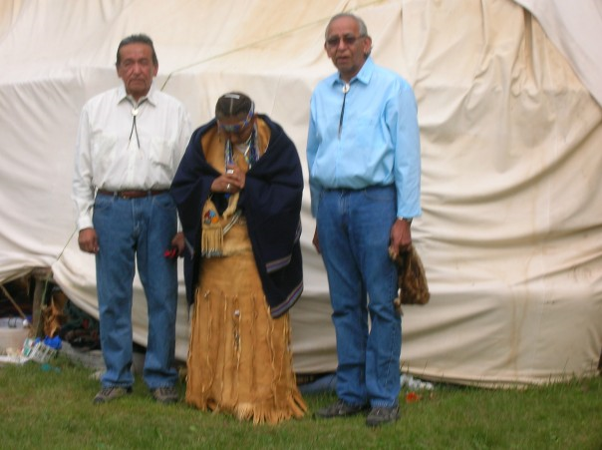
Another of these active members of trying to promote the tribal traditional cultures is Cecil Garvin. He and I have been working together for the past two years. He has been my contact for getting a Ho-Chunk language class offered to UW-Madison students here as a way to promote language use in Ho-Chunk students. He and his son, Henning, were able to offer a university level Ho-Chunk language course at the University of Wisconsin-Madison this spring semester and we hope that this class can be offered again in the spring. 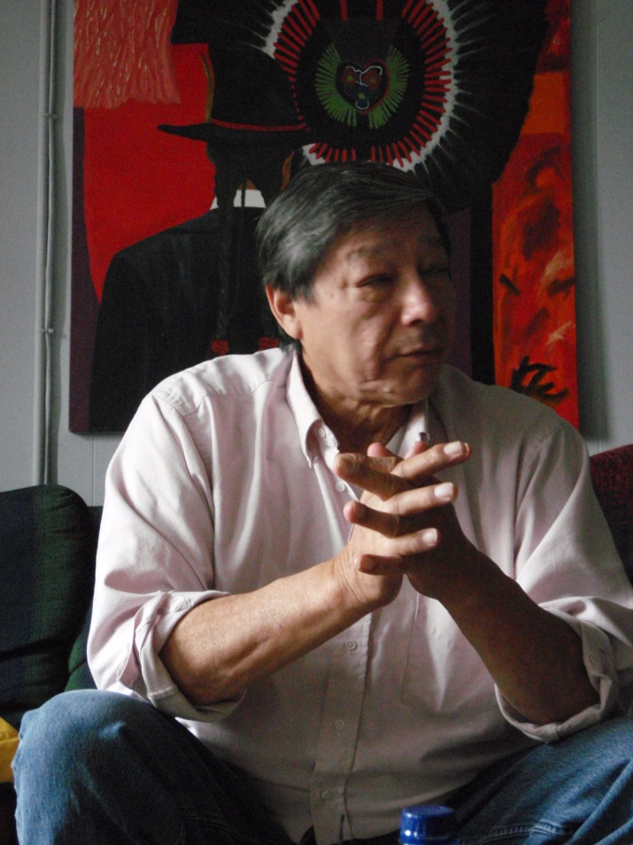
Using the language is part of what makes us Ho-Chunk and the stories and guidelines are a part of the language. As my Tega Richard has told me many times in the past, without the language, there is no need for these guidelines and there is no need for us to recognize each other as a group. The guidelines are meant to protect us as a people and without their knowledge we will fall apart.

Bibliography

Birmingham, R. A., and L. E. Eisenberg. 2000. Indian Mounds of Wisconsin. University of Wisconsin Press, Madison.

Garvin, Cecil. Interview April 14, 2009.

Greendeer-Lee, Joan. Interview April 24, 2009. May 8, 2009.

Mann, Richard. Interview April 23, 2009.

Pritzker, Barry M. October 2000. Native American Encyclopedia: History, Culture, and Peoples. Oxford University Press.

Radin, Paul. 1923. Republished 1990. The Winnebago Tribe. University of Nebraska Press, Lincoln and London.

Theler, J. L. and R. F. Boszhardt. 2003. Twelve Millennia: Archaeology of the Upper Mississippi River Valley. University of Iowa Press, Iowa City.

Tega means maternal uncle.
They said or it was said is a reference to elders saying such a thing. It could mean your grandparents, or people far back in our tribal identity history.

