“GO BLUGOLDS!!!” : THE HISTORIC DEVELOPMENT OF ATHLETICS AT THE UNIVERSITY OF WISCONSIN- EAU CLAIRE.

Kaitlyn R. Acker
History 489
May 16th, 2012

Copyright for this work is owned by the author. This digital version is published by McIntyre Library, University of Wisconsin- Eau Claire with the consent of the author.

CONTENTS
ABSTRACT iii

INTRODUCTION 1

1920’S AND 30’S: EMERGENCE AND DEVELOPMENT OF ATHLETICS 3
AT EAU CLAIRE

1940’S AND 50’S: EMERGENCE INTO THE NAIA 7

1960’S: EXPANSION OF ATHLETICS 10

1970’S: THE IMPACT OF TITLE IX 15

1980’S: EXCELLENCE? IS THAT A QUESTION? 17

1990’S: DECADE OF CONTROVERSIAL CHANGES 19

CONCLUSION: 2000’S TO PRESENT 21

APPENDIX 23

BIBLIOGRAPHY 29

Abstract
This paper examines the history of the athletic department at the University of Wisconsin-Eau Claire. It starts with a brief introduction of athletics and how division I and division III athletics are so different. Then the paper goes in chronological order through the 1920s and 1930s when only football and basketball were offered. The 1950s brought a significant change to the university when Eau Claire entered the NAIA. The 1960s saw a huge expansion of the variety of sports offered at a varsity level along with emergence of the recreation department. The 1970s saw the impact of Title IX especially for female athletes. The last couple of sections discuss the 1980s, 1990s and present decades and how the athletic department have helped to shape the university as a whole. This paper is a breakthrough on academic literature about Division III athletics.
Introduction
“The city, the campus and its facilities, the academic programs and the extracurricular activities all create a favorable image of the university. Athletics have a significant positive influence on that image” – From “Report: Administrative audit and review men’s athletics, 4/6/1983”.
436 All-Americans. Thirty-six individually recognized Academic All-Americans with forty-seven All-American awards. Eleven National Championships. These statistics speak for themselves and paint a clear image of an athletic program with a background of excellence. The road to building an athletic program with high standards has been a long one, but it’s been a process well worth the wait. Athletics at UW- Eau Claire has always been a great program and has had many great pioneers to pave the way for athletics and the recreation department today. These pioneers include Bill Zorn, Ken Anderson, Sandy Schumacher, and Clayton Anderson, just to name a few. While most of the history of athletics is bright, there were also a couple of bumps along the way. Eau Claire’s athletic program went through many changes during the past ninety years including recreation sports during the 1920s and 1930s to the NAIA (National Association for Intercollegiate Athletics) during the 1950s and finally into the NCAA Division III and the WIAC (Wisconsin Intercollegiate Athletic Conference) during the 1990s.
There have been many great athletes that have come through the university that have helped to shape and leave a definite footprint on the university. As time went on, the university expanded and so did the athletic program. The university added more varsity sports, not only for men but also for women with the approval of Title IX. It also developed a recreational program for students that wanted a bit of a break from their studies but didn’t want the full commitment of a varsity sport.
Since UWEC is now a Division III school, it means that the athletes that play varsity sports play for the love of the game, not for scholarships. Some might say that Division III athletes have to be more committed than say a Division I player. Others say that because Division III athletes don’t have a scholarship “tying” them down to a school, that Division III athletics is more pure and less pressured. Even though Division III athletics don’t have as many restrictions as a Division I program has, it does have a lot of the same rules.
One of these rules in particular is the Bona Fide student rule. This rule states that no student shall participate in intercollegiate athletic competition, conference or non-conference, unless he is a bona fide student, regularly enrolled and doing passing work in twelve credit hours. This is a very important rule and is still in use today. The Bona Fide rule stresses the importance of finishing school and getting your degree. Although the athletic experience is a bit different for Division I and Division III athletes, most of these athletes in both Divisions I and III will more than likely be doing something else with their lives; like teaching a classroom or owning a small business and have to earn a degree to make their futures happen.
It was very hard to find any sources on Division III athletics as most books that are published focus mainly at the Division I level. By giving a chronological history and background of athletics at UW-Eau Claire, this paper hopes to give some insight into how important having an excellent athletic and recreation program is to the rest of the university and the community of Eau Claire has been over the past ninety plus years. This paper will also hope to be a breakthrough source for other academic literature on Division III athletics as this is an unusual academic source.
1920s and 30s: Emergence and Development of Athletics at Eau Claire
UW-Eau Claire was founded in 1916 as a normal school. In 1917, the football team had its first season which established the first athletic team to the normal school. Men’s basketball was also added in 1917. The Wisconsin Normal Athletic Conference (WNAC) was established in 1913 and included Superior, River Falls, Stevens Point and La Crosse (northern division) and Oshkosh, Whitewater, Milwaukee and Platteville (southern division). The object of this Conference shall be the regulation, supervision, and control of normal school athletics thru-out the state in order that the athletic activities in the normal schools of the state of Wisconsin may be maintained on an ethical plane in keeping with the dignity and high purpose of education. Since Eau Claire did not exist when the conference was founded, Eau Claire was the last one to join in January 1917. Stout became a member in 1914 and was the only normal school not named after the city the school is located in (Menomonie). Adding Eau Claire and Stout to the conference made it a ten-team conference in football and basketball. Each member school played everyone in their division once and the champion was decided on a winning percentage basis. Football and basketball were the only varsity sports for the conference.
The first couple of years for the men’s basketball and football programs were quite rough. Because the normal school was so small at this time, many of the same players played on both the basketball and football teams. The coaches for these programs were William C. Phillips (basketball) and George Simpson (football).
The Periscopes, were the university’s yearbooks, did a couple of pages on each of the teams. They gave a short synopsis on each game. In some of the Periscopes, they made the players seem very heroic. They included a picture of each player on the team and incorporated a couple of sentences for each player that included nicknames and their accomplishments. Attendance at home games was pretty good; the field was located right behind Schofield hall and had a set of bleachers (figure 1). The community supported the football team and many students attended games to cheer on their fellow blugolds. They even had “pep” groups to keep the crowd in it. In addition to the “pep” groups, Eau Claire had a couple of school songs that were popular to chant during games (see Appendix A).
Men were not the only ones who participated in sports at the normal school. Each April, the normal school held a basketball tournament for women for a couple of days each academic year. Each team would play one another and the team which had the best record at the end of the tournament won. Some of the other students would come out and support their fellow classmates and watch the tournament. At this time, basketball was only a half-court sport and each basket was only one point as opposed to two or three points like they are today. Women also were allowed to participate in track events at the school. The basketball tournaments were held in the gym that was located in the basement of Schofield hall, the only building for the Eau Claire normal school at this time. These tournaments occurred for a couple more years until the women’s athletic association was set up for women on Eau Claire’s campus in 1929.

Figure 1: Aerial View of Schofield Hall and Football Stadium
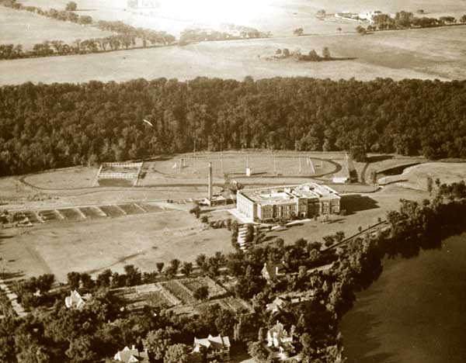
Source: The University of Wisconsin-Eau Claire, A history, 1916-1976.
In 1928, Eau Claire became a member of the Wisconsin State Teachers College Athletic Conference. This conference kept the northern and southern divisions from the Wisconsin Normal Athletic Conference. The 1930s brought a whole new era to the development of athletics at Eau Claire State Teachers College. The Men’s Athletic Association was organized in 1929 to “promote inter-class athletics and some of the minor sports, as well as interest in all school activities”. This organization had 130 members and was one of the liveliest organizations on campus.
There was also a Women’s Athletic Association on campus that was for women who wished to participate in sports and athletics. This association was also organized in 1929. Since there were no varsity sports for women at this time, if women wanted to participate in athletics, this was the only way they could. They learned a variety of sports including tennis, basketball, baseball, soccer, hiking, skating and swimming. Membership for this organization was not as large as the men’s organization as there were only thirty-one members. In the 1930’s, football and basketball were the only varsity sports offered for men, so if they wanted to participate in another sport, they looked to the recreational sports that were offered. These sports included tennis, hockey, wrestling, horseshoe, free-throw contest (basketball), handball, kittenball (softball), track and basketball. There were plenty of ways for students to get involved in athletics at the teachers college.
One of the biggest pioneers for athletics at UW-Eau Claire was Willis “Bill” Zorn (Appendix B). He was hired in 1928 as a football and basketball coach. His nickname was “Mr. Enthusiasm” because he was known for his strong character and leadership on and off the athletic field. He coached football until 1943 and continued with basketball until 1963. He led Eau Claire to four basketball conference championships in 1938, ‘39, ‘55 and ‘56. Zorn also led Eau Claire to the National Intercollegiate basketball tournament in Kansas City, Missouri in 1939, ‘45, ‘46, ‘51 and ’56. Zorn was also the athletic director and the dean of men, and was hired at a later part of his career for these two positions. In Zorn’s first season at Eau Claire as the basketball coach, the Blugolds had a .500 season, which in comparison to past seasons was an improvement.
1940’s and 50’s: Emergence into the NAIA
The 1940s and 50s continued to show development in athletics at Eau Claire. In 1940, Eau Claire merged with the other schools in the Eau Claire State Teachers College Conference and formed the Wisconsin State University Athletic Conference (WSUAC). During the 1940s, football and basketball were still the only varsity sports. On the other hand, the recreation department was going strong along with the Men’s and Women’s Athletic Associations. The number of sports was still the same that the associations offered. The Women’s Athletic Association held a track and field meet and a basketball tournament for students to compete against each other annually. Students supported the teams as best they could; football moved to Carson Park so going to watch the football team play was a little harder for the majority of the students. The Men’s basketball team went undefeated under Coach Zorn for the first time in school history in 1940. During World War II, there was no football team during the 1943-44 academic year. In 1947, the University hired Ade Olson to take over the football program so Zorn could focus on the men’s basketball team, as well as being the athletic director and the dean of men.
The 1950s brought a lot of change to the university’s athletic program. The Women and Men’s Athletic Associations were no longer around but the recreational sports were. Women formed another organization called the Women’s Recreation Association that included volleyball, basketball, softball, badminton, table tennis, bowling and tennis. At the end of each school year, the association held an annual banquet that highlighted achievements for the women during that particular school year.
Women made headways in athletics in 1958 when Eau Claire joined the Wisconsin Athletic and Recreation Federation of College Women (WARFCW). This federation was formed for the purpose of coordinating athletic activity among Wisconsin institutions of higher education. The representatives were from Eau Claire, La Crosse, Milwaukee, Oshkosh, Platteville, Ripon College, River Falls and Madison. The federation held sports days at all the representatives’ colleges in different sports such as archery, badminton, basketball, golf, gymnastics, tennis and volleyball. This gave an opportunity for women to participate in different sports and strengthen their skills, but also it allowed them to compete against other female students. WARFCW also allowed women to start having a voice and participate in a more equal setting compared to men’s athletics.
The biggest change to occur for Eau Claire was entering the National Association for Intercollegiate Athletics (NAIA) in 1959. The entire conference (WSUAC) entered the NAIA at the same time. The NAIA was originally the National Association of Intercollegiate Basketball which was founded in 1941. A.O. Duer took over the NAIB in 1948 as director of the association. “Thus Duer managed to lead the NAIA for 26 years and remain optimistic through all the trials of that tumultuous time. This Christian understanding of life led him to continually focus on the ties between ethics and sports, a focus that helped distinguish the NAIA from the NCAA”. Since the NAIA had more of a Christian understanding and incorporated it into how Duer ran the association, many schools joined the NAIA over the NCAA because of the connection with Christianity. Also, the NAIA was a smaller organization, so that also appealed to some schools that maybe didn’t have as strong of a program as some larger schools that they could compete against in the NCAA.
The NAIB began naming All-Americans in 1951 and in 1952 the name became the NAIA so that more institutions would join and so that more athletics could be covered under one association. The NAIA was an amateur association so that college athletes could participate in the Olympics and other World Cups. College students were not allowed to be classified as professional athletes because that would mean that they could be paid which was not allowed. A convention was held in 1957 to come up with a set of beliefs that each university or college that entered the NAIA had to believe in and stand by.
The National Association of Intercollegiate Athletics believes:
- That one of the purposes of higher education is to develop each individual to the fullest extent of his capabilities both as an individual and as an athlete.
- That everything which takes places in a college must be evaluated in terms of the educational purpose of higher education.
- That the major emphasis of the program of athletics should be instrumental in educating participants and other students in moral and ethical values inherent in the program.
- That colleges should compete with other colleges having similar educational philosophies, policies and practices.
- That all students participating in intercollegiate athletics should be admitted to college in the same manner as other students and should be regularly enrolled students making normal progress, both quantitatively and qualitatively, toward a degree.
- That the role of the association is that of working co-operatively with and providing leadership to member institutions, toward the realization of these basic beliefs.
There were more beliefs listed under the original 1957 convention, but these were the ones that were most important in the development of a successful but respectful collegiate program at any university or college. The NAIA sponsors seventeen national championship events in cross country, soccer, water polo, football, indoor and outdoor track, hockey, basketball, wrestling, swimming, gymnastics, bowling, volleyball, decathlon, baseball, golf and tennis. The country was divided into thirty-two districts. When Eau Claire was a part of the NAIA, they were in district 14. To get to the national tournament for any sport, a team would have to win their district in order to move on to the national tournament. In other words, there would more than likely be thirty-two teams in any given national tournament.
1960’s: Expansion of Athletics
Like the 1950s, the ‘60s saw the greatest expansion in varsity sports for the men’s teams in the history of the athletic department. In 1962, the conference name changed yet again as the colleges’ names were changed to the Wisconsin State College Athletic Conference. The same schools were in this conference as they had from the normal school conference in 1913. Yet again in 1965, the conference name changed, this time it was changed to the Wisconsin State University Athletic Conference (WSUAC). This was due for a couple of reasons. First, the University of Wisconsin- Milwaukee dropped out of the conference in 1964. Also, most of the schools in the conference changed their names to Wisconsin State University then their town. For example, Eau Claire was Wisconsin State University-Eau Claire. The only one who did not follow this path was Stout. Their name was Stout University: Menomonie.
The athletic department added men’s cross country, golf, tennis and wrestling all in the 1966-67 academic school year. The addition of these sports brought the total up to seven varsity sports in the athletic department. Baseball was also added to the athletic department during the 1960s. Adding five sports to the athletic department put a crunch on the funds that could be given to each sport. Since football guaranteed the university the most money and was the most expensive sport, they were allocated the most out of the budget for the entire department.
Also in 1966, the recreation department was created by Leonard Haas but was directed by Clayton Anderson. It was expanded to meet the needs of the expanding student body. The National Intramural Association (NIA) was founded on February 22, 1950, but the name was changed on March 26, 1975 to the National Intramural-Recreational Sports Association (NIRSA) to fit the expansion to intramural and recreational sports. The objectives of the NIA are as follows:
Section 1. To promote and encourage intramural and recreational programs.
Section 2. To meet annually for professional growth.
Section 3. To serve as medium for the publication of research papers on intramurals of both members and nonmembers.
Section 4. To work in close cooperation with the American Association for Health, Physical Education and Recreation, The College Physical Education Association and the Educational Policy Committee of our respective institutions.
These objectives are very similar to the same ones that every conference that Eau Claire has belonged to. Even though they are recreational and intramural sports, there is still a sense of pride throughout the program. The same holds true for Eau Claire’s varsity athletic programs.
The budget for the entire university during the 1960s was tight; money was hard to come by. The 1960’s saw the most dramatic shift in expansion of the university than any other decade. Phillips hall, Horan hall, Schneider Social Science Hall, Bridgeman, Murray and Sutherland halls were all built during the 1960s. Many of the halls were built on state funds. The state university thought that it might be a good opportunity to use the students as a sort of “community donation” and raise their tuition a couple of dollars and give the athletic department some more money.
In the years 1963-1964, Eau Claire had the third highest enrollment at 3,009 out of the state colleges behind Oshkosh (4,221) and Whitewater (3,811) so Eau Claire should have been able to get a substantial amount of student fees for their athletic department. But instead, Eau Claire was bringing in the least amount for a total of $12,800 for this academic year. There were a couple of colleges that didn’t charge student fees (Oshkosh, Platteville and La Crosse). The other universities got more money than Eau Claire. River Falls got $17,500, Whitewater and Stevens Point received $20,000, Superior $21,000 and Stout at $22,000. This information shows that Eau Claire wasn’t charging as much as the other schools. With that said, Eau Claire should be able to obtain more money and have a bigger budget for athletics and other areas that are in need at the state college. Table one shows a table that was taken from the Activity Fees of the State Colleges from 1957 in which shows a little different story than the budget reports from 1963-64.
Table One: Activity Fees of the State Colleges: 1957
Stout $24.00
Superior $17.00
Oshkosh $15.00
River Falls $10.00 per quarter
La Crosse $14.00
Whitewater $14.00
Stevens Point $12.50
Eau Claire $15.00
Milwaukee $0.00
Platteville $7.50
Source: Bill Zorn Papers, Box 7 Folder 9.
These were the activity fees that each state college expected each student to pay towards their state colleges’ athletic department. There is quite a range with Stout at twenty-four and Milwaukee expected nothing. Eau Claire is in the middle; when they asked their students for fifteen dollars. It doesn’t seem like that much and wouldn’t go a long way now but back in the 1960’s, fifteen dollars was a lot of money and went a long way in the budget. Appendix C shows an example budget from the baseball team in 1965. It breaks down every single budgetary item; everything from bats to balls to transportation and food costs for the team.
In comparison to other years, the Athletics budget for 1965-66 was $20,200. In 1966-67 it went up to $30,400. Out of all the other organizations on campus, the Athletic department had the biggest budget. The next highest was the University Senate with $20,050 for the 1966-67 academic year. The grand total for eighteen organizations on Eau Claire’s campus was $168,125. These statistics show that the Athletic department had eighteen percent of the budget for Eau Claire’s organizations. This shows how important Athletics really were to the university and to the Eau Claire community by receiving that much of the budget.
Within the athletic department’s budget for 1965-66, football was budgeted about $12,000 for that year. Since the budget was $20,200 for the year, football’s budget was over half for the entire department. Football got a lot of support from the community and brought in a lot of money so because of all that, they were allowed over half the budget. The least expensive sport for that year was track which received only $450.
Bill Zorn retired in 1968 from the men’s basketball coaching position. Zorn remained working at Eau Claire until 1984 in the athletic department. Zorn compiled a 397-357 record in forty years from 1928-68. Zorn Arena was built on lower campus in 1952 (see Appendix D) and dedicated to Coach Zorn for all his hard work in building and shaping the athletic program at Eau Claire. The men’s basketball team was often nicknamed the “zornmen” after Coach Zorn. Zorn is one of the true pioneers and help to build the way in making Eau Claire what it is today. With Zorn gone, Ken Anderson (Appendix E) was hired to replace him as the head men’s basketball coach in 1968. The next year in 1969, Anderson led the Blugolds to the NAIA national basketball tournament in Kansas City for the first time in school history under Anderson. This trip to the NAIA national tournament started a string of return trips to the tournament for the blugolds and really started to pave the way for excellence for men’s basketball.
1970’s: A Decade of Excellence and the Impact of Title IX
The 1970s were probably the most important decade in the history of athletics in the United States. Title IX was very important to athletics because it allowed women to participate and equal treatment in varsity sports for the first time in U.S. history. Title IX is a portion of the Education Amendments that were passed in 1972. Title IX stated that no person in the United States shall, on the basis of sex, be excluded from participation in, be denied the benefits of, or be subjected to discrimination under any education program or activity receiving Federal financial assistance. Eau Claire had their own legislation that prohibited discrimination on the basis of sex in the operation of any interscholastic, intercollegiate, club or intramural athletic program offered by an institution (section 86.41). The athletic department gave all sports until July 21, 1976 to self-evaluate their policies and fix them to fit the title IX requirements.
With the impact of Title IX, many more varsity sports, especially women’s sports, were added to the university. These included Men’s and Women’s swimming and diving and Gymnastics both started in 1969-70. Women’s basketball, Volleyball and Tennis all had their first seasons in 1970-71. Men’s hockey’s first season was 1977-78. The addition of these seven teams brought the total of varsity sports up to thirteen for the entire athletic department. The department has come a long way since 1917 when it was only men’s basketball and football as the varsity sports. It is truly amazing how much can happen and change in fifty years.
1970 was really an amazing year for the athletic department. Football had their first winning season since 1961. Men’s basketball had their first conference championship since 1956 under Coach Anderson. The men’s basketball team had three straight trips to the NAIA national tournament in Kansas City; 1969-1970, 1970-71 and 1971-72. They also made a trip during the 1973-74 season, but they never won it all. The pattern of going to post season play showed consistency in the athletic department and especially in men’s basketball. Swimming and diving for both men and women’s inaugural seasons were 1969-70 but they only won one meet the entire year which is to be expected in the first year of a program.
The rest of the 1970s were just as bright as 1970. The swimming and diving teams were very influential in the success of the athletic department. Their coach, Tom Proyer, was coach of the year in 1970-71, ‘71-‘72, ‘73-‘74 and ‘75-’76. Having the consistency Eau Claire did drew more students into Eau Claire. The tennis program was also starting to build a track record of excellence. They had two all district tennis teams in 1972-73 and ’75-’76. With the track record that this university was starting to build in the excellence on and off the field was a huge selling point to many students who looked at coming to this university. Also, because the success that the different sports were having, the university started to get more and more support from the community. Zorn Arena was usually packed for men’s basketball games with the clear excellence they had. This excellence continued on in the 1980s.

1980’s: Excellence? Is that a Question?
The 1980s were another decade that had plenty of change and excellence all rolled into one. The 80s started with a bang with Eau Claire winning conference titles in men’s basketball, men’s golf, men and women’s swimming and diving and men’s tennis. Eau Claire also won the WSU conference all sports champion for the 1979-80 academic year. Also, a bunch of NAIA national championships were won during the 1980s; one individual gymnastics title in 1985, one women’s cross country team title in 1984, men’s hockey in 1984 also and three women’s swimming and diving titles in 1983, 87 and 88. Two varsity sports were also added in the 80s; women’s softball in 1984-85 and women’s soccer in 1989-90. With statistics like these, consistent appearances and good finishes, why wouldn’t Eau Claire’s athletic program be considered excellent?
The students have been supportive of athletics throughout history, but when athletic teams performed at a high level, there is more reason for them to come out and support their fellow Blugolds by attending sporting events. Also, there were a variety of sports for students to choose from so there was always something for everybody to go to and be excited to go and watch. The student athletes loved the support of seeing the stands full not just with their parents, but with their friends, professors and classmates. Gib Hinz, a men’s basketball player in 1980 said it best; “nobody has fans like we do at Eau Claire”. This is something that many student-athletes that go here can attest to very strongly. “The [athletic] program plays a special role in the university by providing a means for students to participate in a wide range of activities not only as active participants but as spectators. It brings many members of the community into close association with the university”.
An interesting story that also demonstrates the level of excellence at Eau Claire is in 1980 when Ken Anderson, the men’s basketball coach and one of his players, Joe Merten participated in the tenth World University Games in Mexico City. During the few weeks of the tournament, Anderson and Merten helped the United States bring home a gold medal beating Yugoslavia 88-70. This shows the caliber of athletes and coaches that Eau Claire has been fortunate to have over the last couple of decades and the impact they can make on the world.
The recreation program that was established in 1966 by Haas and Clayton Anderson expanded during the 1980s to meet the needs of the student body. The program went from accommodating a few thousand students in the 1960s to more than two million during the 1970s and 80s. Total attendance in the recreation program during the 1970s was 2,338,796. “The recreation programs let the students relieve themselves from the pressures of college. They [students] go out and have fun”. Recreational sports also allowed students to get out of their studies and go out and meet some new people as well. This program is great for freshmen that come to the university and do not know anyone. By playing recreational sports, they can meet some new people and build new relationships.
The budget reports for the 1980s are different than the ones for the 1960s. For example, the budget for the 1982-1983 academic year was $179,000. This is for a couple of reasons. First, there were way more students enrolled at the university in the ‘80s than the ‘60s. Second, there were fifteen varsity sports that needed funding with 445 participants. These sports include: baseball, basketball (men’s and women’s), cross country (men’s and women’s), football, golf, hockey, swimming and diving (men’s and women’s), tennis (men’s and women’s), track (indoor/outdoor and men’s and women’s) and wrestling.
Softball had a couple of years before their first season in 1985 as a club sport (not part of the athletic department as a varsity sport) where they had records of 4-2, 10-2 and 17-6. Following this information, softball was nominated to be considered as a varsity sport. The discussion of varsity status for women’s softball was put to a vote and passed the athletic committee by a vote of four to three in 1981. This made the ratio of men and women teams more balanced. Even though the numbers of teams were more balanced, the budgets for men and women teams were not. The 1985-87 seasons showed that men were still receiving more money over women teams ($118,500 v. $100,200).
1990’s: Decade of Controversial Changes
The 1990’s brought a lot to the athletic programs. It brought joy, sweat, tears and for the first time, huge controversies over which sports to keep and which ones to get rid of. The first season occurred for women’s golf in 1995-96. Baseball’s last season was the 1994-95 season. Baseball is a club sport at the university presently; as men’s soccer, volleyball and rugby (men and women). During the 1990’s the number of varsity sports expanded to twenty-two in total; 11 men and 11 women. “Whatever the sport, Eau Claire athletes proved that success did not come by accident, but by a combination of commitment, dedication and pride. Blugold athletes and fans were united in the colors of Eau Claire sports.” This quote is truly fitting of the way the program has, is and will be. The number of athletes that participated from Eau Claire was in the middle of the pack in fourth in the WSUC. In 1990-91, there were 2,745 participants in the conference and 309 were from Eau Claire. Ahead of Eau Claire was La Crosse with 472, Whitewater with 364 and Stevens Point with 355.
There was also a bit of controversy throughout the WSUC about switching from the NAIA into the NCAA at the division III level. Some of the schools were skeptical and had growing concerns with the differences in dues structure [amount paid to be a member], eligibility rules, surveys and paperwork requirements, qualifying standards for championships and cost factors for national competition. They were skeptical because they didn’t know if the Wisconsin systems could compete with the schools that were already in the NCAA- division III. In 1993, Eau Claire joined some of the other Wisconsin schools in the NCAA-division III.
On July 1st, 1997 the nine members of the former Wisconsin State University Conference (Whitewater, Stevens Point, Oshkosh, River Falls, Platteville, Eau Claire, Stout, Superior and La Crosse) and the Wisconsin Women’s Intercollegiate Athletic Conference joined together to form a single conference which we know today as the Wisconsin Intercollegiate Athletic Conference (WIAC). Dr. Gary Kamer was appointed commissioner in July 1996. In all of division III, the WIAC is known as one of the premier conferences in the country. This is evident in the number of post season appearances and number of NCAA championships that are captured annually by the WIAC teams and the overall finishes of WIAC schools in the division III Learfield Sports Directors’ cup Standings. The WIAC has also been recognized for its advances in gender equality and the community activism of its student-athletes. Being a part of the WIAC was a good move by Eau Claire.
The WIAC is unique because most of the schools that are in division III are private schools whereas the entire WIAC are public universities. Also, all of the WIAC schools are located within the same state; there is only one other conference in division III like that (SUNY in New York is the other). Most WIAC campuses are situated in mid-sized towns; Platteville being the smallest at 10,000 and Oshkosh is the largest at 66,000. Because all of the schools are situated in the same state, the rivalries are pretty intense and athletes often end up playing against other players that they played with or against in high school. There really is no other conference like the WIAC in the country in terms of consistency and Eau Claire is definitely a big part of it.
Conclusion: 2000’s to present
Not much changed between 2000 and the present in the WIAC and at Eau Claire. Women’s hockey had their first season in 2000-2001. A couple of individual national titles were won in Gymnastics, the softball team won a team title in 2008 against UW-Whitewater in Salem, Virginia and the women’s cross country team won a team title in 2009. In February 2012, the basketball court in Zorn Arena was named “Ken Anderson court” (Appendix F). There have been numerous conference championships, national championships, All-American awards and fun along the way.
The history of Eau Claire’s athletic program is long but extraordinary. Eau Claire’s athletic program is one of the strongest in the nation all around. There are good student-athletes, coaches, professors, and community support from this wonderful city. The intramural/recreation program and club teams are also very strong and make any student that enrolls in this exceptional university feel right at home and in the midst of excellence.

Appendix A- Eau Claire State Teachers College School Songs
- Let’s go Eau Claire, to victory,
Let’s fling our banner high,
Let’s sing her praise in these humble lays,
And we’ll shout it to the sky.
And we’ll shout it to the sky.
U-rah-rah!
Let’s cheer them on to victory,
And all their honor share.
Beaten never, fighting ever,
Let’s go Eau Claire.
- Eau Claire College, Teachers College,
You’re the best of all;
We’ll be true to your traditions,
Whatever may befall.
U-rah-rah!
Eau Claire College, Teachers College,
Pride of the whole northwest;
We’ll fight to show our loyalty
And help to win the victory,
Our Alma Mater of Eau Claire.
- The schools are many in our state,
And colleges not a few,
But there are none can hope to rate,
Our college dear, with you.
The Chippewa river pays thee homage,
Bowing low before thy feet,
And the scenes they stir our heart beat
Which the trees, the bluff, the meadows make complete,
And we thy loyal sons and daughters,
Our love and fealty will swear,
To thee, our Alma Mater, Thou College of Eau Claire.

From UW-Eau Claire Archives, Bill Zorn Papers Box 7 Folder 7.
Appendix B: Willis “Bill” Zorn: “Mr. Enthusiasm”

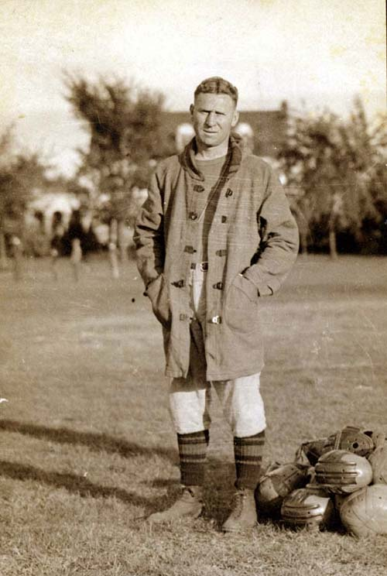

Courtesy of UW-Eau Claire McIntyre Library

Appendix C- Baseball Budget 1965
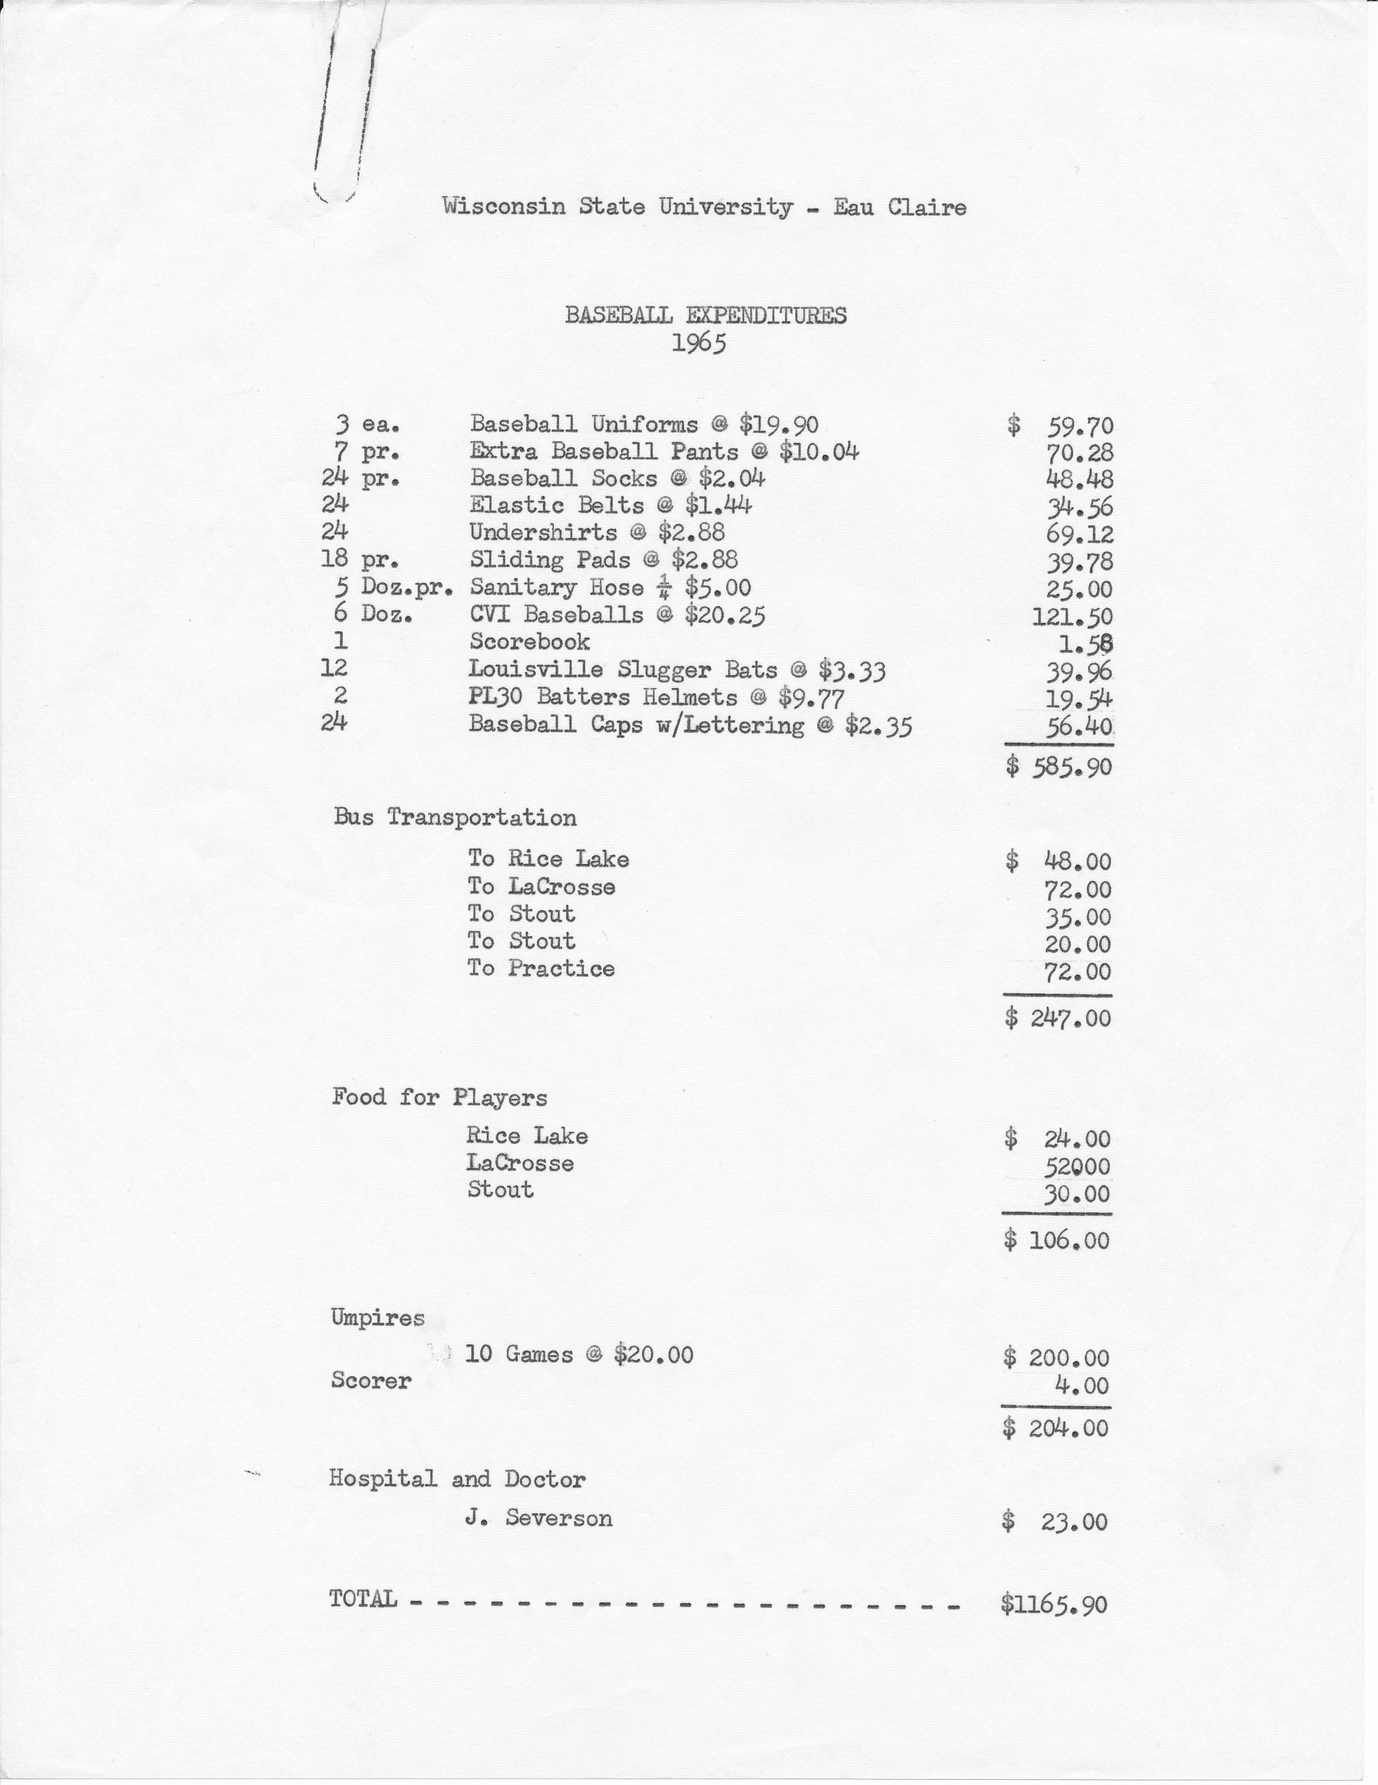
Courtesy of the UW-Eau Claire Archives at McIntyre Library
Appendix D- Zorn Arena
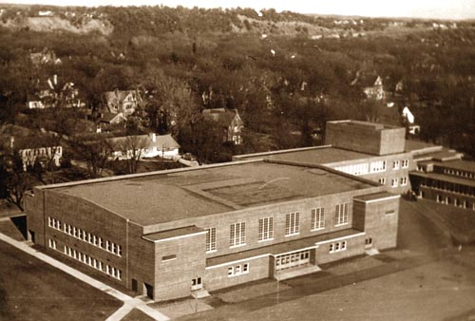
Courtesy of the McIntyre Library webpage

Appendix E- Ken Anderson
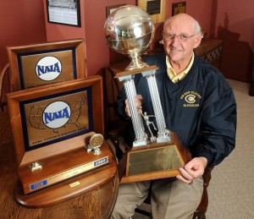

Appendix F- “Ken Anderson Court” in Zorn Arena
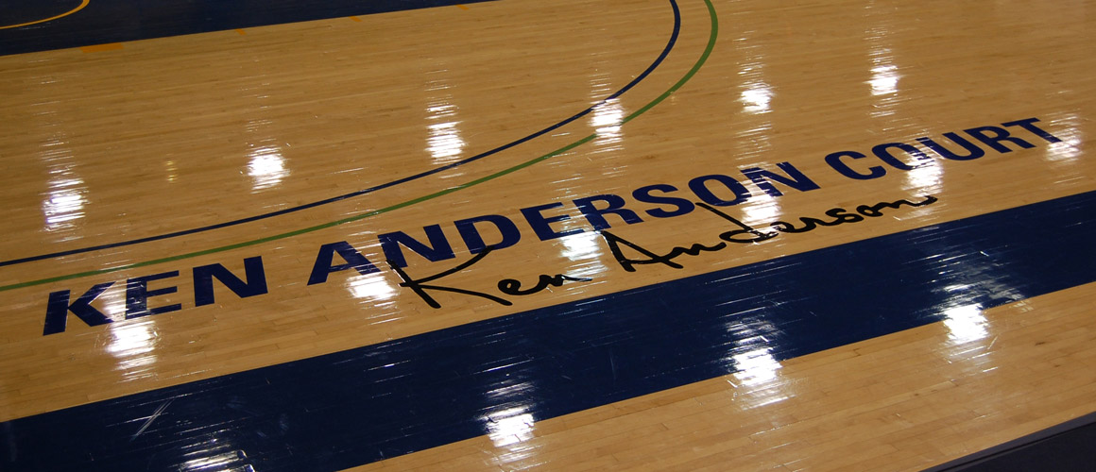

Courtesy of the Spectator; Eau Claire, Wisconsin

Works Cited
Primary Sources
Bill Zorn Papers, 1925-1984, UW- Eau Claire Special Collections and Archives.
Periscopes, UW-Eau Claire Special Collections and Archives.
University of Wisconsin-Eau Claire Athletic Committee Records, 1947-1991, UW-Eau Claire Special Collections and Archives.
Wisconsin State University Conference records, 1915-1992, UW-Madison Archives, Steenbock Library, University of Wisconsin- Madison, Madison, Wisconsin.

Secondary Sources
Carter, Hilda R., Jenswold, John R. The University of Wisconsin- Eau Claire: A History, 1916- 1976. (Stevens Point: Worzalla Publishing Co., 1976).
Clarke, James S. Challenge and Change: A History of the Development of the National Intramural Recreational Sports Association, 1950-1976. (West Point: Leisure Press, 1978).
Gardiner, Andy, “Wisconsin’s D-III athletic conference very stable,” Sports, USA Today, October 27, 2011, http://www.usatoday.com/sports/college/story/2011-10-26/wisconsin-division-3-athletic-conference-very-stable/50947270/1 (accessed 20 March 2012).
United States Department of Labor. “Title IX, Education Amendments of 1972,” http://www.dol.gov/oasam/regs/statutes/titleix.htm (accessed 20 March 2012).
University of Wisconsin-Eau Claire. “Athletics homepage,” http://www.blugolds.com/landing/index (accessed 19 March 2012).
Wilson, John R.M. The History of the National Association of Intercollegiate Athletics: Competition, Tradition, Character (Monterey: Coaches Choice, 2005).
Wisconsin Intercollegiate Athletic Conference. “History,” http://www.wiacsports.com/sports/2010/7/29/GEN_0729100843.aspx?tab=history (accessed 19 March 2012).

Report: Administrative Audit and Review Men’s Athletics, April 6, 1983, UW-Eau Claire Athletic Committee Records, Box 1 Folder 3, UW-Eau Claire McIntyre Library Archives, Eau Claire, Wisconsin, 2.
Wisconsin Intercollegiate Athletic Conference webpage. http://www.wiacsports.com/(accessed 19 March 2012).
Handbook of Wisconsin State College Athletic Conference: Constitution and by-laws 1962, Bill Zorn Papers 1925-1984, Box 7 Folder 10, UW-Eau Claire McIntyre Library, Eau Claire, Wisconsin.
Constitution and By-laws of the Wisconsin Normal Athletic Conference, Bill Zorn Papers, Box 7 Folder 7.
Ibid.
1922 Periscope, Series 131, Box 1, Folder 6, UW-Eau Claire McIntyre Library Archives, Eau Claire, Wisconsin, 53-62.
1920 Periscope, Series 131, Box 1, Folder 9, UW-Eau Claire McIntyre Library Archives, Eau Claire, Wisconsin, 60.
1930 Periscope, UW-Eau Claire McIntyre Library Archives, Eau Claire, Wisconsin, 64.
Ibid., 80,105.
Bill Zorn Papers, Biographical/Historical Note.
1930 Periscope, 96.
Bill Zorn Papers, NAIA historical overview district #14, Box 6, Folder 11, 3; 1940 Periscope, 54, 82, 88-89.
1950 Periscope. WIAC webpage. History of the WIAC, http://www.wiacsports.com/sports/2010/7/29/GEN_0729100843.aspx?tab=history 19 March 2012.
John R.M.Wilson, The History of the National Association of Intercollegiate Athletics: Competition, Tradition, Character (Monterey: Coaches Choice, 2005) 16, 26-27, 29.
Ibid, 28, 34.
Ibid., 42-43.
Bill Zorn Papers, National Association of Intercollegiate Athletics: General Information, Box 6, Folder 11.
Ibid, Box 7, Folder 10.
Ibid, Box 7, Folder 11.
University of Wisconsin- Eau Claire Athletics webpage. History by Sport, http://www.blugolds.com/sports/general/sports 19 March 2012.
1980 Periscope, 154.
James S. Clarke, Challenge and Change: A History of the Development of the National Intramural-Recreational Sports Association 1950-1976 (West Point: Leisure Press 1978) 14.
Ibid., 135.
Hilda R. Carter and John R. Jenswold, The University of Wisconsin- Eau Claire: A History, 1916-1976 (Stevens Point: Worzalla Publishing Co., 1976) 87-89.
Bill Zorn Papers, Box 7 Folder 3, Money Allocated to Athletics from Student Fees of State Colleges.
Bill Zorn Papers, Box 7, Folder 4, University Activities and Programs Budget.
UWEC Athletic Committee records, Box 2, Folder 19, Budget Report for Sports; 1965-66.
UWEC athletics webpage. 1960 Periscope,71. Bill Zorn Papers, Box 6, Folder 11,6-7.
United States Department of Labor webpage, Title IX: Education Amendments of 1972, http://www.dol.gov/oasam/regs/statutes/titleix.htm 20 March 2012.
UWEC athletics webpage.
1970 Periscope, 117,120-122. Bill Zorn Papers, Box 6, Folder 11, NAIA Historical Overview District #14, 73-74.
Ibid., 17.
1980 Periscope, 115. WIAC webpage.
Ibid, 147.
UWEC Athletic Committee Records, Box 1 Folder 3, Administrative Audit and Review Men’s Athletics, 3.
1980 Periscope, 148.
Ibid., 154-155.
UWEC Athletic Committee Records, Box 1, Folder 3, Organized Activity Budget Request.
Ibid. UWEC Athletic Committee Records, Box 1 Folder 3, Women’s Organized Activity Budget Request.
UWEC Athletic webpage. 1995 Periscope. 1990 Periscope, 157.
WSUC Athletic Directors Minutes/Correspondence Wisconsin State University Conference Records, 1915-1992, Box 7, UW- Madison Steenbock Library, Madison, Wisconsin.
Ibid., 4.
WIAC webpage.
Andy Gardiner, “Wisconsin’s D-III athletic conference very stable,” Sports, USA Today, October 27, 2011.
UWEC Athletics webpage. WIAC webpage.

