Hasenfus:
Iran-Contra and the Man Who Broke the Scandal

Tristen Seymour
HIS-489
Fall 2018

Copyright for this work is owned by the author. The digital version is published in McIntyre Library, University of Wisconsin – Eau Claire with the consent of the author.

Contents

Figures iii
Dedication iv
Abstract v
Introduction 1
Historiography 3
The Operation 6
Hasenfus 9
The Scandal Breaks 15
The Investigation 18
Conclusion 23
Bibliography 25

Figures
Figure 1 Eugene Hasenfus Taken to Crash Site 1
Figure 2 Sally Hasenfus 10
Figure 3 Crash Location 11
Figure 4 The Crash Site 15
Figure 5 Wallace Blaine Sawyer, Jr. 16
Figure 6 Oliver North testifying before Congress. 22

For Jean

Abstract
While Ronald Reagan and Oliver North became the faces of the Iran-Contra affair, one man transitioned from a position on the front page of every newspaper in America to an afterthought of a government scandal. Eugene Hasenfus, the sole American survivor of the plane crash that broke the scandal to the world, possessed a very important, and to this day forgotten, role in the entire operation. Hasenfus, a veteran, hails from a small Wisconsin town. He needed work and used his military experience to gain a position flying supply missions with Southern Air Transport over Nicaragua. For his role in the covert mission, Hasenfus was arrested and given a thirty-year prison sentence in Nicaragua but was later pardoned. His testimony was used during the congressional investigation into the case.
Introduction
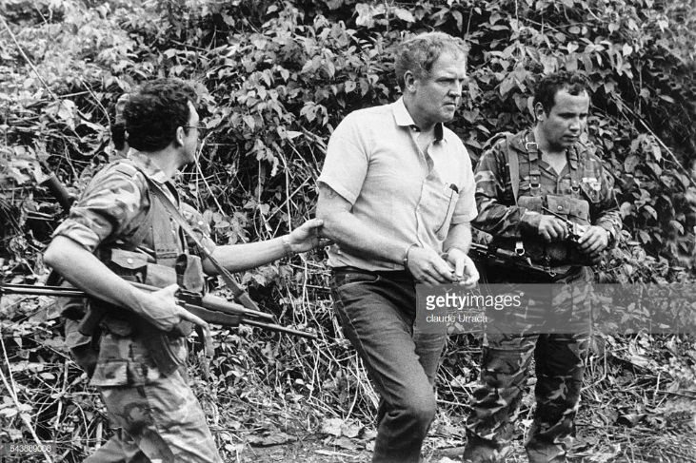
On an October morning in 1986, the regulars at a diner in Marinette, WI, sit down for their usual breakfast. The diner is small enough that they are all able participate in the same conversations. The room typically bustles with jokes and laughter, but that day was different. That day, the usually raucous group was silent. They sat down, ate their meals, and left without saying a word. The difference? Reporters from the New York Times. Several days earlier, A Marinette man was captured in Nicaragua following a plane crash. Eugene Hasenfus, the sole American survivor of the downed aircraft, had his name released to the media and they wanted to investigate Hasenfus’s origins. Unfortunately, there was nothing exciting about his past. Although the research into the origins of the mystery airman were deemed uneventful, Hasenfus served as the gateway into a government scandal that would have remained buried far beneath the popularity of the Reagan administration.
Figure 1: Eugene Hasenfus Taken to Crash Site
Urraca, Claude. Civil War in Nicaragua. November 15, 1986. Sygma, Getty Images.

Gene Hasenfus, a former Marine, was involved in the covert operation of supplying arms to the Contras, a guerilla army in Nicaragua. Hasenfus’s role in the operation was as simple as being a crew member of the supply plane during its runs. His role in the investigation, however, ranged from witness to that of accuser, as he was asked to identify the conspirators. His testimony in this case lead to a national distrust of the Central Intelligence Agency, and just how involved they were in foreign affairs. While Eugene Hasenfus has been seemingly forgotten in history, his story is still responsible for bringing national attention to a small Wisconsin town.
Eugene Hasenfus is far from a household name, and the same can be said for the entire Iran-Contra scandal. In an attempt to bolster the public image of an iconic American president, the affair that rocked the 1980s has been all but ignored. The remembrance of the scandal is not as important on its own, however, when examined as a back-room abuse of presidential power, it suddenly becomes relevant to every generation of Americans. Iran-Contra began as an objective to halt the spread of communism, but it quickly changed into a profit-making scheme, which continued until it was discovered following the plane that contained Hasenfus being shot from the sky.
When a political scandal occurs, it is easy to think of everyone involved as an enemy to democracy. For example, following the Watergate scandal, Americans began to question their own privacy, as well as the legitimacy of their elections. Iran-Contra, however, enlightened the Nation on the ways in which politicians can go around the law, which leads to corruption and even death.
This study will focus on the parameters that define the Iran-Contra affair, including special focus on Eugene Hasenfus, the forgotten player of the scheme. We will examine Hasenfus’s role, as well as the make up of the convoluted operation that provided missiles to Iran, supplies to the former dictator of Nicaragua, and undermined the careers of several high-ranking CIA, military, and political officials.

Historiography

Being a presidential scandal, along with being an international scandal, Iran-Contra instantaneously became the source of intense scrutiny and public interest. Sadly, as the decades have passed, this scandal has become seemingly unknown to the generations that did not experience it. Many Americans born after the time of these events possess little to no knowledge that they ever occurred. One example of a recent spotlighting of the Iran-Contra Scandal comes from the popular animated television series American Dad!. In season Three, episode fifteen, the main character of the show sings a musical number which briefly, and surprisingly accurately, teaches viewers about the forgotten scandal. The aforementioned musical number is one of the very few pop culture references to Iran-Contra. Unfortunately, many retellings of the affair completely ignore the role of Eugene Hasenfus. They, understandably so, focus on the corruption with Ronald Reagan, Donald Gregg, Richard Secord, and Oliver North. Luckily, the leading historians on this topic do give mention to Hasenfus and his role in the scandal.
The most notable, and arguably most respected, expert on Iran-Contra is Malcolm Byrne. In his book IRAN-CONTRA: Reagan’s Scandal and the Unchecked Abuse of Presidential Power, Byrne covers every faction of the scandal. He begins his chronological writing by focusing on the causes and reasoning of the United States’ involvement in Nicaragua. He then continues to the influx of scandalous behavior to maintain aid supplies without congressional permission. Following this, he examines the breaking of the scandal along with the attempted coverup by the CIA. Byrne finishes his work by addressing the congressional hearings to determine guilt of the members involved in the case. While Byrne displays a stunning understanding of Iran-Contra, he only mentions the name of Eugene Hasenfus a handful of times, and these times are almost all associated with a passing reference to the plane crash, and nothing more. Another renowned author on the topic is Theodore Draper.
In his book A Very Thin Line, Draper, like Byrne, provides a very in depth and analytical allotment of information regarding the scandal. One thing he does exceptionally well is include a productive amount of information when he introduces a new player to the situation. Unlike Byrne, Draper takes several paragraphs to provide a backstory to Hasenfus. He explains Hasenfus’s career with the USMC, his six-year career flying in Southeast Asia with Air America, his fourteen-year construction career, and finally his short-lived career flying with Southern Air Transport in Central America. The information in this section of his book is taken directly from Hasenfus’s testimony in Nicaraguan courts. Draper also includes some specifics of the C-123k’s contents when it crashed, as well as Hasenfus’s twenty-four hour wandering of the Nicaraguan jungle before being captured. Draper’s inclusion of Hasenfus in his retelling of the saga provides further depth to the role Hasenfus played in the scandal. The final author I will be referencing has experiences with this case that none of the other scholars do.
Lawrence Walsh, author of the Walsh report, was an American attorney. Walsh was appointed Independent Counsel for the 1986 investigation into the Iran-Contra affair. His report contained his opinion on the guilt of Reagan, Bush, North, and other parties involved in the scandal. The Walsh Report, however, was not his only contribution to the scholastic annals of Iran-Contra. Walsh also authored a book titled Firewall: the Iran-Contra Conspiracy and Cover-up. In his book, Walsh mentions the name of Hasenfus more than the two other authors combined, however, all but one mentioning is anecdotal as his name is used simply to describe which downed aircraft is being referenced. Walsh’s book fails to include much about the details of Hasenfus’s involvement in the scandal. This exclusion is most likely due to Walsh’s focus on the judicial investigation of the situation, as opposed to the men involved. Walsh’s book includes an immense amount of details surrounding Iran-Contra and the investigation thereof.
All three authors give unique, in-depth perspective into the Iran-Contra scandal. They all bring their own experiences and research to the table, and reading their findings provides a well-rounded, and overall unbiased retelling of the botched foreign affairs coverup that occurred in the late 1980s. While their information regarding the scandal in its entirety is considered pristine, they all fail to give proper credit to Eugene Hasenfus, the man who made it all possible. It is understandable that a book discussing such an intricate and complex operation would need to focus its pages towards the more influential players, but all three books only use Hasenfus as a call sign for the downed C-123k that broke the scandal. This lack of attention for Eugene Hasenfus is the very reason why his story needs to be told. He has been swept under the rug to the point of his own town not teaching about him in schools. I attended Marinette schools through my first year of high school, and only knew of Hasenfus because my grandmother told me about him.
Including the forgotten faces of history in future monologues of an event, or series of events, allows for greater empathy to be formed. This empathy creates the opportunity for increased understanding of the case for the historian. In this particular case, it demonstrates governmental power, and the abuse thereof, which lead to an American citizen, who sought a well-paying job, to be sentenced to thirty years in a Nicaraguan prison.

The Operation
The end of World War II brought many political changes to the world. One of the most powerful of these changes was the US foreign policy of containment. Containment, as the name suggests, was a call to prevent communist governments from expanding and overtaking other, non-communist controlled nations. Deadly conflict occurred as a result of containment processes. Korea, Vietnam, and a few other hot wars were instigated in response to communist nations attempting to conquer non-communist states. One thing was certain, however, the US wanted to increase their involvement in Central American.
The nations of El Salvador, Guatemala and Nicaragua were all ruled by corrupt and violent regimes. These regimes were allowed to operate without interruption because as long as a strong government was in place, no communist group could gain power. It is for this reason the United States was quietly supported by brutal dictatorships. That is, until 1979 when the Somoza regime of Nicaragua fell. Recognizing the geopolitical interest of the United States in their success, the Somoza regime, El Salvador, and Guatemala requested military aid to regain and/or retain their political power.
The Somoza family gained power in Nicaragua in 1937. Following their seizing of power, they quickly instituted a military dictatorship to the country. They were quick to suppress their opponents. They maintained full control of their nation until 1961, the onset of the Nicaraguan Revolution. The Somoza dictatorship was challenged by the Sandinista National Liberation Front, who violently overthrew the dictator in 1979. Following this overthrow, the Contra war ensued, and lasted until 1990. The new Sandinista government established a socialist state, backed by communist nations, including the USSR.
In 1981, the CIA decided that the Argentinian government would oversee the Contra counter insurgency group that fought for the reestablishment of the Somoza regime, while the United States would supply the rebels with money and weapons. The process of supporting the Contras was hindered, however, by the First Boland Amendment (1982). This amendment prohibited the United States from supporting an armed insurrection in Nicaragua. Reagan’s administration would not take no for an answer and worked to find a loophole for the amendment. The CIA discovered and acted upon their newfound loophole that stated they could not support the Contras in the process of overthrowing the Sandinista government, but were able to support them in their “self-defense”. With the US and Argentina supporting the Contras, and the USSR and Cuba supporting the Sandinistas, the conflict was starting to look like an all-out war. A bombing, backed by the United States, led to over 25,000 civilians being evacuated from their homes. The Second Boland Amendment (1985) stated the US could, in no way, shape, or form, assist the Contra rebels in their fight against the Sandinista government. Lieutenant Colonel Oliver North and the CIA refused to give up.
Unable to donate any supplies to the Contras, the CIA looked eastward for support. While some nations refused to assist (Israel), Saudi Arabia donated the equivalent of $32 million, as well as another $2 million from Taiwan. The Sultan of Brunei gave $10 million for Contra support; however, the funds were deposited in the wrong account, losing the money. Robert McFarlane, Reagan’s National Security Advisor, given the project of glorified fundraising, turned from nations to private donors. These donors did not provide the needed level of support, meaning the United States needed to turn elsewhere for funding. Enter Iran.
McFarlane helped construct an elaborate scheme that would benefit everyone involved. The plan was to sell missiles (at a substantially inflated price) to Iran, with Israel acting as an intermediary, and the incoming profits would be given to the Contra forces. Iran’s need for weapons was drawn from the ongoing Iran-Iraq war which was fought from 1980-1990. After the outbreak of the war, the United States declared a trade embargo on Iran, but following the capture of US hostages in Lebanon in 1984, an Iranian businessman realized the need to reopen negotiations, and constructed the basis for what would become the arms deal. Robert McFarlane outlined the potential deal to Reagan, in which 100 antitank missiles would be traded for American hostages in Lebanon to be freed because the Iranian government had connections to the terrorist groups holding the hostages. The deal also included the reopening of communications between the US and Iran. McFarlane and the CIA believed their plan would solve many foreign affairs issues at once. They would reopen discussions with Iran, free American hostages from terrorists in Lebanon, and help topple a communist government in Nicaragua. In August of 1985, the first shipment of 96 missiles was sent to Iran, through private actors. Lt. Col. Oliver North was brought into the deal merely to manage the many logistics of the complex deal. The deal continued after MacFarlane was succeeded by John Poindexter. North later involved Maj. Gen. Richard Secord to deal with the logistics relating to Israel’s weapon store. The profits from the weapons sales, instead of being paid to Israel, were directed to the Contras, a move that Israel accepted. In the final deal, Iran paid a total of $3.6 million. $2 million of which went to the CIA to pay for the weapons, the remaining $1.6 million was diverted to the Contras. The United States then sent 1,500 missiles to Iran. The complex plan worked smoothly until it was discovered in 1986.
On October 5th, 1986, an American plane was shot down while flying over Nicaragua. Three of the four crew members were killed. The sole survivor, Eugene Hasenfus, was taken prisoner by the Sandinista government. This event broke the scandal to the world and caused the darkest blemish on Ronald Reagan’s presidency.
Hasenfus
Eugene Harry Hasenfus Sr., born in January 1941, graduated from Marinette High School in 1960. Following his graduation, Hasenfus enlisted in the US Marine Corps. While in the Marines, Gene achieved the rank of E4. He was assigned to 1st Air Delivery Platoon at Camp Pendleton, California. He was stationed at Camp Pendleton and in Okinawa, Japan. Hasenfus was discharged in 1965. Following his discharge, in 1966, he used a career service to obtain a job with Air America. For this position, Hasenfus was a crewmember on covert supply flights during the Vietnam war. His supply drops were primarily for Hmong and American soldiers in Laos, as well as the South Vietnamese Army. “I worked with Air America until 1973 in which I terminated myself.” After leaving Air America, Eugene married his wife Sally in 1973.

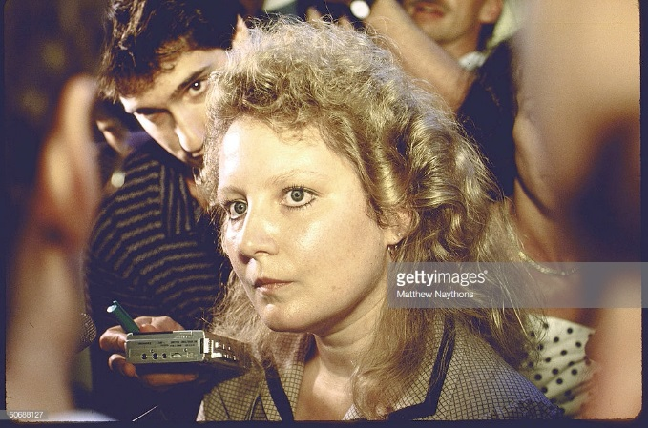

Figure 2: Sally Hasenfus
Naythons, Matthew. Sally Hasenfus. October 1986. The LIFE Images Collection, Getty Images.

Eugene worked in construction until 1986 when he received a call from William Cooper, another former Air America pilot. Cooper asked Hasenfus if he would be willing to crew a flight to Central America, doing a similar job to what he did in Southeast Asia. On July 7, 1986, Hasenfus was hired in Miami, Florida by Southern Air Transport. Following the interview, Hasenfus was shown the C-123 airplane his team would be flying.

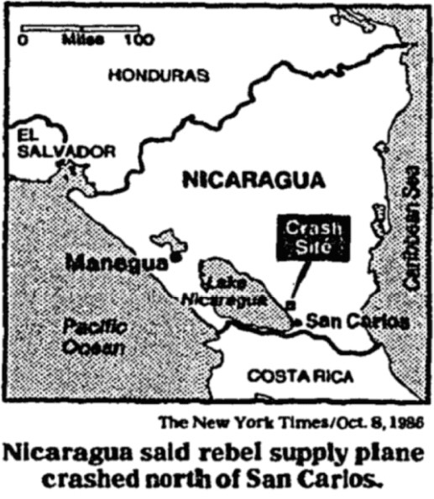
Figure 3: Crash Location
LeMoyne, James. Nicaragua Shows Reporters Man Is Says Is Flier. Map. New York Times, 1986. 8.

The job required them to fly from Ilopango, El Salvador to Honduras, over Nicaragua. They would be paid $3,000 a month ($6,928 in current dollars), including a $750 bonus ($1,732 in current dollars) for each supply run over Nicaraguan airspace. The coordination was handled by two known CIA agents: Max Gómez and Ramón Medina. Gómez, whose real name was Félix Rodriguez, was one of the agents who assassinated Cuban activist Che Guevara. In fact, Rodriguez is known to wear one of Guevara’s famous Rolex watches. Additionally, Rodriguez was known to be an associate to Donald Gregg, as well as George Bush. Notably, Bush recommended Rodriguez to be an advisor to the Salvadoran military. Ramón Medina, whose real name was Luis Posada Carriles, was wanted in the nation of Venezuela under the charge of terrorism relating to a 1976 bombing of a passenger aircraft; an attack that killed over 70 Venezuelan citizens. Hasenfus claimed Posada Carilles was responsible for organizing flights from Ilopango, El Salvador, to Nicaragua. Posada Carilles was jailed in Venezuela for eight years before he escaped under suspicious circumstances. It is widely believed that the CIA is responsible for this escape from prison.
During his incarceration and trial in Nicaragua, Hasenfus was questioned by Luis Carrion, Nicaragua’s Deputy Interior Minister. Carrion acted primarily as a press secretary. He spoke to the press regarding the dealings of the Nicaraguan government in relation to the case, as well as relaying the results of questioning and interrogations of Hasenfus. When asked about Hasenfus’s cooperation in assisting with the investigation, Carrion is quoted as having said “He is cooperating of his own volition, Hasenfus has said that this isn’t his war. He got into it because he needed the money, and he doesn’t feel he has any obligation to conceal any information about this operation.” A year earlier, in September of 1985, Carrion spoke on behalf of the Nicaraguan government, requesting the United States to “…terminate its support for the contras…because the contras are an artificial force, artificially created by the United States, that only exists because it counts on US direction, on US training, on US assistance, on US weapons, on US everything.”
Hasenfus was represented by Nicaraguan lawyer, Enrique Sotelo Borgen. Hasenfus was charged with terrorism, conspiracy and violating public security. Sotelo Borgen was advised by former US attorney general Griffin Bell. The tribunal’s president stated that Sotelo Borgen was allowed a maximum of fifty advisors, however, he was the only one allowed access to evidence. The main piece of evidence was the restricted access card given to Hasenfus for the Salvadorian Air Force base at Ilopango. Hasenfus confessed to running ten missions from El Salvador to Nicaragua. Throughout the trial, Hasenfus denied any connection to the Central Intelligence Agency. Eugene Hasenfus was convicted to thirty-years in a Nicaraguan prison.
On December 18, 1986, Eugene Hasenfus was pardoned by the Nicaraguan government, and was released to the custody of Senator Christopher J. Dodd, a Democrat from Connecticut. This gesture, however, was a blatant move to gain public support for their cause. Nicaraguan President Daniel Ortega Saavedra announced with his pardoning: “We trust and hope that with this gesture of peace by the people of Nicaragua we can avoid further bloodshed and achieve a true peace.” His main objective in releasing Hasenfus was not out of the goodness of his heart, but rather as a political stunt to persuade the American government to cease their support of the Contra rebel fighters. For Hasenfus, however, he could not have been more excited: “Today has been a day of great surprise, a day I’ll surely remember in my heart forever.” Hasenfus returned to his hometown of Marinette and continued his previous job working in construction.
In 1988, following his return to the United States, Hasenfus, along with the family of Wallace B. Sawyer Jr. (one of the men killed in the crash), sued Richard Secord for the amount of $3.4 million for damages and lost wages. Their reason for suing Secord is that he was officially the employer of the men in the operation, directly contracting Corporate Air Services, which was funded by Southern Air Transport, the company the men flew for. The plaintiffs in the case also sued Southern Air Transport, the airline company that contracted the plane and was a front for the CIA, citing they did not include proper safety equipment in the aircraft. Hasenfus claimed that the crew accepted the lack of parachutes, survival gear, and working navigational radios, under the guise that they were acting as patriots to fight communism in Central America. As it was later discovered, the process of financing was designed to be as convoluted as possible, in order to confuse investigators and to hide the money flow to Oliver North, Richard Secord, and Southern Air Transport. This deception had further effects, as the parties involved claimed Hasenfus violated a secrecy agreement, following the sale of his story rights to CBS for $10,000. Richard Secord was sentenced to two years’ probation in 1989, after pleading guilty to lying to Congressional investigators. Hasenfus and the Wallace family eventually dropped their lawsuit.
After the end of his lawsuit, Hasenfus began to fade from the public spotlight. In February of 1991, Hasenfus participated in a television special for PBS. In his interview he discussed his involvement in the scandal, as well as his life following his return to Marinette. He and his wife lived on the shore of Green Bay, on Frog Pond Road in Marinette. They suffered a house fire, and during the interview Hasenfus shows a selection of charred images from his time in Central America. Following the documentary, the public’s interest in Hasenfus tapered off until it reached extinction.
Hasenfus currently lives in Marinette, WI. He has three children, Eugene Jr, Adam, and a daughter, Sarah. He and his wife Sally are now divorced. According to the Wisconsin Consolidated Court Automation Program (CCAP), Hasenfus has had several minor legal battles regarding hunting without proper licensure, and other offenses. He is currently 77 years old.
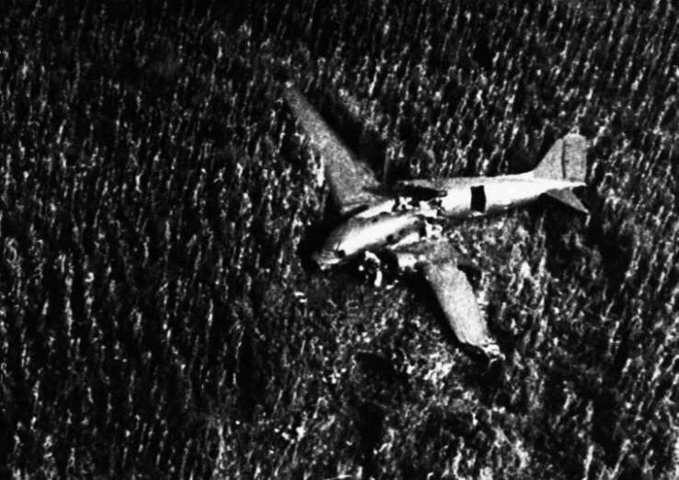
The Scandal Breaks
On October 5th, 1986, at 9:30am, a C-123k cargo plane departed Ilopango, El Salvador and flew South. The plane contained four men: Captain Bill Cooper, co-pilot Buzz Sawyer, a Nicaraguan radio operator, and the kicker: Eugene Hasenfus. The aircraft contained 10,000 – 20,000 lbs. of cargo. The cargo consisted of jungle boots, Ak-47s, ammunition, and other small arms. The aircraft flew forty miles South before turning East towards the mainland. They flew over Costa Rica, until they reached the Nicaraguan border. They turned into Nicaragua and proceeded to fly North towards their drop-zone, which was located in the Southern portion of the country. Roughly four miles from the drop-zone, the C-123k was struck by surface-to-air missiles. The right wing of the plane was hit, and the aircraft immediately lost control. At an altitude of roughly 3,000 ft, Hasenfus parachuted from the plane, using a parachute he had borrowed from his skydiving brother. He landed safely, while the remaining crew members perished in the crash. For the next day, Hasenfus wandered the Nicaraguan jungle in an attempt to reach the airport in San Carlo. When he reached the airport, he was taken captive by the Sandinista regime. The supplies to be dropped were the property of Southern Air Transport.
Figure 4: The Crash Site
AP Photo/Barricada. Eugene Hasenfus. October 6, 1986. Madison.com, Madison, WI.
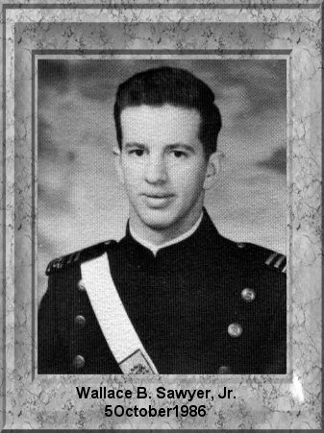
Southern Air Transport was a cargo airline company based in Miami, Florida. The company existed and operated as a front for the Central Intelligence Agency. The company is most well known for its involvement in the Iran-Contra affair, however, it also participated in supplying Angolan rebels who were fighting a Marxist regime. During the Iran-Contra operation, Southern Air Transport executed the transport of missiles to Iran, as well as delivering supplies to Contra fighters in Nicaragua. Southern Air Transport directly employed Wallace B. Sawyer Jr, the co-pilot killed in the Nicaragua crash.
After graduating in 1968 from Magnolia High School, in Magnolia Arkansas, according to his father, Sawyer served in Vietnam. However, according to some, Sawyer spent no time serving in Vietnam. He was honorably discharged as a captain in 1974. He moved to Taiwan where he worked as a pilot, flying for Trans America and Lockheed. There he married his second wife. Following his time in Taiwan, Sawyer returned to the United States and worked for Southern Air Transport. Whenever his father would question his occupation and if he worked for the military or the CIA, Sawyer denied his involvement. He flew supply runs to rebels in Angola, eventually transitioning to supplying the Contras in Nicaragua. Sawyer’s body was identified due to a card which contained his name, as well as his employment for Southern Air Transport.
Figure 5: Wallace Blaine Sawyer, Jr.
Wallace B. Sawyer Jr.1968. USAFA68, United States Air Force Academy, Air Force Academy, CO.
After the information about Southern Air Transport and Eugene Hasenfus broke, the world’s eyes turned towards Reagan and his cabinet. Initially, it was believed that the story was simply the United States supplying aid to the rebel Contras. On November third, however, the plot thickened. Two Lebanese newspapers broke the story of Iran’s involvement in the arms deal with the United States. At this point, the scale of the scandal began to become clearer. In December 1986, President Ronald Reagan gave an address regarding the Iran Arms deal and the controversy in Nicaragua. He stated that “There is an urgent need for full disclosure of all facts surrounding the Iranian controversy. I want to get this information out.” Reagan continued by requesting partial immunity for testifying witnesses before congress. He wanted this immunity to be granted to Oliver North, and John Poindexter so they would testify freely and openly without fear of self-incrimination. Reagan concluded his statement by reiterating the need to move along with this process so that the government could get back to focusing on its own business.
Following the breaking of the scandal and knowing he would be the primary suspect, Oliver North, along with the help of his secretary Fawn Hall, shredded most of the incriminating documents located in his office. Their goal was to shred any evidence in preparation for the Justice Department’s lawyers who would be searching his office the following day. The only piece of evidence remaining in the room, was the so called “diversion memo.” The memorandum was from the office of the President and was sent to several of his top advisors. While no specific plans were included, Reagan discussed in the memo that he wanted to use his Presidential power to send aid to the Contras, after being declined that power by Congress. This memo was highly debated as some used it as proof that Reagan knew what his staff was doing, while others used it as proof that Reagan had no idea his staff was diverting funds from Iran arms sales to the Contra fighters.

The Investigation
Following the breaking of the Iran-Contra scandal, President Reagan requested an internal investigation by his Attorney General. Due to a lack of results, Reagan appointed Texas Senator John Tower to lead an investigative commission into the scandal on November 26th, 1986. The commission was tasked with “evaluating the operation of the National Security Council in general and the role of the NSC staff in particular.” During his testimony before the Tower Commission, President Reagan admitted that he approved the sale of missiles to Iran, as well as approved a replenishment of Israeli missile supplies. This testimony contradicted that of Reagan’s chief of staff Donald Regan, who had testified previously that the US did not approve the missile sales. During his second testimony before the Tower Commission, Reagan’s speech was incoherent and confused, which lead to many speculations about the Presidents potential struggle with Alzheimer’s or dementia. The Tower Commission ultimately decided that the National Security Council staff was responsible for the weapons sales to Iran. They also decided that Ronald Reagan was not directly at fault but was out of touch and failed to keep tabs on his advisors. Following the Tower Commission’s report, Congress decided to launch a full-scale investigation, led by independent counsel and including party selected attorneys.

Independent Counsel Walsh
On December 19th, 1986, Attorney General Meese III, along with a panel of three other judges, selected Lawrence Walsh to the position of Independent Counsel for the legal investigation regarding Iran-Contra. Walsh was a former judge and had served as deputy Attorney General under President Eisenhower. While the constitutionality of Walsh’s appointment was still under question, Walsh asked for an appointment by the acting Attorney General, to give him legal permission to continue the investigation. His request was granted. From the onset of his investigation, Walsh faced many challenges. All four defendants (Poindexter, North, Albert Hakim, who was Secord’s business partner, and Richard Secord himself) were granted partial immunity during their own testimony, to encourage participation. The defendants, however, argued that their immunity was only against their individual testimony, so if they were to testify and incriminate another defendant, they would break that immunity for their counterpart. and they would lose their right to a fair trial. A US District Judge agreed, and all four defendants were granted individual trials. This change significantly increased the amount of work associated with a legal investigation of this scale. Another major problem was the publicity of the trail in coordination with classification of government documents. Walsh needed to craft a case that avoided the use of classified documents. Although faced with a plethora of difficulties, Walsh was able to continue with his investigation into the matter.
During the process of indictment, a long look was taken at the conduct of the President and Vice President, and their roles in the affair. After much deliberation, Walsh decided that Reagan had “created the conditions which made possible the crimes committed by others.” However, he decided that Reagan’s actions “fell short of criminality which could be successfully prosecuted.” Walsh determined that “It could not be proved beyond a reasonable doubt that President Reagan knew of the underlying facts of Iran/Contra that were criminal or that he made criminal misrepresentations regarding them.” The extent to which Vice President Bush was involved was not fully known to Walsh and his team. They later learned that Bush had knowledge of both the Iran deal and the Contra affair. They also discovered that he was present in many of the same meetings as Reagan when the details of the scandal were discussed. Lastly, notes were later discovered that proved Bush’s involvement in the Contra Aid program, going as far as making arrangements with Central American governments. Following his presidential inauguration in 1989, Bush refused to be questioned unless it was limited to his failure to produce his notes and diary.
On December 24, 1992, President George H. W. Bush pardoned several major Iran-Contra players: Caspar Weinberger, Robert McFarlane, Elliot Abrams, Clair George, Alan Fiers, and Duane Clarridge. Many of those pardoned were convicted of withholding evidence, perjury, and obstruction of justice. Walsh was livid at the pardoning by Bush and cited that the pardons given completed the cover-up by allowing the last major players to be freed.
The Walsh investigation determined that crimes had been committed in violation of laws and executive orders during the Iran-Contra affair. He determined that the sale of arms to Iran was in violation of the Arms Export Control Act, the aid and support sent to the Contras violated the Boland Amendment, the operation reached to the highest levels of the Reagan administration, large amounts of documents were withheld from investigators by the Reagan administration, and lastly that the back door nature of the crimes being committed allowed the opportunity for financial crimes to occur as well. Concurrently with the Walsh investigation, the most compelling collection of evidence regarding the Iran-Contra affair was the testimony given my Lieutenant Colonel Oliver North.
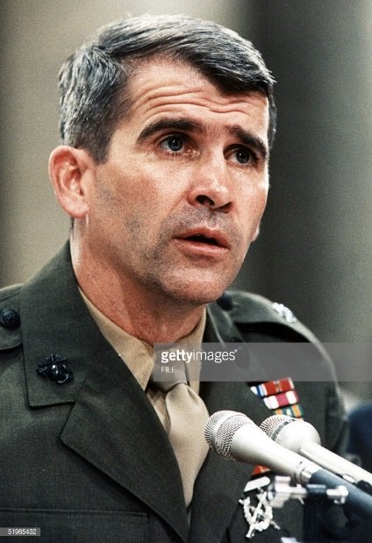
North’s Testimony
Figure 6: Oliver North testifying before Congress
FILE. Oliver North. July 9, 1988. AFP, Getty Images.
At the time of the Iran-Contra affair, Lt. Cl. Oliver North served on Reagan’s National Security Council, holding the position of deputy director of political-military affairs. Although his superiors were influential to the ignition of the scandal, North is considered to be the mastermind behind the deal. Oliver North stood trial while being charged on twelve counts. His charges include obstruction of Congress, obstruction for falsifying documents, accepting illegal money in exchange for government services, and conspiracy to defraud the United States by using a tax-exempt organization to raise funds to purchase weapons. Prior to his trial, however, North delivered testimony regarding his involvement in the scandal. During his congressional testimony, North divulged the entire operation. During his testimony, North claimed that he was acting towards the goals of his superiors. He claimed innocence because his superiors approved of his actions and encouraged him to do so.
In July of 1989, Lieutenant Colonel Oliver North was convicted of destroying documents, accepting a gift of a $13,000 home security system, and obstruction of Congress. North was sentenced to 1,200 hours of community service, two years’ probation and a fine of $150,000. The maximum sentence would have consisted of ten years in prison and a maximum fine of $750,000. North’s sentence was delivered by Judge Gerhard A. Gessell, a Federal District Judge.

Conclusion
During the Iran-Contra affair, then President Ronald Reagan showed the world that sometimes, doing what you think is right, is the wrong thing to do. Iran-Contra is a perfect example. After having been told to ignore the civil war in Nicaragua, Reagan was determined to intervene to try and overthrow the new communist Sandinista regime. In doing so, he violated a US arms embargo by selling weapons to Iran. This action also violated the United States’ strong stance against paying ransoms for hostages. The most challenged portion, however, is the obstruction of investigation that occurred. Once the scandal broke, the major players took to destroying whatever evidence they could; a sign that they knew they were engaging in borderline criminal activity. The scandal showed how the American political system can be manipulated to protect those who act in a questionable manner. It goes to show that with the right connections, a person can become untouchable by the hands of law.
Iran-Contra is the pinnacle of the United States being caught meddling in international affairs. During the Cold War, the United States and the USSR were known to relentlessly attempt to spy and infiltrate the others’ government. This proved one thing: Americans are terrible at being inconspicuous. All too often American spies were being captured and returned to their homeland. In the United States, it took a witch hunt to capture sufficient numbers of Soviet spies. This inability to succeed at clandestine behavior led to scandals breaking that included most of the United States’ Presidents during the Cold War.
The breaking of Presidential scandals can be traced to one specific person. As is the case with Iran-Contra, Eugene Hasenfus is that person. Hasenfus’s testimony during his initial trial in Nicaragua named the CIA and US government responsible for his presence in their airspace. By returning him to the United States, the United States revealed that they were in fact responsible for Hasenfus’s presence, leading to a further unraveling of what would become the most convoluted government scandal in the last century. Had it not been for Eugene Hasenfus borrowing his brother’s parachute, we may have never known the covert actions taken to support a failed dictatorship through the illegal sale of weapons to a now enemy state.

Bibliography

Primary Sources:

Aleman, Filadelfo. "Trial of Captured American Begins in Nicaragua." Associated Press, October 29, 1986. Accessed December 11, 2018.

AP, "Testimony Begins in Lawsuit Over Effort to Aid Contras." New York Times, July 29, 1990.

Bernstein, Richard. "WORLD COURT HEARING NICARAGUA'S CASE AGAINST U.S." New York Times, September 13, 1985.

"The Confession of Eugene Hasenfus." Ann Arbor Agenda, January 1987.

"CONTRAS HELP TERRORISM SUSPECT ESCAPE VENEZUELA, GIVE HIM JOB IN MIAMI, FL." Associated Press, November 2, 1986.

Engelberg, Stephen. "IRAN-CONTRA HEARINGS; NORTH CONTRADICTS THE TESTIMONY OF OTHERS ONCONTRA AID EFFORTS." New York Times, July 9, 1987.

Frease, Jean. (Marinette Local) Interview by author, November 22, 2018.

Fulton, Mary Lou. "Father Says Son Killed in Nicaragua Crash Spoke Little of Job With US-Nicaragua." Associated Press, October 8, 1986.

Goepfert, Paul. "Nicaragua: Captive's Contact Bombed Jet." Chicago Tribune, October 16, 1986.

"JAILED AMERICAN SAID TO HAVE IDENTIFIED MAN WHO BLEW UP CUBAN AIRLINER." Associated Press, October 15, 1986.

Johnston, David. "THE NATION; The Punishment Of Oliver North." New York Times, July 9, 1989.

Kinzer, Stephen. "Hasenfus Is Freed by Nicaraguans and Heads Home." New York Times, December 18, 1986.

PBS, "The Eugene Hasenfus Story." February 21, 1991.

Reagan, Ronald. "Statement on the Iran Arms and Contra Aid Controversy." Address. https://www.reaganlibrary.gov/research/speeches/121686a.

Walsh, Lawrence E. Final Report of the Independent Counsel for Iran - Contra Matters, PA: Diane Publishing Company, 1993.

Secondary Sources:

Walsh, Lawrence E. Firewall: The Iran-Contra Conspiracy and Cover-up, New York, NY: Norton, 1998.

Malcolm Byrne, Iran-Contra: Reagans Scandal and the Unchecked Abuse of Presidential Power, Lawrence, KS: University Press of Kansas, 2014.

Seth MacFarlane, writer, "American Dad!" May 11, 2008.

Theodore Draper, A Very Thin Line: The Iran-contra Affairs, New York: Simon & Schuster, 1992.

"Understanding the Iran-Contra Affairs." Decameron Web | Society. https://www.brown.edu/Research/Understanding_the_Iran_Contra_Affair/iran-contra-affairs.php

Jean Frease (Marinette local), Interview by Tristen Seymour, (Marinette, WI, November 22, 2018).
American Dad. “Stanny Slickers II: The Legend of Ollie’s Gold.” Written by Seth MacFarlane. FOX Broadcasting, May 11, 2008.
Malcolm Byrne, Iran-Contra: Reagans Scandal and the Unchecked Abuse of Presidential Power (Lawrence University Press of Kansas, 2014).
Theodore Draper, A Very Thin Line: The Iran-contra Affairs (New York: Simon & Schuster, 1992).
Lawrence E. Walsh, Firewall: The Iran-Contra Conspiracy and Cover-up (New York, NY: Norton, 1998).
"Understanding the Iran-Contra Affairs." Decameron Web | Society, https://www.brown.edu/Research/Understanding_the_Iran_Contra_Affair/iran-contra-affairs.php. (Accessed November 19, 2018).
"Understanding the Iran-Contra Affairs." Decameron Web | Society.
"Understanding the Iran-Contra Affairs." Decameron Web | Society.
"The Confession of Eugene Hasenfus." Ann Arbor Agenda, January 1987. (accessed November 26, 2018)
"The Confession of Eugene Hasenfus." Ann Arbor Agenda, January 1987
Ibid.
"Contras Help Terrorism Suspect Escape Venezuela, Give Him Job In Miami, FL." Associated Press, November 2, 1986.
"Jailed American Said To Have Identified Man Who Blew Up Cuban Airliner." Associated Press, October 15, 1986.
Ibid.
Ibid.
Paul Goepfert, "Nicaragua: Captive's Contact Bombed Jet." Chicago Tribune, October 16, 1986.
Richard Bernstein, "World Court Hearing Nicaragua’s Case Against U.S." New York Times, September 13, 1985.
Aleman, Filadelfo. "Trial of Captured American Begins in Nicaragua." Associated Press, October 29, 1986. Accessed December 11, 2018.
Stephen Kinzer, "Hasenfus Is Freed by Nicaraguans and Heads Home." New York Times, December 18, 1986.
Ibid.
AP, "Testimony Begins in Lawsuit Over Effort to Aid Contras." New York Times, July 29, 1990.
Ibid.
“The Eugene Hasenfus Story.” Aired February 21, 1991, on PBS, (Accessed December 2, 2018) https://www.pbs.org/video/wpt-documentaries-eugene-hasenfus-story/
"The Confession of Eugene Hasenfus." Ann Arbor Agenda, January 1987.
Mary Lou Fulton, "Father Says Son Killed in Nicaragua Crash Spoke Little of Job With US-Nicaragua." Associated Press, October 8, 1986.
Mary Lou Fulton, "Father Says Son Killed in Nicaragua Crash Spoke Little of Job With US-Nicaragua." Associated Press, October 8, 1986
Ronald Reagan, "Statement on the Iran Arms and Contra Aid Controversy." Address. https://www.reaganlibrary.gov/research/speeches/121686a. (Accessed December 1, 2018)
"Understanding the Iran-Contra Affairs." Decameron Web | Society.
"Understanding the Iran-Contra Affairs." Decameron Web | Society.
Byrne, Iran Contra 311.
Byrne, Iran Contra, 311
Ibid., 324.
Ibid., 325.
Byrne, Iran Contra, 326
Lawrence E. Walsh, Final Report of the Independent Counsel for Iran - Contra Matters, (PA: Diane Publishing Company, 1993).
Stephen Engelberg, "Iran-Contra Hearings; North Contradicts the Testimony of Others On Contra Aid Efforts." New York Times, July 9, 1987.
"Understanding the Iran-Contra Affairs." Decameron Web | Society.
David Johnston, "THE NATION; The Punishment Of Oliver North." New York Times, July 9, 1989.

