"GIRL-MAN":
CORA ANDERSON AND THE WISCONSIN "EUGENIC" MARRIAGE LAW

Desirae Lezotte
History 489
May 16, 2012

CONTENTS

ABSTRACT | iii
INTRODUCTION | 1
PART I. PASSING AS A SINGLE MAN | 6
Timeline of Anderson’s Intermittent Passing | 8
Anderson’s Motives for Passing | 11
PART II. ANDERSON AND WISCONSIN’S 1913 MARRIAGE LAW | 16
Gendered Clothing + Gendered Behavior = Perceived Sex | 17
Sexual Double Standards | 24
Complexities and Contentiousness of the Law | 26
CONCLUSION | 29
APPENDIX | 31
WORKS CITED | 37

Copyright for this work is owned by the author. This digital version is published by McIntyre Library, University of Wisconsin Eau Claire with the consent of the author.
Abstract

For 13 years in the early 1900s, Cora Anderson, a Potawatomie-Cherokee and African- American female from Kendallville, Indiana, intermittently, yet effectively, passed as Ralph Kerwinieo, a South American man ten years her junior. While residing in Milwaukee, Wisconsin, Anderson obtained a male's certificate of health, as required by a 1913 Wisconsin law, in order to marry her second wife, Dorothy Kleinowski. The 1913 Marriage Law, ostensibly designed to prevent the spread of sexually transmitted diseases, was inspired by the eugenics movement and later became a model for similar laws throughout the U.S. Although Anderson’s case has been examined in sexuality and gender studies, this aspect of her case – as well as her intermittent ‘passing’ – has remained largely unexplored. This thesis fills in apparent gaps in literature on Anderson's complex case, exploring the timeline and the complex motivations for Anderson's intermittent passing as well as the intersections of Anderson's case with the 1913 Wisconsin "eugenic" marriage law.

Introduction

"'They are writing the last chapter of the life of Ralph Kerwineo,' she smiled. 'When we leave this courtroom Kerwineo will be dead.'
'And who will take his place?' a reporter inquired.
'Cora Anderson,' she replied. 'My name when I leave here will be Cora Anderson.'"
--"Writing Life's Last Chapter," Milwaukee Journal, 4 May 1914.

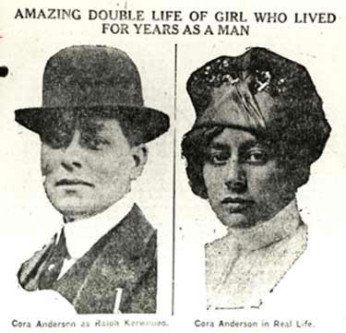
On May 2, 1914, Milwaukee police arrested Ralph Kerwineio for disorderly conduct, revealing soon afterward that he, in fact, was a she. Cora Anderson, a 38-year-old Potawatomie-Cherokee and African American woman from Kendallville, Indiana, had effectively passed as Ralph Kerwinieo, a South American man ten years her junior, intermittently for thirteen years (Figure 1). Evidence suggests that from 1901-1914 Anderson passed as a single man, then as the husband of Marie White for eight years before obtaining in 1914 a male’s certificate of health, as required by a 1913 law only for grooms, to legally marry her second wife Dorothy Kleinowski (Figure 2). After the outting of Anderson's gender crossing secret to Milwaukee police by her jealous first wife, White (to whom she was never legally married), police held Anderson on a charge of disorderly conduct for passing as a man and obtaining a certificate of health under false pretenses. The scandalous case became a national newspaper sensation (Figure 3). Although a Milwaukee judge dropped the disorderly conduct charge, he ordered Anderson to dress and behave as a woman if she wished to remain in Milwaukee, warning that if she did not, she would find herself in trouble."
Figure 1. Cora Anderson as a man and as a woman, circa 1914.
Source: http//outhistory.org (accessed 8 Apr. 2012).
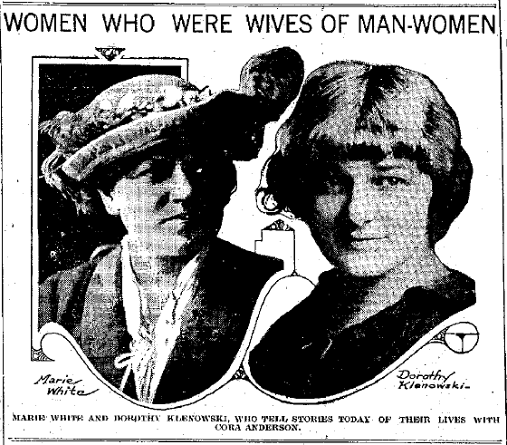
Anderson took advantage of her newfound infamy to make a living, performing vaudeville acts across Wisconsin throughout 1914. By the end of 1914, however, interest in Anderson's act died out she found that she again could not make a living as a woman. Anderson began passing as a man--and began having run-ins with law enforcement--once again. Anderson's last confirmed appearance in historical records was in Milwaukee, Wisconsin, in September 1919 when the Milwaukee District Court freed her from probation and a charge of vagrancy.
Figure 2. Anderson’s “wives.”
Source: “Anderson Was Good Man to Both Her Wives,” Des Moines Daily News, 12 May 1914.

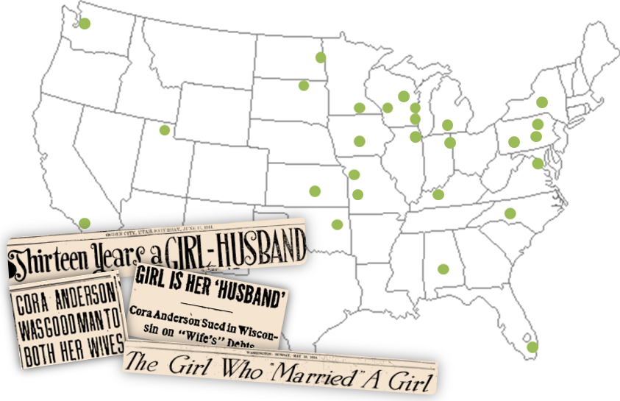
Despite research on Anderson's case in a variety of disciplines, no author who has analyzed the case has examined the following two aspects which are analyzed in this paper for the first time. The first aspect is the possibility that Anderson began passing as a single man in Milwaukee in 1901, and intermittently thereafter, before passing as the husband to her first female companion, White. This timeline and Anderson's own writing provides a new interpretation of her motivations for passing as a person of a different gender and ethnicity. The second aspect of the case analyzed in this paper is the extent to which Anderson's case exposed gendered social expectations inherent in the 1913 Wisconsin "eugenic" marriage law. The intent of this analysis is to fill in the research gaps in Anderson's case and to use Anderson's case as a lens through which to view the Wisconsin "eugenic" marriage law in the social and cultural context of Midwestern America during the Progressive Era (1890s-1920s, characterized by an upsurge in social activism and political reform).
Figure 3. Locations where articles about Anderson’s passing were printed in 1914 and a sampling of headlines.
Source: Created by author.

Literature Review
Since 1976 academics in a variety of disciplines have cited Anderson's case among groupings of other cases presented as lesbian and transgendered histories. These academics and associations of academics include: historian Jonathan Katz, anthropologist Jason Cromwell, historian Lillian Faderman, historian Joann Meyerowitz, the interdisciplinary San Francisco Gay and Lesbian Project, and specialist in women's and gender studies, African American studies, and English, Siobhan Somerville. These authors addressed the fact that Anderson and other females who passed as men often did so in part for economic opportunities and greater freedoms that were only available to men in the early twentieth century only. However, the primary motivation of their writing was to reclaim lesbian and transgendered history. Katz pioneered this movement towards the reclamation of gay and lesbian history in 1976 with the debut of his groundbreaking book Gay American History: Lesbians and Gay Men in the U.S. which illuminated instances of gay and lesbian relationships in the public sphere at a time when homosexual space was scarcely claimed in academia and in American society. Other scholars followed because, according to anthropologist Jason Cromwell, "One agenda and a strategy for empowerment is reclaiming history." Another example of this reclamation of history is found in Somerville's book Queering the Color Line: Race and the Invention of Homosexuality in American Culture which exposed African American homosexual history and positioned Anderson's passing as a person of a different gender and race as a response to "the cultural and economic limitations attached to her gender, race, and sexual orientation." Other authors, including early twentieth century social hygiene advocate Bernard Roloff, historian and journalist Christine Rosen, and English specialist Tamsen Wolff, have cited Anderson's case as part of the greater national eugenics movement of the early to mid- twentieth century.
Some authors, such as Meyerowitz, Faderman and Cromwell, have contributed works that understand Anderson's case in terms of sexuality. Meyerowitz states that Anderson and White's long-term partnership, an alternate to traditional family life, was not a situation uncommon to single young women in the early 1900s. What was unusual about Anderson's case, Meyerowitz conceded, was that Anderson and White passed as husband and wife so that the partner passing as a man could attain even higher wages than the couple would if both partners were working as women. Meyerowitz explained Anderson's exceptional case by stating that Anderson's writing highlights her unusually insightful understanding of male privilege, and proposed that Anderson and White were probably lesbians. Faderman took a different approach, notably addressing in her book Odd Girls and Twilight Lovers: A History of Lesbian Life in Twentieth-Century America that women who passed as men (whom she termed transvestites) perhaps "did not become lovers with other women until they took on the persona of men and had available to them only those sexual opportunities available to men." This proposal came contrary to the way that women who dressed and behaved as men were generally viewed by sex analysts in the 20th century, which was generally as lesbians, since they assumed that if women took on male-gendered social roles, they must have taken on male sex roles as well. In other words, Faderman contributed the idea that a woman could prefer to be masculine or even pass as a man with the primary motive of obtaining male social and economic privileges. Agreeing with Faderman's assertion that females could adopt male gender roles yet not engage in homosexual relations, Cromwell insightfully added that, "although at the body level it would seem that sexual intimacy between the couple would indicate a lesbian relationship, it is not the case from the mental and emotional levels for individuals who did not (or do not) identify as women." Although he did not show that a non-sexual relationship could have been the reality in Anderson's case, Cromwell contributed the important argument that not all transsexuals would define themselves as lesbians, an idea that could have been the reality in Anderson's case.
Other authors, including Roloff, Rosen and Wolff, have preferred to analyze Anderson's case in terms of the United States' "eugenics" movement of the early 1900s. Roloff, the Executive Secretary of the Illinois Social Hygiene League at the time he published his 1920 article entitled "The 'Eugenic' Marriage Laws of Wisconsin, Michigan and Indiana," pointed to Anderson's ability to obtain a male's marriage license as a female as a unique incidence of the law's "weakness in practice." Rosen observed that Anderson's case "became known in eugenics circles as the 'infamous Ralph Kerwinieo episode'" because this case validated the fear of some eugenicists that even accredited physicians did not always perform thorough physical examinations, ones that confirmed the male sex of the groom and revealed the sexually transmitted diseases that eugenic marriage laws were purposed to discover. Wolff addressed Anderson's ability to effectively pass as a man and obtain a certificate of health intended for males as an instance of the "sexually subversive female body" which could pose a "threat of visual deception" which eugenicists were concerned could undermine their single sex-directed efforts. In an effort to obtain a male privilege, marriage to a female, Anderson challenged the "eugenic" marriage law.

Passing as a Single Man, Without a Female Companion

As the confusing and at times conflicting timeline of Anderson's passing presented in Milwaukee newspapers suggests, Anderson may have first passed without White, the woman reported to be Anderson's first female companion while passing as Kerwinieo. Indeed, much of the timeline compiled from Milwaukee newspaper accounts, covering Anderson's court appearances and reporter's interviews with Anderson, suggests that Anderson's passing as Kerwinieo was intermittent based on situational necessity. Since the court records for Anderson's court appearances no longer exist due to file retention limits, we must rely on these newspaper accounts, many of which include Anderson and her wives' own words, for their story. However, we must take into account the personal and commercial motivations of Anderson, her wives, and Milwaukee's for-profit newspaper syndicates that reported the most extensively on her case.
As Cromwell has warned, Anderson's, White's, and Kleinowski's testimonies to the courts and to newspaper reporters must be questioned to some extent because they had social retribution to fear since "chances of condemnation and prosecution became more real for all parties involved" with lesbianism/homosexuality in the twentieth century. Although the terms "homosexual" and "lesbian" were not yet an integral part of the nomenclature at the time of Anderson's arrest and were never used in 1914 periodicals about the case, homosexual acts were not considered socially acceptable behavior. Cromwell's assertion seemed to be born out by Judge Page, the judge that presided over Anderson's case, when he declared, "Had the case been reversed, and it had been a man posing as a woman, it would have been far more serious," revealing a sexual double standard in the prosecution of gender crossing which worked in Anderson's favor. Anderson's, White's, and Kleinowski's comments to newspaper reporters demonstrated their understanding of potential condemnation. During interviews with newspaper reporters after Kerwinieo/Anderson's arrest, White addressed suspicions of homosexuality in her relationship with Anderson, declaring their story "clean all the way through." Kleinowski, while claiming that she did not know that her husband, Kerwinieo, was a female until after his arrest, declared, "As a man I loved her, but when she donned skirts that love died." Nonetheless, Anderson and her “wives” could have been telling the truth about the non-existence of homosexuality in their relationship. Some people involved with the case openly stated that they believed the women’s denials of participation in any sexual activities that were socially unacceptable and considered "morally perverse." Milwaukee police Captain John T. Sullivan declared that no "moral perversion" was involved in the case, and Louis Hartman, the detective on the case, testified in court that Anderson had not committed a crime nor induced others to commit crimes while passing as Kerwinieo. Hartman also testified that as far as he knew, Anderson had been honest with him since her arrest, showing that Anderson's willingness to converse with police (and newspaper reporters) after her arrest made her appear more credible.
The newspapers also had their own agendas which probably influenced the material they chose to print about the case. As for-profit newspapers, their agendas were probably to cover a sensational story that would provide information to fulfill their reader's curiosities and help sell more newspapers, leading to higher revenues. Nonetheless, if we assess newspaper data contemporary to the case, we can achieve a better understanding of the probable timeline of Anderson's gender crossing and her primary motivations passing as a person of a different gender and ethnicity. Since newspaper accounts are conflicting at times, these have been checked against existing primary source materials when possible.
In order to fully understand this issue, it is necessary to examine the timeline of Anderson's gender crossing as Kerwinieo and assesses the motives which contributed to her initial decision to pass as a person of a different gender and ethnicity. The following section provides the argument that Anderson's primary motivations for initially passing as man probably did not include the motivation to be with a female companion, since the timeline suggest that she first passed as a single man. This section also proposes that Anderson may have been later motivated to pass/keep passing as Ralph to maintain her existing relationship(s).

Timeline of Anderson's Intermittent Passing

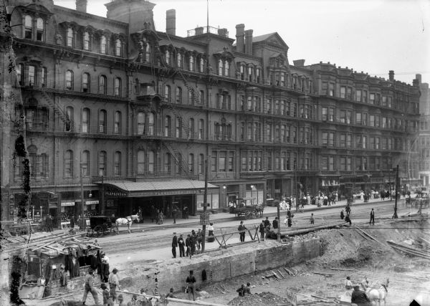
In court for the charge of disorderly conduct, which the Milwaukee district attorney had leveled against her, Anderson told Judge Page that she had been in Milwaukee “about thirteen years off and on after graduating from Provident Hospital's School of Nursing in Chicago. Indeed, federal census records placed Anderson in Chicago rooming with a family in 1900. These records show that Anderson was a trained nurse but had been unemployed for four months when the census was taken in June 1900. This period of unemployment may have influenced her decision to begin passing as Kerwinieo since Anderson began passing as a man soon after in 1901, taking a job as bellboy at the then-famous Plankinton House Hotel in Milwaukee before moving to Cleveland around 1904 (Figure 4). However, shortly after Anderson's arrest, Anderson proposed a different time frame for her gender crossing. Both she and White stated that Anderson first passed as a man when she began passing as White's husband ten years prior, which would put the beginning of her gender crossing in 1904, and provided an elaborate description of her transformation into a man including descriptions of her changes in appearance and habits which are illuminated later in this paper. White too confirmed that she and Anderson/Kerwinieo had lived together for ten years, ever since she met Anderson in Cleveland, Ohio where they were working at the same place as nurses before deciding to team up and begin passing as husband and wife "for economical reasons," and, "for the fun of the thing," according to White. Since neither Anderson nor White ever said that they were together for over ten years, we can infer that Anderson passed as a man without White, and presumably by herself, from 1901-1904, before she met White.
Figure 4. Plankinton House Hotel, circa 1905.
Source: http://www.wisconsinhistory.org. (accessed 3 Apr. 2012).

Thus by 1901 Anderson began passing as a man, and by 1904 Anderson began gender crossing intermittently; moving from Milwaukee, where she had passed as a man, to Cleveland as a woman, then teaming up with White there and passing as a man. After their brief stay in Cleveland, "husband and wife" White and Kerwinieo moved around for two years before settling in Milwaukee in 1906 where Kerwinieo resumed work at the Plankinton Hotel. Around 1909, a Neenah couple recognized that Kerwinieo, the bellboy at the Plankinton Hotel where they were staying, bore a striking resemblance to the "highly regarded" nurse who took care of their friend in Neenah around 1904. Reportedly, they told Kerwinieo of this resemblance to which he replied, "I ain't got any sister at all." If this were true, the couple must have seen Kerwinieo earlier than 1909, because he began working at Gimbel's in 1908 and presumably no longer
worked at the Plankinton in 1909. Nonetheless, their proposal is entirely probable, especially since White was
Figure 5. Timeline of Anderson’s intermittent gender crossing.
Source: Created by author.

from the neighboring city of Menasha, and would place Anderson in Neenah in 1904, again working as a female nurse after she had already teamed up with White as her husband.
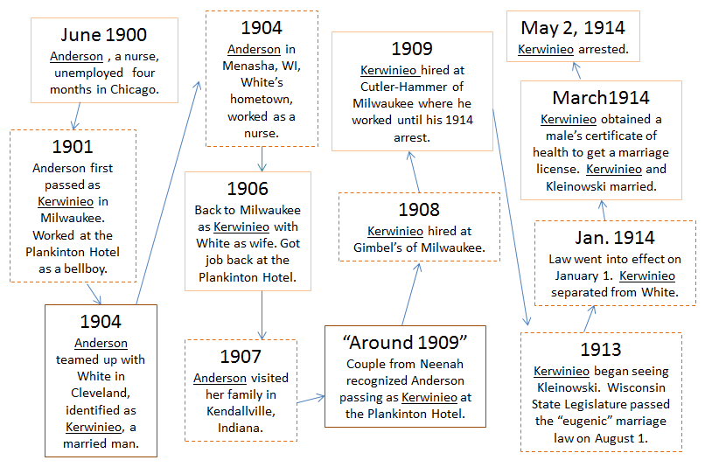
Although Anderson and White claimed in the Milwaukee Journal that Anderson passed only as man for the eight years they lived as husband and wife in Milwaukee, a telegram from Kendallville, Indiana police containing information from Anderson's father suggests further intermittent gender crossing. The telegram stated that Anderson visited Kendallville, her hometown, to see her family in 1907. Although according to Kendallville police, "her father believed then that she was hypnotized," the meaning of his observation is not expanded upon in the article. Nonetheless, it is most likely that Anderson visited her family as a woman since they knew her as no as no other gender. It is perhaps possible that, even dressed as a woman, her father thought her hypnotized because she probably had short hair (if not wearing a wig) and men's mannerisms. After visiting her family, most likely as a woman for the last documented time until her arrest, Anderson resumed work as Kerwinieo at the Plankinton House. In 1909 Anderson began employment at Cutler Hammer of Milwaukee, her employer at the time of her arrest. Figure five (previous page) provides a timeline with brief descriptions of Anderson’s intermittent passing, highlighting her manipulation of identity.

Motives for Passing

"This world is made by man--for man alone. I, who have lived as a man among men, realize it. I, who have talked with men as a man, know it... Is it any wonder that I determined to become a member of this privileged sex, if possible?"
--Cora Anderson in "Girl-Man Says That Man Is a Hunter of Women," Milwaukee Journal, May 13, 1914

Anderson probably had complex motives for her intermittent passing and these motives likely evolved over the course of her life as a man. There is no primary evidence from 1901, when Anderson began passing as a man. However, Anderson consistently maintained after her arrest that her reasons for choosing to identify as a man of a different ethnicity were primarily threefold: to obtain freedom from men's sexual exploitation, to obtain better economic opportunities, and to avoid racial discrimination.
Anderson wrote poignantly on the sexual exploitation she encountered in her work as a nurse, and was able to escape while passing as a man, in two articles that were published in both the Milwaukee Journal and the Day Book of Chicago. According to Anderson, when she passed as a man among other men, she realized that sexually exploitative behavior toward women was the overwhelming norm among men. However, Anderson made clear in her article entitled, "Girl Man Says That Real Man Is a Hunter of Women," that she was not a man hater, stating, "Don't misunderstand me; there are good men in the world, just as there are good women, but living, both as a man and a woman, I have found that most men do not consider sexual sins of any great consequence."Anderson expressed that she felt men were naturally polygamous and explained in a dramatic metaphor that men "hunted" for beautiful women as if hunting birds, "...and after they have denuded them of their plumage cast them away to die."
Anderson cited incidences of men's predatory behavior that she observed both before and after she began passing as a man. Anderson said that as a nurse, two-thirds of the male physicians she encountered "made a nurse's virtue the price of their influence in getting her steady work." In other words, men with the ability to grant women work exploited their higher position of authority by demanding sex in exchange. As Anderson said of the lower position of women at the turn of the twentieth century, "At every turn she is shown how easy it is to get on in the world--to gain the goal of her ambition--if she will only be complacent to the demands of men." She also proclaimed that the sexual standards for men and women varied greatly, citing the pride with which men boasted of their sexual encounters with women and the frequency with which men cheated in supposedly monogamous relationships. Of this behavior, Anderson quipped, "society forgives a man for being found out but woman never."
One of the other primary concerns Anderson cited when discussing her decision to pass as a man were men's greater economic opportunities. Both Anderson and White stated this as the primary reason for their passing as husband and wife in the first article printed about the case in the Milwaukee Journal. Anderson addressed this reason further in her own writing. Anderson explained women's funding dilemma, writing, "The well cared for woman is a parasite, and the woman who must work is a slave." Anderson cited the fact that women earned less than their male counterparts when performing the same jobs and cited examples of further price differentials along sex lines, writing of women:
Her board, as a rule, costs more; her lunches always cost more, as a man can go to places where an inviting lunch is set before him for 10 cents; her amusements also are more expensive. Respectability is always costly. Her clothes cost much more. I had a good illustration of this when I was compelled to buy a woman's hat when I was told by the court that I must dress in women's clothes. The hat, a very modest black one trimmed with jet, cost $5, and it can only be worn for about six months and then I'll probably have to hand out another five for something new. The derby I was wearing when the police were told I was a woman cost me $3 and I had worn it two years.

Anderson proclaimed that even if minimum wage laws were enacted, helping working women support themselves more easily, the problem of women slaving for their living would not be solved because women needed more money to attain a lifestyle similar to that of men in their socioeconomic class.
Eleven days after the printing of Anderson's second article cited above, another woman expressed views similar to Anderson's in an article also printed in the Milwaukee Journal. The article quoted Eva Booth, a European reformer who had worked with the poor in the United States for ten years as chief of the Salvation Army. Booth expressed her views on the economic and sexual exploitation of women, which, in her view, were mutually dependent problems. According to Booth, women living in cities were "exploited by millionaire employers" and were usually paid less than ten dollars a week--barely a subsistence wage. Booth said that such women, often young and without the guidance of their parents, were sometimes advised to "get a friend" to take care of them in exchange for sexual favors, a practice referred to as "treating" that was common in the twentieth century.
Racial discrimination, the final primary reason Anderson cited for passing as a man, is perhaps most apparent in Anderson's choice to identify as a South American man because of cultural assumptions about South American men. Anderson/Kerwinieo’s first wife, White, explained the choice of South American, saying, “men of that country have soft ways and effeminate mannerisms, and she thought that was the best way to get along; our dark skins also helped that story.” Generalizing about South American men, White’s claim that men from South America have “effeminate mannerisms” reveals a Midwestern cultural assumption about Latin Americans. That Anderson chose to identify as a man from South America suggests that commonly held assumptions about South Americans carried less stigma than assumptions about Native Americans or African Americans, two other ethnicities Anderson could have claimed as Kerwinieo. However, regardless of ethnicity, people of color faced obstacles that their white counterparts did not, as Anderson testified of her own hardship, telling the courtroom filled with spectators, "It is hard for people with dark skins to make a living. I was a trained nurse; people don't like colored nurses." Anderson continued, saying, "So I conceived of bettering myself by donning male attire. I did so and have not been in want since."As historian Siobhan Somerville articulates in Queering the Color Line: Race and the Invention of Homosexuality in American Culture (1999), Anderson clearly, “…illustrate(s) her understanding of identity as performance of gender, race and sexuality as socially constructed scripts rather than innate biological differences.”
Although Anderson continued to pass as Kerwinieo in part to support her female friends, she probably did not pass for this reason from the beginning of her passing as a man. This assertion is demonstrated in the timeline of her intermittent passing which began, presumably, with a period of passing as a single man with neither White nor Kleinowski passing as her wife. Additionally, Anderson's written insights into the primary reasons that pushed her to pass as a person of a different gender and ethnicity, including better economic opportunities and freedom from sexual exploitation and racial discrimination, suggest that she did not pass to be with a female companion, or for love, when she first began passing as a man in 1901. Nonetheless, Anderson's story is most often cited for her relationships with women, including her marriage to Dorothy Kleinowski, that were sensationalized in national newspapers. Anderson's success in obtaining a male's certificate of health which allowed her to marry Kleinowski raised serious questions about the law in newspapers and amongst the eugenicists whose motivations for a disease-free society had inspired the law

Anderson and the Wisconsin "Eugenic" Marriage Law in Social and Cultural Context

Termed “The infamous Ralph Kirwinio Episode" in eugenics circles at the time, Kerwinieo/Anderson’s case revealed a significant flaw in the 1913 Wisconsin marriage law-- it did not require confirmation of the groom’s sex as male. As one of the first laws of its kind in the United States to require male premarital examination and testing for venereal diseases, the 1913 Wisconsin marriage law stipulated that grooms had to present a physician issued certificate of health declaring their freedom from venereal disease before a county clerk could issue a marriage license. This law, predicated on the eugenic-based goal of improved offspring who were to originate from married couples free of transmittable venereal diseases, was created with the aim of preventing the spread of sexually transmitted diseases to female brides because mothers could transmit these diseases, especially congenital syphilis, to offspring at birth. Andersons’s case—including her ability to obtain a groom’s health certificate declaring her a male fit for marriage—became a nationwide newspaper sensation and generated criticism for Wisconsin enacting the law.
Anderson’s case, and the influential Peterson v. Widule case, which will be explored later, indicated serious problems with Wisconsin’s law that resulted in changes when the law came up for judicial review in 1915. Thus, Anderson’s case provides an ideal lens through which to view the Wisconsin “eugenic” marriage law in the social and cultural context of Progressive Era Midwestern America. In examining these changes in the Wisconsin “eugenic” marriage law and Anderson’s case, I intend to make three points: first, that Anderson’s case suggests that sex in the Progressive Era was determined and socially enforced by gendered appearance and behavior; second, that the “eugenic” marriage law reflects cultural assumptions that women were “pure” and men “promiscuous” before marriage; and finally, that this case illustrates the complexities and contentiousness of eugenically inspired state intervention in marriage to maintain the “purity” of the race.

Gendered Appearance + Gendered Behavior = Perceived Sex

"Probably one of the oldest adages of the world is that which reads 'Clothes make the man.' It is now demonstrated that it is possible for 'clothes to fool man'"
--"The Girl Who 'Married' a Girl," Washington Post, May 10, 1914.

On Saturday, May 2, 1914, after Ralph Kerwinieo’s jealous first wife, Marie White, revealed his secret, Milwaukee police arrested Kerwinieo, dressed in his men’s derby hat and suit, at his employer Cutler-Hammer for passing as a man. Upon arrest, he presented identification as Senor Ralphero E. Kerwinies, Spanish Teacher and graduate of Quen College in Tirija, Bolivia. The story quickly leaked to the press. At the police station Anderson, insisting that people refer to her as Ralph Kerwinieo for the first two days of her incarceration (before admitting her former female identity), told reporters that the men’s social habits and behaviors she quickly acquired while living as Kerwinieo allowed her to pass as a male and to eventually obtain the health certificate that allowed her to officially marry Kleinowski, pictured in figure six.
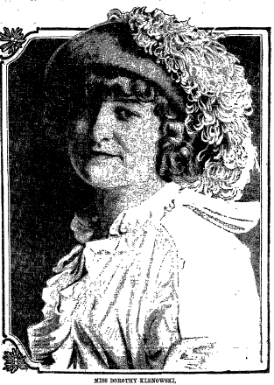
Immediately, police and newspapers wanted to know who issued Kerwinieo the health certificate declaring him a healthy man fit for marriage. This certificate, required by the 1913 law, allowed Kerwinieo to obtain a marriage license from the Milwaukee county clerk on March 19, 1914, which enabled Milwaukee County Justice of the Peace Edward Burke to pronounce Kerwinieo and Klienowski husband and wife five days later, on March 24. An image of Kerwinieo and Kleinowski’s marriage certificate is provided in the appendix. Initially, the identity of the physician who issued the certificate was unknown, according to the Milwaukee Journal, but two days after her arrest, the county clerk released records that showed that Dr. Scollard of Milwaukee had issued the health certificate to Kerwinieo.
Figure 6. Dorothy Kleinowski.
Source: “The Girl Who ‘Married’ a Girl,” Washington Post, 10 May 1914.

When Kerwineo sought the required health certificate from Scollard, the doctor apparently neglected to physically examine Kerwinieo, but drew his blood and tested it for venereal disease in bare minimum compliance with the Wisconsin "eugenic" marriage law. Scollard claimed that he had known Kerwinieo and his "wife" White for seven years and, "never treated Ralph for any trouble that would have led me to suppose he was not a man," and therefore never doubted that he was male. Defending his actions to curious newspaper reporters, Scollard said, “there was no criminal intent on my part—I simply was fooled as many others have been," adding, "This girl who posed as Ralph Kerwineo has been deceiving everyone for years, why shouldn’t she deceive me too?" His defense proved necessary because Scollard could have faced serious consequences for issuing the health certificate to a female since, as the 1913 law stated: Any physician who shall knowingly and willfully make any false statement in the certificate provided for in subsection I of this section shall be guilty of perjury and upon conviction shall be punished as for perjury, and a conviction under this subsection shall revoke the license of such physician to practice in this state. In addition, Dr. Scollard claimed that he had no reason to doubt Kerwinieo’s male sex because in addition to “looking like” a man, Kerwinieo exhibited exclusively male-gendered behaviors such as smoking, cursing, and telling stories "just as a man would, and I had no reason for thinking him anything but a man.” Wolff, referencing Anderson’s case in Mendel’s Theater: Heredity, Eugenics and Early Twentieth-Century American Drama (2009), described Scollard’s assumptions about Kerwinieo’s sex as an, “infamous example of bodily misreading.” According to Wolff, this case became infamous among eugenicists because it made real one of their fears pertaining to categories of identification which, “frequently overlap and converge and all pose a threat of visual deception."
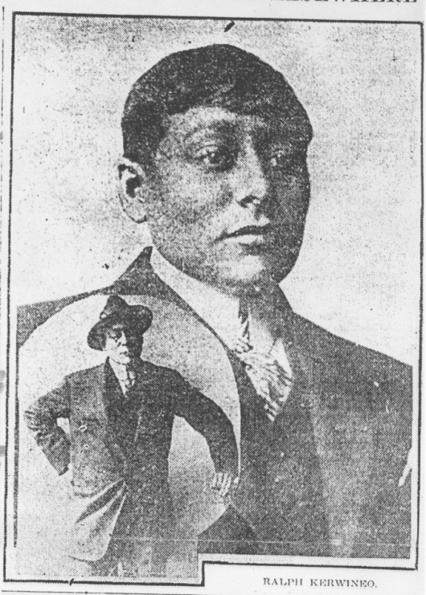
Before the press revealed that Kerwinieo was a female, Scollard and the Milwaukeeans who knew Kerwineio, perceived him as a man from his behaviors, habits, and clothing, and believed that he had heterosexual relationships. According to Anderson, her visual transition from a woman to a man and as society saw it, from female to male, was quite simple. Anderson said that when she began passing as White’s husband in Cleveland (the second time she passed as a man after working in Milwaukee): “I bought a suit of boy’s clothing. It fitted well. I had my hair cropped. I was a good-looking young man.” As Anderson suggested, a man’s gendered appearance, as exhibited in figure seven, worked to convince people that she was a male. Anderson realized that in addition to men’s appearance, men’s behaviors were an integral component to “acting the man.” To acquire these behaviors, Anderson claimed, "I watched men closely. I learned to smoke cigarettes. I practiced until I smoked carelessly —occasionally swore—so that others might think me a man.” As
Figure 7. Anderson as Kerwinieo, circa 1914.
Source: "Writing Life's Last Chapter," Milwaukee Journal, 4 May 1914.

Kerwinieo, Anderson also used men’s coat rooms and bathrooms, went to saloons for drinks and inexpensive lunches, frequented a barbershop for haircuts and sometimes for an upper lip shave, and swapped jokes and stories with male co-workers before work (Figure 8). Adopting male gendered appearances and behaviors and daring to go places respectable women would avoid as Kerwinieo, Anderson demonstrated that a female had to adopt the behaviors and social habits of men, in addition to looking like a man to be seen as a man, and thus a male, by others.
Figure 8. Cartoon of Anderson behaving as a man.
Source: “The Girl Who ‘Married’ a Girl,” Washington Post, May 10 1914.
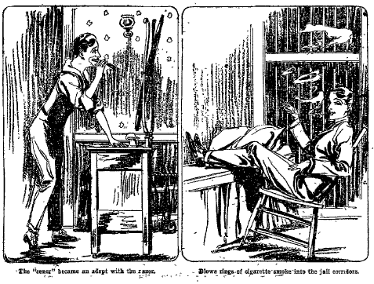
Understanding well the social implications and barriers posed by gender, race and sexuality, Anderson was not eager to go back to female-gendered clothing, which was impractical from her perspective, and face the economic obstacles of racism and sexism that she confronted fourteen years earlier while working and living as a woman. As Anderson told reporters, "it is easier, far easier, for a girl to don trousers and get along as a man than it is for her to continue to wear skirts. She can remain a better girl, and she is not subjected to the dangers and temptations that befall lone girls when their sex is known.” Yet, District Attorney Edward Yockey’s top priority, even before ascertaining with what he would charge Anderson, was getting Anderson back into the gendered clothing associated with the female sex. By the time Yockey announced to newspaper reporters, “We are going to clothe her as she should be dressed. Then we shall take care of whatever charges there are against her,” Anderson had spent two nights in jail. Although there was no law against female's wearing of men's clothing, Yockey's position suggests that a female in a men’s hat and suit was far too culturally taboo.
Anderson’s gendered appearance was also the foremost concern of Judge Page when he dismissed her case on the condition that she behave like a woman and wear women’s clothing if she remained in Milwaukee. At the closing of Anderson’s case, Judge Page declared:
It seems to me that a woman who had been living as she has, dressed as a man, frequenting dance halls, saloons and other places, and associating with men, using profane and coarse language, will find it rather difficult to live as a woman should live if she is to keep out of trouble. If she remains in Milwaukee, she must conduct herself as one at all times. If she does not, she will find herself in trouble.

Although Judge Page told the court Anderson had not violated any state law, the court's decision suggests a strong cultural taboo against it. Additionally, Judge Page’s explanation of his verdict does not suggest how females should behave, but rather states how they should not behave, even though the same behaviors were perfectly acceptable for males and were not against the law for females. Perhaps Judge Page wanted to prevent people’s misidentification of Anderson as a male, and thus prevent her from attaining exclusively male legal and social privileges (such as going to dance halls, saloons and associating freely with men) which could only result in "trouble," according to his closing statements after dropping the charge of disorderly conduct against Anderson.
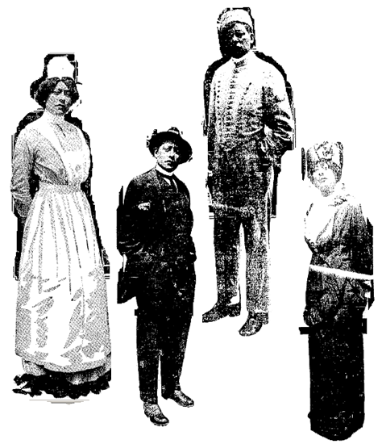
Back in women’s clothing on Judge Page’s orders, and unable to earn the wages she earned as Kerwinieo in a man’s job, Anderson again faced financial problems. Although reluctant, Anderson agreed to perform a vaudeville act at The Orpheum Theater in Milwaukee as a source of income in order pay her court fees. Anderson’s act, performed in front of full audiences, consisted of telling her story in four outfits pictured in figure nine: Anderson in a nursing uniform and in women’s street clothes, and Kerwinieo as a hotel bellboy and in the men’s street clothes he wore when arrested (Figure 9). As a result of the popularity of her act at the Orpheum Theater, Anderson received contracts to perform at venues across Wisconsin throughout 1914.
Figure 9. Anderson in outfits worn during her vaudeville performances.
Source: “Thirteen Years a Girl Husband,” Ogden Standard (Utah), June 13, 1914.

By the end of 1914, however, interest in Anderson’s act had died out and she again faced financial problems. In late March 1915, without a job or money, Anderson boarded a Chicago-bound train in Milwaukee but was expelled in nearby Racine, Wisconsin, for failing to pay her fare. After departing the train, Anderson changed into men’s clothing in an alleyway and got a hotel room under the name of Radaxel Omro; she believed she could more easily, and without suspicion, register for a hotel room as a single man instead of a single woman. A hotel employee noticed Omro made calls from his room but did not come out, so when he left the hotel the next day without stopping at the front desk, the employee followed Omro and saw him change into women’s clothing in an alley before heading to the train station. The employee followed Omro/ Anderson and, upon arrival at the train station, alerted a Racine police officer who arrested Anderson.
One week later, on March 31, 1915, after finding Anderson walking a downtown Milwaukee street intoxicated and alone at three in the morning, a police officer accosted Anderson, then arrested her for disorderly conduct. Before arresting her, the officer called her “vile” names and ordered her to take her clothing off in the street to see if she had men’s clothing on underneath. When Anderson refused, the officer called for backup. When another officer arrived, both tried ripping Anderson’s clothing, at which point Anderson put up a fierce resistance. The officers handcuffed Anderson, arrested her, and took her to the Milwaukee Central Police Station. At the station, the matron, in charge of the women’s jail, found that Anderson had men’s pants on under her skirts. In the courtroom, Anderson faced Judge Page, the same judge who had, eleven months prior, ordered her to wear women's clothing if she were to remain in Milwaukee. Instead of reprimanding the police officers, Judge Page dismissed the police harassment that caused the fight and focused on Anderson's non-compliance with norms of women's gendered clothing. Ordering that Anderson pay a five dollar fine for being disorderly, Judge Page further indicated that gendered clothing and behavioral norms would be legally enforced although no law existed against female's wearing of male gendered clothing.

Sexual Double Standards

Social and cultural assumptions about women and men were not limited to their clothing and behaviors; they extended to the morality associated with gendered behavior. Anderson’s case and the discourse of the 1913 Wisconsin “eugenic” marriage law illustrate that society assumed women were “pure” before marriage and men, “promiscuous.” The law, specifically applicable only to male grooms, addressed a real social issue—that males had higher rates of diagnosed sexually transmitted diseases than women. However, since the law applied only to male grooms, the law discriminatorily reinforced the accepted behavioral assumption that males would be promiscuous before marriage while making no attempt to address female sexual behavior. Unlike Kerwinieo, Kleinowski did not have to undergo testing for venereal disease before marriage because as a woman, much of society assumed that if unmarried and respectable, she must be virginal and thus free of disease.
However, not everyone agreed with these legally encoded behavioral assumptions, including women who led the campaign for a law that would prevent the spread of sexually transmitted diseases. These women felt that since the law applied only to males, it discriminated against men as a class. They wanted the law to apply to both males and females. Still others did not see testing women for venereal diseases as necessary. According to the Milwaukee Sentinel which exhibited this point of view:
The medical evidence… corroborates what we supposed to be common knowledge that the great majority of women are pure while a considerable percentage of the men have had illicit sexual relations before marriage and consequently that the number of cases where newly married men transmit such diseases to their wives is naturally greater than the number of cases where women transmit the disease to their newly married husbands.

Clearly, the commonly accepted belief that the majority of women were virginal before marriage, and thus free of sexually transmitted diseases whereas men were not, was so strong that it was considered “common knowledge."
As one physician who opposed the Milwaukee Sentinel's opinion pointed out in the same article, “Women who marry and transmit a harmful disease to their husbands do just as much harm as men who transmit the disease to their wives.” Nonetheless, commonly held assumptions about the “purity” of women outweighed the rationale that women could just as easily transmit venereal diseases to their partners as men could. In 1914 the Wisconsin State Supreme Court decided to uphold the law only for men despite arguments that the law should extend to both sexes. Upholding the requirement for examination and testing only for males, the law dismissed the females who transmitted venereal diseases to men. Apparently, these “impure” women were not seen as marriage material as were the men who had sexual relations with them.
Newspaper articles about Anderson's case across the country exhibited this preoccupation with the “purity” and thus, the morality of women by repeatedly announcing that Kleinowski knew nothing of her husband’s female sex. Newspapers probably felt it necessary to proclaim this due to their reader’s curiosity and to quell any question regarding the existence of “moral perversion” (i.e. lesbianism) in the case. Likewise, since Kleinowski continued living with Anderson after Anderson's trial, she probably felt that she needed to allay any suspicion that, even after a month of marriage, she knew or suspected Ralph's sex.

Complexities and Contentiousness of the 1913 "Eugenic" Marriage Law

The sensationalistic nature of the case also resulted in a nationwide discourse about the failings of the controversial Wisconsin “eugenic” marriage law. Most frequently, articles appeared with titles highlighting Anderson’s gender crossing, such as, “Girl Gets a Eugenic License as a Man then Weds a Girl,” and “Ralph’s Real Name is Cora Anderson, and she has a Doctor’s Certificate That She is a Healthy Man.” Such articles portray the sensation Anderson caused by procuring a marriage license intended for males, but they also exhibit mockery of the Wisconsin’s “eugenic” marriage law.
One especially critical article entitled, “Eugenic Statute Enforced in Wisconsin Shown to be a Huge Joke,” syndicated by the New York World, appeared in North Dakota, Florida, and Alabama newspapers. According to that article, Cora’s case showed: "…the absurdity of the Wisconsin eugenic statute under which this strange marriage was contracted…[since]…Dr. W. J. Scollard, who signed the eugenic certificate unquestionably lived up to the ruling of the attorney general of the state on the law, by his test which revealed the absence of one disease but did not show that the person tested was even of the masculine gender." In Preaching Eugenics: Religious Leaders and the American Eugenics Movement Historian Christine Rosen explains that Anderson's exploitation of this flaw in the law, "...prompted many eugenics supporters to retreat from their initial stand in favor of health certificates.” Thus, Anderson's case affected the opinions of eugenicists who originally supported the passage of such laws.
Another major case, this one dealing with the financial constraints of the law, also affected the opinions of eugenicists and lawmakers. On May 25, 1914, just as the hype surrounding Anderson’s case was declining, a Milwaukee Circuit Court declared the Wisconsin “eugenic” marriage law unconstitutional. The case, Peterson v. Widule, came about because of Alfred Peterson’s attempt to obtain a marriage license. Peterson saw four Milwaukee physicians, each of whom refused to examine and test him, according to the law, because of their lack of lab facilities or the cost they would incur if they performed the Wasserman test. Lacking a certificate of health, Peterson went to Milwaukee Deputy Clerk William Widule to seek a marriage license, but Widule denied that request.
Peterson, asserting that the law was unreasonable and thus unconstitutional, brought his case to the Milwaukee Circuit Court, where Judge Eschweiler agreed. Eschweiler stated that the fee grooms had to pay a physician, $3.00 (approximately $70 in current value), was unreasonable since it impaired a person’s right to marry. According to Eschweiler, the law inhibited (heterosexual) people’s inalienable right to marry (and thus, their freedom of religion and right to enjoy life), and presented a burden to Wisconsin physicians since the majority lacked the lab facilities to perform the complex Wasserman test. Ultimately, on June 17, 1914, the Wisconsin Supreme Court overturned the ruling of the Milwaukee Circuit Court, and upheld the constitutionality of the Wisconsin “eugenic” marriage law.
Up for judicial review in 1915, the Wisconsin legislature approved an appended version, on August 15, 1915, which added that examinations for venereal disease must be “thorough” presumably to ensure that physicians would visually examine patients for venereal disease and confirm the male sex of the patient. The examination was to cost men only two dollars instead of three as it had according to the 1913 law. The legislature also added that the State would incur the cost of examining blood specimens for gonoccocci and administering the Wasserman test for syphilis at state facilities if either of these diseases were suspected. Thus, the law no longer required testing unless deemed necessary by physicians. Fines for issuing an unlawful or false statement of health were also reduced, clerks and physicians facing a fine of $100, and imprisonment for no more than six months, rather than, under the original guidelines, losing their license to practice in the state.

Conclusion
That Anderson’s case was interwoven with the Wisconsin “eugenic” marriage law of 1913 suggests much about social and cultural assumptions of what gender should or should not be, especially in Midwestern, Progressive Era America. The Wisconsin “eugenic law” and responses to Anderson’s case after she obtained a eugenic license, even though she was biologically female, suggest that socially enforced gendered appearance and behavior determined perceived biological sex, and that state intervention in marriage for the benefit of public health was highly controversial. The law also legally codified the social and cultural assumption that women were “pure” before marriage and men were promiscuous.
Research findings also suggest that Anderson's motives for gender crossing, at least at first, differed from the findings of contemporary scholars who have observed that Anderson began gender crossing to be with and improve the stations of her and her female companions. Although Anderson began passing as a man to improve the quality of her life, the possibility that she first gender crossed without a female companion suggests that she initially decided to pass as Kerwinieo because of motives outside of her relationships with other women, especially since these relationships reportedly began three years after Anderson claimed she had begun passing as a man. Indeed, Anderson's own writing confirms this, asserting that she decided to pass as a man for better financial prospects and to avoid the sexual exploitation and racial discrimination she had been subjected to as a female nurse.
Due to the complex nature of Anderson's case, this topic lends itself to further research. Future research endeavors may include further analysis of the topics addressed in this paper since Anderson's case provides a unique view of early twentieth century Progressive Era Midwestern society. The case reveals cultural and legal assumptions and realities associated with gendered, racial, and sexual identities, and prompts the contemporary reader to question the extent to which these assumptions are still realities in American society today.

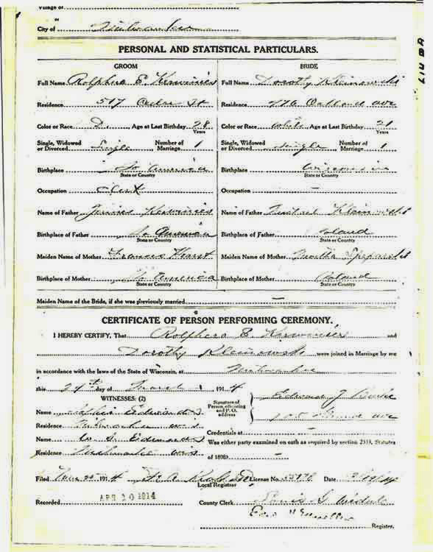
Appendix

Kerwinieo (Kerwinies) and Kleinowski's marriage certificate, March 24, 1914.
Source: http//outhistory.org (accessed 8 Apr. 2012).
Works Cited

Primary Sources
Katz, Jonathan Ned. "Ralphero E. Kerwinies and Dorothy Kleinowski Marriage Certificate." Outhistory.org http://outhistory.org/wiki/Day_Book:_Cora_Anderson/Ralph_Kerwinieo,
_May_15-16,_1914. (accessed 23 Nov. 2010).

Roloff, Bernard C. "The 'Eugenic' Marriage Laws of Wisconsin, Michigan and Indiana." Journal of Social Hygiene 6 (1920): 228-231.
Supreme Court of Wisconsin. "Peterson v. Widule, County Clerk." Northwestern Reporter, vol.147. St. Paul, MN: West Publishing Co., 1914, 966-976. http://books.google.com
/books?id=bY8AAAAIAAJ&source=gbs_navlinks_s. (accessed May 4, 2012).

U.S. Department of the Interior, Census Office. "Twelfth Census of the United States." edited by F. B. Forcke. Ward 4, Chicago, South Town, Cook, IL, 1900: 15.
Vedder, Edward Bright. Syphilis and Public Health. Philadelphia and New York: Lea & Febiger, 1918.
Wisconsin State Board of Health. Proceedings of the Biennial Conference of Health Officers of the State of Wisconsin. Madison: Wisconsin State Board of Health, 1916.
Wisconsin State Legislature. Laws of Wisconsin, 1913. Chapter 525, 1062. Madison: Democrat Priting Co., State Printer, 1913.

________. "Laws of Wisconsin, 1915." Chapter 525, 695-696. Madison: Democrat Printing Co., State Printer, 1915.

Secondary Sources

Clement, Elizabeth Alice. Love for Sale: Courting, Treating, and Prostitution in New York City, 1900-1945. Chapel Hill: The University of North Carolina Press, 2006.

Cromwell, Jason. Reclaiming Genders: Transsexual Grammars at the Fin De Siècle. Edited by Kate and Stephen Whittle More. London and New York: Cassell, 1999.

________. Transmen and Ftm's: Identities, Bodies, Genders, and Sexualities. Illinois: Board of Trustees of the University of Illinois, 1999.

Faderman, Lillian. Odd Girls and Twilight Lovers: A History of Lesbian Life in Twentieth-Century America. New York: Columbia University Press, 1991.

Katz, Jonathan Ned. Gay American History: Lesbians and Gay Men in the U.S. New York: Crowell, 1976.

________. Gay American History: Lesbians and Gay Men in the U.S. New York: Meridian, 1992.

Meyerowitz, Joann J. Women Adrift: Independent Wage Earners in Chicago, 1880-1930. Chicago: University of Chicago Press, 1988.

Rosen, Christine. Preaching Eugenics: Religious Leaders and the Amerian Eugenics Movement. New York: Oxford University Press, 2004.

San Francisco Lesbian and Gay History Project. "'She Even Chewed Tobacco:' A Pictorial Narrative of Passing Women in America." In Hidden from History: Reclaiming the Gay and Lesbian Past, eds. Martha Vicinus Martin Duberman, and George Chauncey, Jr. New York: Penguin Books USA Inc., 1989.

Somerville, Siobhan B. Queering the Color Line: Race and the Invention of Homosexuality in American Culture. Durham: Duke University Press, 2000.

U.S. Bureau of Labor Statistics. CPI Inflation Calculator. http://data.bls.gov/cgi-bin/cpicalc.pl. (accessed May 4, 2012).

Ralph's last name is spelled many ways in documents, including Kirwinio, Kerwinieo, Kerwin, and Kerwinies. Likewise, White's first name is alternatively cited as Mary, Mamie and Marie. This paper employs the most frequent spellings, "Kerwinieo" and "Mary."
This paper employs the terms "gender crossing" and "passing" interchangeably when referring to Anderson's intermittent identification as a person of the opposite sex and gender and off a different ethnic background.
"Girl-Man Now Is Free Again," Milwaukee Journal, May 7, 1914.
"Former Girl Man Again Arrested," Milwaukee Sentinel, June 9, 1919; "Girl Man Again in Court," Milwaukee Journal, June 9, 1919; "Woman Who Posed as Man Is Freed," Milwaukee Sentinel, Sept. 11, 1919.
Jason Cromwell, Reclaiming Genders: Transsexual Grammars at the Fin De Siècle, ed. Kate and Stephen Whittle More (London and New York: Cassell, 1999); Jason Cromwell, Transmen and Ftm's: Identities, Bodies, Genders, and Sexualities (Illinois: Board of Trustees of the University of Illinois, 1999); Lillian Faderman, Odd Girls and Twilight Lovers: A History of Lesbian Life in Twentieth-Century America (New York: Columbia University Press, 1991); Jonathan Ned Katz, Gay American History: Lesbians and Gay Men in the U.S. (New York: Meridian, 1992); Joann J. Meyerowitz, Women Adrift: Independent Wage Earners in Chicago, 1880-1930 (Chicago: University of Chicago Press, 1988); San Francisco Lesbian and Gay History Project, "'She Even Chewed Tobacco:' A Pictorial Narrative of Passing Women in America," in Hidden from History: Reclaiming the Gay and Lesbian Past, ed. Martha Vicinus Martin Duberman, and George Chauncey, Jr. (New York: Penguin Books USA Inc. , 1989); Siobhan B. Somerville, Queering the Color Line: Race and the Invention of Homosexuality in American Culture (Durham: Duke University Press, 2000).
Jonathan Ned Katz, Gay American History: Lesbians and Gay Men in the U.S. (New York: Crowell, 1976).
Cromwell, Transmen and Ftm's: Identities, Bodies, Genders, and Sexualities, 142.
Somerville, 104.
Christine Rosen, Preaching Eugenics: Religious Leaders and the Amerian Eugenics Movement (New York: Oxford University Press, 2004); Tamsen Wolff, Mendel's Theatre: Heredity, Eugenics, and Early Twentieth-Century American Drama (New York: Palgrave Macmillan, 2009).
Meyerowitz, 90-91.
Ibid., 95.
Ibid., 96.
Faderman, 45.
Ibid., 45.
Cromwell, Reclaiming Genders: Transsexual Grammars at the Fin De Siècle, 58.
Bernard C. Roloff, "The 'Eugenic' Marriage Laws of Wisconsin, Michigan and Indiana," Journal of Social Hygiene 6 (1920): 230.
Ibid., 72.
Wolff, 84.
Cromwell, Reclaiming Genders: Transsexual Grammars at the Fin De Siècle, 58.
"Girl-Man Now Is Free Again."
"Writing Life's Last Chapter," Milwaukee Journal, May 4, 1914.
"Girl-Man Goes Free on Bail," Milwaukee Journal, May 5, 1914.
"Girl-Man Now Is Free Again."; "Writing Life's Last Chapter."
"Girl-Man Now Is Free Again."
Prior to this, newspapers stated that Anderson had passed as a man for eight to ten years, a calculation based upon the length of time she passed as White's husband. After Anderson's testimony, newspapers began citing the thirteen year figure when describing the length of time Anderson passed as a man. Ibid.
Census Office U.S. Department of the Interior, "Twelfth Census of the United States," ed. F. B. Forcke (Ward 4, Chicago, South Town, Cook, IL: 1900), 15.
"Girl-Man Now Is Free Again."
"Girl Lives as Man and Weds," Milwaukee Journal, May 3, 1914.
"Girl-Man Goes Free on Bail."; "Girl Lives as Man and Weds."; "Writing Life's Last Chapter."
"Girl-Man Now Is Free Again."
"Ain't Got Any Sister, at All," Milwaukee Journal, May 8, 1914.
"'Wife' Is Native of Menasha; High School Graduate," Milwaukee Journal, May 5, 1914.
"Girl-Man Goes Free on Bail."
"Girl-Man Now Is Free Again."
Ibid.
Cora Anderson, "Girl-Man Says That Man Is a Hunter of Women," Milwaukee Journal, May 13, 1914; Cora Anderson, "Man-Woman Says Man out in the World Is a Hunter of Women," Day Book, May 15, 1914; Cora Anderson, "Man Displays His Conquests," Milwaukee Journal, May 15, 1914; Cora Anderson, "Will a Man Kiss and Not Tell?--No, Says Cora Anderson, the Man-Woman," Day Book, May 16, 1914.
Anderson, "Girl-Man Says That Man Is a Hunter of Women."; Anderson, "Man-Woman Says Man out in the World Is a Hunter of Women."
Ibid.
Ibid.
Ibid.
Ibid.
"Girl Lives as Man and Weds."
Anderson, "Man Displays His Conquests."; Anderson, "Will a Man Kiss and Not Tell?--No, Says Cora Anderson, the Man-Woman."
Ibid.
Elizabeth Alice Clement, Love for Sale: Courting, Treating, and Prostitution in New York City, 1900-1945 (Chapel Hill: The University of North Carolina Press, 2006); Nixola Greeley-Smith, "Eva Booth, Salvation Chief, Reports Ten Years with Poverty in America," Milwuakee Journal, May 26, 1914.
Although South American as an ethnicity is problematic, Anderson/ Kerwinieo does not provide a specific country of origin, simply identifying as “Ralphero E. Kerwinies, birthplace: S. America,” as seen on the certificate of his marriage to Dorothy Klenowski. Jonathan Ned Katz, "Ralphero E. Kerwinies and Dorothy Kleinowski Marriage Certificate", Outhistory.org. http://outhistory.org/wiki/Day_Book:_Cora_Anderson/Ralph _Kerwinieo,_May_15-16,_1914 (accessed 23 Nov. 2010).
"Girl-Man Now Is Free Again."
"Girl-Man Is Free; Judge Suspends Sentence in Court," Milwaukee Sentinel, 7 May 1914.
Somerville, 104.
Wisconsin State Legislature, Laws of Wisconsin, 1913, (Madison: Democrat Priting Co., State Printer: 1913), 1062.
Roloff, 228-231.
"Girl Lives as Man and Weds."
Ibid.; "They Are Now Writing the Last Chapter in the Life of Ralph Kerwinieo--I Shall Leave Here and Start Life over Again Elsewhere," Milwaukee Journal, May 4, 1914.
"Girl Lives as Man and Weds."
Katz, "Ralphero E. Kerwinies and Dorothy Kleinowski Marriage Certificate."; "Writing Life's Last Chapter."
"Girl Lives as Man and Weds."; "They Are Now Writing the Last Chapter in the Life of Ralph Kerwinieo--I Shall Leave Here and Start Life over Again Elsewhere."
"They Are Now Writing the Last Chapter in the Life of Ralph Kerwinieo--I Shall Leave Here and Start Life over Again Elsewhere."
Ibid.
Wisconsin State Legislature, Laws of Wisconsin, 1913, 1062.
"They Are Now Writing the Last Chapter in the Life of Ralph Kerwinieo--I Shall Leave Here and Start Life over Again Elsewhere."
Wolff, 84.
Ibid., 84.
"Girl Lives as Man and Weds."
Ibid.
"Girl-Man Goes Free on Bail."
"Girl Lives as Man and Weds."
"Writing Life's Last Chapter."
"Girl-Man Now Is Free Again."
"Girl-Man is Free; Judge Suspends Sentence in Court," Milwaukee Sentinel, May 7, 1914.
"Girl-Man Now Is Free Again."
"Man Woman at Orpheum," Milwaukee Journal, May 9, 1914.
"Both Houses Packed: Miss Cora Anderson, the Man-Woman," La Crosse Tribune, May 29, 1914; "Cora Anderson Is at the Majestic," La Crosse Tribune, May 27, 1914; "Cora Anderson, the 'Girl-Man'," Grand Rapids Tribune, Nov. 4, 1914; "Crowd Theater to Hear Man-Woman," La Crosse Tribune, May 27, 1914; "Dates to Be Remembered," Sheboygan Press, Nov. 3, 1914; "It Doesn't Take Much to Get People out to a Vaudeville Attraction," Oshkosh Daily Northwestern, Aug. 10, 1914; "Man-Woman Will Lecture in This City," Sheboygan Press, Nov. 10, 1914; "Man Woman at Orpheum."; "Matinee Tomorrow, Grand Theater: Cora Anderson, Milwaukee's Man-Woman," Wisconsin State Journal, May 26, 1914; "Orpheum," Milwaukee Journal, May 11, 1914; "Thirteen Years a Girl Husband," Ogden Standard, June 13, 1914; "Woman Posed as Man for 13 Years," La Crosse Tribune, May 26, 1914.
"Clothed as Man, Woman Is Locked Up," Racine Journal-News, Mar. 24, 1915.
"Cora Anderson in Police Court," Eau Claire Leader, Apr. 2, 1915; "Girl-Man Taken into Custody in the Cream City," Racine Journal-News, Mar. 31, 1915; "'Man-Girl' Is Fined for Being Disorderly," Milwaukee Sentinel, Apr. 1, 1915.
Wisconsin State Board of Health, Proceedings of the Third Biennial Conference of Health Officers of the State of Wisconsin, (Madison: Wisconsin State Board of Health, 1916), 49-50.; Edward Bright Vedder, Syphilis and Public Health (Philadelphia and New York: Lea & Febiger, 1918), 27, 53, 57-58.
"Wasserman Test Not Needed for Marriage Permit," Milwaukee Sentinel, June 18, 1914.
Ibid.
Wisconsin State Legislature, Laws of Wisconsin, 1915, (Madison: Democrat Printing Co., State Printer, 1915), 695-696.; "Wasserman Test Not Needed for Marriage Permit."
"Cora Anderon So Mannish Her Wife Left Her," Des Moines News, May 11, 1914; "The Girl Who Married a Girl," Washington Post, May 10, 1914; "Kendallville Girl-Boy Returning Home," Fort Wayne Journal-Gazette, May 9, 1914; "Writing Life's Last Chapter."
"Girl-Man Goes Free on Bail."
"Girl Gets a Eugenic License as a Man, Then Weds a Girl," Reading Eagle, May 4, 1914; "Ralph's Real Name Is Cora Anderson," Fort Wayne News, May 4, 1914.
"Eugenic Statute," Montgomery Advertiser, May 13, 1914; "Eugenic Statute," Miami Herald Record, May 12, 1914.; "Eugenic Statute: Enforced in Wisconsin Is Shown to Be Huge Joke," Grand Forks Herald, May 12, 1914.
Rosen, 72.
Peterson v. Widule, County Clerk. Northwestern Reporter, 147. St. Paul, MN: West Publishing Co., 1914, 966-967. http://books.google.com/books?id=bY8AAAAIAAJ&source= gbs_navlinks_s (accessed May 4, 2012).
Ibid.; U.S. Bureau of Labor Statistics, CPI Inflation Calculator, http://data.bls.gov/cgi-bin/cpicalc.pl (accessed 4 May 2012).
Supreme Court of Wisconsin, 966.
Wisconsin State Legislature, Laws of Wisconsin, 1915, 695-696.
Ibid.

