BUILDING AUDIO, VIDEO, AND DATA-RESCUE KITS
Dorothea Salo


INFORMATION SCHOOL
a project of the

Table of Contents
Table of Contents 2
Welcome! 4
Cases and foam 5
Cases 5
Foam 5
Laptop and peripherals 7
Specifications 7
The FireWire problem 7
Windows or MacOS? 7
Peripherals, cables, and adapters 8
Equipment sources 8
Audio equipment 9
Audio interface 9
Cassette player 9
Microcassette player 9
Cables and adapters 10
Software 10
VHS and VHS-C equipment 11
VCR 11
VHS-C adapter 11
Cables 11
Capture dongle and software 11
Mini-DV equipment 12
Camcorder 12
Cables 12
Drivers and software 12
Slides and 35mm photographic film 13
Digital equipment 14
5.25" floppy diskettes 14
3.5" floppy diskettes 14
Iomega Zip disks 14
SD cards 15
Software 15
Hard drives/whole computers 16
PROUD and PRAVDA budget 17
PROUD 17
PRAVDA 17

Welcome!
I truly appreciate your interest in building portable kits for audio and video (A/V) and digital data rescue. We cannot possibly save all or even most of the at-risk 20th-century treasures in all our communities without many kit builders and users!
I could not have built PROUD (Portable Recovery of Unique Data, our digital-data rescue kit) and PRAVDA (Portably Reformat Audio and Video to Digital from Analog, our A/V rescue kit) without a great deal of help. I am very grateful to:
- The Institute of Museum and Library Services for financial support (Sparks! grant number SP-02-16-0015-16)
- The staff of the University of Wisconsin-Madison’s Information School Laboratory Library, especially Anjali Bhasin, for clearing space and for their patience
- Project Assistant Jesse Hocking, documentor extraordinaire
- Information School chair Kristin Eschenfelder
- Jen Gerber of the Oscar Grady Library in Saukville WI, Marcia Sarnowski of the Winding Rivers Library System (WRLS), and Kristen Anderson of WRLS for inspiration and advice
- Many members of the iSchool, UW-Madison, Madison, as well as several Wisconsin library and archives communities for equipment donations, repair tips and help, interest, and encouragement
I can only wish you as much support in your efforts as I have had.

—Dorothea Salo
October 2017
salo@wisc.edu

This whitepaper is copyright 2017 by Dorothea Salo. It is licensed under a Creative Commons Attribution 4.0 International license (https://creativecommons.org/licenses/by/4.0/). Please do adapt it for your own purposes!

Cases and foam

Cases
The case you use for your kit should ideally meet the following requirements:
- Shippable via whatever means you plan to use
- Water-resistant
- Tough enough to protect its contents from damage
- Lockable
- Not too heavy
- Wheeled
For kits belonging to a library (or other) consortium with established interlibrary-loan shipping arrangements, an interlibrary loan box may be perfect. Avoid “crates” with sides open to the elements. Solid-sided boxes such as the various Stak-Paks from Orbis Corporation are a much better choice.
For a kit that will be shipped by ground or air, look for a case that is “ATA approved.”
Semi-custom cases are readily available. Pelican is the top brand name, but also the priciest. I used Case Club (http://www.caseclub.com/) for PROUD and PRAVDA and have been very pleased with the build quality. Be careful of no-return policies, however; be very, very sure you have sized your case appropriately.
The exterior of some custom cases will resist stickers and stuck-on label pouches. If you need a shipping label for such a case, buy one that attaches to one of the handles.

Foam
Since any kit you build will contain electronic equipment, all foam padding should be “anti-static.” An added benefit is that anti-static foam is water-resistant. Anti-static foam is recognizable by its unfortunate color: Pepto-Bismol pink.
If you are purchasing a custom case, the manufacturer can probably line it with foam for you. Definitely take advantage! I lined PROUD and PRAVDA’s cases with one and a half to two inches of foam, which in hindsight was excessive; one inch all around will suffice. Plan for a minimum of one inch of foam between kit components.
You can buy foam from your custom-case manufacturer, but shop around to be sure their markup is not excessive. Try Uline (https://www.uline.com/) or Foam Factory (http://www.foambymail.com/) first. They ship only in bulk, but a bulk shipment still costs less than much less foam from case manufacturers. Try to share a shipment with another kit-builder!
Foam comes in three basic types: sheet foam, eggcrate foam, and “pick-and-pluck” foam, which is scored along a grid to make it easy to create irregular shapes. Pick-and-pluck foam is quite handy, but not as tough as sheet or eggcrate foam.
You will also need spray adhesive to glue foam pieces together. “3M Super 77” is what I used. Apply in a well-ventilated area, consider wearing rubber or latex gloves to keep the adhesive off your hands, and be prepared to let the glued foam dry in the open for at least a week—it smells hideous until it airs out completely.

Laptop and peripherals

Specifications
As with any computer, you want the most RAM and biggest/fastest hard drive you can afford, subject to the very important caveats in the rest of this section. You also want at least one USB3 port.
Be aware that video rendering to DVD or file is amazingly slow and there are no ideal ways to speed it up. A faster CPU and more RAM will help… but less than you might think.

The FireWire problem
The archivally-appropriate way to retrieve lossless digital video from Mini-DV playback is via FireWire (also known as iLink and IEEE 1394). Unfortunately, FireWire is an obsolete technology and options for connecting it to laptops are scarce and becoming scarcer.
Current options and their tradeoffs include:
- Windows laptop with a FireWire port. No modern example exists. PROUD and PRAVDA use “business-class” HP laptops that are two or three generations old and correspondingly slow.
- Windows laptop with an ExpressCard slot; FireWire ExpressCard. The ExpressCards are still readily available (e.g. from StarTech), but no modern Windows laptop has an ExpressCard slot.
- Mac laptop with a Thunderbolt port (note: not USB-C, but the older Thunderbolt port) and a Thunderbolt-to-FireWire adapter. Again, current-generation Mac laptops do not have the older Thunderbolt port.
- Windows laptop with a (used; these are no longer manufactured) Pinnacle MovieBox. This is the only gadget I know of that purports to transmit lossless digital video by wrapping FireWire input in USB. I have not tried this and do not know how well it works!
(Desktop computers can use a PCI/PCIe FireWire card, still readily available new, but these cards cannot be installed in laptops.)
Obviously, none of the above is an ideal option! Unless/until someone manufactures a dongle that bridges USB-C and FireWire, however, it is the best anyone can do.

Windows or MacOS?
For a data-rescue kit, Windows. MacOS is unacceptable because it refuses to recognize 3.5" floppy drives. (I have also had ridiculous amounts of trouble getting virtual-machine software to work on MacOS. If you want to use a BitCurator VM, stick with Windows.)
For an A/V rescue kit, either will do. A Mac may be somewhat preferable because the latest FireWire-capable (via old-style Thunderbolt) Mac laptops are much more capable than the latest FireWire-capable Windows laptops.

Peripherals, cables, and adapters
A/V rescue kits will probably need to rip and burn optical media such as DVDs. (DVDs are not archivally-correct video captures, being lossy and hard to audit, but many patrons archiving their own video history will want them.) Laptops with internal DVD-burners are becoming uncommon, but USB DVD burners are still readily available.
An external hard drive (1TB minimum) is a must for an A/V rescue kit, and a good idea for a data-rescue kit. Video files—even lossy ones—are enormous! Either a USB3 or eSATA connection is fine, laptop ports permitting. USB2 connections are annoyingly slow for video work and file copying.
The cables and adapters you will need for A/V kits and most data-rescue kits are readily available from Monoprice (https://monoprice.com/) at excellent prices. If you need something Monoprice does not have, try Newegg (https://newegg.com/).

Equipment sources
Always ask your community what they can donate or lend to your cause! Their generosity will be inspiring.
Of course, eBay and Craigslist as well as local thrift stores are excellent sources of secondhand working equipment. Additional possibilities include:
- Local government or university surplus stores or auction sites
- ShopGoodwill, http://shopgoodwill.com/
- Freecycle, if there is one in your area, http://freecycle.org/
- Recycled Goods, http://recycledgoods.com/ (mostly for drives and rare cables)
- Everything But The House, http://ebth.com/
- PropertyRoom, http://propertyroom.com/

Audio equipment

Audio interface
Laptop sound cards are not designed for audio or video capture work; the sound quality you achieve will be quite poor. To improve capture quality, purchase an audio interface. Minimum requirements:
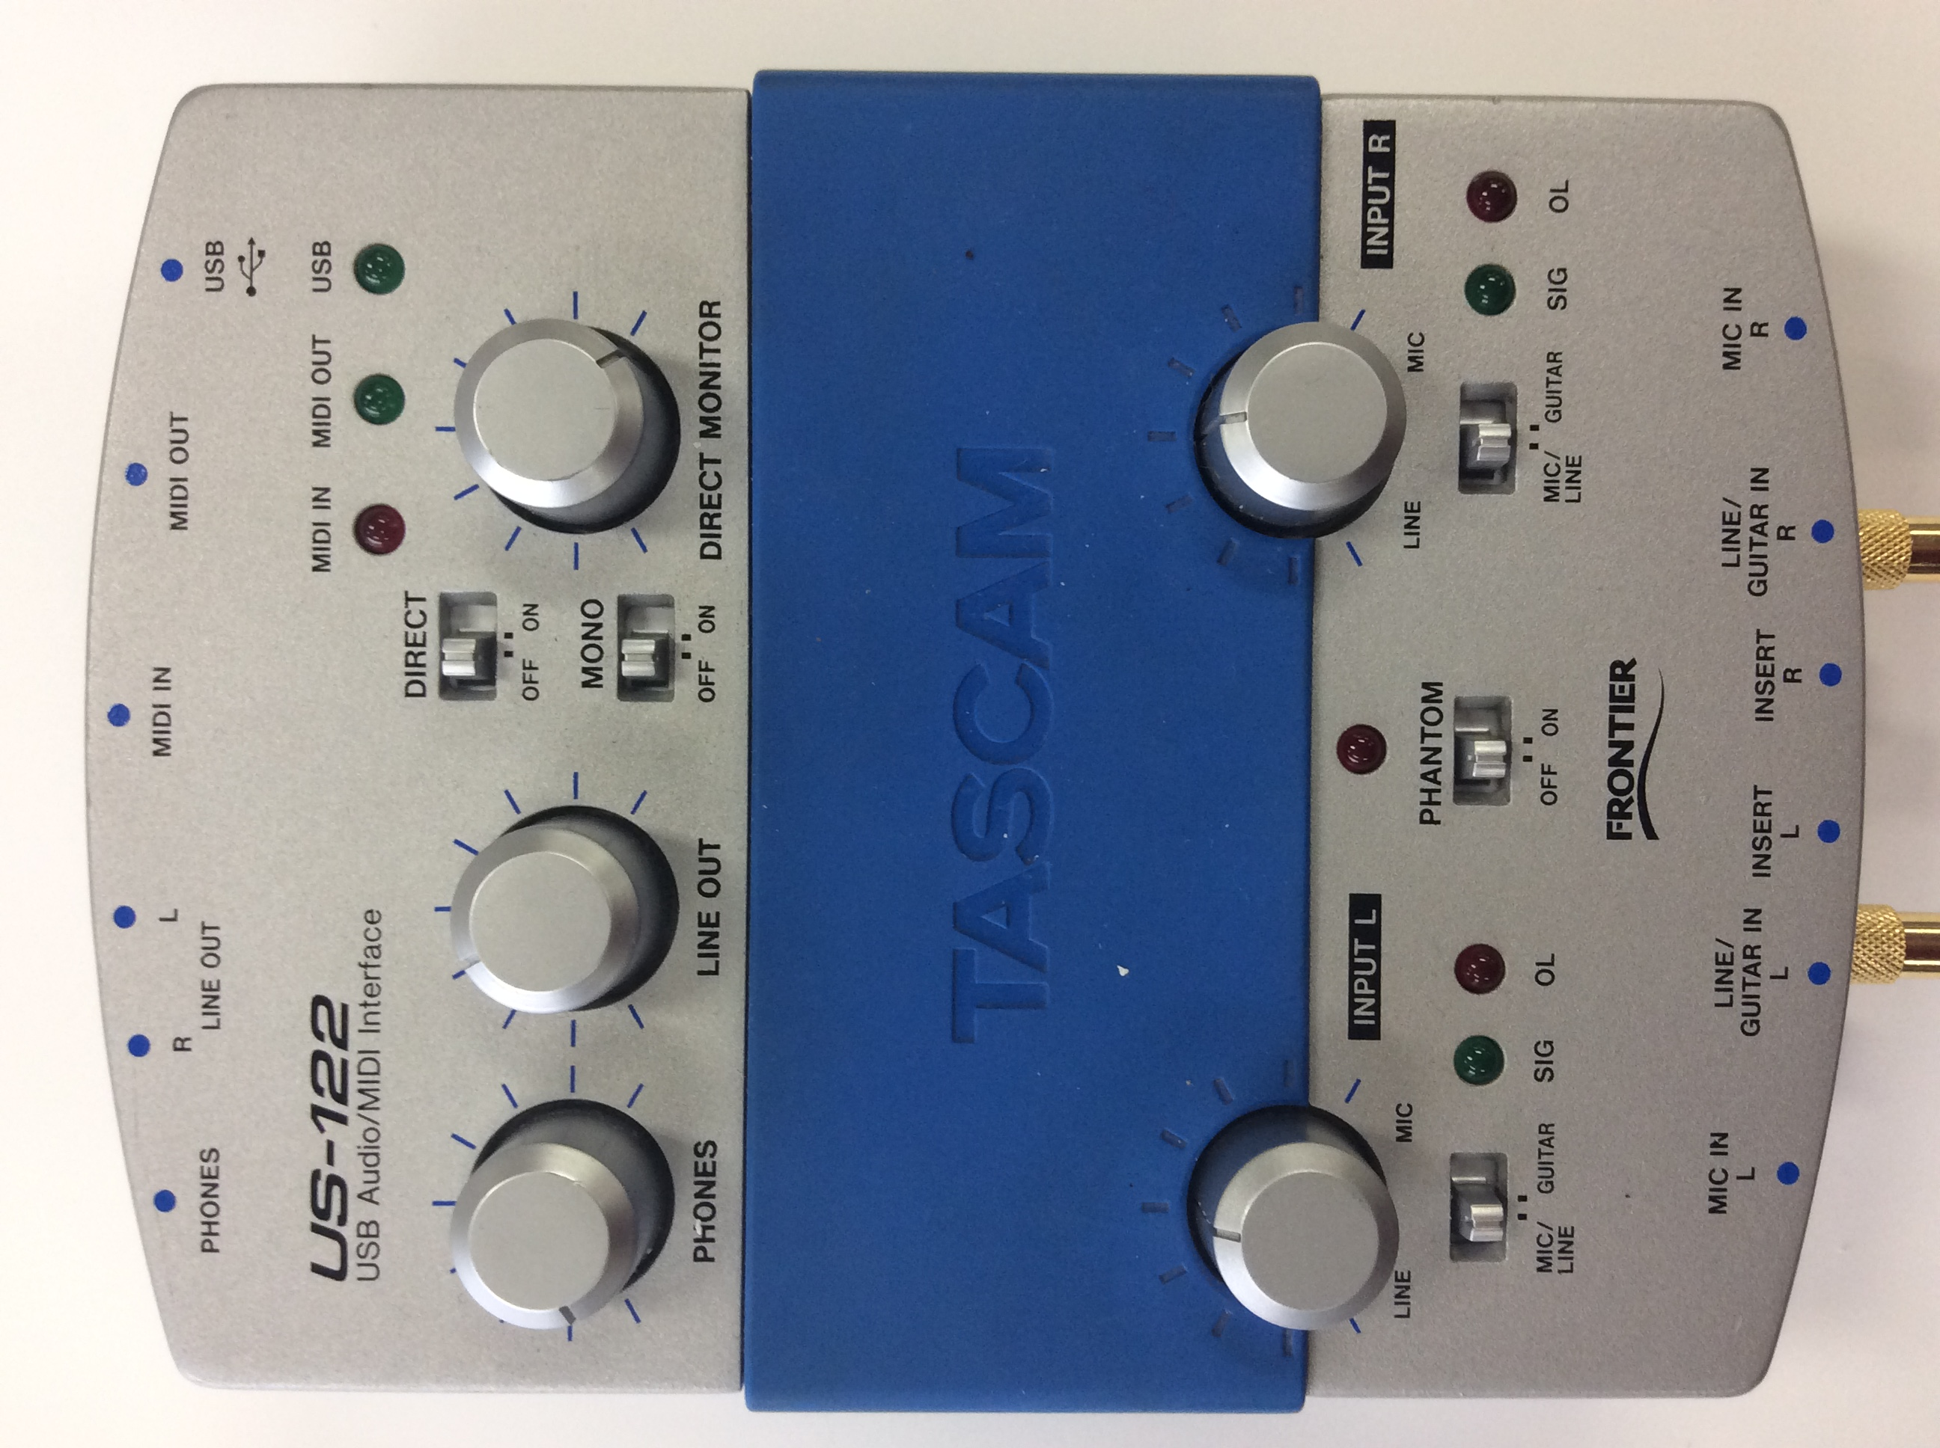
- 24-bit/96kHz minimum capture capacity. (Research this! Many audio interfaces top out at 16-bit and/or 48kHz.)
- USB connection. (Many excellent audio interfaces rely on a FireWire port, which is unfortunately obsolete.) USB2 is fine; it need not be USB3.
PRAVDA uses a secondhand TASCAM/Frontier US-122 (right), which is probably the oldest audio interface that meets the above requirements. Getting this machine working under Windows 7, 8, or 10 is non-trivial, but achievable via the Windows ability to pretend to be earlier versions of Windows for purposes of running drivers. Note that Windows 10 is reported to be pickier about running old drivers than Windows 8 and 7 are.

Cassette player
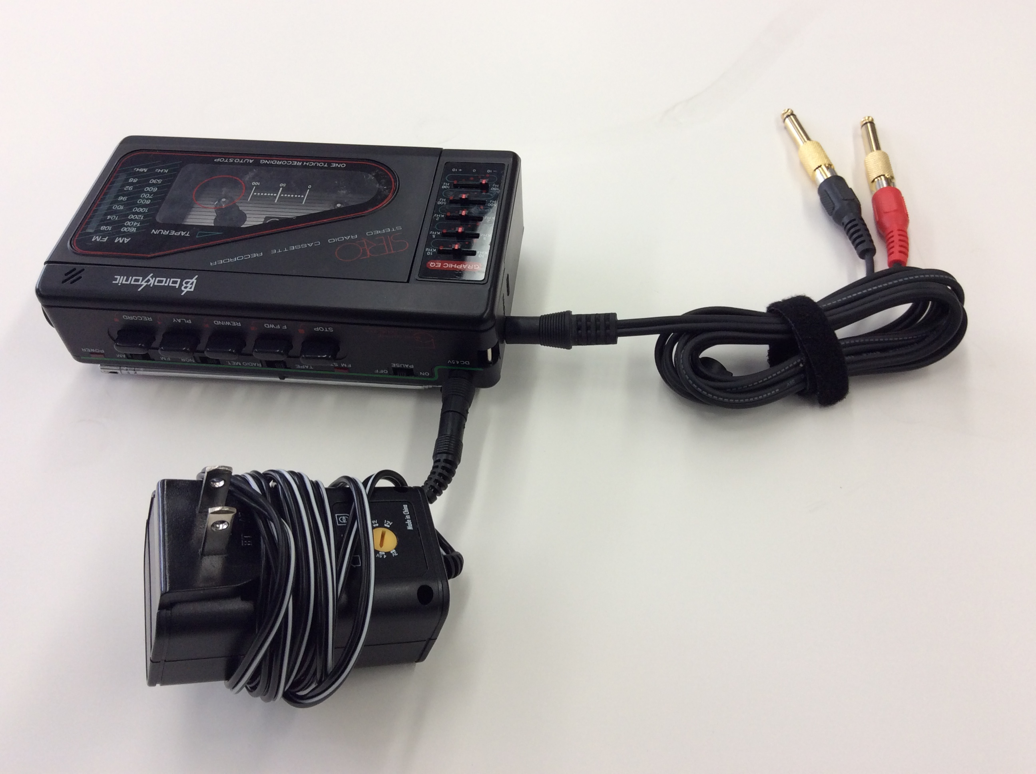
Avoid secondhand Walkman-type cassette players unless you know how to refurbish one; in my experience, most have been heavily used and are in poor condition. PRAVDA uses a Broksonic player purchased new from Amazon (right).

Microcassette player
These are readily available secondhand. You may have to buy two or three before you find one in good working order. They rarely come with power cords, but should run fine on regular AA or AAA batteries.
A microcassette player is certainly a lower priority for an A/V kit than a standard cassette player, but I have been surprised at how often interview tapes have come in from researchers on campus, not to mention answering-machine tapes that represent the only known recording of a patron’s loved-one’s voice.

Cables and adapters
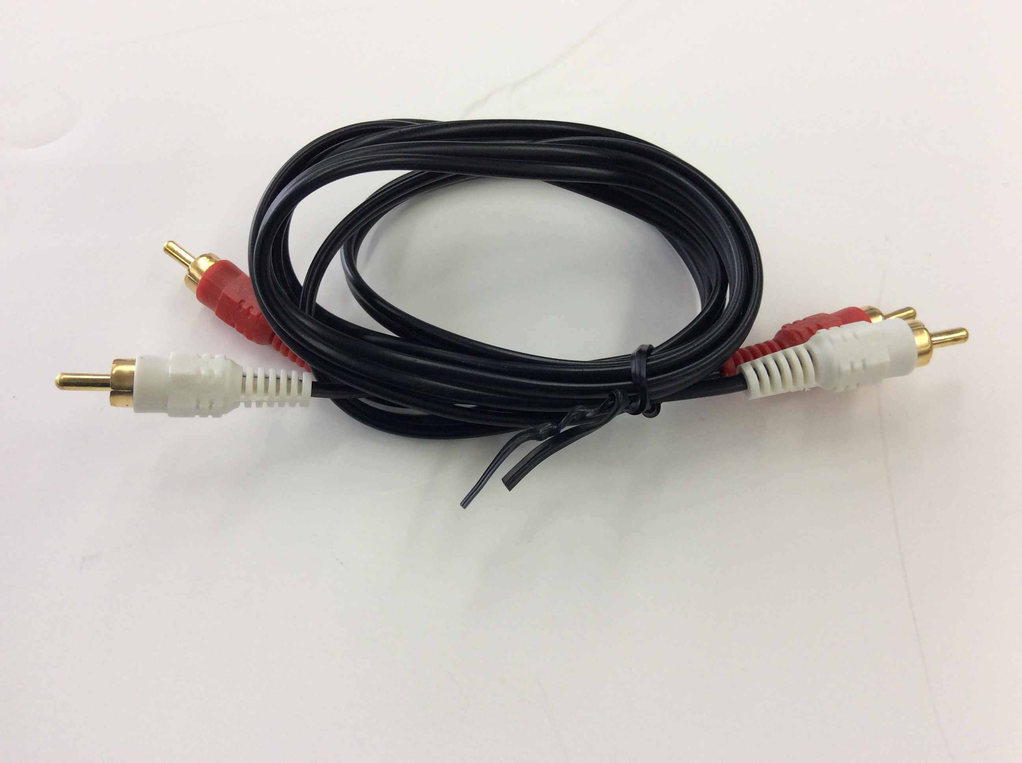
The workhorse audio cable is an RCA/composite cable (right), with its familiar red-and-white (or red-and-black) plugs. It is perfectly fine to use an RCA video cable while ignoring the yellow plugs, but this may confuse staff or patrons and requires cable-switching between audio and video work, so I recommend adding an audio-specific cable to the kit.
Some audio interfaces have RCA sockets, but not all—and even those that have them can be frustratingly finicky about capturing input from them. PRAVDA therefore contains two RCA-to-¼" (RCA female, ¼" male) adapters, because all audio interfaces have ¼" sockets.
For cassette and microcassette players, you will need a 3.5mm-to-RCA (3.5mm male, RCA female) or a 3.5mm-to-¼" adapter.
Open-reel players and turntables are generally too heavy and/or fragile to ship in a kit. With the above cables and adapters, however, it will be possible to connect practically any on-site player to the audio interface for use.

Software
Audacity is open-source and works fine. I strongly recommend removing unnecessary toolbars (e.g. the Transcription toolbar) from the default configuration—their proliferation is distracting.

VHS and VHS-C equipment

VCR
The best VCR is a stereo S-VHS player made by JVC. In practice, however, even secondhand JVC players are expensive, and S-VHS machines are hard to find. Any decent stereo VHS player will be fine. Do not use a VCR that only outputs mono audio; it will have only white and yellow RCA/composite jacks, instead of the stereo VCR’s red, white, and yellow.
Either RCA (yellow) or S-Video (round black socket that looks a bit like an old-style PS/2 mouse/keyboard socket) is fine.
Many VCRs have both input and output sockets. I recommend putting a strip of electrical tape over input sockets to prevent accidental cable misconnections.

VHS-C adapter
Because regular-size VHS tapes meant absurdly large and heavy camcorders, camcorder manufacturers invented the smaller “VHS-C” (for “compact”) tape format. It is playable in ordinary VCRs with purchase of a battery-powered adapter, readily available new on Amazon.

Cables
All you should need is one video/audio cable. If your VCR uses RCA video (yellow socket), choose an RCA video cable; otherwise, choose an S-video cable and an RCA audio cable, or purchase an S-video to RCA adapter (S-video male, RCA female) from Monoprice.

Capture dongle and software
You cannot capture lossless video to archival standards with a laptop. (It is theoretically possible, but the necessary equipment is expensive and becoming scarce, and the software is fussy and hard to use.) You can burn DVDs and capture decent mp4/H.264 files.
Roxio, ElGato, and others sell small dongles for VHS capture with associated software. PRAVDA uses Roxio because its software usability is decent. Avoid no-name dongles (often found on Amazon) because the software is usually abysmally bad.
For slightly greater ease of kit assembly, I connected the capture dongle with the RCA video cable and electrical-taped them together.

Mini-DV equipment

Camcorder
Any Mini-DV camcorder with a FireWire/iLink/IEEE 1394 port (which is almost all of them) is fine. These are easy to find secondhand. You may need to purchase a power cord for it; check the manufacturer and model number on Amazon or eBay. Avoid Sony Handycams because they require a small and easily-lost dock for capture.
If you need a camcorder repaired, I had excellent results from Royal Camera Service (http://royalcameras.com/) in northern Illinois.

Cables
The FireWire port on camcorders invariably takes a 4-pin cable. Most laptops do as well, but there is a slight chance yours will accept a 6-pin cable. Monoprice has both 4-to-4 pin and 4-to-6 pin cables (search on “1394”); pin-size adapters for an existing cable are also available.

Drivers and software
Some camcorders are finicky about the FireWire driver Windows uses. If your laptop refuses to recognize your camcorder, follow the instructions at https://www.studio1productions.com/Articles/Firewire-1.htm to install a different driver that is more likely to work.
If you are using Windows 7 or earlier, Windows Movie Maker works fine. Otherwise, I recommend installing Scenalyzer Live from http://www.scenalyzer.com/.

Slides and 35mm photographic film
PRAVDA does not contain equipment for these, but slides and photographic film are so commonly encountered both in cultural-heritage organizations and among patrons that they deserve a mention.
Many kits will contain small flatbed scanners for photographs and documents. If the scanner in your kit has slide/film attachments available, by all means purchase and use them.
Lacking that, a kit aimed solely at patrons will probably want one of the easy-to-use, compact Wolverine or Jumbl digitizers. These are not acceptable for creating archival master files, however, because they cannot output lossless files such as TIFFs, only lossy JPEGs. Minimum requirements for a scanner that can create archival master files:
- 24-bit color (Research this! Many scanners stop at 16-bit.)
- Ability to output lossless TIFF files
Despite their high price, I recommend PlusTek OpticFilm scanners for archival-master digitization; they are compact and surprisingly fast. (Pacific Image scanners are much slower, in my experience.) These are not easy to find secondhand, unfortunately, but be patient; one will turn up on eBay or shopgoodwill. The OpticFilm 7300 is the oldest model with Windows 10 drivers.
Buy extra slide and film trays. These lower total scanning time by allowing you to load/unload one tray while another is in use. OpticFilm slide trays accept glass slides, I have found.
VueScan is the most usable scanning software I have yet found; it is worth the purchase price. SilverFast is awful to use.

Digital equipment

5.25" floppy diskettes
You will need a drive, case, power source, ribbon cable, controller, and USB cable.
All available drives will be secondhand. The standard archival drive is the TEAC FD-55GFR, but most drives will work fine. Purchase power source and FC5025 floppy controller card from Device Side Data (http://deviceside.com/). The card comes with Windows/Mac/Linux software capable of capturing disk images as well as (clunkily) individual files. Any USB A-to-B cable will work.
Build tips: Ribbon cables have a thin, faint red stripe along one side. When you plug the ribbon cable into the controller card, make sure that red stripe is on the same side as the “PIN 1” text printed on the card. Also, be extra careful to line up pins with sockets; nothing prevents installing the cable slightly askew. For cables with two sets of sockets that fit the card pins (designed for two drives, in other words), you can use either set.
Finding a suitable case is difficult! If you have access to a 3d printer, Yvonne Eadon designed a printable cover and stand (https://www.thingiverse.com/thing:2441163). Otherwise, the closest match is a case designed to house a 5.25" full-height optical (CD/DVD) drive. Make sure the back is plastic (or removable), not metal—you may have to cut parts of it out to feed the power and ribbon cables through. The Addonics Sapphire (http://addonics.com/products/sesu3cs.php) looks workable. PROUD uses a CoolGear case that is no longer available new.

3.5" floppy diskettes
USB drives for these are occasionally available new and readily available secondhand. No special brand or model is necessary, but it may make sense to buy two different models, as some diskettes are finicky about drives.

Iomega Zip disks
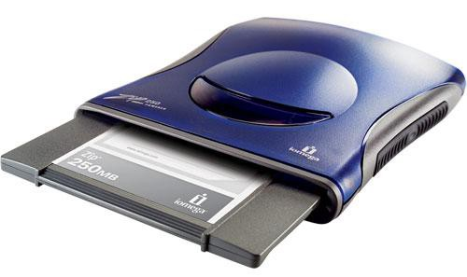
Do not buy a SCSI drive! SCSI is thoroughly obsolete and all but impossible to connect to a laptop. Make absolutely sure any drive you obtain connects with USB.
Zip disks come in two capacities: 100MB and 250MB. Squarish drives (in dark blue or lighter translucent blue) are almost always 100MB-only and require a separate power cable. Slimmer, more rounded drives in royal blue (right) handle both kinds of Zip disk and run fine off USB power; they are therefore the smarter buy.

SD cards, Compact Flash cards, etc.
Buy a USB “20-in-1” reader. In fact, buy several—some kinds of cards are frustratingly easy to mis-insert such that pins on the reader are bent.

Software
The FC5025 floppy controller card comes with its own software.
To create archival disk images, I recommend FTK Imager Lite from Access Data (http://accessdata.com/). You will need to sign up with a valid email address to download this.
Another option is BitCurator (http://bitcurator.net/) running in Oracle VirtualBox, but if you only want the kit to capture disk images and copy files, BitCurator is overkill. (VirtualBox also has an extraordinarily annoying showstopper bug that will not let you use a USB mouse and capture a disk image from a USB floppy drive at the same time, a major reason I recommend FTK Imager Lite instead.) You can always install BitCurator later (on the kit’s laptop or a different computer entirely) to process captured disk images!
For Mac-formatted 3.5" floppy disks, you may want MacDrive from MediaFour (http://mediafour.com/) because Windows will not recognize them natively.

Hard drives/whole computers
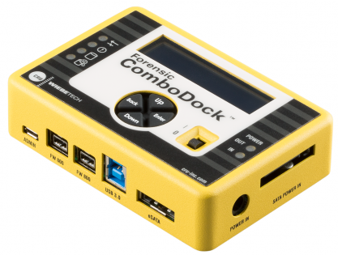
Many kit builders, especially those building kits for personal digital archiving by patrons, will decide not to tackle these. I wholeheartedly endorse such a decision! Many professional archivists will need this capacity, however.
PROUD uses a WiebeTech/CRU Inc. Forensic ComboDock (right). I recommend at least version 5.5 for less USB2/USB3 hassle, but the version 5 is also a capable machine. The ComboDock comes with cables that connect and power most hard drives you are likely to encounter.
The other reasonable (though considerably more expensive) option is the Tableau Forensic Universal Bridge plus a 5.25" half-height external drive case for power.
You should not need any software other than FTK Imager Lite and the configuration software that comes with the ComboDock.

PROUD and PRAVDA budget
These figures, from early 2017, are meant only to give you a ballpark idea of the expense to expect. You may spend more or less than this, depending on what you have at hand, what Newegg or thrift-store sales look like, or what your community is able to donate.
Items purchased secondhand or refurbished are marked with asterisks (*). Items donated, or reused from a prior RADD purchase, are marked as such.

PROUD
Item | Budgeted | Paid
PROUD laptop | $269.99* | $253.01*
external 3.5 drive | $16.50* | (reused)
5.25 floppy drive | $59.99* | $49.95*
5.25 enclosure | $36.78 | $19.03
SATA adapter | $6.97 | (unnecessary)
FC5025 card/power cable | $60.50 | $86.29
Zip drive | $175.48 | (donated)
Forensic ComboDock | $299.00 | $294.99
Two USB cables | $4.00 | (reused)
PROUD case/foam | $516.27 | $608.47
MacDrive license | $0.00 | $59.00
WinImage license | $0.00 | $27.00
extra foam | $0.00 | $112.50
cassette player | $0.00 | $49.99
TOTAL | $1445.48 | $1560.23

PRAVDA
Item | Budgeted | Paid
PRAVDA laptop | $251.99* | $253.00*
External hard drive | $59.00 | $56.87
Firewire card | $27.26 | $31.20
Firewire cable | $5.09 | (reused)
Roxio video capture | $79.22 | (reused)
Audio cables | $4.00 | (reused)
RCA cable | $2.00 | (reused)
PRAVDA case/foam | $911.83 | $608.47
VHS VCR | $70.00 | (donated)
mini-dv camcorder | $99.99 | (donated)
firewire adapter, cable | $1.26 | (reused)
microcassette | $59.99* | (donated)
TOTAL | $1571.63 | $949.54

