Department of History
University of Wisconsin—Eau Claire

A Right to Half: Regulation of Ojibwe Deer Hunting as a Treaty Right 1990

By: Nicholas Dean Schauer

History 489
Research Seminar
Prof. Oscar Chamberlain

5-16-16

Table of Contents

Preface 2

Abstract 3

Introduction and Historiography 4

Anti-Treaty Concerns 10

State Regulation 17

Night Hunting and Regulation 23

Conclusion 25

Annotated Bibliography 27

Preface
I first became interested in Ojibwe history as a student at the University of Wisconsin-Eau Claire. It was here that I had become exposed to the intricate histories of Wisconsin and its relations with the indigenous population. During my studies I closely examined treaty rights issues and was able to relate it to my own experiences as a Midwesterner in a family of sportsmen. I grew increasingly aware of racism instilled into communities that was amplified by issues such as treaty rights. It is important to note, that despite my position on the issue, I am still examining history from a “white” perspective. What this means is that this paper may include cultural misrepresentation and the publication of information that can be considered inappropriate from an indigenous perspective. The analysis I provide is derived from my own understanding of the events, and my interpretation of historical documents and secondary sources.

Abstract
Throughout the 19th century the United States Federal Government purchased land from Native Americans through treaties in which select groups of American Indians ceded (gave up) their land to the US for payment and annuities but retained the right to hunt, fish, and gather on said lands. After achieving statehood, Wisconsin, like other states that had contained land purchased through treaties began to regulate their natural resources. The State did not recognize the rights reserved by the Indians in the treaties and began to prosecute them into the 20th century for harvesting resources out of regulation. After several legal battles and the intervention of the Federal Supreme Court the Ojibwe Indians retained their rights to hunt, fish, and gather on ceded lands. Before the Ojibwe were able to practice their treaty rights, the State was given the responsibility to regulate Ojibwe harvests so that the resources could be maintained and harvested by non-natives as well. The reintroduction of Ojibwe treaty rights sparked opposition from large numbers of non-natives insisting that Wisconsin’s natural resources would be subject to depletion. Native harvesters faced harassment for all of their practices, perhaps none more than the spearing of Walleye. Resistance groups (often labeled as hate groups) were formed and protests were held where extreme racism ensued. Ojibwe Indians continue to practice treaty rights while attitudes of local non-natives have become less radical but tension remains. The regulation of deer hunting as a treaty right was intended to represent both Indian’s and non-Indians. This paper analyzes the regulation of the deer harvest specifically and its impact within the ceded territories.

Introduction and Historiography
Venison, fish, and wild rice have been staples in the Ojibwe diet since they migrated to the Great Lakes Region. (Having previously lived in/around present day New York). The Ojibwe people have been utilizing Wisconsin’s abundance of resources as a means of sustenance for their entire existence within the state. The practices of fishing, ricing, harvesting maple syrup, and hunting can be traced back for generations. The processes of obtaining these food sources are considered traditional and retain their value among tribal members looking to keep their culture alive. “I hunt for the health of my family, and I hunt for the health of my community.” Said Greg Johnson or “Biskakone”, an enrolled member of the Lac du Flambeau Band of Lake Superior Chippewa. In a documentary called “hunting” published on theways.org, Johnson explains the importance of deer to Ojibwe culture and how continuing to hunt helps to keep traditional ways alive. The preservation of Ojibwe culture relies heavily on the practices of hunting, fishing, and gathering. If the Ojibwe do not use their treaty rights, they are in danger off having them considered unnecessary, and as a means, revoked.
The history of Ojibwe treaty rights begins in 1837 when Governor and Superintendent of Indian Affairs in the Wisconsin territory, Henry Dodge, negotiated a land cession treaty with representatives from surrounding Ojibwe bands. Dodge wanted access to the extensive resources that the territories had to offer, specifically the timber. In these negotiations the Ojibwe agreed to cede a portion of their lands in exchange for annuities and the rights to hunt fish and gather on them so that they may sustain themselves. It’s important to note that in Satz’ put emphasis on Dodge’s attempt to rush the agreement before the representatives most affected by the treaty arrived. “The assembled Indians were mostly from Minnesota, and only a small fraction of their land was involved in the proposed cession; those from the Lake Superior shoreline had no land involved. All refused to discuss the proposal until the arrival of representatives of the interior Wisconsin bands whose lands were the focus of the proposed cession. After the Indians delayed the proceedings for two days, Dodge impatiently requested a reply even though the interior Wisconsin Indians had not yet arrived.” It was Satz intention in his work to emphasize the true intentions of the Government. There were two more land session treaties signed in 1842 and 1854 that had similar layouts as the first.
Into the twentieth century Wisconsin Indians began to face prosecution for exercising their rights and it was ruled that Indians had the right to practice treaty rights on their reservations. In 1978 a Federal District Court Judge, James Doyle ruled that the Lac Courte Oreilles Ojibwe had surrendered their treaty rights from the 1837 and 1842 treaties when the boundaries of their reservation were determined “pursuant” to the 1954 treaty. The Lac Courte Oreilles then appealed to the U.S. Court of Appeals who in 1983 reversed Doyle’s decision and “reaffirmed the sanctity of the treaties”. After ruling in the Indians favor the U.S. court of appeals then instructed Doyle to establish state regulation over the exercise of these rights. Doyle created a three-phase plan in which the newly retained rights were to be executed. Phase one was to determine the “nature and scope” of the Ojibwe treaty rights. Phase two was to determine the regulation necessary for these rights which is the primary focus of this paper in relation to the deer harvest. Finally, phase three was to determine the damages and disturbance treaty rights have had on the natural resources in the ceded lands.
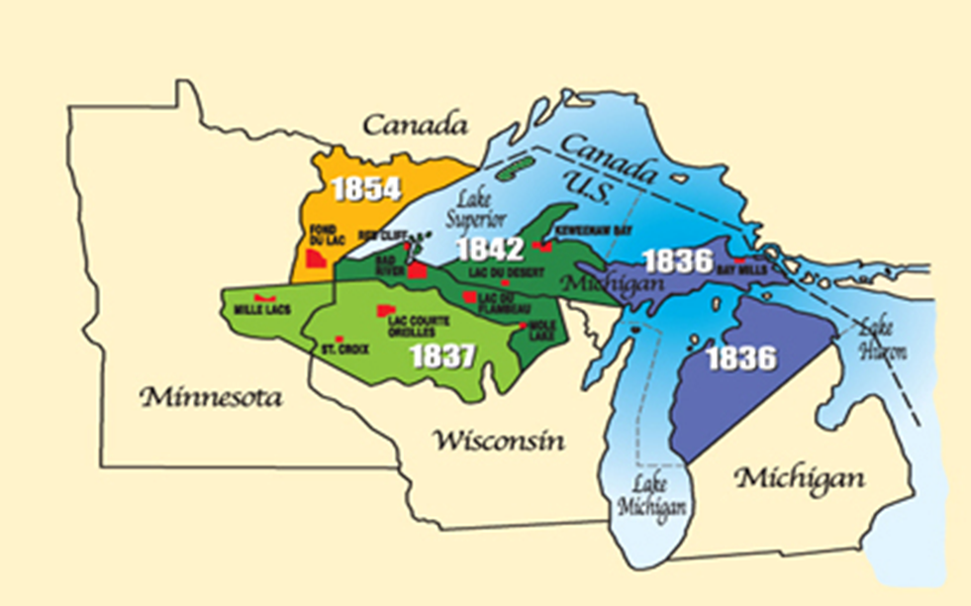
The picture above displays the ceded territories in accordance with the treaty in which they were associated with. Map courtesy of the Great Lakes Indian Fish and Wildlife Commission.

Source: http://www.glifwc.org/map.html

As news of the government’s recognition of the Ojibwe treaty rights reached local non-Indians, protests ensued and violence came with them. “The peaceful harvesting of fish by Chippewa spearfishes has been disrupted by non-Indians hurling rocks, insults, and racial epithets like “timber niggers,” waving effigies of speared Indian heads and signs with slogans like “Save Two Walleye, Kill a Pregnant Squaw,” and using large motorboats trailing anchors to capsize Indian boats.” The protests at boat landings in Northern Wisconsin against Ojibwe treaty rights throughout the late 1980s and early 90s sparked debate on to whether the protesters were fueled by racism or the threatening of Wisconsin’s resources. The treaty rights practiced by American Indians were seen as special rights there for igniting opposition from rural whites who did not see themselves as having the same advantages. Without a proper understanding of tribal sovereignty and interpretation of the treaties protesters grew fierce and allowed hate to emanate.
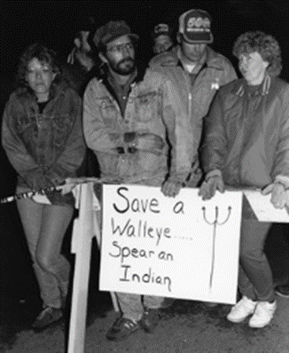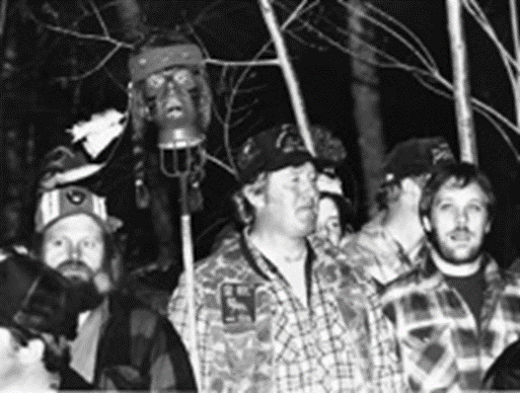Protesters were abundant at boat landings in an effort to bring an end to treaty rights. Protesters were not concerned with being racist, but claimed to desire equality. Photo Courtesy of the Great Lakes Indian Fish and Wildlife Commission.

Source: http://www.glifwc.org/TreatyRights/protest.html

However sportsman opposition groups rallied under the protection of American Resources as their main cause for protest. Government officials had spoken out against the spearing of walleyes as well and several anti-treaty groups formed such as WARR (Wisconsin Alliance for Rights and Resources), PARR (Protect Americas Rights and Resources), and Equal Rights for Everyone (ERFE), and STA (Stop Treaty Abuse). These groups rallied under the cause of “Equal Rights”. Propaganda was spewed into the community furthering the misunderstanding that was taking place.
As the Ojibwe kept practicing their rights, the media coverage died down, due to the inherent racism used to rebel against the Indians. Treaty Rights were becoming largely accepted and the state resumed to pass regulations. In order to effectively regulate to hunting, fishing, and gathering the Ojibwe tribes formed the Great Lakes Indian Fish and Wildlife Commission more commonly known as GLIFWC. Established in 1984, GLIFWC works cooperatively with the Department of Natural Resources to establish and enforce regulations within the ceded territory. GLIFWC also provides educational resources for Indians and non-Indians alike to educate themselves about treaty rights. In phase two of Doyle’s three phase plan, each right was regulated in its own trial. Regulations were proposed by both parties and decisions were made in the best interest of the Ojibwe and the State with cooperation from the Department of Natural Resources and the newly formed Great Lakes Indian Fish and Wildlife Commission.
Treaty rights have been documented thoroughly since the protest died out, and its histories are revisited whenever a news story airs about a change in regulations or there is a change in the harvest quotas. There is not an enormous amount of information left to be written about the subject but what I intend to examine is the shift in attitudes toward treaty rights throughout the process of regulations. To do this I will examine methods used by anti-treaty groups and the questions they raised in communities. I will also examine the trial in which deer hunting regulations were established and the effects that the first hunts had within the ceded territories. It is my intention to further the readers understanding of treaty right regulation as well as their connection the eventual departure of anti-treaty protests.
From a local perspective, treaty rights is a topic that generates interest from the communities and is definitive in Wisconsin culture today. As far as historical documentation, it is often written about from an Indian-sympathetic perspective highlighting the intensity of interactions between Indians and non-Indians. If it is broken down, it will more often than not, discuss the regulation of spear fishing, as that was the most disputed of the rights acknowledged and the harvest totals are much higher. However, many of the incidents that took place, such as the prosecution of native hunters, initiating the Indians declaration of rights reserved. The best historical sources that I found on the topic are Larry Nesper’s “The Walleye War” and “Chippewa Treaty Rights” by Ron Satz. Nesper’s book provides a personal narrative and is focused around the protesting of spearfishing in the 80s and 90s. Satz provides a deep historical insight into the beginning of the conflict and brings it up to date focusing on the protests in its second half. Both sources write from the Indian-sympathetic approach noted earlier. In his book, Nesper discusses the beginning of the prosecutions that took place against Ojibwe men harvesting resources in the ceded territories. According to Nesper the state began to look upon Wisconsin’s resources as the foundation for a booming tourist Industry. He wrote that the Lac de Flambeau Ojibwe had specifically remembered their treaty rights and continued to pursue off reservation resources. In 1897, warden arrested two elderly men for possession of venison outside of the reservation. In 1951, eighteen Ojibwe men were arrested for hunting deer out of season. Their convictions lead to fines and some even served time in jail. Nesper uses the term “violating” as a term whites used to describe Ojibwe sustenance hunting. There was little compassion for Indians and it is incidents like this that leads me to believe whites or non-Indians were becoming increasingly aware of off-reservation harvests and concerned of the effects that this may have of their claim to the states resources. In other words, whatever racisms existed toward the Ojibwe were becoming tied to resources within the non-Indian population.
Satz provided similar insights into the “curtailment” of treaty rights, but his focus was more on the Wisconsin Supreme Court ruling that the admission of Wisconsin as a state repealed Ojibwe treaty rights within the borders of the state. This would result in further difficulties for Ojibwe because the state had also ruled that Indians were subject to state law in 1879. The analysis of Ojibwe difficulties and prosecutions for the practice of treaty rights in the late 19th and early 20th centuries are documented similarly by both Nesper and Satz as a majority of the resources available to them were the same. Satz goes into a much more detailed approach as far as decisions made by the state, and trials held in which the state made these decisions.
Anti-Treaty Concerns
To better understand the concerns and objectives of the anti-treaty organizations I examined series of documents called the Larry Peterson Papers held on microfilm by the Wisconsin Historical Society. Peterson was a leader in the movement that opposed the liberal interpretation of Indian treaties by the Federal and state governments. He was also a founder and board chairman of PARR and ERFE. The papers in this collection provide an insight into the thoughts and concerns of the anti-treaty movement. When combined with the Satz and Nesper texts we are able to examine the conflict of treaty rights regulation from both perspectives.
In all accounts there is an analyzation of the interpretation of the treaties. In the Anti-Treaty papers PARR had made an official statement suggesting that they treaties were interpreted so “liberally” that they were clear indications of white guilt brought on by the Indians current predicament stating “Our opinion is that the Court of Appeals was being most generous to these Indians, and that this court’s decision was based upon non-existent evidence and faulty readings of the few fragments they were allowed to see or chose to consider. Their decision, we think, was based upon what scholars call “law-office history”. It is clear to see from this statement alone that there is a fear and apparent disgust for the government’s handling of the issue. PARR also went as far to state that the treaties were well understood by both sides.
“At the time, and through the end of the 19th century, there was a clear understanding on the part of all concerned - - federal authorities, state authorities, local citizens, and the Chippewa themselves. So long as these Chippewa remained “in” their reservations they were under the jurisdiction of the federal government. “Off” the reservation they were subject to state law and regulations.” In Satz’ documentation of treaty understanding, he states that the details of the treaties were poorly communicated and that the Ojibwe that were present during its signing were not clear on the terms. “…the interior bands assumed American use of the timber from ceded lands would not result in permanent white occupation of the region. They steadfastly believed that access to their ceded lands as well as to resources and wildlife (as agreed in the treaty) would allow them to perpetuate their traditional lifestyle.”
As I read further into the Peterson Papers I began to see why so many opposed the encouragement and regulation of treaty rights such as harvesting deer. PARRs official statement questioned the intentions of Ojibwe Indians and sparked rage in the hearts of non-Indians throughout northern Wisconsin. One of the largest arguments in opposition of the treaties was ancestry. It was argued that Indians today are nothing like the Indians of the 19th century and that they are in fact mostly European. “…The modern Chippewa are simply not the same people - - culturally, linguistically, or biologically - - as the genuine Indians who originally negotiated the treaty. With maybe a rare exception, all are descendants of European-Americans, more so than Indian Americans.” PARRs statement held firmly that the “lack” of indigenous blood and the change in culture were acceptable means to separate the Ojibwe from Indians of the past and therefore surrender any claim to rights that may have been preserved. In order practice treaty rights and participate in the harvest, a person must be an enrolled member in an Ojibwe Tribe. The enrollment qualifications are different for each tribe. The Lac Courte Oreilles Ojibwe established provisions for membership within their constitution. To briefly summarize their qualifications a person must possess LCO Blood and be a lineal descendant of an enrolled member. In 1998 the Sault Ste. Marie Ojibwe (Michigan) closed membership to all adults not enrolled. Children can still be enrolled but are require to have at least one parent who is enrolled in the Sault Ste. Marie as a full “genuine” member.
PARR members and officials were active in the protests of Treaty Rights at boat landings. On Sunday, April 26, 1987 a protest took place on Butternut Lake. This lake is located just outside of Park Falls which was were PARR was based out of. The protest that took place was estimated to have had between 250 and 500 and was documented as one of the most racist, and hateful protests. Law enforcement from four counties was required to disperse the crowd. According to Nesper, it was after this protest that anti-treaty movements started to become associated with racism. PARR responded to the accusations from the Wisconsin Media, Church groups, and academics by stating that by “committing themselves publically to the award of such special rights to a group of citizens based on race…” they themselves were the racists.
In a series of ads referred to commonly as the “Did you know?” ads were one of the methods PARR used to promote its cause. The Ads brought forth information that in the context was alarming and most likely resulted in action and support for the fight against treaty rights. They were used to target non-Indians, specifically sportsmen, in an attempt to increase membership. One particular ad that PARR distributed to local papers read as follows.
“ATTENTION ICE FISHERMAN: Do you know that Chippewa tribe fisherman are allowed 20 lines each, and that they only have to be attended every 24 hours? Do you know Chippewa tribal fisherman are allowed to spear muskies? Do you know they are permitted a 2’ x 3’ hole in the ice for spearing on all ceded lakes within northern Wisconsin? Protect Americans’ Rights and Resources is concerned - - are you?”
The ad would have undoubtedly provoked reactions resulting in increased opposition for treaty rights. The Tribal Chairman, Michael Allen Sr. of the Lac Du Flambeau Chippewa Indians dismissed the ad as “inflammatory” and stated that a one sided ad was no way for the public to educate themselves about their neighbors. In addition to ads PARR frequently printed and distributed “fact” sheets throughout the community. These sheets would present information in a way that suggested Indians had ulterior motives. Such statements included findings which indicated Ojibwe could purchase land and turn the deed over to the tribe thus expanding the reservation or insisting that the Ojibwe once again took the law into their own hands by opening casino gambling. The continued production of these ads would continue to grow support for the anti-treaty movement. By 1987 PARR claimed 4,000 members and an additional 25,000 supported in affiliated groups. They even gained support from a would-be Governor in Tommy Thompson. Thompson campaigned in the north a year earlier speaking out in opposition to treaty rights. As Governor, Thompson, along with Representative David Obey, would try to purchase, or lease the Ojibwe’s treaty rights in an attempt discontinue them.
PARR continued to challenge the Governments recognition of Ojibwe Treaty Rights as protest them stating they were “unconstitutional”. They attributed much of the government’s decisions to an overwhelming desire to be politically correct. “PARR is also keenly aware of how sensitive political leaders are about being accused of racism, of not making contributing to the enhancement of the American national image by making regular, large donations to distant, radically changed descendants of America’s original population…) Statements like this implied that the groups were not openly concerned about being considered racist themselves and explains why they would continue to attribute their cause to equality.
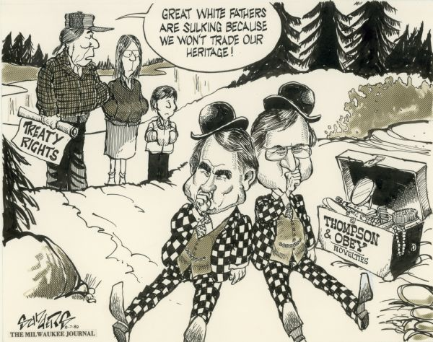
In the Political Cartoon above, Governor Tommy Thompson and Representative David Obey “sulk” as the Ojibwe are unwilling to sell their usufructuary rights. Photo courtesy of the Wisconsin State Historical Society

Source: http://www.wisconsinhistory.org/Content.aspx?dsNav=Ny:True,Ro:0,N:4294963828-4294955414&dsNavOnly=N:1135&dsRecordDetails=R:IM58374&dsDimensionSearch=D:treaty,Dxm:All,Dxp:3&dsCompoundDimensionSearch=D:treaty,Dxm:All,Dxp:3

The effects of PARRs repeated attacks on treaty rights can be effectively seen in letters from citizens sent to the governor and DNR officials concerning treaty rights. In a letter addressed to the Wisconsin Department of Natural Resources, a citizen named Mike from the town of Withee expressed his concern.

Dear Sir,

I am very concerned about the Indians spearing game fish in our lakes. I buy my licenses so you can stock lakes that Indians get to spear out, when the fish are spawning in the shallows. You could use all that money for many other things like cleaning lakes, making marshes for ducks, or stocking lakes that Indians can’t spear. They should only be able to spear certain kinds of fish or spear them when the fish are not spawning, because you just don’t kill that one fish you kill all the eggs to. They should also buy licenses to help stock lakes instead of getting everything free. If you have any information on the subject I would sure like to have it very much. Thank you for your time and I am hoping to hear from you in the near future.

Sincerely Yours,
Mike

Mikes concern for the depletion of fish in Wisconsin lakes is consistent with the concerns of organizations like PARR. His assumptions about harvesting spawning fish and Indians getting everything for free suggest that he has come across anti-treaty publications at one point. His reaction to treaty rights is similar to a lot of other letters that had been received by the Department of Natural Resources and government officials. Mike was lucky enough to get a letter in response.
Dear Mike,

We appreciate your concern about the issue of Chippewa treaty spearfishing. The Department of Natural Resources shares your concerns. I have included a copy of our report from the 1987 treaty spearfishing season which describes our concerns.
The federal courts have recognized the unique hunting and fishing rights of the Chippewa tribes. It is because of these court decisions that the tribes have special seasons and methods of hunting and fishing. I have included for you copies of the three most important court decisions. Also as a result of these decisions, the Chippewa do not have to purchase state hunting and fishing licenses.
Thank you for your interest and concern on this important issue.

George E. Meyer, Administrator
Division of enforcement

These letters were mailed in 1987 while the regulations were still being adjusted. The Department of Natural Resources concern for the topic. Since Ojibwe were now allowed to practice their treaty rights, there was little information to support what kind of impact may occur on Wisconsin’s resources. Regulations were still being adjusted, and different quotas were established. In an article in the Larry Peterson Papers tribal representatives predicted that “public furor” over Indian treaty rights would fade over time as the realization would be made that no significant depletion had occurred in regards to the states resources.
State Regulation of Ojibwe Hunting
Establishing regulations for the Ojibwe harvest was phase two of Judge Doyle’s three phase plan. After his death in 1987, Judge Barbara Crabb took over the case, and began the regulation. It was established by Crabb that the State could regulate treaty rights in the interest of conservation, public health, and safety as long as the regulations were reasonable, necessary, and non-discriminative. What this meant for Ojibwe is that they could not be discriminated against in their right to the harvest. The regulations established for the Ojibwe would coincide with the State in order to maintain a healthy and sustainable resource, while still allowing the Ojibwe to harvest significant portions. This is where the “fairness” of the regulations passed comes into consideration. Not only did Judge Crabb have to assist in the establishment of the regulations but was subject consider regulations that did not violate the Ojibwe or their culture. It was to be recognized that the interpretation of the treaties was to benefit both parties.
In the 1837 and 1842 treaties between the United States and the Lake Superior Chippewa, the parties did not intend that the Indians' reserved rights would entitle them to the full amount of the harvestable resources in the ceded territory, even if their modest living needs would otherwise require it. The non-Indians gained harvesting rights under those same treaties that must be recognized. The bargain between the parties includes competition for the harvest.

This meant that the non-Indian population was to be considered in the establishment of regulations so as the entire resource did not get harvested or managed by the Ojibwe. This is where the concerns of PARR were to be addressed so that they did not become a reality.
On May 9, 1990 the trial to determine regulations for the off-reservation hunting of white-tailed deer, fisher, and small game within the ceded territories established by the treaties of 1837 and 1842. The parties had resolved much of the regulatory differences when the Ojibwe recognized the “biological soundness” of the states deer management program. The Wisconsin DNR has been a national leader in managing the deer harvest for quite some times, as they require registration of every deer killed and set quotas in turn to achieve population goals. To understand the regulation of deer hunting in Wisconsin, it is necessary to become familiar with the method used by the Department of Natural Resources. The DNR has divided Wisconsin into areas of one similar kind of habitat with boundaries established by roads and rivers. These areas are called “units” and all have different capacities in which they can support deer. There are 64 units located within the ceded territory. When setting a quota it is the objective of the state to preserve a harvestable size population in each unit for the following years. Many factors come into consideration when setting these population goals, like the projected loss of deer during a harsh winter, those that are killed by predators such as wolves and bear, and even the number of deer projected to be hit by cars. The maximum sustained yield is the number of deer required to maintain the population goal. This number is about 50 to 60% carrying capacity (the number of deer per square mile that a unit can support). Population goals can be set differently depending on the states objective. Population goals set above the maximum sustained yield provide more deer for hunting, while goals set below the maximum sustained yield provides fewer deer but reduces crop damage and car accidents.
There were several key regulations passed during this trial that would set a mold for the Ojibwe hunting season today. In the draft of proposed regulations presented by GLIFWC during the trial the goal was to be able to hunt antlered deer from July 1 to December 31 with an antlerless season from September 1 to December 31. They also proposed to wear blaze orange during the state gun season along with tags provided by the tribes. These proposed regulations would allow the Ojibwe to harvest deer for six months providing plenty of opportunities for sustenance and also providing safety for both parties when the hunting seasons coincide.
Ojibwe hunters were not allowed to extend their hunting season into the summer months. Instead a season was established from Labor Day until the end of December. The Ojibwe were also denied the ability to hunt at night and on private lands within the ceded territories. Most importantly, during the trial, Crabb decided that the Ojibwe Indians were entitled to one-half of the deer harvest. This would put the Ojibwe on “equal footing” with the non-Indian population as far as the deer harvest was concerned.
The prohibition of summer hunting was seen as a means to protect non-Indians from the dangers of high powered weapons during their most active months. This should not be considered racist as its primary objective is safety, and it does not further discriminate against Indians as non-Indians are not permitted to hunt during the summer either. Another regulatory law prohibited hunting at night for the same reason. This was a justifiable action by the court although the decision would later be overturned and allowed with extensive regulation. Though these regulations did limit Ojibwe access to resources, they were passed as a means of perusing the best interests of both parties, with safety and conservation in mind.
The Ojibwe had already been harvesting White-tailed deer under the supervision of GLIFWC for five years at this point. They increased their harvest slightly every year and raised the quotas accordingly. Within this period the Ojibwe had not harvested their entire quota for any of the years. In 1987 tribal members harvested 71% of their overall quota and 66% in 1988. The number of deer that were harvested by Ojibwe in comparison to number harvested by non-Indians was miniscule. In actuality, the number of deer harvested by Ojibwe in these first five years were only a fraction of the road kill population within the ceded territories. It became apparent to the opposing parties that the Ojibwe would not be capable of harvesting all the deer they were entitled to. In 1989 the quota for Ojibwe hunters would total over 14,000 deer. They stated that they intended to harvest 4,786. This would have a lot less drastic effect on non-Indian hunters who were in turn prepared to be entitled to 50% of the harvestable deer population.
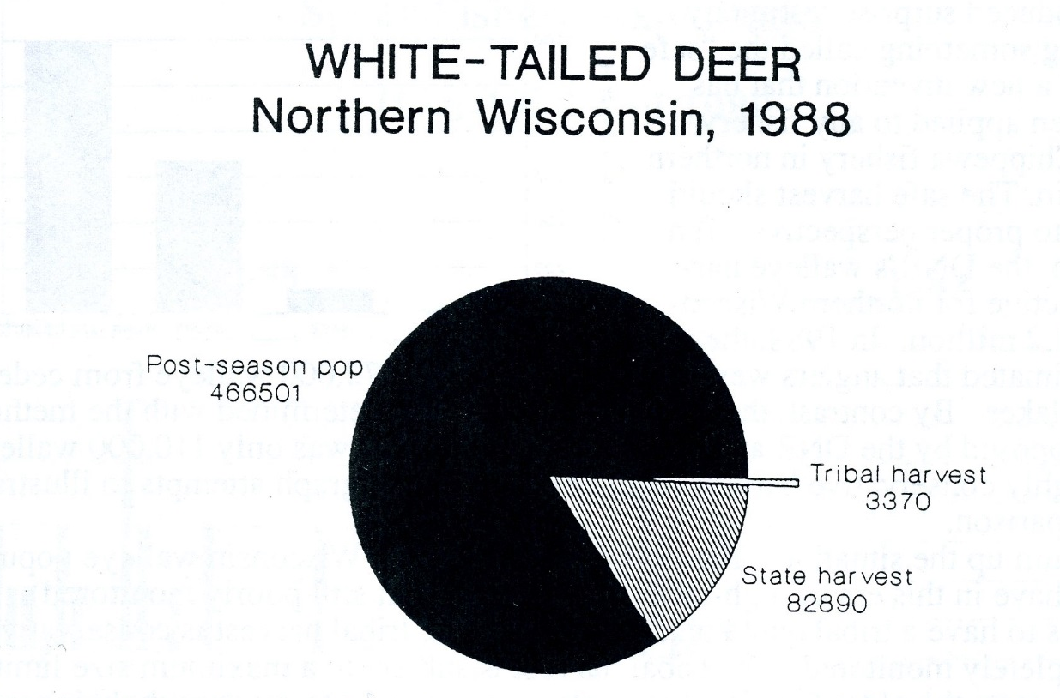
Graph showing harvest totals for 1988 within the ceded territories. Source: Busiahn, Thomas R. Biological Impact of the Chippewa Off-Reservation Treaty Harvest, 1983-1989. Great Lakes Indian Fish and Wildlife Commission. Biological Services Division. Page 6.

As it can be observed in the graph above, the tribal harvests in 1988 were only a fraction of the Deer harvested within the ceded territory. Even when the state harvest is included, the population of deer that made it through the hunting season are still the majority. Though this information cannot be descriptive of every unit, another chart shows the impact within the four most popularly harvested units. After examining the grafts together it can be concluded that the
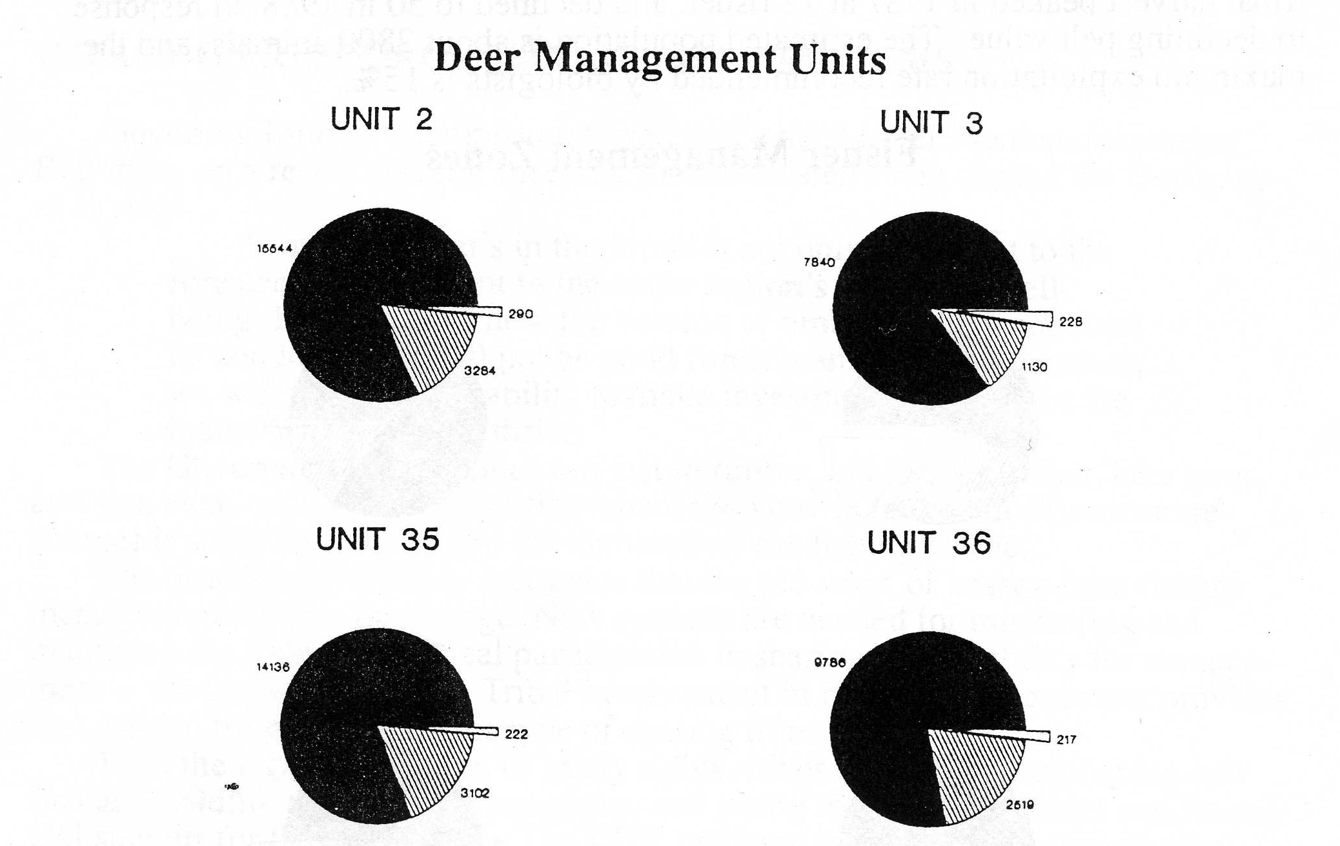
The above graph shows the four top harvested units within the ceded territories. Source: Busiahn, Thomas R. Biological Impact of the Chippewa Off-Reservation Treaty Harvest, 1983-1989. Great Lakes Indian Fish and Wildlife Commission. Biological Services Division. Page 7.

Ojibwe harvest of White-tailed deer has a similar effect in all units. It is important to note, and is often noted by those in opposition to treaty-rights, that the non-Indian population is significantly higher. This would in turn still entitle Ojibwe people to more deer, per person, but as a part of sustenance Ojibwe tradition, that is a right they have reserved. What can be determined by the graph is the much larger impact that non-Indian sportsman have on Wisconsin resources. It would be harder to compare fish totals as sport fishermen are not required to register every fish as a hunter would a deer, but it can be seen that the abundance of sportsmen are what have the biggest impact within the ceded territories.
According to GLIFWCs website, the current deer hunting regulations for Ojibwe Indians are as follows. Tribal members may hunt on public land during the season associated with each ceded territory. The Minnesota 1837 Ceded Territory deer season begins the day after Labor Day and runs through December 31st. Deer Season in the Michigan and Wisconsin 1837 and 1842 Ceded Territories runs from the day after Labor Day through the first Sunday after the first Saturday in January. Hunting hours in Minnesota begin one-half hour before sunrise to one-half hour after sunset. Michigan and Wisconsin had similar hours with only 15 minutes before sunrise and after sunset. The typical gun deer hunting season for non-tribal members occurs for 10 days in November, with an additional seasons for muzzleloader. The regulations posted on GLFWCs website come with an advisory stating that additional changes do occur, and encouraging individuals to consult with their Tribal regulations as they vary between tribe. The date posted on the website is 8/25/14. Additional regulations concerning methods such as shooting from vehicles and distance an individual has to be from public roads before firing are consistent with State hunting regulations for non-tribal deer seasons.
Night Hunting and Regulation
One major change that has occurred since GLFWCs last posting is the reversal of a ruling made by the District Court for the Western District of Wisconsin in 1990. The Court had previously prohibited tribal members from hunting deer at night due to concerns for safety. After continuing to approach the DNR and the State in pursuit of night hunting, the Ojibwe were able to have their case heard in federal court. Originally the federal court sided with the state and the DNR to determine that night hunting should remain prohibited, but were able to appeal and won. Night hunting prohibition has been overturned since being banned officially in 1991.
Hunting White-tailed deer at night is one of the largest concerns for non-Indians when it comes to treaty rights. The concerns have found their way into newspapers and in turn drew more attention for concern.
Though hunting is regulated thoroughly it is still necessary to have DNR involvement. There are many occurrences in which regulations are broken and the media provides coverage accordingly. Such occurrences provide non-Indians with negative connotations of Natives and Treaty Rights. When a minority person is arrested for criminal activity race is assumed to have played a part. When a white person is arrested it is a question of their character.
Night hunting does come with some additional regulations. The DNR has listed these additional regulations on their website along with answers to questions non-Indians might have concerning the night hunts. Night hunting for whitetail deer occurs from November 1st throughout January 4th, not including the night before, after, or during the states 9 day gun hunting season. Hours for night hunting occur one hour after sunset until one hour before sunrise. Night hunters are required to complete a night hunting training course and have an approved tribal shooting plan. A tribal shooting plan includes a diagram of the proposed hunting site that displays a stationary position the hunter will shoot from, the directions of the shots, the safe zone of fire, and an adequate backstop. They will also be required to possess a night hunting permit issued by the Tribe. Additionally shots cannot be taken from more than 100 yards. Non-tribal members are not permitted to hunt at night. The DNR has also taken this opportunity to make a statement regarding safety over treaty rights. “Safety was one of the primary reasons the DNR declined to agree that night hunting should be permitted, resulting in the federal litigation. While the Chippewa Indian Tribes’ proposed regulations attempt to mitigate the risks of hunting white-tailed deer at night, the DNR continues to have safety concerns about the practice, and will work alongside GLIFWC wardens to ensure regulation compliance in accordance with the Court’s ruling.”
Night Hunting has raised concerns in the communities where it will take place. Many non-Indians express concern about the safety of night hunting while others make the argument that it is an unfair advantage (as was made at the boat landing protests). However there are already established hunting seasons that take place at night such as Raccoon hunting. Although many disapprove no large gatherings or protests have taken place.
Conclusion

To provide the reader with a better grasp on the topic, it was necessary to provide a brief history about how treaty rights came to be. When the Ojibwe signed the treaties in the 19th century, they reserved the right to hunt fish and gather on these lands. As Wisconsin proceeded into Statehood, Ojibwe treaty rights were no longer recognized and Indians were held to their reservations. After continuing to pursue off-reservation rights and facing prosecution for doing so, the Ojibwe finally got the federal government to overturn the ruling is which prohibited them from pursuing resources outside of the reservation. The Great Lakes Indian Fish and Wildlife Commission was established and worked closely with the Department of natural resources to ensure that the harvests regulated efficiently as the court would decide how to regulate the newly recognized rights of the Ojibwe.
The approval of Treaty Rights granted by the state was widely protested by non-Indians in fear that their resource population would deplete in turn having drastic effects on tourism. Arguments made by those opposed to treaty rights included attacks on Indian identity, Incompetence of the State, and accusations of Indian “lust”. The anti-treaty groups expelled propaganda throughout the communities and protested the use of treaty rights in large crowds resulting in a large misunderstanding of the treaty rights themselves, and their low impact on the environment. Though the hunting of white-tailed deer as a treaty right was opposed by many non-Indians and the State, the biological effects of the Ojibwe harvest were minimal.
In 1990 a trial was held to determine the tribal regulations for the harvesting of White-tailed deer. Judge Crabb ruled that the Ojibwe were entitled to 50% of the harvest, and seasons were establish for the Ojibwe. It was a turning point for treaty rights in Wisconsin. Along with the effective regulation of the deer harvest, the fish harvest was wildly successful, treaty support groups were growing on a world scale, and the protests in opposition to treaty rights were beginning to diminish.
Because the regulations were successful in preserving the resources, in this case, white-tailed deer, opposition against treaty rights began to fade. The non-Indian fear of fished-out lakes and deer-less woods was no longer a concern within the state. Because of the effectiveness of the regulations, the Ojibwe were able to pursue their rights further and overturn the ruling against night hunting. Without effective regulation of Ojibwe deer hunting, that would have not been possible.

Annotated Bibliography

PRIMARY SOURCES

Chippewa Tribal Night Hunting FAQs and Regulations 2015. Dnr.wiconsin.gov.
- Provides expansive insight on the regulation of night hunting for deer by the Ojibwe tribes. Answers questions that would otherwise be concerning to non-Indians.

Department of Natural Resources. Chippewa Tribal Night Hunting FAQs. http://dnr.wi.gov/topic/hunt/documents/tribalFAQ.pdf last updated 10/30/15
- Rules and regulations for Ojibwe harvesting at night, new rule. Suggests that some treaty rights are being furthered today.

Elliot, Dakota. Oral History interviews with Robert Johnson, Greg Walker, Brandon Thoms, Gary Kmiecik, and Sara Kuchler. University of Wisconsin--La Crosse. Impact and Effects of Spear Fishing Oral History Collection, 2014.
- Oral interviews with former Native and non-Native students and teachers about the spearing conflict. Study was targeting the effects of the conflict on high school students.

Larry Peterson Papers (microfilm edition, 1991) State Historical Society of Wisconsin. Originals in possession of Larry Peterson. Park Falls, Wisconsin.
- These papers are a collection of documents from an anti-treaty perspective. They provide insight into the concerns of non-Indians as far as the preservation of natural resources. In comparison with Indian-sympathetic sources, these papers provide many different perspectives to consider.

LAC COURTE OREILLES BAND OF LAKE SUPERIOR CHIPPEWA INDIANS; RED CLIFF BAND OF LAKE SUPERIOR CHIPPEWA INDIANS; SOKAOGON CHIPPEWA INDIAN COMMUNITY, MOLE LAKE BAND OF WISCONSIN; ST. CROIX CHIPPEWA INDIANS OF WISCONSIN; BAD RIVER BAND OF THE LAKE SUPERIOR CHIPPEWA INDIANS; LAC DU FLAMBEAU BAND OF LAKE SUPE-RIOR CHIPPEWA INDIANS, Plaintiffs, v. STATE OF WISCONSIN, WISCONSIN NATURAL RESOURCES BOARD, CARROLL D. BESADNY, JAMES HUNTOON, and GEORGE MEYER, Defendants. UNITED STATES DISTRICT COURT FOR THE WESTERN DISTRICT OF WIS-CONSIN.
- This is the court case in which Judge Crabb ruled that the Ojibwe were entitle to 50% of the harvestable population of deer. Since I focus heavily on the regulation of deer hunting, this case is most important.

Treaty Hunting Regulation Summary 1837 and 1842 Cede Territories of Michigan, Wisconsin, and Minnesota. Great Lakes Indian Fish & Wildlife Commission. http://www.glifwc.org/Regulations/Hunting37and42_82514.pdf Accessed 3/17/16
- Lists all regulations concerning hunting and fishing in the ceded territories. I will be able to use these to determine the level of regulation and management of resources concerning the Ojibwe.

Knight, Joe. “Chippewa walleye spearing levels could hurt sport fishing” McClatchy – Tribune Business News, March 20, 2013.
- Newspaper article about the effects of walleye spearing on the bag limits for sport fisherman. Current news that reflects possible growing tensions between tribes and the state.

SECONDARY SOURCES

Busiahn, Thomas. 1989 Chippewa spearing season: separating myth from fact. Odanah, WI, Great Lakes Indian Fish & Wildlife Commission, 1989.
- Government source about the spearing conflict. Covers many of the misunderstandings of spear fishing and its effects on the sport anglers.

Lac Courte Oreilles Tribal Government. Amended Constitution of the Lac Courte Oreilles Lake Superior Chippewa Indians of Wisconsin. Accessed Via http://www.lco-nsn.gov/lac-courte-oreilles-constitution.php 5/10/16
- Tribal constitution that is specific in enrollment qualifications. Important to note who can participate in treaty harvests.

Sault Ste. Marie Tribe of Chippewa Indians. Tribal Enrollment. Accessed via http://www.saulttribe.com/membership-services/tribal-enrollment 5/16/16
- Tribal document that is specific in enrollment qualifications. Important to note who can participate in treaty harvests.

Grossman, Zoltan. Unlikely Alliances: Treaty Conflicts and Environmental Cooperation between Native American and Rural White Communities. American Indian culture and research journal. , 2005, Vol.29, p.21-43
- Case study about the coming together of Native Americans and rural whites to protect natural resources. Determines reasons groups turned from conflict to cooperation.

Grossman, Zoltan. Mcnutt, Debra. From Enemies to Allies: Native Americans and whites transformed violent treaty conflicts into a powerful environmental movement in Wisconsin. Colorlines, Apr 30, 2001, p.22
- A text about the evolving relationship between Indian spear fisherman and white sport anglers. The conflict is seen as necessary to educate people about spear fishing.

Lipsitz, George G. Walleye warriors and white identities: Native Americans’ treaty rights, composite identities and social movements. Ethnic & racial studies, 2008, Vol.31, p.101-122
- Article that interprets the racial tensions and hate crimes during the Ojibwe spearing conflict. Indicates that American Indians had to adopt a white identity to effectively communicate and work with the government.

Loew, Patty. Thannum, James. After the storm: Ojibwe treaty rights twenty-five years after the Voigt decision. The American Indian Quarterly. Spring, 2011, Vol.35, p.161
- Focuses on the legal and social crisis surrounding treaty rights in the 1980s and discusses Indians’ right to spearfish walleyes in the Great Lakes. Presents for information about GLIFWC.

Busiahn, Thomas R. Biological Impact of the Chippewa Off-Reservation Treaty Harvest, 1983-1989. Great Lakes Indian Fish and Wildlife Commission. Biological Services Division. Page 6.
- Shows minimal impact of the deer harvests during the time of regulation. This paper is based on the harvest of deer.

Loew, Patty. Hidden Transcripts in the Chippewa Treaty Rights Struggle: A Twice Told Story. Race, Resistance, and the Politics of Power. American Indian Quarterly, 1 October 1997, Vol.21, pp.713-728
- An article describing the walleye spearing conflict and treaty rights. An American Indian perspective of the government’s tribal relations and the political resistance of tribes.

Loew, Patty. Indian Nations of Wisconsin: Histories of endurance and Renewal. Wisconsin Historical Society Press, Madison. 2001.
- This book gives a brief history into the different Indian nations present in Wisconsin. I reference this book for migratory patterns and relationships between different groups.

Nesper, Larry. The Walleye War. Lincoln, NE. University of Nebraska Press. 2002
- Tells the story of the spearfishing conflict in northern Wisconsin. Gathers experiences and perspectives of people who experienced the conflict. Describes historical and cultural significance of spearfishing.

Nesper, Larry. Negotiating Jurisprudence in Tribal Court and the Emergence of a Tribal State: The Lac du Flambeau Ojibwe. Current Anthropology, 2007, Vol.48, p.675-699
- Examines an Ojibwe tribal court and the trials held in concern to violations of tribal law and off-reservation hunting. Discusses tribal sovereignty and its importance in the spearing conflict.

Norrgard, Chantal. Seasons of change: labor, treaty rights, and Ojibwe nationhood. Chapel Hill, the University of North Carolina Press, 2014.
- Observes Ojibwe effort to maintain tribal sovereignty and traditions. Draws on past experiences that lead to the spearing conflict in the late 80s.

Myers, Ransom A. Smith, Matthew W. ; Hoenig, John M. ; Kmiecik, Neil ; Luehring, Mark A. ; Drake, Melissa T. ; Schmalz, Patrick J. ; Sass, Greg G. Transactions of the American Fisheries Society, 2014, Vol.143, p.438-450
- Study of sizes of fish recorded. Goes into detail to describe the process in determining number of fish allowed to harvest by Indians and non-Indian anglers.

Riemer, Jeffrey W JW. Chippewa Spearfishing, Lake Property Owner/Anglers, and Tourism—a Case Study of Environmental Social Conflict. Sociological spectrum, 2004, Vol.24, p.43-70
- Examines off-reservation spearfishing and its effect on tourism, lake property owners, and DNR representatives. Emphasizes a drop in tourism since the legalization of spearfishing.

Satz, Ronald N. Chippewa Treaty Rights. Madison, WI. University of Wisconsin Press. 1997
- Account of the complex political, legal, and social history of the Ojibwe Indians in northern Wisconsin and their struggle for justice. Provides primary source documents.

Stampe, Jennifer. A swing of the pendulum, maybe’: Ojibwe self-representation, settler intolerance, and the collaborative state. Settler Colonial Studies. Volume 3, Issue 2, 2013
http://www.tandfonline.com/doi/abs/10.1080/2201473X.2013.781931
- Analysis of the Mille Lacs Band of Ojibwe’s struggle for treaty rights and a museums attempt to politicize tolerance.

Thompson-Ruddy, Abby. Minnesota Tribes Call for Resignation of Department of Natural Resources Chief. Knight Ridder Tribune Business News, May 21, 2003, p.1
- Article about tribes’ relationships with the state. The state states importance of keeping a healthy relationship with tribes.

Loew, Patty. Indian Nations of Wisconsin: Histories of endurance and Renewal. Wisconsin Historical Society Press, Madison. 2001. Pages 54-55
Theways.org is an educational resource designed to educate students from grades 6-12 about indigenous culture in the great lakes region. The Ways is a production of Wisconsin Media Lab.
Satz. Ronald N. Chippewa Treaty Rights: The Reserved Rights of Wisconsin’s Chippewa Indians in Historical Perspective. Wisconsin Academy of Arts and Sciences. Madison, 1991. Pages 13-21
Satz. Ronald N. Chippewa Treaty Rights: The Reserved Rights of Wisconsin’s Chippewa Indians in Historical Perspective. Wisconsin Academy of Arts and Sciences. Madison, 1991. Page 17
Milwaukee Public Museum website. http://www.mpm.edu/wirp/ICW-110.html
Satz. Ronald N. Chippewa Treaty Rights: The Reserved Rights of Wisconsin’s Chippewa Indians in Historical Perspective. Wisconsin Academy of Arts and Sciences. Madison, 1991. Pages 83-90
Satz. Ronald N. Chippewa Treaty Rights: The Reserved Rights of Wisconsin’s Chippewa Indians in Historical Perspective. Wisconsin Academy of Arts and Sciences. Madison, 1991. Page 94
Satz. Ronald N. Chippewa Treaty Rights: The Reserved Rights of Wisconsin’s Chippewa Indians in Historical Perspective. Wisconsin Academy of Arts and Sciences. Madison, 1991. Page 17
Satz. Ronald N. Chippewa Treaty Rights: The Reserved Rights of Wisconsin’s Chippewa Indians in Historical Perspective. Wisconsin Academy of Arts and Sciences. Madison, 1991. Page 101
Satz. Ronald N. Chippewa Treaty Rights: The Reserved Rights of Wisconsin’s Chippewa Indians in Historical Perspective. Wisconsin Academy of Arts and Sciences. Madison, 1991. Page 106
Nesper, Larry. The Walleye War. Lincoln, NE. University of Nebraska Press. 2002 Page 49
Nesper, Larry. The Walleye War. Lincoln, NE. University of Nebraska Press. 2002 Page 52
Satz. Ronald N. Chippewa Treaty Rights: The Reserved Rights of Wisconsin’s Chippewa Indians in Historical Perspective. Wisconsin Academy of Arts and Sciences. Madison, 1991. Page 83
Nesper, Larry. The Walleye War. Lincoln, NE. University of Nebraska Press. 2002 Page 50
Larry Peterson Papers (microfilm edition, 1991) State Historical Society of Wisconsin. Originals in possession of Larry Peterson. Park Falls, Wisconsin.
“Law-Office History” refers to a lawyers or legal academic’s misuse of history for their own benefit or using historical evidence to interpret the law.
Larry Peterson Papers (microfilm edition, 1991) State Historical Society of Wisconsin. Originals in possession of Larry Peterson. Park Falls, Wisconsin.
Satz. Ronald N. Chippewa Treaty Rights: The Reserved Rights of Wisconsin’s Chippewa Indians in Historical Perspective. Wisconsin Academy of Arts and Sciences. Madison, 1991. Page 23
Lac Courte Oreilles Tribal Government. Amended Constitution of the Lac Courte Oreilles Lake Superior Chippewa Indians of Wisconsin. Accessed Via http://www.lco-nsn.gov/lac-courte-oreilles-constitution.php 5/10/16
Sault Ste. Marie Tribe of Chippewa Indians. Tribal Enrollment. Accessed via http://www.saulttribe.com/membership-services/tribal-enrollment 5/16/16
Nesper, Larry. The Walleye War. Lincoln, NE. University of Nebraska Press. 2002 Page 91-93
Nesper, Larry. The Walleye War. Lincoln, NE. University of Nebraska Press. 2002 Page 93
Larry Peterson Papers (microfilm edition, 1991) State Historical Society of Wisconsin. Originals in possession of Larry Peterson. Park Falls, Wisconsin.
Larry Peterson Papers (microfilm edition, 1991) State Historical Society of Wisconsin. Originals in possession of Larry Peterson. Park Falls, Wisconsin.
Larry Peterson Papers (microfilm edition, 1991) State Historical Society of Wisconsin. Originals in possession of Larry Peterson. Park Falls, Wisconsin.
Larry Peterson Papers (microfilm edition, 1991) State Historical Society of Wisconsin. Originals in possession of Larry Peterson. Park Falls, Wisconsin.
Nesper, Larry. The Walleye War. Lincoln, NE. University of Nebraska Press. 2002 Page 90
Nesper, Larry. The Walleye War. Lincoln, NE. University of Nebraska Press. 2002 Page 111
Wisconsin Department of Natural Resources. Legal Services. Native American policy correspondence. 155. 1963-1993. Wisconsin Historical Society.
Wisconsin Department of Natural Resources. Legal Services. Native American policy correspondence. 155. 1963-1993. Wisconsin Historical Society.
Satz. Ronald N. Chippewa Treaty Rights: The Reserved Rights of Wisconsin’s Chippewa Indians in Historical Perspective. Wisconsin Academy of Arts and Sciences. Madison, 1991. Page 97-98
LAC COURTE OREILLES BAND OF LAKE SUPERIOR CHIPPEWA INDIANS; RED CLIFF BAND OF LAKE SUPERIOR CHIPPEWA INDIANS; SOKAOGON CHIPPEWA INDIAN COMMUNITY, MOLE LAKE BAND OF WISCONSIN; ST. CROIX CHIPPEWA INDIANS OF WISCONSIN; BAD RIVER BAND OF THE LAKE SUPERIOR CHIPPEWA INDIANS; LAC DU FLAMBEAU BAND OF LAKE SUPE-RIOR CHIPPEWA INDIANS, Plaintiffs, v. STATE OF WISCONSIN, WISCONSIN NATURAL RESOURCES BOARD, CARROLL D. BESADNY, JAMES HUNTOON, and GEORGE MEYER, Defendants. UNITED STATES DISTRICT COURT FOR THE WESTERN DISTRICT OF WIS-CONSIN. Page 2
Great Lakes Indian Fish and Wildlife Commission, Biological Impact of the Chippewa Off-Reservation Treaty Harvest, 1983-1989
LAC COURTE OREILLES BAND OF LAKE SUPERIOR CHIPPEWA INDIANS; RED CLIFF BAND OF LAKE SUPERIOR CHIPPEWA INDIANS; SOKAOGON CHIPPEWA INDIAN COMMUNITY, MOLE LAKE BAND OF WISCONSIN; ST. CROIX CHIPPEWA INDIANS OF WISCONSIN; BAD RIVER BAND OF THE LAKE SUPERIOR CHIPPEWA INDIANS; LAC DU FLAMBEAU BAND OF LAKE SUPE-RIOR CHIPPEWA INDIANS, Plaintiffs, v. STATE OF WISCONSIN, WISCONSIN NATURAL RESOURCES BOARD, CARROLL D. BESADNY, JAMES HUNTOON, and GEORGE MEYER, Defendants. UNITED STATES DISTRICT COURT FOR THE WESTERN DISTRICT OF WIS-CONSIN, Case Summary. Page 8.
LAC COURTE OREILLES BAND OF LAKE SUPERIOR CHIPPEWA INDIANS; RED CLIFF BAND OF LAKE SUPERIOR CHIPPEWA INDIANS; SOKAOGON CHIPPEWA INDIAN COMMUNITY, MOLE LAKE BAND OF WISCONSIN; ST. CROIX CHIPPEWA INDIANS OF WISCONSIN; BAD RIVER BAND OF THE LAKE SUPERIOR CHIPPEWA INDIANS; LAC DU FLAMBEAU BAND OF LAKE SUPE-RIOR CHIPPEWA INDIANS, Plaintiffs, v. STATE OF WISCONSIN, WISCONSIN NATURAL RESOURCES BOARD, CARROLL D. BESADNY, JAMES HUNTOON, and GEORGE MEYER, Defendants. UNITED STATES DISTRICT COURT FOR THE WESTERN DISTRICT OF WIS-CONSIN, Case Summary. Page 10.
Nesper, Larry. The Walleye War. Lincoln, NE. University of Nebraska Press. 2002 Page 209-210
Satz. Ronald N. Chippewa Treaty Rights: The Reserved Rights of Wisconsin’s Chippewa Indians in Historical Perspective. Wisconsin Academy of Arts and Sciences. Madison, 1991. Page 98
Busiahn, Thomas R. Biological Impact of the Chippewa Off-Reservation Treaty Harvest, 1983-1989. Great Lakes Indian Fish and Wildlife Commission. Biological Services Division. Page 6.
LAC COURTE OREILLES BAND OF LAKE SUPERIOR CHIPPEWA INDIANS; RED CLIFF BAND OF LAKE SUPERIOR CHIPPEWA INDIANS; SOKAOGON CHIPPEWA INDIAN COMMUNITY, MOLE LAKE BAND OF WISCONSIN; ST. CROIX CHIPPEWA INDIANS OF WISCONSIN; BAD RIVER BAND OF THE LAKE SUPERIOR CHIPPEWA INDIANS; LAC DU FLAMBEAU BAND OF LAKE SUPE-RIOR CHIPPEWA INDIANS, Plaintiffs, v. STATE OF WISCONSIN, WISCONSIN NATURAL RESOURCES BOARD, CARROLL D. BESADNY, JAMES HUNTOON, and GEORGE MEYER, Defendants. UNITED STATES DISTRICT COURT FOR THE WESTERN DISTRICT OF WIS-CONSIN, Case Summary. Page 9.
Great Lakes Indian Fish and Wildlife Commission. Treaty Hunting Regulation Summary 1837 and 1842 Ceded Territories of Michigan, Wisconsin and Minnesota. http://www.glifwc.org/Regulations/Hunting37and42_82514.pdf Last accessed 5/16/16
Malina, Chris. Ojibwe Tribes Hope For Restoration Of Nocturnal Deer Hunting Tradition: State Officials Have Requested for U.S. Supreme Court to Review Matter. Wisconsin Public Radio. January, 7, 2015. http://www.wpr.org/ojibwe-tribes-hope-restoration-nocturnal-deer-hunting-tradition Last accessed 5/16/16
Du, Susan. Ojibwe deer hunters in trouble with DNR cite 180-year-old treaty. City Pages. March 3, 2016. http://www.citypages.com/news/ojibwe-deer-hunters-in-trouble-with-dnr-cite-180-year-old-treaty-8092950 Last Accessed 5/16/16
Department of Natural Resources. Chippewa Tribal Night Hunting FAQs. http://dnr.wi.gov/topic/hunt/documents/tribalFAQ.pdf last updated 10/30/15
Department of Natural Resources. Chippewa Tribal Night Hunting FAQs. http://dnr.wi.gov/topic/hunt/documents/tribalFAQ.pdf last updated 10/30/15
Nesper, Larry. The Walleye War. Lincoln, NE. University of Nebraska Press. 2002 Page 209

