University of Wisconsin – Superior
McNair Scholars Program

Douglas County, WI Veterans Treatment Court Needs Assessment

Adelia Kindstrand, Social Work

Mentor: Maureen Rappley-Larson, UW-Superior

7/21/2017

Veterans struggle with post-traumatic stress disorder (PTSD) is well documented in recent years as constant engagements overseas have brought the issue into center stage with soldiers returning home and struggling to reintegrate into civilian life. One common aspect of that struggle is involvement with the criminal justice system (Knudsen & Wingenfeld, 2016). To address this issue many judicial systems across the country have adopted a diversion court model known as Veteran Treatment Court (VTC). This research project consists of conducting a needs assessment in the Douglas County, WI region, to determine whether conditions exist that would support the development of a specialized Veteran Treatment Court to serve criminal justice involved veterans who reside in the area.

Introduction
Following the signing of the 1944 G.I. Bill, which provided higher education benefits to service members, President Franklin D. Roosevelt stated that veterans “have been compelled to make greater economic sacrifice and every other kind of sacrifice than the rest of us, and are entitled to definite action to help take care of their special problems” (Peters & Woolley, 2017, p. 1). Though this statement was made over half a century ago, the sentiments are still relevant for veterans today whose “special problems” exceed the need for higher education and all too often can result in involvement with the criminal justice system (Arno, 2015). The prevalence of invisible wounds like Posttraumatic Stress Disorder (PTSD), Traumatic Brain Injury (TBI), Mental Illness (MI), and Substance Abuse (SA), are higher among the veteran population and this contributes to their criminal justice involvement (Cartwright, 2011; Frederick, 2013; Knudsen & Wingenfeld, 2016). In addition, Intimate Partner Violence (IPV) is more prevalent among veterans with a PTSD or MI diagnosis (Hoyt et al., 2014). In 2008 Judge Robert Russell of Buffalo, New York, responded to what he identified as an increase in criminal justice involved veterans by developing a specialized docket, known as Veterans Treatment Court (VTC). VTC’s are a diversion program similar to mental health and drug courts which divert clients to rehabilitative services, often in lieu of incarceration (Arno, 2015; Cartwright, 2011). In the case of criminal justice involved veterans, VTC’s consider whether the client’s service experience can be connected to their crime as a contributor to their mental health status or substance abuse history (Arno, 2015). Provision of veteran specific resources like peer support and mentorship, VA services, and a non-adversarial approach, VTC’s have been shown to be effective at rehabilitating veterans thereby reducing their risk for criminal behavior recidivism (Arno, 2015; Cartwright, 2011). In addition to reducing recidivism risks, VTC’s also conserve resources and help to “reintegrate veterans into their families and communities” (Arno, 2015, p. 1041). This research was to examine whether there is a need for a veterans’ treatment court in Douglas County, Wisconsin.
Veterans Treatment Courts
PTSD was first added to the Diagnostic and Statistical Manual of Mental Disorders (DSM) in 1980 following a “number of soldiers returning from Vietnam with severe and highly publicized mental problems” (Cartwright, 2011, p. 296). However, Vietnam veterans were not the first to experience what we now recognize as PTSD, the terminology was just different. Terminology included “Battle fatigue shell shock, soldier’s heart (Civil War), combat fatigue (World War I), gross stress reaction (World War II), and post-Vietnam syndrome” (Moses, 2009, p. 9). No matter what terminology is used, we know that service members often experience trauma because of their service. The recent Iraq and Afghanistan wars have contributed to high rates of psychological trauma (Cartwright, 2011). “The insurgent, guerrilla warfare in both combat zones increases the number of soldiers who are exposed to traumatic experiences…” (Cartwright, 2011, p. 300). Despite increased exposure to traumatic environments, advances in both armor and medicine have resulted in fewer physical wounds and lower death rates in recent wars. This means that service members are now surviving events that would have previously seriously injured or killed them and as a result their scars are less visible and require specialized psychological care (Cartwright, 2011). Coping with the experiences of military service often means developing “habits that later impede their readjustment to civilian life” (Cartwright, 2011, p. 300). When survival dominates the thinking process, there is a loss of self-regulation. Things like hypervigilance, a need to command and control the environment, aggressive driving, and carrying weapons at all times can mean the difference between life and death when in a combat zone, but in civilian life the same habits often result in criminal behavior (Cartwright, 2011).
In addition to the type of combat experienced, the nature of the all-volunteer military increases the strain on service members because there is no ability to draft new recruits. Subsequently, deployments are longer, more frequent, and breaks between are shorter (Cartwright, 2011). These longer and more frequent deployments increase the risk of trauma exposure and injury, and increase the strain on familial relationships (Cartwright, 2011). In recent years there have also been more units activated from both the Reserves and National Guard. Members of these units often live in more rural areas where they are limited to civilian health care providers which may not understand their mental health needs specific to combat stress (Cartwright, 2011). Even if location is not a barrier to service, stigma often is. Service members often fear being labeled as weak or cowardly if they were to seek mental health treatment (Cartwright, 2011).
Resuming roles in the family, community, and workforce all come with challenges for returning veterans. One reason this reintegration is hard is that the military is highly structured, leaving service members unsure of how to conduct themselves outside of that structure (Arno, 2015). Veterans also struggle relating to non-military peers and loved ones they were once close to, because they have been through things that other people cannot understand or imagine in some cases (Arno, 2015; Cartwright, 2011; Frederick, 2013; Knudsen & Wingenfeld, 2016). When faced with these challenges during this adjustment, veterans often resort to self-medicating with drugs and alcohol, again leading them to greater risk of criminal justice involvement (Cartwright, 2011; Frederick, 2013). To address the issue of criminal justice involved veterans “whose criminal behavior can be linked to physical or emotional trauma experienced in the course of military service” many judicial systems across the country have adopted the VTC diversion model in some form (Arno, 2015, p. 1040).
The goal of a VTC is to divert eligible veteran defendants from traditional courts (and subsequent incarceration) to a specialized court docket where there is increased potential to “reduce recidivism, promote the reintegration of low-level offenders into productive society, and decrease the financial burdens of incarceration on government – all while respecting the sacrifices of U.S. veterans” (Arno, 2015, p. 1041). Eligibility for VTC varies from court to court. Some, like Judge Russell’s for example, have no specification for type of service. While others accept only veterans who have been in combat (Arno, 2015). Judge Russell’s VTC also only accepts nonviolent offenders, while other courts accept some violent offenders, if the offense can clearly be connected to service related trauma (Arno, 2015). By providing this specialized approach, VTC’s across the country have seen reductions in criminal justice recidivism among the veteran offenders who completed the programming (Baldwin & Rukus, 2015; Cartwright, 2011; Frederick, 2013; Knudsen & Wingenfeld, 2016). For example, in Judge Russell’s VTC, of those who completed the program, there was a 0% recidivism rate (Arno, 2015). In addition, veterans who are able, through participation in VTC’s, to reduce their charges or get them dismissed, are more likely to secure gainful employment and positively contribute to the community (Arno, 2015; Cartwright, 2011; Knudsen & Wingenfeld, 2016). Though some say that VTC’s result in preferential treatment of veteran offenders, others argue that “as a matter of equity, those who have served in defense of the United States may be due special consideration in light of their special sacrifices” (Arno, 2015, p. 1039).
Though VTC’s have been developed throughout the state of Wisconsin, there is not one that serves the veterans residing in Douglas County, Wisconsin. According to the most recent census, the Douglas County veteran population is just under 10%, which parallels national statistics of the veteran population (2015 Census). Based upon this information, it is hypothesized that there could be a significant percentage of the veteran population in Douglas County, WI, who are criminal justice involved. This research project consisted of conducting a needs assessment in the Douglas County, WI region. This assessment sought to determine whether conditions exist that would support the development of a Veterans Treatment Court to serve criminal justice involved veterans who reside in the area.
History of Veterans Treatment Courts
Veterans make up over 10% of the overall prison inmate population, and many incarcerated veterans have a history of PTSD, mental health, or chemical dependency issues (Tsai et. al., 2013). A 2014 study focused on reported history of incarcerated Vietnam era veteran’s pointed to there being a long track record of veterans with PTSD, or other service related issues, being incarcerated when they could have been better served through treatment and rehabilitation (Coker & Rosenheck, 2014). Thus, veterans’ involvement with the criminal justice system is not new. However, in the years following the terrorist attacks of September 11, 2001, and the subsequent wars in the Middle East, people like Judge Robert Russel began seeing an increased presence of veterans on his mental health and drug court dockets. Judge Russell recognized that the justice system fell short of addressing the unique needs of these veterans, despite their being “treatment courts” available for drugs and mental illness (Cartwright, 2011). He also noticed that there seemed to be a comradery between veterans on his staff and the veterans coming through his docket that seemed to impact the outcome of the treatment. This prompted him to develop what we now regard as the nation’s first veterans’ treatment court (Cartwright, 2011). Since then, Judge Russell has developed and implemented training to establish VTC’s across the U.S. (Cartwright, 2011).
Derived from other problem solving or treatment courts, VTC’s are
“designed to address the underlying problem at the root of criminal activity: for drug courts, a substance dependency, or for mental health courts, a mental illness. But for combat veterans, their underlying problem is not their substance abuse, or even their PTSD – it is their combat trauma…many veterans have experienced things that are uncommon or unheard of among civilian defendants” (Cartwright, 2011, p. 303).

Alternatives to incarceration provide benefits to both the system and the client (Frederick, 2013). The system benefits by saving money, as it is very costly to house inmates and provide all their basic needs. The client benefits by maintaining not just their physical freedom, but also their ability to work, maintain family relationships, and in some cases, avoid a criminal record that could further impeded their ability to recover and desist from criminal behavior (Green, 2011). Participants also gain access to professional support people that have experience working with service related trauma (Arno, 2015). In addition, many say that there is a lack of rehabilitation during incarceration, thus leaving individuals no better able to live lawfully post release, then they were prior to arrest. Some even argue that not only are we failing to rehabilitate, we are also making it worse through exposure to criminogenic behavior thus increasing the likelihood of recidivating (Bales & Piquero, 2012). In many ways, the diversionary approach of a VTC is a type of restorative justice which is “a response to the often-perceived failure of legal interventions to lower crime rates, and it features diversions from the formal criminal justice procedures” (Baldwin & Rukus, 2015, p. 184). Restorative justice tends to take on a more holistic approach than other justice models. The idea behind this is that you need to address the whole person and their environment to create lasting change (Baldwin & Rukus, 2015).
Due to the volunteer design of the VTC, their financial costs for implementation are no greater to the court than what would already be experienced for a traditional court docket setting (Arno, 2015; Frederick, 2013). In addition, by bringing in the Veterans Administration, professional services can be coordinated under benefits of which the veterans are already entitled to, further minimizing the fiscal impact of a VTC, while also reducing barriers in access to these services for the veteran. Finally, VTC’s are usually federally funded, so the burden will not fall on local governments (Frederick, 2013). As a result, VTC’s can be implemented in areas which have a lack of services available because the participants are not limited to localized resources as their veteran’s benefits give them a greater network to tap into (Frederick, 2013). There are social benefits as well because veterans who have service related issues, will receive specialized therapy to get to the root cause of their symptoms which will often lead to a cessation of criminal behavior (Cartwright, 2011). This saves the courts money in the long run and less money would be spent on incarceration as well. In addition to this, veterans who are rehabilitated and can emerge from the criminal justice system without a criminal record are more likely to find ways to positively contribute to society (Cartwright, 2011). Finally, further research into best practices for VTC’s could lead to best practice based initiatives that go beyond the veteran population and improve upon the current restorative justice models of treatment courts (Frederick, 2013).
It is a challenge to establish a consistent evaluation for how effective VTC’s are because at present, there is no required structure for a VTC. Though they all have similarities, there are enough inconsistencies that it makes generalizing their outcomes difficult (Frederick, 2013). However, a study conducted by Knudsen and Wingenfeld of the Ohio Department of Mental Health and Addiction Services indicated that “veterans involved in the Veterans Treatment Court programs experienced significant improvement in PTSD, depression, substance abuse, overall functioning, emotional wellbeing, relationships with others, recovery status, social connectedness, family functioning, and sleep” (2016, p. 1). From its inception, VTC’s have shown to be effective at reducing recidivism. In a study of the first 100 participants in Judge Robert Russell’s first year of the VTC, only two were arrested within the first-year post completion of the program, compared to a nearly 70% recidivism rate for those not in the program (Frederick, 2013).
Methodology
Without the presence of a VTC in Douglas County, WI, veterans with mental health issues who encounter the criminal justice system may not be served in a way that will help them become productive members of society again. To establish whether there is a need that could justify the development of a VTC, it was determined that the most appropriate research strategy was quantitative descriptive research to gain a better understanding through exploratory research. This research examined what, if any, protocols were in place for identifying criminal justice involved veterans, whether there is a population of criminal justice involved veterans to be served by a VTC in the area, what the level of involvement between service providers is, and to determine what existing services exist in the area that could be utilized in a VTC. The use of quantitative data was determined to be the most appropriate for this study as we were not looking for subjective information, but rather objective data which could be generalized and used as a justification for the development of a VTC.
The literature review for this study was conducted using the University of Wisconsin Superior’s Jim Dan Hill Library online database. Search terms, with filters to include only peer reviewed articles, included but were not limited to: Veterans Treatment Courts, Criminal Justice + Veterans, Veterans + Incarceration, Veterans + Recidivism. In addition to reading articles, interviews with professionals who are involved with the emerging Veterans Treatment Court in St. Louis County, MN were conducted. Douglas County WI, and St. Louis County, MN share a border between MN and WI, but since they are two different states, they have very separate systems and operations within. To avoid bias, individuals who currently work with veterans in Douglas County, WI, or who work in the criminal justice system in Douglas County, WI, were excluded from these interviews. Post literature review, survey questions were developed with a focus on exploring for the needs of a Veterans Treatment Court, and what the level of criminal justice involved veterans is. This study applied for Institutional Review Board (IRB) approval through the University of Wisconsin – Superior prior to conducting the research. All materials related to this study were included in the application; including the Survey Introduction and Invitation Letter, the Electronic Informed Consent, the Survey Questions, and the Research Proposal. The application was approved on May 18, 2017, receiving IRB Protocol #1374.
The survey contained a total of sixteen questions, with up to three additional questions contingent on prior answers, for a total of nineteen questions. The survey questions sought to identify whether conditions existed in the region that would justify the need for a VTC and better serve criminal justice involved vets. First an email introducing the research project was sent to all identified professionals, requesting their participation. Then, approximately one week later, a second email which contained electronic informed consent and a unique link to the Qualtrics survey was sent to each of the identified professionals. The survey was open for two weeks, and a reminder was sent to those who had not used their unique link at the halfway point. Data was collected on only the surveys which were completed.
Participants were identified through both networking and public database searches. Agencies and organizations were identified first by looking on the Douglas County, WI website. In addition, this researcher attended a Veterans Expo at the University of Wisconsin – Superior and collected business cards. Finally, this researcher utilized a google search to determine area resources. If email addresses were not available online, calls were made to determine the name of the individuals within the agency that would be the contact person for the veteran population, when applicable. In total, surveys were successfully sent to one hundred and ten professionals.
Data Analysis
Quantitative data was collected via an electronic Qualtrics survey sent to professionals in the area who are known or assumed to be involved with the veteran population or the criminal justice system. The Qualtrics platform allows for the anonymization of responses in such a way that not even the researcher can connect the answers with the participants. This tool was utilized to protect confidentiality and to protect the participants from the fear of professional backlash should the results identify needs that reflect poorly on their organization or field.
As indicated above, a nineteen-question email survey was sent to one hundred and ten professionals in Douglas County. Twenty-two surveys were completed, resulting in a 24.5% response rate. The categories of professionals were drawn from a diverse pool of 30 agencies. See questions and responses below:
Q1 – Which of the following best describes your current occupation?
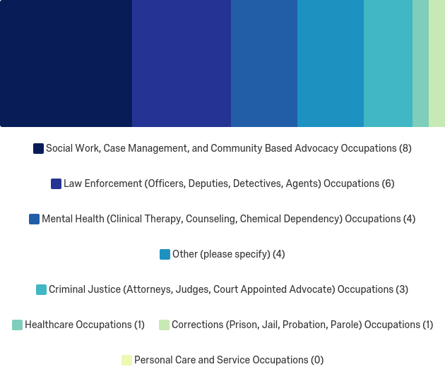
The four answers provided in the “other” section for Q1 were: an individual who identified as both Law Enforcement and Corrections, house manager, public service, and a veteran employment case manager.
Q2- What types of service does your agency provide? Check all that apply.
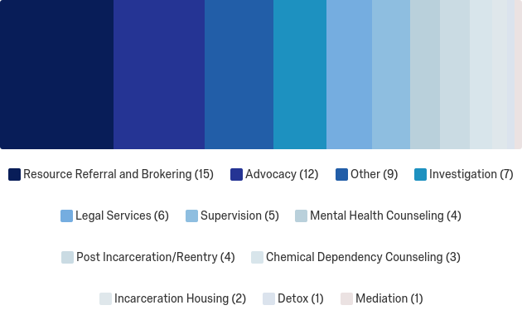
There was a fair amount of diversity among the respondents regarding both their occupation and their agencies service provision. Answers provided in the ‘other’ section for this question were: Resource and referral, case management, temporary housing, transitional housing, shelter, employment training and assistance, life skills training, emergency shelter, public services, housing and food insecurity, traffic enforcement, emergency response.
Q3 – Are you a veteran?

Q4 – Are you aware of any coworkers who are veterans?
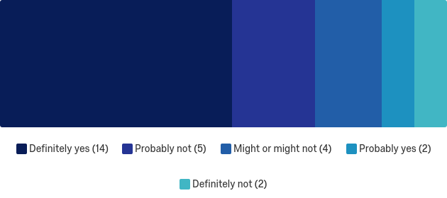
More than half of respondents indicated that they are aware of veteran coworkers.
Q5 – How often do you come into contact with veterans through your occupation?
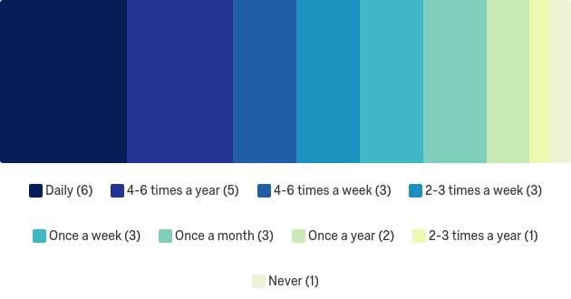
The majority of respondents had contact with veterans through their occupation, at least once per week.
Q6 – Are veterans on your caseload involved in criminal justice?

Nearly 30% of respondents indicated that veterans that they have on their caseload are criminal justice involved, and just over 40% said they were unsure.
Q6a – If yes, approximately what percentage of those veterans on your caseload are involved in criminal justice?
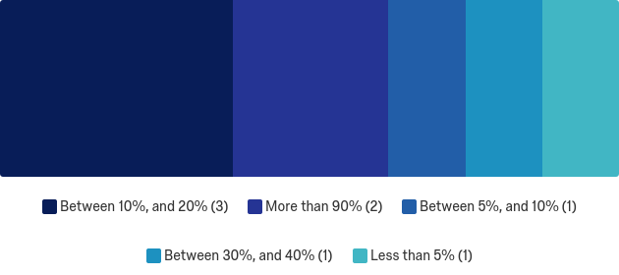
Of those who answered yes to Question 6, 75% indicated that at least 10% of the veterans on their caseload were criminal justice involved.
Q7 – How often do you work with veterans who have been or are currently involved with the criminal justice system?
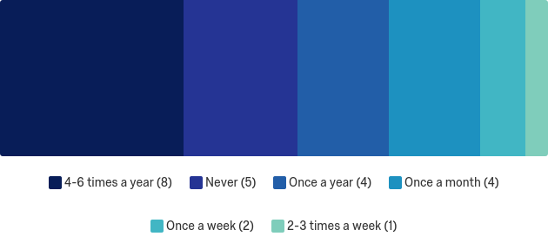
The majority respondents have in the past, or currently are working with vets who have criminal justice involvement. 29.27% work with criminal justice involved vets at least once per month.
Q8 – What type of contact have your veteran clients had with the criminal justice system? Check all that apply.
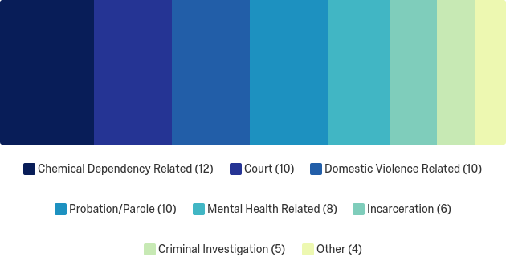
Answers provided in the “other” section were: victims of crime, none, sexual assault, and traffic crimes.
Q9 – In your opinion, has the veterans military or combat experience contributed to the crime?
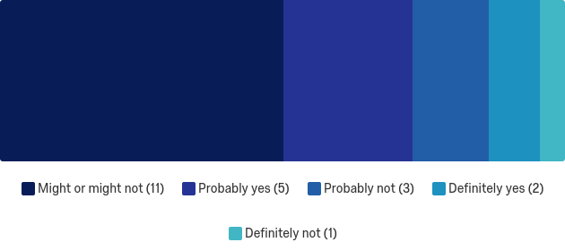
81.82% of respondents felt that the veteran’s service experience was, or may be a contributor to the crime.
Q10 – Of the veterans on your caseload, approximately what percentage have been diagnosed with a service related condition i.e. Post-Traumatic Stress Disorder (PTSD, Traumatic Brain Injury (TBI), or other service related mental health diagnosis?
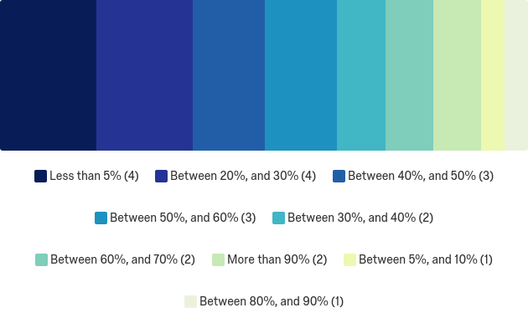
77.28% of respondents indicated that at least 20% of the veterans on their caseload have a service related mental health diagnosis.
Q11 – Does your agency or organization have a protocol for identifying veteran clients?

54.17% of respondents indicated that their agency has a protocol for identifying veteran clients.
Q12 – If no, are there other means by which veterans are identified?
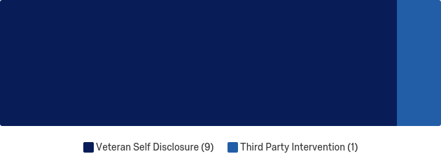
90% of respondents said that their agency relies on veteran self-disclosure for identification.
Q11b – If yes, when are veterans most often identified by your agency?

First contact or Intake was chosen by 92.31% of respondents.
Q12 – If a client is identified as a veteran, does your agency work with the VA to assist the client?
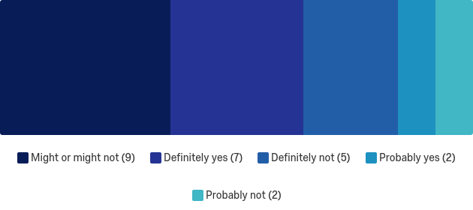
36% of respondents said that their agency was likely to work with the VA. An additional 36% said that they might or might not, with 20% responding that they definitely do not work with the VA to assist clients.
Q13 - What is your agencies level of involvement with other agencies which provide services to the veteran population?
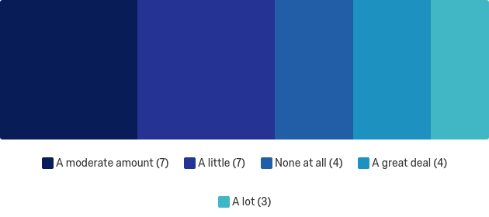
56% of respondents indicated at least a moderate amount of involvement with other agencies who serve the veteran population.
Q14 – How familiar are you with the history and purpose of Veterans Treatment Courts?
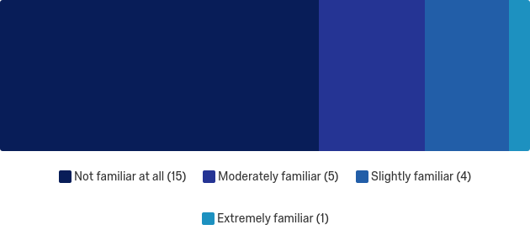
60% of respondents said that they were not familiar at all with VTC’s, an additional 36% said that they were either slightly or moderately familiar, and 4% responded that they were extremely familiar.
Q15 – Do you believe that there is a significant enough local population of criminal justice involved veterans to warrant the consideration of a Veterans Treatment Court?
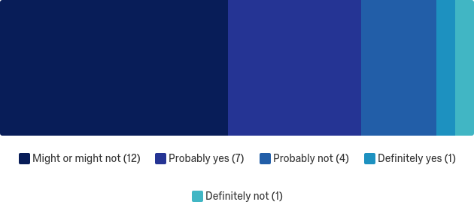
48% of respondents felt that there might or might not be enough local population, with an additional 32% saying either probably yes, or definitely yes. 20% of respondents said either probably not, or definitely not.
Q16 – What barriers would you anticipate in the development and implementation of a Veterans Treatment Court in Douglas County, WI.
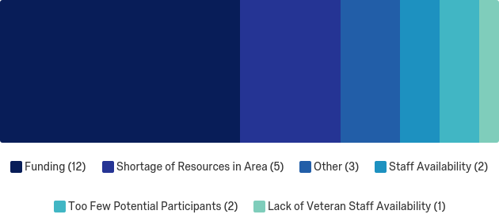
48% indicated funding to be a potential barrier, with shortage of area resources coming in second at 20%, staff availability and too few potential participants both being indicated at 8%, and lack of veteran staff availability being 4%. In addition, there was one respondent who wrote in the ‘other’ field that there was not enough information to answer, and two responded with “all of the above”.
Due to the emphasis on service member involvement in the interdisciplinary VTC team, a cross tabulation was created in Qualtrics examining the relationship between Question 1, regarding occupation, to Questions 3 and 4 which identified occupation with veteran status and knowledge of veteran coworkers.
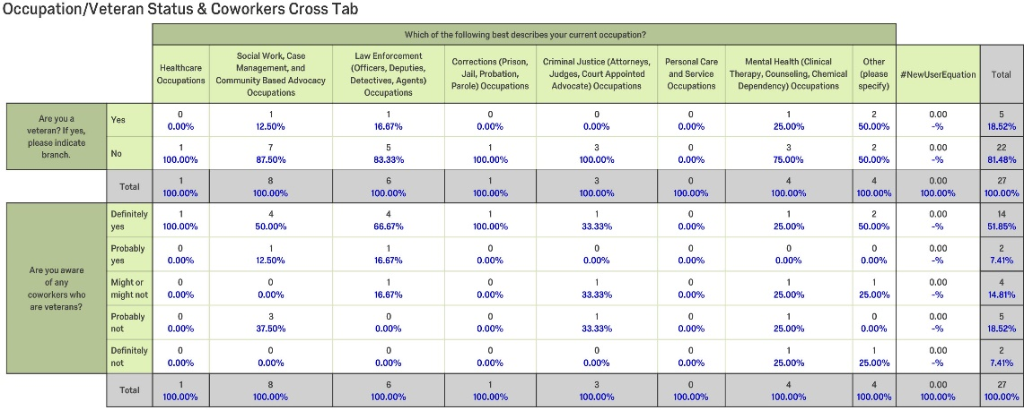
This indicates that there is at least one veteran on staff at each of the agencies who are represented. An important component of VTC’s is the veteran mentorship. The presence of veterans in these agencies will be important if development of a VTC is pursued.
With a high percentage of respondents indicating that they have an agency protocol for identifying veteran clients (Question 11), a cross tabulation was made to examine the relationship between Question 11, the ‘yes’ contingency question 11b, when are veterans most often identified by your agency, and Question 12, inquiring about whether the agency works with the VA to assist identified veteran clients. This was done to determine how frequently those agencies who are already following best practices, by having a protocol for identifying veterans, are taking the next step for veteran clients by working with the VA.
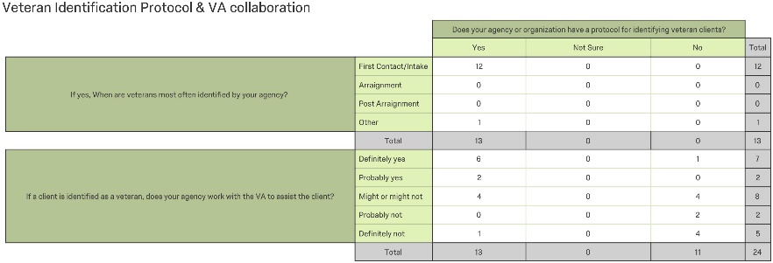
Of those who stated that they have a protocol for identifying veterans and do so at first contact or intake, only half said that they will definitely work with the VA to assist the client, following this identification. This identifies an area that could use improvement, even if a VTC is not pursued.
Discussion
This data supported the hypothesis that a need exists in Douglas County WI, that would justify the development of a Veterans Treatment Court. The reported frequency of criminal justice involved veterans who have a service related mental health diagnosis, indicates that there is a population of veterans who could be eligible for this type of diversionary court docket. In addition, the majority of respondents indicated that among the veterans they work with whom are criminal justice system involved, service experience is suspected as a contributor to their crime. Finally, the data indicates that at present there is a low level of interagency, and VA involvement with identified veteran clients. Thus, it is concluded that these three things support the need of the veteran community for a specialized docket that will assist them in overcoming their service related mental health challenges, and help restore them to be contributing community members.
Given the small sampling size, it should be noted that the data points are too few to draw true statistical analysis upon. However, since this is a needs assessment, this researcher feels that there is ample data to satisfy the purpose of this project, and to subsequently draw conclusions regarding the needs of the criminal justice involved veterans in Douglas County, WI.
There are several strengths worth highlighting in this data. Prior to the last decade very few agencies in the country had any sort of system or protocol for identifying veteran clients (Moses, 2009). Thus, it is a definite strength that despite there not being a formal VTC, the majority of the respondents identified their agency protocol for identifying veterans to be taking place at first contact/intake, which happens to be the best practice recommendation (Moses, 2009). In addition, that so many participants could provide an estimate for how many veterans they work with whom have a service related diagnosis indicates that the staff or agency has some level of awareness regarding the challenges that veterans face. Finally, the data shows that in the majority of cases, if a client is identified as a veteran, agencies work with the VA to assist the client. Not only do these findings indicate a heightened awareness to the unique needs of veteran clients, it also serves as a solid foundation for which a formal VTC could begin to be built.
The survey data also highlighted areas which could be improved upon through development of a VTC, thereby supporting the hypothesis that there is a need for development of a VTC in Douglas County, WI. For example, though more than half of the respondents stated that they have a protocol at their agency for identifying veteran clients, 46% said that they did not, and of that 46%, 90% relied on veteran self-disclosure to identify veteran clients, and 10% relied on third party intervention. Criminal justice involved veterans are not likely volunteer their veteran status. Their very involvement in the criminal justice system, stands in contrast to the place of honor their role as a service member signifies in society.
The range of occupations represented among the responses received are reflective of the diversity of the invited participants. Because there is not one occupation that dominates in this regard, it is believed that this data is free from any bias that would be present if the participants were to have occupations in common. It should also be noted that over 18% of participants self-disclosed veteran status. This is nearly double the county’s veteran population percentage which makes them overrepresented in this research in comparison to the general population.
It is the recommendation of this researcher that future studies explore what can be done to address the identified potential barriers and begin developing a multidisciplinary approach to meet the needs of criminal justice involved veterans in the community. This would enable Douglas County to be one step closer to following suit with the rest of the state of Wisconsin as well as many other states in the nation who are currently providing this resource to veterans, their families, and the community.

References
Arno, C. (2015). Proportional response: The Need for More-- and More Standardized-Veterans'
Courts. University of Michigan Journal of Law Reform, 48(4), 1039-1072.
Baldwin, J. M., & Rukus, J. (2015). Healing the wounds. Criminal Justice Policy Review, 26(2),
183-207. doi:10.1177/0887403413520002
Bales, W., & Piquero, A. (2012). Assessing the impact of imprisonment on recidivism. Journal
of Experimental Criminology, 8(1), 71-101. doi:10.1007/s11292-011-9139-3
Cartwright, T. (2011). "To care for him who shall have borne the battle": The recent
development of veterans treatment courts in America. Stanford Law & Policy Review, 22(1), 295-316.
Coker, K., & Rosenheck, R. (2014). Race and Incarceration in an Aging Cohort of Vietnam
Veterans in Treatment for Post-traumatic Stress Disorder (PTSD). Psychiatric
Quarterly, 85(1), 79-89.
Peters, G., & Woolley, J. (n.d.). Franklin D. Roosevelt: Statement on Signing the G.I. Bill. - June
22, 1944. Retrieved July 27, 2017, from http://www.presidency.ucsb.edu/ws/?pid=16525.
Frederick, A. (2013). Veterans Treatment Courts: Analysis and Recommendations. Law &
Psychology Review, 38, 211-230.
Green, B. (2011). Criminal justice - What's Ahead? Roadblocks and New Directions. Criminal
Justice, 25(4), 1-64.
Hoyt, T., Wray, A. M., & Rielage, J. K. (2014). Preliminary Investigation of the Roles of
Military Background and Posttraumatic Stress Symptoms in Frequency and Recidivism of Intimate Partner Violence Perpetration Among Court-referred Men. Journal of Interpersonal Violence, 29(6), 1094-1110.
Knudsen, K. J., & Wingenfeld, S. (2016). A specialized treatment court for veterans with trauma
exposure: Implications for the field. Community Mental Health Journal, 52(2), 127-135.
Moses, M. C. (2009). Do Ask, Do Tell: An Examination of Veterans Behind Bars. Corrections
Compendium, 34(4), 9-12.
Tsai, J., Rosenheck, R. A., Kasprow, W. J., & McGuire, J. F. (2013). Risk of incarceration and
other characteristics of Iraq and Afghanistan era veterans in state and federal prisons. Ps, 64(1), 36-43. doi:10.1176/appi.ps.201200188
QuickFacts. (n. d.). Retrieved June 26, 2017, from
https://www.census.gov/quickfacts/table/PST045216/55031

