A Cure for What Ails You:
Advertising and Labeling of Patent Medicine Before and After 1906

Hayden Yokes

HIST 489: Research Seminar

Spring 2017

Copyright for this work is owned by the author. This digital version is published by McIntyre Library, University of Wisconsin - Eau Claire with the consent of the author.
Contents

Table of Figures iii

Abstract iv
Introduction 1

Part I. The World of Patent Medicine
Historiography 3

Part II. A Case Study on the Sale of Patent Medicine: Willson Monarch Laboratory
Company Introduction 13
Advertising of Willson Laboratory Products before 1906 16
Increased Federal Regulation 26
Violations of Federal Law 30

Conclusion 34
Today’s Patent Medicine Industry 36

Works Cited 38

Figures

1 Willson Laboratory Ode to House of Quality 14

2 Monarch Olozon ad featuring the Statue of Liberty 20

3 Willson’s Camphor and Eucalyptus Ointment label 21

4 Willson’s Monarch Laxative label 22

5 Willson’s Monarch Oil label 25

6 Willson’s Sarsaparilla label marked for revision 28

7 Willson’s Tonic for the Nerves and Vital Strength marked for revision 29

8 Willson’s Camphor and Eucalyptus Ointment Charge Sheet 33

Abstract

The American Western frontier was a dangerous place full of hazards people desperately needed to counter, and rather than turning to physicians they did not trust, they utilized patent medicine. These remedies were used across the United States, and they were promised to perform miracles for those who relied on them. As criticism of the industry increased, the government passed a series of laws controlling the manufacturing, labeling, and advertising of these drugs. This legislation eventually led to the highly controlled market in the United States today, and though these laws were intended to limit the sale of patent medicines, companies found ways to get around them and continue to sell their products.
This paper is a case study of how one Wisconsin company was forced to adapt their labeling and advertising in order to operate within the confines of changing laws. This was something all companies selling patent medicines at the time had to do, and Willson Monarch Laboratory was not unlike others in their methods to survive in the better controlled market. They had to undergo drastic change to be able to keep selling their products, and the surviving records indicate the specific ways in which their labels changed.

Introduction

After the Louisiana Purchase in 1803 and the further acquisition of territory in the West, people began migrating in order to populate this newly acquired land and find work as well as freedom. It was a dangerous journey, often one which could result in sickness, injury, or death, and the jobs people found themselves in were extremely dangerous. People faced the same old sicknesses they had moved away from as well as unfamiliar ones. Doctors moved to follow this shift in population, settling in newly formed towns to care for the people there, but they were generally distrusted and often called in too late to make a difference. Settlers instead turned to proprietary medicine, utilizing it in order to cure whatever ailed them.
People relied on patent medicines for everything. They claimed to cure every issue imaginable, both life threatening and mundane. The remedies were highly trusted, and in a time when people were either unwilling or unable to turn to doctors, these were often their only choice. These medicines were often harmful, however, containing high amounts of alcohol and hazardous opiates, but still people came crawling back for more. Testimonials and word of mouth bolstered the medicine’s reputation, and as people turned to friends and to neighbors to ask for advice seeking medical concerns, it was not uncommon to be directed towards patent medicines rather than to physicians.
Despite the public’s heavy reliance on patent medication, manufacturers faced scorn, and as these criticisms increased, so did legislation controlling the sale, manufacture, and advertising of these products. After the passage of major legislation such as the Pure Food and Drugs Act of 1906, signed into law by President Theodore Roosevelt, companies had to adapt in order to operate within the confines of the law and change not only their marketing strategies but also the products themselves. Eventually, as restrictions grew tighter and the government closed its iron fist around the medicine industry, patent medicines faded into history, although their influences still live on in advertising and the products sold today. Despite the harsh restrictions, though, several decades of federal legislation that regulated drugs did not stop companies from selling quack medicine.

I. The World of Patent Medicine

Historiography
In a dangerous time of migrating people and unfamiliar work, ailments and injuries alike were not something settlers were strangers to. These plaguing wounds and sicknesses were something that required treatment. With doctors either unavailable or untrusted, people turned to other remedies. One such method was through the use of patent medicines. Patent medicines were one popular treatment used all across the United States and elsewhere in the world in order to cure a wide variety of ailments, including things like major diseases or headaches. This was a highly competitive market, but the passage of several laws after 1906 which called for increased control of medicines eventually caused the industry to die out almost entirely. The passage of the 1906 Pure Food and Drugs Act and the following legislation required companies to prove their products were safe and effective, and these regulations demanded that manufacturers change their advertising and marketing methods.
Living in the American West was dangerous, and doctors were not always able to help deal with these hazards. Though the West was not always cowboys and gunfighters as often displayed in popular culture, the work was hazardous and medicine was not nearly as advanced as it is in modern times. It was a land of vigor and a place where drought, malnutrition, and poor sanitation caused injury and epidemics alike. The settlers found themselves dealing with chronic and acute disease, epidemics, infant mortality, and accidents in several occupations such as mining and farming. There were little or no resources available for mental health concerns, and people had to deal with these issues on their own. It was not uncommon to face yellow fever, cholera, typhoid, pneumonia, tuberculosis, dysentery, and sexually transmitted infections. Drug addiction was also a new issue to be faced, and not many doctors seemed to know how to help. Settlers faced an overwhelming number of medical concerns, and they eagerly demanded treatment for these issues.
Doctors moved west in order to meet the demands of the shifting population, but still they were unprepared to handle many of the issues they faced there. Many of their treatments were ineffective against the problems these people dealt with. The Civil War had given doctors a place to practice, but their abilities to aid the pioneers on the frontier were limited. They had to travel on horseback to reach their patients and were often called in too late to actually assist, subsequently being blamed for their death. They had to be prepared to think on their feet, and they were often unable to perform surgery due to unsanitary conditions. They had a reputation of using ‘heroic’ methods in which doctors would turn to purging and bleeding, and many people did not want to subject themselves to this. People instead turned to proprietary medicines which promised instead a quick, cheap, and painless remedy for good health.
Instead of relying on physicians, people used patent medicine. These drugs got their name from England where they received the king’s crest on their bottles, and though they did not actually hold a legal patent, it was this crest which inspired the term. Patent medicines were increasingly advertised, and these ads promising cures to whatever may ail you drew people of all walks of life in, and settlers all the way from California to Wisconsin used them. These products, dubbed snake oil, cure all, nostrums, and a wide variety of other names, all promised the same general thing – to cure a huge number of issues. They were a trusted source of medicine, and miners and mothers alike would utilize them in order to help themselves and their families. Though they were often a concoction of opiates and alcohol, their claims drew people in, and until the passage of federal laws which restricted the ways they were produced and advertised clamped down on the industry, it was a highly lucrative market in which the common man could fashion a recipe for success by curing whatever ailments a person faced with a clever blend of the ingredients of his choice. Doctors struggled to show that they were better than these methods, and they found it extraordinarily difficult to compete with proprietary medicine.
Before government regulation clamped down on how products were sold, the market of snake oil was entirely unregulated and highly competitive, hitting its peak from 1880 to 1910. The penny press and mass printing of newspapers allowed for ease of advertising, and patent medicine was being distributed to soldiers during the Civil War. People had new concerns about health, hygiene, and disease, and patent medicines were a perfect craft to offer some peace of mind for these worries when they had the time to think about them after the war. Patent medicine manufacturers also played into consumer culture in order to push their products. Women had incredible difficulty finding practical care for their medical needs. Doctors would avert their eyes when examining them, and their medical concerns were often blamed on gynecological causes. When this care came to be hard to find, women turned instead to patent medicines which were catered to suit their specific needs. These products were also often branded with exotic names, and though this may have just been because these names were easier to remember, it could also have been a clever strategy to appeal to immigrants in the United States. This competitive market had many ways of catering to the public’s demands, and they cleverly advertised their products in order to get people to purchase them.
Medicine men had numerous ways to advertise their products to the public. They could hand out pamphlets utilizing testimonials and lists of everything their drugs could aid with, and they could hold public displays of what exactly their product was capable of. Advertisements could include wild tales of how the product assisted those who used it, or they could make use of “doctors” and their testimonials of how it helped their patients. Depending on the size of the company, they could hold street pitches sharing their products, or they could also put on extravagant medicine shows. During medicine shows, wild displays during which the products were advertised and tested, medicine men would often erect tents and include things like shooting demonstrations, Indians, circus acts, and bands. It was a dramatic display which involved telling people what they wanted to hear and entertaining them to get them to buy the products advertised. These shows typically did not stay long in the towns they came to, moving onto the next quickly to peddle their goods there. Medicine men also knew to use a variety of tactics in order to get people to purchase their goods. One was by claiming the quantity was limited or by saying they were almost sold out, stirring up a frenzy of desperate people hoping to get their hands on a limited item. Another was by using the ‘tapeworm’ tactic. This involved convincing people they had a tapeworm or something similar by listing off things like sleeplessness and an appetite which had the public matching these up to their own behavior. By offering a product to cure them of this tapeworm just in case they had one, they could draw people into purchasing a product out of fear. Advertising was a carefully orchestrated art, and it was one which patent medicine salesmen perfected.
Wild and extensive claims had originally been expanded from the simple promises a product made in early Colonial advertisements. These claims were tailored to prey on people and exaggerate their fears of suffering from a disease, which, of course, these companies had a cure for. Many people believed that an effective way to rid themselves of disease was to literally empty their bodies of its contents, and patent medicines catered to this belief, containing powerful cathartics and emetics which would cause a person to vomit and purge their bowels. Patent medicines promised the outlandish and the mundane, to cure a person of life threatening illnesses and minor headaches. They would often list a huge number of ailments which a person could be suffering from, and this one product promised to cure them all. Often the dosage would be at the discretion of the user. Instructions would be vague or direct a person to just use more of the product if it did not work. There often were no differences between recommended uses for children and adults either, and some products also claimed to work wonders on humans, animals, or even in the home. The claims these remedies made were sweeping and their directions vague, and they often promised to work as a miracle treatment which could cure a person of anything and everything.
Although the market of patent medicines was one which was highly trusted and constantly utilized by the common man, it faced criticism. With the rise in advertising and in movements against things like alcohol, patent medicines came under scrutiny as well. These criticisms were highly published, and these reproaches eventually helped to spark enough concern for the government to pass a series of laws controlling the marketing and manufacture of medicine.
The business of muckraking was born with advertising, and as more people were pushing their drugs and pumping out ads, newspapers were criticizing the use of patent medicines. They presented the potential harmful effects of consuming these remedies and exposed their salesmen for the truth of what they were doing. Medicine men were accused of pushing poison on the gullible public. Muckraking came a step before the government intervened in the medicine industry, and it assisted in adding fuel to the fire of controlling patent medicines.
Currently, federal law requires that a drug must be shown to be both safe and effective in order to be sold on the market. Prior to 1906, there were few such laws regulating the sale, manufacturing, or advertisement of these drugs, however. This allowed for a huge market in which unsafe and ineffective patent medicine was able to be sold to the public. Prior to the passing of FDA legislation, medicine men were able to concoct any sort of drug and market it as able to perform miracles and cure any ailment. It is estimated that this industry was worth $1.4 billion in 1998 dollars with about 50,000 patent medicines being manufactured and sold in the United States. Medicines were able to be sold through colorful testimony and reputation, rather than through the government and its scrutiny. This allowed a company to build a trusted reputation for the effectiveness of their products, and things like snake oil could be sought out because of the reputation of the manufacturer or word of mouth about its results. Patent medicine was a huge industry that was built largely on reputation.
Before the federal government intervened with major laws, there were a few small scale legislative acts passed which did virtually nothing to control the market. In 1836, if a company desired to patent their medicine, they had to prove the ingredients used were not harmful, but this only dissuaded people from seeking patents. This was not restrictive enough, but it was a major step in government regulation of drugs.
In 1906, the Pure Food and Drugs Act required that product labels be truthful and that any statement made about the medicine itself or its ingredients could not be false or misleading in any way. This had a massive impact on changing the way patent medicines were sold, as they no longer could be labeled as a cure all or list countless ailments which it could solve if these claims were indeed false. This limited manufacturers greatly in the ways which they advertised and labelled their products. Although they did not have to prove their statements before the product was sold and the burden of proof was on the government after it was already on the market, they had to advertise and label their products in ways which would not get it removed for the government to evaluate. These restrictions only grew tighter with the passage of the 1911 Sherley amendment which required that medicine could not be labeled with any false therapeutic claims after the Supreme Court ruled that the 1906 legislation only restricted falsely labeling ingredients. In 1938, Congress passed the Food, Drug, and Cosmetic Act. This required companies to list all active ingredients, make only claims that they could support, and reveal all relevant information about their product. Companies were supposed to refrain from producing products to deal with any life-threatening diseases. Medical devices that had been previously used in medicine shows were also regulated. They were also required to give directions for use of the product as well as list warnings about its potential dangers. When finally the effectiveness of a product had to be proven before it was marketed in 1962 with the passage of the Kefauver-Harris Drug Amendments, and products had to be shown to be both safe and effective before ever being allowed on the market, the industry of patent medicine suffered a great blow which drastically impacted how they were able to sell, manufacture, and market their products within the confines of the law. Drugs could no longer be sold simply on the basis of the placebo effect, something which many patent medicines had relied on. Despite these regulations, however, companies were still able to find ways to sell their patent medicines. These laws were intended to protect the consumer from harmful products, although they did not have a huge impact on the industry of patent medicine initially.
If after government scrutiny products were still allowed to be on the market, they had to go through rigorous relabeling in order to be sold. Their new labels had to advertise the presence and amount of dangerous drugs. As a general rule, it was advised that manufacturers avoid using the word ‘cure’ on their labels because it could be easily flagged for government intervention because of the implications the word ‘cure’ had; if the product did not entirely eradicate whatever it claimed to fix, it was considered misbranded. They had to be far more specific in their directions and what the product really could treat, and certain phrasing like ‘due to exposure’ or ‘lame’ in reference to humans had to be cut out. Many products had to be entirely rebranded to avoid being flagged as false or misleading.
Prior to 1906 and the legislation’s increased control on the manufacture and sale of medicines, the patent medicine industry was one brimming with products which claimed to cure everything from headaches to major illnesses. It was a flourishing business in which one could produce dangerous drugs and market them to the vulnerable public, selling them with false claims and brilliant testimonial. After the passage of increasingly restrictive legislation, however, in order to continue to operate under the law, these drugs had to go through both safety and effectiveness testing. This meant numerous ingredients were banned from use, and it also meant that many of the snake oil remedies which people had trusted and relied on for years were taken off the market because of safety concerns, their results came from a placebo effect, or the concoction of ingredients simply did not have any significant impact on health. The products which were still able to be sold had to be relabeled and remarketed. The lucrative market, which allowed for the common man to manufacture his own medicines and sell them to anyone who would believe his claims was drastically cut back, and with increasing regulation, it became only more restricted as the industry morphed into the highly controlled one it is today.
The patent industry medicine was one which was highly profitable, but it was also filled with people who would not hesitate to throw harmful ingredients into their products. Many of these drugs contained dangerous ingredients, but these companies relied on testimony and their sterling reputations to sell their products. In a time when many people turned away from traditional medicine in favor of home remedies and snake oil treatments, medicine men were ready to peddle their products to the American public. These treatments were widely used to treat a huge variety of ailments, from life-threatening diseases to minor aches and pains. This industry, however, faced criticism and concern which eventually resulted in controlling its marketing and manufacture. These acts which required drugs to be proven to be both safe and effective before being marketed greatly impacted the industry caused a sharp decline in sales due to the restrictions. Despite these laws, there were still companies able to skate beneath them in order to continue selling their products to the public.

II. A Case Study on the Sale of Patent Medicine: Willson Monarch Laboratory
Company Introduction
Willson Monarch Laboratory was a company based in Edgerton, Wisconsin. This company was also known as Willson Monarch Laboratories, Willson Brothers, Monarch Laboratory, and Willson’s Monarch Laboratory. It was founded by Dexter I. and Benjamin C. Willson. It operated from 1882 until it was liquidated in 1958. It was then transferred to Otto Bartz in 1960 and stopped operating at some point before 1970. They manufactured and sold a variety of products to the public out of a pharmaceutical shop, including food products, cosmetics, stock and poultry minerals, and patent medicines.
The company operated mainly on going door to door in order to sell their products in the Midwest. Although a branch store opened in Milwaukee in 1932, it was not profitable and was closed in 1936. They taught their salesmen which products they had available for sale and what they were capable of doing, and they were well prepared to go out to speak with potential clients. With them they carried a briefcase containing samples of their products, presumably to hand out to let people test them for themselves before committing to purchasing the full size.
Monarch Laboratory also went through various changes of hand. In 1927, Benjamin Willson’s daughter Maybelle Willson Shearer became the president. In 1946, Dr. F. E. Shearer, Maybelle’s husband, became the president. He bought all of the Monarch interests and continued to operate his medical clinic in the same building as the laboratory.
The company promised quality for all their products, even adopting the phrase “house of quality” to describe themselves. They promised that “the drugs have to pass through the Chemist’s hands and be pronounced pure” before being sold and that they would all be “inspected and tested for quality”. They built their trusted reputation not only on how long their company had been operating but also on this promise for quality. This was only bolstered by the reputation their products had, and as people learned to trust what they produced, sales increased and their company was able to grow.
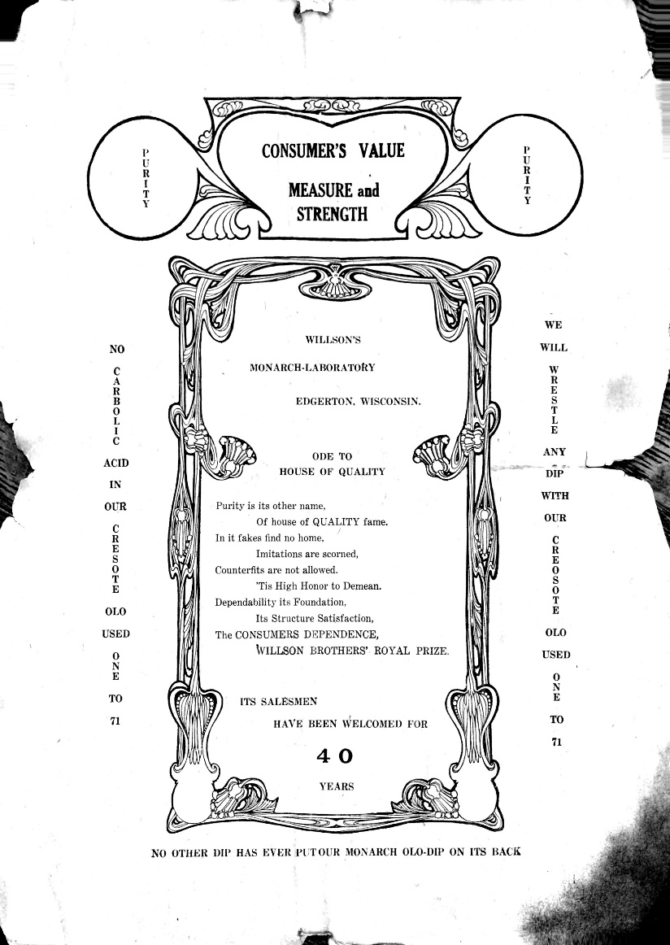
The Laboratory building suffered from a fire the morning of August 3rd, 1928, but the damages were largely covered by insurance. Many of the early records were lost, however, and not much is known about the company’s early history because of this. They had a positive enough relationship with their customers that they were able to ask that any surplus goods they would not be using within the few days following the fire to be returned to the company so they could ship it to those who had been expecting the goods. Not only does this point to the way they did business, ensuring everyone had the products they needed when they needed them, but it also suggests they had a positive relationship with those who purchased their goods. Willson Monarch Laboratories was accommodating and able to adapt to issues that arose, both minor and major.
Figure 1. Willson Laboratory Ode to House of Quality. Source: Willson Monarch Laboratory Records, 1889-1966, Box 7, Folder 5.
The workers at Willson Laboratory seemed to have a shared sense of community among them. The Monarch News was a paper that was mailed out to people in multiple states. It was “news from the field and from the factory”, and in these papers, the writers covered everything from how certain salesmen were doing to information about the company, and they even included illustrations. This paper operated at least from November 14, 1928 to July 14, 1933. The Weekly Punch was also published as a follow up to The Monarch News, and it included product information, updates on how sales were going, and general tips on sales. It also included deals on products on occasion. It was printed from July 21, 1933 through July 19, 1935. These papers were meant to keep everyone involved and up to date on the company.
The Willson Laboratories was a trusted company, and their products were held in high esteem. Their customers relied on them, and the faith they had in the items they purchased can be seen in various letters they addressed to the company after using their products. One item which had been on the market since 1882 and was one of the company’s best known products was Olozon, also known as Monarch Oil. Lewis S. Borden, one of the company’s salesmen, penned one of these letters to tell the company that is was so successful that “It would almost be impossible to exaggerate the merits of Monarch Oil…” He had sold a bottle to a good friend who proclaimed he would always have one in the house. Another customer used it on abscessed gums, and their friend used it on their “lame shoulder” which it cured. Apparently it worked within fifteen minutes to diminish extreme pain from earaches, and it restored the ability for a pained child to act like a child again and return to play. The company received a multitude of letters like these, all professing the various uses they had found for Willson products. They enjoyed it enough that they felt the need to not only share it with their family and their friends but also to take the time to sit down and write a letter in order to thank the company for making it. These customers held Willson Brothers products in high esteem, and they trusted that when a problem arose, their trusty bottle of Monarch Oil or some other patent medicine would be there to solve the issue for them. In a time when people turned to patent medicines before they went to ask a doctor’s opinion, Willison Laboratories was there to offer them a variety of items they could use to solve their problems on their own at a reasonable price.
Willson Monarch Laboratories functioned both before and after restrictive government regulation. They were able to experience the highly competitive market of patent medicines which promised outlandish cures, and they also had to learn to adapt to federal legislation to continue selling their products.

Advertising of Willson Laboratory Products before 1906
Patent medicine salesmen had a variety of tactics which they could use to sell their products, and Willson Laboratory was not immune to employing these methods as well.
The Willson salesman came well equipped with a manual and weekly sales tips. When a salesman was hired, he was given a sales manual which advised him on everything from company policy to a list of every product sold. Under each listing he could read about the claims of each product, the dosage information, tips on how to sell it and what to say to get a customer to purchase the item, as well as why their products were better than the competitors. New dealers would receive weekly letters in order to get sales tips from the General Manager, and these included advice on things like how to make a sales call, how to be engaging, and general advice on how to be a good salesman and how to advance necessary skills. Salesmen knew what they were doing, and this helped greatly in moving merchandise.
One tactic which the Willson Monarch Laboratory used to push their products was the tapeworm tactic – making people suspect they had an ailment by listing off generic symptoms and providing them with the company’s product in order to cure them just in case they had it. They also stated things like “the most particular person that travels is liable at some time to get body lice”, inspiring worry among anyone reading this that they too would suffer from body lice and should pick up Willson Laboratory Monarch Oil immediately just in case. They also pointed out that “germs are everywhere” and “it will disinfect everything” if used to clean the house. They published a pamphlet which educated people on how to prevent colds and a rhyme which gave symptoms for the flu. In their tips on preventing colds, their recommendations are littered with references to their own products, and they remind the readers of which products would be good for soothing various unpleasant aspects of colds. Willson Brothers products were ready to treat any symptom, and by advising people on what they may have faced, they could get ahead of the potential ailment and be prepared with a Willson product to treat the issue if it arose.
The Willson Laboratory salesman was advised to keep an illustrated cookbook with him in his case of samples. This book was used to advertise the other products they had available for sale including those which the dealer did not have samples of. This was presumably done with other pamphlets as well, and the dealer would have distributed these to his clients for them to look through the products the Willson Monarch Laboratory had to offer. These pamphlets often contained illustrations of the product or its label, as well as listing the price and the huge number of ailments the product could cure. Coupled with clever testimony, it was a brilliant way to get customers to consider a wide range of products rather than just the ones the dealer could carry samples of.
Testimony was invaluable in the sale of Willson Laboratory products. The words of doctors were often used as well to bolster the reputation of a product, and Willson Laboratory was not shy about using this tactic. In one pamphlet, they quoted Dr. S. L. Lord as saying “’I have found it paid me to carry [Monarch Oil] in my emergency case.’” The words of a “druggist of years of experience” are used to profess how often he uses their goods to save the life of an animal when nothing else has worked. This is because “it took years of work to perfect the process to get the full value out of the drugs used” so he was unable to duplicate the products even though he knew the ingredients of them. “It is not always what drugs are used in a remedy, but it is how much Pharmaceutical knowledge is there back of the process of production.” The company had men working for them who had dedicated their lives to the production of these medicines, and this bolstered the reputation of the company. Doctors, although not always trusted, were often used in testimonials to make the product advertised seem more reliable and authentic.
Testimony came not only from physicians, but also from customers who had already used the product and could speak about its uses. One such testimony came a Willson customer who wrote a letter to the company. This customer claimed to have used it on their own abscessed teeth in order to soothe the pain of the cavities, and when the neighbor came over complaining of headaches that kept her awake and aching in her legs, the customer recommended that she use Olozon. After hearing her neighbor’s testimony of how useful the product was, the ailing woman said she would try it for herself. Occurrences like these happened often where friends would consult those around them for remedies. Before ever going to a doctor, they would ask around to see what had worked for people suffering the same sort of ailment, and customers who trusted a product would share its name and its uses with the suffering and prompt them to try it for themselves. This was one way of spreading the word of a product while also bolstering the reputation of the company. If the people using their products trusted them to work on themselves, they would spread the word on their own.
Despite knowledge of sales tactics used by the company, salesmen also trusted the products to use on their own families. James Williams relied on Olozon, a popular Willson Brothers product, to help aid his entire family for a variety of concerns. He found it useful enough to trust and utilize for the past thirty years, and claimed that “really we cant [sic] praise it to [sic] highly”. The salesmen who used his own products could share these personal experiences with the customers he was speaking to. He could gain their trust and share his own faith in his products while also telling them of the doctors who used it as well as recounting stories of satisfied customers.
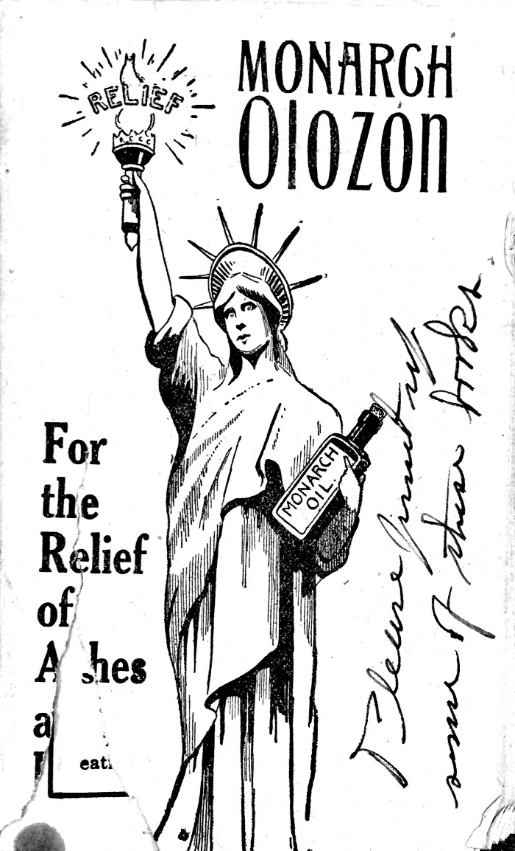
Advertising was also targeted at specific groups in order to get them to buy more of a certain product. Nationalism was invoked in order to increase sales of products to those who may have been passionate about their country who wanted to support U.S. made items. There is one image in which the Statue of Liberty can be seen holding a bottle of Monarch Oil. This held the promise that this was an all American product, and that may have been a huge motivator to purchase Willson’s cure all pain reliever over another company’s. One pamphlet for the same product was also printed in German which would have allowed a huge immigrant group to access the advertising. Especially in Wisconsin where there were large numbers of Germans coming from overseas, the Willson Laboratory advertisers were smart to market their products towards this group in particular. Willson’s Tonic for the Nerves and Vital Strength was also advertised in German, and its label could be printed in German as well for any speakers of the language to read their bottle with ease. Ads were aimed towards particular groups in order to increase the number of sales, and this was something which was common among proprietary medicine manufacturers.
Figure 2. Monarch Olozon ad featuring the Statue of Liberty. Source: Willson Monarch Laboratory Records, 1889-1966, Box 7, Folder 5.
The claims of the Willson Monarch Laboratory products were not unlike those made by countless other patent medicines of the time. They were often vague and sweeping, covering every degree of severity of a disease or proclaiming a product could be used on humans, animals, and even for household cleaning. The directions were often unclear as well, allowing for the freedom of self dosage which people were seeking at the time. Treatment was to be repeated as often as necessary and the dosage determined “according to age”. It was shown to be able to used “by people in all walks of life”; it was not only bachelors or men in dangerous working conditions who could use a product, but rather mothers and doctors as well.
Products were often advertised as something which could perform miracles, and it was not uncommon that they claimed to save lives. Willson Monarch Laboratory products were proponents of this: “Many times a horse or cow has been saved when everything else failed, simply because a package of Willson’s goods always has virtue and does the work”. There was another tale of a hog which was unable to stand or eat, and when the farmer received the recommendation to get it to drink Monarch Oil and followed through with this, the hog was back on its feet overnight and the farmer no longer would be forced to kill the hog.
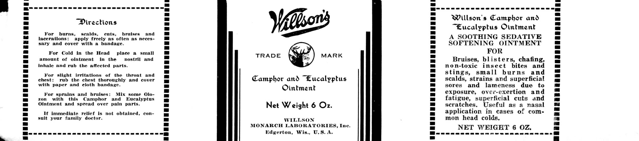
One product carried by Willson Monarch Laboratory was Willson’s Camphor and Eucalyptus Ointment. It promised relief for everything from bruises and blisters to lameness due to exposure and even fatigue or common colds. This salve could be applied “freely as often as necessary” or rubbed and “spread over pain parts”, although it was advised that if pain persisted one should see a physician. The claims were broad and the directions vague, something which was commonplace among proprietary medicine.
Figure 3. Willson’s Camphor and Eucalyptus Ointment label. Source: Willson Monarch Laboratory Records, 1889-1966, Box 31, Folder 7.

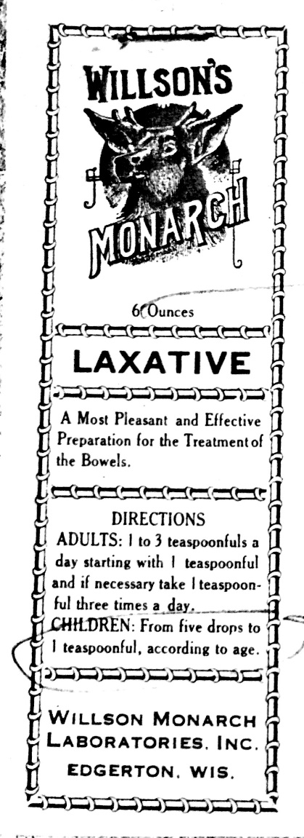
Willson’s Monarch Laxative was advertised in a similar way. While it was not sold as a cure all, the things which it did promise to treat were unclear, simply marketed as a treatment of the bowels. Though labeling it a laxative did give a clearer idea of what it should do for the body, it did not state clearly anywhere on the label exactly what the results should have been on the bowels after treatment besides that it was “pleasant and effective”. The directions for dosage do not seem to make much sense, and the instructions for children offer little help whatsoever for a parent looking to give their child this laxative. They could give a child any amount within the range listed “according to age”. This freedom, however dangerous it could turn out to be if the person took too much, allowed those who wished to medicate themselves to determine their own dosage to suit their needs. While the amount included is listed on the label, there is no indication of what ingredients may have been in the product, something which was common before legislation was passed requiring it. This is one example of common elements in patent medicine labels found in a Willson Monarch Laboratory product.
Willson’s Monarch Oil, later called Olozon, was the product which got the company started in 1882, and it was branded as a cure all and a pain reliever. Olozon was able to be used for animals, on people, and as a household cleaner. It was advertised as “The Only Reliable Antiseptic”, and it was a hugely popular product. It could be used both internally and externally, and it was so easy to use it would be impossible to go wrong with it. It was “absolutely free from poison to man and beast”, promoted health, and furthermore it was perfectly prepared, the ingredients “perfectly assimilated”. It was also “the most economical as well as the most efficient article of its kind”. It claimed it could kill “all kinds of animal and vegetable parasites”, and it could even “absorb the deadly gases and their dangers, as well as the offensiveness” of any musty or damp area. Olozon could be sprayed on trees and shrubs to drive away moths and spiders as well as kill weeds in grass. It could be used to treat injuries in animals like nails in hoofs as well as any severity of wound that a human may have sustained ranging from cuts, bruises, and wounds. It could be used to clean the house and to disinfect telephones as well as treat bee stings. The directions were often vague with instructions like use “as often as necessary”, and to saturate a cloth with it or mix up a 1 to 100 solution of Monarch Oil. They promised that “the United States agricultural department has made many tests and proves the above to be true”, something which was entirely false and had to be removed later on with the passage of restrictive legislation. They claimed that “Monarch oil does not simply relieve, but effects more permanent cures than any other similar remedy. All the leading doctors indorse [sic] it.”
Figure 4. Willson’s Monarch Laxative label. Source: Willson Monarch Laboratory Records, 1889-1966, Box 31, Folder 5.
Olozon was also branded using other methods over time. It was advertised as an instant relief, but furthermore it promised to cure a variety of ailments ranging from a simple headache to diphtheria. This list apparently was too long for the label, though, and instead of naming everything this product would cure, it just said “etc.” as the final item in the long list of its abilities. It was for “pains of all description”. Monarch Oil was displayed to be only one dollar on the label, something which stayed consistent through the years it was sold. Not only did it promise relief within ten minutes, but it guaranteed it. These promises were commonplace among patent medicines, but this label in particular is unique because of the fine print. Willson Monarch Laboratory offered warnings of sort by advising their consumers that the medicine should be taken only according to the directions inside. They also boasted that their pain reliever did not contain any poison, something which implied other companies may have had it in their products. This may have not only driven away sales from other companies for their similar cure all pain relieving tonics, but it would have given people a sense of security and trust in Monarch Oil. They knew it would not bring them harm, and it would help to relieve any pain they may have had. While the advertising of Olozon evolved over time, before restrictive legislation was passed, it was always branded as a sort of cure all product, promising to solve a huge array of issues for both man and beast.
The Willson Monarch Laboratory products were not unlike others of the 19th century. They promised to solve overwhelming lists of issues, bringing relief to any ailment a person could face. Not only could they be used for the family, but they could also be used on animals and even in the household to clean. Their usage directions were often vague and allowed for self-dosage, and the company utilized a variety of sales tactics in order to get people to buy their products. Despite this, people relied on their products and they trusted them to get the job done in their time of need.

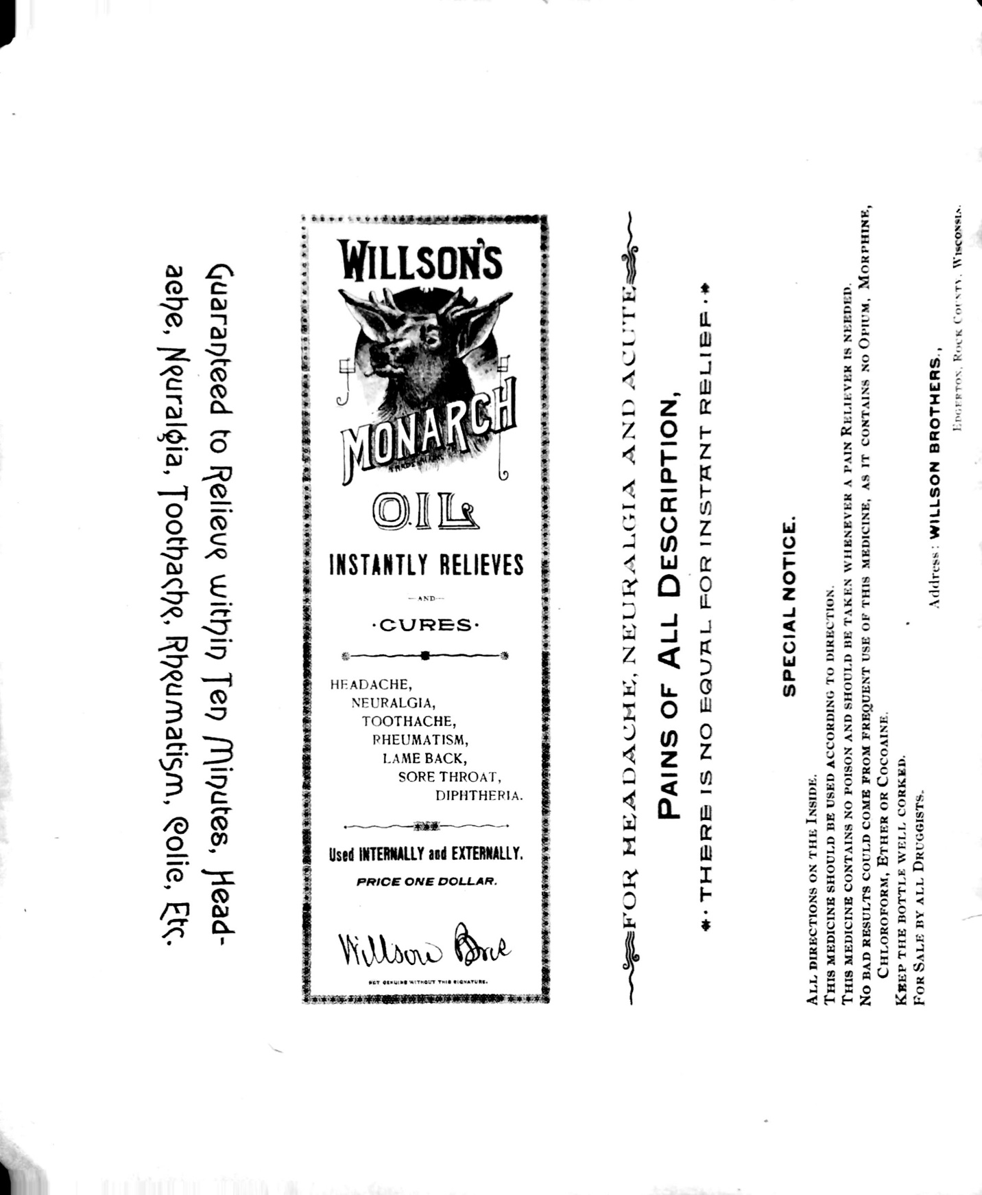
Figure 5. Willson’s Monarch Oil label. Source: Willson Monarch Laboratory Records, 1889-1966, Box 31, Folder 7.

Increased Federal Regulation
Due to public criticisms and increasing concerns about health as well as advancements in medicine, the government passed several laws controlling the advertising and labelling of patent medicine. In 1906 the regulations increased, and under the Pure Food and Drugs Act products labels had to be truthful and the statements made about the product or its ingredients could not be false or misleading. With the passage of the Sherley amendment in 1911, no false therapeutic claims could be made, and in 1938 with the approval of the Food, Drug, and Cosmetic Act companies were required to list all active ingredients, make only claims they could support, and reveal all relevant information about their product. The 1962 the Kefauver-Harris Drug Amendments required that the effectiveness of a product had to be proven before it was marketed. While previously there had been no regulation in this highly competitive market, products had to be shown to be both safe and effective before being sold, and this changed how advertising and sales were conducted.
The heads of Willson Monarch Laboratory warned their employees of the changes that may have come, advising them not to print too many labels since the laws would likely change. J.M. George warned the members that they may have to state how much of the product was contained in each package, indicated that labels may have to contain the name and address of the manufacturer, and that warning statements would be required for some ingredients. Some of these changes were soon to come as they suspected, and it was wise to limit the production of these labels as the first of these restrictive acts was signed into law only months after the publication of this bulletin on June 25, 1938.
As legislation was passed, the employees at Willson Monarch Laboratory actually used these laws to their advantage despite the difficulties in adapting to them. They promised that “Every bottle or package that comes from Monarch Laboratory is manufactured in accordance with the United States pure food requirements. Where it is possible, our goods are from ten to twenty-five percent better.” They make a point to tell customers that until this can be regulated properly, this statement means almost nothing even when it is guaranteed on the label. They also promised that “We have our pure food analytical department where we can analyze our own goods” in order to ensure quality. According to Willson Laboratory, “All pure food chemists recognize Willson’s quality to be the best, and every test they make proves it.” They used quality laws to their advantage to bolster their reputation as the “house of quality”.
The new laws forced many companies to rethink their entire marketing scheme. They had been built so long on outlandish claims and promising cures to whatever may have ailed a person, and to suddenly need to not only justify these claims but also remove some entirely was a massive shift. Willson Laboratories believed these changes came about because language changes over time, and they were ready to acknowledge that although the wording they used on their labels currently was deemed acceptable, it may not have been in the future. Every label had to be thoroughly examined by the company for any potential violations, and they combed through each word to determine what may have passed government scrutiny and what would be objected to.
Generally, it was advised that labels remove all references to physicians, especially on vitamins. The word ‘remedy’ was not able to be used, and instead it needed to be replaced with ‘medicine’ or ‘preparation’. Labels could no longer say they could treat things that had come about due to ‘exposure’, but rather had to list specific causes of an injury. They could no longer use the word ‘lameness’ or call things lame in reference to human beings, something which various Willson Monarch Laboratory products had done. Therapeutic claims had to be changed by using ‘temporary relief’ in reference to them. Vague labels had to be modified in order to have clearer directions. Advising consumers to use the product ‘according to age’ or ‘until relieved’ would no longer fly. Harmful ingredients like chloroform had to be indicated on the label, and percentages of substances like alcohol had to be stated as well. Many changes had come about, and Willson Brothers products had to change with these new requirements.
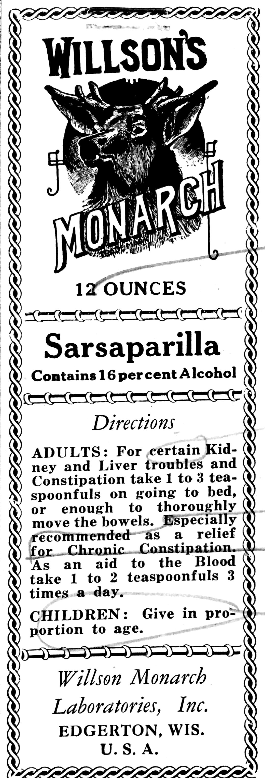
Willson’s Dyspepsia and Digestive Tablets was one product label that had to be reworked. Previously, it had promised to “correct all digestive disturbances” and destroy irritating bacteria that “retards proper digestion and assimilation”, as well as increasing the appetite and restoring “the natural processes of digestion”. These claims were too vague and potentially misleading, and they were flagged to be reworded before the government could take issue to them. Because the label also vowed that the product relieved all forms of indigestion, the claims had to be worn down to something more modest since this promise was false.
Figure 6. Willson’s Sarsaparilla label marked for revision. Willson Monarch Laboratory Records, 1889-1966, Box 31, Folder 7.
Willson’s Sarsaparilla also had to be revised. Its reference to treating “certain kidney and liver troubles” was extremely vague, and the direction to take “enough to thoroughly move the bowels” would not have gone over well with government regulation. The advice to give it to children “in proportion to age” was a direction which had to be changed on many labels, and it was necessary to revise this here as well. Vague wording had to be avoided at all costs. It did abide by the law, however, by listing how much of the product was contained in the bottle as well as clearly stating how much alcohol was in the product. Despite conforming in some key ways to the laws, the label still had to be reworked to follow all sections.
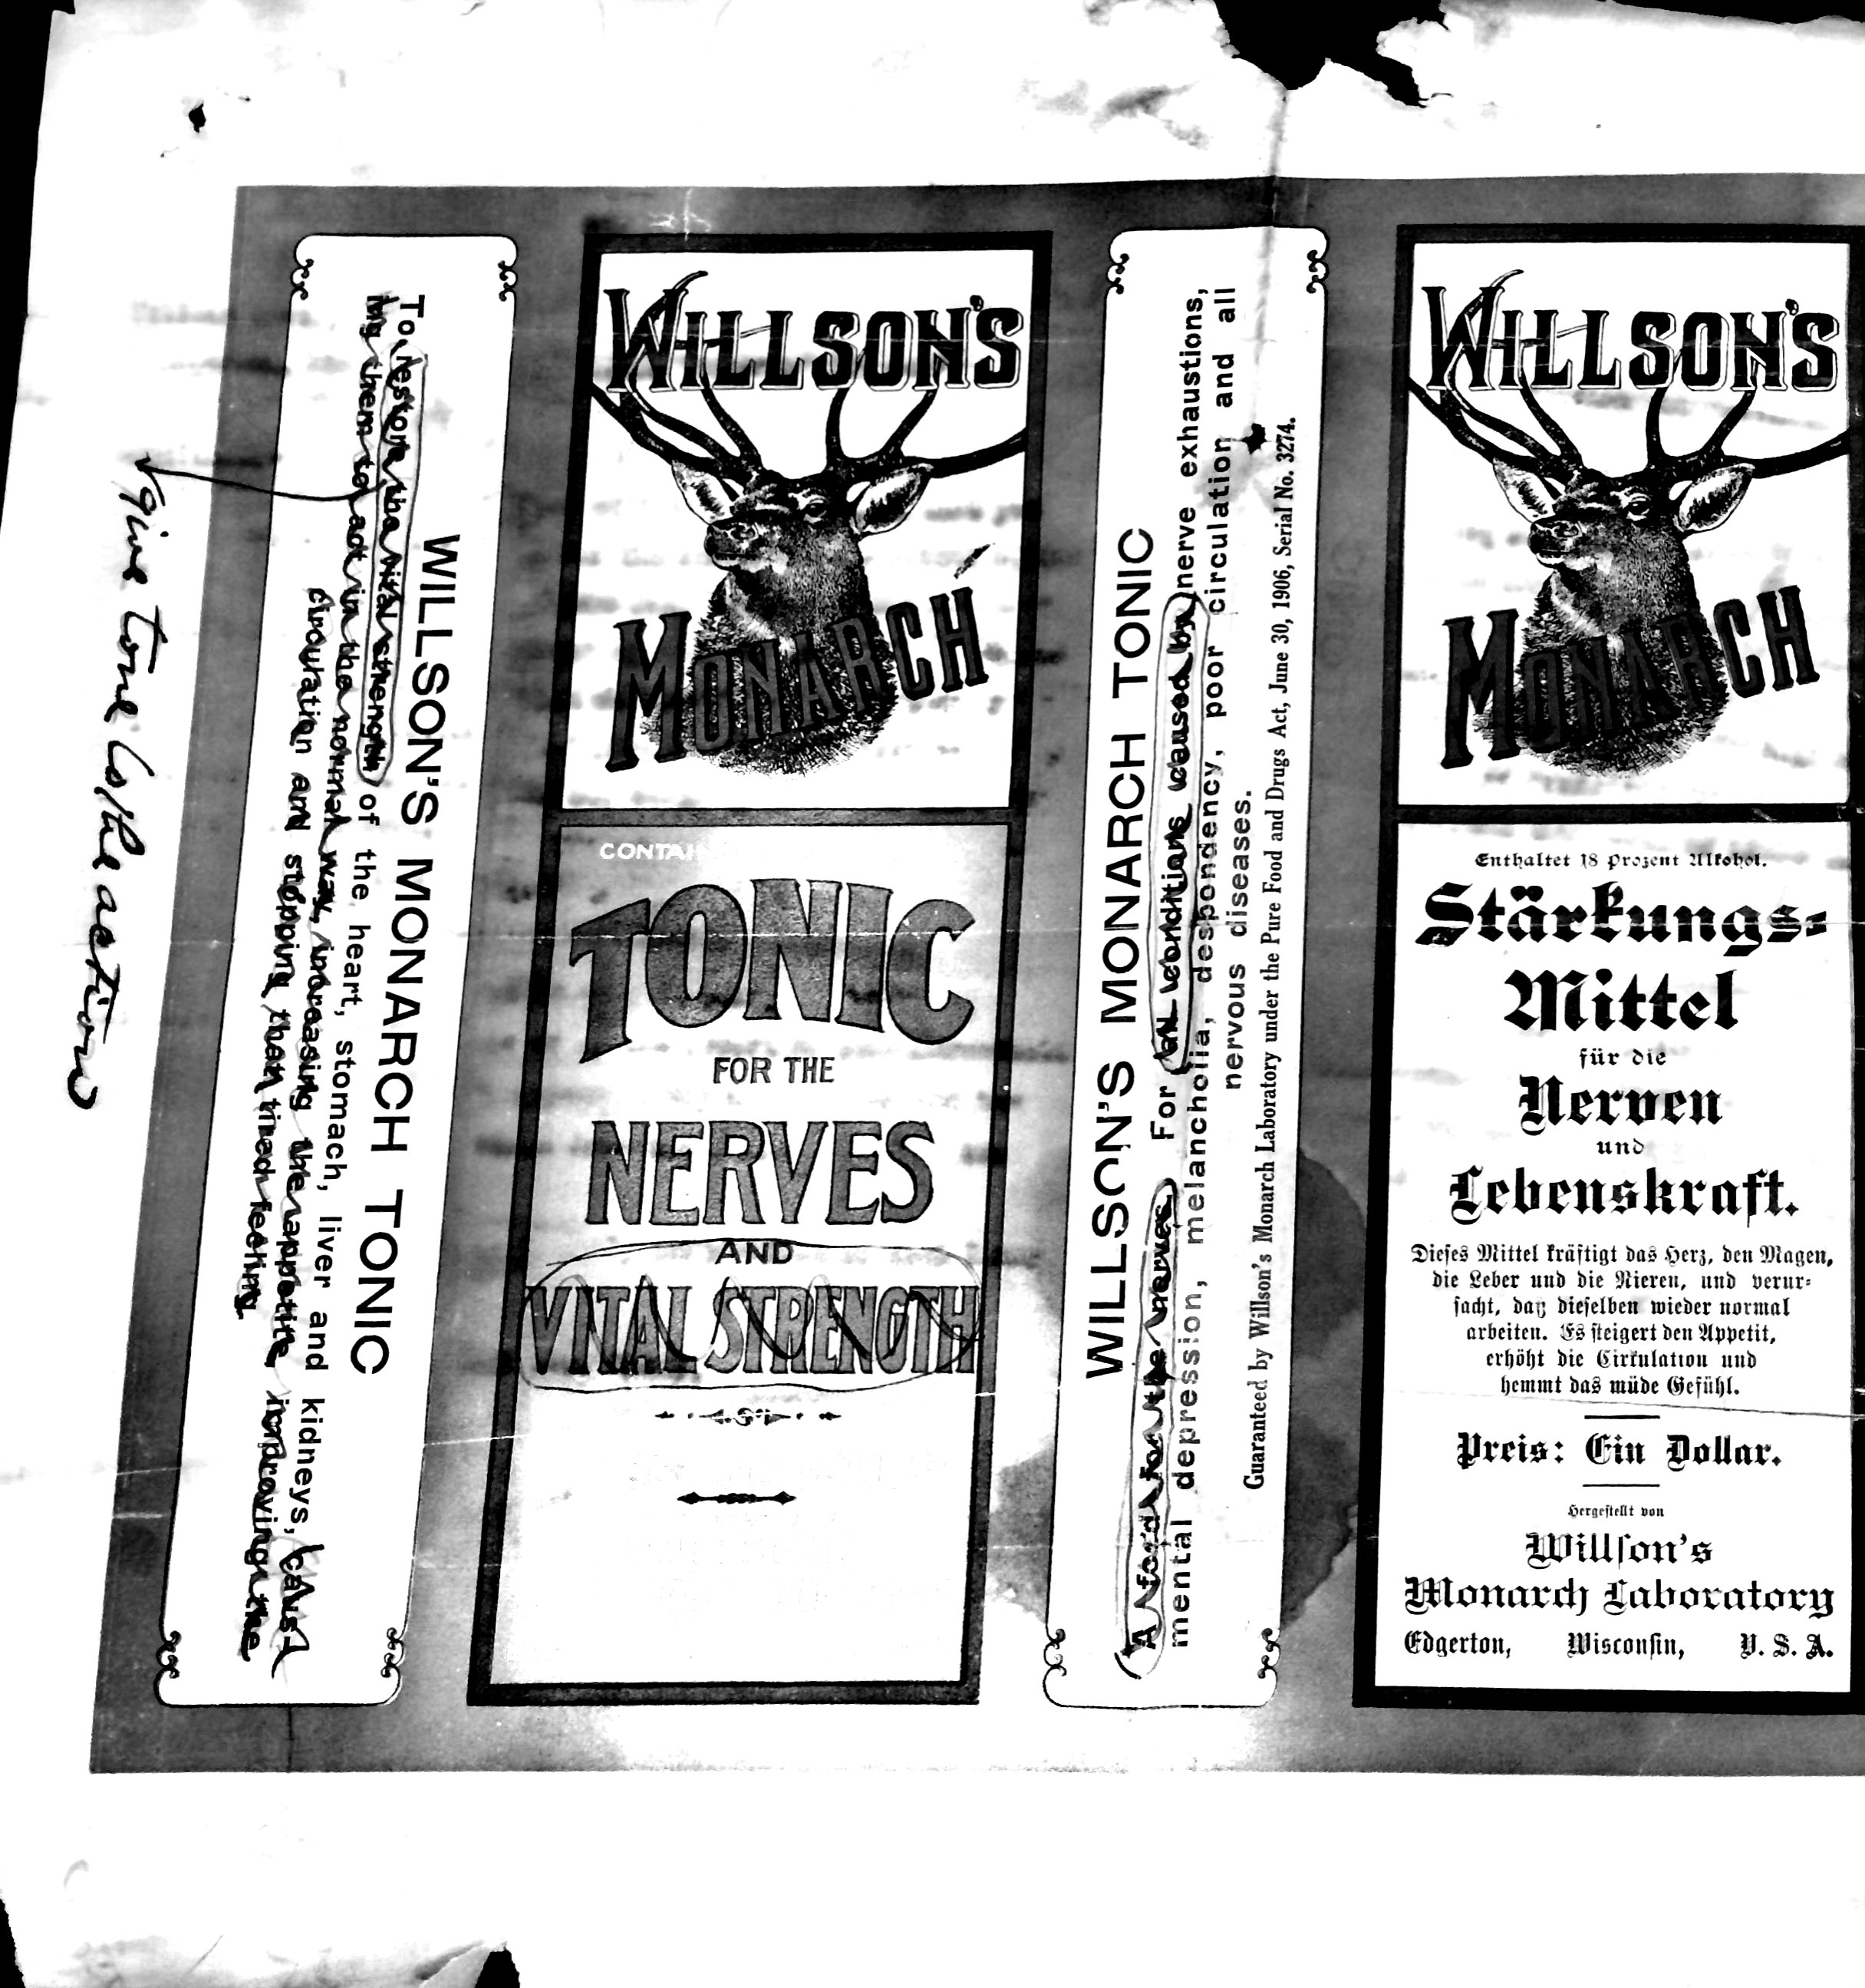
Willson’s Tonic for the Nerves and Vital Strength was one popular remedy on which the label had to be reconsidered as well. ‘Vital strength’ was a reference to important aspects of masculinity which the culture viewed as important, and promising to increase this vital strength in men would have had them scrambling to purchase the tonic. Though this labelling was acceptable before FDA legislation was passed, the wording had to be changed in order to describe what it would actually treat rather than telling customers it would amp up their masculine energy.
Figure 7. Willson’s Tonic for the Nerves and Vital Strength marked for revision. Willson Monarch Laboratory Records, 1889-1966, Box 31, Folder 7.
Their Buchu Compound was another example of a drug which came under scrutiny. There was issue with the name because it was branded after only one of its ingredients. It made too many references to the kidney and the bladder, and the therapeutic claims listed were too broad to be allowed. The burden to prove its usefulness was on Willson Monarch Laboratory, and they were required to do so before selling their product again. Perhaps most concerning was the potential for it to be found dangerous for use except when directed to do so by a physician. The U.S. Dispensary stated that Buchu should not be used when inflammation is severely acute, and because it could be argued that this product would therefore be dangerous in self dosage, it was recommended that the company look over the product carefully before deciding what to state on their label.
Many changes had come about due to the passage of restrictive federal legislation, and every word on every label had to be scrutinized in order to ensure it fit with the requirements of each new law passed.

Violations of Federal Law

There were, of course, ways to get around the law, and Willson Monarch Laboratory was one of many companies which used these loopholes to their advantage to make the sale of their products easier.
One way to get out of these laws was by cleverly naming products. For example, a product was considered misbranded if it was named after a single ingredient if it was actually a compound of multiple. By calling an aspirin compound containing other medical ingredients ‘Yum Yum’ or something else entirely meaningless, the company could operate within the law. The same product would have been in violation had it been named ‘Aspirin Compound’, however. Despite none of the active ingredients being stated in a meaningless name such as ‘Yum Yum’, it was not considered to be misbranded. This was just one way of getting around federal regulation.
Products were also able to be labelled as cosmetics rather than as medicines in order to get around the more restrictive regulations surrounding the marketing of drugs. Willson’s Antiseptic Mouth Wash was able to be branded as a cosmetic only if all medicinal claims and any references to antiseptic were removed from the label. The company followed this advice, and they deleted the necessary items, citing the percentage of alcohol and the fluid ounces contained, and the product was able to be back out on the market once again. By marketing something which had previously been sold as a drug as a cosmetic item instead, Willson Laboratories was able to avoid highly restrictive laws which did not yet apply to cosmetics.
Though there were ways to sneak around the federal regulation of the patent medicine industry, there were instances when companies got caught, and their labels were scrutinized and sent back to them for review for violating Congressional legislation. When this happened, Willson Monarch Laboratory submitted a new revised label for review and discontinued shipment of the product until it was approved.
The company received several charge sheets stating what was wrong with the labels of their products on medicines and food ingredients alike. Their cough syrup violated federal law due to the listed items it claimed to treat when in fact these claims were fraudulent, and it did not contain a statement about the amount of chloroform in the product. Their healing salve did not contain the same weight which was stated on the label, and much of the wording had to be changed to avoid claiming it was things like “healing”, “the best skin remedy”, and “a specific remedy for old ulcers”. Their Camphor and Eucalyptus Ointment faced similar treatment as well with claims of its uses found to be false and fraudulent as well as a different weight stated than what was true.
Although Willson Monarch Laboratories faced numerous citations and charges on products which were deemed to be false and misleading, they were able to handle it without any serious repercussions, and by cooperating with authorities they could rebrand their products to get them back on the market.

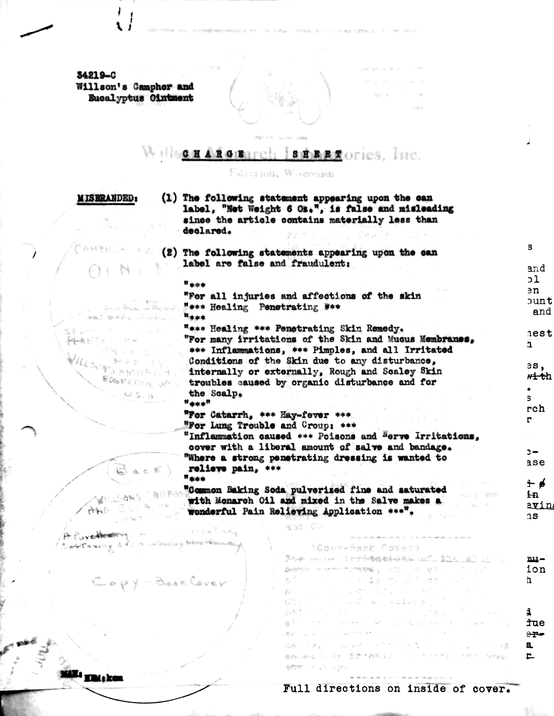
Figure 8. Willson’s Camphor and Eucalyptus Ointment Charge Sheet. Willson Monarch Laboratory Records, 1889-1966, Box 32, Folder 3.

Conclusion

The Willson Monarch Laboratories of Edgerton, Wisconsin functioned both before the federal government passed restrictive laws concerning the labeling, advertising, and manufacturing of drugs, foods, and cosmetics. They were forced to adapt to the changes required of them under these new laws.
Willson Brothers used various advertising tactics to sell their products. Not only did they offer samples door to door, but they also used testimony from doctors and satisfied customers alike. This was common practice for medicines that were sold often based on reputation alone, and word of mouth helped the company greatly. In a time when people were unwilling to ask advice from physicians, they instead relied on friends and neighbors to tell them what to buy, and people were not shy about recommending Monarch Oil and other Willson products to help them.
Although many of their early records were lost due to their laboratory fire in 1928, it is known that Monarch Oil was the product which bought them their early success. They, like many other companies were able to brand it as a cure all. It could be used on people, animals, and the household alike, and it promised to work miracles. Not only could it relieve pain but it was also able to save the lives of animals who were in desperate need of a cure. The directions to use it were vague and often advised people to just use more of the product as their ailment got more severe. This label along with many others had to change after the passage of federal legislation, and employees had to look over every single label in order to ensure that the way they were branding their products was legal.
Willson Laboratories was able to experience both the unregulated and regulated patent medicine industry. The company started out branding their products with outlandish claims and promises that could not possibly be true, but they had to learn to adapt quickly in order to continue to sell their products. Despite receiving several citations for a variety of their labels, they maintained their promise of quality and the trust their clients had in them. Willson Laboratories operated in the same ways as many other patent medicine manufacturers, and they, like all other companies who wished to continue selling their drugs, were forced to change and rebrand some of their most iconic products in order to follow federal laws. Despite the massive changes required of them, Willson Brothers handled these in stride and the company was able to continue manufacturing their products late into the 20th century.

Today’s Patent Medicine Industry
Despite how controlled the field of medicine is today, there are still miracle products being sold to the public, though they would first have to be proven to be safe and effective to be on the market.
Products like testosterone boosters for aging men which claim to boost vitality and increase sex drive seem oddly reminiscent of the remedies sold in the nineteenth and twentieth centuries. Patent medicines often claimed to do things like give a man more energy and increase sexual prowess, though their effectiveness at delivering on these claims is questionable. It seems that today there are still companies who wish to push products like these on consumers, and in a culture which places high value on a man’s sex drive, people are eager to purchase them and try these products for themselves.
Weight loss products are also guilty of claiming to work miracles, though they have to do so carefully to avoid being taken off the market. Despite how dubious the effectiveness of these products may be, people are willing to trust in their claims of burning fat quickly and painlessly in order to see results for themselves, and this is not unlike the motivations which drove people to use patent medicine in the first place. They were looking for a quick and painless solution to a problem, and this is what many weight loss drugs offer.
With recent calls to repeal the 1906 Pure Food and Drugs Act, we may soon see a world in which patent medicine runs rampant again. President Trump wishes to cut government regulations on drug companies to lower prices and allow patients with terminal illnesses to try treatments that have not been approved. This may allow for an environment similar to that of the world of patent medicine in which consumers have to decide for themselves whether a product is actually safe and effective.
Patent medicines may have been useful in offering people another choice when doctors were unavailable or untrustworthy, but in a world of modern medicine and scientific advancement, it should be questioned whether or not potentially harmful drugs should be offered to the public simply to allow them more freedom in their medication.
Works Cited
Primary Sources
Willson Monarch Laboratory Records, 1889-1966. Created by Willson Monarch Laboratory. Call Number: Whitewater Mss BJ; PH 3819.

Secondary Sources

Anderson, Ann. Snake Oil, Hustlers and Hambones: The American Medicine Show. Jefferson, NC: McFarland & Company, Inc., 2000.
Charles E., Orser Jr. “Consumption, Consumerism, and Things from the Earth,” Historical Methods: A Journal of Quantitative and Interdisciplinary History 27, no. 2 (Spring 1994): 61-70.
Dary, David. Frontier Medicine: From the Atlantic to the Pacific, 1492-1941. New York: Vintage Books, 2008.
Finch, L. Boyd. “Doctor Diamond Dick: Leavenworth’s Flamboyant Medicine Man,” Kansas History: A Journal of the Central Plains 26 (Spring 2003): 2-13.
Karoleuitz, Robert F.. Doctors of the Old West: A Pictorial History of Medicine on the Frontier. Seattle: Superior Publishing Company, 1967.
Lankton, Larry. Beyond the Boundaries: Life and Landscape at the Lake Superior Copper Mines, 1840-1875. New York: Oxford University Press, 1997.
Marcellus, Jane. “Nervous Women and Noble Savages: The Romanticized ‘Other’ in Nineteenth-Century US Patent Medicine Advertising,” The Journal of Popular Culture 41, no. 5 (2008): 784-808.
Rentetzi, Maria. “Packaging Radium, Selling Science: Boxes, Bottles and Other Mundane Things in the World of Science,” Annals of Science 68, no. 3 (July 2011): 375-399.
Smith, Duane A., and Ronald C. Brown. No One Ailing Except a Physician: Medicine in the Mining West, 1848-1919. Boulder: The University Press of Colorado, 2001.
Sobel, Russell S. “Public Health and the Placebo: The Legacy of the 1906 Pure Food and Drugs Act,” Cato Journal 21, no. 3 (Winter 2002): 463-479.
Temin, Peter. Taking Your Medicine: Drug Regulation in the United States. Cambridge, MA: Harvard University Press, 1980.
Valuck, Robert J., Suzanne Poirier and Robert G. Mrtek. “Patent Medicine Muckraking: Influences on American Pharmacy, Social Reform, and Foreign Authors,” Pharmacy in History 34, no. 4 (1992): 183-192.
WebMD. “Trump: I'll Cut Drug Company Taxes, Regulations.” WebMD News. Last modified January 31, 2017. Accessed March 3, 2017. http://www.webmd.com/health-insurance/news/20170131/trump-drug-company-taxes-prices.
Wisconsin Historical Society. “Willson Monarch Laboratory Records, 1889-1966.” Accessed February 22, 2017. http://digital.library.wisc.edu/1711.dl/wiarchives.uw-whs-whit00bj.
Young, J.H. The Toadstool Millionaires. Princeton: Princeton University Press. 1961. Quoted in Russell Sobel, “Public Health and the Placebo,” Cato Journal 3, no. 3 (Winter 2002): 463-479.

Duane A. Smith and Ronald C. Brown, No One Ailing Except a Physician: Medicine in the Mining West, 1848-1919 (Boulder: The University Press of Colorado, 2001), 76-104.
Larry Lankton, Beyond the Boundaries: Life and Landscape at the Lake Superior Copper Mines, 1840-1875 (New York: Oxford University Press, 1997), 145.
Robert F. Karoleuitz, Doctors of the Old West: A Pictorial History of Medicine on the Frontier (Seattle: Superior Publishing Company, 1967), 52, 146.
David Dary, Frontier Medicine: From the Atlantic to the Pacific, 1492-1941 (New York: Vintage Books, 2008), 249.
Charles E. Orser, Jr., “Consumption, Consumerism, and Things from the Earth,” Historical Methods: A Journal of Quantitative and Interdisciplinary History 27, no. 2 (Spring 1994): 65.
Lankton, 151.
L. Boyd Finch, “Doctor Diamond Dick: Leavenworth’s Flamboyant Medicine Man,” Kansas History: A Journal of the Central Plains 26, (Spring 2003): 4.
Jane Marcellus, “Nervous Women and Noble Savages: The Romanticized “Other” in Nineteenth-Century US Patent Medicine Advertising,” The Journal of Popular Culture 41, no. 5 (2008): 784.
Orser, Jr., 66.
Maria Rentetzi, “Packaging Radium, Selling Science: Boxes, Bottles, and Other Mundane Things in the World of Science,” Annals of Science 68, no. 3 (July 2011): 276.
Marcellus, 794.
Finch, 8; Ann Anderson, Snake Oil, Hustlers and Hambones: The American Medicine Show (Jefferson, NC: McFarland & Company, Inc., 2000), 1-9.
Finch, 11.
Anderson, 69.
Anderson, 129-130.
Marcellus, 786.
Lankton, 158-159.
Robert J. Valuck, Suzanne Poirer, Robert G. Mrtek, “Patent Medicine Muckraking: Influences on American Pharmacy, Social Reform, and Foreign Authors,” Pharmacy in History 34, no. 4 (1992), 187.
J. H. Young, The Toadstool Millionaires (Princeton: Princeton University Press, 1961), quoted in Russell Sobel, “Public Health and the Placebo,” Cato Journal 3, no. 3 (Winter 2002): 468.
Dary, 251.
Sobel, 469.
Sobel, 469.
Sobel, 466; Sobel, 470.
Anderson, 159.
Peter Temin, Taking Your Medicine: Drug Regulation in the United States (Cambridge, MA: Harvard University Press, 1980), 43.
Sobel, 471.
Sobel, 473.
Rentetzi, 383.
“Willson Monarch Laboratory Records, 1889-1966,” Wisconsin Historical Society, accessed February 22, 2017, http://digital.library.wisc.edu/1711.dl/wiarchives.uw-whs-whit00bj.
“August 14, 1912 correspondence to Mr. William G. Henderson”, Willson Monarch Laboratory Records, 1889-1966, Box 33, Folder 1.
“Booklet”, Box 32, Folder 13.
“August 4, 1928”, Box 30, Folder 1.
“The Monarch News”, Box 29, Folders 2-3. “Mailing List”, Box 15, Folder 14.
“Weekly Punch”, Box 29, Folders 4-6.
“Letter from Lewis S. Borden”, Box 27, Folder 4.
“Letter beginning ‘Gentlemen,’”, Box 27, Folder 4.
“Praises for Olozon (Monarch Oil)”, Box 27, Folder 4.
“Sales Manual”, Box 30, Folder 3.
“Weekly sales tips 1-52”, Box 30, Folder 4.
“Booklet”, Box 32, Folder 13.
“Prevent a Cold” Box 7, Folder 5.
“Weekly Sales Tip No. 5”, Box 30, Folder 4.
“Monarch Olozon ad”, Box 7, Folder 5.
“Booklet”, Box 32, Folder 13.
“Letter from a Willson Customer”, Box 27, Folder 4.
“Feb-15 35”, Box 27, Folder 4.
“Monarch Olozon ad”, Box 7, Folder 5.
“Willson’s Tonic for the Nerves and Vital Strength label”, Box 31, Folder 7.
“Monarch Olozon ad”, Box 7, Folder 5.
“Booklet”, Box 32, Folder 13.
“Monarch Olozon ad”, Box 7, Folder 5.
“Camphor and Eucalyptus Ointment”, Box 31, Folder 1.
“Willson’s Monarch Laxative”, Box 31, Folder 5.
“Booklet”, Box 32, Folder 13.
“Price lists”, Box 33, Folder 3.
“Monarch Oil ad”, Box 31, Folder 7.
“Legal Bulletin No. 482”, Box 25, Folder 13.
“Booklet”, Box 32, Folder 13.
“Legal Bulletin No. 1540”, Box 25, Folder 13.
“Legal Bulletin No. 1535”, Box 25, Folder 13.
“July 26, 1937” Memorandum”, Box 32, Folder 1.
“Legal Bulletin No. 1540”, Box 25, Folder 13.
“Willson’s Dyspepsia and Digestive Tablets label”, Box 31, Folder 7.
“Willson’s Monarch Sarsaparilla label”, Box 31, Folder 7.
“Willson’s Tonic for the Nerves and Vital Strength label”, Box 31, Folder 7.
“July 26, 1937 Memorandum”, Box 32, Folder 1.
“General Bulletin 278”, Box 25, Folder 13.
“Willson’s Antiseptic Mouth Wash Memorandum Re Labels”. Box 31, Folder 3.
“July 30, 1937 correspondence to the Department of Agriculture”, Box 32, Folder 7.
“Willson’s Monarch Cough Syrup Charge Sheet”, Box 32, Folder 5.
“Willson’s Healing Salve Charge Sheet”, Box 32, Folder 7.
“Willson’s Camphor and Eucalyptus Ointment Charge Sheet”, Box 32, Folder 3.
“Trump: I'll Cut Drug Company Taxes, Regulations,” WebMD, last modified January 31, 2017, accessed March 3, 2017, http://www.webmd.com/health-insurance/news/20170131/trump-drug-company-taxes-prices.

