Around the World on a Bicycle:
A Study of American Manhood 1884-1887

Jeremiah Rau
History 489
May 12, 2014

Abstract
In 1886 Thomas Stevens became the first man to circle the globe on a bicycle. The feat was an amazing accomplishment for the time but his account is far more than just an interesting anecdote in history; his overall journey and press coverage highlight a popular ideals of American manhood in the late 1880s. At the time, manhood in general was an exclusive condition; it was specific to white middle class men and needed to be proven either in the burgeoning marketplace and/or by strenuous acts of adventure. Bicycling in the early 1880s was an activity for young, wealthy, white men. This paper shows how Steven’s decision to bicycle around the world was, in part, due to popular conceptions of American manhood and how the “manly” culture surrounding the bicycle in the United States during the 1880s became a means through which Stevens could achieve normative manhood. Although we cannot be sure what Stevens thought to himself, his decision to bicycle around the globe was not only a means to make a living—he could achieve that through more ordinary means, it was a way to achieve his own manhood in a culture which valued toughness, passion, and freedom as male virtues.

We recognize a splendid type of man--
A hero formed upon the Stanley plan.

These two lines were among a collection of odes and poems printed on the menus for a banquet held in the honor of Thomas Stevens in Boston, February of 1887. Stevens had just finished the first tour around the world on a bicycle and over 100 members of the Bay State Wheelman, a prominent Boston cycling club, welcomed him back to the states. The night began with a dinner and was followed by prominent members of the club taking turns to pay their respects and praises to the wheelman. As the couplet above suggests, Stevens was put on par with Henry Morton Stanley an adventure journalist famous for his exploits in Africa primarily during the 1870s. Stanley became famous through recording his adventures and sending them to popular media publications like Harpers and the New York Herald which serialized his stories for their readers. The American reading public devoured Stanley’s writings and his books became bestsellers.
To many, Stanley represented the pinnacle of American manhood—an individual, tough, adventurous, white male risking his life and limb in foreign and exotic lands. After Stevens completed his circumcycle, like Stanley, he became a famous adventure journalist. An article in the New York Times proclaimed that Stevens’ trip was “the most splendid personal journey of this century.” The Boston Daily Globe announced upon his return that "so much has been written about the remarkable ride of Thomas Stevens that there are few who have not heard of him." However, Stanley and Stevens were not enigmas or supermen. They contributed to and were a product of a culture which valued certain masculine characteristics. These men in their time were relatively unaware of what modern academics would call “masculinized” behavior. To them, these values made them men, it gave them their sense of place, and they achieved their manhood through their exploits. The form of manhood represented by Stanley and Stevens was something few men at the time embodied but, nevertheless, many men saw Stanley and Stevens’ life as an ideal one to aspire to. In this way, the standard of manhood Stanley embodied was normative—white American men assumed that this is what a man ought to be like. The exaltation of Stevens by the men at the banquet displays how men valued these qualities in their fellow man and that the men understood Stevens’ journey as proof of achieving this standard of manhood represented by Stanley.
The claim that Stevens’ cycling peers saw him to achieve this standard of manhood is shown by other forms of praise Stevens received during the banquet. For instance, H.J. Boardman, President of the Senate of the state of Massachusetts, hailed Stevens as “an honor to the wheelman profession, an honor to his race.” As “The Anglo-Saxon race has always been considered the most famous of all races for feats of daring.” The president of the Bay State Wheelmen said that Steven’s efforts affirmed that “there is nothing like the genuine, fearless old Teutonic pluck.” And Albert A. Pope, the entrepreneur who manufactured the bicycle Stevens used to ride around the world claimed “had Stevens been around in the time of Columbus, instead of begging for ships and subsidies from kings, he would have sailed away in an open boat to find a new continent.”
All the preceding praise given to Stevens contains elements of race (white), cycling (wheelman profession), ethnicity (German, Anglo-Saxon) as well as “manly” attributes like toughness, daring, and individuality which, together, contributed to manhood or what it meant to “be a man” in the late 1880s. This, of course, was from the standpoint of the white, middle class males of German and/or Anglo-Saxon descent, who for reasons this paper will address were the most influential demographic at the time in the United States.
The question of what did it mean to be a man in the late 19th century and how did men achieve or fail to achieve this standard still resonates with historians today. In the era of Thomas Stevens, “men” were risk taking, passionate individuals who were bent on success either in the burgeoning capitalist marketplace and/or through acts of toughness. Stevens chose to prove himself by taking one of the earliest bicycles in American history around the world— definitively proving his own manhood and obtaining a career as an adventure journalist.
Adventure journalism was largely invented by Henry Morton Stanley. Not only did this man embody the normative conception of manhood at the time—he developed a style of journalism which espoused the stories of his adventures to the reading public in a way which had not been done before. In 1869, during a time when journalists waited for events to happen to report on them, Stanley convinced his editors for Harpers to fund an expedition to “find” the explorer David Livingstone—an undertaking which could be made into a story. In turn, Stanley’s editors concocted the idea that Livingstone was “lost” so that Stanley could find a man who, in reality, knew where he was. This idea of reporting on difficult expeditions in and of themselves proved to be a great success for the rapidly growing newspaper presses of the time.
Civilian men traveling around the world in Stevens’ day was becoming a popular venture as well. With the construction of the Suez Canal, the Transcontinental and the Trans-Indian Peninsular railroad by 1870, wealthy businessmen began attempting to circle the planet. A Boston business man by the name of George Francis Train was the first man to do so in the same year. The reality made its way into the world of fiction in 1871 when Jules Verne published his extremely popular novel, Around the World in 80 Days. In brief, the story chronicles the circling of the globe by the wealthy and mysterious character, Phileas Fogg, who took up the challenge over a bet made during a card game. What all these feats have in common is that they had no tangible goal to be accomplished. Their purpose was not to find and exploit resources—the deed was an end in itself.
Steven’s journey around the world began nearly three years prior to the banquet in Boston. In the morning of April 22, 1884 Stevens left San Francisco atop a fifty-inch, big wheeled, penny-farthing bicycle. He traveled light—only bringing a change of clothes, some tools, writing utensils, and a revolver. Over the duration of the nearly three year journey Stevens crossed the United States via the Transcontinental railroad to Boston. From there, he hopped a steamship to England and proceeded to make his way across Europe and the Ottoman Empire; he wintered in Persia as a guest of the Shah, got arrested in Afghanistan, took the British military roads through India and nearly got stoned to death in China. He finished his trek in Yokohama Japan having traveled well over 13,000 miles. See figure 1. 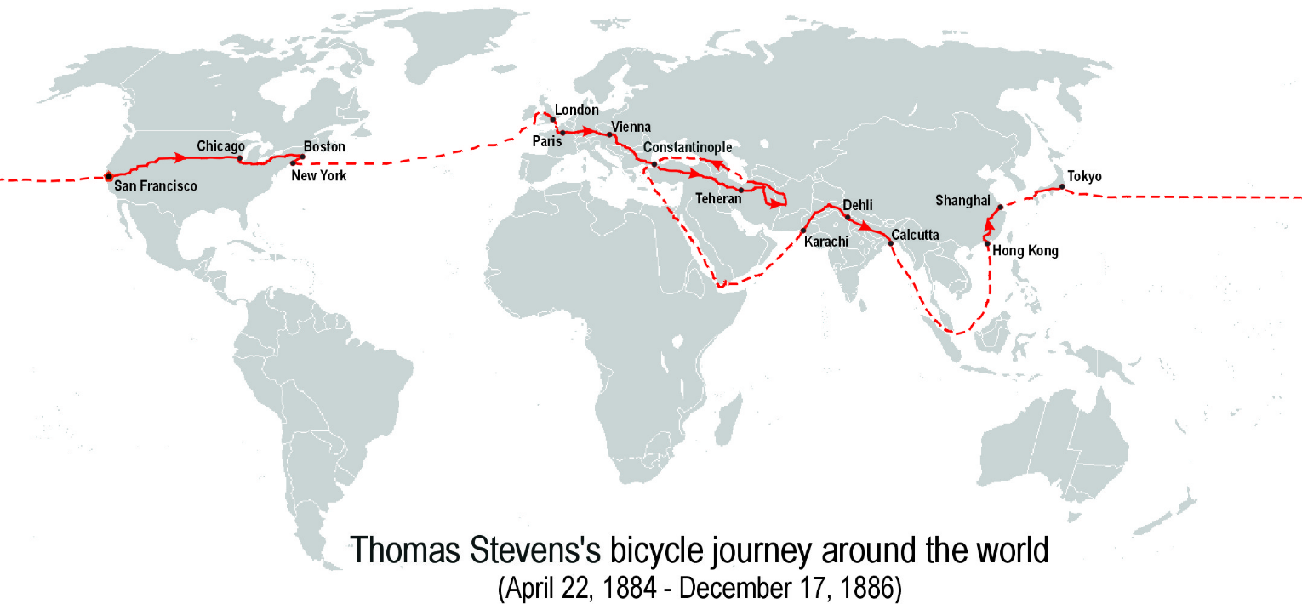
Figure 1. Source: http://en.wikipedia.org/wiki/File:Thomas-Stevens%27s-bicycle-journey-EN.png
Primary Sources and Thesis
Thomas Steven’s overall journey and press coverage can be used to learn about American manhood in the late 19th century. In general, manhood is referred to as the state or condition of being an adult male. As most serious scholars agree, the state or condition of being an adult man in society (manhood) is a socially constructed concept—it has no inherent basis in the world. Therefore, changes in manhood can be studied and traced over time through the analysis of primary sources.
Steven’s trip would have been an almost entirely forgotten event in history had he not written extensively about it. Over the course of his journey Stevens compiled a narrative of his experiences he would later publish as Around the World on a Bicycle. Stevens writes about a variety of topics from describing the rigorousness of his travels, the weather and landscape, and the people and his opinions of others. Much of his writing is framed in tropes and structures which show his American values as well as his masculine attributes. This author’s analysis of his writings and those of the various media publications following his journey in order to show how Stevens exploits and the publics’ understanding of his journey highlight popular conceptions of American manhood from 1884 to 1887 and how the new “manly” culture surrounding the first mass produced bicycles in the United States raised Stevens to the height of Stanley.
The role the bicycle played in Stevens’ journey was significant. It was not only a form of transportation it can be shown that the bicycle took Stevens from anonymity to a masculine icon. The rugged tenacity needed to cycle over railroads, across rivers, through suffocating groups of curious people, over the searing hot roads of India, and dragged over precarious stone footpaths in China put Stevens on par with the masculine ideal Stanley represented. Also, Steven’s decision to buy a bicycle connected him to a large network of upper class Wheelmen with advantageous connections which facilitated his success. The sporting magazines and newspapers which covered Stevens tended to focus on characteristics of Stevens journey that directly related to American manhood in the late 1880s and at times embellished Stevens past and made him to be a masculine icon.
Historiography of Stevens
There is little scholarship on Stevens himself besides a wide-spanning case study of his journey coauthored by Gabrielle Porter and Tom Taylor, both from the history department at the University of Seattle. They treated it as a case study; their goal was to “bring to life the world of the late 19th century” through their research on Stevens. Porter and Taylor argued that Steven’s bicycle ride symbolized the encounter of westernization and modernism with the rest of the world. They showed how Stevens’ English/American identity meshed within the complex world of geopolitics at the time (his British identity saved him from being accused as being a Russian spy) and how the public reacted to his circumcycle through a survey of relevant newspaper coverage. The duo also touched upon many significant cultural trends and their connection to Stevens, such as the burgeoning field of adventure journalism and the “bicycle bubble” which was underway in the United States at the time as well as Stevens as an Orientalist. Porter argued that although Stevens did hold typical stereotypes of Eastern peoples he was a revisionist in his time because his writing was not as damning of other peoples as that of other contemporary western travelers. Throughout their paper, Porter and Taylor expertly showed how Stevens understood himself while in the company of the “other” and how his bicycle acted as both a reason for his own presupposed cultural superiority as well as an instant conversation starter. To Porter and Taylor, Stevens’ trip signified the West’s interaction with and perception of the East not only as Stevens made his way around the world but his readers as well. The two authors interpreted the bicycle during Steven’s trip as a tool of modernity in the context of what Steven’s considered the “backward” or “lagging” societies of the East. Overall, the two authors produced a comprehensive case study focusing mainly on international relations of the time period through Stevens and his travels.
The broad themes in Porter and Taylor’s work is well supported, but because of the nature of their case-study’s approach no theme they touched on was elucidated in depth and no single thesis united the paper. Besides touching on Stevens’ self-proclaimed identity as a cowboy and his rugged individualism, they did not fully flesh out the influence American manhood had on Stevens’ journey. The two authors claim the bicycle symbolized the modernity of the West in the context of the East. However, I will argue that the bicycle may also be interpreted as a means for Stevens to achieve normative manhood in a culture which valued a certain bundle of manly characteristics: toughness, adventure seeking and freedom.
Historiography of Manhood
The historical sociologists who study manhood are interested in how and why normative conceptions of manhood change or remain constant over time. They go about framing this phenomenon in a multitude of ways. Beginning In the early 1980s, historical sociologists created “sociological ideal types” to study the transformations of what a certain demographic in a specific time period consider to be ideal manhood. In 1993, Anthony Rotundo published American Manhood: Transformations of Masculinity from the Revolution to the Modern Era. Rotundo argued that in colonial New England the ideal type of manhood was a “communal” one. A man’s position in society was largely fixed by birth and so his identity was bound up in the obligation to his family, God and community over any individualistic aspirations. As society became more commercialized, manhood was not a birthright, it needed to be proven in the burgeoning competitive marketplace by attaining financial wealth. In order to do this the “self-made” man separated from his family and community in order to prove himself in the public sector or market place. By the late 19th century the ambition of the “self-made” man became more exaggerated as society began to value competitiveness, unbridled ambition, aggression and toughness as male virtues. Rotundo describes his concept as “Passionate manhood.”
Starting in the 1880s, mens’ bodies became an important facet to manhood. To have physical strength and a fit body was one way to demonstrate self-control, so physical strength was often linked to strength of character. It was also in the 1880s that struggle was looked at as an end in itself. According to Rotundo this was best exemplified by Theodore Roosevelt preaching the virtues of the strenuous life. This was part of boyhood as well. Young boys partook in dangerous acts for their own sake, also known as “doing a stump”. Physical prowess, struggle, and risk were defining attributes to Rotundo’s “Passionate Manhood” and important parts to white American manhood in the late 1880s.
In 1996, Rotundo’s typology was built on by Michael Kimmel who published his book, Manhood in America: A Cultural History of Masculinity. Kimmel claimed that manhood in colonial times was covered by two archetypes: the working class “Heroic Artisan” and the landowning “Genteel Patriarch”. In American Manhood, these archetypes, bound to land and community, were eclipsed by the “self-made” man which Kimmel maintained to be the reigning type of manhood until modern times. Kimmel describes manhood in the 1880s as something that was not complicit with being employed under somebody else, manhood was equated to those highest on the ladder the owners and entrepreneurs who answered to no one but themselves. This standard of freedom in a competitive capitalist economy would become increasingly difficult to achieve as the American economy changed from an agrarian based one in the early 1800s to an industrial one by the end of the century. The freedom to choose how to make one’s living which was tied to manhood was increasingly difficult to obtain. This created a restless environment for men because few of them achieved normative manhood by these standards as they worked in manufacturing and industry—jobs at the bottom of the socioeconomic ladder. Immigration was another significant factor that affected white manhood. Between 1880 and 1900 nine million immigrants came to the United States. The post-bellum black migration to the north also increased at this time with almost 400,000 blacks migrating north between 1870 and 1890. The ideal types of manhood these two scholars create describe the same demographic of men over time—white, middle class, Protestant, geographically northern, and heterosexual men. They chose this demographic because historians have shown that these men were the most influential economically, politically and culturally from the late eighteenth to the twenty-first centuries. “Through [their] power in the pulpit press and publishing and through their far-flung economic ties these men exercised a certain hegemony in nineteenth-century American culture.” One important outcome of the organization of American society was that white men were able to espouse their beliefs and assumptions of manhood to the public.
All of these sociological ideal types of manhood change over time, but they describe hegemonic manhood—or the most honored form of manhood in a given gender hierarchy. When the ideal type of manhood of a time period is challenged or is incapable of continually justifying its privilege or changes for social, political, or economic reasons, it causes anxiety for men which initiates a redevelopment of a new ideal type by the dominant classes. At a national level, manhood for white men was in a state of crisis. Traditional ideas of manhood were being uprooted by rapid industrialization; the entry to the public sphere by large numbers of women, free blacks, and immigrants, and the closing of the frontier. White men needed more masculine forms of work and something to set themselves apart from people who were formerly segregated from them by societal institutions. Men did many things to cope, some escaped the situation, formed exclusive fraternities, denigrated “others” or people different from the norm, and some displayed their superiority and found careers through partaking in challenging adventures like cycling around the world. The men who succeeded in their efforts telegraphed their manhood through these techniques and often garnered notoriety, therefore perpetuating the same activity among their peers.
Working Class Laborer to Skilled Cyclist
Although Stevens came to embody a quintessentially American ideal of manhood, he was not born in the United States. He was born in Berkhamstead, Hertfordshire, England to working class parents in 1855. During his childhood, he learned how to read and write at one of the few grammar schools outside of London and as a teenager he worked as a part time grocer. In 1869, at the age of 18, Stevens immigrated to Springfield, Missouri with his half-brother. Like many young men at that time, he sought his fortune in the western frontier. Over the next fourteen years Stevens worked a variety of jobs in many different places: farmer and rancher in Missouri, a railroad worker, and a part time newspaper contributor in Laramie, Wyoming. While working for the newspaper in Laramie he had heard of, and possibly met, men trying to cycle across the nation. In 1883, Stevens found himself in Denver working as a miner having neither settled nor succeeded in making a sustainable living on the American frontier. It was while he was in Denver that Stevens decided he would ride across the United States. At the time of his decision he had never been on a bicycle before. Near the end of his journey, The North China Herald, would explain that: "Mr. Stevens admits that he undertook the journey partly from the wish to travel; but mostly from the desire for notoriety—in other words pursuing the bubble reputation—which adventure would give him." This type of reasoning could only seem feasible in a culture which valued the manly pursuit of adventure as a significant part of manhood.
When Stevens decided to take up his bicycle adventure the sport was new to the country. The first steel-made bicycles were shipped to the United States from England in 1876 and put on display at the Centennial in Philadelphia in front of an enthusiastic crowd. From that point on entrepreneurs like Colonel A. Pope, inspired by what he saw, began importing English bicycles en masse and selling them as well as copying their design, and buying up patents in order to mass produced them in the United States. By 1878, Pope had begun manufacturing his own model of the ordinary which was the highest quality bicycle of its day. The bicycle bubble in the United States had begun.
Cycling was initially an exclusive activity for middle class, athletic, white men. Most cyclists in large towns formed clubs and were generally referred to as “wheelmen.” These clubs were highly organized and their purpose went beyond social—they were political. They demanded better roads, respect from carriages and lobbied on the behalf of their interests. In 1880, a national league for bicycle clubs was formed. The League of American Wheelmen was organized to “promote the general interests of bicycling, to ascertain, defend, and protect the rights of wheelmen, and to encourage and facilitate touring.” L.A.W members touted their hobby and considered themselves leaders through their profession:
The wheelman being generally a man of enterprise, as he shows by the fact of becoming a bicycler, he is not a person to whom routine forms are an impassible barrier; and therefore the bicyclers collectively form inevitably a body of persons to whom the public can legitimately look with confidence, for the future, as men ready to examine the claims for consideration of the new, while not contemptuously disregarding the old; that is, a class who infused with the best spirit of the times, can naturally be counted upon to make themselves felt as a power in the future, to be counted upon the side of the right in the work before us for the further development of the possibilities of life.

The price of enrollment in the group matched the level of importance in society many wheelmen ascribed to themselves. A membership cost between $100 and $150. This was roughly four months pay for the average factory hand. The bicycles themselves were astronomically expensive as well. Stevens paid $110 for his “Columbia”, an extremely risky investment given Steven’s level of income. Most wheelmen at the time were skilled professionals who could afford such things. For example, according to records taken by the Boston Globe, the occupations of the Bay State Wheelmen were as follows: eighteen merchants, one capitalist, ten manufacturers, four insurance salesmen, three publishers, two architects, five lawyers, one electrician, four photographers, one teacher, one designer, one author, one stenographer, two tailors, three brokers, one machinist, three musicians, one auctioneer, two dentists, thirty three salesmen, one physician, one clergyman, three carpenters, seventeen book-keepers, two treasurers, seven bank clerks, three artists, and five journalists. Penny-farthings were extremely dangerous to ride, especially on rough roads as one was prone to be thrown over the handle bars if the tire hit a divot—what Stevens called “headers” in his writings. Although Stevens’ purchase of the bicycle seemed like a risky investment it gave him the opportunity to become a famous cyclist and connected him to a network of upper class wheelmen.
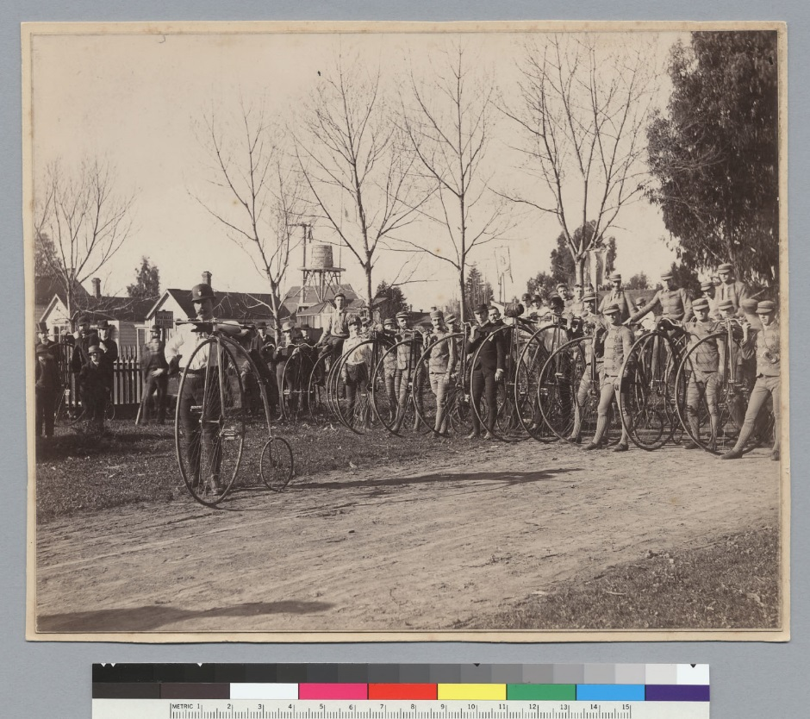
Early in 1884 Stevens made his way to San Francisco where he bought his bicycle and learned how to ride. By the time of his departure he had gathered a small following in the members of the Oakland and San Francisco bicycling clubs. See figure 2.
Whether or not he decided to ride across the nation or around the world from the outset is unclear, but not long after he departed San Francisco multiple newspapers in California mentioned him in small blurbs. The Sacramento Daily Union was the earliest newspaper found to publish his intention to travel around the world. Another California newspaper mentioned that he was taking notes to eventually write a book. As the newspapers kept track of Stevens’ progress through the telegraph, his following grew. Regardless of what was true or embellished by the newspapers, Stevens had gone from a lowly laborer to a relatively famous adventure cyclist in a short amount of time.
Figure 2. Stevens in front with members of Oakland Bicycle club. Source:http://historyinphotos.blogspot.com/2013/11/uc-berkeley.html
By the time Stevens reached Boston on August 4, 1884 he was being approached by reporters for interviews. When asked why he was doing such a thing Stevens replied, “I am making the journey partly for pleasure and partly for other reasons.” The Boston Daily Globe posted in an interview on August 5th. “Did you have any trouble with the Indians?” “None whatever.” He replied. “How about the cowboys?” To which Stevens replied laughingly, “Oh, they treated me all right. In fact, I am a cowboy myself, and you know we don’t go back on one another.” Stevens’ self-proclaimed identity as a cowboy is illuminating. The solitary and free image of the cowboy was just as prevalent in the late 1880s as it remains to be today. The idea of the cowboy, like the explorer, represented the quintessential aspects of American manhood in the 1880s. Later, Stevens expressed in an article published in Outing how strongly the idea of the cowboy resonated with him.
As I lean on my bicycle on this mountain-top, drinking in the glorious
scene, and inhaling the ozone-laden air, looking through the loop-holes
of recent experiences in crossing the great wonderland to the west; its
strange intermingling of forest-clad hills and grassy valleys; its barren,
rocky mountains and dreary, desolate plains; its vast, snowy solitudes
and its sunny, sylvan nooks; the no less strange intermingling of people;
the wandering red-skin with his pathetic history; the feverishly hopeful
prospector, toiling and searching for precious metals locked in the
eternal hills; and the wild and free cow-boy who, mounted on his wiry
bronco, roams these plains and mountains, free as the Arab of the desert -
I heave a sigh as I realize that no tongue or pen of mine can hope to do the subject justice.

From his lookout, Stevens describe the diverse lands of the west and juxtaposes its eternal beauty with the aimless and shameful image of the Native American and the foolish image of the “toiling” prospector. From the perspective of Stevens, or white men in general, the unfortunate history of the Native American and the greed of the prospector cut them off from the freedom and beauty the West had to offer—something only the cowboy could appreciate. The imagery Stevens uses and the perspective he takes speaks volumes to his ideas of freedom and when it meant to be the best kind of man as the cowboy represented the most favored qualities of manhood in the 1880s. A man who was wild, white, and free in every way.
Adventure Journalist 1883-1886
Once Stevens reached Boston he made a connection which lead to his career as an adventure journalist. Stevens met with Colonel A. Pope who was by now the largest manufacturer of bicycles in the country. Since starting the bicycle business, Pope was launching a vigorous marketing campaign to further popularize the bicycle in the minds of the American public. As part of this effort he helped establish Wheelman magazine, which later became Outing, one of the most important sporting magazines in the 19th and early 20th centuries in the United States. Initially, Stevens asked Pope for funding to continue his journey under the pretenses that they would benefit from each other. Pope would get advertising for his product and Stevens would be able to continue his journey around the world and write a book. Pope agreed, in fact he thought that Stevens’ everyman background would help widen the market for bicycles as from that point the bicycle was only associated with upper class men. And so, Stevens spent the next six to seven weeks creating a 38,000 word narrative of his experiences cycling across the nation and sold it to Outing magazine. Pope was impressed with the work and later commissioned Stevens as a regular correspondent for the magazine. As Stevens made his way around the world he would create rich narratives of his experiences and mail them to the Outing headquarters in New York City which printed them in their monthly magazines. Papers around the world copied and reprinted excerpts of Steven’s journey and put him well on his way to being a prime example of American manhood.
Adventure and exploration was a significant aspect of American manhood in the 1880s. Stevens’ overall undertaking was an adventure, but he wrote about many escapades within his expedition. In the United States he wrote about being approached by a mountain lion in the Sierra Nevada mountain range. On one occasion, a train came down a trestle while he was on it and with one hand he held to a railroad tie and with the other he dangled his bicycle over the valley below. While riding through desolate regions of Western Afghanistan Stevens wrote, "I bowl along southward, led by the strange infatuation of a pathfinder, traveling terra incognita…" Stevens was a lone explorer who experienced the outside world first hand. His audience adored reading his passages partly because his writing captured the glorified notions of rugged individualism inherent to American manhood at the time. Yet, most of the places Stevens visited he was treated with generosity almost to the point that his trip became boring. While pedaling across the Anatolian Plateau Stevens hoped that someone would attack him "for sake of livening things up a bit, and making my narrative more stirring; after venturing everything, I have so far nothing to tell but a story of being treated everywhere with the greatest consideration, and much of the time even petted." This treatment did not coincide well with the image of the intrepid adventure journalist who took up travel for the very reason that it was difficult.
As mentioned before, a specific attribute of late 19th century American manhood was a preoccupation with the male body. Many newspapers and magazines commented on Stevens physical condition noting how much weight he lost over the past weeks and how sturdy or virile he seemed to be at the time of the interview. In a portrait of Stevens, Outing magazine described him as a man who “stands 5 feet 6 inches, is built like a compressed giant, bears the stamp of personal courage and chivalrous enthusiasm upon his handsome features." In this way Outing glossed over the fact that Stevens was relatively short in stature by emphasizing his stocky build and masculine qualities.
While Stevens was abroad he equated the physical features of other peoples to their relative manhood and womanhood and came up with his own interesting observations because of it. While traveling in Yuzgat (modern day Turkey), he sought the hospitality of a sheikh and his tribe. While sitting down to a bowl of food he described the men flanking the sheikh:
These latter seem to be the picked young men of the tribe; fine, strapping fellows, well-dressed, six-footers, and of athletic proportions; perfect specimens of semi-civilized manhood, that would seem better employed in a grenadier regiment than in hovering about the old Sheikh's tent, attending to the filling and lighting of his nargileh, the arranging of his cushions by day and his bed at night, the serving of his food, and the proper reception of his guests.

First, it is important to note that Stevens considers the young men “semi-civilized”
specimens because they are Easterners, but it is also evident that Stevens does not deem it befitting for “strapping fellows” such as these to be submissive to another man when there are more “manly” things to be done, in this case, war. The mens’ subservience to the sheikh was odd, but this odd feeling was accentuated by the fact that these men were physically tall and athletic. Stevens assumed that the physical body was directly linked manhood. He also used this reasoning to describe women he met along his way. While resting in a Koordish camp (also in modern day Turkey) he juxtaposes the exotic qualities of the women he meets with their physical features:

Other women come to take a look at the stranger, gathering around and staring at me, while I eat, with all their eyes - and such eyes. I never before saw such an array of "wild-animal eyes;" no, not even in the Zoo. Many of them are magnificent types of womanhood in every other respect, tall, queenly, and symmetrically perfect; but the eyes-oh, those wild, tigress eyes.

Here Stevens used the adjective “wild” in a different way than when he described the cowboy of the American West. For the Koordish (sic) women, “wild” meant exotic and their “wild animal eyes” were in opposition to their bodies which were otherwise acceptable, even desirable examples of womanhood. When Stevens used the adjective “wild” to describe the cowboy he was emphasizing the freedom of the cowboy—not their strangeness.
These subtle differences in word use may seem trivial but they reveal a significant underlying belief Stevens held in regards to manhood and womanhood. The belief that the quality of a person’s physical attributes translated to their level of manhood or womanhood. However, these physical attributes were only noticed by Stevens when juxtaposed by another observation (male subservience, exotic females) which Stevens deemed to be unbecoming. Implicitly Stevens regarded “true” manhood to be of Western descent noted by the fact that he discounted the cultural and physical aspects of the Easterners toward their own man and womanhood.
Stevens exclusive thought process reflected the general populations’ idea of manhood. As said, manhood is a socially constructed concept and it is hierarchical. After Stevens safely returned to the United States Outing magazine was quick to publish a portrait of the cycler. In the feature the magazine embellished Stevens’ past and mythologized his character. According to the article, Stevens was the descendent of English royalty but his widowed grandmother married a corrupt man who squandered the families’ wealth and ruined their good name. Although it is possible, this author was unable to find any evidence of Stevens’ ancestry being of royal blood. The rest of the article recounts Stevens from a young and determined lad to the accomplished cycler and adventure journalist he became. The article concluded that Stevens “reflects honor upon the Anglo-Saxon stock, of which he is a magnificent type.” Outing magazine portrayed Stevens as the best type of man—a symbol of American manhood.
Conclusion
To many, Stevens’ trip was an example of American manhood and, as we have seen, the bicycle was a means of joining an influential group of men and attaining a profitable career. Stevens also proved his own manhood by progressing from a life of labor to an internationally known adventure journalist. Stevens had many favorable masculine qualities, namely strength, determination, and the ability to record his experiences in almost any condition, but these qualities would not have been as influential had Stevens not inhabited a culture which valued these masculine qualities. The image of the adventure journalist risking life and limb simply for the sake of adventure itself was a valued form of American manhood. Stevens remained a popular journalist the rest of his life. In 1888, the New York World sent him to Africa to look for none other than Henry Morton Stanley. Stevens was unable to find Stanley but found the explorer’s unoccupied camp. He wrote another book about his experiences titled Scouting for Stanley in East Africa. By the time Stevens gave up journalism he had written four books about separate adventures he had taken around the world. The world of adventure seeking males had served him well.

Works Cited
Primary Sources:
Stevens, Thomas. Around the World On a Bicycle. Mechanicsburg, PA: Stackpole Books, 2001.
Kron, Karl. Ten Thousand Miles On a Bicycle. New York: Emil Rosenblatt, 1982.
Outing. Outing's Portrait Gallery No. 1 Thomas Stevens. 1887.
Secondary Sources:
Berenson, Edward Heroes of Empire: Five Charismatic Men and the Conquest of Africa.
University of California Press, 2012.
Connell, R.W. Masculinities. 2nd ed. Berkeley, CA: University of California Press, 2005.
Kern, Stephen. The Culture of Time and Space, 1880-1918: with a New Preface. Cambridge,
MA: Harvard University Press, 2003.
Kimmel, Michael. Manhood in America: a Cultural History. New York: Oxford
University Press, 2011.
Merriam-Webster. The Merriam-Webster Dictionary. Springfield, MA: Merriam-Webster Mass Market,
2004.
Porter, Gabrielle, and Tom Taylor. “The Impractical Scheme of a Visionary:” Thomas Stevens
and the Quest to Travel Round the World on a Bicycle.” World History Connected. April 4, 2014. http://worldhistoryconnected.press.illinois.edu/10.2/forum_porter.html.
Rotundo, E. Anthony. American Manhood: Transformations in Masculinity from the Revolution
to the Modern Era. New York: Basic Books, 1994.
Smith, Robert A. A Social History of the Bicycle, Its Early Life and Times in America. New
York: American Heritage Press, 1972.

"Thomas Stevens: The World's Navigator on a Cycle," The Boston Globe, 26 February 1887, 5.
Gabrielle Porter and Tom Taylor, “'The Impractical Scheme of a Visionary:' Thomas Stevens and the Quest to Travel Round the World on a Bicycle,” World History Connected, accessed April 4, 2014, http://worldhistoryconnected.press.illinois.edu/10.2/forum_porter.html.
"Thomas Stevens' Bicycle Journey," New York Times, 3 October 1885.
"Thomas Stevens: The World's Navigator on a Cycle," The Boston Globe, 26 February 1887, 5.
Ibid., 5.
Ibid., 5.
Ibid., 5.
Edward Berenson, Heroes of Empire: Five Charismatic Men and the Conquest of Africa (University of California Press, 2012), 34.
Stephen Kern, The Culture of Time and Space, 1880-1918: with a New Preface (Cambridge, MA: Harvard University Press, 2003), 211.
Porter and Taylor, “'The Impractical Scheme of a Visionary.”
Merriam-Webster, The Merriam-Webster Dictionary. (Springfield, MA: Merriam-Webster Mass Market, 2004), 256.
R.W. Connell, Masculinities, (Berkeley, CA: University of California Press, 2005), 1.
Porter and Taylor, “The Impractical Scheme of a Visionary.”
Porter and Taylor, “The Impractical Scheme of a Visionary”.
Ibid.
Ibid.
E. Anthony Rotundo, American Manhood: Transformations in Masculinity from the Revolution to the Modern Era, (New York: Basic Books, 1994), 12.
Rotundo, American Manhood, 226.
Michael Kimmel, Manhood in America: a Cultural History. (New York: Oxford University Press, 2011), 16.
Ibid., 82.
Ibid., 82.
Ibid., 83.
Ibid., 295.
Connell, Masculinities, 46.
Kimmel, Manhood in America: a Cultural History, 26.
Karl Kron, Ten Thousand Miles On a Bicycle (New York: Emil Rosenblatt, 1982), 484.
Thomas Stevens, Around the World On a Bicycle (Mechanicsburg, PA: Stackpole Books, 2001), iv.
Kron, Ten Thousand Miles On a Bicycle, 484.
Stevens, Around the World On a Bicycle, iv.
Kron, Ten Thousand Miles On a Bicycle, 474.
Porter and Taylor, “'The Impractical Scheme of a Visionary”.
"Round the World on Wheels," The North China Herald, 24 November 24 1886, 555.
Ibid., 555.
Robert A. Smith, A Social History of the Bicycle, Its Early Life and Times in America, (New York: American Heritage Press, 1972), 8.
Peter Zheutlin, “Backstory: Chasing Annie Londonberry,” Christian Science Monitor, August 28, 2006, accessed May 10, 2014, http://www.csmonitor.com/2006/0828/p20s01-algn.html. This is true, however, by the 1890s the safety bicycle became a social equalizer. In fact, journalist Annie Londonberry became the first woman to bicycle around the globe in 1895—she did it in almost half the time it took Stevens to finish his tour.
Smith, A Social History of the Bicycle, Its Early Life and Times in America, 16.
Smith, A Social History of the Bicycle, Its Early Life and Times in America, 13.
Ibid., 13.
Ibid., 13.
Stevens, Around the World On a Bicycle, iv.
"Thomas Stevens: The World's Navigator on a Cycle," The Boston Globe, 26 February 1887, 5.
Stevens, Around the World On a Bicycle, 54.
Ibid., iv.
“Around the World on a Bicycle,” Sacramento Daily Union, 24 June 1885, 1.
“The Bicycle Tourist,” Sacramento Daily Union, 30 June 1884, 2.
"Thomas Stevens: The World's Navigator on a Cycle," The Boston Globe, 26 February 1887, 5.
Stevens, Around the World On a Bicycle, ii.
Smith, A Social History of the Bicycle, Its Early Life and Times in America, 12.
Kron, Ten Thousand Miles On a Bicycle, 484.
Stevens, Around the World On a Bicycle, 125.
Stevens, Around the World On a Bicycle, 222.
Stevens, Around the World On a Bicycle, 356
“Around the World on a Bicycle,” Sacramento Daily Union, 24 June 1885, 1.
Outing, Outing's Portrait Gallery No. 1 Thomas Stevens, 1887, 183-85.
Stevens, Around the World on a Bicycle, 368.
Ibid., 402.
Outing, Outing's Portrait Gallery No. 1 Thomas Stevens, 1887, 183-85.
Outing, Outing's Portrait Gallery No. 1 Thomas Stevens, 1887, 183-85.
Porter and Taylor, “'The Impractical Scheme of a Visionary”.

