A Look at the Remnants of Scottish Highlands Identity in Lot 58 of Prince Edward Island, Canada, 1841-1881

Roger C. Wilcoxson
History 489: Senior Thesis
December 1, 2015

Copyright for this work is owned by the author. This digital version is published by McIntyre Library, University of Wisconsin – Eau Claire with the consent of the author.

Contents

Abstract iii
Maps and Tables iv
Glossary v
Introduction 1
Historiography 2
The Highlanders and Clearances 4
Emigration to Canada 15
Prince Edward Island 19
Censuses of Lot 58
1841 Census 23
1861 Census 27
1881 Census 29
Conclusion 32
Appendix A 33
Appendix B 35
Works Cited 37

Abstract

A compounding series of poor economic conditions and systematic changes led to what is known today as the Scottish Highland Clearances. The mass emigration that took place during the latter half of the 18th and first half of the 19th centuries saw many Highlanders leave for colonies and former colonies of the British Empire. This paper covers broadly the reasons for the Highlanders leaving in the first place and their general story of emigration to Canada. It then focuses on a specific Township, Lot 58, on Prince Edward Island in Eastern Canada. By looking at the censuses from this Township for the years 1841, 1861, and 1881, this paper is able to discuss the remnants of Highland identity in view of religion, land-ownership, occupation, and production statistics when provided.

Maps and Tables

Maps
1 Major Regions of the Highlands 6
2 Greater Regions of Prince Edward Island and Scotland 16
3 Lot Map of Prince Edward Island 22
Tables
1 1841 Agricultural Production 26
Glossary

Cotter. Tenant who has a very small parcel of rented land only large enough for subsistence agriculture.
Crofter. Tenant who has a small parcel of rented land which can support some degree of income farming; usually performs seasonal work for the landlord.
Distrain. The seizure of property as payment for money owed.
Escheat. The turning over of properties to the Crown or to the heir of the titleholder.
Fee Simple. Highest level of property ownership for private individuals.
Factor. A steward who manages the estate for a proprietor.
Grazier. A person who rears cattle or sheep primarily by rotational pasture feeding grounds; generally has no grain agriculture.
Highlands. The mountains and glens running from the southwest to the northeast across northern Scotland.
Lowlands. The flatter low grasslands that cover approximately the southern half of Scotland
Tacksman. An intermediate lessee of varying degrees in between the Landlord and the tenant who sublets a larger property to tenants, crofters, and cotters.

Introduction

“I found people scattered about along a mile of shore, a few in barns etc., belonging to 3 unauthorized settlers, the rest in hovels or whigwams [sic], built oblong like the roof of one of our European cottages, and thatched in general with spruce boughs, some of them very close, and fit to turn a good rain – but the fine weather had not yet put them to the test.”

From Lord Selkirk’s Diary; Belfast, Prince Edward Island. Aug. 13th 1803.

A little over one year ago I had the privilege of studying abroad at the University of Stirling, Scotland. Although the city of Stirling technically resides in the Lowlands, it has for some time been known as the “Gateway to the Highlands”. Serendipitously, I was given the penthouse apartment for students in town. If I looked south out the windows I saw plains and fields of sheep; north and I saw rolling hills looming in clouds in the distance. Having easy access to what many told me was the most beautiful landscapes in the world, I frequently travelled north over, around, and through those hills that grew into mountains.
One of the first things anyone notices is the starkness of the landscape. As I travelled through the Grampian Mountain Range, central Highlands, I rarely saw even a tree; only mountains of rock and grass. However, nearly all the roads we travelled upon were lined with old free-stacked stone walls. Additionally, many of these barren landscapes had stone walls partitioning empty brown patches of grass. Upon further inspection of some of these patches revealed the rubble piles of stone structures strewn about and settled into the ground, partially reclaimed by the moss and grass. Why were these buildings and walls here? Who built them, and more importantly, where did they go? Asking these questions of the locals left me with the same bland answer that I failed to fully appreciate at the time: “the Clearances”.
For the Scottish Highlands the 18th and 19th centuries brought not only a new agricultural revolution but also the industrial revolution. The mass switch from tenant and crofter farming to sheep and beef graziers reduced the amount of required labor. The introduction to more widespread markets pushed the opportunities for profits against the common renter. With tenants less than willing to leave their way of life many landlords eventually resorted to removing their renters; some violently and most others more gradually through the increase of rents. These events became known as the Highland Clearances and were the reason for the miles of abandoned stone walls and rubble. With options limited to either working the factories of the Lowlands or emigrating to one of the colonies, many Highlanders chose the latter. Prince Edward Island, Canada (PEI) was one of the popular destinations for Highlanders emigrating abroad. Once they arrived the Scots had to adjust to a vastly different landscape and environment; however, through their efforts in working the new land, many Highlanders retained their routine of life and their sense of heritage. This paper will cover the basics of Highland life, detail the reasons why they left, and look at the results of immigration and its lasting effects within Lot 58 of Prince Edward Island by examining the censuses of 1841, 1861, and 1881.

Historiography
Almost since the moment the Clearances began, scholars, officials, and eminent figures were attempting to explain, understand, and even predict and control the causes and future implications of the removal of the Scottish Highlanders. Although I utilized many resources from the entire span of this research and speculation on the subject, there are a few that take prominence over others, even if not always evident through direct citation in the notes.
Of the three major works given prominence, the first written is Andrew Hill Clark’s Three Centuries and the Island: A Historical Geography of Settlement and Agriculture in Prince Edward Island, Canada. This seminal work covers the entire history of Prince Edward Island, from the first European sighting to the time he wrote the book in the 1950s. A geographer, his work in cartography is unparalleled for anything done with the Island. He quite thoroughly covers the history of the Island while compiling almost all available data to build maps that give the much needed visual history. The maps help to bring to life multiple strands of data covering years and centuries, lots and counties, and everything in between for the Island.
The next noted work is Eric Richards’ A History of the Highland Clearances, Volume 2: Emigration, Protest, Reasons. Quite self-explanatory, this book covers briefly the studies being done by scholars, parliament officials, and enthusiasts of the time as they tried to understand what exactly was happening and the best course of action for the Scottish Highlands. It then covers nearly every aspect of the emigration process, the reactions of many of the tenants throughout the Highlands, and covers the reasons that both the landlords and the Highlanders had for acting and reacting the way they did. While the first volume of the two book set is just as detailed and well done, Volume 2 most directly related to this study by means of its focus on the generalities of what helped to force the events. The detailed work compiling many of the still scattered and individual figures from around the Highlands allows this book to give some insight into the lives of Highlanders themselves; an area that has surprisingly little reliable study.
Where Richards leaves off with the generalities of why and how they left Scotland, Lucille H. Campey writes about how and where they ended up. Her book, An Unstoppable Force: The Scottish Exodus to Canada, narrows the range of information to mostly the Maritime Provinces of Eastern Canada but also covers briefly their ventures into Western Canada. She gives a nice distinction throughout the book of Highland immigrants in Canada from Lowland immigrants through her very precise work in tracking ship crossings throughout the majority of the Highland Clearances. While briefly mentioning Prince Edward Island throughout the narrative, this book is meant as a survey of the whole of Canada and thus lacks the necessary focus for this project.
The focus of this research paper going forward is to enhance the detail that has been utilized and built upon by these other works and cover the base census data for a single lot over the course of forty years from 1841 to 1881. The work should help to affirm many of the areas already covered by the mentioned authors and assist in any future studies of the Highland Clearances, their emigration, or their stay on Prince Edward Island. Although, these works are not referenced continuously throughout, they were invaluable throughout the research for this paper and cover, better than any other works I have found, the whole story of Highlanders from the glens of Scotland to the sands of Prince Edward Island.

The Highlanders and Clearances
The Highlands of Scotland have traditionally and continually become a land of folklore and legend. A place shaped by the clan system that formed out of early lordship and kingship stretching back through the Pictish and Gael peoples who inhabited the land until the start of the Middle Ages, when the system became more formalized. This system of clans lasted in part of its original form in the Highlands until roughly the end of the 18th century when the traditional clan ties began to finally collapse under the pressures of a modern economy, forcing the majority of the poor and landless to find lives elsewhere.
The clan system of the Scottish Highlands was a unique blend of feudalism. In short, it was the clan member offering military, labor, and other rendered service in exchange for land to work, but it worked on a much smaller scale than that which would be found in the classical application of feudalism. This micro-form in the Highlands system saw an increased number of clans; each one with a chief to whom all of the clan members were bound. Lord Duncan Forbes defined the Scottish clan in a letter from the 18th century:

A Highland Clan is a set of men bearing the same sirname [sic] and believing themselves to be related the one to the other and descended from the same common Stock. In each Clan there are several subaltern tribes, who own their dependence on their own immediate Chief; but all agree in owing allegiance to the Supreme Chief of the Clan or Kindred, and look upon it to be their duty to support him at all adventures.

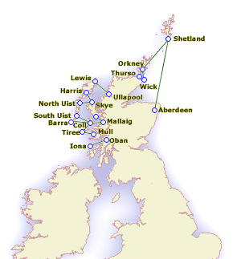
Initially this was a smaller scale system of warlords, with many clans vying for the same pieces of land. Eventually, around the 15th century the Scottish Kingdom began to make claims to the land, and having the power to do so, anchored the clan chief’s loyalty to the Scottish Crown. The clan chiefs let sizeable pieces of land to a tacksman, an intermediate vassal on par with a knight, who did not actually work the land. The tacksmen then divided the land they were given amongst the lowest levels of clansmen, the tenants, crofters, and cottars. This pyramid system brought with it many advantages when it came to raising armies, for not only could Kings quickly leverage these men by merely convincing the chiefs, they could also guarantee the soldiers’ loyalty to the commanding officer (essentially a minor chief or the tacksman) within each Highland Battalion. The power to raise an army quickly could not be overlooked at a time of tensions between England and Scotland.
By the 18th century, the distinction between a clan chief and a landlord was mostly non-existent. Any landed proprietor had the ability to muster a force from his tenants, in essence making him a minor chief. A pyramid of power dependence still owed to the Crown, but now the relationship between the landowners and tenant farmers had become more civil and based less on ties of kinship. However, despite the slow disintegration of the traditional chief overlord, the rents paid and the expectations upon the tenants still remained.
Map 1: Major Regions of the Highlands. http://www.land-care.org.uk/tourism/current_topics/2003/march2003/harris_ferry_27_03/harris_ferry_27_03.htm. Accessed December 2, 2015.
This was in part because those who served the clan chief benefited as well. A chief did not reign as a tyrant, but depended upon his subjects. Any fights between clans would be settled by show of force. The chiefs increased their local power and security by rallying more clan members to their cause. Because of the dependency of the chief upon his subjects, the land allotted to the clan members was given at a very reasonable price, mostly military service but also payment in produce of some kind. Thomas Douglas, Earl of Selkirk noted how as late as 1805 the prices that the Highlanders paid in rent to their chiefs (who were essentially landlords at this time) was significantly less than the amount paid for that same parcel of land elsewhere in the British Isles. By providing low rent to his tenants, the landlord guaranteed himself the ability to muster a reliable force very quickly. For many chiefs the idea of cash income proportional to the properties worth seemed secondary to that of military capacity. One clan chief, MacDonell of Keppoch, claimed his rent roll was “500 men” rather than pecuniary. The power being dependent upon the number of men as followers meant the chiefs had to sacrifice potential gains in rent in return for the loyalty of their subjects.
The extension of this system into the 18th and 19th centuries saw Highland tenants paying extremely low rents for properties that had the capacity to produce a great deal more in wealth for the landlord. As the 18th century progressed it became apparent that the production value of the land was increasing dramatically without parallel increases in rents, and traditional grain and tenant farming was no longer a sufficient revenue source for landlords; it was necessary to expand the amount of land used. This saw the non-arable sections of land that were too rough or extreme for traditional grain farming effectively be used to graze cattle. More land was to be used in order to increase the amount of goods that could be produced by one’s entire estate. More potential wealth for the landlord was also more potential wealth for the Crown in tax. With the rise of prices for wool, many lands saw the addition of sheep alongside the cattle. This eventually became the most important resource of the Highlands.
By the end of the 18th century the process of specialization and industrialization had taken place in most other parts of England, Wales, and the Scottish Lowlands, but the Highlands remained difficult terrain to traverse. The Caledonian Canal, arguably one of the first real opportunities for Highlanders to be connected to the rest of Britain and Europe, was not even completed until 1822. Due to the lack of improvements in all areas the Scottish Highlands were still a remote land to penetrate. Markets were limited to more localized regions. This phenomenon is explained as circular monopolies. Because of the limited nature of transport due to the lack of improved roads, most every town had a monopoly of some sort on the surrounding area. All goods that were to be sold by a tenant near a town would be sold only to those able to buy from that limited market. This limited market helped keep the necessity of improvement due to competition, as Adam Smith would have explained it, from ever happening. The free markets certainly existed but were just limited geographically. As the transportation system grew and systems of improved roads, railways, and the canals eventually began to free the Highlands from their isolated nature, the expanding markets began to feel the price shifts of certain goods, and many tenants and landlords began to feel the need for specialization in order to compete. Coinciding with these market shifts, events abroad began to shape the markets for the Highlands.
Competition in international markets created by the industrial revolution was one of the external factors affecting the Highland economy. Because of the length of time other regions had for specialization, they held an advantage in mass producing cheap goods such as textiles in the North of England. With the connections being made into the Highlands, these low prices were now available to northern markets. Although an influx of cheap goods is generally an opportunity sought by many to save money through expense reduction, the Highlanders had been known for some time to be very self-reliant. Adam Smith alluded to the economic backwardness of Highlanders by noting how “every farmer must be a butcher, baker, and brewer to his own family”. This lack of division of labor was part of what made the Highlands so vulnerable to the influence of outside markets. Although the cheapness of certain goods such as textiles had little effect on savings for the average tenant family, the lack of ability to sell goods at the market due to increased competition played a significant role in pushing for more income from other sources.
The French Wars, during the end of 18th and beginning of the 19th centuries, additionally affected the Highland economy. Although the American Revolutionary War had caused some disturbances to the markets, the French and Napoleonic Wars at the turn of the century created an opportunity for the Scottish Highlands to specialize. Due to the volatility of foreign markets for imports as well as the increased need for supplies for the military, the prices of homegrown cattle and sheep began to rapidly rise. Additionally due to cut off supply chains the need for local fish markets increased, assisting many of the coastal regions in providing some seasonal work for tenant farmers. Shore fishing was the preferred method of the Highlanders. Herring and shellfish became common side occupations for many of these crofters. The price for kelp and timber also increased during this time.
With the most notable increase being in sheep and cattle, the tenant farmers began to use less of their arable land for subsistence and increased the amount of grazing fields or put the arable portions into the production of feed for the stock. This helped to hold over a surplus stock during the winter months. The increased reliance on specialized farming to maximize the amount of livestock left the tenant farmers less able to cope later on when the prices would fall, but for the time being the advantage would be taken. The amount of wealth being produced by the increase in prices allowed for a subsidized form of agriculture to form, one that could support a population increase not traditionally allowed by cereal grains. This meant that a portion of the population was being supported on the assumption that the prices were going to stay at their current levels indefinitely. To compound the problem of increasing the number of livestock, the tenant farmers were able to further reduce the amount of arable subsistence necessary by introducing the potato as a portion of their diet.
The introduction of the potato allowed for the population to begin a second boom even during the switch of industries in the Highlands. As the prices for Highland goods increased, the potato became a staple crop, providing far more calories for families than traditional grains. Originally, Highlanders had rejected the potato. Clan chiefs and tacksmen were expected to provide supporting produce to their tenants in times of famine in the pre-1745 clan system, reducing the apparent need for the potato. Mass introduction of the potato throughout Highland parishes between 1740 and 1770 combined with the beginnings of clearance behavior on many estates saw a quick rise in the potato as a staple part of the diet allowing continued population growth. Between 1801 and 1841 the population of the Isle of the Skye rose by 42 percent; and this during a time of minor clearances on the island. The potato transformed the ability of the subsistence farmer to put not only less land to use for sustenance, but also less time and effort. This meant even more time for either grazing or seasonal work.
Possibly the greatest example of the boom and bust that happened in the Highlands came in the form of the seasonal work of kelp farming. Up until between 1810 and 1820 kelp was a source for an alkali extract that was used in making soap. The kelp farms that existed in the coastal cities of the west Highlands became increasingly important at the start of the Napoleonic Wars. The traditional region for kelp farming had been Spain; however, with Spain’s alliance with France and the subsequent conquest by supposed ally, Britain’s source for imports was stifled. This caused kelp prices to nearly double in the ten years up to 1813. It would have seemed to the tenant farmer that the previous lack of industrialization had actually come to their advantage at the start of the wars. The increase in kelp prices naturally created a demand for kelp farming laborers. The process of producing the alkali from the kelp requires an intensive amount of manual labor. Hands are required in harvesting the kelp at sea, then pulling it ashore and burning it, and finally collecting the reduced ashes which were used to make soap alkali. This intensive process meant that the spare hands being created through crop reductions on tenant and crofter farms could be given surplus seasonal work kelp farming. An additional problem for the tenant farmers of the coastal regions was their dependence upon their landlord for marketing their goods. Because the landlord was the link for many of their tenants good to the greater markets, they were able to raise rents, or alternatively lower the pay, for the amount of kelp sent to market. The offseason labor only provided the tenant and crofter with a minimal amount of extra cash; with the landlord keeping the majority of the profits. The opportunities provided by kelp farming and the fishing industries only delayed the symptoms of a high population and failed to provide a lasting solution.
Once the prices for sheep, cattle, and kelp had all risen during the bubble of the warring period, the apparent end of the wars acted as the pin to burst it. After 1813 with the Napoleonic wars nearing their end, international markets began to open up once again, and the prices for most imports dropped to pre-war levels. No longer was there a surplus income from the prices of cattle and sheep being bloated. By 1830 cattle prices were half of what they had been in 1810. The reduction in kelp prices was even more significant as it too was halved, but by 1820. The Spanish market took back the leading role in kelp farming, and after the industry in Scotland had fallen a new method for procuring the alkali from salts completely eliminated kelp farming as an industry altogether. In order to combat the falling prices the farmers performed the natural step of producing more. In order to keep the income level at the same rate, tenant farmers had to squeeze every bit of arable land into production of livestock, the one remaining industry that had not completely collapsed.
This was the famous shift to sheep farming. Although the demand for sheep, both their mutton and their wool, had dissipated some after the international markets were freed up once again, they still remained the most profitable options available. Landlords had realized for some time that the most efficient way they could attain more in rent from the tenants was to actually promote their removal to some extent in order to maximize the amount of livestock the land could carry. Additionally, by making the switch from cattle to sheep, they could increase the amount of livestock available to sell. Sheep were far more efficient at grazing the mountainous regions and were hardy and well suited to the weather. The Agricultural View of the Northern Counties stated that “for every pound of beef that can be produced in a hilly district, three pounds of mutton can be obtained”. Sheep had the ability to turn more of the herbage that they consumed into meat and wool. They also possessed the ability to graze somewhat during the winter months on the minor vegetation that remained. Cattle were far less suited for the hilly terrain and climate and required more winter feed to be grown by the farmer. The great discrepancy became more apparent as the 19th century progressed and the knowledge of the value of sheep over cattle became more widespread. Another consequence of the sheep herder over the cattle farmer was the amount of land required for sheep. In order for sheep to be effectively grazed they must be consistently moved about in large units over large tracts of land. A tenant farmer would need only a few cattle for a profit to be made at market, but a shepherd only brought equivalent profits when there were large tracts of land to graze the sheep over. This led to many tenant’s rental units no longer being parceled in as many portions as previously. Throughout many parts of the Highlands this would be where violence finally erupted.
As Highlanders were asked to leave their homes, because the land was not owned by them, many refused to leave. After rental agreements were not renewed, many who lived on the land felt betrayed; their families had been farming these properties for hundreds of years in many cases and rental agreements simply had never existed formally. The most famous example being that of the Sutherland evictions in which violence resulted when tenants were physically removed from their houses and the buildings along with the possessions inside burned by the factors hired to remove them. Although for the majority of Highlanders this sort of violence did not exist, the sentiment from most of the proprietors for the tenants to leave was certainly extant.
For the Scottish Highlanders, the end of their traditional lifestyle was becoming ever more apparent. Modernization had worked its way through the glens of the Highlands and opened their closed lives to the volatility of the open markets. As the system of clansmen, tacksmen, and chiefs slowly amalgamated into the modern system of proprietorship, those who were landed and held the capability of earning rents realized the potential income they were missing. With the forces of the free market more at play to determine the vocational direction, most landowners opted for raising beef and mutton in order to serve the southern markets. The industrial south of Britain modernized and its cities grew. The demand for these raw products in turn grew with it; this created a self-feeding cycle of which demanded more and more property left for grazing. This system of providing raw materials was similar in fashion to that which would form in many of Britain’s early colonies as well. As landowners demanded more rents from properties the renters were forced to look for supplementary income. By “luck” of international warfare, the sudden increase of demand for traditionally imported goods, in the Highlanders’ case specifically sheep, cattle, fish, and kelp, created that needed opportunity for seasonal work and allowed for a minor labor migration to the coastal regions during the summer. This seasonal work and the coastal towns that formed to support the burgeoning maritime industries only exacerbated the problem when the collapse of the industries ensued after markets reopened. With the exception of wool to some degree, every industry the Highlands had taken up in the fifty years before 1810 peaked in that year and then crashed sharply at first with a continued steady decline over the next several decades. With many tenants already having their properties reduced to areas only capable of minimal subsistence, they were left with the choices of guaranteed poverty or emigration south or to one of the colonies.

Emigration to Canada
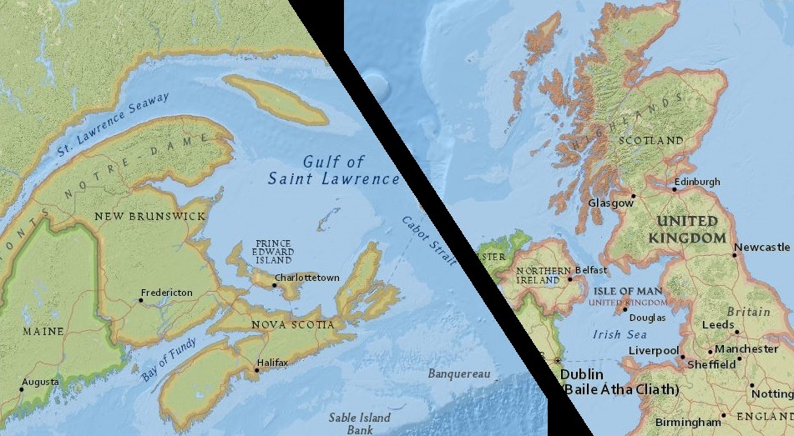
The process of emigration had begun long before the situation in the Highlands had reached its boiling point in the early and mid-1800s. In fact a trickle of emigration had been occurring even before the period of the Highland Clearances and would continue after as well. Staunch idealists and rebellious Highlanders had emigrated after the failure of the Second Jacobite Rising in 1745. Additional localized famines destroyed the potato and grain crops, leaving emigration an ever more enticing alternative. Although the tone of the Highland Clearances has taken on the most visual image of landlords forcibly removing their tenants, the reality was more the opposite. Most tenants that migrated during the 18th and 19th century did so voluntarily to escape the destitute situation. For most of the poor, this change of habitat did not actually mean leaving the British Isles.
Map 2: Greater Regions of Prince Edward Island and Scotland. Map created by author courtesy of: http://mapmaker.education.nationalgeographic.com. Accessed December 3, 2015.
The vast majority of all those that migrated from the Highlands simply went south to work in the growing industrial cities. This trend began early in the first stages of the Clearances. Between 1760 and 1775 only three percent of Scotland’s population actually emigrated out of Scotland. The easiest choice for many to make was also the economical one; the industrialized Lowlands and England were eager for workers. But Highlanders found it difficult to adjust. A friend of Lord Selkirk informed him how when they recruited families from the Isle of Mull, only the children were of use in the factories of Glasgow. Additionally, in Glasgow especially there was intense competition upon arrival against the cheap labor flowing in from Ireland. Some Highlanders had been slowly introduced to the industrial life through seasonal work in the factories of Glasgow, but the increased flow of Irish emigrants, along with some Lowlanders making Glasgow their permanent residence, pushed more competition into the market creating a wage gouge in favor of employers. While being the cheapest choice, the Highlanders were still left vying for the lowest wages; albeit in a new environment to which they had some adjustment issues. For those migrants still wanting of Gaelic life, community, and culture, the more enticing choice was emigration abroad.
In the latter half of the 18th century a strong link between the West Highlands and Nova Scotia formed, pairing the two and eventually acting as a beacon for future emigrating Scots from all over their homeland. As the thought of emigration to America spread throughout Scotland, the desire to still remain in familiar communities also kept the variety of destinations fairly limited. After 1775 most of the Scottish emigration went to British North America from the Colonies. As much as movement to North America offered a fresh escape, the draw of kindred and clan was still very strong, and many Scots moved in chain-migrations or communal emigrations. Many larger emigrations were led by the tacksmen of the former lands. Being the middleman, the tacksmen often had enough accumulated wealth that they subsidized the voyage for all of their tenants and clansmen who were directly under them; essentially transplanting the entire community. Despite these efforts the clan system did not survive wholly intact into the Maritime Provinces, with most communities in a few generations becoming landed themselves and not dependent upon a tacksman.
Because of this propensity to travel via communal relations to parts already settled, the Canadian immigrants remained mostly in and near the Maritime Provinces, preferring poorer land and conditions within the vicinity of their community rather than better lands further away. There are many instances of Highland emigrants choosing to travel to their families in Nova Scotia, and further up the St. Lawrence River, despite finding opportunities to own property elsewhere. Early immigrants in Prince Edward Island also made this choice to continue past what was considered first rate land in Lots 57 and 58 in 1775, as they moved out of the lots and to the community developing in Pictou, Nova Scotia. Communal relations took great precedence over many other factors that should have otherwise deterred would be settlers. Of course, settlement via communal ties brought with it the religious affiliations of Highlanders. Presbyterians, Baptists, Methodists, and Catholics all came in groups and settled in slightly separate regions from one the other.
Although the majority of Highlanders were still heading to the southern industrialized regions of Britain, emigration abroad was striking fear in the eyes of landlords back home. In 1803 after pressure from these landlords in parliament they passed the Passenger Vessel Act, which required better conditions, such as food provisions, a doctor, etcetera, to be provided to all the passengers aboard a ship sailing to any colonies. The real reason for passing the law would be admitted later and found out as an effort to stem the flow of population from the Highlands by the very poor. By passing this act the price of a voyage across the Atlantic more than doubled from £4 to £10 per person. This pushed the cost just out of reach of many of the poor. They had already struggled before to pay for the trip by selling all of their belongings before they left, but now the additional cost was nearly unfeasible. This is where subsidization by tacksmen and the timber trade with Britain helped to continue the flow of emigrants, albeit at a lesser rate. As ships dropped loads of American timber off at the shipbuilding ports of Great Britain, they sometimes left with unregistered Highlanders in tow. With the end of the Napoleonic Wars a decade later, emigration continued again at pre-war levels, as sponsors subsidized the extra cost of the voyage.

Prince Edward Island
Previous to the 1750s, the Maritime Provinces of North America were unavailable to the British. These territories, at the time known as Acadia, were ceded to the British at the end of the Seven Years War. Prince Edward Island, known at this time by its Acadian name Ile St. Jean, was part of the transferred territories. Inhabited by approximately 5,000 Acadians and the Mik’Maq Natives at the time of cession, the British General Jeffery Amherst deported all but around 300 between 1758 and 1763. Even though the populations had been mostly concentrated around a few central villages and towns, this deportation left the island mostly empty.
Over the next forty years the island experienced a number of changes. The British divided the entire island into 66 lots or Townships. The lots were then given away through a national lottery to prominent members of government back in England. Though the intention was for these prominent figures to promote settlement on the island by sponsoring lower class passengers from British colonies, the result was far less compelling. Very few made any effort at all to improve their lots or send any passengers over with the exception of several boats of Highlanders landing on the north and east shores of St. John’s Island, the Anglicized Acadian name. For the most part, and especially with regards to Lot 58, the lots were left unattended by their proprietors who were supposed to be paying taxes. The properties went through several cycles of distrains and lotteries and sales until a more successful class of proprietors was found at the end of the 18th century.
The notable figure in the new wave of proprietors was that of Lord Selkirk. After inheriting his father’s fortune, Selkirk bought out a number of proprietors on the Southern and Eastern portions of the island amassing nearly 150,000 acres of land. His first groups of settlers, brought in 1803, were almost all Highlanders from the west Highlands and the islands of Skye and Uist. These first groups of Highlanders were wealthy enough tenants that they could buy the rest of their rental lease in Scotland, but this left little wealth to survive on once they arrived at Belfast, the new settlement they would create on the border of Lots 57 and 58 in Prince Edward Island. The Belfast name was given to the property in around 1770 by the previous proprietor, this around the time “New Ireland” was in the running for future island names. New Ireland as a name was rejected by the British government in 1780. Selkirk bought provisions for his tenants and encouraged already settled Islanders from the northern lots to assist in both clearing and teaching the new arrivals. Possibly the most contrasting difference between Selkirk and the previous sets of proprietors was his generosity with his properties.
Lord Selkirk’s intentions were not to act as landlord but to actually sell the properties off to the settlers themselves in due time. He even made no issue over squatters settling on some parts of his Lots 57 and 58. Most settlers elsewhere on the island continued an existence early on as tenants. Lots 57 and 58 were distinct from the rest of the island early on with the majority of residents becoming fee simple landowners. The desire to be landed was not restricted just to Prince Edward Island either. The majority of clansmen that applied for land grants in Glengarry County, Southwest of Nova Scotia, would be approved between 1800 and 1820. An island wide Escheat Movement would be attempted in the 1830s in an effort by many of the tenant farmers to rid themselves of the new absentee landlords. Most of the proprietors lived abroad in Great Britain.
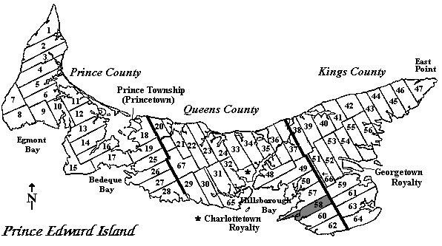
Map 3. Lot Map of Prince Edward Island with Lot 58 highlighted in the bottom right. http://www.islandregister.com/lotmap.gif. Accessed November 26, 2015. Map edited from original by author.

Censuses of Lot 58
Throughout the first half of the 19th century the Highlanders in Lot 58 were joined by even more immigrants. Retaining their communal habits, they sorted themselves by religion, family, and even land tenure. Lot 58 itself offers a total of 18,880 acres of available land. By observing the initial habits from the first extant reliable census of Lot 58, the census of 1841, we will discern both the patterns that remain and those that change over the course of seventy years.

1841 Census
The first census to be looked at took place thirty-eight years after Lord Selkirk’s first landing. Although the enumeration only takes into account the head of household and mentions the others in the family only numerically, it records a wide array of useful information; from vital statistics such as age range, gender, and occupation to religion, land ownership, agricultural statistics, and birthplace. The population in 1841 is an even 700 with the enumerator remarking that the majority of these people are living near the coast and rivers. The enumerator recorded only the name of the head of household including all others living there through only numerical count. There are only 100 recorded heads of household and 63 of these are holding their property in fee simple. It is important to note that after I remove the predominantly Irish families, chosen as such by having both the majority of their family from Ireland as well as Roman Catholic as their majority religion, the maximum possible Scottish households drop to 89 with a population of 649. Only 17 households of the 89 are renters, averaging 82 acres per family at less than one Shilling per acre in rent.
Interestingly the records of religion compared to land ownership show very communal habits. The majority of Irish, the ones I removed from earlier numbers, appear to be located in one region of Lot 58 and all of them are renters and Roman Catholics. Because there are no addresses or locations provided on the census, the clustering of peoples must be determined by their placement on the census register itself. A household that is next to another is in turn recorded by the enumerator on the next available line. Thus, a distance of one line between two similar names likely means the two households are relatively near each other. This does tell us exact distances or directions these households live from one another, but it does provide evidence for the broader patterns of settlement. Looking at this ordering of families in the census, the origins of the families switch to Scottish but remain Roman Catholics. Continuing it blends into a large renter community of Scots with the Church of Scotland, eventually blending into free-holding Scots. Judging by the distribution of religion amongst the Scottish elsewhere in the census, it is unlikely that the enumerator made any concerted effort to single out the Irish or Roman Catholics all at once. This is just the major example of the settlement pattern.
The greatest correlation for settlement pattern seems an obvious one, family name. The distances describes in this portion of study are the number of lines of separation on the census itself. Of all the Scottish households listed that share their surname with at least one other household, the average distance is 4.8 lines on the census, but this number is thrown off by five outlier families. Removing those five leaves the average at 2.6 lines distance from a repeat surname. It is important to remember that there are one hundred households recorded 89 of which are Scottish. The median distance is by far only one line. There is no guarantee that the listing of these households is done with any correlation to the geographic distribution, but it is highly unlikely to assume that the enumerator would once again go out of his way in order to mark down the similar families while crisscrossing the Township. Additionally, comparisons to the earliest datable Lot Plan map from 1880 show the Irish enclave in the center of the lot. Although possible, it is unlikely these families rotated properties within the Lot itself after ownership. Overall, the first influence affecting location choice was family. After which they grouped themselves by rental or owned properties and by religion.
Because the majority of the population are of the Church of Scotland, the outliers tell us the most about settlement pattern. Roman Catholic being the second largest religion in the Township, all Roman Catholic families are located in one region in the Irish neighborhood. A Roman Catholic family is again defined as a household in which the majority of the members are Roman Catholic; this hones the data by removing households harboring only one Roman Catholic and nine members of the Church of Scotland, a Presbyterian church. None of the Scottish Roman Catholics have similar surnames to any others, and thus all but one household has chosen the Irish enclave. The geographic distribution was very similar in the Highlands as well. By 1800 Presbyterianism had left only a small concentration of Catholics in the West Highlands and Islands and several communities of Episcopalians in the northeast. There was certainly some religious carryover. The Baptists are an interesting comparison to the Scottish Roman Catholics because they do have households with similar surnames living in the lot. Their households are all majority Baptists, but they are all spread far away from other Baptists and near others with the same surname. It seems again the communal pull is the driving force.
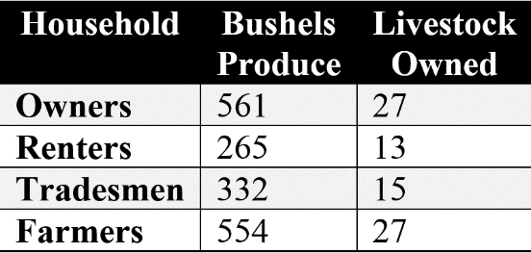
A look at the occupations the Scots have chosen is another indicator of their past. Fifty-six heads of households have “Farmer” listed as their occupation, but the actual percentage of that is certainly much higher. Crop production is listed for all households, and even those that have an alternate occupation listed have some crop production, albeit less than those listed as Farmers. These numbers may be skewed when taking widows into consideration as well. No occupations are listed for the five widows in the Lot, but their agricultural produce is on par with other households listed as Farmers, so it is likely that these families too were farmers. This brings the total to 61 households out of 89 that are farmers.
Table 1: 1841 Agricultural Production. Created by the author.
Of the alternative occupations, everything from Tavern Keeper to Taylor is covered. Of note there is only one household with a maritime industry associated with it: a ship carpenter. The comparison of the alternative occupations, which I will dub “trades”, becomes more interesting when looking at property ownership. Of those that are squatting on a property, meaning they are neither renting nor owning, not a single one is listed as a farmer. Of those who are renting their property, nine of the seventeen have trades listed. These may be the cotters. Their arable land was on average ten acres fewer than that of the free-holders, but their crop production and livestock were half that of the property owners. When the tradesmen are singled out, regardless of ownership or not, there production increases slightly. For the former cotters and crofters of Scotland, this part time lifestyle would have been very familiar.

1861 Census
The census of 1861 provides much the same data as the previous. It adds some information for smallpox vaccinations, marital status, more details for crops and manufactures, and offers split options for Canadian Presbyterian or Scottish Presbyterians, called the “Kirk of Scotland” on this census. As an interesting note nearly all the unvaccinated population is Irish.
Twenty years on, many parts of the township are close to if not the same. The Irish enclave still existed, although all but one Scottish Roman Catholic family had disappeared. The one household that remained is located near their surname. There were 1,284 people recorded with 1,070 Scottish, 280 Irish, and four English; ethnicities determined again by cross-referencing religion and birthplace. The rapid increase in population as well as the loss of the evident Scottish Roman Catholics may be explained by the intermarriage of the groups. Many of the Scottish Catholics’ population were women born on PEI and were under the age of sixteen in the 1841 census, so their intermarriage to an Irishmen would not appear blatant on the 1861 census. This explains why the population within the Irish enclave of those born on PEI increased by 1,800% in only twenty years with zero new immigration from Ireland. Scottish immigration did not slow during this period. Between 1841 and 1861 Scottish foreign nationals increased by 159% while their native born descendants increased by 284%. Proportionally, the Irish would appear to have outpaced them with an overall increase in population by 409%, although these numbers may be slightly skewed due to that loss of the detectable Scottish Roman Catholic population.
The occupations have interestingly swung drastically away from trades. Ninety-four percent of Scottish households in 1861 are listed as farming households. Ironically, the increase in immigrants may have diminished the production of farmers. On average the 1861 farming households had one more acre of arable land compared to 1841, yet produced 149 bushels less produce for the year. They also showed a slight decrease in livestock kept, dropping to nineteen livestock per family in 1861 from twenty-two in 1841. The households listed with trades fared much better in their agricultural pursuits than those listed as farmers. On average a trades household produced 417 bushels of produce and held 27 livestock. There are other manufactures listed that may have helped to cover the cost. Roughly thirty-six yards of cloth were produced per family as well as 45 pounds weight of butter and cheese. An additional 2.6 tons of hay per family would have fetched £5/12s according to retail prices from 1851. To put that into perspective, the average rent for 100 acres in 1841 on Lot 58 was £4/1s. It is possible that alternative means of subsistence may have been enough to survive for the newcomers.
Additional help to this apparent lack of income can be better understood in view of the property situation. Of the 191 households in 1861, 161 owned their property outright. Only 21 properties were rented and of these, three households were renting lands in addition to their owned properties, leaving only 18 households dependent on their rental property representing a full range of age groups. This meant property ownership increased by 16 percent over the twenty year period. Free-holding meant an owner could get by without owing a proprietor. With the Land Purchase Act still fifteen years away, all of the former Selkirk properties were years ahead of the rest of the island in free-holding.
There was also a break from the standard for education. Highland tenants were not renowned for their educational practices outside of the church, but in Lot 58 the number of schoolhouses actually grew faster than the number of churches. For the first several decades of the 19th century, the predominantly Highland regions of British North America placed little emphasis on education. This was no doubt due to the issue of survival for the new immigrants; necessity calling for economic priorities. But in the middle decades there was a surge throughout the Maritime Provinces in educational reform. While only one church was built in Lot 58 since 1841, three more schools went up around the Township. This would be needed to aid the burgeoning population of native born Islanders.

1881 Census
The last census to be reviewed comes nearly eight decades after the settlements of the Selkirk Highlanders. Unfortunately, it also provides the least amount of data, taking no information regarding land ownership and agricultural production. It does, however, provide individual enumeration for each family member. Most often it only provides information of occupation on those over sixteen years, but it includes whether the individuals are in school along with the occasional woman’s occupation; wholly devoid in the previous two censuses. It also offers the first ethnic data, describing the major groups as English, Irish, and Scotch helping to remove some of the guesswork of their ancestry.
The census of 1881 records an increase in population of only 61 people since 1861 to a total of 1,343. The census of 1881 and 1891 would be the peak populations for Prince Edward Island. Emigration from the island to western Canada as well as to the United States would draw not only residents of the island, but also what remained of the potential emigrants from Scotland. Although land ownership is not provided for Lot 58, the rest of the island reached its near height in free-holdings in 1881 with 93.4 percent owning.
The traditional grouping of the Irish enclave finally begins to show some diffusion in the 1881 census. One Catholic Scottish family remains, but it is a new family married in from Nova Scotia. Catholics and Canadian Presbyterians, Scottish Presbyterians, and especially family names still show some regionalization according to their position on the census, but they are far more interwoven than in 1841.
Although the populations have changed little, the religious affiliations have shown a dramatic swing. The previously referred Kirk of Scotland, now again denoted the Church of Scotland, shifted from 61 percent of the population in 1861 to barely 10 percent in 1881. Canadian Presbyterianism is what gathers the most converts as its numbers jump from 21 percent of the population in 1861 to 64 percent twenty years on. Catholics make a steady gain to 24 percent. This swing was likely due to the split of the Presbyterian Church of Canada from the Scottish Church in the 1840s. The non-existent Presbyterians in the 1841 census owing to this. After the reconsolidation of many of the Presbyterian congregations in North America in the following decades, the Church of Scotland again reunited with the Presbyterian Church of Canada. Although not a large theological change, it certainly describes the grander loss of connection that the Scottish ancestors of Lot 58 feel towards their ancestral home.
In looking at occupations of the census somewhat the opposite is found. The most variety of occupations to date are described and some offer multiple occupations. For the first time more than one household has someone listed in the maritime industries. In fact, the percentage of farming occupations has dropped to 58, while some involvement with the sea, either as sailors, shipbuilders, fishermen, etcetera, encompasses 32 percent of the Scotch population. Part time farmers, that habit of the former tradesmen and crofters, involves 15 percent of the Scotch population. Some women are listed as well. The criteria for listing a woman’s occupation appears to have required that she be unmarried, over the age of eighteen, and be involved in either weaving, dress making, or teaching. Twenty-seven women are listed with occupations the prominent of them being Dress Maker, though education is also a large part.
Although there is no listing of the number of schools, there are seven School Mistresses in 1881. There are also seven male teachers, and for the first time, four college students listed. All of the students and teachers are in their twenties and one thirty-three year old; none are married. They also cover all ethnicities and religions on the island, being spread fairly evenly throughout the census. If anything is to be inferred from these numbers, it is that the rate of growth for education since 1861 continued at around the same rate as the previous two decades.

Conclusion
Throughout, the examination of the censuses the overarching trend is one that is to be expected; assimilation. The emigration and population boon for Lot 58 really started to accelerate in the early 1800s and the pull of family drew in relatives from abroad. 1861 had the largest number recorded for residents born in Scotland, but this was still decreasing by proportion to the native Islanders. The settlement patterns integrated across the decades as well, with greater distancing from religious and familial ties. The Presbyterian nature of the Highlanders changed very little throughout their progeny, and the Catholic enclave proved a surprisingly close representative of Scotland’s religious proportions. As the 19th century closed the religious links were remade.
The Highlander’s plight has often been lost amongst its diaspora’s descendants. A group of people held by clan ties left their homeland were pushed to the economic threshold of survival in an unfriendly agricultural environment. Economic forces, technological advancements, and foreign wars crumbled the system they adapted to. Forced abroad they remained unified, until, the lure of opportunity combined with time pulled them apart as well. Of all the complimentary stereotypes attached to Highlanders, surely the most accurate would be adaptable.
Appendix A
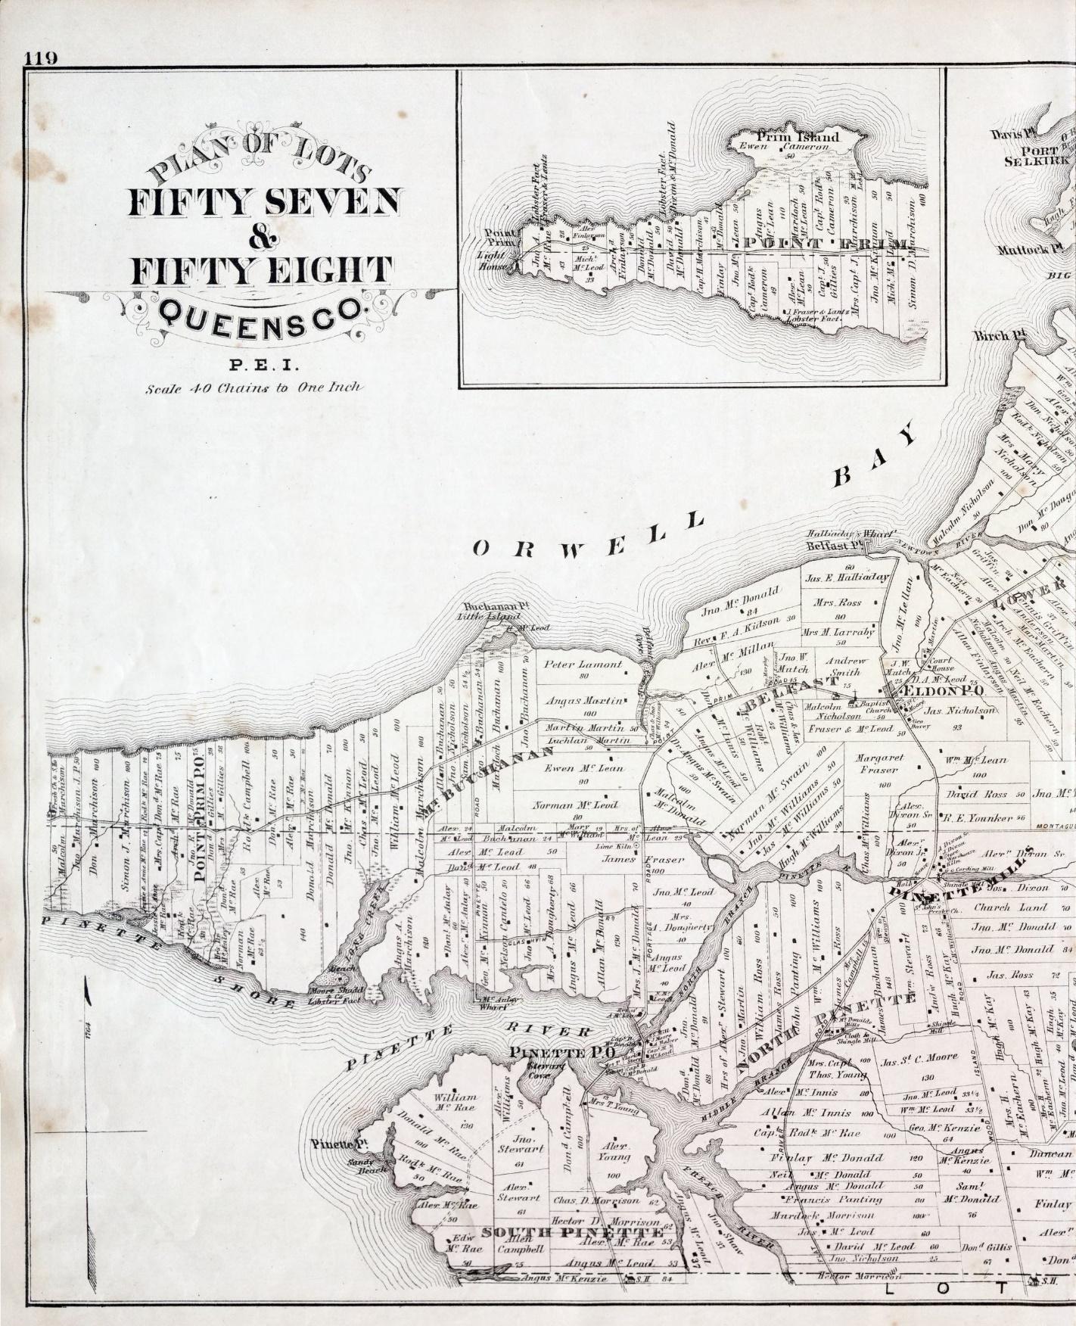
Map From Approx. 1880 with individual properties marked. Source: C. R. Allen, Plan of Lots Fifty Seven & Fifty Eight: Queens Co., P.E.I., Robertson Library, University of Prince Edward Island, Charlottetown, Prince Edward Island, Canada, accessed December 18, 2015, www.islandimagined.ca.

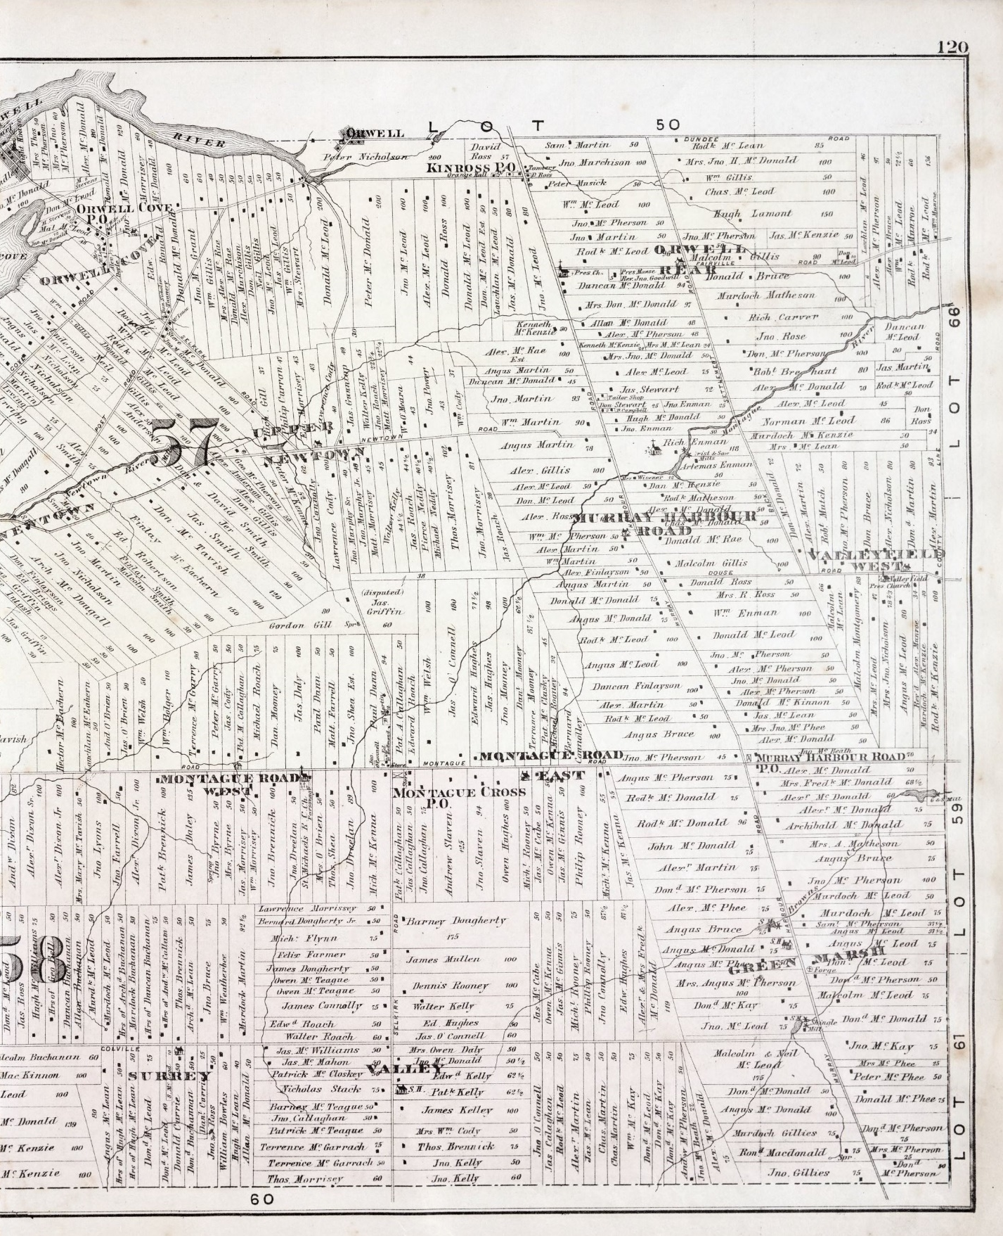
Appendix B

Page One from 1861 Lot 58 Census. Source: Ancestry.com and The Church of Jesus Christ of Latter-day Saints. 1861 Census of Canada [database on-line]. Provo, UT, USA: Ancestry.com Operations Inc, 2009. Library and Archives Canada; Ottawa, Ontario, Canada; Census Returns For 1861; Roll: M-898.

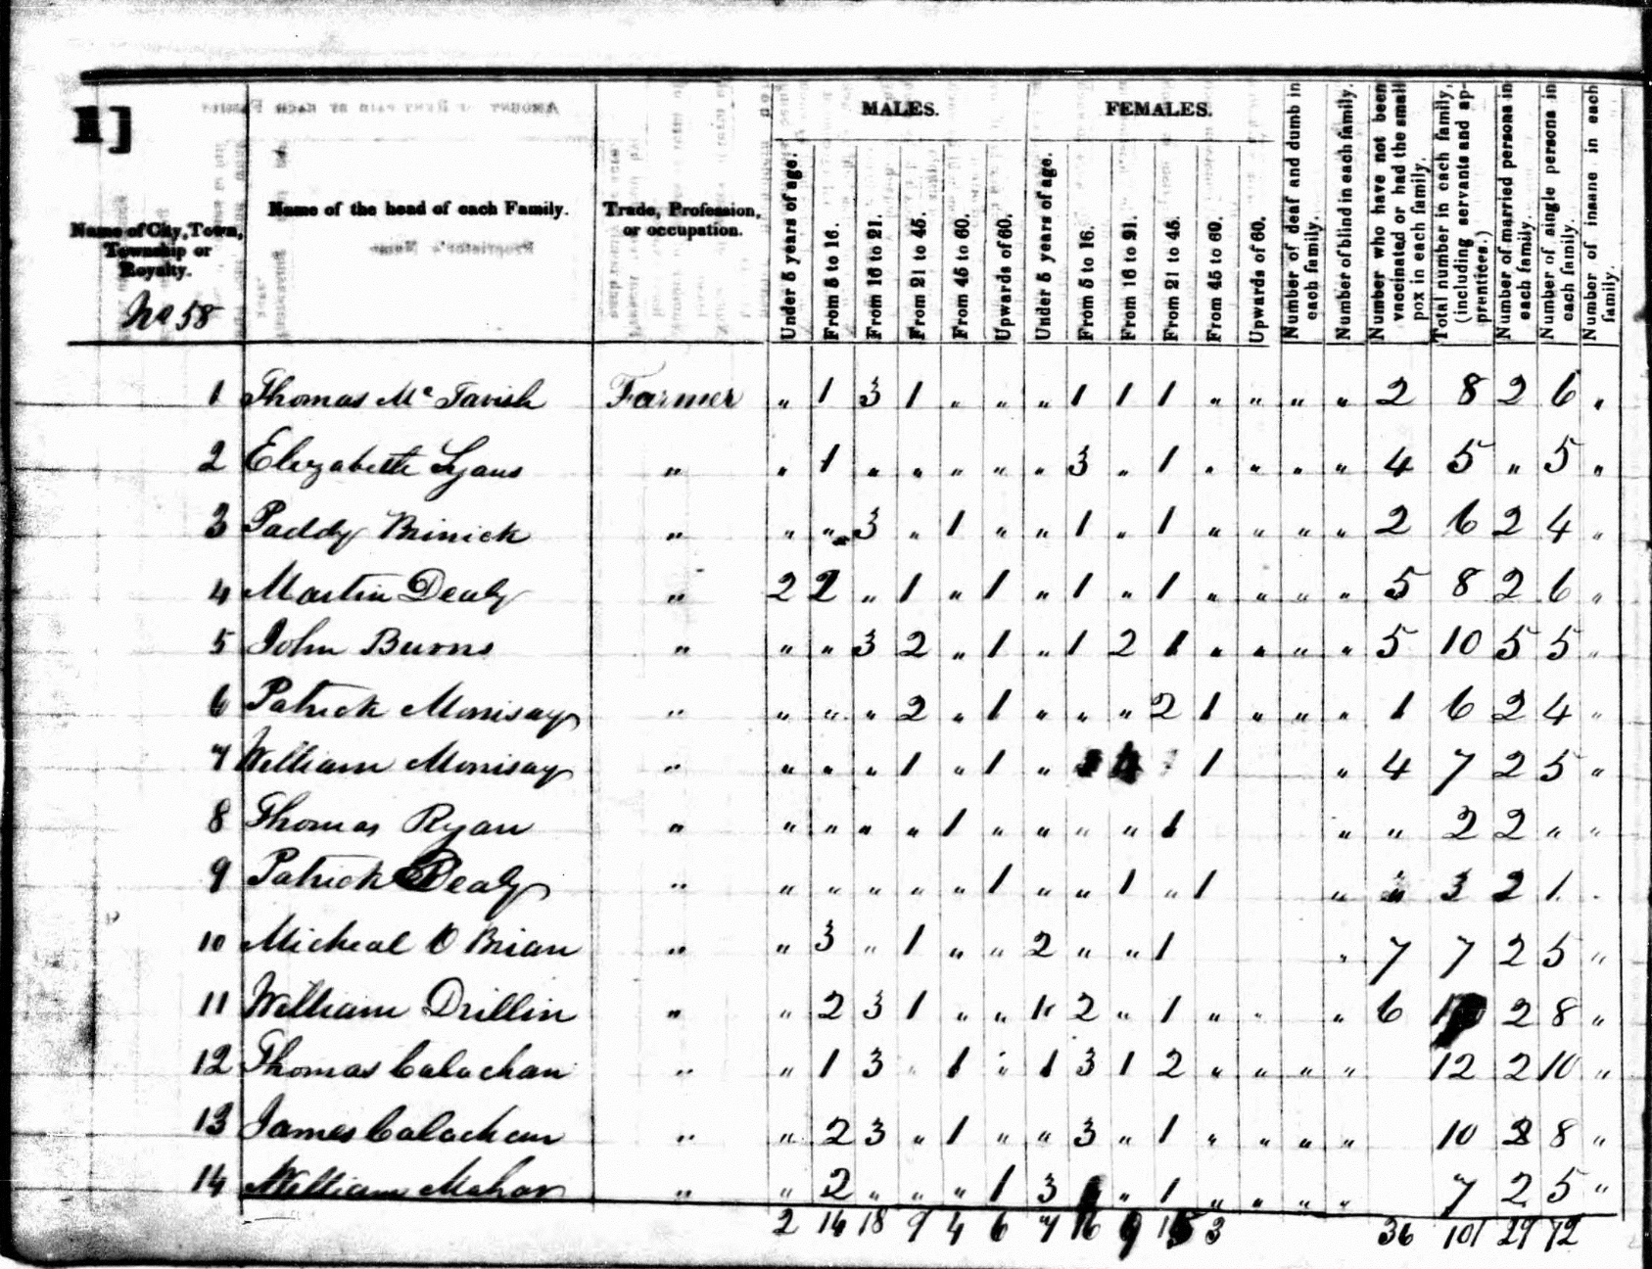
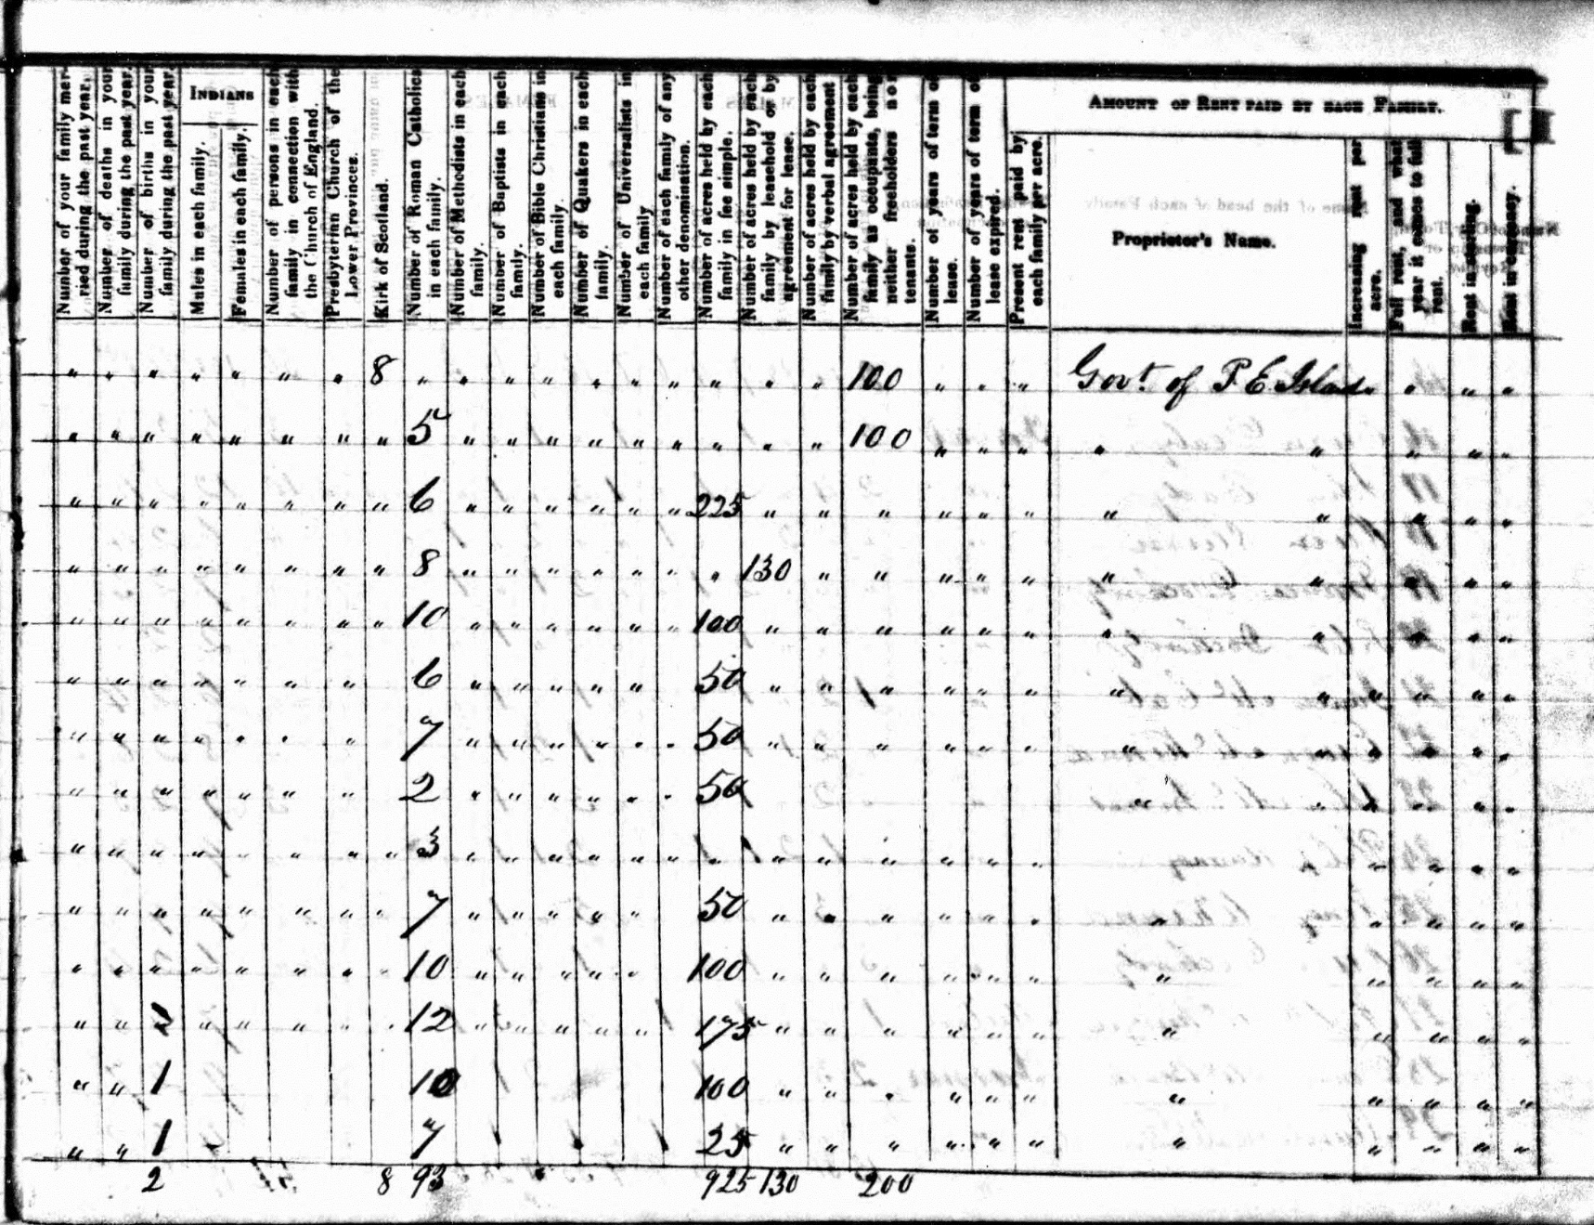

Works Cited

Censuses
Public Archives of Prince Edward Island. “1841 Census, Township No. 58”. Charlottetown, Prince Edward Island, Canada. Accession no. RG18.
Ancestry.com and The Church of Jesus Christ of Latter-day Saints. “1861 Census of Canada” [database on-line]. Provo, UT, USA: Ancestry.com Operations Inc., 2009. Library and Archives Canada; Ottawa, Ontario, Canada; Census Returns For 1861; Roll: M-898.
Library and Archives Canada. "Census of Canada, 1881". Ottawa, Ontario, Canada. Statistics Canada Fonds, Record Group 31-C-1, LAC microfilm roll: C-13164.

Additional Sources
Beaton, A. “On the Art of Making Kelp”. Transactions of the Highland Society 1 (1799): 32-41.
Bitterman, Rusty. Rural Protest on Prince Edward Island: From British Colonization to the Escheat Movement. Toronto: University of Toronto Press, 2006.
Bumsted, J.M. The People’s Clearance: Highland Emigration to British North America 1770-1815. Edinburgh, UK: Edinburgh University Press.
Campbell, D. and R. A. MacLean. Beyond the Atlantic Roar: A Study of the Nova Scotia Scots. Toronto: McClelland and Stewart Ltd., 1974.
Campey, Lucille H. A Very Fine Class of Immigrants: Prince Edward Island’s Scottish Pioneers, 1770-1850, 2nd Edition. Toronto: Natural Heritage Books, 2007.
An Unstoppable Force: The Scottish Exodus to Canada. Toronto: Natural Heritage Books, 2008.
Clark, Andrew Hill. Three Centuries and the Island: A Historical Geography of Settlement and Agriculture in Prince Edward Island, Canada. Toronto, CA: University of Toronto Press, 1959.
Clough, Monica and Eric Richards, Cromartie: Highland Life 1650-1914 (Aberdeen, UK: Aberdeen University Press, 1989.
Cowan, H. I. British Emigration to British North America. Toronto: University of Toronto, 1961.
Dodgshon, Robert A. From Chiefs to Landlords: Social and Economic Change in the Western Highlands and Islands. Edinburgh, UK: Edinburgh University Press, 1998.
Forbes, Duncan. “Some Thoughts Concerning the State of the Highlands of Scotland”. Culloden Papers: Comprising an Extensive and Interesting Correspondence From the Year 1625 to 1748; including Numberous Letters from the Unfortunate Lord Lovat, and Other Distinguished Persons of Much Historical Importance. London, UK: T. Cadell and W. Davies, 1815.
Gray, Malcolm. The Highland Economy, 1750-1850. Edinburgh, UK: Oliver & Boyd, 1957.
Hanley, Cliff. History of Scotland. Greenwich, CT: Dorsett Press, 1989.
Henderson, Captain John. General View of the Agriculture of the County of Caithness; With Observations on the Means of Its Improvement. London: Sherwood, Neely & Jones, Paternoster-Row, 1815.
Hunter, James. The Making of the Crofting Community. Edinburgh, UK: John Donald Publishers Ltd., 1976.
Island Imagined. “St. John’s Island Becomes Prince Edward Island”. Accessed December 15, 2015. http://www.islandimagined.ca/guides/discovery/st_johns_island.
Maclean, Marianne. The People of Glengarry: Highlanders in Transition, 1745-1820. Montreal, CA: McGill-Queen’s University Press, 1991.
Pacione, Michael. “The Geography of Religious Affiliation in Scotland”. The Professional Geographer 57, no. 2 (2005): 235-55. Accessed November 30, 2015. www.ebscohost.com.
Richards, Eric. A History of the Highland Clearances, Volume 2: Emigration, Protest, and Reasons. Sydney, AU: Croom Helm Ltd., 1985.
Salaman, Redcliffe N. The History and Social Influence of the Potato. 1949. Reprint, Cambridge, UK: Cambridge University Press, 1985.
Schaff, Rev. Philip, ed. A Religious Encyclopӕdia: Or Dictionary of Biblical, Historical, Doctrinal, and Practical Theology. Based On the Real-Encyklopӓdie of Herzog, Plitt and Hauck. Vol. 3. Toronto: Funk & Wagnalls Company, 1891.
Selkirk, Thomas Douglas, 5th Earl of. Diary, August 13, 1803 – October 1804, Prince Edward Island Public Archives. Charlottetown, Prince Edward Island, Canada. Accession no. 2534, item 19.
Letter to Dr. McAulay, Prince Edward Island Public Archives. Charlottetown, Prince Edward Island, Canada. Accession no. 2690, item 5c, 6c.
Observations On the Present State of the Highlands of Scotland, with a View of the Causes and Probable Consequences of Emigration. 2nd Edition. Edinburgh: J. Ballantyne & Co., 1806.
Smith, Adam. An Inquiry into the Nature and Causes of the Wealth of Nations: With a Life of the Author. Edinburgh: William Creech, 1806.
Stewart, Major General David. Sketches of the Character, Manners, and Present State of the Highlanders of Scotland; With Details of the Military Service of the Highland Regiments. 3rd Edition. Edinburgh, UK: Archibald Constable and Co. Edinburgh, 1825.
Wagner, John and Anthony Davis. “Property as a Social Relation: Rights of ‘Kindness’ and the Social Organization of Lobster Fishing Among Northeastern Nova Scotian Scottish Gaels”. Human Organization 63. No. 3 (Fall 2004): 320-33. Accessed November 18, 2015. http://search.proquest.com/docview/201162978/fulltextPDF?accountid=14790.

Andrew Hill Clark, Three Centuries and the Island: A Historical Geography of Settlement and Agriculture in Prince Edward Island, Canada (Toronto, CA: University of Toronto Press, 1959).
Eric Richards, A History of the Highland Clearances, Volume 2: Emigration, Protest, and Reasons (Sydney, AUS: Croom Helm Ltd., 1985).
Lucille H. Campey, An Unstoppable Force: The Scottish Exodus to Canada (Toronto: Natural Heritage Books, 2008).
Duncan Forbes, “Some Thoughts Concerning the State of the Highlands of Scotland”, in Culloden Papers: Comprising an Extensive and Interesting Correspondence From the Year 1625 to 1748; including Numberous Letters from the Unfortunate Lord Lovat, and Other Distinguished Persons of Much Historical Importance, ed. H.R. Duff (London, UK: T. Cadell and W. Davies, 1815), 298.
Robert A. Dodgshon, From Chiefs to Landlords: Social and Economic Change in the Western Highlands and Islands (Edinburgh, UK: Edinburgh University Press, 1998), 7-8.
James Hunter, The Making of the Crofting Community (Edinburgh, UK: John Donald Publishers Ltd., 1976), 9.
Thomas Douglas, 5th Earl of Selkirk, Observations On the Present State of the Highlands of Scotland, with a View of the Causes and Probable Consequences of Emigration, 2nd Edition. (Edinburgh: J. Ballantyne & Co., 1806), 60-5; Dodgshon, From Chiefs to Landlords, 31-3.
Dodgshon, From Chiefs to Landlords, 13.
Selkirk, Observations On the Present State of the Highlands, 12-3.
Major General David Stewart, Sketches of the Character, Manners, and Present State of the Highlanders of Scotland; With Details of the Military Service of the Highland Regiments, 3rd Edition (Edinburgh, UK: Archibald Constable and Co. Edinburgh, 1825), 50. It is unclear whether Stewart is quoting this from an interview with MacDonell (MacDonald) himself or from an earlier source.
George Mackenzie, General View of Agriculture of the Counties of Ross and Cromarty (London: Sherwood, Neely, & Jones, 1813); William Marshall, General View of the Agriculture of the Central Highlands of Scotland: With Observations on the Means of Their Improvement (London: T. Wright, 1792); John Knox, A View of the British Empire, More Especially Scotland; With Some Proposals for the Improvement of that Country, the Extension of Its Fisheries, and the Relief of the People (London: J. Walter; Shepperson and Reynolds; W. Richardson; W. Gordon, 1785). These are examples of a number of inquiries and studies, some funded by the state others privately, that were published and taken notice of by landlords in Scotland.
Cliff Hanley, History of Scotland (Greenwich, CT: Dorsett Press, 1989), 114.
Dodgshon, From Chiefs to Landlords, 236-7.
Adam Smith, An Inquiry into the Nature and Causes of the Wealth of Nations: With a Life of the Author, (Edinburgh: William Creech, 1806), 24.
John Wagner and Anthony Davis, “Property as a Social Relation: Rights of ‘Kindness’ and the Social Organization of Lobster Fishing Among Northeastern Nova Scotian Scottish Gaels”, Human Organization 63, no. 3 (Fall 2004): 322, accessed November 18, 2015, http://search.proquest.com/docview/201162978/fulltextPDF?accountid=14790.
Dodgshon, From Chiefs to Landlords, 236.
Redcliffe N. Salaman, The History and Social Influence of the Potato (1949; repr., Cambridge, UK: Cambridge University Press, 1985), 353-360.
Ibid., 364-380.
Richards, A History of the Highland Clearances, 420.
Ibid., 425.
A. Beaton, “On the Art of Making Kelp”, in Transactions of the Highland Society, 1, (1799): 33-39.
Hunter, The Making of the Crofting Community, 18-9.
Richards, A History of the Highland Clearances, 434.
Richards, A History of the Highland Clearances, 425.
Captain John Henderson, General View of the Agriculture of the County of Caithness; With Observations on the Means of Its Improvement (London: Sherwood, Neely & Jones, Paternoster-Row, 1815), 58.
Hunter, The Making of the Crofting Community, 12.
Richards, A History of the Highland Clearances, 44, 303-4, 315-6.
Malcolm Gray, The Highland Economy, 1750-1850 (Edinburgh, UK: Oliver & Boyd, 1957), 86-91.
Richards, A History of the Highland Clearances, 506.
Monica Clough and Eric Richards, Cromartie: Highland Life 1650-1914 (Aberdeen, UK: Aberdeen University Press, 1989), 200-2.
Richards, A History of the Highland Clearances, 184-5.
Marianne Maclean, The People of Glengarry: Highlanders in Transition, 1745-1820 (Montreal, CA: McGill-Queen’s University Press, 1991), 78.
Selkirk, Observations On the Present State of the Highlands, xxxviii (Appendix K).
Richards, A History of the Highland Clearances, 436.
J.M. Bumsted, The People’s Clearance: Highland Emigration to British North America 1770-1815 (Edinburgh, UK: Edinburgh University Press), 63-5.
Richards, A History of the Highland Clearances, 185.
Maclean, The People of Glengarry, 195-201.
Lucille H. Campey, A Very Fine Class of Immigrants: Prince Edward Island’s Scottish Pioneers, 1770-1850, 2nd Edition (Toronto: Natural Heritage Books, 2007), 29-30.
Campey, An Unstoppable Force, 202-3.
Maclean, People of Glengarry, 145-8.
Bumsted, The People’s Clearance, 192-3.
H. I. Cowan, British Emigration to British North America (Toronto: University of Toronto, 1961), 52.
Andrew Hill Clark, Three Centuries and the Island: A Historical Geography of Settlement and Agriculture in Prince Edward Island, Canada (Toronto, CA: University of Toronto Press, 1959), 40-1.
Ibid, 45, 49-50.
Rusty Bitterman, Rural Protest on Prince Edward Island: From British Colonization to the Escheat Movement (Toronto: University of Toronto Press, 2006), 25-6.
Lucille H. Campey, An Unstoppable Force: The Scottish Exodus to Canada (Toronto: Natural Heritage Books, 2008), 74.
Bumsted, The People’s Clearance, 195.
“St. John’s Island Becomes Prince Edward Island”, Island Imagined, accessed December 15, 2015, http://www.islandimagined.ca/guides/discovery/st_johns_island.
Thomas Douglas, 5th Earl of Selkirk, Letter to Dr. McAulay, Prince Edward Island Public Archives, Prince Edward Island, Canada, accession 2690, item 5c, 6c; Selkirk, Diary, August 13, 1803 – October 1804, Prince Edward Island Public Archives, Prince Edward Island, Canada, accession 2534, item 19.
Selkirk, Diary, August 14, 1803.
Clark, Three Centuries and the Island, 80-1.
McLean, The People of Glengarry, 189.
Bitterman, Rural Protest On Prince Edward Island, 15-22, 69-73.
Clark, Three Centuries and the Island, 261.
“1841 Census, Township No. 58”, Public Archives of Prince Edward Island, Canada, accession no. RG18. All further discussion pertaining to hard data of 1841 was pulled directly from this census unless otherwise noted.
See Appendix A for a later map of Lot 58 and Appendix B for a page from one of the censuses.
Michael Pacione, “The Geography of Religious Affiliation in Scotland”, The Professional Geographer 57, no. 2 (2005): 238, accessed November 30, 2015.
Ancestry.com and The Church of Jesus Christ of Latter-day Saints. 1861 Census of Canada [database on-line]. Provo, UT, USA: Ancestry.com Operations Inc, 2009. Library and Archives Canada; Ottawa, Ontario, Canada; Census Returns For 1861; Roll: M-898. All statistics going forward pertaining to 1861 were pulled from this census unless otherwise noted.
Clark, Three Centuries and the Island, 116.
£/s/d. In Old British currency £1 = 20 shillings (s) = 240 pennies (d).
Bitterman, Rural Protest On Prince Edward Island, 275.
D. Campbell and R. A. MacLean, Beyond the Atlantic Roar: A Study of the Nova Scotia Scots (Toronto: McClelland and Stewart Ltd., 1974), 121-36.
Canada, "Census of Canada, 1881", Statistics Canada Fonds, Record Group 31-C-1, LAC microfilm roll: C-13164. All statistics going forward pertaining to 1881 are pulled from this census unless otherwise noted.
Clark, Three Centuries and the Island, 121.
Ibid., 132-3.
Rev. Philip Schaff, ed., A Religious Encyclopӕdia: Or Dictionary of Biblical, Historical, Doctrinal, and Practical Theology. Based On the Real-Encyklopӓdie of Herzog, Plitt and Hauck, vol. 3, s.v. “Presbyterian Churches”, (Toronto: Funk & Wagnalls Company, 1891), 1916.

