Biosand Filters in Kenya: Monitoring and Evaluation
Engineers Without Borders UW-Madison Chapter; Kenya Project
By: Claire Davis
Advisor: Norm Doll

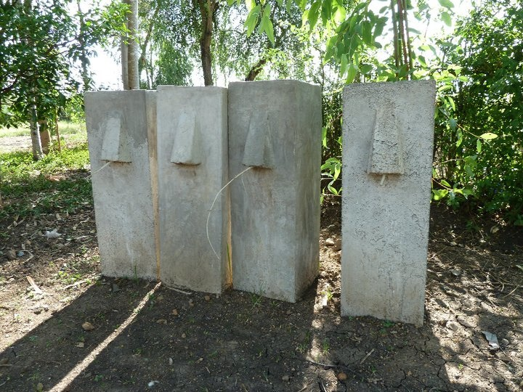

May 2011
Table of Contents
Tables and Figures 3
I. Introduction 4
Engineers Without Borders 4
Orongo, Kenya 4
Current Water Sources 4
Current Treatment Methods 5
Biosand Filters 6
Project Timeline 8
Pre-January 2010 8
January 2010 8
August 2010 9
January 2011 10
II. Objectives 11
III. Related Work 12
Challenges of NGOs 12
Unintended Consequences 13
Heifer International 15
Aqua Clara 15
IV. Post Implementation Results 18
Steel Mold 18
Materials 18
Filters Built 19
Memorandum of Understanding 20
Marketing 20
Communication 21
V. Cost Analysis 21
Fixed Costs 22
Variable Costs 22
Revenue Variations 23
Profit 23
VI. Monitoring and Evaluation 23
Technical Effectiveness 24
Business 24
Water Quality 25
Social Effectiveness 26
Marketing 26
Filter Use 27
Community Health Effects 28
Data Collection and Recording 28
VII. Conclusions and Future Work 29
References 30
APPENDIX A 33
APPENDIX B 34
APPENDIX C 36
APPENDIX D 36

Tables and Figures

Figure 1: Water Sources Used in Orongo. Data from Jan 2010 trip. 3
Figure 2: Water sources and treatment frequency. Taken from Jan 2010 survey data. 4
Figure 3. Classical Waterbourne Infection Cycle (Tebbutt, T.H.Y., 1992) 5
Figure 4: Comparison of single treatment processes. 6
Figure 5: Group members posing with filter and filter recipient, Peter Odonga. 7
Figure 6: Biosand filters poured August 2010 in Orongo. 9
Figure 7: Founders of AFGO Filters posing with steel mold. 10
Figure 8: Completed steel mold. 17
Figure 9: Steel mold construction. 17
Figure 10: Founders of AFGO Filters posing with sieves. 17
Figure 11: Completed filters. 18
Figure 12: Members of AFGO Filters demonstrating the swirl and dump method of maintenance. 26

Table 1: Description of biosand filter project in comparison to the Aqua Clara business franchise analysis & planning guidelines. 17
Table 2: Stauts of distributed filters to date. 19
Table 3: Variable costs for filters 23
Table 4: Data collection summary 29

I. Introduction

Engineers Without Borders
Engineers Without Borders-Madison (EWB-UW) is a student group whose mission is to “partner with disadvantaged communities to implement sustainable solutions to community problems” (About Engineers Without Borders, 2010). Our project in Orongo, Kenya is one of five projects in the EWB-Madison organization. The Kenya project was formed in 2007 in response to a student’s personal interest in Orongo and its poor water quality. Since then students have made six trips to the village to assess the situation and develop a biosand filter project for making clean water accessible to the community.

Orongo, Kenya
Located in the south of Kenya, about ten minutes from Kisumu and right off the shore of Lake Victoria is a small farming community called Orongo. Almost all of the people in Orongo are subsistence farmers who live off less than $1 a day (Levicki, 2004). The village is home to an estimated 3,000 people, divided into 500 families (Werbeckes, 2010) and it is spread over about 10 sq. km (Levicki, 2004).

Current Water Sources
The main ways that villagers get their water are from boreholes, shallow wells, rainwater from streams or catchment systems, and from Nyamasaria, which is a nearby water treatment plant (see Figure 1). Boreholes are protected wells that are drilled at least 50 meters into the ground. The water from boreholes should be bacteriological safe but it has a very salty taste. Shallow wells, while relatively clear, have shown an intermediate to high-risk bacteriological level (Levicki, 2004) due to fecal contamination from flooding and nearby pit latrines. Streams are both highly turbid and highly contaminated due to domestic washing, open grazing, and severe flooding. Rainwater is safer than streams and shallow wells (Levicki, 2004) but also carries the risk of fecal contamination from bird or bat droppings and storing it in an open container. While about 30 percent of the village relies upon unsafe water for consumption (Levicki, 2004), the entire village runs the risk of fecal contamination after collection. A study investigating the potential for water quality to deteriorate between the points of collection and consumption showed that the quality of borehole water went from 1 FC/mL to an average of 72 FC/mL between collection and consumption (Trevett, 2002). Similar results were shown for well water. This contamination is most likely due contaminated jerry cans used for collection, hand-water contact during collection and while walking the water home, and contamination of the serving container i.e. hands, cups, ladles, beakers, straining cloth (Levicki, 2004).
Figure 1: Water Sources Used in Orongo. Data from Jan 2010 trip.

Current Treatment Methods
The current water treatment methods available and used in Orongo are chlorine disinfectant, boiling, or buying pre-treated water as is shown in the survey data collected in January 2010 (Figure 2). However due to cost, time, or the belief that clear water is safe water these methods are used very inconsistently among the villagers. Additionally, chlorine gives the water a bad taste. Without treatment, the contaminated water can result in serious diseases such as cholera, E-coli, typhoid fever, and diarrheal disease as shown in Figure 3 (Levicki, 2004).
Figure 2: Water sources and treatment frequency. Taken from Jan 2010 survey data.
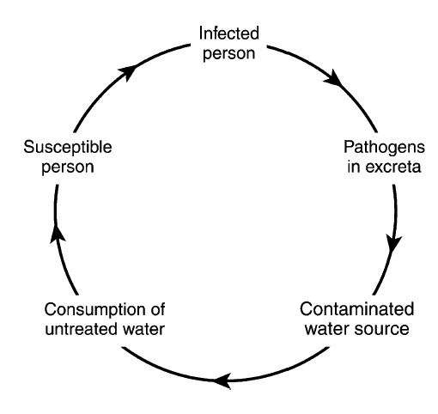
Figure 3. Classical Waterbourne Infection Cycle (Tebbutt, T.H.Y., 1992)

Biosand Filters
Biosand filters use slow sand filtration to remove harmful pathogens from water (Figure 4). In addition to being relatively inexpensive, and simple to operate and maintain, the filters are one of the best single-process methods of improving the physical, palatable, and bacteriological quality of surface waters (Shaw, 1999; See Appendix A). A filter is constructed with a layer of fine sand and two layers of different sized gravel. As water is poured through the filter the microorganisms in the water collide and collect forming a bio-layer, called the schmudstecke, on top of the sand layer. There are four processes involved in the removal of pathogens with the biosand filter (CAWST, 2008). The bio-layer is critical because it consumes pathogens from the water that passes through it. Sediment and pathogens are also removed by being “mechanically trapped” in the spaces between the sand grains. Attraction between pathogens and sand removes more of the pathogens, and pathogens surviving the first three removal processes die naturally due to lack of food and oxygen inside the filter. Studies done in Kenya show that together these processes can remove more than 93% of fecal coliform (Snider, 2002) and result in 54% reduction in child diarrhea (Tiwari, 2009). Based on the .6L/minute recommended flow rate, and 6-12 hours required for pause periods, the biosand filter can effectively treat 60-80 L/day, which is sufficient for the typical consumption (CAWST, 2008). It should be noted that the filter does not remove 100 percent of pathogens and should thus be used in combination with another treatment method for 100 percent removal (the amount of chlorine used in combination can be significantly less) (CAWST, 2008).

Figure 4: Biosand filter diagram.

Project Timeline

Pre-January 2010
Since the beginning of the project, the group’s goal has been to develop a project that addresses the water quality in Orongo. Research of several different treatment methods including SODIS, moringa water purification, and biosand filters led the group to decide that biosand filters would be the most effective treatment method in terms of cost, feasibility, and benefits. The group built a prototype filter on campus to learn about the process and in January 2009 and August 2009 built two plastic filters in country as an initial small-scale implementation to observe whether the community was receptive to the new concept and to see if a large-scale implementation would be welcome and feasible.
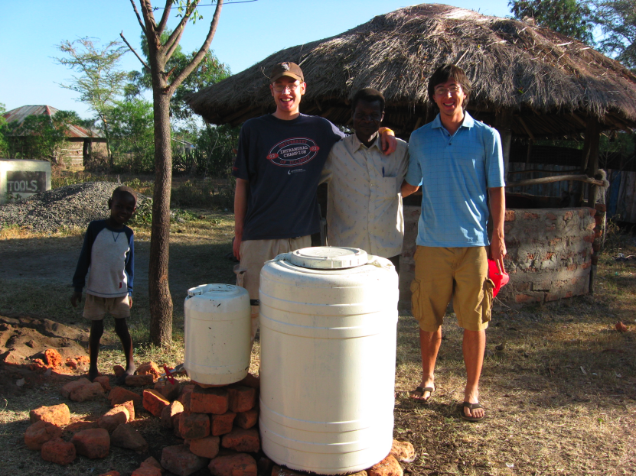
Figure 5: Group members posing with filter and filter recipient, Peter Odonga.

January 2010
In January 2010 a group of students returned to Orongo for an assessment trip. Data on water collection methods, costs, and treatment methods were collected to confirm that the biosand filter would be a good treatment method for the area. In addition, follow-up visits were made to the two existing filters. One of the filters, which had been given to the community nurse, did not appear to be working and it was concluded that this was due to lack of use (the bio-layer dies with lack of use). The other filter had been used successfully for a while until the owner poured extremely turbid stream water (mud) through the filter causing it to clog and require some maintenance. The conclusions made from these follow-up visits were that the filter education had not been sufficient enough and would need to be a key component in any further implementation.

Additionally, some water testing was conducted on several water sources. The results from these tests showed several of the sources contaminated with coli form too numerous to count (TNTC) (Ministry of Water and Irrigation, 2010). While this proved that there is a need for treatment, it did not provide a good baseline for comparative data. It was decided that a search for a more extensive water testing method for the following trip would be beneficial.

Also during this trip the group met Amos Omondi Oyoo, a young local who had independently received training on the Center for Affordable Water and Sanitation Technology (CAWST) biosand filter construction during a workshop at the Divinity Church in Kisumu. At this workshop a man from Canada taught Amos and approximately 10 others how to properly construct and install biosand filters. Amos is 30 years old and grew up in Orongo, Kenya. He is the Chairman of the Buoye Quarry Youth Group and knows the community well enough to understand what will work and what will not. EWB realized that Amos and his Buoye Quarry Youth Group would be a perfect partner for implementing such a project. Discussions about the partnership were started and the team planned to move forward during the next trip if the mutual interest in the project was still present.

August 2010
In August 2010, a group returned to Orongo and continued discussing the way forward with Amos on this project. During this trip, Amos, two of his friends, Geoffrey, Frederick, and the Engineers Without Borders team successfully constructed 4 biosand filters and Amos and his crew constructed 4 more after the team left.
Figure 6: Biosand filters poured August 2010 in Orongo.
The extent of the partnership was outlined in a memorandum of understanding, which was signed by Engineers Without Borders and the Buoye Quarry Youth group at the end of the trip. The document stated that Amos and the Buoye Quarry Youth Group would work together with EWB to implement several biosand filters successfully and would do so without any pay or compensation. These filters would be paid for by EWB. Upon completion of this, Amos and the Buoye Quarry Youth Group would be awarded the steel mold used to construct these filters. A business plan would be implemented so that Amos and his crew could sell the filters and use the revenue to purchase more materials, with the intention for a profit generating business.

January 2011
In January 2011 the group officially established AFGO Filters with Amos Omundi Oyoo, Fred Agonda, and Geoffrey Odhiambo Yengo, had a steel mold built and donated to the company, and built one filter. A new memorandum of understanding was signed along with forms detailing marketing, business, and education strategy within the community. See Appendix B for these documents.
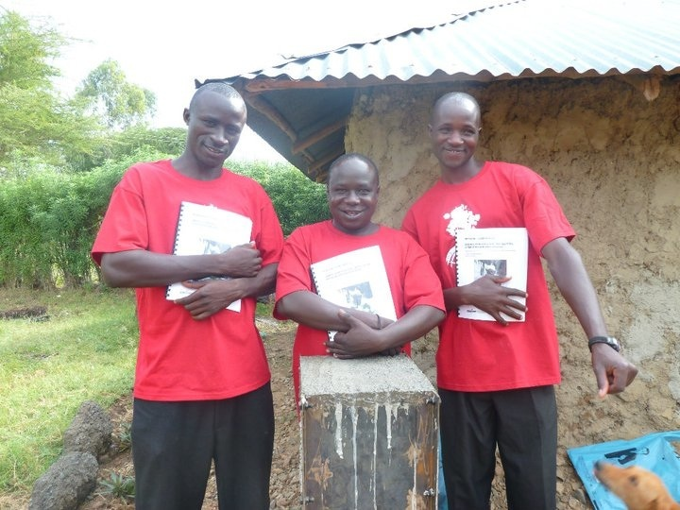
Figure 7: Founders of AFGO Filters posing with steel mold.

II. Objectives

With the biosand filter project underway, the next step in this project is to monitor the progress and make adjustments as needed in order to reach the overall goal to have biosand filters available to the whole community. The rest of this paper is aimed towards assessing the technical and social effectiveness of the project and defining a method for continuing evaluation of the project into the future.

Technical effectiveness will be defined as AFGO Filter’s ability to operate as a profit-making business. Methods of assessment are to see whether the filters can be produced at a price that is significantly lower than the amount that can be obtained from the sale of a filter, to analyze the rate at which filters are being sold, and to judge whether there is enough labor available to meet demands. Additionally, technical effectiveness will be defined as whether or not the filters are being built, maintained, and operated successfully, and whether the filters are effective in producing clean water and improving community health. Assessment will include comparative water testing and standardized follow-up surveys of filter owners. It is necessary for this evaluation to involve both a continuous short-term assessment and a plan for continuing the evaluation into the long-term.

Social effectiveness will be defined as the ability for EWB and AFGO Filters to implement marketing strategy so that AFGO Filters are a desirable commodity, and to create community health awareness so that community members demonstrate an understanding of the health risks of contaminated water and a drive to take action. Further it will evaluate whether training and education is effective by looking at whether the filters are being used and maintained properly. Assessment will involve surveying filter owners to see whether they understand how to use their filter and are using it regularly, and collecting marketing data to show whether the community is becoming aware of the product and demonstrating interest. Additionally, EWB and AFGO Filters will work together to continually improve the education and marketing techniques already established.

The final objective of this paper is to define a method for collecting this data in the future and for making the research and conclusions easily available to students facing the same challenges. Since the project is fully run by students, there is a quick turnover rate and it is important that the efforts made in this project are not lost once the founders move on. Providing a clear history of the project and laying out what information should be collected for future monitoring and evaluation will help minimize communication disconnects between incoming and outgoing students and will minimize the amount of “repeated work” that is done for the project. It is important to extend the results of the project to the long-term so that others can learn from our successes and failures.

III. Related Work

Challenges of NGOs
Non-governmental organizations and non-profits such as Engineers Without Borders have been attempting to alleviate poverty in Africa for decades, and while some have been effective, efforts as a whole have not met the expectations to reduce poverty in Africa because everyone has faced similar challenges in implementing change. The main challenges that arise are finding a way to help a community without being regarded only as a source of money, and finding a way to help a community in the long-run rather than putting a temporary “band-aid” on an issue. Promoters of NGOs suggest that the human touch and dedication of its highly motivated members is a real asset and that NGO members tend to view hardships as challenges rather than punishments (Mwansa, 2007). However, the downfalls of NGO projects appear when there is a divergence in ideology between NGOs and the people they are helping. For a project to be effective, it is thought that the NGO should help the poor on the poor’s terms (Mwansa, 2007). The villagers should be the ones stating their problems and what method of assistance they are seeking. Doing this will minimize the probability of arising conflict of interest, distrust, or misunderstandings. Failure to start a project in this way has often lead to passive recipients, lack of leadership in the community, misdirection of resources, and lack of sustainability. While Mwansa states the extreme, that there needs to be a paradigm shift in which community based organizations (CBOs) replace NGOs, it is safe to say that a partnership between the community and the assisting organization needs to be formed in order to be effective. A partnership should reflect equality, transparency, shared responsibility, joint decision-making, trust, and mutual understanding (Mommers, 2009). This is the first step in developing an effective project.

Unintended Consequences
If an NGO can beat the odds and develop an effective project, another issue arises which is unintended consequences. Unintended consequences refer to outcomes other than those intended, both positive and negative. This next section will focus on negative unintended consequences that may arise with development projects. One of the most common unintended consequences is referred to as the “dependency syndrome”. This has been a problem for as long as volunteers have been in Kenya. “White people” in Kenya are immediately looked to as a source of money and in many situations this has pushed people towards a less independent society. For example, when visiting an irrigation scheme that was implemented in a rural village right outside of Kisumu, Kenya the dependency syndrome was very obvious. The system had been a collaborative effort - built with physical help from the community, technical help from the Ministry of Irrigation, and financial help from an outside donor. Our EWB-UW group visited the site a year after its implementation to make assessments for a similar project. What was witnessed was that the once cleanly dug canals were dry had become overgrown, the water tank necessary for the pump to run was cracked and empty, and the community leaders were showing no intention of fixing these problems, notifying the Ministry of Irrigation, or using the system. The farmers said that they could not use the irrigation system until trenches were dug to keep the hippos from destroying their crops. The community had not yet come together to find a way to dig these trenches or have them dug but instead they repeatedly asked every one of our members for funding to have the trenches dug. This detrimental unintended consequence has been present for a long time and is not something that can easily be avoided. But awareness of the issue is important so that one can try to implement a project that gives as much responsibility and ownership to the community as possible.

The EWB-UW El Salvador group experienced more of a unique unintended consequence with their project to install piping to bring waste water from a local community, La Granga, to a water treatment plant in a nearby village. The project began 5 years ago and was requested by the mayor’s office. Per request, the group designed and installed a complete piping system from La Granja to the water treatment plant; however soon after, the water treatment plant started having issues where the water was now leaving the treatment plant in worse condition than it was arriving because it was passing over key processes in the treatment process. While the El Salvador group successfully implemented their assignment, severe unintended consequences arose and left them with a serious ethical question of whether or not it was their responsibility to fix the problem. According to current project manager, Chris Dawson, “It is absolutely our responsibility to stay and fix the plant and […] it would be unfitting to do what so many other volunteer groups do and just go to a community, do the job, and leave. The plant is experiencing issues due to what we have done and it wouldn’t be right to just leave it for others to fix.” The detrimental implications of their well-intended actions have stretched the project duration from 1-2 years to many more. Another question that arises is whether or not the consequences could have been avoided. Previous project manager Chris Bareither states that the appropriate research was done before implementing. The treatment plant had a projected capacity of 27L/s and was only operating at 10.5L/s (Bretl, 2006). The design for expansion was implemented taking these numbers into consideration and it is thought that lack of proper maintenance at the plant was what caused the improper function. While hindsight bias says yes, it is impossible to predict all of the unintended consequences that might arise from a project. This example is not meant to place blame on anyone but to remind groups working on similar development projects that it is important to incorporate, consider, and monitor all of the known components that a project is made up of, and that even if this is done, unintended consequences may still arrive and it is necessary to have a plan of action for these consequences.

The next section of this paper will look at two projects that have seen success and work off of similar cornerstones that are most likely necessary for an effective project. The first, Heifer International embodies the ideas of full participation, self-reliance and sustainability, and education and training among nine other cornerstones that they define for their success. Aqua Clara, a new program dedicated to spreading clean water technology, similarly has a focus on training and sustainability.

Heifer International
Heifer International began in 1944 with the mission to give out female cows “heifers” to families in need so that they can have food. In return, the family has to agree to give one of the offspring to another family in need. The family can then eat or sell the original heifer and her remaining offspring. The idea was developed so that families would be receiving a source of food rather than a one-time relief. Included in the donation is extensive training in livestock care, how to develop income generating activity, and leadership (Chiana, 2006). Since its beginnings in 1944, Heifer International has directly and indirectly 13.6 million families (Our History, 2011). When the EWB-UW Kenya group visited a Heifer International location in Kenya, one of the major distinctions seen with the methods of implementation was that the entire establishment was ran by locals. Locals, who are experts in the area of study, performed all of the management and training. This is a key feature because it adds to the local sustainability. Aside from funding, the system could and does run smoothly and effectively without the assistance of “outsiders”.

Aqua Clara
Aqua Clara International is an organization that aims to start locally sustainable water solution projects in developing countries. The organization, which had its first full year of operation in 2008 is a fairly new organization but seems to understand some of the key features of an effective project. After realizing that many previous clean water projects had been overlooking the sustainability concept, Aqua Clara developed its mission to focus on training rather than placing filters. Aqua Clara facilitates local financial sustainability by sending trainers to communities who request their presence. It aims to transfer technical knowledge for production, maintenance, business, and marketing to locals so that the projects can be maintained a replicated after they leave the area. Additionally, they recognize that “affecting behavioral change / product adoption is the biggest challenge in community development projects (How we work, 2001).” and therefore try to work with trusted, local leaders in the community to help in overcoming this challenge. The AC Franchise Program that the organization offers is free of charge and includes the following (Franchising the solution, 2011):
- On-site instruction of AC Water Purifier manufacture
- The right to produce and sell our patent-pending technology at a profit, if desired
- Business planning and launch collaboration
- Our supply of written, illustrated and film resources – in English and translated into various local languages (as needed)
- The ACWP construction and maintenance manuals
- AC business planning and management materials
- Basic accounting and business tracking materials
- Marketing and awareness-raising materials
- Continued Technology Center support
- The AC Engineering Team stands by to answer any technical questions that may arise
- The AC Engineering Team will work to develop new and appropriate solutions to specific local water issues
- AC will aid in the facilitation of Purifier output testing to ensure quality
- On-going business support
- Business tracking assistance
- Access to AC personnel for troubleshooting and/or expansionary planning
- The future offer of additional related products, including health & hygiene products, for sale into the local market

The goals and methods of Aqua Clara (AC) fall strongly in line with what the EWB-UW Biosand Filter project has established in Orongo and review of AC’s business and analysis planning can help us to identify areas of strengths and weaknesses in our project so that we might be able to identify future challenges and unintended consequences before they arise. The following table will list AC’s considerations for starting an effective franchise, describe the criteria, and then identify where the EWB-UW Biosand Filter project falls (weak, moderate, or strong) and explain why (Microfranchise, 2008).

Criterion | Description | Biosand Filter Project Score | Project Details
People: Established Community Relationship | An ongoing internal-external trusting relationship with community | Moderate | EWB has had an established relationship with Orongo since 2007. A background of successful collaboration with the community prevents a “strong” score.
People: Local trust relationship | Local contact with a strong value system and the trust and respect of the community. | Moderate | Local contact, Amos, has a strong dedication to the project but not necessarily an n explicitly strong network of trust and respect in the community. This is not due to character issues but the layout, politics in the community.
People: Communication Maintenance | Ability for local contact(s) to communicate clearly and frequently with the external partner | Strong | Amos and 2 of his close “co-workers” have internet access in Kisumu, and communicate frequently through email and Facebook.
Place: Water Source | Water testing of the source can be performed to establish need and a baseline for monitoring change. | Strong | Water testing has been sourced locally, and done in country by EWB-UW students providing a need and baseline for change. More efficient, effective methods of treatment are still being explored.
Place: Community | General awareness of water quality issues and health implications | Moderate | Community leaders and others understand the water problems but many are uniformed or uninterested in changing.
Place: Transportation | Transportation between business site and materials, and between business site and market customers. | Moderate | The distance between Orongo and Kisumu (supplies) is short and there are many methods of transportation available. Within the community there is less transportation methods available. Cost is a small but present issue.
Things: Tools & Materials | How available / costly are tools and materials. | Strong | All of the tools and materials can be purchased in Kisumu, which is about a 10-minute ride from Orongo. Initial tools and materials have been purchased by EWB-UW.
Place: Space for production | Space for storage and construction, secure enough to prevent inventory theft, and should be convenient to its target market. | Moderate | Currently the production site is in Amos’ families yard. The area is large enough for production but not secured in any way.
Table 1: Description of biosand filter project in comparison to the Aqua Clara business franchise analysis & planning guidelines.

Based on the above table the biosand filter project looks to have a moderate chance of being effective. The relationship between EWB-UW and the local leaders and need for this water treatment method are strengths of the project, whereas transportation needs, an established business site, and community awareness will need to be monitored and modified frequently until successful solutions are found.

IV. Post Implementation Results
Immediate results and analysis of the January 2011 implementation trip will serve as a baseline for the effectiveness of the project and again serve to identify the strengths and weaknesses that will be monitored into the long term. The breakdown of the trip is as follows.
- Built the steel mold that is necessary for pouring the filters
- Bought all materials and tools for building filters
- 4 filters have been distributed for use and 5 remain unused
- Signed agreements detailing the roles of AFGO Filters and EWB in the project. Additionally guidelines for marketing and communication were written.

Steel Mold
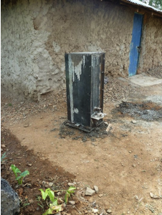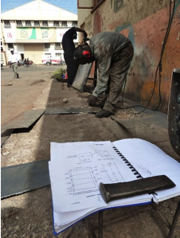 EWB paid 64000ks (about $853.30) for the construction of the steel mold, which is used for pouring the filters. The steel for the mold was all purchased locally and was cut and welded by Kisumu local, Erick Otieno Obiero, at Hever Technical Services. Based on the successful construction of four filters in between the time EWB visited in August 2010 and January 2011, the mold was handed over to Amos of AFGO filters for full ownership. Ownership of the mold eliminates having to pay a rental fee to rent the mold for pouring filters and thus leads to a much more financially effective business. The mold was successfully built by following the plans in the CAWST biosand filter manual.
Figure 8: Completed steel mold.
Figure 9: Steel mold construction.

Materials
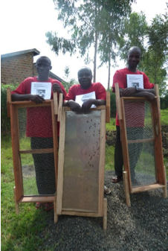 All of the materials and tools needed for pouring filters were purchased by EWB for AFGO Filters as per the agreement for EWB to pay the startup business costs. A batch of sand, cement, and gravel, and most of the tools were purchased during the August 2010 trip. The sieves, which are used for sifting the sand and gravel into desired sizes, a mallet, and another batch of cement was purchased during the January 2011 trip. All of these materials are available locally in Kisumu, which cuts costs and transportation feasibility, adding to the effectiveness of the project.
Figure 10: Founders of AFGO Filters posing with sieves.

Filters Built
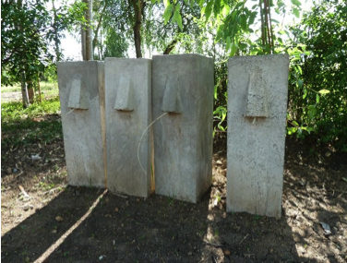 As of August 2010, nine filters have been built. EWB and AFGO Filters built three filters in August, AFGO Filters built five filters, between August and January, and AFGO Filters built one filter in January under the observation of EWB members. Of the nine filters, four of the filters had been distributed and five remain unused. The first batch of filters was distributed to families close to the business and was agreed upon by both EWB and AFGO Filters members. All filters were built on-site at Amos’ compound and delivered by wheelbarrow. None of the filters have been sold yet.
Figure 11: Completed filters.

Filter Recipient | Reason for donation | Current filter status
Tobias Nyalik | Has hosted and advised EWB for several years | Has been using filter to clean water for his family of 7. Swirl and dump maintenance was performed on the filter
Geoffrey’s mom | Mother of co-founder of AFGO Filters | The filter has not been filled with sand or gravel yet and is not in use.
Amos Omondi Oyoo | Co-founder of AFGO Filters | Uses the filter regularly.
Mama Rose | Community nurse; replaced plastic filter previously built by EWB | Has been using the filter regularly and 3M water testing showed 0-2 fecal coli form counts
Florence Gundo | Has bought 2. One for 2500ks and one by installments totaling 2200. | The filters have not yet been installed.
Table 2: Status of distributed filters to date.
Effective construction of nine filters shows that AFGO Filters will be able to fulfill its role in constructing technically sound filters. The lack of sales thus far and lack of proper use in at least 2 of the 4 filters distributed filters identifies marketing and education as the areas that will need a lot of focus in the upcoming business development stages. It will be crucial to establish a need for clean water in the community and important that each filter owner gets individual attention so that they understand how the filter works and what they must do ensure that it is working properly.

Memorandum of Understanding
An agreement was signed that defines the roles of both EWB and AFGO Filters in the bio-sand filter project. The agreement states that EWB will hold a consulting role in the business and covered all start-up costs totaling 130000ks ($1735). AFGO Filters agrees to carry out all operations relating to business including construction, marketing and sales, and follow-up and maintenance. Additionally, they agree to keep accurate and detailed records of sales and costs. The minimal role that EWB will play in the business from here ensures that the business is locally sustainable and independent. The hope is that the business will be able to succeed with limited intervention.

Marketing
Together EWB and AFGO Filters came up with marketing strategies and goals including but not limited to:
- Make brochures with personalized information about AFGO filters and the bio-sand filter in general. Distribute to interested families.
- Talk to City Counsel. Have them recommend filters in their speeches on hygiene.
- Arrange a demonstration or speech at a chief’s meeting.
- Perform an education session at the Orongo Secondary School.
- Get published in the Daily Nation or other media source.
- Painting the filters. Make the filters as attractive as possible by painting them (may need to wait for additional funding or sold filters).

Communication
In order to create an efficient relationship between EWB and AFGO Filters weekly communication is highly encouraged. EWB requested that AFGO Filters send weekly email updates detailing:
- Current marketing strategies. What is working? What isn’t?
- Level of community interest.
- Any difficulties or roadblocks.
- Additional information including questions or comments.

EWB agreed to send weekly updates detailing:

- Questions necessary for EWB work to continue
- Problems or hang-ups
- Documents for distributing in Orongo

Additionally, EWB requested that when a filter is sold the following information is recorded and shared:

- Name of customer
- Selling method chosen (off of customer selling sheet)
- Price of Filter
- The marketing strategy used to attract this customer
- Any difficulties or concerns

Thus far, communication has been week on both ends. While we have not lost all contact, the specifics asked for each week have not been delivered. In order for this project to continue successfully, increased effort on both ends needs to be made to keep constant communication and create continuity between the two entities.

V. Cost Analysis
A total of $1735 has been spent in starting AFGO Filters. This includes fixed costs such as initial mold rentals, and purchase of the mold, sieves, shovels, trowels, buckets, tarps, wrenches, and mallets, and variable costs such as cement, sand, gravel, butter, tape, piping, and transportation. It also accounts for some miscellaneous costs such as additional transportation and renting the mold for the first few batches. The following includes a breakdown of costs and profit analysis.

Fixed Costs

Fixed Costs
Item (qty) | Description of costs | Cost (KS) | Cost (USD)
Filter Mold (1) | steel and labor | 64,000 | $853.33
 | transportation | 650 | $8.67
Sieves (3) | wood | 900 | $12.00
 | small screens | 900 | $12.00
 | medium screens | 1,200 | $16.00
 | large screens | 1,500 | $20.00
 | labor | 1,100 | $14.67
Tools | buckets (2) | 1,050 | $14.00
 | trowels (2) | 220 | $2.93
 | wrenches (2) | 380 | $5.07
 | shovels (2) | 560 | $7.47
 | tarps | 1,390 | $18.53
 | mallets (2) | 550 | $7.33
Total |  | 74,400 | $992.00

Variable Costs
Material | Quantity Purchased | Cost | # of Filters | Cost/Filter (KS) | Cost/Filter (USD)
cement | 1bag | 820 | 2 | 410 | $5.47
sand | 1 pile | 3016 | 5 | 670 | $8.94
piping | 3 meters | 600 | 2 | 300 | $4.00
blue band | 1kg | 250 | 2 | 125 | $1.67
tape | 1 roll | 70 | 10 | 7 | $0.09
diffuser plate | 1 sheet | 600 | 15 | 40 | $0.53
sandpaper | 2 sheets | 10 | 4 | 2.5 | $.03
transportation (estimate) | Round trip | 500 | 2* | 250 | $3.33
Total Cost/Filer |  |  |  | 1804.5 | $24.06
Table 3: Variable costs for filters
* based on buying the minimal quantity of each material at a time

Revenue Variations
The filters can be purchased in one of three ways. Both EWB and AFGO Filters decided on these prices and payment options as appropriate costs for creating a demand and making profit.

- Pay in Full: 2000ks
- Installments: 2200ks (600 initial payment and 550, 550, 500 monthly payments)
- Loan: 2300 (700 non-refundable deposit with a decision to pay in full, pay in installments, or forfeit filter and deposit after 3 months)

Profit
Since EWB paid for the fixed costs and do not expect any of it to be repaid, profit is a simple revenue minus expense calculation and revenue will be generated upon the first sale. Assuming a variable cost of 1804ks per filter. Any sales by the paid in full method will generate 196ks, sales by the installments method will generate 496ks, and sales by the loan method will generate 596ks. This profit can be put towards marketing strategy, purchasing of new tools, and can allow AFGO Filters to donate some of its filters. As the business grows, variable costs should be able to be reduced through ordering large quantities of the required materials. This will lead to increased profit margins.

VI. Monitoring and Evaluation
Monitoring and evaluation of AFGO Filters will be conducted through regular email communication between AFGO Filters and EWB, detailed record-keeping, and bi-annual follow-up visits to the community. In order to ensure that the correct data is collected to judge project effectiveness, the desired data will be clearly defined along with a clear method for collecting and recording this data. There are two main areas where effectiveness will be judged: technical effectiveness and social effectiveness.

Technical Effectiveness
Technical effectiveness judges whether AFGO Filters is able to run a business and make a profit and whether it is able to provide filters that effectively improve water quality.

Business
In order to monitor whether the business is running sufficiently, AFGO Filters should be keeping detailed accounting records and communicating these records with EWB. If EWB is not receiving weekly or bi-weekly updates from AFGO Filters, they should follow-up with reminders to emphasize the importance of communication and record keeping. The following information should be recorded as incurred.
- Materials Purchased: any purchases for the business should be recorded
  - What was purchased?
  - How much was purchased?
  - Where was the purchase made?
  - How much money was spent? How much was transportation?
- Filter sales: Information about every sale should be recorded
  - Name
  - Date of sale
  - Payment method (and when each payment is received)
  - Water source & previous treatment methods
  - How did the family learn about the filters (from a neighbor, directly from AFGO Filters, from a marketing attempt in the community etc.)
EWB has provided AFGO Filters documents for recording this information and a binder for storing this information. Cost information will be used to determine whether AFGO Filters is generating profit and to identify where cuts can be made in terms of cost.

In addition to the continuous record keeping, AFGO Filters will be encouraged to communicate any major changes in operations such as additional labor, change in materials, or acquisition of new assets, and any theft or issues with gathering materials.
During follow-up visits, all of these records should be photocopied for EWB’s record keeping and observations should be made to determine whether there is enough labor to meet demands, enough space to hold resources, enough demand, etc. If changes need to be made to the business they need to be recorded so that consistent long-term record keeping can help track whether changes are effective or not.

Water Quality
Monitoring of water quality will help to judge both the technical and social effectiveness of the project. Water testing will be performed on a bi-annual basis for as long as filters are being sold and EWB is traveling to Orongo. Depending on resources available to EWB about 5-10 filters should be tested for turbidity and fecal coliform counts each trip. Previously water testing has been conducted either at a water quality lab in Kisumu or by using 3M water testing supplies. Testing the water in Kisumu is more detailed and locally provided but costs about 10000ks per test. 3M water testing is inexpensive and provides a learning opportunity for students but results are hard to read and not necessarily that reliable. Until a better method is determined one of these methods should be chosen for each trip (depending on funds). The method should be consistent across before and after testing. For each filter, the water should be tested before it is poured into the filter, and after it comes out of the filter. The information should be recorded and should include:
- Whose filter is being tested?
- How long has the filter been in use?
- How regularly is it being used?
- Has any maintenance been performed and if so what kind?
- What the water source is?
- Turbidity and fecal coliform and e.coli counts of “before” water
- Turbidity and fecal coliform and e.coli counts of “after” water
Any improvement in water quality should be noted but water should only be deemed safe if it meets the World Health Organization (WHO) standards of 0 mpn/100 mL and 5 NTU (KEBS, 1996). The presence of e.coli should be measured as because it is the recommended fecal bacterial indicator of drinking water quality and is closely associated with diarrheal disease (Stauber, 2007). If the results show that the filters are not effectively removing bacteria, the filter should be tested for proper flow rate and use by the owner, which will be explained later.

AFGO Filters should participate in the water quality collection and use the data for further marketing. EWB should transfer all water quality data from notebooks to an organized document that holds ALL water quality information for the biosand filter project and it should be accessible to all students through the EWB UW Kenya Project’s Google page found at https://sites.google.com/site/uwkenya/. This way data can be tracked across a long period of time and students can look for trends in the social and technical effectiveness of the project.

Social Effectiveness
Social effectiveness judges whether the community understands the importance of water treatment and how to use the filter, and whether AFGO Filters can create a demand for the filters. This addresses marketing and usability aspects of the project.

Marketing
A combination of marketing data and sales data will provide some sort of “brand recognition” data and will help to evaluate whether the community understands the importance of water treatment. Anytime either AFGO Filters or EWB implements marketing strategy or community health education in the community, the following should be recorded:
- What was done?
- Who was involved on the AFGO Filters or EWB side?
- Who was the target audience?
- How many people were targeted?
This information along with the data of who has received a filter and how each recipient heard about the filters will show which marketing techniques are the most effective. Also a comparison of the number of people who have been targeted by filter marketing and education verses the number of people who have purchased a filter will show whether a need is being created in the community. It is very possible that AFGO Filters will successfully inform the community about the filters but that the community as a whole will still not see enough incentive to purchase a filter. In this case, the project would not be as effective as hoped. Again, all of this information should be collected in a uniform manner, recorded in one spot, and should be accessible to all students.

Filter Use
Use of the filters will also be monitored on a bi-annual basis as long for as long as filters are being sold and EWB is traveling to Orongo. This should be evaluated on the same 5-10 filters as the water testing each trip. EWB members with the help of AFGO Filters members should verbally survey each owner to determine:
- How often are they using the filter (how many times/day, how long of a pause period)?
- How much water are they pouring into the filter?
- What have they been using the water for?
- Does the filter appear to be working?
- Have they performed any maintenance on the filter? If no, does it need it?
- Are they generally satisfied with the filter?
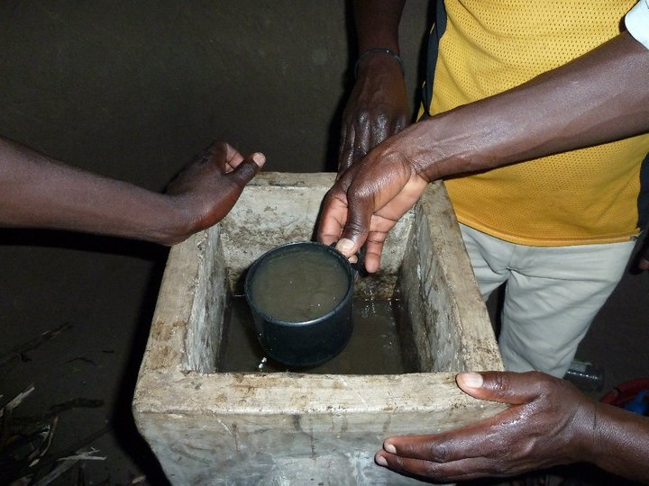
Eventually users will get to the point where their filter needs some simple maintenance, most likely the swirl and dump technique. If the user keeps the filter past this point, it is a good sign of effectiveness because it means that the user understands the importance for the filter, understands how it works, and sees the benefit in putting effort into maintenance. If users are not keeping their filter past maintenance then they either don’t see the importance of the filter, or are uninformed on how to properly use the filter. Questions should be asked to determine the cause of this lack of maintenance, and action should be taken. If the user is uninformed this is a sign of an ineffective education component and may mean that AFGO Filters members need to spend more time working with their customers and making follow-up visits. AFGO Filters members should spend time with the family to show them how to recognize when the filter needs maintenance and how to perform the simple swirl and dump technique to clean the top layer of the filter and re-establish the bio layer. If the user still doesn’t see the importance of the filter, and this is common among the community, then the project may be less effective than desired.
Figure 12: Members of AFGO Filters demonstrating the swirl and dump method of maintenance.

Community Health Effects
Ideally, we would collect diarrheal incidence rates of filter owners and non-filter owners before and after the distribution of the filters in order to measure the effectiveness of the filters to reduce diarrheal diseases. However, since we have not collected baseline data prior to distributing filters, and since we only have the means to travel twice per year, it would be difficult to conduct a proper longitudinal health study. A field study conducted in the Dominican Republic found a 53% lower incidence rate of diarrhea in filter owners compared to non-filter owners (Stauber, 2007), and CAWST sites an estimated 30-40% reduction in diarrhea among all age groups (CAWST, 2008). While the percentages vary, studies have proven that biosand filters help to reduce diarrhea. Thus, if our surveys show that the filters are being used properly, and our water testing shows a reduction in e.coli and fecal coliform, then we can conclude that the filters are providing a positive health effect.

Data Collection and Recording
The following summarizes what data needs to be collected, how it should be collected, and where it should be collected. Additionally EWB and AFGO Filters should be aware of “moderate & weak” areas of the project as specified in the “previous work” section and should take notes on any changes that effect the ratings in these categories. Proposed survey collection sheets can be found in Appendix C.
Category of data | How often it should be collected/ recorded? | What should be collected | Where it should be recorded
Purchases | Anytime purchases for AFGO Filters are made | Item, quantity, location of purchase, and cost (including transportation) should be written down | 1.) In a notebook by AFGO Filters 2.) in an email to EWB 3.) in a document kept by EWB
Filter sales | Anytime a filter is sold or donated | Family, family size, date, payment method, water source, previous treatment method, how they heard about filters | 1.) Payment form should be filled out and AFGO Filters 2 should record other info in a notebook.) in an email to EWB 3.) in a document kept by EWB
Water testing | Bi-annually by EWB | Samples of source water and filtered water should be tested for 5-10 filters for turbidity and fecal coli form counts | 1.) Info should be recorded in a notebook and transferred to an excel sheet that will hold ALL water testing results
Marketing data | Anytime marketing strategy is implemented | Method, people involved, target audience, how many people were targeted | 1.) In a notebook by AFGO Filters 2.) in an email to EWB 3.) in a document kept by EWB
Filter use | Bi-annually by EWB | Verbal surveys of 5-10 filter recipients to determine use, maintenance, health effects, and satisfaction | 1.) Info should be recorded in a notebook and transferred to an excel sheet that will hold ALL user survey data
Table 4: Data collection summary
One issue that needs to be addressed is who should be managing the email communication. If one person on the EWB side is in charge of communication it is easier to make sure that all of the information is going to the same place and nothing is lost. However, there is the potential for that information not to be shared with the group. If no one is specified for keeping email communication, then it is hard to ensure that all of the bits and pieces of information that get shared with various members gets shared amongst the group and it is hard to know what each EWB member is responding and make sure that contradictions aren’t being made. The best way for the information to be shared would either be through an open forum or through one person whose role is to move this information to a source that is accessible by all as it comes in. The advantages of an open forum are that there is complete transparency among the whole group and the information is immediately available for all. The advantage of having one person in charge of communication is that there is no contradiction or overlap in communication and the one person can be in charge of pursuing information if the weekly emails are falling behind. The group can choose whichever way works best for them but should be decided and made clear to all.

VII. Conclusions and Future Work
The two main goals originally set for the biosand project were 1.) to provide the opportunity for clean water technology to the Orongo community and 2.) to help provide a small business opportunity to a local in the community. The seeds have been planted for both of these goals to be met and monitoring along with continual adjustments will help to grow the project towards these goals. While there is definitely clean water awareness in the community a possible weakness in the project may be a lack of perceived value of the filters. It may take some time for the filters to become a desired household commodity and for that reason we want to stay and work with the community and AFGO Filters to strengthen and develop the project rather than move on to a new community.
The monitoring and evaluation will allow EWB students to identify weaknesses in the project and continually advise changes to the business, marketing, and education operations. The information that is to be collected will be valuable to AFGO Filters, EWB-UW Kenya project members, and any similar student or professional groups attempting similar projects in similar situations. Further, monitoring and evaluation of the biosand filter project will help to judge the effectiveness of the business AFGO Filters, the effectiveness of implementing new technology into a developing rural community, and the ability to instill change in a community. We hope to make this information as detailed, consistent, and available as possible so that those who may benefit from the information know exactly where to find it and how to interpret it.
In the end, it will help us to judge specific details like “are the filters a cost-efficient product”, “is the product making a difference in the community” etc. However it will also help us answer a general question that is repeatedly asked –can one effectively start a project that is sustainable and can be left and independently run by the community? More specifically, is the business model feasible in this situation or is community ownership and donation-based implementation the best way to help the largest amount of people in the most effective way? The answer to this question will be key to starting and planning all projects from here on out and it will be extremely beneficial to be able to build off experiences and learn from what has already been done.

References
About Engineers Without Borders. Retrieved February 4, 2010, from UW Madison, Engineers Without Borders website, http://www.ewbuw.org/about.

Bretl, M., Weinberg N., & Karthikeyan K.G. (2006, December). Design of a Low-cost Wastewater Collection System for Communities in El Salvador. University of Wisconsin Madison.

Centre for Affordable Water and Sanitation Technology (CAWST). (2008). Biosand Filter Manual. Retrieved from www.cawst.org.
Chianca, T. (2006, Nov. 7). Heifer International External Evaluations: What Needs to Improve? The Evaluation Center, Western Michigan University. Retrieved from http://www.wmich.edu/evalctr/eval_cafe_archive/chianca_handout.pdf
Franchising the solution. Retrieved April 17, 2011, from Aqua Clara Website, http://aquaclara.org/what-we-do/the-franchise-program/
How we work. Retrieved April 17, 2011, from Aqua Clara Website, http://aquaclara.org/what-we-do/how-we-work/
Kenya Bureau of Standards (KEBS), Specification for drinking water Part 1: The
requirements for drinking water and containerized drinking water, First Revision, KEBS, Nairobi, Kenya, 1996

Levicki, Ken. (2004). A catchment to consumer approach to rural water resource assessment: baseline study and safe drinking supply strategy for orongo village, lake victoria basin, kenya (Master of Science Thesis). Royal Institute of Technology (KTH)

Microfranchise business module business analysis & planning. Retrieved April 17, 2011, from Aqua Clara Website, http://aquaclara.org/wp- content/uploads/2008/12/businessplanning.pdf
Ministry of Water and Irrigation. (2010). Bacteriological Analysis. Analyzed by Alex Mulima, Lake Victoria Environment Management Programme.
Mommers, C., & van Wessel, M. (2009). Structures, values, and interaction in field-level partnerships: The case of UNHCR and NGOs. Development in Practice, 19(2), 160-172.
Mwansa, L. (2007). Non-governmental organisations and poverty reduction in africa: The need for a paradigm shift. Journal of Social Development in Africa, 22(1), 53-70.
Our history. Retrieved April 17, 2011, from Heifer International Website, http://www.heifer.org/site/c.edJRKQNiFiG/b.201520/
Snider, B., Maertens, M., Liang, K., Kaiser, N. (2002). BSF evaluation report samaritan’s purse – 6 country study. Retrieved from http://www.cawst.org/assets/File/BSF_Literature_Brief.pdf. Pg. 13.

Stauber E. Christine. (2007). THE MICROBIOLOGICAL AND HEALTH IMPACT OF THE BIOSAND FILTER IN THE DOMINICAN REPUBLIC: A RANDOMIZED CONTROLLED TRIAL IN BONAO. Unpublished Chapel Hill.

Tiwari, S.K., Schmidt, W-P., Darby, J., Kariuki, Z. G., Jenkins, M.W. (2009). Intermittent slow sand filtration for preventing diarrhoea among children in Kenyan households using unimproved water sources: randomized controlled trial. Tropical Medicine and International Health, Volume 14 No 11, 1380.

Trevett, Andrew, Household Water Security – the Quality Component, Waterlines Vol. 21 No.
4 April 2002, ITDG Publishing, [online www.itdgpublishing.org.uk/waterlines.htm, accessed10 March 2005]

Werbeckes, N. (2010). Orongo Household Survey. Madison, Wisconsin: Engineers Without Borders- University of Wisconsin-Madison Chapter.

APPENDIX A
The table below ranks slow sand filtration as the second most effective of all single treatment processes.
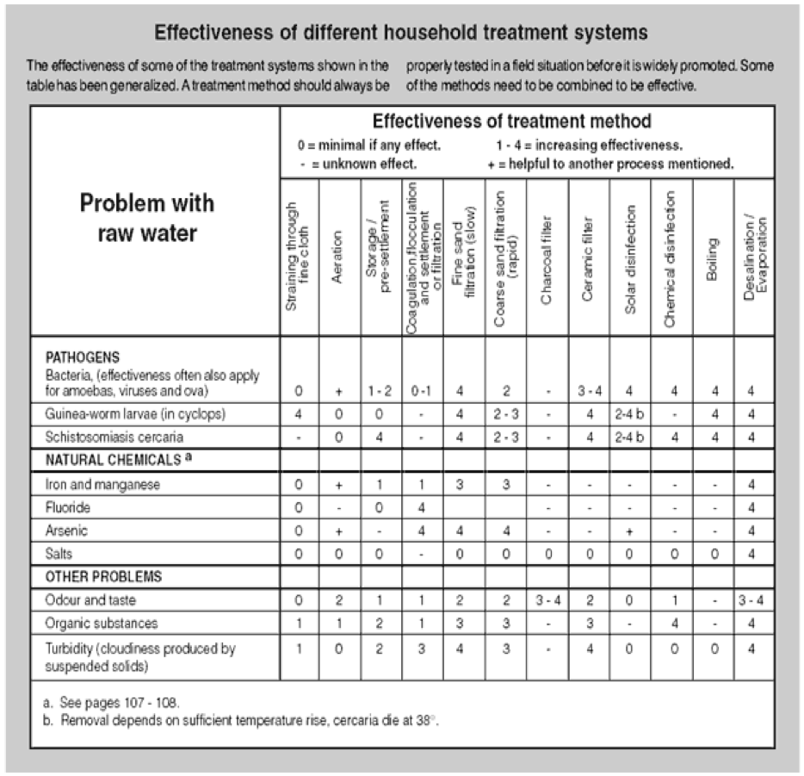

Shaw, R. (Ed) (1999). Running Water: more technical briefs on health, water and sanitation. Intermediate Technology, London, UK, p.103.

APPENDIX B
Biosand Filter Business
Memorandum of Understanding (MOU)
Between
Engineers Without Borders—Madison
And
AFGO Filters
Amos Omondi Oyoo, Geoffrey Odhiambo Yengo, Fred Agonda
I. Purpose and Scope
- The previous Memo of Understanding (from August 2010) is invalid after the completion and signing of this memo.

II. EWB Responsibilities under this MOU
- Pay for the labor, materials, and transportation of one mold. Will also oversee construction and provide technical assistance.
  - EWB is not liable for errors found within the construction of the mold, or malfunctions of the mold. For further assistance consult the welder.
  - After delivery of the mold, EWB is not responsible for replacement or repair costs (i.e. if the mold is broken or stolen)
- EWB will provide three copies of the CAWST manual instructions to Geoffrey, Amos, and Fred Agonda. Also, a copy of the welding sections will be supplied for the welder.
  - While in country, EWB will provide technical assistance pertaining to this manual, to the best of our ability.
- EWB has provided 130,000 Ksh to assist in the start up of this business. These funds were allocated for the purchase of a mold, sieves, and supplies to create the first batch of filters. This also includes transportation, and other costs associated with obtaining these materials.
- EWB will provide the outline of how to construct a business plan
- EWB will fill the role of a consultant by providing recommendations and suggestions.

III. AFGO Filter’s Responsibilities under this MOU
- Carry out all operations related to the business. This includes, but is not limited to: labor for biosand filter construction, maintenance, procurement of additional materials, marketing
- Keep accurate and detailed records of sales and costs.
- Carry out marketing plan as agreed on.
- Maintenance and upkeep on materials purchased by EWB.

IV. Funding
- Beyond the funding provided by EWB, Amos, Geoffrey, and Fred must raise their own funding through selling filters or alternative means.

Signatures

EWB Representatives
__________________________ _________________________

AFGO Filters
_________________________
_______________________ _______________________

APPENDIX C
AUGUST 2010 Trip Expenses
Vendor Name | Address | Items Purchased | Amount Paid (KS)
Cement Center Ltd. | PO Box 1869 Kisumu | 4 meters of tarps | 400
Yatin Limited | PO Box 1176 Kisumu | garbage bags and blue band | 430
Deliverance Church Kondele | PO Box 1357 Kisumu | biosand filter mold rental | 2500
Nakumatt | PO Box 2805 Kisumu | wrenches, trowel, sandpaper, tarps | 1500
Bahati Hardware | PO Box 1087 Kisumu | one bag of cement | 820
Ndugu Transport CO Ltd | PO Box 940 Kisumu | gravel/sand | 3016
Lakhami Electrical and Hardwares LTD | PO Box 191 Kisumu | one bag of cement | 800
Alpha Hardware Supplies Ltd | PO Box 946 Kisumu | piping and shovels | 1300
Michael Ouma | PO Box 4141 Kisumu | transportation of mold | 4000
Deliverance Church Kondele | PO Box 1357 Kisumu | mold hiring | 12500
Alpha Hardware Supplies Ltd | PO Box 946 Kisumu | piping and wirebrush | 1620
Amos Omondi Oyoo | Orongo | Biosand Filters | 2700
Alpha Hardware Supplies Ltd | PO Box 946 Kisumu | piping | 1880
Nakumatt | PO Box 2805 Kisumu | buckets for cement | 1050
Tusky's United | PO Box 54280 Kisumu | blue band | 440
Kisumu Shiva Enterprises | PO Box 9798 Kisumu | cement | 2380
Migosi Hardware | PO Box 3993 Kisumu | cement | 3950
National Printing Press Ltd | PO Box 224 Kisumu | tape | 70

APPENDIX D

Sample questionnaire. The full survey that will be used for monitoring is not yet finished.

