Holocaust Memory and Public History:
Examining Holocaust Museums from 1947-2001

Hannah M. Lahti
History 489: Research Seminar
Fall 2018

Teresa M. Sanislo
James W. Oberly

Copyright for this work is owned by the author. The digital version is published in
McIntyre Library, University of Wisconsin-Eau Claire with the consent of the author.
Contents

List of Figures…………………………………………………………………………………….iii

Abstract………………………………………………………………………...…………………iv

Introduction…………………………………………………………………………………….….1

Historiography…………………………………………………………………………………….4

Auschwitz-Birkenau Memorial and Museum……………………………………………….…….8

Yad Vashem - World Holocaust Remembrance Center………………………………………….15

United States Holocaust Memorial Museum…………………………………………………….22

Jewish Museum Berlin…………………………………………………………………………...28

Conclusion……………………………………………………………………………………….35

Works Cited……………………………………………………………………………………...37

Figures

Figure 1 Auschwitz-Birkenau Memorial and Museum exhibit of shorn hair…...……...…11

Figure 2 Auschwitz-Birkenau Memorial and Museum wooden barracks and ruins…...….13

Figure 3 Exterior of the Holocaust History Museum at Yad Vashem……………….…….20

Figure 4 The Valley of the Communities at Yad Vashem………………………….……...21

Figure 5 United States Holocaust Memorial Museum exterior…………………………....24

Figure 6 Reconstructed barracks in the permanent exhibition of the USHMM…………...27

Figure 7 Exterior of the Jewish Museum Berlin……………………………......................30

Figure 8 Shalekhet - ‘Fallen Leaves’ by Menashe Kadishman……………………...….…33

Abstract

Holocaust museums and memorials are central features to Holocaust memory and education. The phrase “Never Again” continues to be a theme in Holocaust memory, which has led to the support for Holocaust education. The Auschwitz-Birkenau Memorial and Museum, Yad Vashem World Holocaust Remembrance Center, United States Holocaust Memorial Museum (USHMM), and Jewish Museum Berlin (JMB) were established in different geographic locations and at different times since 1945. These museums are influenced by different factors, such as nationalism, religion, politics, and culture. Each museum teaches about the Holocaust similarly, but their unique exhibits are designed to evoke emotion and memory in different ways.

Introduction

Holocaust museums and memorials are sites of Holocaust education and remembrance. Not all such museums are the same, nor do all Holocaust museums produce similar historical memories. Many Poles recall a visit by President Barack Obama to Auschwitz-Birkenau in 2012, and criticize him for using the phrase “Polish death camps,” rather than making the distinction that it was a Nazi death camp in Poland. The Polish government and many of its citizens were appalled at the phrase, explaining that Poles, too, were victims in the camp. They asserted that it was the German Nazi government that set up the camp, and by calling the site a “Polish death camp,” it is akin to blaming victims and placing responsibility for the Holocaust on Poland. In January of 2018, the Polish government established a law prohibiting references to the Holocaust as the responsibility of Poland. Historians of the Holocaust attribute this reaction to the increasingly right-wing government of Poland, and “… historians are worried that the party might attempt to make it more difficult to discuss the culpability of at least some Poles in Nazi crimes.” This exemplifies the complexity of Holocaust memory, especially in terms of the politicization of history.
Holocaust memory has transformed according to geography, politics, and the passing of time. Peter Novick defines collective memory as the process by which issues of the present determine how individuals or groups within society remember aspects of history, or it is “…understood to express some eternal or essential truth about the group - usually tragic. A memory, once established, comes to define that eternal truth, and, along with it, an eternal identity, for members of the group.” With changing understandings of history over time, Holocaust museums contribute to different and changing memories of the Holocaust, create exhibits for different purposes, and face unique challenges. In other words, museums are not fixed, but change over time and many Holocaust museums have unique qualities that set them apart from other museums and contribute to the formation of collective memories.
Auschwitz-Birkenau Memorial and Museum was established on the site of the former death camp. Unlike other museums, Auschwitz-Birkenau is a museum in context. This means that while other museums take artifacts out of context and attempt to exhibit history in new spaces, Auschwitz-Birkenau itself is the context, so a museum at the site keeps artifacts and history within the framework from which it originated. Even though many of the artifacts at the Auschwitz museum are placed in exhibits behind glass walls, the artifacts remain at the site. The artifacts have been moved within the camp to facilitate the design of exhibits, but they remain at Auschwitz nonetheless.
Yad Vashem was founded just five years after the establishment of the State of Israel. Even though the museum is outside of the geographical location where the events of the Holocaust took place, the museum has proclaimed itself the World Holocaust Remembrance Center. Unlike most other Holocaust museums, Yad Vashem was established through a law passed by the Israeli government, making the museum a national responsibility. Due to its government connection, Yad Vashem focuses on the Jewish experience during the Holocaust and incorporates Jewish nationalism and Judaism as key features of the museum.
The United States Holocaust Memorial Museum was founded as the result of an executive order by President Jimmy Carter and an Act of Congress, but is run by a private foundation. This executive order came at a time of support for Israel by the United States in the Arab-Israeli War, making a United States Holocaust Museum a political move to solidify support for Israel. The United States Holocaust Memorial Museum was not opened until 1993 and most of the artifacts in the museum are those taken from Europe. Although some of the artifacts in the museum were donated by survivors that immigrated to the United States after the Holocaust, the fact that there are artifacts in the museum from Holocaust sites in Europe poses the question of historical ownership.
The Jewish Museum Berlin as a whole is not a Holocaust museum, but rather a museum dedicated to Jewish Germans and Jewish heritage. However, the museum includes the Libeskind Building; a specific building of the museum dedicated to the Holocaust. Most Holocaust museums are dedicated solely to the Holocaust, but the Jewish Museum Berlin is focused on the history, heritage, and culture of Jews in Germany. This is important because the goal of the Holocaust was to not only rid Europe of Jews, but to eliminate their history and culture entirely. A museum dedicated to the heritage of German Jews exhibits that Holocaust history is important, but the wider scope of Jewish history and culture in Germany is also significant. The Jewish Museum Berlin is housed in the nation of the Holocaust perpetrators, but it is not a national German Holocaust museum.
Whether the museum is on the grounds of a former death camp in Europe or in a modern complex with symbolic architecture, Holocaust museums remain an important vehicle for the memory of the Holocaust. This study will examine the differences between four Holocaust museums. Auschwitz-Birkenau Memorial and Museum represents a museum built on the former death camp site, one of the earliest Holocaust museums, and the complexity of Holocaust representation through time. Yad Vashem World Holocaust Remembrance Center constitutes a museum dedicated specifically to the Jewish representation of the Holocaust and of a Jewish nationalist narrative. The United States Holocaust Memorial Museum represents a museum established nearly fifty years after the Holocaust and a space dedicated to teaching the humanistic “lessons of the Holocaust.” The Libeskind Building at the Jewish Museum Berlin represents a museum in the nation of the perpetrator and a Holocaust museum dedicated to symbolic architecture and art installations over historical artifacts. By studying the Auschwitz-Birkenau Memorial and Museum, Yad Vashem World Holocaust Remembrance Center, the United States Holocaust Memorial Museum, and the Jewish Museum Berlin, a further understanding of how the Holocaust is presented and remembered can be developed. Public historians are interested in studying how the Holocaust is represented in museums and how museum-goers interact with Holocaust history and memory. Especially how museums decide what to exhibit, how those exhibits support the narratives that are portrayed in museums, and how museum visitors understand Holocaust memory.

Historiography

Public historians study Holocaust museums to understand how collective memories and historical understandings are shaped. Factors such as politics and religion can play a major role in how memory is exemplified in a museum. This includes how Holocaust museums change over time, whether it be in the context of shifting political ideologies in the geographical location of the museum, or how the additions of new exhibitions can change the remembrance narrative of a museum. Technology is perhaps one of the most important ways in which Holocaust museums have changed in the last twenty years. Video testimonies and digital archives have expanded the influence of Holocaust museums outside of the museums themselves; venturing into classrooms and homes around the world. Museums are not fixed, but constantly change and add exhibits according to public memory in order to offer new ways of connecting with history.
While many Holocaust museums are dedicated to remembrance and education, others focus on religion, Zionism, and Jewish culture. In “Representing Auschwitz,” written in 1995, Sidra DeKoven Ezrahi asserted that representation of the Holocaust at Auschwitz was originally exhibited as a space of remembrance for victims of fascism, rather than to the specific memory of the six million Jews and millions of other victims that died at Auschwitz-Birkenau death camp. As Pam R. Jenoff later added, the main issues surrounding the Auschwitz-Birkenau Memorial and Museum include the religious and ethnic ownership of the site and its history. For example, many Poles recognize the camp as a site of Polish, or national, oppression, rather than “racial” oppression. Because Auschwitz-Birkenau Memorial and Museum was one of the earliest established Holocaust museums, it has undergone considerable changes since its inception. The connections between nationalism and the Holocaust were explored further in 2000 by Yehuda Bauer. In Rethinking the Holocaust, he asserted that there were two main areas of thought regarding Israel and the Holocaust; that the State of Israel was created by the Holocaust and that the establishment of Israel was the epilogue to the Holocaust. Bauer disagrees with the former, believing that Israel was more the work of generations pre-Holocaust, but survivors made great impacts on the nation. Yet, the idea of Israel as the epilogue to the Holocaust is precisely how Yad Vashem is presented. The concept of Holocaust representation in museums and the influence of nations that house those institutions was continued by Peter Chametzky in 2008. Chametzky explained, “The JMB’s [Jewish Museum Berlin] role, instead, is to present a German national narrative in postnational form, whereby it can contain things Jewish as a positive and continuing presence, even in their apparent absence.” DeKoven Ezrahi, Jenoff, Bauer, and Chametsky agree and expand upon the idea that Holocaust museum narratives are influenced by geographic location, especially when it comes to representation of the Holocaust within a specific nation.
In addition to the political and geographical locations of Holocaust museums, public history and the creation of exhibitions are vitally important to the representation of Holocaust history. Peter Novick argued in The Holocaust in American Life, written in 1999, that the United States Holocaust Memorial Museum is significantly an “emotional encounter, is bound to be productive of lessons,” meaning that Holocaust education is paramount in the museum. Novick, however, disagreed with the idea of learning “so-called lessons of history,” because it can take away from the context and complexities of the event in order to more easily compare and contrast it, in this case the Holocaust, with other events. In Oren Baruch Stier’s Committed to Memory: Cultural Mediations of the Holocaust, written in 2003, Stier analyzed the complexity of exhibiting the Holocaust in museums and memorials, particularly in terms of religion and culture. Stier argued that the use of icons, or symbolic artifacts, in museums has the potential to memorialize exhibits and artifacts above Holocaust history. He asserted, “At the extreme, we, as visitors to contemporary constructed memorial environments, risk ‘forgetting’ the events referred to, the things we are asked to try to remember, and ‘remembering’ only the representations of those events.” The use of symbolism in museums and memorials is a powerful tool for public history; it draws the museum visitor in and draws connections to the history before them. However, symbolism is also a way in which museums shape the memories that are formed, which Stier explained, can replace historical memory with memory of symbols.
More recent research on Holocaust museum exhibits was conducted in 2012 by Michael Bernard-Donals, which analyzed the relationship between memory and museums and expanded on the work of Stier in “Synecdochic Memory at the United States Holocaust Memorial Museum.” He asserted that Holocaust museums represent history through metonymic or synecdochic memory. Bernard-Donals explained that “...we typically understand the work of Holocaust representation as metonymic: it is through the fragments of memory and the material leavings of history (its documents, photographs, artifacts, and oral or written testimonies) that we can work backwards to the event as a whole, to understand it or at least to know ‘this happened.’” In other words, Holocaust history is often represented through reduction, or the use of a single artifact to represent the larger history. Synecdochic memory is the reverse; the representation of the larger history to understand a more specific idea. The concept of synecdochic memory that is analyzed by Bernard-Donals is not unlike the icons described by Stier. However, Bernard-Donals adds that both metonymic and synecdochic representations of memory are utilized as counterparts in Holocaust museums.
Holocaust memory and public history are complex ideas to examine. Memory and museums are not fixed, but change according to contemporary understandings and identification with history. It is important to understand that Holocaust museums and memorials are not all alike. While Holocaust museums teach the same history, each museum contains unique characteristics that are dependent on the exhibition of artifacts and their geographic location. Holocaust memory is formed within the context of changing contemporary understandings of history and public historians facilitate this memory in museums and memorials.

Auschwitz-Birkenau Memorial and Museum

The Auschwitz-Birkenau Memorial and Museum was established by an Act of the Polish Parliament in 1947, under the political authority of the communist government. The idea to establish a museum and memorial at the site of the former death camp was presented by a former prisoner. Alfred Fiderkiewicz, an Auschwitz survivor, presented the idea to the government’s Ministry of Culture and Arts in 1945, and a permanent exhibition opened less than two years later. Due to the communist government of Poland, the original intention of the museum was to be a space of remembrance for victims of fascism, recognizing the nations impacted by Nazi aggression, rather than to the specific victims that died at Auschwitz-Birkenau. The museum and memorial were to focus on the national identities of the victims at Auschwitz, but not explicitly to the over one million Jewish victims. For example, “Exhibits and tours focused almost exclusively on Auschwitz I, which had primarily housed Polish prisoners, while ignoring Birkenau, the camp where the majority of the Jewish victims had perished.”
Poland as a country has its own connection to the camp, which was greatly considered with the opening of the museum in 1947. The camp has been a site of Polish remembrance, with many Poles wanting to dedicate the museum and memorial spaces to the Polish victims during the Holocaust. The communist government in Poland focused on the nationalities represented in the camp, rather the targeted groups of people murdered there, from the establishment of the museum through the 1980s; until the end of the communist government. Being a predominantly Catholic country, the issue of religious identity at the site has also been a topic of controversy. The “convent at Auschwitz” issue in 1984 was the result of a group of nuns opening a convent on the former site. Polish Catholics thought this to be a form of honorable remembrance, but Jews thought it to be the “Christianization” of what was the Jewish Holocaust. Ultimately, the issue of religion at the camp has been an issue of religious identity and the idea of ownership by Jews, Catholics, and Poles of the historic site. The Polish government post-communism was more attentive to the remembrance of Jews at the museum and memorial, especially when Poland was being considered for North Atlantic Treaty Organization (NATO) membership in 1997.
The museum at Auschwitz I was constantly changed and adapted since its origins under communism. The blocks became exhibits; telling the stories of oppressed nationalities and groups of those imprisoned in the camp, focusing increasingly on the Jewish victims. The collections at Auschwitz include the stolen physical possessions of prisoners. Auschwitz is unique, as far as the concept of museums. Museums are often faced with the argument that artifacts in museums are taken out of their original places, and therefore taken out of context, thus complicating whether or not it is appropriate, or even ethical, for those objects to be housed in a museum. This idea is not unique to Holocaust museums, but is an overarching public history consideration. In the case of Auschwitz, the objects being exhibited were taken directly from the camp after the war and are housed at the site.
Auschwitz faces a different problem, however. One must keep in mind that the objects on display were not donated to the museum from survivors, but were stolen by the Nazis from prisoners. Because Auschwitz was a death camp, designed for the destruction of Jews and other ‘enemies’ of the German Reich, many of the owners of those objects were murdered. In Block 4, for example, there is a massive glass case with the shorn hair of prisoners that was collected after their murder in the gas chambers. In this case, the hair exhibited was a physical part of the murdered prisoners at Auschwitz. The exhibit was opened as part of the Permanent Exhibition in 1955. In other exhibits, stolen shoes, prayer shawls, glasses, and suitcases are displayed, but the hair exhibit is unique. The objects that are exhibited help to humanize the story of life in Auschwitz. These artifacts alone show the museum visitor the massive scale and destruction of the Holocaust. The museum visitor can make connections between what they are seeing to aspects of their own life; the shoes that they see are not dissimilar to the shoes that they wear. However, the hair, shown in figure 1, was collected from prisoners, just after they were murdered in the gas chambers. The reactions by museum visitors are intensified in this exhibit, solidifying their understanding of Holocaust memory through the humanization of the victims.

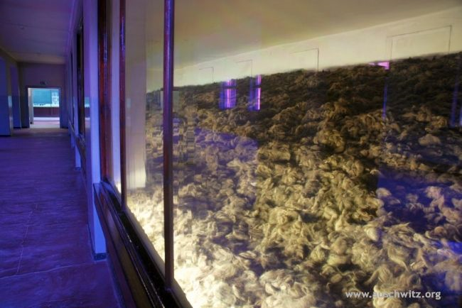
Figure 1. Auschwitz-Birkenau Memorial and Museum exhibit of shorn hair. Paweł Sawicki, Hair, Auschwitz-Birkenau Memorial and Museum, accessed November 6, 2018, http://auschwitz.org/en/gallery/exhibits/evidence-of-crimes,1.html.

Auschwitz II, or Birkenau, was originally established as the main killing center of the Auschwitz-Birkenau death camp complex. Birkenau became the memorial site and was left largely untouched since its liberation in January of 1945. Most of the wooden barracks and the crematoriums were destroyed by the Nazis at the end of the war, but the brick barracks and ruins of the destroyed buildings remain. One of the most deliberate and impactful aspects of the memorial is the entrance. Museum visitors follow the railroad tracks that lead into the camp through the main entrance, the “Gate of Death;” the same path that the prisoners took in railcars to enter the camp. The remaining wooden barracks, shown in figure 2, are open to museum visitors, allowing them to witness the buildings where prisoners lived at the camp. Because what remains in the memorial are ruins of the camp, public historians are faced with the issue of conservation. Conservation efforts are constant at the museum and memorial, especially in the case of wooden barracks that are unsheltered from the environment. The ruins of the gas chambers, crematoriums, and mass graves at the back of the camp are able to be approached, but not accessed directly. The gas chamber stairs are perhaps one of the most memorialized spaces in the camp. Many visitors place written Jewish prayers, prayer candles, or stones on the crematorium steps as a sign of remembrance and memorial of the deceased. There are no creative exhibitions and few information boards at Birkenau; the museum visitor derives Holocaust memory through the evocation of emotion, the witnessing of the massive factory-like scale of the former camp, and the viewing of the camp remains that attempt to exhibit life in Birkenau. Museum visitors are encouraged to remember the Holocaust by remembering artifacts, such as the barracks and gas chambers. Without an abundance of standard museum information boards at the site, purely witnessing the memorial at Birkenau shapes Holocaust memory.

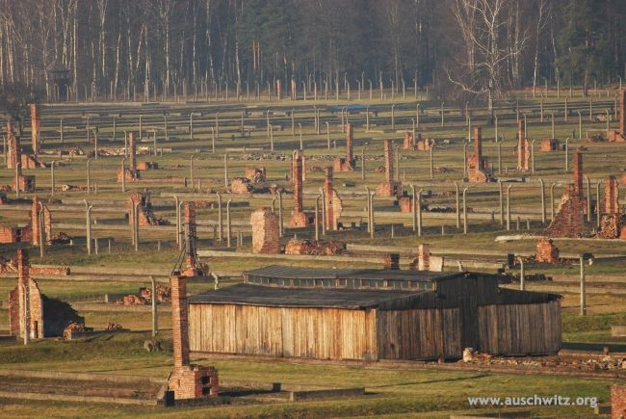
Figure 2. Auschwitz-Birkenau Memorial and Museum wooden barracks and ruins. Ruins of wooden huts at sector BII, Auschwitz-Birkenau Memorial and Museum, accessed November 6, 2018, http://auschwitz.org/en/gallery/memorial/former-auschwitz-ii-birkenau-site/aerial-photographs,13.html.

When this author went to the Auschwitz-Birkenau Memorial and Museum in September of 2017, she was interested in understanding how the museum preserved and exhibited Holocaust history. Some of the most striking artifacts in the museum are actually the structures of the former death camp themselves. In addition to the impact of witnessing the stolen property of the camp prisoners, visitors at the museum can actually enter Gas Chamber 1 as part of the Permanent Exhibition at Auschwitz I. The gas chamber is not set up as a museum exhibit, yet the impact of being in the physical site of such horrific murder is overwhelming and emotional. At Auschwitz II-Birkenau, the pure scale of the site is astounding. Even though much of the former death camp lay in ruins, the expanse of the camp and what remains of the barracks contribute to the understanding of Holocaust history. This author was amazed at the commitment to the preservation of Holocaust history and the ability of the site to impact memory, especially in the spaces that highlighted the scale of the genocide at Auschwitz-Birkenau.
Auschwitz-Birkenau is unique in the realm of Holocaust memory and public history. It was formerly a death camp; used as a tool to implement the Final Solution to the Jewish Question in Europe. It was later developed into a museum, exhibiting the physical structures of the camp itself and the stolen property of former prisoners. The museum at Auschwitz focuses on the historical memory of the camp, helping the museum visitor to understand the workings of the former death camp and provide exhibits of historical artifacts. Birkenau remains as ruins and preservation efforts help maintain the site to the condition of its liberation in 1945. There are few directed ideas on information boards for memory, rather, the museum visitor shapes memory of the Holocaust through witnessing the ruins of the memorial and understanding the scale of the atrocities that happened there. Auschwitz-Birkenau Memorial Museum is unique as a memorial space because it retains the artifacts in the context from which the museum’s history is told and it exemplifies the change in narrative of a museum through its exhibitions.

Yad Vashem - World Holocaust Remembrance Center

The Yad Vashem World Holocaust Remembrance Center was established in 1953 by the State of Israel with the passing of the Martyrs’ and Heroes Remembrance (Yad Vashem) Law 5713-1953. The museum, therefore, was to be funded by the Israeli government. There were many reasons for the construction of the museum in Jerusalem, especially as a place of memorial, outlined in the Yad Vashem Law: to remember (1) the six million Jews that died during the Holocaust, (2) Jewish families that were obliterated, (3) communities destroyed, (4) heroic Jews, (5) Jewish resistors, (6) Jews trapped in ghettos, (7) “the sublime”, (8) liberators, and (9) the “righteous among the nations”. All those named in the law were to be memorialized at Yad Vashem. Even though Israel was not the site of Nazi atrocities during the Holocaust, a national memorial so soon after the establishment of Israel in 1948 was seen not only as appropriate, but mandatory. Because of this, Yad Vashem became one of the earliest Holocaust museums. Just two years after the establishment of Israel as a nation and just a few years before the Yad Vashem Law, the State of Israel passed The Law of Return, granting Jews all over the world the right to settle in Israel. It stated that “Every Jew has the right to come to this country as an oleh [immigrant to Israel].” This law was a direct reaction to the struggle of Jews to immigrate to tolerant nations during the Holocaust. The law is a supposed conclusion to the horrors of the Holocaust, asserting that persecuted Jews from around the world could find refuge in Israel; this is the final message at the end of the Holocaust History Museum at Yad Vashem.
Like other Holocaust memorials, Yad Vashem was to be a place of education and remembrance, but also a place of Jewish nationalism and religion. Yad Vashem is more than a museum, however. Outside of the museum walls are other memorial areas, such as the Avenue of the Righteous Among the Nations and the Memorial to the Deportees. The museum itself is a place of history and education, with its memorials represented through symbolism. The memorials surrounding the museum are places of remembrance, and what later became spaces of religious pilgrimage. It is important to note that Yad Vashem focuses on the Jewish perspective of the Holocaust. Yad Vashem, like other museums, has faced the issue of artifact displacement. When the museum was established in 1953, many immigrants to the new nation were Holocaust survivors. Like the United States Holocaust Memorial Museum, many of the artifacts in the museum were donated by survivors, but Yad Vashem was designed in a way that explained the aftermath of the Holocaust with the creation of Israel. Yad Vashem exhibits the Holocaust within the context of Zionism and Judaism in the new State of Israel, so the creation of the museum was seen as a history that ended with the new country, complicating the issue of artifact displacement. Because Yad Vashem is the self-depicted World Holocaust Remembrance Center, it is faced with the task of maintaining collections of Jewish historical, religious, and cultural significance, while at the same time functioning as a Holocaust memorial and educational center.
Unlike most other Holocaust museums, Yad Vashem is often explicitly religious in its remembrance. Yad Vashem has a synagogue within the museum where Jewish museum visitors may go to pray the Kaddish, or the memorial prayer for the deceased. While many other Holocaust museums and memorials are considered sites of religious significance, few others have a synagogue for visitors to use. Chairman of the Yad Vashem Directorate since 1993, Avner Shalev, explained, “The Yad Vashem synagogue serves as a memorial to the destroyed places of worship of European Jewry. It is a testimonial to the indestructible faith, the rich spiritual world of European Jewry and the extraordinary will of the Jewish people to survive, to remember and to rebuild.” The synagogue, as a part of the museum, represents religious and cultural memory. As Shalev explained, the synagogue serves as a tool for memorial and remembrance, which was incredibly important after the plan to annihilate all Jewish people and culture during the Holocaust.
The main part of the museum, the Holocaust History Museum, is divided into galleries, or exhibits in the form of a timeline. It is the new Holocaust History Museum, replacing the former history museum in 2005 after a decade of planning. The gallery, “The Awful Beginning,” displays the beginning of the war and the German occupation of Poland. At the end of this gallery, museum visitors see a wagon like those used to move Jews out of their homes and into ghettos. This serves as a connection between this gallery and the “Between Walls and Fences” gallery on life in the ghettos. “The Final Solution” is the largest gallery in the Holocaust History Museum. It focuses on Jewish resistance in the ghettos and the deportations of Jews to Auschwitz-Birkenau. The “Resistance and Rescue” gallery is dedicated to the attempts at resistance by Jews and includes acknowledgement for the Righteous Among the Nations; the non-Jews that resisted the Nazis in order to save Jewish lives. This gallery features the original Schindler’s List, or the list of the 1,200 Jews that Czech-German businessman Oskar Schindler saved during the Holocaust. The final galleries in the main exhibit are “Return to Life” and “Epilogue - Facing the Loss.” “Return to Life” focuses on life just after liberation, including the struggle to unify families and the desire of some Jews to reach Israel. The epilogue gallery, “Facing the Loss,” is an artistic exhibit designed by Israeli artist Uri Tzaig. It includes responses to the Holocaust by Jews today and features a video with excerpts from Holocaust-era texts.
While the Holocaust History Museum galleries follow a historic timeline, much of the memory that is achieved by the museum comes from its architecture. Architect Moshe Safdie designed the Holocaust History Museum, shown in figure 3, to be mainly underground. The building is made of concrete and includes skylights for the underground sections, according to the light requirements of specific galleries. The museum is shaped in a prism, with each end of the building extending outward from the center. Symbolism in the museum comes from the building’s centermost galleries, representing darkness, and ending with openness and light. Before leaving the museum, visitors walk through the Hall of Names; the record of all known Jews that died during the Holocaust. “The main circular hall houses the extensive collection of ‘Pages of Testimony’ – short biographies of each Holocaust victim. Over two million Pages are stored in the circular repository around the outer edge of the Hall, with room for six million in all.” This is considered one of the memorial segments of the museum, drawing attention to the individual lives lost during the Holocaust and making Holocaust history more personal than the historical timeline of galleries that preceded it. Other Holocaust museums try to draw attention to individual lives of those that experienced the Holocaust, usually through oral histories or photographs, but no museum does so as comprehensively as the Hall of Names at Yad Vashem. The museum visitor exits the galleries on a platform surrounded by glass facing outward to the hills of Jerusalem, which symbolizes an emergence from darkness with the hope of finding new life in Israel. The use of symbolism to build Holocaust memory is prominent, especially the use of political symbolism, which is explicit in Yad Vashem compared to other Holocaust museums outside of Israel.

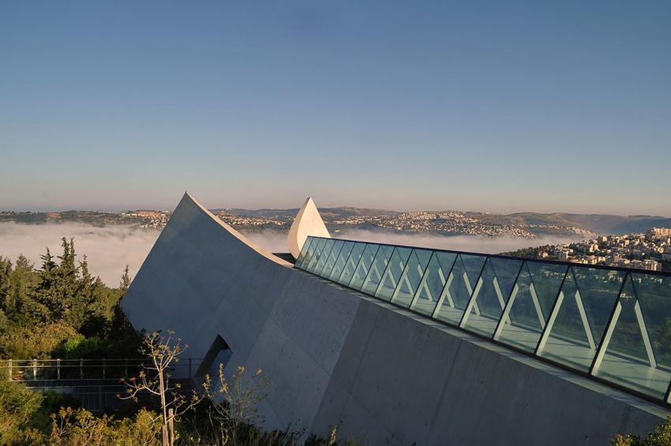
Figure 3. Exterior of the Holocaust History Museum at Yad Vashem. The Holocaust History Museum, Yad Vashem, accessed November 14, 2018, https://www.yadvashem.org/museum/holocaust-history-museum.html.

Outside of the museum walls are numerous memorials on the museum grounds. One of those memorials, shown in figure 4, is The Valley of the Communities; a monument which covers over two acres of bedrock engraved with the names of established Jewish communities of Europe from before the Holocaust. Like the Holocaust History Museum, The Valley of the Communities is focused on memory through symbolism. For example, “The Valley itself is a labyrinth of courtyards and walls, of openings and dead ends in which it is intended that visitors will sense some degree of insecurity, of being trapped in a frustrating maze which threatens to collapse upon them, of being caught in a place from which escape is difficult. At the same time, the open sky above and the surrounding flora express the continuity of life.” The use of symbolism and goal of remembrance helps evoke Holocaust memory, especially the religious and cultural memory, of European Jews. Because of the religious connections between Judaism and the Holocaust, it is very common for museum visitors to bring prayer candles or Hebrew prayers with them to leave at the base of community walls. The Valley of the Communities is a monument and memorial to the communities, culture, and heritage of European Jews that perished during the Holocaust, offering the visitor an opportunity to build memory outside of the museum.

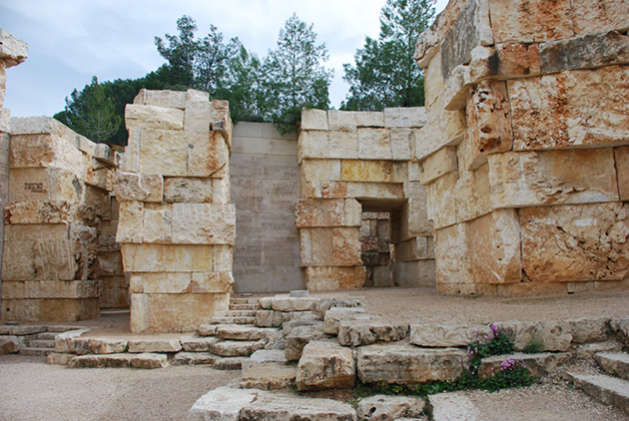
Figure 4. The Valley of the Communities at Yad Vashem. The Valley of the Communities, Yad Vashem, accessed November 14, 2018, https://www.yadvashem.org/yv/en/exhibitions/valley/walls.asp.
Yad Vashem is a remembrance center focused on preserving the memory of individuals and communities of Jews that died during the Holocaust. It explicitly includes the importance of the creation of a Jewish State in Israel in the aftermath of the Holocaust, including political symbolism in architecture and memorials. Because it was established and is run by the federal government, it is under the discretion of the nation’s policies. The unsaid condition of many politicians visiting Israel is the agreement to visit Yad Vashem. Nevertheless, Yad Vashem is an authority on the Jewish experience during the Holocaust and is dedicated to remembrance with the understanding of Israel as the epilogue to the Holocaust.

The United States Holocaust Memorial Museum

The idea for a United States memorial to the Holocaust originated in an Executive Order by President Jimmy Carter in 1978. Executive Order 12093 was the President’s Commission on the Holocaust, which sought to build a commission of advisors that would create a Holocaust memorial on the National Mall in Washington, DC. In 1980, Congress passed an Act to establish the United States Holocaust Memorial Council. The land for the memorial was donated by the federal government, but the funds for its construction were acquired through a newly established foundation and non-governmental donations. The original intent for the commission was to design a memorial to the Holocaust, but eventually the project became focused on the creation of a memorial museum. The United States Holocaust Memorial Museum (USHMM) opened its doors in 1993, fifteen years after the Executive Order in 1978. The Holocaust Commission faced many challenges in the production of the USHMM, with differing opinions on artifacts by commission members, some of whom were Holocaust survivors. The most important aspects of the museum, it was determined, would be remembrance, research, and education. Since the museum was to be situated on the National Mall with other American memorials and museums, it was understood that the USHMM would be widely visited by tourists and school groups. The location of the museum in the United States is quite interesting because the Holocaust did not happen in the United States, so why is there a memorial in the nation’s capital? What is the purpose of constructing a Holocaust museum so many years after the atrocities were committed? What is the impact of artifact displacement and relocation from central Europe to the United States? These questions bring attention to the complexity of Holocaust memory and public history.
The decision to establish a Holocaust museum in the United States was one that caused great speculation. Of course there is the idea that a Holocaust museum in the United States would demonstrate political support for Israel. Just prior to the Commission on the Holocaust, the United States was an active supporter of Israel in the Arab-Israeli war in 1973, with the United States government sending millions of dollars in aid to Israel. Reasons for Senate support of Israel include the understanding of Israel as the “underdog,” American memory of the Holocaust, and the support of Israel as a democratic nation. The importance of Israel as a democratic government can not be overstated. During the Cold War period, the United States was eager to support international democracy, countering Soviet support for communism.
Another reason for the museum was the United States wanted to present itself as the nation that helped defeat the Nazis, liberated German concentration camps, and became a world leader in human rights. As outlined in the museum’s mission statement, “The Museum’s primary mission is to advance and disseminate knowledge about this unprecedented tragedy; to preserve the memory of those who suffered; and to encourage its visitors to reflect upon the moral and spiritual questions raised by the events of the Holocaust as well as their own responsibilities as citizens of a democracy.” The museum, pictured in figure 5, seeks to provide Holocaust education, memorial, and reflection. The last aspect of their mission statement clearly addresses the museum visitor, outlining that visitors should reflect on the exhibits in the museum in order to create memory and take away lessons from the Holocaust.

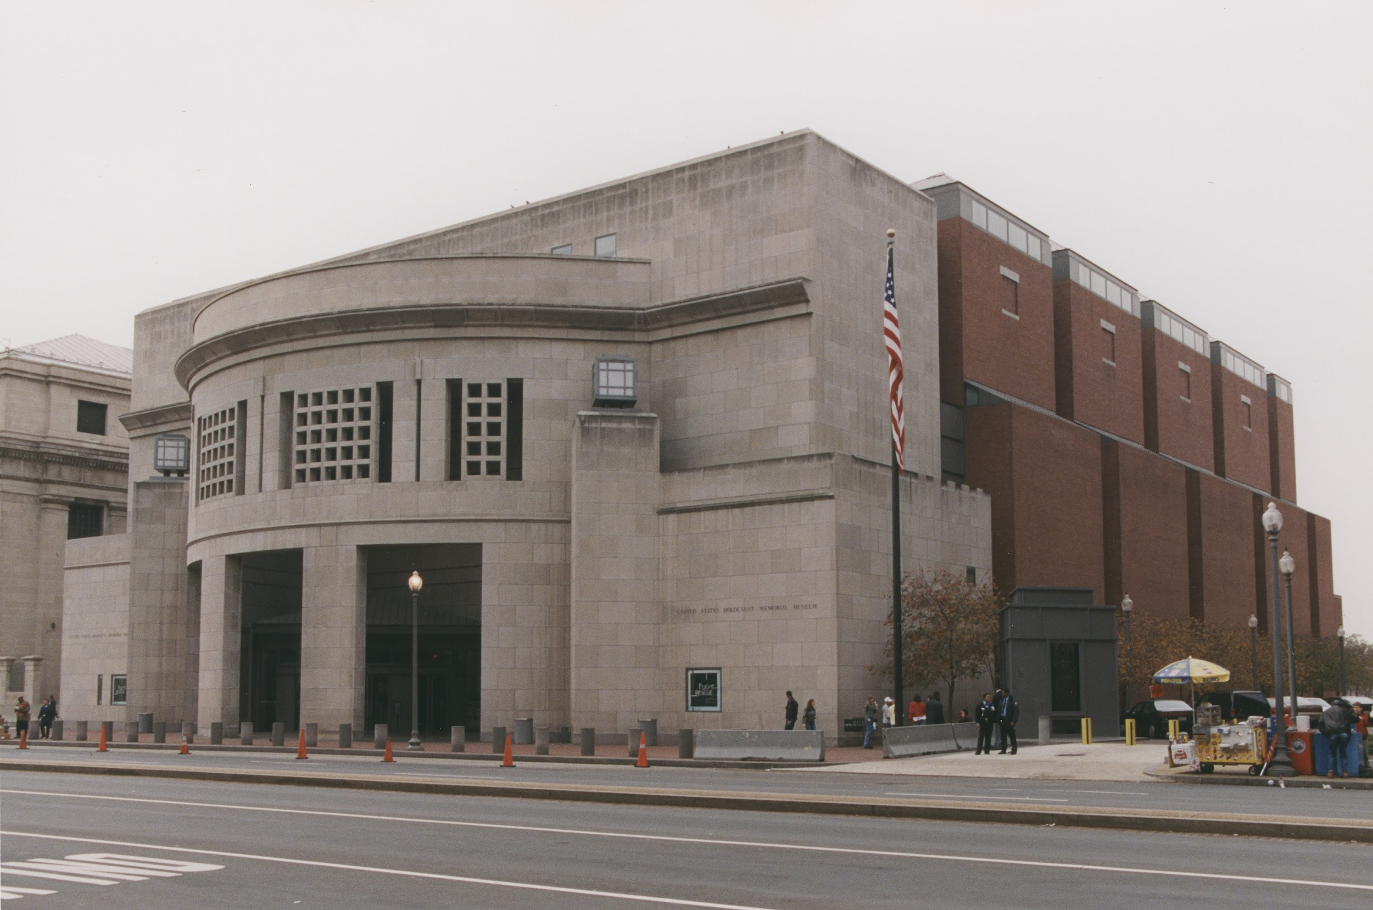
Figure 5. United States Holocaust Memorial Museum exterior. Max Reid, View of the U.S. Holocaust Memorial Museum from across 14th Street, United States Holocaust Memorial Museum, Copyright United States Holocaust Memorial Museum, accessed November 1, 2018, https://collections.ushmm.org/search/catalog/pa1126740.
The main exhibit at the museum seeks to have the visitor “experience,” or be witness to, the Holocaust. Each visitor receives an identification card of a person that lived during the Holocaust upon entry to the Permanent Exhibition, so they walk through the museum following the experiences of that particular victim. The identification card project was developed as an educational tool; a sort of lesson plan for teachers bringing their students to the museum. The Permanent Exhibition: “The Holocaust” follows a timeline of the Holocaust, beginning in 1933 and ending with the liberation of the concentration camps and survivor testimonies. The first segment of the exhibit is “Nazi Assault - 1933 to 1939,” and includes the Nazi rise to power beginning with the appointment of Adolf Hitler as Chancellor of Germany in 1933, the implementation of the Nuremberg Race Laws in 1935, Kristallnacht (Night of Broken Glass in German) in November of 1938, and the section ends with the beginning of World War II with the invasion of Poland in September of 1939. The next section, “The Final Solution - 1940 to 1945” follows the progression of hatred toward Jews by the Nazis. The main focus of this exhibit is the Final Solution in death camps. One of the exhibits is a model of a wooden barrack, representative of the barracks at Auschwitz-Birkenau death camp. Museum visitors may walk inside the barracks and view reconstructed bunks and prisoner food dishes. The final section of the Permanent Exhibition, “Last Chapter,” focuses on the liberation of the camps and life after the Holocaust. This exhibit includes survivor testimonies and information on those that helped Jews escape persecution. Unlike Yad Vashem, the “Last Chapter” focuses little on Israel as the epilogue to the Holocaust, instead drawing attention to the human lessons from the Holocaust through survivor testimonies and what can be learned about the perpetrators of the genocide, the bystanders, and those that saved Jews.
The use of models of barracks in the permanent exhibition, shown in figure 6, is crucial to the goals of Holocaust remembrance at the USHMM. Since the museum is outside of Europe, and therefore not the owner of actual historical artifacts such as the barracks, the museum is trying to bring Holocaust memory and history to the United States. The goal of using a model of the barracks is one in which the museum tries to shape memory by allowing museum visitors to witness and interact with a model of a historical artifact, without the issue of artifact displacement from their origins in Europe. Museum visitors are encouraged to walk through the barracks to learn about the living conditions in the camps, keeping in mind that no museum could accurately portray the reality of the horrors found in the camps. There are problems with the use of barracks, however. Often the use of an artifact is used to portray a larger story, in this case, the barracks represent the living conditions in concentration camps. The danger with using one artifact to symbolize or be responsible for representing a larger historical context comes down to memory being shaped around objects rather than history. The phrase “Never Forget” does not refer to the remembrance of barracks or other artifacts, but to the remembrance of the victims. The barracks, nonetheless, are a powerful tool used to shape Holocaust memory within the specific context of the museum because the USHMM faces different concerns regarding artifact ownership compared to museums and memorials in Central Europe.

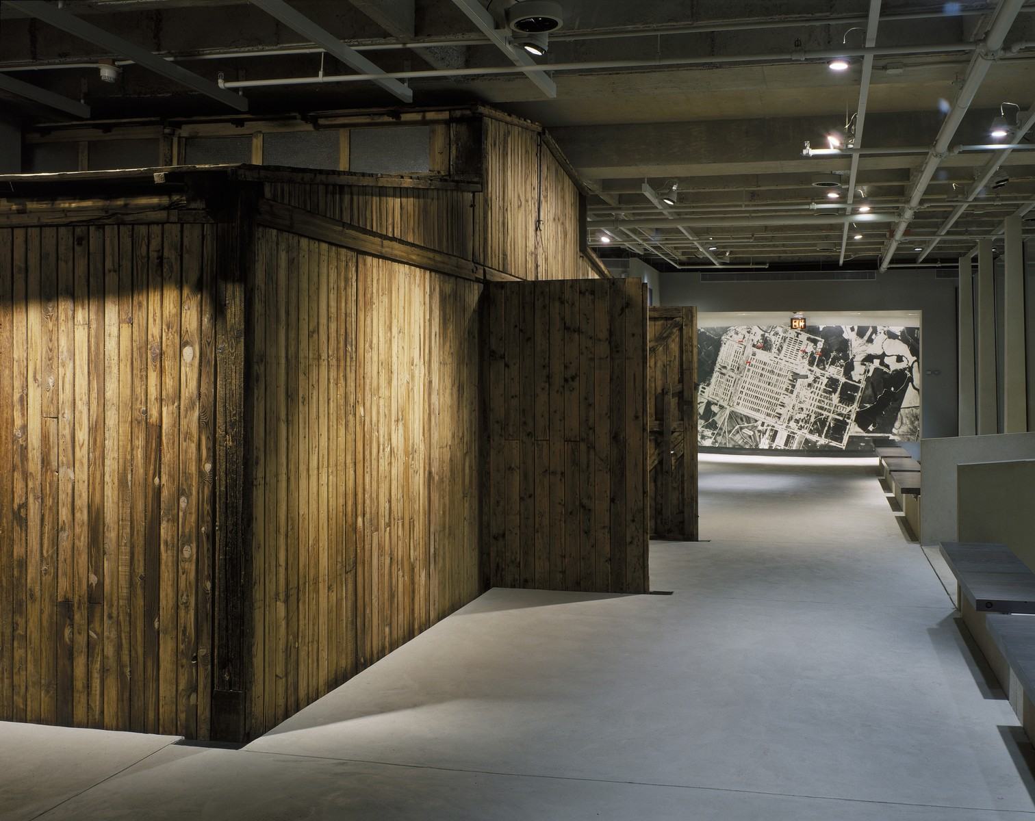
Figure 6. Reconstructed barracks in the permanent exhibition of the USHMM. Edward Owen, Exterior view of the reconstructed barracks from Auschwitz on display in the permanent exhibition of the U.S. Holocaust Memorial Museum, United States Holocaust Memorial Museum, Copyright United States Holocaust Memorial Museum, accessed November 1, 2018, https://collections.ushmm.org/search/catalog/pa1092937.

Although the events of the Holocaust did not happen in the United States, a Holocaust museum and memorial stands in the nation’s capital. The museum focuses on Holocaust education and remembrance, keeping in mind that the United States can not claim ownership to many of the artifacts that they present, unless they were explicitly donated by a survivor or their family. The issue of artifact displacement is heightened even more so than the issue would be in a museum in Europe. Unlike other Holocaust Museums, such as Yad Vashem, the USHMM does not end the narrative of their exhibits with the creation of Israel. Instead, the USHMM ends the permanent exhibit with a reflection of the human lessons that can be learned from the Holocaust through survivor testimonies, the impact of bystanders, and the importance of the resistors that risked their lives to save Jews. Nonetheless, the USHMM remains a world renowned museum dedicated to the education and remembrance of the Holocaust.

Jewish Museum Berlin

The Jewish Museum Berlin, or Jüdisches Museum Berlin in German, has perhaps the longest history among Holocaust Museums. Initially founded as the Jewish Museum in 1933, the museum was opened with the intentions of creating a center for Jewish art and artifacts from Palestine that were to be displayed in Berlin. The Jewish Museum was destroyed by Nazis in 1938, however, some of the surviving original collections from the Jewish Museum are housed in the Jewish Museum Berlin today. In 1962 the museum reopened as the Berlin Museum, which was dedicated to the culture and history of Berlin, remaining open until 1995. The idea to repurpose the Berlin Museum into the Jewish Museum Berlin dated back to the 1970s, even though it was not opened as the Jewish Museum Berlin, pictured in figure 7, until nearly thirty years later. The addition of the Libeskind Building to the existing Berlin Museum by architect Daniel Libeskind transformed the museum into the Jewish Museum Berlin (JMB) in 2001. The unification of East and West Germany after the fall of the Berlin Wall in 1989 helped facilitate the advancement of the museum as the nation tried to answer the question of what it meant to be German. The JMB was to be run by a foundation under the supervision of the Federal Government, but not owned by the State of Germany or the City of Berlin.
Beginning in February of 1976, the Society for a Jewish Museum Berlin was founded, but their goal was not immediately realized. The Berlin Senate advocated for an extension to the existing Berlin Museum, but it was decided in December of 1997 that the future museum would become a Jewish museum. In the same year, W. Michael Blumenthal was named the Founding Director of the Jewish Museum Berlin. In August of 2001, just one month before the scheduled grand opening of the museum, the Jewish Museum Berlin Foundation was established. Finally in September of 2001, the JMB opened to the public, after being rescheduled out of respect for the terrorist attacks of 9/11 in the United States. Despite the establishment of the JMB in the capital of Germany, the country responsible for perpetrating the crimes of the Holocaust, the JMB was not intended to become a national museum to the Holocaust like Yad Vashem in Israel or the USHMM in the United States. In fact, Germany has never had a national Holocaust museum like those in other countries, but instead has many smaller museums and memorials. The JMB is unique as a Holocaust museum because it is not a national museum dedicated to the Holocaust, but rather a museum dedicated to the Jewish heritage, culture, and history of Berlin, which includes the history of the Holocaust in the Libeskind Building.

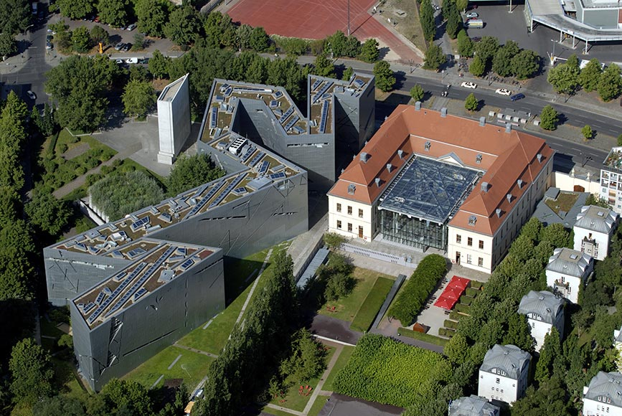
Figure 7. Exterior of the Jewish Museum Berlin. Günter Schneider, Aerial View of the Jewish Museum Berlin, Old Building and Libeskind Building, Jewish Museum Berlin, accessed October 25, 2018, https://www.jmberlin.de/en/press-images.

The most prominent and symbolic feature of the Libeskind Building is its architecture. “The building allows for many interpretations. For some people it brings to mind a broken Star of David; for others it is a bolt of lightning. Many people are left with a feeling of insecurity or disorientation.” The design was named “Between the Lines” and included “voids,” or spaces intended to be disorienting and empty. “Daniel Libeskind uses the voids to address the physical emptiness that resulted from the expulsion, destruction, and annihilation of Jewish life in the Shoah, which cannot be refilled after the fact. He wanted to make this loss visible and tangible through architecture.” The lower level of the exhibition is defined by three axes that tell three historical narratives of German Jews. They are the Axis of Exile, the Axis of the Holocaust, and the Axis of Continuity. The Axis of Exile tells the story of Jewish emigration efforts out of Germany in 1933 and after the Kristallnacht. The Axis of the Holocaust ends at the “Holocaust Tower,” where “Daylight penetrates the tower only through a narrow slit in the unheated concrete silo and any exterior sounds are heavily muffled by the walls. Many visitors experience a feeling of oppression or anxiety inside the Holocaust Tower.” The final axis, the Axis of Continuity, leads museum visitors to a staircase, where they are stopped abruptly in front of a white wall. This axis is different than the final exhibits in other Holocaust museums because it does not have a resolution. Yad Vashem ends with the hope of new life for Jews in Israel, the USHMM ends with lessons from the Holocaust and survivor testimonies, and the Auschwitz-Birkenau Memorial and Museum is not organized in such a linear way, but the JMB’s Axis of Continuity does not provide a definitive resolution at the end of the exhibit. Instead, the axis demonstrates that the future is uncertain, reflecting the uncertainty that survivors felt after liberation. The windows throughout the axes are cut into slits that make those walking through the exhibit unable to discern their location underground compared to their location to the street level. The purpose of the axes furthers the architect’s intention of anxiety and disorientation, encouraging museum visitors to draw on the emotions that are evoked in the exhibit to connect with memory. While emotion is an important tool in the shaping of memory, the museum has little written information on Holocaust history exhibited. As a result, it is important for visitors to understand the intentions and historical connections of the symbolic architecture in shaping Holocaust memory in order to avoid creating memory of architecture rather than memory of the Holocaust.
The exhibition Shalekhet, or “Fallen Leaves,” by Menashe Kadishman is perhaps one of the most prominent features of the Libeskind Building. This installation, shown in figure 8, includes over 10,000 open-mouthed iron faces which cover the floor of a “void.” Visitors are encouraged to walk over the faces, disrupting the silence of the museum with the loud noise of the metal plates clashing together. The walk to the back of the void is unsteady as the iron plates move underfoot and as visitors look to watch their step, they are looking at the faces representing those that lived during the Holocaust; the sounds of the plates as the sound of their oppression. The initial reaction to walking on the metal plates is apprehension and anxiety, but emotions are perhaps most invoked when the visitor reaches the end of the exhibit and realizes that they must walk back to where they began at the front of the installation. The Shalekhet exhibition is an example of how the JMB encourages emotional reactions to installations and architecture over the more traditional museum experience of learning historical concepts through information boards in exhibits. Unlike the USHMM and Yad Vashem, the JMB does not focus on the teaching of concepts but encourages emotional reflection on the installations. This is a powerful tool to help shape memory, however, it poses a potential risk for remembering exhibits and installations but not understanding the history that is more explicitly taught at museums like Yad Vashem and the USHMM. This exhibit, of course, is a defining feature of Holocaust public history and greatly impacts how Holocaust memory is shaped in the museum.
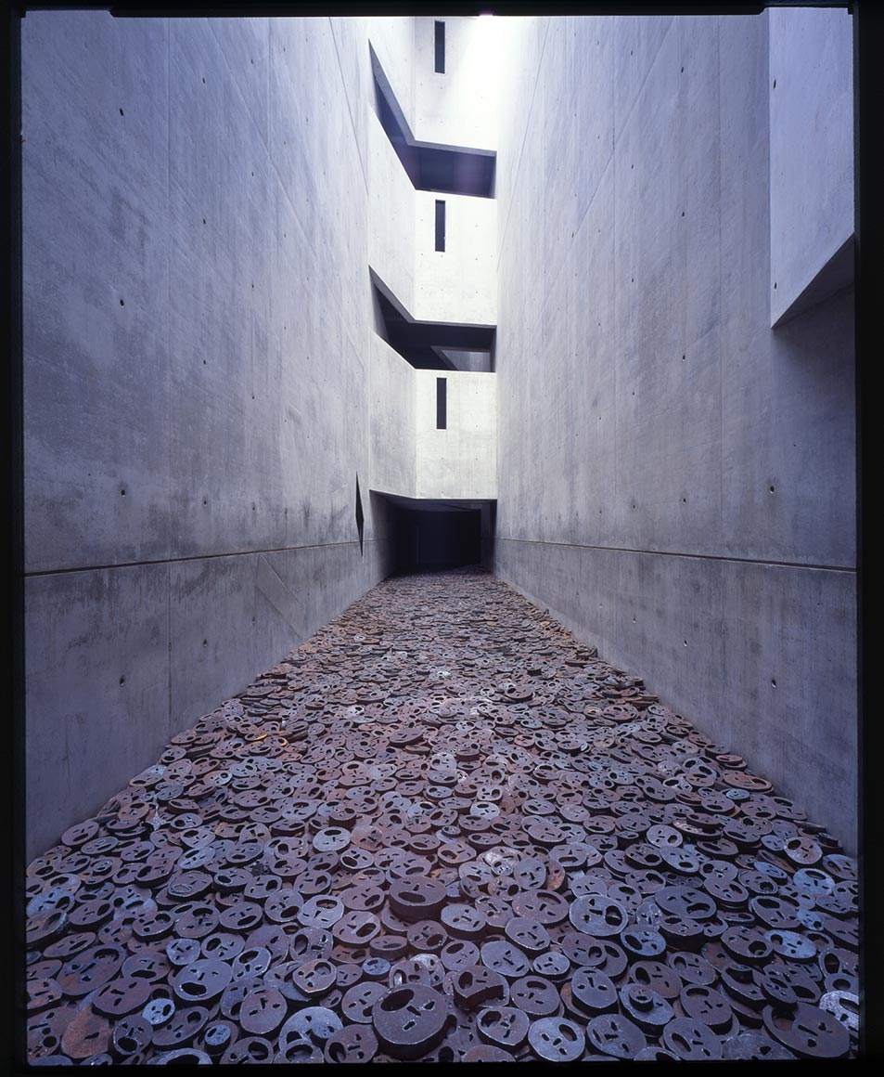
Figure 8. Shalekhet- Fallen Leaves by Menashe Kadishman. Jens Ziehe, Shalekhet (Fallen Leaves) installation by Menashe Kadishman, Jewish Museum Berlin, gift of Dieter and Si Rosenkranz, accessed October 25, 2018, https://www.jmberlin.de/en/press-images.

When this author visited the JMB in December of 2017, she was amazed at the complexity of the museum as a whole. It is important to note that the museum highlights German-Jewish history and Jewish heritage and culture, all of which were threatened to be forgotten with the murder of European Jews during the Holocaust. The museum draws attention to the horrific history of the Holocaust in the Libeskind Building, but also elaborates on the importance of Jews in German society before and after the Holocaust. The JMB is a sort of reclaiming of history by Jews, proving that Jewish heritage and culture was not made extinct during the Holocaust and that Jewish history is significant. The art installations and symbolic architecture combined with limited text on information boards in the exhibits made for a unique museum experience. Understanding the intentions of the museum’s architecture is vitally important in understanding the museum narrative and its representation of the Holocaust. Therefore, information on the symbolism and architecture of the building is included throughout the museum. The JMB truly tries to represent Holocaust history through symbolism and art installations, from which museum visitors derive an emotional connection to the history.
The exhibits in the Libeskind Building are an example of the importance of symbolism in shaping Holocaust memory. While artifacts in the axes hallways include explanations of the item and its owner, few of the installations in the Libeskind Building include detailed written explanations other than descriptions of their symbolic design and emotional representation. This leaves the installation open for interpretation, allowing visitors to pull meaning from symbolism. The power of symbolism in the architecture and art installations encourage emotion to shape Holocaust memory, rather than through a timeline of historical concepts and events that are standard in other Holocaust museums. Memory in the museum is not defined by boards of text, but rather, memory is formed by what the visitor takes away from their own understanding of the symbols. The JMB exhibits a larger history of German Jews than the Holocaust; an important consideration given that the Holocaust sought to destroy not only a people, but an entire heritage and culture.

Conclusion

Most Holocaust museums and memorials share common ideas surrounding how the Holocaust is to be remembered. Education, remembrance, research, and prevention of genocide remain the most consistent ideas among museums, however, the way in which the Holocaust is exhibited in museums has changed since the establishment of the Auschwitz-Birkenau Memorial and Museum in 1947. Originally a memorial to the communists that died at the hands of fascism, the site memorialized all victims of fascism, rather than the targeted groups that faced oppression under the Nazis. Under democratic Polish authority, the museum developed into a center for research and a museum dedicated to the memorialization of the specific groups of prisoners that were sent to the camp. Politics, too, has played a role in how the Holocaust is ingrained in the fabric of historical memory. Yad Vashem is controlled by the State of Israel, enacted into law by the Israeli government. The overarching message of the museum, whether acknowledged explicitly or symbolically, is of hope for the prosperity of Jews in their own Jewish state. Museums continue to be built over seventy years later around the world. The United States Holocaust Memorial Museum was founded in the United States, even though the events of the Holocaust did not happen there. It focuses on the humanistic lessons that can be learned from the Holocaust and stresses the importance of Holocaust remembrance. The museum remains one of the most renowned Holocaust museums in the world, with other modern Holocaust museums modeled after it. Other museums are dedicated to Jewish heritage and include Holocaust exhibits, like the Jewish Museum Berlin. A prominent feature of the museum is its architecture and art installations, with the focus of the museum being the display of Jewish heritage and history in Germany, despite the fact that it is not intended to be a national German Holocaust museum.
Holocaust museums and memorials are not all alike, especially in how they choose to design their exhibits. Public historians work to provide educational and memorial exhibits in Holocaust museums, bearing in mind the violent and horrific history that they must portray. Museum visitors acquire Holocaust memory in museum spaces and at memorial sites, witnessing the photos, artifacts, historical documents, and film footage housed in those institutions. In addition to the physical artifacts found in museum collections, Holocaust memory in museums often comes through the symbolism of art installations, exhibit layouts, and architecture. The memory is not fixed, and is shaped by the design of the exhibits, the historical narrative, and the artifacts displayed in the museums. It is important to form memory of the Holocaust and to understand the complexity and circumstances of memory, especially how that memory is shaped by public historians and museum visitors in Holocaust museums as the time approaches when there will be no survivors left to share their stories.

Works Cited

Primary Sources:

Auschwitz-Birkenau Memorial and Museum, 1947-Present. http://auschwitz.org/en/.

Jewish Museum Berlin, 2001-Present. https://www.jmberlin.de/en.

Jimmy Carter. “Executive Order 12093 - President’s Commission on the Holocaust.” Presidential Papers (November 1, 1978).

Jimmy Carter. "President's Commission on the Holocaust Appointment of the Membership and Advisers to the Commission.” Presidential Papers (November 8, 1978).

State of Israel. The Law of Return 5710-1950. Jerusalem (1950).

State of Israel. Martyrs’ and Heroes Remembrance (Yad Vashem) Law 5713-1953. Jerusalem (1953).

United States Holocaust Memorial Museum, 1993-Present, https://www.ushmm.org.

US Congress. An Act to establish the United States Holocaust Memorial Council. Public Law 96-388. 96th Cong. (October 7, 1980): 1547.

Yad Vashem - The World Holocaust Remembrance Center, 1953-Present, http://www.yadvashem.org.

Secondary Sources:

Bartov, Omer. "Chambers of Horror: Holocaust Museums in Israel and the United States." Israel Studies 2, no. 2 (1997): 66-87, http://www.jstor.org/stable/30246813.

Bauer, Yehuda. Rethinking the Holocaust. New Haven, Connecticut: Yale University Press, 2000.

Baum, Rob. "United States Holocaust Museums: Pathos, Possession, Patriotism." Public History Review 18 (2011): 26-46, https://epress.lib.uts.edu.au/journals/index.php/phrj/article/view/1016.

Bernard-Donals, Michael. "Synecdochic Memory at the United States Holocaust Memorial Museum." College English 74, no. 5 (2012): 417-36, http://www.jstor.org.proxy.uwec.edu/stable/23212923.

Chametzky, Peter. "Not What We Expected: The Jewish Museum Berlin in Practice." Museum & Society 6, no. 3 (2008): 216-45, https://journals.le.ac.uk/ojs1/index.php/mas/article/view/125/140.

Ezrahi, Sidra DeKoven. "Representing Auschwitz." History and Memory 7, no. 2 (1995): 121-54, http://www.jstor.org/stable/25618691.

Jenoff, Pam R. “Managing Memory: The Legal Status of Auschwitz-Birkenau and Resolution of Conflicts in the Post-Communist Era.” The Polish Review 46, no. 2 (2001): 131-153, https://www-jstor-org.proxy.uwec.edu/stable/25779250?.

Novick, Peter. The Holocaust in American Life. Boston: Houghton Mifflin, 1999.

Sodaro, Amy. "Memory, History, and Nostalgia in Berlin's Jewish Museum." International Journal of Politics, Culture, and Society26, no. 1 (2013): 77-91, http://www.jstor.org.proxy.uwec.edu/stable/42636436.

Stier, Oren Baruch. Committed to Memory : Cultural Mediations of the Holocaust. Amherst, MA: University of Massachusetts Press, (2003).

Stier, Oren Baruch. "Different Trains: Holocaust Artifacts and the Ideologies of Remembrance." Holocaust and Genocide Studies, Volume 19, Issue 1, (2005): 81–106, https://doi-org.proxy.uwec.edu/10.1093/hgs/dci004.

Trice, Robert H. "Congress and the Arab-Israeli Conflict: Support for Israel in the U. S. Senate, 1970-1973." Political Science Quarterly 92, no. 3 (1977): 443-63, https://www-jstor-org.proxy.uwec.edu/stable/2148502?sid=primo&origin=crossref&seq=1#metadata_info_tab_contents.

Rick Noack, “Obama once referred to a ‘Polish death camp.’ In Poland, that could soon be punishable by 3 years in prison.,” Washington Post, August 17, 2016, accessed November 17, 2018, https://www.washingtonpost.com/news/worldviews/wp/2016/08/17/obama-once-referred-to-a-polish-death-camp-in-poland-that-could-soon-be-punishable-by-3-years-in-prison/?noredirect=on&utm_term=.c5f3b08aaf93.
Ibid.
Peter Novick, The Holocaust in American Life, (Boston: Houghton Mifflin, 1999), 3-4.
Robert H. Trice, "Congress and the Arab-Israeli Conflict: Support for Israel in the U. S. Senate, 1970-1973." Political Science Quarterly 92, no. 3 (1977): 454, accessed November 17, 2018, https://www-jstor-org.proxy.uwec.edu/stable/2148502?sid=primo&origin=crossref&seq=1#metadata_info_tab_contents.
Peter Novick, The Holocaust in American Life, 242.
Sidra DeKoven Ezrahi, “Representing Auschwitz." History and Memory 7, no. 2 (1995): 126-127. accessed September 29, 2018, http://www.jstor.org/stable/25618691.
Pam R. Jenoff, “Managing Memory: The Legal Status of Auschwitz-Birkenau and Resolution of Conflicts in the Post-Communist Era.” The Polish Review 46, no. 2 (2001): 133-138, accessed November 15, 2018, https://www-jstor-org.proxy.uwec.edu/stable/25779250?.
Yehuda Bauer, Rethinking the Holocaust, (New Haven, Connecticut: Yale University Press, 2000), 67.
Peter Chametzky, "Not What We Expected: The Jewish Museum Berlin in Practice," (Museum & Society 6, no. 3, 2008): 240, accessed November 17, 2018, https://journals.le.ac.uk/ojs1/index.php/mas/article/view/125/140.
Novick, The Holocaust in American Life, 260.
Ibid., 261.
Oren Baruch Stier, Committed to Memory: Cultural Mediations of the Holocaust (Amherst, MA: University of Massachusetts Press, 2003), 31.
Ibid.
Michael Bernard-Donals, “Synecdochic Memory at the United States Holocaust Memorial Museum,” (College English 74, no. 5, 2012): 420, accessed November 18, 2018, http://www.jstor.org.proxy.uwec.edu/stable/23212923.
Ibid.
Bernard-Donals, “Synecdochic Memory at the United States Holocaust Memorial Museum,” 420-421.
“1945-1949,” Auschwitz-Birkenau Memorial and Museum, 1947-Present, accessed October 2, 2018, http://auschwitz.org/en/museum/history-of-the-memorial/memorial-timeline/years-1945-1949.
“1945-1949,” Auschwitz-Birkenau Memorial and Museum.
DeKoven Ezrahi, “Representing Auschwitz,” 126-127.
Jenoff, “Managing Memory,” 138-139.
Ibid., 143-144.
Jenoff, “Managing Memory,”148-149.
“Exhibits: Hair,” Auschwitz-Birkenau Memorial and Museum, 1947-Present, accessed October 27, 2018, http://auschwitz.org/en/gallery/exhibits/evidence-of-crimes,1.html.
“Permanent Exhibition,” Auschwitz-Birkenau Memorial and Museum, 1947-Present, accessed December 5, 2018, http://auschwitz.org/en/visiting/permanent-exhibition/.
“Exhibits,” Auschwitz-Birkenau Memorial and Museum, 1947-Present, accessed October 27, 2018, http://auschwitz.org/en/gallery/exhibits/evidence-of-crimes,1.html.
“Former Auschwitz II-Birkenau Site,” Auschwitz-Birkenau Memorial and Museum, 1947-Present, accessed October 27, 2018, http://auschwitz.org/en/gallery/memorial/former-auschwitz-ii-birkenau-site/the-unloading-ramp-and-the-gate-of-death,1.html.
“Preservation,” Auschwitz-Birkenau Memorial and Museum, 1947-Present, accessed October 27, 2018, http://auschwitz.org/en/gallery/work-of-the-museum/preservation/preservation-department,1.html.
“Former Auschwitz II-Birkenau Site,” Auschwitz-Birkenau Memorial and Museum.
State of Israel, Martyrs’ and Heroes Remembrance (Yad Vashem) Law 5713-1953 (Jerusalem, 1953).
Ibid.
State of Israel, The Law of Return 5710-1950 (Jerusalem, 1950).
Ibid.
“The Holocaust History Museum,” Yad Vashem: The World Holocaust Remembrance Center, 1953-Present, accessed October 20, 2018, https://www.yadvashem.org/museum/holocaust-history-museum.html.
Omer Bartov, “Chambers of Horror: Holocaust Museums in Israel and the United States,” Israel Studies 2, no. 2 (1997): 66-67, accessed September 15, 2018, http://www.jstor.org/stable/30246813.
“Synagogue: The Synagogue at Yad Vashem Showcases Judaica from Destroyed Synagogues in Europe,” Yad Vashem: The World Holocaust Remembrance Center, 1953-Present, accessed October 20, 2018, https://www.yadvashem.org/museum/museum-complex/synagogue.html.
“Inauguration of the New Holocaust History Museum,” Yad Vashem: The World Holocaust Remembrance Center, 1953-Present, accessed December 5, 2018, https://www.yadvashem.org/events/15-march-2005.html.
“The Awful Beginning: World War II and the Beginning of the Destruction of Jewish Life in Poland,” Yad Vashem: World Holocaust Remembrance Center, 1953-Present, accessed October 18, 2018, https://www.yadvashem.org/museum/holocaust-history-museum/galleries/the-awful-beginning.html.
“Between Walls and Fences: The Ghettos,” Yad Vashem: World Holocaust Remembrance Center, 1953-Present, accessed October 18, 2018, https://www.yadvashem.org/museum/holocaust-history-museum/galleries/between-walls-and-fences.html.
“The ‘Final Solution’: Jewish Uprisings in the Midst of Destruction,” Yad Vashem: World Holocaust Remembrance Center, 1953-Present, accessed October 18, 2018, https://www.yadvashem.org/museum/holocaust-history-museum/galleries/the-final-solution.html.
“Resistance and Rescue,” Yad Vashem: World Holocaust Remembrance Center, 1953-Present, accessed October 18, 2018, https://www.yadvashem.org/museum/holocaust-history-museum/galleries/resistance-and-rescue.html.
“Return to Life: She’erit Hapleita,” Yad Vashem: World Holocaust Remembrance Center, 1953-Present, accessed October 18, 2018, https://www.yadvashem.org/museum/holocaust-history-museum/galleries/return-to-life.html.
“Epilogue- Facing the Loss,” Yad Vashem: World Holocaust Remembrance Center, 1953-Present, accessed October 18, 2018, https://www.yadvashem.org/museum/holocaust-history-museum/galleries/epilogue.html.
“Architecture,” Yad Vashem: World Holocaust Remembrance Center, 1953-Present, accessed October 19, 2018, https://www.yadvashem.org/museum/holocaust-history-museum/architecture.html.
“Hall of Names,” Yad Vashem: World Holocaust Remembrance Center, 1953-Present, accessed December 5, 2018, https://www.yadvashem.org/museum/holocaust-history-museum/hall-of-names.html.
Ibid.
“Architecture,” Yad Vashem: World Holocaust Remembrance Center.
“The Valley of the Communities at Yad Vashem: Different Views,” Yad Vashem: World Holocaust Remembrance Center, 1953-Present, accessed October 19, 2018, https://www.yadvashem.org/yv/en/exhibitions/valley/views.asp.
“The Valley of the Communities at Yad Vashem: Different Views,” Yad Vashem.
Oren Baruch Stier, “Different Trains: Holocaust Artifacts and the Ideologies of Remembrance." Holocaust and Genocide Studies, Volume 19, Issue 1, (2005): 83, accessed September 20, 2018, https://doi-org.proxy.uwec.edu/10.1093/hgs/dci004.
Jimmy Carter, Executive Order 12093, “President’s Commission on the Holocaust, 1978,” Presidential Papers (November 1, 1978).
Act to establish the United States Holocaust Memorial Council, Public Law 96-388. 96th Cong. (October 7, 1980): 1547.
Robert H. Trice, "Congress and the Arab-Israeli Conflict,” 454.
Ibid.
“Mission and History,” United States Holocaust Memorial Museum, 1993-Present, accessed October 29, 2018, https://www.ushmm.org/information/about-the-museum/mission-and-history.
Rob Baum, “United States Holocaust Museums: Pathos, Possession, Patriotism." Public History Review 18 (2011): 35, accessed September 10, 2018, https://epress.lib.uts.edu.au/journals/index.php/phrj/article/view/1016.
“Activities and Resources for Use Following a Visit to the Permanent Exhibition,” United States Holocaust Memorial Museum, 1993-Present, accessed December 6, 2018, https://www.ushmm.org/information/visit-the-museum/group-reservations/resources/after.
“Nazi Assault - 1933 to 1939,” United States Holocaust Memorial Museum, 1993-Present, accessed October 15, 2018, https://www.ushmm.org/information/exhibitions/museum-exhibitions/permanent/nazi-assault-1933-to-1939.
“‘Final Solution’- 1940 to 1945,” United States Holocaust Memorial Museum, 1993-Present, accessed October 15, 2018, https://www.ushmm.org/information/exhibitions/museum-exhibitions/permanent/final-solution-1940-to-1945.
“Last Chapter,” United States Holocaust Memorial Museum, 1993-Present, accessed October 15, 2018, https://www.ushmm.org/information/exhibitions/museum-exhibitions/permanent/last-chapter.
Oren Baruch Stier, Committed to Memory, 31.
“The First Jewish Museum in Berlin,” Jewish Museum Berlin, 2001-Present, accessed October 10, 2018, https://www.jmberlin.de/en/first-jewish-museum-berlin.
“The History of the Jewish Museum Berlin,” Jewish Museum Berlin, 2001-Present, accessed October 8, 2018, https://www.jmberlin.de/en/history-our-museum.
Peter Chametzky, "Not What We Expected: The Jewish Museum Berlin in Practice,” 223.
“The History of the Jewish Museum Berlin,” Jewish Museum Berlin.
Ibid.
“The Libeskind Building,” Jewish Museum Berlin, 2001-Present, accessed October 9, 2018, https://www.jmberlin.de/en/libeskind-building.
Ibid.
“The Libeskind Building,” Jewish Museum Berlin.
Ibid.
Ibid.
Amy Sodaro, “Memory, History, and Nostalgia in Berlin's Jewish Museum." International Journal of Politics, Culture, and Society26, no. 1 (2013): 83-86, accessed September 21, 2018, http://www.jstor.org.proxy.uwec.edu/stable/42636436.
Oren Baruch Stier, Committed to Memory, 31.
“Shalekhet- Fallen Leaves: An Installation by Menashe Kadishman,” Jewish Museum Berlin, 2001-Present, accessed October 9, 2018, https://www.jmberlin.de/en/shalekhet-fallen-leaves.
“Memorial timeline,” Auschwitz-Birkenau Memorial and Museum, 1947-Present, accessed October 2, 2018, http://auschwitz.org/en/museum/history-of-the-memorial/memorial-timeline/.
“The Holocaust History Museum,” Yad Vashem: The World Holocaust Remembrance Center.
“About the Museum,” United States Holocaust Memorial Museum, 1993-Present, accessed October 29, 2018, https://www.ushmm.org/information/about-the-museum.
“Who We Are,” Jewish Museum Berlin, 2001-Present, accessed October 10, 2018, https://www.jmberlin.de/en/who-we-are.

