FROM SCHOLARS TO SOLDIERS: MEN OF THE EAU CLAIRE NORMAL SCHOOL AND THE FIRST WORLD WAR

Michael Schmitz
History 489: History Seminar
April 5, 2012

Copyright for this work is owned by the author. This digital version is published by McIntyre Library, University of Wisconsin-Eau Claire, with the consent of the author.

Contents
Prologue 1
Introduction 3
The Powder Keg Explodes 4
The Normal School: The Scholars 6
America Enters the War 11
The National Army: Conscription in World War I 13
To the Sound of the Guns: The Soldiers of the Normal School 1917-1918 18
Post War 27
Epilogue 29
Appendixes 31
Works Cited 41

A soldier and a teacher rolled into one; the result is a man who can’t be out done.

- George Simpson Persiscope: 1920

Prologue: Chateau-Thierry, July 18th, 1918
“Half a league, half a league, half a league onward, all in the valley of Death rode the six hundred.”
Neither, Lieutenant Arthur Marcus Olson, nor any of his men, had eaten in two days, and they had not slept in twenty-four hours. He and his platoon, in fact his entire division, had been marching non-stop since the evening of July, 16th. Olson had only a slight notion of where they were going, but he had guessed that because of the urgency of the march, something big was about to happen. Olson had navigated his men through roads clogged with other troops, ammunition wagons, artillery guns, tanks, trucks, and above all, mud. It had been raining all night, and anyone could have seen that there was no way the tanks were going to get to the jump off point with the infantry. As they approached a small road sign stating “Chateau-Thierry,” they were told they needed to double time it. Olson looked at his watch; it was 4:00am. He ordered his men to sprint towards a line of trenches. A half hour later, Olson’s platoon, along with the rest of the 23rd Infantry Regiment of the 2nd Division, arrived in the trenches exhausted at having run several kilometers, when the word came to fix bayonets and prepare to go over the top. Artillery shells began to streak overhead and crash in front of the line. Olson and every other junior grade officer ordered their units out of the trenches. They did not have enough ammunition, they did not have a preparatory barrage, they did not have tanks, they did not have machine guns, and they did not have any rest. What they did have were rifles, bayonets, and a rolling barrage in front of them. As they advanced the Germans had no idea what was happening, only a few weeks before they had had the Allies on the ropes and seemed poised to reach Paris, now nearly 50,000 Americans and as many French troops were suddenly attacking. Olson and his men quickly cleared the first three kilometers of the offensive.
The time had come to turn southeast in order to reach the divisional objective and avoid getting tangled up with the neighboring divisions. Olson could not tell whether they had turned or not. The lack of maps and clear orders, combined with the confusion of battle blinded him and the rest of division. They cleared another German defensive position with the help of the 75mm howitzers, but it became clear when they reached the main objective of the day, at 9:30 am that the 75’s were out of range. They prepared for a renewed charge. Olson urged his men forward as he had been doing all morning, when a German machine gun opened fire. As he looked down he saw he was bleeding from bullet wounds. His men removed him from the field. His regiment, the 23rd, had lost half of its officers and men, and it had been the lucky one, the other regiment of the brigade, the 9th, could only account for 300 of its 3,000 men. However, the sacrifice, although maybe unneeded in a tactical sense, had not been in vain. The 2nd Division had gone further than any other Allied Division. They had captured 3,000 German troops, 11 kilometers of ground, and seventy-five artillery pieces. They had also made it possible for Allied artillery to shell a critical German supply line. The cost had been horrendous. Olson was one of 4,319 casualties, nearly all of them from the infantry. Later that day Arthur Olson died, becoming the first and only death from the Eau Claire Normal School in the Great War.
Introduction
When I first came up with this topic I had wanted to write about Arthur Olson. The portrait of the young man in an army uniform with the faintest hint of a smile tormented me since I had been a freshman. Who was he? Where did he come from? What was he like? How did he die? The answers to these questions were as simple as they were tragic. He was born in 1893 in Superior, Wisconsin. By all accounts he was a tall man with the nickname “Big Ole,” a friendly man who inspired confidence in those around him. He died as described above from bullet wounds sustained on July 18th, 1918 at a place in France called Chateau-Thierry, at the age of twenty-three. He never married. He left nothing behind except that portrait and a memory in his classmates and comrades in arms. In sum, he is a historical enigma, but as I delved into the archives to figure him out, I found other men. Ernest Dearth, George Simpson, Carl Berg, and Clarence Cleasby just to name a few. They all either went to the Normal School in 1917-18 or came to the school afterwards on a piece of legislation that every citizen of Wisconsin should be proud of.
The Normal School was founded in 1916, within a year of its founding its first class of young men and two of its professors were wearing the uniform of their nation’s army and were heading off to war. Who were these men? The last history of the University, by Carter and Jenswold, does have the words World War I in its index. No mention is made of the interruption of the lives of these young men. Therefore this paper will consist of several parts. The first is how the war came to be, both for the world and for the United States. Second, I shall investigate what the Normal School looked like in the eight months before the beginning of hostilities. Next I shall discuss how the draft was handled as the majority of those who served in World War I were conscripted. Then through the use of both military records and secondary sources trace the movements of the Normal School boys through France and Germany. Finally, I will end with the passage of Soldiers Education Bill, and what happened to several of those who served their country. The records for these men are mostly incomplete, but their story is one that deserves to be told, as they endured a frightful war and asked for nothing in return. We shall begin with that fateful day in June, 1914 that sent the world hurtling into war.
The Powder Keg Explodes
“One day the great European War will come out of some damned foolish thing in the Balkans” – Otto von Bismarck
Archduke Franz Ferdinand was continuing his tour of Sarajevo. He had just finished accepting the official welcome from the mayor at the town hall after a failed assassination attempt earlier in the day. Ferdinand was going to the hospital with his wife to visit those who had been injured. Thank God, the Archduke thought, no one had died. He was, at this point, used to the idea that certain elements of his empire wanted him dead, but such were the burdens of leadership. And leader he would be. He was the heir to the throne, and his uncle Franz Josef couldn’t live forever. As his car went along the river, his aide noticed they had missed a turn, and instructed the driver to turn around. As they stopped to change direction, a young man filled with ambition and nationalistic pride, stepped onto the running board of the car and fired two bullets at point blank range into the Archduke and his wife. As he saw his wife slump over in the seat, the Archduke pleaded with her, “Sophie, Sophie! Don’t die! Live for our children!” They were both dead within five minutes and Gavrilo Princip was to be the man who triggered World War I.
Europe in 1914 was at the height of its glory. The sun never sat on the British Empire, Germany was going to have its place in the sun, and Russia was industrializing and poised to catch up to the West. France had recovered from the Franco-Prussian War and had expanded its empire in North Africa and Indochina, and Japan had proved itself worthy of the title Great Power in the upset of the decade during the Russo-Japanese War. It was a period of technological innovation and seeming political progress. The telegraph, and soon the telephone, was making the world smaller, as were steamships. Women were campaigning to have the right to vote in America and the United Kingdom. The principle of self-determination was becoming a reality in the Balkans as Serbia, Romania, and Greece threw off the dominion of the Ottoman Empire. Beneath the surface of political progress, economic prosperity, imperial growth, and grandiose power was a brittle international system. This system had had crystallized in the first decade of the Twentieth Century as the Central Powers of Germany, Italy, and the Austrian-Hungarian Empire, and the Entente Powers of France, Russia, and Britain. The competing nationalisms of Europe combined with the system interlocking alliances insured that any provocation – no matter how trivial or small – or any mistake by one power would entangle the rest. The assassination the Archduke did just that.
The opening moves of the war, or the general conduct of it, are not material to what this paper is about. However it is germane to understand the terrible consequences of the war, and the bloody struggle which occurred between 1914 and 1917. The battles at the Marne, Gallipoli, the Somme, Verdun, and Ypres caused somewhere in the area of four to five million casualties for both sides combined. Added to this the fact that the frontline of the Western Front moved less than one hundred miles between December, 1914 and March, 1918, America, as a whole, felt very blessed that it had not been involved with the war at its start.

The Normal School: The Scholars
“And when a lady’s in the case. All other things are out of place.” – Floyd Monk, Vice President of the Senior Class, second semester 1917.
Formally established in 1916, the Eau Claire Normal School was the baby of the Normal School system in Wisconsin. There were twenty-two men in the school when America entered World War I, nearly all of them would either enlist or be drafted. Added to this number were those who in the military during the war, after returning home took advantage of the Wisconsin State Bonus Act. The Normal School would be home to over forty veterans in 1919 out of a total student population that topped just over 100. However, let us focus our attentions primarily on those who were at the school in 1917 before they were called to the colors. The following men were at the Normal School on April, 6th, 1917: Floyd Monk, Arthur Olson, Ernest Dearth, Arthur Zieman, Adolph Regli, Clifford Bruden, Ralph Bing, Gustave Krause, Carl Berg, Bernard Raether, Alfred Bergman, Calvin Johnson, Harry Tandberg, Harold Gelein, William Bowman, Eugene Warner, Rudolph Severson, and as an instructor, George L. Simpson. This is primarily known through the publication of the “Periscope.” A sort of year book that the school had, it documented the student organizations, whether they were athletic, scholarly, artistic, or social. This will be a sort of road map to understanding in some small way these very real lives and what they were doing before their military service.
The “Periscope” itself was staffed with a large number of people who were destined for the fields of France, Flanders, and Germany. Floyd Monk with four other people was one of the business managers. Ernest Dearth was one of three Literary and Administration staff. Floyd Monk, who was involved in many organizations, and Arthur Zieman were two of the five reporters for Organizations and Athletics. Adolph Regli was one of five members who wrote and organized the History and Sidelights sections. Finally, all three “assistants” to the “Periscope,” Clifford Bruden, Ralph Bing, and Gustave Krause, were to go war.
Music was a very important part of the Normal School, and nearly all of those in the Men’s Glee Club would eventually be in the army. First Tenor, Krause, Second Tenors Berg and Raether , First Basses Bergman, and Bruden, and Second Basses Dearth, Regli, and Zieman. Dearth and Krause were also in the Men’s Quartet, while Johnson was in the Mandolin Club. Music however was not the only thing that was important to those who attended the Normal School. Scholarly pursuits were important. Eau Claire’s current Forensics Team has storied ancestors, as the First and Second Place for the State Oratorical Contest were taken by Normal students. The second place winner was Floyd Monk with a speech that I was unable to find, but was called, “The Worth of the Jew.” Eau Claire also had a debate team, which through an irony of history had to debate the following proposal: “Resolved, that a national system of compulsory military training should be adopted by the United States.” Floyd Monk debated the point with the team from River Falls at home and lost two to one, while Dearth went to Stevens Point and lost three to zero.
Finally there were athletics. Strangely enough, there were not enough men physically fit enough to form a football team in the fall of 1916, so they committed themselves to basketball. The team did not do well until the arrival of Arthur Olson, having recently returned from service with the National Guard along the Mexican border. Olson stabilized the team and then Harry Tandberg joined for what looked like a dream team, but then Olson hurt his shoulder and was out for the rest of the season. The basketball team at the end of the season was five and five, and consisted of the following players: Tandberg and Berg at center, Gelein, the team captain, at right forward, Regli at left forward, Olson at right guard, Bowman at left guard, Raether and Severson as substitutes, Warner as the manager, and Simpson as coach. All of these men served in the army.
These were the men from Eau Claire Normal that served, but to track each and every one of them down, to find their draft cards, military records and attempt to piece together every fragment of their lives could fill a book. Thus in the interest of time I will be focusing my efforts on the following five men: Olson, Simpson, Dearth, Berg, and Monk.
Olson was born Arthur Marcus Olson, on October 18th, 1893 in Superior, Wisconsin. The eldest son of Nels and Betty or Nettie, the census doesn’t seem too sure about it, both of whom were Norwegian immigrants who moved in 1885 and 1888 respectively. By the time of the 1910 census (he would not live to be counted in 1920) he had four younger siblings, two brothers and two sisters. Somewhere between 1910 and 1917 he moved to Eau Claire, Wisconsin, possibly after his service in the National Guard, and lived with his aunt at 219 East Madison Street. This was the residence he gave on his draft registration card in 1917.
Carl Berg was born on October 9th, 1898, in Eau Claire, Wisconsin. He was at the time the youngest of four children to Ole and Annie Berg, both of whom emigrated from Norway in 1881 and 1880 respectively. By 1910, he had two younger siblings. His father was small businessman and by 1917 Carl was a student at the Normal School. He lived at 439 Vine Street, and on April 17th, 1917 he officially enlisted in the United States Army.
George L. Simpson, instructor in Geography was born June 13th, 1891 to Eber and Meta Simpson in Oshkosh, Wisconsin. Eber was a saloon keeper originally from New York. George had an older sister and three younger siblings, a brother and two more sisters. He attended the Oshkosh Normal School; he began teaching at the Eau Claire Normal School in 1916, and enlisted for military service on May 8th, 1917. At the time he was not married.
Floyd Monk was born into the family of Robert and Mina Monk on August, 21st, 1896, his father was a physician in Floyd’s hometown of Neillsville. He was their second son, the elder being Robert Jr. Monk was a student at the Normal School in 1917 as we have previously seen, and was unmarried at his time of service.
Ernest W. Dearth was born October 7th, 1898 in Royerton Indiana to Ernest C. Dearth and Cora Etta Dearth. His father had employment as a bookkeeper in his hometown. By the time of the 1910 census the family had moved to Indianapolis and Ernest Sr. was working as a traveling auditor. The Dearth family had also grown; Ernest Jr. now had a younger sister and two younger brothers. At some point between 1910 and 1917 the family moved to Eau Claire, and there seems to be a degree of confusion as to whether or not his mother Cora is still alive in 1917. His enlistment papers stated that she was deceased, but the 1920 census lists Ernest C. Dearth’s wife as the same one he had in 1910 and 1900. Regardless, he was student in 1917 and lived with his family at 317 Summit Street. He, like all the others, was unmarried at the time of the outbreak of the war.
America Enters the War
“The world must be made safe for democracy.” – Woodrow Wilson
Woodrow Wilson arrived at the capitol building on April 2nd, 1917 with a heavy heart. A committed pacifist, he dreaded what he was about to ask. As he delivered his reasons for why America should involve itself in the war, he wondered how it was to be received. Would the Congress laugh him out and humiliate him? Or would they decide, as he had decided, that war with Germany was necessary in order to live in a free, peaceful world? His speech was unemotional, and fair minded. It would do, he thought, to make a bellicose statement like that warmongering Theodore Roosevelt. As he concluded his speech and returned to the White House, the streets were lined with supporters cheering him on. The President turned to his aid and gravely noted, “Think what it was they are applauding. My message to-day was a message of death for our young men. How strange it seems to applaud that.” Four days later, the Senate voted eighty-two to six in favor of war with Germany.
The road to the Great War was, for the United States, just as long and tortuous as it had been for the Europeans in the years before 1914. America had attempted a policy of isolationism and neutrality, believing that the Atlantic Ocean, and the large volume of trade it did with the belligerents, would protect it from foreign threats. However the German submarine campaign combined with German political missteps made war with between the two nations unavoidable.
The first threat to peace between the United States and Imperial Germany was the latter’s choice of unrestricted submarine warfare. In 1915, if Germany decided to bring Britain to its knees it would need to stop the trade between it and its foreign suppliers – be they Dominions or America. This culminated in the infamous Lusitania incident on May 7th, 1915. The ship went down with 1198 of its passengers, 128 of whom were Americans. The ship was indeed carrying armaments, but Wilson demanded an apology, which Germany refused to give. Secretary of State William Jennings Bryan decided to resign rather than continue with such a bellicose foreign policy, removing on of the most prominent principled pacifists from the cabinet. The Lusitania incident may have stirred up anti-German feeling, but it did unleash a demand for war. Germany did bow to Wilson’s demand to give up unrestricted submarine warfare with the signing of the Sussex pledge in March of 1916.
By 1917, both sides of the war in Europe were becoming desperate. The Allied armies were on the verge of collapse, and Germany was beginning to feel the bite of fighting a two front war while having a naval blockade imposed upon it. It was in this atmosphere of panic that the German leadership, Ludendorff and Hindenburg, decided that bringing America into the war was worth the price of reinstating unrestricted submarine warfare. Thus, on February 1st, 1917, Germany stated that all ships traveling in the waters around the British Isles would be subject to submarine attack. Less than three weeks later the British intercepted the Zimmermann note which further outraged the United States. Wilson broke off diplomatic relations with Germany on February 3rd, 1917. The following month, several American merchant vessels were sunk by German submarines with several hundred American lives lost. Wilson and his government decided that an abandonment of the Sussex pledge was an effective declaration of war, and on April 2nd asked Congress for a war. On the 6th, Congress obliged him and America officially entered the Great War as an “associated power” with the Allies.
The National Army: Conscription in World War I
Life is a trifle;
Honor is all;
Shoulder a rifle;
Answer the Call.
“A nation of traders”!
We’ll show what we are,
Freedom’s crusaders
Who war against war – “The New Crusade”

On July 20th, 1917, the Secretary of War, Newton E Baker, stood in front of a group of reporters, civil servants, and military men. In front of him was a large fish bowl filled with registration numbers. The Secretary was blindfolded and then he reached into the bowl and withdrew a slip of paper, on that paper was a number. That number was the first registration number of the Selective Service Act of 1917 and meant the first round of young men who were to be drafted for military service in the Great War.
The war that had torn Europe apart for three years had finally come to America, and America, despite the growing threat of the war, were woefully unprepared. The standing forces of the United States in 1917 consisted of 127,588 men and officers in the regular army with another 80,446 in the National Guard. This force of just over 200,000 men was the equivalent of the casualties of one battle on the Western Front. It should have become clear very quickly that a new, very large, army would be needed to effectively intervene in Europe. However, Woodrow Wilson hoped against all hope that the Allies would not need American ground troops. He hoped that American money, credit, ships, and war material in ever greater amounts would be enough. He hoped that he could claim that he kept American boys “out of the war.” However in the summer of 1917 the Italians were nearly broken at Caporetto, which was closely followed by the official withdrawal of Russia from the war. This combined with the near destruction of both the French and British armies in the fall meant that as Marshal Joffre simply stated, “We [the Allies] want men, men, men.” It was in this atmosphere of near calamity that America would be sending its young men such as Arthur Olson, Ernest Dearth, and Carl Berg.
The real question soon came to be, what kind of army would be sent over to Europe? The only experience the United States had with conscription had been during the Civil War, where both sides had used it. However, it had not worked well as it was either seen as an overextension of central authority or as a tool for getting poor men to fight a rich man’s war. In fact the worst riots in American history occurred as a direct result of the Union’s conscription policy. The riots finally required six regiments of infantry fresh from the fighting at Gettysburg to put down the mob. The experiences in New York during the Civil War soured many to the possibility of a new draft, but the experiences of the Spanish-American War also did not bode well for a volunteer army. During that war, Theodore Roosevelt had raised a regiment of volunteer cavalry nicknamed the “Roughriders.” They had been the springboard for Roosevelt’s presidency and in 1917 he offered to raise an entire division, 28,000 men, to go to France and fight. Wilson, who had a major dislike for Roosevelt, and the army, which realized that Roosevelt’s scheme would “milk the regular army of all its best officers for his one division… leaving the great army of millions less well instructed and on an inferior status.” Thus it was decided for political as well as military reasons that there would be no private volunteer units.
The decision for a draft during the First World War should not be seen as an entirely political decision. There were many practical and philosophical reasons that both President Wilson and War Secretary Newton Baker gave for Selective Service. One of the major problems with modern war that both Wilson and Baker pointed out to the opponents of the draft was how dependent it was on industry. Wilson wrote to Guy T. Helvering in the House of Representatives to explain that,

Our object is a mobilization of all the productive and active forces of the nation and their development to the highest point of cooperation and efficiency… The volunteer system does not do this. When men chose themselves, they sometimes chose without due regard to their other responsibilities. Men may come from the farms, or from the mines, or from the factories, or centers of business who ought not to come but ought to stand back of the armies in the field and see that they get everything that they need and that the people of the country are sustained in the meantime.

This fear that those who would volunteer for service would be leaving vital war winning industries was not a delusion, nor a purely political argument. Britain, the only nation in 1914 with an all-volunteer army, had major disruptions in its industries in both 1914 and 1915 as workers left for the front. The disruptions led to shortages of essential war materials such as shells. It was Wilson’s firm desire to make sure that such things did not happen to the American war effort.
Wilson was not the only one attempting to allay the Congress’s concerns over the draft. War Secretary Baker gave testimony before Representative S. Hubert Dent’s House Military Affairs Committee on the three main reasons for the draft.

1. It spreads the burden of military preparation equally throughout the United States. 2. It is certain in its operation… every man in the country will know whether he is to be called… allowing those who are not to be called, or whose call is to be postponed, to continue their normal pursuits… 3. It starts at the beginning… and has none of the character of a penalty which attaches to the draft when it is used after the volunteering has been tried and failed.

Baker made much the same argument as Wilson on the issue that the confusion volunteerism would have in the military industrial complex, but he added a moral argument. He alluded to the supposedly punishing nature of the Civil War draft, a characteristic, he contended, that the Selective Service Act did not have. Wilson made one more moral argument; that the draft as it was to be enacted would not put public or peer pressure on men to serve, but rather would make that decision for them. He stated that in nations with volunteer armies, huge amounts of pressure had been placed on young men, normally by those who did not have to serve, to enlist. Baker, as well as Wilson, was of the opinion that this was unfair and undemocratic.
Ironically, it was the Republicans and not Wilson’s own Democrats who passed the Selective Service Act through Congress. Wilson and Baker had their draft, and they were going to use it. As stated earlier, the American army consisted of roughly 200,000 men at the onset of hostilities; by the end of the war nearly five percent of the population – twenty percent of the 18-45 male population – was in the armed services. The army alone nearly reached four million men, of this seventy-two percent were drafted, this compared to the Civil War Union army which was composed of ninety-two percent volunteers. The draft itself was a truly herculean task. In a nation in which the average person’s interaction with the federal government was the post office, the government managed to create 4,648 local draft boards, employing 135,000 officials. This was both a major increase in the powers of the federal government, while simultaneously be very clever in its execution. Since the draft boards were local, and thus were staffed by local citizens, resistance to the 1917-1919 draft – while intriguing and real, and in some cases violent – was not on the scale of either the Civil War or Vietnam. Therefore Simpson, Olson, Dearth, Berg, Monk, and others from the Normal School would have known, or at least heard of, the men who were calling them to the colors in 1917 and 1918.
Two final points, the first is the sheer size of the draft and the army that was to be sent to Europe. The 32nd Division was a National Guard Division in 1916 and an internal memo stated the requirements that had to be met should a draft come into effect. It assumed that Wilson would only call 600,000 men, that there were 10,000,000 able bodied men for the draft, and finally that 375,000 of them lived in Wisconsin. Thus, the document concluded, Wisconsin would raise 22,800 men to form twenty regiments of 1,200 men each. And that 410 would come out of Eau Claire County. When the total number of men drafted is nearly seven times greater than anticipated it shows the lack of reality many Americans had about what war in 1917 meant, and that one can understand the confusion that overtook the American war effort for most of the time. The second point, the one that makes an interesting problem in the area of deciding who enlisted and who was drafted. Earlier in the paper I mention dates of enlistment for several of the Normal School boys; however this would be a good place to mention “volunteering” under the Selective Service Act. In order to retain a semblance of the old system, all men called up were then given the chance to step forward and volunteer. Knowing that they had already been drafted many did so for the sake of appearances and thus “volunteered.” The other problem is that, as mentioned previously, none of them were married, and all except Simpson were students, all of them could have been drafted as they would have had no deferments. Finally, Simpson and Schofield may have been responsible for the enlistments. Simpson remained in the army after the war, and thus thought of military life in a positive light, and it can be reasonably assumed that through his position as basketball coach that influenced several of the players to join. Schofield, for his part, gave a speech on the importance of patriotism the same day that the Senate declared war. Whether these men and their actions had any effect on whether anyone from the Normal School volunteered is unfortunately a bit of history that might very well be lost.
To the Sound of the Guns: The Soldiers of the Normal School, 1917-1918
“Good Lord! You’re not going to send soldiers over there are you?” Senator Thomas S. Martin of Virginia
A crowd of over 150 packed into the Normal School on the evening of May 12th, 1917, for a farewell dinner. It was an amazing feast, Pineapple Delicious, Veal Birds, Scalloped Potatoes, Pocket Book Rolls, Corn Oysters, mixed pickles, olives, Thousand Island Dressing Salad, Wafers, with Strawberry Short Cake and Coffee for desert, as one observer noted, “The finest spread offered to the faculty and students.” All of this was served on tables bedecked in American Flags, wild flowers, and baskets filled with red and white sweet peas and daisies. The Normal School was bidding goodbye to Simpson, Dearth, and Olson, all three of whom were heading to training camps around the state. Simpson was off to the Reserve Army Officers Corps at Fort Sheridan, Dearth was to enter the medical corps at Camp Douglas, and Olson was to meet with his Company E, in Superior. It was a bittersweet moment for many in the room, although feelings ran high, there was a lingering feeling of sadness to see friends and colleagues go off to war. C.J. Brewer officiated the night’s festivities and there were many performances by members of the school, including a presentation on submarines by Clifford Bruden, a man who would soon find himself at war. The night ended with Simpson giving a short farewell talk.
February 5th, 1918 was a cold night off the coast of Ireland. Ernest Dearth and his fellow soldiers of the 107th Supply Train, of the 32nd Division had just finished eating dinner. They were the first soldiers of their division to cross the Atlantic and were supposed to get supplies the other necessities of modern war in order before the combat arms of the division arrived. As they were about to get into their bunks – there wasn’t much to do on a transatlantic convoy voyage, they were ordered to the deck, and to stay there until 8:30 p.m. Another ship in the area had been sunk ahead of the S.S. Tuscania and the officers were not taking any chances. The soldiers gathered their things and headed topside. Must be some sort of exercise thought Dearth and his friends; they were not terribly uncommon given German propensity for attacking American convoy ships.
As they reached a stairwell to the deck they could smell the powder of the explosion, as the entire ship rocked from the torpedo that had just struck. The soldiers inside the ship were thrown like ragdolls. The lights went out and other men started to panic. In that moment Dearth remembered he had a flashlight which helped him and his friends find a stairwell to the deck. Upon arriving on deck, Dearth saw lifeboats being lowered into the water. Seeing that most of the boats were either already in the water, or were in the process of going in, Dearth grabbed a rope and slid down into the water. He struggled through icy waves before a lifeboat came near – and with the help of those inside – managed to get aboard. They soon realized their ordeal was not over, as the boat could not get loose and was in danger of being smashed against the ship, and so Dearth and others in the boat pulled out knives and bayonets and went to work cutting the ropes. Once they were free they were greeted with the awful sight of other men who were not so lucky and were struggling in the water. His evening ended with an Allied destroyer picking him up with other survivors and they were soon ferried to Ireland and then over France. 210 soldiers and sailors, 13 of whom were from the 32nd, did not make it off the Tuscania, making it the worst troop transport disaster of the war.
The scene at the Normal School after the declaration of war must have been interesting. Young men, preparing themselves either to volunteer or to be drafted, either way, as The Eau Claire Leader reported on February 12th, 1918, only one week after Dearth’s close brush with an icy death, “Russ Armies Quit; Are Being Demobilized: U.S. Is in War to Say, Wilson Says, But Sees Chance For Peace With Austria.” The main idea in that particular headline was that America was in the war to stay, and since conscripts and volunteers served for the duration it was going to be a long war. However none of those from the school had yet engaged in combat. Most were either still in training in the United States or Europe, or were in transport across the Atlantic.
Several of those who either attended the school in 1917-18 and those who would attend the school in the years to follow served in the 32nd Division. Arthur Olson, the only one to die in the war, served in the 2nd. Thus the story of the 2nd will end on July 18th, with the death of Olson at Chateau-Thierry. The story that shall unfold in the following pages will be that of the 2nd and 32nd Divisions in varying degrees of detail. Then a recording of the other units as can be determined to the best of this researcher’s ability from other records that have to this date been found.
The 2nd Division was one of five regular army divisions that existed before the war, but was different in two ways. The first is that unlike every other infantry division it did not have two brigades of infantry. Rather it consisted of one brigade of infantry – the 3rd – but also of one brigade of Marines, the 4th. This gave the division a unique character. The second was that the division was not gathered and trained in the United States , all five regular Army divisions were understrength in 1917. Every other division whether it was the 1st, 32nd, or 85th, was marshaled and trained in the United States. The 2nd Division by contrast was gathered in assembly areas in America, and then shipped across to France where it did all of it training. This again, gave the division a much different view of itself and also exposed it to more hands on training from either British or French instructors.
The 2nd Division was created in France in September 1917; some of their units were already in theatre, while others had to make the journey across the Atlantic. And although the division had existed on paper since the beginning of the war, and had been formally created in September, it did not begin any sort of training until the middle of January 1918. This was primarily due to the general confusion of the American war effort in 1917. Although the draft had ostensibly been designed for speed, efficiency, and reliability, the fact of the matter remained that over one million men had been called into service, and the Army had very little idea how to handle them. The training period had to be cut short as the division was needed to stem the tide of the German Spring Offensives that were threatening to disembowel the Allies. The 2nd Division saw its first major action at a place that went down in Marine Corps lore: Belleau Wood. The 23rd Infantry Regiment, of which Olson was a part, was used in a hastily organized attack to be conducted simultaneously with the 4th Marine Brigade’s attack. Although the assault accomplished little, it is fair to assume that Olson got his first taste of combat there.
After being pulled out of the line around Belleau Wood, it was rushed up to the Marne sector to participate in the counter offensive of July 18. This is where Olson was killed in action during the offensive at Chateau-Thierry and the story of the 2nd Division ends for the purpose of this paper.
The 32nd Division, which Dearth, Berg, and it is reasonable to assume Monk, were soldiers in (although I was unable to find any record of military unit he was a member of) – was organized at Camp McArthur in Texas in the summer and fall of 1917. It was one of the first combat divisions to arrive in France, and consisted of Michigan and Wisconsin National Guardsmen, although it would eventually be augmented by National Army soldiers (conscripts). After several months of training, the division was sent to Hoboken, New Jersey, Newport News, Virginia, and New York for embarkation to France. Considering that a division of infantry during World War I was supposed to consist of over 28,000 men, the unit was shorthanded when it left. The 32nd was transported to France between January and March, 1918, and landed in Liverpool, England, and St. Nazaire and Brest, France, and with the exception of the Tuscania incident, no ships were lost during the convoy phase. Following disembarkation, the division grouped up at Le Havre, France and spent March and April conducting training exercises, without its artillery and engineers. Before being moved into the line with the French XL Corps in a quiet sector just north of the Swiss border. It stayed in these positions, training with the French, and gaining experience until it began repositioning for the Aisne-Marne Offensive between July 19th, and 21st.
Dearth who had been with the division since it had left the United States was joined by Berg when his 120th Field Artillery Regiment finally linked back up with the division in June. However, just before the big push, Berg, was returned to the United States in July for a discharge and admittance to the Military Academy at West Point. Berg and Dearth were also joined by men like Cleasby and Bing, the former would end up at Eau Claire Normal, the other would join Berg at West Point.
The Aisne-Marne Offensive received its name from the fact that the original boundary of the offensive was these two rivers. It was commenced on July 18th, 1918, and was the same offensive that Olson had died in. The 32nd Division entered the line on July, 27th, with the French Sixth Army, XXXVIII Corps. It first relieved the 3rd Division at 11am on the 30th and captured Bois des Grimpettes and part of the Bois de Cierges with the 28th Division on the same day. The 28th Division was removed from the sector on the 31st, so that the 32nd was the only division in its sector. On the 31st, the division captured Belleveu Ferme, and the following day Hill 230 and Les Jomblets. The fighting grew more intense, as on the 2nd of August the division advanced six kilometers north of Dravegny and on the 3rd, made similar gains which put their line north of St Gilles, and Mont St. Martin. Fismes was occupied between August 4th and 6th, and they were finally relieved on August 8th by the 28th Division. The division had suffered 569 killed in action, 1,057 severely wounded, 2,828 slightly wounded, 146 missing, 3 captured (both of which were enlisted men only), for a total of 4,750 casualties between July 30th and August 23rd (this includes time in reserve). They captured 97 prisoners, six heavy artillery guns, five light artillery pieces, ten mortars, one hundred and twelve machine guns and seven hundred rifles, after advancing a total of seventeen kilometers.
After having been moved off the line, they were transferred to Oise-Aisne sector under the French Tenth Army. It arrived in the sector as a reserve unit on August 18th, and was put into the frontline to relieve the French 127th Division ten days later. The first thing the division did was attempt to finish off a small pocket of German resistance that was left over from the French 127th. An attack was launched at 7am on the 28th of August and managed to push the Germans past the railroad they were defending. However a gap developed in the middle of one of the advancing regiments, the 126th, and at 11am the Germans launched a counter attack. The French 59th Division which had been on the 32nd’s right were forced back and the 126th had to readjust its flank to conform to the new line. The 32nd was ordered to launch a new attack the next day. Supported by tanks they managed to make a quick breakthrough, but German artillery and machine gun fire soon stopped the attack. The French Tenth Army met with even less success and the attack was called off. However, the Germans, bloodied by the two days of intense fighting, withdrew six kilometers. This was discovered by the French in the morning who then ordered a general attack. The general attack managed to break the enemy line and advanced five and half kilometers between August 30th and September 2nd. At that point, the 32nd was withdrawn to take part in the Meuse-Argonne Offensive. The butcher’s bill for five day stint in the front line was high. 303 killed in action, 562 severely wounded, 1771 slightly wounded, and 76 missing, but they had captured 937 prisoners.
The final offensive that the 32nd Division participated in was the only truly American offensive of the war. The Meuse-Argonne Offensive caused more casualties than any other battle in American history, and it lasted from September 26th to November 11th. The 32nd was in the line from September 30th to November 8th. General Pershing, from the moment he had gotten off the boat, had wanted to launch an all American offensive. Military necessity had dictated that American forces be committed piecemeal and under the direction of either British or French armies. By late September, 1918 it seemed finally possible to conduct the long awaited offensive. Dearth, having now seen the horrors of war from the Marne to Soissons, would not now experience the hell of the Argonne. For reasons that this researcher could not find, his military service card does not state that he was in the October 1918 campaign. Whether this is an omission, a mistake, or the truth is anyone’s guess. However other men who would be bound for the Normal School in 1919 were with the division in the Argonne. Pershing’s objective for the offensive was to take the German supply yards at Sedan, 53 kilometers behind the German frontline. Should Sedan fall into Allied hands, the Germans would have to make a large scale withdrawal. Between the Americans and Sedan were four German defensive positions. The first lay right behind the front line, the second included Montfaucon and crossed the Argonne. The third was a portion the Germans named the Kriemhild Stellung, what the Allies referred to as the Hindenburg Line, and finally there was a defensive line on the heights of Baricourt. These combined with the dense forests of the Argonne and the hilly terrain was going to make the 32nd’s job very difficult.
The 32nd entered the line on the 30th of September, and would not be withdrawn for nearly a month. They had started as the reserve for the V Corps, and when it entered the line it relieved the 37th Division. Its first large scale action came on October 4th, after it had shifted two and half kilometers to the west to take over the 91st’s zone. Between the 4th and 5th of October the Division attacked Gesnes and heights west of Romage-sous-Montfaucon. These attacks made very little progress despite the heavy use of both artillery and tanks. The division reorganized itself October 6th-8th and prepared to attack again. On the 9th the division managed to gain two kilometers of ground, unfortunately the attack of the 10th and 11th yielded no results. The dense terrain favored the defender and World War I tanks could not cope with it. The division continued to slug it out, and on the 14th of October, ten days after they had been given the objective, the 32nd took the Romage-sous-Montfaucon heights. The division spent the next six days attempting to clear out pockets of resistance, shore up their line and move the line forward whenever possible. They were relieved by the 89th Division on October 20th. The division suffered heavily during this period of time. 535 dead, 934 severely wounded, 3282 slightly wounded, and 659 missing and captured for a total of 5560 casualties. By far the highest suffered by the division during the entire war.
The 32nd Division had been put back into the line on the 9th of November and was slated to go over the top once again on the 11th, but then the most unexpected thing happened. Peace. The armistice that ended the war had been signed and the division halted all operations. The 32nd Division, starting on the 12th of November began its march to Coblenz, Germany to take up its post as an occupying force.
Post War
Every warrior’s boot used in battle and every garment rolled in blood will be destined for burning, will be fuel for the fire.
Ernest Dearth returned home a very different man. True, he had not been a combat rifleman, but he had worked in the medical corps, and he knew what the face of battle looked like. It was not something that one easily forgets. When he returned to Eau Claire, he did not stay at the school. He decided to move on with his life and headed for Milwaukee. He got a job in a factory and got married, though we do not know, as the census is silent as to her name. He died at the age of 65 on August 1st, 1965.
America had built a truly impressive army. As stated previously nearly four million men had been conscripted or enlisted into the army. What was even more impressive was how fast that army disappeared. In the months following the war, the American Congress growing impatient with both the expense of the war and the failure of Wilson to make an acceptable peace, began demobilizing the army. The boys from Eau Claire – as they were from everywhere else – demobilized quickly. They all went their different ways. Floyd Monk, after having been demobilized, finished school and by 1920 had moved home to Neillsville and was working as a teacher in the local high school. By 1930 he was married to a woman named Isabel, they had gotten married in 1928, presumably having met in his new hometown of Racine, Wisconsin. He was working as an attorney at a private law firm.
Others, such as Carl Berg and Ralph Bing excelled enough at being soldiers that they had been sent to West Point where he finished his education. Berg was still there in 1920, but by 1930 was living in Marshall, Indiana, still working as an Army officer. He lived there with his wife Mary of five years and their son, Carl, who was just a babe at the time.
And finally there was Simpson. He was discharged from Camp Grant, Illinois on August 9th, 1919. He ended his service as a captain and would soon be taking over the command of a company of National Guardsmen in Wisconsin, as part of a shakeup of the 32nd Division, “Simpson, is especially well qualified for the command… having served two years during the world war… since the war he has been prominent in military affairs locally and received recognition of the Citizens Military Training camp.” He returned to the Normal School to teach Geography. He got married to Marie in 1925 and by 1930 he had two sons Eber, and George Jr.
The school itself was about to take on a new character as the state of Wisconsin honored its veterans. In the summer of 1919, as Ireland seemed on the verge of civil war, and the threat of Bolshevism seemed all too real, the Wisconsin Assembly passed a measure to put on a referendum on September 2nd, the following proposal: fifteen million dollars to be raised for “Badger soldiers.” The measure passed through both houses with unanimous votes of all those present. That fall after the referendum passed, another bill; this one for education was passed. This one faced stronger opposition, particularly from Assemblyman Dolan from Janesville, who stated that loyalty “doesn’t mean robbing the taxpayer.” And that they “who were not wounded have come back in better condition than they went away – fit meet the trials of life. Why should we coddle them?” He went onto say in the same speech that they should work out their own education. The most direct result for the school was “what is confidently expected to be the best year in the history of Eau Claire State Normal will begin Monday, Sept. 13. This expectation is based on the number of inquiries from former and new students.” The article went on to explain that several of those new students would be in fact returning soldiers taking advantage of the opportunity afforded by the state.
Epilogue
America’s present need is not heroics, but healing; not nostrums, but normalcy. – Warren Harding, 1920
With a single speech, Warren Harding insured that the sacrifice of millions of American soldiers should be trivialized and forgotten. By the time the isolationism and forgetfulness wore off, another world spanning catastrophe had occurred, and the service of men like Olson, Berg, Dearth, Monk, and Simpson seemed futile, as their sons had to fight another war. The War to End all Wars had only ensured that another generation of Americans had to be, in the words of Abraham Lincoln, sacrificed upon the altar of liberty. Even the triumph of World War II must have been disappointing to those who fought at Chateau-Thierry, or on the Marne, or in the Argonne. Not because they hungered for glory, not because they wanted attention, but rather because now it seemed not only did their sons have to fix their mistakes, but they did it better. Americans, in the triumphalism of the post 1945 world, are hard pressed to say what country the Argonne Forest is, or what two cities are connected by the Chateau-Thierry road. Today the only remaining, tangible measure of Arthur Marcus Olson is a portrait. It was given to the school in 1921, and by given I mean that every student donated money so that his old friend and comrade in arms, Clarence Cleasby and his associates could purchase the portrait. That portrait now hangs within the Special Collections and Archives section of the library. It is the opinion of this author that the memory of all of those who fought the Great War from this country is fading. Let me close with these remarks from Cleasby dated April 7th, 1921:
When we are old and look back upon the days spent at this Normal, let us not forget the one man who was a student of this school and who paid the supreme sacrifice for his God and country. Let his life inspire us with the same loyalty, the same patriotism, and the same Americanism. Let his life inculcate a sense of our duties to our country. Let his life set forward an example which will make our lives and country better.

Appendix A – Organization a standard division in 1918
Note on Division Size – The maximum authorized size of an American division in November 1918 was as follows: 991 officers and 27,114 for a total size of 28,105
- Division Headquarters – 1
- Infantry Brigades – 2
  - Brigade headquarters – 1 per brigade
    - Infantry Regiment – 4 per division, 2 per brigade
    - Regimental Headquarters – 4 per division, 1 per regiment
    - Headquarters Company – 4 per division, 1 per regiment
    - Machine Gun Company – 4 per division, 1 per regiment
    - Supply Company – 4 per division, 1 per regiment
    - Infantry Battalions – 12 per division, 3 per regiment
      - Battalion Headquarters – 12 per division, 1 per battalion
      - Rifle Companies – 48 per division, 4 per battalion
  - Machine Gun Battalions – 2 per division, 1 per brigade
  - Medical Department and Chaplains – 1 per brigade
  - Ordinance Department – 1 per brigade
  - Veterinary Field Units – 2 per division, 1 per brigade
- Field Artillery Brigade – 1 per division
  - Brigade Headquarters – 1 per brigade
  - Regiments, 75mm – 2 per brigade
  - Regiment, 155mm – 1 per brigade
  - Trench Mortar Battery – 1 per brigade
  - Medical Department and Chaplains – 1 per brigade
  - Ordinance Department – 1 per brigade
  - Veterinary Field Units – 4 per brigade
- Machine Gun Battalion – 1 per division
  - Headquarters Company – 1 per battalion
  - Machine Gun Companies – 2 per battalion
  - Medical Department – 1 per battalion
  - Ordinance Department – 1 per battalion
- Engineer Regiment – 1 per division
  - Medical Department – 1 per regiment
  - Ordinance Department – 1 per regiment
- Field Signals Battalion – 1 per division
- Trains – 1 per division
Appendix B – Organization of the 2nd Division
List of personal from the Eau Claire Normal School in division:
- Lieutenant Arthur Olson – killed in action, July 18th, 1918 at Château-Thierry France
Figure 1 – Table of Organization: 2nd Division
3rd Infantry Brigade | 4th Marine Brigade | 2nd Field Artillery Brigade | Divisional Troops
9th Infantry Regiment | 5th Marine Regiment | 12th Field Artillery Regiment (75mm Guns) | 4th Machine Gun Battalion
23rd Infantry Regiment | 6th Marine Regiment | 15th Field Artillery Regiment (75 mm Guns) | 2nd Engineer Regiment
5th Machine Gun Battalion | 6th Machine Gun Battalion (Marines) | 17th Field Artillery Gun Regiment (155mm Guns) | 1st Field Signal Battalion
 |  | 2nd Trench Mortar Battery | Headquarters Troops
 |  |  | Trains

Appendix C – Organization of the 32nd Division
List of Personal from the Eau Claire Normal School in division:
- Ernest Dearth – survived the war
- Carl E. Berg – survived the war, was sent to West Point for an officer’s commission
- Clarence Allen Cleasby – survived the war and attended the Eau Claire Normal School
- Ralph Bing – survived the war, also was sent to West Point for an officer’s commission
Figure 2 – Table of Organization: 32nd Division
63rd Infantry Brigade | 64th Infantry Brigade | 57th Field Artillery Brigade | Divisional Troops
125th Infantry Regiment | 127th Infantry Regiment | 119th Field Artillery Regiment (75mm Guns) | 119th Machine Gun Battalion
126th Infantry Regiment | 128th Infantry Regiment | 120th Field Artillery Regiment (75mm Guns) | 107th Engineer Regiment
120th Machine Gun Battalion | 121st Machine Gun Battalion | 121st Field Artillery Regiment (155mm Guns) | 107th Field Signal Battalion
 |  | 107th Trench Mortar Battery | Headquarters Troop
 |  |  | Trains

Appendix D: Photographs
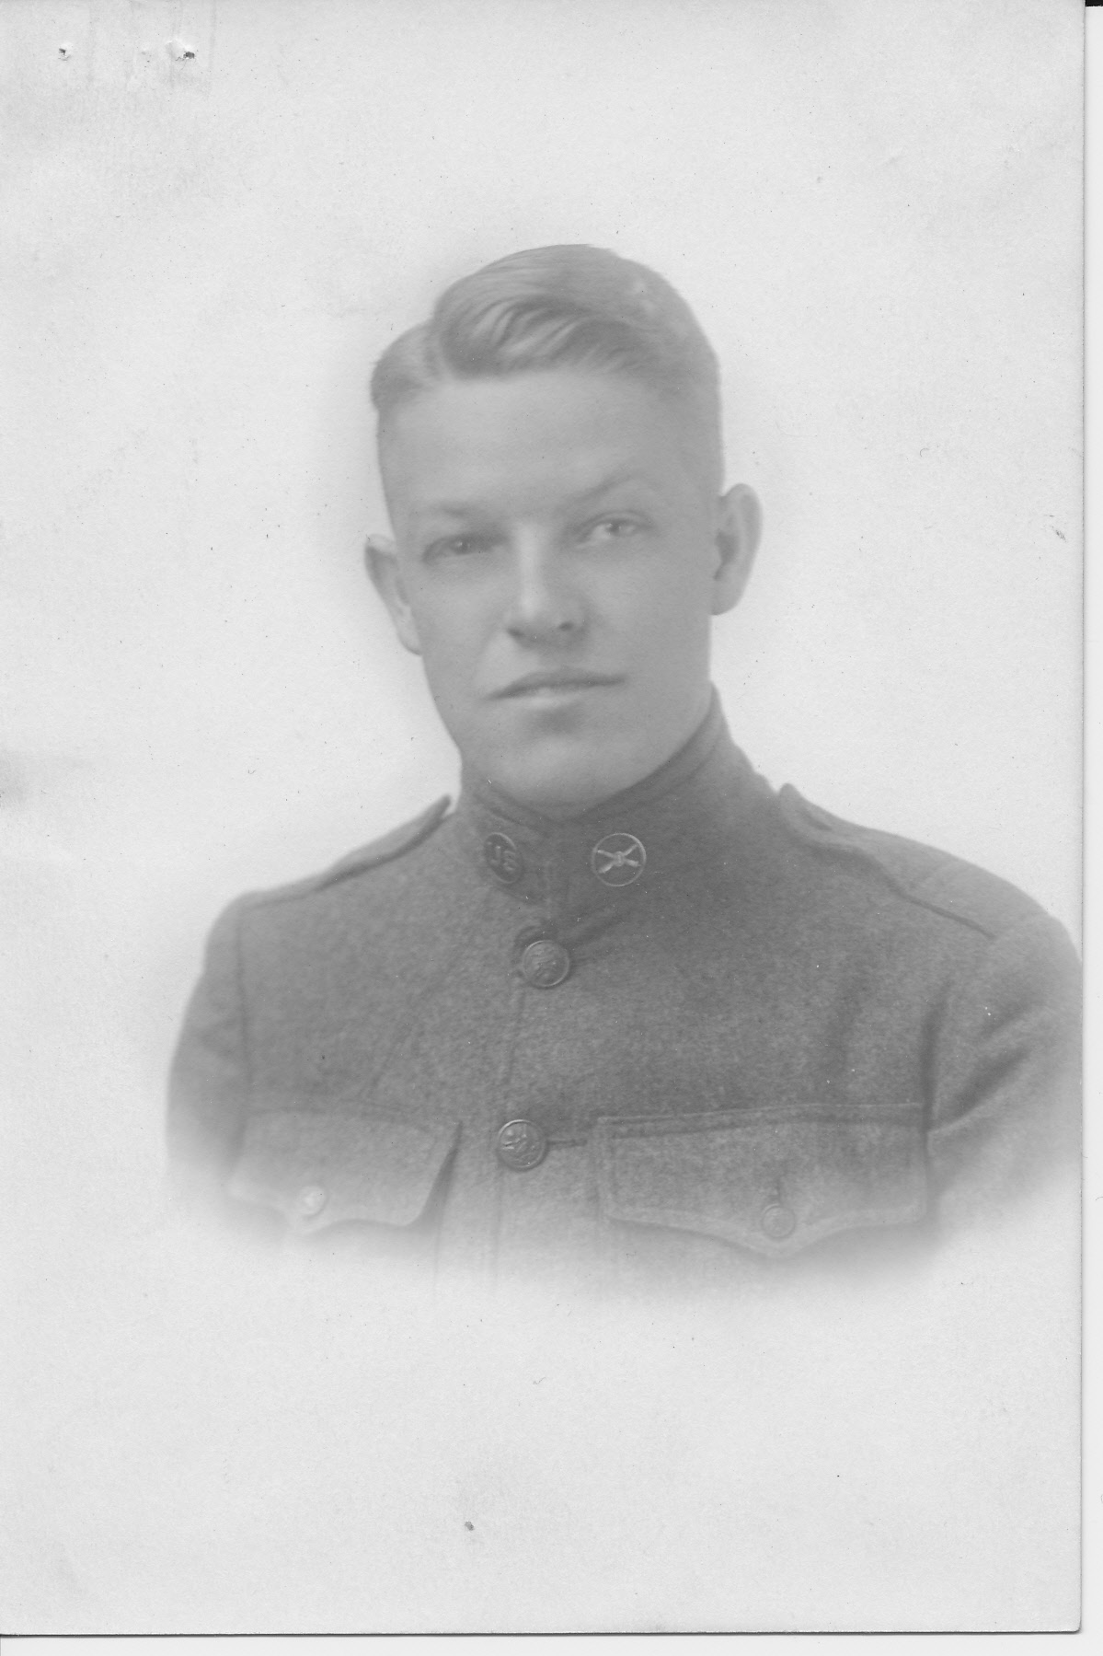
Figure 3 - Clifford O. Bruden: Motor Truck Driver, 9th Motor Truck, Battery B – World War I Service Records. Box 2, Folder 2.
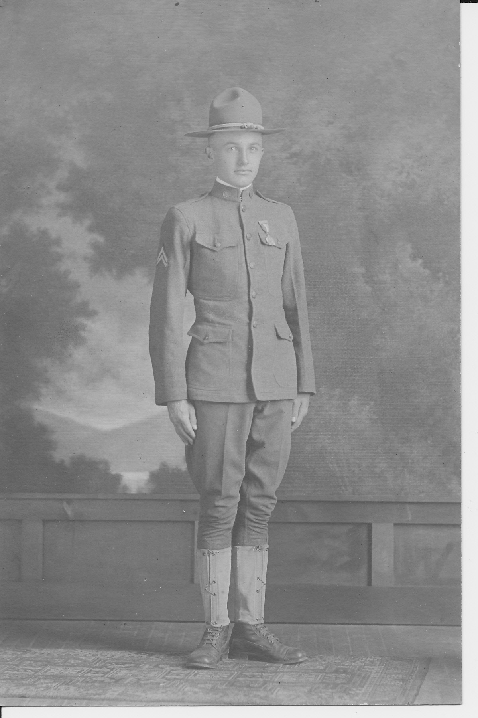
Figure 4 - Clarence Allen Cleasby: Sergeant, Company E, 127th Infantry Regiment, 32nd Division – World War I Service Records, Box 2, Folder 2.
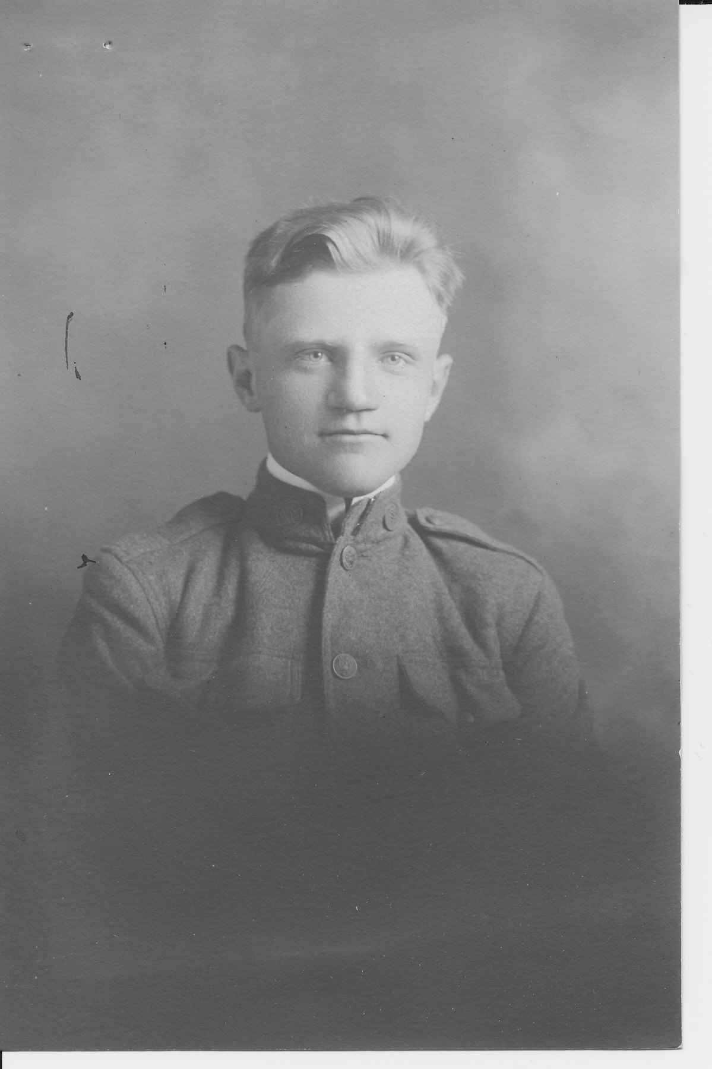
Figure 5 - Ernest W. Dearth: Private 1st Class, Sanitary Squad 7, 32nd Division – World War I Service Records, Box 2, Folder 3.

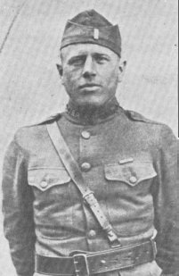

Figure 6 - Arthur Olson, 2nd Lieutenant, Company E, 23rd Infantry Regiment, 2nd Division, killed in action at Chateau-Thierry France, July 18, 1918 – Courtesy of the University of Wisconsin-Eau Claire Archives.

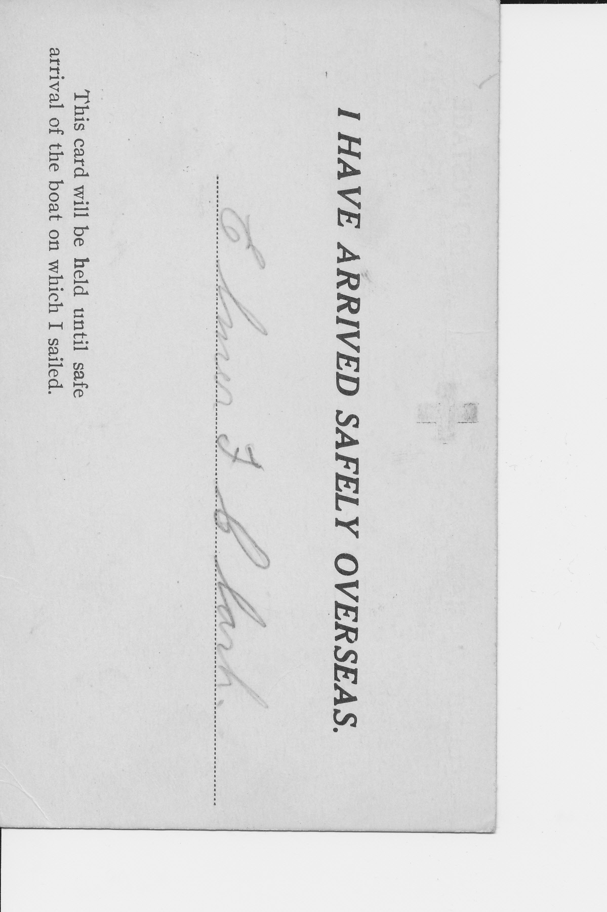
Figure 7 – Card every soldier was given which was issued so that family could keep track of traveling soldiers – University of Wisconsin-Milwaukee. Elmer F. Clark Papers. Milwaukee Mss 187. Box 1, Folder 4. University of Wisconsin-Milwaukee, Milwaukee, Wisconsin.
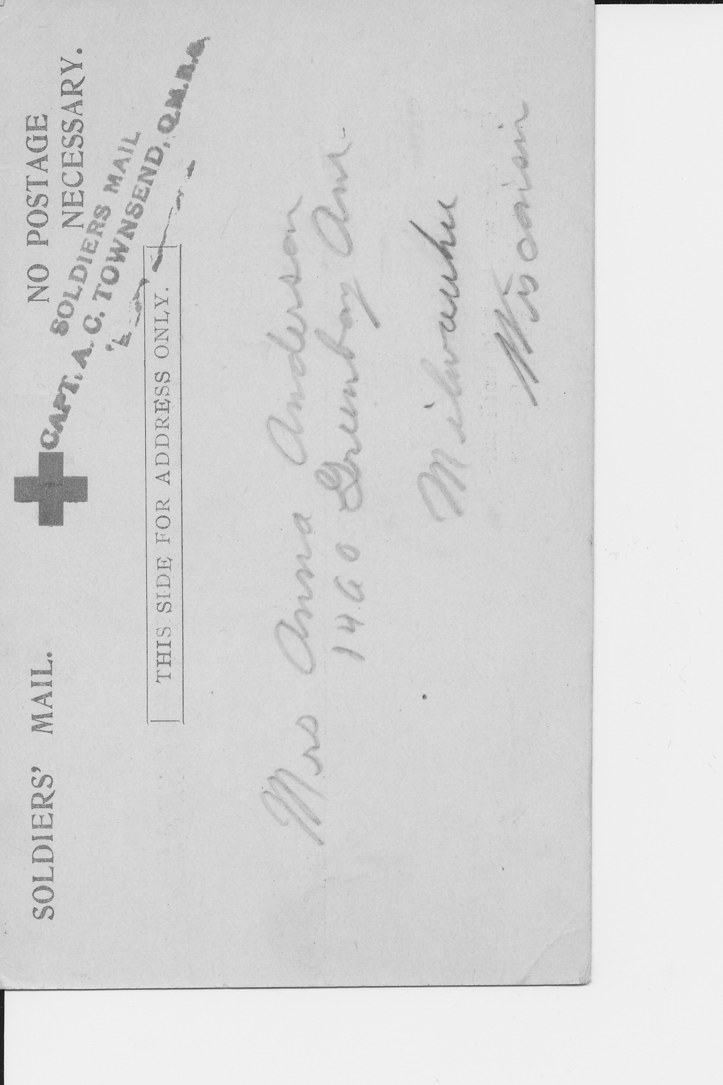
Figure 8 – reverse side of the safe passage card – Ibid.
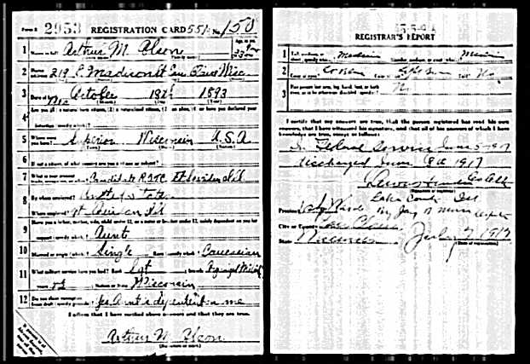
Figure 9 – Arthur Olson’s Draft Card – www.ancenstory.com Registration Location: Eau Claire County, Wisconsin; Roll: 1674599; Draft Board: 0..

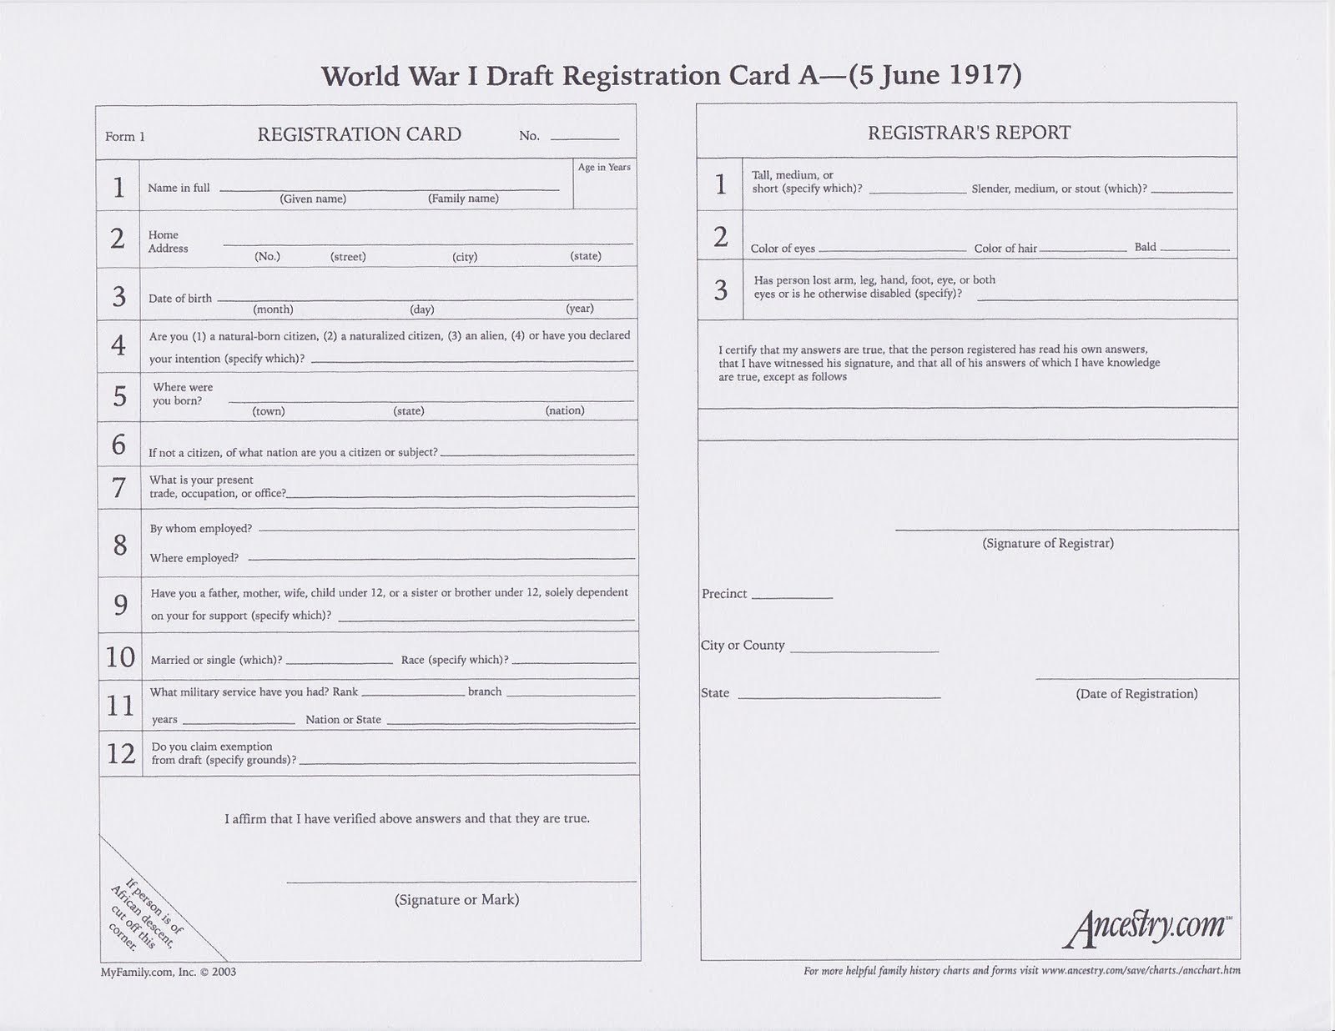
Figure 10 – Blank Draft Card From “A” - http://www.genealogydiaries.com/2011/08/world-war-i-draft-registration-card.html accessed April 5, 2012.
Appendix E: French Terms
- Bois – wood
- Ferme – farm
- Fontaine – spring
- Moulin – mill
- Ruisseau – brook
- Route – highway

Appendix F: Maps
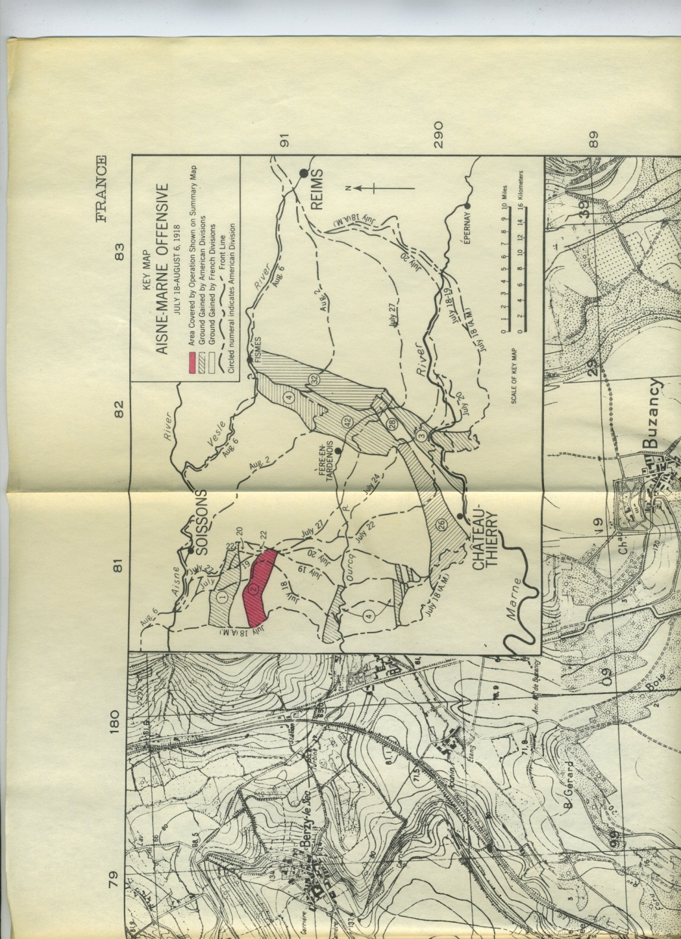
Figure 11 – 2nd Division Advance at Chataue-Thierry, July 18-20, 1918, Note the Right turn half way through, this is where the confusion for the 2nd Division really began
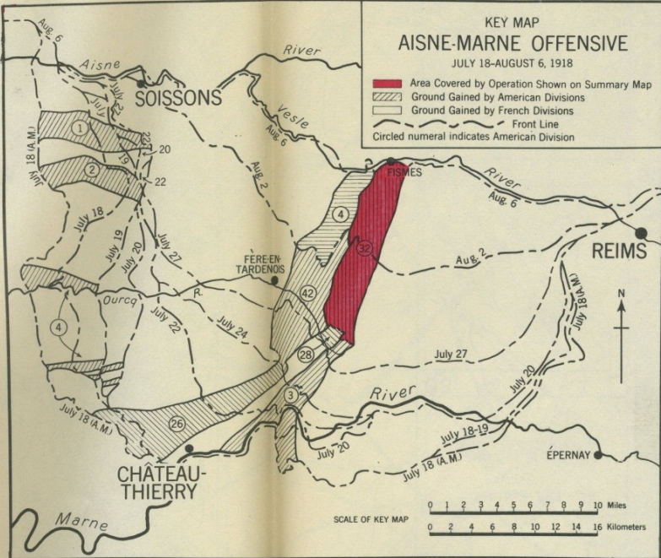
Figure 12 – 32nd Division’s offensive between the Aisne and Marne Rivers July 28 – August 6. Note that the 32nd Advanced the same length – without being relieved as the 42nd and 4th Divisions on its right flank.
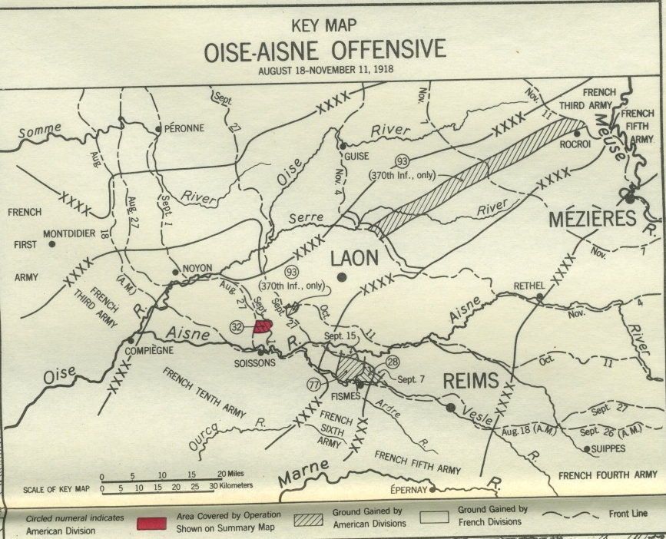
Figure 13 – 32nd Division’s Participation of the Oise-Marne Offensive. Notice the very short amount of progress made for the casualties sustained.

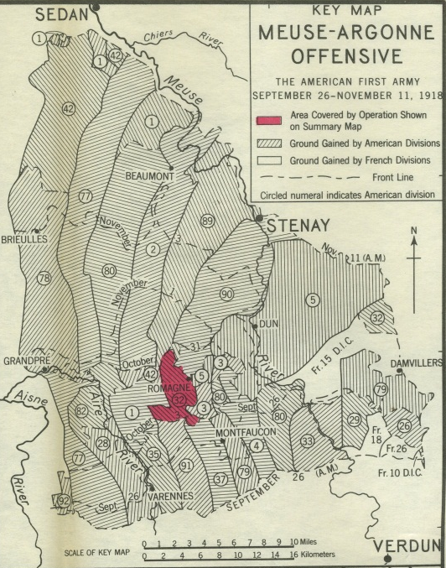
Figure 14 – 32nd Division’s participation in the Meuse Argonne Offensive from September 30 – October 20, 1918

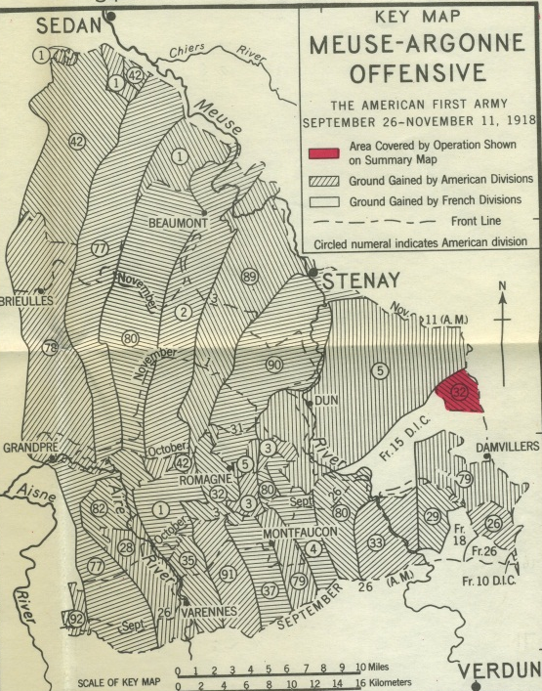
Figure 15 – The 32nd Division’s last operation, November 9th through 11th, 1918

Works Cited: Primary Sources
Eau Claire Leader, Eau Claire, Wisconsin.
Harding, Warren. “Return to Normalcy.” May 14th, 1920. http://teachingamericanhistory.org/library/index.asp?document=954 accessed April 4, 2012.
Simpson, Robert J. 32nd Division Materials. SC 2161. Wisconsin Historical Society. Madison, Wisconsin.
United States Government, “Census: 1900.” Roll: T623_1786; Page: 23 B; Enumeration District: 73, Roll: 375; Page: 7B; Enumeration District: 85, Roll: T623_1824; Page 3A; Enumeration District: 145, Roll: 1780; Page: 9B; Enumeration District: 5, and Roll: 375; Page: 7B; Enumeration District: 85. Accessed from Ancestry.com.
------. “Census: 1910.” Roll: T624_1707; Page 15 B; Enumeration District: 1038, Roll: T624_1710; Page: 15A; Enumeration District: 0057, oll: T624_1744; Page 11A; Enumeration District: 0147, Roll T624_1704; Page 15A; Enumeration District: 0035, and Roll: T624_367; Page: 9B; Enumeration District: 0079. Accessed from Ancestry.com.
------. “Census: 1920.” Roll T625_1979; Page 2A; Enumeration District: 27, Roll: T625_1252; Page 1B; Enumeration District: 106. Accessed from Ancestry.com.
------. “Census: 1930.” Roll: 2585; Page: 24A; Enumeration District: 21, Roll: 2607; Page 6B; Enumeration District:16, and Roll: 2571; Page: 16B; Enumeration District: 10. Accessed from Ancestry.com.
University of Wisconsin-Eau Claire. “Pearl Seguin Papers: 1917-1944.” UHC 279. McIntyre Library, Eau Claire, Wisconsin.
University of Wisconsin-Eau Claire. “Periscopes, 1917-1923.” Series 131 LD 6090.A58 1917-1923. McIntyre Library, Eau Claire, Wisconsin.
University of Wisconsin-Eau Claire. “World War I Materials: 1917-1920.” McIntyre Library, Eau Claire, Wisconsin.
University of Wisconsin-Milwaukee. “Elmer F. Clark Papers” Mss 187. University of Wisconsin-Milwaukee, Milwaukee, Wisconsin.
Wisconsin Death Index. Wisconsin Death Index, 1959-67, 1969-97. Madison, Wisconsin, USA: Wisconsin Department of Health.
Wisconsin National Guard. “32nd Division Records.” Draft Projections. Wisconsin Historical Society, Madison, Wisconsin.
Works Cited: Secondary Sources
American Battle Monuments Commission. 2d Division Summary of Operations in the World War. Washington D.C.: United States Government Printing Office, 1944.
------. 32d Division Summary of Operations in the World War. Washington D.C.: United States Government Printing Office, 1943.
Chambers II, James Whiteclay. Draftees and Volunteers: A Documentary History of the Debate over Military Conscription in the United State, 1787-1973, New York: Garland Publishing Inc, 1975.
------. To Raise an Army: The Draft Comes to Modern America. New York: The Free Press, 1987.
Grotelueschen, Mark Ethan. The AEF Way of War: The American Army and Combat in World War I. New York: Cambridge University Press, 2007.
Keene, Jennifer D. Doughboys, the Great War and the Remaking of America. Baltimore, MD: John Hopkins University Press, 2001.
Stevenson, David. With Our Backs to the Wall: Victory and Defeat in 1918. Cambridge, MA: Belknap Press of Harvard University Press, 2011.
Stokesbury, James L. A Short History of World War I. New York: HarperCollins, 1981.
Tuchman, Barbara. The Guns of August. New York: Ballantine Books, 1961.
Zieger, Robert H. America’s Great War: World War I and the American Experience. New York: Rowman and Littlefield Publishers Inc, 2000.

Alfred Lord Tennyson, “The Charge of the Light Brigade.” 1854. http://www.ram.org/contrib/the_charge_of_the_light_brigade.html (Accessed April 1st, 2012.)
Mark Ethan Grotelueschen. The AEF Way of War: The American Army and Combat in World War I. (New York: Cambridge University Press, 2007). 229-233.
Grotelueschen, The AEF Way of War, 229-233 and Eau Claire Normal School, The Periscope: 1921. (Eau Claire, WI: Eau Claire Normal School, 1921) in McIntyre Library, University of Wisconsin-Eau Claire. For more information on the 2nd Division see Battle Monuments Commission. 2d Division: Summary of Operations in the World War. (Washington D.C.: United States Government Printing Office, 1944), and see Appendix A and B for organization of World War I divisions, and the 2nd Division in particular.
Eau Claire Normal School. Periscope: 1919. (Eau Claire WI, Eau Claire Normal School, 1919) 5-6.
Barbara Tuchman, The Guns of August. (New York: Ballantine Books, 1961), 71.
James L. Stokesbury, A Short History of World War I. (New York: HarperCollins, 1981), 23-24.
Ibid., 11-14 and 25-27.
Eau Claire Normal School, Periscope: 1917. (Eau Claire WI: Eau Claire Normal School, 1917). (side note, the 1917 Periscope had no page numbers, so please bear with me).
Ibid.
Eau Claire Normal School. Periscope: 1917.
Ibid.
Year: 1900; Census Place: Superior Ward 5. Douglas, WI; Roll: T623_1786; Page: 23 B; Enumeration District: 73, Year 1910; Census Place: Superior Ward 5. Douglas, WI; Roll: T624_1707; Page 15 B; Enumeration District: 1038; FGL Number: 1375720, and Registration Location: Eau Claire County, WI; Roll 1674599; Draft Board: 0.
Year: 1900; Census Place: Eau Claire Ward 9, Eau Claire, Wisconsin; Roll: 1788; Page: 9B; Enumeration District: 31; FHL microfilm: 1241788., Year: 1910; Census Place: Eau Claire Ward 9, Eau Claire, Wisconsin; Roll: T624_1710; Page: 15A; Enumeration District: 0057; Image: 448; FHL microfilm: 1375723., and World War I Service Records. Box 2, Folder 1. McIntyre Library, Eau Claire, Wisconsin.
Year: 1900; Census Place: Oskosh Ward 9, Winnebago, WI; Roll: T623_1824; Page 3A; Enumeration District: 145., Year: 1910; Census Place: Oshkosh Ward 9, Winnebago, WI; Roll: T624_1744; Page 11A; Enumeration District: 0147; Image: 876; FHL Number: 1375757., and World War I Service Records. Box 3, Folder 2. McIntyre Library, Eau Claire, Wisconsin.
Year: 1900; Census Place: Chilton, Calumet, Wisconsin; Roll: 1780; Page: 9B; Enumeration District: 5; FHL microfilm: 1241780., Year: 1910; Census Place: Neillsville Ward 2, Clark, WI; Roll T624_1704; Page 15A; Enumeration District: 0035; Image 461; FHL Number: 1375717., and Registration Location: Clark County, Wisconsin; Roll: 1674590; Draft Board: 0.
Year: 1900; Census Place: Jackson, Hamilton, Indiana; Roll: 375; Page: 7B; Enumeration District: 85; FHL microfilm: 1240375., Year: 1910; Census Place: Indianapolis Ward 4, Marion, Indiana; Roll: T624_367; Page: 9B; Enumeration District: 0079; Image: 662; FHL microfilm: 1374380., Year: 1920; Census Place: Eau Claire Ward 3, Eau Claire, Wisconsin; Roll: T625_1984; Page: 9B; Enumeration District: 121; Image: 97., World War I Service Records. Box 2, Folder 3. McIntyre Library, Eau Claire, Wisconsin.
Ed. Charles F. Horne, Source Records of the Great War, Vol. V, ed. Charles F. Horne, National Alumni 1923 from http://www.firstworldwar.com/source/usawardeclaration.htm .
Merrill D Peterson, The President and His Biographer: Woodrow Wilson and Ray Stannard Baker. (Charlottesville, VA: University of Virginia Press, 2007), 86-87.
Robert H. Zieger, America’s Great War: World War I and the American Experience (New York: Rowan and Littlefield Publishers, Inc. 2000), 23-25 and Stokesbury A Short History of World War I. (New York: William Morrow and Company, Inc. 1981), 113 and 170.
Zieger, America’s Great War. 49-52, Stokesbury, A Short History of World War I. 221-222, and David Stevenson. With our Backs to the Wall: Victory and Defeat in 1918. (Cambridge, Massachusetts: Harvard University Press, 2011) 20
Katherine Lee Bate. The Retinue and Other Poems, Copyright 1918 by E.P. Dutton and Co. in Wisconsin Memorial Day Annual: 1920. 20-21 in Pearl Senguin Papers Eau Claire McIntyre Library
Jennifer D. Keene, Doughboys, the Great War and the Remaking of America, (John Hopkins University Press: Baltimore, Maryland, 2001), 10-11.
Keene, Doughboys and the Great War. 9 and Robert H. Zieger. America’s Great War: World War I and the American Experience. (Rowman and Littlefield Publishers Inc: New York, 2000), 57-58.
John Whitclay Chambers II, To Raise an Army: The Draft Comes to Modern America. (New York: The Free Press, 1987), 75 and Michael Pearlman, To Make Democracy Safe for America: Patricians and Preparedness in the Progressive Era, (University of Illinois Press: Chicago, 1984), 149.
President Woodrow Wilson to Rep. Guy T. Helvering of Kansas, April 19, 1917, Woodrow Wilson Papers, Series IV, Case File 3735, Library of Congress, in Draftees or Volunteers: A Documentary History of the Debate over Military Conscription in the United States, 1787-1973. John Whitclay Chambers II. (New York: Garland Publishing Inc., 1976), 241.
Zieger, America’s Great War. 58-59.
Secretary of War Newton E. Baker to Rep. S. Hubert Dent Jr., chairman of the House Military Affairs Committee, April 17, 1917, U.S. House of Representatives, Committee on Military Affairs, Increase of the Military Establishment: Hearings, 65 Congress., 1st Session., April 17, 1917, (Washington, D.C., 1917), pp. 217-218 in Draftees or Volunteers. 239.
Ibid., 239-240.
Stevenson, With Our Backs to the Wall: Victory and Defeat in 1918, 245-246 and Zieger, America’s Great War, 59-63.
Wisconsin National Guard “32nd Division Records: Draft Projections.” Series 2386, Folder 5, Box 1. Wisconsin Historical Society, Madison, Wisconsin, Keene, Doughboys and the Great War, 11, “Geo. L. Simpson Takes Command of Company B,” The Eau Claire Leader, November, 29, 1923. and “Periscope 1917”
Zieger, America’s Great War. 58.
“Banquet Given To Normal Boys.” The Eau Claire Leader, May 12, 1917.
“Ernest Dearth Got Icy Bath When Tuscania Went Down But Finally With Help, Climbed Into Life Boat,” The Eau Claire Leader, March 13, 1918.
G.W. Garlock. Tales of the Thirty-Second. (West Salem, Wisconsin: Badger Publishing Company, 1927) 7-8 and “Ernest Dearth Got Icy Bath When Tuscania Went Down But Finally With Help, Climbed Into Life Boat,” The Eau Claire Leader, March 13, 1918.
The Eau Claire Leader, February, 12, 1918. And John Whiteclay Chambers II, To Raise an Army: The Draft comes to Modern America, (New York: The Free Press, 1987), 54.
University of Wisconsin, Eau Claire, “1919 Periscope,” 4-5, and World War I Service Records. Mss BN. Box 2, Folders 1, 2, 3, 4 and Box 3, Folder 2 McIntyre Library, Eau Claire, Wisconsin.
See Appendix B.
Grotelueschen, The AEF Way of War, 201-203.
Grotelueschen, The AEF Way of War, 213-214.
Ibid., 233.
American Battle Monuments Commission, 32d Division: Summary of Operations in the World War, (Washington D.C.: United States Government Printing Office, 1943), 1-5.
World War I Service Records. Box 2, Folder 1. McIntyre Library, Eau Claire, Wisconsin.
All American division will simply be referred to by number, all foreign units will carry their nationality before them (i.e. 3rd Division and French Sixth Army) for French words see Appendix E.
American Battle Monuments Commission, 32d Division 7-17 and Robert J. Simpson Papers, 32nd Division Materials. S.C. 2161 Wisconsin Historical Society. For map of the operation see Appendix F.
American Battle Monuments Commission, 32d Division. 23-32 and Robert J. Simpson Papers. 32nd Division Materials. S.C. 2161 Wisconsin Historical Society For map of the operation see Appendix F.
American Battle Monuments Commission, 32d Division. 33-34 and Robert J. Simpson Papers. 32nd Division Materials. S.C. 2161 Wisconsin Historical Society., and World War I Service Records. Box 2, Folder 3. McIntyre Library, Eau Claire, Wisconsin.
American Battle Monuments Commission, 32d Division. 35-37 and 65-67 and Robert J. Simpson Papers. 32nd Division Materials. S.C. 2161 Wisconsin Historical Society.
Isaiah 9:5.
Year: 1930; Census Place: Milwaukee, Milwaukee, Wisconsin; Roll: 2585; Page: 24A; Enumeration District: 21; Image: 915.0; FHL microfilm: 2342319., Wisconsin Death Index, 1959-1997 Original data: Wisconsin Vital Records Office. Wisconsin Death Index, 1959-67, 1969-97. Madison, Wisconsin, USA: Wisconsin Department of Health.
Year: 1920; Census Place: Pine Valley, Clark, Wisconsin; Roll T625_1979; Page 2A; Enumeration District: 27; image: 1098 and Year: 1930; Census Place: Racine, WI; Roll: 2607; Page 6B; Enumeration District: 16; Image: 86.0.
Year: 1920; Census Place: Highland, Orange, New York; Roll: T625_1252; Page 1B; Enumeration District: 106; Image: 50 and Year: 1930; Census Place: Culver, Marshall, Indiana; Roll: 617; Page: 24; Enumeration District: 16; Image: 903.0.
World War I Service Records. Box 3, Folder 2. McIntyre Library, Eau Claire, WI. “Geo L. Simpson Takes Command of Company B,” Eau Claire Leader. November 29, 1923., and Year: 1930; Census Place: Eau Claire, Eau Claire, Wisconsin; Roll: 2571; Page: 16B; Enumeration District: 10; Image: 726.0; FHL microfilm: 2342305.
“Soldier Bonus Bill Goes to Referendum” Eau Claire Leader, July 17th, 1919, “Service Men Receive Free Education as State’s Gift” The Eau Claire Leader, September, 7th, 1919. and “Record Classes Expected at State Normal Next Week.” The Eau Claire Leader. September, 9th, 1919.
Warren Harding., “Return to Normalcy.” May 14, 1920 http://teachingamericanhistory.org/library/index.asp?document=954 accessed April 4, 2012.
“Students Present Portrait of A.M. Olson to School” The Eau Claire Leader. April 7th, 1919.
American Battle Monuments Commission. 2d Division Summary of Operations in the World War. (Washington D.C.: U.S. Government Printing Office, 1944) 1and 99.
American Battle Monuments Commission. 2d Division Summary of Operations in the World War. (Washington D.C.: U.S. Government Printing Office, 1944) 1.
American Battle Monuments Commission. 32d Division Summary of Operations in the World War. (Washington D.C.: U.S. Government Printing Office, 1943) 1 (note on this source: it has the same table of organization for a division in 1918 as the summary for the 2nd Division).
32d Division. X.
2d Division Summary. Attached Materials.
32d Division Summary. Attached Materials.
32d Division Summary., Attached Materials.
Ibid., Attached Materials.
32d Division Summary., Attached Materials.

