From Logs to Hogs: The Transition from Logging to Celebrating Sustainable Agriculture in Chippewa Falls

Kalene Amondson
History 489: Senior Capstone
December 2015

Copyright for this work is owned by the author. This digital version is published by the McIntyre Library, University of Wisconsin – Eau Claire with the consent of the author.

Contents:
List of Figures iii
Abstract iv
Introduction 1
Background 4
Historiography 7
Primary Source Analysis 13
Conclusion 24
Works Citied 26

List of Figures:
Figure 1- 2015 Fair Brochure 1
Figure 2- Bluff Siding, Green Dot 3
Figure 3- Chippewa Falls, Blue Dot 4
Figure 4- Des Moines, IA 10
Figure 5- Fairgrounds in 1896 12
Figure 6- The Constitution of the Northern Wisconsin State Fair 13
Figure 7- Fruits and Vegetables 15
Figure 8- The new Chippewa Shoe Manufacturing building 16
Figure 9- Leinenkugel’s Ad 17
Figure 10- Icetime Grandstand Act 18
Figure 11- The Midway Advertisement 19
Figure 12- Advertisements 20
Figure 13- Advertisements 20
Figure 14- Map of current fairgrounds 2016 23

Abstract:
The Northern Wisconsin State Fair has been in the city of Chippewa Falls since 1896. Logging was a main economic staple until 1911 when the last saw mill shut down. Agriculture became the main way for the people of Chippewa Falls to make a living. This paper examines the history of how the city of Chippewa Falls celebrates Agriculture through the county fair annually. The history of the Northern Wisconsin State Fair has been a long and difficult story due to financial issues, attendance lows, and the ever changing entertainment business. From small venders, to education displays and large musical acts the fair has it all. The Northern Wisconsin State Fair continues to bring in new audiences with tribute bands, and new rides.

Introduction
“It’s a Family Affair” is printed in yellow on a red pamphlet. It advertises rides, food, fun, games, and live entertainment for five days in July 2015. This brochure is displaying an annual event known as the Norther Wisconsin State Fair which is held in Chippewa Falls, Wisconsin. (Figure 1) This event is something that I have gone to every year since 2002. As the quote states it has always been a family affair for me.
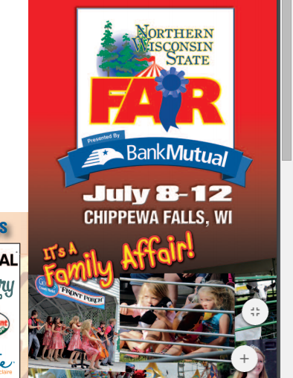
Figure 1- 2015 Fair Brochure

My parents took me to see the livestock, and to try all kinds of new fair foods such as funnel cakes. My fondest memory of the far is when I was just eight years old. My father bought tickets to go on a ride called Tilt-a-Whirl. This ride was my father’s favorite, and he wanted it to become mine as well. We stood in line for hours it seemed, and finally we were able to get into one of the purple egg shaped cars. I sat on the outside, and my father sat next to me with the largest grin I had ever seen. The ride started and I knew was in for a treat, my father started to lean against me and told me to “hold on squirt”. I am glad I listened because the next thing I knew I was being held against the side and back of this car as it was spinning incredibly fast. This ride seemed to last for hours, but I was loving every second of it, and so was my father. He had his arm around me and was laughing as I was screaming at every spin. That day was the day that I fell in love with the Northern Wisconsin State Fair.
My passion for the Northern Wisconsin State Fair has been a way for me to connect to the long history of Chippewa Falls. As I entered college and started to think about projects, I thought of the fair and how the origin of it fair was a mystery to me. I tried to find books and other histories on it, but there was nothing. So I began to ask how long the fair had been around, had it always been in Chippewa Falls, were there any periods of time that the fair didn’t happen due to financial issues, and what was the general history of the Northern Wisconsin State Fair. These questions led me to this choosing the Northern Wisconsin State Fair as my capstone project. The questions will serve to construct this history in the local and also national narrative. The aim of this research is to also connect the local history of the Northern Wisconsin State Fair to the larger United States History by looking at fairs throughout the country at this time from the beginning of modern American logging to the days I started going to the fair in the early twenty-first century.
I discovered that the fair was rooted in a transitional period between the logging era and the farming era. This transition has not been discussed in the history of the state of Wisconsin. After the logging industry collapsed in the late 1890’s many cities in the Midwest found that they had a crucial time frame to decide what their next move was going to be. Some cities succeeded in this transition like Chippewa Falls, others like Bluff Siding in Buffalo County did not and ended up being small washed out towns along rivers. A closer look must be taken at this transition to fully understand the event. (Figure 2)
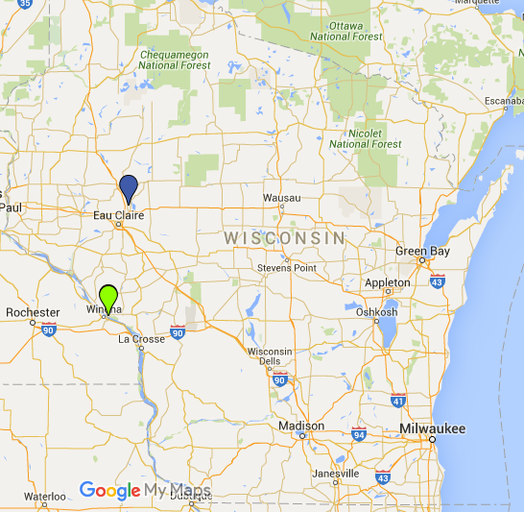
Figure 2- Bluff Siding, Green Dot

Background
The city of Chippewa Falls is located in Chippewa County, which is north of Eau Claire County. (Figure 3) The city of Chippewa Falls has a long history, but I would like to focus on the logging and more on the agricultural portion of this history for some context. Chippewa Falls was first settled in 1836 by Jean Brunet when he built the first sawmill. Logging took off in Chippewa Falls due to the close proximity to the Chippewa River.
Figure 3- Chippewa Falls, Blue Dot

Throughout the 1800’s Chippewa Falls was able made a sustainable economy from the logging industry, and at one point in time the area had the largest sawmill in the Chippewa Valley. Logging was a large portion of Chippewa Falls’ history, and to talk about the logging history in this paper would take away from the Northern Wisconsin State Fair and its history. One reason Chippewa Falls was able to keep logging around for a long time was due to the Chippewa River. Since the river is wide and fast it made it easy to float logs down to the mills.
Farming became a great way to supplement income and work from the off season of logging. Logging was normally done in the winter and early spring. The snow helped move logs easily to the river and then the spring floods helped the logs carried to the mills. The off season in late spring was a great time to plant crops to sustain families and the surrounding Chippewa Falls community. Logging declined in Chippewa Falls due to the expansion of railways, these rail road lines bypassed major rivers to get to the large cities where lumber could be processed into materials. Another issue the logging industry started to develop was the lack of trees. During this time period in the late 1800’s many lumber companies were clear cutting and not replanting. This lead to the forests being depleted without new trees. William Irvine, who had many interests in Chippewa Falls created the Irvine Park to have a safe space for vegetation to flourish. Many industries started to flourish with unemployed loggers. Chippewa Falls is now known for a few of these including: breweries, shoe making, and agriculture.
The farming aspect of Chippewa Falls is a large part of my research. It is a puzzling area because farmers lived outside of the downtown limits to have large areas of land to grow food, but they would have to come downtown for supplies and to sell their goods from past harvests. This is a perplexing relationship that has kept Chippewa Falls on the map for almost two hundred years. This relationship also created an odd spectacle called the Northern Wisconsin State Fair, previously the Chippewa County Fair. The first county fair that was held in Chippewa Falls was in 1896, this fair was designed to give area farmers a place to congregate. This gathering would have included many activities like buying and selling livestock, demonstration of different seeding methods to ward off pests, and the displaying of new farm machinery and technology. The county fair is now known as the Northern Wisconsin State Fair, and each summer around 70,000 people turn out for a five day adventure with farm life, rides, food, and entertainment in many sorts.

Historiography
As stated above Chippewa Falls has many aspects to its history, but I am going to discuss only a couple of these aspects. One is about the harvesting of logs and transitioning to the harvesting of crops full time, and the other is about how the state of Wisconsin fits into the larger national narrative of local fairs compared to the state of Iowa. The first book that I would like to discuss is titled Mixed Harvest: The Second Great Transformation in the Rural North, 1870-1930.
Hall Barron rewrites the “born in the country, moved to the city” narrative. He examines the rural aspect of this transition rather than the urban expansion aspect as so many have done before him. He states that he used a variety of stories to understand the larger trend that happened throughout much of the land in the United States. Barron breaks down this transition into three groups: citizens, producers, and consumers. He was able to take stories from people in rural America and put them into one of these three areas to bring his overall argument to life.
In the introduction Barron, discusses how people in the country had to change their way of life to continue to thrive in a new era of business. This is an area of interest to me because this is what I want to relate my paper to. This book details how farmers in particular were able to face the urbanization and still live in the country but also continue to prosper and make a living doing so.
Barron discusses how farmers were forced to pay for roads that they didn’t want to use, their equipment ran fine on dirt roads, but cars could not do this as easily. Farmers were then forced to pay an increase in taxes for city dwellers to use roads that were accessible to cars. This is the beginning of the long transition period of how to balance country and city. This chapter also gives way to another issue that Barron discusses later in the producer and consumer areas. He states that there were bad times when farmers had to withhold products to drive up prices that would support their families. This struggle against product and price helped farmers realize how to reshape their products into a business aspect that allowed the consumer to want to purchase this item from the farmer.
In the producer section, Barron offers great evidence as to how farmers were able to benefit from the urbanization and industrialization movements. He uses price information and sales reports to argue that farmers bought grain elevators and other machinery to help them increase the quantity of their crops and to store a larger amount of grain to allow for more consumption in later times of the year. Seeing the farmer as a producer and a consumer changes how people think about agriculture and the struggle of living far away from the city but also trying to feed the city.
The final area Barron examines is about farmers being consumers but also city people being consumers of goods that farmers produce. He reflects on his argument back from the first section about cars and roads. Barron projects the car as a positive item for farmers and that their tax money was not wasted because a few years later, the farmers are now able to purchase cars and have greater mobility in delivering their crops to the people in the city. This point about the farmers fighting against something that they end up finding useful is a contradictory point but yet still able to prove his original thesis that he is changing the way this transition is perceived. Farmers needed the technology from the city to provide quality goods for the people of the city. This unique relationship is what has kept the city of Chippewa Falls as the site of the Northern Wisconsin State Fair.
To further understand how the Northern Wisconsin State Fair relates to other county fairs I had to look at a history of the Iowa State Fair in Des Moines, Iowa. This book is not scholarly, but does offer an in depth history of a county fair that is similar in size and has been around for about the same amount of time as the Northern Wisconsin State Fair. This source will enable me to understand the larger development of county fairs throughout the Midwest in the 1800 and 1900’s.

“Since 1854, the Iowa State Fair has celebrated the best of Iowa – its quality food, its fertile land, and its hard-working people. The State Fair was designed to educate Iowa’s farmers about the very best ways to raise food and livestock. As a result, Iowa has evolved to a world leadership level in agricultural production. Today, the Iowa State Fair provides a showcase for Iowa as the Food Capital of the World.” – Governor Thomas J. Vilsack, 2000

The Iowa State Fair now in Des Moines, IA was just a venture, but has now kept the tradition with modern upgrades to bring one million people to the grounds every August. (Figure 4) From the start in 1854 the agriculture world has been able to communicate and share ways to improve their techniques. Our State Fair Iowa’s Blue Ribbon Story details the birth and current strides of the Iowa State Fair as it continues to bring people together.
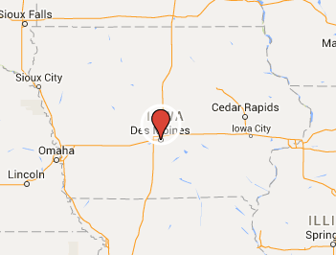
Figure 4- Des Moines, IA

In 1879 the Iowa State Fair was able to go from a “fair on wheels” to an area with structures in Des Moines. By 1884 Des Moines was officially made the home of the Iowa State Fair. At this time entertainment was not a factor in where or how structures were to be built. The fair has now been in Des Moines for 130 years and the grounds have been growing ever since.
Shanely discusses many aspects of the fair, from animal contests to the introduction of the 4H club, and also the arrival of live entertainment acts. The live entertainment acts range from horse races in the early 1900’s to car and bike races in the 1930’s. The area of entertainment that becomes a staple of all fairs today is the live musical acts. In the book the author quotes a fairgoer in the 1980’s who recalls waiting for Lou Christie who was a rock n’ roll singer to come on the grandstand stage to sing for thousands of people. This era of grandstand musical acts is something that has helped raise attendance at state fairs and has become a main attraction. The musical acts can be very high profile people, the author has photographs of the Jackson 5, Sonny and Cher, and Little Richard as just some examples of the acts that come to entertain in the American Midwest.
Together these contextual books offer a way of framing the discussion of the Northern Wisconsin State Fair. In examining my primary sources I will outline the way that Chippewa Falls as a city was able to overcome the hardships of losing an economic staple and navigate through history to still be on the map. I also will be discussing how the Northern Wisconsin State Fair was able to stand the test of time and be successful for over 110 years. The picture below shows the land where the fair first took place in 1896 and these buildings are now the animal barns for the fair today. (Figure 5)
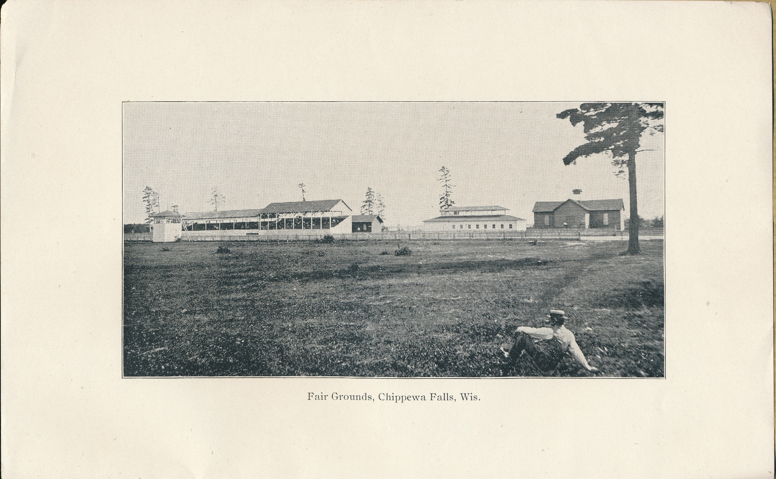
Figure 5- Fairgrounds in 1896

Primary Source Analysis 1896-1966
The Northern Wisconsin State Fair began in 1896 as the Chippewa County Agricultural Society Fair. The president of the society was Alex McLaren, he lived in Chippewa Falls most of his life and in the 1905 state census he lists having 3 females and 3 males in his household. He was president of the society until 1900 when Jesse R. Sharp took over. Other offices held at the time of the 1896 fair were the Vice President and the Treasurer W.M Irvine and C.A Hayes held respectively. The office of president helped establish when the fair would take place, which venders would be there and set rules and regulations for the contests. (See Figure 6)
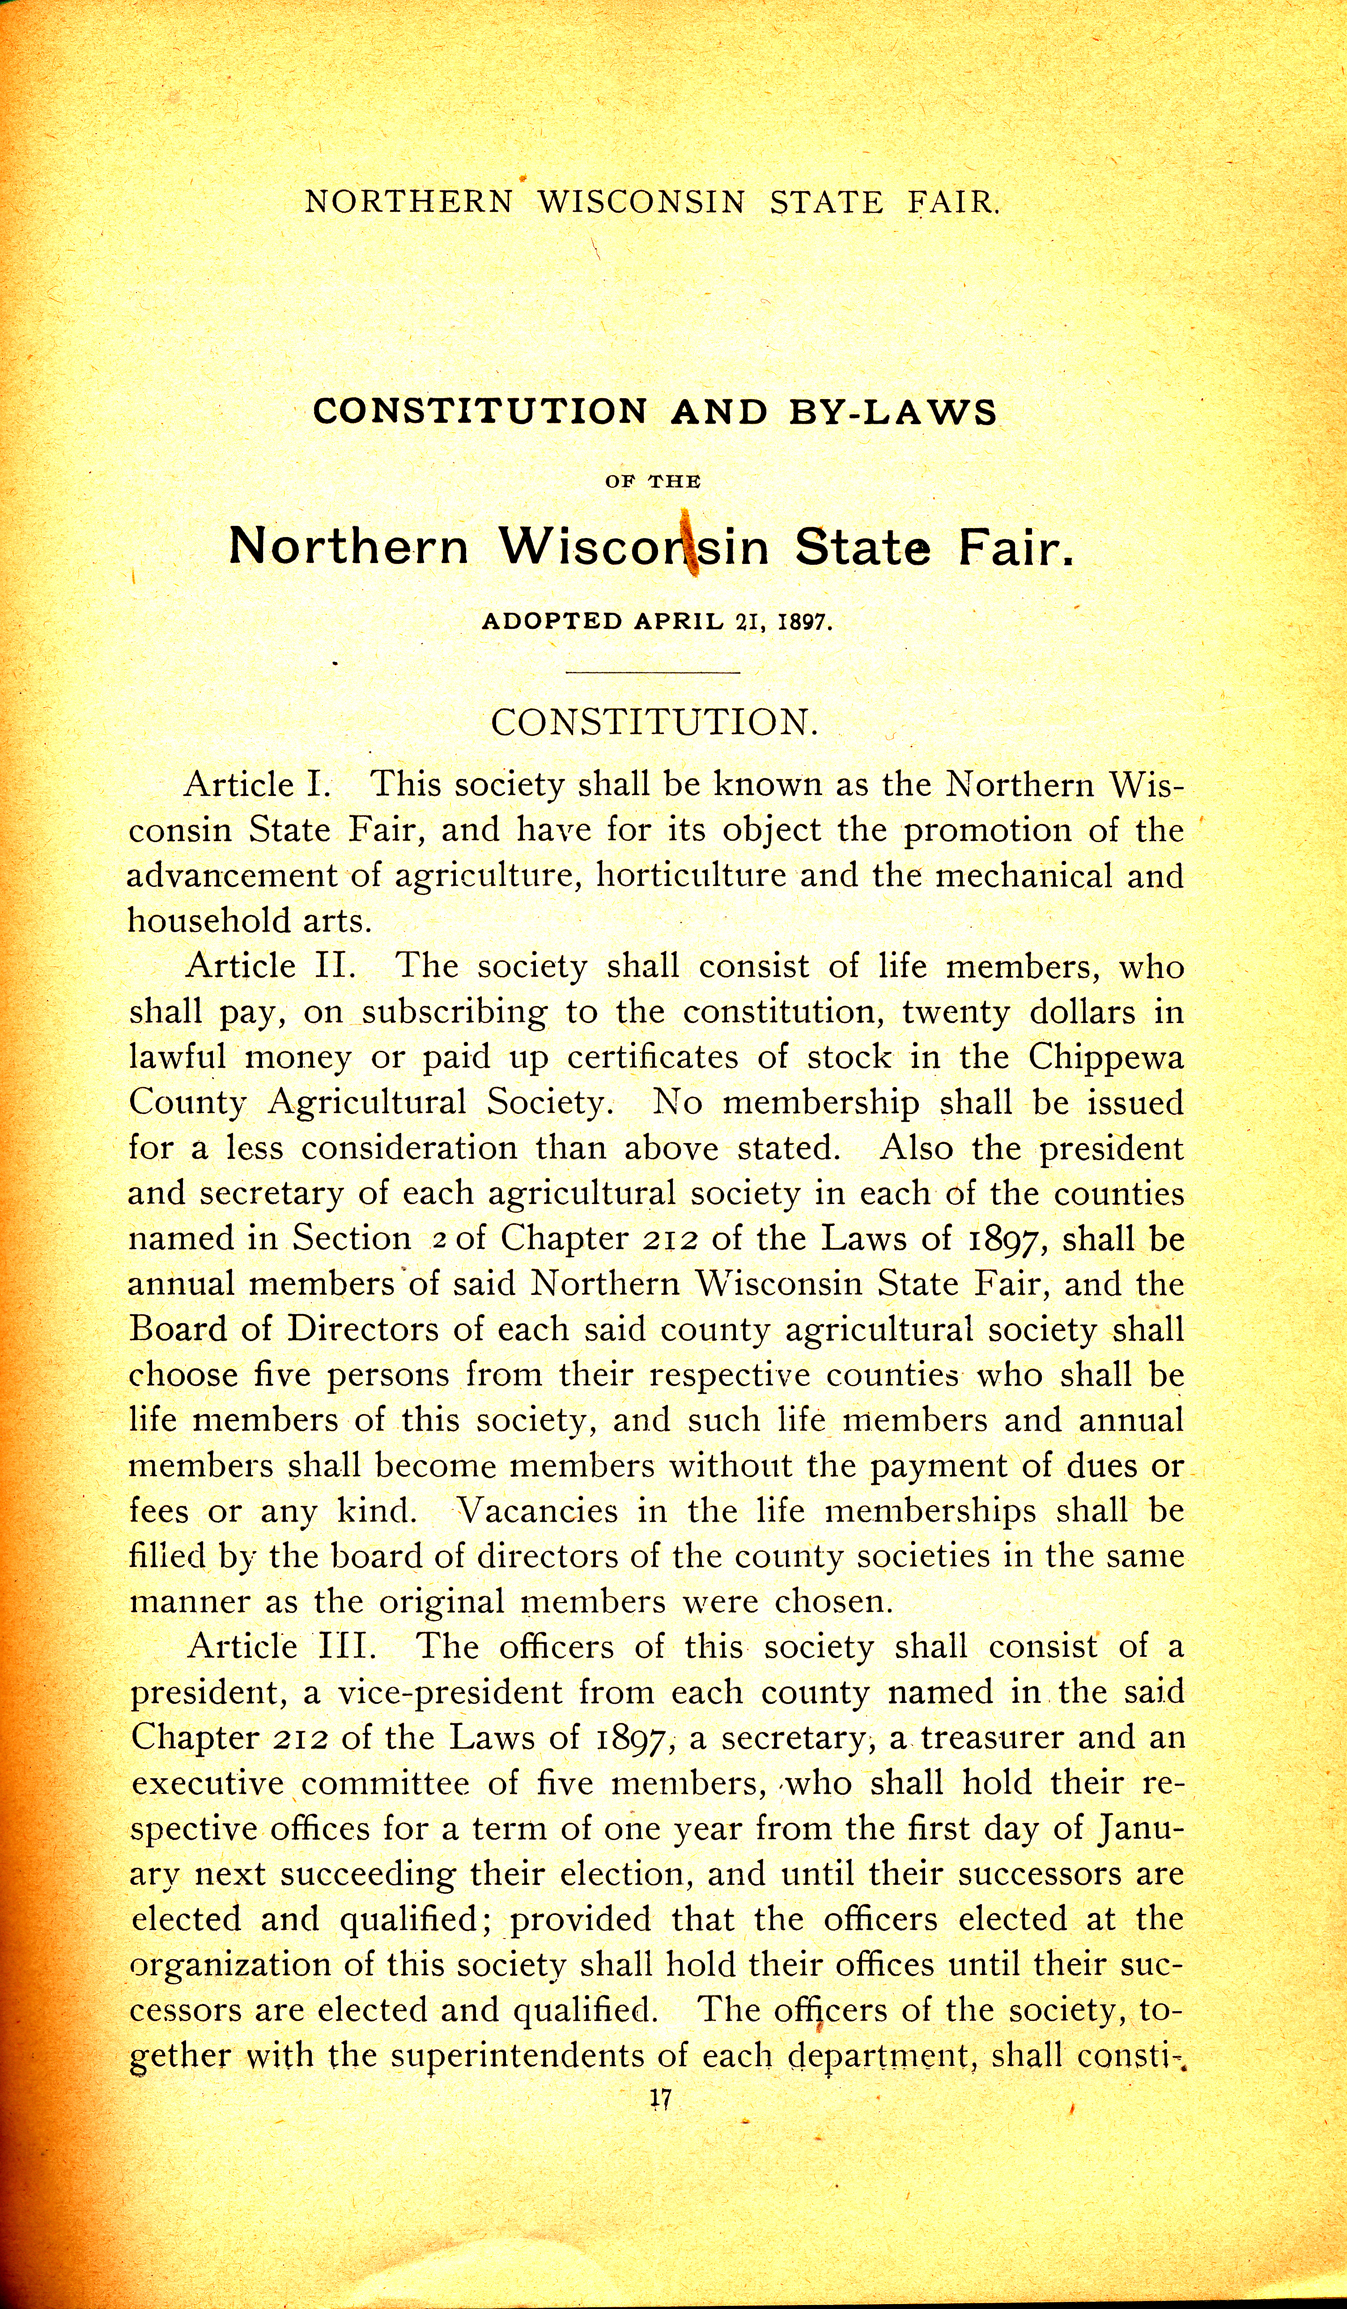Figure 6 - The Constitution of the Northern Wisconsin State Fair

These rules are written out in each premium book although don’t change much from 1897 when they were first printed, until 1935 the rules changed to accommodate the midway and the way the grandstand acts would be handled. The first fair had set prices for entries and also had categories for livestock and crops. The winners in these categories sold for the most amount of money and also were in the best shape compared to all other entries. The contest for the best of each category is a common aspect of all county fairs. This system of categories helped determine prices for products that were produced by the farm.
In 1900 the categories that farmers were concerned with most were livestock, and grains because they would set up the market for fall harvest. Also other categories started to grow in entries like vegetables and fruits. (See Figure 7) This expansion of the categories helped gain attendance for future fairs. Domesticity became a highlight of the fair with new categories added like paintings, clothes, household toys such as dolls and wood cars. These items were made by hand usually by women, this spotlight on the home gave women a chance to showcase their daily life and make the fair truly a family affair. From the start of the fair in 1896 up until the 1920’s it was a rather small event and catered only to farm life and the farm family. Other city families would go but only to view the domestic aspects of the fair. Women would share details of how to paint, and make family toys to city women who would be able to create homemade creations with a country touch. This is still done today at many festivals and at the Northern Wisconsin State Fair.
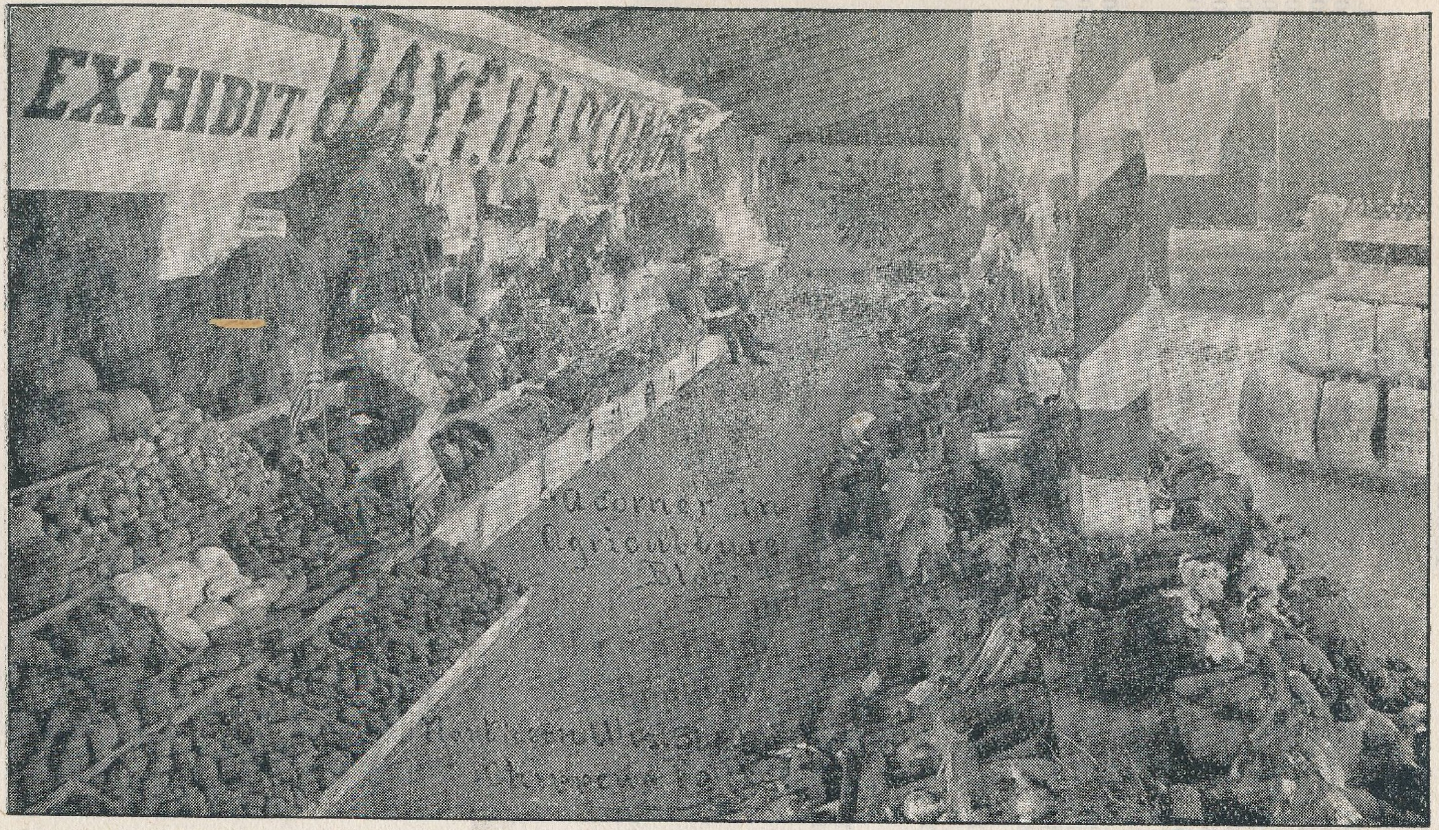
Figure 7- Fruits and Vegetables

In the 1921 premium book advertisements appear that entice fairgoers away from the fair and to venture out into the city of Chippewa Falls since they are there already for the fair the visitors can see what downtown Chippewa Falls offers. This is a pivotal moment in the city’s survival, if the city and its businesses did not advertise to the fairgoers the city would have likely become a ghost lumber town. In one advertisement, Chippewa Shoe Manufacturing Company appeals to fairgoers as the ultimate shop to buy shoes for any activity and also starts a tourism plea to see their new building.
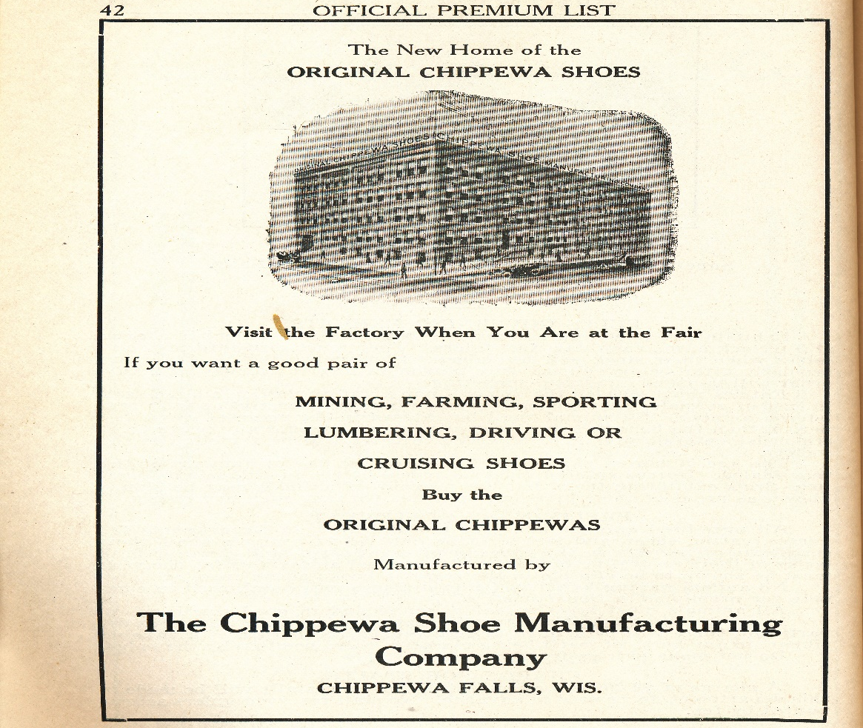
Figure 8- The new Chippewa Shoe Manufacturing building

The 1935 Northern Wisconsin State Fair was an interesting fair due to the large expansion of advertisements placed in the premium book for that year. Many of the advertisements stated that they would have a vender booth at the fair and that fairgoers should stop by. One advertisement that stood out in this way was Leinenkugel’s page for Chippewa Pride Beer. This was the first full page advertisement for beer in any of the premium books. This page tells fairgoers to come and try their beverage and to also see their booth in the manufactures’ building at the fair. (See Figure 9)
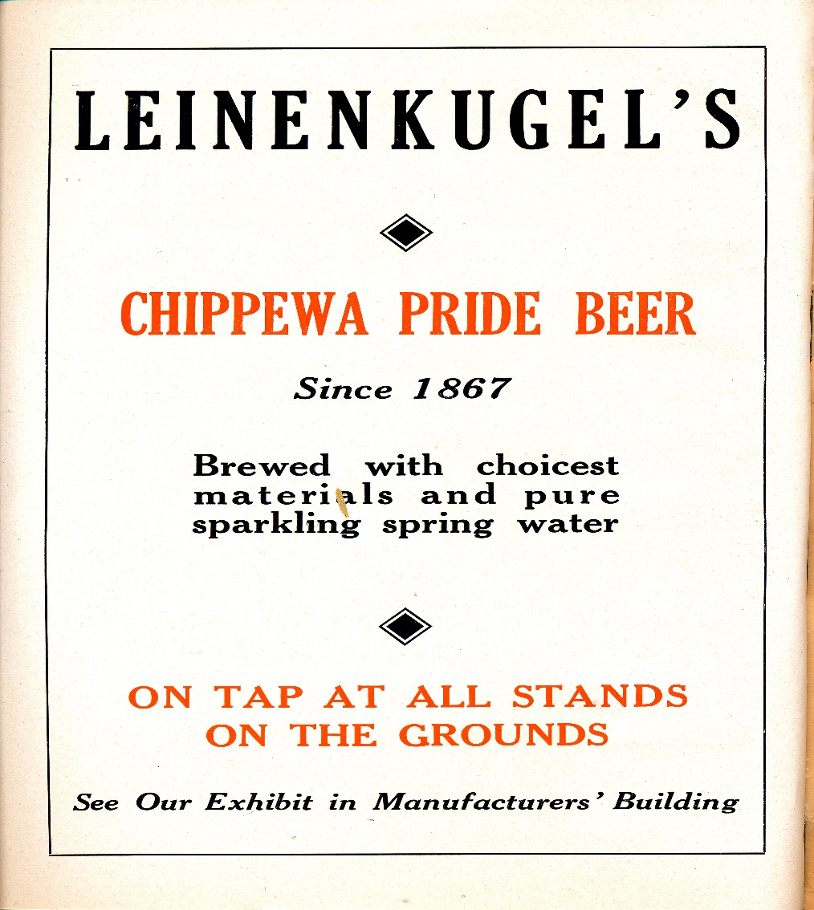
Figure 9- Leinenkugel’s Ad

The Northern Wisconsin State Fair began live entertainment in the early 1950’s on the grandstand stage. In 1958 a show called “Icetime” was featured each night in front of the grandstand. This entertainment drew crowds that would otherwise not go to the fair due to the heavy farm life aspect. People who would usually not go to the fair now had a reason to go to see acts that were only held in big cities. The grandstand was a way for the fair to gain attendance and a new audience. “Icetime” featured dance numbers with local aspects like the dairy cow in the figure below. This allowed the act to relate to the audience in a new way. (Figure 10)
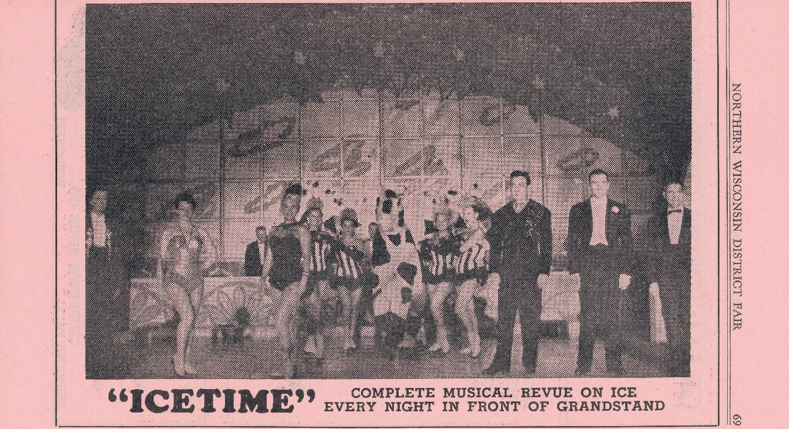
Figure 10- Icetime Grandstand Act

Another new layer of the modern fair began in 1958 as the midway made its debut at the Northern Wisconsin State Fair. The midway is the area in the middle of the main road of the fair that contains games where everyone is a winner, and also rides that adults and children can enjoy. The midway is advertised for the first time in the 1958 premium book, the Olson Shows were a popular ride and game company that traveled to fairs to give thrilling rides to fairgoers. The advertisement below also displays that there is a special pricing day for children on the children’s day. This advertisement outlines that parents would be more willing to bring their children to the fair when it is a special pricing day that the midway provides. This idea is still seen today at the Northern Wisconsin State Fair with carload days, and kid nights that have reduced pricing. (See Figure 11)
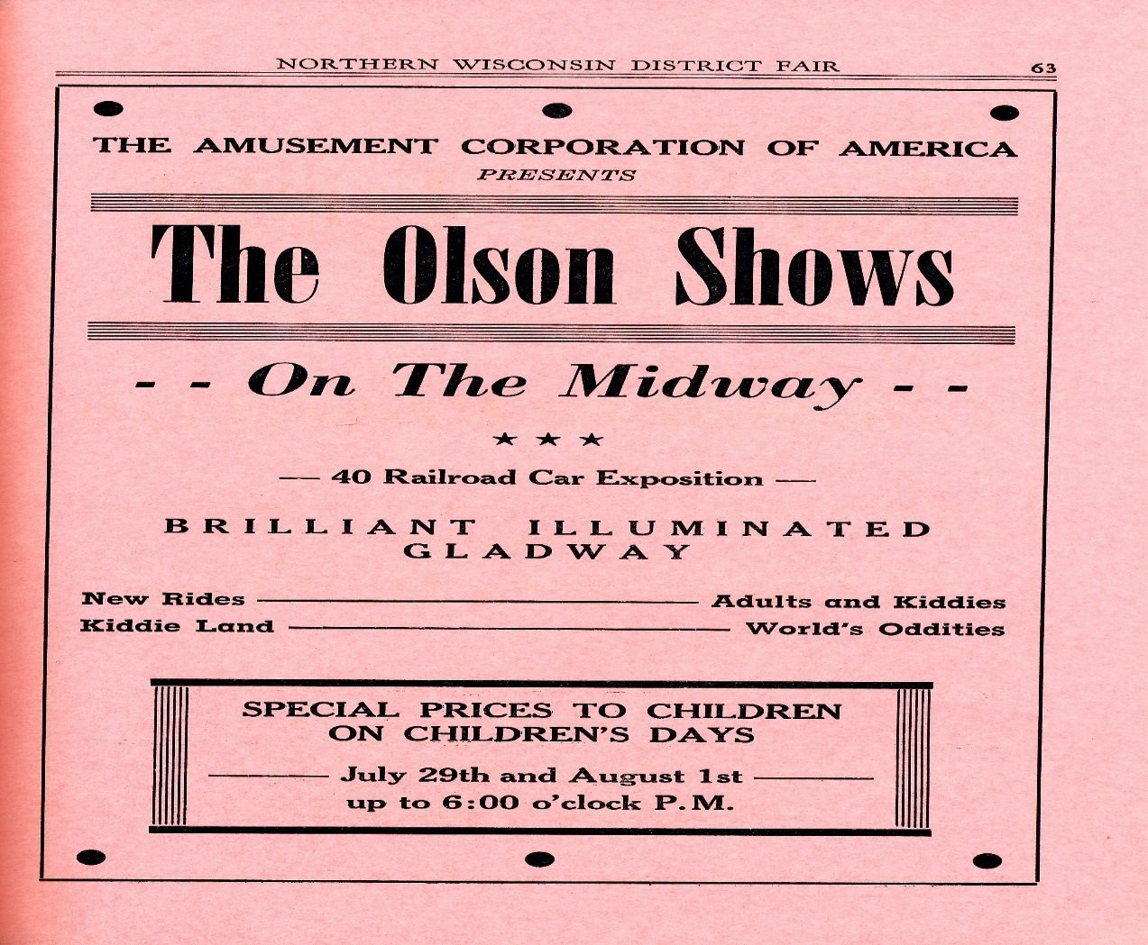
Figure 11- The Midway Advertisement

The final year that I examined was the 1966 fair, other fairs after this point did not add any new aspects to the fair, and they only expanded on what attractions they already had. In the 1966 premium book the fair relied heavily on advertisements to attract visitors, these advertisements were targeted toward all demographics from children to adults, and from farm families to city dwellers. Advertisements featured popular products such as Coco-Cola and well-known bands such as “The Thunderbirds” from Chicago as seen in these two pictures below.
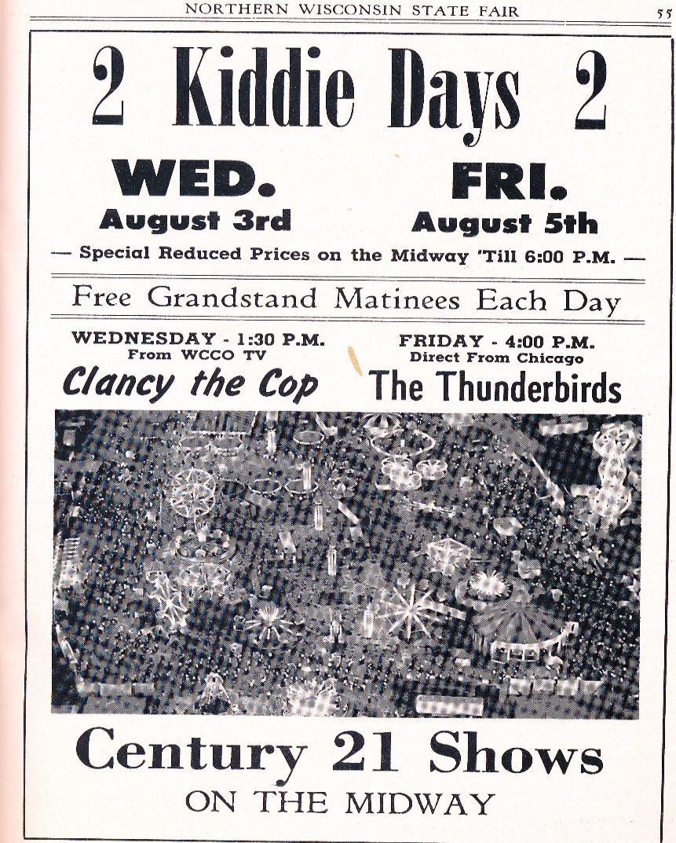
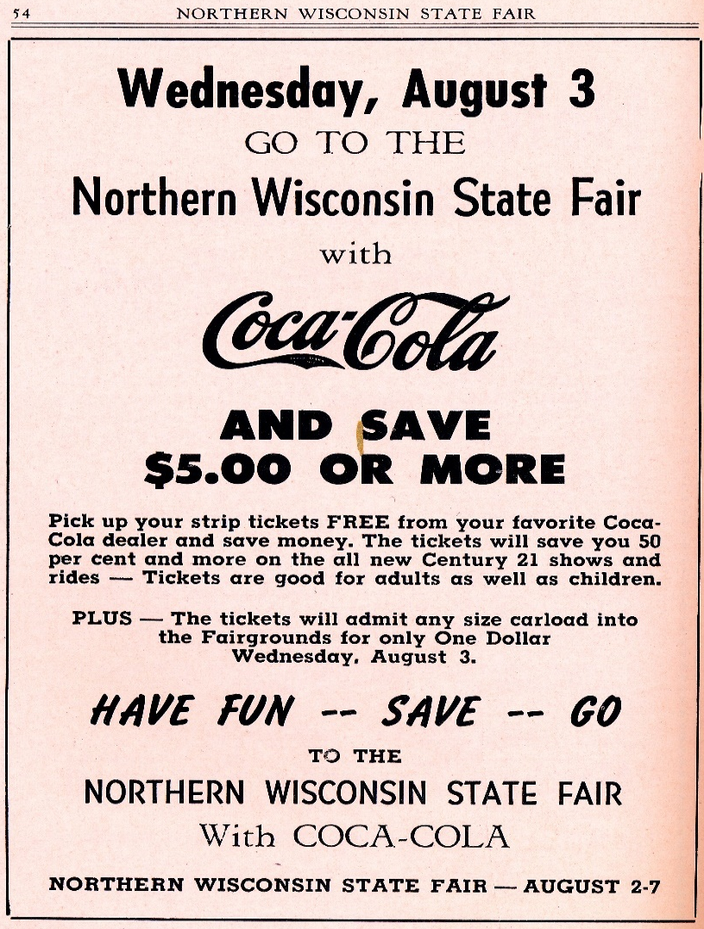
Figure 12 and 13- Advertisements

Throughout the years the Chippewa County Fair which was renamed to the Northern Wisconsin State Fair in 1897 has had great success for attendance and at creating a space for people to join together to celebrate agriculture. The success has not come without some hard times. The Leader Telegram reported in November 1931 that the fair and its creditors were filing for bankruptcy and that low attendance throughout the early years of the great depression were to blame. By early December the creditors voted to work with the community to figure out new ways of gaining attendance and getting more venders including musical acts, food carts, rides, and business to put booths in the educational buildings.
The community allowed local schools to come play music and to show off art works, as well as have the 4H members help more with setting up to lower costs.The 4H program is defined by their mission statement which reads “4-H empowers youth to reach their full potential, working and learning in partnership with caring adults.” The 4-H’s stand for head, health, hands, heart as seen in the photo below.
The fair now hosts 3 buildings devoted to displaying educational works from all schools in Chippewa County as well as volunteer projects from the 4H.
Unfortunately this was not the only time the fair has seen a hardship that threatened its survival. In 2007 it was reported that the owners that had owned and operated the grounds for twenty years were nearing retirement and were debating to sell the land. Having to sell the land would leave a gap in the Northern Wisconsin State Fair annual event. Once again the Chippewa Falls community was able to step up, this time in the form of the Chippewa Foundation and they were able to buy the grounds and continue to run the fair as usual.
Financial issues were not the only threat to the Northern Wisconsin State Fair’s existence, in 2011 soaring temperatures kept the fair attendance at bay according to the Leader Telegram. People expected the heat during the five day event so the cooler day’s attendance was good and there were no medical emergencies. Both of these circumstances are very unpredictable so it is not easy to expect these issues with low attendance. Although hot, muggy weather can have a negative effect, cool summer weather can have a boost for attendance as was the case in 2015 with over 80,000 which was 2,000 more people than 2014. Every year can be a gamble with how many people want to experience and celebrate agriculture.
Since 2007 the fair has done nothing but continue to grow and become a key summer attraction for people here in the Chippewa Valley. The Leader Telegram reported in 2012 that the attendance at the fair exceeded 2011 statics and that venders and exhibitors had increased 12 percent from the previous two years. This most recent article reveals that the Northern Wisconsin State Fair has been able to continue to bring farmers and people from the city together for one hundred years. In recent years the fair has attracted much younger audiences by booking new country artists for the grandstand acts. The fairgrounds have also gone through many updates, and there are now fourteen permeant buildings and eight semi permeant buildings that don’t have a roof as seen below. (Figure 14)
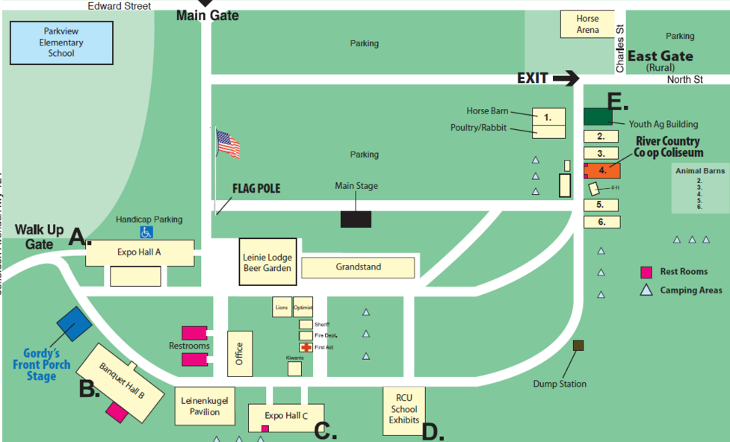
Figure 14-Map of current fairgrounds 2016

Conclusion
Chippewa Falls is a city that has revolved around certain economic industries since its early settlement in the 1830’s. The city has been able to reinvent itself to best serve the residents that continue to live there. Logging supported the town for almost one hundred years as the last sawmill was decommissioned in 1911. Although this era will never be forgotten, the city had to turn toward the fields of farmers to continue to survive. Farmers had to come back to the city to buy supplies for the next season of planting and to also sell the current seasons harvest. This was a perfect way for the city of Chippewa Falls to make a yearly event for farmers to come and trade food for supplies and methods for farming or raising livestock.
The Northern Wisconsin State Fair has also had to reinvent itself many times to keep up with the demand from the fairgoers. People wanted to see music stars that they would otherwise have to travel hours to see would only have to travel minutes. The fair has also had to update the midway with new games and technology to attract children who play on IPads every day. The midway also started games to win pets like gold fish. I remember when I was about eleven years old my father had played a basketball game and he won, he had asked me when what I wanted to take home. I looked around the tent and saw goldfish in water, I said “Daddy, I would really like two goldfish please.” A minute later I was walking down the midway with a new pair of pet goldfish. Unfortunately I only had them for about two weeks before they were belly up.
I now own a piece of the Northern Wisconsin State Fair, a root beer sign that hung in front of the 4-H building from 1940-1960. It has neon lights and also strobe light bulbs to make the sign sparkle. The sign is twelve feet long and has three brackets to hang on, this sign is now my very own piece of history that I can appreciate for a long time. I go back to the fair every year to gather with my family to celebrate farm life. The gathering turned into something bigger than the city could ever hope for and for almost two hundred years has kept generations of families entertained and connected each summer.

Works Cited
Secondary Sources
Barron, Hall S. Mixed Harvest: The Second Great Transformation in the Rural North, 1870-1930. North Carolina: The University of North Carolina Press, 1997.
Google. “Maps.” Accessed December 18, 2015. https://www.google.com/maps.
Shanley, Mary Kay. Our State Fair: Iowa’s Blue Ribbon Story. Ames, Iowa: Sigler Publishing, 2000.
Primary Sources
Ancestory.com. Search People: Alex McLaren. Accessed December 16, 2015, Ancestry.com. Wisconsin, State Censuses, 1895 and 1905 [database on-line]. Provo, UT, USA: Ancestry.com Operations Inc, 2007.
Bank Mutal, Northern Wisconsin State Fair, July 8-12, 2015. Chippewa Falls, WI, 2015. Accessed December 3, 2015, http://www.northernwistatefair.com/pdf/2015Brochure.pdf.
Chippewa County Agricultural Society. Fair Premium Book 1896. Special Collections and Archives, University of Wisconsin Eau-Claire, 1896. Box 1.
Knight, Joe. Weather helps boost attendance at Northern Wisconsin State Fair, 2015, Leader Telegram, July 13, 2015, accessed December 18, 2015, http://www.leadertelegram.com/News/Front-Page/2015/07/13/Following-the-sun.html.
Lyksett, Dan. “Thin Ice: Chippewa County Has Rich Fair History,” Leader Telegram, July 8, 2015, accessed November 20, 2015, http://www.leadertelegram.com/News/Front-Page/2015/07/08/Fair-bit-of-history.html.
Museum Tour, Paul Bunyan Logging Camp Tour, October 16, 2015.
Northern Wisconsin State Fair. Fair Premium Book 1896. Special Collections and Archives, University of Wisconsin Eau-Claire, 1897, 1900, 1921, 1935, 1958, 1966. Box 4.
Northern Wisconsin State Fair, Maps, 2015, accessed December 18, 2015, http://northernwistatefair.com/map_fairgrounds.html.
Vetter, Chris. “Fair Attendance Exceeded 2011 tally,” Leader Telegram, December 2, 2014, accessed November 20, 2015, http://www.leadertelegram.com/News/Local/2012/09/08/Fair-attendance-exceeded-2011-tally.html.
Volk, Rusty. Northern Wisconsin State Fair Results, 2012, accessed November 20, 2015, http://www.northernwistatefair.com/pressreleases.html?id=2.
Wisconsin Historical Society, “Chippewa Falls, Wisconsin-A Brief History,” Madison, WI, 2009, accessed November 18, 2015. http://www.wisconsinhistory.org/Content.aspx?dsNav=N:42949638284294963805&dsRecordDetails=R:CS2449.
4-h.org accessed December 18, 2015 http://www.4-h.org/about/.

Bank Mutal, Northern Wisconsin State Fair, July 8-12, 2015, 1-2. Accessed November 23, 2015 http://www.northernwistatefair.com/pdf/2015Brochure.pdf.
Ibid
Google Maps, accessed December 18, 2015 https://mapsengine.google.com/map/edit?hl=en&hl=en&authuser=0&authuser=0&mid=zkFjGw3Oo-z8.kmJdSGXOw7z8.
Wisconsin Historical Society, “Chippewa Falls, Wisconsin-A Brief History,” Madison, 2009, accessed November 18, 2015, http://www.wisconsinhistory.org/Content.aspx?dsNav=N:4294963828-4294963805&dsRecordDetails=R:CS2449
Google Maps, accessed December 18, 2015 https://mapsengine.google.com/map/edit?hl=en&hl=en&authuser=0&authuser=0&mid=zkFjGw3Oo-z8.kmJdSGXOw7z8.
Wisconsin Historical Society, “Chippewa Falls, Wisconsin-A Brief History,” Madison, 2009, accessed November 18, 2015, http://www.wisconsinhistory.org/Content.aspx?dsNav=N:4294963828-4294963805&dsRecordDetails=R:CS2449.
Paul Bunyan Logging Camp Tour, Paul Bunyan Logging Camp Museum, October 16, 2015.
Ibid
Ibid
Wisconsin Historical Society, “Chippewa Falls, Wisconsin-A Brief History,” Madison, 2009, http://www.wisconsinhistory.org/Content.aspx?dsNav=N:42949638284294963805&dsRecordDetails=R:CS2449.
Chippewa County Agricultural Society, Fair Premium Book 1896 (Special Collections and Archives, University of Wisconsin Eau-Claire, 1896) Box 1.
Ibid
Rusty Volk, Northern Wisconsin State Fair Results, 2012, accessed November 20, 2015, http://www.northernwistatefair.com/pressreleases.html?id=2.
Hal S. Barron, Mixed Harvest: The Second Great Transformation in the Rural North, 1870-1930 (North Carolina: The University of North Carolina Press, 1997), xi.
Ibid
Hal S. Barron, Mixed Harvest: The Second Great Transformation in the Rural North, 1870-1930 (North Carolina: The University of North Carolina Press, 1997), 30-31.
Ibid
Hal S. Barron, Mixed Harvest: The Second Great Transformation in the Rural North, 1870-1930 (North Carolina: The University of North Carolina Press, 1997), 114-115.
Hal S. Barron, Mixed Harvest: The Second Great Transformation in the Rural North, 1870-1930 (North Carolina: The University of North Carolina Press, 1997), 196-202.
Mary Kay Shanley, Our State Fair: Iowa’s Blue Ribbon Story, (Ames, Iowa: Sigler Publishing, 2000), i.
Google Maps, Google Maps, accessed December 18, 2015 https://mapsengine.google.com/map/edit?hl=en&hl=en&authuser=0&authuser=0&mid=zkFjGw3Oo-z8.kmJdSGXOw7z8.
Mary Kay Shanley, Our State Fair: Iowa’s Blue Ribbon Story, (Ames, Iowa: Sigler Publishing, 2000), 22.
Mary Kay Shanley, 30.
Mary Kay Shanley, 68-70.
Mary Kay Shanley, 129-130.
Mary Kay Shanley, 129-130.
Chippewa County Agricultural Society, Fair Premium Book 1896 (Special Collections and Archives, University of Wisconsin Eau-Claire, 1896) Box 1.
Chippewa County Agricultural Society, Fair Premium Book 1896 (Special Collections and Archives, University of Wisconsin Eau-Claire, 1896) Box 1.
Ancestory.com accessed December 16, 2015, Ancestry.com.. Wisconsin, State Censuses, 1895 and 1905 [database on-line]. Provo, UT, USA: Ancestry.com Operations Inc, 2007.
Northern Wisconsin State Fair, Fair Premium Book 1897 (Special Collections and Archives, University of Wisconsin Eau-Claire, 1897) Box 4.
ibid
Northern Wisconsin State Fair, Fair Premium Book 1896 (Special Collections and Archives, University of Wisconsin Eau-Claire, 1935) Box 4.
Northern Wisconsin State Fair, Fair Premium Book 1896 (Special Collections and Archives, University of Wisconsin Eau-Claire, 1900) Box 4.
Ibid
Northern Wisconsin State Fair, Fair Premium Book 1896 (Special Collections and Archives, University of Wisconsin Eau-Claire, 1900) Box 4.
Northern Wisconsin State Fair, Fair Premium Book 1896 (Special Collections and Archives, University of Wisconsin Eau-Claire, 1921) Box 4.
Ibid
Northern Wisconsin State Fair, Fair Premium Book 1896 (Special Collections and Archives, University of Wisconsin Eau-Claire, 1935) Box 4.
Ibid
Northern Wisconsin State Fair, Fair Premium Book 1896 (Special Collections and Archives, University of Wisconsin Eau-Claire, 1958) Box 4.
Northern Wisconsin State Fair, Fair Premium Book 1896 (Special Collections and Archives, University of Wisconsin Eau-Claire, 1958) Box 4.
Ibid
Northern Wisconsin State Fair, Fair Premium Book 1896 (Special Collections and Archives, University of Wisconsin Eau-Claire, 1966) Box 4.
Ibid
Dan Lyksett, “Thin Ice: Chippewa County Has Rich Fair History,” Leader Telegram, July 8, 2015, accessed November 20, 2015, http://www.leadertelegram.com/News/Front-Page/2015/07/08/Fair-bit-of-history.html.
Ibid.
Ibid.
4-h.org accessed December 18, 2015 http://www.4-h.org/about/.
Dan Lyksett, “Thin Ice: Chippewa County Has Rich Fair History,” Leader Telegram, July 8, 2015, accessed November 20, 2015, http://www.leadertelegram.com/News/Front-Page/2015/07/08/Fair-bit-of-history.html.
Ibid
Joe Knight, “Weather helps boost attendance at Northern Wisconsin State Fair,” Leader Telegram, July 13, 2015, accessed December 18, 2015, http://www.leadertelegram.com/News/Front-Page/2015/07/13/Following-the-sun.htmll.
Chris Vetter, “Fair Attendance Exceeded 2011 tally,” Leader Telegram, December 2, 2014, accessed November 20, 2015, http://www.leadertelegram.com/News/Local/2012/09/08/Fair-attendance-exceeded-2011-tally.html.
Northern Wisconsin State Fair, Maps, 2015, accessed December 18, 2015, http://northernwistatefair.com/map_fairgrounds.html.

