University of Wisconsin- Eau Claire
Department of History

Be He Worthy
Thor's journey from Edda to Avenger
Michael T. Ekenstedt
Advising Professor: Robert J. Gough
Fall 2012

Copyright for this work is owned by the author. This digital version is published by McIntyre Library, University of Wisconsin – Eau Claire with the consent of the author

Abstract
There’s just something about heroes. Through time people have followed their exploits through stories, found inspiration through them we learn about ourselves. Their names have changed as time goes on Achilles, Theseus, and Rama. They gave way to superman, batman, and the Hulk. The heroes and gods of our past are just that past but what does it say about a culture when it turns a hero from their past into one the modern world’s mightiest heroes. This paper will explore how Thor made the journey from a god of legends to a modern day superhero.

Table of Contents

Abstract i
Contents ii
Acknowledgments and Dedication iii

Introduction 1

1. A crash course in Norse mythology 2
2. From Vikings to Wagner: A history of Thor and Norse imagery and culture 6
3. Time for the Hammer to fall: The comic book rises falls and recovers 12

4: I need a hero: The graphic new life of Thor in a Marvelous universe 23

5. Conclusion and room for expansion 33

Bibliography
37

Acknowledgments: Special thanks to Marvel Enterprises for permission to reproduce and use images from their comic lines.

Dedication: To my friends, family, coworkers, classmates, students, people trapped in elevators with me, and anyone else who has politely listened to me ramble on about Vikings, comic books, or history at any point over the last quarter century. Thank you.

Introduction

During the 9th century across the lands that are now called Scandinavia people gathered around fires and told stories of a god named Thor. This god hailed from a place called Asgard, flew across the skies, and with the help of his mythic hammer Mjolnir, protected the people of Migard (earth) from such forces of evil as Loki his half-brother who sought to destroy the world. In 1962 a young man somewhere in in the United States stops by a gas station to buy a comic book. He stops and picks up the newest comic from Marvel. The comic is about a larger than life character who flies across the skies, and with the help of his mythic hammer Mjolnir, protected the people of Migard (earth) from such forces of evil as Loki, his half-brother, who sought to destroy the world.
How did this happen? Why eleven centuries later is Thor not only remembered as a mythological entity but still fresh as a pop culture icon, and where does a Pagan god fit in among the world of superheroes? The purpose of this paper is to explore and explain how over the course of a thousand years the imagery and identity of Thor has shifted and how this all came to pass.

1: A crash course in Norse mythology
Norse gods are different from Pantheons found elsewhere. Like many other pantheons such as the gods of Rome, Norse gods lived lives not unlike those of mortals; they married, loved, fought, strayed, and reproduced. Unlike most other pantheons, though, the gods of Norse culture were not strictly speaking immortal; gods were powerful and had awesome power, but they required magic apples to retain their youth and though it was difficult they could be injured or slain. For the sake of brevity insofar as the gods are concerned we will focus on the three most important to the story of Thor.
Odin who is called the all-father or king of the gods was the god of wisdom power wisdom, poetry, and battle. He traded an eye for wisdom and is omniscient. Most importantly Odin (prepares) for Ragnarök, the death of the gods and the end of the world in his hall Valhalla; which he fills with slain heroes who will fight for him in the the last great battle. When the universe would burn and good and evil would have their final showdown. During the Viking age Odin was primarily worshiped by Kings and Chieftains.
Loki, god of mischief and chaos; Loki is a shape shifter and is actually the child of two giants but he’s often referred to as an considered an Æsir. Loki is father and mother to some of the biggest and bad-est of the monsters of Norse mythology, for example the giant snake in figure one is called the Migard Serpent, during Ragnarök it and Thor will fight and both die in the duel which will kill them both. Loki’s relationship with the rest of the gods is complicated to say the least. For a time he and Thor traveled together going on adventures and yet he is destined to lead the armies against the rest of the gods during Ragnarök. Loki is not evil so much as he is the embodiment of chaos and a slave to his nature that would one day lead him from mischief to malice.
Finally we come to Thor. Thor was the god of the everyday Norsemen. Thor is the first born son of Odin and the champion of Asgard and Midgard. He fought evil giants and trolls, as often as not using wit and intelligence to do it. Thor controlled the storms, created lightning and thunder, and with Mjolnir a hammer so heavy that only Thor could lift it, a weapon that was a nearly unstoppable force. Thor also had gauntlets which allowed him to throw the hammer which would always return to him, and a magic girdle which doubled is already unmatched strength. A giant of a man with blazing red beard and hair, everything about Thor makes him to be the biggest and best the Æsir could ask for in a champion. For example in a drinking competition Thor once drank so much water from the sea that the level of the ocean shifted thus casuing the tides. In another story while at a wedding Thor ate an Ox, eight salmon, and three barrels of mead, and was still hungry. But, mostly Thor taveled the worlds and defeated evil forces while protecting those who needed protecting. Thor was massively popular and pendants of Mjolnir are the only pre Christian jewelry found from Scandinavia that was for religious purposes.
Within Norse mythology the entire universe is an ash tree called Yggdrasill, within which there are nine worlds. The gods could travel between these worlds through use of Bifrost, a rainbow bridge that connected the worlds. The nine worlds are as follows: Asgard, home of the Æsir and Valhalla (Odin’s army of worthy dead Danes), Vanaheimr: the home of the Vanir (Old gods who ruled before the Æsir won control in a war eons ago), Álfheimr: home of the elves, Migard: home to mortal men, Jötunheimr: home of the Jötnan, or giants, Svartálfar: home of the dark elves, Nidavellir: Home of the dwarves, Niflheimr: land of Ice and Hel, home of the dishonorable dead, and Muspellsheimr: the land of Fire
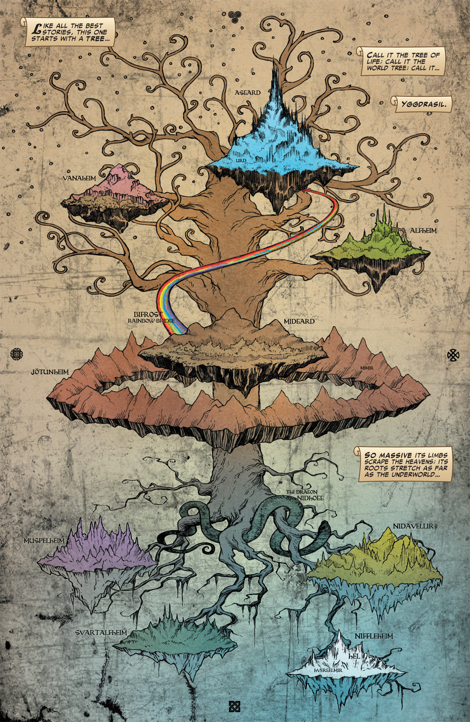
Figure 1 Yggdrasil© and TM Marvel and Subs. Used with permission.

2: From Vikings to Wagoner:
A history of Thor and Norse Imagery.

No one is so wise he can recount all of Thor’s great deeds. I myself can tell you so many significant tales about him that hours would pass before I said all I know. :Snorri Sturlson

So how do we know about the myths and gods of Norsemen? Well, in part we have to thank the traders and men going Viking. During the Viking age Danes had established trade routes reaching from Iceland to Gorgan, in Modern Iran. Somne traders settled in these places and intermarried while others just did their business and went home, but they all told stories and poems from their homes, and some of these stories have survived through to the modern. Throughout many of the early poems and stories Thor is killing giants or trolls to protect his home, Midgard. In fact, some of the first poems about Thor are just list of things he killed or maimed in combat.
There are a few accounts of Nordic pagan traditions, we also have the account of Adam of Breman, an eleventh century German chronicler wrote about the pagan Temple in Uppsala Sweden in 1075. He stated “In this temple decked out entirely in gold, the people worship the statues of three gods in such wise that the mightiest of them, Thor, occupies the throne in the middle of the chamber.”
During the thirteen century a man named Snorri Sturlson lived in Iceland. Snorri was a poet, writer, farmer, and wealthy politician. In the 1220’s Snorri wrote the Prose Eddas. The Prose Eddas are a collection of three books that outline how Eddic poetry is to be written as well as an anthology of Icelandic mythology. Despite the fact that Snorri was born more than one hundred years after Iceland’s conversion to Christianity his works have been confirmed archeologically. This remarkable accuracy is explained because of Iceland’s extreme isolation from the rest of Europe.
Fast forward to the seventeenth century; Sweden is a considerable world power, but it was considered culturally void, unable to draw its history back to the glory of Rome. The royal line did claim to be direct descendants from Odin but that fails to present a legitimate challenge to Rome’s glory and right to rule. Then in 1554 Johannes Magnus wrote Historia de omnibus Gothorum Sueonumque regibus (History of all Kings of Goths and Swedes), and in it outlined the theory of Gothicism. Within the theory of Gothicism, Swedes are the natural descendants of the Goths who were of course the oldest people in the world. Indeed according to Magnus Sweden was founded by Magog, a grandson of Noah, in Uppsala, Sweden. Because the great flood happened before the tower of Babel and the scattering of the languages the Swedes were never punished for the Babel and ipso facto Swedish was the oldest language in the world and the original language. Thus, Magnus stated the Swedish was the language that god used to speak to mankind. This establishment of Sweden with a glorious past and founding was of course logically dubious to say the least, but it gave the world a real push to learn more about early Nordic culture. It was at this time that the Icelandic Sagas and Eddas were first translated. These translated texts and Magnus’s writings fueled a new interest in ancient Nordic history. Plays were written and scholars were looking at the Eddas and Sagas. This need for a more legitimized view of Scandinavian culture to this point in the late eighteenth century led King Fredrick V of Denmark to hire Paul Henri Mallet, a Swiss professor and writer to write a new history of Denmark. Within his book Mallet does not discuss Thor very extensively; Mallet sees Thor as the sole protector of mankind who can be seen as good representative in the never ending battle of good vs. evil. The works of Mallet would prove to be the start point for both future research and popular support for the hammer wielding giant slayer.
During the late 18th and early 19th century the idea of Vikings began to take on a new significance. In Great Britain industrialists and capitalists saw Vikings as free and heroic conquerors bringing trade and conquest to foreign lands, exemplifying personal ambition and thriving under adverse conditions. Thor kept showing up in popular media Henry Fuseli featured the red headed hero, in Thor in Hymirs Boot bekämpft die Midgardschlange 1788, As did Mårten Eskil Winge Thor's Battle Against the Jötnar 1872. In this painting Thor is engaged in battle with giants, light emanates from his hammer which simultaneously basks the god in golden light while blinding his foes. Henry Longfellow wrote a poem The challenge of Thor, which opens:
I AM the God Thor, I am the War God,
I am the Thunderer!
Here in my Northland,
My fastness and fortress,
Reign I forever!
Here amid icebergs
Rule I the nations;
This is my hammer,
Miölner the mighty;
Giants and sorcerers
Cannot withstand it!
Clearly Longfellow is demonstrating this idea of a larger than life hero of gods who is defiant mighty and strong.
Vikings were not some strange peoples from distant lands. They were Germanic Scandinavians with whom the people of Britain had been trading with for over five hundred years. In an era where racial identity and social Darwinism were really beginning to take hold in the minds of many Europeans, ties to racial supremacy and
Meanwhile in the free German states that would become Germany, nationalism built a common German identity to latch onto. This identity was to be of a very wide Germanic heritage, people who speak Germanic based languages such as German and the Scandinavian languages reaching back to time immemorial to when there were no Prussians or Austrians, but Germanics, or Germans if you would. To aid in this common identity Norse mythology was called on. Germanic tribes and the tribes of Scandinavia did share much of their religious beliefs; Germanic peoples worshiped Wotan (Odin) Donor (Thor) and the rest of the host as Asgard. However, because of their much earlier conversion to Christianity during a time when very few could read or write, German nationalist looked to the Icelandic sagas for the imagery of this Germanic identity they envisioned.
The German nationalist and composter Richard Wagner would compose The Ring Cycle in 1876. The ring cycle is deeply based in Iceland’s Volsunga Saga, but goes farther covering the entirety of Norse mythology and with its sweeping and powerful imagery involving powerful feelings of national pride and power. To this day in popular culture if you want to signify the powerful cavalry coming in to save the day you play Wagner’s Ride of the Valkyries. Wagner succeeded in as O'Donoghue puts it “transforming Norse myology into a national epic for Germany” For his part Thor is portrayed as the bar knuckled fist of Odin blond haired and like most of the protagonists portraying the idealized image of the Nordic-Germanic Volk. Wagner masterfully creates bold heroes who share “strong Germanic physical characteristics”. It should be noted there had been talk among scholars of the similarities of how Wagner choose to have trolls and goblins portrayed caricatures of Jews during this time.

This use of Nordic imagery and the idea of using Viking imagery to represent a perceived ideal person would become all too apparent in Nazi Germany. The swastika, for example, has been found on weapons and tombs dating back to the Viking age and is believed to represent Thor’s hammer or lighting. The Nazi government also adapted many Norse Runes to be used as military insignia, most notably the Schutzstaffel, or SS, used the Norse Rune Sig as its official insignia. This idea can also be seen in recruitment posters that Germans circulated through Scandinavia during this time. These uses of Norse imagery would have a lasting effect that can still be scene today in how we think of Vikings and symbols such as the swastika

\

3. Time for the Hammer to fall:
The comic book Rises, Falls, and Recovers.
Comics as we know them first came into existence in the 1890’s. Newspapers were trying to attract readership and saw the non-English literate immigrants as a completely untapped market. So publisher Joseph Pulitzer purchased a printing press and began to run a four page Sunday supplement of cartoons the subject of which ranged from the exotic to political. These brightly colored comic strips were wildly successful and it did not take very long at all before these funny papers we being produced on their own as books of comics, or a comic book if you will. Today comic books feature one story, the customer goes out and buys the latest Spiderman, Hulk, or avengers comic and gets on with his day. This had not always been standard practice, in the early days a comic book featured several short stories in each issue.
Everything changed in 1929; it was then that the first comic strips that featured existing pulp fiction characters such as, Buck Rogers, Flash Gordon, the Phantom, and Dick Tracy hit newsstands. Pulp fiction was the descendant of the early 19th century dime novel; produced from cheap pulp paper, hence the name, it was filled with stories of fantasy, science fiction, or high adventure. These books directed towards lower class adults were cheap, easily accessible at newsstands, and wildly popular. These pulp-based comics became wildly popular. In 1938 one of these pulp based companies Detective Comics, which would later change their name to D.C., tried something new. June 1938 saw the premier of Action Comics. The cover featured a caped man carrying a car over his head. Harry Donenfeld, one of the publishers, expressed concern over this new comic, he though the idea of this Superman was too out there and audiences wouldn’t be interested in a superhuman fighting crime and corruption. By 1939 Superman, the first super hero, became the first one character dedicated comic book. With that, the age of the comic book was off and running. Superman was not alone; his new breed of Superhero’s soon joined him. This hero represented something more than we mere morals, and we loved them for it. When it came time to go to war our heroes were there to entertain out troops, to encourage the war effort, and to fight alongside our boys.
The perfect example is Marvel Comic’s Captain America. In issue one released in 1941 Steve Rodgers, a scrawny kid form New York City sees what’s happening in Europe and is not happy about it. He tries to join the army but is rejected because he is just too small and weak to be of use, but Steve keeps trying and shows he won’t give up and is accepted to a secret government super soldier program and becomes Captain America, or Cap for short. Cap has one thing on his mind, bringing the third Reich to her knees Figure 2 demonstrates the subtlety in which Captain America’s conveys this message.
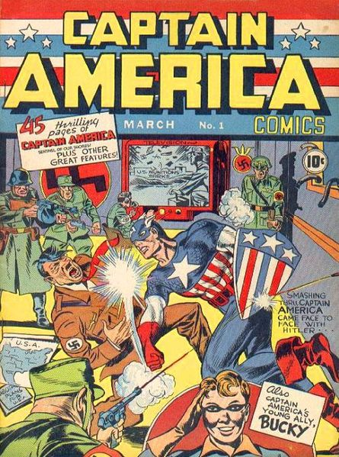
Figure 2 Captain America First Issue cover © and TM Marvel and Subs. Used with permission.
The cover of the very first issue Cap is giveing Hitler a good old American haymaker. Nine months later when the US actually joined the war, the industry dropped this subtlety and went into full war mode. Comics were shipped overseas and provided soldiers with light escapist entertainment. On the home front comic book characters did their part for the war effort as well. During this time if you were a superhero you fought and killed Nazis, but the responsibilities of supers didn’t stop there. Superman advocated for the Red Cross, Batman sold war bonds, and Cap taught us to save paper and metal for the war effort.
But why throw so much support towards the war effort? No doubt it was partially because it was the right thing to do, but it didn’t hurt that a significant number of people in the comic industry were of Jewish and found what the Nazis were doing to be morally repugnant. As an added bonus by throwing its support behind the war effort the industry linked itself with patriotism and legitimized itself as an industry. Cap also represents for the first time a superhero who’s creation was a response to real world problems and a call for action.
By the end of the late 1940’s the comic book was at the top of its game with 80-100 million copies sold every month and annual revenue of at least $72,000,000. Roughly one half of the United States population read comic books. As Wright sights regarding comic book readership “approximately 95 percent of boys and 91 percent of girls ages six to eleven, 87 percent of boys and 81 percent of girls ages twelve to seventeen, 41 percent of men and 28 percent of women aged eighteen to thirty and 16 percent of men and 12 percent of women over the age of thirty” read comics Clearly the popularity of comic books cannot be overstated during this time.
But this golden era of comic readership was not to last. In post war America people didn’t seem to need supers. During this time DC went from featuring superheroes in 90% of its comics to around 50%. Publishers saw a need to start diversifying; for some this meant adding a curvy female sidekick to try to give the male readership a boost. For example Captain America’s faithful sidekick Bucky literally takes a bullet and is replaced by a buxom blond named golden girl.
Other companies such as Fire House comics took this idea and went to the extreme. Comics featuring “jungle queens”, sadomasochistic dominatrices, and bondage scenes begin to grace the pages of comic books. The king of this new world of comics, however, was the crime comic. The first appearance was that of true crime comics; these comics depicted graphic violent images. As the title suggests, these comics depicted actual cases of crimes from police reports. The comics were a huge hit and the market was soon flooded with comics about both real and fictional crime. These comics depicted the exploits of criminals such as Machine Gun Kelly and other gangsters. While the comics were touted as cautionary tales, they depicted daring and free spirited criminals who took what they wanted, be it money or women; who were almost exclusively depicted as sex objects which it was perfectly acceptable to brutalize or kill. These comics became a major force in the industry, and by 1948 Crime doesn’t Pay was selling a million copies a month.
The comic book industry’s relationship with public approval had always been a little tense. It is almost universal belief in western culture that whatever the cool thing the kids like is probably reasonable for juvenile delinquency, violence, and the death of the American family. Through history this list has included: Rock music, movies, the power rangers, punk music, metal music, and the list goes on. Comics had for a while had a shaky relationship with the moral right of America. As early as 1940 there were editorials in papers calling for the destruction of comic books. Comics were referred to as “cultural slaughter of innocents” But the popularity of crime comics and a perceived rise in juvenile delinquency after 1947 seemed linked in the minds of the protectors of American youth and had to be stopped.
Critics began to label comics as the cause for low literacy, eye strain, and encouraged anti-social and destructive behavior in children. In 1948 John Mason Brown, a drama critic for The Saturday Review of Literature, refereed to comics as “The comic book [is] the marijuana of the nursery, the bane of the bassinet, the horror of the home, the curse of the kids and a threat to the future.” Stories began to pop up about how comics gave kids the idea to commit this crime or the other. The industry stated this was a first amendment issue, but in early 1948 it released a six point comic book code. This code banned sexual imagery, crude language, and stated that crime should not be shown favorably. The trouble was less than one third of publishers hoped on the bandwagon and those who did never through their full support behind enforcement; the result was this 1948 code did little than buy some short lived favorable press for participants.
Outrage continued and legislation was passed. In March 1948 the Supreme Court ruled on Winters v. New York. The state of New York had passed a law prohibiting the sale distribution or publication of materials made up primarily of criminal news, police reports, accounts of criminal deeds, or pictures and or storied of bloodshed. The Supreme Court over ruled with Winters and the law was struck down with the court declaring that crime, unlike obscenity has First Amendment protection. However other laws, debates and ordinances in response to the perceived threat sprung up across the nation. In 1948 Los Angeles passed an ordinance fining $500 and up to six months imprisonment to news sellers who sold publications which depicted crime to minors. Back in New York there was discussions of a need for permits to print comic books. In 1950 the Senate funded an investigation to look into ties between delinquency and comic books. The report found no connection. After Winters v New York and the Senate findings things started to cool down. The industry also won a little public favor with a new slew of patriotic comics when Captain Marvel and the gang got to go fight the Soviets in Korea. While the industry was still taking criticism, things were beginning to cool down, and it seemed like it was all going to be ok. As anyone who as ever read a comic can tell you that is exactly what happens right before the big bad guy shows up.
In 1953 Ladies Home Journal began talking about the upcoming finding of Dr. Fredric Wertham, a psychiatrist, about the dangers of comic books and their scientific linkage to juvenile delinquency. Wertham’s book entitled Seduction of the Innocent hit the book shelves in 1954. The book touts itself as a scientific book based on seven years of research, something the anti-comic movement did not have up to this point. Drawing on his years working with young delinquent patients Wertham makes his case. Wertham links comics to illiteracy saying the comics create “word blindness”, a reading disability that meant the individual was all but illiterate and could only read comics because of the pictures which did most of the work of the story telling. This disability was apparently rampant among the juvenile delinquents of New York. Seduction sights many crimes committed by comic book readers. Shining examples include the account of a thirteen year old boy who committed a “lust murder” of a six, after his arrest he asked for a comic book to read in his cell.
According to Wertham, comics didn’t just make kids violent, they caused permanent emotional damage. Also, characters such as Catwoman, with her whips and skin tight outfit show our children overtly sexual imagery which perverted children. Catwoman in particular is show to demonstrate that all attractive women in comic books are villains and this combined with the homosexual nature of Batman and Robin may subconsciously encourage homosexuality. Later Wertham makes a case for the circuit between sex and violence being a short and easily confused and that comics leave adolescence unable to separate the two ideas. While Wertham never said comics made children delinquents, he did say it was a contributing factor in every case of delinquency he came across. Remember that during this time 87 percent of all male’s in the age groups Wertham was “researching” read comic books. In the end Wertham came to the following conclusion:
The general lesson we have deduced from our large case material is that the bad effects of crime comic books exist potentially for all children and may be exerted along these lines:
1) The comic-book format is an invitation to illiteracy.
2) Crime comic books create an atmosphere of cruelty and deceit.
3) They create a readiness for temptation.
4) They stimulate unwholesome fantasies.
5) They suggest criminal or sexually abnormal ideas.
6) They furnish the rationalization for them, which may be ethically even more harmful than the impulse.
7) They suggest the forms a delinquent impulse may take and supply details of technique.
8) They may tip the scales toward maladjustment or delinquency.
Crime comics are an agent with harmful potentialities. They bring about a mass conditioning of children, with different effects in the individual case. A child is not a simple unit which exists outside of its living social ties. Comic books themselves may be the virus, or the cause of a lack of resistance to the social virus of a harmful environment.
One small issue with Wertham’s book is that no actual scientific research was conducted. The books definition is written sloppily virtually all comics under his definition are considered crime comics and his finding are simply from his notes working with his patients while treating patients at three New York City treatment centers. While Wertham never said comics made children delinquents, he did say it was a contributing factor in every case of delinquency he came across. This correlation causation thesis is at the root the academic issues.
The lack of empirical science behind the research did absolutely nothing to slow the fervor of hate that was thrown at the comic industry over Wertham’s findings. Dr. Werthham became famous and gained much support. Interestingly enough one of the most compelling rebuttals came from David Pace Wigransky a 14 year old comic enthusiast. In editorials Wigransky eloquently and compellingly argued that comics had nothing to do with delinquency, and that “Capable as Dr. Wertham may be in the psychoanalyzation of adults, I certainly do not believe him able to deal equally as well with children, due to his fanatical hatred and prejudice towards comic books.” Unfortunately most people were not ready to listen to a mere teenager when they had moral right and a doctor on their side to begin with. Comic book burnings became a regular occur ace across the country. The Senate opened another investigation and because of several factors, including the comic book companies failing to mount a united defense, an interview by the committee of William Gaines, a publisher and owner of EC comics, went completely off the rails and the backlash eventually drove EC comics out of business.
In September of 1954 the industry, in order to self-regulate rather than allow the government to restrict it, announced the formation of the Comic Magazine Association of America, or CMAA for short, and on October 26th 1954 the CMAA relied a new set of rules and practices that would apply across the industry; this was the comic book code. Unlike the 1948 codes these were far more specific and very restrictive rules. A ban was placed on werewolves, vampires, the words "crime", "horror", and "terror" in comic book titles, sex perversion, sexual abnormalities, illicit sex relations, seduction, rape, sadism, and masochism. Also policemen, judges, government officials, and respected institutions had to be portrayed in such a way as to not create disrespect for established authority. There was actually a requirement that demanded "in every instance good shall triumph over evil". All but three major publishers were members and were bound to these codes. The comic industry meant business. With the codes in place the fire storm settled and with the appearance of rock music a newer threat to the American youth comics were left in peace. The question was where did do they go from here?
Under the codes many companies, such as EC comics, went under. They had simply done too well with crime comics and didn’t know how to make it without them. Comics also now had television to compete with. The market was in a serious slump. After the codes went into effect the industry lost most of its teen and adult readership. It’s not unlike being told you can only make G movies. A few companies such as DC which had been operating under their own moral code since 1941, and Marvel which had been diversified enough to stay afloat, never caught the full heat of the anti-comic movement. Then after years of marginalization something happened; superhero comics started to sell again. Under the creative mind of Stan Lee and Jack Kirby, Marvel introduced us to the Hulk and the fantastic four which featured something new; the reluctant superhero. In 1962 Lee had his biggest hit yet with the debut of Spiderman. These reluctant heroes were a hit and Marvel secured itself as the front runner in the new ear of comic books. Where would Lee and Marvel go next? The answer lies in the past.

4. I need a hero:
The Graphic New Life of Thor in a Marvel-ous Universe

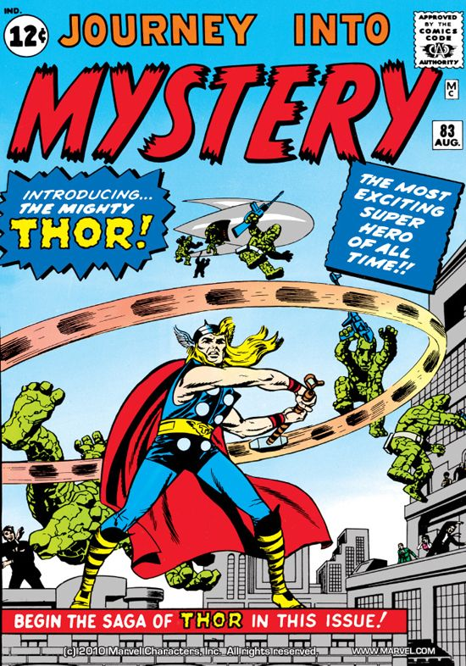
Figure 3: Journey into Mystery #83, © and TM Marvel and Subs. Used with permission.
In August 1962 Marvel comics released Journey into Mystery #83 which featured a new superhero, Thor the Norse god of thunder. The girdled hammer-wielding champion of Asgard was back. In the issue Dr. Donald Blake, a young frail American doctor on vacation in Norway, overhears a local talking about giant monsters in the woods. Intrigued Blake decided to check it out and runs across the stone men of Saturn. Trying to escape Blake runs into a cavern and finds a stave of wood on the ground. While trying to use the stave to pry a bolder that obstructs his path, the piece of wood strikes the ground and Blake instantly transforms into Thor! The cane transforms into a hammer. Thor then wipes the floor with the alien invaders and saves the day! How did Thor get here? Why is he here? What does this mean?
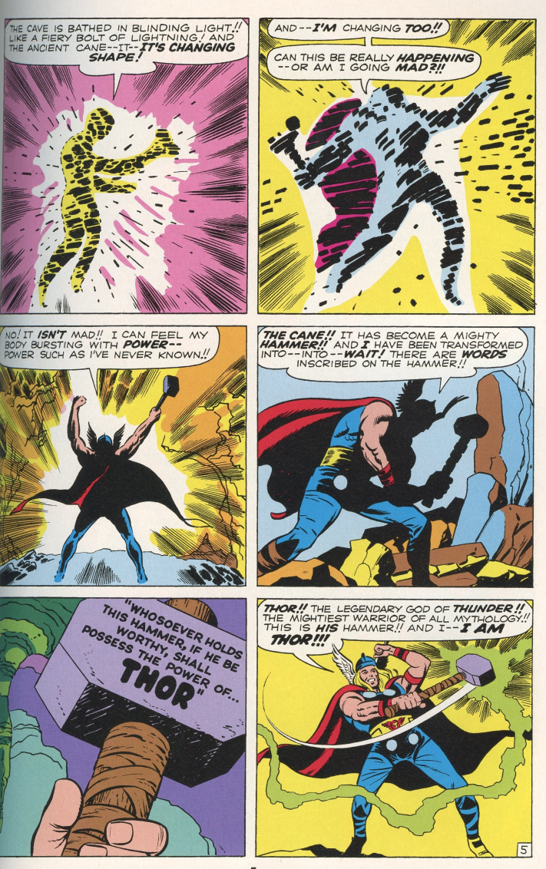
Figure 4: Journey into Mystery 88© and TM Marvel and Subs. Used with permission.
It all started when Stan Lee was being interviewed on New York public radio. “The interviewer kept calling our caped cavorters our generation’s mythology. Then he asked what we planned to unleash on the world next and it all came together. Enter the world of the myth. Come up with a god.” Lee wanted something bigger and stronger then the hulk and a god seemed to be the only thing that could do the job. Lee went on to explain he didn’t want to go with a Roman or Greek god who he said had gotten a lot of press already, instead he wanted a god that was a little less well known. The idea of Thor intrigued him; Thor was incredibly strong, and able to control the weather. Lee loved the idea of Thor’s hammer. To add a little flair Lee gave Thor the ability to fly by having him tie himself to his hammer and throw it into the air.
This makes sense but knowingly or not Lee’s choice to use Norse mythology was a decisively good move. Beyond having less recognition then Zeus but more than, say, Quetzalcoatl or any other deity from Aztec mythology; the Norse god would prove to fit in more comfortable in the supers world then many other deities would have. Within Norse mythology there is the constant threat and knowledge of the Ragnarök, which drives the characters to fulfill their destinies. Similarly modern comic developed the Norse nobility and self-sacrificing warrior’s ethos. While visually Thor appeared to harken back to 19th century Germanic visions of a Norse god, with his blond hair clean shaven face, winged helm, blue eyes. But within the character of Thor/Blake mindset of Thor more closely resembles the clever thunder god of ancient Iceland than Wagner’s quick tempered hammer fisted behemoth. Some have argued this as an attempt to redefine or reclaim Norse Germanic imagery and identify from the stigma Nazism.
After the first few issues establish the basic rules of being Thor in this Marel-ous universe. Originally Blake was his own man who was simply given the power of Thor because he was worthy. We later find out Dr. Blake was actually Thor the whole time he had just been cast from Asgard and made to live among mortals and forget his forer life to teach the impetuous god some humility. Thor is now both Dr. Blake and Thor, giving the audience what they really want a little inner turmoil. Originally if Blake lets go of the hammer for more than sixty seconds he loses all of Thor’s power and goes back to being plain old Dr. Blake. This is scarped for reasons that are never explained but I would infer it was just too much of a needless plot device to make sure he never let go of the hammer.
Thor becomes the first super to speak in what Lee classifies as “neo-Shakespearian” Lee stated Thor doesn’t speak like a person, because he really isn’t. Thor spoke to teenagers Thor is pretty untouchable physically but he was emotionally venerable. For example the endangering of his love interest Jane Foster who had an unrequited love with both Thor and Blake, this turns into a whole situation because she’s human and he isn’t. Unlike Spiderman and the other supers of the day, Thor was not so much reluctant as he was torn. He isn’t really human but he loves a human and the world, his father doesn’t approve of his feelings. He protects earth and Asgard is constantly torn between the two but never really fitting into either. This would strike a chord with the teenage target audience of Thor. There is even room for augment that Thor represents a model for white American male teens, speaking to questions of finding ones place as new powers reshape the old world order and finding your place between duty and personal desires.
Thor made a big smash and quickly became the newest star in the marvel universe. There is a question that begs asking. What foes can possibly stand against this deity.
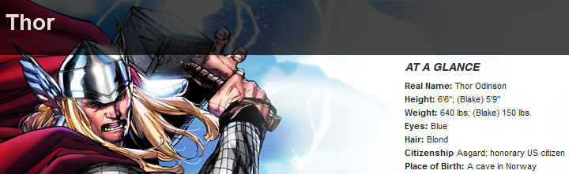
Figure 5 Image Thor© and TM Marvel and Subs. Used with permission.

Lee and Kirby decided the only logical answer was to bring back Loki to provide Thor with a worthy opponent. With the reintroduction of Loki eventually Odin and the world of Asgard, Thor for the first time in a thousand years begins protecting Asgard and Midgard from unimaginable foes. In 1963 during a fight with Loki Thor teamed up with Iron man, Hulk, Captain America, Thor, Wasp , and Ant-Man joined forces to fight “foes no single superhero could withstand” and formed the original Avengers. This gave Thor the opportunity to play with others as well as expand the market comic of one of the avengers to branch out and gain interest in other hero’s stories. However it has also been theorized this supports the idea of the modern powers of the ages joining forces to combat unstoppable le evils.
American Mythologist Joseph Campbell has made the case for a human deed for mythology. We need to believe in something bigger then ourselves that can teach us how to succeed and overcome things bigger then we are. Campbell makes the case for comic books, television, and movies being the modern mythology. In this respect, superheroes have come to take the place of gods and epic heroes. Thor certainly fits the bill for this. Faced with his own doom fighting to protect both his home and the defenseless earth from powers beyond our imagination, but what separates our helmeted hero from others in his field?
Firstly, Thor is more. He is called the Mighty and the greatest of Marvels heroes. Secondly Thor faces villains that are things from out of man’s nightmares. While Spiderman fights crooks and human mutants, and Superman is off fighting crime and the evil genius Lex Luther. Thor generally doesn’t get involved unless the threat is something bigger. This means gods, aliens, or sometimes communism. Thor represents the pinnacle of honorable warriors standing against the tide of evil.
Thor represents the ultimate power thought the history of the comic. On several occasions it is made clear Thor is holding back so as to not kill his opponent. A common story arch is that Thor holds back too much and is beaten by his foe then recalibrates how much to pull the punch and smears the would be threat to earth across the sky’s. Feats of this literal god among men include: lifting a snake the weight of the earth, hitting a villain so hard the shockwaves destroy nearby mountains, and breaks free form a force equal to the gravitation of a neutron star, roughly 100 billion times that of earth. Clearly we’re looking at one tough Asgardian.
Over time Thor became the hero of the super heroes. Captain America is clearly the leader of the Avengers. When things look bleakest people turn to superheroes, but when things look dire for mortal heroes they turn to Thor to be their savior. To this end please refer to figure five and six.
In the Avengers Vol. 3 #22 Ultron has captured Scarlet Witch, Wasp, Giant Man, and Wonder Man and replaced them with cyborg doppelgangers. Ultron, confident his minions have dispatched his captives, when suddenly a wall of his base implodes.
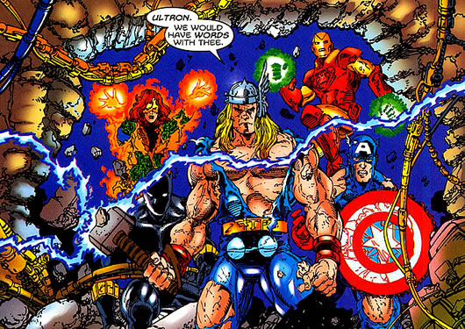
Figure 6: Avengers Vol. 3 #22© and TM Marvel and Subs. Used with permission.

The assumed defeated avengers led by Thor come to the aid of their comrades and Ultron is then defeated and we all live happily ever after, or at least until lest issue.
In the opening combat of Amazing Spiderman 648 Spiderman is fighting the robotic minions of Doc Ock and after a near miss for him has a conversation with his sidekick Spidergirl.
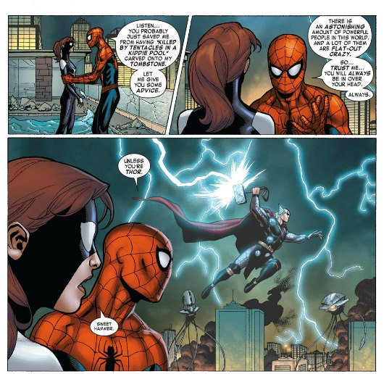
Figure 7 Amazing Spider-Man #648 © and TM Marvel and Subs. Used with permission.
In the season finally of season two of Marvel’s TV show Earths Mightiest Hero’s in the episode Air-Walker, Firelord, Stardust, Terrax and Galactus; five of the Marvel universe’s biggest bad-est villains attack the earth at the same time. An epic battle ensues and things are looking bleak for Earth and her hero’s. At this point Spiderman has a mild freak-out in front of Captain America.

Spider-Man (to Captain America): It’s the end of the world! I'm freaking out! Why aren't you freaking out?
Cap: Because I can hear it.
Spidey: Hear what?
Cap (looks up slightly): Thunder.
It is here we find Thor’s place. From the examples it is plain Thor holds a strange position as the hero that heroes can turn to. I cannot help but see the social implications of when superheroes of the modern age, the product of science or technology are in trouble they turn to a god of the old world. Thor shows our need for a link to the past to an identity that goes beyond us.

5. Conclusion and room for expansion:
Due to the fact that academic research centered on comic books has been extremely limited in any capacity, there is a lot of room for expansion from this topic. I’d like to go deeper into the topic of this paper tracing cultural cues over time. I’d also like to expand into more modern interpretations of Marvel’s Thor, particularly focusing on The Trials of Loki in which Loki retells events from Norse myth to Marvel’s Thor, and Thor’s reaction to these stories and attempts to explain Loki’s role as not a villain but a creature of destiny. Figure 7-9 depicts Loki is retelling a story from Norse mythology about Thor and Loki; where Loki is caught in a tick he had played and the consequences that resulted, but he is telling it to Mighty Thor’s reaction. I find this juxtaposition of what we expect from a hero compared to what the people of medieval Europe expected of their hero very interesting.
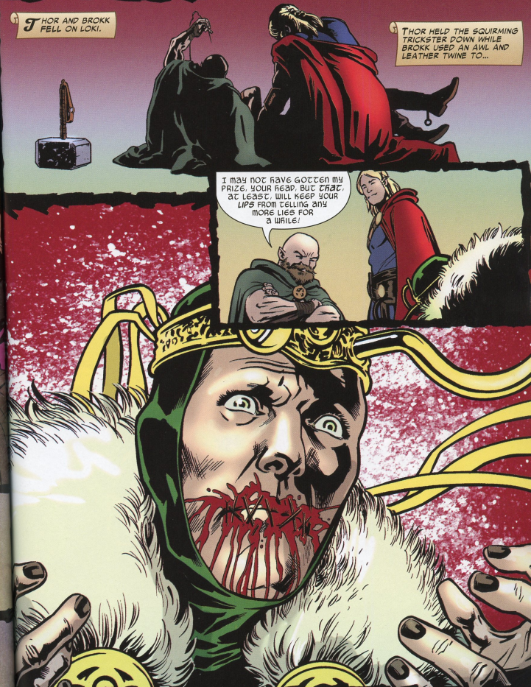
Figure 8 and 9: Trial of Loki © and TM Marvel and Subs. Used with permission.
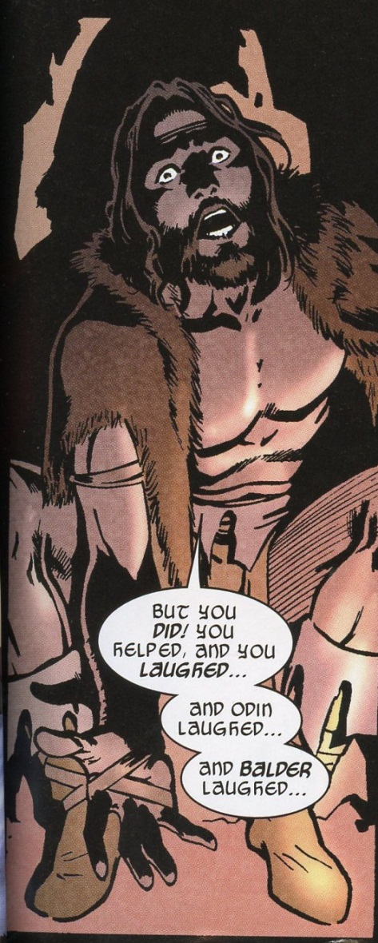
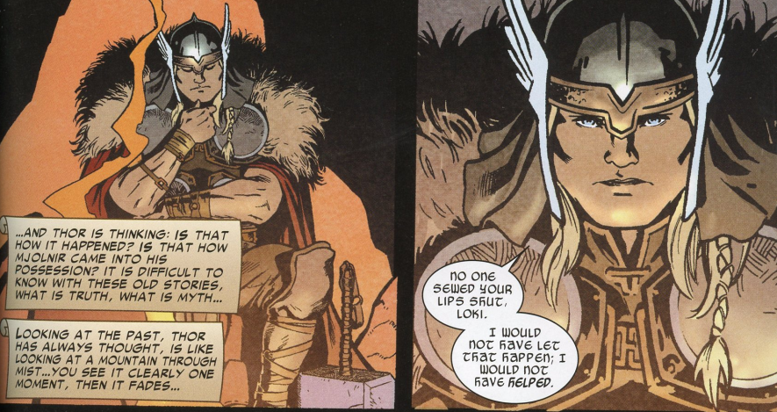
There is also a lot of room for exploration in the field of Thor being used as a model for the perceived threat to white male power in the 1960’s. With the civil rights movement in full swing, feminism, technology, the dawn of the nuclear age, and the cold war. Thor represents the old Western European male power base.
When faced with new heroes for earth in the form of super soldiers, robotic suited billionaires, aliens, and a myriad of other new powerful beings.
When Thor encounters these new powers does he see them as a threat to his power? No, instead he joins forces with those who are good to fight the new forces of evil the threaten the world. It is possible the Marvel set out to give white middle class American boys a model to respond to what were seen as threats to their traditional power base.

Bibliography
Secondary Sources:
Arnold, Martin Thor : Myth to Marvel, London: Continuum 2011

From Myth to Marvel in a deep reaching look into Thor, primarily as an figure in literature but also depictions in art. A very valuable resource for finding shifts in perceptions of Thor.

Davidson, Hilda Roderick Ellis Gods and Myths of Northern Europe Baltimore: Penguin Books,1964

Gods and myths gives more insight into the world of Pagan Scandinavia. Insightful and very to the point Gods and Myths is a guild describing Norse gods, rituals, myths, and rights.

Hajdu, David The Ten Cent Plauge the Great Comic Book Scare and How it Changed America, New York: Picador 2008
The Ten Cent Plauge is excellent look into the history of comic books with focusing on the creation of the comic book codes and the backlash in the industry.

Knowles, Christopher Our Gods Wear Spandex: Secret History of Comic book Hero’s (San Francisco: Weisner Books
Knowles looks at comic book across time and extrapolates on tendencies within the industry such as supers who’s powers originate from accidents, experiments, strange or unexplainable vents or come from somewhere else. Knowles also makes the case for Comics taking a primary role in taking the place of myths in modern popular culture.

Krug, Kurt Anthony 15 Defining Avengers Moments, January 22, 2010 http://www.mania.com/15-defining-avengers-moments_article_120091.html

An article exploring important moments in the Marvel universe from the fans perspective; this article is useful as it is good to remember this is a source of media with a consumer base in mind.

Miller, M. Coleman Introduction to Neutron Stars http://www.astro.umd.edu/~miller/nstar.html

A fascinating introduction to the Neutron Star including what makes one up and the features of this celestial feature.

Nyberg , Amy Kiste “Comic book Censorship in the United States” in Pulp Demons, ed. John A. Lent (London: Associated University Press, 1999

Nyberg covers the history of censorship within the comic book industry and track and questions the current concerns that were happening in the 1990’s in a post comic coed world.

O'Donoghue, Heather From Asgard to Valhalla : The Remarkable History of the Norse Myths London:I.B.Tauris
2009
This remarkable book looks into Norse mythology through time and it’s interpretations From the Viking age through the modern. The view on Romanticism and German nationalism was f particular use.

Roesdahl, Else The Vikings, London: Penguin Books, 1998
The Vikings stands as the first modern scientifically minded hooks on Viking history in English. It was Dr. Roesdahl is a professor of Archeology and one of the foremost authorities on Vikings. Tis book was the perfect into to Vikings guide.
Wright, Bradford W. Comic Book Nation: The Transformation of Youth Culture in America (Baltimore: The Johns Hopkins University Press
In in depth look into the history of comic books and their impact on United States culture. Wright explains the origins of comic books and the ups and downs and trends in the industry through time. Truly a must read for comic book history.

Primary sources

Bremen, Adam von History of the archbishops of Hamburg-Bremen Translated Francis Joseph Columbia: Columbia University Press, 1959

Campbell, Joseph The Power of the Myth Highbridge Audio, released 1988

The Power of the Myth is a six part interview between Bill Moyers and Joseph Campbell at Skywalker ranch, in which they discuss the roll of the hero and mythology’s place in society; These recordings are a treasure trove of mythological theory as well as a gret look at the role of the hero and what we look for in a hero.

Lee, Stan Jack Kirby Marvel Masterworks: The Mighty Thor volume 1 Salem: R.R. Donnelley Inc., 2010
A reprinted collection the first 17 Thor comics with an opening letter from Stan Lee.

Lee, Stan interview 1990’s http://www.youtube.com/watch?v=7XIBSdS63R0

Stan Lee discusses the creation of Thor as a character.
Wertham, Fredric Seduction of the Innocent, Toronto: Main Road Books, 1953
Wertham’s book charging the comic book industry with corrupting he youth of America

Longfellow, Henry Wadsworth. The challenge of Thor http://www.pitt.edu/~dash/longfellow.html#challenge

In this poem Longfellow paints a portrait of Thor which is entirely representative of the new Norse mythological identity being portrayed in Europe during int 19th century.

Image sources:

Figure 1: Trials of Loki by Roberto Aguirre-Sacas, Sebastian Fiumara (Illustrator) Marvel Enterprises, April 27, 2011

Figure 2: Captain America #1 Marvel Enterprises

Figure 3:Journey into Mystery #83 Stan Lee, Larry Lieber, Robert Bernstein and Jack Kirby Marvel Enterprises first published 1963

Figure 4: Journey into Mystery #83 Stan Lee, Larry Lieber, Robert Bernstein and Jack Kirby Marvel Enterprises first published 1963

Figure 5: Thor found at www.marvel.com’characters/bio/1009664/thor?nav.1

Figure 6: Avengers Vol. 3 #22 Marvel Enterprises

Figure 7: Amazing Spider-Man #648, Dan Slott , Humberto Ramos (Illustrator) Marvel Comics Marvel Enterprises 2010

Figure 8-9-:Trials of Loki by Roberto Aguirre-Sacas, Sebastian Fiumara (Illustrator) Marvel comics April 27, 2011

In this paper the terms Danes, Norse, Norsemen, and Northman refer to any one from Scandinavia during the 8th through 12th centuries and may be used interchangeably.
Else Roesdahl, The Vikings, (London: Penguin Books, 1998) 149
Roesdahl, The Vikings, 150
Hilda Roderick Ellis Davidson, Gods and myths of northern Europe (Baltimore, Penguin Books,1964) 85
Roesdahl, The Vikings, 150
See figure one.
Note Viking is a job description and not ethnic group of people.
Roesdahl, The Vikings, 292
A prime example of this is Beowulf which the first story written in English is about a Swede saving a bunch of Danes from a troll.
Heather O'Donoghue, From Asgard to Valhalla : The Remarkable History of the Norse Myths (London:I.B.Tauris 2009), 32
Adam von Bremen, History of the archbishops of Hamburg-Bremen Translated Francis Joseph (Columbia: Columbia University Press, 1959) 207
Martin Arnold, Thor : Myth to Marvel (London: Continuum 2011) 12
Arnold, Thor, 18
O'Donoghue, From Asgard to Valhalla, 103
O'Donoghue, From Asgard to Valhalla 107-8
Arnold, Thor 132
Arnold, Thor 141
O'Donoghue, From Asgard to Valhalla 128
Henry Wadsworth Longfellow, The challenge of Thor http://www.pitt.edu/~dash/longfellow.html#challenge
O'Donoghue, From Asgard to Valhalla 145
Martin, 196
O'Donoghue, From Asgard to Valhalla 132
Davidson, 83
Runes are the Old Norse alphabet, they also were used for religious purposes and as a form of oracle, Sig represents the sun and Joy.
David Hajdu, The Ten Cent Plauge the Great Comic Book Scare and How it Changed America (New York: Picador, 2008) 10
For whom the Pulitzer prize was named.
Hajdu, Ten cent plague, 9
Usually costing ten cents
Bradford W. Wright, Comic Book Nation: The Transformation of Youth Culture in America (Baltimore: The Johns Hopkins University Press) 3
Wright, Comic Book Nation 9
Wright, Comic Book Nation 34
Hajdu, Ten cent plague, 112
Wright, Comic Book Nation 57
Wright, Comic Book Nation 58
Hajdu, Plauge 54
Wright, Comic Book Nation 86
Amy Kiste Nyberg “Comic book Censorship in the United States” in Pulp Demons, ed John A. Lent (London: Associated University Press, 1999) 42
Nyberg, Censorship, 43
Wright, Comic Book Nation 89
Nyberg, Censorship, 44
Nyberg, Censorship, 46
Nyberg, Censorship, 47
Newspapers were exempted.
Nyberg, Censorship, 49
Fredric Wertham, Seduction of the Innocent (Toronto: Main Road Books, 1953) V
Wertham, Innocent 167
Wertham, Innocent 141
Wertham, Innocent 179
Wertham, Innocent, 118
Hajdu, Plauge, 236
Wright, Comic Book Nation 100
Wright, Comic Book Nation 167
Wright, Comic Book Nation 173
Wright, Comic Book Nation 178
Wright, Comic Book Nation 210-12
Stan Lee and Jack Kirby Marvel Masterworks: The Mighty Thor volume 1 (Salem: R.R. Donnelley Inc., 2010 )
Stan Lee interview 1990’s http://www.youtube.com/watch?v=7XIBSdS63R0 3:36
Christopher Knowles Our Gods Wear Spandex: Secret History of Comic book Hero’s (San Francisco: Weisner Books) 72
Joseph Campbell The Power of the Myth
Lee, Thor volume 1 3
See appendixes.
Lee, Thor #272, 1978
M. Coleman Miller, Introduction to neutron stars http://www.astro.umd.edu/~miller/nstar.html
A robot originally created by one of the avengers but who became self-aware and decided to wipe humanity off the face of the earth using an army of robots.
Kurt Anthony Krug 15 Defining Avengers Moments, January 22, 2010http://www.mania.com/15-defining-avengers-moments_article_120091.html
Marvel Earth’s Mightiest Hero’s Season two episode 26, aired 2012

