Displaying Children’s Artwork

By
Michelle Kuhnert

A Master’s Paper
Submitted in Partial Fulfillment of
The Requirements for the Degree of
Master of Science in Education - Montessori

___________________________________
Major Advisor’s Signature
___________________________________
Date

University of Wisconsin – River Falls
2014
Abstract
Displays of children’s artwork are common in early childhood classrooms. Maria Montessori, however, did not write about visual displays. Just like in all other areas of the classroom a Montessori guide should ponder over the materials’ purpose. In an action research project with a class of 40 children, 33 months to 5-years-old, this article offers insight into how children’s artwork and visual displays should be used in a Montessori classroom to benefit children’s learning. Over 7 weeks the Montessori Children’s House bulletin boards were changed weekly. Each week parents completed surveys and children were interviewed. Parents loved seeing photographs of their children working and their child’s artwork on display. Ultimately, Montessori guides should continue to leave freedom to the children about what they would like to display to create more personalization in the classroom.

Introduction
The environment is a critical component of any classroom, but especially in Montessori. The Montessori guide thoughtfully prepares the environment for the children. Everything is chosen carefully and purposefully to foster the children’s developmental needs (Montessori, 1988). How the classroom is arranged and what is displayed is just as vital as what materials it possesses. Displays of children’s work can affect their behavior, their self-esteem, and their learning. They are also a form of communication and documentation to parents and other visitors. Personalization of displays creates a sense of ownership for the children, but displaying too much may be over stimulating. A Montessori classroom is to be calm and peaceful. Thus, a guide’s duty is to create classroom displays that contain the perfect balance for the children, parents, and visitors that do not distract from the Montessori materials.

Purposes of Classroom Artwork Display
There are multiple purposes of displaying artwork including affirming children’s ideas and interests, communication to classroom visitors, and documentation of children’s learning journeys. By displaying children’s artwork, a Montessori guide affirms children’s thoughts, ideas, and imaginations (Bae, 2004; Heejin, Eunhye & Jeehyun, 2001; Kocer, 2012; Schroeder-yu, 2008; Seefeldt, 2002; Short, 2007; Spodek, 1993; Twigg, 2011). Children express their emotions through their artwork. “Doing art requires children to think about their ideas, feelings, or experiences with the world, to find symbols to express them, and to share them with others” (Bae, 2004, p. 247). We are recognizing and valuing their work when we put it on display. When children’s artwork is on display, they are proud and have a sense of ownership and belonging (Killeen, Evans & Danko, 2003; Maxwell & Chmielewski, 2008; Short, 2007). Children’s self-esteem may also increase if they participate in classroom and school personalization displays (Heejin, Eunhye & Jeehyun, 2001; Maxwell & Chmielewski, 2008). Yet, at the same time, we need to be sensitive to children’s needs (Seefeldt, 2002; Twigg, 2011). By having a place to allow wet paintings to dry and store work before taking it home, we are respecting them and their work. Also, if they want to take their artwork home, instead of displaying it, we should respect their wishes (Twigg, 2011).
The Montessori prepared environment is beautiful and ordered. Everything displayed in it should also have these characteristics. The Montessori environment belongs to the children in it, so they should make the environment beautiful with art they create (Seefeldt, 2002). The findings of Maxwell and Chmielewski concur with those of Killeen, Evans and Danko (2003) in suggesting that “elementary school classrooms should have the capacity for visual personalization of the environment and that children should participate in the process of creating such displays” (Maxwell & Chmielewski, 2008, p. 151).
Displays of children’s artwork is a form of communication to those who enter the classroom (Bae, 2004; Heejin, Eunhye & Jeehyun, 2001; Schroeder-yu, 2008; Seefeldt, 2002; Short, 2007; Spodek, 1993; Twigg, 2011). Children’s art products can sometimes communicate better than children can verbally. As Heejin, Eunhye and Jeehyun (2001, p. 42) stated, “…they can be used to make teachers, parents, and visitors aware of the children’s potential, their developing capacities, and what goes on in the school.” Children are proud to show their artwork to their parents and friends and reminisce on the creation process (Short, 2007). Parents and visitors are aware of what the children are working on and studying in the classroom.
Documentation is another purpose of displaying children’s artwork (Schroeder-yu, 2008; Seefeldt, 2002; Spodek, 1993; Twigg, 2011). This is a big part of the Reggio Emilia approach. “Documentation typically includes samples of a child’s work at several different stages of completion; photographs showing work in progress; comments written by the teacher or other adults working with the child; transcriptions of the child’s discussions, comments, and explanations of intentions about the activity; and comments made by parents” (Schroeder-yu, 2008, p. 127).

Artwork to Enhance Children’s Learning
Children learn by the process of creating artwork as well as by participation in the display of artwork in the environment. Especially for young children, art is about the process, not the final product (Heejin, Eunhye & Jeehyun, 2001; Schroeder-yu, 2008; Spodek, 1993; Twigg, 2011). They enjoy doing art and aren’t necessarily concerned about what it is in the end. However, in Hale Kocer’s research group of 10 preschool teachers in Antalya, even though they were against it, the teachers said that “the activities in educational institutions are product-oriented and this product-oriented works cause aesthetic concern and rivalry among teachers because of presentations such as exhibitions” (Kocer, 2012, p. 293). Parents would also affect this rivalry between teachers by comparing artwork displays between the classes.
Engaging in art activities develops children’s fine motor skills (Kocer, 2012; Ross-Degnan, 2001). Children develop eye-hand coordination by coloring in the lines. They cut with scissors, squeeze glue bottles, mold clay, paint, draw and color with crayons, markers, pencils, or chalk, all by using their hands. Maria Montessori said, “The education of the hand is particularly important since the hand is an organ of the mind, the means which the human intelligence uses to express itself” (Montessori, 1988, p. 284).
Art activities promote children’s imagination, creativity and self-expression (Kocer, 2012; Ross-Degnan, 2001). Montessori teachers encourage children’s creativity and freedom to express themselves through all of the Montessori materials, especially in art. Studio Art, an art program at Thacher Montessori School in Milton, MA developed by Nancy Donovan, enhances children’s learning by extending the individual research projects of each child (Ross-Degnan, 2001). Donovan follows the Montessori philosophy by guiding the children through their art projects on the Great Lessons given in their classrooms. Studio Art is also a choice for the children, and some children choose not to go to the art room (Ross-Degnan, 2001).
Displays of fine art can enhance children’s learning (Spodek, 1993). Children can study the styles of several artists, look at reproductions, and then create their own examples to display. Books or other activities near a display may expand children’s learning as well (Seefeldt, 2002). Visual displays or bulletin boards are more memorable if the children create them, their work is exhibited, or it is interactive (Baggett, 2010). Paige Baggett, an instructor in the College of Education at the University of South Alabama, assigned students in her elementary education art class to create a bulletin board display about an artist to promote knowledge of and interest in the arts. Baggett (2010, pp. 24-25) stated that, “Too often these ‘corkboard palettes’ are viewed as areas to fill for decoration purposes only, but pre-service teachers in my classes are challenged to consider the learning that can occur through student-created boards, exhibiting student work and interactive components—all presented with attention-getting visuals!”
“Teachers have important roles in facilitating children’s artistic development” (Bae, 2004, p. 252). In Ji-Hi Bae’s research the six teachers in an early childhood art classroom of four and five-year-olds in the Midwest believed that simply providing art materials in early childhood classrooms was “not a sufficient condition for enhancing children’s artistic growth. Teachers need to guide children’s artistic development” (Bae, 2004, p. 253). Montessori teachers guide children by giving them lesson presentations. Montessori teachers, like teachers in the guided-exploration orientation, “provide guidelines that help children observe things carefully, use their sensitivities, and express their ideas when they create artwork” (Bae, 2004, p. 248).
My research question was: “How should children’s artwork and visual displays in the Montessori classroom be used to benefit children’s learning?” My subsidiary questions that I was hoping to answer through my research were:
- What should and should not be displayed in a Montessori classroom?
- Where should children’s artwork be displayed (outside the classroom, cabinets, bulletin boards, chalkboard or wipe board, or from the ceiling)?
- How does artwork that is hung on the walls, bulletin boards, and from the ceiling affect children’s behavior?
- How do parents respond to displays of their children’s artwork?
- What do parents do with their children’s artwork after it leaves the classroom?
- What do children want to see in their classroom?
- How do children and parents respond to fine artwork in the classroom?
- What effective strategies have Montessori teachers used for displaying artwork?
The purpose of this action research was to see the effects of displaying children’s artwork and other visual displays in a Montessori Children’s House classroom on the children and their parents. I am currently a Montessori teacher at a private Montessori school in the Midwest and am always searching for ways to improve the prepared environment for the children. My classroom wall space is occupied with four bulletin boards (see Figure 1). It has been a struggle for me to keep changing them monthly. It is also challenging when children would like to take their art projects home, however, their parents would like to see it on display. What should or should not be displayed in a Montessori classroom? What do parents and children want to see being displayed in the classroom? With my research I was searching for a balance between pleasing the parents and not taking away from the Montessori materials. I kept Maria Montessori’s words in mind: “The child must live in an environment of beauty.”

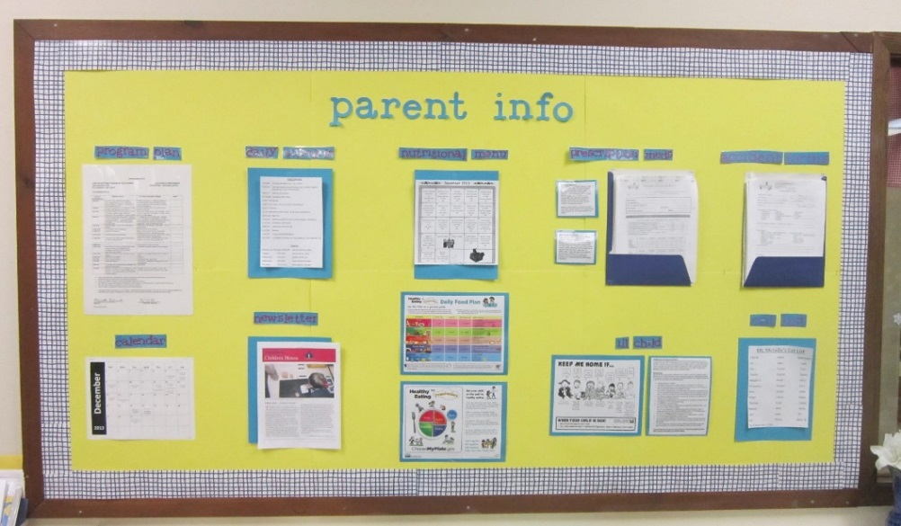
My Classroom Bulletin Boards at the Beginning of Research

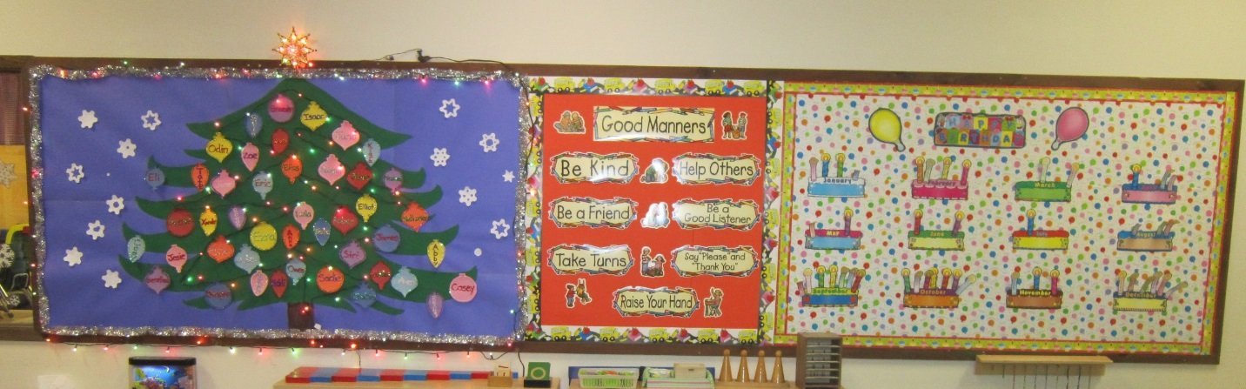
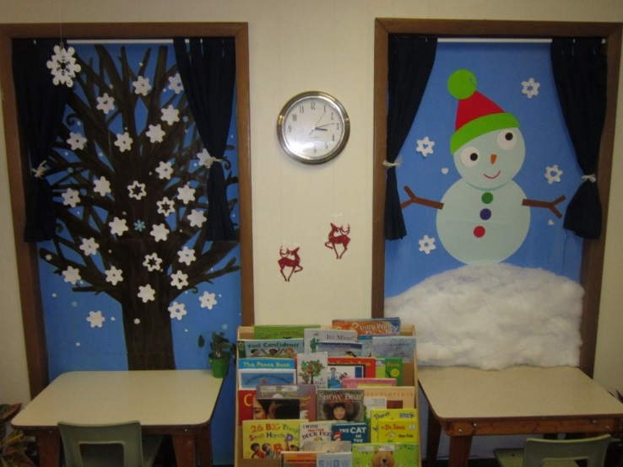

Figure 1: Bulletin Boards Prior to Study
Methodology
Participants
Twenty-five 4 and 5-year-old children from my classroom participated in the study. My class consists of 40 children (excluding three elementary children that come before and after school), 23 boys and 17 girls between the ages of 33 months to 5-years-old. I concluded it would be best to interview the 4 and 5-year-old children, 16 boys and 9 girls, because they can articulate their likes and dislikes more clearly. The parents of all the children also participated in weekly surveys. Approval to conduct the research was sought from the children’s parents (see Appendix A).

Setting
The research site was at a private Montessori school in the Midwest. The location has about 150 children enrolled, 6 weeks to 8-years-old. There are two Children’s Houses for children 33 months to 6-years-old with a before and after school program available through 8-years-old, a transition room for the 24 to 31 months, a young toddler room for the 16 to 24 months, and an infant room for babies ages 6 weeks to 16 months. I am the lead Montessori teacher in one of the Children’s Houses.

Materials
There were several materials I utilized for my research. The bulletin boards in my classroom were used for the various visual displays. White and neon colored poster board, various fabrics, “We All…” International Posters, photographs of children working, and children’s artwork were obtained for weekly displays. A camera was needed to document the weekly bulletin boards. Parent surveys were also prepared (see Appendix B).

Procedure
There were essentially three parts to my data collection: changing the bulletin boards weekly, parent surveys, and children interviews. The first part of my data collection consisted of changing the bulletin boards over the weekends. I would then place a sign on our classroom door each week asking parents to fill out a survey on the bulletin boards sometime during that week. At the end of the week I would ask the 4 and 5-year old children in my classroom whether they liked or didn’t like the bulletin boards and why or why not.
During the first week in January the bulletin boards were covered with white poster board (see Figure 2). I wanted to start with white, as if the bulletin boards did not exist to provide no visual stimulation on the walls.
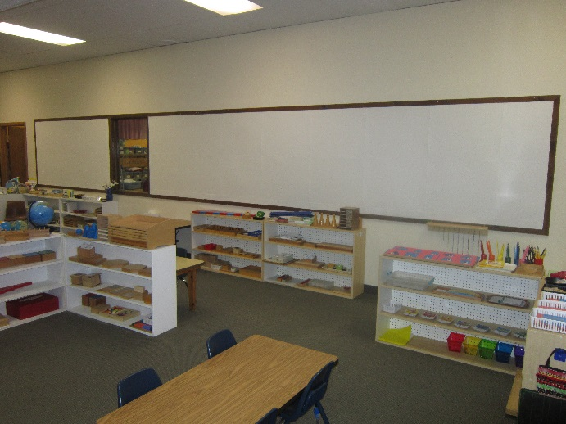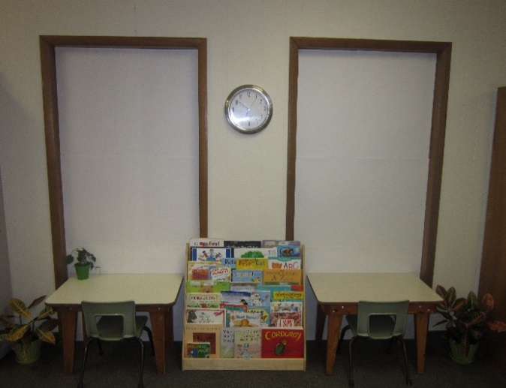
Figure 2: White Bulletin Boards
Week two the bulletin boards were covered with neon colored poster board (see Figure 3). Compared to week one with white bulletin boards, I wanted week two to be a complete contrast. Week one there was no visual stimulation, however, week two with neon colored bulletin boards there was overstimulation.
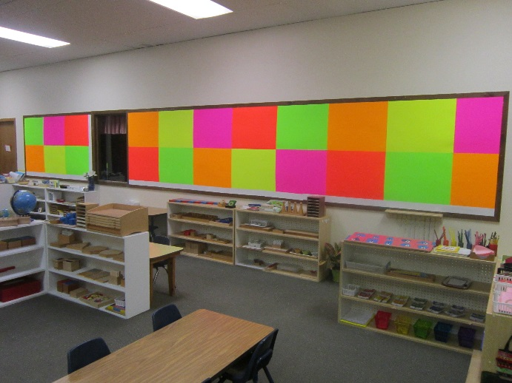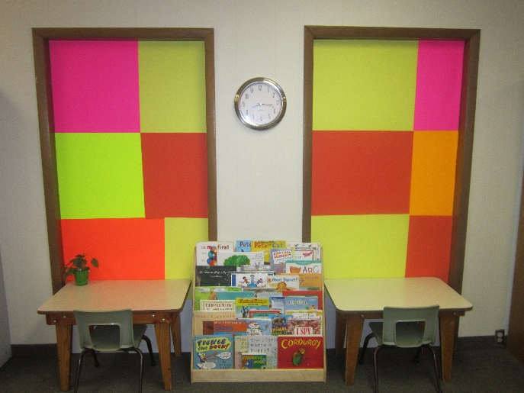
Figure 3: Neon Bulletin Boards
During week three I covered the bulletin boards with three various fabrics: a light blue color, black with white stars, and white snowflakes (see Figure 4). Instead of using paper, I wanted to see how the children and parents would react to fabric. I thought of upcoming displays and decided on background colors and patterns that would complement them. Light blue is thought to be a calming color, and the black and white color and pattern contrasted each other.
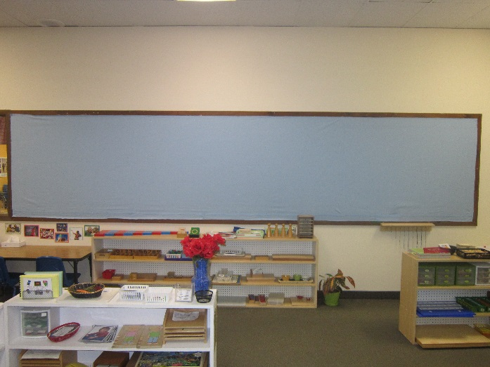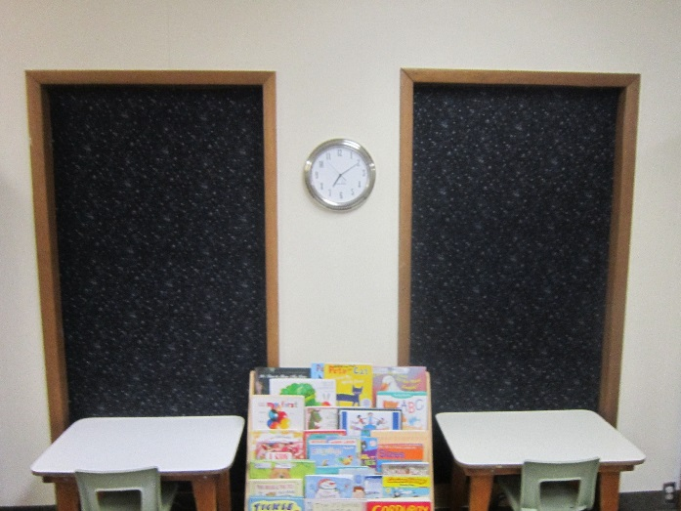
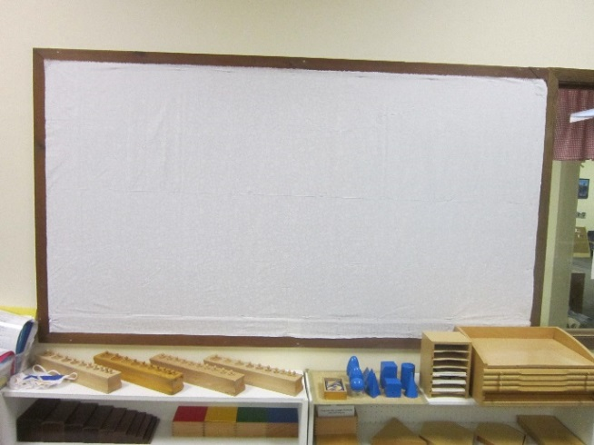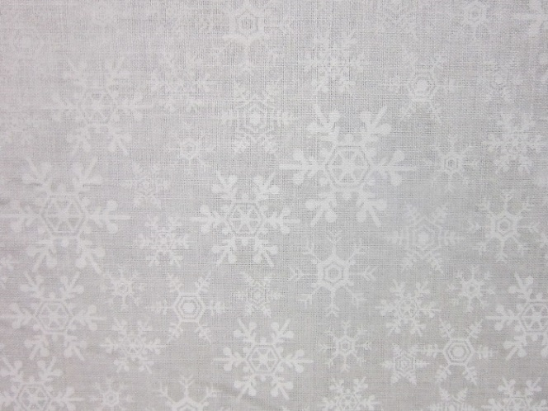
Figure 4: Varied Fabric Bulletin Boards
The “Information” Board was displayed during week four (see Figure 5). Much information is required to be displayed in the classroom by state licensing and NAEYC, such as our program plan, daily schedule, calendar, classroom rules, nutritional information, and a cot list. Other information included on the Information Board consists of our monthly classroom newsletter, lunch menu, ill child information, prescription medicines, medication forms, and incident forms.
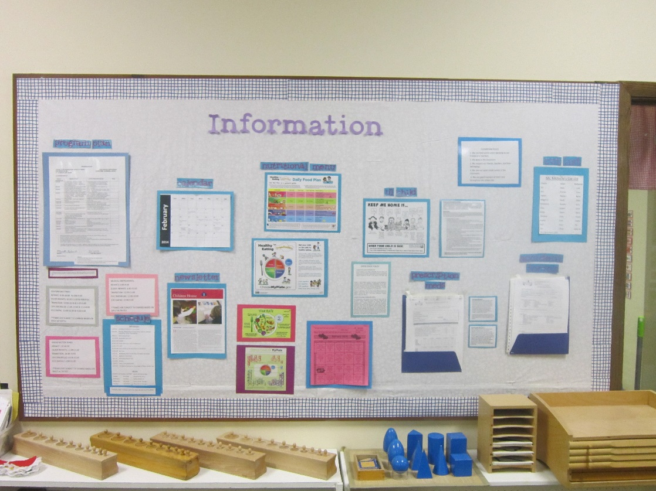
Figure 5: Information Bulletin Board
Week five “We all…” International Posters were displayed (see Figure 6). “The set focuses on commonalities we all share globally. The first set illustrates the basic needs of food, water, housing, work, and clothing. The second set continues with social needs: we all learn, play, go places, shop, and need friends. And the final set has themes of self-esteem and respect for all: peace, health, energy, celebration, and create” (http://rpcvmadison.org/weall). The posters are a wonderful addition to the cultural area in a Montessori classroom. During this week I displayed two of the basic needs posters, “we all eat” and “we all need water.” I have continued to change them every two weeks to keep the children’s interest.

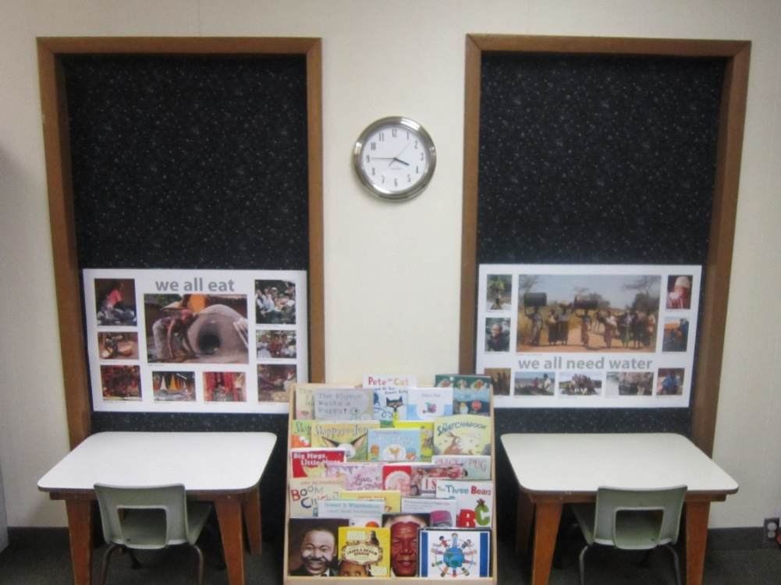
Figure 6: International Posters
Week six “Our Photo Gallery” was displayed (see Figure 7). Throughout the year I have been taking pictures of the children working. Each child had a designated frame, starting with the oldest in the upper left to the youngest in the lower right. Two pictures of each child working were placed in his or her frame.
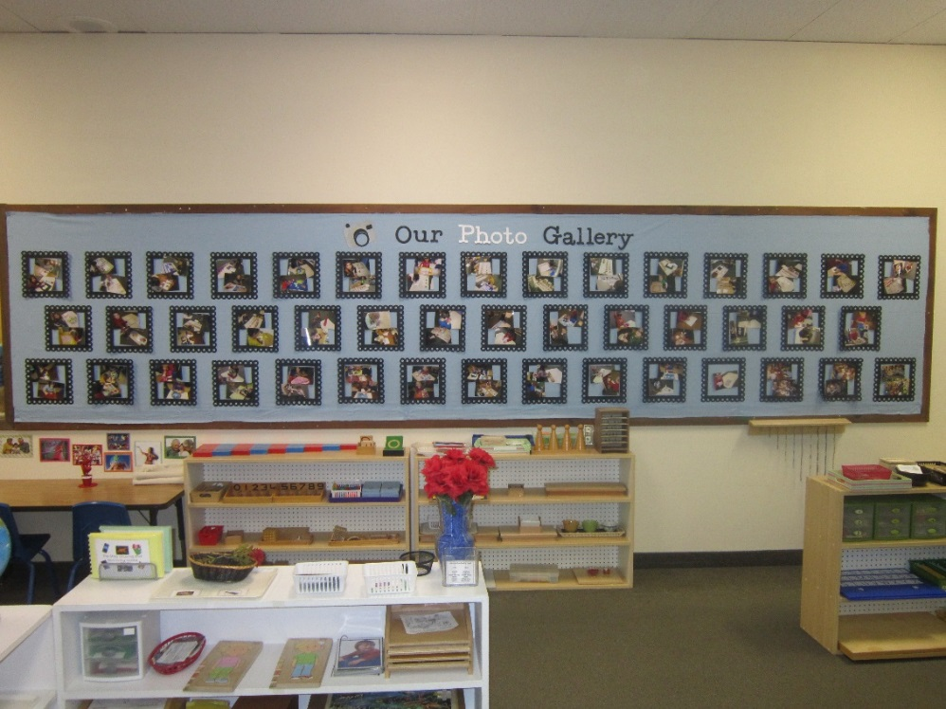
Figure 7: Our Photo Gallery
I changed “Our Photo Gallery” to “Our ART Gallery” for week seven (see Figure 8). Each child personalized a frame by writing his or her name, some with teacher assistance, on a white sheet of paper that I placed below the child’s frame. The children were given the freedom to choose what to display from art projects we had done that month or pictures that they drew in class. Many children chose to display a watercolor painting they drew using oil pastels. This continues to be displayed in my classroom, since I had a lot of positive feedback from parents, visitors, other teachers, and of course the children.
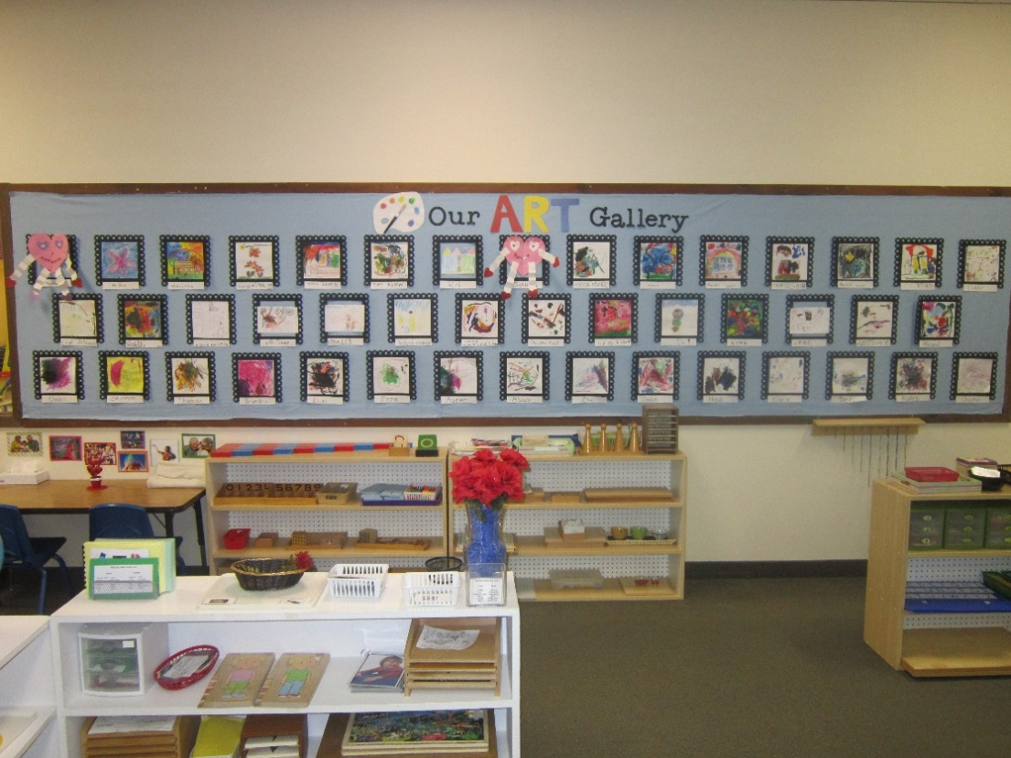
Figure 8: Our Art Gallery

Results
During week one with the white bulletin boards about half of the parents that participated in the survey were neutral, 8 out of 15. Some of the comments from parents who were neutral said, “Plain,” “Just feels like we’re waiting for something,” and “I like how the white looks clean, but it’s not very interesting. The kids don’t seem to notice it.” I would agree that the children didn’t look or comment on the bulletin boards, until I asked them at the end of the week. Five out of the 16 four and five-year-old children I asked did not like the white boards. One girl commented she didn’t like them because “I think we should have stuff on it. I think we should have Christmas stuff like decorations because it was really pretty.” Another boy didn’t like them “because I like them black.” A couple of parents who disliked them said, “No fun and not good visual stimulation,” “All white boards are not as warm and inviting to me—not as comfortable (institutional feeling),” and “Feels sterile with no ownership by kids.” However, 11 out of the 16 children said they liked the boards white. Some comments were because “They look like snow,” “My favorite color is white,” “They look like the clouds and air in the sky,” and “They’re back to normal.”

Figure 9: Parent Opinion on White Poster Board
During week two the bulletin boards with neon colors were more noticeable for everyone that walked into the room. I was surprised that parents were split. Eight parents liked the neon colored poster board; eight did not. Parents who liked them said, “The color is much better than white!” “Looks like a rainbow,” “Bright colors offset the drab, grey weather,” “The neon colors are very bright and they are eye catching. It starts a conversation every day with my child.” However, those who disliked them commented that they were “Too distracting, almost painful,” “The colors are unnatural,” “I like bright colors, but these may be too bright. It would be nice to see “teaching” or learning opportunities—themes maybe? Are they doing art?” All 13 four and 5-year-old children I asked said they liked the neon colored bulletin boards because “They look like a rainbow in the sky and they look pretty,” “They’re different colors,” and “They’re bright.”

Figure 10: Parent Opinion on Neon Colored
Weeks three, four, and five I only received seven parent surveys total. Three dislikes, three likes, and one strongly like. Parents disliked the “Plain blue wall” and were “Hoping for art soon.” Another parent said, “I don’t like pastels but love snowflakes. I have a bias toward earth tones.” The parents who liked the bulletin boards said, “Seems calming. My son likes the colors: black=night, blue=sky, white=snowflakes” and “Very detailed ‘we all’ posters, but it was nice to know what the kids were up to.” None of the parents commented on the information board.
I only received positive feedback week six with “Our Photo Gallery.” One parent liked it, however nine parents strongly liked it. Some parent comments were “I like seeing a snapshot of what he does during the day,” “Love the consistent frames but variation in photos,” “’Our Photo Gallery’ is adorable and I love that the kids see themselves working on different skills,” “Favorite—Love it. The kids love to point out themselves and friends, very interactive,” and “LOVE!” All 16 children I surveyed agreed with the parents. The children really liked it because “It looks pretty,” “I like the pictures,” “It has cool pictures and hard work,” “I like myself and my friends in it,” and “I’m on it!”

Figure 11: Parent Opinion on Photo Gallery
Week seven’s display of “Our ART Gallery” was also very successful. Not many parents participated in the survey, but all the feedback I got from them, other teachers, and visitors was outstanding. Our music teacher insisted that “This MUST stay up!” Parents said, “I like the kids artwork, they seem to enjoy showing us which is theirs,” “Love the Art and NAMES,” “It is great how the art is displayed-just like in a fancy museum,” “Love the variety of art and the headline décor!” “My favorite thing in the room!” All of the 12 children I interviewed also liked the Art Gallery. The children said they liked it because, “It has pretty pictures,” “I like my art that I drew,” and “We get to put up our stuff that we want to put up.”

Figure 12: Parent Opinion on Gallery of Children’s Art

Data Analysis
A conclusion from my research, just as I predicted and was told by others, is that parents enjoy seeing their children’s artwork on display. They also enjoy seeing photographs of their child working, like one parent commented, “I like seeing a snapshot of what he does during the day.” The median to pleasing the parents and children is giving the children freedom to choose what art and pictures they would like to put on display for everyone to see. This practice also creates more personalization and ownership for the children, which boosts their self-esteem.
The children interviews were surprising. I thought more of the children would dislike the white and neon colored boards. The children were apparently easy to please and very agreeing.
I would have liked more parental feedback from the surveys, but I didn’t feel I had the ability to control and force parents to fill one out every week. I understand that parents are extremely busy, which is why I tried to make the survey very brief. I can’t come to any valid conclusions from weeks three, four, and five based on the limited amount of data. I can only guess this is a busy time of year after the holiday season, or not many parents felt compelled to participate.
I should have been clearer in my directions to the parents about their survey. Parents filled the surveys out based on whether they liked or disliked the bulletin boards that week because that’s how long they were displayed. If I would’ve instructed parents to think about whether they would like to see the bulletin boards like that long-term, I think many of their responses would have changed, especially about the white and neon colored poster board. I wasn’t surprised that many parents either were neutral or didn’t like the white bulletin boards. However, the results of the neon colored bulletin boards did shock me. The parent surveys were split. While I was putting the poster boards up, I would agree with the parent who said, “…Almost painful.” I thought for sure I would need to take Tylenol on a daily basis that week at work. Surprisingly, while working and staying busy, I did not find myself focusing on the neon bulletin boards. The children could perhaps agree that because the bulletin boards are not at their eye level, it is not something they stop and stare at.

Action Plan
This study has transformed my Montessori Children’s House environment. In the beginning I was overwhelmed with the burden of creating visual displays that were attractive and showcased the children’s artwork and learning. Having a classroom with four bulletin boards that occupied so much wall space was not ideal to me. There was also art hanging from the ceiling, which was the first thing to be eliminated after doing my research. I would also hang everyone’s artwork, not being considerate of the children’s choice to take it home. Providing freedom of choice for the children is a key Montessori concept and should be applied in all areas of the classroom, including displaying children’s artwork.
One could argue that perhaps my classroom has too many bulletin boards. However, I could also argue that because not all of them are at the children’s eye level, they are not all there for the children. Displays that are for the children should be at their eye level. This is why I placed the “We all” posters on the two tall and lean bulletin boards in front of the reading tables. These are the only two bulletin boards that are at all of the children’s eye level. Not only did they fit well on these bulletin boards, but they are a cultural piece of art for the children to observe. In my classroom we have “Star (child) of the Month.” In the month of their birthday the children, with the help of their parents, fill out a short fact sheet about them and bring in about five pictures of themselves and their family. We display the fact sheet with the children’s pictures around it on a cabinet in the classroom at the children’s eye levels. Every day children will stop and look at their pictures and pictures of their friends.
I am very pleased with my current bulletin boards and can defend every part of them. I continue to change the “We all…” International Posters every two weeks. I would like to purchase some prints of famous artwork to display on these two bulletin boards as well, since they are at the children’s eye level. Featuring famous artists and their works could engage the children in discussions, providing opportunities for language development. The children could also create replicas of these famous artworks to display in Our Art Gallery. “Our ART Gallery” is a permanent fixture in our environment, and the teachers continue to encourage children to display new artwork for everyone to see. I would like to keep updating the children’s writing of their names as well. To create more personalization and ownership the children could make their own frames. The “Information” Board is also a permanent fixture, more so because the information is required by state regulations and NAEYC to be displayed.
Although this study was informative and helpful to my Montessori environment, some unanswered questions remain. It is important to acknowledge that this study took place in a private Montessori center that has at least two bulletin boards in each room. It raises the question, how many bulletin boards are common in other Montessori Children’s House classrooms? Also, in our environment parents come into the classroom for drop off and pick up. In schools where parents do not enter the classroom, some of the purposes of the visual displays would change and focus even more on the children. If there is no wall space available at the children’s eye level, where should children’s artwork and fine art reproductions be displayed? How much should be displayed?

Conclusion
Not only the environment, but most of all the children, have benefited from my research. This study provided insight into how children’s artwork and visual displays should be used in a Montessori classroom to benefit children’s learning. Through my research, I have concluded that it is vital that a Montessori guide thoughtfully and purposefully displays children’s artwork. Displays may affect children’s behavior, self-esteem, sense of ownership, and cognitive development. By displaying children’s artwork a Montessori guide affirms children’s thoughts, ideas, and imaginations, communicates to others, and documents what children learn. Children’s artwork can also beautify the prepared environment. Since a Montessori environment encourages freedom of choice in the materials to work with, we should also be mindful of children’s freedom to choose what to display. This research was profound for me and helped me make better, more informed choices about what to display and how. I hope it will be for others as well as they prepare their children’s environments.

Appendix A
Parent Permission Letter
October 21, 2013

Dear Parents,

As many of you know, I am taking graduate courses at the University of Wisconsin-River Falls. I am working toward a Master’s Degree in Montessori Education. As part of my course work, I am doing an action research project in the classroom. This project is in the early stages, but it will focus on displaying art in the classroom. Your children will be involved as I observe their behaviors toward various art displays in the upcoming months. My goal is to provide a prepared Montessori environment with art displays that engage student’s learning and produces positive student behaviors.

All identifying information will be kept confidential. I will use a pseudonym to protect your child’s privacy. The information will be shared in educational settings and as part of my Plan B research paper.

I would appreciate your permission for your child to participate in this action research study. Please sign the permission form at the bottom of the page and return it to me as soon as possible.

If you have any questions or concerns, please feel free to call or email me. Phone at work 612-788-8010 or email michelle.kuhnert@my.uwrf.edu.

Sincerely,

Michelle Kuhnert

I give permission for my child _______________________________________________ to participate in the Action Research Project.

Parent’s Name (Please Print) ________________________________________________

Parent’s Signature ________________________________________________________

Date ___________________________________________________________________

Appendix B
Parent Survey

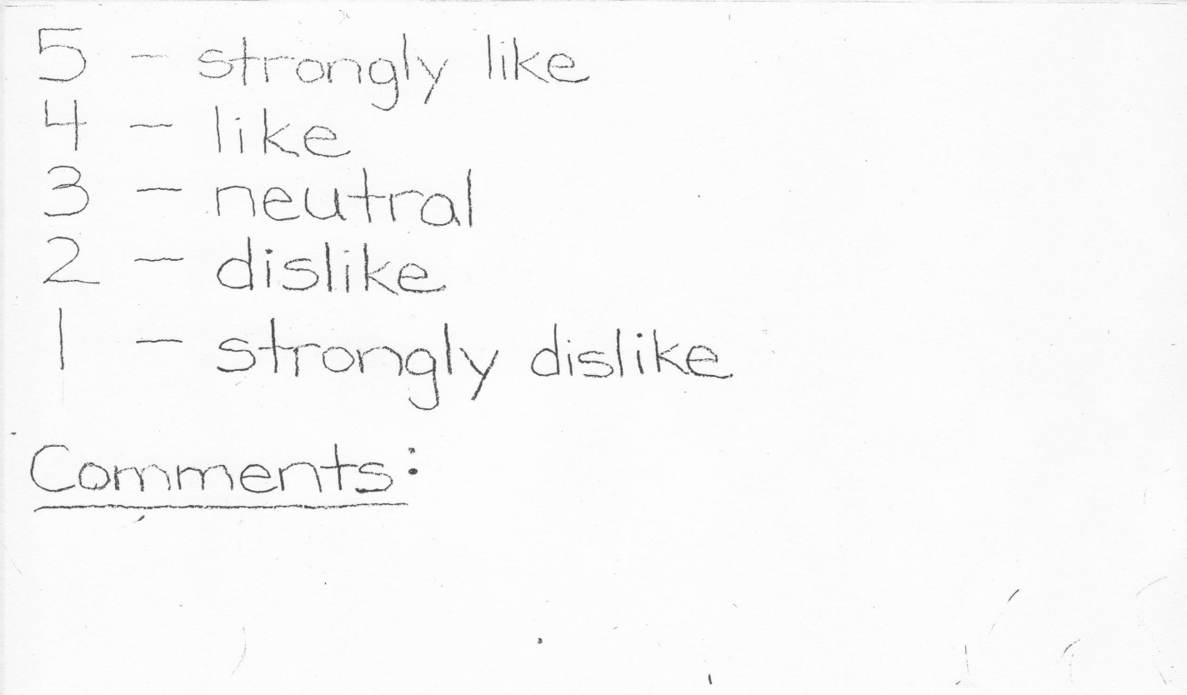

References
Bae, J. H. (2004). Learning to teach visual arts in an early childhood classroom: The teacher's
role as a guide. Early Childhood Education Journal, 31(4), 247-253.

Baggett, P. (2010). Art-rageous bulletin boards. Arts & Activities, 146(5), 24-25.

Heejin, K., Eunhye, P., & Jeehyun, L. (2001). "All done! Take it home." Then into a trashcan?:
displaying and using children's art projects. Early Childhood Education Journal, 29(1), 41-50.

Killeen, J. P., Evans, G. W., & Danko, S. (2003). The role of permanent student artwork in
students' sense of ownership in an elementary school. Environment and Behavior, 35(2), 250-263.

Kocer, H. (2012). The evaluation of the art activities applied in preschool education programmes
in terms of self-expression opportunity given to child. Procedia - Social and Behavioral
Sciences, 51, 289-295.

Maxwell, L. E., & Chmielewski, E. J. (2008). Environmental personalization and elementary
school children's self-esteem. Journal of Environmental Psychology, 28(2), 143-153.

Montessori, M. (1988). The discovery of the child. Oxford, England: Clio Press.

Ross-Degnan, L. (2001). Great lessons in art. Montessori Life, 13(1), 30-31.

Schroeder-yu, G. (2008). Documentation: ideas and applications from the Reggio Emilia
approach. Teaching Artist Journal, 6(2), 126-134.

Seefeldt, C. (2002). Creating rooms of wonder: valuing and displaying children's work to
enhance the learning process. Beltsville, MD: Gryphon House.

Short, B. (2007). Guiding the future: how art enhances a Montessori child's life. Montessori Life,
19(2), 20-22.

Spodek, B. (1993). Selecting activities in the arts for early childhood education. Arts Education
Policy Review, 94(6), 11-17.

Twigg, D. (2011). Look out below (and above)! Challenging adult understandings of displaying
young children's artwork. Contemporary Issues in Early Childhood, 12(3), 262-273.

