From the Battlefield to the Silver Screen: How the Failed Makin Atoll Raid was Spun into a Success, 1943-1943

Logan P. Duerst

History 489

November 25, 2015

Copyright for this work is owned by the author. This digital version is published by McIntyre Library, University of Wisconsin Eau Claire with the consent of the author.

Contents

Figures iii
Abstract iv
Introduction 1
Historiography 6
Primary Source Analysis 12
The Battle 13
The Film 23
Battle versus Film 29
Conclusion 32

List of Figures
Figure 1 World War II Movie Poster……………………………………………………...3
Figure 2 The Pacific Theater and Japanese Territory……………………………………..5
Figure 3 Donald Duck Movie Poster, 1943……………………………………………...11
Figure 4 Photo of Lt. Col. E.F. Carlson and Maj. James Roosevelt……………………..14
Figure 5 Map of Makin Atoll…………………………………………………………….19
Figure 6 Movie Poster for the Film ‘Gung Ho!’…………………………………………24

Abstract
A day after the attack on Pearl Harbor the United States of America entered into World War II, declaring war on the Empire of Japan. Although not prepared to make any significant military counterattack on the vast Japanese Pacific Empire, the American military, and people, wanted retribution for the attacks on Pearl Harbor on December 7, 1941. Built to strike quickly and effectively, 211 marines comprised the 2nd Raider Battalion. On August 17, 1942 the 2nd Raider Battalion was tasked with raiding the Japanese military garrison on the Makin Atoll, deep behind Japanese controlled territory. The raid was far from a success, with few to no objectives accomplished, along with 18 marines killed and 12 missing in action. However, in the aftermath of the failed mission success was found, or rather created as the film ’Gung Ho!’: The Story of Carlson’s Makin Island Raiders was released to theaters in December of 1943. A highly praised movie at the time, this paper will examine the relationship and varied success levels between the raid and the subsequent film.

Introduction
“Never allow a good crisis go to waste.”
-Winston S. Churchill

Propaganda is a term with multiple interpretations and understandings. Weighed down by historical context and examples, propaganda is a difficult word to properly analyze as a historian. From a certain perspective it could be an example of an oppressive regime pushing its agenda on a downtrodden population. On the other hand, it could be viewed as a call to arms, a rallying cry, or a counterattack against an injustice persecuted on a group of people. Obvious to the public or not, propaganda has played a huge role in history and will be at the center of examination in this paper, specifically the fictionalized film, ’Gung Ho!’: The Story of Carlson’s Makin Island Raiders that retold the Makin Atoll Raid during World War II.
Although not linked in every case of propaganda and more commonly found in the twentieth century, the huge demands of war always necessitate the use of it. The need of an increased military force and budget, sacrifices made by the civilian population, the rationing of supplies, and positive public opinion of conflict are all examples of difficult inevitabilities that come with war, and in which propaganda can assist with. Whether used on the home front or on the battlefield, the altering of public perception through propaganda in the media can be found.
Modern propaganda even affected me, almost altering my life in a huge way. As a youth during the nationalist resurgence following the terrorist attacks committed on September 11, 2001 in New York City, I had an abundance of toy soldiers and American pride. Even before the terrorist attacks in 2001, I was constantly playing with toy soldiers, watching and re-watching war movies like “The Longest Day”, “The Dirty Dozen”, and “Saving Private Ryan.” I was drawn to the characteristics of the American serviceman who was brave, noble and a strong leader, always ready for an action-packed fight. Also, I was living in a post-9/11 world filled with advertisements for the American military that challenged me, along with tens of thousands of other Americans across the nation, to be “Army Strong”. This path eventually led me to signing up for the Reserve Officers’ Training Corps (ROTC) in the fall of 2012. I would chase this childish, idealized life for two years until I made the difficult decision that I was not fully committed to the service and desired a different start to my young adult life. I completely believe that modern American propaganda, because of the necessity for soldiers during the time period, is one of the main reasons I almost chose to commit to the American military. So, because this life event, I have chosen to research a slightly unknown example of propaganda during World War II.
This need of propaganda during war climaxed during World War II, and will be the main focus of this study. A combination of the advent of total war, the global scale of the conflict, and the expanded use of media outlets like newspapers, magazines, comic books, film and radio culminated in some of the most historical iconic examples of modern propaganda, as seen in Figure 1.

Figure 1 – World War II Movie Poster
Source: http://www.moviepostershop.com/this-is-the-army-broadway-movie-poster-1942 (accessed on December 16, 2015)

This American film, released in 1943, shows the integration of the military, propaganda, Hollywood, and the American public. Bernard F. Dick writes about the Hollywood in wartime, “The American World War II film… transforms history into plot, inventing boldly, sometimes rashly, but at least inventing.” Working as tenaciously as the American military economy, this poster joined Rosie the Riveter, Donald Duck, Ronald Reagan and many more cultural icons in the media fight against Nazi Germany and the Empire of Japan.
In order to examine this propaganda of World War II, and the fictionalized world it can create, I have chosen to focus my research on one example in particular. As big of a morale loss as it was a military loss, the Japanese surprise attack on the American naval base of Pearl Harbor on December 7, 1941 left many Americans furious and hungry for a response by their military. Author Craig Shirley described the feeling of revenge many Americans felt as, “Within a matter of hours of the attack, America is moving quickly to get on a war footing. American attitudes about the war change radically, [as do] American attitudes about the economy, about giving to the war. The war is not part of the culture; the war is the culture. Everything is viewed through the prism of the war effort”
However, with a crippled navy and the nineteenth largest army in the world behind smaller countries like Portugal, a full-scale invasion or counterattack on any significant Japanese territory was not possible at the time. Due to this desire for retaliation and inability to mount a significantly seized assault, the 2nd Marine Raiders Battalion was created on February 4, 1942. Specially trained for quick insertion and retreat, the Raiders were tasked with the destruction of the Japanese military garrison on the Makin Island Atoll, a small part of the Gilbert Islands, as seen in Figure 2. Along with other objectives like intelligence gathering, the Raiders embarked to the atoll on August 17, 1942, less than a year after the attack on Pearl Harbor. Unfortunately for the Raiders, their first taste of combat was almost a disaster, as they failed to accomplish nearly every objective and took multiple casualties. This, however, was not the tale told to the American public.
Figure 2 – The Pacific Theater and Japanese Territory
Source: http://www.history.army.mil/brochures/eastman/eastman.htm (accessed December 16, 2015)

In little over a year the Makin Atoll Raid was retold by Hollywood on the silver screen. ‘Gung Ho!’: The Story of Carlson’s Makin Island Raiders played in theaters across the country in December of 1943, detailing the recruitment and training of the 2nd Marine Raider Battalion, as they displayed acts of heroism and bravery on the Makin Atoll. A fictionalized version of the failed raid was given to the public as a propaganda film, detailing an American victory that never was. This dramatization spurs up many historical questions like is it morally correct to change a military blunder into a success? Did the Marine Raiders contribute more to the war as a propaganda tool or as a military battalion? Were the Marine Raiders a necessary part of the Pacific Theater of War? Is propaganda a necessary part of war? This paper will answer these questions as well as examine both the Makin Atoll Raid and the recounted film version in detail, and compare and contrast both the raid and film’s successes and failures, to see which had more of an impact on World War II.
Due to the generous amount of research and historical writing done about World War II, the Pacific Theater of War, and the United States Marine Corp, I have utilized many secondary sources for this paper. Narrowing down those best suited and most creditable for my research was challenging, but I believe I have a strong assortment of secondary sources to back up my research questions and claims. I also have used primary sources to my advantage while researching the Makin Atoll Raid and the movie made about it. Along with the film, other primary sources include news articles about the battle and film, and debriefing military reports. All of these primary sources have given me an insight into the time period and general thought process from a first-hand account.

Historiography
To gain a better understanding of the importance of this research, and how it will fit with similar historical works secondary sources must be studied and evaluated. The goal of this section is to link together the topics of the Pacific Theater of War during World War II, the United States Marine Corps and the 2nd Marine Raider Battalion by examining sources that deal with these topics. This will illustrate to the reader the historical background aspects that surrounded and made up the Makin Atoll Raid. Through my research and evaluation of sources, I have discovered a lack of research that specifically deals with the Makin Atoll Raid, and none that have examined its film counterpart. This was surprising due to the fact that World War II is a popular subject to cover by historians. My paper will fill the gap between sources strictly dealing with the battlefield, and those sources that only focus on the home front and social aspects of war.
The secondary source that will best explain the Pacific theater of war as a whole is Admiral Samuel Eliot Morrison’s History of United States Naval Operations in World War II: Coral Sea, Midway and Submarine Actions May 1942-August 1942. This book, one part of a multiple volume series, is the Admiral’s account of war in the Pacific. He offered to document the war while serving in the American Navy, and provides an excellent inside look at how the American Navy attempted to beat the Japanese. His book is a great resource for looking at the large scope of the conflict, and how the Makin Raid fit into it as it receives a small chapter in his book.
One secondary source I have drawn on the most is American Commando: Evans Carlson, His WWII Marine Raiders, and America’s First Special Forces Mission written by John Wukovits. Wukovits writes an extremely detailed look at the timeline of the 2nd Marine Raiders journey through World War II in the Pacific.
The Marine Raiders pulled most of their inspiration from small, highly trained commando units similar to the units used by the Germans and British. In order to better understand the distinctiveness of these commandos the history of these pioneering military units must also be studied. Wukovits does an excellent job describing the sharing of tactical knowledge that created the Raiders. He then follows their journey through the Pacific Theater of War, specifically highlighting their actions on the Makin Atoll. This source is extremely detailed and well researched.
The source I will be drawing from to examine the tactics and strategy of the Marine Raiders as commandos is Commandos and Rangers of World War II, by James Ladd. Ladd is a military historian specializing in amphibious warfare, which is very beneficial when considering the main focus of this paper is on the amphibious landing and retreat on the Makin Island Atoll. The book, while dated, has a considerable amount of information detailing not only the Marine Raiders, but countless other commando-type military units that served during World War II. This allows the research done for the paper to gain a varied and more informed perspective on the tactics and strategies used by other small commando or raider military units, and how that affected the Marine Raiders. For example, a failed British commando amphibious assault on the French town of Dieppe changed what gear was brought and how much could be carried by amphibious landing crafts. The British commandos in Dieppe unfortunately had too much gear weighing their landing crafts down, making it difficult for these boats to gain speed and caused many to run aground, which resulted in high casualties and a failed military operation. I will compare and contrast these different commando units with the Marine Raiders and their operation on the Makin Atoll.
The book segments off a chapter specifically for Marine Raiders in the Pacific, describing the inception of the Raiders and their actions in the Pacific. The 2nd Marine Raiders and the Makin Atoll raid are detailed in-depth as well. This book will assist the research by providing background to the strategies and objectives of the Raiders, and how they came to be such a distinctive part of the United States Marine Corps.
Finally, the importance of propaganda, and its history, must be brought up in this research. The Oxford Illustrated History of World War II sets a new perspective on the old topic of the Second World War. Published in 2015, the book’s tagline to bring the reader in is “World War II reassessed for a new generation.” He accomplishes this goal by looking at ignored aspects of World War II, instead of the usual country leaders, destruction, battles and weaponry. The book highlights overlooked aspects like total war, the economics of war, inventions of war, and “the culture of war: ideas, arts, and propaganda.” This large portion of the book detailing the cultural war of World War II was written by David Welch and observes the many ways propaganda was implemented to help a nation win the war. Most major countries’ use of propaganda are exhibited in this book, and the American section will be the focus of my research. In line with the new perspective theme of the book, the propaganda portion begins with discussing how war is closer to the home front than ever.
The theory of “total war” means war not just on the battlefield, but also in the cities with civilians caught in the crossfire or working in the war factories. Public opinion was more important than ever because some civilian populations had to sleep with bombers overhead, and isolated nations like the United States had expanded forms of media, like television, radio and film, to get them news of the war fast and directly. The America section of the book discusses the idea of propaganda and the commercial sector merging. Fame and culture met government goals head on as public symbols like Charles Lindbergh, Warner Brothers, Universal Studios, Norman Rockwell, the Saturday Evening Post, Life and Time magazines, and countless other cultural heavyweights collaborated with the Office of War Information (OWI), created in June of 1942, to distribute information to the public to achieve national goals. Even Donald Duck was recruited by the OWI, as seen in Figure 3.
The book is a creditable source from the Oxford University Press, and has a unique perspective on World War II, a refreshing take in a time period often oversaturated by historical secondary sources. The Oxford Illustrated History of World War II has up-to-date information, especially when considering its examination of propaganda during World War II.
Along with this source I have collect a few more books on Hollywood during World War II. Thomas Doherty’s Projections of War: Hollywood, American Culture and World War II, Bernard F. Dick’s The Star-Spangled Screen: The American World War II Film, and Jeanine Basinger’s World War II Combat Film: Anatomy of a Genre. Each book was similar in its goal of examining how Hollywood, like the rest of the American public, helped the war effort. While these sources are dated, they effectively take multiple examples of wartime films like Gung Ho and show how they altered the public’s perception of the war.

Figure 3 – Donald Duck Movie Poster, 1943
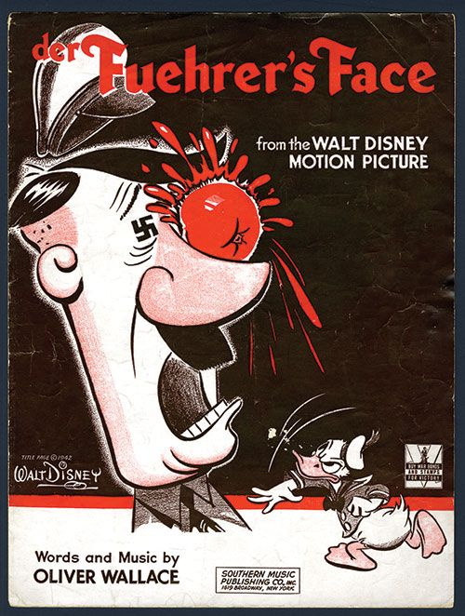
Source: http://www.icollector.com/Walt-Disney-s-Der-Fuehrer-s-Face-Donald-Duck-Cartoon-Sheet-Music-from-Movie-of-Same-Name_i14071203 (accessed on November 19, 2015).

Knowing and understanding the background of my topic is critical to the effectiveness of this capstone. I need to properly understand the War in the Pacific, the Marine Raiders tactics as a commando unit, and the various aspects of wartime propaganda. I believe that with these secondary sources I can accurately achieve the goals of this capstone. As well as be able to bridge the gap between the battlefield and the the movie theater.

Primary Source Analysis
The film is my main primary source as it encompasses the bulk of my discussion. Another primary source that also helps with my research on the 2nd Marine Raiders a news article titled “We Mopped Up Makin Island” found in the Saturday Evening Post in December of 1943. Lieutenant W. S. Le Francois was the author, and a commanding officer that took part in the Makin Atoll Raid. This article was one of the main points of inspiration for the film on the same event. This six-page article details the raid in surprising detail, given how much wartime governments censor military specifics. This news article is an excellent example of American propaganda during World War II. Brave and heroic rhetoric comprise a story surrounded by advertisements for light bulbs and cigarettes, effectively combining military and commercial propaganda.
The eulogy given by Evan Carlson for the men who perished on the Makin Island is another primary source used in this research paper. The eulogy was given after the 2nd Raider Battalion returned from Makin in late August 1942. The eulogy is an excellent source that does a fantastic job of humanizing the story of the Raiders of Makin. Carlson’s speech is somber, yet commends the marines’ bravery. This source will help display the reality of wars that is not properly shown in films like Gung Ho! In order to properly compare both the battle and film to see which had more of an impact on the war each event will be broken down individually.

The Battle
Many factors led to the creation of the Marine Raiders. One such factor was the combined guidance of leaders like William J. Donovan, James Roosevelt, and Evans F. Carlson. Donovan was a high-ranking military advisor, with a direct ear to the American President, Franklin D. Roosevelt. He believed strongly in highly trained, smaller squads that could impact a battlefield more precisely than a large, cumbersome army. This thought process would lend well to Donovan’s role in creating the Office of Strategic Services (OSS), a precursor to the Central Intelligence Agency (CIA). Along with Donovan, James Roosevelt also had an influence over the president, as he was his son. Roosevelt was a Captain with the 2nd Marine Raiders and persuaded his father to allocate military spending to the raider units. Finally, and most importantly, Evans F. Carlson spent the years leading up to the Second World War in China and Nicaragua as an intelligence officer. Here he discovered the fighting technique of guerrilla warfare. Seeing the benefits of having specially trained units that could act without direct support Carlson began advocating for guerrilla warfare to be included into the United States Marine Corps. Even British Prime Minister Winston Churchill, who believed strongly in his British Commandos, promoted the idea of commandos and may have influenced President Franklin Roosevelt’s thoughts on the matter. Carlson and Roosevelt would become the strongest advocates for the Raiders, and worked together for a considerable amount of the war, as seen in Figure 4. Another factor that created the Marine Raiders was the situation the Pacific War was in for the American side of the conflict.

Figure 4 – Lt. Col. E.F. Carlson (left), and Maj. James Roosevelt (right)
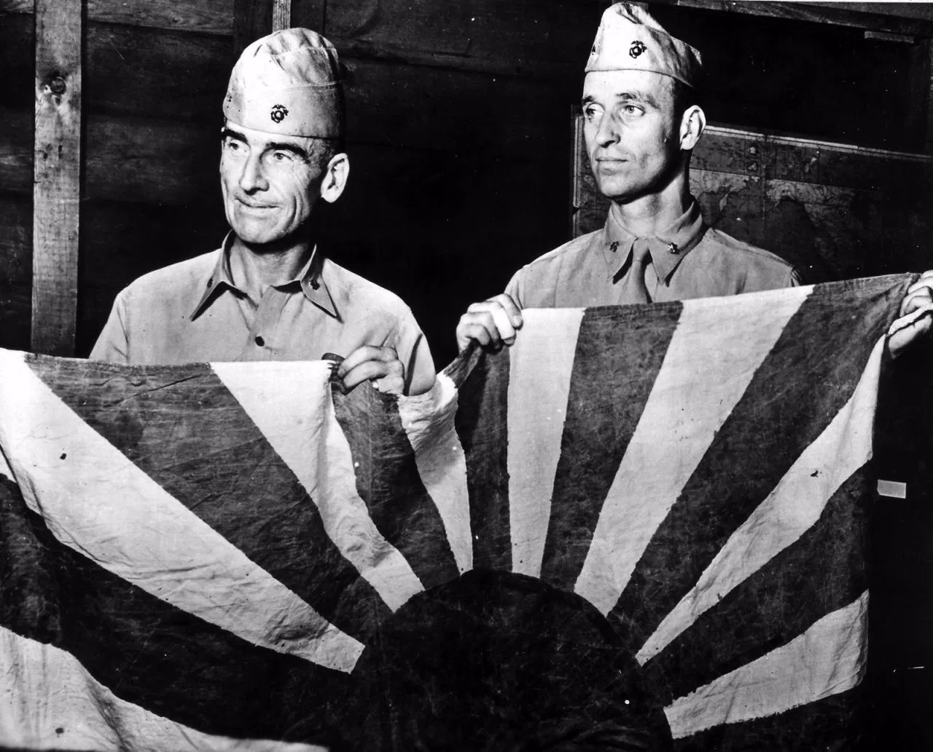
Source: http://www.defensemedianetwork.com/photos/u-s-marine-raiders-in-world-war-ii-photos/ (accessed November 27, 2015).

Although many high-ranking officials in the Marine Corps disagreed with smaller units being as effective as an entire invasion force, the United States was simply not prepared to fight a two-front war in 1942, let alone fight both an Axis and Japanese army, both of which had many years of fighting experience already. The famous Doolittle Raid was the example that solidified the Raiders’ importance in the Marine Corps. On April 18, 1942 a risky air raid was launched by the United States aimed at the Japanese capital, Tokyo, and other strategic locations deep in Japanese territory. These targets were so far that the bombers sent were too far for fighter plane coverage, and had only enough fuel to make it there, resulting in all bombers crash landing in China or Russia after dropping their bombs. Although the 16 B-25B Mitchell medium bombers failed to harm the Japanese war effort, they still had a huge impact on war morale for both sides. Japan, believed to be invincible after years of military victories, felt vulnerable for the first time, and American morale climbed as the first act of revenge for Pearl Harbor was carried out by the military. President Roosevelt and many others believed the Raiders could achieve the same public relations victory as the Doolittle Air Raid accomplished.
So with influence from important characters of the time, and a need for quick acting, well trained soldiers the 2nd Separate Battalion was created on February 4, 1942. By mid-February the battalion was renamed Raiders, and Major Evans Carlson was placed in command. From the beginning of the Raiders creation they recruited differently, trained differently and separately from the other marines, and led a less rigid military lifestyle more comparable to British commandos or Chinese guerrilla fighting units. In fact, Carlson adopted many of his methods and teachings from these sources including the battalion’s motto “Gung Ho” which is a Chinese saying meaning “to work in harmony.”
Excited to see the Raiders perform what they were created to do, Admiral Chester W. Nimitz decided on Makin Island as the location where Carlson and his Raiders would have their baptism by fire. Being close to Hawaii and a smaller target, the Makin Island was a suitable location for a tactical and morale victory for the Marines. Japan occupied the Makin Atoll on December 10, 1941 and was one of the easternmost Japanese held territories in the Pacific. There was also supposed to be a sizeable force on Makin as it was the headquarters for the entire Japanese occupying force on the Gilbert Islands, and a seaplane base, however definite information on the island was less than reliable. With the target set and limited intelligence of the island, Carlson selected 200 men, Companies A and B (out of four companies total), to partake in the raid. After countless hours of training for both jungle warfare and amphibious landings, the marines were loaded into two submarines the USS Nautilus and Argonaut on August 8 and made their journey to the Makin Atoll.
Their objectives were simple on paper, but had bigger, unwritten objectives as well. Wukovits writes in his book, “Carlson’s Raiders were to destroy enemy installations at Makin, seize prisoners and documents for the intelligence sector, discourage the Japanese from advancing toward Samoa or to attempt to interdict the crucial United States-Australia communications lines.” One of the main goals, however, was to create a diversion. As the first major Allied invasion into Japanese held territory was taking place on the island of Guadalcanal, in the South Pacific, the United States military hoped to divert some Japanese forces to the Gilbert Islands, tricking the Japanese military into strengthening an area for an invasion that would not come for some time. However, this mission was first and foremost a morale booster, as this was the plan the entire operation was centered around.
For most of the 2,029-mile submarine trip the two Raider companies, supplies, intelligence, and the president’s son were completely vulnerable, as no escort was given so the submarines could remain hidden to the enemy. It wasn’t until the marines were uncomfortably in their submarines that they were told where they were going and that no friendly forces would support them on this supposedly quick mission. The trip was cramped for the Marines, as Admiral Morison writes, “There was no place to sit and no place to stand, so the Marines and off-watch sailors kept to their bunks except when eating. The air was hot and fetid with the odor of unwashed bodies.”
On August 16 around 3:00 a.m., the Nautilus, the quicker of the two submarines, reached Makin. After scouting the island and regrouping with the second submarine, the marines prepared to land on Makin around 2:00 a.m. on August 17. The weather was less than ideal for the marines as rain, wind and waves crashed into the rubber boats that were used to approach the island. With proper training the marines silently left the submarines on their rubber boats without anyone falling into the sea, which is good because with over 60 pounds of equipment strapped on to each raider falling in would more than likely result in death. Around 3:30 a.m. each rubber boat met at a rendezvous point before landing on the island. Most had to paddle their way through the stormy weather, as most of the motors on the rubber boats quickly flooded with salty ocean water, rendering them useless.
The original plan had been for two separate landings. Company A would land in the center of the island at a designated point called Beach Y, and move west down the island while attacking any Japanese forces. At the same time Company B would land at Beach Z and do the same, moving southwest attacking the Japanese until they met up with Company A. However, due to the weather limiting communication to form the two companies, Carlson decided to take the entire force and land at Beach Z. Choosing the importance of landing on the beach together over setting up the original plan, the marines landed, chaotically, on the Makin Atoll at 5:20 a.m.
An example of how confusing the landing process was, one boat with 11 marines onboard landed one mile southwest of the main marine force. Unbeknownst to these lost soldiers, they had unintentionally positioned themselves behind the enemy positions. Surprising, this became a benefit as these lost marines created havoc and confusion behind enemy lines. Some of the local, native population had spotted the landing. Also, around 5:30 a.m. just as the marines began to establish a beachhead and move into the island a marine accidently discharged his rifle, eliminating the marines’ element of surprise.
As the sun began to rise, Carlson readjusted his original plan, leading Company A toward the enemy while Company B lagged behind in reserve. Company A began to move and secure the northeastern end of the island, stationing marines on the sides of the main road, and at the house and wharf both labeled “Government House” and “Government Wharf” respectively. From here the men moved down the road toward where the native population had informed the marines where the Japanese were located. It was around this time that the Japanese garrison on the island was at full alert, and ready to react to the marines’ invasion. Figure 5 is a map of the Makin Atoll and the describable places the marines would have used to tell where they were.

Figure 5 - Map of Makin Atoll
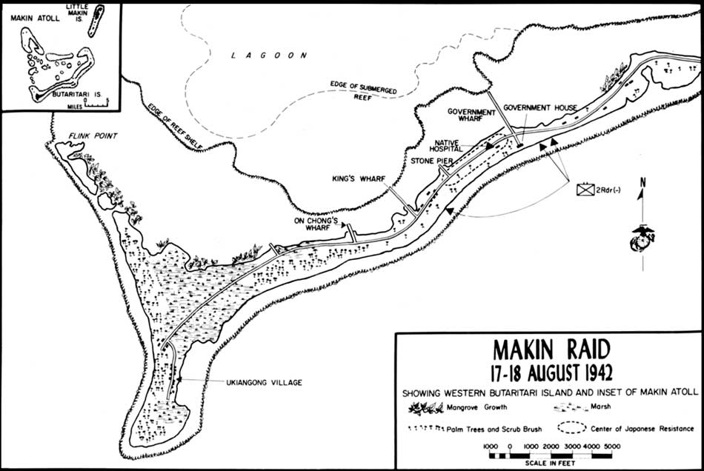
Source:http://www.nps.gov/parkhistory/online_books/npswapa/extContent/usmc/pcn-190-003130-00/sec4.htm (accessed November 27, 2015)

At 6:30 a.m. heavy fighting began, with the Americans being the aggressors and causing Japanese causalities. However, their aggression got the better of them and only 30 minutes into the firefight and nine Raiders had been killed from heavy machine gun fire and snipers hidden on top of palm trees. Among the killed was Sergeant Clyde Thomason who was the first enlisted Marine in World War II to be awarded the Medal of Honor for his bravery on the Makin Atoll.
As the morning went on the invaders and defenders dug in, and the battle on the Makin Atoll bogged down. The Raiders successfully stopped two banzai charges, a Japanese tactic of rushing an enemy line in an attempt to crush any form of structure in their ranks, and the Japanese snipers managed to keep the Raiders from moving westward down the island. It was in this instance that the Marine Raiders’ inexperience harmed them, as they lost countless opportunities to advance on the smaller Japanese unit that had lost many soldiers due to the ineffective banzai charges. If the marines had countered the Japanese with their own offensive action they would have realized that any strong Japanese defense of the island was almost eliminated. While their commanding officer and most of their remaining unit had been killed, it was only through the remaining Japanese soldiers fanatical fighting that the marines were slowed down in their progress.
As the morning ended, the marines had destroyed one radio station, eliminated most of the Japanese defenders, and used the submarine Nautilus to sink two Japanese boats harbored in the Makin lagoon. Carlson and Roosevelt feared that these could be the first transports of a possible Japanese counterattack, and destroying them was critical. This small victory for the marines was ended by aerial bombardments from the Japanese around 11:30 a.m. and 1:20 p.m. that forced the submarines to dive and the marines to take cover. As the marines hid from the bombings, two Japanese seaplanes landed in the lagoon. Fearing more Japanese soldiers coming from these planes, the marines sunk both in the lagoon with antitank rifles and heavy machine gun fire. The confusing nature of the boats and planes landing may have led to Carlson’s cautious assault on the island for fear of increased Japanese numbers and reinforcements.
All this uncertainly caused Carlson to call for his soldiers to withdraw from the general area around 4:00 p.m. At first many marines questioned their commanding officer’s bravery, but soon recognized that it was a tactical retreat. Carlson realized that the Japanese bombers were slowly becoming more accurate with every pass they took. So he ordered his soldiers to retreat, fooling the remaining Japanese forces into the marines’ previous positions. When the Japanese bombers returned at 4:30 p.m. they accidentally bombed their own men, causing countless casualties.
Faced with another opportunity to move southwest down the island and take prisoners, gather intelligence, and destroy any enemy installations Carlson instead opted to begin retreating to the submarines for evacuation. Carlson, having no concrete evidence that a large counterattack could come at any minute, decided to pull his men off the front line at 6:30 p.m. and return to the beaches.
Utilizing the darkening sky to their advantage, the marines made their way back onto the rubber boats at 7:00 p.m. and back to the submarines. However, this proved as difficult as when they arrived on the island. The waves were huge and pushed the boats back to the island as they were on the ocean side of the island and not protected from the wind and surf. Several marines were reported to have drowned, as multiple boats capsized on their way to the submarines.
At 7:45 p.m. only 80 of the starting 200 Raiders were on back on the submarines, while 120 were still on the island unable to make it past the troublesome waves. Along with these 120 were Evans Carlson and James Roosevelt, who had to rally together the remaining soldiers with whatever weapons and ammunition they had. At 11:00 p.m. the Japanese sent a scout force of eight soldiers to the beach, but were repelled by a few Raiders who were on security detail. At this point the Raiders knew they would not be reaching the submarines soon and the Japanese could return with a larger force at any time. The Marine Raiders had such low morale and fear of death that they contemplated surrender for a brief time. Whether this was a serious idea brought up by the commanding officer is up for debate, and in the end the Raiders believed in their training and chose to remain on the beach until they could try to reach the submarines again.
Staying the entire night, with fear of letting the president’s son be captured, the marines got little to no sleep. However, on the second day at 7:19 a.m. four Raider rubber boats reached the submarine Nautilus, with Roosevelt in one of the boats. After the men reached the submarine, however, a Japanese fighter plane forced the submarines to dive down to avoid bombings. They had to stay underwater for the remainder of the day, leaving Carlson and 70 more Raiders still on Makin Island.
Carlson and his remaining force took action on August 18. Scouting out the island some more, Carlson soon realized that his force outnumbered the Japanese. So he led the Raiders into the island destroying supplies, gathering intelligence, and stealing Japanese souvenirs and food, all the while eliminating any Japanese soldiers and avoiding Japanese bombing runs.
Wanting nothing more than to get off Makin Island, the Raiders used native canoes and the remaining rubber boats to reach the submarines for a final time. Choosing to be rescued on the lagoon side of the idea, the Raiders on the island had less of a difficult time reaching safety. At 11:53 a.m. August 18, the Nautilus and Argonaut pulled back to Pearl Harbor.
In the end, 21 Marine Raiders died on Makin Island, while nine others were accidently left there only to be beheaded at a Japanese prison on Kwajalein Island. The Japanese losses were less clear, with some statements saying that as many as 160 Japanese soldiers were killed, along with destroyed supplies and stolen intelligence.

The Film
Part Hollywood drama, part military training film, and all propaganda, the movie ’Gung Ho!’: The Story of Carlson’s Makin Island Raiders was released December 20, 1943, a little over one year following the battle the movie is based upon. Directed by Ray Enright, written by Lucien Hubbard, starring Randolph Scott and Robert Mitchum, the film was released by Universal Pictures. Scott stars as the leader of the Raiders, Lieutenant Colonel Thorwald (Evans Carlson’s character but with his name changed). The film came from the firsthand account of Lt. W. S. Le Francois who participated in the Makin Atoll Raid and wrote about it in the Saturday Evening Post. The New York Times reviewed this movie in January of 1944 stating, “Mr. Enright has directed for good tension and pyrotechnic display, the settings are true and the fights on the island is as hot and lurid as any that we’ve seen.” As displayed by this review, fictionalized events did not keep the film from gaining positive reviews and public acclaim. The movie poster seen in Figure 6 summarizes the action and epic tone of the movie.
Figure 6 – Movie poster for the film “Gung Ho!”
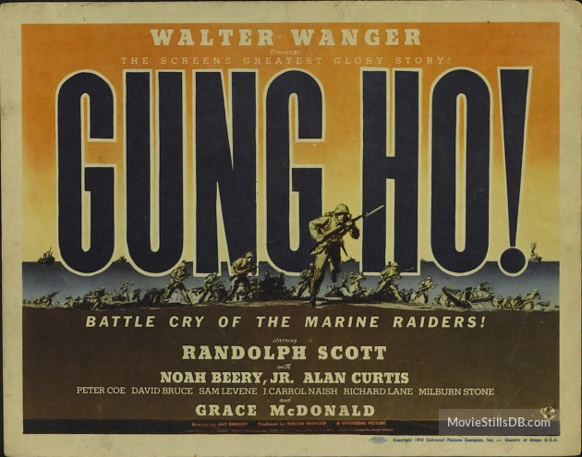
Source: http://www.moviestillsdb.com/movies/gung-ho-the-story-of-carlsons-makin-island-raiders-i35958/IRjz5t (accessed on November 21, 2015)

The film opens with a narration, bugles blaring and real footage of war, reminiscent of newsreels of the time, summarizing the ongoing war in the Pacific. The narrator sets the stage, citing the necessity for a highly trained squad to strike back at the Japanese Empire. As the narration ends, a commanding officer asks a series of Marines questions why they signed up for the marines, or “why they want to kill Jap soldiers?” This is how the main and supporting cast is introduced, as the American soldiers interviewed display a diverse background from all across the nation. Characters such as a Kentucky farmer, a preacher who abandoned the church to fight, a plucky kid from Brooklyn, a second-generation Greek immigrant, and a Filipino native seeking revenge all are interviewed Each soldier gives macho, patriotic answers like doing their duty, fighting against fascism, or revenge for Pearl Harbor. As the cast is introduced, the Marine Raiders begin their training as more narration leads the audience through a training montage explaining and demonstrating the skills taught to marines. Hand combat, weapon training, and marching in formation are all shown during this portion of the film. Gung Ho! would become a training film for the United States Marine Corp and was filmed on Camp Pendleton Marine Corp Base in California. The first act of the film consisted mostly of training and preparation for the raid.
Once the 200 Marine Raiders are chosen for the Makin Atoll Raid, they are shipped off to Hawaii for training in a tropical environment. They pass the wreckage of Pearl Harbor, quietly reflecting on what they are fighting for. At this point in the film, the marines are told of their mission, the removal of the Japanese military garrison on the Makin Atoll. The marines enter their submarines for transport and spend most of the second act in the confines of their transportation. Characters are fleshed out during the ride to the Makin Atoll, and the lighthearted tone begins to come through as soldiers joke around, and throw a birthday party for their commanding officer. Around this point in the film, the propaganda goals and themes begin to become extremely apparent.
In the film’s final act, the marines reach the island and silently approach the beachhead as the narrator returns again to explain the danger the marines are about to experience. The Raiders establish a beachhead and perimeter, but are spotted by a Japanese scout. Soon after the Raiders lose the element of surprise, and are ambushed by camouflaged Japanese snipers perched on top of trees. The marines quickly eliminate the snipers and move deeper into the island’s interior, and soon are met with barbwire, machine gun nests and heavy Japanese resistance. However, the Raiders display heroism, sacrifice, and battlefield ingenuity to take out the Japanese force on the island. The marines cause huge Japanese casualties, and destroy a headquarters and barracks before they are forced to make a quick retreat as Japanese reinforcements are suspected to be coming. The battle takes up a large portion of the film, and uses real battlefield footage. The entire battle is never is a negative light; all deaths are heroic, the Marines joke the entire time, no mistakes are made by the Americans, and the entire operation is viewed as a success. The good guys get away; smiling at the smoldering wreckage they leave in their wake, as one marine ends the film on a high note, “When do we go to Tokyo?” The film prides itself in its action sequences, which take up a majority of the film. Or as Basinger writes, “The film presents a blast of combat that is intense, hand-to-hand, fast furious, ugly, dirty and, I regret to add, very entertaining if one can detach one’s moral and political conscience from it.”
The blatant propaganda seen in the film was noticeable even during the time period, as The New York Times review writes, “as one might suspect at moments ‘they have gilded the lily just a bit, if they have touched up the desperado aspects with a dash of Hollywood coloring here and there.” As a propaganda film, Gung Ho has many goals and messages it wants to instill in the audience, all of which could affect the American public and war in ways the actual Makin Atoll Raid could not.
The theme of any man can fight, no matter their background, is apparent. The scene in the beginning of the film in which many marines are shown from across the country banding together in the name of honor, duty and revenge against the Japanese. Doherty comments on this diversity objective Gung Ho attempts, “So venomous toward the Japanese enemy, it purrs good-naturedly at a mélange of divergent ethnicities and sensibilities… Dedicated to expunging every ‘Jap’ from Makin Island, Carlson’s Raiders nonetheless function as a model of OWI tolerance.” This is a common theme of the time period, as patriotism and nationalism had reached an all time high in many countries across the globe, including the United States.
The idea of creating a strong fighting unit out of these many differing backgrounds is apparent as well. The soldiers come from fighting one another at the beginning of the film to eventually operating together under the motto, “Gung Ho” Chinese meaning, “to work in harmony”. Although this was the real motto of the 2nd Marine Raiders, the camaraderie the marines display toward the end of the film is almost too unrealistic.
More common American propaganda goals can be seen throughout the film as well. A love story between the only female character and two soldiers vying for her affection is forced in the first act of the film. The female character cannot contain herself around the two marines, demonstrating that every woman in America loves a man in uniform. Also, Pearl Harbor, and the revenge waiting for the Japanese Empire is mentioned consistently by the marines in the film.
On the battlefield, the Japanese soldiers sneak up on the Americans, set booby traps, and are presented as cunning, trickster soldiers. However, the Americans outsmart them in the end, fooling Japanese aerial bombers to bomb their own soldiers by painting an American flag on top of a Japanese military barracks. Also, no marine shows any type of characteristic or feeling on the battlefield aside from heroic. Every marine casualty is dramatic, and sacrificial. A soldier even removes his cumbersome gear and sprints at a Japanese machinegun nest, hurling grenades as he goes.
These themes and examples should not be surprising; this is a propaganda film after all. Its main goals were to raise public morale and opinion on the war, sell war bonds, encourage men and women to sacrifice their lives for the war effort, and to salvage a failed operation into something of a success. While there are too many variables complicating the relationship between this film and an increase in war bonds or women working in war factories, this film nonetheless grossed 2.18 million dollars. This box office gross demonstrates a public eager and willing to pay to watch fictionalized films, with war propaganda themes. Even a less-than-well known film like Gung Ho can make a significant impact on the American war effort.

Battle versus Film
As stated earlier, the Makin Atoll Raid, in comparison to other operations in the Pacific Theater of War, was a limited engagement with minor objectives and results. Although they recorded more casualties than the Japanese, the American soldiers who died for that operation have little to show from it. Limited intelligence was gathered from this operation, no prisoners were taken, and the goal of diverting Japanese forces to this island had not worked out as the Americans had hoped for.
However, a morale victory was achieved with the heavy press this battle received in America and the film that came afterwards. Similar to the Doolittle Raid, it can be said that this raid made up for its failures on the battlefield at the box office. After months of hearing about Japanese conquest of American, British, French, Dutch and Australian colonies in Asia and the Pacific, the Makin Raid was the first strike back at an opponent that was all but invincible up to this point. The Makin story would run in conjunction with the victories at Guadalcanal, another major victory in the early parts of the American war effort.
A positive aspect of the battle that the film does not have is its instant benefits. The results on the battlefield has an immediate outcome, altering the war for better or worse. Also, news was entering the age of instant access, and battles could be reported a few days after they happened. On the other hand, Gung Ho was released almost a year after the battle. In this time America invades and helps win back North Africa, American bombers begin to target Germany, the German army surrenders at Stalingrad, Allies invade Sicily and Italy, and other major events that clogged up the news headlines in Allied countries. By the time the film is released the famous Makin Island Raid is a distant memory.
The film is propaganda at its finest, simultaneously praising a daring raid and adding unnecessary themes for war goals. The real operation was a confusing mess, resulting in the death of many Raiders, but the film illustrates a smooth, tactical attack on an unsuspecting enemy. The film barely mentions marine causalities, men who never made it home. In the eulogy speech given by Carlson once the Raiders made it back from their mission, “It was not possible to render honors to these fallen comrades on the field of battle. I did what I could.” The eulogy is the reality, while the film is propaganda fiction. In the film the Americans outsmart the Japanese at every turn; utilizing a bulldozer to smash their dug in positions, and painting an American flag on top of a Japanese barracks tricking the Japanese bombers into bombing their own soldiers. This cartoonish defeat of the Japanese juxtaposes the reality of snipers, drowning in surf and the possibility of surrendering the president’s son. These huge differences question the legitimacy and morality of propaganda films, and with books like American Commando detailing the fear and reality of war only coming decades after films like Gung Ho!
The moralities of propaganda films are questionable, often doing a disservice to those who actually sacrificed themselves in real situations. However, the success of war films and other works of propaganda are undeniable. ’Gung Ho!’: The Story of Carlson’s Makin Island Raiders fails miserably of retelling a story worthy of being told again, but left its mark on the war effort in ways the actual battle could not.

Conclusion
Now that both the Makin Atoll Raid battle and the film have been explained, along with their successes and failures, a claim for which one had a more meaningful effect on the war must be made.
War is no longer won or lost on the battlefield alone. This has become a trend of the twentieth century, as a victory against an opposing army can now be just as significant as a magazine article or billboard sign reminding the public to donate scrap metal or reduce the amount of food consumed. The Makin Atoll Raid demonstrated this idea by being more of a success in living rooms and movie theaters, than in foxholes and trenches. The raid’s legacy influenced the American public’s morale and opinion on the war for the better, perhaps leading to an increase in war bonds or labor in war factories. While this does not diminish the training, hard work, sweat and sacrifice those in the armed forces give on the battlefield, but the Makin Atoll Raid was an example of the “total war” trend that would become a definite part of modern history. Total war asks for every part of population and culture to participate. In World War II men joined the military, weaponry was made, and money was donated because of news articles like “We Mopped Up Makin Island,” and films like Gung Ho!: The Story of Carlson’s Raiders. The dual threat of military triumph and commercial value cannot be ignored in the modern world.

Works Cited

Primary Sources
Carlson, Evans. “Eulogy Given by Colonel Carlson at the Memorial Meeting After the Return of the 2nd. Battalion from Makin Island. August 1942.” Eulogy. Accessed December 16, 2015. http://www.usmarineraiders.org/makin.html.

Crowther, Bosley. “Gung Ho (1943).” The New York Times, January 26, 1944. Accessed on November 21, 2015. http://www.nytimes.com/movie/review?res=9F07EFDD153DE13BBC4E51DFB7 66838F659EDE.

‘Gung Ho!’: The Story of Carlson’s Makin Island Raiders. Directed by Ray Enright. Universal Studios, 1943. https://archive.org/details/Gung_Ho. Accessed on October 4, 2015.

Le Francois, W.S. “We Mopped Up Makin Island.” Saturday Evening Post 216.23 (1943): 20-110. Accessed on November 21, 2015. http://connection.ebscohost.com/c/articles/21485794/we-mopped-up-makin- island.

Secondary Sources

Basinger, Jeanine. The World War II Combat Film: Anatomy of a Genre. New York: Columbia University Press, 1986.

Dick, Bernard F. The Star-Spangled Screen: The American World War II Film. Lexington, KY: The University Press of Kentucky, 1985.

Doherty, Thomas. Projections of War: Hollywood, American Culture, and World War II. New York: Columbia University Press, 1999.

Ladd, James. Commandos and Rangers of World War II. New York: St. Martin’s Press, 1978.

Lush, Tamara. “9/11 inspired many young Americans to enlist in military.” The Seattle Times, September 4, 2011. Accessed November 21, 2015. http://www.seattletimes.com/nation-world/9-11-inspired-many-young-americans- to-enlist-in-military/.

International Movie Database. “Gung Ho!’: The Story of Carlson’s Makin Island Raiders.” Accessed October 4, 2015. http://www.imdb.com/title/tt0035958/?ref_=tttr_tr_tt.
Morison, Samuel. History of United States Naval Operations in World War II. Vol. 2, Coral Sea, Midway, and Submarine Actions, May 1942-August 1942. Boston: Little, Brown and Company, 1967.

Welch, David. “The Culture of War: Ideas, Arts and Propaganda.” In The Oxford Illustrated History of World War II, edited by Richard Overy, 373-402. New York: Oxford University Press, 2015.

Woolner, David. “The ‘Special Relationship’ between Great Britain and the United States Began with FDR.” The Roosevelt Institute, July 22, 2010. Accessed November 21, 2015. http://rooseveltinstitute.org/special-relationship-between-great-britain- and-united-states-began-fdr/.

Wukovits, John. American Commando: Evans Carlson, His WWII Marine Raiders, and America’s First Special Forces Mission. New York: New American Library, 2009.

Tamara Lush, “9/11 inspired many young Americans to enlist in military,” The Seattle Times (September, 2011): http://www.seattletimes.com/nation-world/9-11-inspired-many-young-americans-to-enlist-in-military/ (accessed by November 21, 2015).
Bernard F. Dick, The Star-Spangled Screen: The American World War II Film, (Lexington, KY: The University Press of Kentucky, 1985), viii.
Craig Shirley. 2012. Interviewed by Michael Morella. “How America Changed After Pearl Harbor: The December of 1941 radically altered American and its global role,” U.S. News (January, 2012): http://www.usnews.com/opinion/articles/2012/01/06/how-america-changed-after-pearl-harbor (accessed on December 16, 2015)
David Woolner, “The ‘Special Relationship’ between Great Britain and the United States Began with FDR,” The Roosevelt Institute (June 2010): http://rooseveltinstitute.org/special-relationship-between-great-britain-and-united-states-began-fdr/ (accessed on November 21, 2015).
Samuel Morison, History of United States Naval Operations in World War II, vol. 4, Coral Seas, Midway and Submarine Actions, May 1942-August 1942 (Boston: Little, Brown and Company, 1967), 235-241.
John Wukovits, American Commando: Evans Carlson, His WWII Marine Raiders, and America’s First Special Forces Mission, (New York: New American Library, 2009).
James Ladd, Commandos and Rangers of World War II, (New York: St. Martin’s Press, 1978).
Ibid., 23.
Ladd, Commandos and Rangers, 104.
David Welch, “The Culture of War: Ideas, Arts, and Propaganda,” in The Oxford Illustrated History of World War II, ed. Richard Overy (New York: Oxford University Press, 2015), 373.
Ibid., 373.
Ibid.
Welch, “The Culture of War: Ideas, Arts, and Propaganda,” The Oxford Illustrated History of World War II, 373-401.
Wukovits, American Commando, 19.
Wukovits, American Commando, 83.
Ibid.
Ibid., 89.
Wukovits, American Commando, 92.
Ibid., 89.
Ibid., 89.
Ibid., 93.
Morison, History of United States Naval Operations in World War II, 236.
Wukovits, American Commando, 99.
Ibid., 102.
Wukovits, American Commando, 94.
Ibid., 109.
Wukovits, American Commando, 112.
Ibid., 161.
Wukovits, American Commando, 124.
Wukovits, American Commando, 126.
Ibid., 126.
Ibid., 128.
Wukovits, American Commando, 134.
Wukovits, American Commando, (New York: New American Library, 2009), 151.
Ibid.
‘Gung Ho!’: The Story of Carlson’s Makin Island Raiders,’ directed by Ray Enright, (Universal Studios, 1943), accessed on October 4, 2015, https://archive.org/details/Gung_Ho.
W. S. Le Francois, “We Mopped Up Makin Island,” Saturday Evening Post (December, 1943), http://connection.ebscohost.com/c/articles/21485794/we-mopped-up-makin-island. (Accessed on April 2015).
Bosley Crowther, “Gung Ho (1943),” The New York Times (January 26, 1944): http://www.nytimes.com/movie/review?res=9F07EFDD153DE13BBC4E51DFB766838F659EDE (accessed on November 21, 2015).
Gung Ho!’ (Universal Studios, 1943), accessed on October 4, 2015, https://archive.org/details/Gung_Ho.
Ibid.
Ibid.
“’Gung Ho!’: The Story of Carlson’s Makin Island Raiders,” International Movie Database: http://www.imdb.com/title/tt0035958/?ref_=tttr_tr_tt (accessed on October 4, 2015).
Gung Ho!’, (Universal Studios, 1943), accessed on October 4, 2015, https://archive.org/details/Gung_Ho.
“’Gung Ho!’: The Story of Carlson’s Makin Island Raiders,” International Movie Database: http://www.imdb.com/title/tt0035958/?ref_=tttr_tr_tt (accessed on October 4, 2015).
Ibid.
Jeanine, Basinger. The World War II Combat Film: Anatomy of a Genre, (New York: Columbia University Press, 1986), 204.
Crowther, “Gung Ho (1943),” The New York Times (January 26, 1944)
Gung Ho!’, (Universal Studios, 1943), accessed on October 4, 2015, https://archive.org/details/Gung_Ho.
Thomas Doherty, Projections of War: Hollywood, American Culture, and World War II, (New York: Columbia University Press, 1999), 139.
Wukovits, American Commando, (New York: New American Library, 2009).
Gung Ho!’, (Universal Studios, 1943), accessed on October 4, 2015, https://archive.org/details/Gung_Ho.
Ibid.
Gung Ho!’, (Universal Studios, 1943), accessed on October 4, 2015, https://archive.org/details/Gung_Ho.
“’Gung Ho!’” International Movie Database: http://www.imdb.com/title/tt0035958/?ref_=tttr_tr_tt (accessed on October 4, 2015).
Evans Carlson, “Eulogy Given by Colonel Carlson at the Memorial Meeting After the Return of the 2nd. Battalion from Makin Island. August 1942” accessed December 16, 2015, http://www.usmarineraiders.org/makin.html.

