Juvenile play behavior in cohabitating captive siamangs (Symphalangus syndactylus) and orangutans (Pongo abelii)

Jo Gansemer

Abstract: This research looks at the social play habits of a juvenile orangutan and juvenile siamang housed together at the San Diego Zoo, hypothesizing that the juvenile apes would prefer heterospecific juveniles as play partners over conspecific adults in the absence of conspecific juveniles. Using the San Diego Ape Cam for ten hours of focal animal sampling, the activity budgets for the juveniles were assembled, with emphasis on the rates of social versus solo play. The study confirmed, in this specific context, that the apes preferred heterospecific juvenile play to conspecific play with adults.
Keywords: primates, apes, orangutan, siamang, juvenility, play

Introduction
This research looks at two primate species – siamangs (Symphalangus syndactylus) and Sumatran orangutans (Pongo abelii) – in order to test the hypothesis that if juvenile apes do not have access to juvenile conspecifics, then they will prefer juvenile heterospecifics to adult conspecifics as play partners. The primates studied are one juvenile siamang and one juvenile orangutan whose species cohabitate at the San Diego Zoo.
Siamangs and orangutans
Siamangs are physically the largest members of the family Hylobatidae that makes up the so-called lesser apes, which also contains the gibbons. Siamangs are brachiators throughout high canopy montane and lowland forests of Sumatra as well as some parts of the Malay peninsula (Bartlett 2011, 300-12; Rowe 1996, 217). Primarily frugivorous, they lack the midday rest period of many other primates, instead only extending their activity until two to three hours before the sun sets (Bartlett 2011, 300-12).
Siamangs’ social system is consistent with that of the other hylobatids but relatively uncommon among primates as an order. Siamangs have small social groups, usually comprised of one adult male, one adult female, and up to four of their shared offspring (Fleagle 2013, 155). The male and female are monogamous, pair-bonded, and participate together in "great calls” in which their throat sacs expand to produce long, voluminous bellows. Heard over long distances, these vocalizations are used to establish and defend territory (Rowe 1996, 217). As the social group is small, they inhabit and defend a small territory that is not shared or overlapping with other groups (Bartlett 2011, 300-12).
Siamangs have an interbirth interval of two to five years, and offspring disperse at around ten years of age (Fleagle 2013, 153-5). Because of this, there are often multiple offspring within a group. As the adults are pair-bonded, infants and juveniles receive an unusually high degree of paternal care, in addition to the maternal nurturing common to most primates (Fleagle 2013, 155). Due to their small group size, siamangs will spend most of their activity hours in close proximity to one another, and rarely leave visual range (Liebal et al. 2004). They will therefore spend all their time socializing with their parents, their offspring, their siblings, and their mate, and have little to no direct social interactions with members of other groups until dispersal.
Orangutans share many of the same ecological constraints as siamangs. As a species, P. abelii have a much smaller inhabited area than siamangs, occupying only certain areas of Sumatra (Knott & Kahlenberg 2011, 313-5). They are also primarily frugivorous and inhabit the canopies of lowland swamps to montane forests across the island (Rowe 1996, 220-1). Orangutans are large, suspensory great apes and in the wild rarely, if ever come down to the ground throughout their lives (Fleagle 2013, 157-9).
Orangutans are the most sexually dimorphic of the great apes, both in body size and in secondary sexual characteristics. Males of the species may be one of two forms; the first have prominent secondary sexual characteristics, including large cheek flanges while the second do not. The latter is sometimes known to engage in forced copulation with females. Males are also unusual among primates in that they have indeterminate growth, continuing to increase in size and mass throughout their lives (Knott & Kahlenberg 2011, 314-6).
Equally uncommon among primates is the orangutan social system. While individuals will sometimes temporarily group together for protection or socialization, they are the most solitary taxon in the order, and as a result have the least amount of social interaction (Roth et al. 2020; Utami et al. 1997; van Schaik 1999). Despite this, the most common social interaction these orangutans tend to have is copulation. Males have a larger territory than females, and the territory of flanged males often envelops or overlaps the territories of multiple solitary females, exhibiting individual based fission-fusion dynamics (Fleagle 2013, 158-9; van Schaik 1999). The primary social group is not the male and females in an area, but that of a female and her offspring (van Adrichem et al. 2006; van Noordwijk & van Schaik 2005). Orangutans have an interbirth interval of eight years, and a female will rarely have more than one offspring to care for at a given time (Knott & Kahlenberg 2011, 318-9). Because of this, juvenile orangutans interact primarily with their mothers, receive no paternal care, and seldom interact with other juvenile peers or adults, though some natural socialization and play does occur when older siblings return or when their mothers band together temporarily to forage or for protection (Mendonça et al 2017; Utami et al. 1997; van Noordwijk & van Schaik 2005). Young orangutans are therefore dependent on their mothers until around eight years, and may at times continue to share or overlap their territory with them after they disperse (Fleagle 2013, 159; Mendonça et al. 2017).
Despite many physical and behavioral differences between the taxa, some captive environments have begun housing hylobatids and orangutans together as a form of social enrichment due in part to their similar ecology, diet, natural environments, habitat usage, and small group sizes, and in response to limited finances or space in some cases (Brando & Coe 2022; Pearson et al. 2010; Veitia 2017). Siamangs and Sumatran orangutans specifically are currently housed together in only two locales; the Adelaide Zoo in South Australia and the San Diego Zoo in California, where this research takes place (Pearson et al. 2010).
Theoretical background
This research is based primarily in life history theory, with emphasis placed on the juvenile period. Juvenility in primates is defined as the period of life after infancy but before reaching sexual maturity in which an individual would be likely to survive the loss of their parent or primary caregiver (Pereira 2002, 19). In primates, this life phase is extended relative to that of other animals (Leigh & Blomquist 2011, 422). As with all aspects analyzed through life history theory, delayed maturation is a trade-off in which primates forgo additional reproductive time for the benefits of larger brain size, longer lifespan, and additional environmental and social experience (Fairbanks & Pereira 2002, 361-2; Janson & van Schaik 2002, 57-64; Pereira 2002, 23-6). One such proposed benefit of juvenility is play. Found in varying types and degrees across mammalia, birds, and sporadically in other taxa, play may be defined as an improvised motor and communicative performance accompanied by context-specific signals (Burghart 2014; Fagen 2002, 182). While this behavior has likely evolved independently on multiple occasions, it is similar across taxa, making interspecific comparisons possible (Smaldino et al. 2019). Though the evolutionary function and benefits of primate play behavior have long been debated, it is of notable occurrence, and presumably, importance, in juveniles. Play behavior often persists through primates’ lives, but peaks during juvenility and decreases over time (Fagen 2002, 185-9).
Socialization has often and historically been hypothesized as the major function of play in juveniles (Fairbanks & Pereira 2002, 363-5; Poirier & Euclid 1974; Smaldino et al. 2019). Poirier and Euclid (1974) hypothesize that play serves to properly socialize juvenile primates, set the basis for future dominance hierarchies, integrate individuals into the existing group structure, and teach juveniles social communication. This framework for studying and analyzing play has persisted for many years in primatological literature (Fagen 2002, 182-96; Fairbanks et al. 2004; Fairbanks & Pereira 2002, 359-66; Palagi & Mancini 2011). In more recent decades, there has been a shift in both the study of play and of juvenility to look at juvenility as it affects the juvenile, rather than solely how it affects the adult it becomes. As a result, historical models of analyzing play are now considered overly simplistic (Montgomery 2014; Smaldino et al. 2019). In addition to studying its impact on juveniles, the analysis of play itself has become more complex (Burghardt 2014; Smaldino et al. 2019). Juveniles are now being studied as autonomous individuals, interacting with a network of kin and group members, developing in a social context that it actively contributes to, and a growing body of literature reflects this (Bolger & Zihlman 2011, 431-2; Fairbanks & Pereira 2002, 359-66; Frölich et al. 2020; Sherrow & MacKinnon 2011, 455-63; Suomi 2005). Play benefits the juvenile as a future adult socially and developmentally, but it also benefits the juvenile as a current juvenile socially, physically, and cognitively.
Play, like all life history variables is a trade-off (Berghänel et al. 2015; Smaldino et al. 2019; Leigh & Blomquist 2011, 423). There are physical risks, as well as consumption of time, energy, and nutrient resources. However, there are physical benefits to play, such as motor skill development and physical training (Berghänel et al. 2015; Fagen 2002, 188). Hypothesized social benefits include group bonding, relationship networking, and selective learning (Fagen 2002, 192-4; Fairbanks et al. 2004; Whiten & van de Waal 2018). Advantageous cognitive or communicative behaviors may also develop, such as using and appropriately responding to signals to improve intentional communication, emotional regulation, and even empathy (Palagi & Mancini 2011; Suomi 2005). Though there is currently no single consensus on the benefits of play to juvenility, there is an expanding and increasingly complex framework being used to analyze the behaviors that include more recent distinctions between social play and other types of more solitary play (Berghänel et al. 2015; Burghardt 2014; Smaldino et al. 2019). Primates are known to engage in both, which is explored in this research.

Methods
This research hypothesizes that if juvenile apes prefer juvenile play partners. To test this hypothesis, research was conducted remotely via the San Diego Zoo (SDZ) Ape Cam, a camera with a live feed into the joint siamang and orangutan enclosure from the hours of 7:30 am to 7:30 pm Pacific Time. During the hours of 7:30 pm to 7:30 am, the SDZ Ape Cam streams the footage from the previous 12 hours. The camera does not show the entirety of the enclosure at all times, but instead moves periodically to various parts of the habitat. The SDZ Ape Cam also lacks the ability for visitors of their website to control what they see, which has become a common feature of many other wildlife parks and sanctuaries.
The study included a family unit of three siamangs; a 37 year old adult male pair-bonded to a 39 year old female and their 2 year old female juvenile, and four Sumatran orangutans; an adult flanged male, a 28 year old adult female, a 34 year old adult female, and her 7 year old juvenile female ((Burns & Judge 2016, Knott & Kahlenberg 2011, 317-8). The focal subjects of the study were the two juvenile apes, although interactions occurred between all subjects in various capacities.
20 bouts of 15-minute focal sampling were conducted on each of the two juveniles, for a total of 10 hours of sampling. All sampling was conducted during the same hours of the day under similar weather conditions; e.g. one bout of focal sampling beginning at noon on a rainy day would be repeated with the other juvenile on another rainy day beginning at noon. All sampling occurred during the SDZ Ape Cam streaming hours of 7:30 am to 7:30 pm from Monday, 12 April to Friday, 16 April 2021. No sampling occurred on the weekend to avoid differences in data due to both the small sample size and increased zoo visitor activity on the weekends. Due to the inability to control the SDZ Ape Cam, focal samples were sometimes interrupted when the camera moved away from the focal animal. In these situations, the entire bout of sampling was discarded, and was then restarted and completed in a single 15-minute bout on another day beginning at the same time, in similar weather conditions.
Sampled activities were resting, feeding or foraging, traveling, approaching another individual, and play. Play was further broken down into the two categories of solo play and social play. The duration of time for each recorded activity was documented. The identity of other individuals involved in social play or which were the target of approaching were recorded as well. Recorded activities were converted to frequency per observation hour and analyzed using chi-squared significance tests. Activity frequencies were compared between the two juveniles across the categories of all activities except approaching. Social and solo play frequencies were further compared between the two juveniles, as well as across all play partners. Approaching was the only behavior not converted into a frequency and was instead left as occurrences.
Regarding the hypothesis that juvenile apes will prefer juvenile play partners, there were three further working predictions. First, for both focal animals, play with a juvenile partner was expected to occur at a higher frequency than play with any other individuals. Second, the juveniles’ play patterns were expected to show statistically significant association between partner frequencies. Finally, the juveniles’ activity patterns were expected to show statistically significant association between behavioral frequencies.

Results
Total activity
For total activity patterns, neither focal animal had the same most frequent or least frequent activity (Table 1). The juvenile siamang’s most frequent activity was play. Her least frequent activity was traveling. The juvenile orangutan’s most frequent activity was rest. Her least frequent activity was grooming. Her play frequency was lower than the siamang’s. Despite these differences, the chi-squared significance test showed a statistically significant association between the juveniles’ total activity patterns, with a calculated p-value of 0.043462.

Table 1: Total time in minutes spent on each recorded activity for each focal animal.
Table 1 | Feed/forage | Groom | Play | Rest | Travel
Juvenile siamang | 27 | 15.75 | 130.5 | 121 | 5.75
Juvenile orangutan | 45.25 | 6.75 | 76.5 | 160.5 | 11

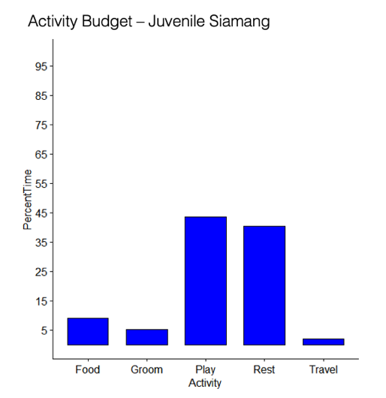
Figures 1 and 2 below graph the results as percentages of total observation time, with the siamang’s data shown in blue (left) and the orangutan’s data shown in red (right).
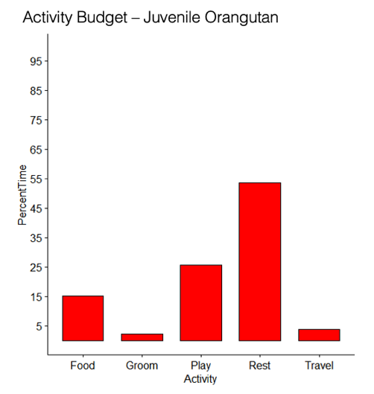
Play activity
Figure 2: Histogram of the juvenile orangutan’s total activities as percentages of total observation time.
Figure 1: Histogram of the juvenile siamang’s total activities as percentages of total observation time.
The juvenile siamang spent a greater amount of time in social play than in solo play. By contrast, the juvenile orangutan spent a greater amount of time in solo play than in social play (Table 2). The juveniles’ social and solo play were not found to be significantly associated, with a high p-value of 0.090806.
Table 2: Time in minutes of all recorded play activity for each focal animal.
Table 2 | Social play | Solo play | Total play
Juvenile siamang | 78.25 | 52.25 | 130.5
Juvenile orangutan | 36.75 | 39.75 | 76.5

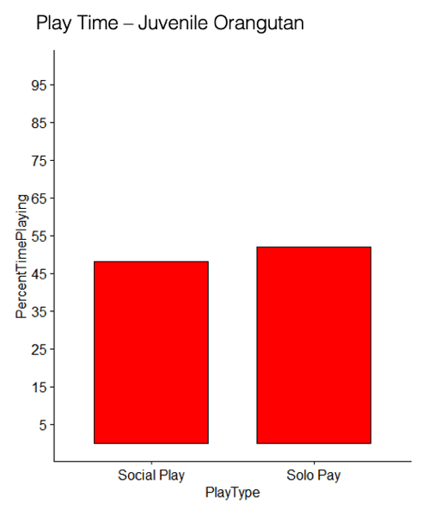
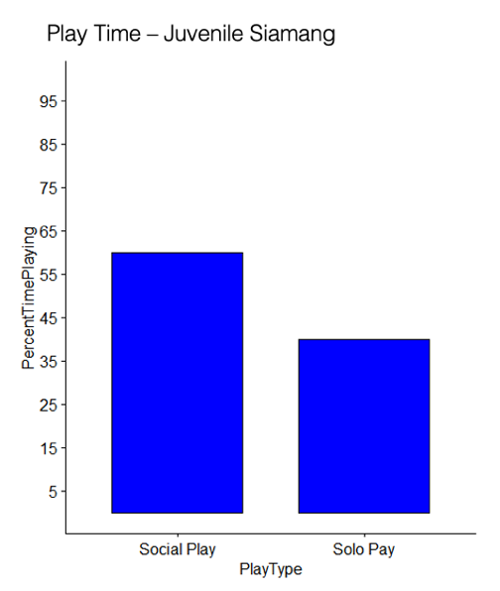
Figures 3 and 4 below graph the results as percentages of total observed play time, with the siamang’s data shown in blue (left) and the orangutan’s data shown in red (right).
Figure 4: Histogram of the juvenile orangutan’s social and solo play as percentages of total observed play time.
Figure 3: Histogram of the juvenile siamang’s social and solo play as percentages of total observed play time.
Social play
Social play was recorded for both of the focal animals not only as a percentage of total play, but also by which partners were most frequently played with (Table 3). The most frequent play partner for each of the juveniles was the other. The second most frequent play partner was also the same for both of the juveniles, human zoo visitors. The two differed in least frequent play partner, with the juvenile siamang’s least frequent play partner being the 28 year old adult female orangutan. The juvenile orangutan’s least frequent play partners were both adult siamangs and the 28 year old female orangutan, with no observed social play time at all.
The juvenile orangutan’s social play partner percentages added together total over 100%, while the juvenile siamang’s social play partner percentages add up to exactly 100%, as should be expected. The juvenile orangutan was observed in social play with multiple partners at once, most frequently the juvenile siamang. The juvenile siamang was not observed in social play with more than one partner at once during any of her focal follow time. The chi-squared significance test of partner frequency revealed a strong statistically significant association between the juveniles’ social play partner frequencies, with a low p-value of 0.000202.

Table 3: Time in minutes spent in social play with each play partner for each focal animal.
Table 3 | Non-focal juvenile | Adult female orangutan 1 (34 year old) | Adult male orangutan | Adult female orangutan 2 (28 year old) | Adult female siamang | Adult male siamang | Human zoo visitors
Juvenile siamang | 53.25 | 4.25 | 1.5 | 1 | 4.5 | 4 | 9.75
Juvenile orangutan | 34.5 | 6.75 | 3.75 | 0 | 0 | 0 | 10.75

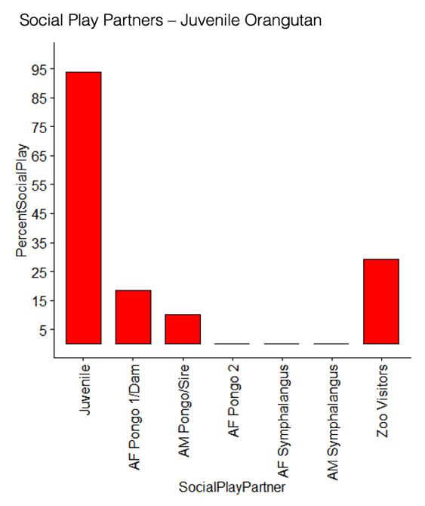
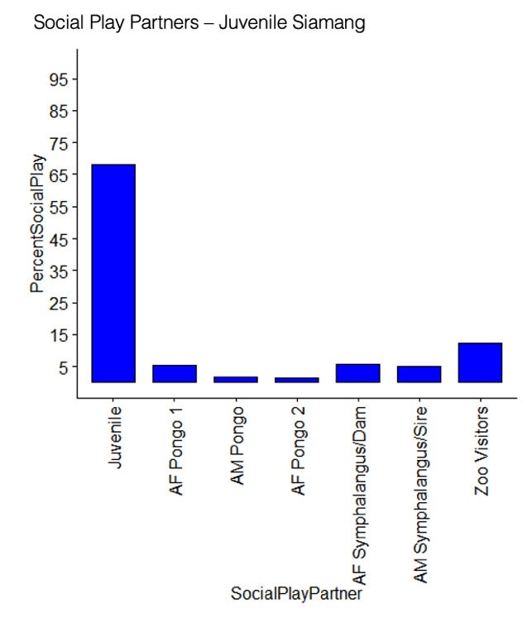
Figures 5 and 6 below graph the results as percentages of total observed social play time, with the siamang’s data shown in blue (left) and the orangutan’s data shown in red (right).
Figure 6: Histogram of the juvenile orangutan’s play partner frequencies as percentages of total observed social play time.
Figure 5: Histogram of the juvenile siamangs’s play partner frequencies as percentages of total observed social play time.

Other results
Observed approaches were not statistically significantly associated between the two focal animals, nor where the number of approaches specifically targeting the other juvenile (Table 4). However, the approaches for both juveniles most often targeted a parent. Grooming comprised a small percentage of observed time for both juveniles. All recorded grooming occurred with parents. The juveniles did not groom one another (Table 5). Traveling comprised a small percentage of observed time for both juveniles. It was the least frequent activity for the juvenile siamang. Much of what could be recorded as traveling for the juvenile siamang was recorded as solo play. Though the end result of the behavior was arrival at a new destination, the means of travel was indirect, often involving swinging, climbing, or somersaulting and doubling back or meandering before arriving at said destination. Such activity met the criteria for play as defined by Pereira (2002, 17-27), and was so coded as solo play. No stereotypies were observed in either juvenile ape during the ten observation hours.

Table 4: Number of approaches towards each ape performed by each focal animal.
Table 4 | Non-focal juvenile | Adult female orangutan 1 (34 year old) | Adult male orangutan | Adult female orangutan 2 (28 year old) | Adult female siamang | Adult male siamang
Juvenile siamang | 4 | 1 | 1 | 2 | 9 | 7
Juvenile orangutan | 4 | 6 | 0 | 1 | 0 | 0

Table 5: Time in minutes spent grooming parents by juvenile siamang.
Table 5 | Adult female siamang | Adult male siamang
Juvenile siamang | 15.5 | 6.25

Discussion
Play appears to be an important part of both the juvenile siamang’s and juvenile orangutan’s activity budgets. It is a frequent portion of both animals’ days and is significantly associated between the two with regard to total activity patterns and frequency of social play partners. Though it is accepted that play is important to juvenile primates’ development and socialization, it is difficult to draw any specific conclusions from the frequency of total play, social play, or solo play in this specific context, due to the limited sample size with regard to both the number of juveniles and the number of observation hours.
Both juveniles appeared to prefer their parents to other adults due to the data recorded for grooming, approaching, and social play. Parents were preferred even over other juveniles for grooming and approaching, though not for social play. This is illustrative of the dependence on parents for many aspects of their care, including for much of their daily social interaction, throughout many primates’ juvenility (Grampp et al. 2019; Suomi 2005; Whiten & van de Waal 2018).
Though parents were the most common social play partners of the adult nonhuman apes, their frequencies did not approach the frequencies of social play with the other juvenile ape. As predicted, the most frequent social play partner for both focal animals was the other. What was not expected was that human visitors to the San Diego Zoo were the second most frequent social play partners; visitors were not expected to constitute any percentage of social play partners. However, human-oriented behavior has been recorded before in captive primates, notably in juveniles (Amalia et al. 2022). Play with visitors included touching the glass window, running back and forth in front of the window with visitors, and performance in front of visitors including somersaulting and rolling. Due to the angle of the SDZ Ape Cam, the visitors were not visible during certain hours of the day because of the glare of the sun on the glass window. When visible, the visitors which engaged in social play with the focal animals were all children, with the exception of performance by the focal animals, which targeted all visitors, including children. Because the visitors were not always visible, it is not possible to say for certain that all such social play partners were children, or even what percentage of human play partners were children.
Though reasons cited for combining orangutan and siamang or gibbon enclosures together include the reason of social enrichment, the specific benefits to juveniles have not been thoroughly explored and deserve to be investigated more fully. In addition to the potential benefits of interspecies play between the juvenile orangutans and hylobatids, zoos could also take advantage of the situation by providing specific opportunities for distance play with the human children who visit the zoo. Some examples might be the inclusion of windowed running corridors, or mirrored climbing equipment or play areas for the humans and apes within view of each other, which would provide further opportunities for social play, as well as a more robust interactive and educational experience for zoo guests.

Conclusion
The data supports the hypothesis that juvenile apes will prefer heterospecific juveniles as play partners over conspecific adults in the absence of conspecific juveniles, specifically confirming it in this context. The other juvenile nonhuman ape was preferred over even their own parent(s), and juvenile humans outside the enclosure could have been, and observationally, but not certainly, were preferred as well, despite their being both less accessible and less familiar than the five adult apes. Play with other juveniles, therefore, appears to be essential to juvenility, even more so than play as a whole. For example, play comprised just over a quarter of the juvenile orangutan’s observed activity, a percentage much less than that of the juvenile siamang, but of her social play, play with a juvenile partner occurred over 90% of the time. Both juveniles’ social play partner frequencies were strongly associated, suggesting that juvenile play was essential to both animals’ daily social play and activity budgets, and that heterospecific juvenile play partners were, in fact, more preferable than conspecific adults.
Additionally, this study illustrates that the cohabitation of hylobatids and orangutans can prove beneficial in animal husbandry situations including zoos. The high frequencies of heterospecific social play has found that cohabitation offers social benefits especially advantageous to juveniles. This is particularly true in cases where no juvenile conspecific peers are available, as is very common in orangutans. Merging hylobatid and orangutan enclosures can provide benefits to the animals’ social wellbeing and should be explored by more zoos.

Works cited

Amalia N, Farajallah DP, & Atmoko SSU. 2022. “Orangutan (Pongo pygmaeus wurmbii) human-oriented
behavior at the Lamandau Wildlife Reserve, Indonesia.” Biodiversitas 23(1): 396-402.

Bartlett TQ. 2011. “The Hylobatidae.” In Primates in Perspective (Second Edition), edited by Campbell C.J.,
Fuentes A., MacKinnon K.C., Bearder S.K., & Strumpf R.M., 300-12. New York: Oxford University
Press.

Berghänel A, Schülke O, & Ostner J. 2015. “Locomotor play drives motor skill acquisition at the expense of
growth: A life history trade-off.” Science Advances 1(7): doi:10.1126/sciadv.1500451.

Bolger D & Zihlman A. 2011. “Primate Growth and Development.” In Primates in Perspective (Second Edition),
edited by Campbell CJ, Fuentes A, MacKinnon KC, Bearder SK, & Strumpf RM, 428-39. New York:
Oxford University Press.

Brando S & Coe J. 2022. “Confronting Back-of-House Traditions: Primates as a case study.” Journal of Zoological
and Botanical Gardens 3: 336-97.

Burns BL & Judge DS. 2016. “The varied path to adulthood: Plasticity in developmental timing in hylobatids.”
American Journal of Primatology 78: 610-25.

Fagen R. 2002. “Primate Juveniles and Primate Play.” In Juvenile Primates (Second Edition), edited by Pereira ME
& Fairbanks LA, 182-96. Chicago: The University of Chicago Press.

Fairbanks LA, Jorgensen MJ, Huff A, Blau K, Hung YY, & Mann JJ. 2004. “Adolescent impulsivity predicts
adult dominance attainment in male vervet monkeys.” American Journal of Primatology 64: 1-17.

Fairbanks LA & Pereira ME. 2002. “Juvenile Primates: Dimensions for Future Research.” In Juvenile Primates
(Second Edition), edited by Pereira ME & Fairbanks L, 359-66. Chicago: The University of Chicago
Press.

Fleagle JG. 2013. “Apes and Humans.” In Primate Adaptation & Evolution (Third Edition), 151-68. San Diego:
Academic Press.

Frölich M, Kunz J, Fryns C, Falkner S, Rukmana E, Schuppli M, Knief U, Utami Atmoko SS, Schuppli C, & van
Noordwijk MA. 2020. “Social interactions and interaction partners in infant orang-utans of two wild
populations.” Animal Behaviour 166: 183-91.

Grampp M, Sueur C, & van de Waal E. 2019. “Social attention biases in juvenile wild vervet
monkeys: implications for socialisation and social learning processes.” Primates 60: 261-75.

Janson CH & van Schaik CP. 2002. “Ecological risk aversion in juvenile primates: slow and steady wins the race.”
In Juvenile Primates (Second Edition), edited by Pereira ME & Fairbanks LA, 57-76. Chicago: The
University of Chicago Press.

Knott CD & Kahlenberg SM. 2011. “Orangutans.” In Primates in Perspective (Second Edition), edited by Campbell
CJ, Fuentes A, MacKinnon KC, Bearder SK, & Strumpf RM, 313-25. New York: Oxford University Press.

Leigh SR & Blomquist GE. 2011. “Life History.” In Primates in Perspective (Second Edition), edited by Campbell
CJ, Fuentes A, MacKinnon KC, Bearder SK, & Strumpf RM, 418-27. New York: Oxford University Press.

Liebal K, Pika S, & Tomasello M. 2004. “Social communication in siamangs (Symphalangus syndactylus): use of
gestures and facial expressions.” Primates 45: 41-57.

Mendonça RS, Kanamori T, Kuze N, Hayashi M, Bernard H, & Matsuzawa T. 2017. “Development and behavior of
wild infant-juvenile East Bornean orangutans (Pongo pygmaeus morio) in Danum Valley.” Primates 58:
211-224.

Mongomery SH. 2014. “The relationship between play, brain growth and flexibility in primates.” Animal Behaviour
90: 281-6.

Pearson EL, Davis JM, & Litchfield CA. 2010. “A Case Study of Orangutan and Siamang Behavior Within a
Mixed-Species Zoo Exhibit.” Journal of Applied Animal Welfare Science 13(4): 330-46.

Pereira ME. 2002. “Juvenility in Animals.” In Juvenile Primates (Second Edition), edited by Pereira ME &
Fairbanks LA, 17-27. Chicago: The University of Chicago Press.

Roth TS, Rianti P, Fredriksson GM, Wich SA, & Nowak MG. 2020. “Grouping behavior of Sumatran orangutans
(Pongo abelii) and Tapanuli orangutans (Pongo tapanuliensis) living in forest with low fruit abundance.”
American Journal of Primatology 82(5): e23123.

Rowe N. 1996. The Pictorial Guide to the Living Primates. Charlestown, RI: Pogonias Press.

Sherrow HM & MacKinnon KC. 2011. “Juvenile and Adolescent Primates.” In Primates in Perspective (Second
Edition), edited by Campbell CJ, Fuentes A, MacKinnon KC, Bearder SK, & Strumpf RM, 455-63 New
York: Oxford University Press.

Smaldino PE, Palagi ., Burghart GM, & Pellis SM. 2019. “The evolution of two types of play.” Behavioral Ecology
30(5): 1388-97.

Suomi SJ. 2005. “Mother-infant attachment, peer relationships, and the development of social networks in rhesus
monkeys.” Human Development 48: 67-79.

van Adrichem GGJ, Wich S, Sterck EHM, Utami SS, & van Hooff JARAM. 2006. “The development of wild
immature Sumatra orangutans (Pongo abelii) at Ketambe.” Primates 47: 300-9.

van Noordwijk MA & van Schaik CP. 2005. “Development of Ecological Competence in Sumatran Orangutans.”
American Journal of Physical Anthropology 127: 79-94.

van Schaik CP. 1999. “The socioecology of fission-fusion sociality in Orangutans.” Primates 40: 69-86.

Utami SS, Wich SA, Sterck EHM, & van Hooff JARAM. 1997. “Food Competition Between Wild Orangutans in
Large Fig Trees.” International Journal of Primatology 18(6): 909-927.

Veitia E. 2017. “Enrichment Use & Social Interactions in a Mixed-Species Enclosure of Sumatran (Pongo abelii) &
Bornean Orangutans (P. pygmaeus) & Northern White-Cheeked Gibbons (Nomascus leucogenys).” All
Master's Theses: 910. https://digitalcommons.cwu.edu/etd/910

Whiten A & van de Waal E. 2018. “The pervasive role of social learning in primate lifetime development.”
Behavioral Ecology and Sociobiology 72: doi:10.1007/s00265-018-2489-3.

