PROUD
Portable Recovery of Unique Data
HOW-TO GUIDE

a project of the

Table of Contents
Table of Contents 2
Unpacking PROUD 3
The PROUD Inventory 4
Connecting PROUD up 5
5.25-inch floppies 5
3.5-inch floppies 5
5.25-inch floppy diskettes 6
Starting the software 6
Discovering the correct Disk Type 6
Imaging the diskette 7
Extracting files from the image 7
3.5-inch floppy diskettes 8
Extracting files from the disk 8
Zip disk 9
Extracting files from the disk 9
Memory cards 10
Extracting files from the card 10
Hard drives 11
Extracting files from the disk 11
Repacking PROUD 12

Unpacking PROUD
When you open PROUD, you will see:
Note: Once you remove the equipment you need, leave the unglued foam pieces inside the box so they don’t get lost.

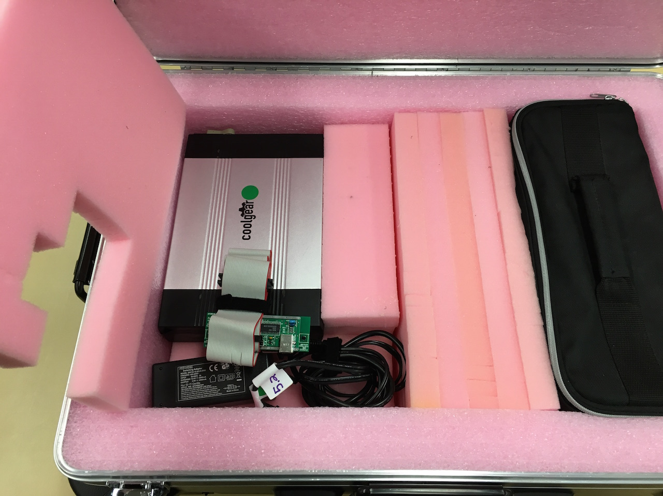
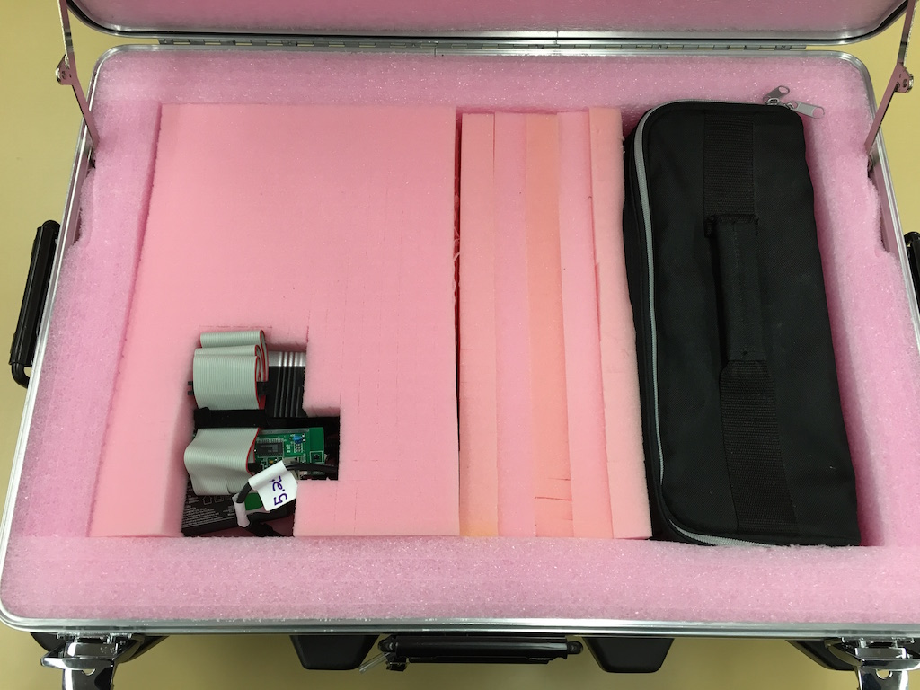
Most of the packing foam is glued in (exceptions noted below). Do not try to remove glued-in foam! You will damage the box!
In the left compartment, you may remove the top piece of foam to reveal the 5.25 floppy disk drive, the attached controller, and power cord.

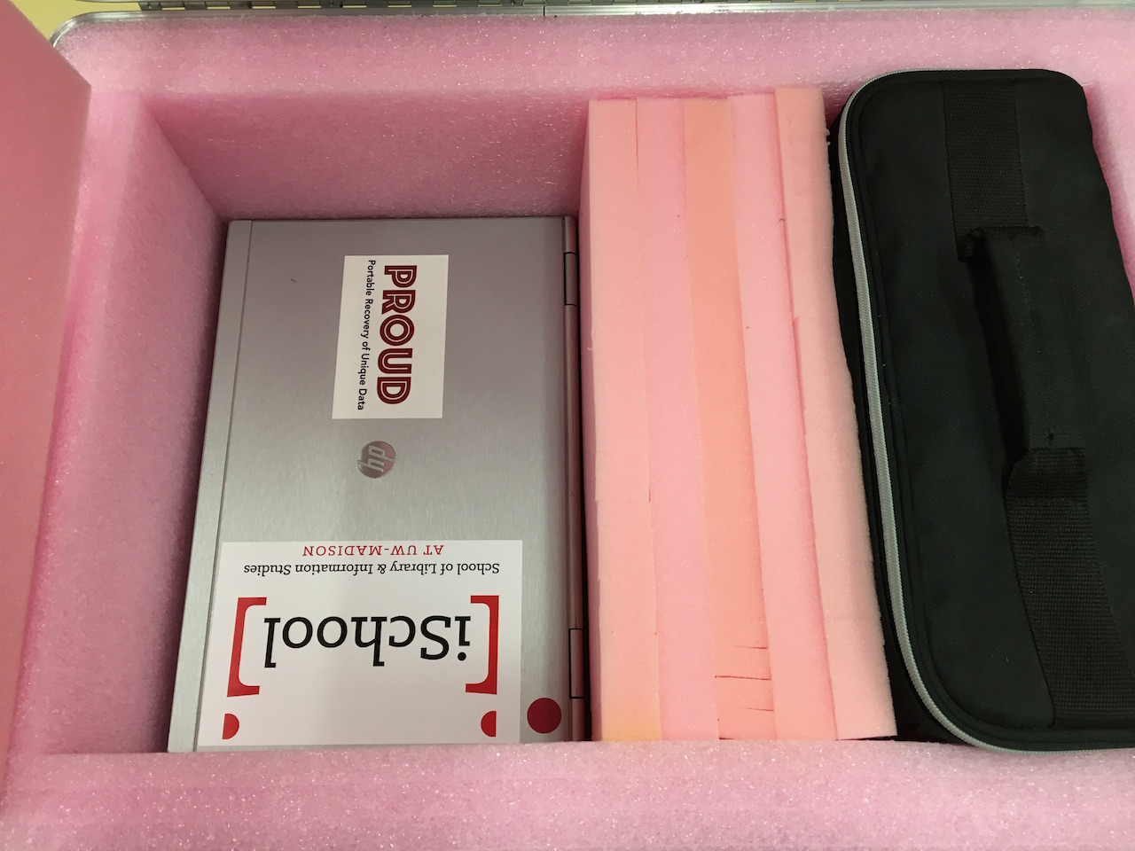

Below the disk drive, is another piece of removable foam, underneath which is an HP laptop.

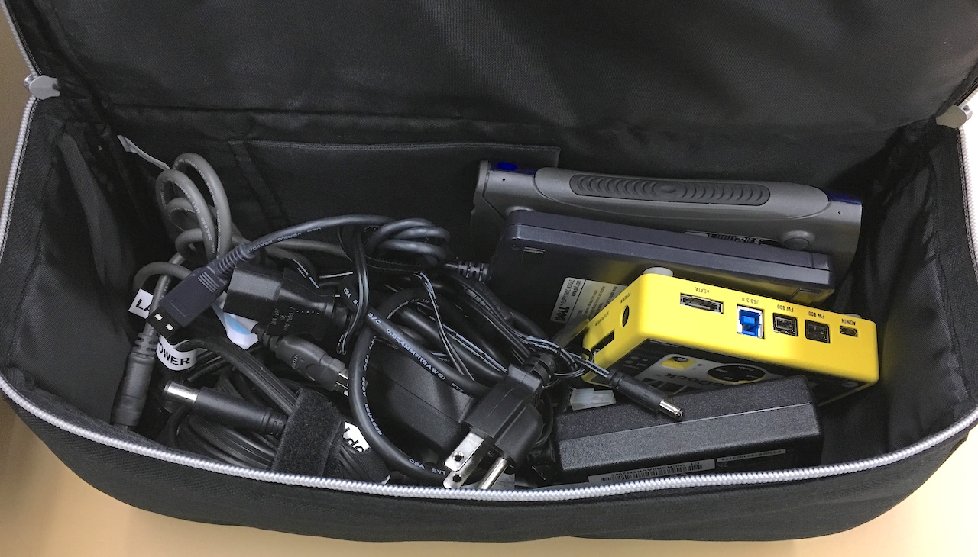

In the right compartment, is a black cloth bag containing several more cords and drives, which will be inventoried on the next page.

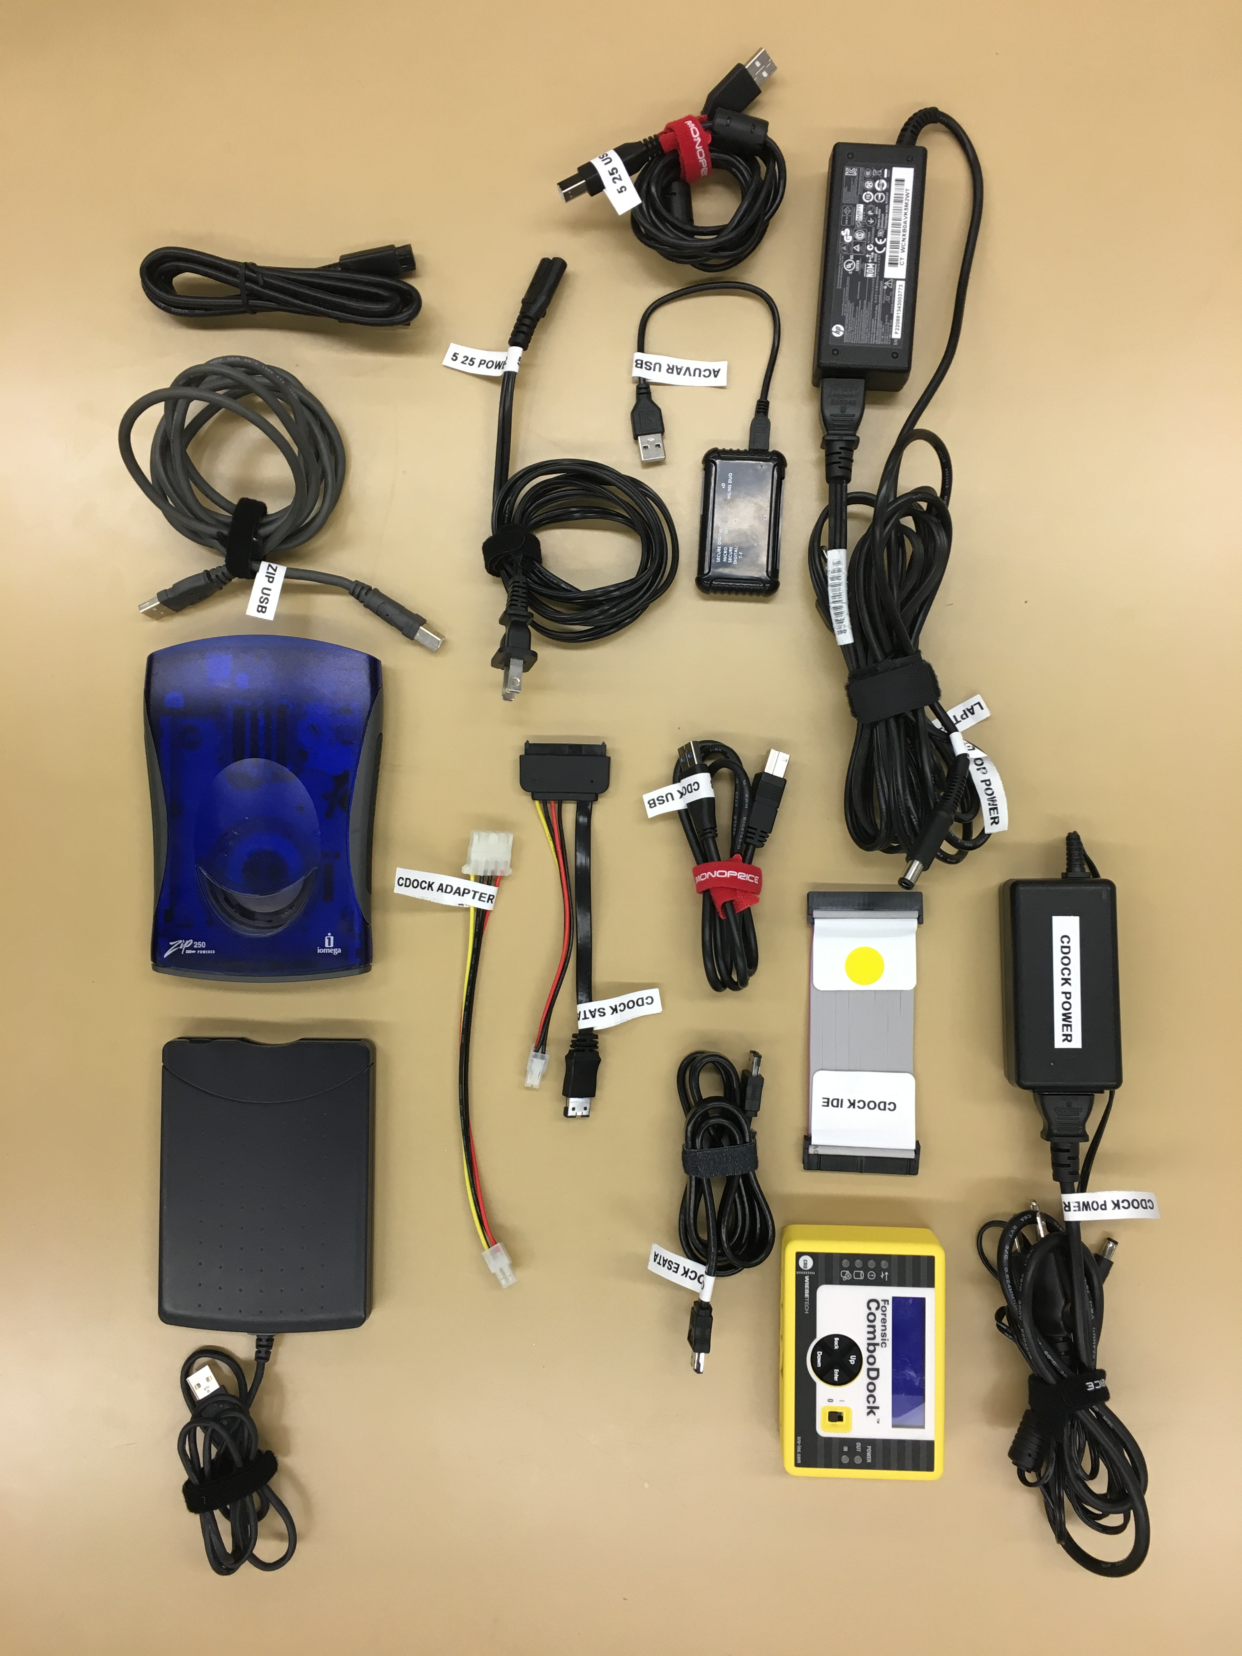
3

4

5

8

1

2

12

6

9

10

7

11

13

14
13127

15
14
13127

The PROUD Inventory
1. ComboDock power cord
2. Laptop power cord
3. Combodock IDE
4. CRU Forensic ComboDock
5. 5.25” floppy USB cord
6. Acuvar memory card reader
7. ComboDock USB cord
8. ComboDock eSATA cable
9. 5.25” floppy power cord
10. ComboDock SATA cable
11. ComboDock adapter
12. Firewire cable
13. Zip disk drive USB cord
14. Iomega Zip disk drive
15. 3.5” inch floppy disk drive
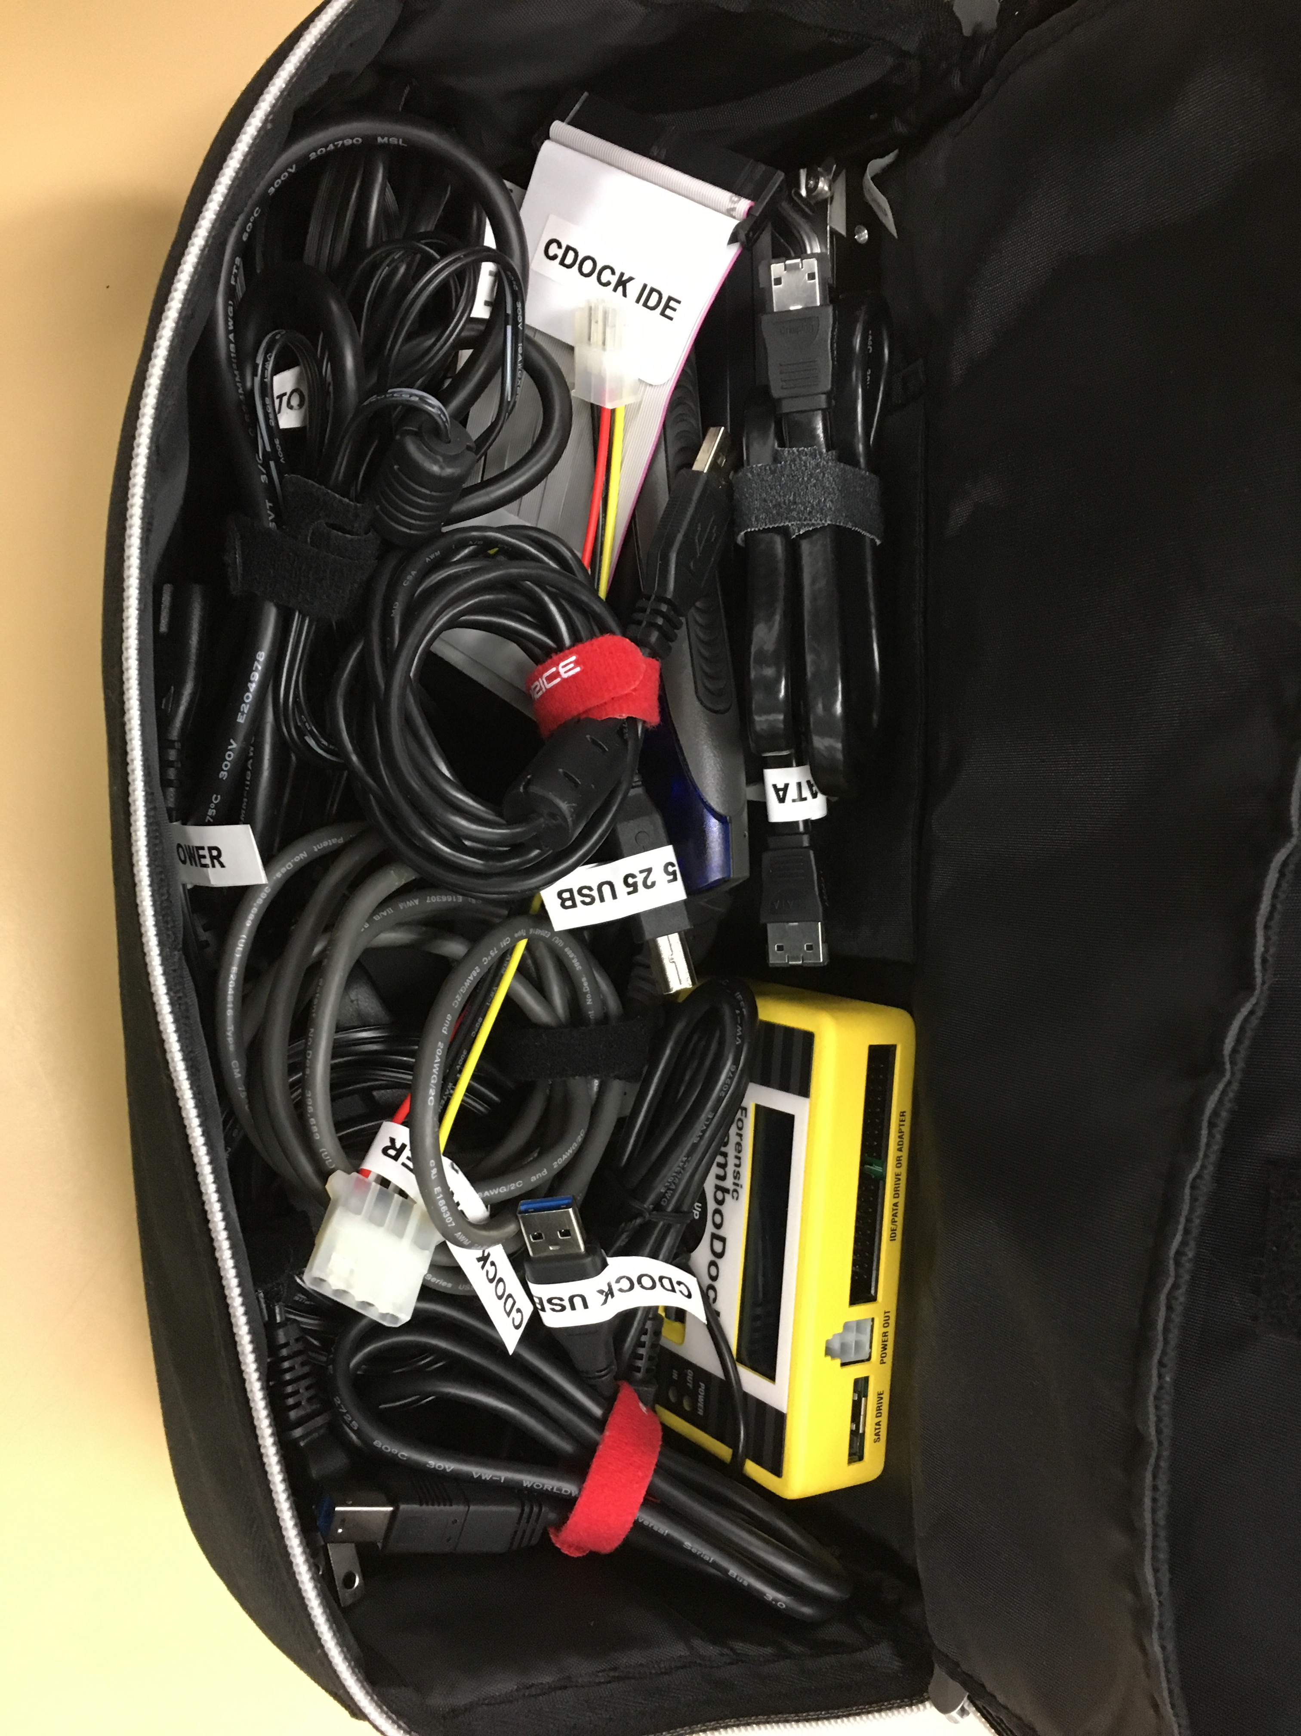

Connecting PROUD up
All PROUD cords and cables have tape labels to help you match them with the machines they belong with.

5.25-inch floppies
You will need:
- HP laptop and its power cables (1)
- 5.25-inch floppy drive (2)
- USB cable (3)
Power connections:
- Connect the HP laptop’s power cable to its socket on the left side near the hinge (4). Plug it in.
- Plug in the drive’s power cord.
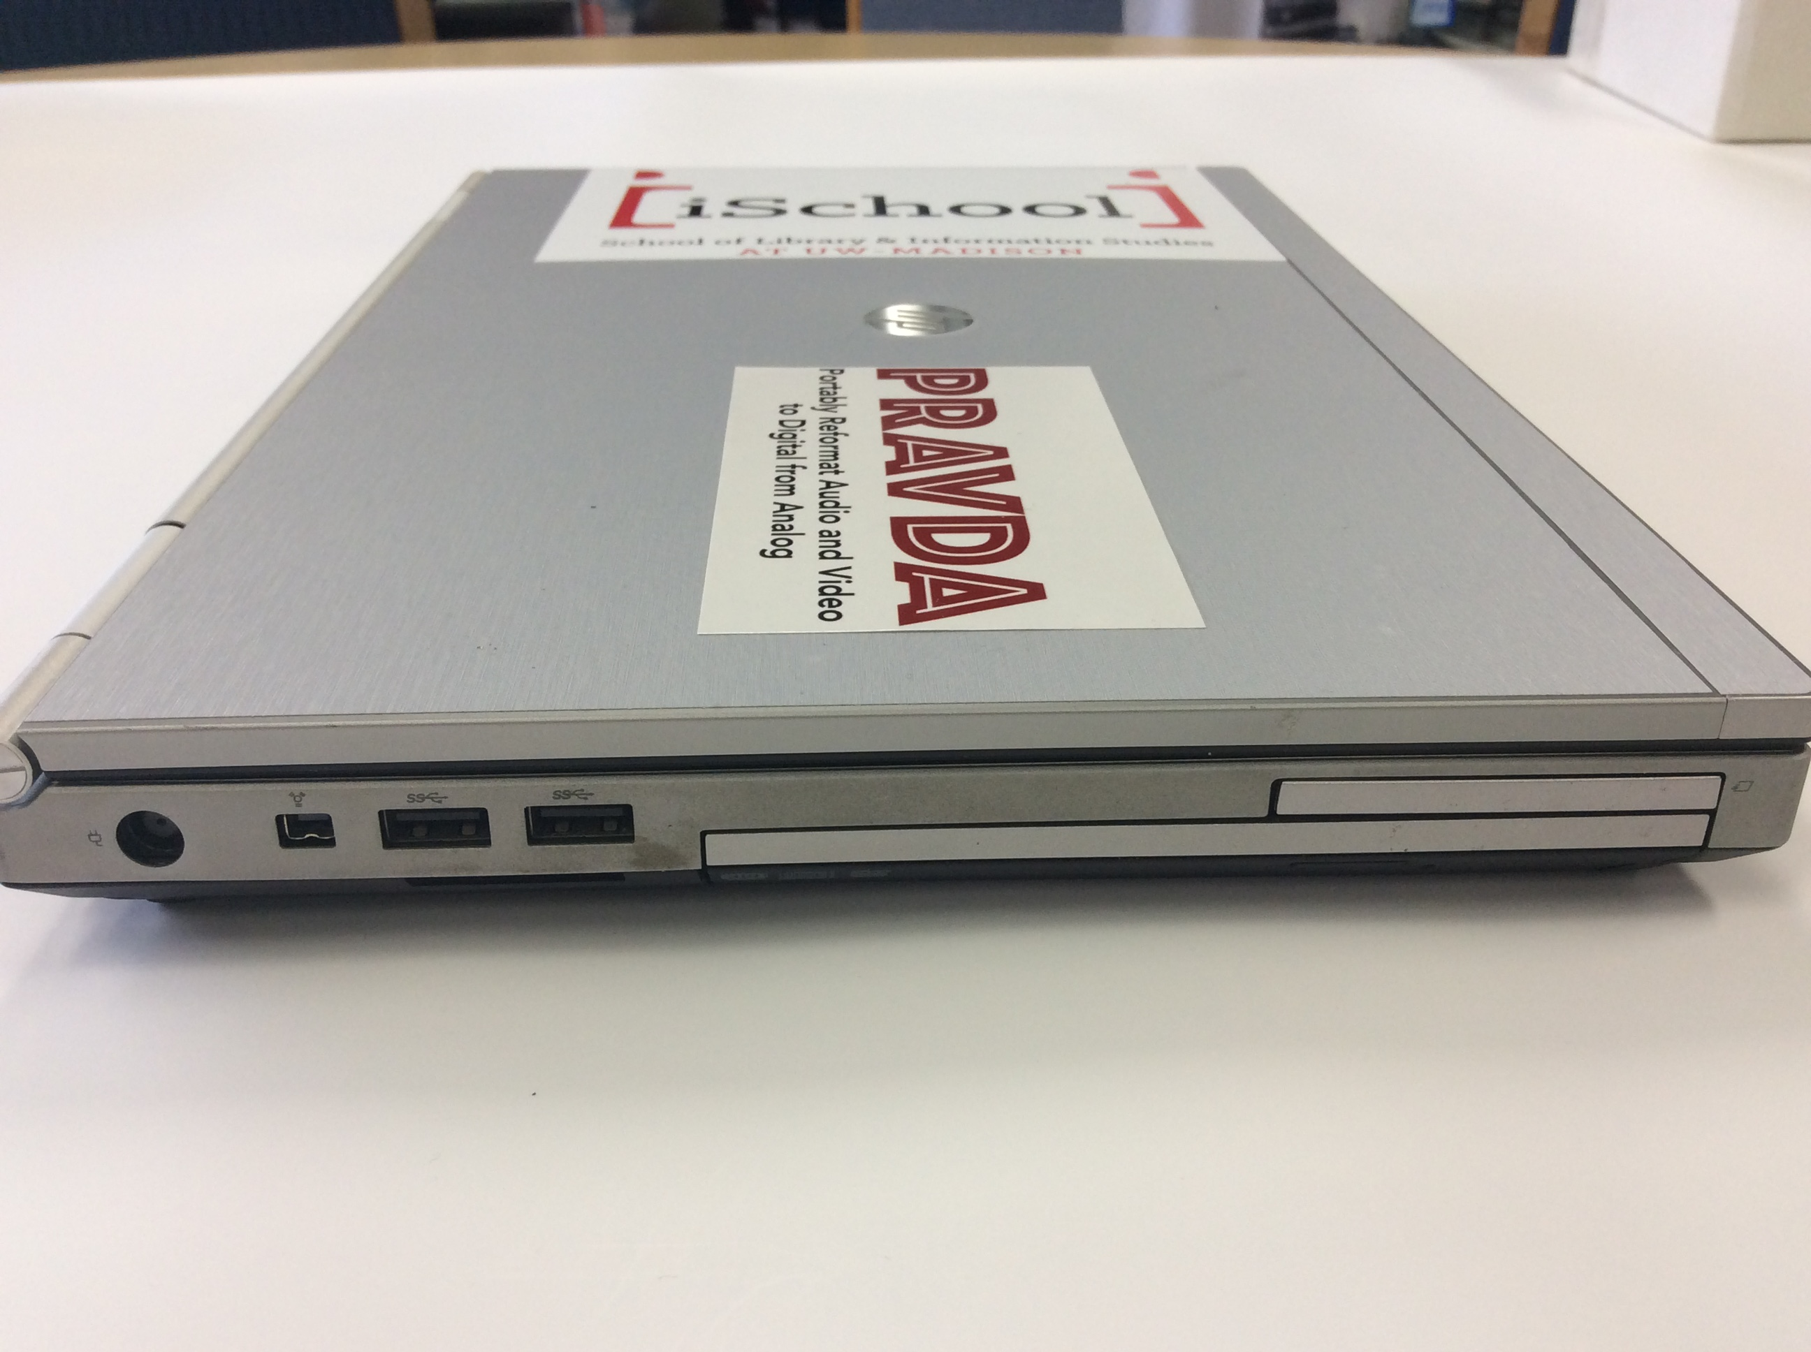
Laptop connections:
Firewire port
8

USB ports
- Connect the drive’s USB cable to the laptop.

3.5-inch floppies
You will need:
- HP laptop and its power cables (1)
- 3.5-inch floppy drive (2)
Power connections:
- Connect the HP laptop’s power cable to its socket on the left side near the hinge (6). Plug it in.
Laptop connections:
- Connect the drive’s USB cable to the laptop.

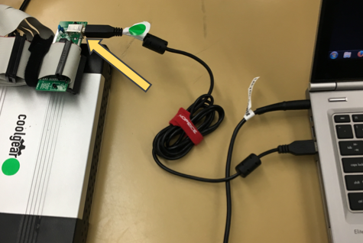
5.25-inch floppy diskettes
Once you have connected the FC5025 to the laptop via the USB cable and plugged it into a power source, insert the floppy diskette into the drive label-side up.

Starting the software
- From the Windows Start menu, choose the “USB Floppy Disk” folder, then “Disk Image and Browse.” The resulting screen looks like:
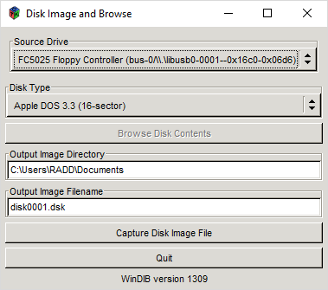
- Make sure the “Output Image Directory” is set to the Desktop.

Discovering the correct Disk Type
Try to find out what kind of computer the diskette was originally used on. That will help you narrow the possibilities.
- Click on the box underneath “Disk Type.” Choose your best guess about the diskette. By far the commonest types are “MS-DOS 360K” and “MS-DOS 1200K.”
- Click “Browse Disk Contents.” If the result is a file listing, you have found the correct Disk Type! If not, try other Disk Types until one works. If none works, the diskette is probably unreadable.

Imaging the diskette
- If you wish, choose a name for the output image in “Output Image Filename.” Keep the same three-letter file extension (it may be “.dsk” or “.img” depending on Disk Type).
- Click “Capture Disk Image File.” A window will pop up:
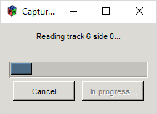
- When the capture is complete, another window will pop up:

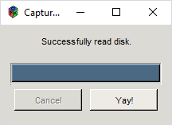
Extracting files from the image
You can do this with Disk Image and Browse, but it is tedious if there are many files on the diskette. The faster way:
- From the Windows Start menu, launch WinImage.
- Choose File Open, and browse to the disk image you created.
- From the resulting file listing, choose the files you wish to extract (shift-click to choose several in a row; ctrl-click to pick and choose).
- Right-click on the selected file(s) and choose “Extract.”
- Choose a location to save the file(s) to.

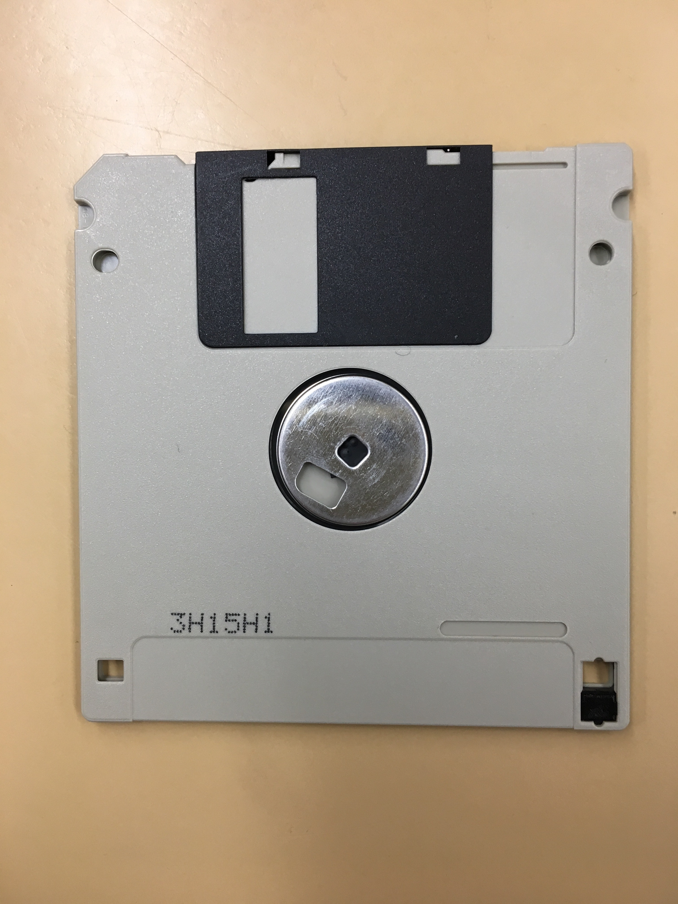
3.5-inch floppy diskettes
Plug the 3.5 inch floppy disk drive into the laptop via its USB connection, and insert the floppy diskette into the drive label-side up. Note: to write-protect the floppy disk, make sure the notch in the bottom corner is switched to the open position.

Extracting files from the disk
- From the Windows Start menu, launch WinImage.
- Choose File Open, and browse to the Floppy Disk Drive.
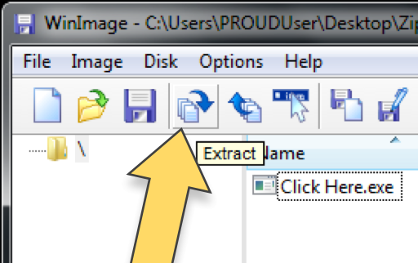
- Choose Disk Read disk
- Under File Save, save as an “Image file .ima”
- Choose a location to save the disk image to.
- Now click the Extract icon (pictured right).
- Browse to find the disk image you just saved.
- Click OK to extract the file(s).

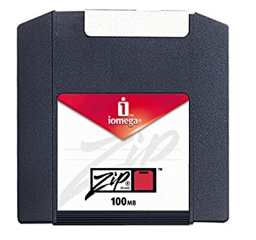
Zip disk
Plug the Iomega Zip disk drive into the laptop via its USB connection, and insert the Zip disk into the drive label-side up.

Extracting files from the disk
- From the Windows Start menu, launch WinImage.
Note: make sure all other windows are closed.
- Choose Disk Use removable disk F:
- Choose Disk Read disk.
- Under File Save, save as an “Image file .ima”
- Choose a location to save the disk image to.
- Now click the Extract icon (pictured right).
- Browse to find the disk image you just saved.
- Click OK to extract the file(s).

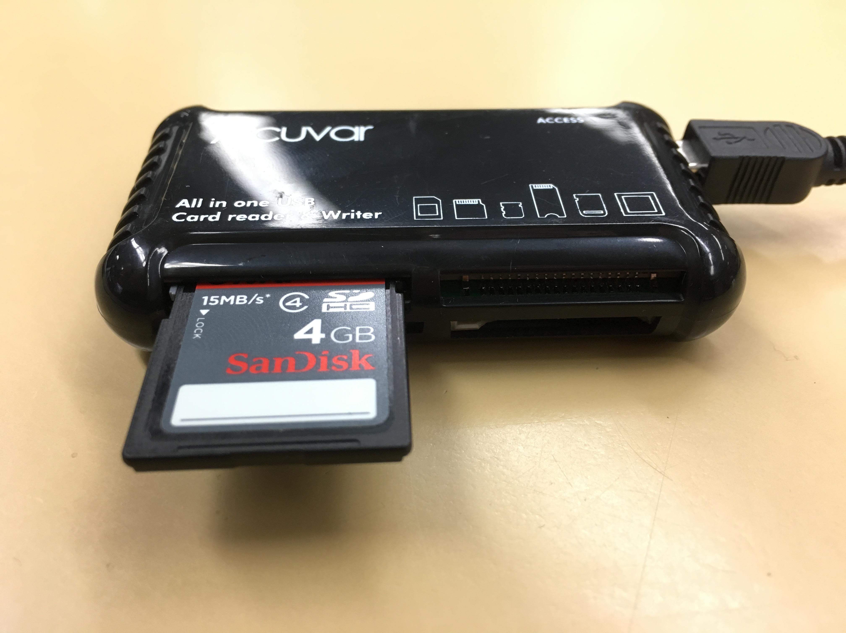
Memory cards
Plug the Acuvar card reader into the laptop via its USB connection, and insert the memory card into the slot in which it fits. Note: be very careful with the slots contaning pins inside, they are delicate and can break easily.
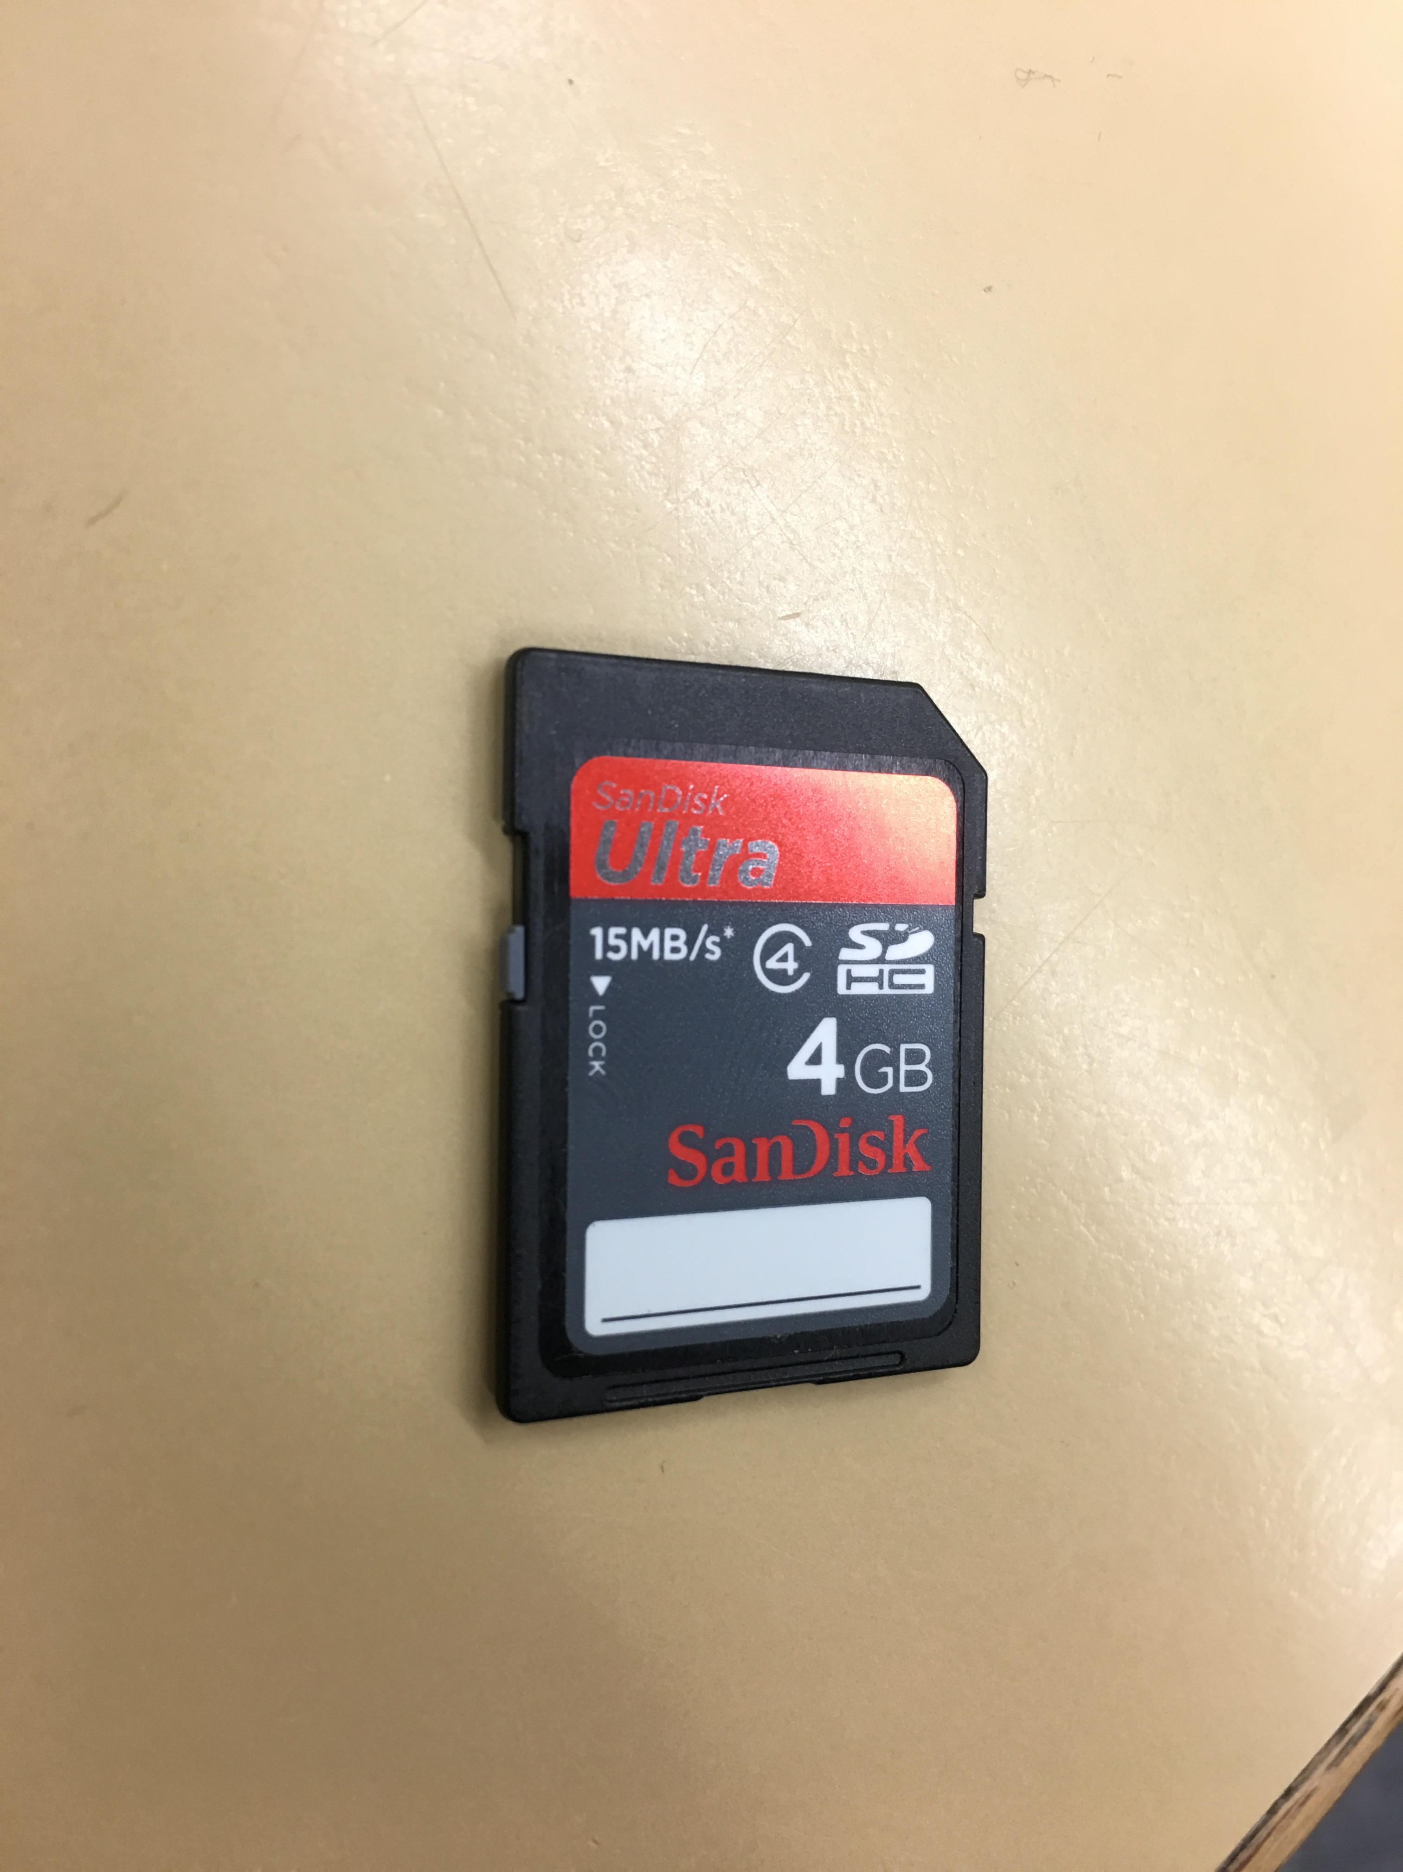
To prevent accidentally deleting or altering files, some memory cards can be write-protected by sliding the notch on the side of the card to lock.

Extracting files from the card
- From the Windows Start menu, launch WinImage.
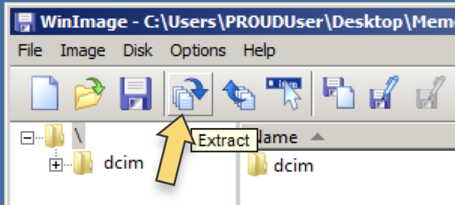
- Choose Disk Use removable disk
- Choose Disk Read disk
- Under File Save, save as an “Image file .ima”
- Choose a location to save the disk image to.
- Now click the Extract icon (pictured right).
- Browse to find the disk image you just saved.
- Click OK to extract the file(s).

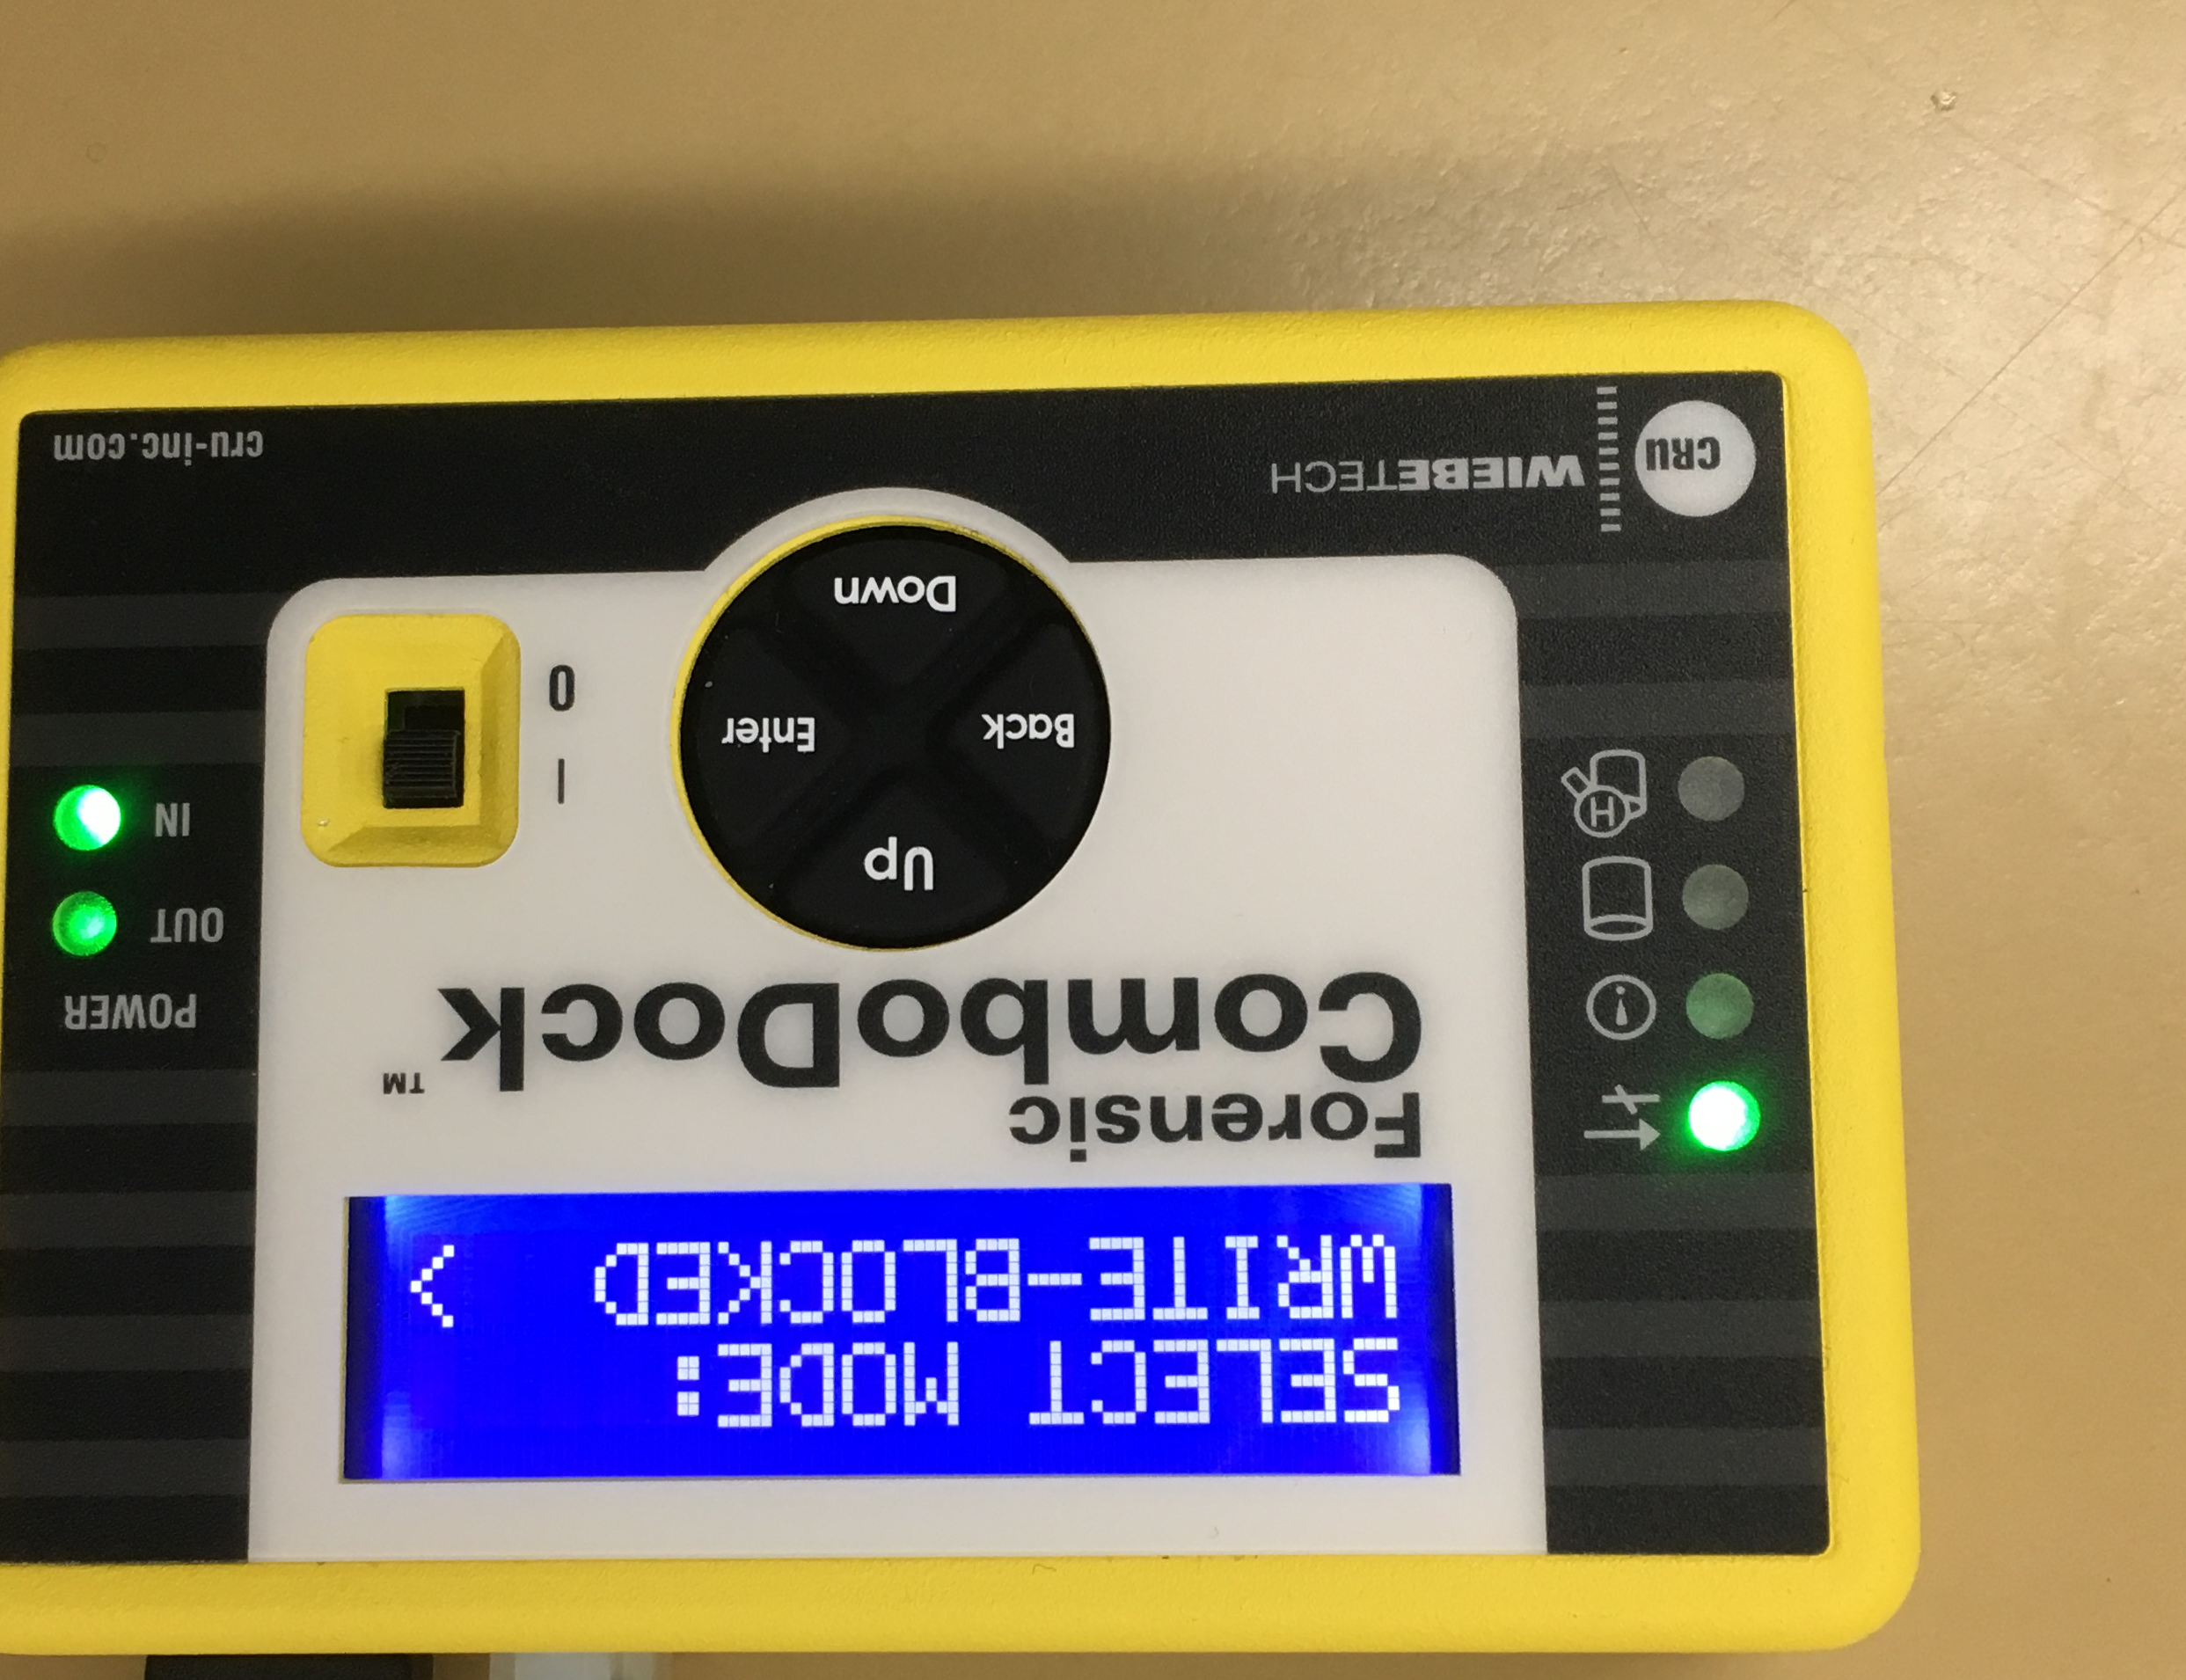
Hard drives
Plug the CRU Forensic ComboDock into the laptop via its USB connection, and insert the floppy diskette into the drive label- side up. Note: to write-protect the floppy disk, make sure the notch in the bottom corner is switched to the open position.

Extracting files from the disk
- From the Windows Start menu, launch WinImage.
- Choose File Open, and browse to the drive.
- Choose Disk Read disk
- Under File Save, save as an “Image file .ima”
- Choose a location to save the disk image to.
- Now click the Extract icon (pictured right).
- Browse to find the disk image you just saved.
- Click OK to extract the file(s).

Repacking PROUD
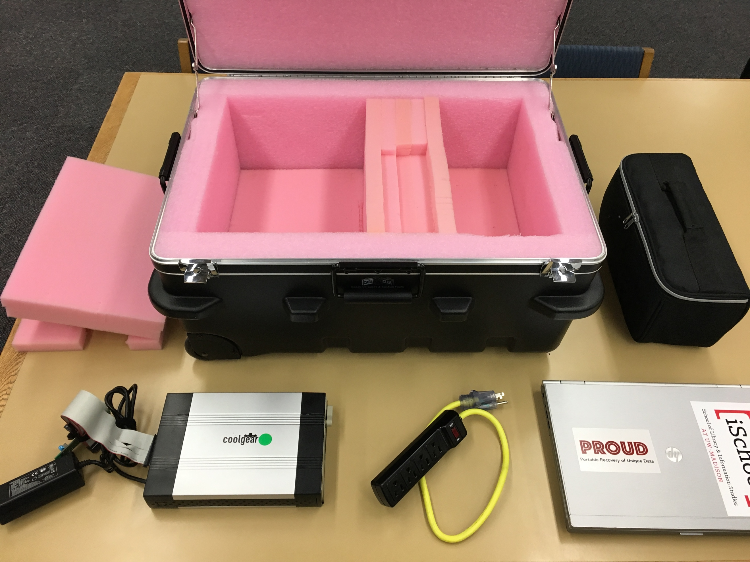
Open PROUD’s box.
First, pack all small components (cables, floppy and Zip drive, etc.) into the black zippered pouch.
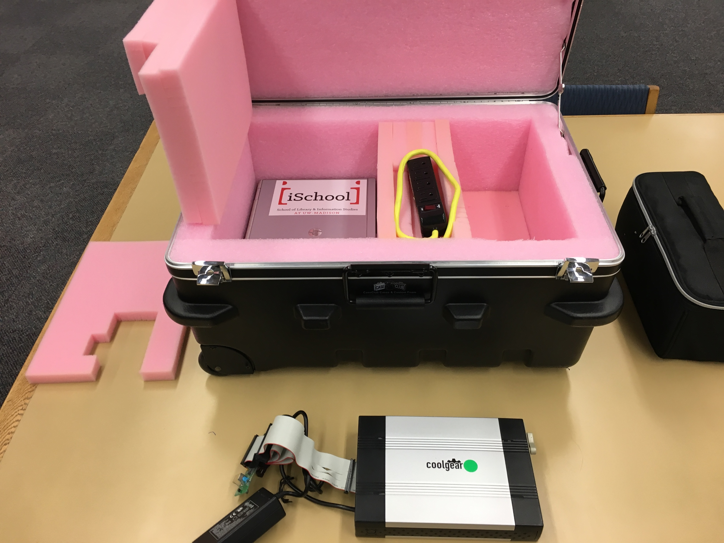
Next, place the closed pouch into the right-hand space. Place the laptop into the left-hand space, and put the rectangular foam cushion on top of it with the glued-on strip pointing up and to the right. Place the power strip into the shallow depression in the middle.

Next, place the 5.25-inch floppy drive on the left, with the disk opening facing the back.
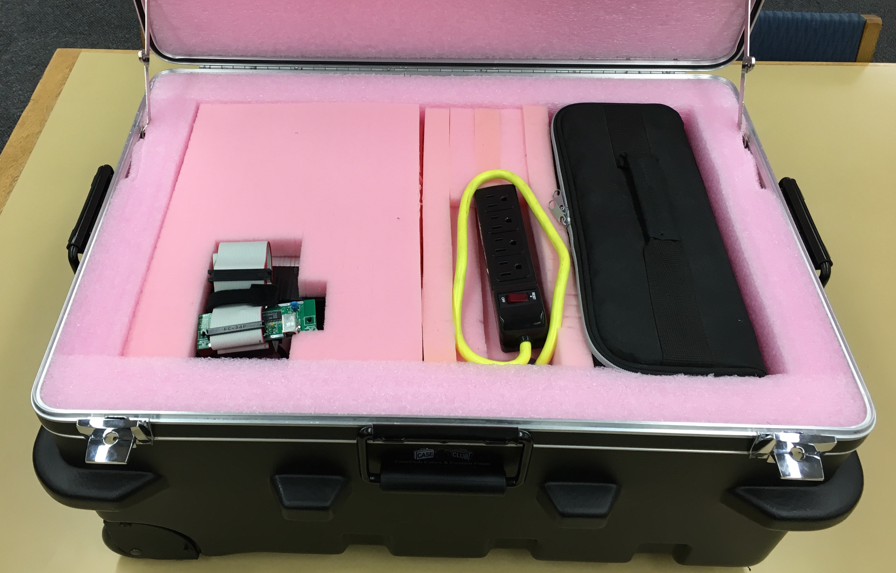
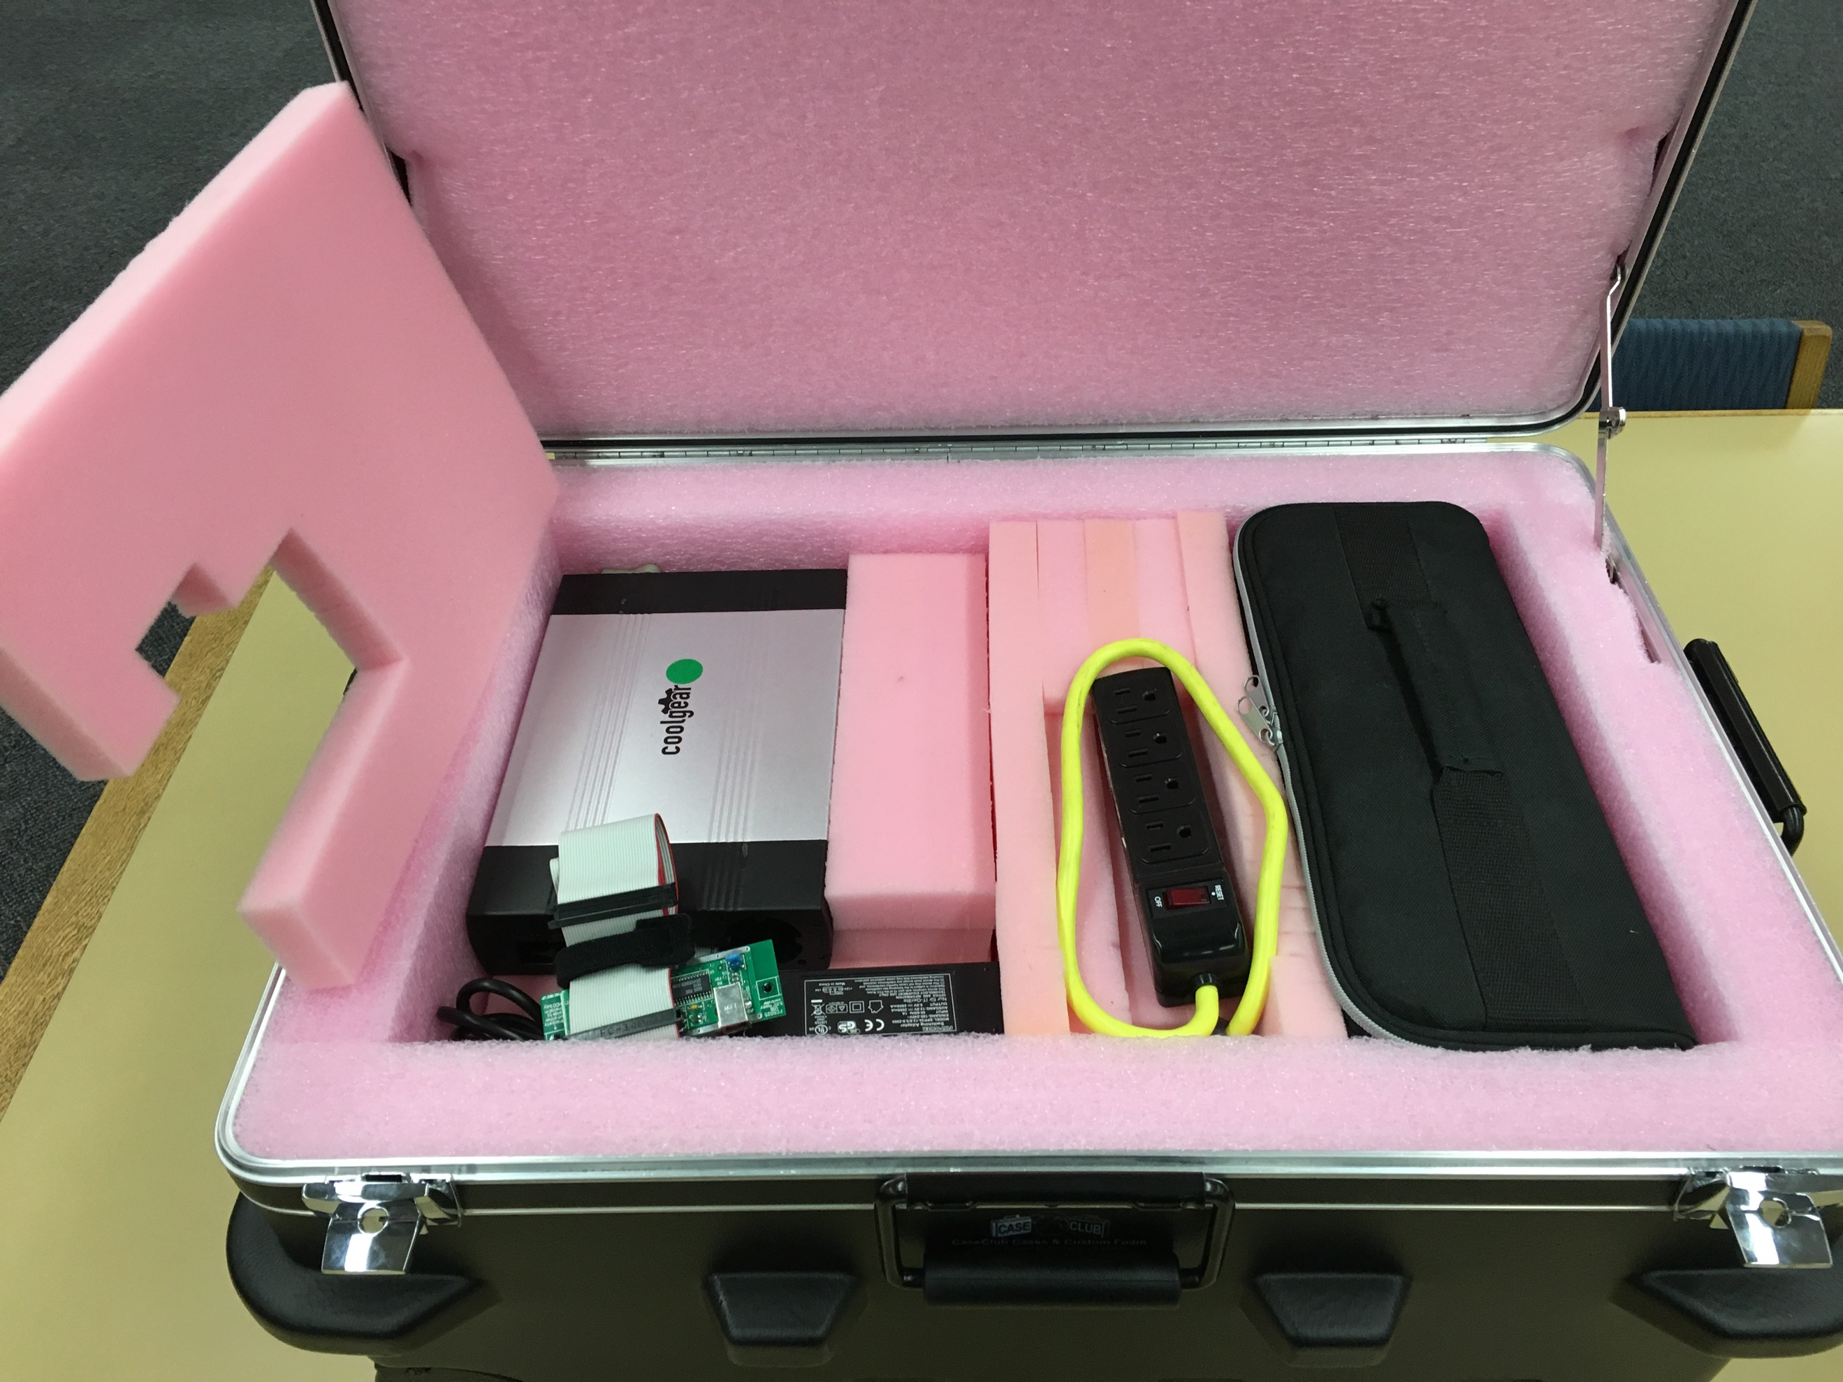
Now place the foam piece with the cutout over the floppy drive, adjusting the ribbon-cable rig to fit into the hole.

Now you can close the box lid and its clasps. You’re done!

