High Power Microwave Breakdown Study

By: David C. Holmquist
Advisor: Professor John Scharer

A Thesis written for a partial fulfillment of the requirements for the degree of

Master of Science
(Electrical Engineering)

University of Wisconsin-Madison
2011

Table of Contents

Abstract........................................................................................................................................................2
Objective of High Power Microwave Study..................................................................................................2
Description of Experimental Set Up……………………………...............................................................................9
Experimental Results……………………………………………………………...................................................................18
Fast Time Scale Plasma Calculation............................................................................................................26
Modeling……………………………………………………………………………………………………………………………………………….28
Visual Plasma Formation…………………………………………………………………………………………………………………….…31
Complex Standing Wave Pattern……………………………………………………………………………………………………………38
Standing Wave Pattern………………………………………………………………………………………………………………………….44
Future Plans…………………………………………………………………………………………………………………………………………..46

Microwave Breakdown Experiments in Ne, Ar and Penning Discharges (Abstract)

In this research a rapidly forming (<50 ns) self-initiating distributed plasma discharge was observed using an X-band (WR-90) microwaves. We also observed slower forming (300-400 nS) plasma breakdown with 1 kHz repeated 800 nS microsecond pulses. Visual plasma formation was observed with a variety of high power reputation rates. The microwave discharge test chamber is an L-band (WR-650) rectangular waveguide with polycarbonate windows. The chamber is illuminated by the output of a 25 kW, 9.382 GHz magnetron with an X-band waveguide pressed against the chamber window. I filled the chamber with Ne, Ar, and mixtures of Ne and Ar. Singles pulse of 0.8 us along with 1 kHz repeated microsecond pulses were investigated. The objective of the experiment was to study conditions and configurations enabling rapid discharge formation with gas configuration, pressure, and pulse variety as different input parameters. The goal was to significantly attenuate the transmission signal on less than 100 nS time scales and visually observe the breakdown process with an ultra high speed ICCD camera.
A. Objective of lower microwave power fast < 50 ns breakdown with high T>-10 dB attenuation. Review previous breakdown and what is different about our objectives.

The goal of this study is to research breakdown in a gas chamber bounded by a dielectric surface. One example of where it could possibly be used would be put on the surface of an airplane’s window it could protect the aircraft from pulsed power destroying sensitive electrical equipment either from the ground or from another plane. There is High Power Microwave systems capable of operating at gigawatt power levels on the nanosecond timescale. (Booske, 2009, pp. 4-6)The objective of this research was to study rapid formation of distributed plasma to attenuate high power microwaves on the surface of a window on the nanosecond time scale. One key question this experiment would like to answer is what initiates the electrons to create the plasma. The factors the research project is trying to answer is what influences the following have on forming plasma on the dielectric surface: (Booske, 2009, pp. 10-11)
- Power Thresholds
- Turn-on time and transmission and reflectivity vs. time
- Recovery time frequency selectivity (X-Band...Etc.)
If the electric field is high enough on the surface of the poly-carbonate window some of the electrons will have inelastic collisions with neutrals when they are above the ionization energy. Because of this there is a chance that a collision will produce a second electron and a positive ion. When these collisions happen so often the production rate of electrons is higher than the loss rate and breakdown will occur. (MacDonald, 1966, p. 71) Loss of electrons is due to diffusion, recombination and a few other more complicated processes. I performed a few calculations to ensure we were going to theoritcally have breakdown in our test chamber.
The first calculation was to find the value of the electric field generated by our magnetron to ensure its higher than the minimum breakdown field for a particular gas configuartion. For this intial check I used an electron temperature of 1 eV and a pressure of 10 torr. Later reasearch has shown if our breakdown time is in the 10’s of nanoseconds the electron temperature is likely higher than this and it could be as high as 10 eV, but to ensure breakdown I assumed a low side estimate. The following is the caclulation for the maximum electric field and the effective maximum electric field after taking into account electron neutral collisions. The effective electric field can be thought of as the effectiveness of the electric field in transfering energy to the electrons. (MacDonald, 1966, p. 63)

Equation Set [1]

Equation set 1 theortically tells what the electrical field strength is on the inside of the polycarbonate window. This is assuming a 1-D model to simplify the calculation. The next calculation set is for the theortical field strength needed for breakdown. If the field strength generated from the magnetron is greater than the minimum field strenghth for a particular gas configuration theortically there should be plasma formed. The following is the calculation for the minimum field strength for breakdown taken from (MacDonald, 1966):

Equation Set [2]

From the equation set 2 calculations it can be seen the field inside the chamber is well above the theoretical minimum breakdown value for plasma to form in Argon gas at 10 torr. But impurities inside the chamber such as air can increase the power threshold for breakdown. On the other hand, there were some assumptions made about electron temperature and mathematical simplifications were made. In addition, there is a large impedance mismatch going from X-band to L-band. Even if there was not a poly-carbonate window at this intersection there would be power reflected. Therefore, the value for the field on the inside of the chamber is probably a rather high estimate. The next part of the set up was trying to find where the power was going if the incident, reflected, and transmitted power do not add up.
There are various ways energy is transferred from fields to plasma: ohmic heating, stochastic heating, resonant wave-particle interaction, and secondary electron emission heating. (Lieberman & Lichtenberg, 2005, p. 329) The main source of our power absorption is through ohmic heating because we are operating at high pressure and the total electron-neutral collision frequency is high. The collisions create an electric field in the plasma which is quite small, but does absorb a lot of power. The time averaged power per unit volume absorbed by the plasma is given by (Lieberman & Lichtenberg, 2005, pp. 97-99):

$P_{abs}=\frac{1}{T}\int_{0}^{T}{J_{T}\left(t\right)∙E\left(t\right)dt where T= \frac{2π}{ω}}$
Equation Set [3]
$$J_{T}\left(t\right)=\left(\frac{∈_{0}ω_{pe}^{2}}{jω+υ_{en}}+jωϵ_{0}\right)∙E(t)$$

There is a more general form which describes the effects of dissipation through an anti-Hermitian component of the dielectric tensor. (Swanson, 1989, pp. 175-177) In general and will be tensors but due to no direct current magnetic field in our experiment they will both only be in the vertical direction.

Equation Set [4]

After some algebra it can be seen that the absorbed power is real and it has no imaginary part to it. But the time averaged stored energy could have an imaginary part to it. Also, it can be seen that the ratio of has significant effects on how much power is absorbed. In our particular case this ratio is of order 1. But, in order to verify this we need to find electron temperature. Finally, the last parameter to increase the absorbed power is the electron density. The density is proportional to the absorbed power. The following parameters are in the above equations for absorption of microwave power:

The plasma frequency: $ω_{pe}=\frac{n_{e}e^{2}}{∈_{0}m_{e}}$ 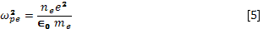
Equation Set [5]
Magnetron frequency: $2π*9.382*{10}^{9} {rads}/s$

The plasma frequency is directly proportional so the density, therefore so is the absorbed microwave power.
There have been other experiments done which are related to this one in the commercial market, in the past at national laboratories, and currently at researching Universities. First I will explain the research currently being investigated at the University level. The study done at Texas Tech is similar to this one. (J. Foster, 2011) But, this experiment is different because their magnetron is running at 2.85 GHz, 5 MW of power, and a pulse length of 3.5 µs. Also, the magnetron set-up of the two experiments is slightly different because we do not have to use a circulator for turning on the microwave power because the power of our magnetron is much less and it does not take nearly as long to turn on to full power. But, on the other hand, both experiments have a WR-650 size plasma test chamber with various gas configurations. The study at Texas Tech concentrates on air and Argon gas while the experiment I performed concentrated on Argon and Neon gas but not air. There are a few commercially available (MacDonald, 1966)Receiver protector technologies made by Communications & Power Industries wireless solutions is similar to our experiment, but their products are all in a single size waveguide and with multiple pulses. (Receiver Protector Technology, 2011) Their product would most likely be used in a radar-receiver’s waveguide. But, the diffuse nature of the plasma in the transition between the X-band to L-band is what makes our research different from CPI technology. Some of their products include: TR tube, diode limiter, ferrite limiter, pre-TR tube, and multipactor. But our objective is different than breakdown in a waveguide. This experiment is trying to simulate a high power microwave pulse being attenuated on the surface of a dielectric. This design would still feature the same functionally as CPI products as far as having a low power state and a high power state. But Receiver protector technology is different from our experiment because it describes full attention as being -3 dB, which means there is only a 50% reduction of the actual power. The criteria of only -3 dB of attenuation would not be enough for our experiment. But it some cases for this experiment I saw a -10 dB reduction of power which is actually a 90% reduction in absolute power. The next place where this research was experimented with was during the 1960’s at Lockheed Palo Alto Research Laboratory. (MacDonald, 1966)
In 1966 A. D. MacDonald wrote a book about his research results of the interaction of microwaves with gases in general and particular how the gases breakdown. (MacDonald, 1966, pp. v-vi) The part of the book resembling most closely this research experiment is Breakdown Theory, Variable Collision Frequency. (MacDonald, 1966, pp. 101-120) During this experiment MacDonald had a slightly different set up. He had a test chamber filled with Argon and Neon gas, but he did not have a double pane polycarbonate window as our experiment, but rather he did the experiments in a large open waveguide. Since our set-up is not exactly the same, the results of this experiment cannot be directly compared to ours, but it is a starting point. In addition, MacDonlds experiment was done in the low pressure regime: ($ω^{2}≫ν_{en}^{2}$) and also the high pressure regime ($ν_{en}^{2}≫ω^{2})$ and this is also slightly different than my experiment because these values are assumed to be approximately equal.
B. Description and photos, drawings of experimental setup, couplers, EH tuner, Circulator probes, base pressure gas flow systems. Two settings for Circulator, EH Tuner, matched load configurations.

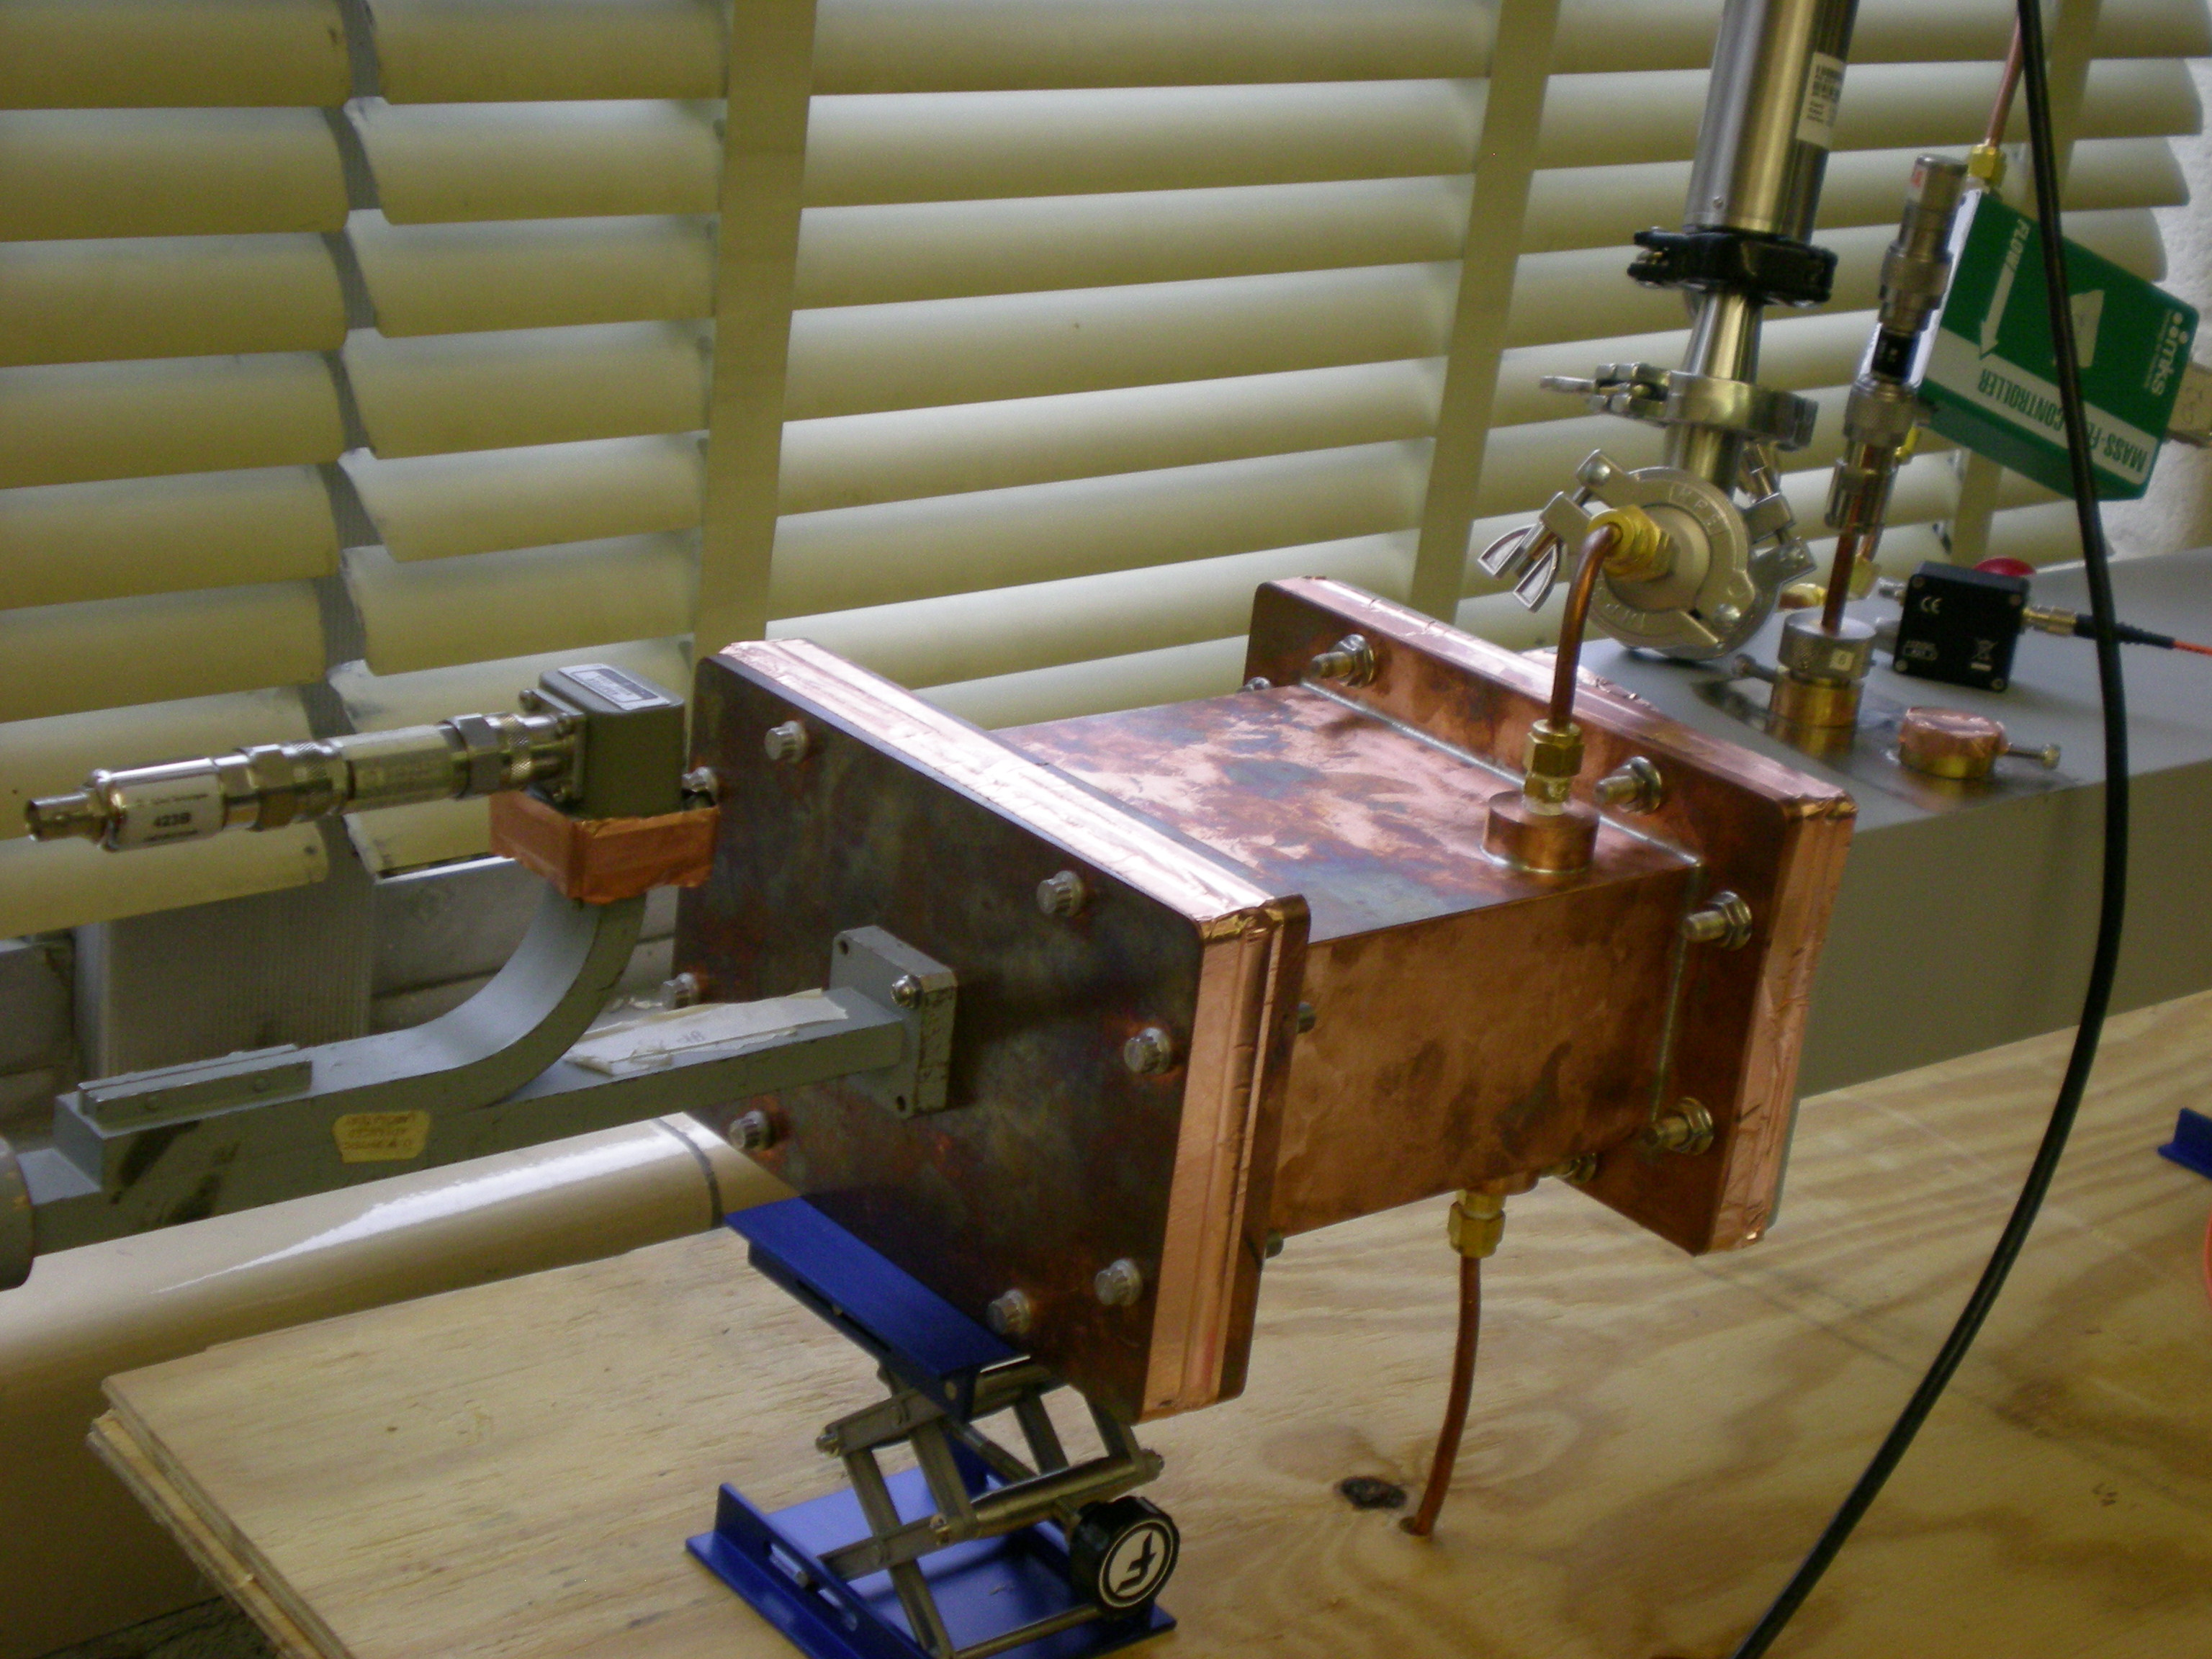
Figure 1-Overall set up

The goal of the set up is to simulate a double pane window similar to what is on an airplane. First, the experiment has an x-band waveguide which has a single mode followed by an overmoded waveguide to simulate free space. The magnetron generates only TE modes and has an X-band connection at the top of it. In our x-band waveguide we have a single TE10 mode. This is found by the following calculation:
$f_{cmn}=\frac{c}{2π}\sqrt{{\left(\frac{mπ}{a}\right)}^{2}+{\left(\frac{nπ}{b}\right)}^{2}}$
Equation Set [6]

The letters m & n are for the different modes traveling in a waveguide and the letters a & b are the dimensions of the waveguide. The letter as is the smaller dimension of the rectangular waveguide. In addition, the letter c is the speed of light. The frequency of the magnetron is 9.382 gigahertz and it has to be greater than the cutoff frequency calculated from equation set 6 otherwise that particular mode will not travel in the waveguide. The single mode field pattern in the X-Band waveguide is much simpler than the field pattern in the overmoded L-Band waveguide.
At the connection of the X-band to L-band there is going to be a lot of reflected power. The power is reflected because of the polycarbonate window and the impedance mismatch going from X-band to L-band. In the future it might be possible to insert a triple stub-tuner to try and minimize the reflections at this intersection. The relative permittivity of the poly-carbonate window is 2.96. The reflection coefficient estimate based on a one dimensional model with no plasma forming is found from the following calculation:
$Γ=\frac{\sqrt{\frac{μ_{0}}{{2.96∈}_{0}}}-\sqrt{\frac{μ_{0}}{∈_{0}}}}{\sqrt{\frac{μ_{0}}{{2.96∈}_{0}}}+\sqrt{\frac{μ_{0}}{∈_{0}}}}= -0.27$
Equation Set [7]
When the microwave pulse reaches the L-band side of the polycarbonate window there are many modes present above cutoff. This is to simulate a free space environment. The propagating modes in the WR-650 test chamber are:
$${TE}_{10},{TE}_{11}{,TE}_{12}{,TE}_{13}{,TE}_{14}{,TE}_{30}{,TE}_{40}{,TE}_{50}{,TE}_{60}{,TE}_{70}{,TE}_{80}{,TE}_{90}{,TE}_{31}{,TE}_{51},{TE}_{71}{,TE}_{91}{,TE}_{32}{,TE}_{52}$$
The difficult part of this set-up is measuring the power of the different modes after the ${TE}_{10}$mode is transitioned to a quasi-free space environment with plasma reflecting and refracting the signal. After the transition the microwaves are affected by the plasma and there will be more than just TE modes present in the discharge chamber. Some of the modes will have significantly more power than others. With the low enough power setting of this experiment the gas will not breakdown and the incident, reflected, and transmitted signals should add up and no power is lost anywhere. But in the plasma case some of the power is lost to the creation of plasma. In addition, this experiment will have some leakage pulse similar to the CPI product because both configurations will have a finite amount of time for the gas to break down. The breakdown time is going to be different and dependent on power, pressure, gas configuration and leak rates. I will explain this concept and results further in the measurements section of this paper.

Figure 2-Detailed Picture of Multiple Set-Up Scenarios

The magnetron has a source of 25.7 kW of power at 9.382 GHz. The time it takes for the magnetron to go from zero to 25.7 kW is 25 nano-seconds as measured by a diode and an oscilloscope. I measured this time by using the oscilloscope and measuring the time it takes the incident power to go from zero to 25.7 kW. Since this time is so short I did not have to use a circulator as a switch. (J. Foster, 2011) A circulator can be used as a turn on switch when the power of the magnetron is so high that it can take on the same order of magnitude as the breakdown time. In order to isolate the incident port from the reflection port a 3-port circulator with matched load is used. The magnetron is fed into an X-band (WR-90) directional coupler. The X-band waveguide has a single ${TE}_{10}$ mode. The reason for a single ${TE}_{10}$ mode is because the power will spread out nicely when it is incident at the polycarbonate window. The next part of the set up is where the x-band waveguide is pressed against the larger test chamber creating a quasi free space environment.
The directional coupler is connected to port 1 of a circulator and this set up can be seen in figure 5. A directional coupler was used to attenuate power preventing the attenuators and diodes from being burned out. At the end of the directional coupler is a 423B Schottky diode from Agilent technologies. The diode is able to measure a voltage and this is converted into a power by calibrating the diode. This data was taken by sending a known power into diode and measure the voltage on the oscilloscope. A typical curve is shown in figure 3. We only take data in the region from-19 dBm to 21 dBm. We don’t take measurements below -19 dBm because the signal to noise ratio becomes too small and it is impossible to tell the difference between noise and actual signal. Also, the maximum power the diodes can safely detect is 23 dBm which corresponds to a value of 200 mWatts.

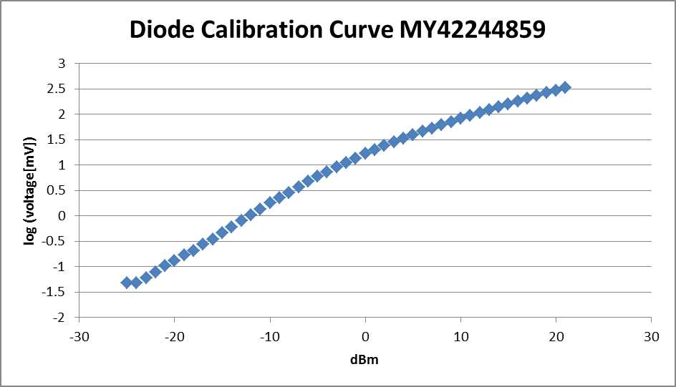

Figure 3-Diode Calibration Example
Port 2 of the circulator is attached to theWR-650 waveguide. The polycarbonate window is attached at this connection. The WR-650 is the discharge chamber. The chamber is pumped down to a base pressure that has varied between 50-500mTorr to ensure high purity of either Ne or Ar in the chamber. The chamber has 3 locations where gas can enter or exit. The gas is pumped in from the top of the chamber and pumped out the bottom. In addition, there are small leaks in every chamber and ours is no different. The volume in our chamber is 2.662 liters and it has a leak rate of 1 mTorr per second. The value of 0.0127 is there to make the units turn out correctly as having the leak rate in sccm.
$Leak Rate= \frac{.001\left[mTorr\right]*2.662[liters]}{0.0127}=0.2 sccm$ Equation Set [8]
The leak rate has varied during the course of this experiment from 1 mTorr per second to as much as 80 mTorr per second. This leak is caused by using a 1/8” thick brass rectangular waveguide as a vacuum chamber. Most of the leaks I have found during this experiment are at the connection of where the gas comes into chamber and where the chamber is being pumped down by the vacuum pump. There are two ways to find leaks. For both methods you need to pump the chamber down to the lowest pressure. After the chamber is pumped down to the lowest pressure either spray air on where you think the leak is or put acetone on it. If the pressure goes up when you have done either of those two things that would mean you have successful found the leak and now it needs to be sent out to have someone braze this location. After the test chamber, there is the other polycarbonate window with the dump chamber connected to it. The dump chamber is where the transmission diodes are located.
The localized measurement of transmission power is found by putting monopole antennas in the dump chamber. The transmission signal if found by taking the average of the middle 60 percent of a microwave pulse. The pulse is on for a total time of 800 nano-seconds and so the middle 60% of the pulse would be from 160 nano-seconds to 640 nano-seconds. The data is taken from the oscilloscope with a matlab program using the read LeCroy file already written. The data is saved in the oscilloscope as a TRC file. TheMatlab file to read in this data to Matlab is called CHPMprocess.m and it is included in the appendix under [1]. Next, the power data is put into another Matlab file called CHPMplot.m. This file is also included in the appendix under [2]. This file has two functions. It can either plot the power vs. pressure or it can take plot the average at each pressure and plot one standard deviation above and one standard deviation below this average. The way I changed the program to include both of this functionality is to comment out the section of the Matlab code you do not want to use by using the % symbol.
The third port is connected to a twenty dB directional coupler with a matched load on the end of the directional coupler. After the power is measured at this port it is absorbed by the matched load. The port on this directional coupler has a diode attached to it to measure the reflected power signal. The matched load is connected to create isolation between ports 1, 2, and 3. The circulator has magnetized ferrite material to create isolation. The circulator only lets power rotate around it in one direction. The power is circulated in a counter clockwise direction going from port 1 to port 2 and finally to port 3. When the power gets to port 3 there is a matched load that absorbs the power. After this all the power that goes from port 1 to part 2 is from the magnetron and this is how isolation is achieved with a circulator and matched load.
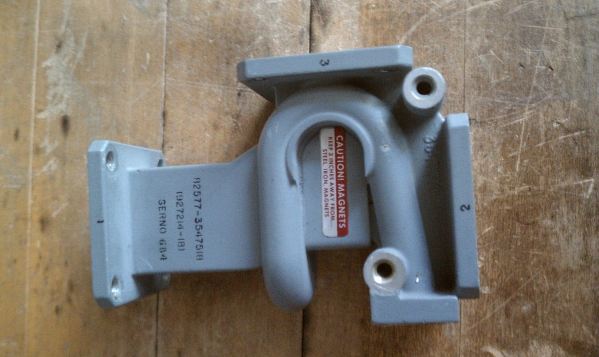
3
1
2
Figure 4-Picture of Circulator

Figure 5-Circulator Set-Up for Isolation

A circulator, E-H tuner, and matched load can also be used to vary the incident power of the magnetron. This cannot be done with attenuators because the maximum power sent through an attenuator is 10 watts and we have a source that is 25.7 kW. The set-up for lower power is similar to Michigan’s set up for peer-to-peer locking of magnetrons. (D.J. Cruz, 2009) The E-H tuner has two adjustable arms which are terminated with a short. The lengths of the arms are adjustable to within an accuracy of 1 µm. The plunger short design of this E-H tuner is oval in shape. When the adjustable arms are moved it changes the impedance as seen by port 3 on the circulator. The impedance is changed because when the waves from the two arms are added together they are no longer in phase. Because of this the value will not be doubled, but will be some fraction of it because the waves are sinusoidal.
To ensure the magnetron is operating at a lower power I first tested the S-parameters of the circulator with a network analyzer operating at 9.382 GHz. After this lower power test I hooked the circulator up as shown in the configuration shown in figure 6 and tested it with high power. This high power test was done with an X-band matched load connected to port one of the circulator. As we change the settings on the E-H tuner the impedance changes. The two arms of the E-H tuner are pieces of waveguide, and the settings change the length of the waveguide. At the end of the waveguide it has a short circuit. As the length of the waveguide changes the signals get added together out of phase and the result is a lower power coming out of port one of the circulator.

Figure 6-Circulator Set-Up for Variable Incident Power
We tested a few settings at low power with the network analyzer and at high power with an X-band matched load. The following table is the result. The low power and high power case does not match up exactly, but it is very close. The reason why the result is probably not exactly the same is when the power is absorbed into the matched load it is hard to obtain zero reflections. The setting column is obtained from the network analyzer and the measured column is from the high power measurement.

Setting (dB) | Measured (dB)
-16.40 | -16.10
-12.50 | -12.10
-9.00 | -8.60
Table 1-Attenuation Values
The first time I set up the network analyzer I chose random settings to try and find different amounts of attenuation. There are only two arms to be changed to change the amount of attenuation. The arms are labeled up and right. I put a piece of tape on the arms to know the difference between the two. The following table shows the settings for the two arms and the amount of attenuation for the corresponding setting.

Up (mm) | Right(mm) | dB
0.52 | 1.75 | -16.40
0.52 | 1.25 | -12.50
0.52 | 0.75 | -9.00

Table 2-Circulator Settings
C. Measurement of Transmission vs. Pressure measurement for Ar, Ne with single shot. Normalized graphs of attenuation vs. probe depth at constant pressure for single shot and repetition of high power microwave pulses.
The first set of experiments I performed was taking attenuation vs. pressure with a monoole antenna which was 6.35 mm in length and the outer diameter of the semi-rigid coaxial cable was also 6.35 mm. The semi-rigid coaxial cable was used as a dipole antenna. The insulator and outer conductor were scaled back to have just the inner conductor showing. This inner conductor served as an antenna. All of the data I have taken has been with this type of antenna configuration. But I also varied the length and diameter of the antenna I was using. Later on during the experiment I used a 2.24 mm outer diameter semi rigid coaxial cable to try and minimize reflections and scattering from the antenna.
This set of data was taken to show evidence of plasma and at a localized position in the overmoded waveguide how much attenuation was caused by plasma forming in front of the X-band waveguide. Theoretically the only values which change during a pressure variation would be plasma properties. The permittivity and permeability of the gas in the pressurized chamber does not significantly change while there are changes in pressure. But the plasma properties are changing, and one example of this can be seen from Eq. [10] that the collisional frequency between the electrons and neutrals is directly proportional to the pressure. The first set of data showed little change in the incident and reflected signals while a large change was shown in the transmission signal.
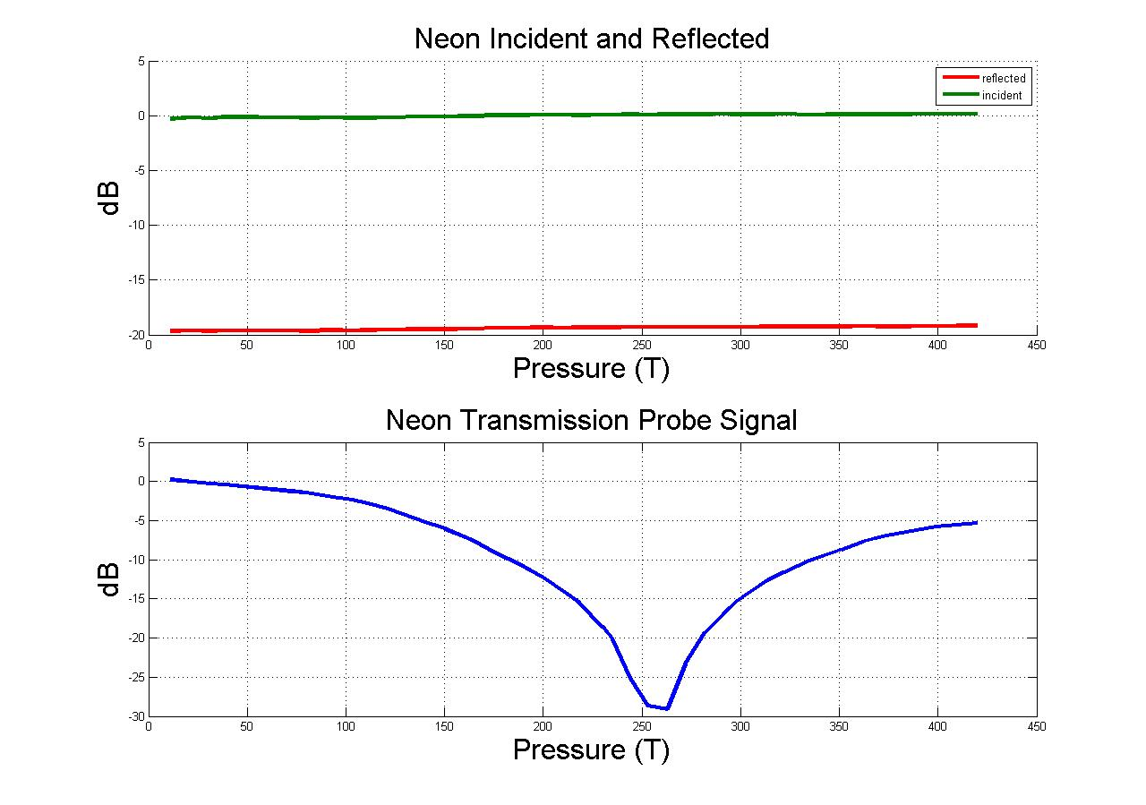
Figure 7-Initial Results of Ne Gas Configuration
The graph above shows the differences between the three signals. All of the values were normalized to the lowest pressure condition. This means the lowest pressure is the zero level and all negative dB values correspond to a negative amount of attenuation as compared to this value. The reflected signal was – 20 dB down from the incident signal and did not change much as the pressure was varied. But the transmission signal changed significantly during this pressure scan. At 250 Torr of pressure this localized position of x = 368.3 mm, y = 4.7625 mm, and z = 82.55 mm in the dump chamber had a 99.85% reduction of microwave power. The x position was measured from the front of the fist polycarbonate window and the outside diameter of the probe was 6.35 mm. This power is being absorbed by plasma. The evidence of the plasma can also be seen from the oscilloscope traces of the transmission signals. The screen shot of the oscilloscope below is when the pressure was at 10 Torr. The trace shows the voltage measured has a value of 20 mVolts and from the diode calibration of the diode ending in serial number 44 has a power value of 1 dBm. This value of 1 dBm is much smaller than the incident signal because power is being reflected of the poly-carbonate window and it is only a localized measurement.
Figure 8-Oscilliscope Screen Shot at Low Pressure

Figure 9 is taken when the pressure in the chamber is 250 Torr. The difference in the two transmission screen shots is again due to plasma formation on the inside of the polycarbonate window absorbing microwave power. The probe positions were the same: x = 368.3 mm, y = 4.7625 mm, and z = 82.55 mm.

Figure 9-Oscilliscope Screen Shot When Plasma is forming

The screen shot in figure 9 shows a voltage value of 1 mVolt. This voltage corresponds to a power level of -12 dBm from the diode calibration curve for power vs. voltage. The difference between the 10 torr in figure 8 and the screen shot of 250 torr shown in figure 9 is 39 millivoltts. From the diode calibration this corresponds to a value that is only -13 dB. From the pressure scan graph it shows a -28 dB of attenuation. I am not sure why there is a difference between the two values in attenuation.
The initial goal of the experiment was to look into the differences between Ne and Ar in the ability to rapidly create plasma. There are many differences between Ne and Ar, but one factor for creating plasma is first ionization energy. The first ionization energy for Ne is 21.56 eV and for Ar is 15.76 eV. Because the ionization energy for Ar is lower than Ne it should be able to create free radical electrons more easily. But there are other factors to consider, such as the area of neutral atoms in the gas. The square area of neutral atoms in Ne is higher than that of Ar. The next set of graphs and oscilloscope screen shots is for Ar.
The incident and reflected graphs for Neon is almost identical to that of Argon. Since they are almost the same I did not include them for this analysis. The following graph is the transmission measurement of Argon. The pressure ideal for breakdown occurs at 240 Torr for Argon and this is similar to Ne but not exactly the same. The amount of attenuation is slightly less than Ne, although this result was not exactly the same every time I ran the experiment.
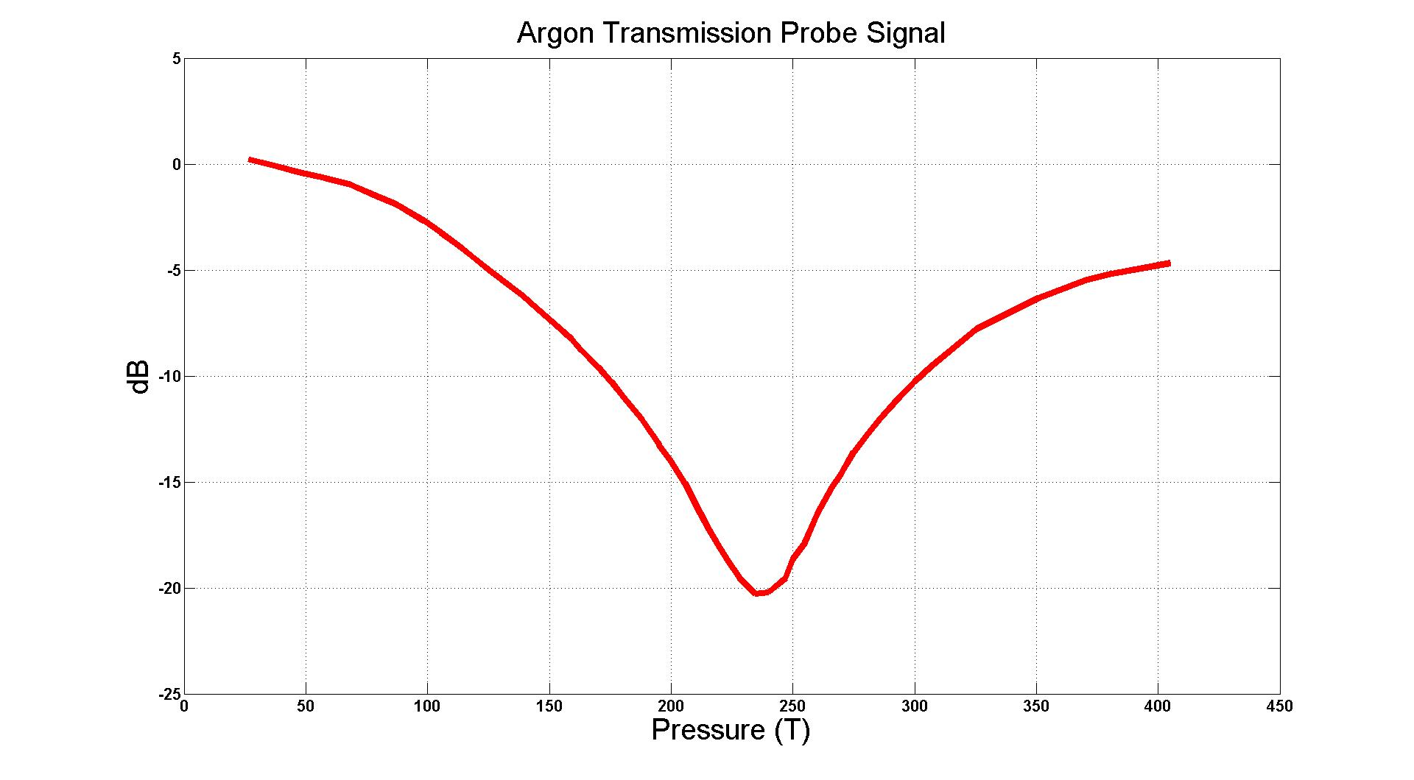
Figure 10-Initial Results of Ar Gas Configuration

Figure 10 was again normalized to the lowest pressure measurement of 10 torr. The localized transmission measurement was also again taken at x = 368.3 mm, y = 4.7625 mm, and z = 82.55 mm with the probe with an outer diameter of 6.35 mm. There are 40 points taken from 10 torr to 400 torr and it can be seen from figure 10 the results were very consistent during this pressure scan. Figure 11 is an oscilloscope screen shot is taken at 10 torr.

Figure 11-Ar Gas Low Pressure Oscilloscope Screen Shot

From figure 11 it can be seen there is not a spike. Although it cannot be certain if there is no breakdown occurring because the only plasma diagnostic with the dump chamber on is the probe in the overmoded waveguide. The value of this oscilloscope shot is 40 millivolts and this is the same as the experiment taken in Ne gas and it has a value of 1 dBm. The next oscilloscope reading show in figure 12 is taken at 240 torr. This screenshot is being shown to again illustrate the “spike” behavior when plasma is forming.

Figure 12-Oscilliscope Screen shot of Ar Gas When Plasma is formed

The value of this screen shot is approximately 1 millivolt. The difference between figure 11 screen shot taken at 10 torr and the value of 240 torr shown in screen shot 12 is 39 millivolts. When calibrated with the diode ending in 44 this value is again less than the -20 dB of attenuation shown in figure 10. Also, I am again uncertain why these values do not equal each other.

D. Fast time scale <50 ns behavior of T, R and I vs. pressure. And fast time scale collision frequency calculation.

One of the original goals of this experiment was to find the time of plasma formation. This means the length of time it takes to attenuate the high power microwave pulse. To estimate this value I am going to make the simplistic assumption that it is on the same order as the collision frequency between electrons and neutrals. This can be assumed because the plasma is generated from free radical electrons.
Electrons are moving around at a very rapid velocity and it is dependent on electron temperature. An electron can make either an elastic or inelastic collision with neutral particles. When an electron makes an elastic collision it obeys momentum conservation and the effective cross sectional are is the momentum transfer cross section. (Francis, 1984, p. 155)The equation for the elastic collision frequency is found in equation set 9:

per second Equation Set [9]

The cross section that an electron sees depends upon its energy and therefore its temperature. If the electron has enough energy it makes an inelastic collision. When this happens it can disturb the electrons orbiting the atom and the atom moves into an excited state. If the electron has enough energy it can knock an electron entirely off the atom ionizing it. For this calculation there is an excitation cross section that needs to be used instead. The first ionization energy for Argon is 15.579 eV and for Neon is 21.564 eV.
$ν_{en}=n_{n}〈σ_{ion}v〉=\frac{8.3*{10}^{14}*Torr}{k_{B}*T_{e}}*\overline{σ_{ion}*\sqrt{\frac{3}{5.56*{10}^{16}}*k_{B}*T_{e}}} Per Second$
Equation Set [10]

The cross sectional area for Ar is found from figure 13 shown below:

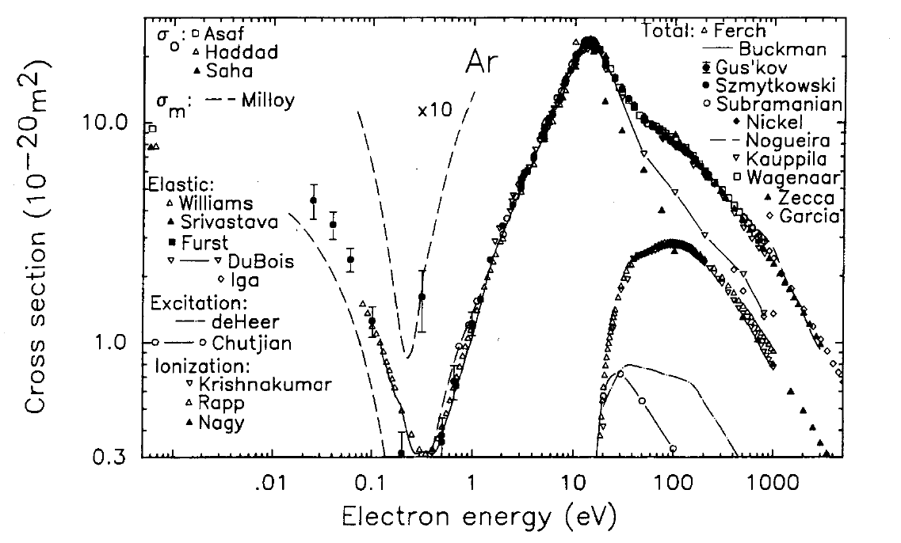
Figure 13-Cross Sectional Area of Ar (Zecca, 1995, pp. 30-38)

Using as illustrative pressure of 100 torr and an electron temperature of 10 eV from equation set [10] the collision frequency between electrons and neutrals is found to be approximately: $5*{10}^{10} S^{-1}$ . When I take this inverse of this value I can find that the estimated value of the breakdown time of Argon is on the order of nano-seconds. I also performed similar calculations with Neon gas and found the value to be also on the order of nano-seconds. When the plasma bright light is emitted and is a good source of evidence for breakdown.
Atoms in the ground state can be excited by collisions or radiation to higher energy bound states. (Lieberman & Lichtenberg, 2005, pp. 67-70) When the single-valence electron is excited the bound state emits a photon. Equation set 11 shows an example reaction with Argon in the test chamber:

$e+Ar→{Ar}^{*}+e→Ar+e+ℏω Equation Set [11]$
${Energy}_{Photon}=ℏω$

The ${Ar}^{*}$ state in equation set [11] means the excited state. The energy given off as a photon can often be seen with a flash of light and the initial plan was to view this flash of light with an ultra high speed ICCD camera. This proved to be a difficult task and was never achieved with repeatable results.
D. Modeling of plasma

The non-repeatable results in the laboratory naturally led to a discussion of trying to explain this by trying to model the plasma by making simplifying assumptions. Although there are many unknowns and assumptions for this modeling section it gives insight into what plasma variables have a large effect on the results of the transmission measurements. The modeling was done with a three region model: air-window-plasma.

E(x)
K(x)

Air Window Plasma

Figure 14-Three Region Plasma Modeling

For this model it can be seen the electric field is assumed to be only in the Y direction and the wave is only traveling only in the X direction. These two assumptions will be true until the plasma is initiated, and when this wave interacts with the plasma these two assumptions will no longer hold. I started with this simple model to as a place to start and if down the road there are more reliable results there would have to be an investment made to purchase more expensive software to try and model what is happening. First, I looked into the reflection and transmission coefficient based on changing plasma properties.
The permittivity of the plasma is found from the following equation:

$\frac{∈_{plasma}}{∈_{0}}=1-\frac{ω_{p}^{2}}{(ω+iν_{en})ω}$ Equation Set [12]

The plasma frequency calculation can be found by equation set 5 and the collision frequency calculation can be found by equation set 10.
The next parameter I modeled was the attenuation constant of the wave as it travels in the plasma. The wave is going to decay at an exponential rate as it enters the plasma region and it does so by the attenuation constant called alpha. The following equation is the model for the attenuation constant as given by: (Inan, 2005)

$$α=\frac{1}{\sqrt{2}c}{\left(\frac{ω\sqrt{ω_{p}^{4}ω_{en}^{2}+ω^{2}{(ω^{2}-ω_{p}^{2}+ν_{en}^{2})}^{2}}-ω^{2}(ω^{2}-ω_{p}^{2}+ν_{en}^{2})}{ω^{2}+ν_{en}^{2}}\right)}^{1/2} \frac{Nepers}{Meter} Equation Set [13]$$

The c given in the above equation is the speed of light. As you can see this is a complicated equation with a lot of variables. To try and gain some understanding of what is going on I plotted the attenuation constant while changing plasma properties to try and figure out what effects these properties has on the experiment.
To try and see the effects of the different plasma properties I calculated the transmission coefficient based on the attenuation constant. But to simplify the math involved I calculated the equivalent input impedance of the three region model. The following calculation shows step by step how this is found.

$$η_{0}=\sqrt{\frac{μ_{0}}{ϵ_{0}}}$$

$${ η}_{p}=\frac{μ_{0}}{ϵ_{0*}\frac{1-ω_{p}}{(ω-iν_{3n)ω}}}$$

$${ η}_{Lexan}=\frac{η_{0}}{\sqrt{2.96}} Equation Set [14]$$

$$β=ω*\sqrt{μ_{0}*ϵ_{0}*2.96 } Equation Set [14]$$

$$Thickness of Lexan= 0.009525 Meters$$

$$z_{in}=\frac{η_{Lexan}((η_{p}*\cos\left(β*0.009525\right)+1*i*η_{Lexan}*sin⁡(β*0.009525)}{η_{Lexan}(\cos\left(β*0.009525\right)+1*i*η_{p}*sin⁡(β*0.009525)}$$

$$Transmission Coefficent= \frac{z_{in}-η_{0}}{z_{in}+η_{0}}$$

This simplifies the amount of math involved because the three region model turns into equivalent input impedance.

E. Visible Plasma formation with repetition of Magnetron
During the course of this experiment I have not been able to see visible plasma with a shot single of the magnetron. From the previous results of the “spike” being seen I was unable to look inside the chamber during this time because the dump chamber was connected to the test chamber. The results of the pressure scan were not always consistent sometimes seeing the “spike” and sometimes not. It started to make me worried about the consistency of plasma formation and if there was plasma forming every single time I fired the magnetron.
The first step I took was taking out the horse hair in the back of the chamber to try and see light from the plasma through it. I went into the lab late at night to ensure if there was a small amount of light showing I would be able to see it. I performed the same procedure of pumping down the test chamber and flowing gas in as I did during the pressure scan experiments I performed earlier. I tried to see light when the pressure in the chamber was around 250 torr because that was when I saw the largest amount of attenuation on the transmission signal. I tried to see light taking hundreds of single shots and I could not see anything.
Over these trials I did not see anything. I thought that it might have just been a bad day and for some reason it was not forming plasma on that particular day and so I came back on three other nights and did not see anything. After getting slightly frustrated with this result I bought a cheap mirror from Wal-Mart and put it in front of the opening in the back of the dump chamber to be absolutely sure there was no light being formed inside the chamber. I again repeated the experiment on different night and was unable to see anything. At this point in time there was some discussion of the possibility of there being no plasma formed at all. On the other hand, there are a few quick answers why there might not be visible plasma every time. It could be light emitted is outside of the visible spectrum, the probe placed in the dump chamber is changing properties, and generating plasma is a statistical process and is not going to form the same every time. To try and gain more insight into our experiment the idea of sending a lot of shots in a short amount of time was brought to the table.
This is when there was a lot of light formed in the chamber. I varied the frequency of the shots from 1 kHz to 20 kHz to look into how the change in the rest or receive time between shots effected the plasma formation inside the test chamber. This is shown in the following diagram labeled figure 15 taken from (Gary, 2005, p. 685).

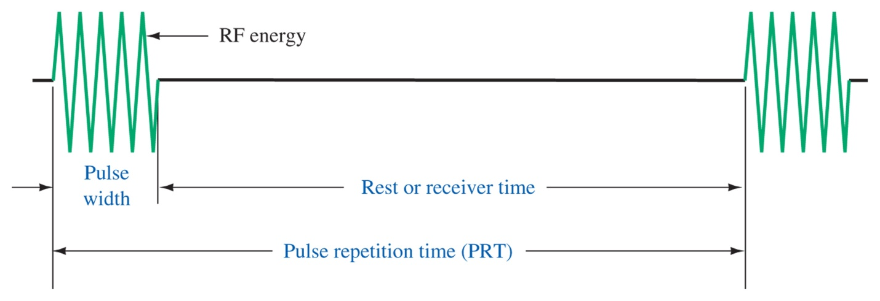
Figure 15-Picture of Repatation of Magnetron

The result of putting a lot of high power microwave pulses in the chamber in a short amount of time was a large visible plasma ball being formed on the inside of the chamber. The smaller the rest or receive time (as shown in figure 15) the brighter the plasma was and the faster the plasma was formed. The negative part of this experiment is the results were again not always repeatable, but this is to be expected from statistical plasma formation. To get a better picture of the ball I rolled up a piece of black construction paper and put it around the lens of the camera. The following shown in figure 16 was taken with a 1 kHz magnetron frequency of high power microwaves.

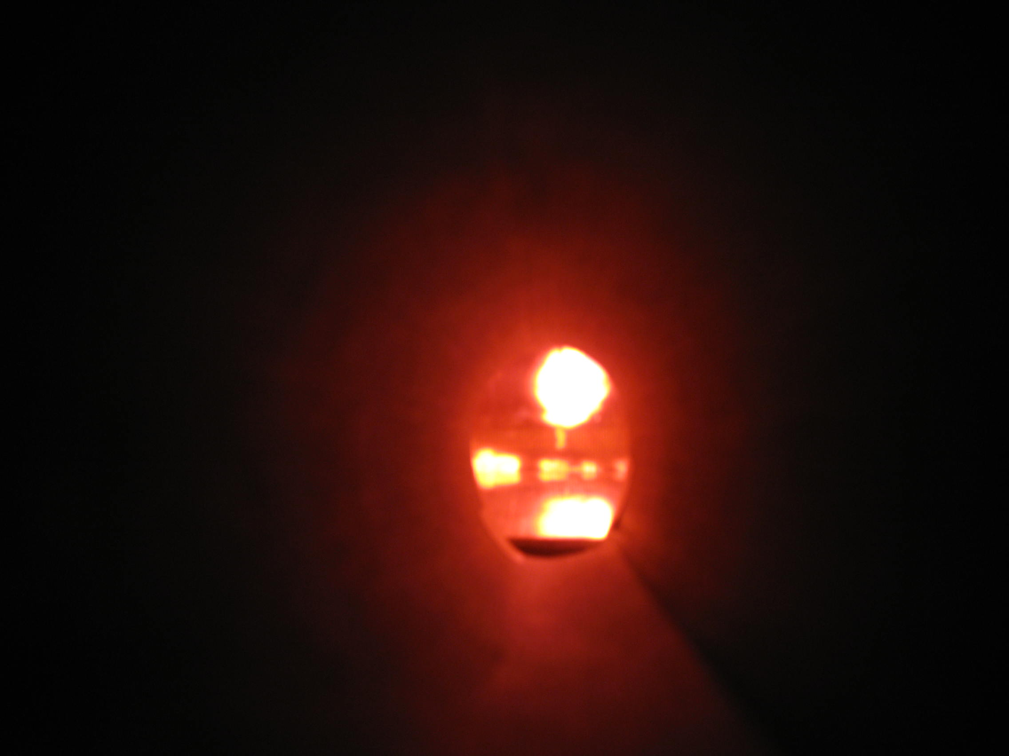
1.35 cm
Figure 16-Plasma Ball with 1 kHz Magnetron Frequency

From the picture it can be seen there are two places where the plasma was formed. The largest amount of plasma was formed directly in front of the x-band waveguide. This can be seen as the plasma ball. This was to be expected because the electric field is the highest at this point. The other location where the plasma was formed was not as expected.
The second point where the plasma was formed is called either a “triple point” or “edge plasma.” Triple point is the junction of metal, dielectric, and vacuum, is the location where electron emission is favored thus increasing the probability of breakdown occurring (Nicholas M. Jordan, 2007). In the previous research experiment they studied high power microwave breakdown on a window surface and experienced the same enhanced breakdown point. This can be seen in figure 16 because even though the magnitude of the electric field at this intersection is much lower there is still breakdown occurring. In addition, I performed other experiments that verified at this intersection breakdown occurred just as frequently and if not more frequently than directly in front of the X-band waveguide.
The next picture, shown in figure 17, illustrates when the magnetron is set at 15 kHz frequency of high power microwave pulses what the plasma formation on the polycarbonate looks like. When the rest or receive time, as shown in figure 15, is longer it also takes longer for the plasma to light up. The time it took for the plasma to light up did not seem to be repeatable. The X-band waveguide is at the location of the brightest spot of plasma in figure 17.

1.30 cm
Figure 17-15 kHz HPM Pulse

To try and gain more insight into what is going on with repeating high pulses of microwave power I tried repeating a large amount of pulses and then sending out a single shot. Some of the time this would result in light being formed inside the chamber. When there was light formed inside the chamber on the first single shot it would most often create plasma as long as only a few seconds passed between shots. I stood directly in from of the chamber when the set up was with wire mesh so I could see what was happening inside the chamber. What I found out was there was always plasma forming at this field enhancement point when the breakdown was occurring in front of the X-band waveguide. An interesting point was a couple of times it had only breakdown at the field enhancement point and not in front of the x-band waveguide. This was also explained in the tech review project as putting a metallic n the inside of the window and it was called a “discharge initiator site” in the paper. (Booske, 2009, p. 6) Although I do not have a definite answer as to why there is bright light with the repetition of the high power microwave pulse and why there seems to be no light with single shot there are a few plausible answers.
The first reason that comes to mind is building up plasma density where plasma density is meaning the amount of free electrons in the chamber. Before all of the ionized electrons can be recombined another burst of microwave power comes onto the surface of the polycarbonate window. There is an exponential decay of the amount of free electrons, but if there are enough electrons in a short amount of time the plasma density can still be building up. Other people have also found this to be true. The time evolution of plasma density can be solved by using the particle and energy balance equations. Lieberman found that excited Ar states affect the calculated plasma density by at most 25 percent. (Lieberman & Lichtenberg, 2005, pp. 369-370) Increasing the plasma density by this amount with excited states of gas in the chamber is the most probable cause of observing bright plasma light inside the test chamber with sending multiple pulses of high power microwaves.
Another possible explanation for visible plasma while having the magnetron repeat at a fast rate versus a single shot could be due to metastable atoms. Energy levels from forbidden electric dipole radiation are called metastable atoms. They are often times present in weakly ionized discharges. This experiment is assumed to be weakly ionized and it could be as little as 1% ionized. When the electron is ionized it may not emit a photon right away causing plasma density build up and increasing ionization frequency causing a large amount of visible light to be seen. Both of the proposed reasons for visible plasma with repeating high power microwave pulses are from building plasma density. Also, there have been experiments in the past which show plasma density builds up while electron temperature does not.

F. Standing Wave Pattern and the need for better antenna systems to measure power
The length of the dipole antenna I used during this experiment was on the same order as the wavelength of our system. To simplify the mathematics of this finite length analysis I am going to assume negligible diameter and use the far field approximation. The wavelength of the magnetron is 31.8 millimeters and this is much larger than the diameter of both of the diameter antenna’s I used during this experiment. The field patterns are found by taking the integral of infinitesimal dipole analysis with the actual length of an antenna. After performing the integral to find the electric field pattern is: (Balanis, 205, pp. 153-155)

Equation Set [15]

The finite length dipole antenna radiation patterns change as the length of the dipole antenna changes. The following table is a list of the antenna properties I used during this experiment.
All of these antennas are going to have a single radiation lobe. The rule is if the length of the antenna is less than the wavelength it will have a single lobe. From the table above it can be seen that for the antennas I used during this experiment this is going to be the case. In addition, as the length of the antenna increases the beam becomes narrower, thus increasing the directivity of the antenna. The following graph shows the radiation patters as the length of the antenna is changing: (Balanis, 205, p. 174)

Figure 17-Radiation Properties of Dipole Antenna (Balanis, 205, p. 174)

As can be seen from above, the antenna measures power over a wide range around the dipole. This causes a problem during this experiment because when there is plasma forming in the chamber it is going to cause reflections, refractions, and scattering of the microwave signal. Therefore the signal measured at the transmission antenna is a localized position of the microwave power from every dimension.
There is a huge impedance reception mismatch between the dipole antenna and the semi-rigid coaxial cable. The impedance of the coaxial cable was given by the company who manufactured it (Pasternack) as being 50 ohms. The dipole antenna has a real and an imaginary part. The values of both are again dependent on the length of the dipole antenna. The following graphs are used to find these values: (Balanis, 205, p. 466)

Figure 18-Resistance and Reactance of Dipole Antenna (Balanis, 205, pp. 179-183)

The absolute value of the reactance is quite high as the size of the dipole antenna gets to be very small. When this value is so large it creates a larger impedance mismatch and that is the reason why I have seen lower localized measured power when using shorter dipole antennas.

The difficult part of this experiment was trying find the effect plasma has on the transmission diode even though I was measuring microwave power in an overmoded WR-650 waveguide. To try and accomplish this I took two measurements: one with plasma and one without. If there was no plasma the following experiment would show that.
For this experiment I held the pressure constant, but I varied the antenna’s height in the test chamber. The height of the WR-650 waveguide is 82.55 mm. I used 1, 3, and 8 mm length antenna. We observed slightly different results as we changed from one antenna to the next. The general trend was the longer the antenna the more received power. But the results between the 1 and 3 mm antenna were only slightly different. Also, the longer the antenna the less variation in the depth scans of data at a constant pressure. The following plot is a normalized graph of data taken at 40 Torr. The normalized data is taken by the following formula:

High Power – (Low Power + 21.1) Equation Set [16]

The high power case is taken at 74.1 dBm and the low power case is taken at 53 dBm. The high power case would be when plasma is being formed and the low power case means there is now plasma being formed. I added in the 21.1 dB because that is the setting of the E-H Tuner. If there was no plasma formed the signals received at the same localized probe location should be identical. For this particular graph I used a 3 mm dipole antenna and measured a depth scan with 14 different points in the WR-650 dump chamber. This means the measurements were taken every 0.2 inches. But, all of this data was taken by physically moving the dipole antenna up and down with my hand. This means the height in the waveguide is probably only accurate to within 0.02 inches. With the current lab set up this is the best that could be done. The distance between the measurements was 5.08 mm. There were two points during this graph where I saw a transmission “spike” and this is evidence of plasma forming. This is explained in the experimental results section earlier in this paper. In addition, all of the points there was negative attenuation between the plasma and no plasma case. The points were taken with a 10 shot average. The error was also plotted and it is one standard deviation above and one standard deviation below the 10 shot average. As can be seen from the graph shown in figure 19 there is not very much variation from shot to shot, but from one experiment to the next during the results are again not very repeatable.

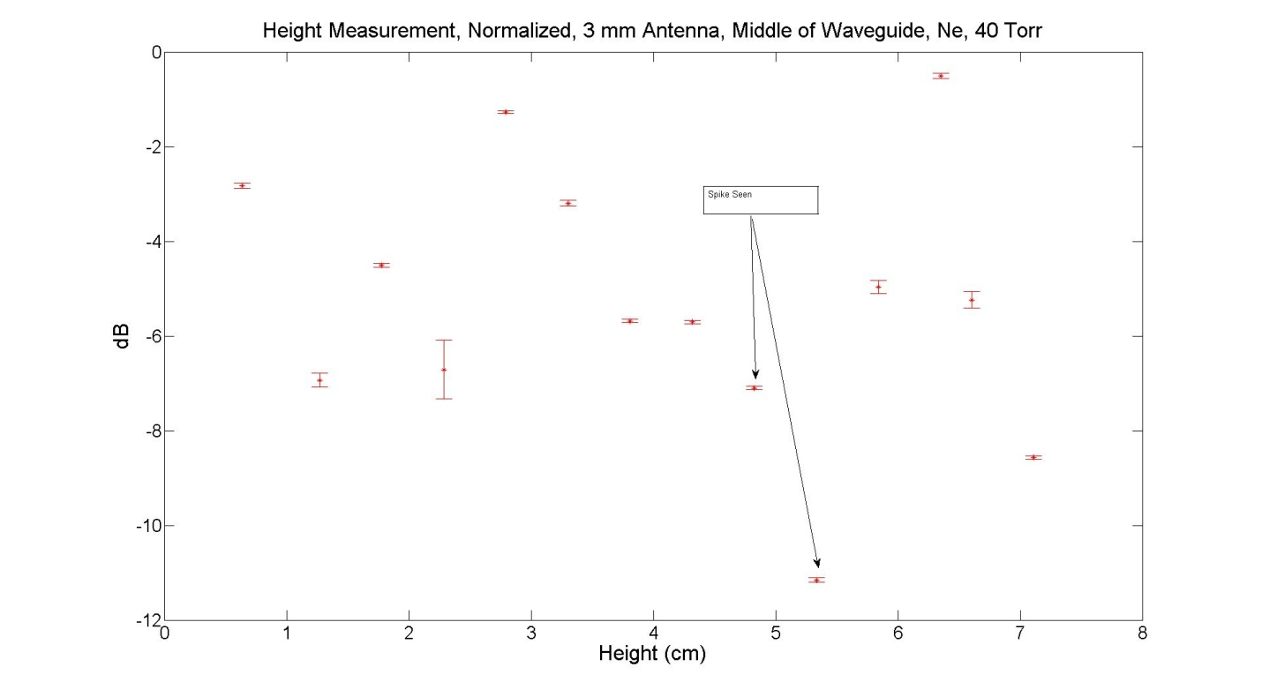
Figure 19-Normalized 3 mm Antenna Measurements

G: Future Plans- loop antenna array, better base pressure-no flexing of chamber, PMT, side port viewing of plasma, finding electron temperature, and inserting triple stub tuner to try and impedance match the transition between X-Band and L-Band
The set up of the experiment was made with a thin 1/8” brass waveguide for the purposes of easily adding viewing ports on the side of the test chamber. The base pressure was not a huge concern in the beginning because the experiment was to take place in the 10’s of torr range. If the base pressure is in the millitorr range and the experiment is running at 100 torr the purity of the gas is relatively good. For example: let’s say the base pressure was 100 millitorr and the operating pressure is at 100 torr. The approximate value of impurities in this chamber would be .01%. The thought was this small amount of impurities would not matter. At this point in time I am still unsure if this amount matters, but the thin brass waveguide caused another issue.
The field pattern inside of the WR-65 waveguide is trying to simulate a free space environment. When the chamber is pumped down to a very low pressure there is some flexing. This flexing is going to cause changes in the field patterns. These changes are going to effect the localized measurement of microwave power in the dump chamber. This is bad because the only factor we want to effect this measurement is the plasma forming on the inside of the poly-carbonate window. The following set of data was taken to make sure the flexing does have an impact on the localized measurement in the dump chamber. The incident power going into the chamber was changed from 25.7 kilowatts to 64.6 watts. I did this because I wanted to make sure there was no plasma being formed inside of the chamber. When the power is only 64.6 watts the value on the surface of the poly-carbonate window is far below the threshold value for breakdown.

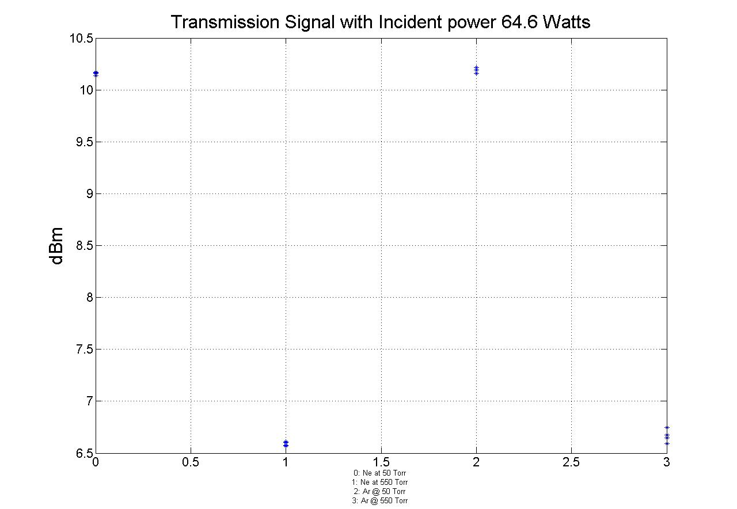
Figure 20-Low Power Measurement
This data is taken with four shots at each point. I took four shots at each setting to make sure there was not much variation between shots. The settings were: four shots with 50 torr of Ne, four shots at 550 torr of Ne, four shots at 50 torr of Ar, and four shots of 550 torr of Ar. The data is taken with a -26 dB setting with the circulator, E-H tuner, and matched load combination. The calculation for the incident power in watts is 74.1 dBm – 26 dB = 48.1 dBm = 64.6 Watts. From the graph we can see a change in signal strength by 3.5 dB. With this amount of attenuation we are seeing a variation of more than 50% from 50 torr to 550 torr. The power on the left is the actual dBm the antenna is seeing. This result shows we are showing attenuation even though it is certain there is no plasma forming. The attenuation of the transmission signal is thought to be caused by flexing of the thin brass chamber. Flexing in the chamber is going to cause a difference in the localized transmission signal in the dump chamber. There was also no difference between the Ne gas and the Ar gas which would need to be the case if there is no plasma being formed. In addition, while I was taking this data I noticed the signal was changing on the oscilloscope even though it was during this low power regime. On the other hand, on the oscilloscope I never saw a “spike” measurement that would signal plasma being formed.
When plasma is forming there is an initial steep downward spike and a certain amount of recovery time. When I saw attenuation on the order of 3-5 dB I did not see the initial huge downward spike. But when I saw attenuation of more than 20 dB I do see the initial downward spike on the oscilloscope. This initial spike downward is explained in the experimental results section of this paper and also in receiver protector technology from CPI. From this result it can be seen the flexing of the chamber does have huge effects n the experimental data. Furthermore, only a 3.5 dB of difference in the transmission signal equates to a source absorbing 50% of the signal. For this reason the plans for a cylindrical stainless steel chamber were put into place. With this chamber the base pressure will be able to g to pressure much less than a 100 millitorr and there should be no flexing of the chamber. The normalized data I took explained in the experimental results section tried to make up for this flexing, but with the new configuration all of the work of trying to take this into account when analyzing the data will not be necessary.
I: Additional Future Plans and suggestions on future research
- What modes in the WR-650 carry most of the power without plasma forming
- Antenna Array
- Ku Band Study

References:
Balanis, C. A. (205). Antenna Theory: Analysis Design, Third Edition,. John Wiley & Sons, Inc.
Booske, J. H. (2009). Basic Studies of Distributed Discharge Limiters for Counter-HPM. Madison, WI.
D.J. Cruz, B. W. (2009). Experiments on peer-to-peer locking of magnetrons. Applied Physcis Letters , 1-3.
F, C. F. (1984). Introduction to Plasmas and Controlled Fusion. New York: Plenum Press.
Inan, U. a. (2005). Engineering Electromagnetics and Waves. Boston: Pearson Custom Publishing.
J. Foster, H. K. (2011). Investigation of the delay time distribution of high power microwave surface flashover. Physics of Plasmas , 1-5.
Lieberman, M. A., & Lichtenberg, A. J. (2005). Principles of Plasma Discharges and Materials Processing. Hoboken, New Jersey: John Wiley & Sons, Inc. .
M, B. S. (2005). Modern Electronic Communication. Upper Saddl River: Prentice Hall.
MacDonald. (1966). Microwave Breakdown in Gases. New York: John Wiley & Sons, INC.
Nicholas M. Jordan, Y. Y. (2007). Electric field and electron orbits near a triple point. JOURNAL OF APPLIED PHYSICS , 1-9.
(2011). Receiver Protector Technology. Beverly, Massachusetts: CPI Wireless.
Swanson, D. G. (1989). Plasma Waves. San Diego: Academic Press, Inc. .
Zecca, A. (1995). One Century of Experiments on electron-atom and molecule scattering. Rivista Del Nuovo Cimento , 1-146.

Appendix
[1]
% Process CHPM waveforms to give
% incident, reflected and transmitted power data

% Path info for data files
path='I:\Win\Desktop\Normalized Repping Ne 100 Torr\'
%date='5-24-10\Ar Data\' % date of data taking
%date='4-23-10\' % date of data taking
%date='4-16-10\';
%name='C2_' %beginning of waveform namefilename
%name='C3_' %beginning of waveform namefilename
name='C3_'; %beginning of waveform namefilename
index = 0; % initiation value of file number
ext = '.trc'; % file extension
%path = 'I:\WIN\Desktop\Ar 5-24-10\Ar'

for l = 1
pressure = [.25 .25 .25 .25 .25 .25 .25 .25 .25 .25 .5 .5 .5 .5 .5 .5 .5 .5 .5 .5 .7 .7 .7 .7 .7 .7 .7 .7 .7 .7 .9 .9 .9 .9 .9 .9 .9 .9 .9 .9 1.1 1.1 1.1 1.1 1.1 1.1 1.1 1.1 1.1 1.1 1.3 1.3 1.3 1.3 1.3 1.3 1.3 1.3 1.3 1.3 1.5 1.5 1.5 1.5 1.5 1.5 1.5 1.5 1.5 1.5 1.7 1.7 1.7 1.7 1.7 1.7 1.7 1.7 1.7 1.7 1.9 1.9 1.9 1.9 1.9 1.9 1.9 1.9 1.9 1.9 2.1 2.1 2.1 2.1 2.1 2.1 2.1 2.1 2.1 2.1 2.3 2.3 2.3 2.3 2.3 2.3 2.3 2.3 2.3 2.3 2.5 2.5 2.5 2.5 2.5 2.5 2.5 2.5 2.5 2.5 2.6 2.6 2.6 2.6 2.6 2.6 2.6 2.6 2.6 2.6 2.8 2.8 2.8 2.8 2.8 2.8 2.8 2.8 2.8 2.8];
end

% Experimental parameters
pwidth = 1e-6; %Pulse width in seconds

for j=1:length(pressure)

if j<11
index=['0000',num2str(j-1)];
else if j<101
index=['000',num2str(j-1)];
else if j<1001
index=['00',num2str(j-1)];
else if j<10001
index=['0',num2str(j-1)];
else
index=num2str(j-1);
end
end
end
end

testfile=[path,name,num2str(index),ext]
test = exist(testfile)

if test>0
%%%%%%% Use if files saved in binary format
S = ReadLeCroyBinaryWaveform(testfile);
time = S.x; %extract time data from file
voltage = S.y; %extract voltage data from file

%%%%%%%% Waveform properties
L = length(time); %Find the total number of sample points in waveform
t0 = (L+1)/2; %Sample number at t=0
T = time(round(t0+1)) - time(round(t0)); %Time between samples (period)

%%%%%%%% Calculate pulse voltage
tsample = pwidth/T; %Total samples corresponding to pulse width
tend = t0 + .9*tsample; %Sample number corresponding to 80% of pulse length
tmid = t0 + .1*tsample; %Sample number corresponding to 20% of pulse length
pvoltage = voltage(round(tmid:1:tend)); %voltage during middle 60% of pulse

%%%%%%%% Calculate voltage between pulses (zero-point)
tz1 = t0 - tsample; %Sample number corresponding to time before pulse
tz2 = t0 - tsample/2; %Sample number corresponding to (time before pulse)/2
nvoltage = voltage(round(tz1:1:tz2)); %voltage between pulses

Vavg(j) = mean(nvoltage)-mean(pvoltage);
end
j=j+1; %advance to next file
end

%%%%%%%% (:,2) = voltage (V) ; (:,1) = power (dBm)
Pavg = interp1(diodecal44(:,2),diodecal44(:,1),Vavg,'spline','extrap');
%Pavg = interp1(diodecal43(:,2),diodecal43(:,1),Vavg,'spline','extrap');
%Pavg = interp1(diodecal37(:,2),diodecal37(:,1),Vavg,'spline','extrap');

Pavg = Pavg + 20; %incident attenuation correction
%Pavg = Pavg + 40 %reflected attenuation correction
%Pavg = Pavg + 60 % ansmitted attenuation correction

outfile = [path,'avgPowerC3.mat'];
save (outfile, 'pressure','Pavg')
[2]
%Plot CHPM data
close all
clear all

stem = 'I:\Win\Desktop\Normalized Ne 100 Torr';

%file1 = '\avgPowerC1';
%file2 = '\avgPowerC2';

file3 = '\avgPowerC3';
file4 = '\avgPowerC4';

%S1 = load([stem,file1]);
%Pavg1 = S1.Pavg;
%Pres1 = S1.pressure;

%S2 = load([stem,file2]);
%Pavg2 = S2.Pavg;
%Pres2 = S2.pressure;

S3 = load([stem,file3]);
Pavg3 = S3.Pavg;
Pres3 = S3.pressure;

S4 = load([stem,file4]);
Pavg4 = S4.Pavg;
Pres4 = S4.pressure;

Pavg5 = Pavg4-(Pavg3 +16.1);

%subplot(2,2,1)
%plot(Pres1,Pavg1,'*')
%title('Incident Power Variation','fontsize',24)
%xlabel('Height (cm)','fontsize',24), ylabel('Output Power (dBm)','fontsize',24)
%grid on;

%subplot(2,2,2)
%plot(Pres2, Pavg2,'*')
%title('Reflected','fontsize',24)
%xlabel('Height (cm)','fontsize',24), ylabel('Output Power (dBm)','fontsize',24)

%subplot(2,2,3)
%plot(Pres3,Pavg3,'*')
%grid on
%title('Transmission Signal Middle of waveguide, Ne, 100 Torr, Repping','fontsize',24)
%xlabel('Height (cm)','fontsize',24), ylabel('dBm','fontsize',24)

A = unique(Pres4*2.54);
E = zeros(size(A));
P = zeros(size(A));
I = zeros(size(A));
for u=1 : length(A)
E(Pres4*2.54==A(u)) = std(Pavg5(Pres4*2.54==A(u)));
P(Pres4*2.54==A(u)) = mean(Pavg5(Pres4*2.54 == A(u)));
I(Pres4*2.54==A(u)) = 2;
end
errorbar(Pres4*2.54,P,E,'*r')
title('Height Measurement,Normalized,3 mm Antenna,Middle of Waveguide,Ne, 100 Torr,SS','fontsize',24)
xlabel('Height (cm)','fontsize',24), ylabel('dB','fontsize',24)

%subplot(2,2,4)
%plot(Pres4, Pavg4-37,'*')
%grid on
%title('Side Transmission,Ne, Pressure 500 Torr','fontsize',20)
%xlabel('Depth (Inches)','fontsize',20), ylabel('dB','fontsize',20)

%subplot(1,1,1)
%hold on

%plot(Pres3, Pavg3,'k')

%plot(Pres2, Pavg2-84,'k:')
%plot(Pres1, Pavg1-84,'k--')
%grid on
%title('Neon Incident and Reflected','fontsize',24)
%legend('reflected','incident')
%xlabel('Pressure (T)','fontsize',24), ylabel('dB','fontsize',24)

