Finding Solace along Walnut Avenue:
Settlement and Turnover in a Milwaukee Ethnic Neighborhood

Kiersten D. Bauer
History 489: Research Seminar
Fall Term 2016

Contents

Abstract…………………………………………………………………………………………………………………………………….iii
Introduction……………………………………………………………………………………………………………………………….1
German Jewish Strife and Immigration to Milwaukee…………………………………………………………………2
German Jewish Walnut Avenue and German Assimilation………………………………………………….…..….5
Russian Jewish Immigration and Establishment.……………………………………………………………………….11
Suburbanization and New Migration………………………………………………………………………………………..17
Becoming Bronzeville: African American Occupancy ………………………………………………………………..21
Walnut Avenue’s Final Exodus…………………………………………………………………………..........................25
Conclusion...…………………………………………………………………………………………………………………………….27
Bibliography …………………………………………………………………………………………………………………………….29

Abstract-

This paper uses the interdisciplinary skills obtained through both history and geography classes and takes a glance at the history of a specific neighborhood in Milwaukee known today as Bronzeville. Over the course of a century, this neighborhood had witnessed the in-migration and out-migration of three distinct ethnic groups: German Jewish immigrants, Russian Jewish immigrants and African American migrants. This case study works to evaluate the ways in which all three of these groups have altered the cultural urban landscape of Walnut Avenue in distinctly different ways, impacting the economy, family life, and the general composition of the neighborhood’s businesses and services district. By focusing on the ways that each of these immigrant groups altered this specific space, not only is one able to draw conclusions about the area’s history and foreign influences, but also about the progression of each specific group of people as they integrate into the typical American lifestyle.

Introduction-
Despite the high degree of segregation and racial tension that the city is known to experience today, Milwaukee had once been a thriving scene of cultural tradition and was home to a diverse group of ethnic enclaves. Just to the east of the Milwaukee River, and bounded by North Avenue, Vliet Street, Third and Twelfth Streets, lies Walnut Avenue: the heart of a long lasting immigrant district. Over the course of a century, three distinct communities came to find sanctuary within the boundaries of this district, each time transforming the landscape in a multitude of ways.
This paper works to explore the rich geographical history of a neighborhood in Milwaukee known today as Bronzeville and the various ethnic groups who have occupied and transformed the area over the course of a century, including German Jews, Russian Jews, and finally, African Americans. For each of these groups, the paper works to address three basic questions: What factors influenced their immigration to the area, how was the neighborhood’s landscape and sense of community transformed under their occupancy, and finally, what motivated the eventual emigration of these groups from the area? The geography aspect of this investigation calls for the focus on the ebbs and flows in the concentration of immigration and emigration settlement patterns within the area, and attempts to use maps to supplement these findings. The historical aspect, then, focuses on the chronology of these demographic changes within the community, accounts for where and when these changes occur in relation to the greater American historic narrative, and works to weigh the significance of these changes.

German Jewish Strife and Immigration to Milwaukee-
Each of the groups that ultimately came to occupy Walnut Avenue had first come from oppressive circumstances within the confines of their former territories. The first of three groups to seek salvation along Walnut Avenue, were Jews who had immigrated to the area seeking escape from religious intolerance and persecution within the Germanic area. Well before Hitler’s anti-sematic campaign in the early-to-mid twentieth century, eighteenth and nineteenth century German attitudes towards the Jews were often still hostile and skeptical. Many governmental restrictions were placed on the Jewish population to regulate their influence within the region. Jews in the area were subject to a variety of economic and housing restrictions, prohibiting them from certain occupational access, subjecting them to a “Jew-tax,” and confining their residency to specific, often rural areas or within established Jewish ‘ghettos’ in the cities. These types of Jewish regulations in the Germanic area even went so far as to limit the number of marriages permitted within the Jewish community. In order for a Jewish couple to be wed, they must have first fulfilled two requirements: the first limitation required an open slot on the Jewish community marriage roster known as the ‘matrikel,’ which in-and-of-itself sought to set a limit on Jewish partnerships. If a marriage slot was available, the second constraint required Jewish men to prove their financial capabilities to support both partners involved in the marriage, and with institutionalized occupational and economic discrimination, this too often proved challenging to satisfy.
Between 1804 and 1815, Napoleon’s rule in France disrupted the prejudice against Jews for a brief time. During his reign, the emperor used his vast influence over Europe and required that many of these formative restrictions on Jews be uplifted. Under only ten years of Napoleon’s influence, much of the German Jewish relationships of the time were amended and the cultures were slowly integrating and assimilating together. His eventual fall at the end of the decade, however, would mark the last of these progressive strides within the region. As prejudice attitudes and discrimination laws returned, Jewish people felt compelled to seek habitation elsewhere.
In the years between 1820 and 1850, the United States received its first considerable influx of Jews from the Germanic area. As with many ethic immigrant groups, the order of arrival consisted first primarily of men, their wives or partners and children to follow them later. During these first few decades, Jewish settlement tended to stay confined to American cities positioned immediately along the Atlantic coast. Beginning in the 1840’s and through the 1860’s, though, they fanned out to occupy small pocket communities in almost every established state and territory in the country. Still, a few cities were known to harbor a larger concentration of these German Jewish immigrants: New York, Philadelphia, Boston, Baltimore, Cincinnati, and Chicago in particular.
As true to the traditional Chicago-Milwaukee relationship, the historical narrative shows that immigration patterns that occur within the precedent city, often also occur with the latter, but to a lesser extent. This relationship once again proved true with German Jewish populations. According to the Wisconsin Historical Society’s Turning Points in Wisconsin History, in addition to receiving some of Chicago’s overflow, the newly established state of Wisconsin was also very active in advertising their tolerance for foreign born peoples by welcoming the settlement of these new immigrants during what would soon become known as the first wave of immigration:
Between 1852 and 1855, the Wisconsin Commission of Emigration actively encouraged the settlement of European immigrants in Wisconsin. Pamphlets extolling the state’s virtues were published in German, Norwegian, Dutch, and English and were distributed throughout Europe as well as in eastern port cities. Advertisements were placed in more than nine hundred newspapers.

Most likely, it was the spirited welcome of new immigrants, in combination with the various audiences that these advertisements targeted, and the overflow of Chicago’s ethnic populations that had attracted a number of German Jewish immigrants to settle in Milwaukee.

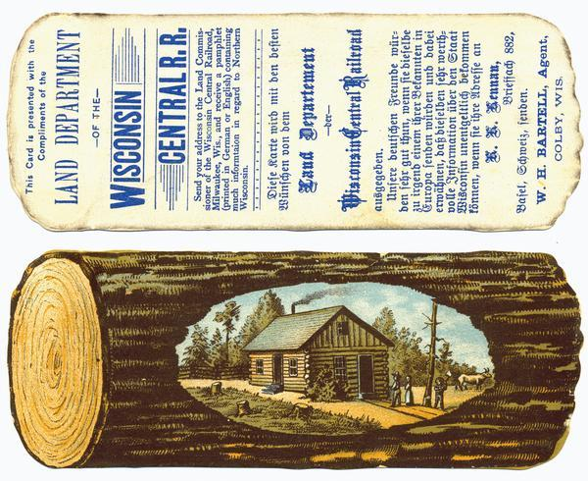
Figure 1. Wisconsin Advertisement for Immigrant Settlement. Wisconsin Historical Society. http://www.wisconsinhistory.org/turningpoints/search.asp?id=962.

German Jewish Walnut Avenue and German Assimilation-
Milwaukee’s first set of Jewish immigrants were slow at first in arriving to the city. According to an article from the Journal Sentinel, April 24, 1921, the first Jewish man to settle the area was a merchant by the name of Gabriel Shoyer in 1845. It took nearly two years after Shoyer’s arrival before the Jewish population within the city had grown large enough to allow for “the formation of the first ‘Minyon’ (a quorum of at least ten male persons to perform rituals.)” At first, the lack of a formal synagogue required Jewish people in the area to host services within the confines of their home, inviting friends and neighbors to participate with them. But finally, in 1849, Milwaukee’s Jewish population formed their first official congregation; “its worshipping place consisted of a small room above a grocery store on Chestnut street.” Shoyer became its first president. The location of this congregation helped to establish the main settlement area that Jewish immigrants occupied when arriving to the city thereafter.
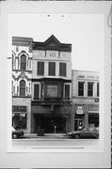
Figure 2. Photo of Grocery Store (hosted the First Jewish Congregation in its upper flat). Wisconsin Historical Society. http://www.wisconsinhistory.org/Content.aspx?dsNav=Ny:True,Ro:40,N:4294963828-4294963814&dsNavOnly=N:1133&dsRecordDetails=R:HI108676.

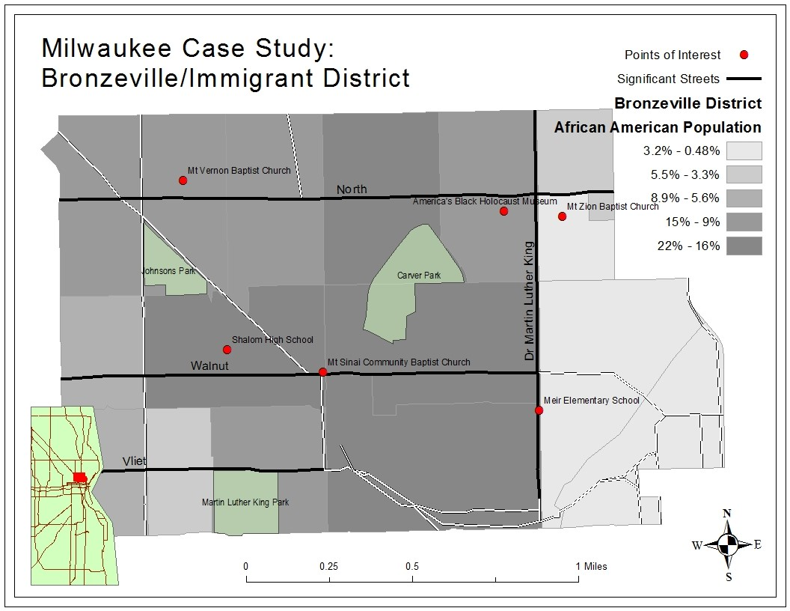
Figure 3. Map of neighborhood and lasting points of interest. Map created by author.
The German Jews of Walnut Avenue were said to have an admirable sense of respect for both the community that they had built up and the residences that they had occupied. Under their care, they slowly fostered an ethic community spanning from Third to Thirteenth Street, cornered by Vliet Street and North Avenue, with Walnut at its center. In this district, they opened up shops for business and welcomed other German Jewry and German immigrants alike as their neighbors. Counter to the common occupations for Milwaukeeans of the late nineteenth century (beer, machinery, tanning, and milling) many of them chose to maintain traditional Jewish businesses, usually positioned either adjacent to or connected directly with their homes, and often included the sale of clothing, dry goods, and tobacco. “In 1895, practically all of the thirteen clothing factories and shops in Milwaukee were Jewish-owned, and remained so into the 1920’s.” Some of the more common industry names in this area were Friend and Adler in the clothing and retail department, who together employed more than 1,800 immigrants, and Landauer and Stern in dry goods, who each competed with big name Chicago companies and together sold seven million to eight million dollars’ worth of product a year. These big name businesses helped establish Walnut Avenue under German Jewish occupation with a thriving economy.
Contrary to the larger American narrative of German Jewish relations in big cities, the usual anti-Semitic German attitudes did not accompany German immigrants to the city of Milwaukee. One German Christian remarks:
“It is a splendid race, splendid in their patience, in their love for one another, in their endurance, in their sagacity and temperate habits, and splendid in their inflexible adherence to the Mosaic ideals…. It is spurious, false Christianity that hates Jews….Convert the Jews! [?] Let us first convert our modern Christians to genuine Christianity.”

Given this welcome, and feeling comfortable with their position in this new society and in their relationship with their former nationals, many of the individuals in this Jewish community had quickly assimilated to the culture and traditions of their new German neighbors. One account reflects that the area “had once been ‘so predominately German that many of the shops could be conducted by people speaking only German.’” Though German Jewish relations were able to make a progressive headway in the area surrounding Walnut Avenue, this assimilation would also help foster the eventual disconnect between this distinctive group of German Jewry and other Jewish populations in the years to come.
Gender roles also developed in a pattern that was unique to Milwaukee’s nineteenth century German Jewish immigrant neighborhood. Prior to their immigration to the States, women in German Jewish households were often responsible as the domestic breadwinners of the home, producing items for their husbands to exchange in the marketplace. Still, their culture remained patrilineally defined. Men were given the most prestigiously valued position in the family; with religion being at the center of Jewish culture, they spent much of their time devoted to the studying of the Torah to ensure their families were adhering to the requirements of their faith. This family dynamic had altered some within Milwaukee’s immigrant district with the Jewish adoption of German practices. Jewish assimilation had continued the patriarchic tradition, but altered so that men became the breadwinners and women took on a more domesticated role in the home, their new restless energy to be exerted elsewhere, often in public service and social reform:
“In this age of family firms, the father was patriarchally dominant in business, and his rule at home was confirmed by German habit and Jewish tradition. The wife gradually emerged from her exclusively domestic life to enter a less confined world, and women’s organizations of broad scope appeared in the city.”

As conservative thinkers influenced by German Milwaukeean Socialism, these Jewish women came to play a large and significant role in the supply of relief programs to new immigrants in the decades to come.
In the latter half of the century, the neighborhood underwent a number of drastic changes. Mainly, these changes occurred as a result of yet another settlement wave, this time consisting mainly of new Russian Jewish immigrants. Much like their predecessors, these Russian Jews came to America in desperation to escape the harsh treatment they had endured while living in their native country. Their numbers were significantly larger than that of the German Jewish settlers had been. Although their cultures and traditions were distinctly different, the German Jews were sympathetic to situations, needs, and concerns of the new Russian Jewish immigrant group, and worked to establish a variety of organizations to help aid their transition in coming to Milwaukee. Still, despite many of their relief efforts, overcrowding within the neighborhood was inevitable. Ultimately, it was this newly established presence of Russian Jews in Milwaukee’s immigrant district that had enticed its former German Jewish residents to leave, seeking settlement in Milwaukee’s more affluent German neighborhoods located to the northeast of the Milwaukee River, and leaving the once polished state of their old neighborhood to decay in their wake.

Russian Jewish Immigration and Establishment-
The situation for Jews in Russia had been much more oppressive than it had been for those who had emigrated from Germany. In the book The Jews of Chicago, author Irving Cutler describes the Old Russian Empire as “backwards, autocratic, steeped in medievalism, a land where serfs were held in bondage until 1861 and where enlightened ideas of Western Europe were slow and late in penetrating.” Under this Empire, Jews faced a long history of religious oppression, occupational constraint, and national blame, dating back to the sixteenth century. At times, they were even known to be the victims of hate crime and massacre, as in the case of the forced baptisms under Czar Ivan the Terrible, when “three hundred Jews who refused to accept baptism were in fact drowned,” and during the Cossack and Ukrainian peasant rebellions, where “one-third of Poland’s Jewish population was killed.”
In 1791, Russia began to colonize the regions adjacent to its western and southern borders. With these newly acquired territories, the empire established a settlement zone known as the “Pale of Settlement,” reserved strictly for the habitation of its Jewish population. Jews living in the realm of Russian jurisdiction who were not already confined to city ghettos were restricted to living in this region, often within the Pale or occasionally in the rural territories that surrounded it. By law, they could not engage in trade with any of Russia’s legitimized provinces, and thus their economy was poor; wealth, limited; and chance for upward mobility, scarce. “Pent up in small towns and cities, they could only engage in petty trade and handicrafts, which new economic developments were undermining. Residentially restricted, politically persecuted, economically frustrated, East European Jewry needed only the stimulus of pogroms and fresh decrees to convert the trickle of emigrants into a torrent.”
When Russia’s czar, Alexander II, was assassinated in 1881, Jews received the blame for the tragedy, and the conditions of their restrictive environment were worsened. Following his death, Jews were then confided strictly to the Pale. Those living in ghettos in Russia’s major cities were exiled, and those living in the country’s rural regions were forced to relocate. As the Pale’s population grew, its boundaries simultaneously contracted. These restrictive conditions and limited housing options was what ultimately motivated Russia’s Jewish population to head for new lands.
Between 1881 and 1900, America received its second immigration influx, comprised of nearly 600,000 Russian Jews. By 1900, 8,000 of them had found their way to Milwaukee, many of them looking to occupy vacancies available within the German Jewish immigrant district. They had heard word of Milwaukee’s reputable tolerance for Jewish immigrants by word of the European Hebrew Press, one remark in a later dated advertising (c. 1910) notes: “Milwaukee has a considerable Jewish population, about 10,000 souls…. Anti-Semitism is very little felt.... The Jewish population can still be very easily increased. Skilled workers can get work in Milwaukee, i.e., those who are skilled in any trade.” Under Russian Jewish occupation, the neighborhood along Walnut Avenue transformed immensely. Not only did the neighborhood relax in terms of its overall upkeep and economic standing, but also in its occupant’s eagerness to Americanize and assimilate. The dominant language in the neighborhood transformed from German to Yiddish, newly erected synagogues adopted orthodox religious views, and the new group that resided there established their own form of locally based politics.
Arriving from such restrictive circumstances, however, many of these Russian-Jews had come over with little to no wealth, and were also limited in terms of their industrial occupational skills. Most had arranged to stay with relatives or friends prior to their emigration, but still, enough came with no set destination in mind. In these cases, it was common for the new Jewish immigrants to simply wait for relief in one of the neighborhood synagogues. In an effort to help offset these financial and housing setbacks, the older and more established German Jewish community opened their arms to the newcomers, offering them aid in the form of financial relief programs with the formation of organizations such as the Russian Relief Committee of Milwaukee and the Jewish Alliance. These efforts greatly contributed to the needs of these new immigrants for some time, but the rapid and large influx of Russian Jewish newcomers made it difficult to supply enough adequate housing and employment opportunities to the new, ever-climbing Jewish population. As a result, these organizations were quickly exhausted of their resources. As the German Jews continued to filter out, even more Russian Jews continued to emigrate in. With little-to-no circulation of currency within its economy, and in the effort for newcomers to save by the pennies for their European relatives to join them, the physical state of the neighborhood was increasingly neglected:
“[The neighborhood] contained ‘a number of old and dilapidated buildings, a considerable amount of basement dwelling, insufficient and unsanitary closet provisions, unclean houses and yards due to careless habits of tenants, and confining of chickens in basements by ‘kosher’ butchers…’ The new arrivals had to inhabit the worst two-story wooden houses: ‘the exterior is weather stained and decayed. The walls are out of plumb, the roofs are sagged. Inside, these houses rarely lack tenants…’”

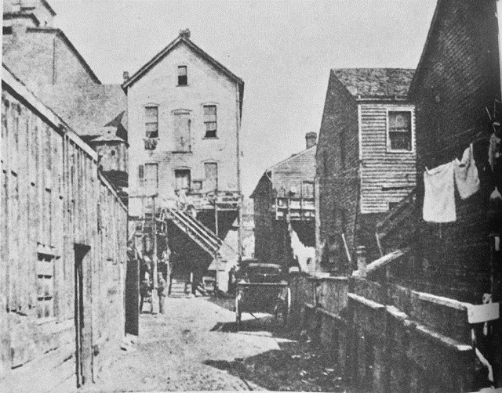
Figure 4. Milwaukee’s Jewish Immigrant District c. 1905. Wisconsin Historical Society. http://www.wisconsinhistory.org/turningpoints/search.asp?id=1327.

The dilapidated state of the neighborhood and poverty within the area became increasingly obvious to the rest of the city, and by 1905, the immigrant quarter gained a new reputation as was “one of the ‘problem areas’ of the city.” The more assimilated German Jewish law enforcers patrolling the neighborhood fought to maintain the implementation of Christian traditions within American law in the new Russian-Jewish ran neighborhood. “In April, 1896, Marcus Silber, proprietor of a dry goods store at Twelfth and Walnut streets, was arrested on complaint of the Retail Clerks’ Association for being open ‘on the [Christian] Sabbath.’ (He was also open on the Jewish Sabbath).” Additionally, many young Jewish peddlers trading in the area were often victims of juvenile molestation by these older generation enforcers. The neighborhood even witnessed the erection of a detention home and juvenile court during their occupancy to help manage ‘youth mischief.’ The district would maintain this overcrowded and dilapidated status until the mid-1920s when, out of racially biased executive opinion, the nation declared an end to its period of free and unchallenged immigration. The period also witnessed an explosion in the construction of educational institutes, which were also intended to help occupy its abnormally large youth demographic and deter them from mischief.
Between 1883 and 1892, a total of twenty-six new school buildings were erected in the around the city, and under the supervision of School Superintended William Anderson, each of them included the enforcement of learning the German language and practicing domestic preparatory curriculum. One of the most famous of these schools was housed directly within the Jewish immigrant neighborhood on Fourth Street, known first as the Humboldt School, later as the Fourth Street School, and eventually, renamed again as the Golda Meir School, a prominent figure of Milwaukee’s Jewish community. Golda was a Russian Jewish immigrant student of the Fourth Street School from 1906 to 1912. Her family had settled on Walnut Street in 1906, where her mother operated a small store and her father worked as a carpenter. Upon graduating, Golda dedicated the first few years of her life to the service of her Jewish peers in the immigrant district; she taught Yiddish at the locale Jewish Community Center, lead and organized various marches and rallies in favor of the Labor Zionist Movement, and provided aid to a number of Jewish relief programs housed in the community during World War Two.
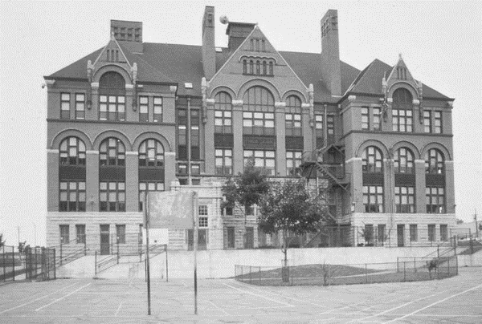
Figure 5. Fourth Street (Golda Meir) School. Wisconsin Historical Society. http://www.wisconsinhistory.org/Content.aspx?dsNav=Ny:True,Ro:20,N:4294963828-4294963814&dsNavOnly=N:1133&dsRecordDetails=R:HI16740.

Suburbanization and New Migration-
The 1920’s marked the beginning of a gradual ethnic exodus from the Jewish immigrant neighborhood. The passing of the Johnson Act in 1924 had brought an end to the immigration torrent, and thus halted the city’s period of Jewish population growth. By the end of the Russian immigration flood, almost half of Milwaukee’s Jewish population was below twenty-one years of age. In the next decade, as this generation grew older, they would also experience an upward rise in social mobility. Many Jewish youth went on to further their educations at the local Marquette University, a Jesuit institution, obtaining degrees for high-standing white collar jobs like attorneys, dentists, and physicians. Several of the University’s Jewish physician graduates kept their practice local, and were eventually employed by Mount Sinai hospital, located just to the south of the Immigrant district on Twelfth and State Streets. Mount Sinai’s affluent Jewish physicians had serviced the needs of their less prosperous neighbors within the community for nearly a decade (between 1905 and 1912).
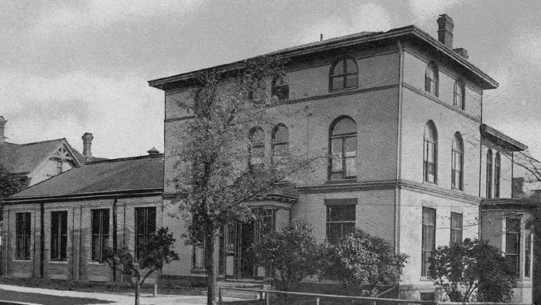
Figure 6. Mount Sinai Hospital. Wisconsin Historical Society. http://www.wisconsinhistory.org/Content.aspx?dsNav=Ny:True,Ro:20,N:4294963828-4294963814&dsNavOnly=N:1133&dsRecordDetails=R:HI16827.

In addition to a shift in social standing, the popularization and new affordability of the automobile also encouraged the dispersement of the Jewish community from Milwaukee’s Sixth Ward. The transportation revolution allowed employers to move further away from their businesses, corporations and practice. Suburbanization allotted for more space within the community and the development of new housing. Many immigrants felt they were doing their part for their community by leaving it and relieving the neighborhood of some of its congestion. Contrarily, for state born citizens, suburbanization represented the assurance of foreign commitment to the United States and promised assimilation. By 1930, the population of the Jewish immigrant district had decreased by a total of almost 3,000 people, “from 17,650 in 1920, to 14,825 in 1930.”
While most periods of anti-Semitic narratives within American History largely bypassed the city of Milwaukee, in the 1930s, Jewish occupants this time did face a degree of anti-Semitic attitudes within the city. Brought on as a side effect of the Great Depression and propelled by the rise of Nazism in Germany, the dominance of the city’s German influence, inhabitants, and economy would have a considerable impact on Milwaukeean attitudes toward the new immigrant population. These attitudes motivated Jews of all origins to band together in solidarity and occupy a new neighborhood to the northwest of its original district. The move ultimately helped generate some distance between the city’s Jewish population, and concentrated German populations within the city. It was the combination of this climb in social mobility, the new transport conveniences of the automobile, and a rise in prejudice attitudes that prompted an increased desire for Jewish suburbanization.
Despite their gradual exodus, the distinctive Jewish characteristics of the neighborhood remained for quite some time, though an exact turnover date is more difficult to pinpoint. “Through the 1930s, the Walnut Street side was occupied by several [Jewish] shops including ladies' apparel, a restaurant, a cigar store and a photo studio.” Still, by glancing at the distinctions marked in the US Census between 1930 and 1940 along Walnut Avenue, one is immediately able to identify the drastic changes in the composition of the neighborhood’s inhabitants. The 1930’s census, for example, reveals an expansive list of Russian immigrants, many of them indicating their native tongue as “Jewish,” and occupying jobs consistent with those exemplified in the previous section such as peddling (‘Junk’), printing, knitting, garments and other artisan-related jobs. By the distribution of the 1940’s census, however, much of the neighborhood had turned over; much of the Russian Jewish population had dispersed, and the area was largely re-occupied by African American residents, many of them indicating their origins to be from southern states, and most of them with jobs occupying those within the industrial division.
The new vacancies in the neighborhood came in perfect conjunction with the migration of many of the country’s southern African American population to the north. In the case of Milton and Mable Childs, Walnut Avenue offered them a chance at slight occupational mobility. Prior to moving to Milwaukee, Milton was reported in the 1930 US census to be a resident of Bradley, Arkansas. Having just completed his education at the 7th grade level, at age 14, Milton was a full-time farm laborer. His working class indicated that Milton was an “unpaid worker, member of the family.” It is likely that Milton’s occupational status prompted him to search for jobs elsewhere as he neared his adulthood. By 1935, Milton was living on his own in Milwaukee. His spouse, Mable Childs, indicates that she was still living in Arkansas at this time, most likely staying back temporarily while her husband sought out work. Still under the oppressive and discriminative implementation of Jim Crow laws, housing options for African American in the north were restricted to some of the most economically impaired former immigrant neighborhoods in the city. Continuing the pattern found within major cities across the nation, in Milwaukee, this meant the occupation of the old Jewish neighborhood centered along Walnut Avenue. By the 1940 census, Mable had finally joined her husband in Milwaukee; the two of them renting a flat along Walnut Avenue at a rate of $14.00/month; by then, Milton was reported to be a laborer of his own foundry. This trend was exemplified time and time again by a number of African American families over the course of the decade, as migrants gradually made their way from low wage occupational circumstances in southern territories to the comfort and eventual prosperity brought about in their new community along Walnut Avenue.

Becoming Bronzeville: African American Occupancy-
Beginning as early as 1910 and continuing through the 1960s, America had witnessed a massive relocation of its African American population from the rural areas of the nation’s southern states, northward, seeking a better life and hoping to obtain job opportunities made available by the war efforts of World War One. Known today as the Great Migration, this event accounted for the passage of more than six million African American citizens to settle in the North’s most major industrial cities, Chicago and thus Milwaukee included. Like the Jewish communities before them, those who came to settle in Milwaukee beginning in the 1920s found comfort and welcome along Walnut Avenue and its adjacent streets that had once defined Milwaukee’s old Jewish immigrant district, soon to be renamed Bronzeville.
When glancing at the neighborhood names of former industrial cities in the Northern half of the country, one name that will appear thematic is that of the name ‘Bronzeville.” The popularly found neighborhood name was granted as part of a greater American narrative. Motivated by racist attitudes, the nation’s white population coined the term ‘Brownsville’ and used it while referring to the rundown designated parts of the city that had been densely populated by African American’s. As an attempt to take back the name, African American’s instead accepted the adaption of the name to Bronzeville. Across the country, these neighborhoods provided a space of unity for African American minorities; Milwaukee’s Bronzeville is often reflected upon fondly by its former residents.
African American population totals in the city remained small until the mid-1940s, but concentrated. Many neighborhoods upheld ordinances that banned the sale of properties to the city’s new, black residents. With limited housing options, African American’s were restricted to the city’s most poor, already decrepit and desolated areas. Of the families who came to live in the areas surrounding Walnut Avenue, eighty-five percent of them were tenants of their homes, renting them out for the economical price of $21.50/month (while the average cost of rent in the city overall was closer to $25.00/month). The African American family unit usually consisted of a nuclear family and some extended family, and as suggested through the illustration below, congestion was not a situation uncommon.

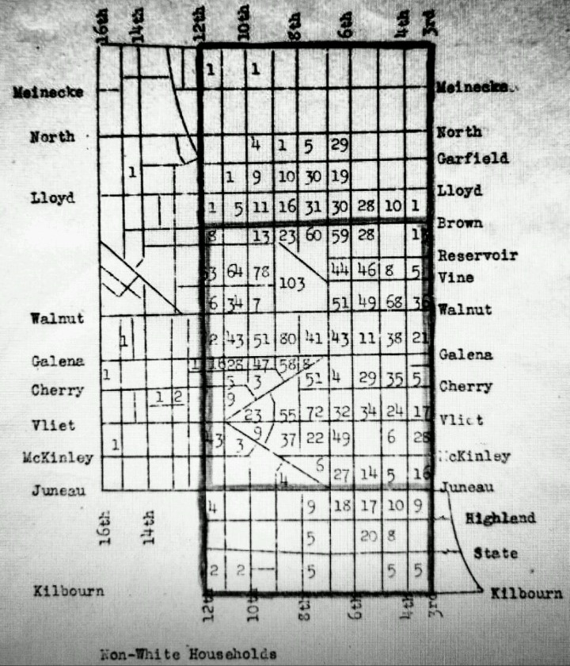
Figure 7. Figures indicate number of non-white households per block (c.1940). Wisconsin Historical Society. http://www.wisconsinhistory.org/turningpoints/tp-018/?action=more_essay.
At first, employment proved to be a struggle for the new African American migrants of Milwaukee. Many of the farms operating in the rural areas surrounding the city were small scale, family owned, and offered few employment opportunities. Additionally, much of the city’s factories maintained discriminatory employment segregation ideologies until the beginnings of World War Two. As a result of this discrimination, the 1940 US Census report testifies that over half of the city’s African American population was unemployed (compared to only seventeen percent of the city’s unemployed white population). After the start of World War Two, of the African Americans of Bronzeville that did finally gain employment in the city’s industrial field, seventy-five percent of them were employed by “companies such as Plankington Packing, Albert Trostel and Sons Company, The Pfister and Vogel Leather Company, and Milwaukee Coke and Gas Company.”
The area’s limited job market and largely unemployed population resulted in a great need for supplementary relief programs to aid the African American community. Indeed, both the 1935 and 1945 Milwaukee County Department of Public Assistance Reports reveal that most of the city’s relief assistance was outsourced to African American families occupying the city’s sixth ward. Additionally, aid could also be found within the community itself sourced from the helping hands of friends, relatives, and small businesses. Local loan services, such as the Columbia Savings and Loan Associations established on Eighth Street by the Halyard family in 1925, helped to fund the start of other African American owned businesses along Walnut Avenue. In turn, these small businesses helped the neighborhood to generate revenue, and it’s African American inhabitants to acquire more wealth, which was then reinvested back into Bronzeville’s community and small businesses— a circular and self-sustaining economy. Speaking on behalf of the Walnut Street Social Gathering Club, historian Normajean Billie Jo Sims reminisces on the old neighborhood as it came to be:
“Bronzeville was home to Black businesses consisting of restaurants, a movie theatre, the Regal, barber and beauty shops, churches, YMCA plus local pool halls and taverns. This is part of our history. Our purpose is to keep these memories alive and pass them on.”

Walnut Avenue’s Final Exodus-
Shortly after the neighborhood had achieved this state of economic stability with credit due mainly to the community and its internal strength, external forces would drive yet another mass migration from the district, though this time by force rather than choice. This exodus was motivated mainly by two critical factors: the construction of Interstate 43 in the late 1950s and early 1960s, and the passing of the Fair Housing Act of 1968.
With suburbanization on the rise, cities around the country were in need of transportation routes that would grant them quick and easy access to the conveniences of the city and back. The answer was the National System of Interstate and Defense Highways. Originally, the state of Wisconsin was home to only two major interstates: I-94 and I-90. After the construction of these highways at a federal level, smaller governments began to follow suit and developed extensions of the system within each state that would connect its major cities through a network of transportation routes. The first of these Interstate system extensions in the state of Wisconsin was located at Georke’s Corners near Waukesha. In Milwaukee, interstate construction continued through the 1950s and into the 1960s. The gradual, but eventual installation of Interstate 43 interrupted and split the neighborhood in the mid-50s. Ultimately, its construction came dually with the displacement of thousands of homes, including the displacement of nearly 800 families in Bronzeville. With housing discrimination policies still freely in place, Bronzeville’s newly displaced population was left with limited options for places to go.
Contrary to the positive reactions of native born citizens towards Jewish suburbanizers in the decades before, this time the popularization of suburbanization did not go without its opposition. During Milwaukee’s 1967 Open Housing Marches, racism motivated Milwaukee’s white South Side residents to respond to the marchers with protest signs advertising swastika symbols:
“[The] jeering, taunting crowd… hurled insults’ at the marchers including cries of ‘niggers go home,’ and ‘go back to Africa’ and ‘why don’t they get a job and earn a living.’ …close to 600 jeering white youths… screaming ‘sieg heil’ and ‘white power.’ …white protestors hurled rocks, bottles, and beer cans at the demonstrators.”

Henry Maier, Milwaukee’s Mayer between 1960 and 1988, was publically a sympathizer to their struggle. During his term, he accused the suburbs of “practicing exclusionary zoning that barred the poor and blacks from suburban housing [and] confined the poor to the city, burdening urban tax payers for the cost of social services.” Though this discrimination did not continue on for long.
In 1968, Congress passed the Fair Housing Act, which barred discrimination based on sex, class, religion, national origin, and race. With the passing of this act, African Americans could finally seek out homes in more suburbanized areas. In conjunction with this act, the city became increasingly concerned about housing standards across the state. They began imposing housing quality standards that would end up condemning many of the residential buildings within the Bronzeville neighborhood, and displacing residents further. With the displacement of so many people, houses, and businesses, the Walnut Street district eventually fell in terms of its economic value once more.

Conclusion-
Though the migrations from the neighborhood in the 1960’s had a significant negative impact on the community’s economy, collapsing businesses and thus damaging its cultural identity, Walnut Avenue survives on today. Over the years, this historic neighborhood within Wisconsin’s most prominent city has served as a sanctuary for people looking to live under better conditions. It has survived despite various waves of immigration and emigration impacting its economic state, turn over in the cultural themes along its business district, and the final destructive disruptor of the neighborhood with the city’s revitalization and interstate planning decisions. Under each of the various ethnic groups it hosted, the community that flourished under its care was tightly knit and provided relief and support to their neighbors and neighborhood newcomers in need. Walnut Avenue represents, for many people, a place of comfort and community that though hurt, has not been forgotten.
This history is very relevant to the area today since plans are currently underway in the city of Milwaukee to revitalize the district, commemorating it as Bronzeville: an African American community. As a call for further research, some questions that may be asked regarding these revitalization efforts could include: why has the African American commemorative narrative survived over that of the Jewish immigrant district memory? Third Street has been renamed Martin Luther King Jr. Street, King’s Park today begins at the corner of Vliet and Fourteenth Street, and Halyard Park runs along W. Brown Street spanning between Fourth and Seventh. These names all commemorate its most recent cultural enclave history, but where has the Jewish memory gone? Also for future studies that focus on the development and progression of this neighborhood through a lens that is both geographic and historic in nature, it would be interesting to see a reconstruction map of Walnut Avenue under each of its three major immigrant occupancies. The map series could include the various services and businesses the area had to offer to its residents, make note of high turnovers, and examine to see if any of these industries survived in future generations extending past its time of major influence.
Bibliography

Primary Sources:
Arkansas. Clay County. 1930 U.S. Census, population schedule. Digital images. Ancestry.com. December 2, 2016. http://ancestry.com.

"Milwaukee's Negro Community." Citizens' Governmental Research Bureau. (Milwaukee: The Bureau, 1946) p. 66; http://www.wisconsinhistory.org/turningpoints/search.asp?id=1095.

Wisconsin Historical Society, Wisconsin Architecture and History Inventory, "Fourth Street School (Sixth District School)", "Milwaukee", "Milwaukee", "Wisconsin", "16740". http://www.wisconsinhistory.org.

Wisconsin Historical Society. Wisconsin Local History & Biography Articles; "Milwaukee Sentinel"; "Milwaukee", "Wisconsin"; "April 4, 1921"; http://www.wisconsinhistory.org on October 29, 2016.

Wisconsin Historical Society. Wisconsin Local History & Biography Articles; "Milwaukee Leader"; "Milwaukee", "Wisconsin"; "May 22, 1918"; http://www.wisconsinhistory.org on October 29, 2016.

Wisconsin. Milwaukee County. 1940 U.S. Census, population schedule. Digital images. Ancestry.com. December 2, 2016. http:// ancestry.com.

Secondary Sources:
Black, Ivory Abena. Bronzeville: a Milwaukee Lifestyle. Port Washington: The Publisher Group, 2005.

Cutler, Irving. The Jews of Chicago: From Shtetl to Suburb. Chicago: University of Illinois Press, 2009.

Gartner, Lloyd P. and Louis J. Swichkow. The History of the Jews of Milwaukee. Philadelphia: The Jewish Publication Society of America, 1963.

Greenstone, Julius H. and Solomon Schechter. “Marriage Laws.” Jewish Encyclopedia (2002- 2011). Accessed November 11, 2016. http://jewishencyclopedia.com/articles/10435- marriage-laws.

Rodriguez, Joseph A., Bootstrap New Urbanism: Design, Race, and Redevelopment in Milwaukee. London: Lexington Books, 2014.

Wisconsin Highways. “Milwaukee Freeways: North-South Freeway.” Wisconsin Highways: Highways and Byways of the Badger State. Last modified October 10, 2016. Accessed November 12, 2016. http://www.wisconsinhighways.org/milwaukee/northsouth.html.

Wisconsin Historical Society. “19th-Century Immigration.” WHS Collections. Accessed October 29, 2016. http://www.wisconsinhistory.org/turningpoints/tp-018/?action=more_essay.

Julius H. Greenstone and Solomon Schechter, “Marriage Laws.” Jewish Encyclopedia (2002-2011): http://jewishencyclopedia.com/articles/10435-marriage-laws.
Irving Cutler, The Jews of Chicago: From Shtetl to Suburb (Chicago: University of Illinois Press, 2009), 5-6.
“19th-Century Immigration,” Wisconsin Historical Society (Collections), accessed October 29, 2016, http://www.wisconsinhistory.org/turningpoints/tp-018/?action=more_essay.
Wisconsin Historical Society. Wisconsin Local History & Biography Articles; "Milwaukee Sentinel"; "Milwaukee", "Wisconsin"; "April 4, 1921"; viewed online at http://www.wisconsinhistory.org on October 29, 2016.
Lloyd P. Gartner and Louis J. Swichkow, The History of the Jews of Milwaukee (Philadelphia: The Jewish Publication Society of America, 1963), 166.
Gartner and Swichkow, The History of the Jews of Milwaukee, 97.
Ibid.
Gartner and Swichkow, The History of the Jews of Milwaukee, 137.
Ibid., 166.
Cutler, The Jews of Chicago, 45.
Gartner and Swichkow, The History of the Jews of Milwaukee, 111.
Cutler, The Jews of Chicago, 40.
Ibid., 42.
Cutler, The Jews of Chicago, 42.
Ibid., 52.
Gartner and Swichkow, The History of the Jews of Milwaukee, 70.
Ibid., 404.
Ibid., 157.
Gartner and Swichkow, The History of the Jews of Milwaukee, 167.
Gartner and Swichkow, The History of the Jews of Milwaukee, 167.
Ibid., 131.
Wisconsin Historical Society, Wisconsin Architecture and History Inventory, "Fourth Street School (Sixth District School)", "Milwaukee", "Milwaukee", "Wisconsin", "16740". URL and date accessed
Gartner and Swichkow, The History of the Jews of Milwaukee, 297.
Joseph A. Rodriguez, Bootstrap New Urbanism: Design, Race, and Redevelopment in Milwaukee (London: Lexington Books, 2014), 13.
Gartner and Swichkow, The History of the Jews of Milwaukee, 168.
Ibid., 309.
Wisconsin Historical Society. Wisconsin Local History & Biography Articles; "Milwaukee Leader"; "Milwaukee", "Wisconsin"; "May 22, 1918"; viewed online at http://www.wisconsinhistory.org on October 29, 2016.
1930 U.S. census, Clay County, Arkansas, population schedule, Bradley, p. 2A, dwelling 16, Milton Childs; digital image, Ancestry.com, accessed December 2, 2016, http://ancestory.com.
1940 U.S. census, Milwaukee County, Wisconsin, population schedule, Walnut Avenue, p. 7b, dwelling 915A, Milton and Mabel Childs; digital image, Ancestry.com, accessed December 2, 2016, http://ancestory.com.
"Milwaukee's Negro Community." Citizens' Governmental Research Bureau. (Milwaukee: The Bureau, 1946) p. 66; http://www.wisconsinhistory.org/turningpoints/search.asp?id=1095
"Milwaukee's Negro Community." Citizens' Governmental Research Bureau. (Milwaukee: The Bureau, 1946) p. 22; online facsimile at http://www.wisconsinhistory.org/turningpoints/search.asp?id=1095.
Ivory Abena Black, Bronzeville: a Milwaukee Lifestyle (Port Washington: The Publisher Group, LLC, 2005), 11.
"Milwaukee's Negro Community." Citizens' Governmental Research Bureau. (Milwaukee: The Bureau, 1946) p. 58; online facsimile at http://www.wisconsinhistory.org/turningpoints/search.asp?id=1095.
Black, Bronzeville, 13.
“Milwaukee Freeways: North-South Freeway,” Wisconsin Highways: Highways and Byways of the Badger State, last modified October 10, 2016, accessed November 12, 2016, http://www.wisconsinhighways.org/milwaukee/northsouth.html.
Rodriguez, Bootstrap New Urbanism, 52.
Rodriguez, Bootstrap New Urbanism, 42.

