UNIVERSITY OF WISCONSIN EAU CLAIRE

A CAMPUS TRANSFORMED: IMPACT OF THE FIRST DAVIES CENTER ON THE UNIVERSITY OF WISCONSIN EAU CLAIRE 1955-2012

Margaret Krohn
History 489 Seminar
Professor Robert Gough
18 December 2012

Copyright for this work is owned by the author. This digital version is published by McIntyre Library, University of Wisconsin-Eau Claire, with the consent of the author
ABSTRACT
For 53 years the original W.R. Davies College Center served the University of Wisconsin Eau Claire as the center of student activities on campus. From the beginning it was envisioned as a place where students, faculty, staff, and alumni would come together as a community. From the planning stages beginning in 1955 to the construction from 1957-1959 to the early years 1960-1964 to the additions and renovations of 1964, 1976, 1982, and 1991 the campus community has been involved in the development and usage of the building. President W.R. Davies worked hard at growing and transforming the institution at Eau Claire and the building which bears his name is a reflection of his legacy.

CONTENTS
ABSTRACT ii
ILLUSTRATIONS iv

INTRODUCTION 1
PART I: THE BUILDING
Section 1: Planning 1955-1957 4
Section 2: Construction 1957-1959 10
Section 3: Early Years 1959-1964 18
Section 4: Additions and Renovations 1964, 1976, 1982, 1991 25
PART II: W. R. DAVIES: THE MAN BEHIND THE NAME 30
PART III: THE DECISION TO DEMOLISH 35
CONCLUSION 40

APPENDICIES
Appendix One: “The Plaint of Minnie Creek” 42
Appendix Two: “College Center” 43
Appendix Three: “Evaluation of Center submitted to the Board of Regents June 24, 1960” 44
Appendix Four: “Statements by faculty, administration, and the student body on their experience with President W. R. Davies” 45
Appendix Five: “Letter to the Editor” 47
Appendix Six: “Additions to the Original Davies Center” 48

BIBLIOGRAPHY 49

ILLUSTRATIONS

Figures
- “Student Union Architect's Rendering c. 1956” 4
- “Davies Center second story under construction c. 1958” 10
- “Groundbreaking November 20, 1957” 14
- “Early Years of the W. R. Davies College Center c. 1960” 18
- “College Center c. 1959” 24
- “W.R. Davies College Center c. 1960” 24
- “Davies College Center c .1967” 25
- “William R. Davies” 30
- “Demolishing Davies” 35

“In both the commonwealth countries and in the United States the student union building has become recognized essential in the well-run institution. It serves as the focus of student social life, providing headquarters for the various student organizations, and snack bars or dining rooms for students. As a popular social center it serves the highly useful purpose of creating a sense of unity in the college or university community.” Oliver C. Carmichael

INTRODUCTION
Going off to college is a unique and complex experience for high school graduates. Gaining a higher education is the main goal for these students, but there is much more to the college experience than academics. Student life involves learning how to live away from home, for many persons the first time, work in a community, and face the challenges of living in society. Social connections are made in college and it is a place to learn how to function in the world as an adult. It is a transition period for students from being adolescents to becoming adults. College is unique in that it helps students become more independent while at the same time creating a community around the campus.
Just out of high school college freshmen are not the only persons that make up the community on campus. Upper classmen, non-traditional students, faculty, staff, and alumni have major roles in the community as well. The key for college institutions is to find a way to create a social and intellectually stimulating atmosphere on campus for the many different groups that make up the college community. The student union or college center serves this purpose. It establishes a place where college community members can go to socially engage with each other. It serves as the “living room” of the campus, a place to relax, eat, socialize, discuss, meet up, and find entertainment. The idea of a student union building was relatively new in the United States in the 1950s, but it caught on quickly as its importance to the campus and supporting community became evident. The institution at Eau Claire, Wisconsin was not different and saw the benefits of having a union devoted to the campus community experiences.
In 1916 the Eau Claire State Normal School was founded with the construction of one building on 12 acres of land in the city of Eau Claire, Wisconsin. Over the years the school transformed through; expansion of its physical landscape, services and programs offered to students, and through increased enrollment. Harvey Schofield served as the first president from 1916 to 1940. In 1927 the normal school became the Eau Claire State Teacher College. William R. Davies became the second president of the college in 1941. He had a vision to expand the institution and transform the campus. In the 1950s and 60s the college grew through physical expansion and programs offered to students. In 1951 the institution became the Wisconsin State College at Eau Claire. Physical transformation of the campus began in 1950 with the groundbreaking of the complex consisting of the Professional Education Building, gymnasium, and theater (named Brewer Hall, Zorn Arena, and Kjer Theatre in the 1960s.) The campus in 1952 consisted of this complex, a music building, a heating facility, and Old Main, the original structure known today as Schofield Hall. This was just the beginning of the campus transformation.
The campus needed a center that would provide specifically for students’ social and non-academic needs. President Davies wanted to create a community and feeling of unity on campus and he felt it needed a place where students, faculty, staff, and visitors could go for meetings, events, and services. In 1955 planning began for a building to house the student union and be used as the center of the college community. The College Center opened in 1959 and was named the W. R. Davies Center in 1960 in memory of President Davies. The center experienced transformations through additions and renovations in the years 1964, 1976, 1982, and 1991.
The W. R. Davies College Center stood as the focus of the university’s social programs and student activities. The center served as the “living room” of the campus since its completion in 1959 until it was taken down in 2012 with the construction of the new center. This paper will explore, the history and impact of this building through its planning, construction, early years, additions and renovations. The decision to demolish the building and construct a new building for the student center will also be addressed.

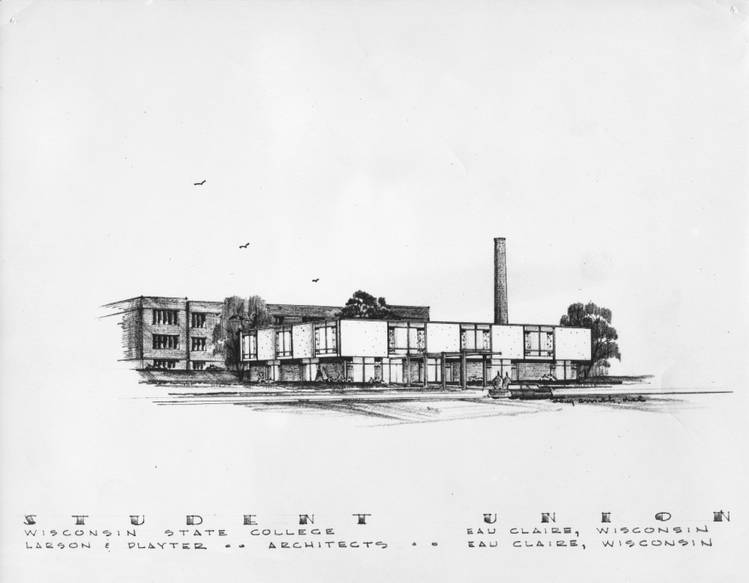
PART I: THE BUILDING
Figure 1 “Student Union Architect's Rendering c. 1956” Archives Series 279 (University Archives Photograph Collection), Box 1, Folder 5.
Section 1: Planning 1955-1957

“The Wisconsin State Colleges Building Corporation for and in behalf of the Board of Regents of State Colleges is planning a student union on each of the Wisconsin State College campuses.”
A student union had been present on campus since the fall semester of 1940; a single room in Old Main, across from the auditorium. President Schofield took it upon himself to oversee the furnishing of the room. An oil painting of log cabins in winter decorated the room. Even with the addition of Brewer Hall and Zorn Arena, Old Main was still the center of campus life. The 1957 Periscope, the campus year book, stated “Old Main is the hub of activity at Wisconsin State College Eau Claire. Classrooms, the Union, the Blugold room, the auditorium, the cafeteria, the bookstore, and the publications offices make this building a busy place.” Yet with a growing student population the limited space of one building became an issue. Meetings were arranged and solutions to the space problem began to circulate.
By December 1955 it was decided to build a new building solely for the purpose of housing the student union. Discussion of converting Old Main’s lower floor into the student union occurred but was dismissed because of the limited space and problems with providing food services. After a thorough discussion with students, alumni, and faculty members President Davies recommended the construction of a separate union building and that $400,000 be borrowed for its completion. He stated in a letter to Eugene McPhee “…such Union to house food service, social and recreational rooms, and college book store.”
A Union Planning Board became organized and began to research union facilities. The board arranged several visits to colleges to observe their union buildings. They came back to Eau Claire with significant overall observations. All the unions had underestimated the needed space for facilities, especially the snack bars. The general layout of the buildings had; lower levels for snack bars and recreational purposes, first floor for kitchens, cafeteria, dining rooms, and offices, and the top floor for lounges and dance halls. Many building regretted making large space for the ballrooms because they were not always in use but took up a lot of square footage. These general guidelines formed the starting point for the Union Planning Board. The Eau Claire College Center did have the Blugold snack bar and game room on the ground floor and the cafeteria and offices on the main. They solved the problem of the ballroom being the large, often unused space, by making it the cafeteria. The Southwoods cafeteria furniture could be cleared away and become the large ballroom. It also had temporary walls that could be set up to create three smaller dining rooms or ballrooms called the Pine, Spruce, and Tamarack sections. Dr. Emans, a member of the board, was the only member to vote against using wood for the cafeteria floor. He did not think it would hold up the daily use by students. He was voted down however as the other members were convinced from their visits to other unions the wood floors would last at least five years.
In an attempt to learn more about planning unions President Davies managed to secure a copy of a speech made by Glen W. Timmons, “Problems and Procedures in Organizing a Union on a Small College Campus.” In this speech Timmons argued that the most important question to ask when planning a student union is; what type of facilities will be wanted and needed for the campus by the students? Facilities such as food services, ballrooms, lounges, meeting rooms, offices, recreational facilities-what should be offered? Timmons stated, “A Union must have the philosophy of service; otherwise, there is no reason for its being.” It was up to President Davies and the Union Planning Board to determine what philosophy of service the union at the Wisconsin State College Eau Claire would follow. It was eventually decided that the union’s purpose came down to three points. One, it must provide social, cultural, and civic developments on campus. Two, it would be used to promote the general welfare of the student body. Three, it would stimulate closer relationships among students, faculty, and alumni.
The Wisconsin State Colleges Building Corporation approved the decision to build a union in Eau Claire in May 1956. Eau Claire was not the only state college in Wisconsin that was planning a new union building. All Wisconsin State College campuses, River Falls, Superior, Platteville, Whitewater, La Crosse, Menomonie, Oshkosh, Stevens Point, and Eau Claire were allocated money to build student unions. The Community Facilities Administration of the Housing and Home Finance Agency approved a loan of $5,400,000 to the Wisconsin State Colleges Building Corporation. The corporation then divided the loan into smaller amounts which were sent to each campus to finance the new union buildings. Eau Claire received $675,000 from the corporation to build their student union.
Now an architect needed to be found who could design the building and how it would fit into the campus’s landscape. The Wisconsin State Colleges Building Corporation, Regent William McIntyre, and President Davies agreed to go with Larson and Playter, an architectural firm established in Eau Claire. They agreed and submitted preliminary architectural and engineering data to the Wisconsin State Colleges Building Corporation for approval of the loan to build the union. This data included preliminary sketches and an outline of specifications for the project.
By the end of the summer of 1957 plans were drawn for the building and discussion began on where it would fit in the landscape of the campus. It was decided the building would be built south of Old Main. In a letter from Chas A. Halbert, who was hired as a consultant to Larson and Playter, Halbert discussed his opinions on the proposed plans for the building’s location. At the time one hundred feet was planned to be between the union building and Old Main. However Halbert felt the distance was too great and the buildings needed to be closer. He felt that doing this conserved campus space, which would allow for expansion in the future. He also argued that the cost of utility services such as clearing walkways would be lower if there was less space between the buildings. There was also the desire for an under-cover connection between the buildings. It was extremely important to everyone on the planning committee that a tunnel or some covered walk way be available. “For so many reasons, and in the minds of all of us – the tunnel is a “must.”” What these many reasons were is unrecorded but their importance is evident. Perhaps the tunnel between the two buildings represented a connection between student life and academics and was seen as a unification tool. Halbert continued his letter with planning ideas for the landscape of the new building. The creek, known today as “Little Niagara,” but at the time called “Minnie Creek,” was south of Old Main and in the planned construction area for the Union. It was decided to reroute the creek farther south and the money to do so was added to the budget. For a short time there was talk of creating a pond next to the union building, where McIntyre Library stands today. Yet it was dismissed because of the fear that algae would make the pond unattractive. So the creek remained the body of water on campus until the expansion over the Chippewa River in 1970..
On October 24, 1957 at 5:42 PM President Davies received a telegram. It was from the Community Facilities Administration of the Housing and Home Finance Agency. “A loan to finance a new student union building to provide dining and recreation facilities, book store, and student activity rooms has been approved for your college.” The preliminary plans were set and now the money to build approved. The union at Wisconsin State College Eau Claire was no longer just an idea or a blueprint but was about to be under construction.

Section 2: Construction 1957-1959
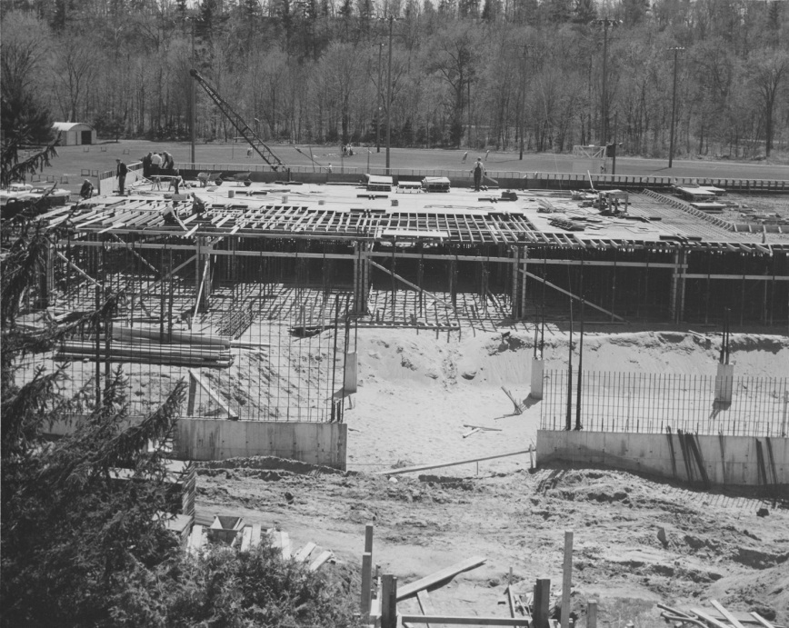
Figure 2 “Davies Center second story under construction c. 1958” Archives Series 279 (University Archives Photograph Collection), Box 1, Folder 3.

“With the enrollment of the college now over the thirteen hundred mark, the college must go through a definite period of growing pains.”
In 1956 the campus newspaper, The Spectator, heralded that the construction of the student union building was to begin in the following spring. According to President Davies $645,000 was allocated for the new building and would be paid off over a 40 year period.
The announcement of a building solely to house the student union must have been welcomed by the students. In the same issue of The Spectator an article complains about Dean William Zorn’s prevention of the homecoming committee from housing the homecoming dance in the gym. Zorn feared the gym floor would be damaged by the dancers and he did not what to encourage students to walk on it with their street shoes. He also argued that too much emphasis was on the dance and not the football game. The student government stated that homecoming was not just about the game but was a social event for the students and alumni and therefore the dance had to occur. They approved the renting of Fournier’s Ballroom to house the dance. Jim DeJung, President of the Student Government, argued in his column “State of the Union” that by relocating the dance the cost increased by $100 needed to rent the ballroom and students were forced to leave campus. Being on campus was important for a social event such as homecoming and it inconvenienced students by making them find transportation to an off campus site. He also argued that supervision at the dance increased because of the off campus location. Soon the problem of finding space for student activities that avoided taking up other departments’ space would be solved with a new building.
The 1957-1958 school year saw the replacement of the Union Planning Board with the College Union Board. Now that the plans for the building were complete, plans for the organization of the facilities offered within the building needed to begin. The board consisted of ten regular members. Six of those were full time students. The other members were one faculty, one alumnus, the Dean of Men, and the Dean of Women. The College President and the Union Director served ex-officio. The first business meeting of the College Union Board was held on February 6, 1958 at 7:30 PM. This meeting established “the specific functions and powers of the Union Board.” President Davies opened the meeting with a history of the student union on the Eau Claire campus since 1940. Officers were then elected. Newly-elected President Glenn Person appointed a constitutional committee to organize and present a constitution for the board to ratify at the next meeting. From the beginning President Davies felt it necessary to include students, faculty, and alumni in the student union development. Students were involved in the planning of the building, researching other student unions, the development of the student union program, and the establishment of the facilities and functions the student union would offer. The College Union Board is an example of President Davies’ style of wanting to create a community on campus of students, faculty, and alumni.
The meeting ended with Steven Playter, the architect who designed the union building, presenting plans for the building and the estimated budget of $725,000 with April 1, 1959 as the tentative completion date. This budget was considerably more than the $400,000 initially proposed and $80,000 more than the most recently proposed budget of $645,000. The actual cost of the building ended up as $750,000 which was close to the final estimated budget.
Two months after the first meeting on April 22, 1958 the College Union Board lived up to the theme of transformation at the Eau Claire campus by changing the name of the building from the College Union to the College Center. From now on they were the College Center Board. Reasons for this change were not given in the minutes.
The accomplishments of the board included assistance in the physical construction and in determining the facilities of the center. The board created committees to establish the constitution of the center and house rules, one of their most important accomplishments. They allowed the elevator to be used by passengers, added rooms to the building plan including the information counter, filing room, and the Blackhawk room, and they selected all the draperies and furniture throughout the building. They were also responsible for making the center a member of the National Association of College Unions and the National Association of College Stores.
Finally after all the planning and preparation, construction began. On Wednesday November 20, 1957 the ground breaking ceremony commenced. The Chief Executive of the Student Government, Bob Southard, was the master of ceremonies and began the program at 10:00 AM. It opened with the singing of the Alma Mater. Then President William McIntyre of the Wisconsin State College Board of Regents, President Davies, and Dean Stella Pedersen were introduced. Hoopnpner and Barletett were then announced as the contractors for the building. An announcement stated actual construction was delayed by the relocation of Minnie Creek to make room for the building. The completion of the building was set for late 1958. Afterward they went outside into the cold and rain which must have contrasted the feelings of looking forward to the bright future of the new center. Jim DeJung, with his involvement as the previous student government executive and the co-president of the College Center Board, had the honor of turning the first shovelful of dirt.
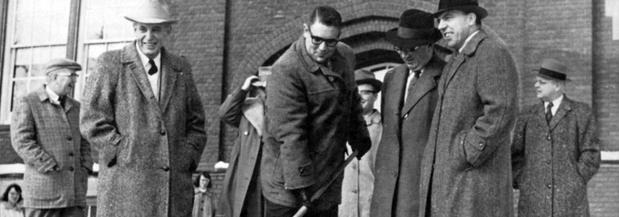
Figure 3 “Groundbreaking November 20, 1957” http://www.uwec.edu/centers/facilities/davies/about.htm

Before construction even began the first casualty occurred, Minnie Creek. It had to be removed, or at least relocated. A new route was bulldozed for the creek to flow farther south. The addition of the new college center not only altered the campus’ building landscape, but transformed the land itself. Tristram Jones particularly felt the grief of diverting the creek and interrupting the natural order. He submitted a poem to The Spectator. Jones claims the poem was “as Tennyson would have uttered it.” Although moved from its original course the creek is still a part of lower campus today flowing under Phillips Science Hall and bridges before falling into the Chippewa River in a tranquil spot often visited by students.
The new position of union director needed to be filled. One of the letters that the Union Planning Committee received with suggestions on running a successful student union advised that the position of the union director be filled quickly, before or at least during construction. This way the director would have a say in the way the building was organized and could begin planning what activities and facilities to offer. President Davies took this suggestion and appointed Clayton Anderson. The Spectator announced the appointment on January 16, 1958. Anderson was an alumnus of Eau Claire, class of 1942, with a Bachelor of Science degree. He served in the Air Force for four years as a physical training instructor. He returned to Eau Claire and worked at the YMCA as the general secretary and physical director. He worked there for twenty one years and then came to the Wisconsin State College Eau Claire to be the first union director. His wife Dorothy was a noted athlete as a golfer, ice skater, and former tennis champion. Anderson’s experience with education, work with young people, the athletic department, and as an administrator prepared him for his work at the college center.
Now that construction of the center was in full swing, discussions began of the future of the building. Anderson was confident that “Our new Student Union will be one of the finest college unions in the U.S. and the students, faculty, and any others who devoted many hours towards its planning certainly should be congratulated for the job they did.” Anderson considered it very important to not only work with the College Center Board but with the students, faculty, and staff as well. He encouraged ideas for the center to be presented to him for consideration. “Ideas from students will help the new Union board to determine additions to present plans. I’m urging students to come with any ideas which may make our new Union enjoyable for everyone.” Anderson understood the center was meant to be a place for students and wanted them to be involved with creating ideas and planning activities and facilities offered at the center. Student academics and student life were to come together in this building and Anderson wanted the students to be a part of determining how that balance would occur. “When we plan Union activities we hope to make them enjoyable so that everyone will want to come. Our aim is that every student will come to the Union at least once a day.”
Two sophomores, Jim Hanson and Bob Vesperman were determined to be the first students to come to the center. They bought a picnic lunch of sandwiches, potato chips, and orange juice in the Blugold room in Old Main. With their lunch they went to the center’s construction area. They jumped over a wall and climbed into the approximate area where the new cafeteria would be in the center. Some hay had to be spread around the sandy ground to sit on and they ate the first of many meals to be consumed by students in the center. Bob told The Spectator, “Fifty years from now we will be able to tell our grandchildren that we were the first to eat in the new college union way back in 1958. It’s a great thrill and honor to have this distinction.” Jim explained his excitement at being the first as well and stated “… we are waiting for the day when we will no longer have to crawl over walls, spread hay, and eat on a sand dune.”
The estimated finish date was set for April 1959. By May 1958 Center Director Clayton Anderson was confident it would be complete around that time. After a summer of construction Anderson announced in October 1958 that the building would be open March 1959 with a precise date yet to be determined. However April rolled around and the center was not complete. The middle of June was next proposed as the completion date but President Davies hoped it would be finished sooner and predicted that a few events might be held in the center before the end of the semester. Anderson explained that the delay in opening was because the State of Wisconsin, the current owner of the building, had not released it to Wisconsin State College at Eau Claire. Until the building passed from the state to the college the center could not be opened to the public. The delay prevented the placement and arrangement of furniture and other facilities in various areas of the building. Once the state released the building the delay would be fixed and the opening would happen shortly afterward. “The College Center will be open on a limited schedule during the 1959 summer school, according to Clayton Anderson….providing that the State will release the building…within the next few weeks.”
Finally the State of Wisconsin released the building to the college, the furniture went in, and the center opened with regular hours June 15, 1959 for the use of summer students. Although the doors were open and all were welcome, not all the services and features of the center were available. However Anderson promised that everything would be open by the 1959-1960 school year. Food services, cafeteria, snack bars, the bookstore, lounges, conference rooms, and the separate space to hold every school dance on campus without fear of ruining the gym floor was now under one roof. The building to house the “living room” of the campus was open.

Section 3: Early Years 1959-1964
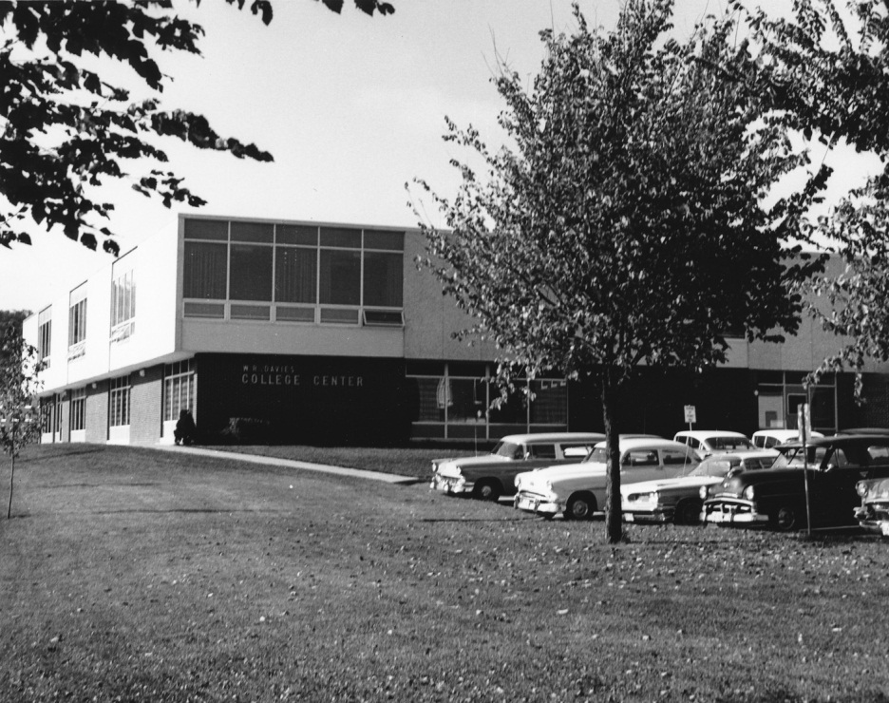
Figure 4 “Early Years of the W.R. Davies Center c. 1960” Archives Series 279 (University Archives Photograph) Collection), Box 1, Folder 8
“I’d like to leave you with one very important procedure for anyone connected with a Student Union operation: under any and all circumstances, no matter what happens, BE CHEERFUL!”
After delays from construction and problems getting the building released to the college from the State of Wisconsin the center opened in September 1959 with all its services available. “A long-awaited dream becomes a reality…Obstacles arose, sometimes delaying work somewhat, but progress continued on.” The Periscope praised the new building with a spread of pictures of its construction and a brief article of the relief the planning and construction was over. “…It is truly an addition to the campus of which all can be proud.”
Members of the College Center Board also expressed satisfaction in the completion of the building they had a large part in bring about to campus. Sylvia Larson, a member of the board, stated that “It’s a good solid feeling to know you’re doing something that’s going to last. I know I can come back here years from now and see people enjoying the Center I helped set up.” The board continued to work for the center but in May 1960 the student government voted that the College Center Board would become a committee of the student government and not be a separate organization. This allowed the student government to control the operations of the board and the center. Many students felt this gave the student body more say in what happened at the center and prevented limiting the student voice to the six students on the board. It also made the center feel more like a part of the larger college because it was under the student government and not a separate organization. Having more students involved and bringing organizations together was the vision President Davies and other members of the college had when they set up the board so the integration into the student government took place.
President Davies stepped down as president in the fall semester of 1959 and the Board of Regents named Leonard Haas as acting president. Davies was to retire on January 5, 1960 but his failing health caused him to take a leave of absence prior to his actual retirement. Davies wrote to Eugene McPhee to explain that,
“On the advice of my physician I must plan to retire from my position as President of the Wisconsin State College at Eau Claire…It is with deep regret that I terminate an active and pleasant relationship with the staff and students, and I wish to thank them all for their splendid cooperation and confidence during the difficult years of the expansion of the college.”

Davies served the college for eighteen years as its president. The Board of Regents, whom McPhee was a member, said that “President Davies has served with distinction since the date of appointment. The college at Eau Claire has doubled in enrollment and the physical facilities at the institution have been improved under his leadership.”
The center opened and the traffic came in. Students on the meal plans filed in to eat in the Southwoods cafeteria or the Blugold Room. The center was also used for meetings and hosting events. The first event held in the center was the President’s Reception for graduating seniors on June 4, 1959. It gave the senior class an opportunity to see the new building and wonder what it would have been like to have it as a part of their college experience. One of the first visitors to the center was Senator John F. Kennedy on November 12, 1959. The Massachusetts senator spoke to students at 2:00 PM in the Little Theatre. Another famous visitor to the center later that same year was Louis Armstrong, the famous trumpet player and singer. He gave a pre-holiday jazz concert on December 19, 1959. These events were a part of the long tradition of The Forum, a program founded in 1941 that brought guest speakers and performers to the campus to better educate the students of the world outside of Eau Claire.
When asked what purpose the center gave to the College Center Director Clayton Anderson told a Spectator reporter,
“…the purpose of the building is not so much recreation as service. He [Anderson] pointed out the food, service, the bookstore, the meeting rooms and conference rooms as examples of this. However the new Union also has adequate facilities for dances and other social affairs, which may be held in the Union with no rental charge.”
Although no classes were to be held in the building it was stressed that it was still a part of the educational experience of the college. “All the facilities of the Center are used to educational advantage. The Center seeks to convert the college from a “house” of learning to a “home” of learning, Anderson said.” The “living room” on campus opened and students took full advantage of their new “home” and the services it provided them.
However there were some glitches with the new building that needed to be addressed. About a year after the center opened Anderson sent President Haas a list of the problems that still needed to be solved with the building’s structure. The memo was then forwarded to Eugene McPhee to bring the problems to the attention of the Board of Regents so they could inform the contractors to fix the various problems. Hass did say that “…much of the critical evaluation listed above is of a minor nature, or of a character that very little can be done about it.” Probably the most disappointing was the tunnel, that everyone insisted on getting to connect the center to Old Main, was having problems. The ceiling plaster crumbled and during heavy rains it would leak. The wonderful tunnel that was supposed to allow walking from Old Main to the center without getting wet, was dripping. The architects, Larson, Playter and Smith, were notified of the problem and added it to the list of things that needed to be fixed. Another major problem was several windows were either broken or leaked during heavy rain. At one point all the windows on the second floor leaked. There were other problems with the installation of some equipment, the heating system, the ventilation, cracks in the wall, and installation of some of the floors. Some of these problems were easy to fix and were resolved quickly while other proved to be more of a challenge.
Visitors who walked through the new doors oblivious to the problems had eyes only for the new paint, furniture, and looked for a map of the new building. The college center rules were laid out clearly for the visitors. The center was not to be used as a classroom but conferences, programs, and meetings could be held there. Smoking was permitted on the first floor and with special arrangement in the President’s room, Southwoods room, or the Sunset Lounge. Alcoholic beverages were not allowed and any one possessing them was expelled from the center. “Gambling, card playing, tipping, obscene language, abusing, reclining, or sleeping on furniture are prohibited.” If anyone was uncertain of how to dress for going to the “living room” of the campus it was clearly laid out. “In the Cafeteria and lounges the acceptable dress is the regular classroom dress. The acceptable dress for Sunday dinner is coat and tie for gentlemen and appropriate Sunday dress for ladies.”
After a few months of operation Anderson evaluated the center. For the first question he had to explain the value the center gave to the college. Anderson replied the center gave value to students, faculty, and other groups.
“The College Center gives the entire student body an opportunity to meet on an informal basis to discuss their studies and problems. It also provides them with a
social, cultural, and recreational programs.

The faculty derives a great deal from meeting with the students as friends in a limited way outside the classroom where questions and answers can be easily exchanged.

The Center presents a wonderful opportunity to promote good public relations through the use of its facilities for worthwhile meetings and conferences.”

In the evaluation Anderson also argued that the center brought about changes by creating “Greater interest in campus life, closer student faculty relationships outside the classroom, and increased pride in the state college.” Although Anderson gave a glowing report he was not afraid to admit a few things he wished could have been done differently. Although the Union Planning Board discovered in its many trips to other unions that it was preferred to have the cafeteria and snack bar on different floors Anderson wished the cafeteria and snack bar were on the same floor with a central kitchen to provide both with food. He also wished the service tunnel had a membrane roof to prevent the leakage problem. The game room was too small. And Anderson agreed with Dr. Emans about not using wood floors in the cafeteria and wanted to replace it with terrazzo, the Union Planning Board should have listened when they voted him down.
Anderson also pointed out that the center was being utilized at almost one hundred percent occupancy, during certain times of the day. One day could see the center serve between 5,000 to 8,000 people. The center also created job opportunities for students and staff. It created twenty five jobs on campus and employed thirty eight students. These students earned an average hour pay rate of 75 to 80 cents per hour. Overall the center was a good thing that happened to the campus by providing services to students, faculty, and other groups and even with its few problems, it provided a needed facility for the college.
Former President W. R. Davies, who put much effort into the expansion of the institution died on December 10, 1959. His death was a great loss to the students and faculty on campus. Living up to the legacy of working as a community instilled by President Davies a committee of students, faculty, staff, and alumni formed to decide what name should be used for the center. On January 14, 1960, about a month after Davies passing, it was announced that the college center would be renamed the W. R. Davies College Center in his memory. The W. R. Davies College Center was the first building on campus to be named in honor of an individual.
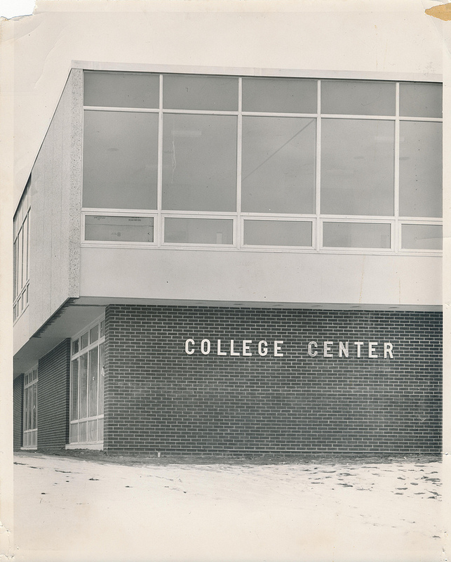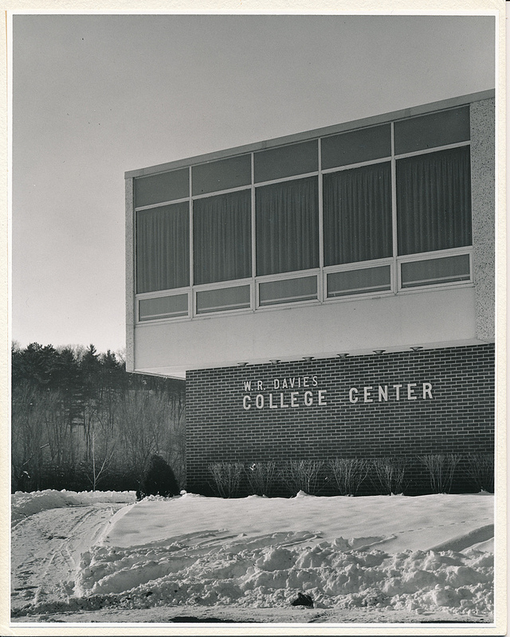
Figure 6 “W. R. Davies College Center c. 1959” Archives Series 279 (University Archives Photograph Collection), Box 1, Folder 3
Figure 5 “College Center c. 1959” Archives Series 279 (University Archives Photograph Collection), Box 1, Folder 3

Section 4: Additions and Renovations 1964, 1976, 1982, 1991
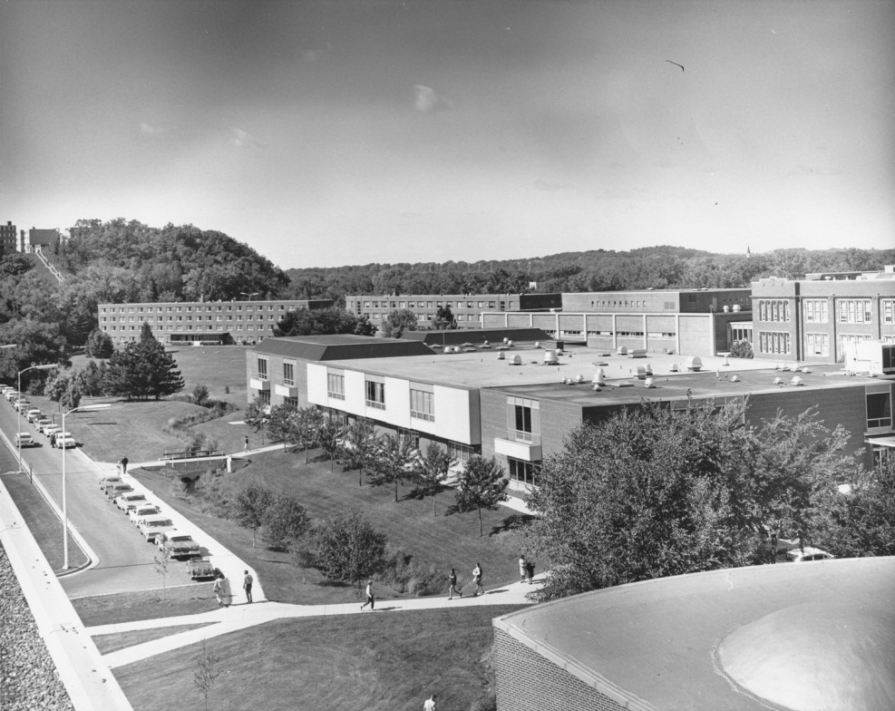
Figure 7 “Davies College Center c .1967” Archives Series 279 (University Archives Photograph Collection), Box 1, Folder 3

“The type of campus you have greatly affects the kind of Student Union you should build. And yet, within a very short time, the kind of Union you have will, in part at least, determine the type of campus you have.”
Enrollment continued to grow for the college and with this came the need for the physical space of the college to grow as well. To go from a single room for the college union to an entire building must have been a big change, but very early on it was evident it was not enough. From its beginning the W.R. Davies Center (Davies) has been too small and dreams of expansion were on all Directors’ minds.
In March 1960 just seven months after the official opening of Davies, Center Director Clayton Anderson stated the center was too small.
“I would like to go on record at this time as saying that the building which we all thought would be adequate for many years to come, is already, during peak periods of use, too small to meet our needs…The Blugold Room is at least 400 seats short of what we need. Plans should be made to expand the building as soon as possible.”
Almost exactly three years later on March 28, 1963 groundbreaking launched for an expansion on Davies. A new annex that would add 39,000 square feet to Davies was underway for $640,000. The expansion was on both the east and west sides of Davies and included the first and second floors. Larson, Playter, and Smith were once again assigned as architects for the building. The Southwoods cafeteria went from seating 600 to 1,000 and the Blugold snack bar accommodated 600 instead of the previous 200. Other areas of expansion included the addition of a new auditorium and visual aids theater on the northwest side, nine new meeting rooms, the expansion of kitchen facilities and lounge space. The Trading Post which housed the bookstore was doubled in size. The entire expansion almost doubled the Davies Center. Construction began in June 1963 and was finished in September 1964.
Another major transformation that took place on the campus was the changing of the college’s name from Wisconsin State College at Eau Claire to Wisconsin State University Eau Claire. The change reflected the expansion of the campus. “According to President Haas a “college” is an institution of higher learning at the undergraduate level. Since each of the nine schools [colleges in Wisconsin] has more than one school on its campus and has been given the right to grant graduate degrees “university” is more appropriate title.” In 1971 the campus joined the UW-system and was given the title it is known by today, the University of Wisconsin Eau Claire (UWEC.)
Almost doubling the size of Davies was satisfactory for twelve years. Then in 1976 another addition was constructed to the east side of the building. Schofield’s annex, which housed a few classrooms and storage space, had been removed to make space for the addition. This allowed Davies to be closer to Schneider and Phillips Halls. Construction was completed in January 1976 and the cost was $1.6 million. To assist in the payment student segregated fees were increased by six dollars per semester. The expansion included food dispensary places with a pizza shop and ice cream parlor. Four handicapped access points were also installed. This addition added 22,000 square feet to Davies. Despite these changes Davies was still one of the smallest student centers in Wisconsin. The Periscope stated “…the addition will accommodate all long range needs for student space and nothing further is planned in the way of expansion.”
Yet 1982 saw the beginning of construction for another addition. A total of 7,000 square feet were added to Davies in three different areas. One area expanded the loading docks on the south side of Davies. The second was a new loading dock for the bookstore on the west side of Davies. The third area also involved the bookstore by expanding it north towards Schofield Hall. This also included a two-story addition on the other side of the tunnel to expand office and meeting room space. There was also 30,000 square feet of Davies that was remodeled. This expansion and remodeling was financed by reserved funds from revenue generated by the building over the years and current revenue from the food services, bookstore, and other operation funds. The total cost was $1.2 million and construction completed in spring 1983. Yet this renovation was the same as the others; Davies was closer to being large enough to accommodate the number of students who used it but it was still undersized.
Nine years later in 1991 Davies was given its final renovation. This one did not include any expansion of the building but internal remodeling. The Blugold Room experienced the most change with the addition of two restrooms and a student locker room. Gary Bartlet, the director of university centers stated that “With the number of students we have, according to (the building) code, we are short on restrooms.” Although it meant the Blugold Room would be slightly smaller the additional restrooms were necessary. Other areas that received remodeling were the Dulany Inn, Davies Cafeteria, the kitchens, and The Cabin, and additional offices were made available. Although most of these changes involved the unseen plumbing system and kitchen upgrades, the visual changes such as replacing much of the dated décor was welcomed by students. Some students approved the changes but a few did protest. Kris Whitfield, a business administration freshman protested the removal of the Multicultural Lounge to make way for a corridor to cut across the building. He argued that the University was trying to promote diversity yet it took away the multicultural lounge. It was temporarily relocated to the penthouse of the Old Library. This was a very out-of-the-way location which made it difficult to find or desire to go there. Whitfield felt it unfair of the university to remove the lounge to make way for a hallway and he asked for all students and faculty to question to true intentions of the university’s commitment to diversity. A diversity resource center was moved back to Davies.
From the beginning Davies had trouble supplying enough space for the campus population. The student enrollment continued to increase and Davies had to keep up with the growing demands for space for student living. As more students came in, the “living room” had to change to make sure everyone had a seat.

PART II: W. R. DAVIES: THE MAN BEHIND THE NAME
Figure 8 “William R. Davies” Archives Series 279 (University Archives Photograph Collection), Box 16, Folder 1

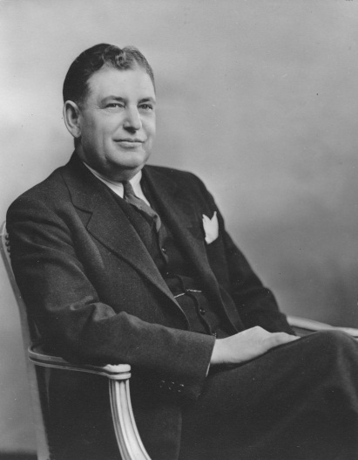
Over the years students identify the name “Davies” with the college center. But few remember or know the man behind the name. Who was W.R. Davies and what did he accomplish for Eau Claire that the first building to be named after a person was given his name?
“The growth and progress of Eau Claire State College are evidence of the finest tribute that can be given to President W. R. Davies. My good fortune to be associated with him during these past 18 years has been the finest experience of my professional life.” acting President Leonard Haas, September 1959.
William Robert Davies was born on August 19, 1893 to David and Sarah Davies in Tenino, Washington. His parents were of Welsh decent and moved to Washington from Wisconsin. They returned to farm near Cambria in Columbia County, Wisconsin when Davies was four years old. Davies graduated from Cambria High School in 1911. He went on to Ripon College with a major in mathematics and philosophy earning his Bachelor of Arts degree in 1915. He then went to the University of Wisconsin Madison where he earned his master’s degree in education. He took additional education courses over the years at the University of Chicago, University of Minnesota, and Columbia University.
After graduating from Ripon College Davies became the assistant principal of the Endeavor Academy which was a private Congregational school located in Marquette County. In September of 1917 Davies joined the YMCA staff at Camp Custer in Michigan. Two months later he enlisted in the US Army Medical Corps. He was discharged in April 1919 as a sergeant first class. He remained in the reserved forces until 1930 and was commissioned as a reserve first lieutenant. From 1919 to 1923 Davies served as principal of McKinley Senior High School in Marshfield, Wisconsin. In 1920 he married Erva Barron. He was then principal and superintendent of schools in Shawana, Wisconsin from 1923 to 1925 and then superintendent of schools at Beaver Dam from 1925 to 1931. It was during this time that his three children, Kathryn Mae, Dorothy Jane, and Robert Barron were born. From 1931 to 1940 Davies served as superintendent of schools at Superior, Wisconsin.
On December 18, 1940 an assembly was held where Davies was introduced to the 700 students and 46 faculty members of the Eau Claire State Teachers College as their new president. He became the second president of the college once his official duties began January 1, 1941.
The early years of Davies’ Presidency saw several setbacks and opportunities. The effects of the Great Depression were still evident and enrollment was on the decline. Davies decided that the college needed to change and expand. Davies set out to expand the campus with new buildings, but the outbreak of WWII halted any plans for expansion. In October 1942 his wife Erva became ill and passed away. This marks a low point for Davies and the thought of leaving Eau Claire entered his mind. He inquired about an opening as a superintendent of schools in Minneapolis in the spring of 1943. However he never pursued the opportunity further and decided to remain in Eau Claire. During the war years Davies decided to pursue a veterans and officers preparation program to help increase enrollment. It worked and early WWII enrollment of less than 400 went up by 300 students during the war. After the war the Wisconsin G.I. Bill assisted greatly in increasing enrollment which led to the expansion of the campus. In 1944 he married Delpha Smith who was the supervisor of music in the Eau Claire public schools system. In 1949 his oldest daughter, who was suffering from injuries from an accident in 1942 and chronic illness, passed away.
The 1950s saw the beginning of expanding the campus. In 1951 the Bachelor of Arts and Bachelor of Science degrees were offered at the campus and the State Teachers College was renamed the Wisconsin State College at Eau Claire. The construction of the first new buildings, which were later named Brewer Hall, Zorn Arena, and the Education Center, began in September 1951. Then on-campus housing for students began with the first residents’ halls opening in 1953 and 1958. 1957 saw major expansion of the campus with the acquisition of the 230 acres of Putnam Park. This included the bluffs which later became Upper Campus and made “the hill” a trademark of the campus. This year also saw the ground breaking of the student center. The library was the final building Davies was directly involved in and its construction began in 1959.
Davies was also instrumental in expanding the programs and services offered on campus. As mentioned already he was active in establishing military veteran programs on campus. He was also involved in creating the campus Forum Series as a way to bring different cultures, perspectives, and experiences from the world outside of Eau Claire. Speakers were invited to the campus to give a lecture on various subjects with a question and answer session afterwards. It was founded in 1941 and is one of the longest running programs of its kind in the United States. Another major organization Davies assisted in founding was the Wisconsin State College Foundation in 1958. This program was set up to raise funds and scholarships for needy but deserving students so they could afford higher education.
Davies declared he wanted to retire on January 5, 1960 but failing health forced him to leave his post as president in September 1959. Leonard Haas was named the temporary president in Davies absence. When Davies heard about Haas’ appointment he wrote to Eugene McPhee,
“I want to thank you and the members of the Board for naming Dean Haas as acting president…in my opinion Dean Haas has to a very high degree all the qualifications for the position as president. He has been my colleague for eighteen years, both in the role of a most excellent history teacher and since then the leader of the administrative group of the college. In every capacity his performance has been top-flight. I believe he has the undivided confidence of the citizens of the area and the faculty and student body and is just a sort of “natural” for the position.”

On December 6, 1959 Davies was admitted to Luther Hospital after he fell and broke his hip and went into shock. Four days later, on December 10 he passed away; the hospital announced the cause of death was a heart attack. It was announced in The Spectator in a simple black bordered box on the front page. A memorial service was held on campus in Old Main Auditorium to a full house. Acting President Haas delivered the main speech in which he discussed the type of man that President Davies was. “A man with an indestructible faith in mankind, a man who managed to live abundantly in the face of adversity, a man who was dedicated to his position as president of Wisconsin State College at Eau Claire.” Haas also told everyone present that the campus was a tribute to the hard work that Davies put forth for the college. The buildings, except Old Main and the Music Building, were constructed during Davies’ administration and are his legacy to the campus. Haas summed up Davies’ philosophy with this saying, “God give us the fortitude to endure the things which cannot be changed, the courage to change the things which should be changed and the wisdom to know one from the other.” Mr. Earl Kjer, of the speech department, also gave a speech and a reading of the 121st Psalm. Mrs. Hazel Ramharter, education faculty member, read a history of Davies’ life and then Connie Crane, a student, read the 23rd Psalm. The service was closed with singing from the college choir, led by Professor Cadwell Johnson with Professor Walter May accompanying on the organ. The Spectator had a section of statements prepared by faculty, administration, and the student body about their experiences with W. R. Davies. Everyone agreed that the college was greatly indebted to Davies for his work on expanding the physical landscape of the campus and improving the college for students to gain a higher, and better, education.
Six days after Davies death the Board of Regents approved the naming of the College Center the W. R. Davies College Center. The formal change was announced on January 14, 1960. It made sense to name the center after Davies. Old Main was the first building and so it was logical to name it after the first president, Schofield. However the center was not the first building Davies was responsible for constructing. Yet, it became the center of student life and housed the campus community that Davies worked hard to create and preserve. Naming the center after him reflects his legacy of bringing people from the college together and working together for a better future.

PART III: THE DECISION TO DEMOLISH
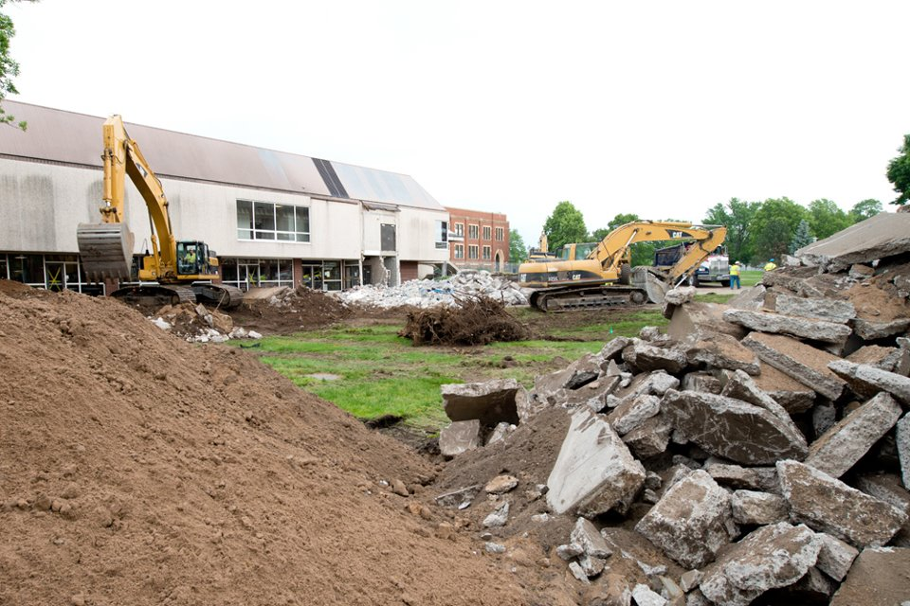
Figure 9 “Demolishing Davies” Bill Hoepner, Copyright UW-Eau Claire 2012

The year 1998 saw once again the discussion of needing more space for the W. R. Davies College Center. A committee was established to determine the student body opinion on expansion and to decide what options were available for the center. The committee came to the conclusion that more space was necessary but they were running out of options for where to expand. The growing campus had left little space around the building to expand. Two options were proposed. The first was to expand eastward toward Schneider Hall. The problem with that was, it would significantly cut down the green space of the campus and limited space meant a small expansion. The committee feared it would not be enough space. The other option proposed expansion southwards. However this would remove the parking lot and parking space was limited on campus. It was proposed to build an overpass over the southern parking lot behind the building and the expansion would be on the green space behind the lot. Bob Severson, building supervisor for the university centers, favored the second option but stated that the expansion process was in the early stages and needed more research before a final decision could be made. More students joined the committee in 1999 to give it more student voices and the research continued.
The committee proposed, in 2000, a referendum of adding $38 to student segregated fees per semester for a total of $8.5 million to fund a “facelift” for Davies. The committee thought this would be enough money to cover upgrading and expanding the building. The referendum was put to a vote by the student body and it passed with 76% for the referendum. Unfortunately the committee was going to be in for a shock.
In 2001 Ayres Associates did an assessment of the current and future needs of the building. It found that Davies suffered from limited space, roof problems, and structural and maintenance issues. The conclusion was it would cost $33.7 million dollars to repair, get up to code, and expand Davies. This was a huge difference from the $8.5 million budget the committee had. The committee had a decision to make; was it worth it to update and expand the existing Davies Center?
The committee answered this question on February 10, 2003 at the Chancellor’s roundtable. It announced the intention for expanding Davies was to start over with a plan for a brand new building. The plan proposed would increase the student segregated fees by $102 per semester, which would be phased in over three academic years. It would begin in the fall semester of 2004 and raise $36.1 million to construct a new building. This news was unexpected and shocked many students. They had assumed the committee’s original assessment of only needing a budget of $8.5 million was correct and that decision to expand was simply to go to the east or to the south, not build an entirely different building. The committee was unanimous in its decision for a new center but it was up to the student body to vote for the referendum.
The students’ reaction to the idea of a new building was mixed. While most agreed additional space in Davies would be beneficial many argued that the cost was not worth it. “I think it’s bad timing to be spending all this money on expansion of our recreational space.” Student Brian Babbitt told The Spectator. “I don’t see why we need a whole new center. The amount that it’s gonna cost is shocking.” This opinion was loudest among the students who publicly discussed the center. The Spectator received three letters to the editor over the next month about why the new center was a bad idea. Only one letter, from a committee member, supported the new center. The committee feared that people only saw the large amount of money and did not understand the circumstances and reasons for the sum. The students feared the committee was charging them a large amount of money for a problem that needed more research.
The committee proposed the new center in February and asked the students to vote in March. This did not give the committee enough time to explain, answer questions, and make sure students made an informed decision. Although attempts to get the word out through brochures and newspaper articles were made most students were not informed of the details and felt the committee was not giving them enough time to understand the situation. The Spectator’s “Question of the Week” in February 27, less than a week before the vote, was “Do you support a new Davies Center?” Three of the five students featured said a definite “no” and the other two said they had “mixed feelings” about the situation. They agreed more space and a new facility would be nice but the cost was the issue.
March 3-6, 2003 brought the highest turnout of student voters in twenty eight years. The referendum failed. It was almost a four to one vote for “no” with 1,435 voting “no” and 386 voting “yes.” After the results Vice Chancellor Andy Soll seemed to think the new center could happen but the student body still needed to be convinced. The Spectator wrote “The vote results don’t mean the end of a Davies expansion or new student center but Soll said the expansion committee’s challenge is to “turn the sentiment around.””
It was decided that to improve the student opinion of getting a new building more research needed to be done. Brailsford and Dunleavy, a firm based in Washington D.C., sent a program manager and facility planner, Bart Hall, to assess the situation at UWEC in 2005. He spoke to about 50 students and faculty and evaluated their opinion on what they were looking for in the campus facilities. Hall specifically discussed whether or not students and faculty felt Davies needed to be expanded. “This process…is the step that should have come before the referendum.” Hall said, speaking of the 2003 failed referendum. From the information gathered from this group Hall created a survey for all the students at UWEC to take to determine the general opinion on the facilities. The survey found that 75% of the 2,666 students that responded thought the Davies Center needed renovation and expansion. Brailsford and Dunlavey then set out to evaluate the cost of renovating and expanding Davies and found it to be approximately $41 million, an increase from the 2003 estimation of $33.5 million. The exploratory committee then set out to gain support for building a new center and gained the backing of the Student Senate, University Centers Advisory Committee, United Hall Council, and Chancellor Brian Levin-Stankevich. Now the committee had research and support from various groups on campus.
However another student referendum did not take place and the student support was based only on one of the 2005 surveys. 64% of 1,640 students who responded supported the redevelopment of Davies. The campus student population was 10,500 so this survey reflected the opinions of 15.6 percent of the student population. However this was one of the highest response rates for students’ votes on campus issues. It was enough student support, according to the committee, to begin making the building a new center a reality.
In 2006 the UW System Board of Regents approved a $48.8 million redevelopment of the Davies Center. Yet it was not until 2008 when it was officially announced that the redevelopment of the student center involved a new building and the demolition of the current Davies Center. The decision to demolish was made. Davies which served the students for 49 years as their “living room” on campus was going to be torn down due to the expensive modifications and renovations needed and replaced with a new building. W. R. Davies College Center was closed in May 2012 and was torn down in August 2012. The new center was located south of the original and the space once occupied by the original building was made into a green space and outdoor amphitheater. After 53 years of service the building was gone.

CONCLUSION
A brand new building now stands on UWEC lower campus to serve as the “living room” and center of student activities. The legacy of W.R. Davies expanding and bringing community to the campus seemed to be lost. It was proposed that the new center be given a new name, most likely after a major financial donor to the center. However the community of UWEC would not have it. A survey in 2011 of students, staff, faculty, alumni, and emeriti found that the majority wished to keep the name W. R. Davies Student Center. President Davies who worked so hard at expanding the physical landscape, the programs offered, and enrollment for the college at Eau Claire was still to be honored and remembered.
The new Davies building is a current event at the time of the writing of this paper so its history is yet to come. Will it be doubled in size in four years like its predecessor? Will the need for more and more space plague its existence? Who will grace its doors? President Davies was constantly striving to transform the campus so his portrait, if it were capable of such thoughts, is probably content to rest in the new building. The impact of this new building on the campus is yet to be determined.
The W. R. Davies College Center was envisioned from the beginning of its planning to be a place to serve the community and the student life aspect of being at college. It was meant to serve the students by providing them food, a bookstore, meeting rooms, ballrooms, and places to come together. It was supposed to combine student academics with student life. This was the vision of the first planning committee. Over its 53 years of service to the campus the W.R. Davies College Center accomplished this vision. It gave students a “living room” to use for their college life purposes. It did not always provide enough space but over the years the center directors and students have done their best to provide services to the students. This meant expansion, the addition of two upper campus centers, and eventually a new building. Overall the goal of providing a place specifically to serve the students was met by the W. R. Davies College Center.
“Like every facility of the college, the Center is an educational resource – planned and designed to strengthen and enrich the lives of those who seek the best in educational experience…This is your College Center. Use it! Take an active part in its program and activities. You will find that your Center has a special place for you.”
Clayton Anderson.

Appendices:
Appendix One
“The Plaint of Minnie Creek” by Tristram Jones
“I ripple over spills
A-splashing like a grampus,
I bubble ‘neath the silent hills
That sentinel South Campus

Pressed on by bracing autumn air
I wind amid the sedges
And gaily saunter on the where
And excavator dredges.

“What is this treat to my delight
In nature’s sweet communion?”
I ask, and learn that here is the site
Of the new Student Union

The tree whose trunk with hearts entwined
Encouraged harmless sparking,
I look for but cannot find;
Instead a sign, “No Parking”

How oft with careless grace I’d wreathe
Below the oak-strewn ridges
As, tranquilly, I’d flow beneath
The –oops, there GO the bridges!

You do not harm my clientele
(They’re deaf as well as finny)
With whistle’s scream, and foreman’s yell;
But – what it does to Minnie!

When cold progressive man diverts
My course, sublimely scenic
He little knows how much
I’ll soon be schizophrenic

I love to weave my magic spell,
But when my course you sever
CONSISTENTLY, oh how, pray tell
Can I go on forever?

Jones, Tristram. “The Plaint of Minnie Creek,” The Spectator, Wisconsin State College Eau Claire, 7.
Appendix Two
“College Center”
Building Traffic: Mondays through Fridays 5,000 to 8,000 people enter the building daily.
Employment: Minimum staffs of 95 people operate the center.
Students…..(part time) 56
Employees...(full time) 39
Meetings:
July 1 thru Dec 31, 1961……….705
January 1 thru March 31, 1962…660
April 1 thru June 30, 1962……...420
Total 1, 785
Special Services Rendered:
Scheduling, check cashing, information, ticket sales, newspapers, distribution area, kitchenette, telephone, food service, school supplies, use of equipment and specials.
Events: Public Relations and Specials: [selected examples by author]
7/18, 7/24, 7/27: Freshmen Pre-registrations meeting of parents
7/18: All-college picnic
7/18-19: Art Exhibit
9/8: Gamma Delta Get Acquainted Party
9/28: Wisconsin State College President’s meeting
11/11: Hope Lutheran Church Banquet
11/17: Sophomore class Sadie Hawkins all-college dance
12/10: Orchestra-Choir Christmas Buffet
1/6: 18th annual Interstate Debate Tournament for High Schools
3/4: All college pre-Lenten Buffet
5/5: Faculty wives spring luncheon
Dances: A total of seven parties were held in the Southwoods room of the center. These dances were all very well attended and the decorations for each event were outstanding.

Clayton Anderson, “College Center,” 1962, Chancellor’s Correspondence, box 21/folder 2.

Appendix Three

“Evaluation of Center submitted to the Board of Regents June 24, 1960”

- After a complete job of calking the windows there was still leakage during the rain storm on June 16.

- The tunnel leaks so badly that it cannot be used during a rain storm. Plaster has fallen from the ceiling in large areas. This is an impossible situation at present, and we must find some means of correcting it

- A roof leak appeared in the north lobby where the lobby area connects to the main building.

- Plaster is falling out around the windows on the second floor due to moisture.

- Fireplaces have a down draft which prevents their use.

- There is no drainage from the refrigerators to meet minimum specifications of the State Board of Health.

Letter Haas to McPhee, June 24, 1960, in Chancellor’s Correspondence box 21/folder 2.

Appendix Four

“Statements by faculty, administration, and the student body on their experience with President W. R. Davies”

Poem submitted by President Leonard Haas

“What Makes A Man?”
Not royal blood, or place grand;
Not stores of gold, or leagues of land;
Not giant form or deeds of fame;
Not creeds which mean no more than name;
Not social rank, with choice of place;
Not learning great or gifts of mind;
Not one of these, nor all combined;
Can make a man.

What makes a man?
A love for truth, in heart made pure,
With faith that truth in God is sure;
A humble mind, devoid of pride,
Which makes God’s Word its constant guide;
A will to serve, at any cost,
And counts that gain which can’t be lost;
True loyalty that stands the test
Of sincere zeal for all that’s best;
When selfishness yields these a place,
The Living God by His free grace,
Will make a man.

Miss Erna Buchholtz, Chief Librarian:
“He was one of the finest persons I have ever worked with. A true gentleman in all his dealings. He was a friend of librarians.”

Ted Wyman on behalf of the student body:
“The student body joins with the faculty and administration in mourning the death of President W.R. Davies. There are a great many of us who feel a great sense of personal loss, knowing him as we did, not only as the President but as an individual as well. We are sure that his presence will be felt here on this campus long after we are gone. Men of such stature are never forgotten.”

Dean Stella Pedersen:
“W. R. Davies was a kind, friendly, magnanimous President. He will continue to live in the hearts and minds of innumerable individuals who regard him as an exceptionally fine person.”

Dr. Richard E. Hibbard:
“The opportunity to serve as an associate of President Davies was a rare and rich privilege. It was, fortunately, an experience which was granted to many individuals as they accompanied him in his career as an outstanding educator in Wisconsin. Each of us is richer for the time he shared with us and we shall ever be his debtor.”

Dr. Lester M. Emans:
“President Davies gave himself as few individuals ever do; his thoughts were always for others. To many of us who knew him well he was like an older brother – always considerate when this set of basic principles. His vision and foresight are reflected in this college. His influence will endure.”

Dean Willis Zorn:
“I have been associated with President Davies for the past nineteen years. He has given of himself 100 percent to the college and community. He has personified the word “Enthusiasm.” His passing is a real personal loss to me and a great loss to the community.”

“Friends Pay Davies Tribute” The Spectator Wisconsin State College Eau Claire, 17 December 1959, 2.

Appendix Five

“Letter to the Editor”

“New Davies Plan too Extravagant”
Here at UW-Eau Claire, the student leadership has presented a plan for a new Davies Center with a price tag of $36.1 million. This sort of proposal ignores both the current budget crisis in Wisconsin and the fact that access to higher education is not affordable for everyone. The tuition increase coming from the state government will be hard enough for students to bear. Because the Davies Center will be entirely funded by students this plan presents an even greater risk to keeping higher education in Wisconsin accessible to people from all walks of life – rich and poor. Some in the Student leadership may be interested in establishing their legacy while making an education at Eau Claire less assessable in future years when they are gone and don’t have to pay for the new building. My primary goal at Eau Claire is to get a degree. I am not interested in creating a legacy for student leadership while making an education at Eau Claire less affordable. Now is not the time for good intentions with a price tag we cannot afford. Vote “no” on a new Davies Center March 3 to March 6.
Duncan Cameron, Senior

The Spectator University of Wisconsin Eau Claire, 17 February 2003, 11.

Appendix Six:
Additions to the Original Davies Center
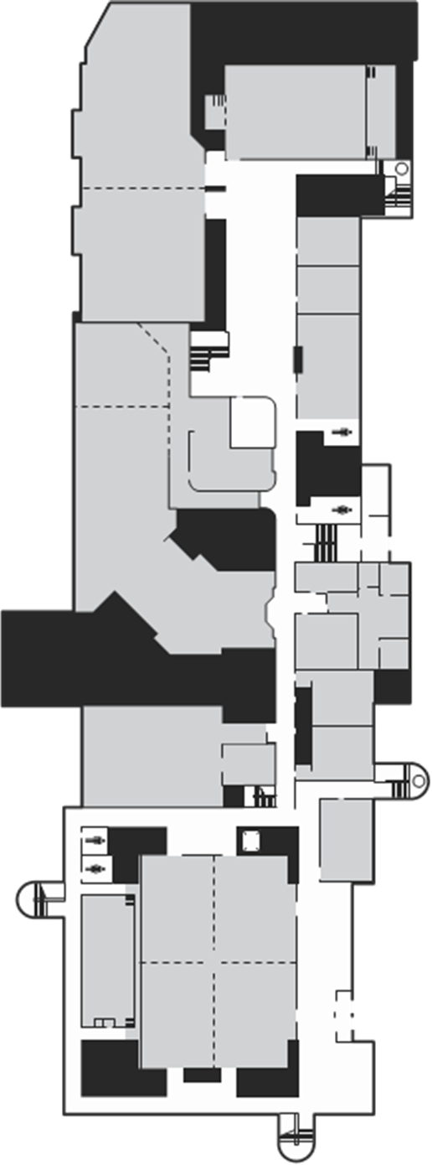

N
- 1959 Original Center
- 1964 First Expansion
- 1976 Second Expansion
- 1982 Third Expansion

Map: http://www.uwec.edu/centers/facilities/upload/DaviesMapColor2011.pdf
Addition depictions by the author.
BIBLIOGRAPHY

Primary Sources:

Carmichael, Oliver C. Universities: Commonwealth and American a Comparative Study. New York, Harper and Brothers Publishers, 1959.

This book explores the history of universities in the United States and compares them to universities in the larger common wealth. It was written in the year the Davies Center was opened and contains ideas of that time about how universities should operate. It mentions Student Unions as a new but important development.

Chancellor’s Correspondence. Letter, memos, constitutions, speeches, brochures. UWEC Archives, Eau Claire, WI.

The Chancellor’s Correspondence is a large collection of letters, memos, constitutions, speeches, brochures, telegrams, and other papers pertaining to the Chancellor or President’s affairs. Many of these papers contained valuable information about the planning, construction, and early years of the Davies Center. It is located in the Special Collections and Archives at the University of Wisconsin Eau Claire.

The Periscope, 1957-1991. UWEC Archives, Eau Claire, WI.

The Periscope was the yearbook of the Eau Claire campus. It contained articles and photographs of the Davies Center for the years of its construction and renovation. It is located in the Special Collections and Archives at the University of Wisconsin Eau Claire.

The Spectator, 1956-2008. UWEC Archives, Eau Claire, WI.

Located in the Special Collections and Archives at the University of Wisconsin Eau Claire The Spectator is the campus’s newspaper. It contains various articles, interviews, and letters to the editor about the Davies Center and the people involved over its 53 years of service to the campus.

University of Wisconsin Eau Claire. UWEC Archives Photostream, 2012. http://www.flickr.com/photos/uwec-archives/7129881375/in/set-72157629936257837/ (accessed 11 October 2012)

A collection of photographs from UWEC Archives. All the photographs, unless otherwise noted, were found from this site. The photographs themselves are in the archives but have been scanned and made available on this website.

Secondary Sources:

“About W.R. Davies” University of Wisconsin Eau Claire, http://www.uwec.edu/centers/facilities/davies/about.htm (accessed 13 October 2012)

An article about W. R. Davies explaining his life and major contributions to the campus. It is located in the section about the new Davies center on the University of Wisconsin Eau Claire’s website.

“A Brief History of UW-Eau Claire,” 25 July 2012, http://www.uwec.edu/advantage/history.htm (accessed 1 December 2012.)

This article is on the University of Wisconsin Eau Claire’s website and gives an overview of the history of the campus. It helps place the Davies Center in the larger campus history.

Carter, Hilda Richardson. “Fifty Years of Higher Education at Eau Claire (1916-1966).” In History of Wisconsin State Universities (1866-1966), ed. Walker D. Wyman, 299-321. River Falls: River Falls State University Press,1968.

A book published for the 100th anniversary of State Universities in Wisconsin. Eau Claire is one of the youngest in the state was only celebrating 50 years. However this gave a good overall history of college and its expansion and hopes for the future.

Carter, Hilda R. and John R. Jenswold. The University of Wisconsin – Eau Claire: A History 1916-1976. Eau Claire: University of Wisconsin-Eau Claire Foundation, Inc, 1976.

A book written for the 60th anniversary of the founding of the University of Wisconsin Eau Claire. This contained valuable information about the history of the campus, W. R. Davies and the Center. It also served as guide for any gapes in the history of the Center up to 1976 that could be filled by this paper.

Davies Center Map. http://www.uwec.edu/centers/facilities/upload/DaviesMapColor2011.pdf (accessed 19 November 2012).

Map of the Davies Center after its final renovation and expansion. It provide a guide to the location of rooms as well as give their names.

Long, Edward LeRoy Jr. Higher Education as a Moral Enterprise. Washington D.C: Georgetown University Press, 1992.

This book discussed Higher Education and its role in helping students develop a moral code. It explained how College is a time of independence as well as fitting into a larger community and discussed how that affects students and their conduct. One side of the spectrum spend all their time studying and have little to no social life where the opposite side do not study and attend parties and social activities. It is up to the college or university to educate their students not just about their chosen academic but also social behaviors and to act responsibly.

“The Forum Tradition” http://www.uwec.edu/Activities/programs/forum/tradition/index.htm (Accessed 3 December 2012).

A brief history of the Forum at the University of Wisconsin Eau Claire. It is located at the University’s website.

“Original Davies Center.” http://www.uwec.edu/centers/facilities/davies/original.htm (accessed 20 November 2012).

This article gave a brief history of the original Davies Center. It was a part of the new Center’s website. It gives the major highlights in the history of the center but lacks details. It was a good starting point for finding dates and names of some of the most involved people in the center.

“Student Initiative to Redevelop Davies Center Goes to Board of Regents” 5 December 2006, http://www.uwec.edu/newsreleases/06/dec/1205DaviesCenterupdate.htm

An article about the decision for a new center and the support it got from different groups on campus. It also includes the numbers and percentages of the surveys taken in 2005 about student opinions on the redevelopment of Davies.

“Wisconsin Tuition Programs for Veterans, Qualifying Spouses, and Children.” http://dva.state.wi.us/WebForms/WDVA_B0105_Wisconsin_Tuition_Programs_WI_GI_Bill_Color.pdf (accessed 3 December 2012).

A website explaining how the GI bill works in the Wisconsin school systems. President Davies used this program after WWII to encourage veterans to get their education at Eau Claire and this played a major part in helping enrollment increase during the post-war years.

Oliver C. Carmichael, Universities: Commonwealth and American a Comparative Study. (New York: Harper and Brothers Publishers 1959), 148.
Edward LeRoy Long Jr., Higher Education as a Moral Enterprise. (Washington D.C: Georgetown University Press) 1992, 26-27, 45-47.
Oliver C. Carmichael, Universities: Commonwealth and American a Comparative Study. (New York: Harper and Brothers Publishers) 1959,148.
“A Brief History of UW-Eau Claire,” 25 July 2012, http://www.uwec.edu/advantage/history.htm (accessed 1 December 2012)
“Original Davies Center.” http://www.uwec.edu/centers/facilities/davies/original.htm (accessed 20 November 2012).
Eugene R. McPhee Director of the Board of Regents to Larson and Playter, 2 May 1956, in Chancellor’s Correspondence box 17/folder 3, UWEC Archives.
At the time of the writing of this paper the painting is on the wall near the Special Collections and Archives on the fifth floor of McIntyre Library.
Hilda Richardson Carter, “Fifty Years of Higher Education at Eau Claire” in History of the Wisconsin State Universities ed. Walker D Wyman (River Falls :River Falls State University Press, 1968), 311.
The Periscope, 1957 (Eau Claire: Wisconsin State College Eau Claire), 2.
Eugene McPhee was a 1923 graduate of the Eau Claire Normal school. He served as Director of Teacher Training in Eau Claire before going to Madison in 1948 with his appointment to secretary of the Board of Regents of State Normal Schools. See http://www.uwec.edu/Library/archives/exhibits/buildings/mcphee.htm
W.R. Davies to Eugene R. McPhee, 29 December 1955, in Chancellor’s Correspondence box 17/folder 3.
Colleges visited include Wartburg College in Iowa, Northwestern Missouri State College, Kansas State Teachers College, State Teachers College Edmond Oklahoma, and Southwestern State Teachers College.
“Observations of College Unions,” in Chancellor’s Correspondence box 17/folder 3.
Ida Hinz, “The College Union Planning Committee Meeting Minutes” 21 May 1957, Chancellor’s Correspondence, box 14/folder7.
Dorothy Erdman, “Minutes of the College Center Board” 6 May 1959, Chancellor’s Correspondence, box 19/folder 18.
Ida Hinz, “The College Union Planning Committee Meeting Minutes” 21 May 1957, Chancellor’s Correspondence, box 14/folder7.
Glen W. Timmons was the Director of the DePauw Memorial Student Union in Greencastle, Indiana. He delivered this speech at the 33rd Annual Conference of the Association of College Unions which was held at Purdue University in Layfayette, Indiana, April 8-11, 1956.
Glenn W. Timmons, “Problems and Procedures in Organizing a Union on a Small College Campus,” April 1956, in Chancellor’s Correspondence box 17/folder 3.
“Constitution of the College Union of Wisconsin State College at Eau Claire,” Adopted 19 March 1958, in Chancellor’s Correspondence box 17/folder 3, 1.
Eugene R. McPhee Director of the Board of Regents to Larson and Playter 2 May 1956, in Chancellor’s Correspondence box 17/folder 3.
William Proxmire, to President William R. Davies, Western Union Telegram, 24 October 1957, in Chancellor’s Correspondence box 17/folder 3.
Ibid
Chas A. Halbert to Larson and Playter, 5 June 1957, in Chancellor’s Correspondence box 17/folder 3.
“Suggestions on Plans for College Union” 22 August 1957, in Chancellor’s Correspondence box 17/folder 3.
Chas A. Halbert to Larson and Playter, June 5, 1957, in Chancellor’s Correspondence box 17/folder 3.
“Haas Fine Arts Center,” University of Wisconsin Eau Claire, http://www.uwec.edu/Maps/bldgtour/hfa/index.htm (Accessed November 18, 2012)
William Proxmire, to President William R. Davies, Western Union Telegram, 24 October 1957, in Chancellor’s Correspondence box 17/folder 3.
Jim DeJung, “State of the Union,” The Spectator (Wisconsin State College Eau Claire) 21 September 1956, 2.
“Construction of Student Union to Begin at College in Spring,” The Spectator (Wisconsin State College at Eau Claire) 21 September 1956, 1.
Dave Wood, “Student Government in Session, Dance Plans stopped by Zorn,” The Spectator (Wisconsin State College at Eau Claire) 21 September 1956, 1.
Jim DeJung, “State of the Union,” The Spectator (Wisconsin State College Eau Claire) 18 October 1956, 2. UWEC Archives.
“College Union Board Proposal,” in Chancellor’s Correspondence box 17/folder 3.
A full time student is one that has enrolled for 12 or more credits per semester.
“Constitution of the College Union of Wisconsin State College at Eau Claire,” in Chancellor’s Correspondence box 17/folder 3, 1.
Dorthy Erdman, “Minutes of the New College Union Board Meeting,” 6 February 1958, in Chancellor’s Correspondence box 17/folder 3.
Two students were elected President, James DeJung and Glenn Person. Three faculty members were elected Vice President, Miss Stella Pedersen, Dr. David Welker, and Mr. Lester Gilbertson. Faculty member Miss Delia Anderson and students Janet Kent and Dorothy Erdman were elected for secretary. Two students were elected treasurer, Lavern Mundinger and James DeJung. James Kolka was another student present at the meeting.
This committee’s members were Miss Pederson, Miss Christensen, James Kolka, Glenn Person, James DeJung, Mr. Lester Gilbertson, Dorothy Erdman and the Union Director Mr. Clayton Anderson.
Ibid.
“The Original Davies Center,” University of Wisconsin Eau Claire, http://www.uwec.edu/centers/facilities/davies/original.htm (Accessed November 20, 2012.)
Darlene Nelson, “Minutes of the College Center Board,” Wisconsin State College at Eau Claire, 22 April 1958, in Chancellor’s Correspondence box 17/folder 3.
“College Center Board Happy with Year’s Achievements,” The Spectator (Wisconsin State College at Eau Claire) 21 May 1959, 4.
“Student Union Ground Breaking Ceremony Held,” The Spectator (Wisconsin State College Eau Claire) 21 November 1957, 1.
“Construction of College Union Begins; Minnie Creek Now Being Diverted” The Spectator (Wisconsin State College Eau Claire) 12 December 1957, 1.
Tristram Jones, “The Plaint of Minnie Creek,” The Spectator, (Wisconsin State College Eau Claire) 12 December 1957, 7.
See Appendix One for the entire poem.
Brain T. Kaiser, Representative Region VI Association of College Unions: Illinois State Normal University to Miss Dorothy Erdman, Student Union Building Secretary, 17 February 1958, in Chancellor’s Correspondence box 17/folder 3.
John Durand, “New Union Manager Named; C. Anderson to take Position,” The Spectator (Wisconsin State College at Eau Claire) 16 January 1958, 1.
San Woller, “Union Director C. Anderson Enthusiastic over New Job” The Spectator (Wisconsin State College at Eau Claire) 27 February 1958, 7.
Ibid
Ibid
San Woller, “Union Director C. Anderson Enthusiastic over New Job” The Spectator (Wisconsin State College at Eau Claire) 27 February 1958, 7
“New Student Union Already being used by Two Eager WSCEC Sophomores,” The Spectator (Wisconsin State College at Eau Claire) 25 April 1958. 5.
“New College Center to open in April 1959,” The Spectator (Wisconsin State College at Eau Claire) 8 May 1958, 1.
“College Center Stated to open in Early Spring,” The Spectator (Wisconsin State College at Eau Claire) 23 October 1958, 1.
“College Center Opening Now is Middle June,” The Spectator (Wisconsin State College at Eau Claire) 9 April 1959, 1.
“Anderson Explains Delay in New Center Opening,” The Spectator (Wisconsin State College at Eau Claire) 16 April 1959, 7.
Ibid
President Haas to Board of Regents State Colleges, Madison Wisconsin, 31 May 1960, in Chancellor’s Correspondence box 21/folder 2.
“Center will Open on Limited Basis during Summer,” The Spectator (Wisconsin State College at Eau Claire) 28 May 1959, 7.
Glenn W. Timmons, “Problems and Procedures in Organizing a Union on a Small College Campus,” April 1956, in Chancellor’s Correspondence box 17/folder 3.
See Appendix Two for a review of the center’s services and events in the 1961 to 1962 school year.
“A Step into the Future: The New College Center,” The Periscope, 1959 (Eau Claire: Wisconsin State College Eau Claire) 150-152.
Sylvia can be proud of the fact that for 53 years the Center was enjoyed by the students, faculty, staff, alumni, and the community of Eau Claire.
“Proposed Center Changes Lauded,” The Spectator (Wisconsin State College Eau Claire) 19 May 1960, 2.
“Haas Named Acting President: Illness forces Davies to Retire from Office,” The Spectator (Wisconsin State College Eau Claire) 24 September 1959, 1.
“Haas Named Acting President: Illness forces Davies to Retire from Office,” The Spectator (Wisconsin State College Eau Claire) 24 September 1959, 1.
President Haas to Board of Regents State Colleges, Madison Wisconsin, 31 May 1960, in Chancellor’s Correspondence box 21/folder 2.
“A Step into the Future: The New College Center,” The Periscope, 1959 (Eau Claire: Wisconsin State College Eau Claire), 150-152, UWEC Archives.
“Kennedy to Visit Here Thursday: Massachusetts senator to Include WSC in Second Wisconsin Tour,” The Spectator (Wisconsin State College Eau Claire) 5 November 1959, 1.
“Armstrong to Play here Saturday,”The Spectator (Wisconsin State College Eau Claire) 17 December 1959, 3.
“Anderson Explains Delay in New Center Opening,” The Spectator (Wisconsin State College at Eau Claire) 16 April 1959, 7.
The Spectator (Wisconsin State College Eau Claire) 17 December 1959, 1.
See Appendix Three for the full evaluation.
Clayton Anderson to Mr. Dennis D’Jock, Larson, Playter and Smith, 10 June 1959, in Chancellor’s Correspondence box 19/folder 18.
President Haas to Eugene McPhee, 24 June 1960, in Chancellor’s Correspondence box 21/folder 2.
Clayton Anderson to Mr. Steven Player, Larson, Playter, and Smith, 11 August 1959, in Chancellor’s Correspondence box 19/folder 18.
President Haas to Eugene McPhee, 24 June 1960, in Chancellor’s Correspondence box 21/folder 2.
Ibid
Clayton Anderson, “Questionnaire College: Eau Claire,” in Chancellor’s Correspondence box 21/folder 2.
Clayton Anderson, “Questionnaire College: Eau Claire,” in Chancellor’s Correspondence box 21/folder 2.
“WSCEC Davies College Center Busy,” The Spectator (Wisconsin State College Eau Claire) 18 February 1960, 3.
Clayton Anderson, “Questionnaire College: Eau Claire,” in Chancellor’s Correspondence box 21/folder 2.
“Research and preliminary selection of the names was done by a special student-faculty-alumni-staff committee comprised of students Joel Uecker, Carol Allen, Janis Dittmer; faculty Inez Sparks, Parker Clark, John Schneider, Genevieve Johnson, and staff members Geraldine Wing and Harley Thompson.” See “Center, One Dorm Named: All School committee selects Memorial Names as Official,” The Spectator (Wisconsin State College Eau Claire) 14 January 1960, 1.
University of Wisconsin Eau Claire “The Original Davies Center,” Davies Center, http://www.uwec.edu/centers/facilities/davies/original.htm (Accessed November 20, 2012.)
See Appendix Six for a map of the additions.
Glenn W. Timmons, “Problems and Procedures in Organizing a Union on a Small College Campus,” April 1956, in Chancellor’s Correspondence box 17/folder 3.
“Director Finds Center Small,” The Spectator (Wisconsin State College Eau Claire) 3 March 1960, 1.
“Ground Work,” The Spectator (Wisconsin State College Eau Claire) 28 March 1963, 1.
“College Center Size will be Doubled by Expansion,” The Spectator (Wisconsin State College Eau Claire) 4 April 1963, 1.
“State Universities’ Name Changes Reflect Alterations of Past Years,” The Spectator (Wisconsin State University Eau Claire) 5 November 1964, 7.
“A Brief History of UW-Eau Claire,” (University of Wisconsin Eau Claire) 25 July 2012, http://www.uwec.edu/advantage/history.htm (Accessed December 1, 2012.)
“While you were gone…” The Spectator (University of Wisconsin Eau Claire) 4 September 1975, 1.
The Periscope (Eau Claire: University of Wisconsin Eau Claire) 1976, 32.
Sid Schwarts, “Davies addition begins this month,” The Spectator (University of Wisconsin Eau Claire) 4 March 1982, 14.
Patty Weber, “Renovations delayed: Davies Construction to be Completed by Spring” The Spectator (University of Wisconsin Eau Claire) 2 September 1982, 8.
The University of Wisconsin Eau Claire has three centers for student use. Davies was the first and main center but there is also Hilltop Center (Constructed in 1968) and Crest Wellness Center (Constructed in 1965) which are located on Upper Campus to accommodate the upper campus student community. See University Centers http://www.uwec.edu/centers/index.htm.
Terri Shager, “Davies’ facelift running smoothly,” The Spectator (University of Wisconsin Eau Claire) 31 January 1991, 3-A.
Candy Pearson, “Davies Remodeled: Students and Ducks Displaced,” The Periscope (Eau Claire: University of Wisconsin Eau Claire) 1991, 46-47.
Kris Whitfield, “University hid multi-cultural lounge,” Letter to the Editor, The Spectator (University of Wisconsin Eau Claire) 21 March 1991, 7.
Davies Center Map, University of Wisconsin Eau Claire, 22 May 2011, http://www.uwec.edu/centers/facilities/upload/DaviesMapColor2011.pdf
“Haas Named Acting President: Illness forces Davies to Retire from Office,” The Spectator (Wisconsin State College Eau Claire) 24 September 1959, 1.
“About W.R. Davies” University of Wisconsin Eau Claire, http://www.uwec.edu/centers/facilities/davies/about.htm, 8 October 2012. (Accessed October 13, 2012)
“Davies’ Life Story Reveals Devotion to College, Area” The Spectator” University of Wisconsin Eau Claire) 17 December 1959, 2.
“About W. R. Davies”
Hilda R. Carter and John R. Jenswold, The University of Wisconsin-Eau Claire: A History 1916-1976 (Eau Claire: University of Wisconsin Eau Claire Foundation, Inc) 1976, 39-46.
Ibid.
“Under the Wisconsin G.I. Bill, an eligible veteran who entered active military duty as a Wisconsin resident is eligible for remission of 100% of standard academic (tuition) and segregated fees at a University of Wisconsin System (UW) institution.” See “Wisconsin Veterans Tuition Programs,” http://dva.state.wi.us/WebForms/WDVA_B0105_Wisconsin_Tuition_Programs_WI_GI_Bill_Color.pdf
“About W. R. Davies”
“Haas Named Acting President: Illness forces Davies to Retire from Office,” The Spectator (Wisconsin State College Eau Claire) 24 September 1959, 1.
Ibid.
“The Forum Tradition” University of Wisconsin Eau Claire, http://www.uwec.edu/Activities/programs/forum/tradition/index.htm 18 June 2012 (Accessed December 3, 2012)
“About W. R. Davies”
W. R. Davies to Eugene McPhee, 8 September 1959, in Chancellor’s Correspondence box 21/folder 2.
“Davies’ Life Story Reveals Devotion to College, Area” The Spectator (Wisconsin State College at Eau Claire) 17 December 1959, 2.
The Spectator (Wisconsin State College Eau Claire) 10 December 1959, 1.
“Davies Leaves Inspiration: Haas lauds Philosophy of Davies” The Spectator (Wisconsin State College Eau Claire) 17 December 1959, 2.
See Appendix Four for the full statements.
“About W. R. Davies”
“Center, One Dorm Named” The Spectator (Wisconsin State College Eau Claire) 14 January 1960, 1.
Karen Rauen, “Davies faces expansion: Senate considers resolution to add input” The Spectator (University of Wisconsin Eau Claire) 5 November 1998, 1.
“The Davies Decision: Members added to Expansion Committee” The Spectator (University of Wisconsin Eau Claire) 30 September 1999, 3.
Andrew Dowd, “Davies Plan to cost $36.1 million: Committee Proposes a $140 Increase in Student Segregated Fees to Build a New Center” The Spectator (University of Wisconsin Eau Claire) 13 February 2003, 1-2.
University of Wisconsin Eau Claire “The Original Davies Center,” Davies Center, http://www.uwec.edu/centers/facilities/davies/original.htm (Accessed November 20, 2012.)
Andrew Dowd, “Davies Plan to Cost $36.1 Million: Committee proposes a $140 increase in student segregated fees to build a new center,” The Spectator (University of Wisconsin Eau Claire) 13 February 2003, 2.
Andrew Dowd, “Davies Plan to Cost $36.1 Million: Committee proposes a $140 increase in student segregated fees to build a new center,” The Spectator (University of Wisconsin Eau Claire) 13 February 2003, 2.
Andrew Dowd, “Students mixed on new Center” (University of Wisconsin Eau Claire) 17 February 2003, 1.
See Appendix Five to read one of these letters.
Letters to the Editor, The Spectator (University of Wisconsin Eau Claire) 17 February 2003, 11.
Kelly McBride, “Davies details available, Senate encourages Involvment in Civic Engagement Week” The Spectator (University of Wisconsin Eau Claire) 20 February 2003, 3A.
Emmalee Rathman, “Question of the Week: Do you Support a new Davies Center?” The Spectator (University of Wisconsin Eau Claire) 27 February 2003, 17.
Andrew Dowd, “Student Center Referendum Fails” The Spectator (University of Wisconsin Eau Claire) 10 March 2003, 1.
Mark Schaaf, “Focus group addresses student concerns: Davies Center main topic discussed” The Spectator (University of Wisconsin Eau Claire)24 February 2005, 1.
“The Original Davies Center”
“Student Initiative to Redevelop Davies Center Goes to Board of Regents” 5 December 2006, http://www.uwec.edu/newsreleases/06/dec/1205DaviesCenterupdate.htm
“The Original Davies Center”
Clayton Anderson, “Introducing Your College Center,” c.1959, in Chancellor’s Correspondence box 19/folder 18.

